|  |  |
| --- | --- |
| **NAME** | **R MAHENDIRAN** |
| **DEPT** | **ECE III YEAR** |
| **REG NO** | **42012106022** |
| **COLLEGE CODE** | **4201** |
| **GROUP** | **IBM-GROUP 5** |

[**Project Submission Part 4: Development Part 2**](https://courses.myclass.skillup.online/courses/course-v1:IBM+IOT101+2023_B5/courseware/7d42e125e8644a62a8ab1b036785cd0e/05559f75685d43a2ab593b60dd707469/)**:**

**Module 9: Node - RED Service:**

Node-RED is a programming tool for wiring together hardware devices, APIs and online services in new and interesting ways.

It provides a browser-based editor that makes it easy to wire together flows using the wide range of nodes in the palette that can be deployed to its runtime in a single-click

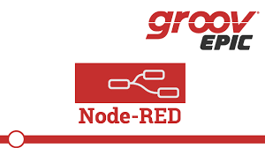

## What’s Node-RED?

### [Node-RED](http://nodered.org/) is a powerful open-source tool for building Internet of Things (IoT) applications with the goal of simplifying the programming component.

### Node-RED runs on the web browser and it uses visual programming that allows you to connect code blocks, known as nodes, together to perform a task. The nodes when wired together are called flows.

### ****Why is**** ****Node-RED a great solution?****

* Node-RED is open source and developed by IBM.
* The Raspberry Pi runs Node-RED perfectly.
* It is a visual programming tool, which makes it more accessible to a wider range of users.
* With Node-RED you can spend more time making cool stuff, rather than spending countless hours writing code

**What can you do with Node-RED?**

* Access your RPi GPIOs;
* Establish an MQTT connection with other devices (Arduino, ESP8266, ESP32 etc);
* Create a responsive graphical user interface for your projects;
* Communicate with third-party services (IFTTT.com, Adafruit.io, ThingSpeak, Home Assistant, [InfluxDB](https://randomnerdtutorials.com/install-influxdb-2-raspberry-pi/)etc);
* Retrieve data from the web (weather forecast, stock prices, emails. etc);
* Create time-triggered events;
* Store and retrieve data from a database.

## Node-RED Overview

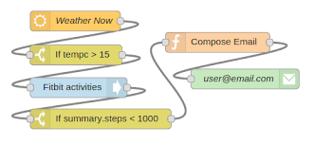

**Module 10 : Mobile Application Development using MIT App Inventor**:

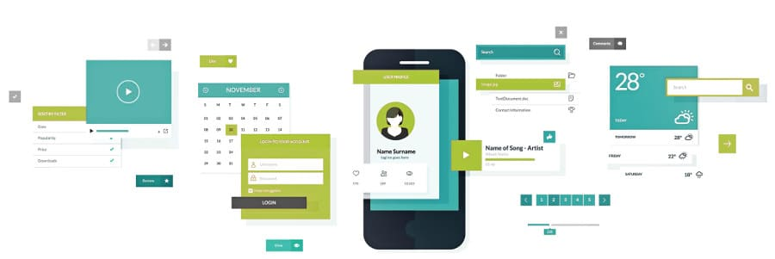

Using MIT App Inventor, you can develop applications for Android devices using a web browser and a connected phone (or emulator). The App Inventor servers store your work and help you keep track of your projects.

**Steps to use MIT app inventor:**

* Step 1: Open a Gmail account in case you don't have one.
* Step 2: Open the link and log in to your Gmail account.
* Step 3: You need to install the App Inventor Companion App (MIT AI2 Companion) on our mobile device that helps in live testing of our application.

**Project Submission Part 4: Development Part 2**

Python doesn't have built-in mobile development capabilities, but there are packages you can use to create mobile applications, like Kivy, PyQt, or even Beeware's Toga library. These libraries are all major players in the Python mobile space.

Python can be used for Android App Development even though Android doesn't support native Python development. This can be done using various tools that convert the Python apps into Android Packages that can run on Android devices.

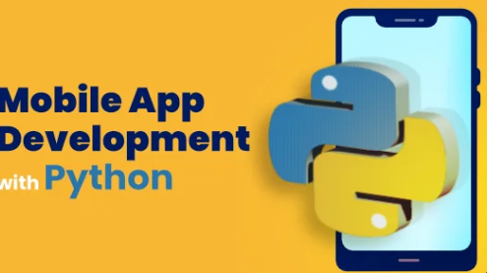

**Create the app**

1. Invoke View > Command Palette.
2. Type “flutter”, and select the Flutter: New Project.
3. Select Application.
4. Create or select the parent directory for the new project folder.
5. Enter a project name, such as my_app , and press Enter.
6. Wait for project creation to complete and the main.dart file to appear.