Web scrapping Method Step-By-Step

With uses of every module

Step 1 – Checking For Main Class in the Website

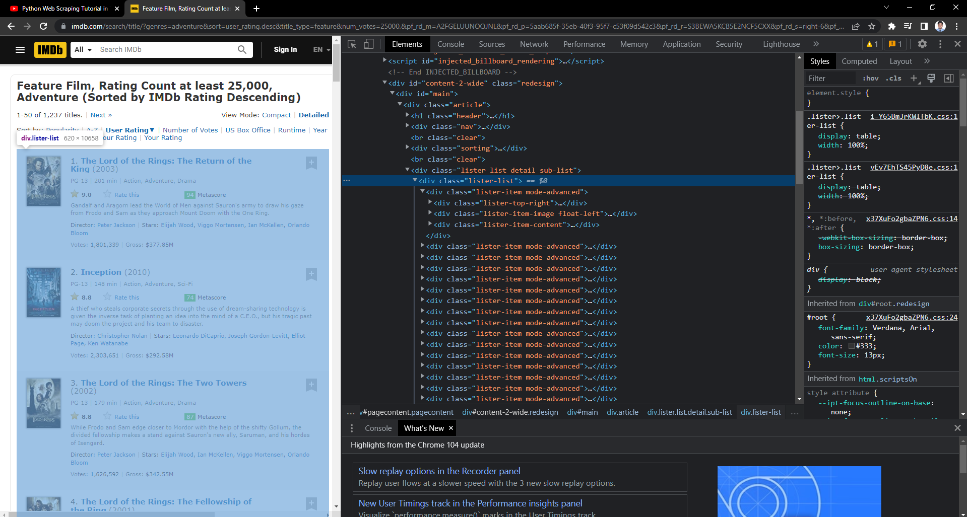

Step 2 – Checking For the sub class

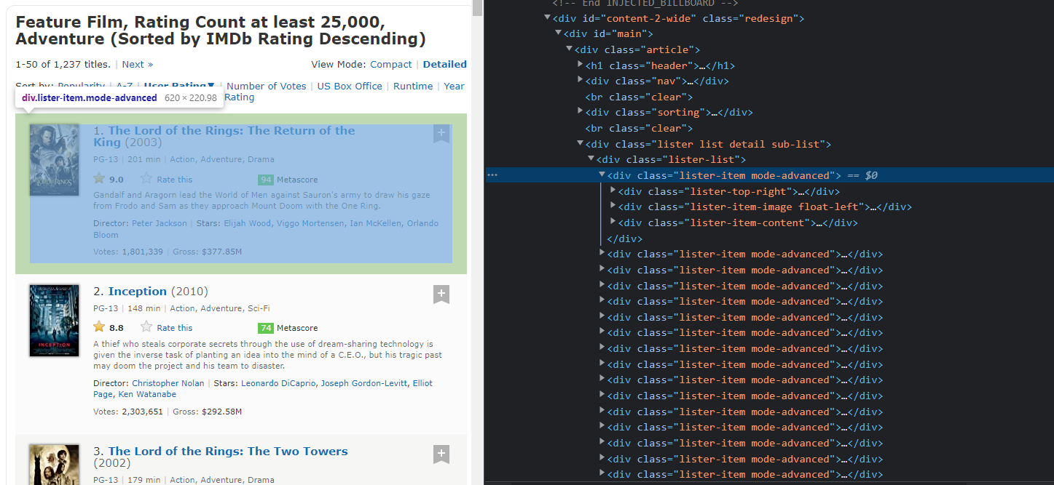

Step 3 Importing all necessary modules

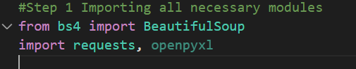

Step 4 – We are using the requests module to get all info about a particular webpage

Step 5 – Then we use beautifulsoup module to get all the html present in the given webpage

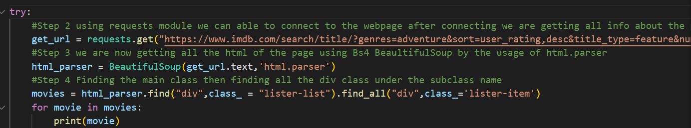

Step 6 – After Printing it out we need to find for the index under which tag it is located and then we need to find under the tag which tag and the class it is located

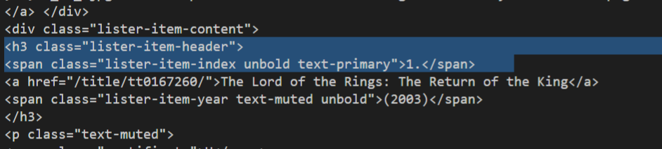

Step 7 – After finding the tag we need to use the command .find to find the tag in the html in the webpage then we are using .find again to find under h3tag which tag and mentioning the class then we are getting only the text using get_text then we use strip to remove the html and split as we don’t need 1’.’ This dot after the one so we are fetching for the first element

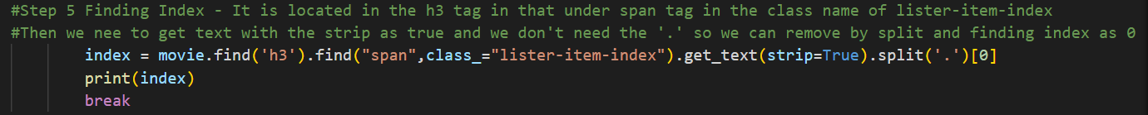

Step 8 – Then we are finding the movie name in the webpage

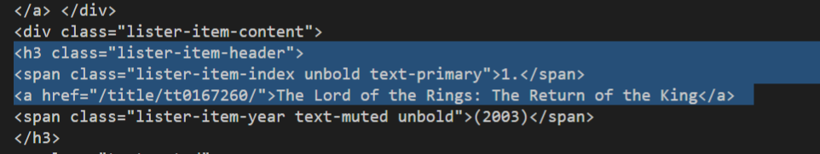

Step 9- It is located under the same h3 tag so we can find as we done for the index and here we can use directly a.text as we can able to find under the h3 tag there is only one anchor tag

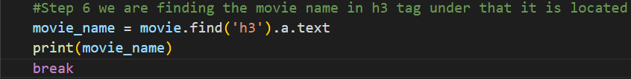

Step -10 Doing the same for all other thing but for year we don’t need those brackets so we can import regular expressions that Is re() then with the help of re we can used to replace the brackets in the format of re.sub("what to keep","what to replace","from where")

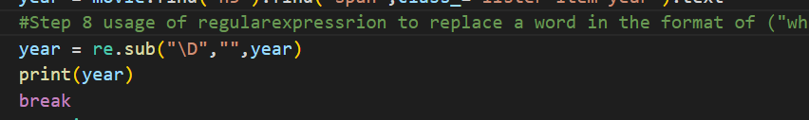

Step 11 – Next we need to find gross price located in the para tag in class sort-num_votes-visible in that we need to find all the span tag so that we can fetch the movie gross price as it is present in the last span tag i=of the same class after we use get_text() to get all the text



Step 12 – Using openpyxl we can able to create a excel file then we are making the current sheet to be active and assigning a title by appending a list containing titles

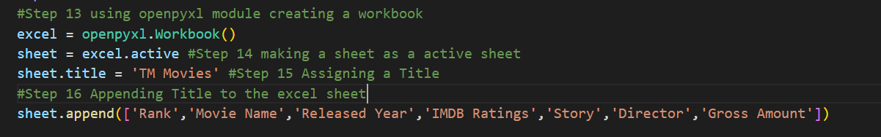

Step 13 – after this we need to append all the values and save the excel sheet by assigning a name to it then after running the program out excel sheet will be saved

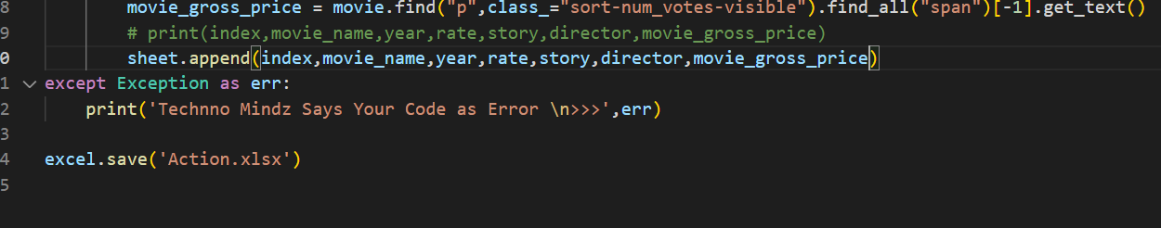

After running the program our excel file will be ready

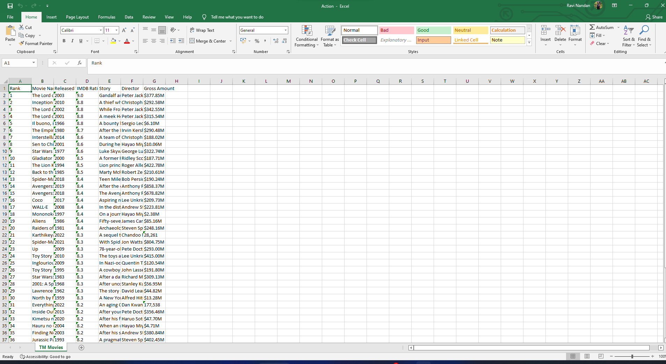

**END OF DOCUMENT**