**How to Use this Template**

1. Make a copy [ File → Make a copy... ]
2. Rename this file: “**Capstone_Stage1**”
3. Replace the text in green

**Submission Instructions**

1. After you’ve completed all the sections, download this document as a PDF [ File → Download as PDF ]
2. Create a new GitHub repo for the capstone. Name it “**Capstone Project**”
3. Add this document to your repo. Make sure it’s named “**Capstone_Stage1.pdf**”

Description

Intended User

Features

User Interface Mocks

Screen 1

Screen 2

Key Considerations

How will your app handle data persistence?

Describe any corner cases in the UX.

Describe any libraries you’ll be using and share your reasoning for including them.

Describe how you will implement Google Play Services.

Next Steps: Required Tasks

Task 1: Project Setup

Task 2: Implement UI for Each Activity and Fragment

Task 3: Your Next Task

Task 4: Your Next Task

Task 5: Your Next Task

**GitHub Username**: ravind88

Gantavya- A Travel App

Description

Simply Travel lets you find restaurants, hotels and tourist places

The app has a rich feature set, some of them are :-

1. Information about the best hotels, their reviews and contact info1
2. App uses your GPS location to find nearby places and attractions
3. Information about restaurants with reviews and contact info
4. Information about flights and their availability.
5. Use GPS to get more detail near your location.

Intended User

People who like to travel can use this app

Features

List the main features of your app. For example:

* Nearby Restaurants
* Nearby Hotels
* Tourist Attractions
* Flight Availability

User Interface Mocks

These can be created by hand (take a photo of your drawings and insert them in this flow), or using a program like Photoshop or Balsamiq.

**Screen 1**

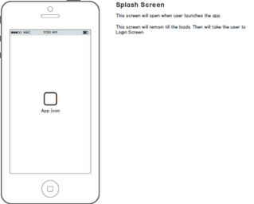

First screen will be a splash screen where a background and app logo will be shown for branding purpose.

**Screen 2**

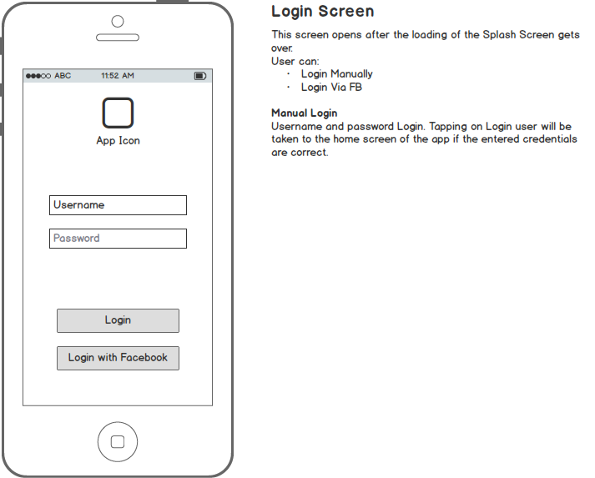

Second screen will be Login Screen. App does not have signup so I will provide test credentials or user can directly use the app via Facebook login.

App will ask user for GPS permission to access nearby places.

**Screen 3**

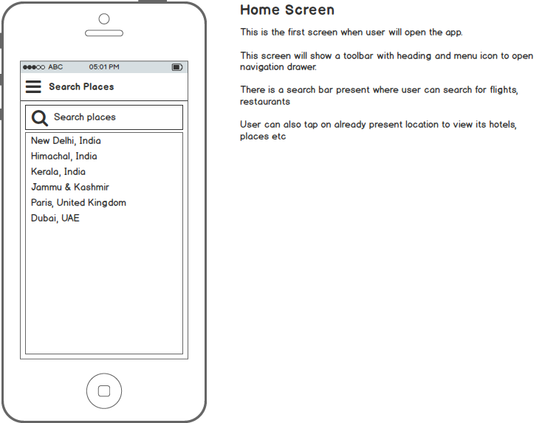

This is first screen when user will come after logging.

User can search for hotels, restaurants, tourist places, flights etc.

User can also view their favorite places, restaurants from the navigation drawer

**Screen 4**

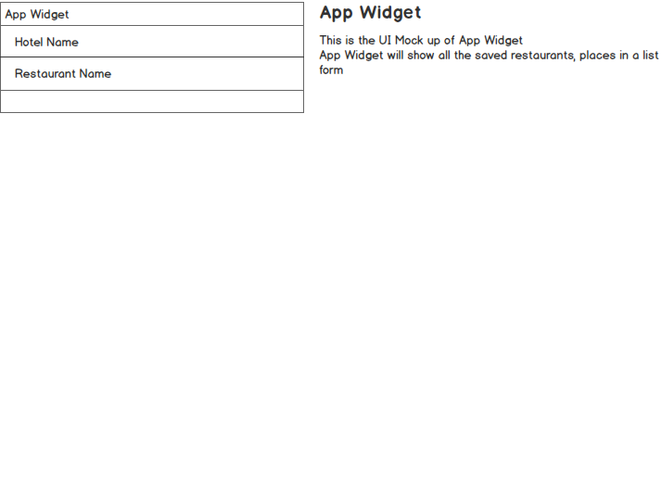

This is app widget of this application

It will show the listing of user’s favorite stored data.

Key Considerations

**How will your app handle data persistence?**

Application will use SQLITE database for caching local data, favorite places. Internal storage will be used for image caching and Shared Preference for user’s data.

**Describe any corner cases in the UX.**

User will be able to choose location and on the basis of location, user can view hotels restaurants etc. User can view saved restaurants in the navigation drawer. App is dependent on GPS so asking permission is a challenge from the user.

**Describe any libraries you’ll be using and share your reasoning for including them.**

* App uses multipleImagePickerLib library which is my own library for picking images and video. This library internally use glide and fresco for image caching.
* Design support library for recycle view and Snackbar.
* Kumulos for online server
* Facebook Sdk to allow login from Facebook
* Volley library to fetch data from Google places API

Next Steps: Required Tasks

This is the section where you can take the main features of your app (declared above) and decompose them into tangible technical tasks that you can complete incrementally until you have a finished app.

**Task 1: Project Setup**

1. Setup project structure. Setup third party libraries and setup libraries that may be required for development.

2. Setup MVP Architecture, which will be used for overall project

3. Design the flow of project

4. Setting up Google Developer console for enabling Google places API

**Task 2: Implement UI for Each Activity and Fragment**

* Build a Splash Screen
* Create MVP Classes for each activity like Login Activity
* Build UI for fragments and activities
* Build UI for places

**Task 3: Implementation of User Registration**

* Store the user information using Kumulos Plateform
* Storing and fetching data based on Kumulos methods and Apis
* Use looper ,handler and Asyntask to display the data.

**Task 4: Implementation of Google Places API**

* Retrieval of data from Google Places API using Networking libraries like Retrofit or Volley.
* Display results in a Tab Form
* Designing layouts to display results as per fetched data

**Task 5: Implementing Google Play Services**

* Admob Integration for monetization
* Mlxpanel integration for user interaction data and analytics
* Build Push notifications.

**Task 6: Implementing App Widget**

* Create Widget for this app

**Task 7: Production Ready**

* Make a Keystore and generate release build

**Task 8: Content Provider**

* Make a content provider having a unique uri to access local data.

Add as many tasks as you need to complete your app.

**Submission Instructions**

1. After you’ve completed all the sections, download this document as a PDF [ File → Download as PDF ]
2. Create a new GitHub repo for the capstone. Name it “**Capstone Project**”
3. Add this document to your repo. Make sure it’s named “**Capstone_Stage1.pdf**”