**Educational Qualification**

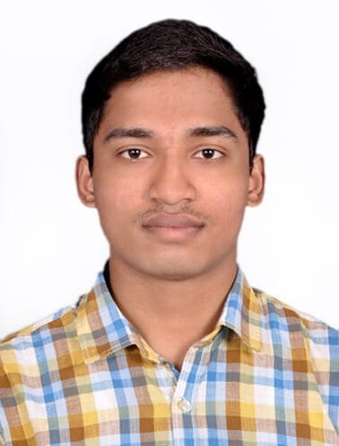

**G RAVINDERNATH YADAV**

B. Tech – Metallurgy and Materials Engineering

Gender: Male

Date of Birth: 09/07/2000

E-mail: ggrnathyadav2960@gmail.com

Contact: +91-8978713329

|  |  |  |  |
| --- | --- | --- | --- |
| **Year** | **Degree/Examination** | **Institution/Board** | **CGPA/Percentage** |
| 2020-Present | B. Tech- MME | NIT, Trichy | 8.20 |
| 2019 | Class XII | Rashtriya Indian Military College, Dehradun, CBSE | 76% |
| 2017 | Class X | Rashtriya Indian Military College,  Dehradun, CBSE | 8.8 |

**Academic Achievements**

* Secured All India Rank 118 in UPSC National Defence Academy (NDA), Pune and joined NDA (boarded out due to medical reasons).

**Internship Experience**

**Yoshops**

Data analytics and ML internship June 2022 – Current

* Current Cleaning and Analysing the current data to extract meaningful insights
* Create ML algorithms with improved accuracy

**Rysecamp Technology Private Limited**

Campus Leadership and Community Building Internship Feb. 2022 - Apr. 2022

* Worked on Growing the community of users engaging with students to gather feedback with a userbase of 150+ students
* Provided recommendations for Rysecamp product and content strategy

**Projects**

**Predicting the possibility of Diabetes** June 2022 - Current

**Sklearn Python Pandas Numpy Matplotlib Seaborn**

* Creating a ML model with high accuracy to predict the chances to contracting Diabetes
* Using Knn model

**Predicting Diamond Prices** May 2022 - June 2022

**Sklearn Python Pandas Numpy Matplotlib Seaborn**

* Found the parameter affecting the diamond prices by EDA
* Created a Machine learning model (linear Regression) to predict the diamond prices based on the parameters
* Improved the accuracy from 80% to 91.3% by cleaning and scaling the data

**Risk to Reward analysis using Sharpe Ratio** May 2022 - July 2022

**Pandas Numpy Matplotlib Seaborn**

* Compared different investment opportunities and identified the best investment with lowest risk and highest reward.
* Employed the principles of Sharpe test Visualized the resulting data.

**Technical Skills**

* Programming Languages: Python, JavaScript
* Other Software: Microsoft Excel, Microsoft BI, SQL, Word, PowerPoint
* Areas of Interest: Machine Learning, Business Analytics, Investing, Stock Analysis

**Positions of Responsibility**

* **Member of the Prakruti Club:** *Feb 2022 - Current*

Tended to the injured and un-healthy animals in the campus along with taking care of their basic requirements

Soon will be part of the team in charge of collecting and distributing food

* **Appointment in school:** *Jan 2019 - May2019*

Responsible and accountable for discipline of the cadets under me. Was part of important managerial decisions for the proper functioning of the section (consisting of 60+ cadets) and the training for the upcoming championships. Was part of the link (chain of command) between the administration and the students

* **Member and subsequently the president of the aeromodelling hobby:** *Jan 2014-2019*

Learnt the skills necessary for flying and building of a radio control plane as a member. Took part in various air displays for a wide range of guests (around 500+ officers and civilians). Air displays like acrobatic flying, flower petal shower, banner display and night flying. Did special displays for the chief of army staff (Gen Bipin Rawat), the chief of air force (ACM BS Dhanoa and ACM Arup Raha) and Late defence minister Manohar Parikar and various other dignitaries. As the president had to spearhead the displays and had to work with real time problems, solve them with quick decisions. Was part of the financial procurement of the planes and spares. Was responsible and accountable for passing down the skills to my juniors and ensuring the continuity of excellence in the hobby.

* **Captain of the school hockey team *Jan 2019***

Responsible for the proper functioning of the hockey team, their punctuality, attitude on the field and for conducting the inter section hockey championship along with my colleagues. To maintain high motivational levels of the team and plan out the course of action for upcoming championship.

**Extracurricular Activities**

***Social Activities:***

* Took part in distribution of old books for the needy and for the distribution of the clothing and supplies for the people affected in the Kerala floods.
* Took part in clean India movement and planted plant saplings across the campus
* Active member of the national social service.
* Actively taking care of the stray animals and providing them with basic healthcare

***Sport Activities:***

* Won the inter section Hockey championship twice (captained both the times)and was awarded with the best player and was awarded with a colour in hockey for my contribution
* Lead my school team in district level hockey championship
* Secured first place in Football championshipin junior’s category
* Secured medals in inter section athletics championship: gold in 100m,4X100 m relay, 400m and bronze in 4X400m relays.
* Secured medals in inter district athletic championship: bronze in 4X100m and came 4th in 400m (broke my personal best)
* Took part in X-country running (5k and 10k) improved my timings both the times

***Adventure Activities:***

• Attended the adventure course in Mountaineering consisting of a 117 km trek to Sandakphu by Himalayan Mountaineering institute, Darjeeling.

• Did rafting in grade 3 rapids of river ganga organized by army sports and adventure wing in Rishikesh