**Educational Qualification**

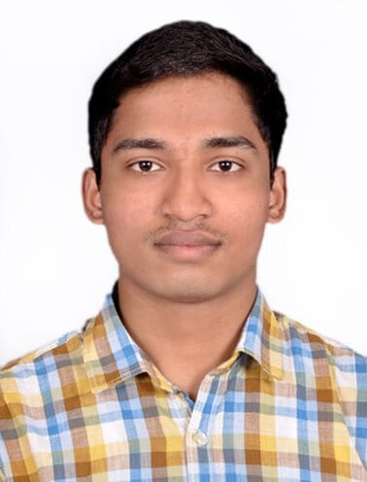

**112120019**

B. Tech – Metallurgy and Materials Engineering

Gender: Male

Date of Birth: 09/07/2000

E-mail: tp@nitt.edu

Contact: + 91-431-2501081

|  |  |  |  |
| --- | --- | --- | --- |
| **Year** | **Degree/Examination** | **Institution/Board** | **CGPA/Percentage** |
| 2020-Present | B. Tech- MME | NIT, Trichy | 8.20 |
| 2019 | Class XII | Rashtriya Indian Military College, Dehradun, CBSE | 76% |
| 2017 | Class X | Rashtriya Indian Military College,  Dehradun, CBSE | 8.8 |

**Academic Achievements**

Secured All India Rank 118 in UPSC National Defence Academy (NDA), Pune and joined NDA.

**Internship Experience**

* **D’Well Research** Aug 2022 – Current

Data analytics and ML intern. Responsible for designing and maintaining data systems and databases. Mining data from primary and secondary sources. Using statistical tools to interpret data sets, paying particular attention to trends and patterns that could be valuable for diagnostic and predictive analytics efforts Cleaning and analysing the current data to extract meaningful insights

* **Rysecamp Technology Private Limited** Feb 2022 - Apr 2022

Campus Leadership and Community Building Intern. Worked on Growing the community of users by engaging with students to gather feedback with a userbase of 150+ students. Provided recommendations for product and content strategy

**Projects**

* **Fraud Transaction detection on banking transactions**  July 2022 Created a Tree based ML model to identify the fraud transaction in the data. Read research papers to solve the class imbalance in data. Used T-links followed by random under sampling to handle the class imbalance and thereby improving the accuracy of the model
* **Fake News Classifier and movie recommendation model** July 2022 Classified fake news by pre-processing the data by using NLP packages such as nltk and spacy.  Followed by classification using Navies Bayes model achieving an accuracy score of 75%. Pre-processed the raw data from the IMDB dataset into clean tokens after lemmatization. Recommended the movie like the user using the tf-idf and cosine similarity method.
* **Predicting Diamond Prices** May 2022

Found the parameter affecting the diamond prices by EDA Created a Machine learning model (linear Regression) to predict the diamond prices based on the parameters. Improved the accuracy from 80% to 91.3% using hyper parameter tuning.

* **Risk to Reward analysis using Sharpe Ratio** May 2022 Compared different investment opportunities among IT stocks listed on the National Stock Exchange and identified the best investment with lowest risk and highest reward, subsequently using the results to take positions. Employed the principles of Sharpe test and Data visualization.

**Technical Skills and Certifications**

* Programming Languages: Python, JavaScript
* Other Software : SQL, Word, PowerPoint, Microsoft Excel, Microsoft BI, Tableau.
* Certifications : Feature Engineering for NLP, Supervised, Unsupervised Learning in Python

**Positions of Responsibility**

* **Manager at Social Council** Feb 2022 – Current

Social Council overlooks the societal aspects in and around the college campus. Coordinated with a team of over 100 students across multiple sub-teams for the smooth functioning of Council for **HumaNITTY**, a charity based weeklong donation drive for the needy which include raising of funds, organising, scheduling of event, crowd management.

* **Manager of the Prakruti Club:** Feb 2022 – Current

Prakruti is the NIT Trichy’s animal welfare club which takes responsibility of strays inside the college campus. Part of the medical team which oversees the administration of pills and first aid. Tended to the injured and sick animals in the campus along with taking care of their basic requirement.

* **President of the aeromodelling club:** Jan 2014-2019

Coordinated among 20 cadets and Organised various air displays for over 400+ guests. Air displays include acrobatic flying, flower petal shower, banner display and night flying. Did special displays for the chief of army staff, the chief of Air staff and various other dignitaries and was part of the financial procurement of the planes and spares.

* **Captain of the school hockey team** Jan 2019

Responsible for the proper functioning of the hockey team consisting of over 40+ cadets, their punctuality, attitude on the field and for organising the inter section hockey championship along with my colleagues. To maintain high motivational levels of the team and plan out the course of action for upcoming championships.

**Extracurricular Activities**

**Sport Activities:**

* Won the inter section Hockey championship twice (captained both the times)**,** lead my school team in district level hockey championship and was awarded with the best player and was awarded with a colour in hockey
* Secured medals in inter district athletic championship: bronze in 4X100m and came 4th in 400m (broke my personal best) and medals in inter section athletics championship: gold in 100m,4X100 m relay, 400m and bronze in 4X400m relays.

**Adventure Activities:**

* Attended the adventure course in Mountaineering consisting of a 117 km trek to Sandakphu by Himalayan Mountaineering institute, Darjeeling.
* Rafting in grade 3 rapids of river ganga organized by army sports and adventure wing in Rishikesh.