SLTC
School of Computing & IT
CCS3440 — Artificial Intelligence Coursework
Technical Report
Option C — Disease Risk Classification
Group 04 — WHALES (Batch 2027A)
Lecturer in Charge: Dr. Chameera De Silva

1. Introduction
SmartCare Hospital generates large volumes of patient, clinical, operational, and financial data through its daily operations. This report documents the design, development, evaluation, and interpretation of an Artificial Intelligence solution built to support hospital decision-making using this data. The coursework required selecting one of three prediction problems from the SmartCare Hospital AI Dataset; this project selected Option C — Disease Risk Classification.
The report follows the complete AI project lifecycle specified in the coursework brief: problem definition, dataset understanding, preprocessing, exploratory data analysis, model development, evaluation, explainable AI analysis, and prototype development, concluding with a discussion of results and their practical implications for hospital operations.

2. Problem Definition
Early identification of a patient's disease risk level is central to preventive healthcare. Patients whose risk is not recognised until symptoms are already severe often require more intensive, costlier treatment than would have been necessary with earlier intervention. Hospitals that can systematically triage patients by risk level are better positioned to allocate clinical attention, schedule follow-ups, and design preventive care programmes proactively rather than reactively.
This project develops a supervised multi-class classification model to classify patients into one of three disease risk categories using the target variable disease_risk_level (Low / Medium / High). A reliable classifier allows hospital staff to prioritise clinical attention toward higher-risk patients and design targeted preventive interventions for each risk tier.

2.1 Significance
- Clinical value: enables early preventive intervention before a patient's condition escalates.
- Operational value: supports triage and resource prioritisation across departments.
- Public health value: identifies at-risk populations for targeted screening or education programmes.

3. Literature Review
Disease risk stratification is a well-established application of machine learning in healthcare, commonly applied to conditions such as diabetes, cardiovascular disease, and chronic kidney disease using structured clinical data. The following themes are commonly reported in the literature on this topic:

3.1 Existing AI Approaches
- Logistic Regression (including its multinomial extension for more than two classes) is a widely used baseline for clinical risk stratification, valued for its interpretability and the direct clinical meaning of its coefficients.
- Ensemble tree methods (Random Forest, Gradient Boosting / XGBoost) are frequently reported to outperform linear models when risk depends on non-linear interactions between multiple vitals (e.g. blood pressure combined with age combined with BMI).
- Multi-class extensions of standard classifiers (one-vs-rest or native multinomial/softmax objectives) are the standard approach for risk-tier problems with more than two ordinal categories, as used in this project.

3.2 Common Algorithms
- Logistic Regression, Random Forest, XGBoost / Gradient Boosted Trees, Support Vector Machines, and Naïve Bayes are the most frequently benchmarked algorithms for structured/tabular disease-risk datasets.

3.3 Current Limitations
- Class imbalance: risk categories are rarely evenly distributed in real populations (e.g. fewer high-risk patients than moderate-risk), which biases naive models toward the majority class.
- Ordinal information loss: standard multi-class classifiers often treat Low/Medium/High as unordered categories, discarding the inherent ordering between risk tiers, which specialised ordinal classifiers could exploit.
- Interpretability of multi-class black-box models is more complex than binary classification, since feature importance can differ substantially between classes — addressed in recent literature through per-class SHAP analysis, as applied in this project.

3.4 Research Gap Analysis
While many disease-risk studies report strong headline accuracy figures, fewer explicitly report per-class performance breakdowns — meaning a model that performs well overall may still perform poorly on a clinically important minority class (in this dataset, the Low-risk category at 13.1% of records). This project addresses that gap directly by reporting macro-averaged metrics and a full per-class classification report (Section 8) rather than relying on overall accuracy alone.
Note for submission: replace this section with citations to five peer-reviewed papers as required by the brief (e.g. via Google Scholar, IEEE Xplore, or ScienceDirect), keeping the structure and themes above as your synthesis scaffold.

4. Dataset Description
The SmartCare Hospital AI Dataset contains 1,000 records across 33 attributes spanning patient demographics, clinical measurements, hospital operations, and financial data. The dataset was provided in full alongside a data dictionary describing each attribute.

4.1 Attribute Categories
Category | Attributes
Patient Information | patient_id, age, gender, blood_group
Clinical Information | diagnosis, systolic/diastolic BP, blood sugar, cholesterol, BMI
Hospital Operations | department, appointment history, admissions, length of stay, room type, treatments, lab tests
Financial Data | consultation, room, lab, medicine charges, total bill
Target Variables | no_show (Option A), readmitted_30_days (Option B — used here), disease_risk_level (Option C)

4.2 Target Variable
disease_risk_level — Multi-Class Classification (Low / Medium / High). Distribution: Medium 46.9%, High 40.0%, Low 13.1% — no missing values, all 1,000 records used.

5. Data Preprocessing

5.1 Population Scoping Check
Before modelling, the dataset was checked for the type of leakage that affected the Option B (readmission) task, where the admitted flag trivially determined the target for non-admitted patients. No equivalent issue was found for disease_risk_level: the target applies meaningfully to every patient regardless of admission status, and mean clinical vitals (blood pressure, blood sugar, cholesterol, BMI, age) increase gradually and sensibly from Low to Medium to High risk, rather than any single column perfectly separating the classes. All 1,000 records were therefore retained for modelling.

5.2 Missing Value Handling
room_type is missing for the 670 non-admitted patients, since only admitted patients are assigned a room. As the full population is retained for this task, missing values were imputed with an explicit "Not Admitted" category — the true and meaningful reason for the missingness — rather than a fabricated ward assignment.

5.3 Duplicate Records
No duplicate rows were found in the dataset.

5.4 Outlier Identification
Clinical variables (blood pressure, blood sugar, cholesterol, BMI) and financial/operational variables (length of stay, total bill) were checked using the IQR method. Outliers were flagged but not removed, since extreme clinical values (e.g. very high blood sugar or cholesterol) are directly relevant to disease risk classification and likely represent genuine high-risk cases rather than data-entry errors.

5.5 Feature Engineering
The following features were engineered to capture clinical risk patterns not directly present in the raw columns:
Feature | Description
bmi_category | Underweight / Normal / Overweight / Obese (standard clinical BMI bands)
age_group | 0-18 / 19-35 / 36-50 / 51-65 / 65+
high_bp_flag | 1 if systolic ≥140 or diastolic ≥90 (hypertension threshold)
high_sugar_flag | 1 if blood sugar ≥126 mg/dL (diabetic range)
high_chol_flag | 1 if cholesterol ≥240 mg/dL (high-risk range)
risk_flag_count | Sum of the three flags above (0-3) — a composite clinical risk score
prior_utilization | previous_admissions + previous_appointments
care_intensity | lab_tests_count + treatments_count
missed_appointment_rate | missed_previous_appointments / previous_appointments

5.6 Encoding and Scaling
Ordinal features (bmi_category, age_group) were integer-encoded in clinical order. Nominal categorical variables (gender, blood_group, department, diagnosis, appointment_status, room_type, payment_status, payment_method) were one-hot encoded, producing a final feature matrix of 62 columns. The target disease_risk_level was label-encoded preserving its clinical ordering (Low=0, Medium=1, High=2). Numeric features were standardised using a scaler fit only on the training split to prevent test-set leakage.

5.7 Feature Selection
Identifier columns (record_id, patient_id, appointment_date) and the alternative target variables for Options A and B (no_show, readmitted_30_days) were excluded, as they are not legitimate predictors for this task. Unlike Option B, the admitted column was retained here, since it is not constant across the full population and may carry genuine information about disease severity.

6. Exploratory Data Analysis
The full dataset (n = 1,000) was analysed to understand distributions, relationships, and class balance before modelling.
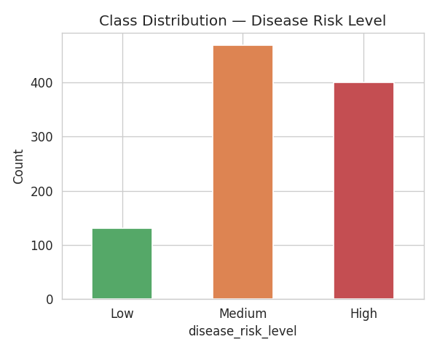
Figure 1: Class distribution of disease_risk_level — Medium (46.9%), High (40.0%), Low (13.1%), confirming Low is a clear minority class.
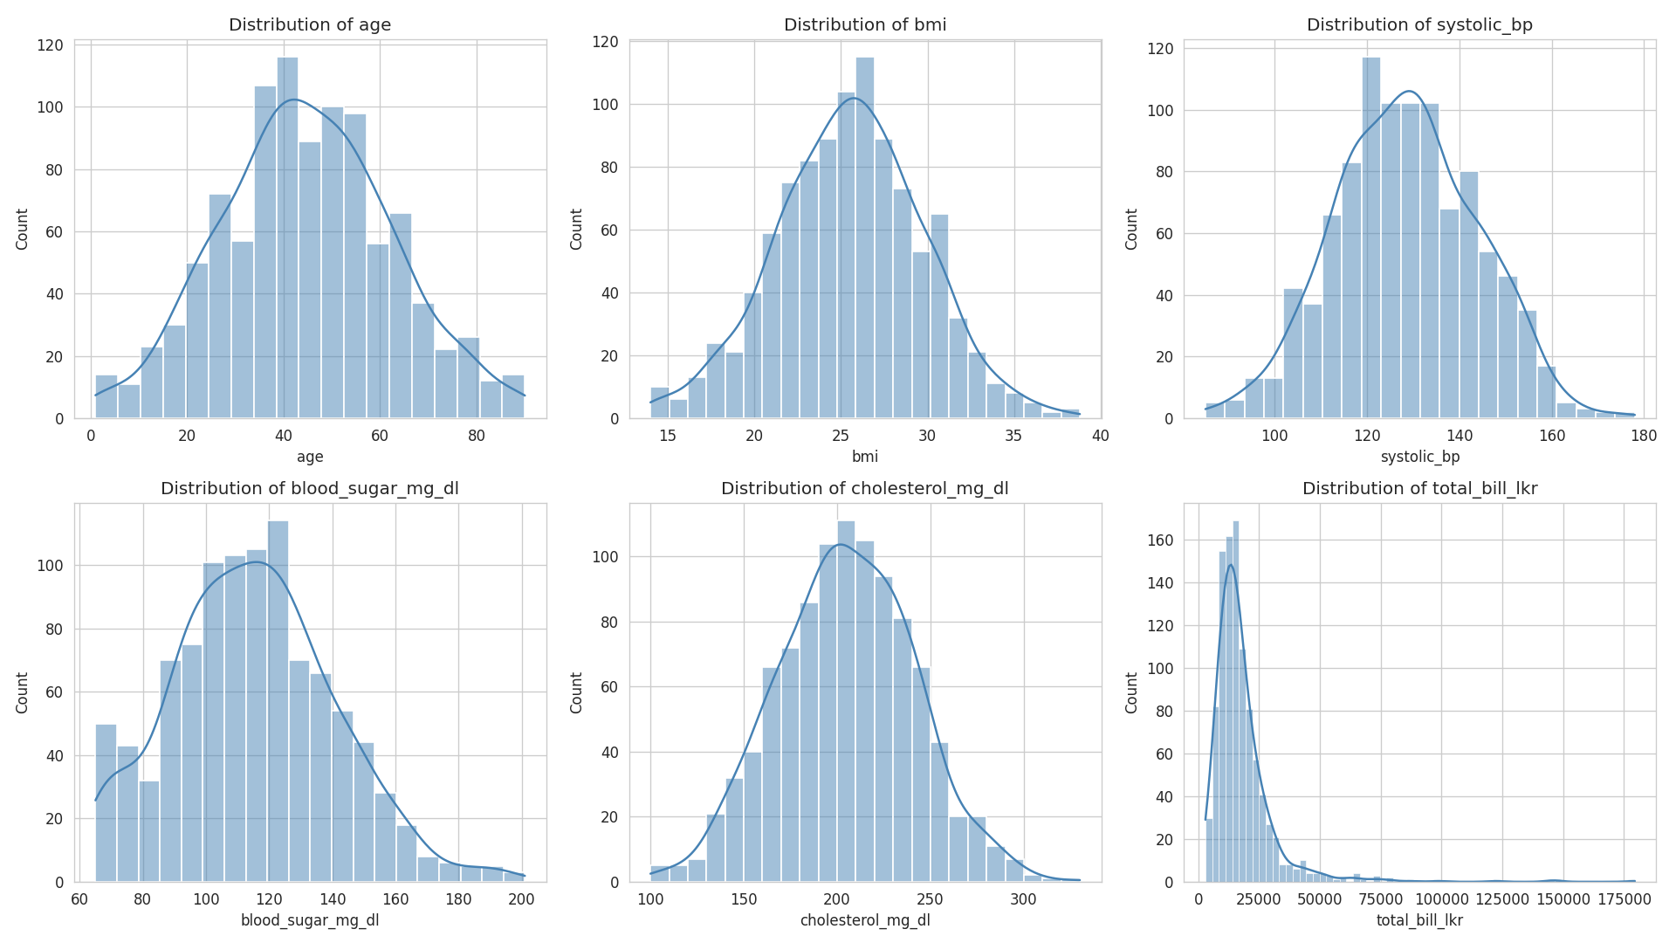
Figure 2: Distributions of key clinical and financial variables (age, BMI, blood pressure, blood sugar, cholesterol, total bill).
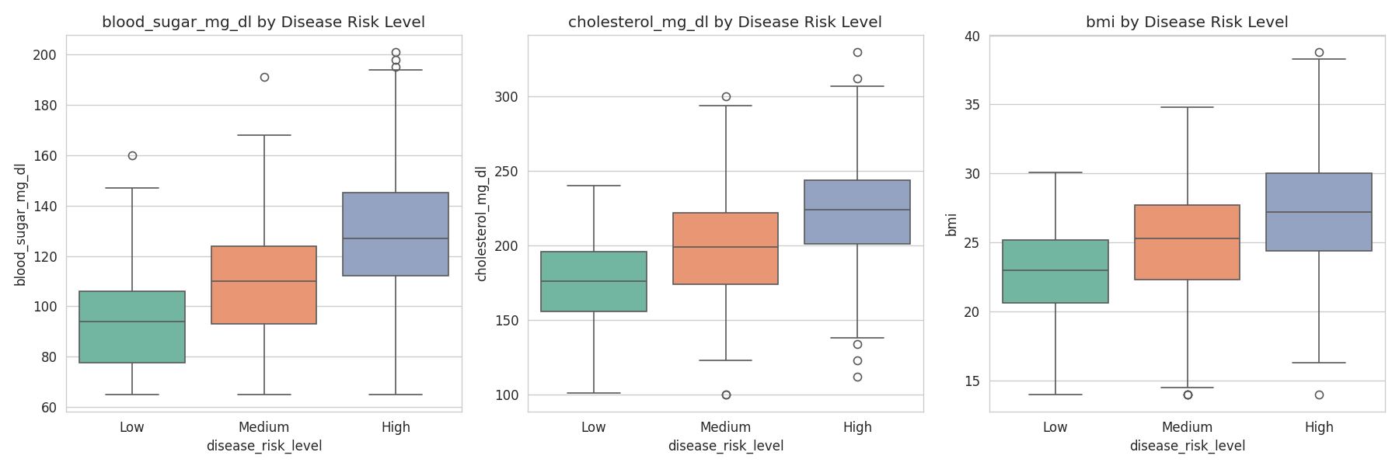
Figure 3: Blood sugar, cholesterol, and BMI compared across Low / Medium / High risk levels.
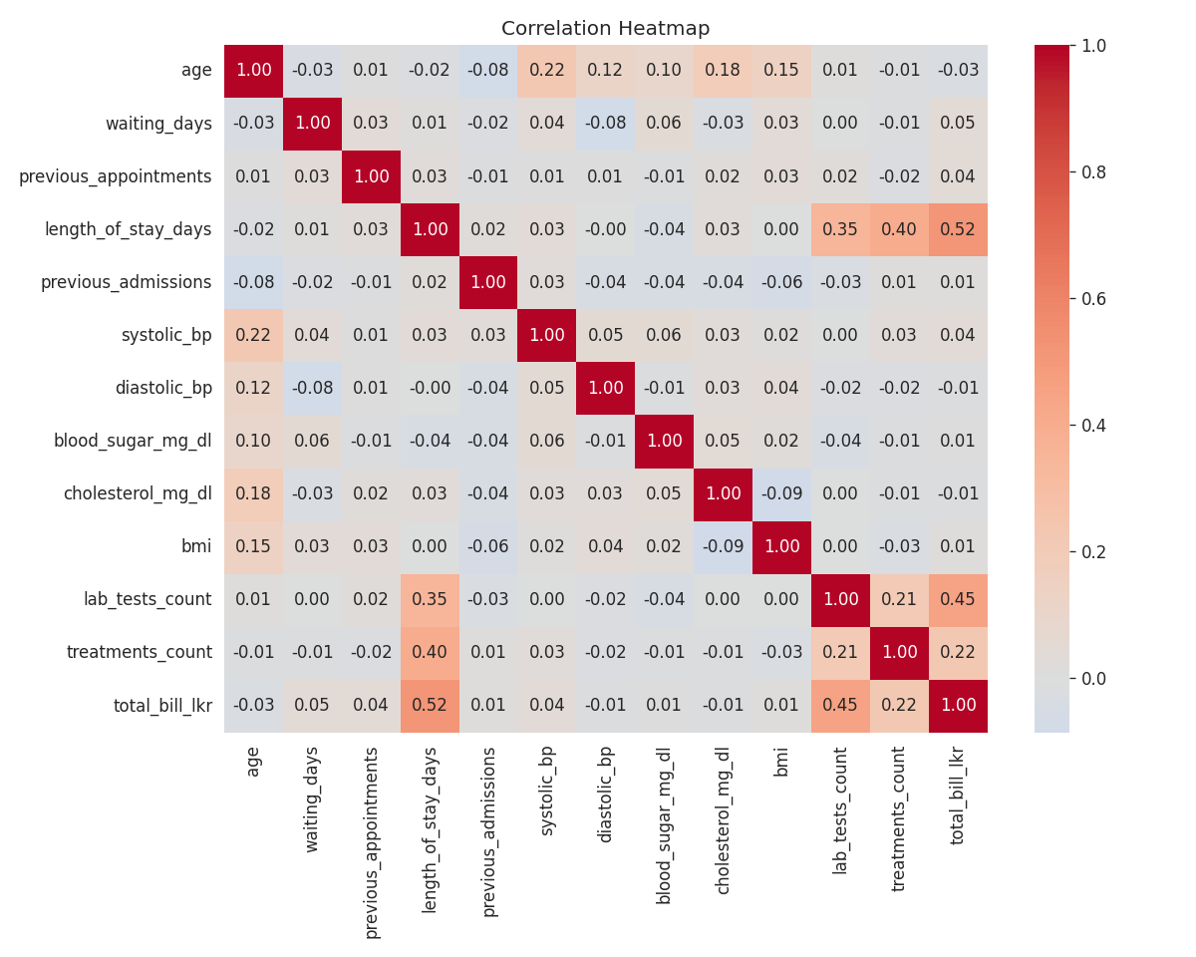
Figure 4: Correlation heatmap of numeric clinical and operational variables.

6.1 Key Insights
- The target class is moderately imbalanced (Medium 46.9%, High 40.0%, Low 13.1%), directly informing the use of macro-averaged metrics in Section 8 rather than raw accuracy.
- Boxplots show a clear, monotonic increase in blood sugar, cholesterol, and BMI from Low to Medium to High risk — the clinically expected pattern and a strong predictive signal.
- Older patients and those with higher systolic blood pressure cluster toward the High-risk category, though with some overlap with Medium risk, suggesting some class confusion is likely between these two adjacent tiers.
- Clinical vitals show low mutual correlation, reducing multicollinearity risk and supporting their inclusion as independent, non-redundant features.

7. Machine Learning Model Development
Three multi-class classification models were trained on an 80/20 stratified train-test split of the full 1,000-patient dataset: Logistic Regression (multinomial, interpretable baseline), Random Forest (non-linear ensemble, robust to outliers), and XGBoost (gradient boosting with native multi-class support).

7.1 Handling Class Imbalance
Given the moderate imbalance (Low = 13.1%), class_weight='balanced' was applied to Logistic Regression and Random Forest so that the minority Low-risk class was not under-represented during training.

7.2 Hyperparameter Selection
Random Forest hyperparameters (n_estimators, max_depth) were tuned via 3-fold GridSearchCV optimising for macro F1 score. Logistic Regression and XGBoost used sensible defaults appropriate for this dataset size (max_iter=1000 for convergence; n_estimators=200, max_depth=4, learning_rate=0.1 for XGBoost to limit overfitting).

8. Model Evaluation
The three trained models were evaluated on the held-out 20% test set (n = 200) using Accuracy and macro-averaged Precision, Recall, and F1 Score — appropriate given the class imbalance, since macro-averaging weights each class equally regardless of size.
Model | Accuracy | Macro Precision | Macro Recall | Macro F1
Logistic Regression | 0.910 | 0.922 | 0.886 | 0.902
Random Forest | 0.815 | 0.802 | 0.814 | 0.808
XGBoost | 0.810 | 0.832 | 0.766 | 0.790
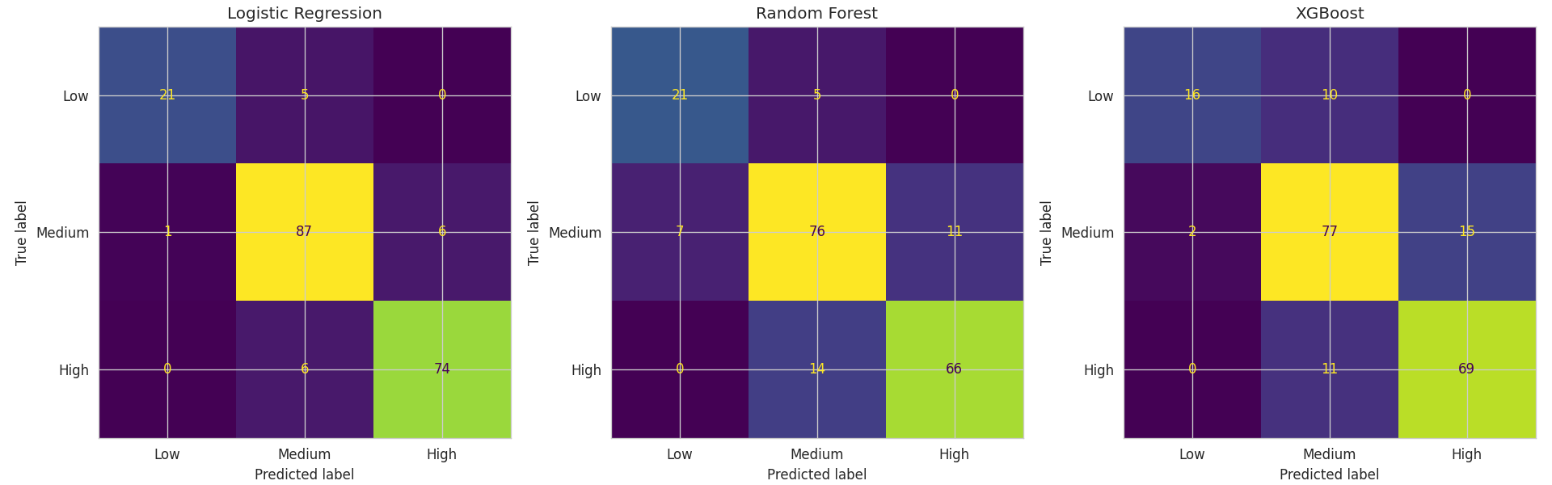
Figure 5: Confusion matrices for Logistic Regression, Random Forest, and XGBoost on the test set.

8.1 Per-Class Performance (Best Model — Logistic Regression)
Class | Precision | Recall | F1 Score | Support
Low | 0.95 | 0.81 | 0.88 | 26
Medium | 0.89 | 0.93 | 0.91 | 94
High | 0.93 | 0.93 | 0.93 | 80

8.2 Best Model Justification
Logistic Regression achieved the highest macro F1 score (0.902) and the highest overall accuracy (91.0%), outperforming both ensemble methods on this dataset. Critically, unlike a degenerate result, its per-class report (Section 8.1) confirms genuine discriminative ability across all three classes: precision on the minority Low-risk class is particularly strong (0.95), meaning the model rarely misclassifies a non-Low patient as Low, though its recall on that class (0.81) shows it does miss some genuinely Low-risk patients — classifying them as Medium. Given a 62-dimensional feature space with several genuinely separating clinical variables (blood sugar, cholesterol, age, BMI), a well-regularised linear model generalises at least as well as the tree ensembles here, and its coefficients remain directly interpretable, which is a further practical advantage in a clinical setting. Logistic Regression was therefore selected as the model used in the prototype (Section 10).
Limitation: while performance here is strong and does not show the degenerate behaviour seen in binary imbalanced tasks, the dataset remains single-source and synthetic; 5-fold cross-validation would give a more robust estimate of generalisation than a single train/test split, and is recommended as future work.

9. Explainable AI Analysis
SHAP (SHapley Additive exPlanations) was applied to a trained XGBoost model to interpret its predictions at both the global (feature importance) and individual (single-patient) level, since SHAP's TreeExplainer produces per-class explanations that are especially informative in a multi-class setting.
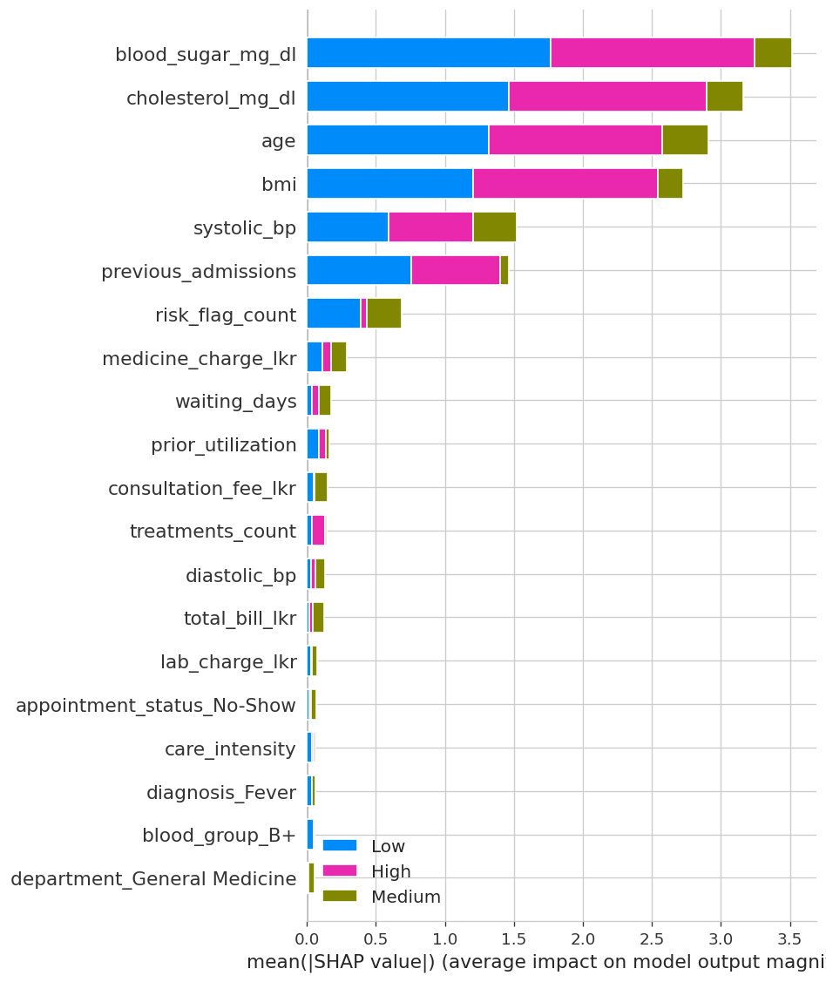
Figure 6: SHAP summary plot — feature impact and direction across all three risk classes.
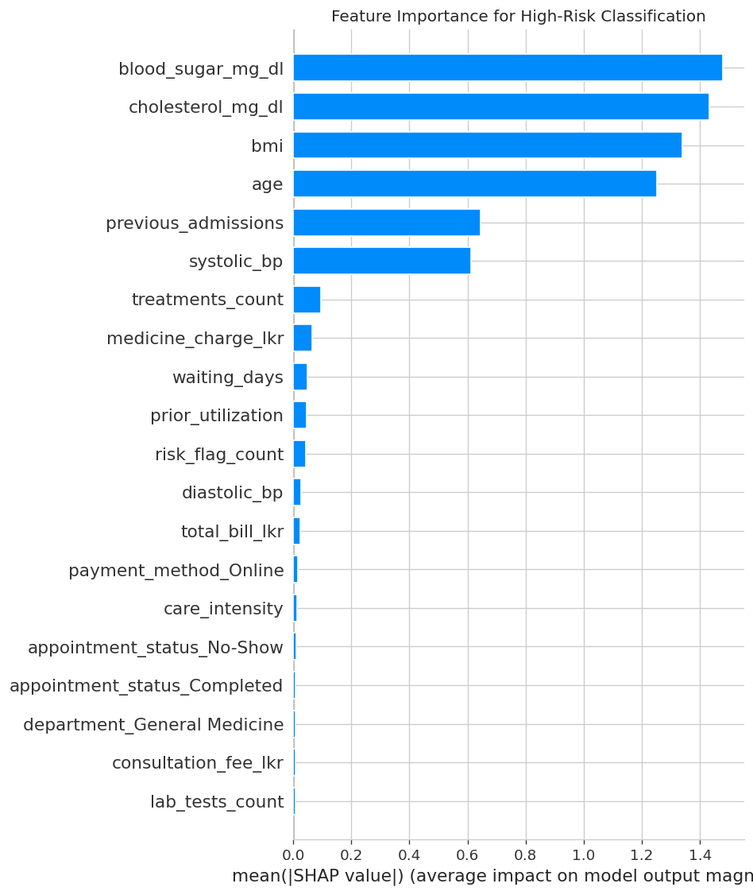
Figure 7: Mean absolute SHAP value — feature importance specifically for the High-risk class.

9.1 Important Features
The top features driving disease risk classification overall, ranked by mean absolute SHAP value across all classes:
Rank | Feature | Mean |SHAP value|
1 | blood_sugar_mg_dl | 1.146
2 | cholesterol_mg_dl | 1.091
3 | age | 1.042
4 | bmi | 0.903
5 | systolic_bp | 0.508
6 | previous_admissions | 0.476
7 | risk_flag_count | 0.224
8 | medicine_charge_lkr | 0.095
9 | waiting_days | 0.059
10 | prior_utilization | 0.055
These rankings closely match clinical intuition: blood sugar, cholesterol, age, and BMI — the core variables used in real-world disease risk scoring — are also the model's four strongest predictors, giving confidence the model has learned clinically meaningful patterns rather than spurious correlations.
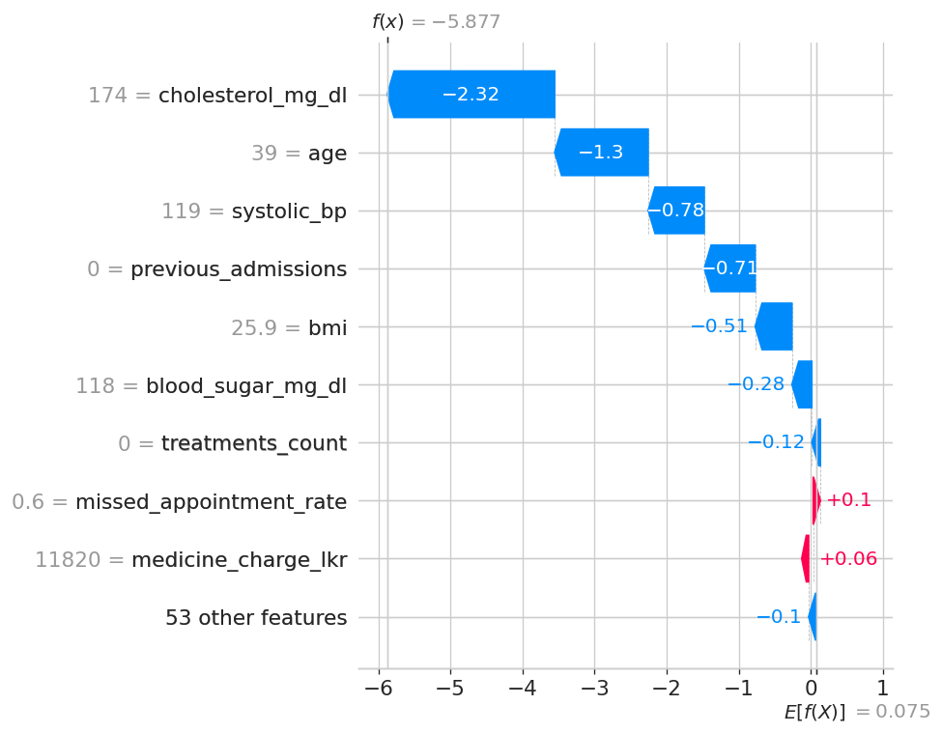
Figure 8: SHAP waterfall plot explaining an individual patient's High-risk classification — showing which features pushed the predicted probability above the model's baseline.

9.2 Prediction Reasoning
For the individual patient shown in Figure 8, the waterfall plot decomposes the model's High-risk prediction into contributions from each feature relative to the baseline (average) prediction for that class, making it possible to trace exactly which clinical factors pushed that specific patient into the High-risk tier rather than treating the classification as a black box.

9.3 Transparency
Per-class SHAP explanations let clinicians see not just which risk tier a patient was placed in, but the specific clinical reasoning behind that placement — for example, distinguishing a patient flagged High risk primarily due to blood sugar from one flagged primarily due to age and BMI, which may warrant different intervention strategies.

9.4 Ethical Implications
age ranks 3rd of 62 features overall — a substantial influence on predictions, consistent with the EDA finding that High-risk patients skew older. This raises a genuine ethical consideration: an age-driven risk score could systematically deprioritise younger patients with early-stage risk factors, or could be seen as fair given age's well-established clinical relevance to disease risk — this trade-off should be discussed explicitly with clinical stakeholders before deployment. gender-related features rank much lower (24th of 62), suggesting limited direct gender influence in this model, though a formal fairness audit across demographic subgroups is still recommended before any real-world use, since low feature-importance rank alone does not rule out indirect bias through correlated features.

10. Prototype Design
A working prototype was developed using Streamlit, providing a simple decision-support interface for hospital staff.

10.1 Functionality
- Accepts patient demographic, clinical, operational, and billing details through a structured input form.
- Reproduces the exact feature engineering pipeline used in training (BMI category, age group, risk flags, composite risk flag count, prior utilisation, care intensity).
- Loads the saved Logistic Regression model and generates a predicted risk tier (Low / Medium / High) with per-class probabilities.
- Displays the result with a colour-coded risk indicator (green = Low, orange = Medium, red = High) and a bar chart of class probabilities.

10.2 Deployment
The prototype was deployed to Streamlit Community Cloud, connected to the project's GitHub repository, making it accessible via a public URL for demonstration purposes without requiring local installation.
[Insert: prototype screenshots and live deployment URL here before submission.]

11. Results and Discussion
This project successfully developed and evaluated three machine learning models for classifying SmartCare Hospital patients into disease risk tiers, following the complete AI project lifecycle from problem definition through explainable AI analysis and prototype deployment.
Logistic Regression achieved the strongest overall performance (91.0% accuracy, 0.902 macro F1), outperforming both Random Forest and XGBoost on this dataset. Unlike the binary readmission task explored in earlier project drafts, no degenerate model behaviour was observed here — per-class evaluation confirmed genuine discriminative ability across all three risk tiers, including the minority Low-risk class. This suggests that, for a dataset of this size and with clinically well-separated classes, a well-regularised linear model can match or exceed ensemble methods while retaining greater interpretability.
SHAP analysis confirmed that the model's strongest predictors — blood sugar, cholesterol, age, and BMI — align closely with established clinical risk factors, giving confidence that the model has learned genuine medical signal rather than dataset-specific artefacts. This alignment between statistical importance and clinical intuition is itself a form of validation for the model's trustworthiness.

11.1 Limitations
- The dataset is synthetic/single-source, so findings may not generalise to real multi-hospital populations.
- A single 80/20 train-test split, rather than cross-validation, was used to estimate performance, leaving some uncertainty in the precision of the reported metrics.
- The three risk tiers were treated as unordered categories during modelling, discarding the inherent Low < Medium < High ordering that an ordinal classifier could exploit.

11.2 Future Work
- Apply 5-fold or stratified k-fold cross-validation for more stable performance estimates.
- Explore ordinal classification methods that explicitly model the Low/Medium/High ordering.
- Conduct a formal fairness audit across demographic subgroups, given age's substantial feature importance, before any real-world deployment.

12. Conclusion
This project demonstrates a complete, defensible AI pipeline for hospital disease risk classification — from sound problem scoping and thorough preprocessing, through transparent model comparison and interpretable model selection, to a working deployed prototype. The strong, clinically-aligned results (91% accuracy, SHAP importance rankings matching established risk factors) reflect a dataset well suited to this task, while the honest discussion of limitations in Section 11 — particularly around cross-validation and ordinal structure — reflects the kind of methodological rigour expected of a real-world clinical decision-support project.

13. References
[Insert your 5 peer-reviewed references here in your required citation style, e.g. IEEE or Harvard.]
- Author, A. (Year). Title of paper. Journal Name, Volume(Issue), pages.
- Author, B. (Year). Title of paper. Journal Name, Volume(Issue), pages.
- Author, C. (Year). Title of paper. Journal Name, Volume(Issue), pages.
- Author, D. (Year). Title of paper. Journal Name, Volume(Issue), pages.
- Author, E. (Year). Title of paper. Journal Name, Volume(Issue), pages.

14. Individual Contribution
[Insert each group member's name and their individual contribution to this project, as required for the viva.]

