Sapient Fee Calculator
Version 1.0
06/17/2018

VERSION HISTORY
Fee Calculator in request JSON object..
Version  # | Implemented  By | Revision  Date | Approved  By | Approval  Date | Reason
1.0 | Ravindra Singh | 06/17/2018 | Supriya |  | Fee Calculator

TABLE OF CONTENTS
1 Introduction 4
1.1 Purpose of The Test Case Document 4
2 Test Case Specification 4
2.1 Description 4
2.2 Resources 4
2.3 Preconditions 4
2.4 Post Conditions 4
2.5 Flow of Events 4
Evidence of Test Case: 5

Introduction

Purpose of The Test Case Document
Accepts JSON objects with multiple arrays and Calculate Fee.

Test Case Specification
Accepts JSON objects with multiple arrays and Calculate Fee

Description
Accepts JSON objects with multiple arrays and Calculate Fee.

Resources
Name: Ravindra Singh
Email : Ravindra.singh14@wipro.com, singh2.ravindra@gmail.com
M No: 8600005928

Preconditions
NA

Post Conditions
Accepts JSON objects with multiple arrays and Calculate Fee.

Flow of Events
NA

Evidence of Test Case:
- Accepts JSON objects with multiple arrays.
- http://localhost:8082/api/feecalculator
- JSON

{
"transactionBeanList":[
{
"externalTransactionID":"SAPEXTXN1",
"clientId":"GS",
"securityId":"RELIND",
"transactionType":"WITHDRAW",
"transactionDate":"18-07-2017 11:34:46",
"marketValue":113.45,
"priority":true
},
{
"externalTransactionID":"SAPEXTXN2",
"clientId":"AP",
"securityId":"ICICI",
"transactionType":"SELL",
"transactionDate":"12-03-2018 10:24:56",
"marketValue":123.90,
"priority":true
},
{
"externalTransactionID":"SAPEXTXN3",
"clientId":"AS",
"securityId":"REL",
"transactionType":"SELL",
"transactionDate":"12-03-2018 10:24:56",
"marketValue":123.90,
"priority":true
},
{
"externalTransactionID":"SAPEXTXN4",
"clientId":"GS",
"securityId":"RELIND",
"transactionType":"DEPOSIT",
"transactionDate":"12-03-2018 10:24:56",
"marketValue":343.90,
"priority":false
},
{
"externalTransactionID":"SAPEXTXN5",
"clientId":"AP",
"securityId":"HINDALCO",
"transactionType":"DEPOSIT",
"transactionDate":"12-03-2018 10:24:56",
"marketValue":123.90,
"priority":true
},
{
"externalTransactionID":"SAPEXTXN6",
"clientId":"AP",
"securityId":"REL",
"transactionType":"SELL",
"transactionDate":"11-02-2013 10:24:56",
"marketValue":563.10,
"priority":false
},
{
"externalTransactionID":"SAPEXTXN7",
"clientId":"GS",
"securityId":"REL",
"transactionType":"SELL",
"transactionDate":"12-03-2018 10:24:56",
"marketValue":123.90,
"priority":true
},
{
"externalTransactionID":"SAPEXTXN8",
"clientId":"HJ",
"securityId":"REL",
"transactionType":"SELL",
"transactionDate":"12-03-2018 10:24:56",
"marketValue":123.90,
"priority":false
},
{
"externalTransactionID":"SAPEXTXN9",
"clientId":"AP",
"securityId":"ICICI",
"transactionType":"BUY",
"transactionDate":"12-03-2018 10:24:56",
"marketValue":400.90,
"priority":true
},
{
"externalTransactionID":"SAPEXTXN10",
"clientId":"AS",
"securityId":"REL",
"transactionType":"SELL",
"transactionDate":"12-03-2018 10:24:56",
"marketValue":143.90,
"priority":false
}]
}
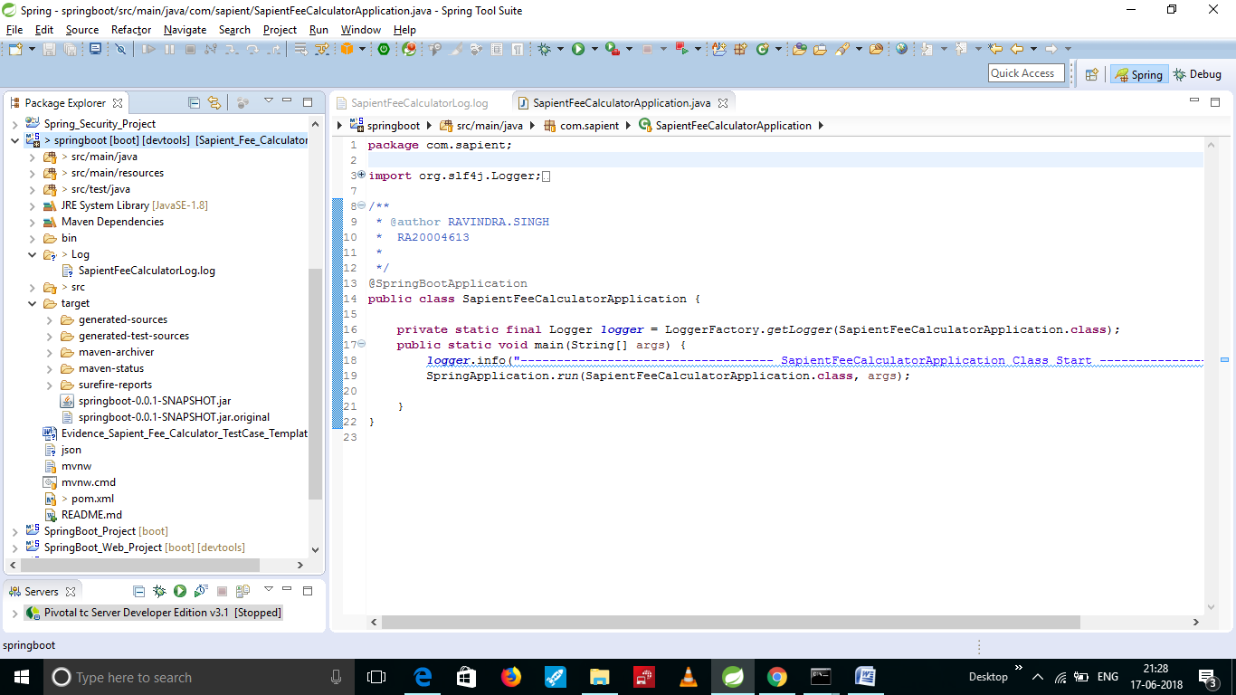

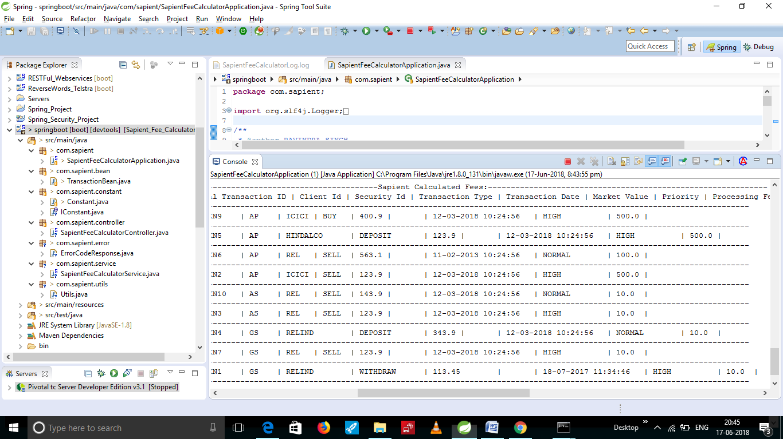

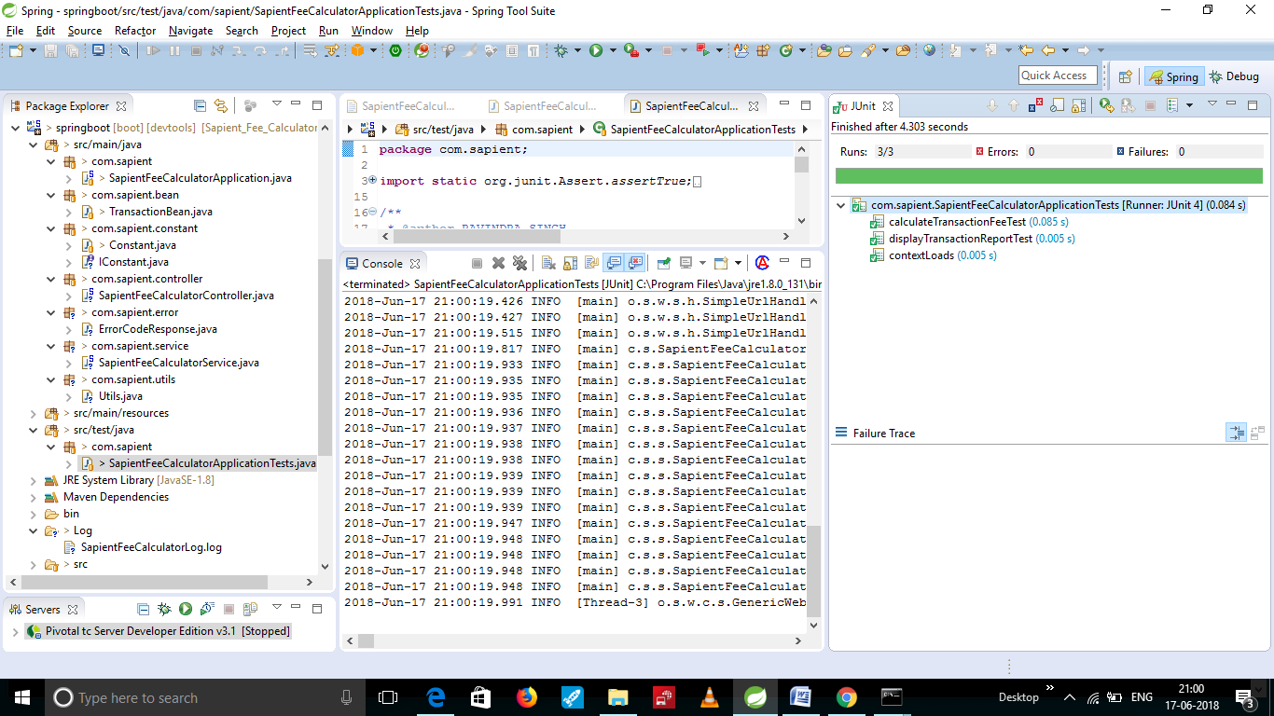

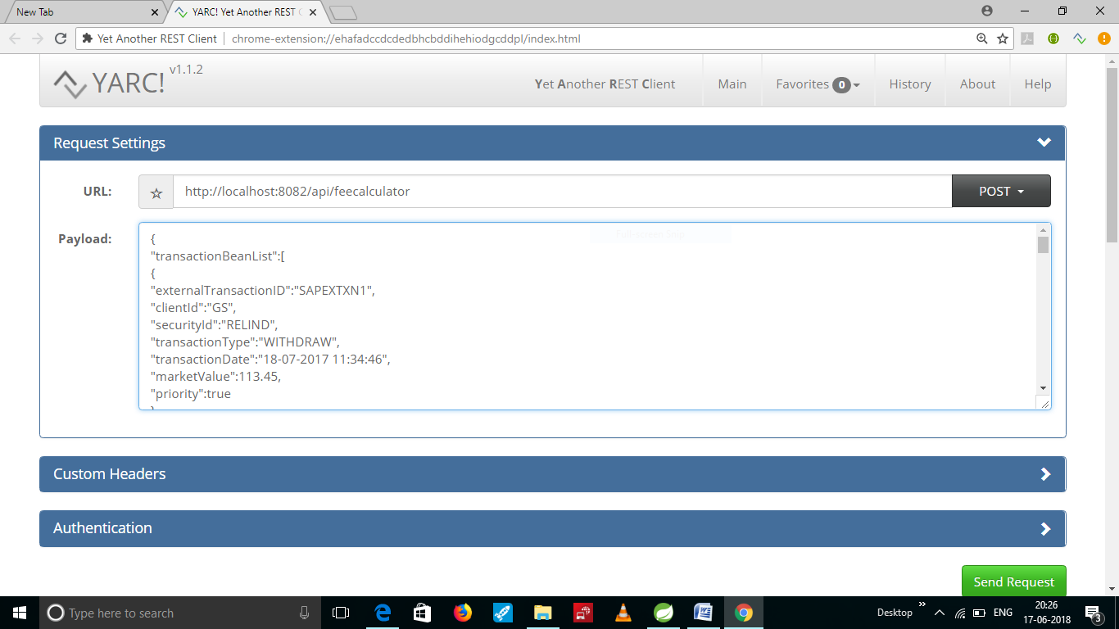

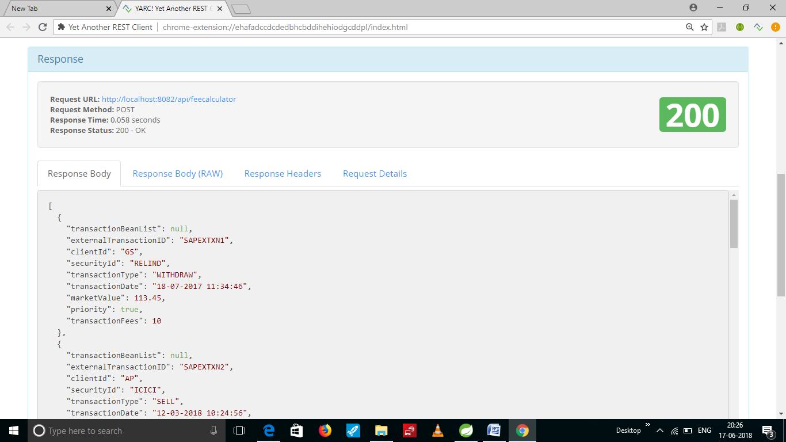

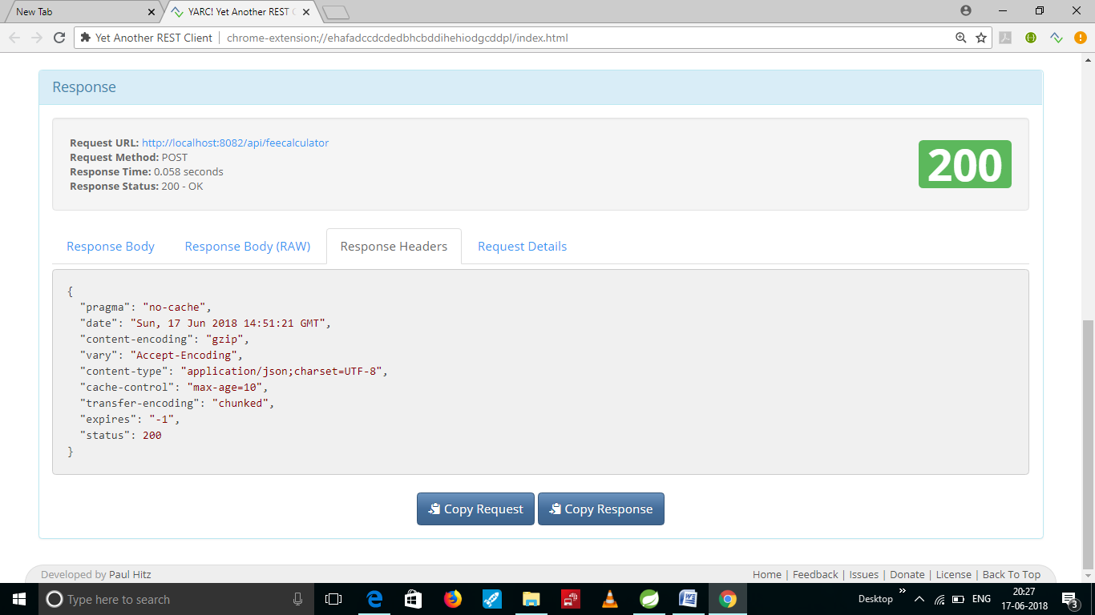

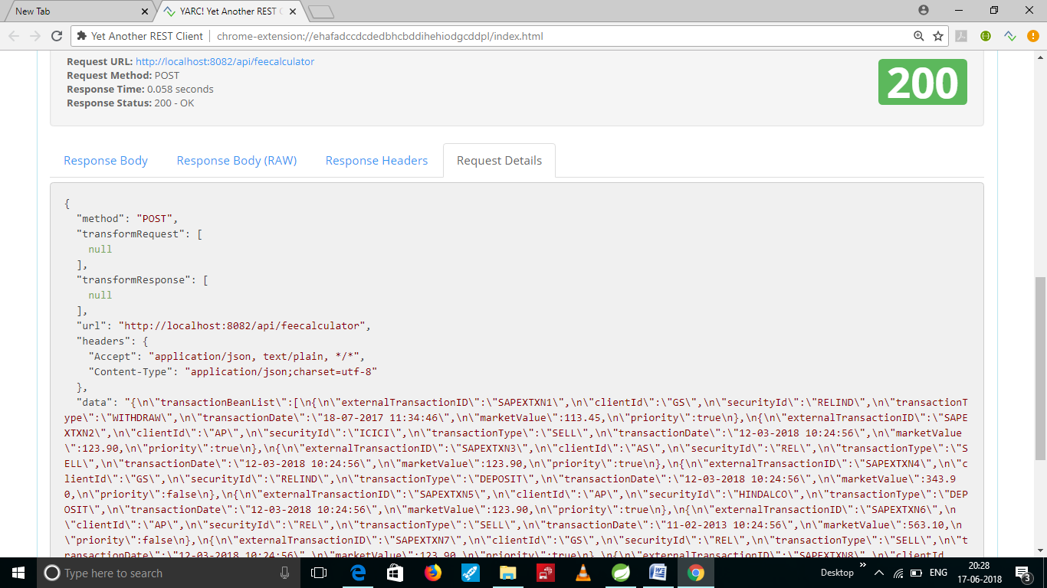

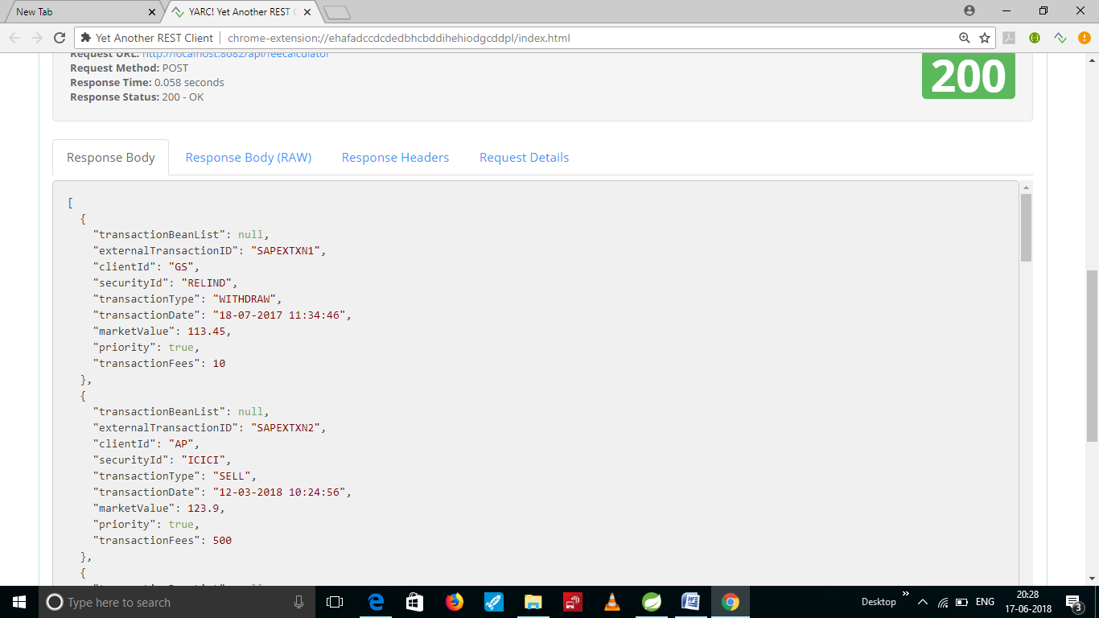

- Error Page : if we send wrong request then show error
- Accepts JSON objects with multiple arrays.
- http://localhost:8082/api/feecalculator
JSON:
Here input wrong JSON then we display the error message.
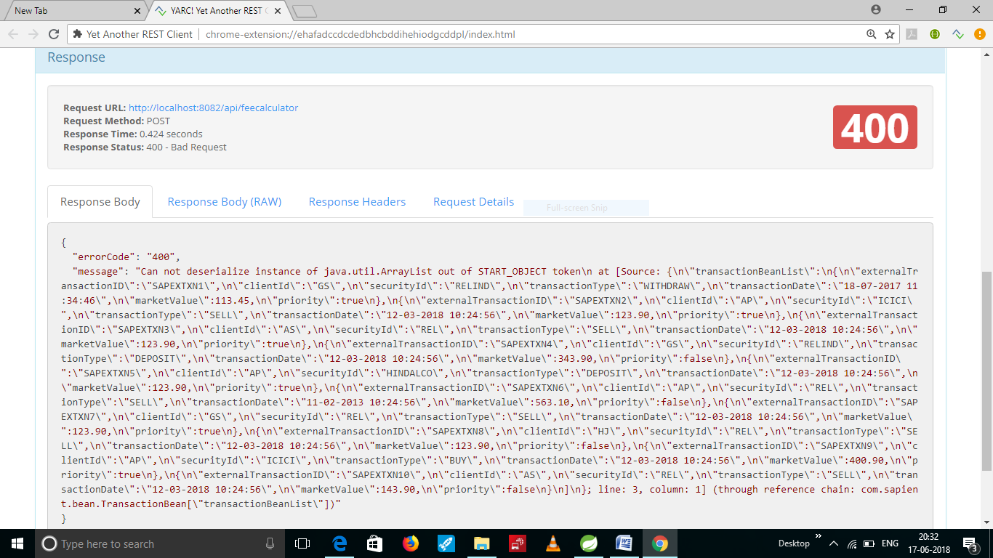

Here highlighted color is missing [ , so we get error.
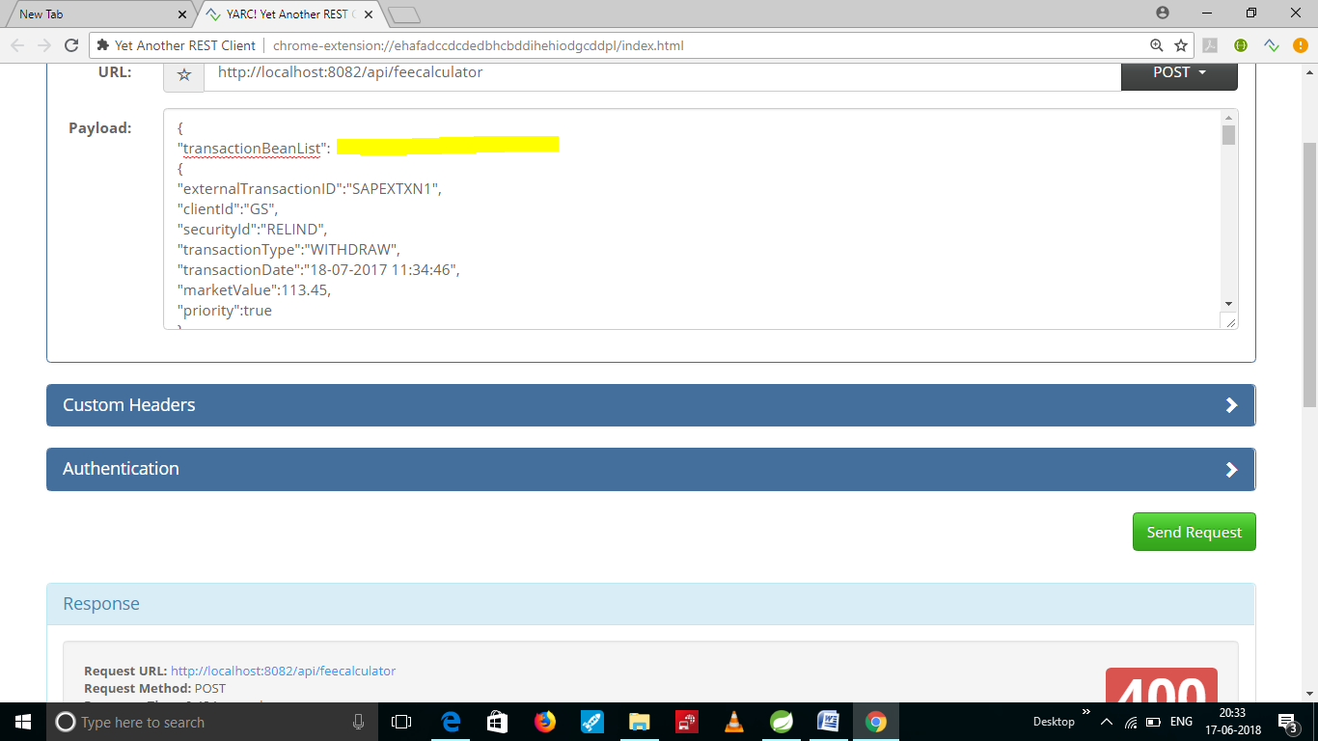

Sonar:
