Innovative Evaluation Practices for BCSE308P -Computer Networks Lab
Fall Semester 2026-27

SECURE SMALL OFFICE NETWORK USING VLANs, INTER-VLAN ROUTING, DHCP, DNS AND ACL-BASED ACCESS CONTROL
24BCI0104 | RAVINDRA SWAMI
24BKT0101 | JASH CHORDIYA
24BAI0012 | PRATYUSH KUMAR SAHOO

B.Tech.
in
Computer Science and Engineering
School of Computer Science and Engineering

October 2026
ABSTRACT
A flat office network places every department in one broadcast domain, relies on manual addressing and lets any host reach any other host. This project designs, configures and tests a secure small office network for three departments (HR, IT and Sales) in Cisco Packet Tracer. The topology has one Cisco 2911 router (R1), one Catalyst 2960 switch (SW1), nine PCs and one server (Company-Server). Each department has its own VLAN (10, 20 and 30) and /24 subnet, SW1 is joined to R1 by an 802.1Q trunk, and R1 provides inter-VLAN routing using router-on-a-stick subinterfaces. R1 also acts as DHCP server and issued nine client leases from .21 onward in each subnet, with .1 to .20 excluded for static devices. Company-Server (192.168.10.10) provides an HTTP company portal and DNS, resolving company.local. Security is added at two layers: an extended ACL (SALES_RESTRICTION) applied inbound on R1 Gi0/0.30 permits Sales traffic to the server but denies Sales traffic to the HR subnet, and sticky-MAC port security (maximum one MAC, shutdown on violation) protects SW1 ports Fa0/1 to Fa0/9. Tests with ping and IOS show commands confirmed gateway, inter-VLAN and server reachability (4/4 replies), DNS resolution of company.local, Sales access to the server, and blocking of Sales access to an HR host, with the ACL deny counter increasing. Two cabling faults found during the build, which caused 100% loss from the server to its gateway, were isolated and corrected. No numerical baseline was measured, so the comparison with a flat network is feature-based. The work shows a low-cost layered design and a systematic troubleshooting method.

Certificate

This is to certify that the project report titled "Secure Small Office Network using VLANs, Inter-VLAN Routing, DHCP, DNS and ACL-Based Access Control" is a bonafide record of the work done by Ravindra Swami (24BCI0104), Jash Chordiya(24BKT0101) and Pratyush Kumar Sahoo(24BAI0012) in partial fulfilment of the requirements of the Innovative Evaluation Practices for BCSE308P - Computer Networks Lab during the Fall Semester 2026-2027.

Name and Signature of the Students
TABLE OF CONTENTS
Sl.No | Contents | Page No.
 | Abstract | 2
1. | INTRODUCTION | 6
 | 1.1 Background and motivation | 6
 | 1.2 Problem statement | 6
 | 1.3 Objectives | 6
 | 1.4 Scope and limitations | 7
 | 1.5 Mapping to course modules and the lab experiment | 7
2. | Literature Survey | 8
 | 2.1 Overview of the existing protocol or scheme | 8
 | 2.2 Review of related work (table: author and year, technique, metrics, merits, gaps) | 8
 | 2.3 Research gap and justification of novelty | 9
3. | Proposed System | 10
 | 3.1 System architecture or topology (diagram) | 10
 | 3.2 Baseline mechanism description | 10
 | 3.3 Proposed mechanism: algorithm, pseudocode, flowchart | 11
 | 3.4 Novelty statement (what exactly differs from the baseline) | 11
 | 3.5 Assumptions and design decisions | 12
4 | Implementation | 13
 | 4.1 Tools, platform, versions and hardware | 13
 | 4.2 Simulation or testbed setup (topology, configuration, parameter table) | 13
 | 4.3 Code structure and explanation of key modules | 14
 | 4.4 Challenges faced and how they were solved | 14
5. | Experimental Setup and Performance Evaluation | 15
 | 5.1 Performance metrics and why they were chosen | 15
 | 5.2 Scenarios and parameter values | 15
 | 5.3 Results: tables and graphs, baseline vs proposed (mean of repeated runs) | 15
 | 5.4 Analysis and discussion (reasons, trends, trade-offs) | 17
 | 5.5 Critical evaluation: strengths, weaknesses, conditions where the proposed scheme fails | 17
6. | Conclusion and Future Work | 19
 | 6.1 Summary of work and key findings (quantified) | 19
 | 6.2 Limitations | 19
 | 6.3 Future enhancements | 19
7. | References | 20
 | References (IEEE style) | 20
 | Appendix A: Important source code or configuration listings | 21
 | Appendix B: Additional screenshots, packet captures, raw result tables | 23

1. INTRODUCTION

1.1 Background and motivation
A small office with several departments usually starts as one flat Layer 2 network: every PC, printer and server sits in the same broadcast domain and can talk to every other device. This is cheap and simple, but it scales poorly. Broadcast traffic reaches every host, an infected or misconfigured machine in one department can affect the others, and there is no technical barrier between sensitive departments such as HR and a customer-facing department such as Sales.
Virtual LANs (VLANs), inter-VLAN routing, DHCP and access control lists (ACLs) are the standard building blocks used to fix this on low-cost Cisco equipment. The motivation of this project is to build a complete, working small office network that uses these blocks together, to test it layer by layer, and to document how real faults (wrong switch ports) were found and fixed. Cisco Packet Tracer is used so that the full design can be built and tested without physical hardware.

1.2 Problem statement
A small company needs a reliable internal network that allows employees to communicate and to access shared services while preventing unauthorised access between departments. The problem is to design and implement such a network for three departments (HR, IT and Sales) and a shared company server, using segmentation, automatic addressing, name-based access to the company web portal, and access control at Layer 2 and Layer 3.

1.3 Objectives
• Create separate VLANs for HR (10), IT (20) and Sales (30).
• Configure inter-VLAN routing using router-on-a-stick over an 802.1Q trunk.
• Assign IP addresses automatically using DHCP on the router.
• Host an internal company website (HTTP) on a central server.
• Configure DNS name resolution for company.local.
• Restrict Sales access to the HR subnet using an extended ACL.
• Enable switch port security (sticky MAC, maximum 1, shutdown on violation).
• Verify the network using Cisco IOS show commands and connectivity tests.

1.4 Scope and limitations
The work covers one router, one switch, nine PCs and one server, simulated in Cisco Packet Tracer. It covers IPv4 only, static trunk configuration, and a single-router design (no redundancy or dynamic routing). Performance figures are taken from single Packet Tracer ping runs, which are simulation results and not measurements on real hardware. The security features are basic controls and do not make the network "fully secure".

1.5 Mapping to course modules and the lab experiment
Course topic (BCSE308P) | Concept used in this project | Lab activity
Data link layer: switching, VLANs, trunking | VLAN 10/20/30, access ports, 802.1Q trunk Gi0/1 | Switch configuration, show vlan brief, show interfaces trunk
Network layer: IPv4 addressing, routing | Three /24 subnets, router-on-a-stick subinterfaces | Router configuration, show ip interface brief, ping and TTL analysis
Application layer: DHCP, DNS, HTTP | Router DHCP pools, server DNS A-record, intranet portal | Server and PC configuration, browser test of http://company.local
Network security | Extended ACL on R1, sticky-MAC port security on SW1 | ACL and port-security configuration, show port-security address

2. Literature Survey

2.1 Overview of the existing protocol or scheme
This project is a configuration and integration project, so the "existing schemes" it builds on are the standard protocols and vendor configuration practices listed below, rather than research prototypes.
• VLANs and 802.1Q tagging [1]: a VLAN splits one physical switch into several logical Layer 2 networks. A trunk port carries frames of many VLANs, each frame carrying a 4-byte 802.1Q tag with a 12-bit VLAN ID.
• Inter-VLAN routing [6], [8]: hosts in different VLANs belong to different IP subnets and need a Layer 3 device. In router-on-a-stick, one physical router interface is divided into subinterfaces, each tagged for one VLAN and acting as that VLAN's default gateway.
• DHCP [2]: a server leases an IP address, mask, gateway and DNS server to clients. Cisco IOS can act as the DHCP server and exclude addresses that are reserved for static devices.
• DNS and HTTP [3], [5]: DNS maps names to IP addresses; HTTP delivers web content. Together they provide the intranet portal reachable as company.local.
• Private addressing [4]: the 192.168.0.0/16 private range used in the design is defined in RFC 1918.
• ACLs and port security [7]: extended ACLs filter routed IP traffic by source, destination and protocol; port security restricts the MAC addresses allowed on a switch port.

2.2 Review of related work (table: author and year, technique, metrics, merits, gaps)
Table 2.1 summarises the standards and practices reviewed. "Metrics and tool" lists how each technique is normally verified.
Table 2.1 Review of related standards and techniques
S.No | Authors, year | Technique | Metrics and tool | Merits | Gaps
1 | IEEE 802.1Q, 2018 [1] | VLAN tagging and trunking | Frame tag inspection; show vlan brief, show interfaces trunk | Splits broadcast domains; one trunk carries many VLANs | Does not itself allow or block traffic between VLANs; needs a router and policy
2 | R. Droms, 1997 (RFC 2131) [2] | Dynamic Host Configuration Protocol | Lease success; show ip dhcp binding | Automatic, consistent IP configuration | No authentication; rogue servers possible without DHCP snooping
3 | P. Mockapetris, 1987 (RFC 1034/1035) [3] | Hierarchical name to address mapping | Name resolution success; nslookup / browser by name | Users use names instead of IPs | Local .local records are not secured; single DNS server is a single point of failure
4 | Cisco Press / Odom, 2019 [6] | Router-on-a-stick inter-VLAN routing | Ping, TTL, show ip route; Packet Tracer | Only one router port and cable needed; low cost | Single link is a bandwidth bottleneck and a single point of failure; routes everything by default
5 | Cisco, Catalyst 2960 and IOS guides [7] | Extended ACLs and port security (sticky MAC) | Ping blocked or permitted; show access-lists, show port-security address | Layer 3 filtering between departments; binds a port to a device | ACLs are static and manual; sticky MAC can lock out a legitimate replacement device
6 | Kurose and Ross, 2021 [8] | Layered network design | Conceptual; textbook examples | Explains why segmentation limits broadcast and failure scope | Does not give device-specific configuration

2.3 Research gap and justification of novelty
Tutorial material usually shows VLANs, router-on-a-stick, DHCP and web services as separate exercises, and a plain VLAN design leaves every department able to reach every other. VLAN separation is not by itself an access policy. The gap addressed here is an integrated, tested design in which the same network provides segmentation, routed access to shared services, automatic addressing, name-based web access, and an explicit access policy (ACL plus port security), together with a documented fault-isolation procedure based on real faults met during the build.

3. Proposed System

3.1 System architecture or topology (diagram)
The network has one router (R1, Cisco 2911), one switch (SW1, Cisco 2960), nine PCs (three per department) and one server. R1 Gi0/0 connects to SW1 Gi0/1 as an 802.1Q trunk. PCs connect to access ports Fa0/1 to Fa0/9 and Company-Server connects to Fa0/10 in VLAN 10.
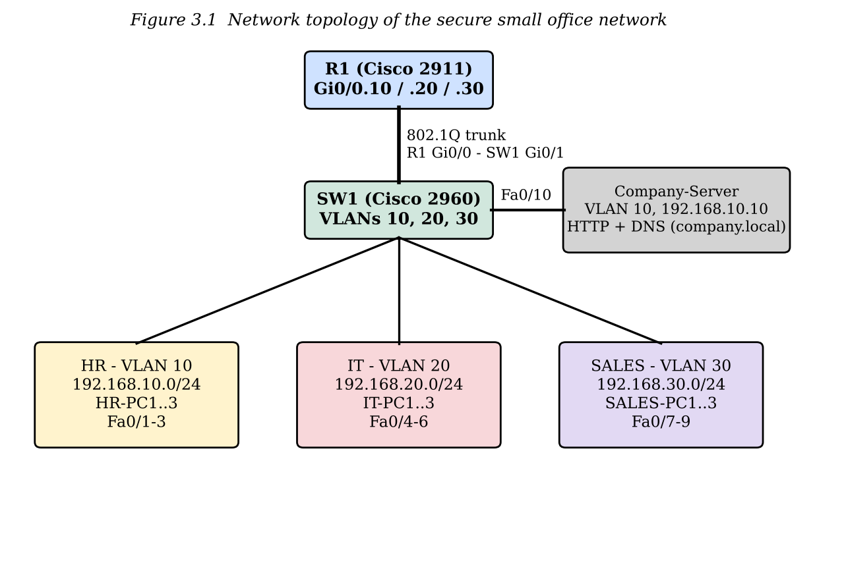
Department / device | VLAN | Network | Default gateway | Switch ports
HR (HR-PC1 to HR-PC3) | 10 | 192.168.10.0/24 | 192.168.10.1 | Fa0/1 - Fa0/3
IT (IT-PC1 to IT-PC3) | 20 | 192.168.20.0/24 | 192.168.20.1 | Fa0/4 - Fa0/6
Sales (SALES-PC1 to SALES-PC3) | 30 | 192.168.30.0/24 | 192.168.30.1 | Fa0/7 - Fa0/9
Company-Server (192.168.10.10) | 10 | 192.168.10.0/24 | 192.168.10.1 | Fa0/10
R1 Gi0/0 (trunk to SW1) | 1,10,20,30 | - | - | SW1 Gi0/1

Table 3.1 IP addressing and VLAN plan

3.2 Baseline mechanism description
The baseline is a conceptual flat office network: one shared network and broadcast domain, manual IP setup, little separation between departments, no central name-based access and no enforced access policy. It is a conceptual comparison only; no separate flat-network simulation was built or measured. The gaps are unnecessary inter-department visibility, addressing errors from manual setup, no name-based access to services, and security policies that are hard to enforce.

3.3 Proposed mechanism: algorithm, pseudocode, flowchart
The proposed network combines VLAN segmentation, router-on-a-stick routing, DHCP, DNS/HTTP services and two security controls: an extended ACL named SALES_RESTRICTION applied inbound on R1 subinterface Gi0/0.30 (Sales), and sticky-MAC port security on SW1 access ports Fa0/1 to Fa0/9. The ACL logic is shown below and in Figure 3.2.
ACL SALES_RESTRICTION applied INBOUND on R1 Gi0/0.30:
for each packet p arriving from VLAN 30 (192.168.30.0/24):
if p.destination == 192.168.10.10 (Company-Server): PERMIT
else if p.destination in 192.168.10.0/24 (HR): DENY
else: PERMIT # permit ip any any

Port security on each protected access port:
on first frame: learn source MAC, store it as sticky secure address
maximum secure addresses = 1
on frame from any other MAC: violation mode = shutdown (port is disabled)

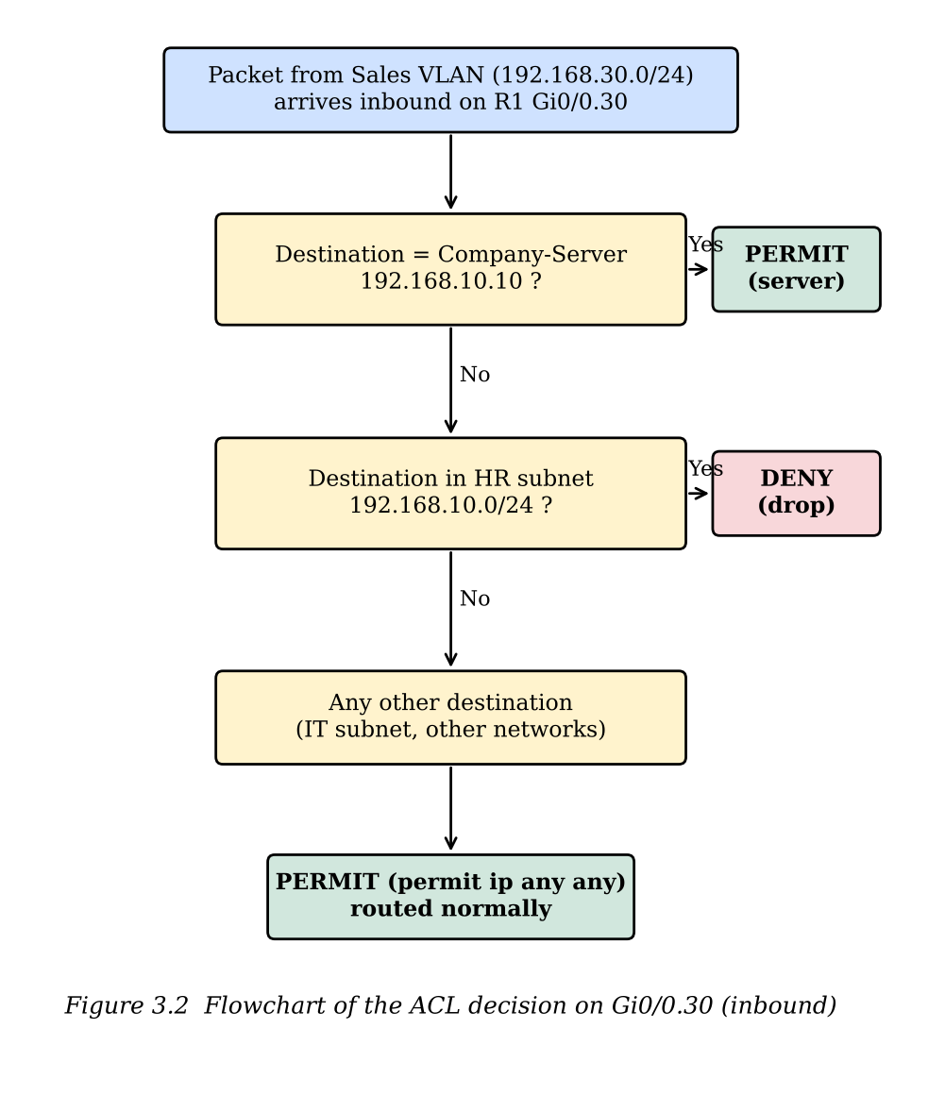

3.4 Novelty statement (what exactly differs from the baseline)
• Segmentation: the baseline has one broadcast domain; the proposed network has three (VLAN 10, 20, 30), joined only through R1.
• Addressing: manual setup is replaced by router-based DHCP with .1 to .20 reserved in each subnet; clients start at .21.
• Services: DNS (company.local) and an HTTP portal on a static-address server give name-based access to a shared service.
• Access policy: Sales traffic to the server is permitted, Sales traffic to the rest of the HR subnet is denied. Because the server lies inside the HR subnet, the rule order is permit-server first, deny-HR second, permit-rest last.
• Device binding: sticky-MAC port security (maximum 1 MAC, violation shutdown) on Fa0/1-Fa0/9 limits unknown devices on access ports.
• A documented fault-isolation sequence (interface status, trunk status, port-to-VLAN mapping, TTL analysis) based on faults met during the build.

3.5 Assumptions and design decisions
• IPv4 with /24 subnets; one subnet per VLAN; gateways use the .1 address of each subnet.
• Addresses .1 to .20 in each subnet are excluded from DHCP and reserved for static devices; the server uses 192.168.10.10 from this range.
• Router-on-a-stick was chosen to keep the design to one router and one cable; a Layer 3 switch would remove the single-link bottleneck but was outside the lab device set.
• The server is placed in VLAN 10 so that it is reachable at Layer 2 from HR and through R1 from IT and Sales.
• DNS server for all clients is 192.168.10.10; the local name used is company.local.

4 Implementation

4.1 Tools, platform, versions and hardware
Item | Details
Simulator | Cisco Packet Tracer (project file CNproject.pkt)
Router | Cisco 2911 ISR, IOS 15.1(4)M4 (CISCO2911/K9), 512 MB main memory (as shown in the boot log)
Switch | Cisco Catalyst 2960-24TT (SW1)
End devices | 9 PCs (HR-PC1..3, IT-PC1..3, SALES-PC1..3) and 1 Server-PT (Company-Server)
Cabling | Copper straight-through between all devices
Services | Router: DHCP. Server: HTTP and DNS

4.2 Simulation or testbed setup (topology, configuration, parameter table)
The network was built in stages and tested after each stage: (1) physical topology, (2) VLANs and access ports, (3) trunk, (4) router subinterfaces, (5) DHCP, (6) server configuration, (7) PC DHCP clients and tests, (8) ACL and port security. The main parameters are listed below; complete listings are in Appendix A.
Parameter | Value
VLANs | 10 = HR, 20 = IT, 30 = SALES
Access ports | Fa0/1-3 and Fa0/10 = VLAN 10; Fa0/4-6 = VLAN 20; Fa0/7-9 = VLAN 30
Trunk | SW1 Gi0/1 to R1 Gi0/0, 802.1Q, switchport nonegotiate; VLANs 1, 10, 20, 30 active
Subinterfaces | Gi0/0.10 = 192.168.10.1/24; Gi0/0.20 = 192.168.20.1/24; Gi0/0.30 = 192.168.30.1/24 (encapsulation dot1Q 10/20/30)
DHCP exclusions | 192.168.10.1-.20, 192.168.20.1-.20, 192.168.30.1-.20
DHCP pools | HR_POOL (192.168.10.0/24), IT_POOL (192.168.20.0/24), SALES_POOL (192.168.30.0/24); default-router = subinterface address; DNS = 192.168.10.10
Server | 192.168.10.10/24, gateway 192.168.10.1, DNS 192.168.10.10; HTTP on (index.html intranet portal); DNS on with A-record company.local -> 192.168.10.10
ACL | SALES_RESTRICTION inbound on Gi0/0.30: permit Sales to host 192.168.10.10; deny Sales to 192.168.10.0/24; permit ip any any
Port security | Fa0/1-Fa0/9: maximum 1 MAC, sticky learning, violation mode shutdown

4.3 Code structure and explanation of key modules
The implementation is configuration code in Cisco IOS. It is organised in modules, each configured on one device:
• SW1 module: creates and names the VLANs, sets access ports, and sets Gi0/1 as a trunk.
• R1 interface module: brings up Gi0/0 and creates one dot1Q subinterface per VLAN. Each subinterface is the default gateway of its VLAN.
• R1 DHCP module: excludes .1-.20 and defines one pool per VLAN with default-router and dns-server options.
• Server module: static IP settings, HTTP service with an intranet page ("ABC COMPANY - Internal Network Portal - Departments: HR, IT, SALES"), and a DNS A-record.
• Security module: extended ACL SALES_RESTRICTION on R1 Gi0/0.30 and sticky-MAC port security (maximum 1, shutdown) on SW1 Fa0/1-Fa0/9.
Key commands: "encapsulation dot1Q <id>" tags a subinterface with its VLAN so R1 can route between VLANs on one cable; "switchport mode trunk" lets Gi0/1 carry tagged frames for all VLANs; "ip dhcp excluded-address" protects the reserved range from being leased; "switchport port-security mac-address sticky" stores the first MAC learned on a port.

4.4 Challenges faced and how they were solved
No. | Problem observed | Diagnosis | Solution
1 | Server ping to gateway 192.168.10.1: 4 sent, 0 received (100% loss). | show ip interface brief on SW1 showed Fa0/11 up/up while the Gi0/1 trunk was down: R1 was cabled to Fa0/11 instead of Gi0/1. | Removed the link and re-patched R1 Gi0/0 to SW1 Gi0/1. show interfaces trunk then showed Gi0/1 trunking on 802.1q with VLANs 1,10,20,30.
2 | Server still unreachable; log showed Fa0/10 link going down. | Tool-tip on the topology showed Company-Server on Fa0/11 (default VLAN 1), not Fa0/10 (VLAN 10), so it was isolated from VLAN 10. | Re-plugged the server into Fa0/10. Ping to the gateway then gave 4/4 replies.
3 | Unable to tell whether HTTP/HTTPS were enabled on the server (dark-theme UI). | Radio buttons were filled blue on the "On" side. | Confirmed that both services were On.
4 | ACL test pings showed TTL=128 for both server and HR PC. | TTL 128 means no router hop: the test was run inside the HR subnet and was switched, not routed. | Repeated the test from a Sales workstation (192.168.30.x) so that traffic passes through R1 and the ACL.

5. Experimental Setup and Performance Evaluation

5.1 Performance metrics and why they were chosen
• Reachability (ping replies received out of 4): shows whether a path works at all and is the main evidence for gateway, inter-VLAN, server and DNS tests.
• Round-trip time (ms) and TTL of the reply: initial TTL of Packet Tracer PCs is 128 and of the router is 255, and each routed hop lowers it by one, so TTL shows whether traffic was switched (128) or routed (127).
• ACL hit counters (show ip access-lists): show which rule matched traffic, so they prove that the deny rule, and not some other fault, blocked Sales-to-HR traffic.
• DHCP binding count (show ip dhcp binding): shows how many clients received automatic addresses.
• Port-security state (show port-security): shows which ports are protected, the maximum MAC count, learned sticky MACs and violation count.
Because the project is a configuration project in a simulator, the results are mainly pass/fail and counter-based. No throughput or delay baseline was collected.

5.2 Scenarios and parameter values
Scenario | Test / command | Parameters
S1 Gateway reachability | HR-PC1 to 192.168.10.1 | ping, 4 echo requests of 32 bytes
S2 Inter-VLAN routing | HR-PC1 to 192.168.20.21 (IT PC) | ping, 4 echo requests
S3 Server reachability | HR-PC1 to 192.168.10.10 | ping, 4 echo requests
S4 DNS resolution | ping company.local | DNS server 192.168.10.10, A-record company.local
S5 Web portal | Browser to http://company.local | HTTP service on, index.html portal page
S6 Sales to server | Sales-PC1 to 192.168.10.10 | ping, 4 echo requests; ACL permit rule
S7 Sales to HR | Sales-PC1 to 192.168.10.21 | ping; ACL deny rule on Gi0/0.30 inbound
S8 DHCP allocation | R1: show ip dhcp binding | 9 PCs set to DHCP
S9 Port security | SW1: show port-security | Fa0/1-Fa0/9, maximum 1 MAC, sticky, violation shutdown
S10 Fault isolation (build stage) | Server to 192.168.10.1 before and after fixing cabling | ping, 4 echo requests; show ip interface brief, show interfaces trunk

5.3 Results: tables and graphs, baseline vs proposed (mean of repeated runs)
The baseline is a conceptual flat network (one shared network, manual addressing, no department boundary). No separate flat-network simulation was built, so no numerical baseline measurements exist. Table 5.1 therefore compares the two designs by features, and the proposed-network entries are the observed results of the captured tests. Each ping test is a single run of four packets, so no standard deviation can be given (shown as "-").
Table 5.1 Results: baseline (conceptual flat network) vs proposed (segmented network)
Scenario | Metric | Baseline (mean ± SD) | Proposed (mean ± SD) | Improvement (%)
S-A Broadcast domains | Number of broadcast domains | 1 (one shared network) | 3 (VLAN 10, 20, 30); trunk active on Gi0/1 | 3x finer separation (feature-based)
S-B Client addressing | IP assignment method | Manual setup possible | 9 DHCP leases (.21 onward in each subnet) | automated
S-C Name-based access | Server access by name | No central name-based access | company.local resolves to 192.168.10.10 | available
S-D Sales to server | Replies to ping | not measured | 4/4 replies | -
S-E Sales to HR host | Result of ping to 192.168.10.21 | No department boundary demonstrated | Blocked; ACL deny counter increased | access boundary added
S-F Inter-VLAN routing | HR-PC1 to 192.168.20.21 | not measured | 4/4 replies | -
S-G Port protection | Secure MACs per access port | Any device accepted | Fa0/1-Fa0/9: max 1 MAC, sticky, violation shutdown | device binding added

Table 5.2 gives the observed result of each captured test. Only tests that were run and observed are marked Pass or Blocked.
Table 5.2 Test matrix and observed status
Scenario | Test / command | Observed status | Evidence / metric
Gateway reachability | HR-PC1 to 192.168.10.1 | Pass | 4/4 replies in captured test
Inter-VLAN routing | HR-PC1 to 192.168.20.21 | Pass | 4/4 replies in captured test
Server reachability | HR-PC1 to 192.168.10.10 | Pass | 4/4 replies in captured test
DNS resolution | ping company.local | Pass | Resolved to 192.168.10.10
Web portal | Browser on IT-PC1 to http://company.local | Pass | "ABC COMPANY - Internal Network Portal - Departments: HR, IT, SALES" displayed
Sales to HR restriction | Sales-PC1 to 192.168.10.21 | Blocked | ACL deny counter increased
Sales to server | Sales-PC1 to 192.168.10.10 | Pass | 4/4 replies in captured test
DHCP allocation | R1: show ip dhcp binding | Pass | 9 client leases shown
Port security | SW1: show port-security | Configured | Fa0/1-Fa0/9; max 1 MAC; sticky MACs seen on Fa0/1 and Fa0/7

Table 5.3 shows the measurements recorded while fixing the two cabling faults (scenario S10). Packet Tracer reports times below 1 ms as "<1 ms"; these were taken as 0 ms when averaging.
Table 5.3 Fault-isolation measurements (Company-Server to gateway 192.168.10.1)
Condition | Packets sent / received | Packet loss | RTT of replies | TTL
Before correction (R1 on Fa0/11, server on Fa0/11) | 4 / 0 | 100% | request timed out | -
After correction (R1 on Gi0/1, server on Fa0/10) | 4 / 4 | 0% | 14, 5, <1, <1 ms (mean 4.75 ms) | 255
Workstation in another VLAN to 192.168.10.10 (routed) | 4 / 4 | 0% | 11, 7, 1, <1 ms (mean 4.75 ms) | 127

5.4 Analysis and discussion (reasons, trends, trade-offs)
• Segmentation and routing: HR-PC1 reached an IT address and the server with 4/4 replies, so VLAN separation did not prevent legitimate routed communication. The TTL of 127 seen for a cross-VLAN ping to the server is one lower than a PC's initial 128, proving that exactly one router hop (R1) was crossed. A TTL of 128 in an earlier ACL test showed that the test stayed inside the HR subnet and was switched, not routed, and was therefore not a valid ACL test.
• Access control: the permit-server rule is placed first so that Sales can still use the company server, which lies inside the HR subnet; the deny rule then blocks the rest of the HR subnet, and the final permit-any rule keeps other traffic working. The increase of the deny counter shows that the Sales-to-HR ping was stopped by the ACL.
• Name services: ping company.local resolving to 192.168.10.10 and the portal opening by name show that the DHCP-supplied DNS address (192.168.10.10) and the A-record work together.
• Fault isolation: the 100% loss in Table 5.3 was a physical-layer/VLAN-assignment problem, not an addressing problem. The gateway IP address was correct; the trunk was not up because R1 was patched to Fa0/11, and the server was in the default VLAN because it was on Fa0/11. Checking interface and trunk status before IP settings found both faults quickly.
• Trade-offs: router-on-a-stick uses only one cable and one router port, but all inter-VLAN traffic shares that one link. The ACL is simple but static and must be edited by hand when policy changes.

5.5 Critical evaluation: strengths, weaknesses, conditions where the proposed scheme fails
• Strengths: uses standard protocols and low-cost devices; each layer was tested separately; ACL counters and port-security output give evidence rather than assumptions; the security features add a real access boundary compared with a flat network.
• Weaknesses: one router and one switch are single points of failure; there is no Internet/WAN connection in the current scope; no measured throughput or delay baseline; DNS and HTTP are internal services and HTTPS was not configured.
• The ACL permits all IP traffic from Sales to the server, not only DNS and HTTP, so a stricter least-privilege policy is possible.
• ICMP success or failure alone does not prove that every application policy works; for example the ACL only filters traffic that passes through R1, so traffic inside one VLAN is not filtered.
• Port security with violation mode shutdown disables a port if a second MAC appears, so replacing a legitimate PC needs the port to be reset and the sticky entry cleared.
• Open item: an HR-PC1 to Sales-PC1 test failed in earlier testing. This is not explained by the inbound Sales ACL alone and is not claimed as a passing test; it should be investigated before stating that traffic works in both directions between every pair of VLANs.
• Failure conditions: a wrong cable (as in the two faults found) breaks the design even when the configuration is correct.

6. Conclusion and Future Work

6.1 Summary of work and key findings (quantified)
A secure small office network was built for HR, IT and Sales with three VLANs, an 802.1Q trunk, router-on-a-stick routing on R1, router-based DHCP (nine client leases, .1 to .20 excluded in each of three /24 subnets), and a server providing DNS (company.local) and HTTP. Captured tests showed 4/4 replies for gateway, inter-VLAN, server and Sales-to-server pings; company.local resolved to 192.168.10.10; and the Sales-to-HR ping was blocked with the ACL deny counter increasing. Sticky-MAC port security (maximum 1 MAC, violation shutdown) is configured on Fa0/1 to Fa0/9. During the build, two cabling faults gave 100% loss (4 of 4 packets) from the server to its gateway; after correction the loss was 0% with mean RTT 4.75 ms.

6.2 Limitations
• Simulation only; single runs and no numerical baseline measurements, so the baseline comparison is feature-based.
• Single router, single switch, single server (no redundancy); no Internet/WAN connection; HTTP only (no HTTPS).
• ACL is static and permits all IP traffic from Sales to the server; basic port security only.
• The failed HR-PC1 to Sales-PC1 test remains to be investigated.

6.3 Future enhancements
• SSH for encrypted administration of R1 and SW1 (with local authentication), if supported by the device model.
• Centralised Syslog and monitoring; regular configuration backups and a documented recovery procedure.
• More granular ACLs that permit only required protocols and restrict administrative access to authorised IT hosts.
• DHCP snooping and Dynamic ARP Inspection, if supported by the switch model and Packet Tracer version.
• Redundant links or devices (tested in a separate project copy), and measured performance tests with repeated runs to report mean and standard deviation.

7. References

References
[1] IEEE Standard for Local and Metropolitan Area Networks - Bridges and Bridged Networks, IEEE Std 802.1Q-2018, 2018.
[2] R. Droms, "Dynamic Host Configuration Protocol," RFC 2131, IETF, Mar. 1997.
[3] P. Mockapetris, "Domain names - concepts and facilities," RFC 1034, and "Domain names - implementation and specification," RFC 1035, IETF, Nov. 1987.
[4] Y. Rekhter, B. Moskowitz, D. Karrenberg, G. J. de Groot and E. Lear, "Address Allocation for Private Internets," RFC 1918, IETF, Feb. 1996.
[5] R. Fielding, M. Nottingham and J. Reschke, "HTTP Semantics," RFC 9110, IETF, Jun. 2022.
[6] W. Odom, CCNA 200-301 Official Cert Guide, Volume 1. Indianapolis, IN, USA: Cisco Press, 2019.
[7] Cisco Systems, Catalyst 2960 Switch Software Configuration Guide (chapters on port security) and Cisco IOS Security Configuration Guide (IP access lists), Cisco Systems, Inc.
[8] J. F. Kurose and K. W. Ross, Computer Networking: A Top-Down Approach, 8th ed. Pearson, 2021.
[9] Cisco Networking Academy, Cisco Packet Tracer learning resources. [Online]. Available: https://www.netacad.com/
[10] Cisco Systems, Cisco IOS configuration guides: VLANs, DHCP, ACLs, SSH and port security. [Online]. Available: https://www.cisco.com/

Appendix A: Important source code or configuration listings

A.1 SW1 (Catalyst 2960): VLANs, access ports, trunk and port security
enable
configure terminal
hostname SW1
vlan 10
name HR
exit
vlan 20
name IT
exit
vlan 30
name SALES
exit
interface range fa0/1-3
switchport mode access
switchport access vlan 10
exit
interface range fa0/4-6
switchport mode access
switchport access vlan 20
exit
interface range fa0/7-9
switchport mode access
switchport access vlan 30
exit
interface fa0/10
switchport mode access
switchport access vlan 10
exit
interface gigabitEthernet 0/1
switchport mode trunk
switchport nonegotiate
exit
interface range fa0/1 - 9
switchport port-security
switchport port-security maximum 1
switchport port-security mac-address sticky
switchport port-security violation shutdown
exit
end
write memory

A.2 R1 (Cisco 2911): router-on-a-stick (from the lab log)
Router>enable
Router#configure terminal
Router(config)#hostname R1
R1(config)#interface gig0/0
R1(config-if)# no shutdown
R1(config-if)#exit
R1(config)#interface gig0/0.10
R1(config-subif)# encapsulation dot1Q 10
R1(config-subif)# ip address 192.168.10.1 255.255.255.0
R1(config-subif)#exit
R1(config)#interface gig0/0.20
R1(config-subif)# encapsulation dot1Q 20
R1(config-subif)# ip address 192.168.20.1 255.255.255.0
R1(config-subif)#exit
R1(config)#interface gig0/0.30
R1(config-subif)# encapsulation dot1Q 30
R1(config-subif)# ip address 192.168.30.1 255.255.255.0
R1(config-subif)#exit
R1(config)#end

A.3 R1: DHCP (from the lab log)
R1#configure terminal
R1(config)#ip dhcp excluded-address 192.168.10.1 192.168.10.20
R1(config)#ip dhcp excluded-address 192.168.20.1 192.168.20.20
R1(config)#ip dhcp excluded-address 192.168.30.1 192.168.30.20
R1(config)#ip dhcp pool HR_POOL
R1(dhcp-config)# network 192.168.10.0 255.255.255.0
R1(dhcp-config)# default-router 192.168.10.1
R1(dhcp-config)# dns-server 192.168.10.10
R1(dhcp-config)#exit
R1(config)#ip dhcp pool IT_POOL
R1(dhcp-config)# network 192.168.20.0 255.255.255.0
R1(dhcp-config)# default-router 192.168.20.1
R1(dhcp-config)# dns-server 192.168.10.10
R1(dhcp-config)#exit
R1(config)#ip dhcp pool SALES_POOL
R1(dhcp-config)# network 192.168.30.0 255.255.255.0
R1(dhcp-config)# default-router 192.168.30.1
R1(dhcp-config)# dns-server 192.168.10.10
R1(dhcp-config)#end
R1#write memory

A.4 R1: extended ACL
The ACL permits all IP traffic from Sales to the server, not only DNS and HTTP; a stricter policy could allow only required services.
ip access-list extended SALES_RESTRICTION
permit ip 192.168.30.0 0.0.0.255 host 192.168.10.10
deny ip 192.168.30.0 0.0.0.255 192.168.10.0 0.0.0.255
permit ip any any
exit
interface gigabitEthernet0/0.30
ip access-group SALES_RESTRICTION in
exit

A.5 Company-Server settings
IP address: 192.168.10.10 Subnet mask: 255.255.255.0
Default gateway: 192.168.10.1 DNS server: 192.168.10.10
Services > HTTP: On (index.html = ABC COMPANY intranet portal)
Services > DNS: On, A-record company.local -> 192.168.10.10

Appendix B: Additional screenshots, packet captures, raw result tables

B.1 Raw CLI output from the lab
R1: show ip interface brief
Interface IP-Address OK? Method Status Protocol
GigabitEthernet0/0 unassigned YES unset up up
GigabitEthernet0/0.10 192.168.10.1 YES manual up up
GigabitEthernet0/0.20 192.168.20.1 YES manual up up
GigabitEthernet0/0.30 192.168.30.1 YES manual up up

SW1: show interfaces trunk (after correcting the cabling)
Port Mode Encapsulation Status Native vlan
Gig0/1 on 802.1q trunking 1
Port Vlans allowed and active in management domain
Gig0/1 1,10,20,30

Company-Server: ping 192.168.10.1 (after correction)
Reply from 192.168.10.1: bytes=32 time=14ms TTL=255
Reply from 192.168.10.1: bytes=32 time=5ms TTL=255
Reply from 192.168.10.1: bytes=32 time<1ms TTL=255
Reply from 192.168.10.1: bytes=32 time<1ms TTL=255
Packets: Sent = 4, Received = 4, Lost = 0 (0% loss)

Workstation in another VLAN: ping 192.168.10.10
Reply from 192.168.10.10: bytes=32 time=11ms TTL=127
Reply from 192.168.10.10: bytes=32 time=7ms TTL=127
Reply from 192.168.10.10: bytes=32 time=1ms TTL=127
Reply from 192.168.10.10: bytes=32 time<1ms TTL=127
Packets: Sent = 4, Received = 4, Lost = 0 (0% loss)

SW1: show port-security address
Vlan Mac Address Type Ports Remaining Age
10 0001.4303.4C53 SecureSticky Fa0/1 -
30 0001.4279.32A5 SecureSticky Fa0/7 -
Total Addresses in System (excluding one mac per port) : 0
Max Addresses limit in System (excluding one mac per port) : 1024

B.2 Screenshots from CNproject.pkt
The following screenshots demonstrate the simulation topology, device configurations, network services, and connectivity test results captured from CNproject.pkt in Cisco Packet Tracer.
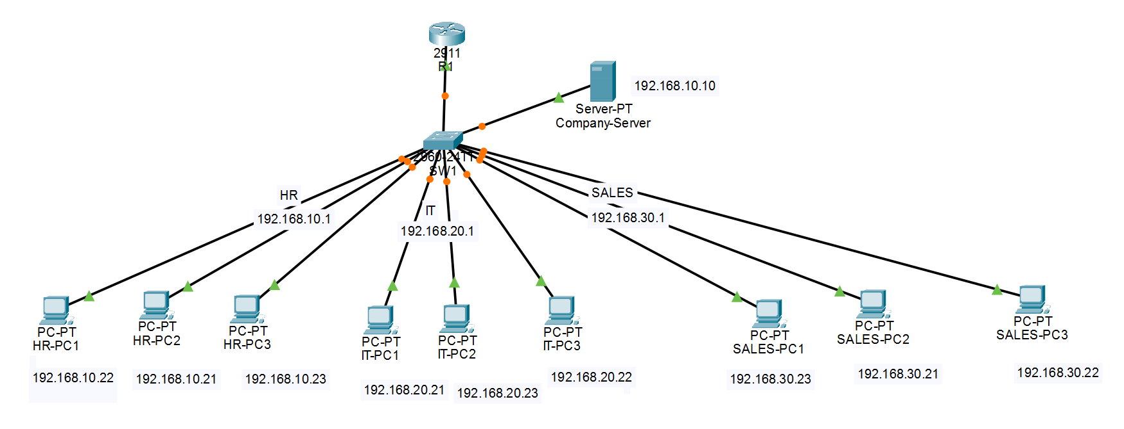
Figure B.1 Complete network topology in Cisco Packet Tracer
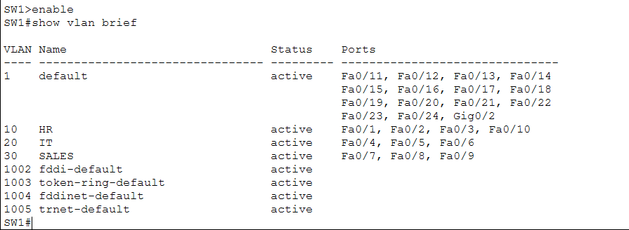
Figure B.2 Switch VLAN assignments and operational status (SW1: show vlan brief)
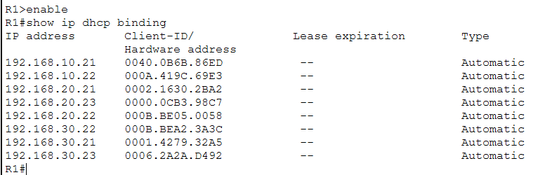
Figure B.3 Router dynamic IP address leases (R1: show ip dhcp binding)
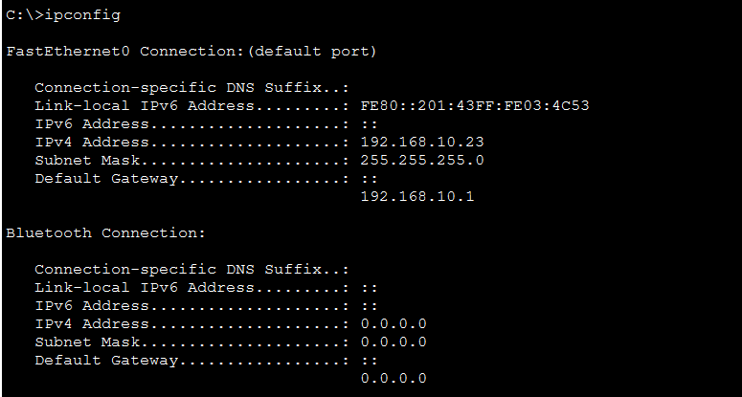
Figure B.4 End-device TCP/IP and DNS configuration via DHCP (HR-PC3: ipconfig)
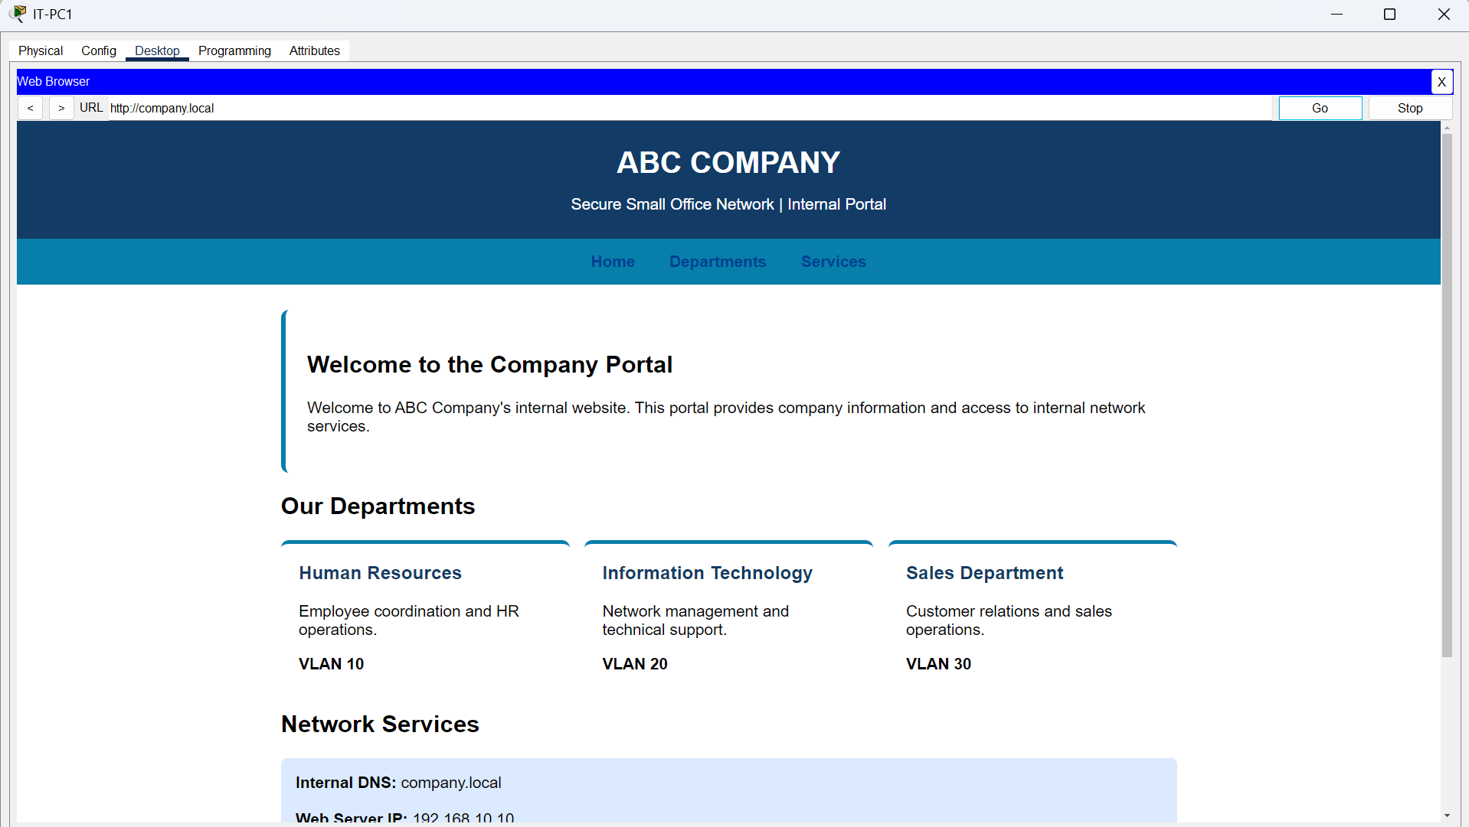
Figure B.5 Intranet portal access via internal DNS domain (IT-PC1 browser: http://company.local)
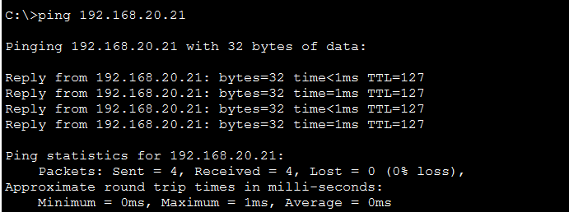
Figure B.6 Inter-VLAN routed connectivity test (HR-PC1 ping to IT-PC1 192.168.20.21)
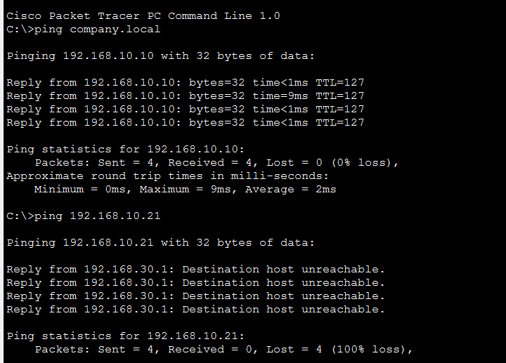
Figure B.7 DNS name resolution and ACL enforcement (Sales-PC1 to company.local and HR-PC2)
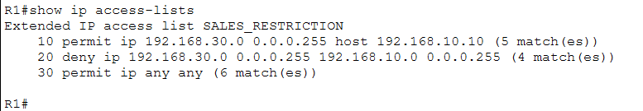
Figure B.8 Extended ACL rule configuration and packet hit counters (R1: show ip access-lists)
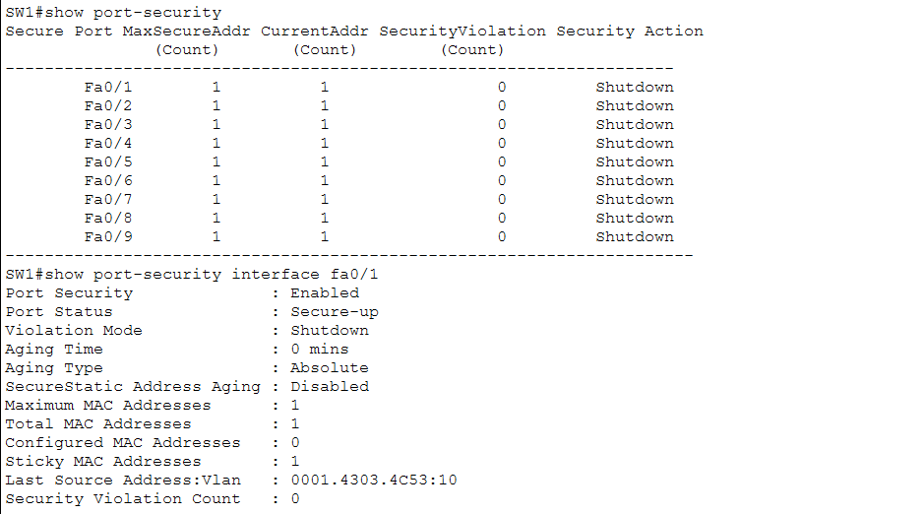
Figure B.9 Switch port security settings and secure sticky MAC table (SW1: show port-security)

