1. Abstract

The project is totally built at administrative end and thus only the admin is guaranteed the access.

This system is named as Electricity Bill Management System. This system is made to keep the records about the bills of the consumers. The admin can manage all the accounts and the registered users like admin can only manage their own accounts. This system helps in maintaining the bills and the payments.

The admin can login to the system with provided id and password to him.Admin can change

User id and password and add new user id and password by that changed id and password he can also log in to the system.

.

This system also has the feature to add and delete customer’saccounts. in case a customer wants to cut the connection in that case admin can delete account of that customer’s. In case a

A new consumer want connection in that case admin can add consumer.

Admin can calculate the bill from unit which was used by consumer in last month. Billis calculated according to charge per unit.

The consumers are divided according to their wards. The rest of the modules are explained in the further sections with the detailed explanation.

Admin can also see the payment status of consumerwhich has paid the bill amount andpending amount.

1. Software Specification

* **Development Tools:**
* Gedit
* Documentation tools :

Edraw Max 5.1

Edraw Flowchart 5.6

Microsoft office Word 2007

* **Hardware Requirement**:
* Processor: Intel Core i3
* Memory: 512MB Ram (minimum requirement)
* Hard disk Space:1GB (minimum requirement)
* **Software Requirements**
* Operating System : Ubuntu 16.04.6 LTS, Windows 8, DOS
* Terminal, turbo c++
* gcc complier

1. Scope & Objectives

* **Objective**

The firm handles all of the work manually, which is very tedious and mismanaged. The objective of our project is as follows:

* The purpose of this project is to build an application program to reduce the manual work for managing the customer, connection, units, and bills.
* To keeps the information of customer.
* To keeps the information of consuming unit of energy of current month.
* To keeps the information of consuming unit of energy of previous month.
* To keeps admin information about his user name and password.
* To maintain the record of department.
* **Scope of project:**

Our project aims at Business process automation, i.e. we have tried to computerize various processes of electricity bill management system. In the sector of electricity board we have computerizes their department and stock maintenance.

Scope of any software depends upon the following things:

* It satisfies the user requirement.
* Be easy to understand by the user and operator.
* Be easy to operate.
* Have a good user interface.
* Be expandable.
* Delivered on schedule within the budget. We have tried to make such type of software, which satisfy the above given requirement.

1. Data Structures (User Defined Data types)

|  |  |  |  |
| --- | --- | --- | --- |
| Structure name | Data type | Variable name | Size |
| Admin | Char | Uname | 30 |
| Admin | Char | Password | 8 |
| Payee | Int | Pid | 4 |
| Payee | Char | Pfname | 20 |
| Payee | Char | Plname | 20 |
| Payee | Int | Hno | 4 |
| Payee | Char | Area | 100 |
| Payee | Long int | Pin | 8 |
| Payee | Int | Status | 4 |

1. System Flow Chart

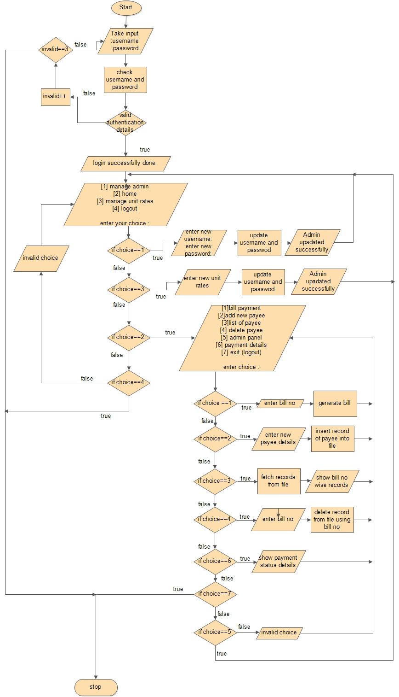

1. Testing

6.1 Test Plan

* 1. Test Data

1. References

* Programming in C, 2nd Edition, Pradip Dey, Manas Ghosh , OXFORD
* Reema Thareja. “Programming in C”,2nd Edition, Oxford University Press
* Programming in ANSI C, by Balaguru samy, Publisher - Tata McGraw Hill
* Let us C, by Yashwant Kanitkar, Publisher – BPB Publication