INT222

Dental Project

Name: Ravinda Yadav

Regis.No. 11708826

Roll.no: A20

**Content:**

**Pages:**

1. Homepage
2. About Us
3. News
4. Services
5. Contact Us
6. Admin **->**
7. Dashboard
8. Appointments **->**
9. Book Appointment
10. All Appointment
11. Update Appointment
12. Cancel Appointment
13. Patients **->**
14. All patients
15. Add patient
16. Delete patient
17. View Patient

Backend Services Implemented:

1. Form created
2. Validation
3. MongoDB using mongoose
4. Create,delete,update all the crud on mongoose done
5. Get,Post,Delete routes implemented
6. Used routes style
7. MVC style
8. Express server is used
9. Front-end done using bootstrap,css and html

**Github link of the project:**

<https://github.com/Ravindrayadavrk1006/expressnodeproject/tree/master>

directory structure:

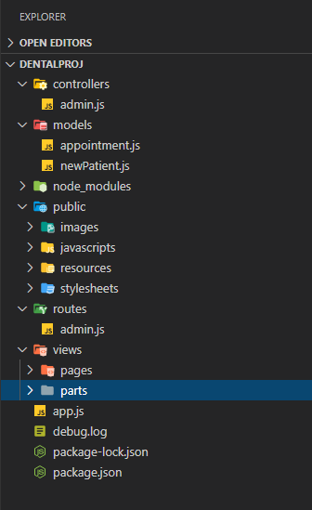

Some code:

Main app.js

const express=require('express');

const bodyParser=require('body-parser');

const mongoose=require('mongoose')

const controllers=require('./controllers/admin')

const adminRoutes=require('./routes/admin')

const port=3001

const app=express();

app.use(bodyParser.urlencoded({extended:true}));

app.use(bodyParser.json());

databaseName='OmDentals'

const url=`mongodb://localhost:27017/${databaseName}`

app.set('view engine','ejs');

app.use(express.static(__dirname+'/public'))

//loading the admin routes over the /admin

app.use('/admin',adminRoutes);

app.get('/',(req,res,next)=>{

    res.render('pages/index')

})

app.get('/aboutUs',(req,res)=>{

  res.render('pages/aboutus')

})

app.get('/news',(req,res)=>{

  res.render('pages/news')

})

app.get('/services',(req,res)=>{

  res.render('pages/services')

})

app.get('/contactUs',(req,res)=>{

  res.render('pages/contactUs')

})

//connecting to dbase and inside it connecting to the express server inside the mongoose promise

mongoose.connect(url,{

  useNewUrlParser:true,

  useUnifiedTopology:true,

})

  .then((result)=>{

    console.log('connected to databse');

    app.listen(port,()=>{

        console.log(`application is running at localhost:${port}`)

      })

    })

    .catch(err=>{

      console.log(err)

    })

The controller file:

// const bodyParser=require('body-parser');

const Patient=require('../models/newPatient')

const bookAppointment=require('../models/appointment')

const {validationResult}=require('express-validator');

exports.addPatients=(req,res)=>{

       let tempObj={

           firstName:req.body.firstName,

           secondName:req.body.secondName,

           mobileNo:req.body.mobileNo,

           DOB:req.body.Dob,

           email:req.body.email,

           treatmentType:req.body.treatmentType,

           treatmentInfo:req.body.treatmentInfo

       }

       console.log(tempObj);

       const aPatient=new Patient(tempObj)

       aPatient

        .save()

        .then(result=>{

            console.log("data saved to the db");

            res.redirect('/admin')

            // res.render('\admin',{msg:"patient added succesfully SUCCESSFULLY!"})

        })

}

exports.bookAppointment=((req,res)=>{

    let tempObj=

    {

        firstName:req.body.firstName,

        secondName:req.body.secondName,

        dateTime:req.body.dateTime,

        email:req.body.email,

        mobileNo:req.body.mobileNo,

    }

    console.log(tempObj);

    let newAppointment=new bookAppointment(tempObj)

    newAppointment

        .save()

        .then(result=>{

            console.log("appointment booked");

            res.redirect('/admin')

        })

        .catch(err=>{

            if (err) throw Error;

            console.log(err);

        })

    // res.redirect('/admin',{msg:"appointment booked SUCCESSFULLY!"})

})

exports.allPatients=(req,res)=>{

    Patient.find({},(err,result)=>{

        if(err) throw new Error

        else

        console.log(result)

        res.render('pages/adminPages/allPatients',{patients:result})

    })

}

exports.getdeletePatient=(req,res)=>{

    res.render('pages/adminPages/deletePatient');

}

exports.deletePatient=(req,res)=>{

    var firstName=req.body.firstName;

    var secondName=req.body.secondName;

    Patient.deleteOne({firstName:firstName,secondName:secondName},(err,result)=>{

        if(err) throw new Error

        else

        {

            console.log("patient deleted")

            res.redirect('/admin')

        }

    })

}

exports.updatePatientInfo=(req,res)=>{

    var firstName=req.body.firstName;

    var secondName=req.body.secondName;

    Patient.findOne({firstName:firstName,secondName:secondName},(err,result)=>{

        console.log(result);

        var oldTreatmentType=result.treatmentType;

        var oldTreatmentInfo=result.treatmentInfo;

        var newTreatmentType=req.body.treatmentType;

        var newTreatmentInfo=req.body.treatmentInfo;

        var treatmentType=newTreatmentType;

        var treatmentInfo=oldTreatmentInfo+ " " + newTreatmentInfo

        Patient.updateOne({firstName:firstName,secondName:secondName},{$set:{treatmentInfo:treatmentInfo,treatmentType:treatmentType}},{upsert:true});

    })

    res.redirect('/admin');

}

exports.allAppointments=(req,res)=>{

    bookAppointment.find({},(err,result)=>{

        res.render('pages/adminPages/allAppointments',{appointments:result})

    })

}

exports.getcancelAppointment=(req,res)=>{

    res.render('pages/adminPages/cancelAppointment')

}

exports.cancelAppointment=(req,res)=>{

    var firstName=req.body.firstName;

    var secondName=req.body.secondName;

    bookAppointment.deleteMany({firstName:firstName,secondName:secondName},(err,result)=>{

            if(err) throw new Error(err);

            console.log(result);

            res.redirect('/admin')

    })

}

exports.getupdateAppointment=(req,res)=>{

    res.render('pages/adminPages/updateAppointment')

}

exports.updateAppointment=(req,res)=>{

    var firstName=req.body.firstName;

    var secondName=req.body.secondName;

    var dateTime=req.body.dateTime;

    bookAppointment.updateOne({firstName:firstName,secondName:secondName},{$set:{dateTime:dateTime}},(err,result)=>{

        if (err) throw new Error("cannot update the appointment")

        console.log("appointment updated with result=>",result);

    });

    res.redirect('/admin');

}

exports.findPatient=(req,res)=>{

    var firstName=req.body.firstName;

    var secondName=req.body.secondName;

     Patient.findOne({firstName:firstName,secondName:secondName},(err,result)=>{

         console.log(result);

         res.render(`pages/adminPages/showPatient`,{patient:result});

     })

}

exports.getfindPatient=(req,res)=>{

    res.render('pages/adminPages/findPatient')

}

exports.getupdatePatientInfo=(req,res)=>{

    res.render('pages/adminPages/updatePatientInfo');

}

Some html views:

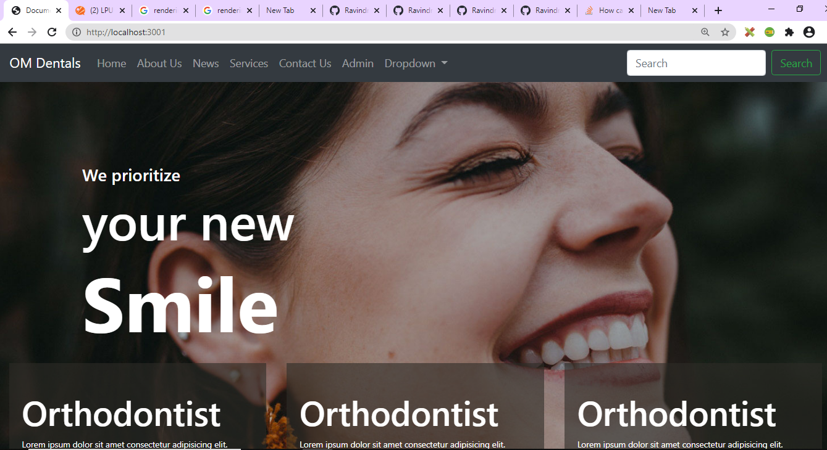

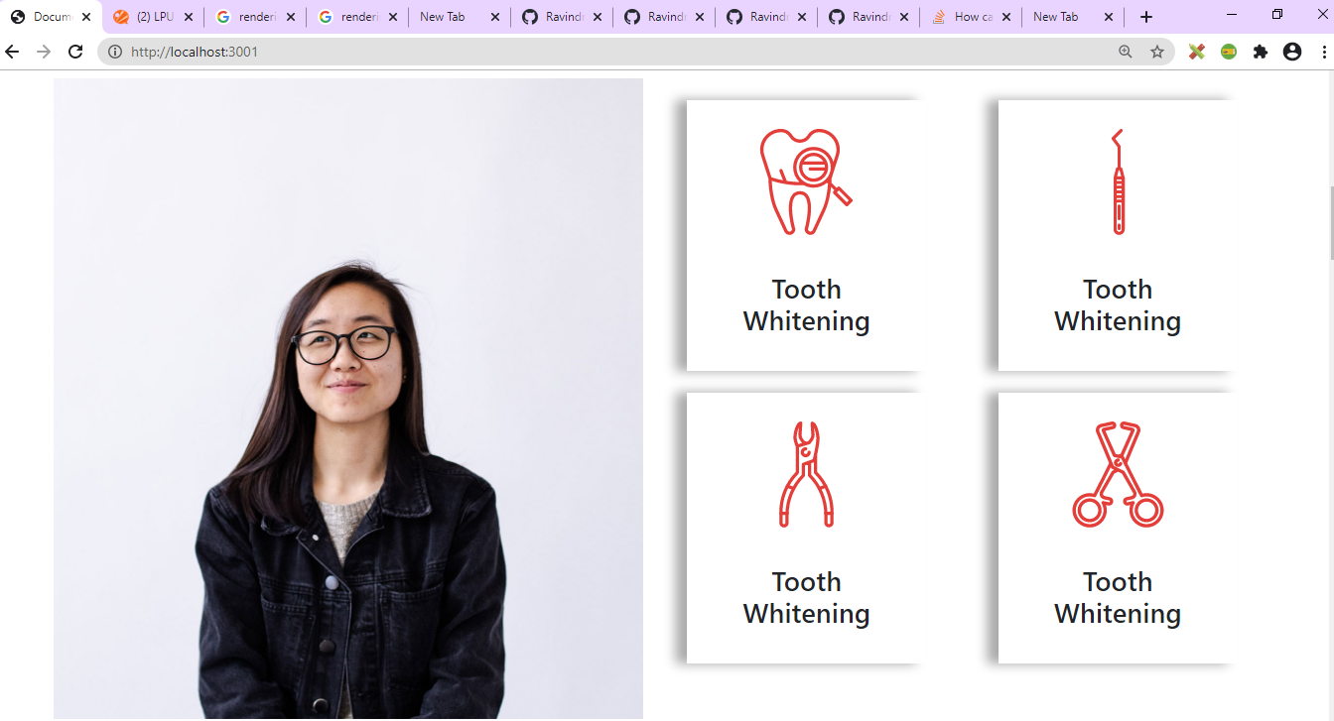

**The Website is made fully responsive :**

**Some check:**

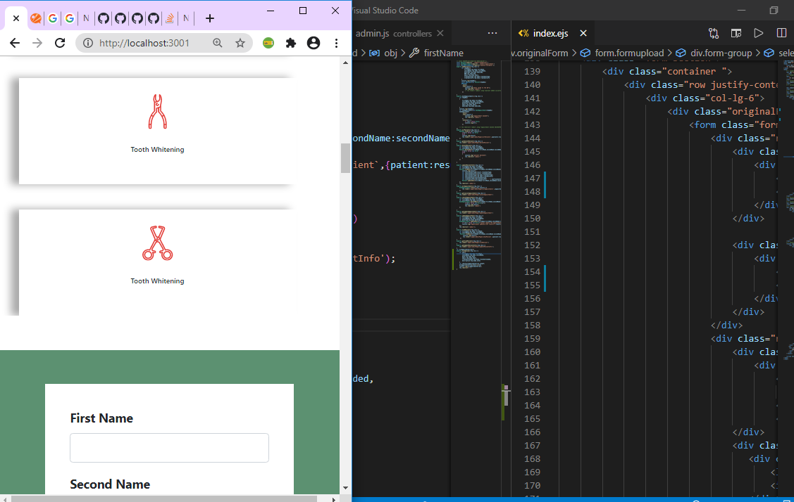

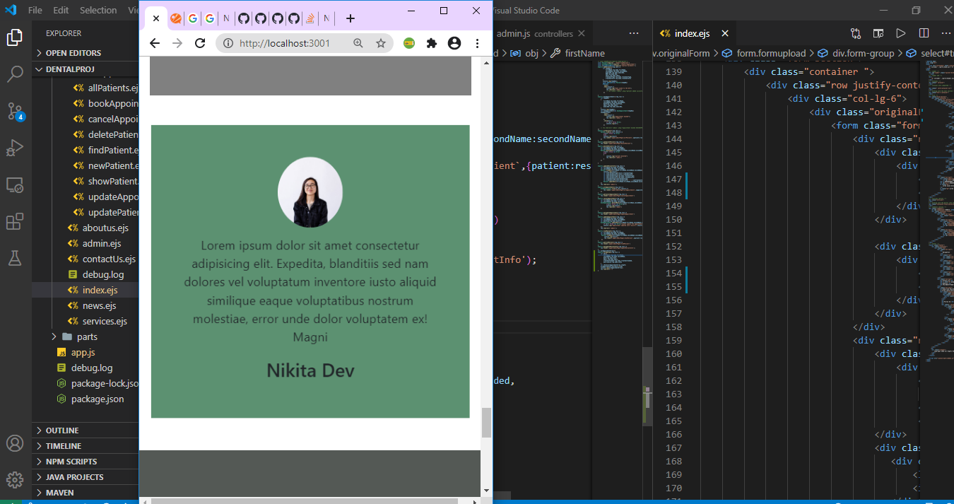

**Some pages of admin section and his functionalities:**

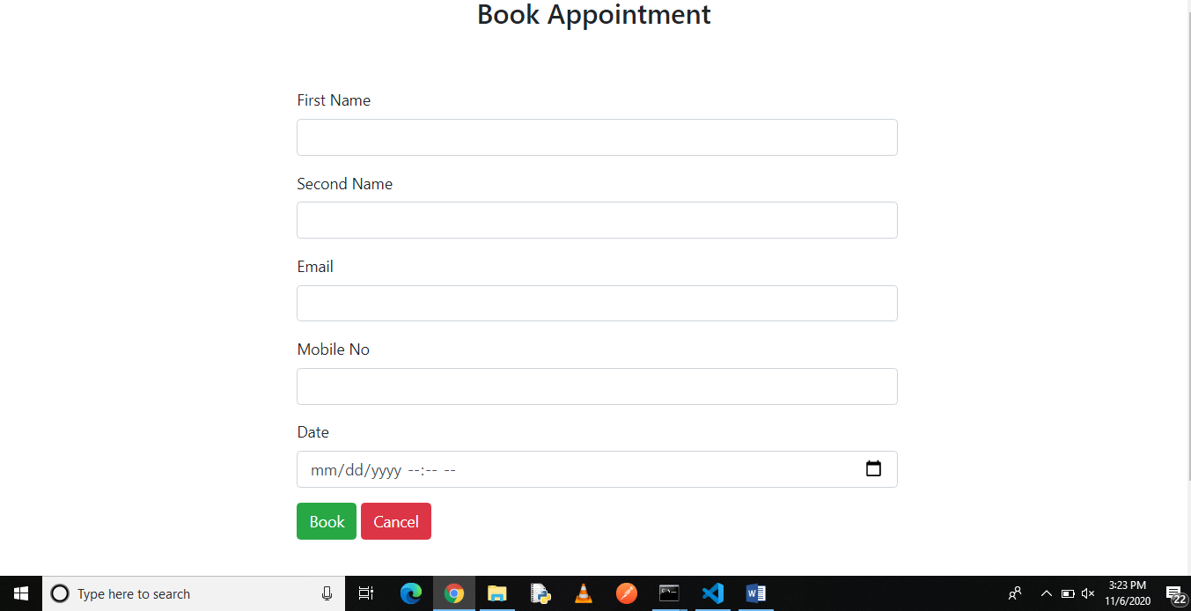

**Add patient :**

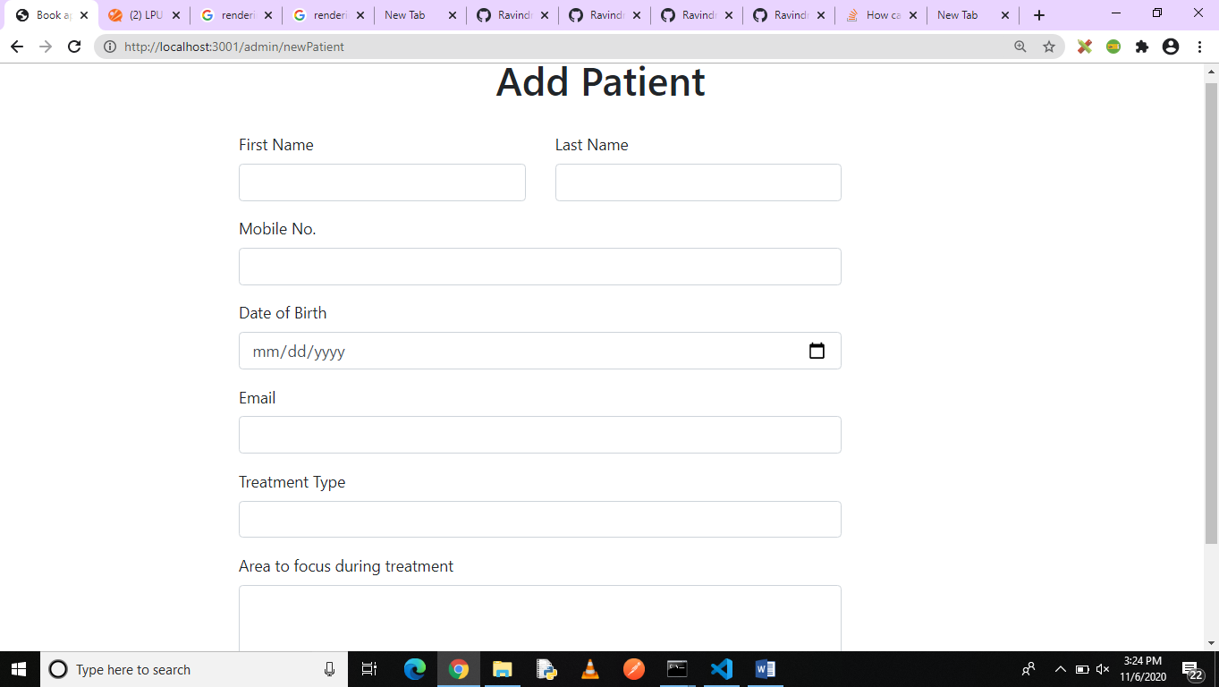

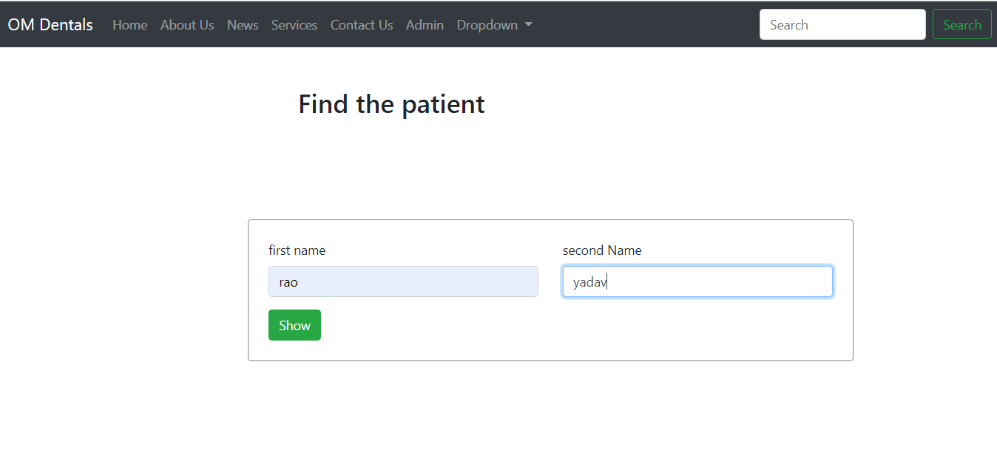

**All the pages are implemented and well working authentication has not been implemented except that almost all functionalities implemented**