SE4040 – Enterprise Application Development
Year 4, Semester 2, 2026 · BSc (Hons) in Information Technology specialising in Software Engineering
Smart Solar Microgrid Trading System
Client–Server Application (Web, Mobile and Web Service)
Assignment 1 · Group project report
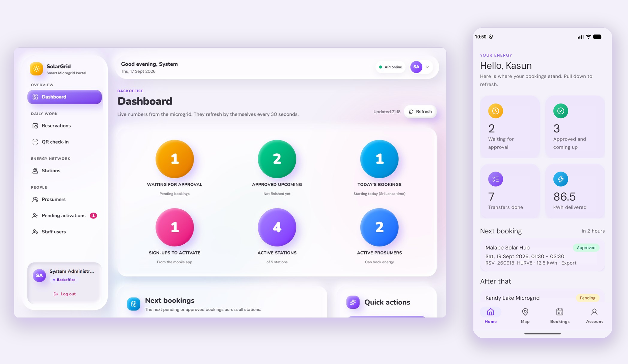
# | Name | IT number | Feature ownership
1 | Ravindu Bandara Subasinha | IT22098450 | Core platform, authentication, staff users, operator QR check-in, IIS hosting
2 | Malith |  | Prosumer accounts (NIC sign-up, activation, deactivation), dashboards
3 | Nimthara |  | Microgrid stations, battery bays, opening hours, energy slots, maps
4 | Hamnad |  | Energy reservations, booking rules and history, QR code generation

Git repository: https://github.com/Ravindu200232/eda-assignment
Submission deadline: 30 September 2026, 11.59 PM

Contents

Word note: if the list above is empty, right-click it and choose “Update Field” (or press F9).

1 Introduction

1.1 About the system
The Smart Solar Microgrid Trading System lets solar prosumers – property owners with solar panels – trade energy with community microgrid battery stations. A prosumer books a time slot at a station, either to send surplus solar energy into the station’s batteries (Export) or to draw stored energy from them (Import).
Backoffice staff register the microgrid stations, keep their opening hours and manage the staff and prosumer accounts. Grid Operators keep the battery bays and slots up to date, approve bookings and check prosumers in at the station by scanning the QR code of their approved booking.
The system follows the client–server architecture of the brief. A web application serves the Backoffice and the Grid Operators, a pure native Android application serves prosumers and Grid Operators, and a central C# Web API on IIS holds all business logic and is the only part that talks to the MongoDB database.

1.2 Parts of the system
Part | Used by | Built with | Where it runs
Web API (FAT service) | Both client apps | C# ASP.NET Core 10, MongoDB.Driver, JWT login tokens, BCrypt, Swagger | IIS site SolarGridApi, http://localhost:8080
Web portal | Backoffice, Grid Operators | React 19, Vite, Tailwind CSS 4, React Router, Axios, Google Maps (OpenStreetMap fallback), ZXing | IIS site SolarGridWeb, http://localhost:8081
Android app | Prosumers, Grid Operators | Java 17 with XML layouts, SQLite (SQLiteOpenHelper), Retrofit and OkHttp, Google Maps SDK, ZXing | Android 9 or newer (tested on a Pixel 10 emulator with Android 17)
Database | Only the Web API | MongoDB Community Server 8.3 | localhost:27017, database SolarGridDb

1.3 How the brief is covered
The table maps each requirement of the brief to the part of the system that meets it and the section of this report that shows it.
Requirement in the brief | How the system meets it | Section
Web: two roles – Backoffice (administration) and Grid Operator (operations) | The Backoffice creates both kinds of staff accounts. Menus, pages and API endpoints are limited by role; the API answers 403 to anyone else. | 4, 5.1, 9
Web: prosumer management with the NIC as the primary key; only the Backoffice reactivates | The NIC is the _id of UserDetails. Staff create, edit and deactivate prosumers; activation and reactivation are Backoffice-only in the API. | 3.2, 4
Web: microgrid nodes with GPS location, capacity, battery slots and schedules; no deactivation while active reservations exist | Stations store a GeoJSON point, solar kW, storage kWh, total and free battery bays and weekly opening hours. Deactivation is refused while pending or approved bookings exist. | 3.2, 4
Web: create, update and cancel reservations; within 7 days; changes and cancellations at least 12 hours before | A booking wizard, change and cancel. The API enforces the 7-day window and the 12-hour notice and never overbooks a slot. | 2.4, 4
Web: responsive UI with React / Tailwind CSS | React 19 with Tailwind CSS 4 and one design system, laid out for desktop and phone screens. | 5.1–5.3
Mobile: pure native Android with SQLite, no frameworks | Java and XML views, SQLiteOpenHelper with four tables; no Kotlin, Flutter, React Native or other cross-platform framework. | 3.6, 5.4
Mobile: prosumers register with the NIC, edit their profile and ask for deactivation | Sign-up (Pending until the Backoffice activates it), profile edit, password change, deactivation confirmed with the password. | 5.4, 5.5
Mobile: reserve, change and cancel slots; a secure QR code once approved | Booking form, change and cancel with the 12-hour rule; an approved booking shows a QR code signed by the API (HMAC-SHA256). | 4, 5.5
Mobile: dashboard counts, bookings, nearby stations on Google Maps, history, pending bookings and search | Home shows the pending and approved-future counts and the next bookings; the Map tab shows nearby stations; the Bookings tab has current, waiting and history tabs with search and filters. | 5.4, 5.5
Mobile: operator mode – scan the QR code, verify with the server, finish the transfer | The Scan tab reads the code (camera or typed); the API checks it; the operator enters the delivered kWh and completes the transfer. | 4, 5.5
Service: FAT service – all business logic in the API | Controllers → Services → Repositories. The clients only show the API’s answers and hide buttons using flags such as canModify. | 2.1
Service: C# Web API on IIS with a NoSQL database; clients use REST only | ASP.NET Core 10 on IIS with MongoDB 8.3; both clients call the API with JSON over HTTP and a login token. | 2.1, 6

1.4 Team
The group has four members. Each member owns one feature from end to end – in the API, the web portal and the Android app – so every member worked on all three parts of the system (details in section 9).
Member | IT number | Feature ownership
Ravindu Bandara Subasinha | IT22098450 | Core platform, authentication, staff users, operator QR check-in, IIS hosting
Malith |  | Prosumer accounts (NIC sign-up, activation, deactivation), dashboards
Nimthara |  | Microgrid stations, battery bays, opening hours, energy slots, maps
Hamnad |  | Energy reservations, booking rules and history, QR code generation

2 System design

2.1 High-level architecture
Figure 1 shows the three tiers of the system: the two client applications, the central Web API and the MongoDB database.
- Clients are user interfaces only. The web portal and the Android app send every request to the Web API over REST (JSON over HTTP). Neither of them opens the database or repeats a business rule; they show the API’s answers and messages.
- FAT service. Inside the API each request passes three layers: controllers read the request and check the role, services hold every business rule (7-day window, 12-hour notice, free bays, account status, QR signatures), and repositories run the MongoDB queries. A middleware turns every error into a standard ProblemDetails answer.
- Security. Login returns a JWT token that lasts 8 hours. Both clients send it with every request and the API checks the role for each endpoint. Tokens of accounts that were deactivated after login stop working at once. Passwords are stored as BCrypt hashes.
- Local persistence. The web portal keeps only the session in the browser. The Android app keeps read-only copies (session, profile, stations and bookings) in SQLite so it can show them offline; every change still goes through the API.
- Hosting. The API and the web portal are two IIS sites on the same Windows PC (ports 8080 and 8081). The Android emulator reaches the API at 10.0.2.2:8080. Google Maps draws the maps in both clients; the station positions come from the API.

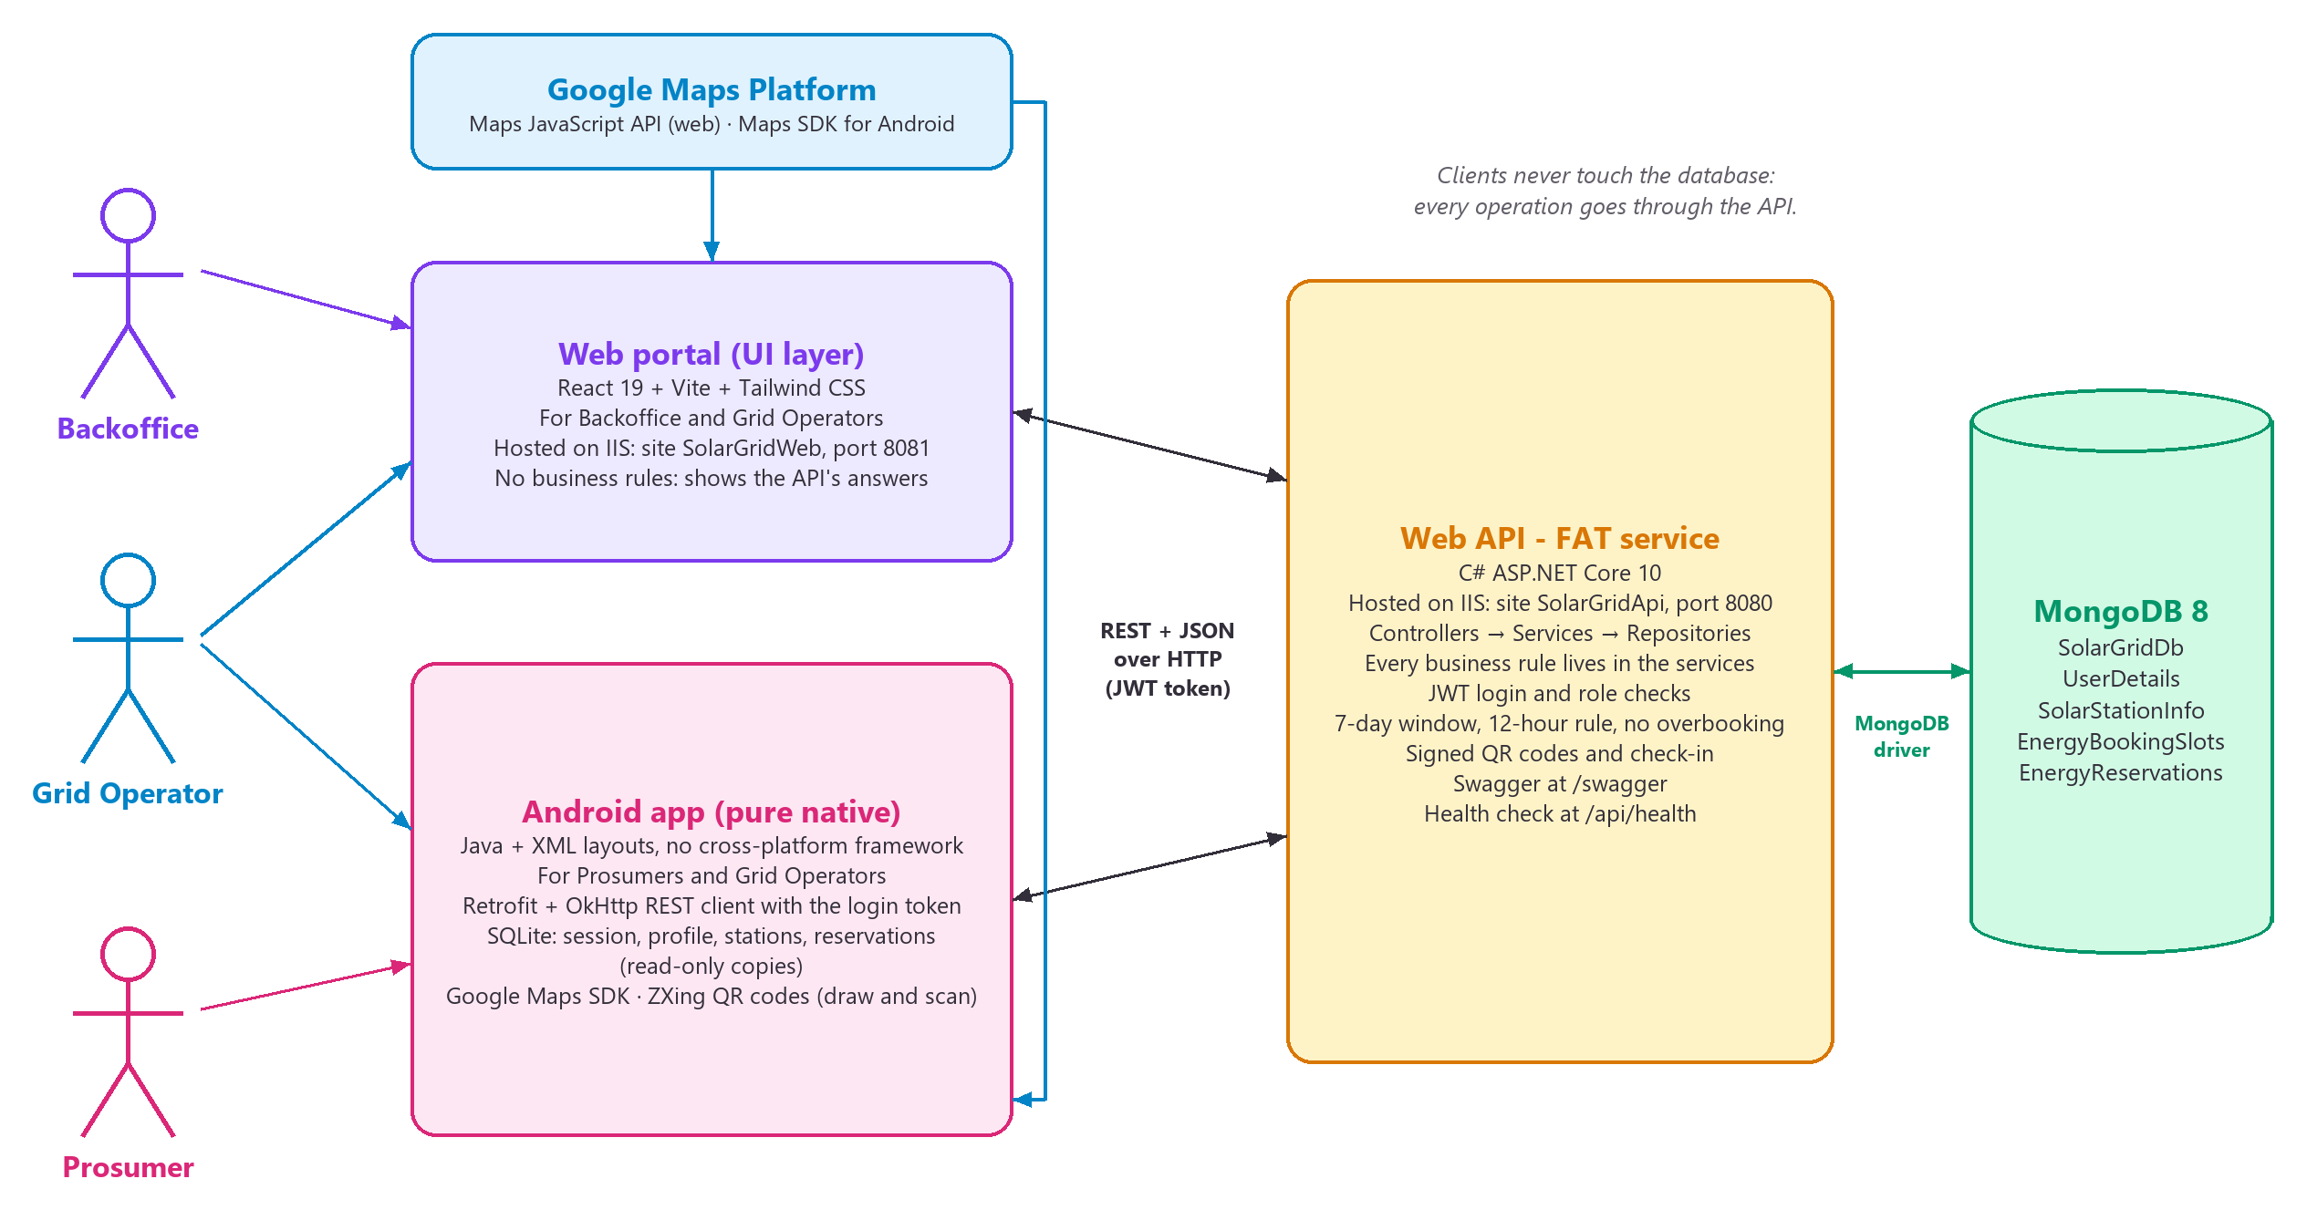
Figure 1: High-level architecture of the Smart Solar Microgrid Trading System

2.2 Use case diagrams
There are three kinds of user. The Backoffice and the Grid Operator are both staff users and share most of the web portal; the Backoffice also manages staff users, stations and opening hours and is the only role that activates or reactivates prosumer accounts. Figure 2 shows this with a generalisation: both staff roles inherit the use cases of the abstract actor Staff user.
The Android app (Figure 3) serves the Prosumer and the Grid Operator. Backoffice accounts are refused by the app, because Backoffice work is done in the web portal.
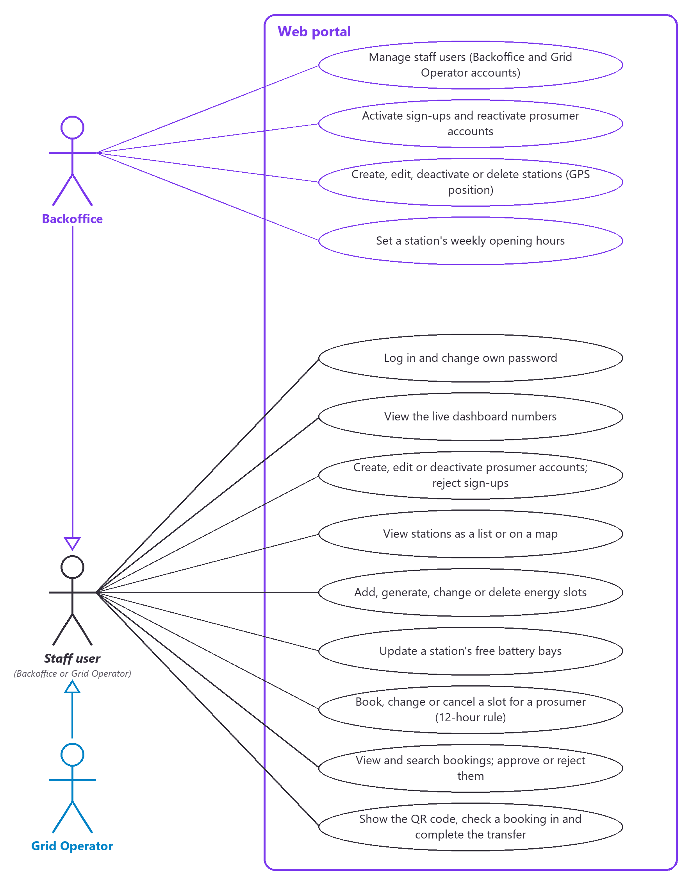
Figure 2: Use case diagram – web portal (Backoffice and Grid Operator)

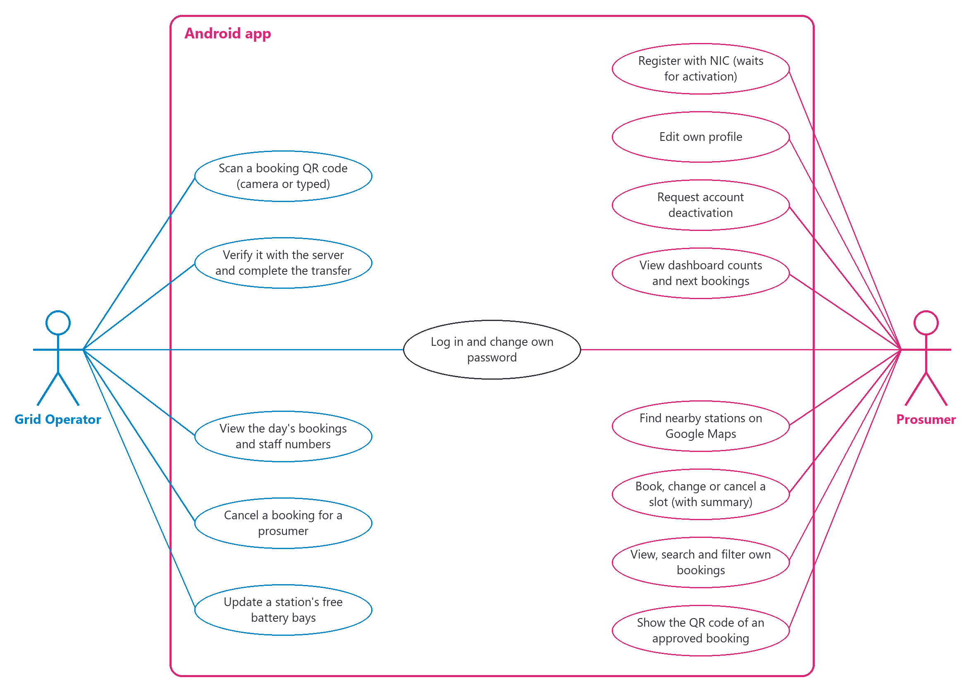
Figure 3: Use case diagram – Android app (Prosumer and Grid Operator)

2.3 Data flow diagrams
The context diagram (level 0, Figure 4) shows the whole system as one process with its three kinds of user and Google Maps. The level 1 diagram (Figure 5) opens the system into six processes and five data stores: the four MongoDB collections (D1–D4) and the read-only copy the Android app keeps in SQLite (D5).
To keep the level 1 diagram readable, each external entity and each data store has its own line, and a short line joins it to every process that uses it. A line that crosses another one jumps over it; a dot marks a real junction. The numbers on the lines are listed in the table after the diagrams.

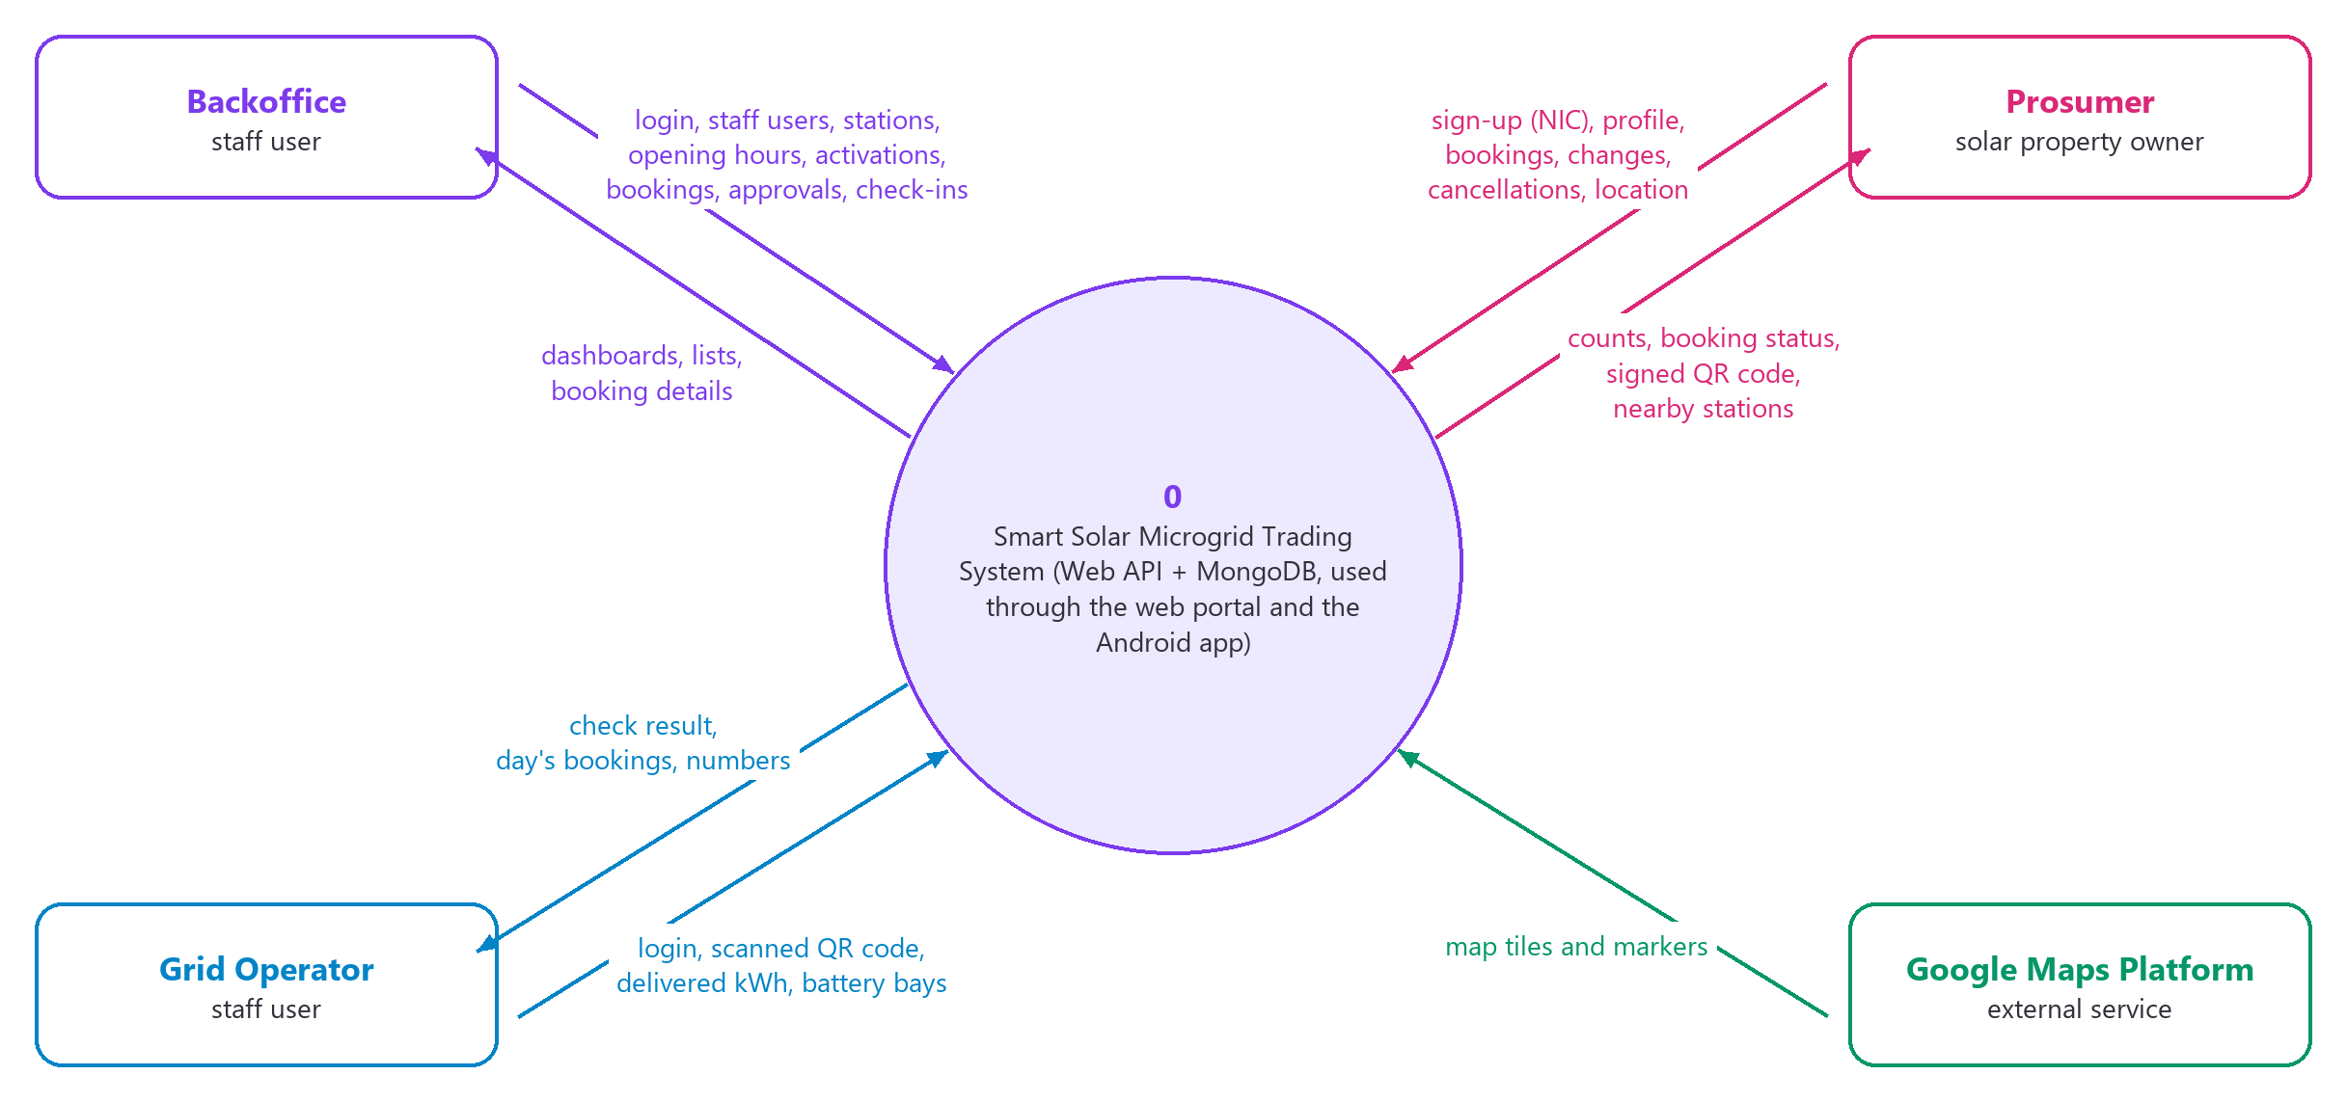
Figure 4: Data flow diagram – level 0 (context diagram)
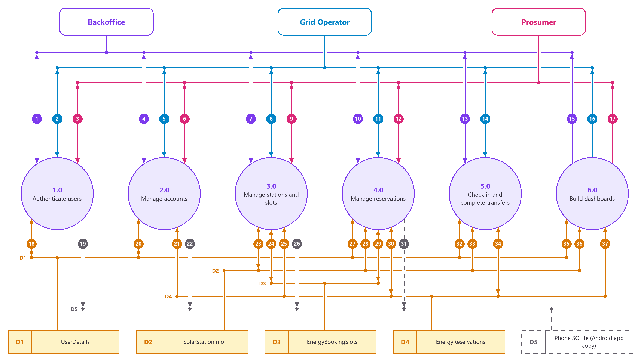
Figure 5: Data flow diagram – level 1 (processes 1.0–6.0 and data stores D1–D5)

Level 1 data flows
Arrows show the direction of the data: “in” goes into the process, “out” goes back to the user. Flows 18–37 read from or write to a data store.
No. | From | To | Data
1 | Backoffice | Process 1.0 | NIC or email and password in; token and role out
2 | Grid Operator | Process 1.0 | NIC or email and password in; token and role out
3 | Prosumer | Process 1.0 | NIC or email and password in; token and role out
4 | Backoffice | Process 2.0 | staff users, prosumer changes and activations in; account lists out
5 | Grid Operator | Process 2.0 | prosumer changes and rejected sign-ups in; prosumer lists out
6 | Prosumer | Process 2.0 | sign-up with NIC, profile changes and deactivation request in; profile out
7 | Backoffice | Process 3.0 | stations, GPS position, opening hours, bays and slots in; stations and slots out
8 | Grid Operator | Process 3.0 | free battery bays and slots in; stations and slots out
9 | Prosumer | Process 3.0 | location and search text in; nearby stations and free slots out
10 | Backoffice | Process 4.0 | bookings for a prosumer, changes, cancellations, approvals and rejections in; booking lists and QR codes out
11 | Grid Operator | Process 4.0 | the same as the Backoffice (web) and cancellations from the app in; the day's bookings out
12 | Prosumer | Process 4.0 | book, change and cancel in; status, summary and signed QR code out
13 | Backoffice | Process 5.0 | scanned QR code and delivered kWh in; check result out (web check-in)
14 | Grid Operator | Process 5.0 | scanned QR code and delivered kWh in; check result out
15 | Backoffice | Process 6.0 | staff dashboard numbers out
16 | Grid Operator | Process 6.0 | staff dashboard numbers out
17 | Prosumer | Process 6.0 | own pending and approved-future counts and next bookings out
18 | Process 1.0 | D1 UserDetails | read the account by NIC or email; save the last login time
19 | Process 1.0 | D5 Phone SQLite (Android app copy) | the app saves the session (token, role, expiry) to stay signed in
20 | Process 2.0 | D1 UserDetails | create and update accounts and their status
21 | Process 2.0 | D4 EnergyReservations | check for upcoming bookings before a prosumer is deactivated
22 | Process 2.0 | D5 Phone SQLite (Android app copy) | the app keeps a copy of the prosumer's own profile
23 | Process 3.0 | D2 SolarStationInfo | station details, GPS point, bays and weekly hours
24 | Process 3.0 | D3 EnergyBookingSlots | create, generate, change and list slots
25 | Process 3.0 | D4 EnergyReservations | check for bookings before a station is deactivated or deleted
26 | Process 3.0 | D5 Phone SQLite (Android app copy) | the app keeps a copy of the stations
27 | Process 4.0 | D1 UserDetails | the prosumer must be active; the name is copied into the booking
28 | Process 4.0 | D2 SolarStationInfo | the station must be in service; the energy one bay holds
29 | Process 4.0 | D3 EnergyBookingSlots | take or give back one bay of the slot (atomic counter)
30 | Process 4.0 | D4 EnergyReservations | bookings, statuses, reasons and the QR nonce
31 | Process 4.0 | D5 Phone SQLite (Android app copy) | the app keeps a copy of the last bookings
32 | Process 5.0 | D1 UserDetails | the prosumer's phone number for the operator
33 | Process 5.0 | D2 SolarStationInfo | the energy one bay holds (limit for the delivered kWh)
34 | Process 5.0 | D4 EnergyReservations | check the signed code and the time window; mark the booking Completed
35 | Process 6.0 | D1 UserDetails | counts of active prosumers and sign-ups waiting
36 | Process 6.0 | D2 SolarStationInfo | count of stations in service
37 | Process 6.0 | D4 EnergyReservations | counts by status and time, next bookings, delivered kWh

2.4 Booking lifecycle and business rules
Every energy reservation moves through the statuses in Figure 6. The API decides every change; the clients only offer the actions that the API allows for the booking (using the canModify, hasQrCode and isPast flags it sends).

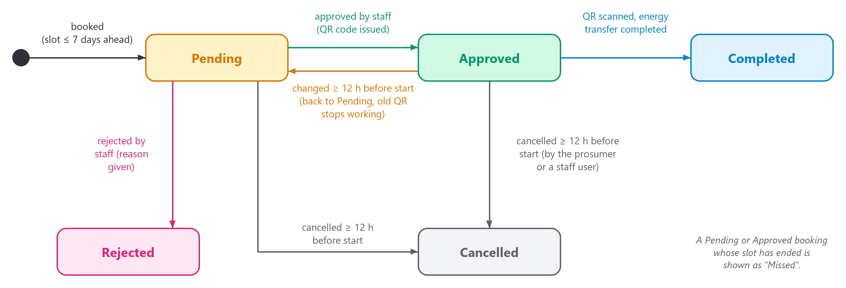
Figure 6: Status lifecycle of an energy reservation

Booking rules enforced by the API
Rule | Error
Slot starts in the future and at most 7 days ahead | 400
Changes and cancellations at least 12 hours before the start | 400
Slot open, station active, prosumer account active | 400
Energy > 0 and ≤ the station's bayCapacityKwh | 400
No two live bookings for the same prosumer at the same time | 409
A free bay in the slot (taken atomically, never overbooked) | 409
Someone else changed the booking at the same moment | 409

Check-in rules
Situation | Result
Text is not a SSG1.… code | 400 "This is not a Smart Solar booking QR code."
Signature does not match (edited or forged code) | 400 "This QR code is not genuine."
Booking was changed and approved again (older code) | 400 "This QR code is out of date…"
Booking is pending, cancelled, rejected or already completed | 200 with canComplete: false and the reason
Earlier than 2 hours before the start, or later than 1 hour after the end | 200 with canComplete: false and the opening time / "has passed"
Delivered energy ≤ 0 or above the station's bayCapacityKwh | 400
Code from a different booking than {reservationId} | 400

The QR code of an approved booking holds the text SSG1.<reservationId>.<nonce>.<signature>. The signature is an HMAC-SHA256 made with a key that only the API knows, so a code that was edited or made up is refused. Changing a booking gives it a new nonce, so older codes stop working.

3 Database design

3.1 Overview
Database: SolarGridDb on MongoDB Community Server 8.3. Only the Web API reads or writes this database; the web and Android apps go through the API. The Android app also keeps a small read-only copy on the phone in SQLite (section 3.6).
The four collections are named after the items in the marking scheme:
Marking scheme item | Collection | C# model
User's detail | UserDetails | Models/User.cs
SolarStationInfo | SolarStationInfo | Models/SolarStation.cs (+ OperatingHours.cs)
EnergyBookingSlots | EnergyBookingSlots | Models/EnergySlot.cs
Energy Reservation | EnergyReservations | Models/EnergyReservation.cs

Figure 7 shows the four collections and how they refer to each other. MongoDB has no foreign keys, so the references are ids that the API checks; names are also copied into each reservation so that booking lists load with one query.

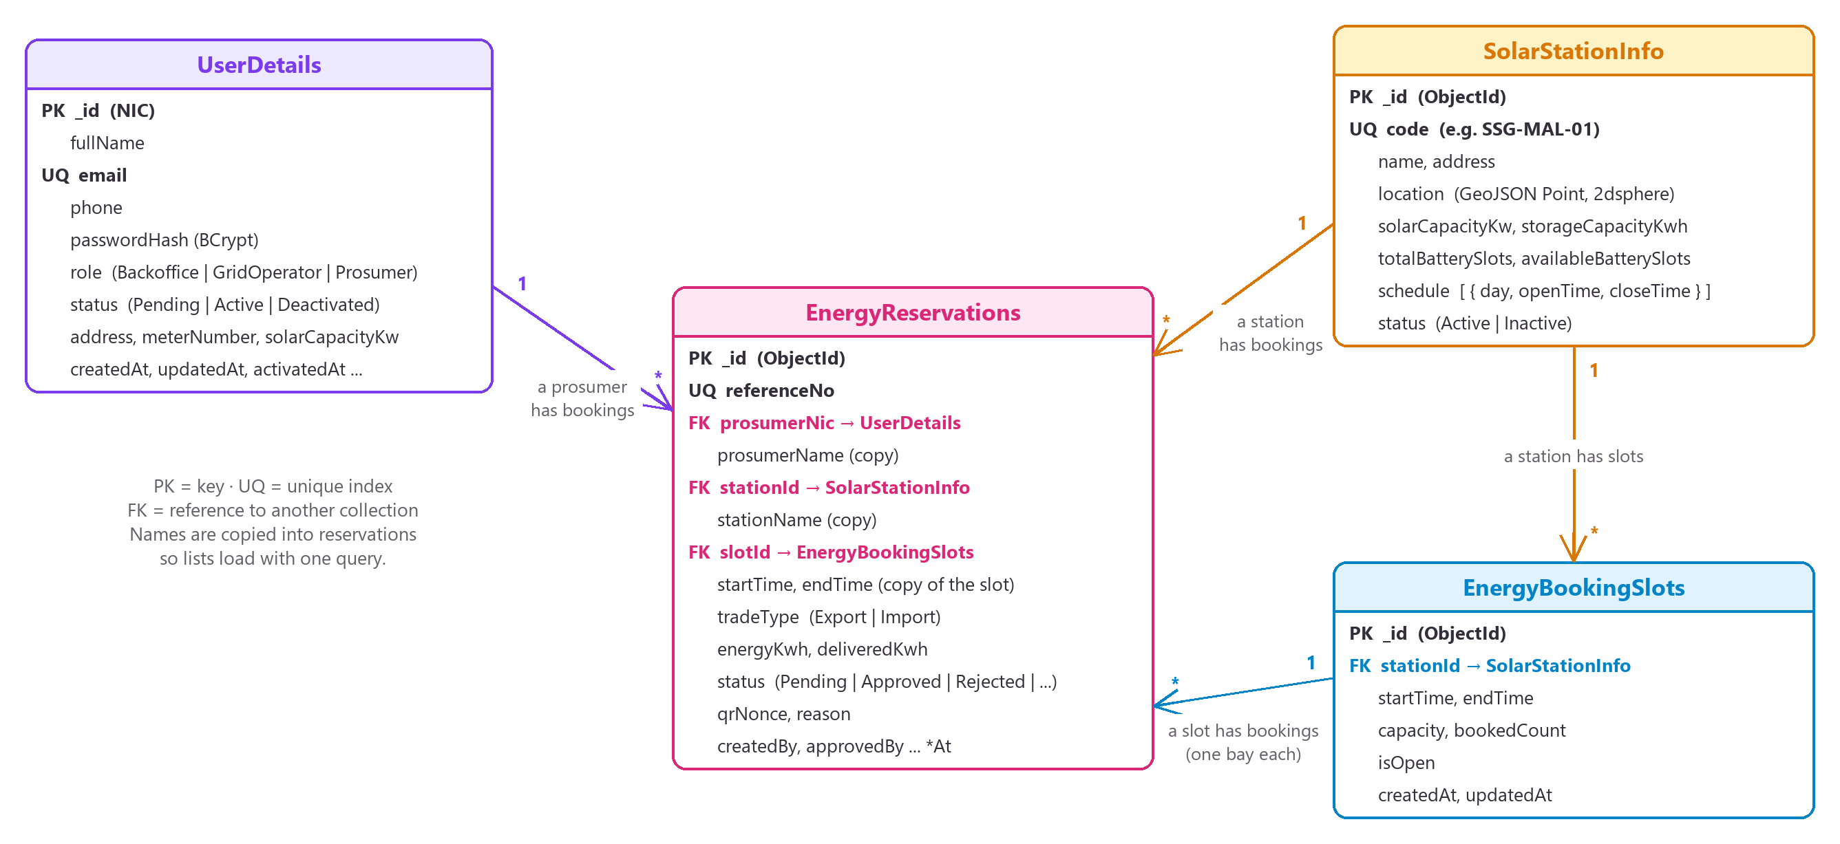
Figure 7: MongoDB collections and the references between them

3.2 Collections

3.2.1 UserDetails
One collection for all people in the system. role decides what each user may do.
Field | Type | Notes
_id | string | NIC — old format 853400937V or new format 198534000937, stored in upper case
fullName | string
email | string | lower case, unique
phone | string | 07XXXXXXXX or +947XXXXXXXX
passwordHash | string | BCrypt hash; the real password is never stored
role | string | Backoffice, GridOperator or Prosumer
status | string | Pending (mobile sign-up), Active, Deactivated
address, meterNumber, solarCapacityKw | string / double | prosumers only
createdAt, updatedAt | date | UTC
activatedBy, activatedAt, deactivatedAt, lastLoginAt | string / date | audit fields

Indexes: _id, ux_email (unique), ix_role_status.

3.2.2 SolarStationInfo
A microgrid node (solar hub with battery storage).
Field | Type | Notes
_id | ObjectId
code | string | e.g. SSG-MAL-01, unique
name, address | string
location | GeoJSON Point | { type: "Point", coordinates: [longitude, latitude] }
solarCapacityKw | double | generation capacity (kW)
storageCapacityKwh | double | total battery storage (kWh)
totalBatterySlots | int | physical battery bays
availableBatterySlots | int | bays currently usable (updated by Grid Operators)
schedule | array | one entry per weekday: { day, openTime, closeTime }, local time HH:mm, 24:00 = midnight
status | string | Active or Inactive
createdAt, updatedAt | date

Indexes: _id, ux_code (unique), ix_location_2dsphere (for "nearby stations"), ix_status.

3.2.3 EnergyBookingSlots
A bookable time window at a station.
Field | Type | Notes
_id | ObjectId
stationId | ObjectId | → SolarStationInfo._id
startTime, endTime | date | UTC
capacity | int | bays that can be booked in this window
bookedCount | int | bays held by Pending, Approved or Completed reservations
isOpen | bool | operators can close a slot
createdAt, updatedAt | date

Indexes: _id, ux_station_start (unique: one slot per station per start time).

3.2.4 EnergyReservations
A prosumer's booking of one bay in a slot.
Field | Type | Notes
_id | ObjectId
referenceNo | string | shown to users, unique
prosumerNic, prosumerName | string | → UserDetails._id (name copied for fast lists)
stationId, stationName | ObjectId / string | → SolarStationInfo._id (name copied)
slotId | ObjectId | → EnergyBookingSlots._id
startTime, endTime | date | copied from the slot so date filters need no join
tradeType | string | Export (send surplus solar into the battery) or Import (draw stored energy)
energyKwh | double | requested amount
deliveredKwh | double | recorded by the operator when completed
status | string | Pending, Approved, Rejected, Cancelled, Completed
qrNonce | string | random value inside the QR code; replaced when a booking changes
reason | string | why it was rejected or cancelled
createdBy, approvedBy, rejectedBy, cancelledBy, completedBy | string | NIC of the person who acted
createdAt, updatedAt, approvedAt, rejectedAt, cancelledAt, completedAt | date

Indexes: _id, ux_reference (unique), ix_prosumer_start, ix_station_status, ix_status_start, ix_slot.

3.3 Status lifecycles
A prosumer account starts as Pending when the prosumer signs up in the Android app, or as Active when a staff user creates it in the web portal (Figure 8). Only the Backoffice can activate a sign-up or reactivate a deactivated account. The lifecycle of a booking is shown in Figure 6 (section 2.4).
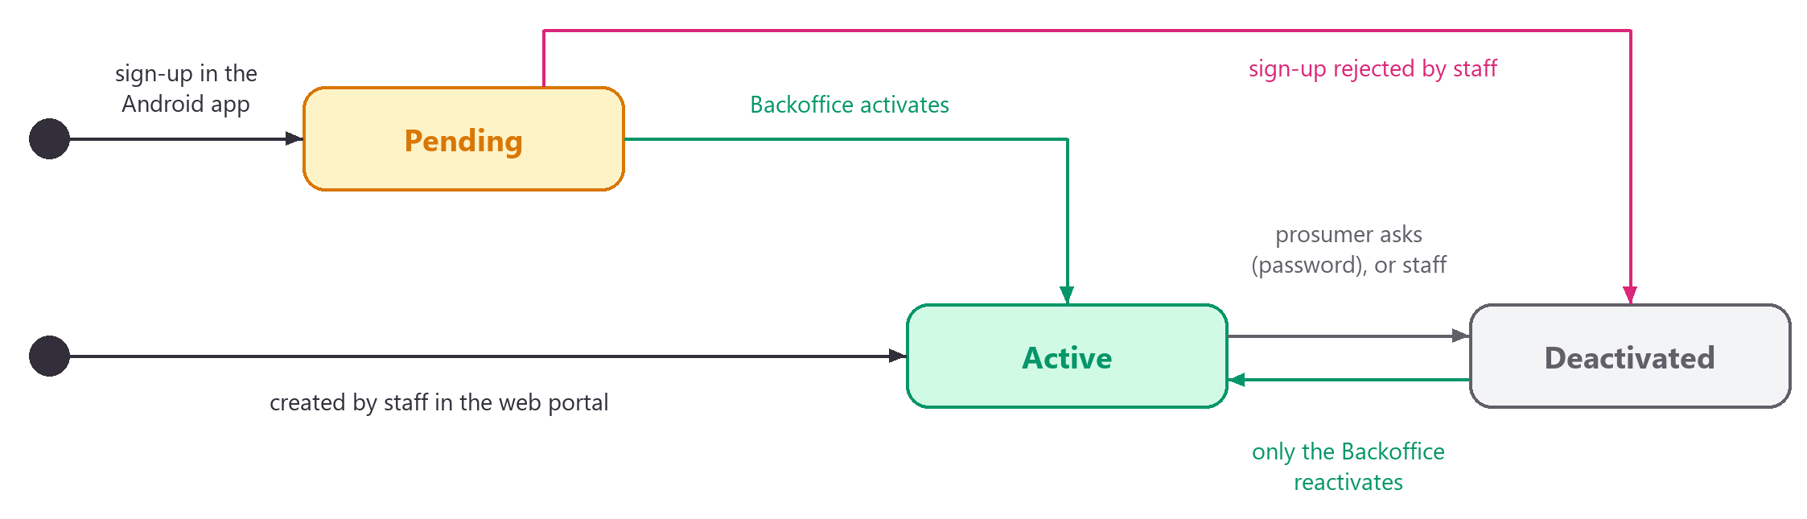
Figure 8: Status lifecycle of a prosumer account

3.4 Design decisions
1. NIC as the document id. The assignment makes NIC the primary key, so _id holds the NIC and MongoDB enforces uniqueness for free.
2. One user collection for all roles. Staff and prosumers share login, password and status logic; a role field separates them.
3. Copied names in reservations. Station and prosumer names are stored inside each reservation. Lists load with one query, which is a normal NoSQL trade-off. The ids are kept, so the full records are always reachable.
4. GeoJSON + 2dsphere index. Lets MongoDB answer "stations near me" and return the distance directly.
5. Booked-bay counter on each slot. bookedCount is changed with a single atomic update that checks capacity, so two people cannot take the last bay. The local MongoDB runs as a single server (no replica set), so multi-document transactions are not available; changes that touch two slots are undone step by step if the second step fails.
6. Times in UTC. All dates are stored in UTC. Rules such as "today" use Sri Lanka time (Asia/Colombo, UTC+05:30) through AppClock.
7. Readable documents. Field names are camelCase, enums are stored as words and empty fields are not written, so data is easy to inspect in MongoDB Compass.

3.5 Sample data
When App:SeedDemoData is true and the database has no stations, the API adds:
Collection | Sample data
UserDetails | 1 Backoffice admin, 1 Grid Operator, 4 prosumers (2 active, 1 pending, 1 deactivated)
SolarStationInfo | 5 stations: Malabe (24 h), Colombo Fort, Kandy, Galle Fort, Negombo (inactive)
EnergyBookingSlots | 2-hour slots from yesterday to 6 days ahead for the active stations
EnergyReservations | 6 bookings covering every status

The log-in details are listed in section 6.9.

3.6 Android SQLite
The Android app keeps a small copy of data on the phone in SQLite (solargrid.db, opened by android/app/src/main/java/lk/sliit/solargrid/data/local/SolarGridDbHelper.java). It is only a cache: the Web API and MongoDB stay the one source of truth, every change goes through the API first, and a copy on the phone never allows a change on its own. Each member added the table of their feature, which is why the database version counts up.
Table | Version | Key | Main columns | What it is for | Owner
session | 1 | id (always 1) | token, expires_at, nic, full_name, email, phone, role, status, saved_at | Login details, so the app signs the user in again until the token expires | Ravindu
profile | 2 | nic | full_name, email, phone, address, meter_number, solar_kw, status, updated_at | The prosumer's own profile when offline | Malith
stations | 3 | id | code, name, address, lat, lng, solar_kw, storage_kwh, total_bays, free_bays, bay_kwh, schedule_json, status, distance_km, cached_at | Reference data for the map, the station list and the station page | Nimthara
reservations | 4 | id | reference_no, prosumer_nic, prosumer_name, station_id, station_name, slot_id, start_utc, end_utc, trade_type, energy_kwh, delivered_kwh, status, reason, can_modify, modify_deadline, is_past, has_qr, created_by, created_at, approved_at, rejected_at, cancelled_by, cancelled_at, completed_at, cached_at | The last bookings seen, for the lists and the booking page when offline | Hamnad

- Logging out clears session, profile and reservations. stations stays, because it holds the same public data for every user.
- Times are stored as the UTC text the API sends and shown in Sri Lanka time.
- Offline rules: a saved booking is read with can_modify off, and its slot counts as past once its end time has gone by, even if it was saved earlier. Slots are never saved, because a booking needs the free bays of right now.

4 Web API design
The Web API is the only part of the system with business logic. Its endpoints are grouped by feature; the owner of each group is written after its name. Every endpoint is listed in the Swagger page at /swagger, where it can also be tried out.
Base URL: http://localhost:5080 when run from Visual Studio, http://localhost:8080 on IIS. Interactive documentation: /swagger.

4.1 Conventions
- Format: JSON with camelCase names. Enum values are words, e.g. "role": "GridOperator".
- Login: call POST /api/auth/login, then send Authorization: Bearer <token> on every other request. Tokens last 8 hours.
- Errors: always a ProblemDetails object. Apps should show detail to the user.
{ "title": "Request not allowed", "status": 400, "detail": "Password must be at least 8 characters ...", "instance": "/api/users" }

Status | Meaning
400 | Invalid input or a business rule was broken (errors lists field problems)
401 | Not logged in, wrong password, expired token, or the account was deactivated / changed role after login
403 | Logged in but not allowed (or account pending/deactivated at login)
404 | Record not found
409 | Duplicate value (NIC, email, code) or a clash with existing data
503 | MongoDB not reachable

- Lists: paged lists return { items, total, page, pageSize, totalPages } and accept page and pageSize (max 100).

4.2 Authentication — Ravindu
Method | Path | Who | Description
POST | /api/auth/login | anyone | Log in with NIC or email + password. Returns token, expiresAt and user.
GET | /api/auth/me | any signed-in user | Current user's details.
POST | /api/auth/change-password | any signed-in user | Body { currentPassword, newPassword }. Returns 204.

4.3 Staff users — Ravindu
All endpoints require the Backoffice role.
Method | Path | Description
GET | /api/users?role=&status=&search=&page=&pageSize= | List Backoffice and Grid Operator accounts.
GET | /api/users/{nic} | One staff account.
POST | /api/users | Create a staff account. Body { nic, fullName, email, phone, password, role }. Returns 201.
PUT | /api/users/{nic} | Update name, email, phone, role; optional newPassword resets the password.
PATCH | /api/users/{nic}/status | Body { isActive }. You cannot deactivate yourself or the last active Backoffice account.

4.4 Prosumers — Malith
Self-service (mobile app):
Method | Path | Who | Description
POST | /api/prosumers/register | anyone | Sign up with { nic, fullName, email, phone, password, address, meterNumber?, solarCapacityKw? }. Returns 201 with status Pending.
GET | /api/prosumers/me | Prosumer | Own profile.
PUT | /api/prosumers/me | Prosumer | Update { fullName, email, phone, address, meterNumber?, solarCapacityKw? }. The NIC cannot change.
POST | /api/prosumers/me/deactivate | Prosumer | Body { password }. Blocked while the prosumer has upcoming Pending/Approved bookings. Returns 204.

Management (web app):
Method | Path | Who | Description
GET | /api/prosumers?status=&search=&page=&pageSize= | Staff | List prosumers.
GET | /api/prosumers/pending-activations | Backoffice | New sign-ups waiting for activation, oldest first.
GET | /api/prosumers/{nic} | Staff | One prosumer.
POST | /api/prosumers | Staff | Create a prosumer (same body as register). The account is Active at once.
PUT | /api/prosumers/{nic} | Staff | Update a prosumer's details.
POST | /api/prosumers/{nic}/deactivate | Staff | Deactivate an account, or reject a pending sign-up.
POST | /api/prosumers/{nic}/activate | Backoffice only | Activate a sign-up or reactivate a deactivated account.

4.5 Dashboards — Malith
Method | Path | Who | Description
GET | /api/dashboard/summary | Staff | Pending reservations, approved future reservations, today's bookings, stations, pending activations, active prosumers and the next 5 bookings.
GET | /api/dashboard/my-summary | Prosumer | Own pending and approved-future counts, completed transfers, delivered kWh, next booking and the next 5 bookings.
GET | /api/dashboard/public | anyone | Active stations, active prosumers, completed transfers and total kWh traded (for the home page).

All numbers are calculated from the database on every call. "Today" means today in Sri Lanka time.

4.6 Stations — Nimthara
Method | Path | Who | Description
GET | /api/stations?status=&search= | any signed-in user | List stations. Prosumers always get active stations only.
GET | /api/stations/nearby?lat=&lng=&radiusKm= | any signed-in user | Active stations within radiusKm (default 10, max 500), nearest first, with distanceKm.
GET | /api/stations/{id} | any signed-in user | One station (inactive stations are hidden from prosumers).
POST | /api/stations | Backoffice | Create a station: { code, name, address, latitude, longitude, solarCapacityKw, storageCapacityKwh, totalBatterySlots, schedule? }. Without a schedule the station opens 06:00–18:00 every day.
PUT | /api/stations/{id} | Backoffice | Update details and GPS location (schedule is changed separately).
PUT | /api/stations/{id}/schedule | Backoffice | Replace the weekly hours: { schedule: [ { day, openTime, closeTime } ] }. Times are local HH:mm; 24:00 means midnight; missing days are closed.
PATCH | /api/stations/{id}/battery-slots | Staff | { availableBatterySlots } — how many bays can be used now (0 to total).
POST | /api/stations/{id}/deactivate | Backoffice | Blocked while the station has pending or approved reservations that have not ended.
POST | /api/stations/{id}/activate | Backoffice | Bring a station back into service.
DELETE | /api/stations/{id} | Backoffice | Delete a station that was never booked, together with its empty slots. Stations with booking history return 400 and can only be deactivated. Returns 204.

Each station response includes bayCapacityKwh (storage ÷ battery slots), the most energy one booking can use.

4.7 Energy slots — Nimthara
Method | Path | Who | Description
GET | /api/stations/{id}/slots?from=&to=&onlyAvailable= | any signed-in user | Slots between two local dates (default: today + 6 days, max 31 days). Prosumers only see open, future slots with free bays.
POST | /api/stations/{id}/slots | Staff | One slot: { date: "2026-09-21", startTime: "08:00", endTime: "10:00", capacity? }. Must be in the future, within 30 days, inside opening hours, 30 min–12 h long and not overlapping another slot.
POST | /api/stations/{id}/slots/generate | Staff | { fromDate?, days (1–7), slotMinutes (30–480), capacity? } — fills the opening hours; times already taken are skipped.
GET | /api/slots/{id} | any signed-in user | One slot.
PUT | /api/slots/{id} | Staff | { capacity, isOpen } — capacity cannot go below booked bays or above the station's total; booked slots cannot be closed.
DELETE | /api/slots/{id} | Staff | Only slots without bookings. Returns 204.

Slot responses contain UTC startTime/endTime, capacity, bookedCount, availableBays and isOpen.

4.8 Reservations — Hamnad
Method | Path | Who | Description
GET | /api/reservations?scope=&status=&stationId=&nic=&from=&to=&search=&page=&pageSize= | any signed-in user | Paged booking list. Prosumers only get their own. scope: current (approved, not finished), pending (waiting for approval), history (completed, cancelled, rejected or ended). from/to are local dates. search matches reference, station, prosumer name or NIC.
GET | /api/reservations/{id} | owner or staff | One booking.
POST | /api/reservations | Prosumer or staff | Book: { slotId, energyKwh, tradeType: "Export"|"Import", prosumerNic? }. Staff must give prosumerNic. Returns 201 with status Pending.
PUT | /api/reservations/{id} | owner or staff | Change { slotId, energyKwh, tradeType }. Needs ≥ 12 h notice; an approved booking goes back to Pending and its QR code stops working.
POST | /api/reservations/{id}/cancel | owner or staff | Optional body { reason }. Needs ≥ 12 h notice. Frees the bay.
POST | /api/reservations/{id}/approve | Staff | Pending → Approved; issues a new QR code.
POST | /api/reservations/{id}/reject | Staff | Body { reason } (required). Pending → Rejected; frees the bay.
GET | /api/reservations/{id}/qr | owner or staff | { payload, referenceNo, stationName, startTime, endTime } for an approved booking. Draw payload as a QR image.

Booking rules enforced by the API:
Rule | Error
Slot starts in the future and at most 7 days ahead | 400
Changes and cancellations at least 12 hours before the start | 400
Slot open, station active, prosumer account active | 400
Energy > 0 and ≤ the station's bayCapacityKwh | 400
No two live bookings for the same prosumer at the same time | 409
A free bay in the slot (taken atomically, never overbooked) | 409
Someone else changed the booking at the same moment | 409

Each response includes canModify (the 12-hour rule), modifyDeadline, hasQrCode and isPast (the booking's time has ended — a pending or approved booking with isPast was missed), so the apps can show or hide buttons and label bookings without re-implementing the rules.
QR payload format: SSG1.<reservationId>.<nonce>.<HMAC-SHA256 signature>.

4.9 Operator check-in — Ravindu
Both endpoints require a Backoffice or Grid Operator token.
Method | Path | Description
POST | /api/checkin/verify | Body { payload } — the text read from the prosumer's QR code. Returns { canComplete, message, prosumerPhone, checkInOpensAt, checkInClosesAt, reservation }.
POST | /api/checkin/{reservationId}/complete | Body { payload, deliveredKwh }. The code is checked again; the booking becomes Completed and the code can no longer be used.

Check-in rules:
Situation | Result
Text is not a SSG1.… code | 400 "This is not a Smart Solar booking QR code."
Signature does not match (edited or forged code) | 400 "This QR code is not genuine."
Booking was changed and approved again (older code) | 400 "This QR code is out of date…"
Booking is pending, cancelled, rejected or already completed | 200 with canComplete: false and the reason
Earlier than 2 hours before the start, or later than 1 hour after the end | 200 with canComplete: false and the opening time / "has passed"
Delivered energy ≤ 0 or above the station's bayCapacityKwh | 400
Code from a different booking than {reservationId} | 400

4.10 Health — Ravindu
Method | Path | Who | Description
GET | /api/health | anyone | 200 with { status: "Healthy", database: "Connected" }, or 503 if MongoDB is down.

5 User interfaces
Both client applications use the same “clay” design: a soft lilac background, rounded cards with soft shadows, violet gradient buttons, the Nunito font for headings and DM Sans for text. The pictures in this chapter were taken automatically by the test suites (Playwright for the web portal, Espresso for the Android app) against demo data, so each screen appears once.

5.1 Web portal pages
The web portal (web/) is the staff user interface. Only Backoffice and Grid Operator accounts can sign in; prosumer accounts are refused with a message to use the mobile app. The portal is a user interface only: every rule is checked by the Web API, and the portal shows the API's answers and messages. Addresses use a # (for example http://localhost:8081/#/stations), so IIS always serves the same page.
Address | Page | Who can open it | What it does | Owner
/ | Home | Everyone | Introduces the system, shows live public numbers (stations, prosumers, energy traded), how trading works and what each user type can do | Malith
/login | Log in | Everyone | Login with NIC or email. Backoffice users land on the dashboard, Grid Operators on the operations page; prosumers are refused | Ravindu
/dashboard | Backoffice dashboard | Backoffice | Live numbers (pending and approved upcoming bookings, today's bookings, sign-ups waiting, stations and prosumers in service), next bookings, quick actions; refreshes every 30 s while visible | Malith
/operations | Operations | Grid Operator | Live numbers, today's bookings in time order with a check-in shortcut, next bookings, and one-click battery bay changes per station | Malith, Nimthara (bays card)
/reservations | Reservations | Backoffice, Grid Operator | Tabs (pending approval, current, history, all), filters (station, status, prosumer NIC, dates), search and paging; approve or reject pending bookings from the list; ended bookings that never happened show as "Missed" | Hamnad
/reservations/new | New booking | Backoffice, Grid Operator | Wizard: active prosumer → station in service → one of the next 7 days → free slot → energy (up to one battery bay) and Export/Import | Hamnad
/reservations/:id | Booking | Backoffice, Grid Operator | Details, timeline, 12-hour change deadline, approve / reject (with reason) / change / cancel (optional reason) depending on status and time, QR code with print and copy once approved | Hamnad
/reservations/:id/edit | Change booking | Backoffice, Grid Operator | The wizard for an existing booking (same prosumer; its own slot is always offered). Closed in the last 12 hours before the start | Hamnad
/check-in | QR check-in | Backoffice, Grid Operator | Read the booking QR code (camera, USB scanner or pasted text), check it, enter the delivered kWh and complete the transfer | Ravindu
/stations | Stations | Backoffice, Grid Operator | List or map of all stations with search and status tabs; clicking a pin shows the station | Nimthara
/stations/new | New station | Backoffice | Details, capacity, GPS position (map click, drag or type) and weekly opening hours | Nimthara
/stations/:id | Station | Backoffice, Grid Operator | Overview with map, battery bays, weekly hours, slots for the next 7 days (one day at a time) | Nimthara
/stations/:id/edit | Edit station | Backoffice | Change the details and GPS position | Nimthara
/prosumers | Prosumers | Backoffice, Grid Operator | Search, status tabs and paging; create (NIC is the key), edit, deactivate; Backoffice also activates and reactivates | Malith
/prosumers/:nic | Prosumer | Backoffice, Grid Operator | Profile, account history and the prosumer's bookings | Malith
/activations | Pending activations | Backoffice | Sign-ups from the mobile app, oldest first, with Activate and Reject; the menu shows how many are waiting | Malith
/users | Staff users | Backoffice | Search and filters; create Backoffice and Grid Operator accounts, edit (with password reset), activate and deactivate (never your own account) | Ravindu
/account | My account | Backoffice, Grid Operator | Own details and password change | Ravindu
any other | Not found / not allowed | — | "Page not found", or "This page is for … staff" when the role may not open it | Ravindu

Every signed-in page also calls GET /api/health for the status dot in the top bar. For Backoffice users the menu calls GET /api/dashboard/summary for the "pending activations" badge. An expired or rejected session returns the user to the login page with a message.

What each role can do in the web portal
The API enforces every permission; the portal hides what a role cannot use.
Task | Backoffice | Grid Operator
See the dashboard with live numbers | ✔ (/dashboard) | ✔ (/operations)
Create, edit, activate and deactivate staff users | ✔ | —
Create, edit and deactivate prosumer accounts | ✔ | ✔
Activate a mobile sign-up or reactivate a prosumer | ✔ | —
Reject a mobile sign-up | ✔ (also on /activations) | ✔ (from the prosumer list)
View stations, the station map and station details | ✔ | ✔
Create, edit, deactivate, activate and delete stations | ✔ | —
Change a station's opening hours | ✔ | —
Change a station's available battery bays | ✔ | ✔
Add, generate, change and delete slots | ✔ | ✔
View and search all bookings | ✔ | ✔
Book a slot for a prosumer, change or cancel a booking (12-hour rule) | ✔ | ✔
Approve or reject pending bookings | ✔ | ✔
Show and print a booking's QR code | ✔ | ✔
QR check-in and completing an energy transfer | ✔ | ✔
Change own password | ✔ | ✔

Rules shown in the portal (and enforced by the API): bookings up to 7 days ahead; changes and cancellations at least 12 hours before the start; one battery bay per booking; stations with active bookings cannot be deactivated; stations with booking history cannot be deleted; only Backoffice reactivates prosumer accounts.

5.2 Web portal screenshots (desktop)
Each page at a desktop size of 1440 pixels wide. Long pages are shown in full.
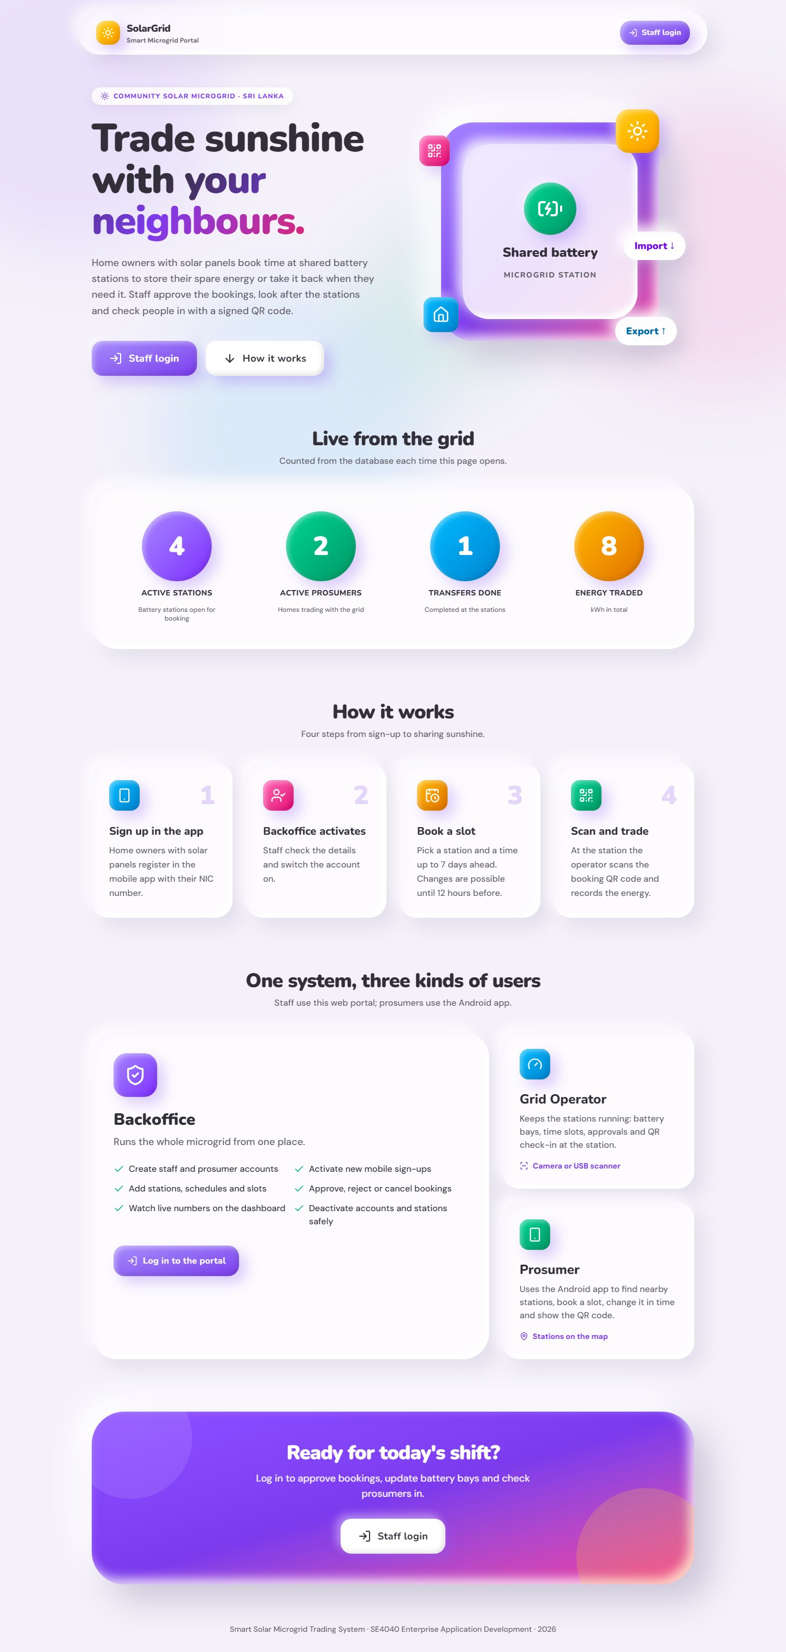
Figure 9: Web portal – Home page (public, with live numbers)
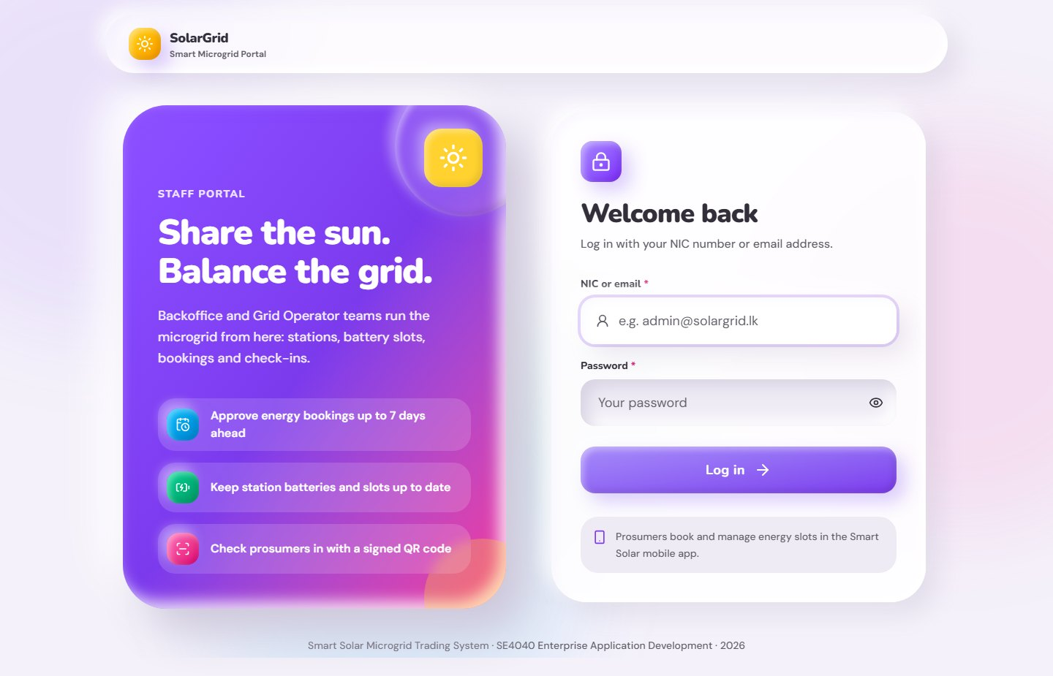
Figure 10: Web portal – Log in
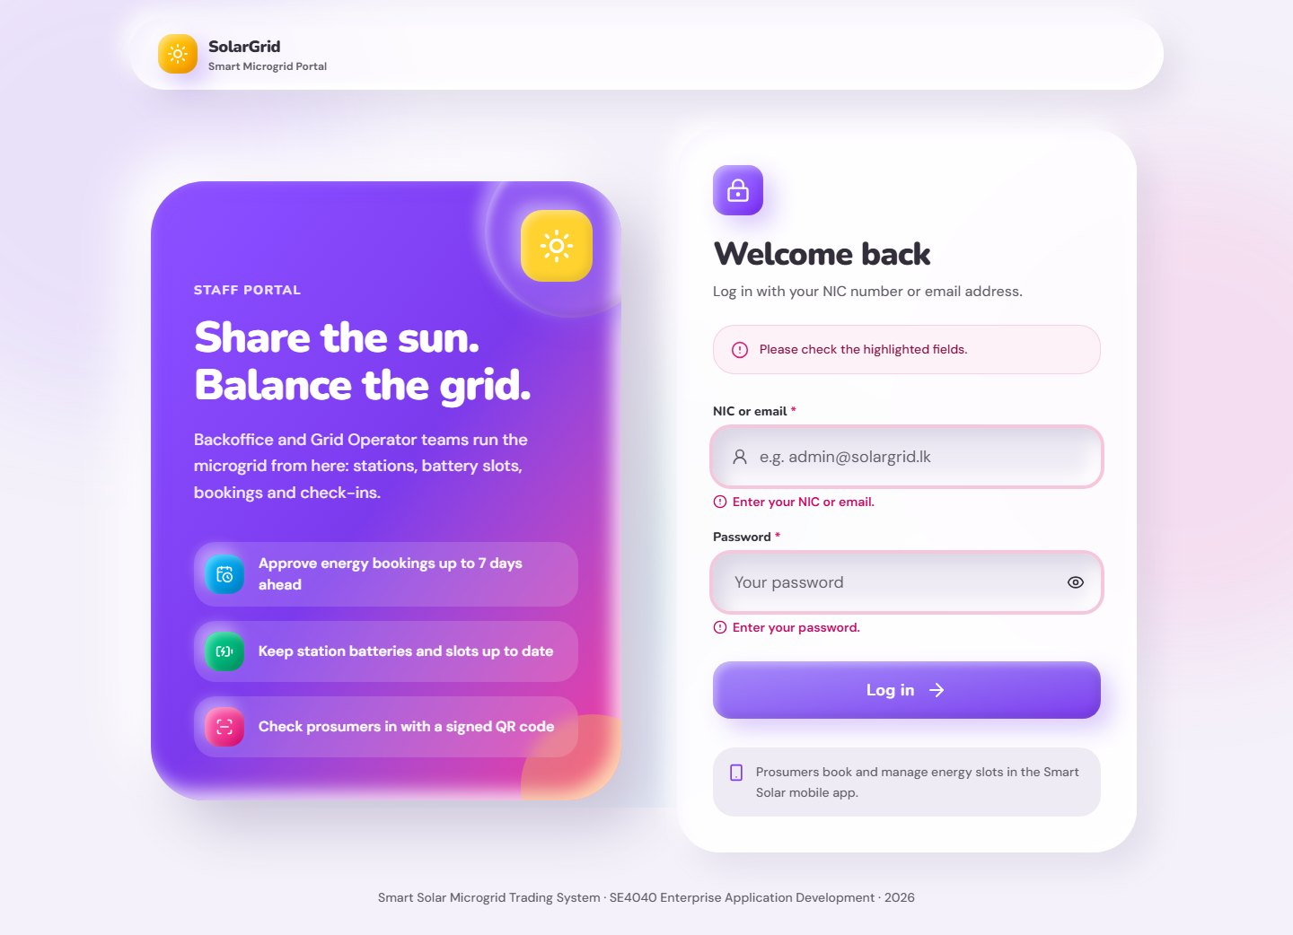
Figure 11: Web portal – Log in with the checks shown under the fields
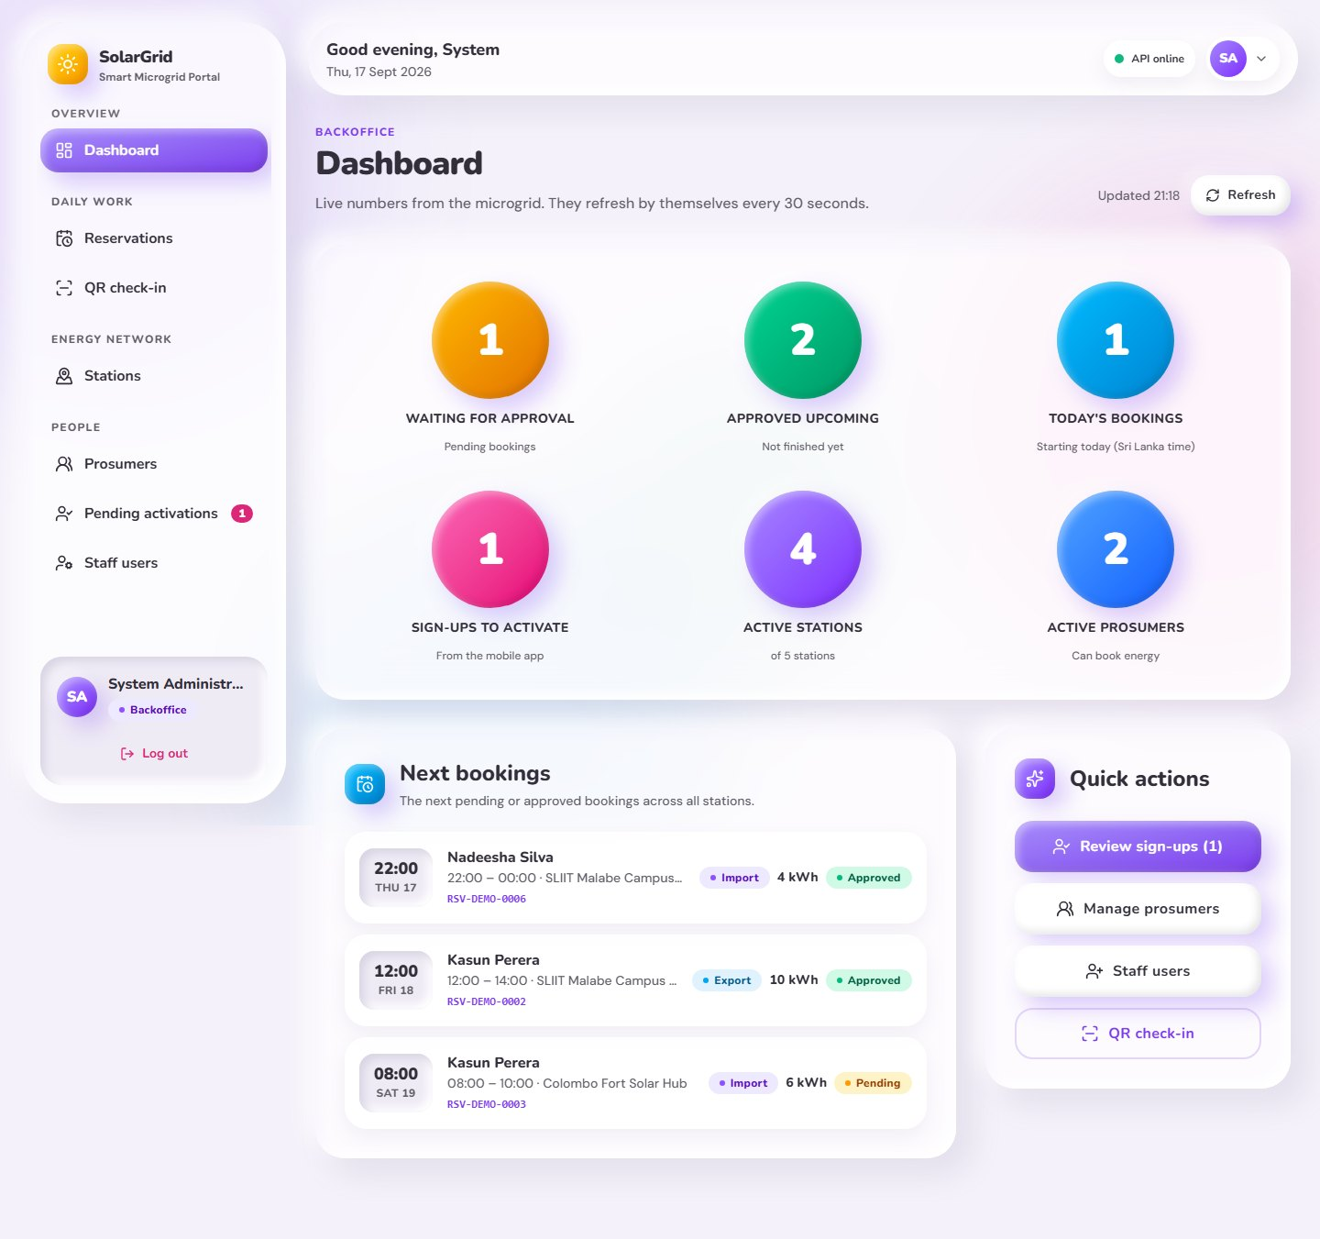
Figure 12: Web portal – Backoffice dashboard
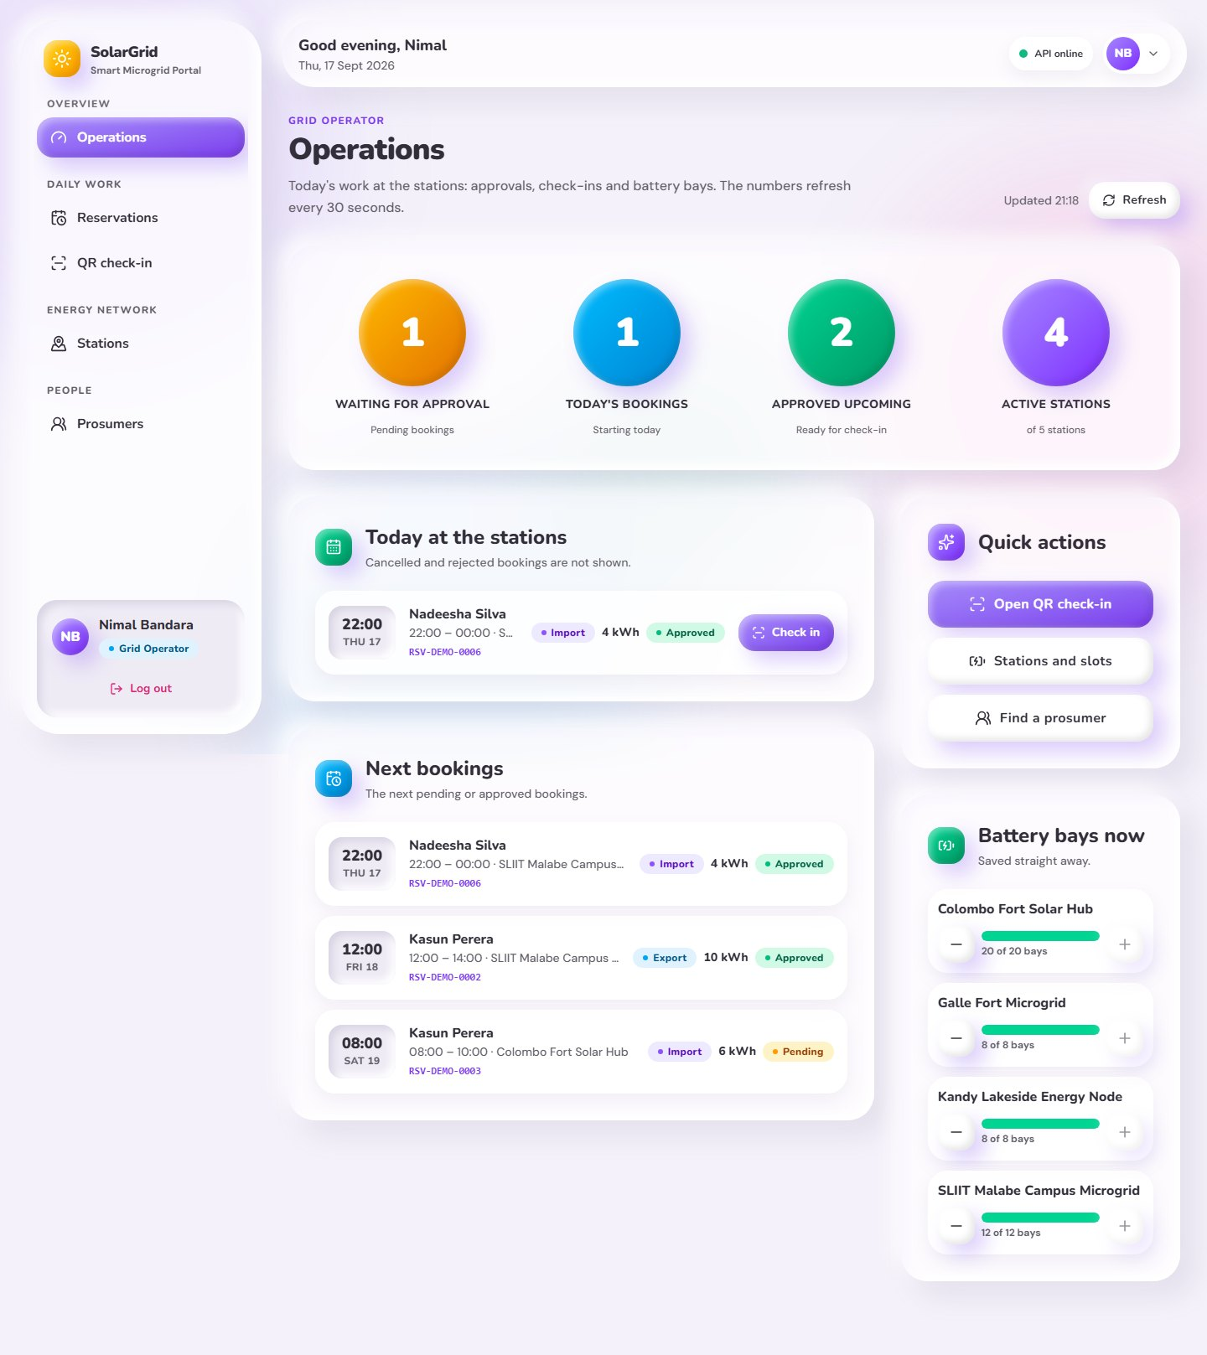
Figure 13: Web portal – Operations page for Grid Operators
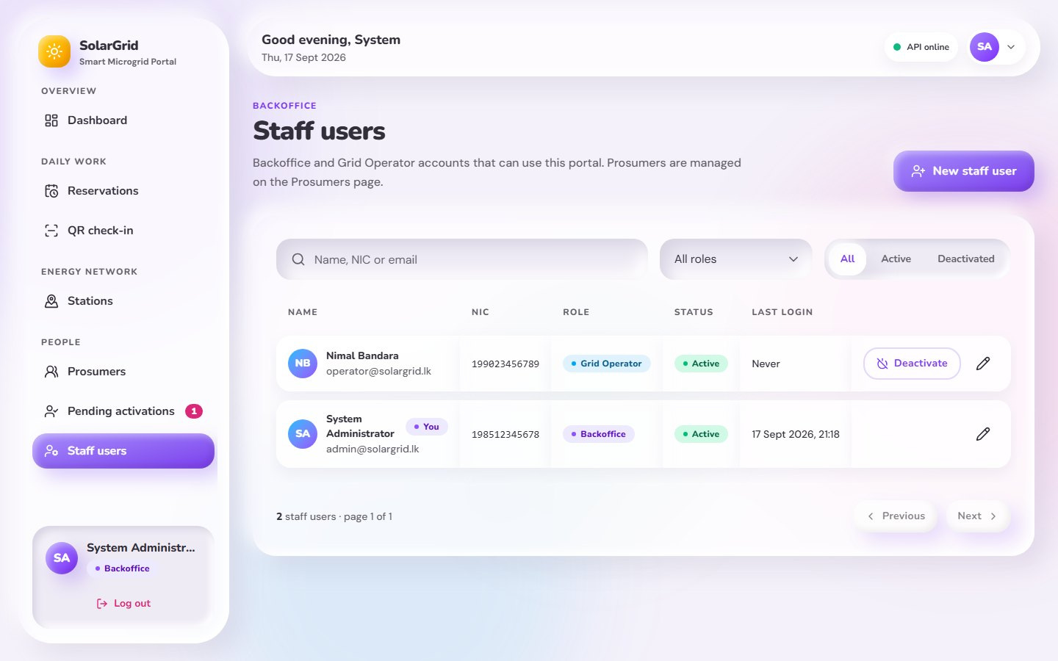
Figure 14: Web portal – Staff users (Backoffice)
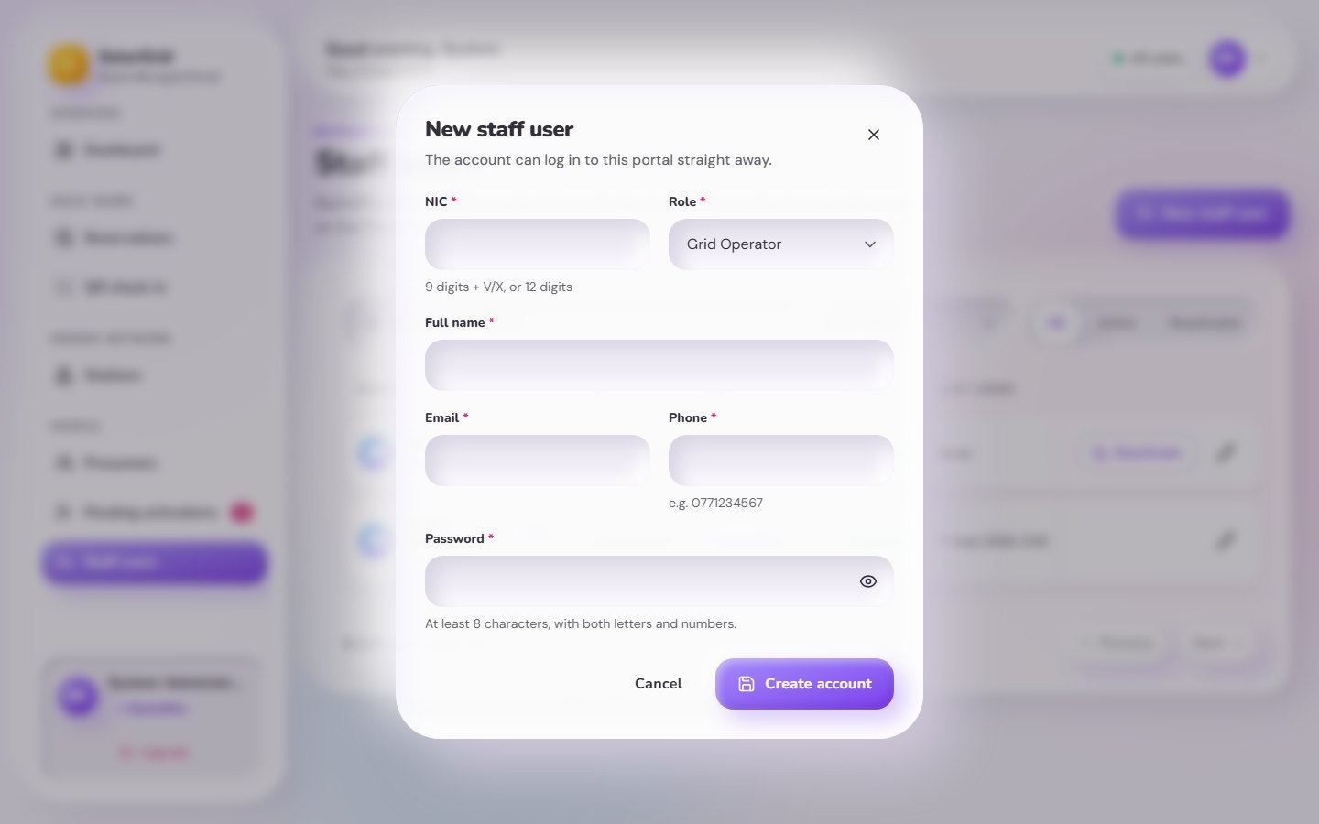
Figure 15: Web portal – New staff user
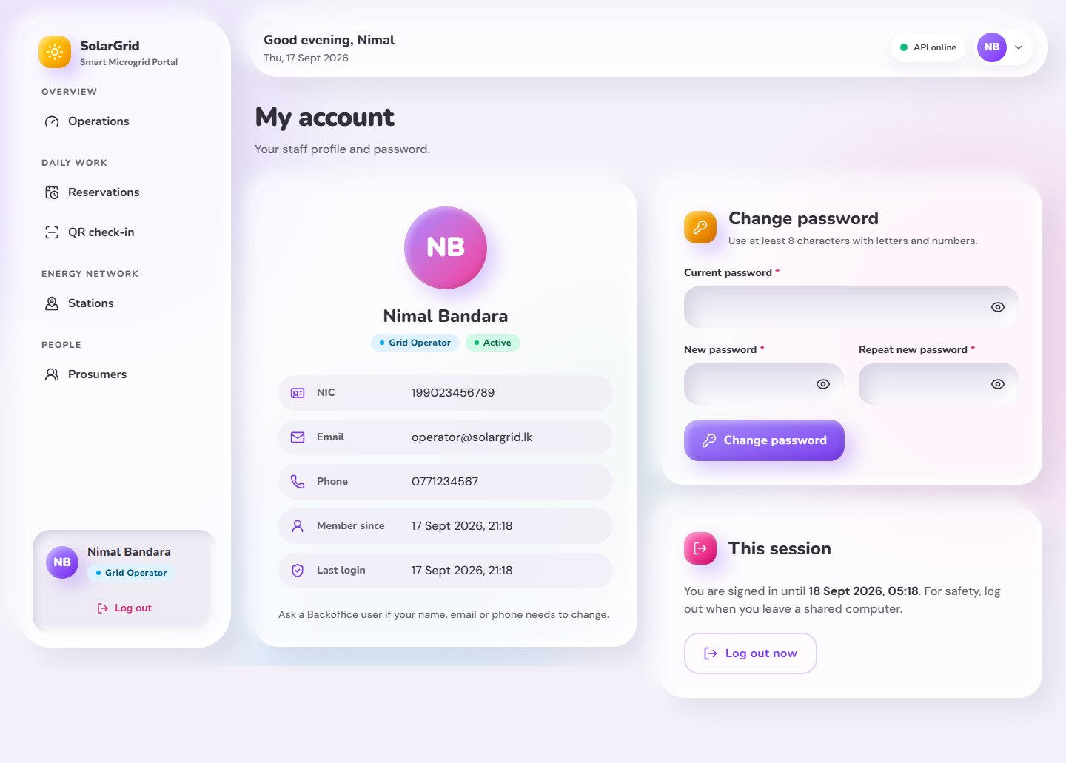
Figure 16: Web portal – My account and password change
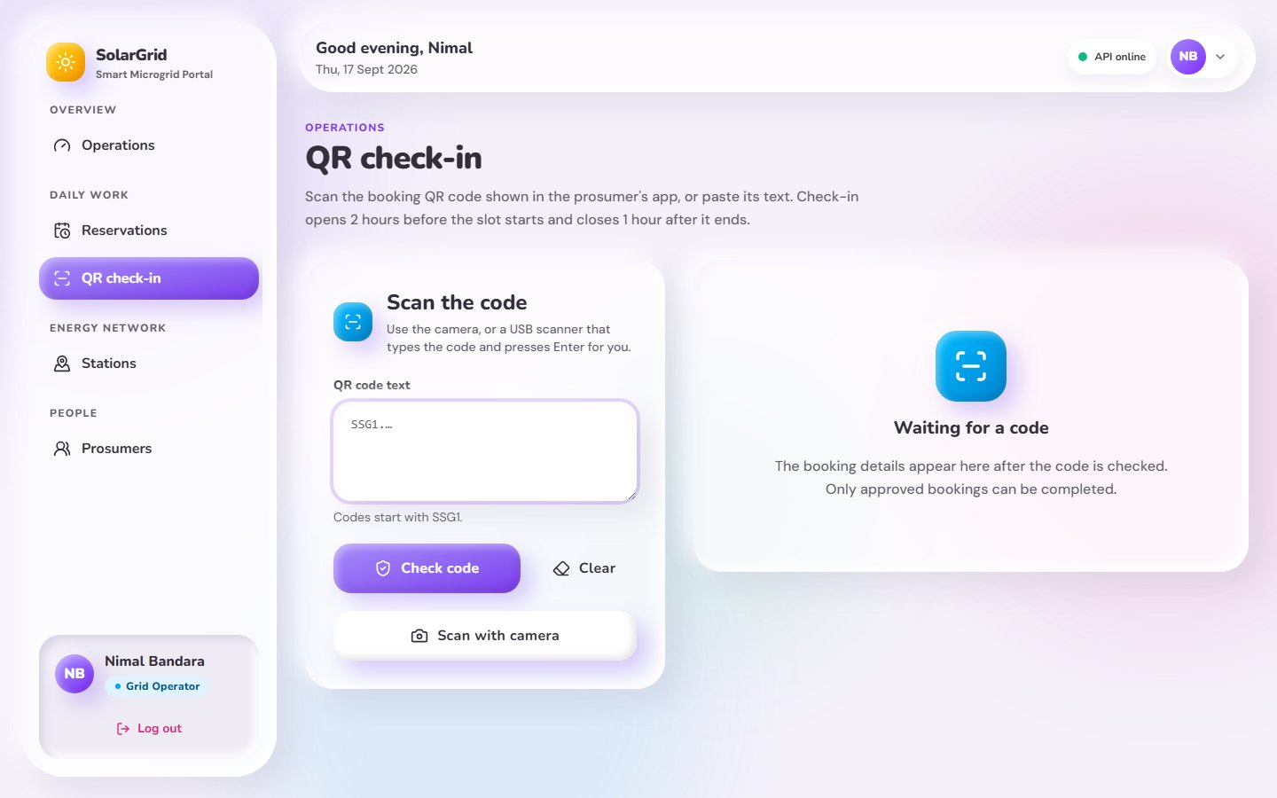
Figure 17: Web portal – QR check-in waiting for a code
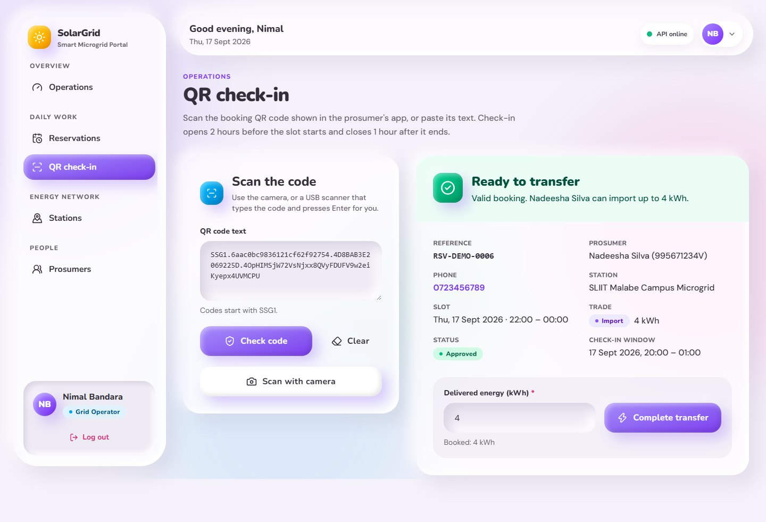
Figure 18: Web portal – QR check-in: booking ready to complete
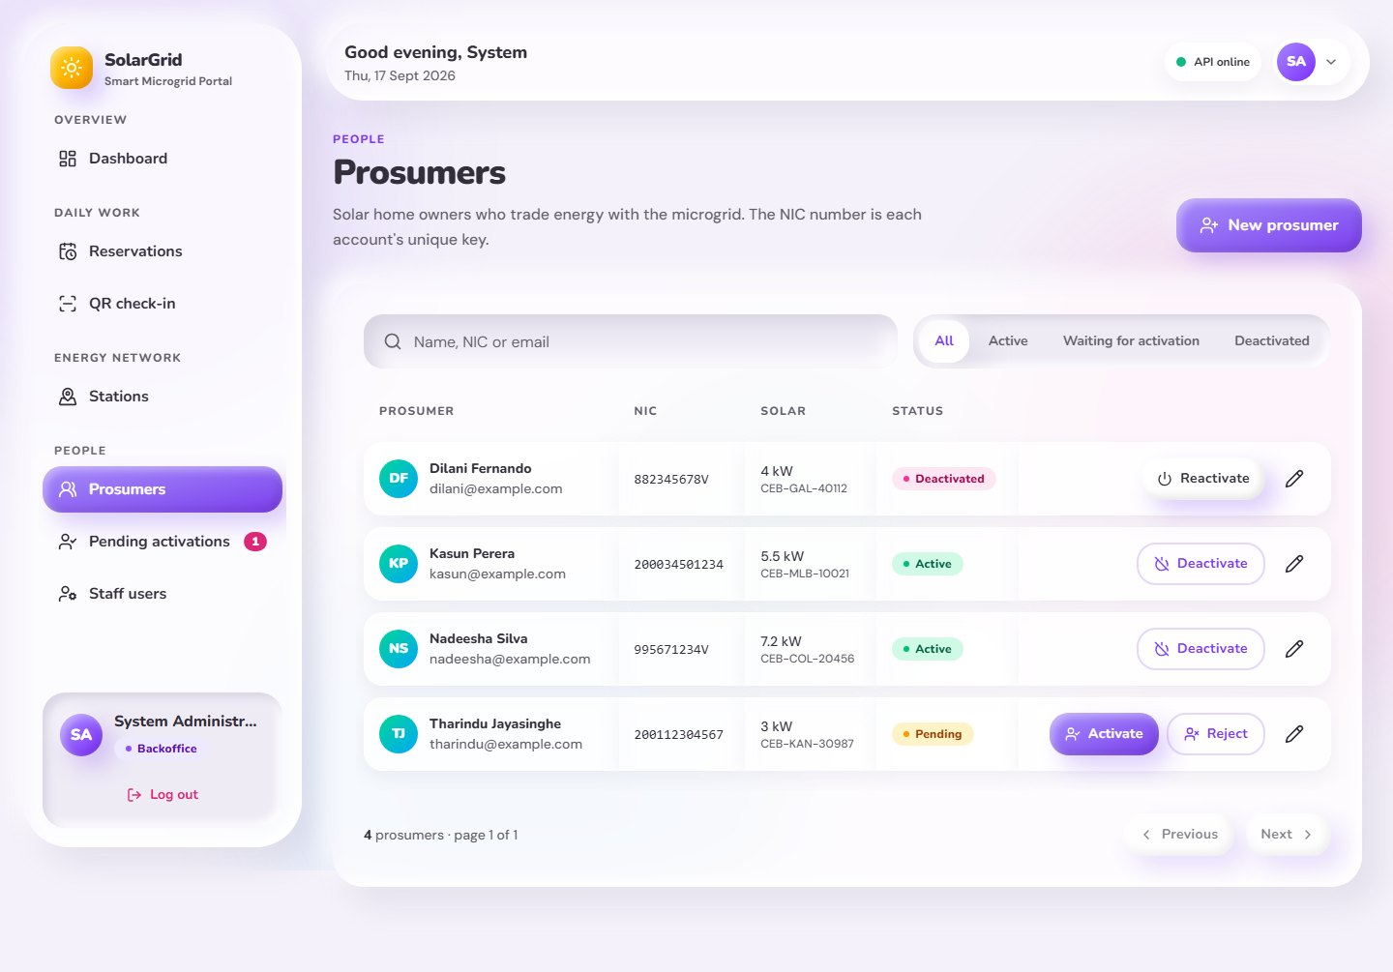
Figure 19: Web portal – Prosumers
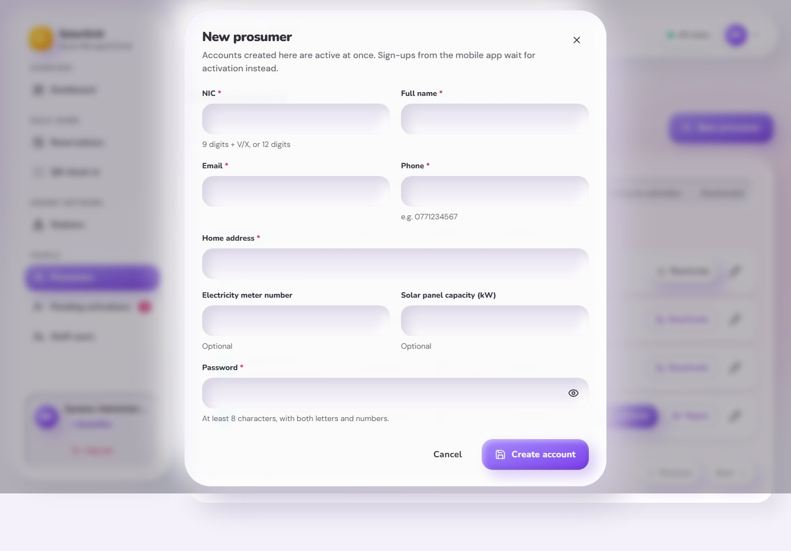
Figure 20: Web portal – New prosumer (NIC is the key)
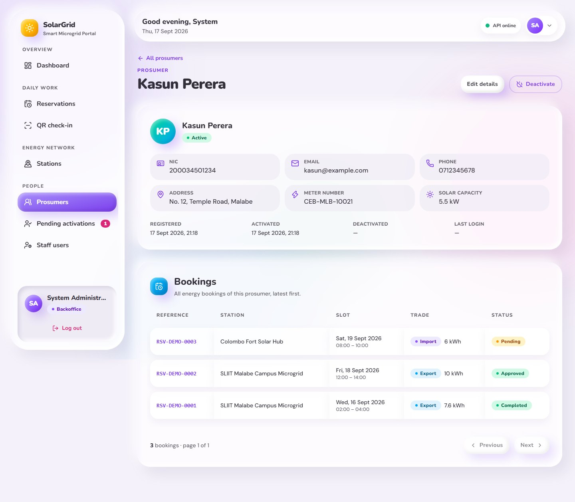
Figure 21: Web portal – Prosumer details and bookings
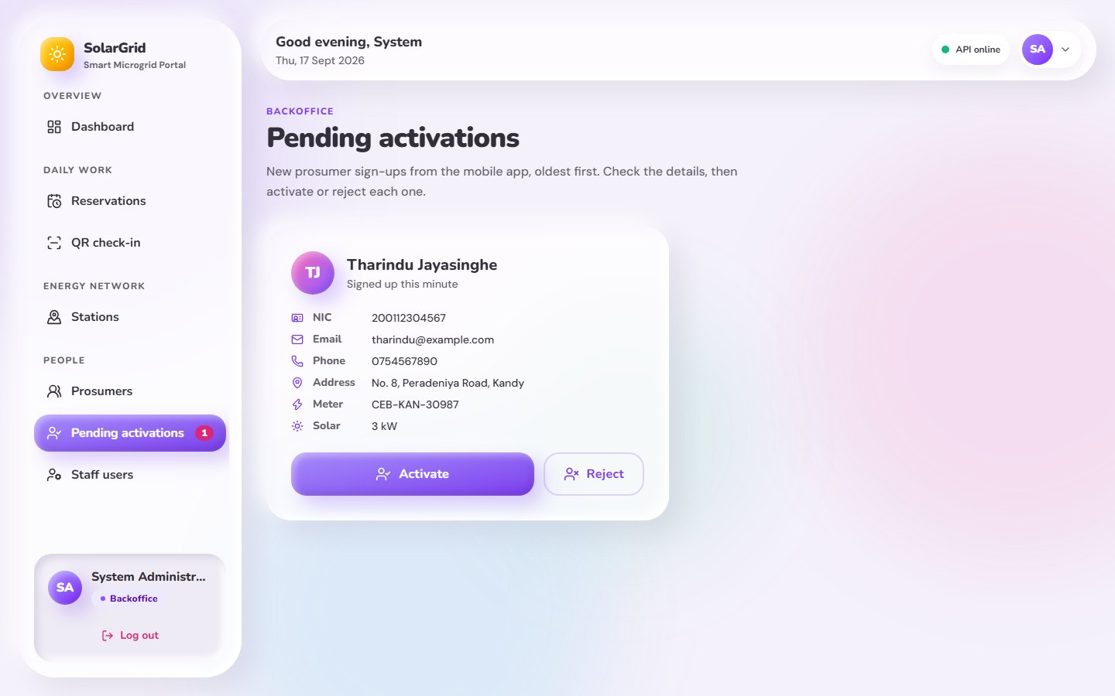
Figure 22: Web portal – Pending activations (Backoffice)
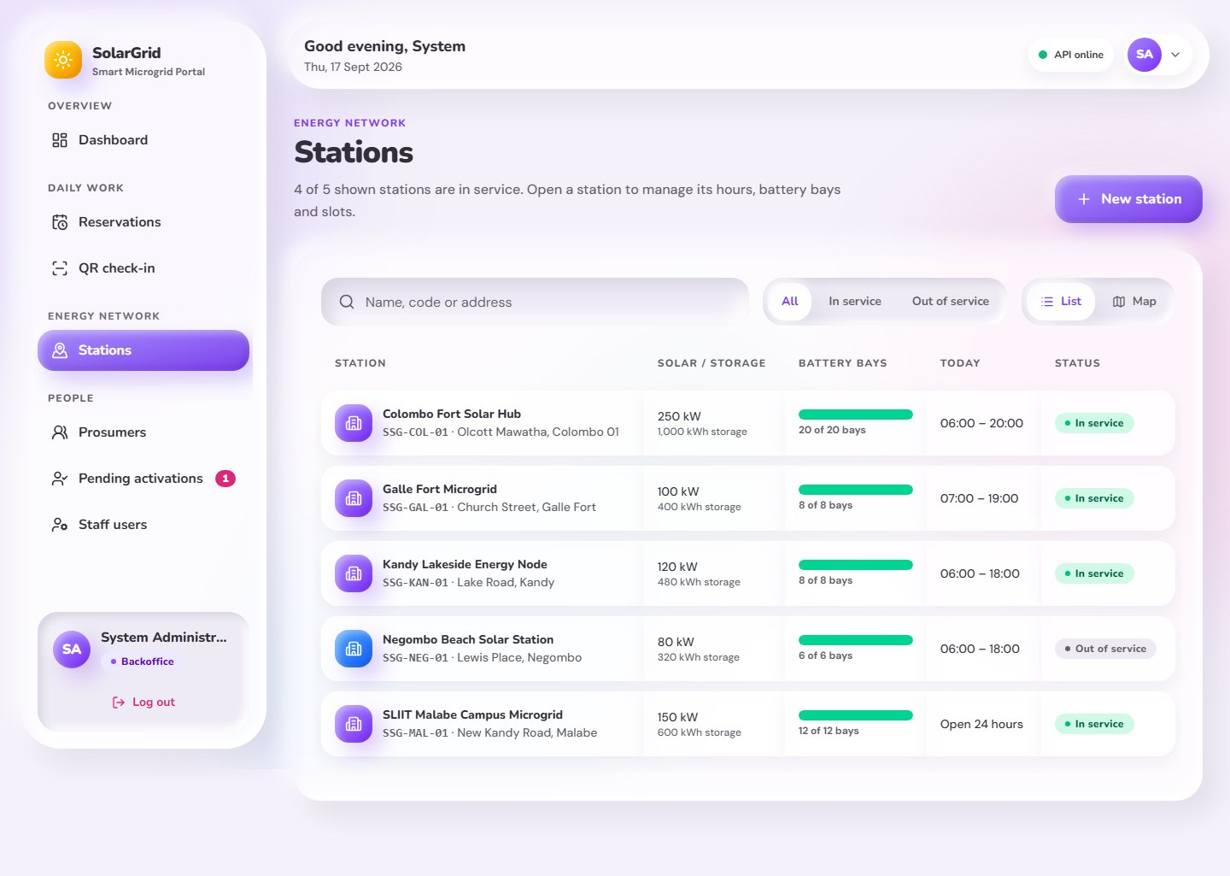
Figure 23: Web portal – Stations list
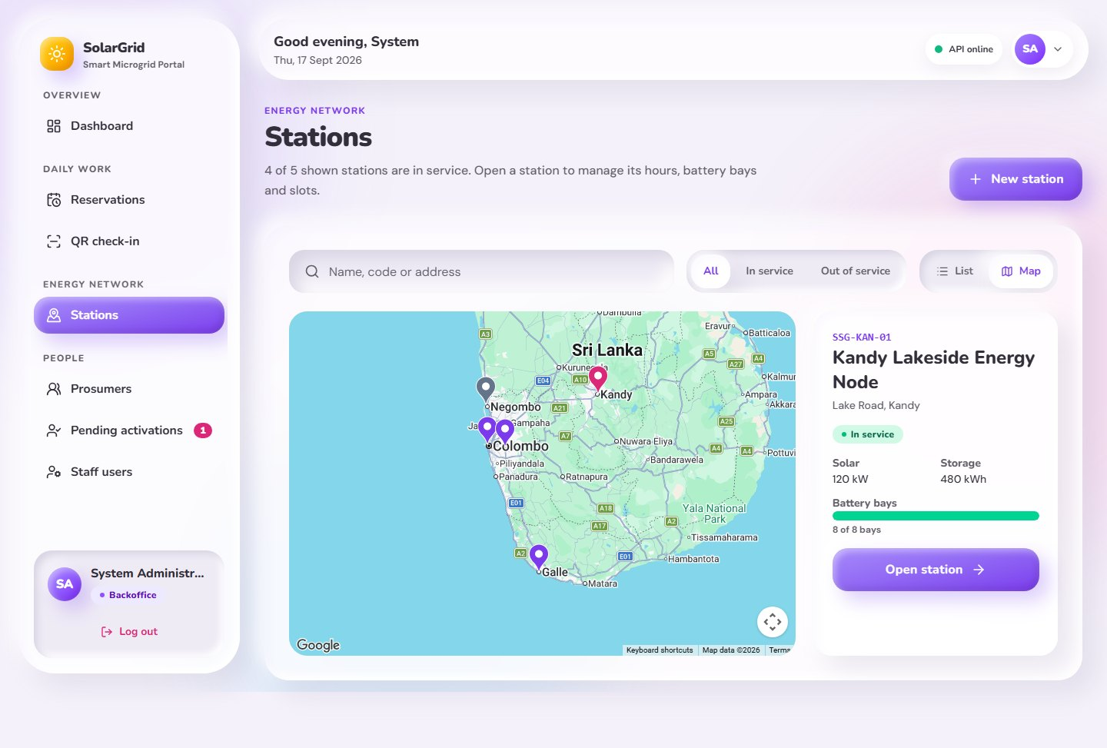
Figure 24: Web portal – Stations on the map
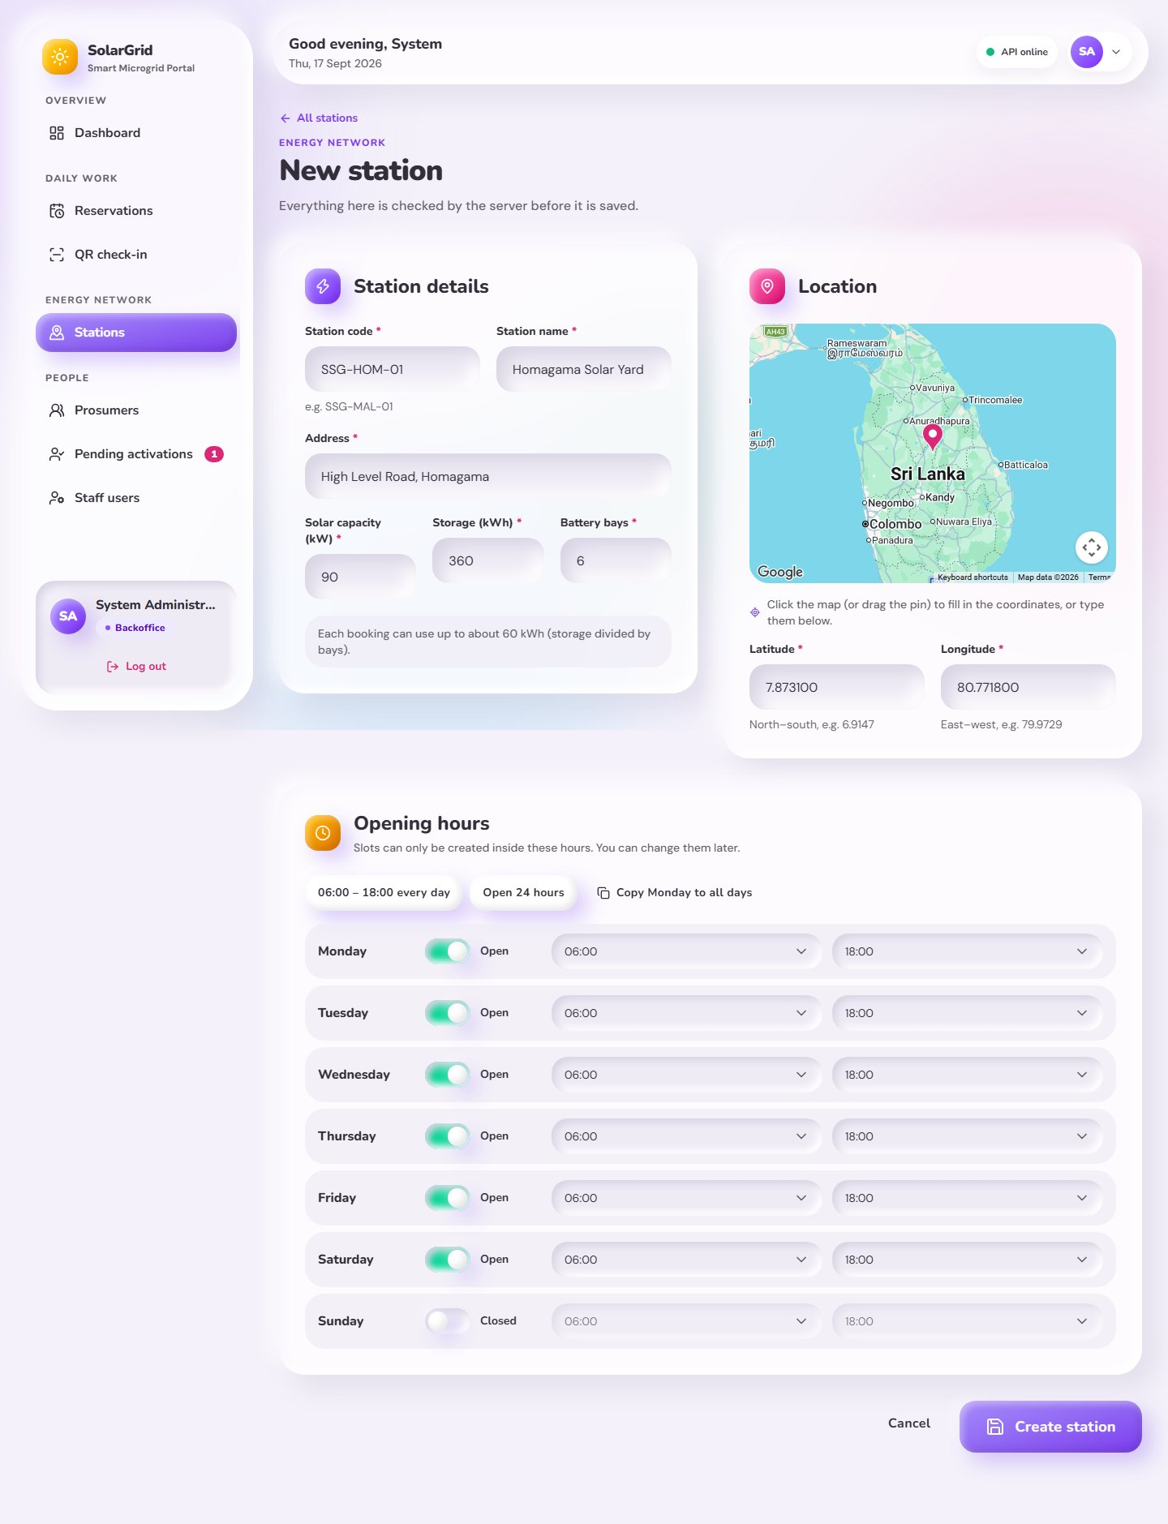
Figure 25: Web portal – New station with its GPS position
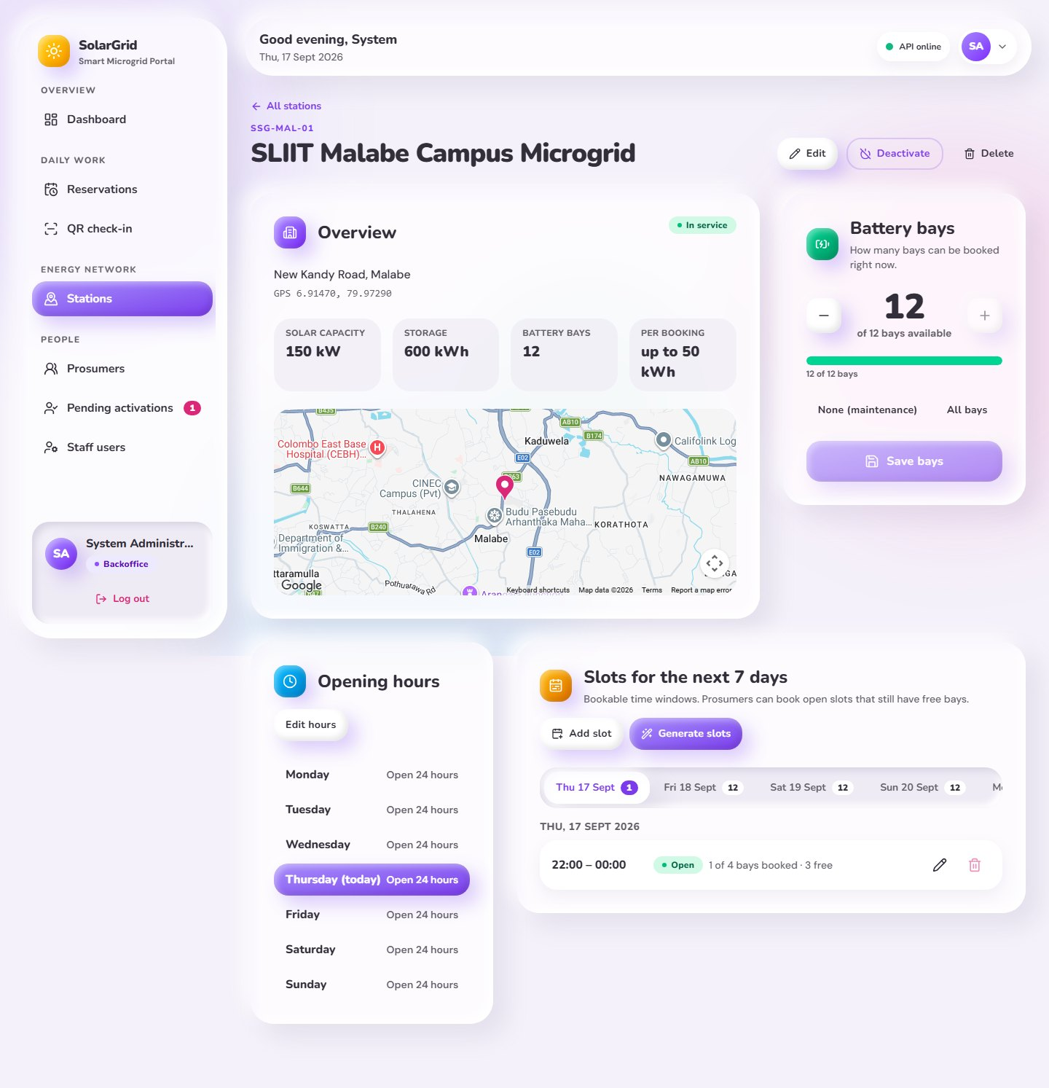
Figure 26: Web portal – Station details: bays, hours and slots
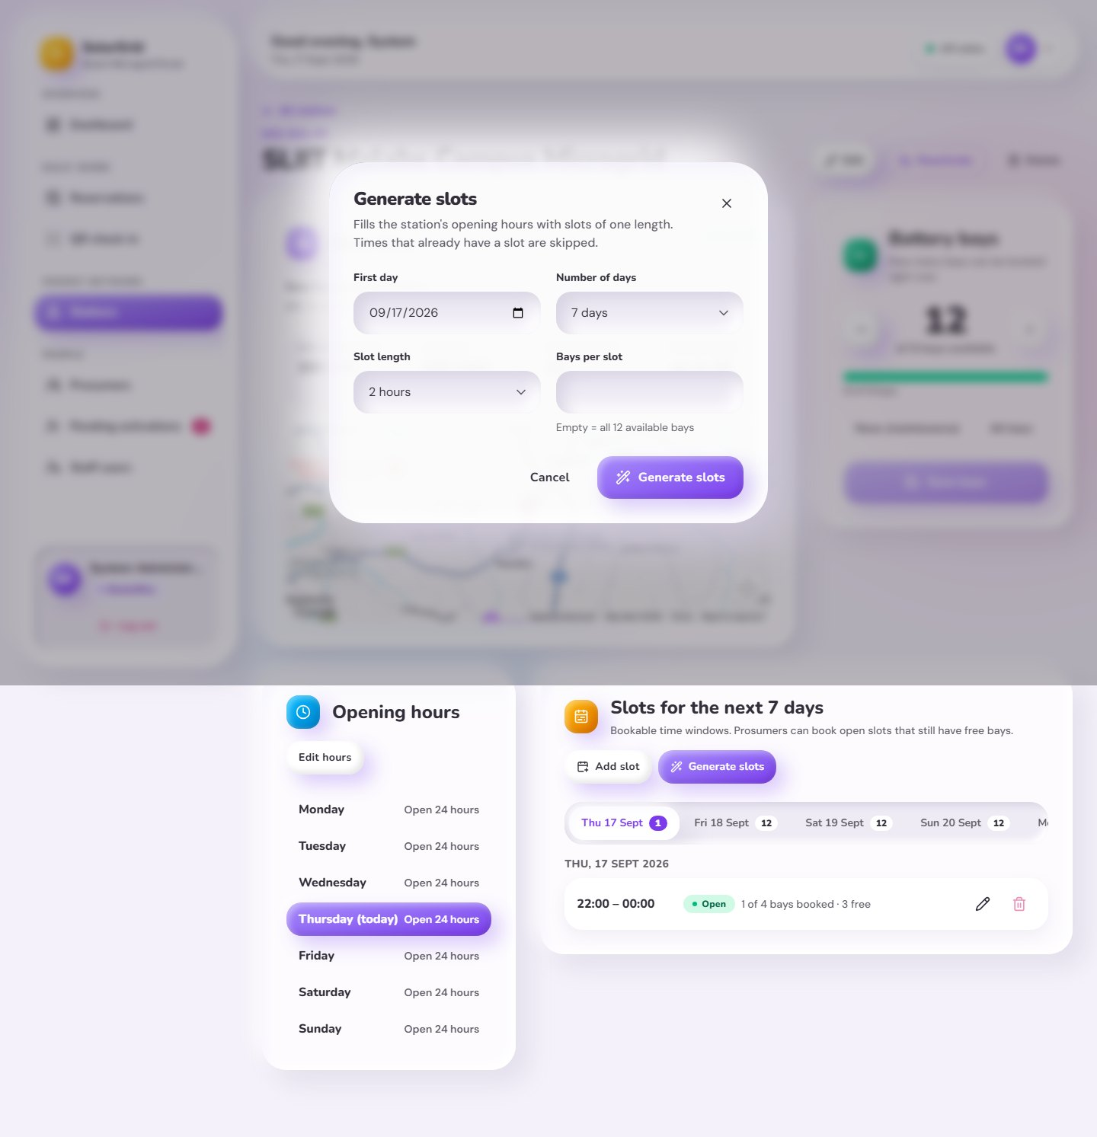
Figure 27: Web portal – Generate slots
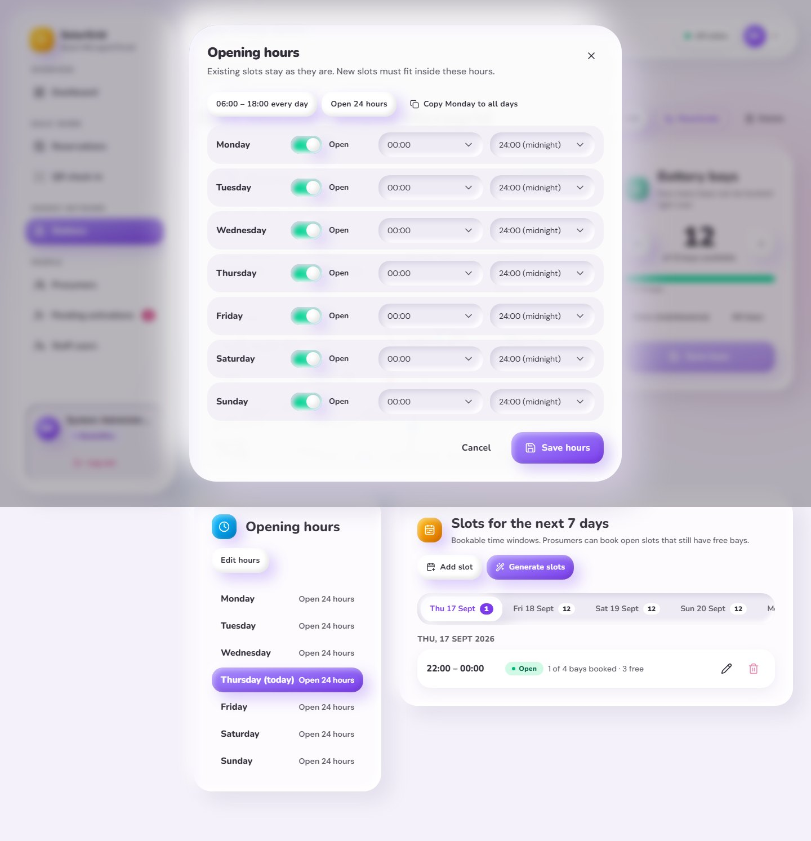
Figure 28: Web portal – Weekly opening hours (Backoffice)
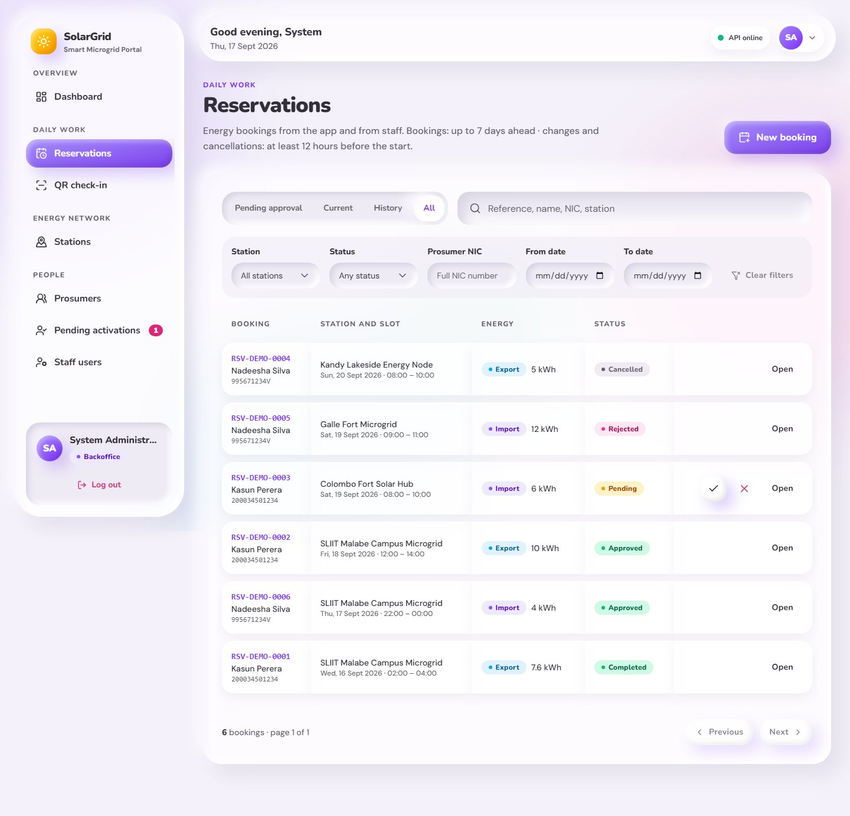
Figure 29: Web portal – Reservations
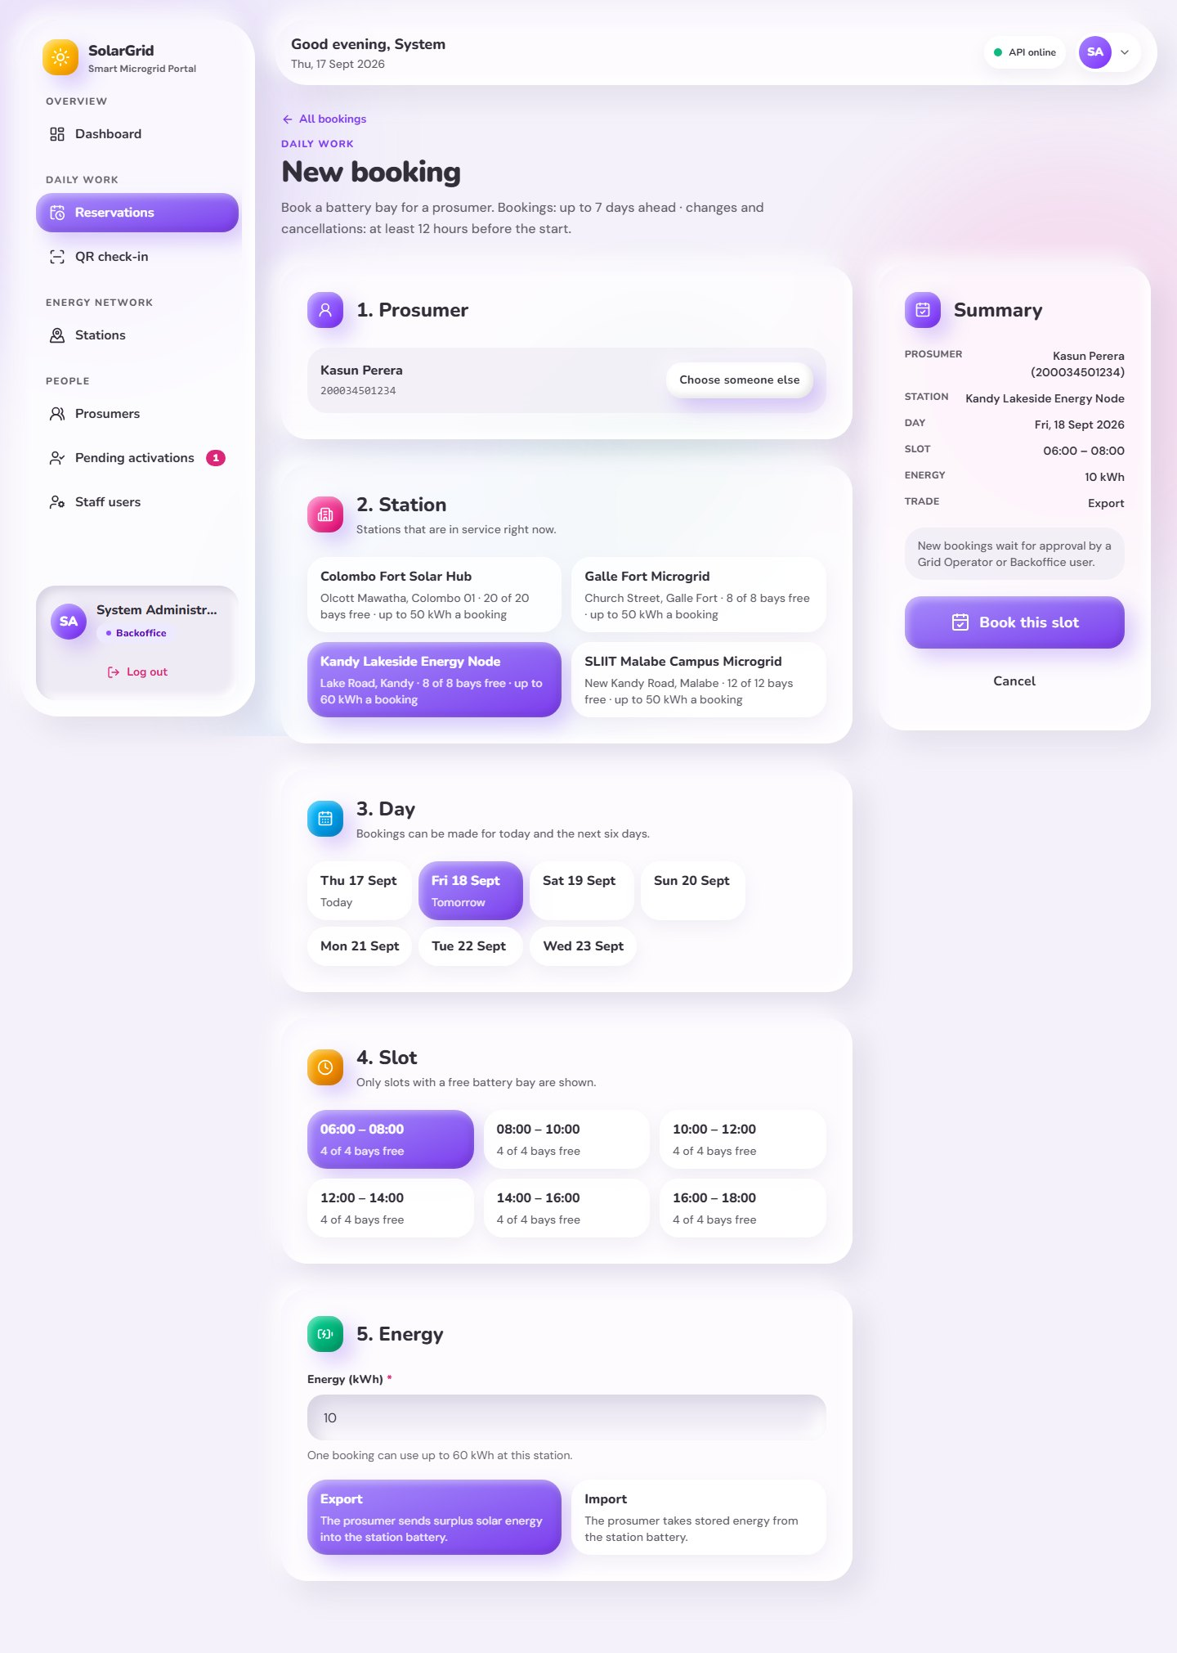
Figure 30: Web portal – New booking for a prosumer
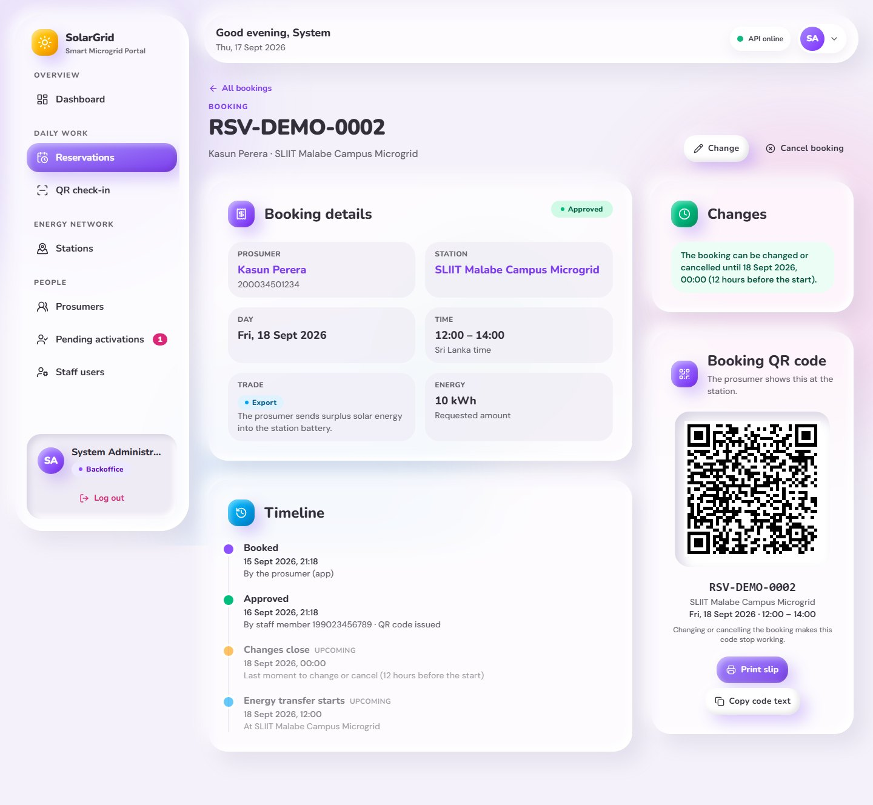
Figure 31: Web portal – Approved booking with its QR code
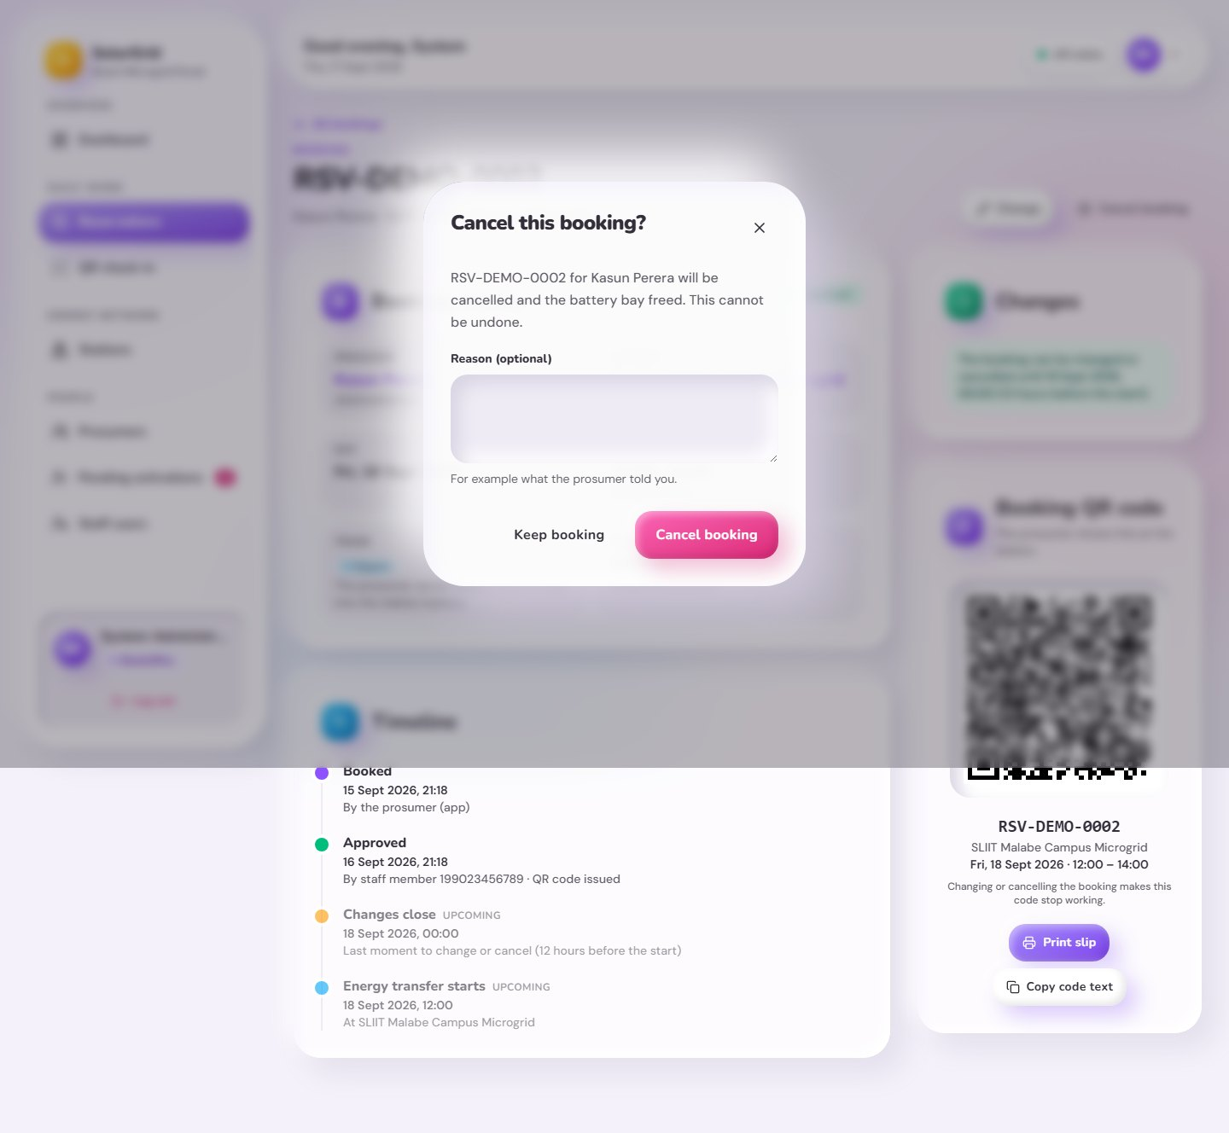
Figure 32: Web portal – Cancel a booking
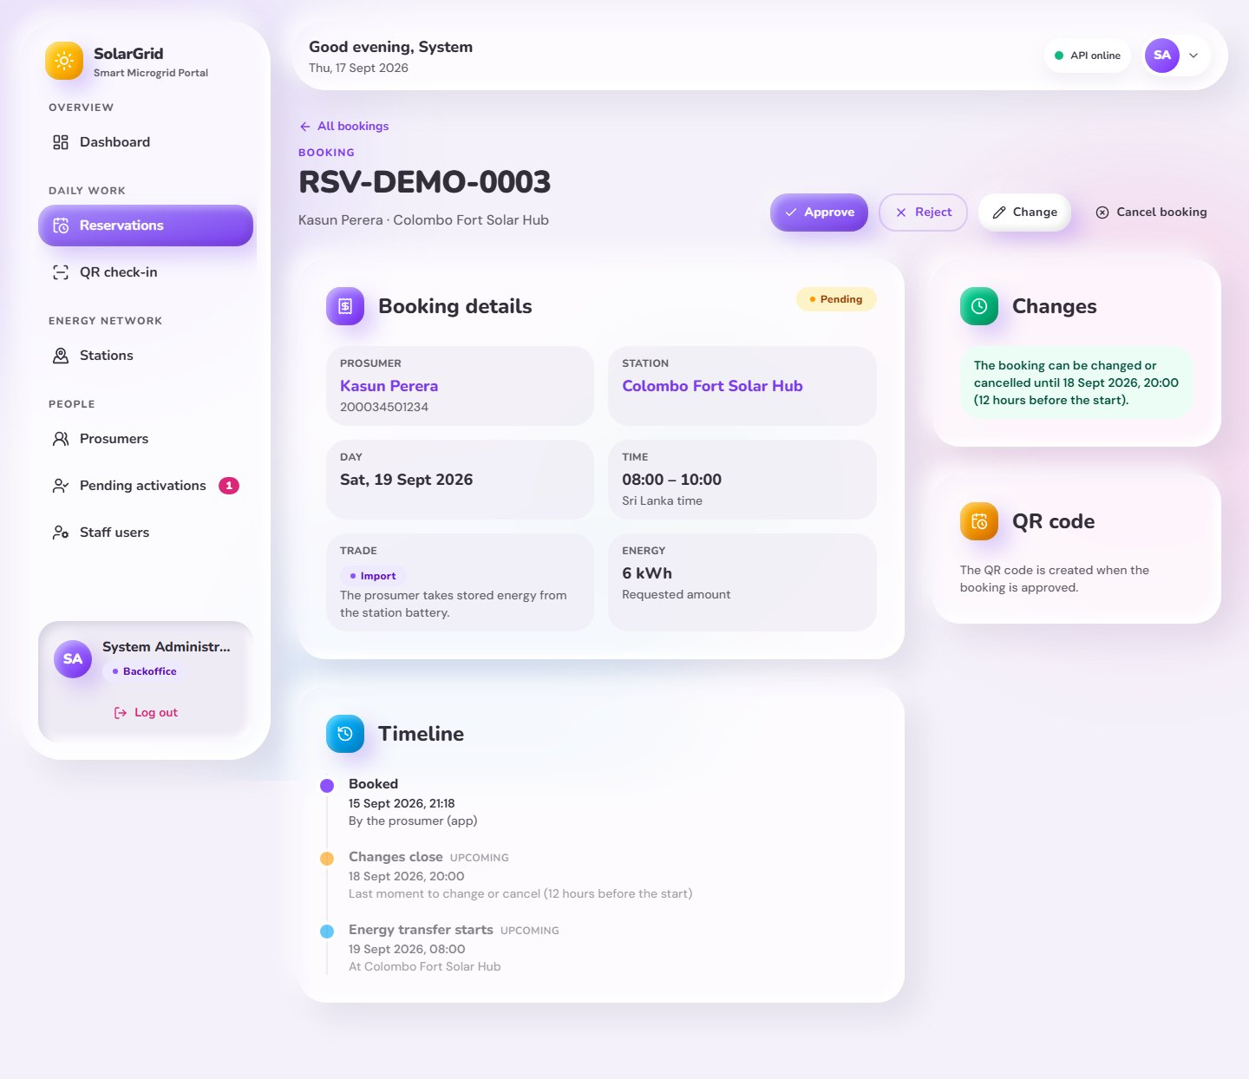
Figure 33: Web portal – Pending booking with approve and reject
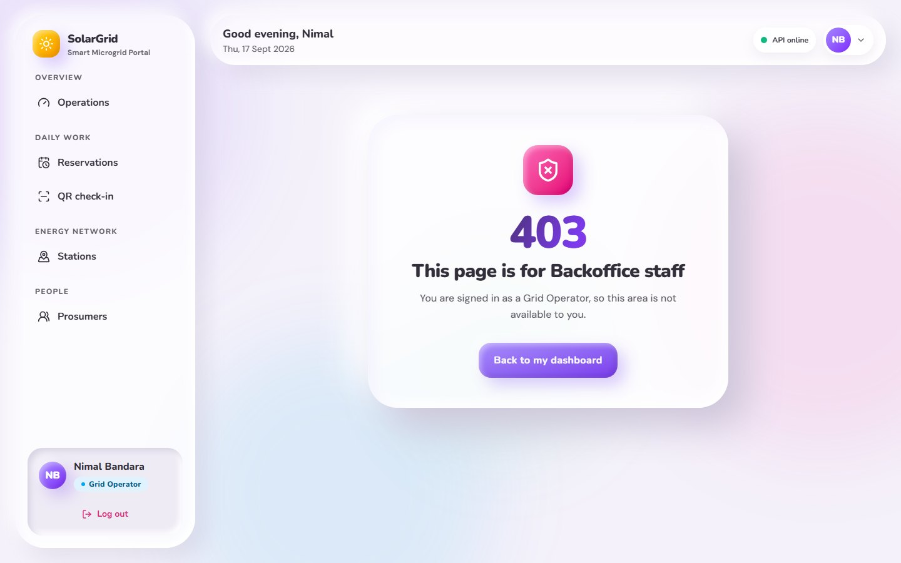
Figure 34: Web portal – Page not allowed for the role
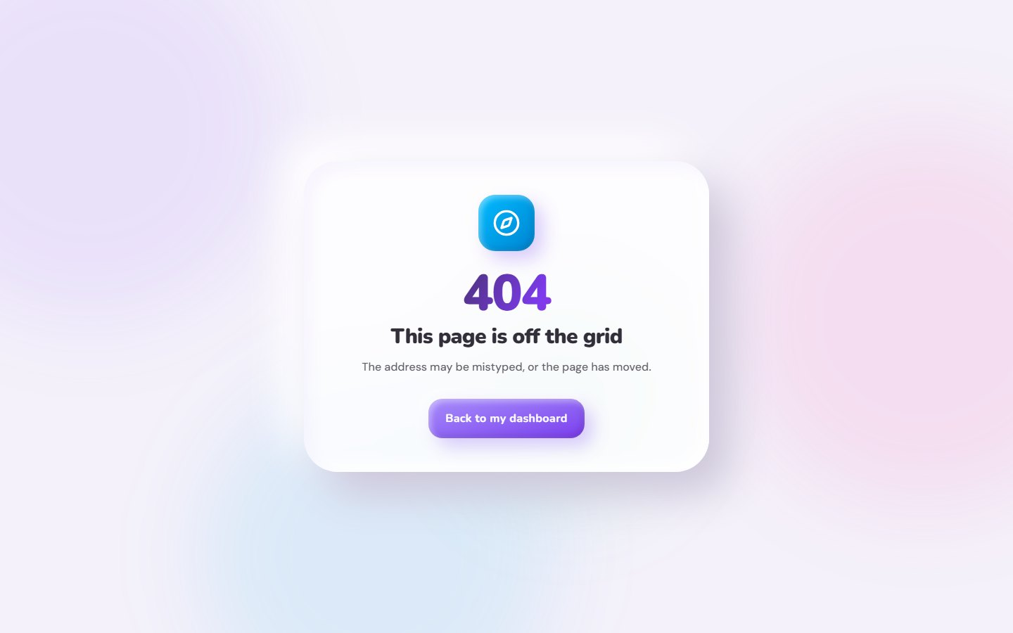
Figure 35: Web portal – Page not found

5.3 Web portal on a phone
The same pages at a phone size (390 pixels wide). The menu moves into a drawer and tables turn into cards. Each picture shows the first screen of the page; the full-length pictures are in docs/screenshots/web/mobile in the repository.
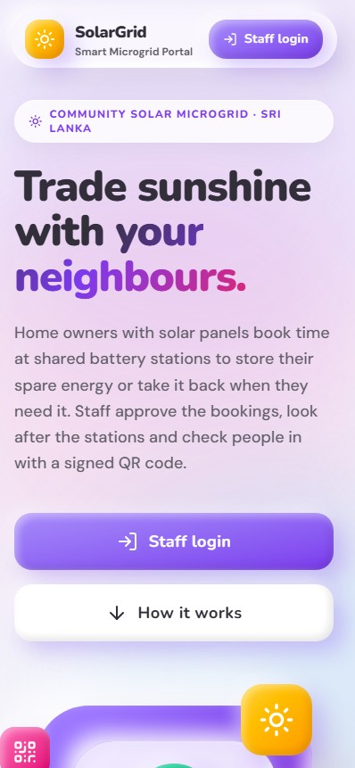  Figure 36: Phone – Home page (public, with live numbers) | 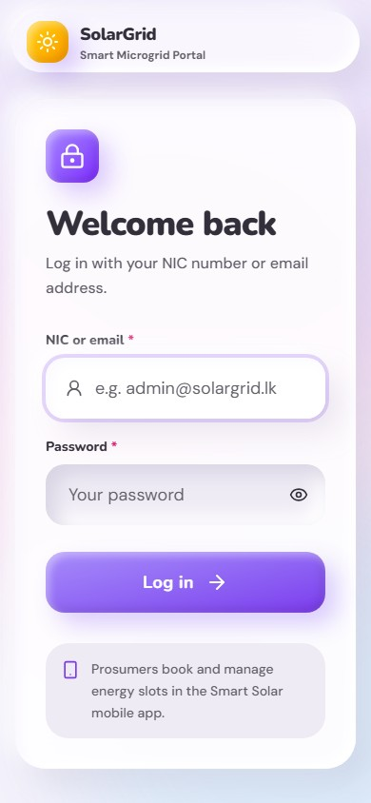  Figure 37: Phone – Log in | 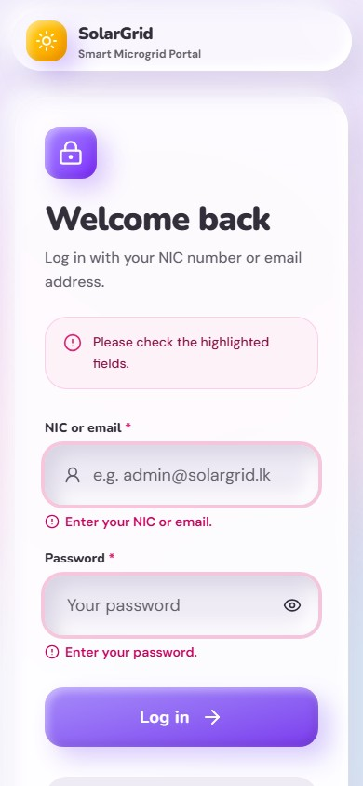  Figure 38: Phone – Log in with the checks shown under the fields | 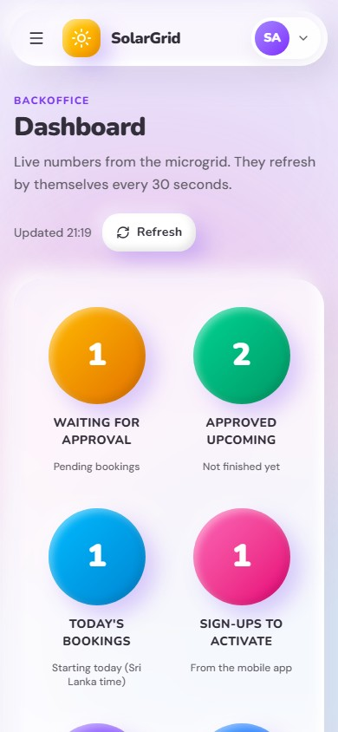  Figure 39: Phone – Backoffice dashboard
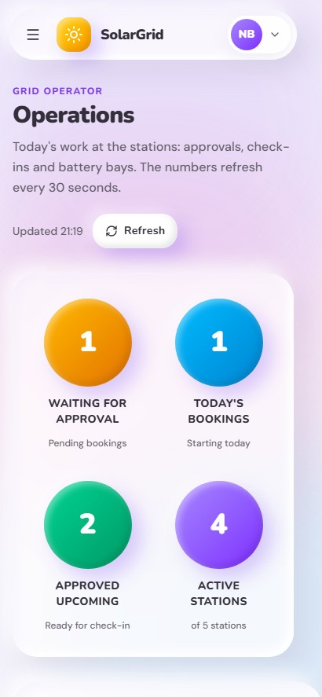  Figure 40: Phone – Operations page for Grid Operators | 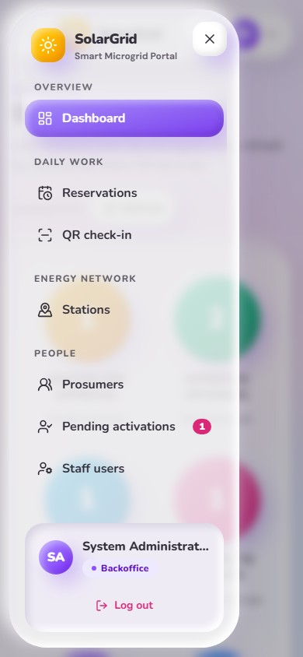  Figure 41: Phone – Menu on a phone | 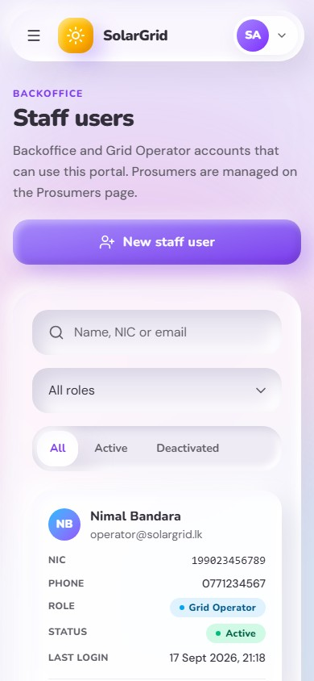  Figure 42: Phone – Staff users (Backoffice) | 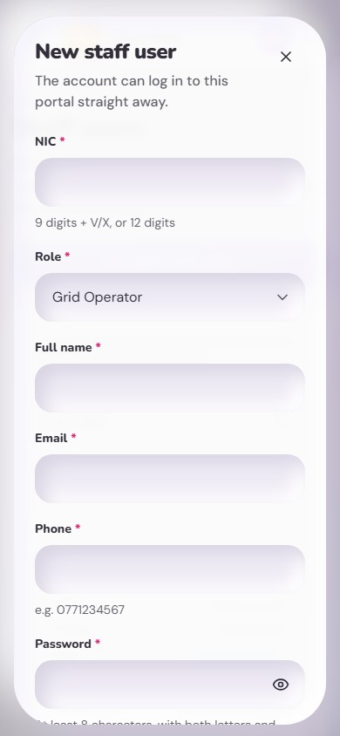  Figure 43: Phone – New staff user
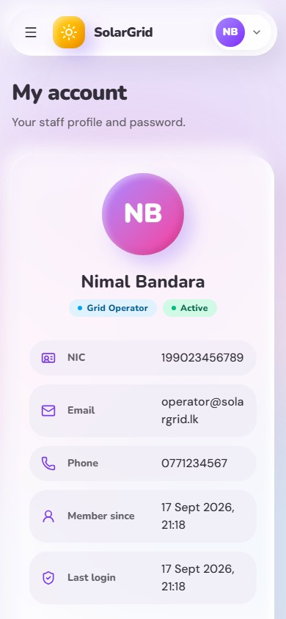  Figure 44: Phone – My account and password change | 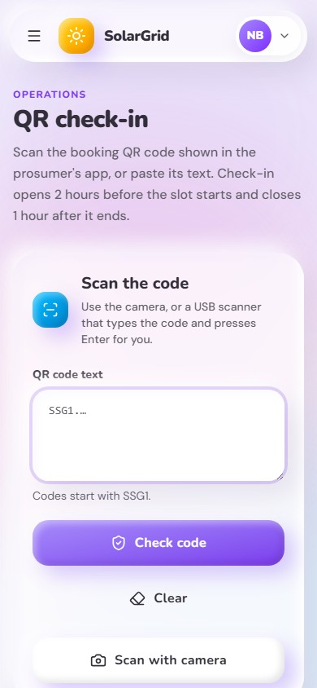  Figure 45: Phone – QR check-in waiting for a code | 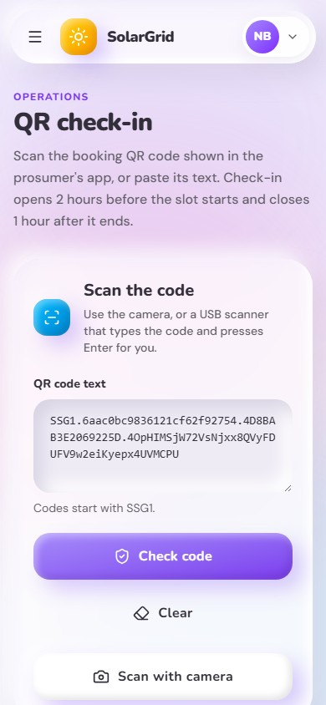  Figure 46: Phone – QR check-in: booking ready to complete | 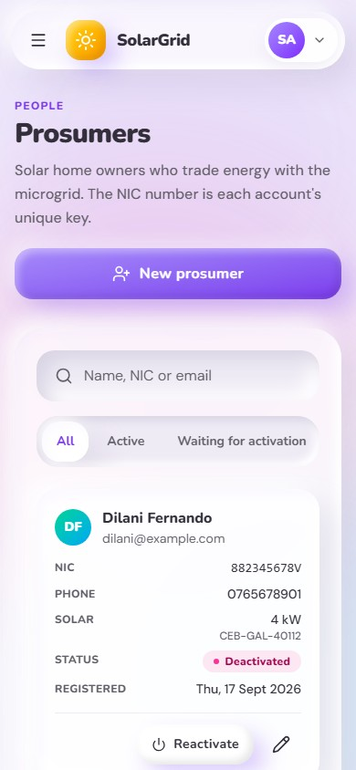  Figure 47: Phone – Prosumers
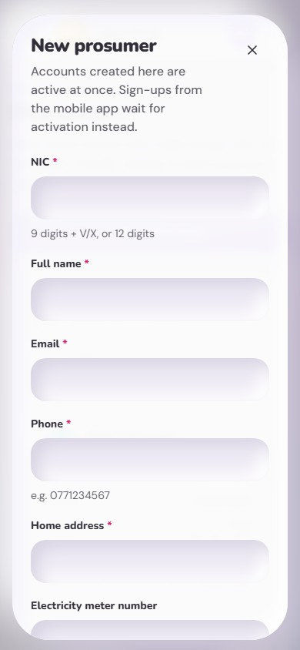  Figure 48: Phone – New prosumer (NIC is the key) | 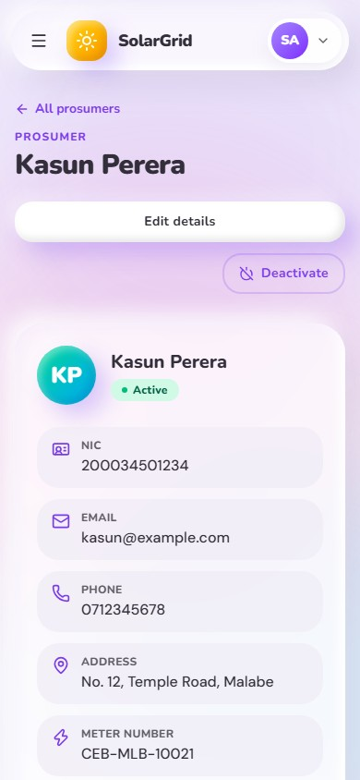  Figure 49: Phone – Prosumer details and bookings | 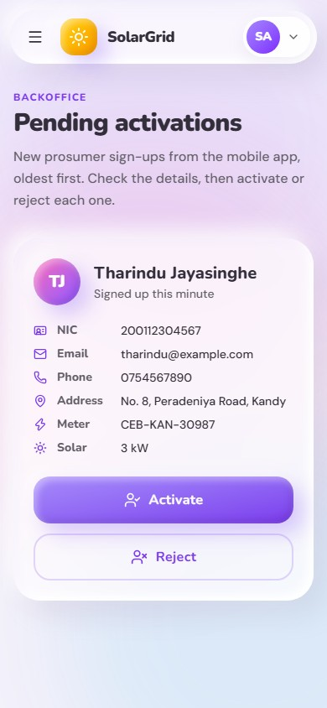  Figure 50: Phone – Pending activations (Backoffice) | 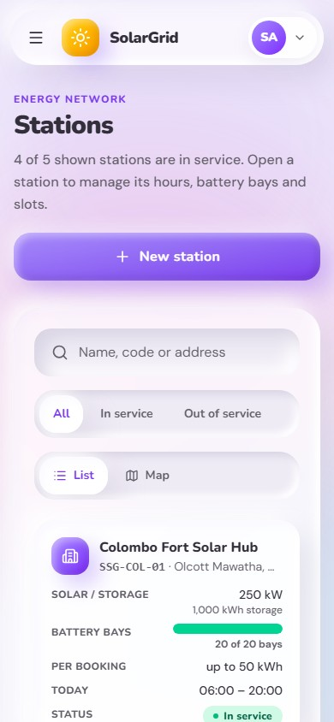  Figure 51: Phone – Stations list
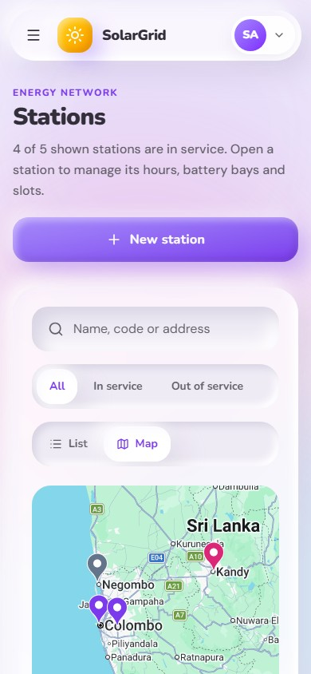  Figure 52: Phone – Stations on the map | 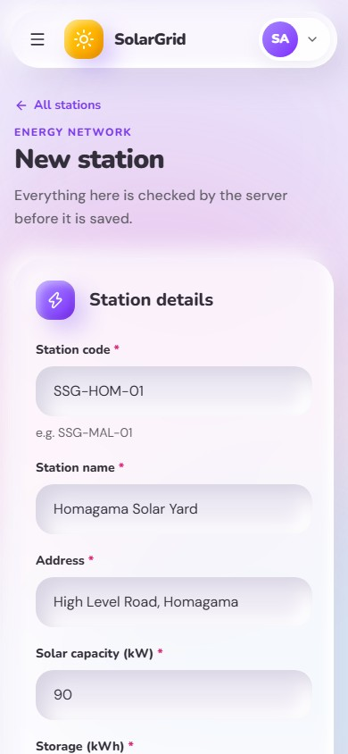  Figure 53: Phone – New station with its GPS position | 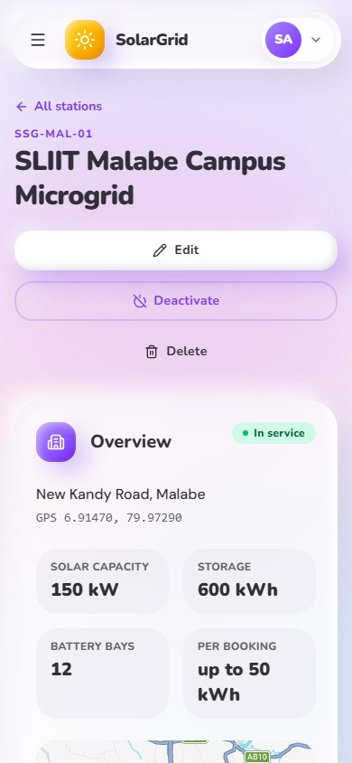  Figure 54: Phone – Station details: bays, hours and slots | 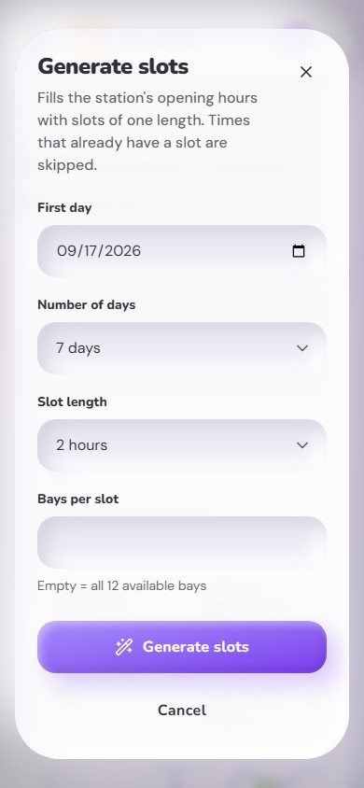  Figure 55: Phone – Generate slots
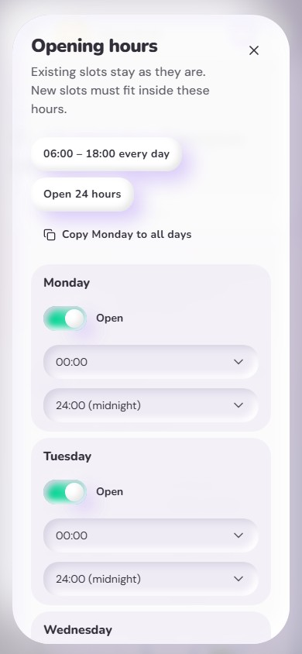  Figure 56: Phone – Weekly opening hours (Backoffice) | 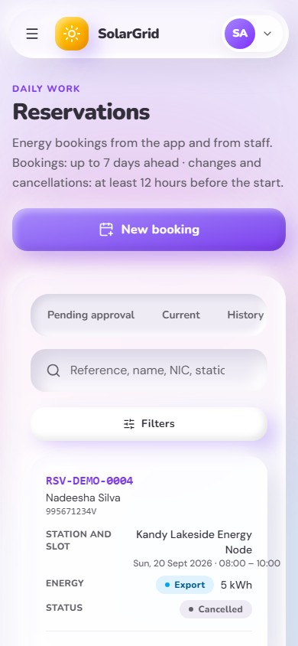  Figure 57: Phone – Reservations | 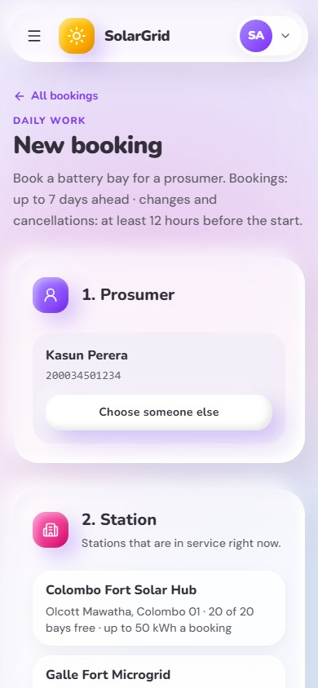  Figure 58: Phone – New booking for a prosumer | 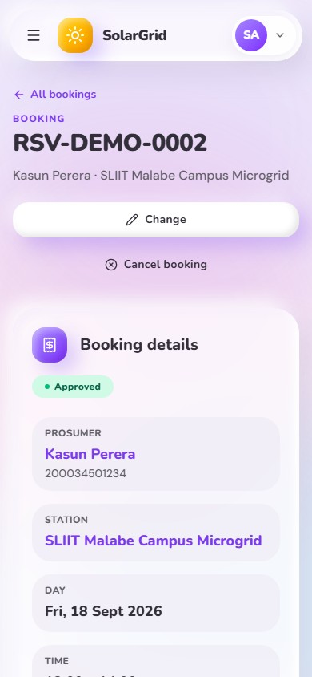  Figure 59: Phone – Approved booking with its QR code
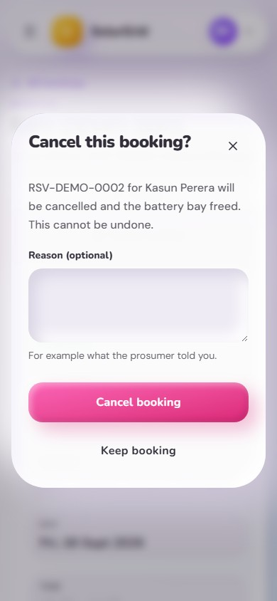  Figure 60: Phone – Cancel a booking | 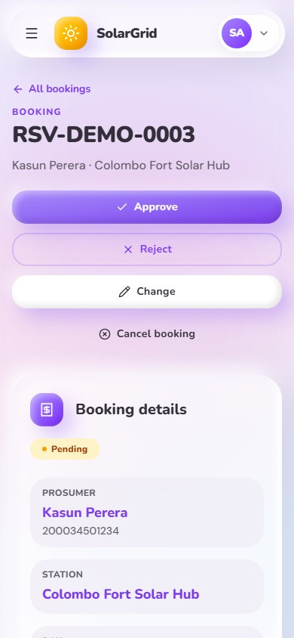  Figure 61: Phone – Pending booking with approve and reject | 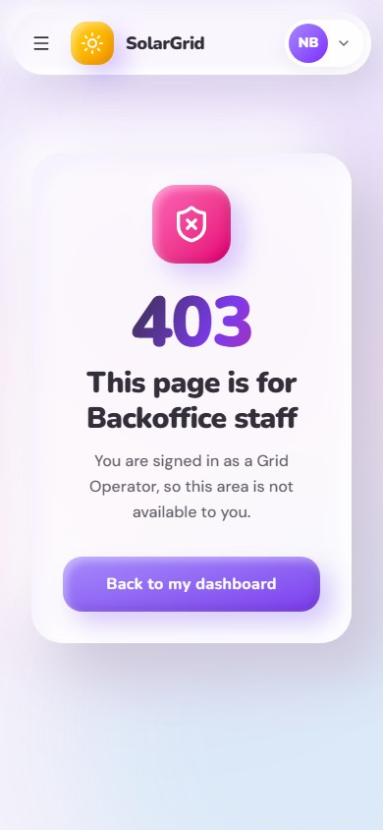  Figure 62: Phone – Page not allowed for the role | 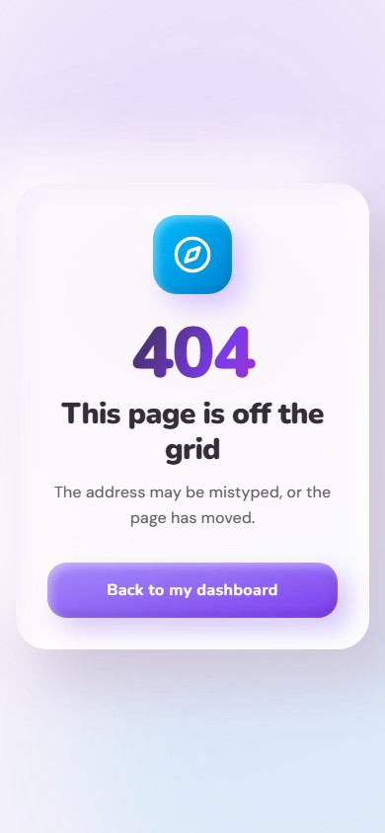  Figure 63: Phone – Page not found

5.4 Android app screens
The Android app (android/) is the mobile user interface for prosumers and Grid Operators. It is a pure native app: Java with XML layouts, SQLite through SQLiteOpenHelper, and no cross-platform framework. Every operation goes through the Web API over REST; the app never talks to MongoDB. The API checks every rule (7-day booking window, 12-hour notice, free bays, the energy one bay holds, account status); the app shows or hides buttons from the flags the API sends (canModify, hasQrCode, isPast) and shows the API's own message when it says no.

Who uses the app
Account | What happens at login
Prosumer, Active | Prosumer home with four tabs: Home, Map, Bookings, Account
Grid Operator, Active | Operator home with four tabs: Scan, Today, Bays, Account
Backoffice | Refused with "Backoffice accounts use the web portal, not this app."
Prosumer, Pending or Deactivated | Refused by the API (403) with its message, for example "waiting for Backoffice activation"

Screens
Pictures | Screen | Who | What it does | SQLite | Owner
— | Start-up | Everyone | Reads the saved session and checks it with the API, then opens the home of the role; an expired session goes to login | session | Ravindu
01–02 | Log in | Everyone | NIC or email and password; a refusal is shown with the API's words | session | Ravindu
09–10 | Sign up, waiting for activation | New prosumers | NIC (the key), name, email, phone, address, meter number, panel size and password; then "waiting for the Backoffice" | — | Malith
03, 13 | Home | Prosumer | Waiting and approved-to-come counts, finished transfers, delivered kWh, the next booking and the ones after it; "Book a slot" | — | Malith
15–17 | Map and station list | Prosumer | Nearby stations on Google Maps (or as a list) with free bays, today's hours and distance; "Book a slot here" | stations | Nimthara
18 | Station page | Prosumer | Bays, energy per booking, weekly hours and the slots of the next seven days; "Book a slot here" | stations | Nimthara
20–22 | Bookings | Prosumer | Current, waiting and history tabs; search; status, station and date range filters; one page at a time | reservations | Hamnad
23–26, 31 | Booking form | Prosumer | Station → day and free slot → Export or Import and kWh → review; the same form changes a booking | — | Hamnad
28–29, 32, 34 | Booking page | Prosumer, Grid Operator | What happens next, the QR code of an approved booking, details, history, and Change / Cancel while allowed | reservations | Hamnad
27, 30 | Summary | Prosumer, Grid Operator | The booking as the API saved it after booking, changing or cancelling, and what happens next | — | Hamnad
04, 14 | Account | Prosumer, Grid Operator | Own details, server address and app version; log out; change password; for prosumers also edit profile and deactivate | clears | Ravindu, Malith
11 | Profile | Prosumer | Edit the whole profile (the API replaces it) | profile | Malith
12 | Change password | Prosumer, Grid Operator | The current password and the new one twice | — | Malith
05 | Scan | Grid Operator | Camera scan of the booking QR code, or the code typed in | — | Ravindu
06–08 | Check-in | Grid Operator | The API checks the code; ready, or blocked with the reason; the delivered kWh; complete the transfer | — | Ravindu
33 | Today | Grid Operator | The bookings of one of the next seven days at every station, earliest first, and three staff numbers; a booking opens the booking page | — | Hamnad
19 | Bays | Grid Operator | Set how many battery bays of a station are free | — | Nimthara

The picture numbers are the file numbers in docs/screenshots/android; section 5.5 shows every picture.

What each role can do in the app
The API enforces every permission; the app only shows what a role can use.
Task | Prosumer | Grid Operator
Create an account (NIC as the key) | ✔ | —
Change own profile | ✔ | —
Change own password | ✔ | ✔
Ask for deactivation (only Backoffice reactivates) | ✔ | —
See the dashboard numbers | ✔ (own bookings) | ✔ (staff numbers)
See nearby stations on the map, station pages and slots | ✔ | —
Book a slot (up to 7 days ahead) | ✔ | — (web portal)
Change a booking (at least 12 hours before the start) | ✔ | — (web portal)
Cancel a booking (at least 12 hours before the start) | ✔ | ✔ (for a prosumer)
See current, waiting and past bookings | ✔ (own) | ✔ (every booking of a day)
Show the QR code of an approved booking | ✔ | —
Scan and check a QR code, finish the transfer | — | ✔
Set a station's free battery bays | — | ✔

Offline use
The app keeps a small read-only copy in SQLite (see section 3.6). The session keeps a user signed in until the token expires; the profile, the stations and the last bookings still show without a connection, with a note that they may be old. A copy on the phone never allows a change: booking, changing, cancelling and checking in always need the API. Logging out removes the session, the profile and the bookings; the stations stay, because they are the same for everyone.

Android permissions
Permission | Why | When it is asked
Internet, network state | Calling the Web API | Granted at install
Nearby devices (local network, Android 17) | Reaching an API on the local network, such as the development PC at 10.0.2.2 | Before the first request to a local address
Location (fine or coarse) | Centring the map on the prosumer | When the Map tab opens; without it the map starts in Colombo
Camera | Scanning booking QR codes | When the operator taps "Scan QR code"; the code can be typed instead

5.5 Android app screenshots
Every screen of the app on a Pixel 10 emulator (Android 17). Picture 03 is the main opening screen of the app for a prosumer.
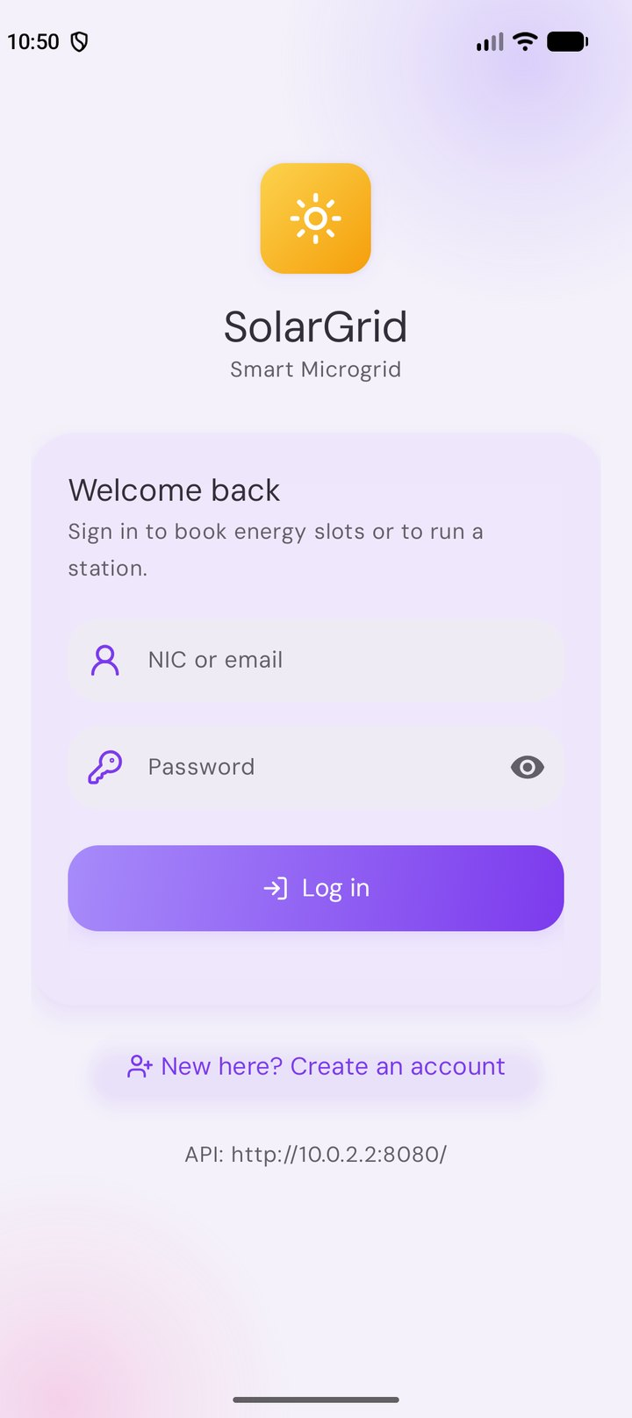  Figure 64: 01 – Log in | 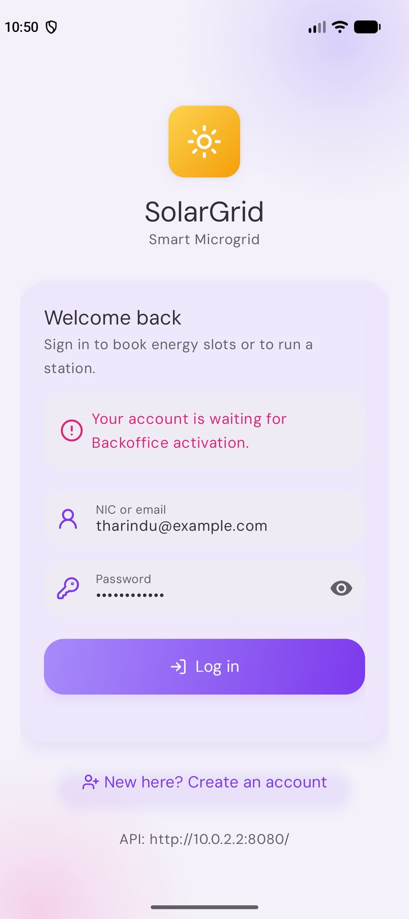  Figure 65: 02 – Log in refused with the API’s reason | 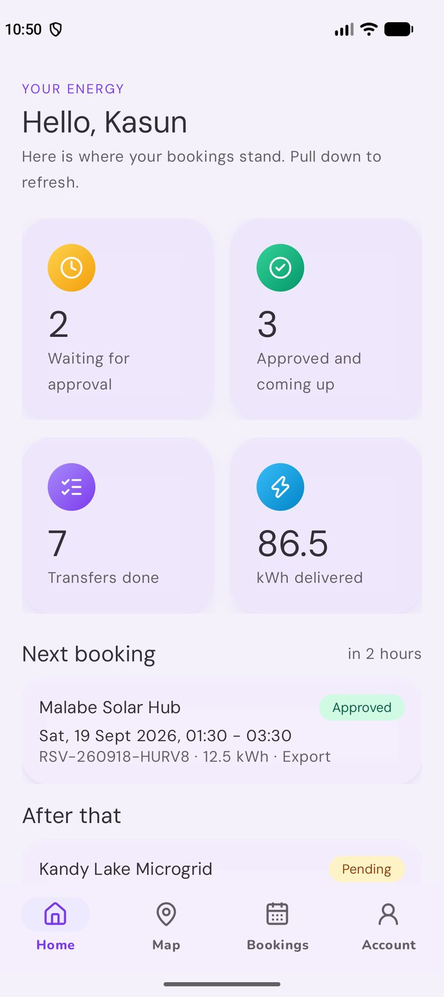  Figure 66: 03 – Prosumer home – the main opening screen
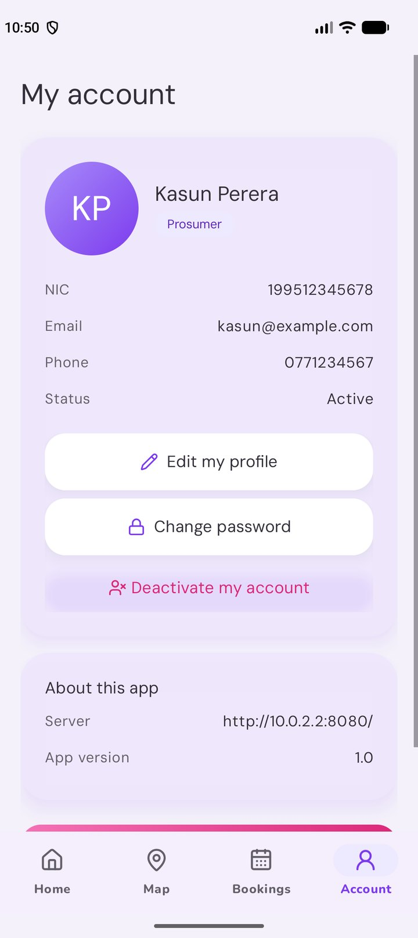  Figure 67: 04 – Account (prosumer) | 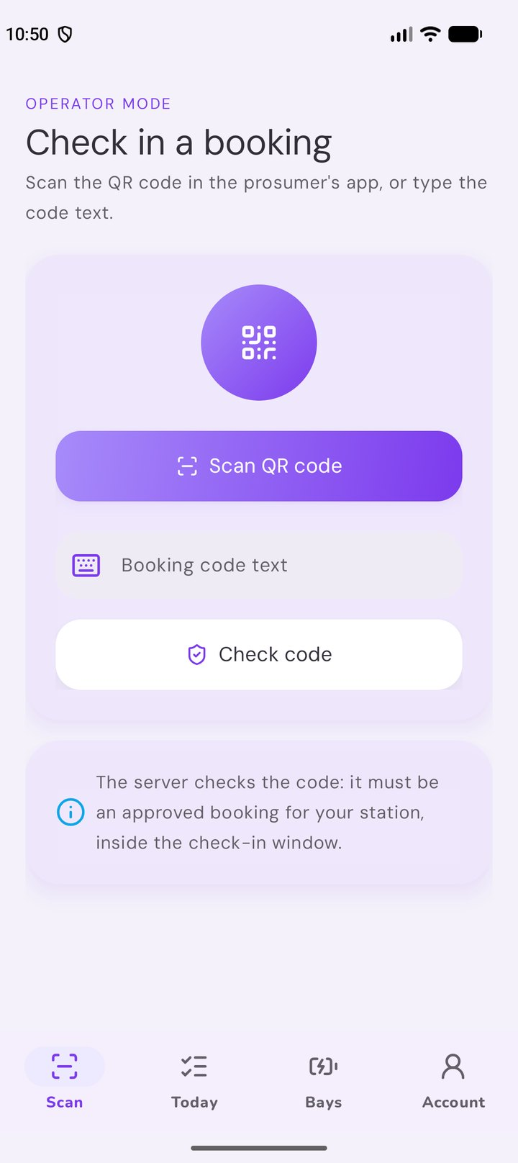  Figure 68: 05 – Operator: scan a QR code | 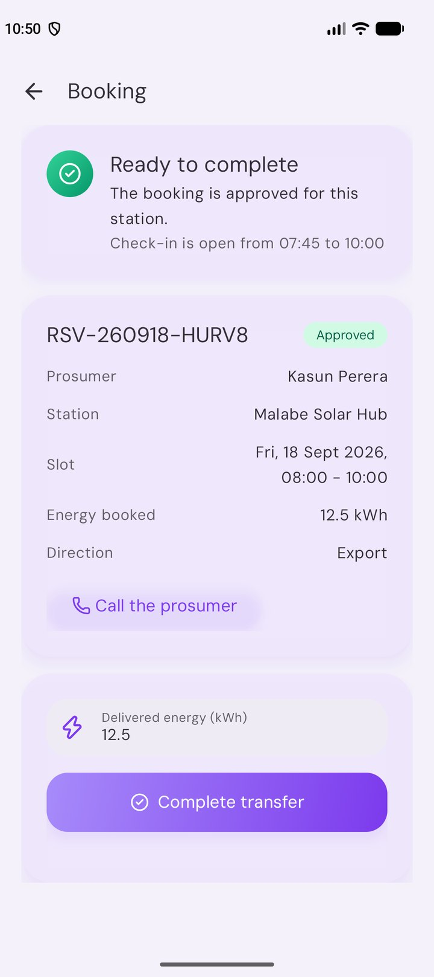  Figure 69: 06 – Operator: check-in ready
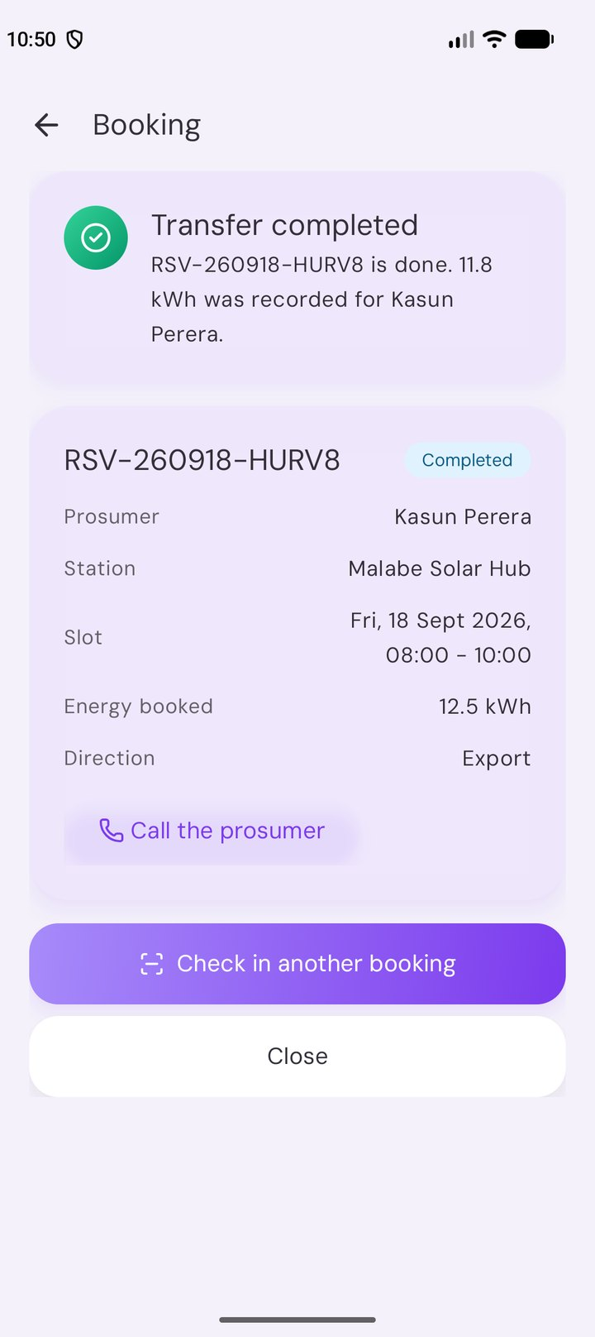  Figure 70: 07 – Operator: transfer completed | 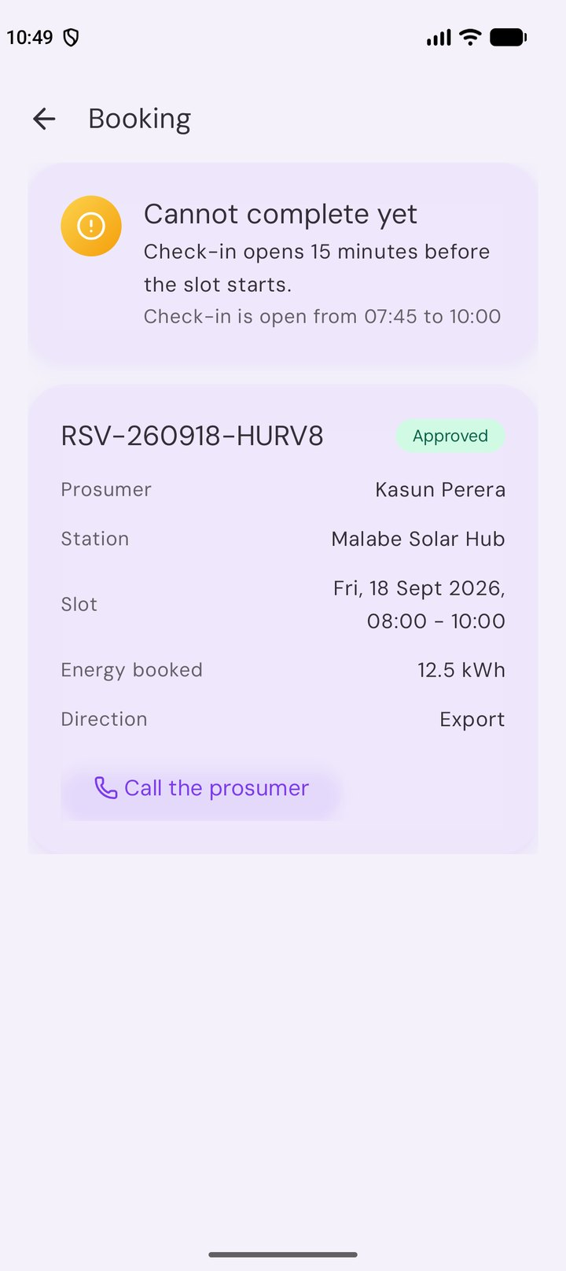  Figure 71: 08 – Operator: check-in blocked with the reason | 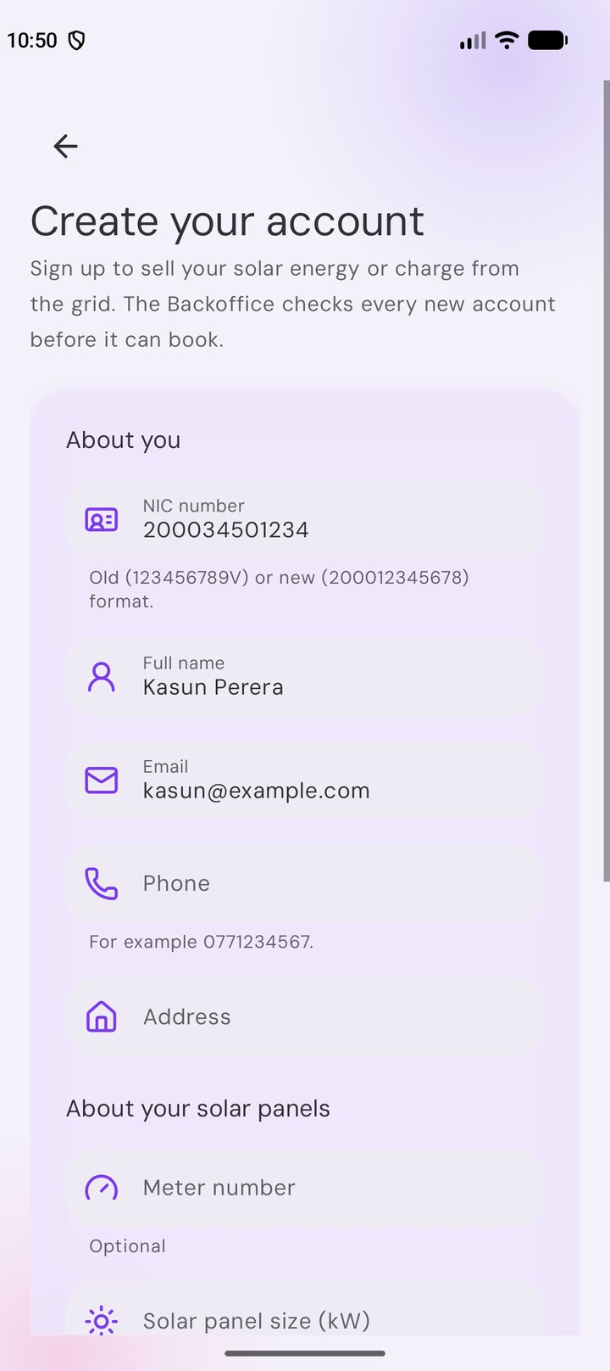  Figure 72: 09 – Sign up with the NIC
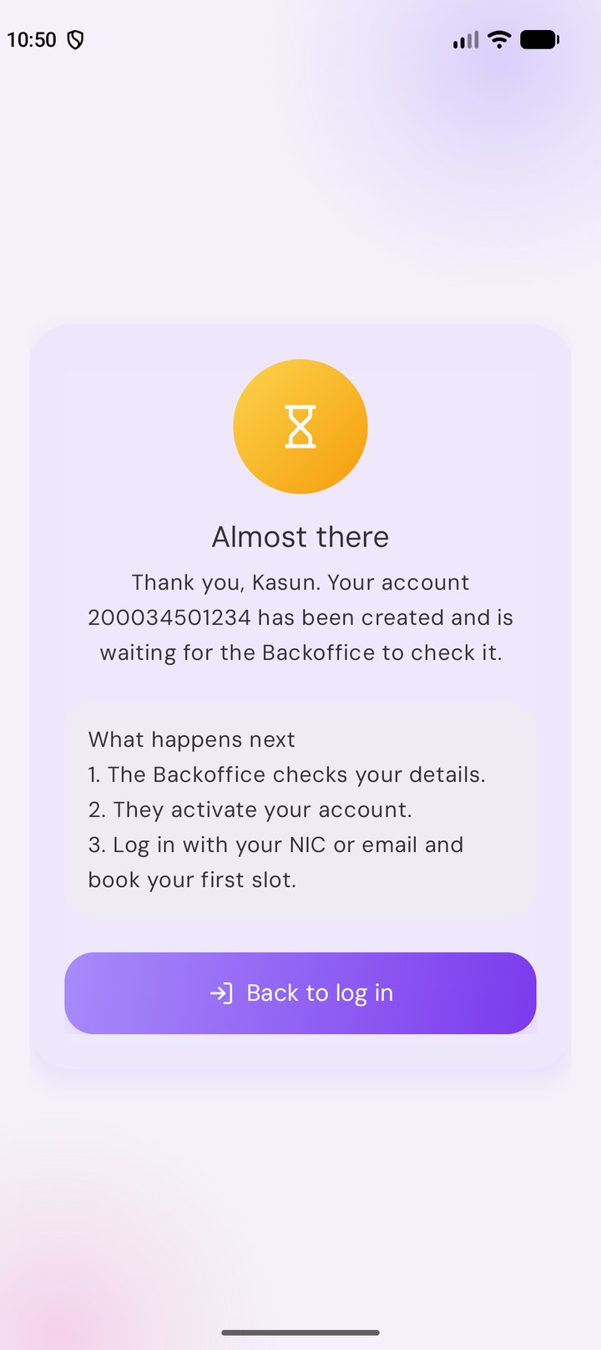  Figure 73: 10 – Waiting for activation | 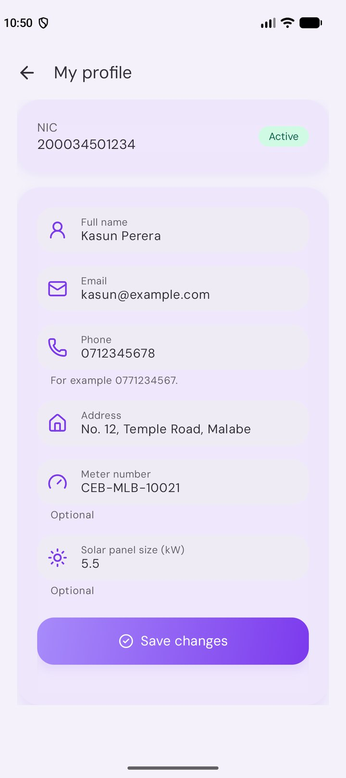  Figure 74: 11 – Edit profile | 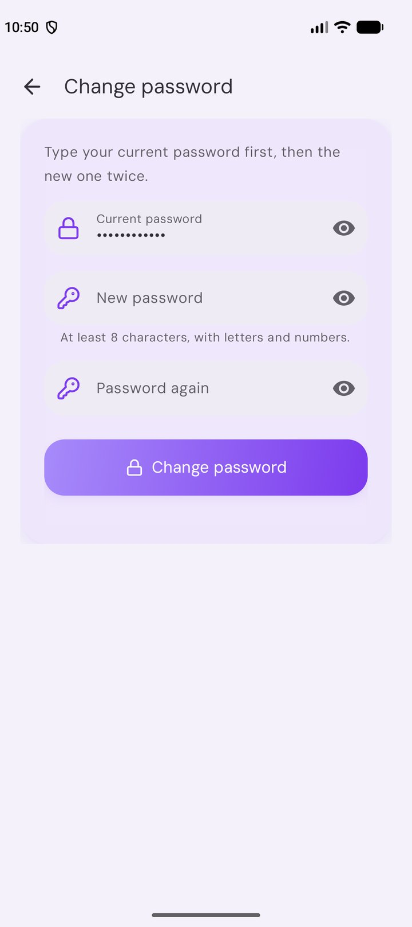  Figure 75: 12 – Change password
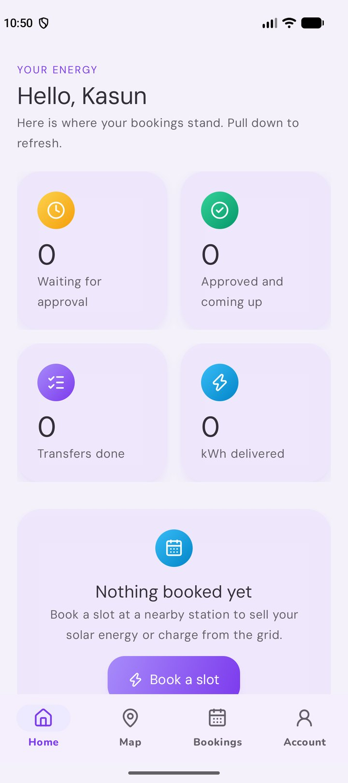  Figure 76: 13 – Home with nothing booked | 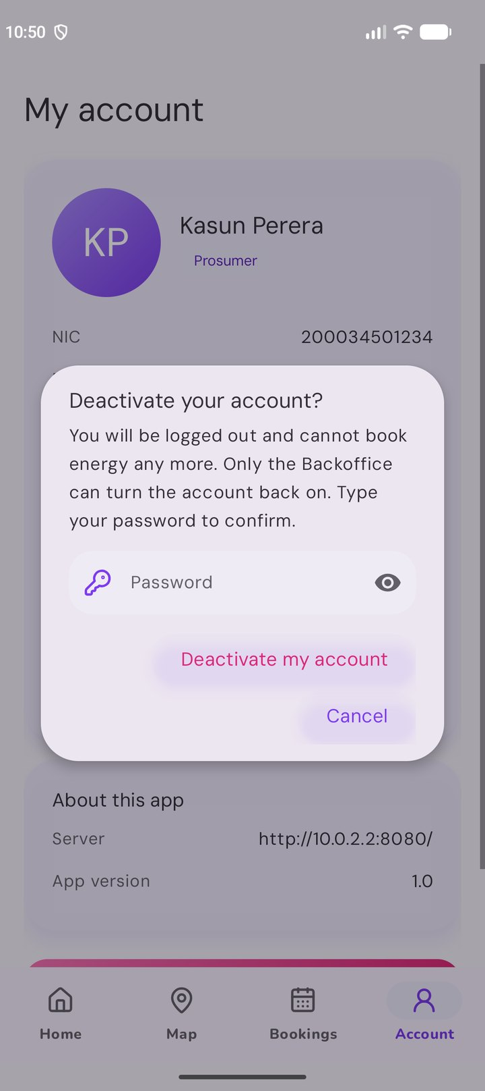  Figure 77: 14 – Deactivate, confirmed with the password | 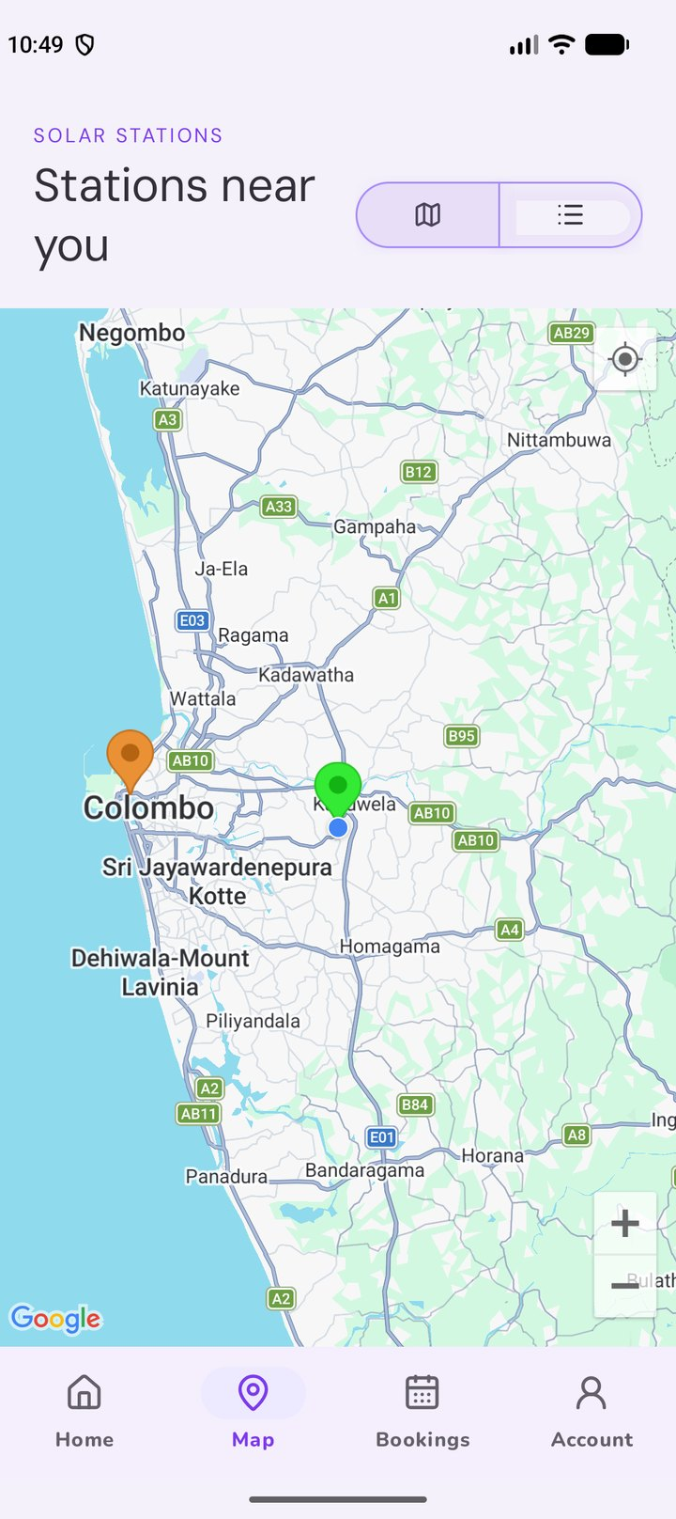  Figure 78: 15 – Nearby stations on Google Maps
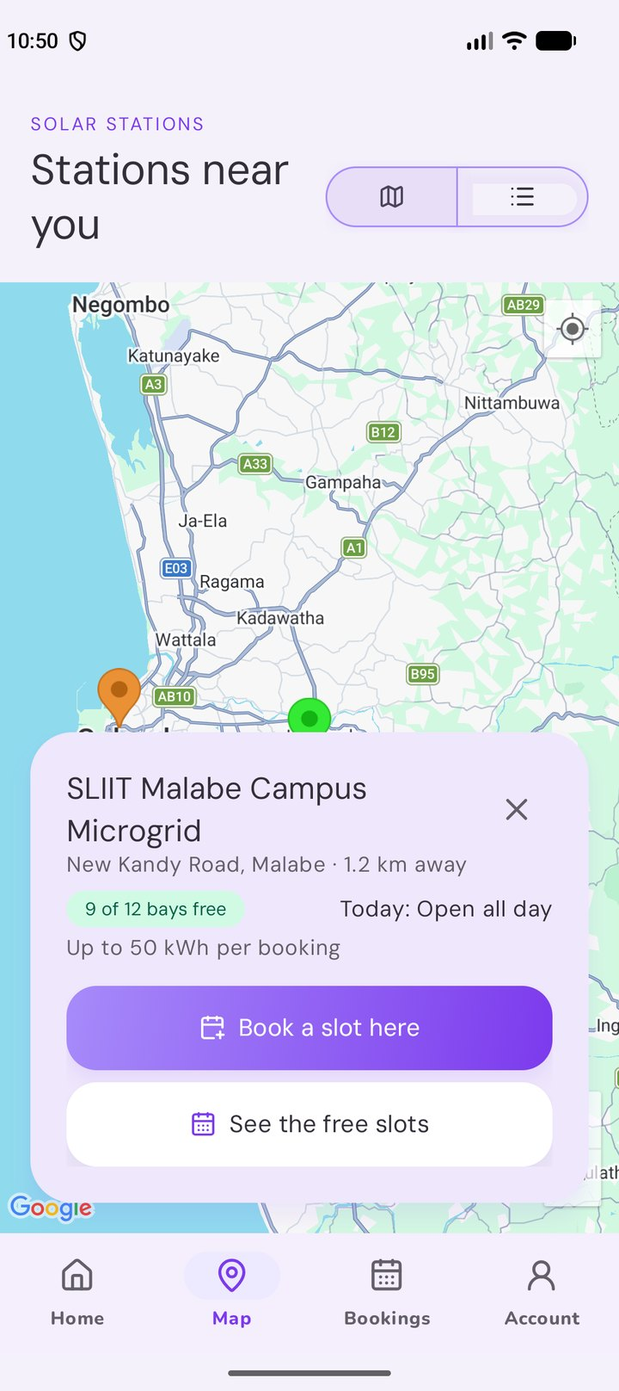  Figure 79: 16 – Station card on the map | 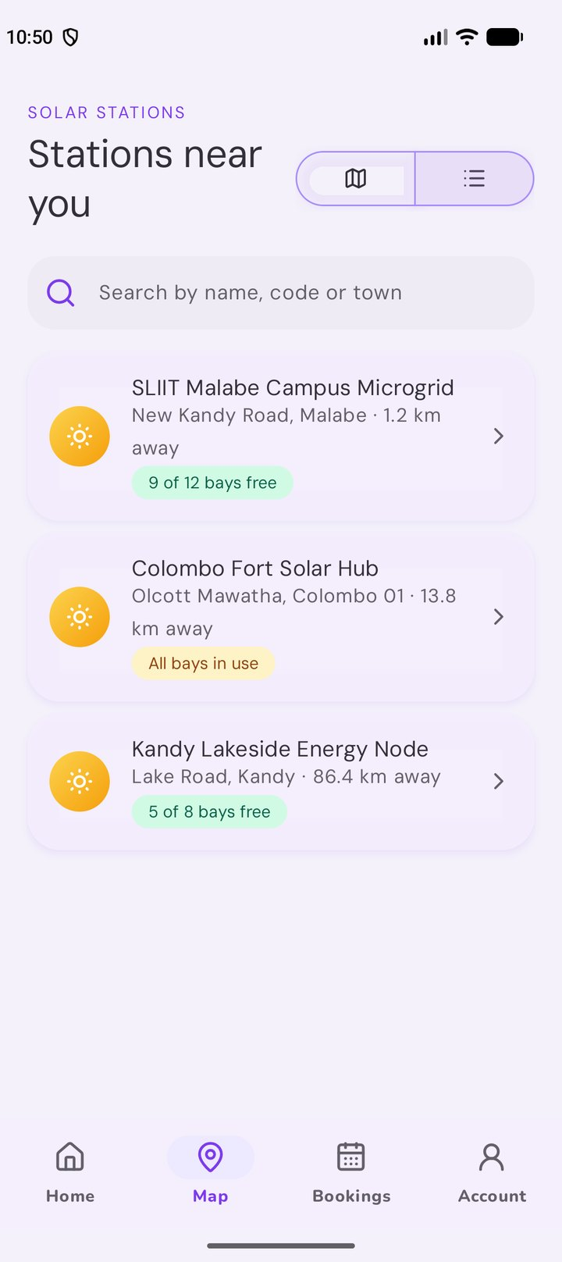  Figure 80: 17 – Station list | 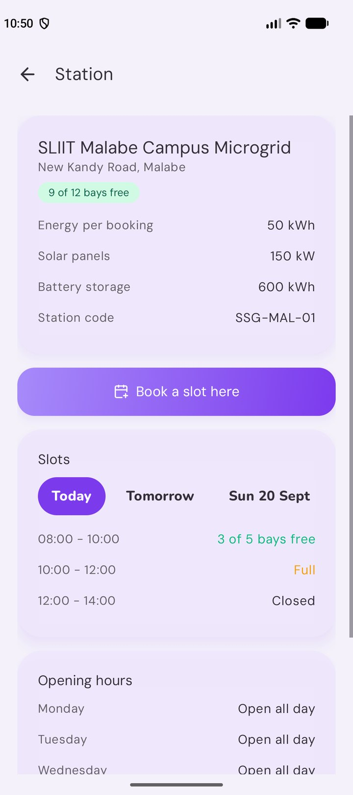  Figure 81: 18 – Station page with hours and slots
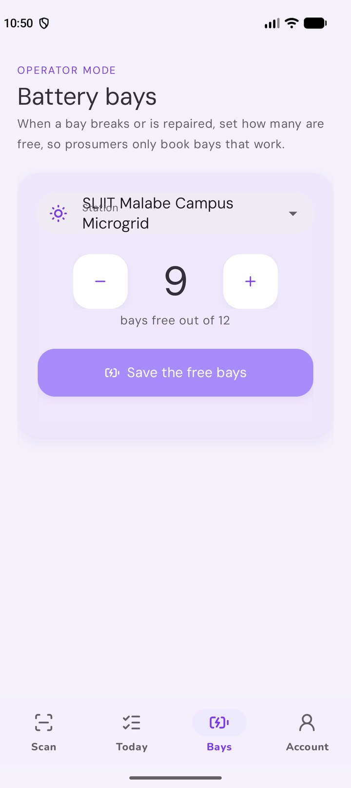  Figure 82: 19 – Operator: free battery bays | 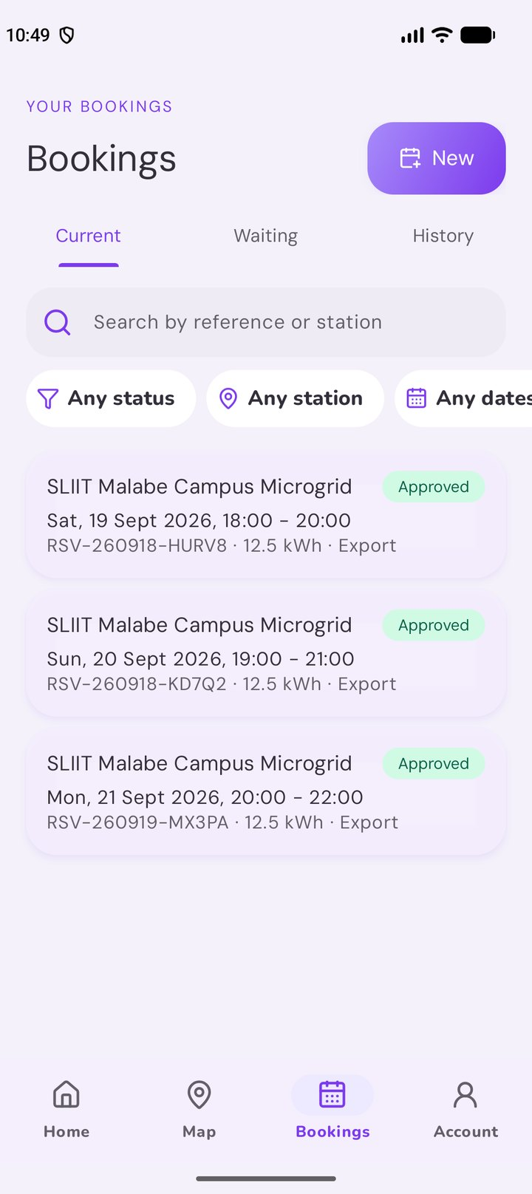  Figure 83: 20 – Bookings: current | 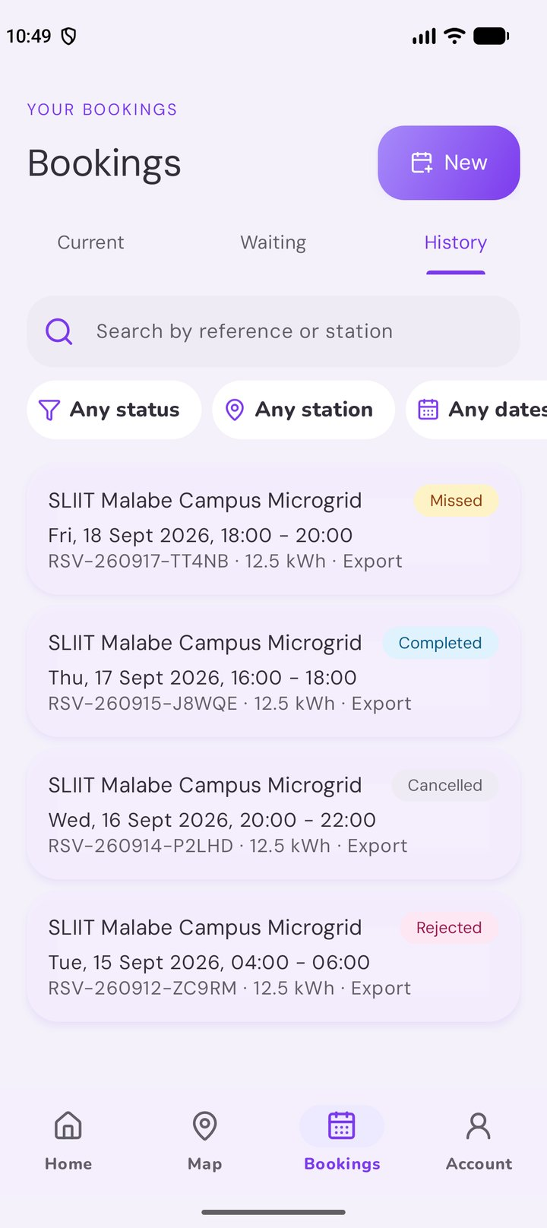  Figure 84: 21 – Bookings: history
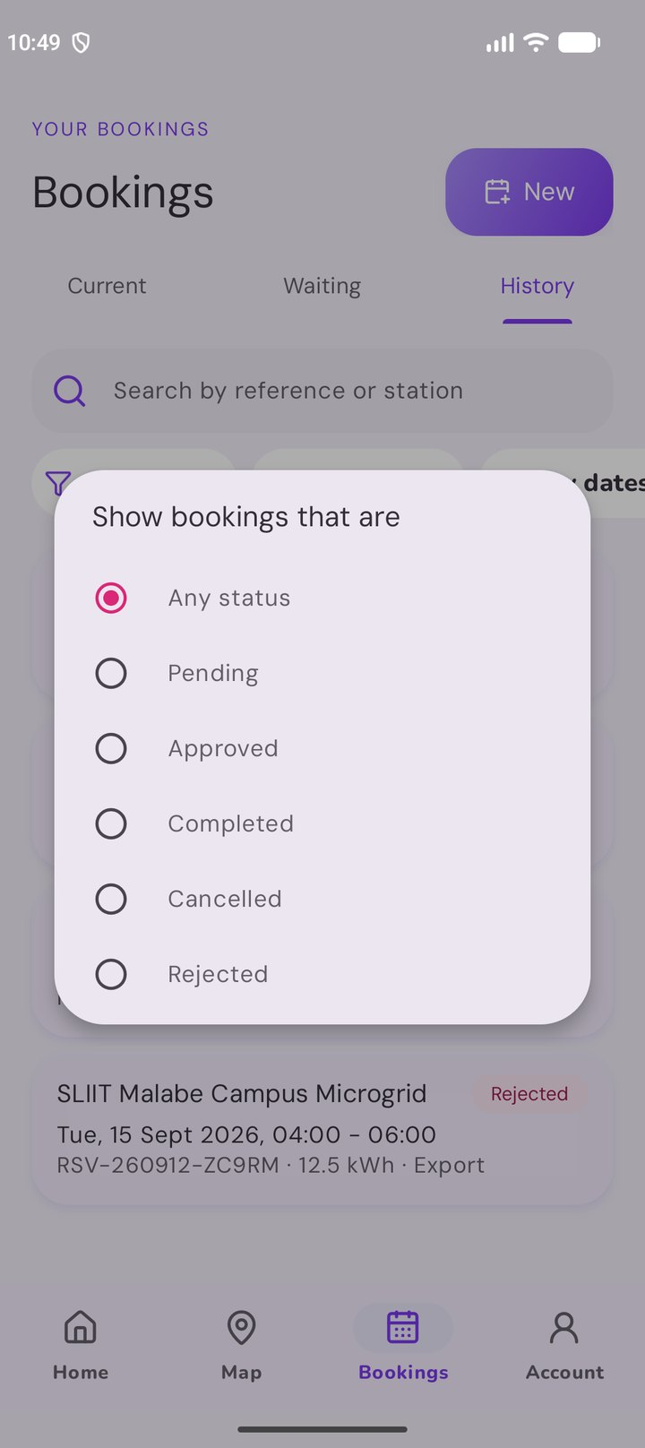  Figure 85: 22 – Bookings: status filter | 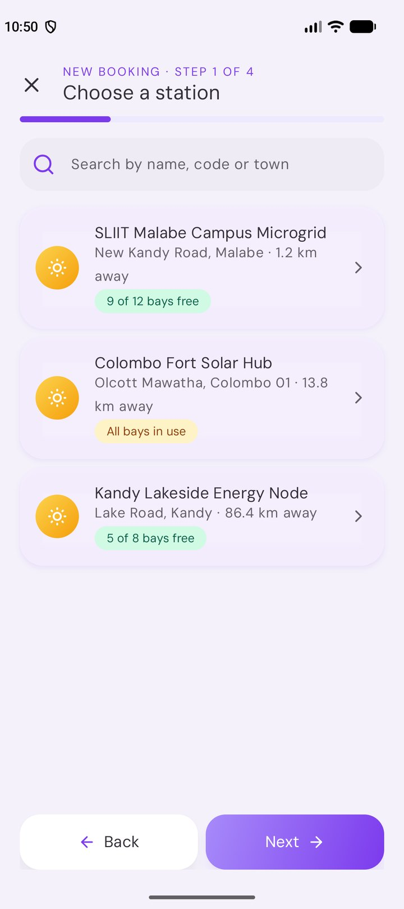  Figure 86: 23 – Booking form: station | 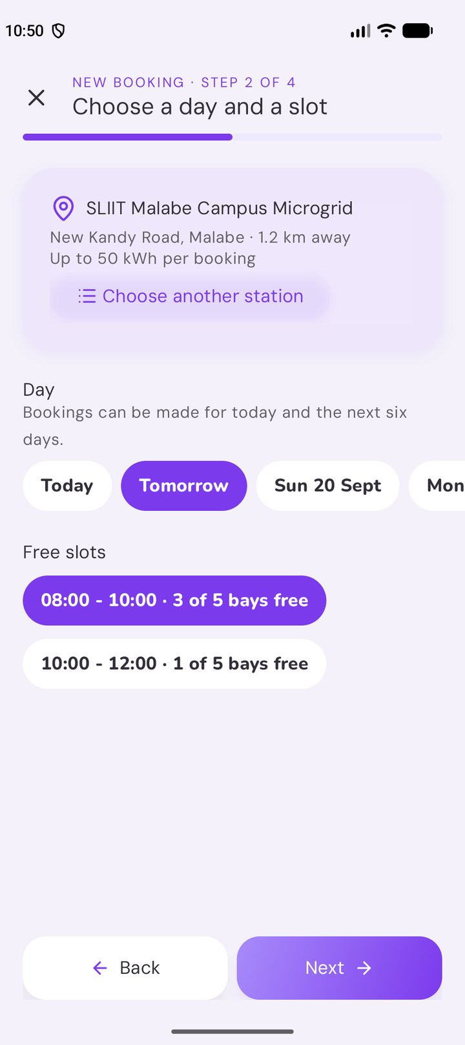  Figure 87: 24 – Booking form: day and slot
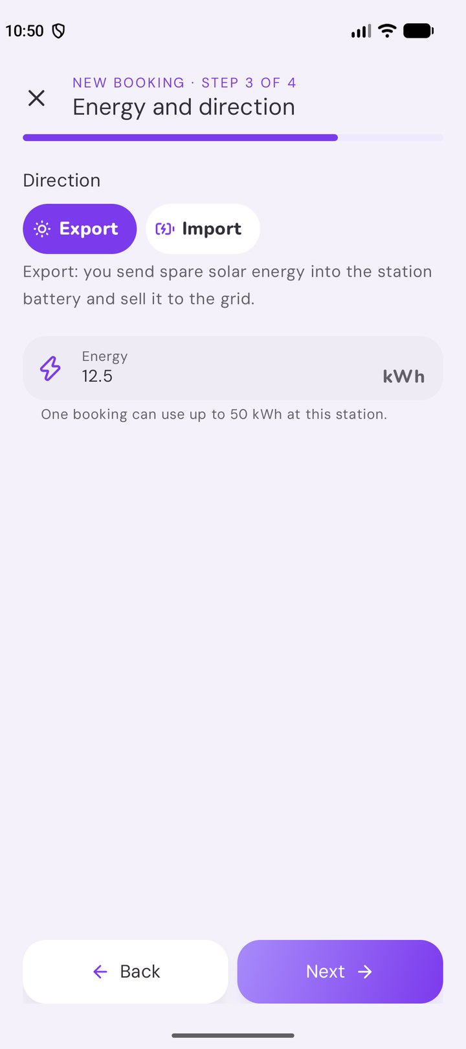  Figure 88: 25 – Booking form: direction and energy | 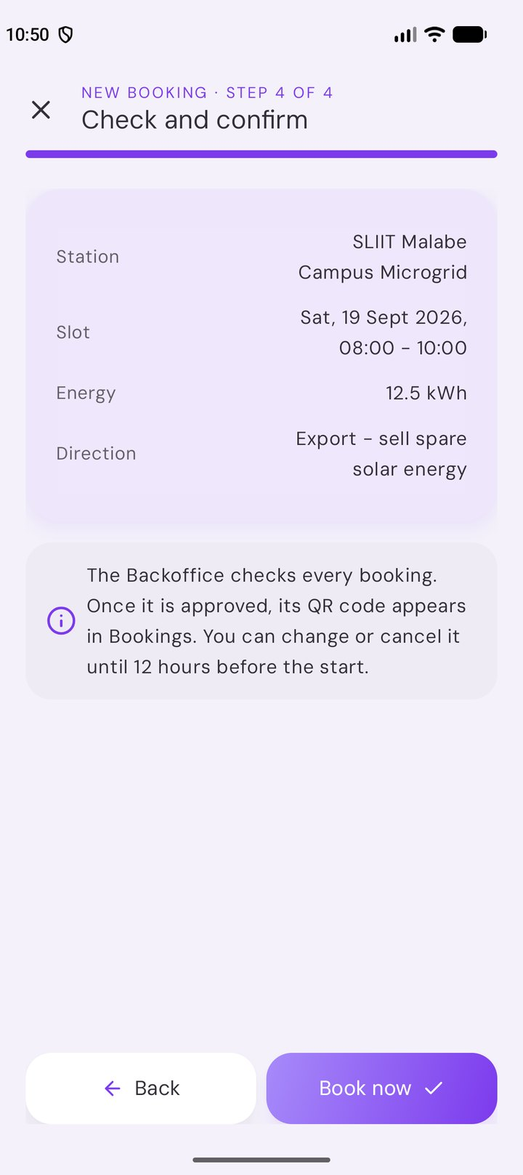  Figure 89: 26 – Booking form: review | 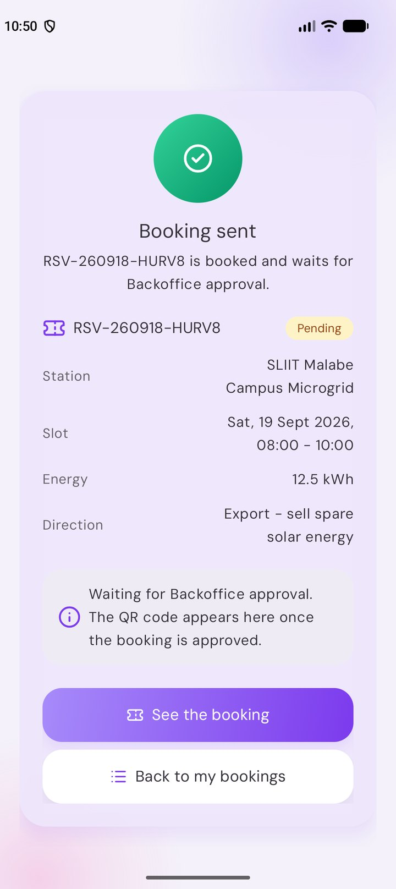  Figure 90: 27 – Summary: booking sent
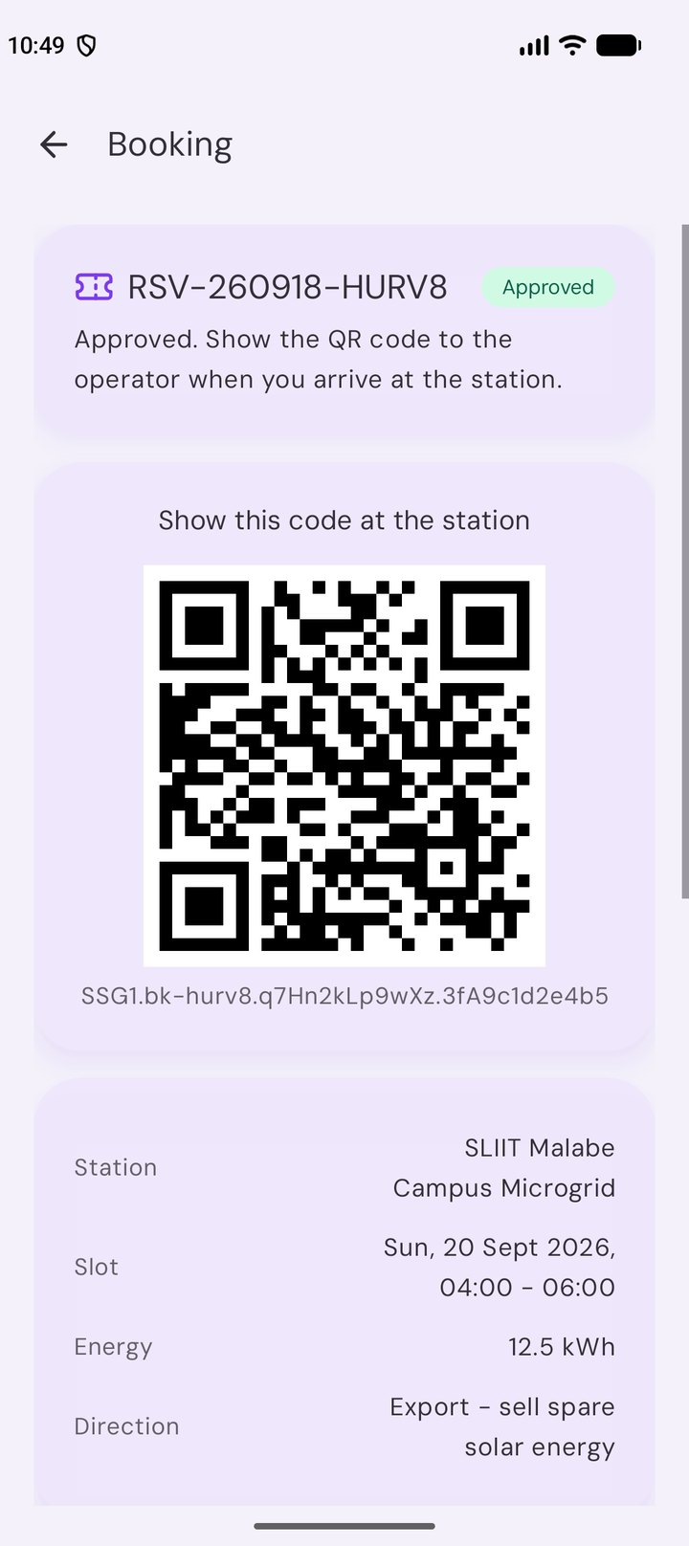  Figure 91: 28 – Approved booking with its QR code | 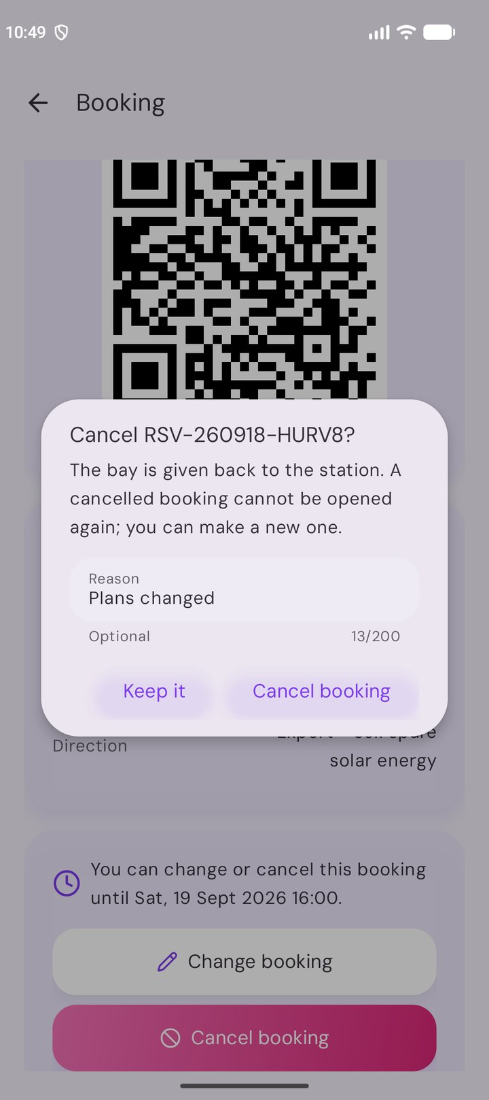  Figure 92: 29 – Cancel with a reason | 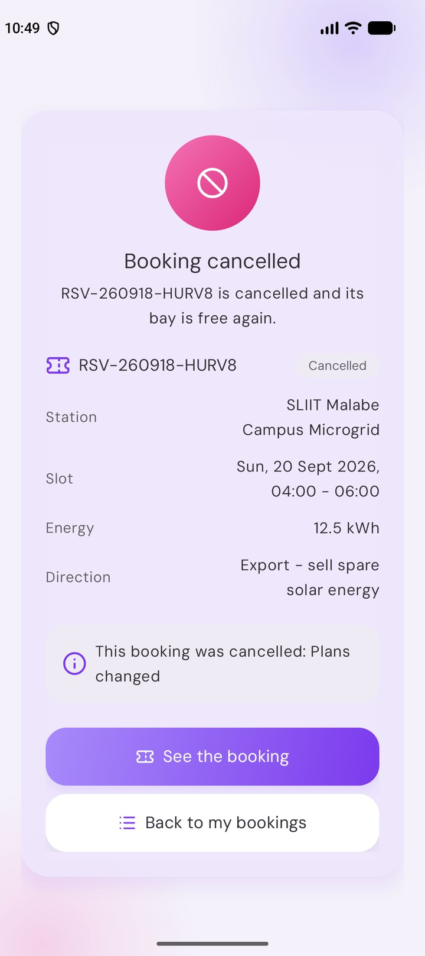  Figure 93: 30 – Summary: booking cancelled
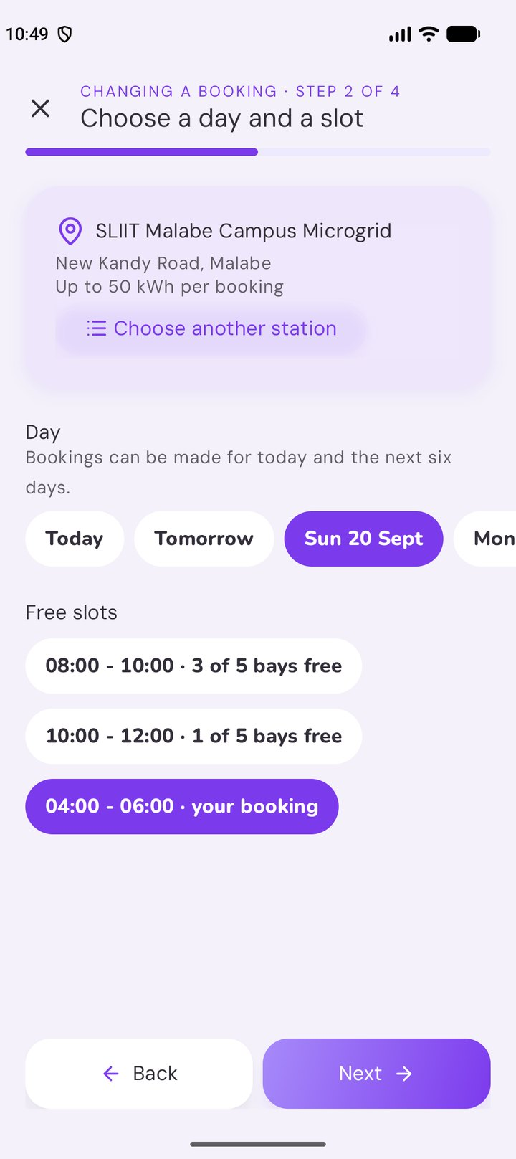  Figure 94: 31 – Changing a booking (own slot kept) | 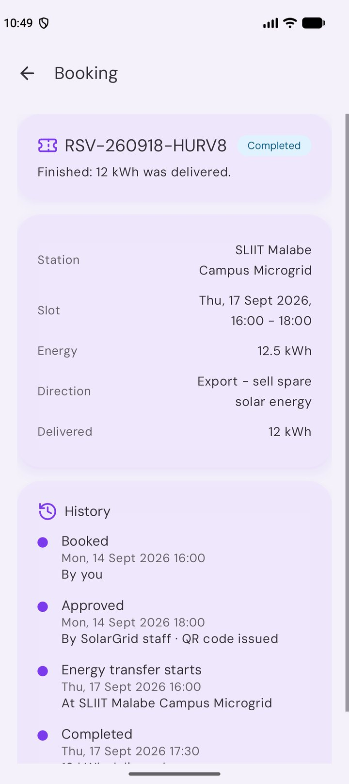  Figure 95: 32 – Completed booking and its history | 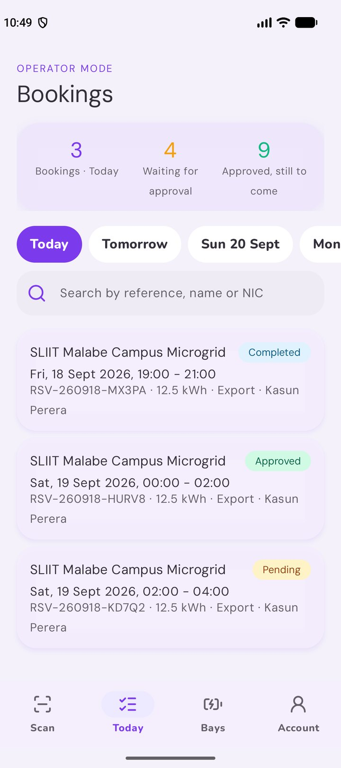  Figure 96: 33 – Operator: the day’s bookings
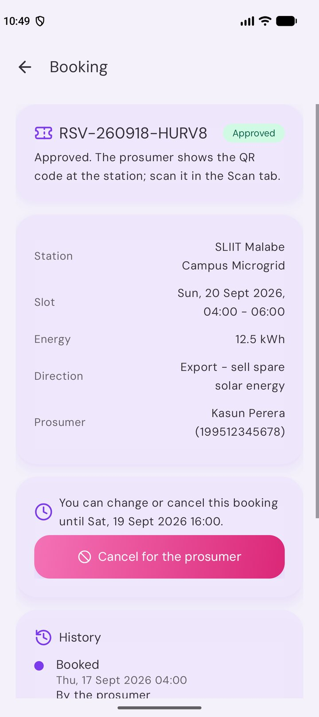
Figure 97: 34 – Operator: booking page with cancel for the prosumer

6 Deployment and hosting
This guide runs the Web API and the web portal locally, hosts both on IIS with MongoDB, and installs the Android app on an emulator or a phone.
Part | IIS site | Address
Web API | SolarGridApi | http://localhost:8080 (Swagger at /swagger)
Web portal (Backoffice and Grid Operators) | SolarGridWeb | http://localhost:8081
Android app (prosumers and Grid Operators) | — (installed on the phone) | Calls the API at http://10.0.2.2:8080/ from the emulator

6.1 Prerequisites
Software | Version used | Notes
Windows 10/11 or Windows Server with IIS | IIS 10 | Turn on Internet Information Services in "Windows Features"
.NET SDK | 10.0 | To build the API
ASP.NET Core Hosting Bundle | 10.0 | Install after IIS; it adds the ASP.NET Core Module to IIS
MongoDB Community Server | 8.x | Running as a Windows service on localhost:27017
MongoDB Compass | any | Optional, for viewing data
Node.js (with npm) | 24.19 (22 or newer works) | To build the web portal
IIS Static Content and Default Document | part of IIS | Installed with the standard IIS web server role

Check the tools from a terminal:
dotnet --list-sdks
Get-Service MongoDB, W3SVC

6.2 Run locally (development)
cd api
dotnet run --project src/SolarGrid.Api

- Swagger opens at http://localhost:5080/swagger.
- On first start the API creates the indexes, the default admin and the demo data.
- Settings are in api/src/SolarGrid.Api/appsettings.json. The development-only token key is in appsettings.Development.json.
The web portal in development mode (with the API running on IIS or with dotnet run):
cd web
npm install
npm run dev

- The portal opens at http://localhost:5173. It calls the API at http://localhost:8080 unless web/.env.local sets another VITE_API_URL (use http://localhost:5080 with dotnet run).
- Optional: VITE_GOOGLE_MAPS_API_KEY in web/.env.local shows Google Maps; without it the maps use OpenStreetMap. .env.local is ignored by Git.

6.3 Host the API on IIS (automatic)
Open PowerShell as Administrator in the repository folder and run:
powershell -ExecutionPolicy Bypass -File deploy\iis\deploy-api.ps1

The script (deploy/iis/deploy-api.ps1):
1. Publishes a Release build to api/publish.
2. Stops the site if it is already running.
3. Copies the files to C:\inetpub\SolarGridApi.
4. Creates appsettings.Production.json there with random keys for signing login tokens (Jwt:Key) and booking QR codes (Qr:SigningKey). The file is kept on later deployments, so existing QR codes stay valid, and it never goes into Git.
5. Creates the application pool SolarGridApiPool with .NET CLR version = No Managed Code.
6. Creates the website SolarGridApi on port 8080.
7. Turns WebDAV off for this site only, if WebDAV is installed. WebDAV answers PUT and DELETE with 405 before the API sees them. The change is written to applicationHost.config, because many IIS installs lock the modules section for web.config files.
8. Gives the application pool read access to the folder, and write access to logs.
9. Optional -OpenFirewall: opens TCP 8080 for devices on the same local network (needed for a real Android phone).
Then check the deployment:
powershell -ExecutionPolicy Bypass -File deploy\iis\smoke-test.ps1

All checks should print PASS. Swagger is available at http://localhost:8080/swagger.

6.4 Host the API on IIS (manual steps, for the report)
1. IIS Manager → Application Pools → Add Application Pool: name SolarGridApiPool, .NET CLR version No Managed Code.
2. Run dotnet publish api/src/SolarGrid.Api -c Release -o C:\inetpub\SolarGridApi.
3. Sites → Add Website: name SolarGridApi, physical path C:\inetpub\SolarGridApi, application pool SolarGridApiPool, port 8080.
4. Create C:\inetpub\SolarGridApi\appsettings.Production.json:
{
"Jwt": { "Key": "<a random string of at least 32 characters>" },
"Qr": { "SigningKey": "<another random string of at least 32 characters>" }
}

5. Give IIS AppPool\SolarGridApiPool Read & execute permission on the folder.
6. If WebDAV is installed: select the site, open Modules, remove WebDAVModule; open Handler Mappings, remove WebDAV. Or run as Administrator:
& "$env:windir\System32\inetsrv\appcmd.exe" set config SolarGridApi "-section:system.webServer/modules" "/-[name='WebDAVModule']" "/commit:apphost"
& "$env:windir\System32\inetsrv\appcmd.exe" set config SolarGridApi "-section:system.webServer/handlers" "/-[name='WebDAV']" "/commit:apphost"

7. Browse to http://localhost:8080/api/health.

6.5 Host the web portal on IIS (automatic)
The API must already be running on IIS (section 3). Open PowerShell as Administrator in the repository folder and run:
powershell -ExecutionPolicy Bypass -File deploy\iis\deploy-web.ps1

The script (deploy/iis/deploy-web.ps1):
1. Installs the packages (npm ci) and builds the portal (npm run build) with VITE_API_URL=http://localhost:8080. Use -ApiUrl http://<PC IP address>:8080 when other devices open the portal, and -SkipInstall to reuse web/node_modules. If web/.env.local has a Google Maps key, the build uses Google Maps; the script only says whether a key is there and never prints it.
2. Copies web/dist to C:\inetpub\SolarGridWeb (old files are removed).
3. Creates the application pool SolarGridWebPool with .NET CLR version = No Managed Code (the portal is only static files).
4. Creates the website SolarGridWeb on port 8081 (it stops if another site already uses that port).
5. Adds the MIME types the portal needs (.js, .css, .svg, .woff2, .json) when IIS does not know them yet.
6. Sets the browser cache: pages are sent with Cache-Control: no-cache, so a new deployment shows at once; files in /assets have a content hash in their names and are cached for a year. Like the WebDAV fix of the API, these settings are written to applicationHost.config.
7. Gives IIS AppPool\SolarGridWebPool and IUSR read access to the folder.
8. Optional -OpenFirewall: opens TCP 8081 for devices on the same local network.
Then check it:
powershell -ExecutionPolicy Bypass -File deploy\iis\smoke-test-web.ps1

The smoke test opens the start page, downloads every script, style sheet and font, checks the cache headers and the API address inside the scripts, and asks the API whether it accepts the portal (CORS). All checks should print PASS.
The portal uses hash addresses (http://localhost:8081/#/stations), so IIS always serves the same index.html and no URL Rewrite module is needed.

6.6 Host the web portal on IIS (manual steps, for the report)
1. In web, run npm ci and npm run build. The files are in web/dist.
2. Copy the contents of web/dist to C:\inetpub\SolarGridWeb.
3. Application Pools → Add Application Pool: name SolarGridWebPool, .NET CLR version No Managed Code.
4. Sites → Add Website: name SolarGridWeb, physical path C:\inetpub\SolarGridWeb, application pool SolarGridWebPool, port 8081.
5. Select the site, open MIME Types, and add .woff2 → font/woff2 if it is missing.
6. Select the site, open HTTP Response Headers → Set Common Headers, tick Expire Web content → Immediately. Then select the assets folder and set Expire Web content → After 365 days. The same with appcmd (as Administrator):
& "$env:windir\System32\inetsrv\appcmd.exe" set config SolarGridWeb "-section:system.webServer/staticContent" "/clientCache.cacheControlMode:DisableCache" "/commit:apphost"
& "$env:windir\System32\inetsrv\appcmd.exe" set config "SolarGridWeb/assets" "-section:system.webServer/staticContent" "/clientCache.cacheControlMode:UseMaxAge" "/clientCache.cacheControlMaxAge:365.00:00:00" "/commit:apphost"

7. Browse to http://localhost:8081 and log in with a staff account.

6.7 The Android app
The app is a normal Android project in android/. It needs no server of its own: it calls the Web API on IIS.

6.7.1 7.1 What is needed
Software | Version used | Notes
Android Studio | 2026.1 | Brings Java (JBR), the Android SDK and the emulator
Android SDK platform | 37 | Installed from Android Studio's SDK Manager
Emulator or phone | Android 9 (API 28) or newer | We tested on a Pixel 10 emulator with Android 17 (API 37)

6.7.2 7.2 Settings (android/local.properties)
cd android
copy local.properties.example local.properties

Setting | Value
sdk.dir | The Android SDK folder (Android Studio fills it in)
MAPS_API_KEY | The Google Maps key for Android. The file is ignored by Git, so the key is never committed
API_BASE_URL | Where the app finds the API (see below)

Where the app runs | API_BASE_URL
Android emulator | http://10.0.2.2:8080/ (the emulator's name for the PC)
Real phone on the same Wi-Fi | http://<PC IP address>:8080/ — find the IP with ipconfig, deploy the API with -OpenFirewall, and add the IP to app/src/main/res/xml/network_security_config.xml (plain HTTP is only allowed for the listed addresses)

On Android 17 the app asks for Nearby devices before it first calls an API on the local network; allow it.

6.7.3 7.3 The Google Maps key
In Google Cloud, restrict the Android key so that only this app can use it:
1. Application restriction: Android apps → package lk.sliit.solargrid and the SHA-1 of the debug keystore (run .\gradlew signingReport in android and copy the SHA1 of the debug variant).
2. API restriction: Maps SDK for Android.
Without a key the map tab shows the station list instead, and everything else works.

6.7.4 7.4 Build and install
cd android
.\gradlew assembleDebug # builds app\build\outputs\apk\debug\app-debug.apk
.\gradlew installDebug # installs it on the running emulator or the phone

The APK can also be copied to a phone and opened there (allow "install unknown apps" for the file manager). APK files are kept out of Git; the submission zip carries a copy.

6.8 Troubleshooting
Symptom | Likely cause | Fix
HTTP 500.19, code 0x8007000d | Hosting Bundle missing, or installed before IIS | Install or repair the .NET Hosting Bundle, then run iisreset
HTTP 500.19, code 0x80070021 | web.config changes a section that IIS has locked (for example <modules>) | Keep such settings out of web.config; our script sets them for the site in applicationHost.config
HTTP 500.30 / app fails to start | Missing or short Jwt:Key / Qr:SigningKey, or a settings error | Check appsettings.Production.json; set stdoutLogEnabled="true" in web.config and read logs\
405 on PUT/DELETE | WebDAV module handles the request | Re-run the deploy script (step 7) or remove WebDAV for the site as shown above; the smoke test checks this
/api/health returns 503 | MongoDB service stopped | Start-Service MongoDB
Phone cannot connect | Firewall or wrong address | Deploy with -OpenFirewall; use the PC's LAN IP, not localhost
The app waits and then says it cannot reach the server | "Nearby devices" refused (Android 17), or a wrong API_BASE_URL | Allow Nearby devices in the app settings; check API_BASE_URL in android/local.properties and rebuild
The map tab shows only the list, or a grey map | No Maps key in local.properties, or the key does not allow this app | Add MAPS_API_KEY; in Google Cloud allow package lk.sliit.solargrid with the debug SHA-1 and the Maps SDK for Android
Portal shows an old version | The browser kept the old index.html | Re-run deploy-web.ps1 (it turns caching off for pages) and refresh once
Portal says "Cannot reach the server" | API stopped, wrong API address in the build, or CORS | Run smoke-test-web.ps1; rebuild with -ApiUrl; add the portal address to Cors:AllowedOrigins in the API settings
Fonts look plain, or 404 for .woff2 | IIS does not know the .woff2 type | Re-run deploy-web.ps1 (step 5) or add the MIME type by hand
Maps show "Google Maps did not accept the API key" | The key does not allow this address | In Google Cloud, add http://localhost:8081/* to the key's website restrictions; OpenStreetMap is used meanwhile

Sources: API-04 and API-11 (Web API), WEB-02 and WEB-18 (web portal) in section 11.1.

6.9 Demo accounts
The API creates these accounts on its first start (App:SeedDemoData):
Role | Login (email or NIC) | Password | State
Backoffice | admin@solargrid.lk / 198512345678 | Admin@123 | Active
Grid Operator | operator@solargrid.lk / 199023456789 | Operator@123 | Active
Prosumer | kasun@example.com / 200034501234 | Prosumer@123 | Active
Prosumer | nadeesha@example.com / 995671234V | Prosumer@123 | Active
Prosumer | tharindu@example.com / 200112304567 | Prosumer@123 | Pending activation
Prosumer | dilani@example.com / 882345678V | Prosumer@123 | Deactivated

The demo data also contains bookings in every status. Booking RSV-DEMO-0006 is approved and starts within two hours of the first start-up, so its QR code can be checked in straight away. Delete the SolarGridDb database in MongoDB Compass and restart the API to get fresh demo data.

7 Testing
Every part has its own automatic tests, and the hosted system on IIS has smoke tests. A pull request was merged only after the tests of its part passed; the complete suite ran again on each integration branch before it was merged into main.
Part | Kind of test | Tools | Tests | What they check
Web API | Unit | xUnit, NSubstitute, a fake clock | 212 (156 tests + 56 data rows) | Every business rule with fake repositories, at any date and time
Web API | End-to-end | xUnit with the real API in memory and a temporary MongoDB database | 67 | Complete journeys over HTTP against a real database, which is deleted afterwards
Web API on IIS | Smoke test | deploy/iis/smoke-test.ps1 | 13 checks | The hosted API: health, Swagger, login, lists, PUT and DELETE through IIS
Web portal | Unit | Vitest, Testing Library | 185 | Shared components, session handling and every page with a fake API
Web portal | Browser (end-to-end) | Playwright with Chromium, the real API on port 5090 and a temporary database | 40 | Every role clicking through the portal, including QR check-in with a pretend webcam
Web portal on IIS | Smoke test | deploy/iis/smoke-test-web.ps1 | 9 checks | Start page, scripts, styles and fonts, cache headers, the API address and CORS
Android app | Unit | JUnit 4, Robolectric, MockWebServer | 104 | SQLite tables, the error reader, the repositories against a stand-in server, booking texts and Sri Lankan time
Android app | Emulator (instrumented) | Espresso, UiAutomator, a stand-in server | 47 | Sign-in for each role, sign-up, profile, map, booking, change, cancel, QR code, operator check-in and every screen for the pictures
Android app | Live | Espresso tests marked @LiveApi, android/scripts/run-e2e.ps1 | 11 | The app against the real API and a temporary database: sign-in and refusals, sign-up, nearby stations, booking and cancelling, the app’s QR code passing the operator check

7.1 How to run the tests
cd api; dotnet test # API unit and end-to-end tests
cd web; npm run lint; npm test; npm run e2e # web lint, unit and browser tests
cd android; .\gradlew lintDebug testDebugUnitTest # Android lint and unit tests
cd android; .\gradlew connectedDebugAndroidTest # emulator tests (a running emulator is needed)
android\scripts\run-e2e.ps1 # Android live tests against the real API
deploy\iis\smoke-test.ps1; deploy\iis\smoke-test-web.ps1 # checks of the IIS sites

The end-to-end and live tests start their own copy of the API on port 5090 with a temporary database whose name starts with SolarGridDb_, and delete it when they finish, so the demo data on IIS is never touched.

7.2 Quality checks
- ESLint for the web portal and Android lint for the app must report no problems.
- Every source file starts with a header block (file, module, owner, purpose) and every method has a comment above it, as the brief requires.
- Code taken from outside sources carries a Source: comment that points to its entry in section 11.1.
- No keys are stored in Git: the Google Maps keys live in files that Git ignores, and the IIS deploy script creates random signing keys on the server.

8 Git repository and workflow
Repository: https://github.com/Ravindu200232/eda-assignment
Demo video (5 minutes or less): [add the YouTube or OneDrive link]
The main branch holds 140 commits: 115 commits with changes and 25 merge commits from 24 pull requests.

8.1 Branches
The work is split into 12 member branches (3 parts × 4 members) and 3 integration branches. Each member's branches have the same name in every part.
Member | API | Web | Android
Ravindu | api/ravindu-core-auth-operator | web/ravindu-core-auth-operator | android/ravindu-core-auth-operator
Malith | api/malith-prosumers-dashboard | web/malith-prosumers-dashboard | android/malith-prosumers-dashboard
Nimthara | api/nimthara-stations-slots-maps | web/nimthara-stations-slots-maps | android/nimthara-stations-slots-maps
Hamnad | api/hamnad-reservations-qr | web/hamnad-reservations-qr | android/hamnad-reservations-qr
Integration | api/integration | web/integration | android/integration

How work reaches main:
1. Each member branch is merged into its part's integration branch through a pull request. The core branch goes first and reservations go last, because they depend on stations and prosumers.
2. The complete unit and end-to-end test suite runs on the integration branch.
3. When everything passes, the integration branch is merged into main through a pull request.

8.2 Folder structure
api/ C# Web API solution (src + unit tests + end-to-end tests)
web/ React web application (staff portal for Backoffice and Grid Operators)
android/ Android Studio project (Java + XML + SQLite) for prosumers and Grid Operators
deploy/iis/ Scripts to host the API and the web portal on IIS and check them
docs/ Database design, API endpoints, web pages, Android screens, deployment guide, demo script, screenshots
sources/ Every outside source and library we used, explained in plain English

8.3 Pull requests
Every pull request was merged with a merge commit, so the history shows which branch each change came from. The branches were kept after merging.
# | Pull request | From → into | Commits | Merged (Sri Lanka time)
1 | API: core platform, login and staff users (Ravindu) | api/ravindu-core-auth-operator → api/integration | 8 | 16 Sep 2026 23:24
2 | API: prosumer accounts, activation and dashboards (Malith) | api/malith-prosumers-dashboard → api/integration | 6 | 16 Sep 2026 23:26
3 | API: stations, schedules, slots and nearby search (Nimthara) | api/nimthara-stations-slots-maps → api/integration | 6 | 16 Sep 2026 23:27
4 | API: reservations, booking rules and QR codes (Hamnad) | api/hamnad-reservations-qr → api/integration | 6 | 16 Sep 2026 23:27
5 | API: operator QR check-in and full-journey test (Ravindu) | api/ravindu-core-auth-operator → api/integration | 8 | 16 Sep 2026 23:30
6 | Integrated Web API: all members (api/integration → main) | api/integration → main | 39 | 16 Sep 2026 23:32
7 | API: delete stations that were never booked (Nimthara) | api/nimthara-stations-slots-maps → api/integration | 1 | 17 Sep 2026 04:42
8 | API: isPast flag for ended reservations (Hamnad) | api/hamnad-reservations-qr → api/integration | 1 | 17 Sep 2026 04:44
9 | API follow-ups for the web app (api/integration → main) | api/integration → main | 4 | 17 Sep 2026 04:45
10 | Web: design system, sign-in, staff users and QR check-in (Ravindu) | web/ravindu-core-auth-operator → web/integration | 9 | 17 Sep 2026 09:52
11 | Web: home page, dashboards, prosumers and activations (Malith) | web/malith-prosumers-dashboard → web/integration | 8 | 17 Sep 2026 10:23
12 | Web: fix a timing-dependent prosumer details test (Malith) | web/malith-prosumers-dashboard → web/integration | 1 | 17 Sep 2026 14:57
13 | Web: stations, slots, opening hours and maps (Nimthara) | web/nimthara-stations-slots-maps → web/integration | 6 | 17 Sep 2026 15:53
14 | Web: reservations, booking wizard and QR codes (Hamnad) | web/hamnad-reservations-qr → web/integration | 8 | 17 Sep 2026 15:56
15 | Web: IIS hosting, documentation and screenshots (Ravindu) | web/ravindu-core-auth-operator → web/integration | 6 | 17 Sep 2026 16:29
16 | Web portal phase (web/integration → main) | web/integration → main | 44 | 17 Sep 2026 16:32
17 | Web: screenshots with Google Maps (Ravindu) | web/ravindu-core-auth-operator → web/integration | 1 | 17 Sep 2026 22:58
18 | Web screenshots with Google Maps (web/integration → main) | web/integration → main | 2 | 17 Sep 2026 22:59
19 | Android core: sign-in, app shells and operator check-in | android/ravindu-core-auth-operator → android/integration | 17 | 18 Sep 2026 07:21
20 | Android prosumer accounts: sign-up, dashboard, profile and deactivation | android/malith-prosumers-dashboard → android/integration | 7 | 18 Sep 2026 08:06
21 | Android stations: map of nearby stations, station page and battery bays | android/nimthara-stations-slots-maps → android/integration | 6 | 18 Sep 2026 12:58
22 | Android bookings: booking form, booking page with QR code, summaries and the operator Today list | android/hamnad-reservations-qr → android/integration | 7 | 18 Sep 2026 23:13
23 | Android docs: screens and permissions, SQLite tables, deployment and demo script | android/ravindu-core-auth-operator → android/integration | 3 | 19 Sep 2026 00:00
24 | Android app: prosumer and Grid Operator app with SQLite, maps, bookings and QR check-in | android/integration → main | 45 | 19 Sep 2026 00:06

8.4 Commits
Commits are small and describe one change each, for example “Add the booking wizard with the 7-day day chips”. All commits were pushed from one GitHub account, the repository owner’s (Ravindu Bandara Subasinha). The branches and pull requests show which member each part of the work belongs to, and every commit message ends with the AI co-author line described in section 9.6.

9 Individual contributions
Each member owns one feature from end to end – in the Web API, the web portal and the Android app. Every source file starts with a header that names its owner, and each member’s part is on the member’s own branches and pull requests (section 8).

9.1 Feature ownership
Member | Feature ownership
Ravindu | Core platform, authentication, staff user management, operator QR verification, IIS hosting
Malith | Prosumer accounts (NIC registration, activation, deactivation), dashboards and summaries
Nimthara | Microgrid stations, battery slots, schedules, maps and nearby search
Hamnad | Energy reservations, booking workflow and rules, booking history, QR code generation

9.2 Web API
Member | Endpoints | Business rules and other work
Ravindu | auth/*, users/*, checkin/*, health | Project set-up, MongoDB data layer and indexes, seed data, JWT login and role checks, blocking tokens of deactivated accounts, staff account rules, QR verification with a 2-hour check-in window, transfer completion, error handling, Swagger, IIS hosting scripts
Malith | prosumers/*, dashboard/* | NIC registration (pending until activated), profile updates, password-confirmed deactivation, Backoffice-only activation, activation queue, live dashboard numbers (Sri Lanka "today")
Nimthara | stations/*, slots/* | Station codes, GPS, capacity and schedule validation, battery slot availability, deactivation blocked by active bookings, nearby search with $geoNear, slot creation and weekly generation inside opening hours
Hamnad | reservations/* | 7-day booking window, 12-hour change and cancel notice, atomic bay counter (no overbooking), overlap check, approval and rejection, signed QR codes, current/pending/history lists and search

9.3 Web portal
Member | Pages | Other work
Ravindu | Login, Staff users, My account, QR check-in (camera, USB scanner or pasted code), not-found and not-allowed pages | Project set-up (Vite, Tailwind CSS, ESLint, Vitest, Playwright), the clay design system and shared components, layouts and menu, API client and session handling, role guards, test helpers and the screenshot run, IIS hosting of the portal
Malith | Home page, Backoffice dashboard, Operations page, Prosumers (list and details), Pending activations | Live numbers that refresh while visible, waiting sign-ups badge in the menu, "Missed" booking status, prosumer create, edit, deactivate and Backoffice-only activation
Nimthara | Stations (list and map), New / edit station, Station details | Google Maps with an OpenStreetMap fallback, location chooser, weekly opening hours editor, battery bays, slots per day with add, generate, change and delete, bay shortcut on the Operations page
Hamnad | Reservations (lists), New / change booking wizard, Booking page | Tabs kept in the address for dashboard links, filters and search, approve / reject / cancel dialogs, 12-hour lock, booking timeline, booking QR code with print and copy

9.4 Android app
Member | Screens | Other work
Ravindu | Start-up, Log in, Account, operator Scan and Check-in | Project set-up (Gradle, Java 17, minimum Android 9), the clay theme on Android (fonts, shapes, clay buttons and cards, icons), the Web API client with the token header and the error reader, the SQLite helper and the session table, role routing and session end, the Android 17 local network permission, edge-to-edge screens, the test set-up (Robolectric, stand-in API, Espresso, screenshots, live test script)
Malith | Sign-up and "waiting for activation", Home dashboard, Profile, Change password, Deactivate | Profile table for offline use, dashboard counts with pull to refresh, form helpers and messages, the password dialog
Nimthara | Map and station list, Station page, operator Bays | Google Maps with coloured markers and a station card, the phone's location with a Colombo fallback, stations table for offline use, weekly opening hours, slots per day, plural strings
Hamnad | Bookings (current, waiting, history), Booking form (new and change), Booking page with the QR code, Summary, operator Today | Reservations table for offline use, search, filters and paging, QR drawing with a bright screen, the booking history, the own slot kept when changing, cancelling for a prosumer

9.5 Files per owner
Counted from the “Owner” line in the header of every source file (application code and tests; generated icons are not counted). Ravindu’s part includes the shared set-up of each app: the project files, the design system and shared components, the API client, the IIS scripts and the test set-up.
Member | Web API | Web portal | Android app | Tests (all parts)
Ravindu | 51 files, 3,309 lines | 70 files, 4,316 lines | 85 files, 6,219 lines | 56 files, 6,116 lines
Malith | 8 files, 724 lines | 14 files, 1,607 lines | 24 files, 2,475 lines | 24 files, 2,524 lines
Nimthara | 8 files, 1,032 lines | 26 files, 2,406 lines | 18 files, 2,201 lines | 25 files, 2,966 lines
Hamnad | 7 files, 903 lines | 8 files, 1,366 lines | 26 files, 4,368 lines | 19 files, 3,130 lines

9.6 Use of AI tools
Tool. We used Claude Code, an AI coding assistant made by Anthropic (model Claude Opus 5), in the Claude desktop app. It was used:
- for planning: reading the brief and the marking scheme, listing the requirements, and planning the branches, the order of work and the tests;
- for development: writing and changing the C# Web API, the React web portal, the Android app, the automatic tests, the IIS scripts and the documentation, and running the builds and the tests;
- for this report: drawing the diagrams from the design and putting the report together from the project documentation.
Visible in Git. Every commit made with the tool ends with the line “Co-Authored-By: Claude Opus 5 <noreply@anthropic.com>”, and the pull request descriptions end with “Generated with Claude Code”, so the AI’s part can be seen in the history of the repository.
Permission. The assignment brief we downloaded (page 6) sets the assessment at Level 2 – AI Planning, which allows AI tools only in the planning stage.
[To be completed by the team: the module lecturer’s confirmation that AI tools may be used for the development in this assignment – who gave it, when, and how (e-mail, announcement or updated brief). Keep a copy for the viva.]
Checking the work. Every change was checked by the automatic tests in chapter 7 before it was merged, and the hosted API and portal were checked with the IIS smoke tests.
[Each member: describe how you reviewed, tested and changed the work of your own feature.]

9.7 Reflections
Each member’s short reflection on the use of AI tools, in their own words.

Ravindu Bandara Subasinha (IT22098450)
[To be written by Ravindu: which AI tools you used and for what, what you checked or changed yourself, what you learned, and what you would do differently next time (about 100–150 words).]

Malith
[To be written by Malith: which AI tools you used and for what, what you checked or changed yourself, what you learned, and what you would do differently next time (about 100–150 words).]

Nimthara
[To be written by Nimthara: which AI tools you used and for what, what you checked or changed yourself, what you learned, and what you would do differently next time (about 100–150 words).]

Hamnad
[To be written by Hamnad: which AI tools you used and for what, what you checked or changed yourself, what you learned, and what you would do differently next time (about 100–150 words).]

10 Challenges
We kept a log of the problems we met while building the system (docs/challenges.md). Each entry says what went wrong, why it happened and what we changed, and “Where” points to the files that hold the fix.

10.1 Web API and hosting
1. IIS refused to start the API (HTTP 500.19, error 0x80070021)
Problem: The API worked in Visual Studio. On IIS, every request returned HTTP Error 500.19 – Internal Server Error.
Why: Our web.config removed the WebDAV module in a <modules> section. On this PC, IIS locks that section at server level, so a site's own web.config may not change it.
Fix: web.config no longer touches <modules>. The deploy script turns WebDAV off for the API site with appcmd ... /commit:apphost, which writes the change to the server-level file where it is allowed.
Where: api/src/SolarGrid.Api/web.config, deploy/iis/deploy-api.ps1 (step 7), docs/deployment.md.
2. PUT and DELETE requests failed with HTTP 405 on IIS
Problem: Updating or deleting a record worked locally but returned 405 Method Not Allowed on IIS.
Why: The IIS WebDAV module handles PUT and DELETE itself, before the request reaches ASP.NET Core.
Fix: WebDAV is removed for the API site only (see challenge 1). The smoke test now sends a PUT and a DELETE and expects the API's own 404 answer, so the problem is caught straight after a deployment.
Where: deploy/iis/smoke-test.ps1 ("PUT and DELETE reach the API").
3. The smoke test counted one station instead of five
Problem: The IIS smoke test reported the wrong number of stations and built a wrong slots address.
Why: Windows PowerShell 5.1 passes a JSON array from Invoke-RestMethod down the pipeline as a single object.
Fix: A small Get-JsonList helper sends the items one by one before they are counted.
Where: deploy/iis/smoke-test.ps1.
4. No database transactions for bookings
Problem: Two prosumers booking the last free bay at the same moment could both succeed.
Why: Our MongoDB runs as a single server, and multi-document transactions need a replica set.
Fix: The bay counter is updated with one atomic $inc that only matches while a bay is still free. Status changes (approve, cancel, complete) use "replace only if the status is still X". If nothing matched, the API answers 409 and asks the user to try again.
Where: SlotRepository, ReservationRepository.ReplaceIfStatusAsync, ReservationService, CheckInService.
5. "Today" and the 7-day / 12-hour rules depend on the time zone
Problem: Dates saved in UTC showed the wrong day around midnight, and rules were hard to test.
Why: The server clock and the users' clocks are not always in the same time zone.
Fix: Times are stored in UTC and every rule uses Sri Lanka time (Asia/Colombo) through one AppClock class. Tests replace the clock with FakeTimeProvider, so a rule such as "12 hours before the start" can be tested at an exact moment. The web app also shows every time in Sri Lanka time.
Where: api/src/SolarGrid.Api/Common/AppClock.cs, web/src/utils/format.js.
6. An invalid role gave a confusing error message
Problem: Sending "role": "Admin" returned "The request field is required."
Why: When JSON cannot be read, ASP.NET Core adds two errors, and the less helpful one was shown first.
Fix: The error response now prefers the JSON error and says which field has an invalid value.
Where: api/src/SolarGrid.Api/Common/ValidationResponse.cs.
7. Saving an unchanged record looked like a failure
Problem: Saving a station without changing anything returned "not found".
Why: MongoDB reports ModifiedCount = 0 when the new document is identical to the old one.
Fix: Repositories check MatchedCount (the record exists) instead of ModifiedCount.
8. Development keys ended up on the IIS server
Problem: The published folder contained appsettings.Development.json with the development signing keys.
Fix: The project file excludes that file from publishing. The deploy script creates random production keys once, in appsettings.Production.json on the server; this file is never committed to Git.
Where: SolarGrid.Api.csproj, deploy/iis/deploy-api.ps1 (step 4), .gitignore.
9. Tokens stayed valid after an account was deactivated
Problem: A login token lasts 8 hours, so a deactivated user could keep working until it expired.
Fix: On every request the API checks that the account is still active and still has the same role. If not, it answers 401 with a clear message, and the web app returns to the login page and shows that message.
Where: api/src/SolarGrid.Api/Extensions/AuthSetup.cs, web/src/api/client.js.
10. The deploy command did not run
Problem: Running the deploy script from Command Prompt gave "'Start-Process' is not recognized".
Fix: The documentation now gives one command that works from any Administrator window: powershell -ExecutionPolicy Bypass -File deploy\iis\deploy-api.ps1.
Where: docs/deployment.md.

10.2 Web app
11. Page refresh gave "404 Not Found" on IIS
Problem: A single-page app needs the web server to return index.html for addresses such as /users.
Why: The IIS on the host PC has no URL Rewrite module.
Fix: The web app uses hash addresses (/#/users). The part after # never reaches the server, so no rewrite rules are needed.
Where: web/src/routes/router.jsx.
12. API field errors did not appear under the right form fields
Problem: The API names fields like FullName or $.role; the forms use fullName and role.
Fix: One helper converts the names, so every form shows the API's message under the matching field and a short summary at the top.
Where: web/src/api/client.js (getFieldErrors), web/src/components/ui/FormAlert.jsx.
13. Unit tests could not open dialogs
Problem: The test browser (jsdom) has no showModal() for <dialog> and no matchMedia.
Fix: The test set-up file adds small stand-ins for both, so dialogs and the phone/desktop table layouts can be tested.
Where: web/src/test/setup.js.
14. The camera only works on secure pages
Problem: Browsers allow the camera only on https:// pages or on http://localhost. A tablet opening the portal through the PC's network address (for example http://192.168.1.20:8081) cannot use the camera.
Fix: The check-in page explains this and always offers two other ways: a USB barcode scanner (it types the code and presses Enter) or pasting the code text.
Where: web/src/pages/checkin/CameraScanner.jsx.
15. Testing the camera scanner without a camera
Problem: The automatic browser tests run on a PC without a webcam pointed at a phone.
Fix: The test creates a short video that shows a real booking QR code and starts Chromium with that video as a pretend webcam. The test then checks that the code is read and checked by the API.
Where: web/e2e/fake-camera.js, web/e2e/checkin.spec.js.
16. Screen readers and tests read "Password*" instead of "Password"
Problem: The red star for required fields was part of the label text.
Fix: The star is now drawn with CSS, so the label's name stays "Password". The field is still marked as required for screen readers.
Where: web/src/components/ui/Field.jsx.
17. A map library's licence did not suit the project
Problem: react-leaflet (Leaflet maps as React components) uses the Hippocratic licence, which adds conditions beyond the usual open-source terms.
Fix: It was removed. The maps use plain Leaflet (BSD licence) through two small components of our own.
Where: web/src/components/maps/LeafletStationMap.jsx, LeafletPickerMap.jsx, sources/libraries.md.
18. Keeping the Google Maps key out of GitHub
Problem: Google Maps needs an API key, and a key pushed to GitHub can be copied and misused.
Fix: The key lives only in web/.env.local, which Git ignores; web/.env.example explains the setting. A key in a web page can always be read in the browser, so it is also restricted in Google Cloud to our local web addresses and to the Maps JavaScript API. Without a key the portal uses OpenStreetMap.
Where: web/.env.example, web/src/components/maps/mapProvider.js.
19. The page crashed when Google refused the key
Problem: The browser tests run on port 5174, which was not in the key's list of allowed addresses. Google reported RefererNotAllowedMapError, and removing its broken pins then threw an error that took down the whole page.
Fix: Google's gm_authFailure callback now switches every map to OpenStreetMap with a short note, pins are removed safely, and an error boundary replaces a failing Google map with OpenStreetMap. Normal test runs use OpenStreetMap on purpose (VITE_MAPS_PROVIDER=osm), so they do not depend on Google or use the key's free quota; only the screenshot run tries Google Maps.
Where: web/src/components/maps/googleMaps.js, MapErrorBoundary.jsx, web/playwright.config.js.
20. Testing maps without a real browser
Problem: Unit tests run in jsdom, which cannot load Google Maps.
Fix: Leaflet works in jsdom, so its tests use the real library. The Google map components are tested with a small pretend Google library that records pins, clicks and drags.
Where: web/src/components/maps/LeafletStationMap.test.jsx, GoogleMaps.test.jsx, web/src/test/fakeGoogleMaps.js.
21. A 24-hour station made a very long page
Problem: Malabe is open all day, so its seven days hold 84 slots and the details page became several screens long.
Fix: The slots card shows one day at a time with day tabs (each with its number of slots). It opens on the first day that still has slots to come, and jumps to the day of a slot that was just added.
Where: web/src/pages/stations/SlotsPanel.jsx.
22. Layout problems found in the screenshots
Problem: The "switched to OpenStreetMap" note became its own grid column beside the map, and full-page screenshots showed the sticky top bar in the middle of the page after the test had scrolled.
Fix: The map component wraps the note and the map in one box, and the screenshot helper scrolls back to the top before taking a picture.
Where: web/src/components/maps/StationMap.jsx, web/e2e/screens.js.
23. The code checker rejected reading the clock while drawing
Problem: The React rules in ESLint do not allow Date.now() while a component is drawn, because the result changes on every draw.
Fix: Whether a slot has already ended is worked out once, when the slots are loaded.
Where: web/src/pages/stations/SlotsPanel.jsx (loadSlots).
24. Tests that failed only on a busy computer
Problem: Long station forms typed key by key needed more than the default 5 seconds when all test files ran together, and one prosumer test checked the bookings request before the page had started it.
Fix: Unit tests may take up to 15 seconds, and the prosumer test now waits for the bookings table first (fixed on Malith's branch).
Where: web/vite.config.js, web/src/pages/prosumers/ProsumerDetailsPage.test.jsx.
25. Booking a slot on behalf of a prosumer
Problem: Staff bookings must name the prosumer (the API asks for the NIC), and only active accounts may book. The first version listed the search results as radio buttons, so moving through them with the arrow keys already picked a person.
Fix: The wizard searches active prosumers only and shows the matches as ordinary buttons; the chosen person stays at the top with a "Choose someone else" button. When a booking is changed, the prosumer cannot change.
Where: web/src/pages/reservations/BookingWizardPage.jsx.
26. Changing a booking whose slot is now full
Problem: The wizard only lists slots with a free bay. A booking in a full slot could not see its own slot, so staff could not change just the energy or the trade type.
Fix: When a booking is changed, its own slot is always added to the list and marked "This booking's slot".
Where: web/src/pages/reservations/BookingWizardPage.jsx (slotChoicesFor).
27. Slots of the previous day stayed on screen while loading
Problem: The data hook keeps the old answer while a new one loads, so after picking another day the old day's slots could still be clicked for a moment.
Fix: Each slot answer is tagged with its station and day, and only an answer that matches the current choice is shown; otherwise a loading placeholder appears.
Where: web/src/pages/reservations/BookingWizardPage.jsx (loadFreeSlots).
28. Demo bookings change while the browser tests run
Problem: The demo bookings move with the clock, and other tests change them (the check-in test completes RSV-DEMO-0006). Tests that edit them would fail depending on the order and the time of day.
Fix: The booking tests create their own active prosumers and bookings through the API and pick slots by time ("starts within 11 hours", "starts after 36 hours"). The demo bookings are only read.
Where: web/e2e/reservations.spec.js, web/e2e/helpers.js.
29. Dashboard numbers linked to pages that did not exist yet
Problem: The dashboards (built earlier) already linked to /reservations?tab=pending and ?tab=current.
Fix: The booking list keeps its tab in the address, so these links open the right list, and the back button returns to it. A browser test clicks the dashboard number to prove it.
Where: web/src/pages/reservations/ReservationsPage.jsx.
30. The booking filters filled a phone screen
Problem: Five stacked filter fields pushed the bookings below the first screen on a phone.
Fix: On phones the filters fold away behind a "Filters" button that also shows how many are in use.
Where: web/src/pages/reservations/ReservationsPage.jsx.
31. Printing only the QR code
Problem: Printing the booking page printed every card, not a slip the prosumer can take away.
Fix: Everything except the page heading and the QR code card is marked no-print, and the Print button opens the browser's print dialog.
Where: web/src/pages/reservations/ReservationDetailsPage.jsx, web/src/components/qr/QrCodeCard.jsx.
32. Serving the portal files from IIS
Problem: IIS only sends files whose extension it knows, and without cache settings a browser may keep an old index.html after a new deployment, which then asks for script files that no longer exist.
Fix: deploy-web.ps1 checks the MIME types the portal needs and adds missing ones, sends pages with Cache-Control: no-cache and lets the hashed files in /assets be cached for a year. The web smoke test checks the page, every script, style sheet and font, both cache headers, the API address and CORS.
Where: deploy/iis/deploy-web.ps1, deploy/iis/smoke-test-web.ps1.
33. Clean screenshots for the report
Problem: The Google Maps key did not allow the test address (http://localhost:5174), so the map pictures showed the "switched to OpenStreetMap" note, and a map tooltip stayed visible where the mouse had clicked.
Fix: E2E_MAPS_PROVIDER=osm takes the screenshots with OpenStreetMap on purpose (Google Maps is used once the key allows that address), and the screenshot helper moves the mouse away before each picture.
Where: web/playwright.config.js, web/e2e/screens.js.

10.3 Android app
34. The clay look needs Android 9
Problem: The app was set to run from Android 8.0, but lint reported errors: the coloured shadows (outlineAmbientShadowColor, outlineSpotShadowColor) and the variable font weights (fontVariationSettings) only work from Android 9.
Why: Those attributes were added in API 28. On Android 8 the shadows would be grey and every heading would fall back to one weight, so the app would not match the web portal.
Fix: The lowest supported version is Android 9 (minSdk 28). It still covers the phones people use, and the design is the same on every one of them.
Where: android/app/build.gradle.kts.
35. Icons drawn in a browser did not draw on Android
Problem: Some screens crashed with "a needs to be followed by a multiple of 7 floats. However, 6 float(s) are found" while the layout was being inflated.
Why: The icons are the Lucide set used by the web portal. In SVG the two yes/no flags of an arc may be written without a separator (a1.5 1.5 0 00-2.4-1.5). Browsers accept that; Android's path reader counts six numbers instead of seven and refuses the whole file.
Fix: The converter now reads each path command itself and writes every number with a space in between, treating the two arc flags as single digits. All icons were made again with it.
Where: android/scripts/make-icons.mjs, android/app/src/main/res/drawable/ic_*.xml.
36. Saving the screenshots off the phone
Problem: The screenshot test ran and passed, but no pictures arrived on the computer.
Why: The test asked Android for the app's own folder on the shared storage, and on this emulator that folder is not given out, so the pictures were written to a read-only place. The failure was silent because the screenshot call only returns true or false.
Fix: The test now hands each picture to the test runner's own storage (the AndroidX test services), which copies it into app/build/outputs, and the script moves the files into docs/screenshots/android. A picture that cannot be saved now fails the test instead of being lost.
Where: android/app/src/androidTest/java/lk/sliit/solargrid/screens/ScreensTest.java, android/scripts/take-screenshots.ps1.
37. The title sat under the phone's clock
Problem: On the check-in screen the back arrow and the title were drawn behind the status bar.
Why: From Android 15 an app is always drawn edge to edge, behind the status bar and the navigation bar.
Fix: Every screen asks the system how much room those bars need and pads itself by that much, so the content starts below the clock and ends above the gesture bar.
Where: android/app/src/main/java/lk/sliit/solargrid/ui/common/BaseActivity.java.
38. The live test script started nothing
Problem: android\scripts\run-e2e.ps1 said it was starting the API, then waited three minutes and gave up.
Why: The repository folder is C:\eda assignment, with a space in the name. PowerShell's Start-Process does not put quotes around the values in -ArgumentList, so dotnet was told the project was C:\eda. The window was hidden, so the message never reached the screen.
Fix: The project path is quoted, and the API now writes to a log file that the script prints when the server does not answer in time.
Where: android/scripts/run-e2e.ps1.
39. The app could not reach the API that the emulator could
Problem: Against a real server, every request from the app ran for 20 seconds and then failed with "failed to connect to /10.0.2.2 (port 8080)", although the emulator itself reached the same port at once.
Why: From Android 17, an app that targets it may not connect to the local network (private addresses such as 10.0.2.2 or 192.168.x.x) until the user allows the "Nearby devices" permission ACCESS_LOCAL_NETWORK. The blocked connection does not fail quickly; it just never answers. Our tests with the stand-in server passed because that server runs on the phone itself, which does not count as the local network.
Fix: The app declares the permission and asks for it before its first request when the API address is on the local network; an API on the internet needs nothing. If the user says no, the login screen explains how to allow it. The live tests grant the permission before they start.
Where: android/app/src/main/java/lk/sliit/solargrid/util/LocalNetwork.java, ui/common/BaseActivity.java, ui/auth/LoginActivity.java, ui/auth/SplashActivity.java, AndroidManifest.xml.
40. The last boxes of the sign-up form could not be reached
Problem: On the sign-up screen the tests could not scroll to the solar panel box: "Scrolling to view was attempted, but the view is not displayed".
Why: The screen leaves room for the status bar, the navigation bar and the keyboard by adding padding. That padding was put on the ScrollView itself, but a ScrollView ignores its own padding when it works out how far to scroll, so a box could end up hidden behind the keyboard.
Fix: The screens whose top view is a ScrollView now have a plain frame around it. The frame takes the padding, so the scrolling area itself becomes shorter and every box can be scrolled into view.
Where: android/app/src/main/res/layout/activity_login.xml, activity_register.xml, activity_registered.xml.
41. A tap on a tab was sometimes lost in the emulator tests
Problem: The operator bay test tapped the Bays tab straight after the screen opened, and now and then the Scan tab stayed on screen, so the test could not find the counter.
Why: The tap arrived while Android was still running the window animation of the new screen, and was dropped. Espresso cannot wait for those system animations.
Fix: The emulator tests run with the window animations switched off (testOptions.animationsDisabled), as the Espresso guide advises. During one long run the emulator's own Android system also restarted, which has nothing to do with the app; restarting the emulator before a full run avoids it.
Where: android/app/build.gradle.kts.
42. The first map on the emulator stayed empty in the screenshots
Problem: The map picture showed a beige area with the Google logo, but no streets and no station markers.
Why: The key and the markers were fine: on the emulator the first map needs several seconds to load its drawing code and tiles, and the picture was taken after four.
Fix: The screenshot walk waits twelve seconds for the map before the picture. The station card was also made solid, because the see-through clay card let the streets show through its words.
Where: android/app/src/androidTest/java/lk/sliit/solargrid/screens/ScreensTest.java, android/app/src/main/res/layout/fragment_stations.xml.
43. Changing a booking whose own slot is now full
Problem: In "Change booking" the slot the booking already held would be missing from the list whenever the booking's own bay was the last one, so the prosumer could not keep the slot and only change the energy.
Why: For prosumers the API only lists slots that can still be booked: open, not started and with a free bay. The booking itself uses one of the bays of its slot, so a slot filled by it is left out.
Fix: The form adds the booking's own slot back when it shows the booking's own station and day, marked "your booking", and chooses it at the start - the same answer the web portal gives (challenge 26). The API still checks everything when the change is saved.
Where: android/app/src/main/java/lk/sliit/solargrid/ui/booking/SlotChoices.java, BookingWizardActivity.java.
44. The summary screen opened a second copy of the booking page
Problem: Every booking action ends on the summary screen, but the booking page that started a change or a cancel is still open underneath it. Opening the booking from the summary would add a second copy of the page, and pressing back would show the booking as it was before.
Why: Starting a screen normally always adds a new copy, and the old page does not know the booking changed.
Fix: The summary screen asks Android to bring back the page that is already open (FLAG_ACTIVITY_CLEAR_TOP with FLAG_ACTIVITY_SINGLE_TOP), and the booking page loads the booking again whenever it comes back to the front. "Back to my bookings" does the same with the prosumer home and opens the list where the booking now is: waiting after a new booking or a change, history after a cancel. The home screen only switches tab once it is on screen again, because a tab cannot be swapped while Android is still restoring the screen.
Where: ui/booking/BookingResultActivity.java, ui/booking/BookingDetailsActivity.java, ui/prosumer/MainActivity.java, ui/operator/OperatorActivity.java.
45. Turning the picked dates back into days
Problem: The first version of the date filter did not build for Android 9, and on a phone set to a time zone behind UTC it would have filtered by the day before the one that was tapped.
Why: The Material date picker answers with midnight UTC of each chosen day, as milliseconds. Reading those in the phone's own time zone moves the moment back a day wherever the clock is behind UTC. The easy LocalDate.ofInstant method is also missing on Android 9, the oldest version the app supports.
Fix: The milliseconds are read as UTC on purpose: Instant.ofEpochMilli(ms).atZone(ZoneOffset.UTC).toLocalDate(), which works on every supported version and gives exactly the day that was tapped.
Where: ui/booking/BookingsFragment.java.
46. The reason for a refused booking disappeared
Problem: While writing the emulator tests we saw that when the API refused a booking because the slot had just filled up, its message would be hidden again a moment later.
Why: After a refusal the form reloads the slots and chooses the same slot again, and choosing a slot also hid the message - even though the prosumer had not tapped anything.
Fix: Choosing a slot no longer hides the message; it is cleared only when the prosumer moves to another step. An emulator test now fills the slot on purpose and checks that the message stays.
Where: ui/booking/BookingWizardActivity.java, android/app/src/androidTest/.../ui/booking/BookingFlowTest.java.
47. The operator's day list started with the evening
Problem: Straight from the API, the operator "Today" list would show the latest booking first, which is the wrong way round for planning the day at a station.
Why: Without a list tab the API sorts bookings newest first, which suits the history lists of the web portal.
Fix: The day list holds at most one day of bookings (one page of up to 100), so the app sorts that page from the morning on before showing it. The API and its other users are unchanged.
Where: ui/operator/TodayFragment.java.
48. Test data showed slots that crossed midnight
Problem: Some booking screenshots showed slots such as "22:30 - 00:30", which no real station has.
Why: The sample bookings started on whole UTC hours. Sri Lanka is 5 hours 30 ahead of UTC, so every sample began at half past the hour in the app, and some ran past midnight.
Fix: The sample bookings now start on whole Sri Lankan hours, like the real two-hour slots, and the booking saved in the form walk uses exactly the slot that was chosen on screen.
Where: android/app/src/testShared/java/lk/sliit/solargrid/testing/Samples.java, ScreensTest.java.
49. An operator's booking history said "by you"
Problem: In the emulator tests an operator opening a prosumer's booking read "Booked - by you".
Why: The test helper signed every role in with the same NIC as the sample prosumer, so the app rightly thought the operator had made the booking.
Fix: The helper now gives an operator a NIC and name of their own and a prosumer the sample prosumer's details. The screenshot script also stopped copying Espresso's "view-op-error" pictures, which it saves whenever a step fails, even one the test expects.
Where: android/app/src/androidTest/java/lk/sliit/solargrid/testing/AppUnderTest.java, android/scripts/take-screenshots.ps1.
50. A tap on a booking tab became a long press
Problem: On a busy emulator the filter test tapped the "Waiting" tab, but the list never changed, and the test failed twice at the same step while every other tap worked.
Why: The emulator was so slow that the finger-up event arrived late. Android then reads the tap as a long press (the log says "Overslept and turned a tap into a long press"), and a long press on a tab only shows its tooltip.
Fix: The tests choose a booking tab directly through a small Espresso action (TabActions.selectTab) and then wait for the app, so the step no longer depends on how fast the emulator is. The screen code is unchanged.
Where: android/app/src/androidTest/java/lk/sliit/solargrid/testing/TabActions.java, BookingFlowTest.java, ScreensTest.java, LiveApiTest.java.
51. The emulator tests stopped after one second
Problem: connectedDebugAndroidTest failed at once with "The process cannot access the file because it is being used by another process" for the folder of the test results.
Why: The Gradle daemon and the emulator had been started from a terminal that was sitting inside that folder. Windows does not delete a folder that a running program uses as its working folder.
Fix: Stop the Gradle daemon (gradlew --stop), start the emulator from its own folder, and run Gradle from the project folder. A slow emulator was also restarted, which brought a full emulator run back from about 45 minutes to about 3.
Where: How the tests are run; nothing in the code changed.

10.4 What we learned
- Test on the real host early. Several problems appeared only on IIS (challenges 1, 2, 11 and 32). The deploy scripts now end with smoke tests, so a broken deployment is found at once.
- Keep every rule in one place. Because the Web API owns all business rules, the web portal and the Android app cannot disagree about the 7-day window or the 12-hour notice (challenge 5), and a fix in the API fixes both clients.
- Plan for two people at the same moment. Our MongoDB runs without transactions, so the booking counter uses one atomic update and status changes use “replace only if the status is still the same” (challenge 4).
- Keep secrets out of Git from the first day. Map keys and signing keys live only in ignored files or on the server (challenges 8 and 18).
- Make tests independent of time and speed. A fake clock, waiting for the server instead of the clock, and tests that do not rely on a quick emulator made the test runs repeatable (challenges 24, 41, 50 and 51).

11 References
Every outside source used in the code is listed here with a short code. The same code is written as a Source: comment in each program file that uses it, so the code and its reference can be matched in both directions. Full details are also kept in the sources folder of the repository. All links were opened and checked in September 2026.

11.1 Code sources

Web API (API-01 to API-16)
[API-01] Microsoft Learn — Create a web API with ASP.NET Core and MongoDB. https://learn.microsoft.com/en-us/aspnet/core/tutorials/first-mongo-app (accessed September 2026).
Connecting the API to MongoDB. Used in: api/src/SolarGrid.Api/Data/MongoDbContext.cs (constructor), api/src/SolarGrid.Api/Data/MongoSettings.cs. What we used: The pattern only: a settings class bound from appsettings.json and a single MongoClient registered once. The four collections, the time-out setting and everything else are our own. Added by Ravindu.
[API-02] Microsoft Learn — Configure JWT bearer authentication in ASP.NET Core. https://learn.microsoft.com/en-us/aspnet/core/security/authentication/configure-jwt-bearer-authentication (accessed September 2026).
Login tokens (JWT). Used in: api/src/SolarGrid.Api/Extensions/AuthSetup.cs, api/src/SolarGrid.Api/Security/JwtTokenService.cs. What we used: AddJwtBearer, the validation settings (issuer, audience, signing key, lifetime) and MapInboundClaims = false. Our own additions: the NIC/role claims, friendly 401/403 messages and the 8-hour expiry. Added by Ravindu.
[API-03] Microsoft Learn — Handle errors in ASP.NET Core APIs. https://learn.microsoft.com/en-us/aspnet/core/fundamentals/error-handling-api (accessed September 2026).
Standard error messages (ProblemDetails). Used in: api/src/SolarGrid.Api/Middleware/ErrorHandlingMiddleware.cs, api/src/SolarGrid.Api/Common/ProblemResponse.cs, api/src/SolarGrid.Api/Common/ValidationResponse.cs. What we used: Results.Problem(...), AddProblemDetails() and replacing InvalidModelStateResponseFactory. The mapping of our own exception types to status codes is our own. Added by Ravindu.
[API-04] Microsoft Learn — Host ASP.NET Core on Windows with IIS. https://learn.microsoft.com/en-us/aspnet/core/host-and-deploy/iis/ (accessed September 2026).
Hosting the API on IIS. Used in: api/src/SolarGrid.Api/web.config, deploy/iis/deploy-api.ps1, docs/deployment.md. What we used: The required settings. The script that automates them (secrets file, permissions, firewall option) is our own. Added by Ravindu.
[API-05] Swashbuckle.AspNetCore documentation — Add Security Definitions and Requirements for Bearer authentication. https://github.com/domaindrivendev/Swashbuckle.AspNetCore/blob/master/docs/configure-and-customize-swaggergen.md (accessed September 2026).
Swagger test page with a login button. Used in: api/src/SolarGrid.Api/Extensions/SwaggerSetup.cs. What we used: The AddSecurityDefinition / AddSecurityRequirement example (about 10 lines), with our own titles and descriptions. Licence: MIT. Added by Ravindu.
[API-06] BCrypt.Net-Next — project README. https://github.com/BcryptNet/bcrypt.net (accessed September 2026).
Safe password storage (BCrypt). Used in: api/src/SolarGrid.Api/Security/PasswordHasher.cs. What we used: The two calls BCrypt.HashPassword and BCrypt.Verify. We wrapped them in our own IPasswordHasher so tests can use a faster setting. Licence: MIT. Added by Ravindu.
[API-07] Microsoft Learn — Integration tests in ASP.NET Core. https://learn.microsoft.com/en-us/aspnet/core/test/integration-tests (accessed September 2026).
Running the whole API inside tests. Used in: api/tests/SolarGrid.Api.E2ETests/Infrastructure/ApiFactory.cs. What we used: WebApplicationFactory<Program> with ConfigureWebHost. The throw-away database per run and the helper methods are our own. Added by Ravindu.
[API-08] Microsoft Learn — What is the TimeProvider class. https://learn.microsoft.com/en-us/dotnet/standard/datetime/timeprovider-overview (accessed September 2026).
A controllable clock for time rules. Used in: api/src/SolarGrid.Api/Common/AppClock.cs, api/tests/SolarGrid.Api.UnitTests/TestSupport/TestClock.cs. What we used: The idea and the two classes. The Sri Lanka time-zone helpers in AppClock are our own. Added by Ravindu.
[API-09] Wikipedia — National identity card (Sri Lanka); The Sri Lanka — Understanding Sri Lanka's National Identity Card System. https://en.wikipedia.org/wiki/National_identity_card_(Sri_Lanka) · https://thesrilanka.lk/docs/national-identity-card/understanding-sri-lankan-nic-system/ (accessed September 2026).
Sri Lankan NIC number format. Used in: api/src/SolarGrid.Api/Common/NicValidator.cs. What we used: Facts only (the number layout). No code was copied; the checking code is our own. Added by Ravindu.
[API-10] MongoDB Docs — Serialization and POCOs (.NET/C# Driver). https://www.mongodb.com/docs/drivers/csharp/current/serialization/ · https://www.mongodb.com/docs/drivers/csharp/current/serialization/poco/ (accessed September 2026).
How data is saved in MongoDB (naming and enums). Used in: api/src/SolarGrid.Api/Data/MongoDbContext.cs (RegisterConventions). What we used: The ConventionPack / ConventionRegistry.Register pattern. The choice of conventions and the namespace filter are our own. Added by Ravindu.
[API-11] Microsoft Learn — Troubleshoot Web API2 apps that work in Visual Studio and fail on a production IIS server; Microsoft Learn — Getting Started with AppCmd.exe; Microsoft Learn — IIS modules with ASP.NET Core. https://learn.microsoft.com/en-us/aspnet/web-api/overview/testing-and-debugging/troubleshooting-http-405-errors-after-publishing-web-api-applications · https://learn.microsoft.com/en-us/iis/get-started/getting-started-with-iis/getting-started-with-appcmdexe · https://learn.microsoft.com/en-us/aspnet/core/host-and-deploy/iis/modules (accessed September 2026).
Turning off WebDAV on IIS. Used in: deploy/iis/deploy-api.ps1 (Remove-SiteEntry, step 7), docs/deployment.md. What we used: The removal of the WebDAVModule module and WebDAV handler, and the appcmd /-[name='…'] and /commit:apphost options. The check that runs it only when WebDAV is installed is our own. Added by Ravindu.
[API-12] MongoDB Docs — Create and Manage Indexes (.NET/C# Driver). https://www.mongodb.com/docs/drivers/csharp/current/indexes/ (accessed September 2026).
Database indexes. Used in: api/src/SolarGrid.Api/Data/IndexSetup.cs. What we used: CreateIndexModel with Builders<T>.IndexKeys (Ascending, Geo2DSphere) and Unique = true. Which fields are indexed is our own design. Added by Ravindu.
[API-13] MongoDB Docs — Aggregation Pipeline Stages (.NET/C# Driver); MongoDB Manual — $group (aggregation stage). https://www.mongodb.com/docs/drivers/csharp/current/aggregation/stages/ · https://www.mongodb.com/docs/manual/reference/operator/aggregation/group/ (accessed September 2026).
Adding up completed transfers (aggregation). Used in: api/src/SolarGrid.Api/Repositories/ReservationRepository.cs (GetCompletedTotalsAsync). What we used: The Aggregate().Match(...).Group(...) builder calls. The totals we calculate (count and delivered kWh) are our own. Added by Malith.
[API-14] MongoDB Manual — $geoNear (aggregation stage); MongoDB Docs — Aggregation Pipeline Stages (.NET/C# Driver). https://www.mongodb.com/docs/manual/reference/operator/aggregation/geoNear/ · https://www.mongodb.com/docs/drivers/csharp/current/aggregation/stages/ (accessed September 2026).
Finding the nearest stations ($geoNear). Used in: api/src/SolarGrid.Api/Repositories/StationRepository.cs (FindNearbyAsync). What we used: The $geoNear options (distanceField, maxDistance, spherical, query) through the driver's GeoNear builder. Converting metres to kilometres and hiding inactive stations are our own. Added by Nimthara.
[API-15] MongoDB Manual — Atomicity and Transactions; MongoDB Manual — $expr (query predicate operator). https://www.mongodb.com/docs/manual/core/write-operations-atomicity/ · https://www.mongodb.com/docs/manual/reference/operator/query/expr/ (accessed September 2026).
Never overbooking a slot (atomic update with a condition). Used in: api/src/SolarGrid.Api/Repositories/SlotRepository.cs (TryTakeBayAsync), api/src/SolarGrid.Api/Repositories/ReservationRepository.cs (ReplaceIfStatusAsync). What we used: The idea of a conditional single-document update. Applying it to battery bays and booking status changes is our own. Added by Hamnad.
[API-16] Microsoft Learn — HMACSHA256 Class; Microsoft Learn — CryptographicOperations.FixedTimeEquals Method. https://learn.microsoft.com/en-us/dotnet/api/system.security.cryptography.hmacsha256 · https://learn.microsoft.com/en-us/dotnet/api/system.security.cryptography.cryptographicoperations.fixedtimeequals (accessed September 2026).
Signing the booking QR code (HMAC). Used in: api/src/SolarGrid.Api/Security/QrTokenService.cs. What we used: HMACSHA256.HashData and CryptographicOperations.FixedTimeEquals. The QR text format (SSG1.id.nonce.signature) and the nonce idea are our own design. Added by Hamnad.

Web portal (WEB-01 to WEB-32)
[WEB-01] Design Prompts — Clay style, "Get the AI prompt for this design". https://www.designprompts.dev/claymorphism (accessed September 2026).
The "clay" look (design system). Used in: web/src/styles/theme.css (colours, shadows, radii, fonts, animations), web/src/components/ui/styles.js, Card.jsx, Button.jsx, IconOrb.jsx, StatOrb.jsx, BackgroundBlobs.jsx, web/src/layouts/AuthLayout.jsx. What we used: The design values: colour codes, the four shadow recipes, corner sizes, font choice and the animation timings. We turned them into our own Tailwind theme tokens and components; the page layouts are our own. Licence: No licence is stated on the site. The prompt is offered for use in building interfaces, and we credit it here. Added by Ravindu.
[WEB-02] Vite — Getting Started and Build Options. https://vite.dev/guide/ · https://vite.dev/config/build-options (accessed September 2026).
Starting a React project with Vite. Used in: web/vite.config.js, web/index.html, web/src/main.jsx, web/eslint.config.js. What we used: The starter project from npm create vite@latest -- --template react (entry file, ESLint set-up) and the build.rolldownOptions setting. Everything inside src/ was rewritten by us. Licence: MIT. Added by Ravindu.
[WEB-03] Tailwind CSS — Installing Tailwind CSS with Vite and Theme variables. https://tailwindcss.com/docs/installation/using-vite · https://tailwindcss.com/docs/theme (accessed September 2026).
Tailwind CSS with Vite and theme tokens. Used in: web/vite.config.js, web/src/styles/theme.css. What we used: The plugin set-up (2 lines) and the @theme / @keyframes syntax. The token values come from WEB-01. Licence: MIT. Added by Ravindu.
[WEB-04] React Router — createHashRouter and Route Object (lazy). https://reactrouter.com/api/data-routers/createHashRouter · https://reactrouter.com/start/data/route-object (accessed September 2026).
Page addresses (React Router). Used in: web/src/routes/router.jsx, web/src/routes/guards.jsx, web/src/App.jsx, web/src/pages/errors/RouteErrorPage.jsx, web/src/test/render.jsx. What we used: createHashRouter, RouterProvider, Navigate/Outlet, errorElement and the lazy route property. The route list, the role guards and the "return to the page you asked for" logic are our own. Licence: MIT. Added by Ravindu.
[WEB-05] Axios documentation — Interceptors (the older axios-http.com address now forwards here). https://axios.rest/pages/advanced/interceptors (accessed September 2026).
Talking to the API (Axios). Used in: web/src/api/client.js. What we used: axios.create and the two interceptors.*.use calls. The error-to-message rules (getErrorMessage, getFieldErrors) are our own. Licence: MIT. Added by Ravindu.
[WEB-06] React documentation — createContext, useSyncExternalStore, useId, useEffectEvent (stable since React 19.2). https://react.dev/reference/react/createContext · https://react.dev/reference/react/useSyncExternalStore · https://react.dev/reference/react/useId · https://react.dev/reference/react/useEffectEvent (accessed September 2026).
Sharing the signed-in user between pages (React). Used in: web/src/context/AuthContext.jsx, web/src/context/ToastContext.jsx, web/src/components/ui/Field.jsx, web/src/components/ui/fieldContext.js, web/src/pages/checkin/CameraScanner.jsx. What we used: The standard usage of each function. The session rules (prosumer refusal, expiry timer, other-tab logout) are our own. Licence: React docs: CC BY 4.0 · React: MIT. Added by Ravindu.
[WEB-07] Fontsource — Nunito and DM Sans. https://fontsource.org/fonts/nunito · https://fontsource.org/fonts/dm-sans (accessed September 2026).
Fonts that work offline (Fontsource). Used in: web/src/main.jsx, web/src/styles/theme.css (--font-heading, --font-sans). What we used: One import line per font. Licence: SIL Open Font License 1.1 (read from the package files). Added by Ravindu.
[WEB-08] Lucide. https://lucide.dev/license (accessed September 2026).
Icons (Lucide). Used in: Most components and pages, for example web/src/routes/navigation.js, web/src/components/ui/Alert.jsx, web/src/pages/checkin/CheckInPage.jsx. What we used: We only import icons by name; no icon was changed. Licence: ISC (some icons come from Feather and are MIT). Added by Ravindu.
[WEB-09] MDN Web Docs — The Dialog element. https://developer.mozilla.org/en-US/docs/Web/HTML/Reference/Elements/dialog (accessed September 2026).
Dialog windows (<dialog>). Used in: web/src/components/ui/Modal.jsx, web/src/components/ui/Drawer.jsx, web/src/styles/theme.css (::backdrop), web/src/test/setup.js. What we used: showModal(), close(), the cancel event and ::backdrop. The "click outside to close" check and the test stand-in are our own. Added by Ravindu.
[WEB-10] MDN Web Docs — Intl.DateTimeFormat() constructor. https://developer.mozilla.org/en-US/docs/Web/JavaScript/Reference/Global_Objects/Intl/DateTimeFormat/DateTimeFormat (accessed September 2026).
Showing Sri Lanka time. Used in: web/src/utils/format.js, web/src/layouts/TopBar.jsx. What we used: The timeZone and hourCycle options. The helpers (for example "the next 7 Sri Lanka dates") are our own. Added by Ravindu.
[WEB-11] MDN Web Docs — prefers-reduced-motion. https://developer.mozilla.org/en-US/docs/Web/CSS/@media/prefers-reduced-motion (accessed September 2026).
Respecting "reduce motion". Used in: web/src/styles/theme.css. What we used: The @media (prefers-reduced-motion: reduce) rule. Added by Ravindu.
[WEB-12] Vitest — Configuring Vitest; Testing Library — React Testing Library; jest-dom README — With Vitest. https://vitest.dev/config/ · https://testing-library.com/docs/react-testing-library/intro/ · https://github.com/testing-library/jest-dom (accessed September 2026).
Unit tests (Vitest and Testing Library). Used in: web/vite.config.js (test block), web/src/test/setup.js, web/src/test/render.jsx, all *.test.js(x) files. What we used: The set-up lines (defineConfig from vitest/config, import '@testing-library/jest-dom/vitest'). All test cases are our own. Licence: MIT. Added by Ravindu.
[WEB-13] Playwright — Web server, Global setup and teardown, Screenshots, Browsers (full Chromium in headless mode). https://playwright.dev/docs/test-webserver · https://playwright.dev/docs/test-global-setup-teardown · https://playwright.dev/docs/screenshots · https://playwright.dev/docs/browsers (accessed September 2026).
Browser tests (Playwright). Used in: web/playwright.config.js, web/e2e/*.js. What we used: The configuration options (webServer list, globalTeardown, screenshot({ fullPage }), channel: 'chromium'). The test journeys are our own. Licence: Apache-2.0. Added by Ravindu.
[WEB-14] MongoDB Node.js driver documentation and API reference — Db.dropDatabase(). https://www.mongodb.com/docs/drivers/node/current/ · https://mongodb.github.io/node-mongodb-native/7.6/classes/Db.html (accessed September 2026).
Removing the test database. Used in: web/e2e/global-teardown.js. What we used: new MongoClient(...), db(name).dropDatabase(). The safety check (only SolarGridDb_WebE2E_* names) is our own. Licence: Apache-2.0. Added by Ravindu.
[WEB-15] Leaflet — API reference (1.9.4): L.map, L.marker (title, alt, keyboard, draggable), L.divIcon, L.layerGroup, bindTooltip, fitBounds, the map click and marker dragend events; Accessibility guide (every pin needs its own title). https://leafletjs.com/reference.html · https://leafletjs.com/examples/accessibility/ (accessed September 2026).
Maps that work without an API key (Leaflet). Used in: web/src/components/maps/leafletSetup.js, LeafletStationMap.jsx, LeafletPickerMap.jsx, LeafletStationMap.test.jsx. What we used: The library calls listed above. The clay pin design, the "choose a location" behaviour and the switch between map services are our own. We use plain Leaflet instead of the react-leaflet wrapper, because that wrapper's Hippocratic licence adds conditions we did not want in a university project. Licence: BSD-2-Clause. Added by Nimthara.
[WEB-16] OpenStreetMap Foundation — Tile Usage Policy; OpenStreetMap — Copyright and License. https://operations.osmfoundation.org/policies/tiles/ · https://www.openstreetmap.org/copyright (accessed September 2026).
OpenStreetMap map pictures and credit. Used in: web/src/components/maps/leafletSetup.js (tile address and credit link), the offline note in LeafletStationMap.jsx and LeafletPickerMap.jsx. What we used: The tile address https://tile.openstreetmap.org/{z}/{x}/{y}.png and the credit text with its link. The maps only load the tiles a person is looking at; nothing is downloaded in advance. Licence: Map data: Open Database License (ODbL). The tile service may be used under the policy above. Added by Nimthara.
[WEB-17] qrcode.react — README (QRCodeSVG and its value, size, level, marginSize and title props). https://github.com/zpao/qrcode.react (accessed September 2026).
Drawing booking QR codes (qrcode.react). Used in: web/src/components/qr/QrCodeCard.jsx. What we used: One QRCodeSVG element with those props. The card around it, the booking details and the print and copy buttons are our own. Licence: ISC (the bundled QR generator is MIT). Added by Hamnad.
[WEB-18] Microsoft Learn — IIS configuration reference: Adding Static Content MIME Mappings <mimeMap> and Client Cache <clientCache> (the appcmd examples); Vite — Deploying a Static Site (npm run build writes the app to dist). https://learn.microsoft.com/en-us/iis/configuration/system.webserver/staticcontent/mimemap · https://learn.microsoft.com/en-us/iis/configuration/system.webserver/staticcontent/clientcache · https://vite.dev/guide/static-deploy (accessed September 2026).
Hosting the portal files on IIS. Used in: deploy/iis/deploy-web.ps1, deploy/iis/smoke-test-web.ps1, docs/deployment.md (sections 5 and 6). What we used: The appcmd set config ... -section:system.webServer/staticContent commands for a MIME type and for cacheControlMode (DisableCache, UseMaxAge) and cacheControlMaxAge. Checking first, writing to applicationHost.config and the smoke test are our own. Licence: Microsoft Learn documentation: Creative Commons Attribution 4.0; Vite documentation: MIT. Added by Ravindu.
[WEB-19] W3C WAI-ARIA Authoring Practices Guide — Tabs Pattern. https://www.w3.org/WAI/ARIA/apg/patterns/tabs/ (accessed September 2026).
Keyboard-friendly tabs. Used in: web/src/components/ui/Tabs.jsx. What we used: The key behaviour and the tablist / tab / aria-selected roles. The component code is our own. Added by Ravindu.
[WEB-20] MDN Web Docs — Window: storage event. https://developer.mozilla.org/en-US/docs/Web/API/Window/storage_event (accessed September 2026).
Logging out in every tab. Used in: web/src/context/AuthContext.jsx, web/src/context/sessionStore.js. What we used: Listening for the event (a few lines). Added by Ravindu.
[WEB-21] MDN Web Docs — Window: print() method; @media (the print media type). https://developer.mozilla.org/en-US/docs/Web/API/Window/print · https://developer.mozilla.org/en-US/docs/Web/CSS/@media#print (accessed September 2026).
Printing a booking slip. Used in: web/src/components/qr/QrCodeCard.jsx (Print button), web/src/pages/reservations/ReservationDetailsPage.jsx (no-print on the other cards), web/src/styles/theme.css (@media print). What we used: The print() call and a print media rule that hides everything marked no-print. Which parts of the page are printed is our own choice. Added by Hamnad.
[WEB-22] ZXing for JS — @zxing/browser and @zxing/library (GitHub). https://github.com/zxing-js/browser · https://github.com/zxing-js/library (accessed September 2026).
Reading QR codes with the camera (ZXing). Used in: web/src/pages/checkin/CameraScanner.jsx, web/e2e/fake-camera.js. What we used: BrowserQRCodeReader.decodeFromVideoDevice, listVideoInputDevices and controls.stop() in the app; QRCodeWriter in the test. The camera choice, error advice and "one preview per session" handling are our own. Licence: @zxing/browser: MIT · @zxing/library: Apache-2.0. Added by Ravindu.
[WEB-23] MDN Web Docs — MediaDevices: getUserMedia() and Secure contexts. https://developer.mozilla.org/en-US/docs/Web/API/MediaDevices/getUserMedia · https://developer.mozilla.org/en-US/docs/Web/Security/Secure_Contexts (accessed September 2026).
Camera permission and secure pages. Used in: web/src/pages/checkin/CameraScanner.jsx. What we used: The error names and the secure-page check (window.isSecureContext). The messages for operators are our own. Added by Ravindu.
[WEB-24] Chromium source code — media/base/media_switches.cc (the two start-up switches) and media/capture/video/file_video_capture_device.h (supported Y4M/MJPEG files); WebRTC — Testing WebRTC applications. https://chromium.googlesource.com/chromium/src/+/HEAD/media/base/media_switches.cc · https://chromium.googlesource.com/chromium/src/+/HEAD/media/capture/video/file_video_capture_device.h · https://webrtc.org/getting-started/testing (accessed September 2026).
A pretend webcam for automatic tests. Used in: web/e2e/fake-camera.js, web/e2e/checkin.spec.js. What we used: The switch names --use-fake-device-for-media-stream and --use-file-for-fake-video-capture, and the Y4M header layout. The code that draws the QR code into video frames is our own. Licence: Chromium: BSD-3-Clause (we only used switch names, no code). Added by Ravindu.
[WEB-25] MDN Web Docs — Intl.RelativeTimeFormat. https://developer.mozilla.org/en-US/docs/Web/JavaScript/Reference/Global_Objects/Intl/RelativeTimeFormat (accessed September 2026).
"3 days ago" style times. Used in: web/src/utils/format.js (formatTimeAgo), shown on web/src/pages/prosumers/PendingActivationsPage.jsx. What we used: The formatter with numeric: 'auto'. Choosing days, hours or minutes is our own. Added by Malith.
[WEB-26] MDN Web Docs — Page Visibility API. https://developer.mozilla.org/en-US/docs/Web/API/Page_Visibility_API (accessed September 2026).
Refreshing dashboards only when they are visible. Used in: web/src/hooks/useAutoRefresh.js (used by the dashboards and the menu counter). What we used: document.visibilityState and the visibilitychange event. The timer hook is our own. Added by Malith.
[WEB-27] MDN Web Docs — Element: scrollIntoView() method. https://developer.mozilla.org/en-US/docs/Web/API/Element/scrollIntoView (accessed September 2026).
Scrolling to a section of the home page. Used in: web/src/pages/home/HomePage.jsx. What we used: One call with the behavior option; it jumps instead of gliding when the user asked for reduced motion. Added by Malith.
[WEB-28] Google Maps Platform documentation — Load the Maps JavaScript API (@googlemaps/js-api-loader, importLibrary), Get started with advanced markers (map ID, DEMO_MAP_ID), Basic marker customization (PinElement colours), Advanced markers reference (gmp-click, gmp-dragend, gmpClickable, gmpDraggable), Events (gm_authFailure), Error messages (RefererNotAllowedMapError), API security best practices (website and API restrictions). https://developers.google.com/maps/documentation/javascript/load-maps-js-api · https://developers.google.com/maps/documentation/javascript/advanced-markers/start · https://developers.google.com/maps/documentation/javascript/advanced-markers/basic-customization · https://developers.google.com/maps/documentation/javascript/reference/advanced-markers · https://developers.google.com/maps/documentation/javascript/events · https://developers.google.com/maps/documentation/javascript/error-messages · https://developers.google.com/maps/api-security-best-practices (accessed September 2026).
Google Maps in the web portal. Used in: web/src/components/maps/googleMaps.js, mapProvider.js, GoogleStationMap.jsx, GooglePickerMap.jsx, web/.env.example. What we used: The loader set-up (setOptions, importLibrary), the map, marker and pin options, the two marker events and the gm_authFailure callback. Choosing between Google Maps and OpenStreetMap, switching over when Google fails, and keeping the key out of Git are our own. The key is restricted to our local web addresses and to the Maps JavaScript API. Licence: Documentation: Creative Commons Attribution 4.0, code samples Apache-2.0. The loader package is Apache-2.0. Using the maps follows the Google Maps Platform Terms of Service. Added by Nimthara.
[WEB-29] React documentation — Component: "Catching rendering errors with an error boundary" (static getDerivedStateFromError, componentDidCatch). https://react.dev/reference/react/Component#catching-rendering-errors-with-an-error-boundary (accessed September 2026).
Keeping a map failure inside the map (error boundary). Used in: web/src/components/maps/MapErrorBoundary.jsx, used by StationMap.jsx and PickerMap.jsx. What we used: The class shape with the two methods (React has no function-component version). What the boundary shows and the switch to OpenStreetMap are our own. Licence: Documentation: Creative Commons Attribution 4.0; React is MIT. Added by Nimthara.
[WEB-30] W3C WAI — ARIA Authoring Practices Guide: Switch pattern and Meter pattern. https://www.w3.org/WAI/ARIA/apg/patterns/switch/ · https://www.w3.org/WAI/ARIA/apg/patterns/meter/ (accessed September 2026).
Switches and bay meters for screen readers. Used in: web/src/components/ui/Switch.jsx (opening days, open/closed slots), web/src/pages/stations/BayMeter.jsx (battery bays). What we used: The roles and attributes: a <button> with role="switch" and aria-checked; role="meter" with aria-valuenow, aria-valuemin, aria-valuemax and aria-valuetext. The clay look is our own. Licence: W3C Software and Document License. Added by Nimthara.
[WEB-31] React Router — useSearchParams (the setSearchParams navigate options, such as replace, are listed in the library's own type definition SetURLSearchParams). https://reactrouter.com/api/hooks/useSearchParams (accessed September 2026).
Keeping the chosen list in the address. Used in: web/src/pages/reservations/ReservationsPage.jsx. What we used: Reading tab and setting it with { replace: true }. The tab names and what each tab asks the API for are our own. Licence: MIT. Added by Hamnad.
[WEB-32] MDN Web Docs — Clipboard: writeText() method. https://developer.mozilla.org/en-US/docs/Web/API/Clipboard/writeText (accessed September 2026).
Copying the QR code text. Used in: web/src/components/qr/QrCodeCard.jsx. What we used: One writeText call with error handling. Added by Hamnad.

Android app (AND-01 to AND-35)
[AND-01] Android Developers — Android build overview · Gradle — Sharing dependency versions between projects. https://developer.android.com/build/gradle-build-overview · https://docs.gradle.org/current/userguide/platforms.html (accessed September 2026).
Android project and Gradle set-up. Used in: android/settings.gradle.kts, android/build.gradle.kts, android/app/build.gradle.kts, android/gradle/libs.versions.toml, android/gradle.properties. What we used: The shape of the three build files and the libs.versions.toml format. The SDK levels, library list and the way we read local.properties are our own. Licence: CC BY 4.0 (text) / Apache 2.0 (samples). Added by Ravindu.
[AND-02] Design Prompts — Clay style (the same source as WEB-01 in web-sources.md). https://www.designprompts.dev/claymorphism (accessed September 2026).
The "clay" look on Android. Used in: res/values/colors.xml, dimens.xml, styles.xml, themes.xml, res/drawable/bg_*.xml, res/animator/clay_press.xml, res/color/*.xml, and every layout in res/layout/. What we used: The colour codes, shadow recipes, corner sizes and the press animation, turned by hand into Android themes, styles and drawables so the phone app matches the web portal. Licence: No licence is stated on the site. The prompt is offered for use in building interfaces, and we credit it here. Added by Ravindu.
[AND-03] Google Maps Platform — Use the Secrets Gradle Plugin · Android Developers — Inject build variables into the manifest. https://developers.google.com/maps/documentation/android-sdk/secrets-gradle-plugin · https://developer.android.com/build/manage-manifests (accessed September 2026).
Keeping the Maps key and the API address out of Git. Used in: android/app/build.gradle.kts, android/local.properties.example, AndroidManifest.xml (the Maps key placeholder is added with Nimthara's map work). What we used: The idea and the manifestPlaceholders / buildConfigField lines. We read local.properties with a few lines of Kotlin instead of adding the plugin, so the build has one dependency less. Licence: CC BY 4.0 (text) / Apache 2.0 (samples). Added by Ravindu.
[AND-04] Google Fonts — Nunito and DM Sans · Android Developers — Fonts in XML. https://fonts.google.com/specimen/Nunito · https://fonts.google.com/specimen/DM+Sans · https://developer.android.com/develop/ui/views/text-and-emoji/fonts-in-xml (accessed September 2026).
The two fonts (Nunito and DM Sans). Used in: res/font/nunito.ttf, res/font/dm_sans.ttf, res/font/heading.xml, heading_black.xml, body.xml, body_medium.xml, body_bold.xml, android/licenses/OFL-Nunito.txt, OFL-DMSans.txt. What we used: The two font files as they are, and the <font-family> file format. The weights we picked and where each font is used are our own. Licence: SIL Open Font License 1.1 (both fonts). The licence text is kept in android/licenses/. Added by Ravindu.
[AND-05] Material Components for Android — Color theming, Text fields, Buttons. https://github.com/material-components/material-components-android/blob/master/docs/theming/Color.md · https://github.com/material-components/material-components-android/blob/master/docs/components/TextField.md (accessed September 2026).
Material Components for Android (theme, buttons, cards, text fields). Used in: res/values/themes.xml, styles.xml, and every layout that uses MaterialButton, MaterialCardView, TextInputLayout or MaterialAlertDialogBuilder. What we used: The list of theme attributes (colorPrimary, shapeAppearance*, materialButtonStyle, textInputStyle, …) and the widget names. Every value in our styles comes from AND-02. Licence: Apache 2.0. Added by Ravindu.
[AND-06] Lucide — Icons · Android Developers — Vector drawables overview. https://lucide.dev/icons/ · https://developer.android.com/develop/ui/views/graphics/vector-drawable-resources (accessed September 2026).
Icons (Lucide drawn as Android vectors). Used in: android/scripts/make-icons.mjs and the res/drawable/ic_*.xml files it writes (each member adds the icons of their screens). What we used: The icon shapes (path data) from the Lucide package that is already installed for the web portal, and the <vector> file format. The converter script is ours. Licence: ISC (Lucide) — https://github.com/lucide-icons/lucide/blob/main/LICENSE. Added by Ravindu.
[AND-07] Android Developers — Create app icons (adaptive icons). https://developer.android.com/develop/ui/views/launch/icon_design_adaptive (accessed September 2026).
The app icon (adaptive launcher icon). Used in: res/mipmap-anydpi/ic_launcher.xml, ic_launcher_round.xml, res/drawable/ic_launcher_background.xml, ic_launcher_foreground.xml, ic_launcher_monochrome.xml. What we used: The file layout, the sizes and the safe area rules. The sun drawing is ours, in the colours of AND-02. Licence: CC BY 4.0 (text) / Apache 2.0 (samples). Added by Ravindu.
[AND-08] Android Developers — Network security configuration. https://developer.android.com/privacy-and-security/security-config (accessed September 2026).
Allowing plain HTTP only for the local API. Used in: res/xml/network_security_config.xml, AndroidManifest.xml. What we used: The file format and the cleartextTrafficPermitted rule. We list only 10.0.2.2, localhost and 127.0.0.1; everything else must use HTTPS. Licence: CC BY 4.0 (text) / Apache 2.0 (samples). Added by Ravindu.
[AND-09] Android Developers — Save data using SQLite. https://developer.android.com/training/data-storage/sqlite (accessed September 2026).
Saving data on the phone with SQLite. Used in: data/local/SolarGridDbHelper.java, data/local/SessionDao.java (each member adds their own table and DAO). What we used: The SQLiteOpenHelper pattern with onCreate/onUpgrade, and the insert, query and delete calls. The tables, the single-row session rule and the DAO classes are ours. Licence: CC BY 4.0 (text) / Apache 2.0 (samples). Added by Ravindu.
[AND-10] Material Components — Bottom navigation · Android Developers — Fragment manager. https://github.com/material-components/material-components-android/blob/master/docs/components/BottomNavigation.md · https://developer.android.com/guide/fragments/fragmentmanager (accessed September 2026).
The bottom bar and swapping screens. Used in: ui/prosumer/MainActivity.java, ui/operator/OperatorActivity.java, res/layout/activity_main.xml, activity_operator.xml, res/menu/nav_prosumer.xml, nav_operator.xml. What we used: The menu file format, setOnItemSelectedListener and the replace() transaction. The tabs, the tags that stop a screen being built twice and the placeholder screens are ours. Licence: Apache 2.0 / CC BY 4.0. Added by Ravindu.
[AND-11] ZXing Android Embedded (journeyapps) — README. https://github.com/journeyapps/zxing-android-embedded (accessed September 2026).
Reading the booking QR code. Used in: ui/operator/ScanFragment.java, res/layout/fragment_scan.xml. What we used: The ScanContract and ScanOptions lines from the README (about six lines). What happens with the code afterwards, and the typed-code way in, are ours. Licence: Apache 2.0 (the library builds on ZXing, also Apache 2.0). Added by Ravindu.
[AND-12] Android Developers — Request runtime permissions and Getting a result from an activity. https://developer.android.com/training/permissions/requesting · https://developer.android.com/training/basics/intents/result (accessed September 2026).
Asking for the camera at the right moment. Used in: ui/operator/ScanFragment.java. What we used: The two registerForActivityResult calls and the check before asking. The message we show when the operator says no is ours. Licence: CC BY 4.0 (text) / Apache 2.0 (samples). Added by Ravindu.
[AND-13] Robolectric — Getting started and Looper mode. https://robolectric.org/ (accessed September 2026).
Running Android code in a normal unit test (Robolectric). Used in: app/src/test/java/** (SessionDaoTest, AuthRepositoryTest, CheckInRepositoryTest, testing/TestWait.java), app/src/test/resources/robolectric.properties. What we used: The @RunWith(RobolectricTestRunner.class) set-up, the sdk= setting and ShadowLooper.shadowMainLooper().idle() for answers that come back on the main thread. The tests are ours. Licence: MIT. Added by Ravindu.
[AND-14] OkHttp — MockWebServer. https://github.com/square/okhttp/tree/master/mockwebserver (accessed September 2026).
A stand-in Web API for the tests (MockWebServer). Used in: app/src/test/java/lk/sliit/solargrid/testing/FakeApi.java, Samples.java, and the repository tests. What we used: Starting the server, enqueue(MockResponse …) and takeRequest(). The answers are copies of what the real API sends. Licence: Apache 2.0. Added by Ravindu.
[AND-15] Android Developers — Espresso basics. https://developer.android.com/training/testing/espresso (accessed September 2026).
Tests that tap through the app (Espresso). Used in: app/src/androidTest/java/**. What we used: The onView(withId(…)).perform(click()) style and the ActivityScenario rule. The test steps follow our own screens. Licence: CC BY 4.0 (text) / Apache 2.0 (samples). Added by Ravindu.
[AND-16] Android Developers — Espresso idling resources. https://developer.android.com/training/testing/espresso/idling-resource (accessed September 2026).
Making the tests wait for the server, not the clock. Used in: util/Idling.java (the counter in the app) and app/src/androidTest/java/lk/sliit/solargrid/testing/ApiIdlingResource.java. What we used: The IdlingResource interface and how it is registered. The counter is ours, and the app keeps no test code of its own beyond it. Licence: CC BY 4.0 (text) / Apache 2.0 (samples). Added by Ravindu.
[AND-17] Retrofit — README and A Simple Example. https://github.com/square/retrofit · https://github.com/square/retrofit/blob/trunk/README.md (accessed September 2026).
Calling the Web API (Retrofit). Used in: data/remote/SolarGridApi.java, ApiClient.java, ApiCalls.java, every DTO in data/remote/dto/. What we used: The annotation style (@GET, @POST, @Path, @Body), the Retrofit.Builder lines and enqueue with a callback. The endpoints, the DTOs and our ApiCallback are ours. Licence: Apache 2.0. Added by Ravindu.
[AND-18] OkHttp — Interceptors. https://github.com/square/okhttp/blob/master/docs/features/interceptors.md (accessed September 2026).
The token header, timeouts and safe logging (OkHttp). Used in: data/remote/AuthInterceptor.java, data/remote/ApiClient.java. What we used: The shape of an interceptor (chain.request(), chain.proceed()), the timeout settings and redactHeader so the token is never printed. What we do on a 401 is ours. Licence: Apache 2.0. Added by Ravindu.
[AND-19] RFC 9457 — Problem Details for HTTP APIs · Microsoft Learn — Handle errors in ASP.NET Core web APIs. https://datatracker.ietf.org/doc/html/rfc9457 · https://learn.microsoft.com/en-us/aspnet/core/web-api/handle-errors (accessed September 2026).
Reading the error answers of the API. Used in: data/remote/ApiError.java, data/remote/dto/ProblemDetails.java. What we used: The field names of the error body. The reading, the field-name change from FullName to fullName and the fallback sentences are ours, and they match the web portal (WEB-05). Licence: IETF Trust (RFC text) / CC BY 4.0 (Microsoft Learn). Added by Ravindu.
[AND-20] Android Developers — java.time package and Java 8+ APIs available through desugaring. https://developer.android.com/reference/java/time/package-summary · https://developer.android.com/studio/write/java8-support-table (accessed September 2026).
Dates and times (java.time). Used in: util/Times.java and every screen that shows a slot. What we used: Instant, ZoneId, ZonedDateTime and DateTimeFormatter, plus the table that told us minSdk 26 needs no desugaring. The formats and the "in 3 hours" wording are ours. Licence: CC BY 4.0 (text) / Apache 2.0 (samples). Added by Ravindu.
[AND-21] Android Developers — Run Android tasks in background threads. https://developer.android.com/develop/background-work/background-tasks/asynchronous/java-threads (accessed September 2026).
Doing slow work off the screen thread. Used in: AppContainer.java, session/SessionStore.java. What we used: The ExecutorService plus Handler(Looper.getMainLooper()) pattern (about five lines). The session rules are ours. Licence: CC BY 4.0 (text) / Apache 2.0 (samples). Added by Ravindu.
[AND-22] Android Developers — Write automated tests with UI Automator. https://developer.android.com/training/testing/other-components/ui-automator (accessed September 2026).
Taking the screenshots for the report. Used in: app/src/androidTest/java/lk/sliit/solargrid/screens/ScreensTest.java, android/scripts/take-screenshots.ps1. What we used: UiDevice.getInstance(...).takeScreenshot(file) and the app folder on the phone that adb pull copies from. The walk through the screens is ours. Licence: CC BY 4.0 (text) / Apache 2.0 (samples). Added by Ravindu.
[AND-23] Android Developers — Local network permission. https://developer.android.com/privacy-and-security/local-network-permission (accessed September 2026).
Reaching the API on the local network (Android 17). Used in: util/LocalNetwork.java, ui/common/BaseActivity.java (withLocalNetwork), ui/auth/SplashActivity.java, ui/auth/LoginActivity.java, AndroidManifest.xml, live/LiveApiTest.java. What we used: The permission name, the rule that it is enforced for apps targeting Android 17, and which addresses count as local. The check of the API address and when we ask are ours. Licence: CC BY 4.0 (text) / Apache 2.0 (samples). Added by Ravindu.
[AND-24] Android Developers — Back up user data with Auto Backup. https://developer.android.com/identity/data/autobackup (accessed September 2026).
Keeping the login token out of backups. Used in: res/xml/data_extraction_rules.xml, res/xml/backup_rules.xml, AndroidManifest.xml. What we used: The two file formats and the exclude rules. Leaving out the database, preferences and files (because the database holds a login token) is our decision. Licence: CC BY 4.0 (text) / Apache 2.0 (samples). Added by Ravindu.
[AND-25] Android Developers — Create dynamic lists with RecyclerView. https://developer.android.com/develop/ui/views/layout/recyclerview (accessed September 2026).
Lists of bookings (RecyclerView). Used in: ui/prosumer/BookingSummaryAdapter.java, ui/prosumer/HomeFragment.java, res/layout/item_booking_summary.xml. What we used: The adapter and view holder pattern and LinearLayoutManager. The card layout and what each row shows are ours. Licence: CC BY 4.0 (text) / Apache 2.0 (samples). Added by Malith.
[AND-26] Android Developers — Add swipe-to-refresh to your app. https://developer.android.com/develop/ui/views/touch-and-input/swipe/add-swipe-interface (accessed September 2026).
Pull down to refresh. Used in: res/layout/fragment_home.xml, ui/prosumer/HomeFragment.java. What we used: The SwipeRefreshLayout wrapper, setOnRefreshListener and setRefreshing. Licence: CC BY 4.0 (text) / Apache 2.0 (samples). Added by Malith.
[AND-27] Android Developers — Dialogs · Material Components — Dialogs. https://developer.android.com/develop/ui/views/components/dialogs · https://github.com/material-components/material-components-android/blob/master/docs/components/Dialog.md (accessed September 2026).
A confirmation dialog that asks for the password. Used in: ui/common/AccountFragment.java (deactivating the account), res/layout/dialog_password.xml. What we used: setView with our own layout and getButton(BUTTON_POSITIVE) after show(). What the dialog checks and says is ours. Licence: CC BY 4.0 / Apache 2.0. Added by Malith.
[AND-28] Android Developers — Get the current location. https://developer.android.com/develop/sensors-and-location/location/retrieve-current (accessed September 2026).
Where the phone is (fused location). Used in: util/LocationFinder.java, ui/map/StationsFragment.java. What we used: getFusedLocationProviderClient(...).getCurrentLocation(PRIORITY_BALANCED_POWER_ACCURACY, token) and the permission check before it. The Colombo fallback and the fixed place used by the tests are ours. Licence: CC BY 4.0 (text) / Apache 2.0 (samples). Added by Nimthara.
[AND-29] Google Maps Platform — Maps SDK for Android: Set up and Markers. https://developers.google.com/maps/documentation/android-sdk/start · https://developers.google.com/maps/documentation/android-sdk/marker (accessed September 2026).
The map of nearby stations (Google Maps SDK for Android). Used in: ui/map/StationsFragment.java, res/layout/fragment_stations.xml, AndroidManifest.xml (the key), app/build.gradle.kts. What we used: SupportMapFragment, getMapAsync, addMarker with coloured default markers, the marker click listener, moveCamera and the "my location" layer. The station card, the list view and the missing-key fallback are ours. Licence: Google Maps Platform Terms of Service (the SDK); CC BY 4.0 / Apache 2.0 (documentation). Added by Nimthara.
[AND-30] Material Components — Menus (exposed dropdown) and Chips. https://github.com/material-components/material-components-android/blob/master/docs/components/Menu.md · https://github.com/material-components/material-components-android/blob/master/docs/components/Chip.md (accessed September 2026).
Picking a station and a day (dropdown and chips). Used in: ui/operator/BaysFragment.java, res/layout/fragment_bays.xml, ui/map/StationDetailsActivity.java. What we used: MaterialAutoCompleteTextView with setSimpleItems, and a ChipGroup with single selection. Licence: Apache 2.0. Added by Nimthara.
[AND-31] Android Developers — String resources: Quantity strings (plurals). https://developer.android.com/guide/topics/resources/string-resource (accessed September 2026).
"1 bay" and "12 bays" (plural strings). Used in: res/values/strings.xml (station_bays_free, slot_bays_free, bays_saved), ui/map/StationTexts.java, ui/map/StationDetailsActivity.java, ui/operator/BaysFragment.java. What we used: The <plurals> format and getQuantityString. Licence: CC BY 4.0 (text) / Apache 2.0 (samples). Added by Nimthara.
[AND-32] ZXing Android Embedded — README, Generate Barcode example · ZXing API documentation — EncodeHintType. https://github.com/journeyapps/zxing-android-embedded · https://zxing.github.io/zxing/apidocs/com/google/zxing/EncodeHintType.html (accessed September 2026).
Drawing the booking QR code (ZXing encoder). Used in: ui/booking/QrImages.java, ui/booking/BookingDetailsActivity.java. What we used: new BarcodeEncoder().encodeBitmap(text, BarcodeFormat.QR_CODE, width, height, hints) with the ERROR_CORRECTION (level M) and MARGIN hints. The library is the same one the operator scanner uses (AND-11). Licence: Apache 2.0. Added by Hamnad.
[AND-33] Material Components — Tabs, Date pickers and Progress indicators. https://github.com/material-components/material-components-android/blob/master/docs/components/Tabs.md · https://github.com/material-components/material-components-android/blob/master/docs/components/DatePicker.md · https://github.com/material-components/material-components-android/blob/master/docs/components/ProgressIndicator.md (accessed September 2026).
Booking tabs, the date range filter and the step bar (Material Components). Used in: ui/booking/BookingsFragment.java, res/layout/fragment_bookings.xml, res/layout/activity_booking_wizard.xml. What we used: TabLayout with TabItems and addOnTabSelectedListener; MaterialDatePicker.Builder.dateRangePicker() and its positive-button listener (the picker answers in UTC milliseconds, which we turn back into dates); LinearProgressIndicator with setProgressCompat and the track attributes. Licence: Apache 2.0. Added by Hamnad.
[AND-34] Android Developers — WindowManager.LayoutParams (screenBrightness, BRIGHTNESS_OVERRIDE_FULL, FLAG_KEEP_SCREEN_ON). https://developer.android.com/reference/android/view/WindowManager.LayoutParams#screenBrightness (accessed September 2026).
A bright screen while the QR code is shown. Used in: ui/booking/BookingDetailsActivity.java (keepScreenBright). What we used: Setting screenBrightness on the window attributes and adding or clearing FLAG_KEEP_SCREEN_ON. When to do it is ours. Licence: CC BY 4.0 (text) / Apache 2.0 (samples). Added by Hamnad.
[AND-35] Android Developers — Provide custom back navigation, Save UI states and Tasks and the back stack. https://developer.android.com/guide/navigation/custom-back · https://developer.android.com/topic/libraries/architecture/saving-states · https://developer.android.com/guide/components/activities/tasks-and-back-stack (accessed September 2026).
Moving between the booking screens. Used in: ui/booking/BookingWizardActivity.java, ui/booking/BookingResultActivity.java, ui/booking/BookingDetailsActivity.java, ui/prosumer/MainActivity.java, ui/operator/OperatorActivity.java. What we used: An OnBackPressedCallback, onSaveInstanceState with a few ids in the Bundle, and FLAG_ACTIVITY_CLEAR_TOP with FLAG_ACTIVITY_SINGLE_TOP plus onNewIntent. Which screen comes next is ours. Licence: CC BY 4.0 (text) / Apache 2.0 (samples). Added by Hamnad.

11.2 Libraries and tools
A library (or package) is ready-made code that we download instead of writing it ourselves. The versions below are the exact ones in the project files. Licences were read from each package's official NuGet page / package metadata.

Web API (C#, from nuget.org)
Library | Version | What it does (plain English) | Licence | Link
MongoDB.Driver | 3.11.2 | Lets the C# code read and write data in MongoDB | Apache-2.0 | https://www.nuget.org/packages/MongoDB.Driver
Microsoft.AspNetCore.Authentication.JwtBearer | 10.0.12 | Checks the login token sent with each request | MIT | https://www.nuget.org/packages/Microsoft.AspNetCore.Authentication.JwtBearer
Swashbuckle.AspNetCore | 10.2.3 | Builds the Swagger page for trying the API in a browser | MIT | https://www.nuget.org/packages/Swashbuckle.AspNetCore
BCrypt.Net-Next | 4.2.0 | Stores passwords as safe one-way hashes | MIT | https://www.nuget.org/packages/BCrypt.Net-Next

API tests
Library | Version | What it does (plain English) | Licence | Link
xunit | 2.9.3 | The testing framework that runs our automatic checks | Apache-2.0 | https://www.nuget.org/packages/xunit
xunit.runner.visualstudio | 3.1.4 | Lets Visual Studio and dotnet test find the tests | Apache-2.0 | https://www.nuget.org/packages/xunit.runner.visualstudio
Microsoft.NET.Test.Sdk | 17.14.1 | The .NET test platform | MIT | https://www.nuget.org/packages/Microsoft.NET.Test.Sdk
coverlet.collector | 6.0.4 | Measures how much of the code the tests run | MIT | https://www.nuget.org/packages/coverlet.collector
NSubstitute | 6.2.0 | Creates fake repositories so rules can be tested without a database | BSD-3-Clause | https://www.nuget.org/packages/NSubstitute
Microsoft.Extensions.TimeProvider.Testing | 10.10.0 | A fake clock, so "7 days" and "12 hours" rules can be tested at any time | MIT | https://www.nuget.org/packages/Microsoft.Extensions.TimeProvider.Testing
Microsoft.AspNetCore.Mvc.Testing | 10.0.12 | Starts the complete API inside the test run | MIT | https://www.nuget.org/packages/Microsoft.AspNetCore.Mvc.Testing

Web app (JavaScript, from npmjs.com)
Licences were read from each package's package.json in web/node_modules.
Library | Version | What it does (plain English) | Licence | Link
react, react-dom | 19.3.0 | Builds the pages from components | MIT | https://www.npmjs.com/package/react
react-router | 8.4.0 | Connects web addresses to pages | MIT | https://www.npmjs.com/package/react-router
axios | 1.20.0 | Sends requests to the Web API | MIT | https://www.npmjs.com/package/axios
tailwindcss, @tailwindcss/vite | 4.3.3 | Styling with short class names and our theme tokens | MIT | https://www.npmjs.com/package/tailwindcss
@fontsource-variable/nunito | 5.3.0 | Heading font, packaged with the app | OFL-1.1 | https://www.npmjs.com/package/@fontsource-variable/nunito
@fontsource-variable/dm-sans | 5.3.0 | Body text font, packaged with the app | OFL-1.1 | https://www.npmjs.com/package/@fontsource-variable/dm-sans
lucide-react | 1.46.0 | Line icons | ISC | https://www.npmjs.com/package/lucide-react
@zxing/browser | 0.2.1 | Reads QR codes from the camera | MIT | https://www.npmjs.com/package/@zxing/browser
@zxing/library | 0.23.0 | Barcode engine used by @zxing/browser; our tests also use it to draw QR codes | Apache-2.0 | https://www.npmjs.com/package/@zxing/library
qrcode.react | 4.2.0 | Draws a booking's QR code | ISC | https://www.npmjs.com/package/qrcode.react
leaflet | 1.9.4 | Interactive OpenStreetMap maps when Google Maps is not used | BSD-2-Clause | https://www.npmjs.com/package/leaflet
@googlemaps/js-api-loader | 2.1.1 | Loads the Google Maps code only when a map is opened | Apache-2.0 | https://www.npmjs.com/package/@googlemaps/js-api-loader

We first installed react-leaflet (Leaflet maps as React components). Its Hippocratic-2.1 licence adds conditions beyond the usual open-source terms, so it was removed and the maps use plain Leaflet.

Online services used by the web app
Service | Used for | Terms
Google Maps JavaScript API | Station map and location chooser when VITE_GOOGLE_MAPS_API_KEY is set in web/.env.local | Google Maps Platform Terms of Service; the key is restricted to our local web addresses
OpenStreetMap tile service | Map pictures for the Leaflet maps | OSMF Tile Usage Policy; data under the Open Database License

Web app tests and build tools
Library | Version | What it does (plain English) | Licence | Link
vite | 8.3.0 | Runs the app during development and builds the final files | MIT | https://www.npmjs.com/package/vite
@vitejs/plugin-react | 6.1.1 | Lets Vite understand React (JSX) | MIT | https://www.npmjs.com/package/@vitejs/plugin-react
eslint, @eslint/js, globals | 10.10.0 / 10.0.1 / 17.12.0 | Finds mistakes and unused code | MIT | https://www.npmjs.com/package/eslint
eslint-plugin-react-hooks | 7.1.1 | Checks the rules of React hooks | MIT | https://www.npmjs.com/package/eslint-plugin-react-hooks
eslint-plugin-react-refresh | 0.5.7 | Keeps files compatible with instant reload | MIT | https://www.npmjs.com/package/eslint-plugin-react-refresh
vitest | 5.0.1 | Runs the unit tests | MIT | https://www.npmjs.com/package/vitest
jsdom | 30.0.1 | A pretend browser page for unit tests | MIT | https://www.npmjs.com/package/jsdom
@testing-library/react | 16.3.3 | Draws components and finds elements like a user would | MIT | https://www.npmjs.com/package/@testing-library/react
@testing-library/user-event | 14.6.7 | Simulates typing and clicking | MIT | https://www.npmjs.com/package/@testing-library/user-event
@testing-library/jest-dom | 7.0.1 | Readable checks such as "is visible" | MIT | https://www.npmjs.com/package/@testing-library/jest-dom
@types/react, @types/react-dom | 19.3.0 | Type hints for React in the code editor | MIT | https://www.npmjs.com/package/@types/react
@playwright/test | 1.63.0 | Drives Chromium through the portal | Apache-2.0 | https://www.npmjs.com/package/@playwright/test
mongodb | 7.6.0 | Deletes the temporary test database | Apache-2.0 | https://www.npmjs.com/package/mongodb

Android app (Java, from Google Maven and Maven Central)
Versions come from android/gradle/libs.versions.toml.
Library | Version | What it does (plain English) | Licence | Link
androidx.appcompat:appcompat | 1.7.1 | Screens and menus that work the same on older Android versions | Apache-2.0 | https://developer.android.com/jetpack/androidx/releases/appcompat
com.google.android.material:material | 1.13.0 | Buttons, cards, text boxes, dialogs and the bottom bar | Apache-2.0 | https://github.com/material-components/material-components-android
androidx.constraintlayout:constraintlayout | 2.2.1 | Lays out a screen by describing how views relate to each other | Apache-2.0 | https://developer.android.com/jetpack/androidx/releases/constraintlayout
androidx.recyclerview:recyclerview | 1.4.0 | Long lists that reuse rows while scrolling | Apache-2.0 | https://developer.android.com/jetpack/androidx/releases/recyclerview
androidx.swiperefreshlayout:swiperefreshlayout | 1.1.0 | "Pull down to refresh" on the dashboard and lists | Apache-2.0 | https://developer.android.com/jetpack/androidx/releases/swiperefreshlayout
androidx.lifecycle:lifecycle-viewmodel, lifecycle-livedata | 2.9.4 | Keeps screen data alive when the phone is turned | Apache-2.0 | https://developer.android.com/jetpack/androidx/releases/lifecycle
com.squareup.retrofit2:retrofit | 2.11.0 | Turns a Java interface into calls to the Web API | Apache-2.0 | https://github.com/square/retrofit
com.squareup.retrofit2:converter-gson | 2.11.0 | Reads the JSON answers into Java objects | Apache-2.0 | https://github.com/square/retrofit
com.squareup.okhttp3:okhttp | 4.12.0 | Sends the HTTP requests, with timeouts and the token header | Apache-2.0 | https://github.com/square/okhttp
com.squareup.okhttp3:logging-interceptor | 4.12.0 | Writes the request line to Logcat while developing | Apache-2.0 | https://github.com/square/okhttp
com.google.code.gson:gson | 2.11.0 | Reads the error answers of the API | Apache-2.0 | https://github.com/google/gson
com.google.android.gms:play-services-maps | 19.2.0 | The Google map with the station markers | Google Maps Platform Terms of Service | https://developers.google.com/maps/documentation/android-sdk/overview
com.google.android.gms:play-services-location | 21.3.0 | Finds where the phone is for the map | Android Software Development Kit License | https://developers.google.com/android/guides/setup
com.journeyapps:zxing-android-embedded | 4.3.0 | The camera screen that reads a QR code | Apache-2.0 | https://github.com/journeyapps/zxing-android-embedded
com.google.zxing:core | 3.5.3 | The barcode reading and drawing engine behind it | Apache-2.0 | https://github.com/zxing/zxing

Android tests
Library | Version | What it does (plain English) | Licence | Link
junit:junit | 4.13.2 | The testing framework | EPL-1.0 | https://github.com/junit-team/junit4
org.robolectric:robolectric | 4.16 | Runs Android code (SQLite, layouts) on the computer, with no emulator | MIT | https://robolectric.org
androidx.test:core, runner, rules | 1.7.0 | Starts screens and runs the tests on a phone | Apache-2.0 | https://developer.android.com/jetpack/androidx/releases/test
androidx.test.ext:junit | 1.3.0 | Joins JUnit 4 and the Android test runner | Apache-2.0 | https://developer.android.com/jetpack/androidx/releases/test
androidx.test.espresso:espresso-core, contrib, intents | 3.7.0 | Taps, types and checks what is on the screen | Apache-2.0 | https://developer.android.com/training/testing/espresso
androidx.test.uiautomator:uiautomator | 2.3.0 | Works across apps, for example with the system keyboard | Apache-2.0 | https://developer.android.com/training/testing/other-components/ui-automator
androidx.test.services:test-services | 1.6.0 | Carries the screenshots off the phone into the build folder | Apache-2.0 | https://developer.android.com/jetpack/androidx/releases/test
com.squareup.okhttp3:mockwebserver | 4.12.0 | A stand-in Web API that answers with our own JSON | Apache-2.0 | https://github.com/square/okhttp

Tools (not part of the code)
Tool | Version | Purpose
.NET SDK | 10.0.401 | Builds and runs the API
ASP.NET Core Hosting Bundle | 10.0.12 | Lets IIS run the API
MongoDB Community Server | 8.3 | The database
MongoDB Compass | 1.50 | Viewing the data during development
GitHub CLI | 2.101.0 | Creating pull requests
Node.js | 24.19.0 | Runs the web build and tests
npm | 11.17.0 | Installs the web libraries
Playwright Chromium | build 1243 (npx playwright install chromium) | Browser used by the web browser tests
Android Studio | 2026.1.4 (Otter 3) | Writing, running and debugging the Android app
Android Gradle plugin | 9.4.0 | Builds the Android app
Gradle | 9.6.0 | The build tool the Android project uses
Android SDK platform | 37 | The Android version the app is compiled against
Android emulator | Pixel 10, API 37 | The pretend phone the Android tests run on
Nunito, DM Sans | Google Fonts (OFL-1.1) | The two fonts bundled with the Android app
Lucide icons | lucide-react 1.46.0 (via the web app) | The icon set both apps use

Appendix A – Source code
The complete source code of the three parts and the IIS scripts, copied from the main branch as text (356 files, 31,505 lines). Test code, generated icons, fonts and the Gradle wrapper are left out here; they are in the repository and in the submitted zip file. Each file starts with its header block, and outside sources are marked with Source: comments.
Part | Files | Lines
Web API (C#, ASP.NET Core) | 79 | 6,258
Web portal (React) | 119 | 9,746
Android app (Java and XML) | 154 | 14,951
IIS deployment scripts (PowerShell) | 4 | 550

A.1 Web API (C#, ASP.NET Core)

api/src/SolarGrid.Api/SolarGrid.Api.csproj
<Project Sdk="Microsoft.NET.Sdk.Web">

<PropertyGroup>
<TargetFramework>net10.0</TargetFramework>
<Nullable>enable</Nullable>
<ImplicitUsings>enable</ImplicitUsings>
</PropertyGroup>

<ItemGroup>
<PackageReference Include="BCrypt.Net-Next" Version="4.2.0" />
<PackageReference Include="Microsoft.AspNetCore.Authentication.JwtBearer" Version="10.0.12" />
<PackageReference Include="MongoDB.Driver" Version="3.11.2" />
<PackageReference Include="Swashbuckle.AspNetCore" Version="10.2.3" />
</ItemGroup>

<!-- Development keys stay on developer machines and are never published to IIS. -->
<ItemGroup>
<Content Update="appsettings.Development.json" CopyToPublishDirectory="Never" />
</ItemGroup>

</Project>

api/src/SolarGrid.Api/Program.cs
/*
* File: Program.cs
* Module: Startup
* Owner: Ravindu
* Purpose: Entry point of the Smart Solar Microgrid Trading API.
* Registers services and builds the HTTP request pipeline.
*/
using SolarGrid.Api.Data;
using SolarGrid.Api.Extensions;
using SolarGrid.Api.Middleware;

var builder = WebApplication.CreateBuilder(args);

builder.Services.AddAppSettings(builder.Configuration);
builder.Services.AddApiControllers();
builder.Services.AddDataAccess();
builder.Services.AddBusinessServices();
builder.Services.AddJwtAuthentication();
builder.Services.AddSwaggerWithJwt();
builder.Services.AddWebAppCors(builder.Configuration);

var app = builder.Build();

app.UseMiddleware<ErrorHandlingMiddleware>();

if (app.Configuration.GetValue("App:EnableSwagger", true))
{
app.UseSwagger();
app.UseSwaggerUI(options => options.DocumentTitle = "Smart Solar Microgrid API");
app.MapGet("/", () => Results.Redirect("/swagger")).ExcludeFromDescription();
}

app.UseCors(ServiceSetup.CorsPolicyName);
app.UseAuthentication();
app.UseAuthorization();
app.MapControllers();

// Indexes and the default admin must exist before the first request.
await app.Services.InitialiseDatabaseAsync();

app.Run();

// Makes Program visible to the E2E test project (WebApplicationFactory).
public partial class Program { }

api/src/SolarGrid.Api/appsettings.json
{
"Logging": {
"LogLevel": {
"Default": "Information",
"Microsoft.AspNetCore": "Warning"
}
},
"AllowedHosts": "*",
"MongoDb": {
"ConnectionString": "mongodb://localhost:27017",
"DatabaseName": "SolarGridDb"
},
"Jwt": {
"Issuer": "SolarGrid.Api",
"Audience": "SolarGrid.Clients",
"Key": "",
"ExpiryHours": 8
},
"Qr": {
"SigningKey": ""
},
"App": {
"TimeZone": "Asia/Colombo",
"EnableSwagger": true,
"SeedDemoData": true,
"DefaultAdmin": {
"Nic": "198512345678",
"FullName": "System Administrator",
"Email": "admin@solargrid.lk",
"Phone": "0112345678",
"Password": "Admin@123"
}
},
"Cors": {
"AllowedOrigins": [
"http://localhost:5173",
"http://localhost:4173",
"http://localhost:8081"
]
}
}

api/src/SolarGrid.Api/appsettings.Development.json
{
"Logging": {
"LogLevel": {
"Default": "Information",
"Microsoft.AspNetCore": "Warning"
}
},
"Jwt": {
"Key": "(development-only key, not printed in the report)"
},
"Qr": {
"SigningKey": "(development-only key, not printed in the report)"
}
}

api/src/SolarGrid.Api/web.config
<?xml version="1.0" encoding="utf-8"?>
<!--
IIS settings for the API (Owner: Ravindu).
WebDAV blocks PUT and DELETE requests, but many IIS installs lock the modules
section, so deploy-api.ps1 turns WebDAV off for this site at server level instead.
Source: API-04 and API-11 (sources/api-sources.md).
-->
<configuration>
<location path="." inheritInChildApplications="false">
<system.webServer>
<handlers>
<add name="aspNetCore" path="*" verb="*" modules="AspNetCoreModuleV2" resourceType="Unspecified" />
</handlers>
<aspNetCore processPath="dotnet"
arguments=".\SolarGrid.Api.dll"
stdoutLogEnabled="false"
stdoutLogFile=".\logs\stdout"
hostingModel="inprocess">
<environmentVariables>
<environmentVariable name="ASPNETCORE_ENVIRONMENT" value="Production" />
</environmentVariables>
</aspNetCore>
</system.webServer>
</location>
</configuration>

api/src/SolarGrid.Api/Properties/launchSettings.json
{
"$schema": "https://json.schemastore.org/launchsettings.json",
"profiles": {
"http": {
"commandName": "Project",
"dotnetRunMessages": true,
"launchBrowser": true,
"launchUrl": "swagger",
"applicationUrl": "http://localhost:5080",
"environmentVariables": {
"ASPNETCORE_ENVIRONMENT": "Development"
}
}
}
}

api/src/SolarGrid.Api/SolarGrid.Api.http
### Smart Solar Microgrid API - sample requests
### Open in Visual Studio or VS Code (REST Client) and press "Send Request".
### Run the "login" request first; the token is reused by the others.

@host = http://localhost:5080
@token = {{login.response.body.$.token}}

### Health check
GET {{host}}/api/health

### Log in as the default Backoffice user
# @name login
POST {{host}}/api/auth/login
Content-Type: application/json

{
"username": "admin@solargrid.lk",
"password": "Admin@123"
}

### Who am I?
GET {{host}}/api/auth/me
Authorization: Bearer {{token}}

### List staff users
GET {{host}}/api/users?page=1&pageSize=20
Authorization: Bearer {{token}}

### Create a Grid Operator
POST {{host}}/api/users
Authorization: Bearer {{token}}
Content-Type: application/json

{
"nic": "199512345678",
"fullName": "Sachini Wijesinghe",
"email": "sachini@solargrid.lk",
"phone": "0771112233",
"password": "Operator@123",
"role": "GridOperator"
}

### Deactivate that operator
PATCH {{host}}/api/users/199512345678/status
Authorization: Bearer {{token}}
Content-Type: application/json

{
"isActive": false
}

### ---------- Prosumers and dashboards (Malith) ----------

### Prosumer sign-up from the mobile app (account starts as Pending)
POST {{host}}/api/prosumers/register
Content-Type: application/json

{
"nic": "200265601234",
"fullName": "Ishara Madushani",
"email": "ishara@example.com",
"phone": "0761234567",
"password": "Prosumer@123",
"address": "No. 5, Lake Drive, Kurunegala",
"meterNumber": "CEB-KUR-50123",
"solarCapacityKw": 3.5
}

### Sign-ups waiting for activation (Backoffice)
GET {{host}}/api/prosumers/pending-activations
Authorization: Bearer {{token}}

### Activate the new prosumer (Backoffice)
POST {{host}}/api/prosumers/200265601234/activate
Authorization: Bearer {{token}}

### Staff dashboard
GET {{host}}/api/dashboard/summary
Authorization: Bearer {{token}}

### Public home page numbers
GET {{host}}/api/dashboard/public

### ---------- Stations and slots (Nimthara) ----------

### All stations
GET {{host}}/api/stations
Authorization: Bearer {{token}}

### Stations within 25 km of SLIIT Malabe
GET {{host}}/api/stations/nearby?lat=6.9147&lng=79.9729&radiusKm=25
Authorization: Bearer {{token}}

### Register a station (Backoffice)
# @name newStation
POST {{host}}/api/stations
Authorization: Bearer {{token}}
Content-Type: application/json

{
"code": "SSG-KUR-01",
"name": "Kurunegala Lake Microgrid",
"address": "Lake Road, Kurunegala",
"latitude": 7.4818,
"longitude": 80.3609,
"solarCapacityKw": 110,
"storageCapacityKwh": 440,
"totalBatterySlots": 8
}

### Generate a week of 2-hour slots for the new station
POST {{host}}/api/stations/{{newStation.response.body.$.id}}/slots/generate
Authorization: Bearer {{token}}
Content-Type: application/json

{
"days": 7,
"slotMinutes": 120
}

### Delete a station that was never booked (Backoffice) - run this last, it removes the station above
# DELETE {{host}}/api/stations/{{newStation.response.body.$.id}}
# Authorization: Bearer {{token}}

### Take two battery slots out of service (Grid Operator or Backoffice)
PATCH {{host}}/api/stations/{{newStation.response.body.$.id}}/battery-slots
Authorization: Bearer {{token}}
Content-Type: application/json

{
"availableBatterySlots": 6
}

### ---------- Reservations and QR codes (Hamnad) ----------

### Pick the first station and its open slots
# @name stations
GET {{host}}/api/stations?status=Active
Authorization: Bearer {{token}}

###
# @name slots
GET {{host}}/api/stations/{{stations.response.body.$[0].id}}/slots?onlyAvailable=true
Authorization: Bearer {{token}}

### Book a slot for a prosumer (staff must give prosumerNic)
# @name booking
POST {{host}}/api/reservations
Authorization: Bearer {{token}}
Content-Type: application/json

{
"slotId": "{{slots.response.body.$[0].id}}",
"energyKwh": 8.5,
"tradeType": "Export",
"prosumerNic": "200034501234"
}

### Approve it (issues the QR code)
POST {{host}}/api/reservations/{{booking.response.body.$.id}}/approve
Authorization: Bearer {{token}}

### QR text for the approved booking
GET {{host}}/api/reservations/{{booking.response.body.$.id}}/qr
Authorization: Bearer {{token}}

### Bookings waiting for approval
GET {{host}}/api/reservations?scope=pending
Authorization: Bearer {{token}}

### Search the history by reference number
GET {{host}}/api/reservations?scope=history&search=RSV-DEMO
Authorization: Bearer {{token}}

### ---------- Operator check-in (Ravindu) ----------

### Scan the QR code of the approved booking (Grid Operator or Backoffice)
# @name qr
GET {{host}}/api/reservations/{{booking.response.body.$.id}}/qr
Authorization: Bearer {{token}}

###
POST {{host}}/api/checkin/verify
Authorization: Bearer {{token}}
Content-Type: application/json

{
"payload": "{{qr.response.body.$.payload}}"
}

### Finish the energy transfer (works from 2 hours before the slot starts)
POST {{host}}/api/checkin/{{booking.response.body.$.id}}/complete
Authorization: Bearer {{token}}
Content-Type: application/json

{
"payload": "{{qr.response.body.$.payload}}",
"deliveredKwh": 8.2
}

api/src/SolarGrid.Api/Common/AppClock.cs
/*
* File: AppClock.cs
* Module: Common
* Owner: Ravindu
* Purpose: Current time and Sri Lanka time conversions in one place.
* Times are stored in UTC; rules such as "today" use local time.
*/
namespace SolarGrid.Api.Common;

// Source: API-08 (sources/api-sources.md) - TimeProvider lets tests control the clock.
public class AppClock
{
private readonly TimeProvider _timeProvider;
private readonly TimeZoneInfo _zone;

// Uses the time zone from settings, e.g. "Asia/Colombo".
public AppClock(TimeProvider timeProvider, string timeZoneId)
{
_timeProvider = timeProvider;
_zone = TimeZoneInfo.FindSystemTimeZoneById(timeZoneId);
}

public DateTime UtcNow => _timeProvider.GetUtcNow().UtcDateTime;

public DateOnly LocalToday => DateOnly.FromDateTime(ToLocal(UtcNow));

// Converts a stored UTC time to local time.
public DateTime ToLocal(DateTime utc)
{
return TimeZoneInfo.ConvertTimeFromUtc(DateTime.SpecifyKind(utc, DateTimeKind.Utc), _zone);
}

// Converts a local date and minutes-from-midnight to UTC.
public DateTime ToUtc(DateOnly localDate, int minutesFromMidnight)
{
var local = localDate.ToDateTime(TimeOnly.MinValue).AddMinutes(minutesFromMidnight);
return TimeZoneInfo.ConvertTimeToUtc(local, _zone);
}
}

api/src/SolarGrid.Api/Common/AppException.cs
/*
* File: AppException.cs
* Module: Common
* Owner: Ravindu
* Purpose: Errors that services throw on purpose when a request breaks a rule.
* ErrorHandlingMiddleware turns them into JSON error responses.
*/
namespace SolarGrid.Api.Common;

public abstract class AppException : Exception
{
// Keeps the HTTP status and a short title next to the message.
protected AppException(string message, int statusCode, string title) : base(message)
{
StatusCode = statusCode;
Title = title;
}

public int StatusCode { get; }

public string Title { get; }
}

public class BusinessRuleException : AppException
{
// The request is well formed but breaks a business rule (HTTP 400).
public BusinessRuleException(string message)
: base(message, StatusCodes.Status400BadRequest, "Request not allowed") { }
}

public class UnauthorizedException : AppException
{
// Login failed or the caller is not signed in (HTTP 401).
public UnauthorizedException(string message)
: base(message, StatusCodes.Status401Unauthorized, "Unauthorized") { }
}

public class ForbiddenException : AppException
{
// The caller is signed in but may not do this (HTTP 403).
public ForbiddenException(string message)
: base(message, StatusCodes.Status403Forbidden, "Forbidden") { }
}

public class NotFoundException : AppException
{
// The requested record does not exist (HTTP 404).
public NotFoundException(string message)
: base(message, StatusCodes.Status404NotFound, "Not found") { }
}

public class ConflictException : AppException
{
// The record clashes with existing data, e.g. a duplicate NIC (HTTP 409).
public ConflictException(string message)
: base(message, StatusCodes.Status409Conflict, "Conflict") { }
}

api/src/SolarGrid.Api/Common/AppSettings.cs
/*
* File: AppSettings.cs
* Module: Common
* Owner: Ravindu
* Purpose: General settings read from the "App" section of appsettings.json.
*/
namespace SolarGrid.Api.Common;

public class AppSettings
{
public const string SectionName = "App";

public string TimeZone { get; set; } = "Asia/Colombo";

public bool EnableSwagger { get; set; } = true;

public bool SeedDemoData { get; set; }

public DefaultAdminSettings DefaultAdmin { get; set; } = new();
}

public class DefaultAdminSettings
{
public string Nic { get; set; } = string.Empty;

public string FullName { get; set; } = "System Administrator";

public string Email { get; set; } = string.Empty;

public string Phone { get; set; } = "0112000000";

public string Password { get; set; } = string.Empty;
}

api/src/SolarGrid.Api/Common/NicValidator.cs
/*
* File: NicValidator.cs
* Module: Common
* Owner: Ravindu
* Purpose: Checks Sri Lankan NIC numbers. NIC is the primary key of every user.
*/
using System.Text.RegularExpressions;

namespace SolarGrid.Api.Common;

// Source: API-09 (sources/api-sources.md) - old and new NIC number formats.
public static class NicValidator
{
public const string FormatMessage = "NIC must be 9 digits followed by V or X, or 12 digits.";

private static readonly Regex OldFormat = new(@"^\d{9}[VX]$");
private static readonly Regex NewFormat = new(@"^\d{12}$");

// Trims and upper-cases a NIC so "853400937v" and "853400937V" are the same key.
public static string Normalize(string? nic)
{
return (nic ?? string.Empty).Trim().ToUpperInvariant();
}

// True when the NIC has a valid format and a valid birth-day number.
public static bool IsValid(string? nic)
{
var value = Normalize(nic);
string dayDigits;

if (OldFormat.IsMatch(value))
dayDigits = value.Substring(2, 3);
else if (NewFormat.IsMatch(value))
dayDigits = value.Substring(4, 3);
else
return false;

// Women's NICs add 500 to the day of the year.
var day = int.Parse(dayDigits);
if (day > 500)
day -= 500;

return day is >= 1 and <= 366;
}
}

api/src/SolarGrid.Api/Common/PagedResult.cs
/*
* File: PagedResult.cs
* Module: Common
* Owner: Ravindu
* Purpose: One page of a list plus the total count, used by all list endpoints.
*/
namespace SolarGrid.Api.Common;

public class PagedResult<T>
{
public const int DefaultPageSize = 20;
public const int MaxPageSize = 100;

// Wraps the items of the current page.
public PagedResult(IReadOnlyList<T> items, long total, int page, int pageSize)
{
Items = items;
Total = total;
Page = page;
PageSize = pageSize;
}

public IReadOnlyList<T> Items { get; }

public long Total { get; }

public int Page { get; }

public int PageSize { get; }

public int TotalPages => PageSize == 0 ? 0 : (int)Math.Ceiling(Total / (double)PageSize);

// Keeps page numbers and sizes inside safe limits.
public static (int Page, int PageSize) Normalize(int page, int pageSize)
{
var safePage = page < 1 ? 1 : page;
var safeSize = pageSize < 1 ? DefaultPageSize : Math.Min(pageSize, MaxPageSize);
return (safePage, safeSize);
}
}

api/src/SolarGrid.Api/Common/ProblemResponse.cs
/*
* File: ProblemResponse.cs
* Module: Common
* Owner: Ravindu
* Purpose: Writes errors in the standard ProblemDetails JSON shape so both
* clients can always read "title" and "detail".
*/
namespace SolarGrid.Api.Common;

// Source: API-03 (sources/api-sources.md) - ProblemDetails error format.
public static class ProblemResponse
{
// Writes a ProblemDetails body with the given status code.
public static Task WriteAsync(HttpContext context, int status, string title, string detail)
{
return Results.Problem(detail: detail, instance: context.Request.Path, statusCode: status, title: title)
.ExecuteAsync(context);
}
}

api/src/SolarGrid.Api/Common/ValidationResponse.cs
/*
* File: ValidationResponse.cs
* Module: Common
* Owner: Ravindu
* Purpose: Shapes the automatic 400 response for invalid request bodies so it
* matches our other errors and has a readable "detail" line.
*/
using Microsoft.AspNetCore.Mvc;

namespace SolarGrid.Api.Common;

// Source: API-03 (sources/api-sources.md) - replacing InvalidModelStateResponseFactory.
public static class ValidationResponse
{
// Lists every field error and repeats the first one as "detail".
public static IActionResult Create(ActionContext context)
{
var problem = new ValidationProblemDetails(context.ModelState)
{
Status = StatusCodes.Status400BadRequest,
Title = "Validation failed",
Detail = FirstMessage(context) ?? "Some fields are missing or invalid.",
Instance = context.HttpContext.Request.Path
};

var result = new BadRequestObjectResult(problem);
result.ContentTypes.Add("application/problem+json");
return result;
}

// JSON type errors (keys like "$.role") come first because they explain why the body was rejected.
private static string? FirstMessage(ActionContext context)
{
var failed = context.ModelState.Where(e => e.Value is { Errors.Count: > 0 }).ToList();

var jsonError = failed.FirstOrDefault(e => e.Key.StartsWith('$'));
if (jsonError.Key != null)
return $"'{jsonError.Key.TrimStart('$', '.')}' has an invalid value.";

return failed.Select(e => e.Value!.Errors[0].ErrorMessage).FirstOrDefault();
}
}

api/src/SolarGrid.Api/Models/EnergyReservation.cs
/*
* File: EnergyReservation.cs
* Module: Data Model
* Owner: Ravindu
* Purpose: A document in the "EnergyReservations" collection - a prosumer's
* booking of one bay in an energy slot.
* Station and prosumer names are copied in so lists need no joins.
*/
using MongoDB.Bson;
using MongoDB.Bson.Serialization.Attributes;

namespace SolarGrid.Api.Models;

public class EnergyReservation
{
[BsonId]
[BsonRepresentation(BsonType.ObjectId)]
public string Id { get; set; } = string.Empty;

public string ReferenceNo { get; set; } = string.Empty;

public string ProsumerNic { get; set; } = string.Empty;

public string ProsumerName { get; set; } = string.Empty;

[BsonRepresentation(BsonType.ObjectId)]
public string StationId { get; set; } = string.Empty;

public string StationName { get; set; } = string.Empty;

[BsonRepresentation(BsonType.ObjectId)]
public string SlotId { get; set; } = string.Empty;

public DateTime StartTime { get; set; }

public DateTime EndTime { get; set; }

public TradeType TradeType { get; set; }

public double EnergyKwh { get; set; }

public double? DeliveredKwh { get; set; }

public ReservationStatus Status { get; set; }

// Random value inside the QR code. A new one makes old QR codes invalid.
public string? QrNonce { get; set; }

// Why the booking was rejected or cancelled.
public string? Reason { get; set; }

public string CreatedBy { get; set; } = string.Empty;

public DateTime CreatedAt { get; set; }

public DateTime UpdatedAt { get; set; }

public string? ApprovedBy { get; set; }

public DateTime? ApprovedAt { get; set; }

// Added by Hamnad for the approval workflow.
public string? RejectedBy { get; set; }

public DateTime? RejectedAt { get; set; }

public string? CancelledBy { get; set; }

public DateTime? CancelledAt { get; set; }

public string? CompletedBy { get; set; }

public DateTime? CompletedAt { get; set; }
}

api/src/SolarGrid.Api/Models/EnergySlot.cs
/*
* File: EnergySlot.cs
* Module: Data Model
* Owner: Ravindu
* Purpose: A document in the "EnergyBookingSlots" collection - a time window
* at a station with a number of battery bays that can be booked.
*/
using MongoDB.Bson;
using MongoDB.Bson.Serialization.Attributes;

namespace SolarGrid.Api.Models;

public class EnergySlot
{
[BsonId]
[BsonRepresentation(BsonType.ObjectId)]
public string Id { get; set; } = string.Empty;

[BsonRepresentation(BsonType.ObjectId)]
public string StationId { get; set; } = string.Empty;

public DateTime StartTime { get; set; }

public DateTime EndTime { get; set; }

// Bays that can be booked in this window.
public int Capacity { get; set; }

// Bays taken by pending, approved or completed reservations.
public int BookedCount { get; set; }

public bool IsOpen { get; set; } = true;

public DateTime CreatedAt { get; set; }

public DateTime UpdatedAt { get; set; }

[BsonIgnore]
public int AvailableBays => Math.Max(0, Capacity - BookedCount);
}

api/src/SolarGrid.Api/Models/Enums.cs
/*
* File: Enums.cs
* Module: Data Model
* Owner: Ravindu
* Purpose: Fixed value lists used by the four collections.
* They are stored as text in MongoDB, e.g. "Pending".
*/
namespace SolarGrid.Api.Models;

public enum UserRole
{
Backoffice,
GridOperator,
Prosumer
}

public enum AccountStatus
{
Pending, // registered from the mobile app, waiting for Backoffice
Active,
Deactivated
}

public enum StationStatus
{
Active,
Inactive
}

public enum TradeType
{
Export, // prosumer sends surplus solar energy into the station battery
Import // prosumer draws stored energy from the station battery
}

public enum ReservationStatus
{
Pending, // waiting for a Grid Operator or Backoffice approval
Approved, // QR code issued
Rejected,
Cancelled,
Completed // energy transfer finished at the station
}

api/src/SolarGrid.Api/Models/OperatingHours.cs
/*
* File: OperatingHours.cs
* Module: Data Model
* Owner: Ravindu
* Purpose: Opening hours of a station for one day of the week, embedded in
* SolarStationInfo. Times are local "HH:mm"; "24:00" means midnight.
*/
using MongoDB.Bson.Serialization.Attributes;

namespace SolarGrid.Api.Models;

public class OperatingHours
{
public DayOfWeek Day { get; set; }

public string OpenTime { get; set; } = "06:00";

public string CloseTime { get; set; } = "18:00";

[BsonIgnore]
public int OpenMinutes => ToMinutes(OpenTime);

[BsonIgnore]
public int CloseMinutes => ToMinutes(CloseTime);

// Turns "HH:mm" into minutes from midnight, or -1 when the text is not a valid time.
public static int ToMinutes(string? time)
{
var parts = (time ?? string.Empty).Split(':');
if (parts.Length != 2 || parts[0].Length != 2 || parts[1].Length != 2)
return -1;

if (!int.TryParse(parts[0], out var hours) || !int.TryParse(parts[1], out var minutes))
return -1;

var total = hours * 60 + minutes;
var inRange = hours is >= 0 and <= 24 && minutes is >= 0 and < 60 && total <= 24 * 60;
return inRange ? total : -1;
}
}

api/src/SolarGrid.Api/Models/SolarStation.cs
/*
* File: SolarStation.cs
* Module: Data Model
* Owner: Ravindu
* Purpose: A document in the "SolarStationInfo" collection - one microgrid
* node with its GPS location, capacity, battery slots and schedule.
*/
using MongoDB.Bson;
using MongoDB.Bson.Serialization.Attributes;
using MongoDB.Driver.GeoJsonObjectModel;

namespace SolarGrid.Api.Models;

public class SolarStation
{
[BsonId]
[BsonRepresentation(BsonType.ObjectId)]
public string Id { get; set; } = string.Empty;

public string Code { get; set; } = string.Empty;

public string Name { get; set; } = string.Empty;

public string Address { get; set; } = string.Empty;

// Stored as GeoJSON so MongoDB can search by distance.
public GeoJsonPoint<GeoJson2DGeographicCoordinates> Location { get; set; } = null!;

public double SolarCapacityKw { get; set; }

public double StorageCapacityKwh { get; set; }

public int TotalBatterySlots { get; set; }

public int AvailableBatterySlots { get; set; }

public List<OperatingHours> Schedule { get; set; } = new();

public StationStatus Status { get; set; }

public DateTime CreatedAt { get; set; }

public DateTime UpdatedAt { get; set; }

[BsonIgnore]
public double Latitude => Location.Coordinates.Latitude;

[BsonIgnore]
public double Longitude => Location.Coordinates.Longitude;

// Energy that one battery slot can hold.
public double BayCapacityKwh()
{
return TotalBatterySlots == 0 ? 0 : Math.Round(StorageCapacityKwh / TotalBatterySlots, 2);
}

// Builds a GeoJSON point from latitude and longitude.
public static GeoJsonPoint<GeoJson2DGeographicCoordinates> ToPoint(double latitude, double longitude)
{
return new GeoJsonPoint<GeoJson2DGeographicCoordinates>(
new GeoJson2DGeographicCoordinates(longitude, latitude));
}
}

api/src/SolarGrid.Api/Models/User.cs
/*
* File: User.cs
* Module: Data Model
* Owner: Ravindu
* Purpose: A document in the "UserDetails" collection. Holds Backoffice staff,
* Grid Operators and solar prosumers. The NIC is the primary key.
*/
using MongoDB.Bson.Serialization.Attributes;

namespace SolarGrid.Api.Models;

public class User
{
[BsonId]
public string Nic { get; set; } = string.Empty;

public string FullName { get; set; } = string.Empty;

public string Email { get; set; } = string.Empty;

public string Phone { get; set; } = string.Empty;

public string PasswordHash { get; set; } = string.Empty;

public UserRole Role { get; set; }

public AccountStatus Status { get; set; }

// Prosumer details (empty for staff)
public string? Address { get; set; }

public string? MeterNumber { get; set; }

public double? SolarCapacityKw { get; set; }

public DateTime CreatedAt { get; set; }

public DateTime UpdatedAt { get; set; }

public string? ActivatedBy { get; set; }

public DateTime? ActivatedAt { get; set; }

public DateTime? DeactivatedAt { get; set; }

public DateTime? LastLoginAt { get; set; }
}

api/src/SolarGrid.Api/Data/DataSeeder.cs
/*
* File: DataSeeder.cs
* Module: Data Access
* Owner: Ravindu
* Purpose: Puts starting data into MongoDB.
* - Always: a Backoffice account, so someone can log in to the web app.
* - When App:SeedDemoData is true and there are no stations yet:
* sample staff, prosumers, stations, 7 days of slots and reservations.
*/
using System.Security.Cryptography;
using Microsoft.Extensions.Options;
using MongoDB.Bson;
using MongoDB.Driver;
using SolarGrid.Api.Common;
using SolarGrid.Api.Models;
using SolarGrid.Api.Security;

namespace SolarGrid.Api.Data;

public class DataSeeder
{
private const int SlotMinutes = 120;
private const string DemoPassword = "Prosumer@123";

private readonly MongoDbContext _db;
private readonly IPasswordHasher _hasher;
private readonly AppClock _clock;
private readonly AppSettings _settings;
private readonly ILogger<DataSeeder> _logger;

// Needs the database, password hasher, clock, settings and a logger.
public DataSeeder(MongoDbContext db, IPasswordHasher hasher, AppClock clock,
IOptions<AppSettings> settings, ILogger<DataSeeder> logger)
{
_db = db;
_hasher = hasher;
_clock = clock;
_settings = settings.Value;
_logger = logger;
}

// Entry point called once at start-up.
public async Task SeedAsync()
{
await EnsureDefaultAdminAsync();

if (!_settings.SeedDemoData)
return;

var hasStations = await _db.Stations.Find(FilterDefinition<SolarStation>.Empty).AnyAsync();
if (!hasStations)
await SeedDemoDataAsync();
}

// Creates the admin from settings when no Backoffice account exists.
private async Task EnsureDefaultAdminAsync()
{
var admin = _settings.DefaultAdmin;
if (string.IsNullOrWhiteSpace(admin.Nic) || string.IsNullOrWhiteSpace(admin.Password))
{
_logger.LogWarning("App:DefaultAdmin is not configured, so no default admin was created.");
return;
}

var hasBackoffice = await _db.Users.Find(u => u.Role == UserRole.Backoffice).AnyAsync();
if (hasBackoffice)
return;

var user = NewUser(admin.Nic, admin.FullName, admin.Email, admin.Phone, admin.Password, UserRole.Backoffice, AccountStatus.Active);
await _db.Users.InsertOneAsync(user);
_logger.LogInformation("Created default Backoffice account {Email}.", user.Email);
}

// Adds a small but realistic data set for demos and screenshots.
private async Task SeedDemoDataAsync()
{
await InsertMissingUsersAsync(DemoUsers());

var stations = DemoStations();
await _db.Stations.InsertManyAsync(stations);

var slots = BuildSlots(stations.Where(s => s.Status == StationStatus.Active));
var reservations = BuildReservations(stations, slots);
await _db.Slots.InsertManyAsync(slots);
await _db.Reservations.InsertManyAsync(reservations);

_logger.LogInformation("Demo data added: {Stations} stations, {Slots} slots, {Reservations} reservations.",
stations.Count, slots.Count, reservations.Count);
}

// Skips users whose NIC or email is already taken.
private async Task InsertMissingUsersAsync(IEnumerable<User> users)
{
foreach (var user in users)
{
var exists = await _db.Users.Find(u => u.Nic == user.Nic || u.Email == user.Email).AnyAsync();
if (!exists)
await _db.Users.InsertOneAsync(user);
}
}

// One operator and one prosumer in each account status.
private List<User> DemoUsers()
{
return new List<User>
{
NewUser("199023456789", "Nimal Bandara", "operator@solargrid.lk", "0771234567", "Operator@123",
UserRole.GridOperator, AccountStatus.Active),
NewProsumer("200034501234", "Kasun Perera", "kasun@example.com", "0712345678",
"No. 12, Temple Road, Malabe", "CEB-MLB-10021", 5.5, AccountStatus.Active),
NewProsumer("995671234V", "Nadeesha Silva", "nadeesha@example.com", "0723456789",
"No. 45, Galle Road, Colombo 03", "CEB-COL-20456", 7.2, AccountStatus.Active),
NewProsumer("200112304567", "Tharindu Jayasinghe", "tharindu@example.com", "0754567890",
"No. 8, Peradeniya Road, Kandy", "CEB-KAN-30987", 3.0, AccountStatus.Pending),
NewProsumer("882345678V", "Dilani Fernando", "dilani@example.com", "0765678901",
"No. 3, Church Street, Galle", "CEB-GAL-40112", 4.0, AccountStatus.Deactivated)
};
}

// Five stations around Sri Lanka. Malabe is open 24 hours for live demos.
private List<SolarStation> DemoStations()
{
return new List<SolarStation>
{
NewStation("SSG-MAL-01", "SLIIT Malabe Campus Microgrid", "New Kandy Road, Malabe",
6.9147, 79.9729, 150, 600, 12, "00:00", "24:00"),
NewStation("SSG-COL-01", "Colombo Fort Solar Hub", "Olcott Mawatha, Colombo 01",
6.9335, 79.8501, 250, 1000, 20, "06:00", "20:00"),
NewStation("SSG-KAN-01", "Kandy Lakeside Energy Node", "Lake Road, Kandy",
7.2926, 80.6413, 120, 480, 8, "06:00", "18:00"),
NewStation("SSG-GAL-01", "Galle Fort Microgrid", "Church Street, Galle Fort",
6.0269, 80.2170, 100, 400, 8, "07:00", "19:00"),
NewStation("SSG-NEG-01", "Negombo Beach Solar Station", "Lewis Place, Negombo",
7.2167, 79.8378, 80, 320, 6, "06:00", "18:00", StationStatus.Inactive)
};
}

// Two-hour slots from yesterday to six days ahead, following each schedule.
private List<EnergySlot> BuildSlots(IEnumerable<SolarStation> stations)
{
var now = _clock.UtcNow;
var today = _clock.LocalToday;
var slots = new List<EnergySlot>();

foreach (var station in stations)
{
for (var offset = -1; offset <= 6; offset++)
{
var date = today.AddDays(offset);
var hours = station.Schedule.First(h => h.Day == date.DayOfWeek);

for (var start = hours.OpenMinutes; start + SlotMinutes <= hours.CloseMinutes; start += SlotMinutes)
{
var startUtc = _clock.ToUtc(date, start);

// Keep yesterday's slots for history, but skip ones that already started today.
if (offset >= 0 && startUtc <= now)
continue;

slots.Add(new EnergySlot
{
Id = ObjectId.GenerateNewId().ToString(),
StationId = station.Id,
StartTime = startUtc,
EndTime = _clock.ToUtc(date, start + SlotMinutes),
Capacity = Math.Min(4, station.AvailableBatterySlots),
IsOpen = true,
CreatedAt = now,
UpdatedAt = now
});
}
}
}

return slots;
}

// Reservations in every status so each screen has something to show.
private List<EnergyReservation> BuildReservations(List<SolarStation> stations, List<EnergySlot> slots)
{
var now = _clock.UtcNow;
var today = _clock.LocalToday;
var malabe = stations[0];
var colombo = stations[1];
var kandy = stations[2];
var galle = stations[3];

var kasun = ("200034501234", "Kasun Perera");
var nadeesha = ("995671234V", "Nadeesha Silva");
var list = new List<EnergyReservation>();

var nextMalabe = slots.Where(s => s.StationId == malabe.Id && s.StartTime > now).MinBy(s => s.StartTime);
var laterMalabe = slots.Where(s => s.StationId == malabe.Id && s.StartTime >= now.AddHours(14)).MinBy(s => s.StartTime);

AddReservation(list, "RSV-DEMO-0001", kasun, malabe, SecondSlotOfDay(slots, malabe, today.AddDays(-1)),
TradeType.Export, 8, ReservationStatus.Completed);
AddReservation(list, "RSV-DEMO-0002", kasun, malabe, laterMalabe,
TradeType.Export, 10, ReservationStatus.Approved);
AddReservation(list, "RSV-DEMO-0003", kasun, colombo, SecondSlotOfDay(slots, colombo, today.AddDays(2)),
TradeType.Import, 6, ReservationStatus.Pending);
AddReservation(list, "RSV-DEMO-0004", nadeesha, kandy, SecondSlotOfDay(slots, kandy, today.AddDays(3)),
TradeType.Export, 5, ReservationStatus.Cancelled, "Solar panels under maintenance");
AddReservation(list, "RSV-DEMO-0005", nadeesha, galle, SecondSlotOfDay(slots, galle, today.AddDays(2)),
TradeType.Import, 12, ReservationStatus.Rejected, "Battery bank reserved for grid balancing");
AddReservation(list, "RSV-DEMO-0006", nadeesha, malabe, nextMalabe,
TradeType.Import, 4, ReservationStatus.Approved);

return list;
}

// Adds one demo booking and takes a bay unless it was cancelled or rejected.
private void AddReservation(List<EnergyReservation> list, string reference, (string Nic, string Name) prosumer,
SolarStation station, EnergySlot? slot, TradeType type, double kwh, ReservationStatus status, string? reason = null)
{
if (slot == null)
return;

var reservation = NewReservation(reference, prosumer.Nic, prosumer.Name, station, slot, type, kwh, status, _clock.UtcNow);
reservation.Reason = reason;
list.Add(reservation);

if (status is not (ReservationStatus.Cancelled or ReservationStatus.Rejected))
slot.BookedCount++;
}

// Picks the second slot of a local day, so demo bookings are not at midnight.
private EnergySlot? SecondSlotOfDay(List<EnergySlot> slots, SolarStation station, DateOnly day)
{
return slots
.Where(s => s.StationId == station.Id && DateOnly.FromDateTime(_clock.ToLocal(s.StartTime)) == day)
.OrderBy(s => s.StartTime)
.Skip(1)
.FirstOrDefault();
}

// Builds a reservation document with the fields each status needs.
private static EnergyReservation NewReservation(string reference, string nic, string name, SolarStation station,
EnergySlot slot, TradeType type, double kwh, ReservationStatus status, DateTime now)
{
var reservation = new EnergyReservation
{
Id = ObjectId.GenerateNewId().ToString(),
ReferenceNo = reference,
ProsumerNic = nic,
ProsumerName = name,
StationId = station.Id,
StationName = station.Name,
SlotId = slot.Id,
StartTime = slot.StartTime,
EndTime = slot.EndTime,
TradeType = type,
EnergyKwh = kwh,
Status = status,
CreatedBy = nic,
CreatedAt = now.AddDays(-2),
UpdatedAt = now
};

if (status is ReservationStatus.Approved or ReservationStatus.Completed)
{
reservation.ApprovedBy = "199023456789";
reservation.ApprovedAt = now.AddDays(-1);
reservation.QrNonce = Convert.ToHexString(RandomNumberGenerator.GetBytes(8));
}

if (status == ReservationStatus.Completed)
{
reservation.DeliveredKwh = Math.Round(kwh * 0.95, 2);
reservation.CompletedBy = "199023456789";
reservation.CompletedAt = slot.EndTime;
}

if (status == ReservationStatus.Cancelled)
{
reservation.CancelledBy = nic;
reservation.CancelledAt = now.AddHours(-3);
}

return reservation;
}

// Builds an active staff or admin account.
private User NewUser(string nic, string name, string email, string phone, string password, UserRole role, AccountStatus status)
{
var now = _clock.UtcNow;
return new User
{
Nic = NicValidator.Normalize(nic),
FullName = name,
Email = email.Trim().ToLowerInvariant(),
Phone = phone,
PasswordHash = _hasher.Hash(password),
Role = role,
Status = status,
CreatedAt = now,
UpdatedAt = now,
ActivatedAt = status == AccountStatus.Active ? now : null
};
}

// Builds a prosumer with the demo password.
private User NewProsumer(string nic, string name, string email, string phone,
string address, string meterNumber, double capacityKw, AccountStatus status)
{
var user = NewUser(nic, name, email, phone, DemoPassword, UserRole.Prosumer, status);
user.Address = address;
user.MeterNumber = meterNumber;
user.SolarCapacityKw = capacityKw;
user.DeactivatedAt = status == AccountStatus.Deactivated ? user.CreatedAt : null;
return user;
}

// Builds a station that keeps the same hours every day of the week.
private SolarStation NewStation(string code, string name, string address, double latitude, double longitude,
double solarKw, double storageKwh, int batterySlots, string open, string close,
StationStatus status = StationStatus.Active)
{
var now = _clock.UtcNow;
return new SolarStation
{
Id = ObjectId.GenerateNewId().ToString(),
Code = code,
Name = name,
Address = address,
Location = SolarStation.ToPoint(latitude, longitude),
SolarCapacityKw = solarKw,
StorageCapacityKwh = storageKwh,
TotalBatterySlots = batterySlots,
AvailableBatterySlots = batterySlots,
Schedule = Enum.GetValues<DayOfWeek>()
.Select(day => new OperatingHours { Day = day, OpenTime = open, CloseTime = close })
.ToList(),
Status = status,
CreatedAt = now,
UpdatedAt = now
};
}
}

api/src/SolarGrid.Api/Data/DatabaseStartup.cs
/*
* File: DatabaseStartup.cs
* Module: Data Access
* Owner: Ravindu
* Purpose: Prepares MongoDB (indexes + seed data) when the API starts.
*/
namespace SolarGrid.Api.Data;

public static class DatabaseStartup
{
// Runs index creation and seeding inside a short-lived service scope.
public static async Task InitialiseDatabaseAsync(this IServiceProvider services)
{
using var scope = services.CreateScope();
var logger = scope.ServiceProvider.GetRequiredService<ILogger<DataSeeder>>();

try
{
await scope.ServiceProvider.GetRequiredService<IndexSetup>().CreateAsync();
await scope.ServiceProvider.GetRequiredService<DataSeeder>().SeedAsync();
}
catch (TimeoutException ex)
{
// Keep the API running so /api/health can report the problem.
logger.LogError(ex, "MongoDB is not reachable. Indexes and seed data were skipped; restart the API once MongoDB is running.");
}
}
}

api/src/SolarGrid.Api/Data/IndexSetup.cs
/*
* File: IndexSetup.cs
* Module: Data Access
* Owner: Ravindu
* Purpose: Creates the MongoDB indexes at startup. Unique indexes also stop
* duplicate emails, station codes and slot times at database level.
*/
using MongoDB.Driver;
using SolarGrid.Api.Models;

namespace SolarGrid.Api.Data;

// Source: API-12 (sources/api-sources.md) - creating indexes with the C# driver.
public class IndexSetup
{
private readonly MongoDbContext _db;

// Needs the database context only.
public IndexSetup(MongoDbContext db)
{
_db = db;
}

// Creates every index. Running it again is safe because MongoDB skips existing ones.
public async Task CreateAsync()
{
var userKeys = Builders<User>.IndexKeys;
await _db.Users.Indexes.CreateManyAsync(new[]
{
new CreateIndexModel<User>(userKeys.Ascending(u => u.Email),
new CreateIndexOptions { Unique = true, Name = "ux_email" }),
new CreateIndexModel<User>(userKeys.Ascending(u => u.Role).Ascending(u => u.Status),
new CreateIndexOptions { Name = "ix_role_status" })
});

var stationKeys = Builders<SolarStation>.IndexKeys;
await _db.Stations.Indexes.CreateManyAsync(new[]
{
new CreateIndexModel<SolarStation>(stationKeys.Ascending(s => s.Code),
new CreateIndexOptions { Unique = true, Name = "ux_code" }),
new CreateIndexModel<SolarStation>(stationKeys.Geo2DSphere(s => s.Location),
new CreateIndexOptions { Name = "ix_location_2dsphere" }),
new CreateIndexModel<SolarStation>(stationKeys.Ascending(s => s.Status),
new CreateIndexOptions { Name = "ix_status" })
});

var slotKeys = Builders<EnergySlot>.IndexKeys;
await _db.Slots.Indexes.CreateOneAsync(
new CreateIndexModel<EnergySlot>(slotKeys.Ascending(s => s.StationId).Ascending(s => s.StartTime),
new CreateIndexOptions { Unique = true, Name = "ux_station_start" }));

var reservationKeys = Builders<EnergyReservation>.IndexKeys;
await _db.Reservations.Indexes.CreateManyAsync(new[]
{
new CreateIndexModel<EnergyReservation>(reservationKeys.Ascending(r => r.ReferenceNo),
new CreateIndexOptions { Unique = true, Name = "ux_reference" }),
new CreateIndexModel<EnergyReservation>(reservationKeys.Ascending(r => r.ProsumerNic).Ascending(r => r.StartTime),
new CreateIndexOptions { Name = "ix_prosumer_start" }),
new CreateIndexModel<EnergyReservation>(reservationKeys.Ascending(r => r.StationId).Ascending(r => r.Status),
new CreateIndexOptions { Name = "ix_station_status" }),
new CreateIndexModel<EnergyReservation>(reservationKeys.Ascending(r => r.Status).Ascending(r => r.StartTime),
new CreateIndexOptions { Name = "ix_status_start" }),
new CreateIndexModel<EnergyReservation>(reservationKeys.Ascending(r => r.SlotId),
new CreateIndexOptions { Name = "ix_slot" })
});
}
}

api/src/SolarGrid.Api/Data/MongoDbContext.cs
/*
* File: MongoDbContext.cs
* Module: Data Access
* Owner: Ravindu
* Purpose: Single entry point to MongoDB. Exposes the four collections used by
* the system: UserDetails, SolarStationInfo, EnergyBookingSlots and
* EnergyReservations.
*/
using Microsoft.Extensions.Options;
using MongoDB.Bson;
using MongoDB.Bson.Serialization.Conventions;
using MongoDB.Driver;
using SolarGrid.Api.Models;

namespace SolarGrid.Api.Data;

// Source: API-01 (sources/api-sources.md) - settings class + shared MongoClient pattern.
public class MongoDbContext
{
private static readonly object ConventionLock = new();
private static bool _conventionsRegistered;

// Opens the database named in settings. Registered once as a singleton.
public MongoDbContext(IOptions<MongoSettings> options)
{
RegisterConventions();

var settings = options.Value;
var clientSettings = MongoClientSettings.FromConnectionString(settings.ConnectionString);

// Fail fast (5 s instead of 30 s) when the MongoDB service is stopped.
clientSettings.ServerSelectionTimeout = TimeSpan.FromSeconds(5);

Database = new MongoClient(clientSettings).GetDatabase(settings.DatabaseName);
}

public IMongoDatabase Database { get; }

public IMongoCollection<User> Users => Database.GetCollection<User>("UserDetails");

public IMongoCollection<SolarStation> Stations => Database.GetCollection<SolarStation>("SolarStationInfo");

public IMongoCollection<EnergySlot> Slots => Database.GetCollection<EnergySlot>("EnergyBookingSlots");

public IMongoCollection<EnergyReservation> Reservations => Database.GetCollection<EnergyReservation>("EnergyReservations");

// Sends a ping so the health endpoint can report the database state.
public async Task<bool> PingAsync()
{
try
{
await Database.RunCommandAsync((Command<BsonDocument>)"{ ping: 1 }");
return true;
}
catch (Exception)
{
return false;
}
}

// Source: API-10 (sources/api-sources.md) - camelCase names, enums as text, no empty fields.
private static void RegisterConventions()
{
lock (ConventionLock)
{
if (_conventionsRegistered)
return;

var pack = new ConventionPack
{
new CamelCaseElementNameConvention(),
new EnumRepresentationConvention(BsonType.String),
new IgnoreExtraElementsConvention(true),
new IgnoreIfNullConvention(true)
};

ConventionRegistry.Register("SolarGridConventions", pack,
type => type.Namespace == typeof(User).Namespace);

_conventionsRegistered = true;
}
}
}

api/src/SolarGrid.Api/Data/MongoSettings.cs
/*
* File: MongoSettings.cs
* Module: Data Access
* Owner: Ravindu
* Purpose: MongoDB connection details from the "MongoDb" section of appsettings.json.
*/
namespace SolarGrid.Api.Data;

public class MongoSettings
{
public const string SectionName = "MongoDb";

public string ConnectionString { get; set; } = "mongodb://localhost:27017";

public string DatabaseName { get; set; } = "SolarGridDb";
}

api/src/SolarGrid.Api/Security/CurrentUser.cs
/*
* File: CurrentUser.cs
* Module: Security
* Owner: Ravindu
* Purpose: The signed-in caller, passed from controllers to services so that
* permission rules stay inside the service layer.
*/
using System.Security.Claims;
using SolarGrid.Api.Common;
using SolarGrid.Api.Models;

namespace SolarGrid.Api.Security;

public class CurrentUser
{
// Creates a caller from a NIC and a role.
public CurrentUser(string nic, UserRole role)
{
Nic = nic;
Role = role;
}

public string Nic { get; }

public UserRole Role { get; }

public bool IsBackoffice => Role == UserRole.Backoffice;

public bool IsStaff => Role is UserRole.Backoffice or UserRole.GridOperator;

// Reads the caller from the claims inside the JWT.
public static CurrentUser From(ClaimsPrincipal principal)
{
var nic = principal.FindFirstValue(JwtClaimNames.Nic);
var roleText = principal.FindFirstValue(JwtClaimNames.Role);

if (string.IsNullOrEmpty(nic) || !Enum.TryParse<UserRole>(roleText, out var role))
throw new UnauthorizedException("Please log in to continue.");

return new CurrentUser(nic, role);
}
}

api/src/SolarGrid.Api/Security/JwtSettings.cs
/*
* File: JwtSettings.cs
* Module: Security
* Owner: Ravindu
* Purpose: Token settings from the "Jwt" section and the claim names we use.
*/
namespace SolarGrid.Api.Security;

public class JwtSettings
{
public const string SectionName = "Jwt";

public string Issuer { get; set; } = "SolarGrid.Api";

public string Audience { get; set; } = "SolarGrid.Clients";

// At least 32 characters. Never commit the production key.
public string Key { get; set; } = string.Empty;

public int ExpiryHours { get; set; } = 8;
}

public static class JwtClaimNames
{
public const string Nic = "sub";
public const string Name = "name";
public const string Email = "email";
public const string Role = "role";
}

api/src/SolarGrid.Api/Security/JwtTokenService.cs
/*
* File: JwtTokenService.cs
* Module: Security
* Owner: Ravindu
* Purpose: Creates signed JWT access tokens after a successful login.
*/
using System.Text;
using Microsoft.Extensions.Options;
using Microsoft.IdentityModel.JsonWebTokens;
using Microsoft.IdentityModel.Tokens;
using SolarGrid.Api.Common;
using SolarGrid.Api.Models;

namespace SolarGrid.Api.Security;

public interface IJwtTokenService
{
IssuedToken CreateToken(User user);
}

public record IssuedToken(string Token, DateTime ExpiresAt);

// Source: API-02 (sources/api-sources.md) - JWT bearer tokens in ASP.NET Core.
public class JwtTokenService : IJwtTokenService
{
private readonly JwtSettings _settings;
private readonly AppClock _clock;

// Needs the token settings and the clock.
public JwtTokenService(IOptions<JwtSettings> settings, AppClock clock)
{
_settings = settings.Value;
_clock = clock;
}

// Builds a token that carries the user's NIC, name, email and role.
public IssuedToken CreateToken(User user)
{
var now = _clock.UtcNow;
var expiresAt = now.AddHours(_settings.ExpiryHours);
var key = new SymmetricSecurityKey(Encoding.UTF8.GetBytes(_settings.Key));

var descriptor = new SecurityTokenDescriptor
{
Issuer = _settings.Issuer,
Audience = _settings.Audience,
IssuedAt = now,
NotBefore = now,
Expires = expiresAt,
SigningCredentials = new SigningCredentials(key, SecurityAlgorithms.HmacSha256),
Claims = new Dictionary<string, object>
{
[JwtClaimNames.Nic] = user.Nic,
[JwtClaimNames.Name] = user.FullName,
[JwtClaimNames.Email] = user.Email,
[JwtClaimNames.Role] = user.Role.ToString()
}
};

var token = new JsonWebTokenHandler().CreateToken(descriptor);
return new IssuedToken(token, expiresAt);
}
}

api/src/SolarGrid.Api/Security/PasswordHasher.cs
/*
* File: PasswordHasher.cs
* Module: Security
* Owner: Ravindu
* Purpose: Hashes and checks passwords with BCrypt. Plain passwords are never stored.
*/
namespace SolarGrid.Api.Security;

public interface IPasswordHasher
{
string Hash(string password);

bool Verify(string password, string passwordHash);
}

// Source: API-06 (sources/api-sources.md) - BCrypt.Net-Next usage.
public class PasswordHasher : IPasswordHasher
{
private readonly int _workFactor;

// A higher work factor is slower and harder to crack. Tests use a low one.
public PasswordHasher(int workFactor)
{
_workFactor = workFactor;
}

// Returns a salted BCrypt hash.
public string Hash(string password)
{
return BCrypt.Net.BCrypt.HashPassword(password, _workFactor);
}

// Compares a password with a stored hash.
public bool Verify(string password, string passwordHash)
{
if (string.IsNullOrEmpty(passwordHash))
return false;

return BCrypt.Net.BCrypt.Verify(password, passwordHash);
}
}

api/src/SolarGrid.Api/Security/PasswordPolicy.cs
/*
* File: PasswordPolicy.cs
* Module: Security
* Owner: Ravindu
* Purpose: The password rule shared by staff and prosumer accounts.
*/
using SolarGrid.Api.Common;

namespace SolarGrid.Api.Security;

public static class PasswordPolicy
{
public const string Message = "Password must be at least 8 characters and contain both letters and numbers.";

// True when the password is long enough and mixes letters and digits.
public static bool IsStrong(string? password)
{
return password is { Length: >= 8 }
&& password.Any(char.IsLetter)
&& password.Any(char.IsDigit);
}

// Throws a friendly error when the password is too weak.
public static void Ensure(string? password)
{
if (!IsStrong(password))
throw new BusinessRuleException(Message);
}
}

api/src/SolarGrid.Api/Security/QrSettings.cs
/*
* File: QrSettings.cs
* Module: Security
* Owner: Hamnad
* Purpose: Secret key used to sign booking QR codes (the "Qr" section of appsettings).
*/
namespace SolarGrid.Api.Security;

public class QrSettings
{
public const string SectionName = "Qr";

// At least 32 characters. Never commit the production key.
public string SigningKey { get; set; } = string.Empty;
}

api/src/SolarGrid.Api/Security/QrTokenService.cs
/*
* File: QrTokenService.cs
* Module: Booking QR Codes
* Owner: Hamnad
* Purpose: Creates and reads the text inside a booking QR code:
* SSG1.<reservation id>.<nonce>.<signature>
* The signature is an HMAC-SHA256 of the id, nonce and prosumer NIC made with a
* server-only key, so a QR code cannot be forged or edited. A new nonce is issued on
* every approval, which makes older QR codes for the same booking useless.
*/
using System.Buffers.Text;
using System.Security.Cryptography;
using System.Text;
using Microsoft.Extensions.Options;
using SolarGrid.Api.Models;

namespace SolarGrid.Api.Security;

public interface IQrTokenService
{
string NewNonce();

string CreatePayload(EnergyReservation reservation);

bool TryRead(string? payload, out QrPayload qr);

bool IsSignatureValid(QrPayload qr, string prosumerNic);
}

public record QrPayload(string ReservationId, string Nonce, string Signature);

// Source: API-16 (sources/api-sources.md) - HMACSHA256 and FixedTimeEquals in .NET.
public class QrTokenService : IQrTokenService
{
public const string Prefix = "SSG1";

private readonly byte[] _key;

// Reads the signing key from settings.
public QrTokenService(IOptions<QrSettings> settings)
{
_key = Encoding.UTF8.GetBytes(settings.Value.SigningKey);
}

// A new random value for an approved booking.
public string NewNonce()
{
return Base64Url.EncodeToString(RandomNumberGenerator.GetBytes(12));
}

// Builds the signed text that the apps show as a QR image.
public string CreatePayload(EnergyReservation reservation)
{
if (string.IsNullOrEmpty(reservation.QrNonce))
throw new InvalidOperationException("The reservation has no QR nonce.");

var signature = Sign(reservation.Id, reservation.QrNonce, reservation.ProsumerNic);
return string.Join('.', Prefix, reservation.Id, reservation.QrNonce, signature);
}

// Splits scanned text into its parts. Returns false if it is not one of our codes.
public bool TryRead(string? payload, out QrPayload qr)
{
qr = new QrPayload(string.Empty, string.Empty, string.Empty);
var parts = (payload ?? string.Empty).Trim().Split('.');

if (parts.Length != 4 || parts[0] != Prefix || parts.Skip(1).Any(string.IsNullOrEmpty))
return false;

qr = new QrPayload(parts[1], parts[2], parts[3]);
return true;
}

// Recomputes the signature and compares it in constant time.
public bool IsSignatureValid(QrPayload qr, string prosumerNic)
{
var expected = Encoding.ASCII.GetBytes(Sign(qr.ReservationId, qr.Nonce, prosumerNic));
var actual = Encoding.ASCII.GetBytes(qr.Signature);
return CryptographicOperations.FixedTimeEquals(expected, actual);
}

// HMAC-SHA256 of the booking details, written as URL-safe Base64.
private string Sign(string reservationId, string nonce, string prosumerNic)
{
var data = Encoding.UTF8.GetBytes($"{reservationId}.{nonce}.{prosumerNic}");
return Base64Url.EncodeToString(HMACSHA256.HashData(_key, data));
}
}

api/src/SolarGrid.Api/Security/Roles.cs
/*
* File: Roles.cs
* Module: Security
* Owner: Ravindu
* Purpose: Role names used in [Authorize] attributes and JWT tokens.
*/
using SolarGrid.Api.Models;

namespace SolarGrid.Api.Security;

public static class Roles
{
public const string Backoffice = nameof(UserRole.Backoffice);
public const string GridOperator = nameof(UserRole.GridOperator);
public const string Prosumer = nameof(UserRole.Prosumer);

// Both web roles, for endpoints any staff member may use.
public const string Staff = Backoffice + "," + GridOperator;
}

api/src/SolarGrid.Api/Extensions/AuthSetup.cs
/*
* File: AuthSetup.cs
* Module: Startup
* Owner: Ravindu
* Purpose: JWT bearer authentication. Tokens are checked on every request and
* 401/403 answers use the same JSON format as other errors.
*/
using System.Security.Claims;
using System.Text;
using Microsoft.AspNetCore.Authentication.JwtBearer;
using Microsoft.Extensions.Options;
using Microsoft.IdentityModel.Tokens;
using SolarGrid.Api.Common;
using SolarGrid.Api.Models;
using SolarGrid.Api.Repositories;
using SolarGrid.Api.Security;

namespace SolarGrid.Api.Extensions;

// Source: API-02 (sources/api-sources.md) - configuring JWT bearer authentication.
public static class AuthSetup
{
private const string InactiveAccountMessage = "This account is no longer active. Please contact the back office.";
private const string RoleChangedMessage = "Your access level has changed. Please log in again.";

// Reads the Jwt settings when the handler is first used, so tests can override them.
public static IServiceCollection AddJwtAuthentication(this IServiceCollection services)
{
services.AddAuthentication(JwtBearerDefaults.AuthenticationScheme).AddJwtBearer();

services.AddOptions<JwtBearerOptions>(JwtBearerDefaults.AuthenticationScheme)
.Configure<IOptions<JwtSettings>>((options, jwtOptions) =>
{
var jwt = jwtOptions.Value;

// Keep claim names short ("sub", "role") instead of long URIs.
options.MapInboundClaims = false;
options.TokenValidationParameters = new TokenValidationParameters
{
ValidateIssuer = true,
ValidIssuer = jwt.Issuer,
ValidateAudience = true,
ValidAudience = jwt.Audience,
ValidateIssuerSigningKey = true,
IssuerSigningKey = new SymmetricSecurityKey(Encoding.UTF8.GetBytes(jwt.Key)),
ValidateLifetime = true,
ClockSkew = TimeSpan.FromMinutes(1),
NameClaimType = JwtClaimNames.Name,
RoleClaimType = JwtClaimNames.Role
};

options.Events = new JwtBearerEvents
{
OnTokenValidated = RejectInactiveAccountsAsync,
OnChallenge = async context =>
{
context.HandleResponse();
await ProblemResponse.WriteAsync(context.HttpContext, StatusCodes.Status401Unauthorized,
"Unauthorized", ChallengeMessage(context.AuthenticateFailure));
},
OnForbidden = context => ProblemResponse.WriteAsync(context.HttpContext,
StatusCodes.Status403Forbidden, "Forbidden", "You do not have permission to do this.")
};
});

services.AddAuthorization();
return services;
}

// A token stays valid for hours, so check the account is still active and has the same role.
private static async Task RejectInactiveAccountsAsync(TokenValidatedContext context)
{
var nic = context.Principal?.FindFirstValue(JwtClaimNames.Nic);
var role = context.Principal?.FindFirstValue(JwtClaimNames.Role);
var users = context.HttpContext.RequestServices.GetRequiredService<IUserRepository>();
var user = string.IsNullOrEmpty(nic) ? null : await users.GetByNicAsync(nic);

if (user == null || user.Status != AccountStatus.Active)
context.Fail(InactiveAccountMessage);
else if (user.Role.ToString() != role)
context.Fail(RoleChangedMessage);
}

// Picks the 401 message that explains why the token was not accepted.
private static string ChallengeMessage(Exception? failure)
{
return failure switch
{
SecurityTokenExpiredException => "Your session has expired. Please log in again.",
{ Message: InactiveAccountMessage or RoleChangedMessage } => failure.Message,
_ => "Please log in to continue."
};
}
}

api/src/SolarGrid.Api/Extensions/ServiceSetup.cs
/*
* File: ServiceSetup.cs
* Module: Startup
* Owner: Ravindu
* Purpose: Registers settings, controllers, data access, business services
* and CORS so Program.cs stays short. New services are added here.
*/
using System.Text.Json.Serialization;
using Microsoft.Extensions.Options;
using SolarGrid.Api.Common;
using SolarGrid.Api.Data;
using SolarGrid.Api.Repositories;
using SolarGrid.Api.Security;
using SolarGrid.Api.Services;

namespace SolarGrid.Api.Extensions;

public static class ServiceSetup
{
public const string CorsPolicyName = "WebApp";

// Binds the settings sections and stops start-up when required values are missing.
public static IServiceCollection AddAppSettings(this IServiceCollection services, IConfiguration config)
{
services.AddOptions<MongoSettings>()
.Bind(config.GetSection(MongoSettings.SectionName))
.Validate(s => !string.IsNullOrWhiteSpace(s.ConnectionString) && !string.IsNullOrWhiteSpace(s.DatabaseName),
"MongoDb:ConnectionString and MongoDb:DatabaseName are required.")
.ValidateOnStart();

services.AddOptions<JwtSettings>()
.Bind(config.GetSection(JwtSettings.SectionName))
.Validate(s => s.Key.Length >= 32, "Jwt:Key must be at least 32 characters long.")
.ValidateOnStart();

services.AddOptions<AppSettings>()
.Bind(config.GetSection(AppSettings.SectionName));

services.AddOptions<QrSettings>()
.Bind(config.GetSection(QrSettings.SectionName))
.Validate(s => s.SigningKey.Length >= 32, "Qr:SigningKey must be at least 32 characters long.")
.ValidateOnStart();

services.AddSingleton(TimeProvider.System);
services.AddSingleton(sp => new AppClock(
sp.GetRequiredService<TimeProvider>(),
sp.GetRequiredService<IOptions<AppSettings>>().Value.TimeZone));

return services;
}

// Controllers with enum names in JSON and our own validation error format.
public static IServiceCollection AddApiControllers(this IServiceCollection services)
{
services.AddProblemDetails();
services.AddControllers()
.AddJsonOptions(o => o.JsonSerializerOptions.Converters.Add(new JsonStringEnumConverter(allowIntegerValues: false)))
.ConfigureApiBehaviorOptions(o => o.InvalidModelStateResponseFactory = ValidationResponse.Create);

return services;
}

// MongoDB context, repositories and start-up database helpers.
public static IServiceCollection AddDataAccess(this IServiceCollection services)
{
services.AddSingleton<MongoDbContext>();
services.AddScoped<IndexSetup>();
services.AddScoped<DataSeeder>();

services.AddScoped<IUserRepository, UserRepository>();
services.AddScoped<IStationRepository, StationRepository>();
services.AddScoped<ISlotRepository, SlotRepository>();
services.AddScoped<IReservationRepository, ReservationRepository>();

return services;
}

// The service layer. Every business rule of the system lives in these classes.
public static IServiceCollection AddBusinessServices(this IServiceCollection services)
{
services.AddSingleton<IPasswordHasher>(new PasswordHasher(workFactor: 11));
services.AddSingleton<IJwtTokenService, JwtTokenService>();
services.AddSingleton<IQrTokenService, QrTokenService>();

services.AddScoped<IAuthService, AuthService>();
services.AddScoped<IUserService, UserService>();
services.AddScoped<IProsumerService, ProsumerService>();
services.AddScoped<IDashboardService, DashboardService>();
services.AddScoped<IStationService, StationService>();
services.AddScoped<ISlotService, SlotService>();
services.AddScoped<IReservationService, ReservationService>();
services.AddScoped<ICheckInService, CheckInService>();

return services;
}

// Allows the React web app to call the API from its own address.
public static IServiceCollection AddWebAppCors(this IServiceCollection services, IConfiguration config)
{
var origins = config.GetSection("Cors:AllowedOrigins").Get<string[]>() ?? Array.Empty<string>();

services.AddCors(options => options.AddPolicy(CorsPolicyName, policy =>
policy.WithOrigins(origins).AllowAnyHeader().AllowAnyMethod()));

return services;
}
}

api/src/SolarGrid.Api/Extensions/SwaggerSetup.cs
/*
* File: SwaggerSetup.cs
* Module: Startup
* Owner: Ravindu
* Purpose: Swagger UI for trying the API in a browser, with an Authorize
* button for pasting a JWT.
*/
using Microsoft.OpenApi;

namespace SolarGrid.Api.Extensions;

// Source: API-05 (sources/api-sources.md) - Swashbuckle setup with a bearer scheme.
public static class SwaggerSetup
{
private const string SchemeName = "Bearer";

// Registers the OpenAPI document and the JWT security scheme.
public static IServiceCollection AddSwaggerWithJwt(this IServiceCollection services)
{
services.AddEndpointsApiExplorer();
services.AddSwaggerGen(options =>
{
options.SwaggerDoc("v1", new OpenApiInfo
{
Title = "Smart Solar Microgrid Trading API",
Version = "v1",
Description = "Central service for the web and Android apps. "
+ "Call POST /api/auth/login, then press Authorize and paste the token."
});

options.AddSecurityDefinition(SchemeName, new OpenApiSecurityScheme
{
Type = SecuritySchemeType.Http,
Scheme = "bearer",
BearerFormat = "JWT",
Description = "Paste the token from /api/auth/login (without the word Bearer)."
});

options.AddSecurityRequirement(document => new OpenApiSecurityRequirement
{
[new OpenApiSecuritySchemeReference(SchemeName, document)] = new List<string>()
});
});

return services;
}
}

api/src/SolarGrid.Api/Middleware/ErrorHandlingMiddleware.cs
/*
* File: ErrorHandlingMiddleware.cs
* Module: Middleware
* Owner: Ravindu
* Purpose: Catches errors from any endpoint and returns them as ProblemDetails
* JSON, so controllers stay free of try/catch blocks.
*/
using MongoDB.Driver;
using SolarGrid.Api.Common;

namespace SolarGrid.Api.Middleware;

// Source: API-03 (sources/api-sources.md) - central exception handling in ASP.NET Core.
public class ErrorHandlingMiddleware
{
private readonly RequestDelegate _next;
private readonly ILogger<ErrorHandlingMiddleware> _logger;

// Receives the next step of the pipeline and a logger.
public ErrorHandlingMiddleware(RequestDelegate next, ILogger<ErrorHandlingMiddleware> logger)
{
_next = next;
_logger = logger;
}

// Runs the request and converts known errors to the right status code.
public async Task InvokeAsync(HttpContext context)
{
try
{
await _next(context);
}
catch (AppException ex) when (!context.Response.HasStarted)
{
await ProblemResponse.WriteAsync(context, ex.StatusCode, ex.Title, ex.Message);
}
catch (MongoWriteException ex) when (ex.WriteError?.Category == ServerErrorCategory.DuplicateKey && !context.Response.HasStarted)
{
await ProblemResponse.WriteAsync(context, StatusCodes.Status409Conflict, "Conflict",
"A record with the same unique value already exists.");
}
catch (TimeoutException ex) when (!context.Response.HasStarted)
{
_logger.LogError(ex, "Database did not respond for {Method} {Path}", context.Request.Method, context.Request.Path);
await ProblemResponse.WriteAsync(context, StatusCodes.Status503ServiceUnavailable, "Service unavailable",
"The database is not reachable right now. Please try again shortly.");
}
catch (OperationCanceledException) when (context.RequestAborted.IsCancellationRequested)
{
// The client closed the connection; nothing to send back.
}
catch (Exception ex) when (!context.Response.HasStarted)
{
_logger.LogError(ex, "Unhandled error for {Method} {Path}", context.Request.Method, context.Request.Path);
await ProblemResponse.WriteAsync(context, StatusCodes.Status500InternalServerError, "Server error",
"Something went wrong on the server. Please try again.");
}
}
}

api/src/SolarGrid.Api/Dtos/AuthDtos.cs
/*
* File: AuthDtos.cs
* Module: Authentication
* Owner: Ravindu
* Purpose: Request and response shapes for login and password change.
*/
using System.ComponentModel.DataAnnotations;

namespace SolarGrid.Api.Dtos;

public class LoginRequest
{
// NIC or email address.
[Required(ErrorMessage = "Enter your NIC or email.")]
public string Username { get; set; } = string.Empty;

[Required(ErrorMessage = "Enter your password.")]
public string Password { get; set; } = string.Empty;
}

public class LoginResponse
{
public string Token { get; set; } = string.Empty;

public DateTime ExpiresAt { get; set; }

public UserResponse User { get; set; } = new();
}

public class ChangePasswordRequest
{
[Required(ErrorMessage = "Enter your current password.")]
public string CurrentPassword { get; set; } = string.Empty;

[Required(ErrorMessage = "Enter a new password.")]
public string NewPassword { get; set; } = string.Empty;
}

api/src/SolarGrid.Api/Dtos/CheckInDtos.cs
/*
* File: CheckInDtos.cs
* Module: Operator Check-in
* Owner: Ravindu
* Purpose: Request and response shapes for scanning a booking QR code at a station
* and finishing the energy transfer.
*/
using System.ComponentModel.DataAnnotations;

namespace SolarGrid.Api.Dtos;

public class VerifyQrRequest
{
// The text read from the QR code.
[Required(ErrorMessage = "Scan or paste the QR code.")]
public string Payload { get; set; } = string.Empty;
}

public class CompleteTransferRequest
{
// The code is checked again when the transfer is finished.
[Required(ErrorMessage = "Scan or paste the QR code.")]
public string Payload { get; set; } = string.Empty;

[Required(ErrorMessage = "Enter the delivered energy.")]
[Range(0.01, 100000, ErrorMessage = "Delivered energy must be more than 0 kWh.")]
public double? DeliveredKwh { get; set; }
}

public class CheckInResponse
{
// True when the operator may finish the transfer now.
public bool CanComplete { get; set; }

// Short explanation to show on the operator's screen.
public string Message { get; set; } = string.Empty;

public string ProsumerPhone { get; set; } = string.Empty;

public DateTime CheckInOpensAt { get; set; }

public DateTime CheckInClosesAt { get; set; }

public ReservationResponse Reservation { get; set; } = new();
}

api/src/SolarGrid.Api/Dtos/DashboardDtos.cs
/*
* File: DashboardDtos.cs
* Module: Dashboards
* Owner: Malith
* Purpose: Summary numbers and short booking lists for the web and mobile dashboards.
*/
using SolarGrid.Api.Models;

namespace SolarGrid.Api.Dtos;

public class StaffDashboardResponse
{
public long PendingReservations { get; set; }

public long ApprovedFutureReservations { get; set; }

public long TodaysReservations { get; set; }

public long ActiveStations { get; set; }

public long TotalStations { get; set; }

public long PendingActivations { get; set; }

public long ActiveProsumers { get; set; }

public IReadOnlyList<ReservationSummary> UpcomingReservations { get; set; } = Array.Empty<ReservationSummary>();

public DateTime GeneratedAt { get; set; }
}

public class ProsumerDashboardResponse
{
public long PendingCount { get; set; }

public long ApprovedFutureCount { get; set; }

public long CompletedCount { get; set; }

public double TotalDeliveredKwh { get; set; }

public ReservationSummary? NextReservation { get; set; }

public IReadOnlyList<ReservationSummary> UpcomingReservations { get; set; } = Array.Empty<ReservationSummary>();

public DateTime GeneratedAt { get; set; }
}

public class PublicSummaryResponse
{
public long ActiveStations { get; set; }

public long ActiveProsumers { get; set; }

public long CompletedTransfers { get; set; }

public double TotalEnergyTradedKwh { get; set; }
}

// A short booking line for dashboard cards.
public class ReservationSummary
{
public string Id { get; set; } = string.Empty;

public string ReferenceNo { get; set; } = string.Empty;

public string ProsumerNic { get; set; } = string.Empty;

public string ProsumerName { get; set; } = string.Empty;

public string StationName { get; set; } = string.Empty;

public DateTime StartTime { get; set; }

public DateTime EndTime { get; set; }

public TradeType TradeType { get; set; }

public double EnergyKwh { get; set; }

public ReservationStatus Status { get; set; }
}

public static class DashboardMappings
{
// Copies the fields a dashboard card needs.
public static ReservationSummary ToSummary(this EnergyReservation reservation)
{
return new ReservationSummary
{
Id = reservation.Id,
ReferenceNo = reservation.ReferenceNo,
ProsumerNic = reservation.ProsumerNic,
ProsumerName = reservation.ProsumerName,
StationName = reservation.StationName,
StartTime = reservation.StartTime,
EndTime = reservation.EndTime,
TradeType = reservation.TradeType,
EnergyKwh = reservation.EnergyKwh,
Status = reservation.Status
};
}
}

api/src/SolarGrid.Api/Dtos/ProsumerDtos.cs
/*
* File: ProsumerDtos.cs
* Module: Prosumer Accounts
* Owner: Malith
* Purpose: Request shapes for prosumer registration, profile updates and deactivation.
* Prosumer details are returned with UserResponse.
*/
using System.ComponentModel.DataAnnotations;

namespace SolarGrid.Api.Dtos;

public class RegisterProsumerRequest
{
[Required(ErrorMessage = "NIC is required.")]
public string Nic { get; set; } = string.Empty;

[Required(ErrorMessage = "Full name is required.")]
[StringLength(100, MinimumLength = 3, ErrorMessage = "Full name must be 3 to 100 characters.")]
public string FullName { get; set; } = string.Empty;

[Required(ErrorMessage = "Email is required.")]
[EmailAddress(ErrorMessage = "Enter a valid email address.")]
public string Email { get; set; } = string.Empty;

[Required(ErrorMessage = "Phone number is required.")]
[RegularExpression(ValidationPatterns.Phone, ErrorMessage = ValidationPatterns.PhoneMessage)]
public string Phone { get; set; } = string.Empty;

[Required(ErrorMessage = "Password is required.")]
public string Password { get; set; } = string.Empty;

[Required(ErrorMessage = "Address is required.")]
[StringLength(200, MinimumLength = 5, ErrorMessage = "Address must be 5 to 200 characters.")]
public string Address { get; set; } = string.Empty;

[StringLength(30, ErrorMessage = "Meter number can have at most 30 characters.")]
public string? MeterNumber { get; set; }

[Range(0.1, 1000, ErrorMessage = "Solar capacity must be between 0.1 and 1000 kW.")]
public double? SolarCapacityKw { get; set; }
}

public class UpdateProsumerRequest
{
[Required(ErrorMessage = "Full name is required.")]
[StringLength(100, MinimumLength = 3, ErrorMessage = "Full name must be 3 to 100 characters.")]
public string FullName { get; set; } = string.Empty;

[Required(ErrorMessage = "Email is required.")]
[EmailAddress(ErrorMessage = "Enter a valid email address.")]
public string Email { get; set; } = string.Empty;

[Required(ErrorMessage = "Phone number is required.")]
[RegularExpression(ValidationPatterns.Phone, ErrorMessage = ValidationPatterns.PhoneMessage)]
public string Phone { get; set; } = string.Empty;

[Required(ErrorMessage = "Address is required.")]
[StringLength(200, MinimumLength = 5, ErrorMessage = "Address must be 5 to 200 characters.")]
public string Address { get; set; } = string.Empty;

[StringLength(30, ErrorMessage = "Meter number can have at most 30 characters.")]
public string? MeterNumber { get; set; }

[Range(0.1, 1000, ErrorMessage = "Solar capacity must be between 0.1 and 1000 kW.")]
public double? SolarCapacityKw { get; set; }
}

public class DeactivateAccountRequest
{
// The prosumer confirms the action with their password.
[Required(ErrorMessage = "Enter your password to confirm.")]
public string Password { get; set; } = string.Empty;
}

api/src/SolarGrid.Api/Dtos/ReservationDtos.cs
/*
* File: ReservationDtos.cs
* Module: Energy Reservations
* Owner: Hamnad
* Purpose: Request, filter and response shapes for energy reservations and their QR codes.
*/
using System.ComponentModel.DataAnnotations;
using SolarGrid.Api.Common;
using SolarGrid.Api.Models;

namespace SolarGrid.Api.Dtos;

public class CreateReservationRequest
{
[Required(ErrorMessage = "Choose a slot.")]
public string SlotId { get; set; } = string.Empty;

[Required(ErrorMessage = "Energy amount is required.")]
[Range(0.1, 100000, ErrorMessage = "Energy must be at least 0.1 kWh.")]
public double? EnergyKwh { get; set; }

[Required(ErrorMessage = "Choose Export or Import.")]
public TradeType? TradeType { get; set; }

// Staff only: the prosumer this booking is for.
public string? ProsumerNic { get; set; }
}

public class UpdateReservationRequest
{
[Required(ErrorMessage = "Choose a slot.")]
public string SlotId { get; set; } = string.Empty;

[Required(ErrorMessage = "Energy amount is required.")]
[Range(0.1, 100000, ErrorMessage = "Energy must be at least 0.1 kWh.")]
public double? EnergyKwh { get; set; }

[Required(ErrorMessage = "Choose Export or Import.")]
public TradeType? TradeType { get; set; }
}

public class CancelReservationRequest
{
[StringLength(200, ErrorMessage = "Reason can have at most 200 characters.")]
public string? Reason { get; set; }
}

public class RejectReservationRequest
{
[Required(ErrorMessage = "Give a reason for rejecting the booking.")]
[StringLength(200, MinimumLength = 3, ErrorMessage = "Reason must be 3 to 200 characters.")]
public string Reason { get; set; } = string.Empty;
}

// Which list the apps are showing.
public enum ReservationScope
{
Current, // approved and not finished
Pending, // waiting for approval
History // completed, cancelled, rejected or already ended
}

public class ReservationQuery
{
public ReservationScope? Scope { get; set; }

public ReservationStatus? Status { get; set; }

public string? StationId { get; set; }

// Staff only: one prosumer's bookings.
public string? Nic { get; set; }

// Local dates (Sri Lanka), both included.
public DateOnly? From { get; set; }

public DateOnly? To { get; set; }

// Reference number, station name, prosumer name or NIC.
public string? Search { get; set; }

public int Page { get; set; } = 1;

public int PageSize { get; set; } = PagedResult<ReservationResponse>.DefaultPageSize;
}

public class ReservationResponse
{
public string Id { get; set; } = string.Empty;

public string ReferenceNo { get; set; } = string.Empty;

public string ProsumerNic { get; set; } = string.Empty;

public string ProsumerName { get; set; } = string.Empty;

public string StationId { get; set; } = string.Empty;

public string StationName { get; set; } = string.Empty;

public string SlotId { get; set; } = string.Empty;

public DateTime StartTime { get; set; }

public DateTime EndTime { get; set; }

public TradeType TradeType { get; set; }

public double EnergyKwh { get; set; }

public double? DeliveredKwh { get; set; }

public ReservationStatus Status { get; set; }

public string? Reason { get; set; }

public string CreatedBy { get; set; } = string.Empty;

public DateTime CreatedAt { get; set; }

public DateTime UpdatedAt { get; set; }

public string? ApprovedBy { get; set; }

public DateTime? ApprovedAt { get; set; }

public string? RejectedBy { get; set; }

public DateTime? RejectedAt { get; set; }

public string? CancelledBy { get; set; }

public DateTime? CancelledAt { get; set; }

public string? CompletedBy { get; set; }

public DateTime? CompletedAt { get; set; }

// True while the booking can still be changed or cancelled (12-hour rule).
public bool CanModify { get; set; }

// Last moment for changes: 12 hours before the start.
public DateTime ModifyDeadline { get; set; }

public bool HasQrCode { get; set; }

// True when the booking's time has already ended (used for "missed" bookings in history).
public bool IsPast { get; set; }
}

public class QrCodeResponse
{
public string ReservationId { get; set; } = string.Empty;

public string ReferenceNo { get; set; } = string.Empty;

public string StationName { get; set; } = string.Empty;

public DateTime StartTime { get; set; }

public DateTime EndTime { get; set; }

// Text to draw as the QR image.
public string Payload { get; set; } = string.Empty;
}

public static class ReservationMappings
{
// Copies a reservation into a response. The service decides the rule flags.
public static ReservationResponse ToResponse(this EnergyReservation r, bool canModify, DateTime modifyDeadline, bool isPast)
{
return new ReservationResponse
{
Id = r.Id,
ReferenceNo = r.ReferenceNo,
ProsumerNic = r.ProsumerNic,
ProsumerName = r.ProsumerName,
StationId = r.StationId,
StationName = r.StationName,
SlotId = r.SlotId,
StartTime = r.StartTime,
EndTime = r.EndTime,
TradeType = r.TradeType,
EnergyKwh = r.EnergyKwh,
DeliveredKwh = r.DeliveredKwh,
Status = r.Status,
Reason = r.Reason,
CreatedBy = r.CreatedBy,
CreatedAt = r.CreatedAt,
UpdatedAt = r.UpdatedAt,
ApprovedBy = r.ApprovedBy,
ApprovedAt = r.ApprovedAt,
RejectedBy = r.RejectedBy,
RejectedAt = r.RejectedAt,
CancelledBy = r.CancelledBy,
CancelledAt = r.CancelledAt,
CompletedBy = r.CompletedBy,
CompletedAt = r.CompletedAt,
CanModify = canModify,
ModifyDeadline = modifyDeadline,
HasQrCode = r.Status == ReservationStatus.Approved && !string.IsNullOrEmpty(r.QrNonce),
IsPast = isPast
};
}
}

api/src/SolarGrid.Api/Dtos/SlotDtos.cs
/*
* File: SlotDtos.cs
* Module: Energy Slots
* Owner: Nimthara
* Purpose: Request and response shapes for bookable energy slots.
* Requests use Sri Lanka local dates and "HH:mm" times; responses return UTC times.
*/
using System.ComponentModel.DataAnnotations;
using SolarGrid.Api.Models;

namespace SolarGrid.Api.Dtos;

public class CreateSlotRequest
{
[Required(ErrorMessage = "Date is required.")]
public DateOnly? Date { get; set; }

[Required(ErrorMessage = "Start time is required.")]
[RegularExpression(SlotPatterns.Time, ErrorMessage = SlotPatterns.TimeMessage)]
public string StartTime { get; set; } = string.Empty;

[Required(ErrorMessage = "End time is required.")]
[RegularExpression(SlotPatterns.Time, ErrorMessage = SlotPatterns.TimeMessage)]
public string EndTime { get; set; } = string.Empty;

// Leave empty to use the station's available battery slots.
[Range(1, 500, ErrorMessage = "Capacity must be between 1 and 500.")]
public int? Capacity { get; set; }
}

public class GenerateSlotsRequest
{
// First local date to fill. Empty means today.
public DateOnly? FromDate { get; set; }

[Range(1, 7, ErrorMessage = "Slots can be generated for 1 to 7 days.")]
public int Days { get; set; } = 7;

[Range(30, 480, ErrorMessage = "Slot length must be between 30 and 480 minutes.")]
public int SlotMinutes { get; set; } = 120;

[Range(1, 500, ErrorMessage = "Capacity must be between 1 and 500.")]
public int? Capacity { get; set; }
}

public class UpdateSlotRequest
{
[Required(ErrorMessage = "Capacity is required.")]
[Range(1, 500, ErrorMessage = "Capacity must be between 1 and 500.")]
public int? Capacity { get; set; }

[Required(ErrorMessage = "Say whether the slot is open.")]
public bool? IsOpen { get; set; }
}

public class SlotResponse
{
public string Id { get; set; } = string.Empty;

public string StationId { get; set; } = string.Empty;

public DateTime StartTime { get; set; }

public DateTime EndTime { get; set; }

public int Capacity { get; set; }

public int BookedCount { get; set; }

public int AvailableBays { get; set; }

public bool IsOpen { get; set; }
}

public class GenerateSlotsResponse
{
public int Created { get; set; }

public int Skipped { get; set; }

public IReadOnlyList<SlotResponse> Slots { get; set; } = Array.Empty<SlotResponse>();
}

public static class SlotPatterns
{
public const string Time = @"^(([01]\d|2[0-3]):[0-5]\d|24:00)$";
public const string TimeMessage = "Time must be in HH:mm format, e.g. 08:30.";
}

public static class SlotMappings
{
// Copies a slot document into a response.
public static SlotResponse ToResponse(this EnergySlot slot)
{
return new SlotResponse
{
Id = slot.Id,
StationId = slot.StationId,
StartTime = slot.StartTime,
EndTime = slot.EndTime,
Capacity = slot.Capacity,
BookedCount = slot.BookedCount,
AvailableBays = slot.AvailableBays,
IsOpen = slot.IsOpen
};
}
}

api/src/SolarGrid.Api/Dtos/StationDtos.cs
/*
* File: StationDtos.cs
* Module: Microgrid Stations
* Owner: Nimthara
* Purpose: Request and response shapes for solar stations and their schedules.
*/
using System.ComponentModel.DataAnnotations;
using SolarGrid.Api.Models;

namespace SolarGrid.Api.Dtos;

public class StationRequest
{
[Required(ErrorMessage = "Station code is required.")]
[RegularExpression(@"^[A-Za-z0-9][A-Za-z0-9-]{2,19}$",
ErrorMessage = "Station code must be 3 to 20 letters, numbers or dashes, e.g. SSG-MAL-01.")]
public string Code { get; set; } = string.Empty;

[Required(ErrorMessage = "Station name is required.")]
[StringLength(100, MinimumLength = 3, ErrorMessage = "Station name must be 3 to 100 characters.")]
public string Name { get; set; } = string.Empty;

[Required(ErrorMessage = "Address is required.")]
[StringLength(200, MinimumLength = 5, ErrorMessage = "Address must be 5 to 200 characters.")]
public string Address { get; set; } = string.Empty;

[Required(ErrorMessage = "Latitude is required.")]
[Range(-90, 90, ErrorMessage = "Latitude must be between -90 and 90.")]
public double? Latitude { get; set; }

[Required(ErrorMessage = "Longitude is required.")]
[Range(-180, 180, ErrorMessage = "Longitude must be between -180 and 180.")]
public double? Longitude { get; set; }

[Required(ErrorMessage = "Solar capacity is required.")]
[Range(0.1, 100000, ErrorMessage = "Solar capacity must be between 0.1 and 100000 kW.")]
public double? SolarCapacityKw { get; set; }

[Required(ErrorMessage = "Storage capacity is required.")]
[Range(0.1, 1000000, ErrorMessage = "Storage capacity must be between 0.1 and 1000000 kWh.")]
public double? StorageCapacityKwh { get; set; }

[Required(ErrorMessage = "Number of battery slots is required.")]
[Range(1, 500, ErrorMessage = "Battery slots must be between 1 and 500.")]
public int? TotalBatterySlots { get; set; }

// Used only when creating a station. Empty means 06:00-18:00 every day.
public List<OperatingHoursDto>? Schedule { get; set; }
}

public class OperatingHoursDto
{
[Required(ErrorMessage = "Day is required.")]
public DayOfWeek? Day { get; set; }

[Required(ErrorMessage = "Opening time is required.")]
public string OpenTime { get; set; } = string.Empty;

[Required(ErrorMessage = "Closing time is required.")]
public string CloseTime { get; set; } = string.Empty;
}

public class ScheduleRequest
{
[Required(ErrorMessage = "Schedule is required.")]
[MinLength(1, ErrorMessage = "Add at least one opening day.")]
public List<OperatingHoursDto> Schedule { get; set; } = new();
}

public class BatterySlotsRequest
{
[Required(ErrorMessage = "Available battery slots is required.")]
[Range(0, 500, ErrorMessage = "Available battery slots must be between 0 and 500.")]
public int? AvailableBatterySlots { get; set; }
}

public class StationResponse
{
public string Id { get; set; } = string.Empty;

public string Code { get; set; } = string.Empty;

public string Name { get; set; } = string.Empty;

public string Address { get; set; } = string.Empty;

public double Latitude { get; set; }

public double Longitude { get; set; }

public double SolarCapacityKw { get; set; }

public double StorageCapacityKwh { get; set; }

public int TotalBatterySlots { get; set; }

public int AvailableBatterySlots { get; set; }

// Most energy one booking can use (storage divided by battery slots).
public double BayCapacityKwh { get; set; }

public List<OperatingHoursDto> Schedule { get; set; } = new();

public StationStatus Status { get; set; }

public DateTime CreatedAt { get; set; }

public DateTime UpdatedAt { get; set; }
}

public class NearbyStationResponse : StationResponse
{
public double DistanceKm { get; set; }
}

public static class StationMappings
{
// Copies a station document into a response.
public static StationResponse ToResponse(this SolarStation station)
{
return Fill(new StationResponse(), station);
}

// Same as ToResponse, plus the distance from the searched point.
public static NearbyStationResponse ToNearbyResponse(this SolarStation station, double distanceKm)
{
var response = Fill(new NearbyStationResponse(), station);
response.DistanceKm = distanceKm;
return response;
}

// Shared field copy for both response types.
private static T Fill<T>(T response, SolarStation station) where T : StationResponse
{
response.Id = station.Id;
response.Code = station.Code;
response.Name = station.Name;
response.Address = station.Address;
response.Latitude = station.Latitude;
response.Longitude = station.Longitude;
response.SolarCapacityKw = station.SolarCapacityKw;
response.StorageCapacityKwh = station.StorageCapacityKwh;
response.TotalBatterySlots = station.TotalBatterySlots;
response.AvailableBatterySlots = station.AvailableBatterySlots;
response.BayCapacityKwh = station.BayCapacityKwh();
response.Schedule = station.Schedule
.OrderBy(h => h.Day)
.Select(h => new OperatingHoursDto { Day = h.Day, OpenTime = h.OpenTime, CloseTime = h.CloseTime })
.ToList();
response.Status = station.Status;
response.CreatedAt = station.CreatedAt;
response.UpdatedAt = station.UpdatedAt;
return response;
}
}

api/src/SolarGrid.Api/Dtos/UserDtos.cs
/*
* File: UserDtos.cs
* Module: Staff Users
* Owner: Ravindu
* Purpose: Request and response shapes for user accounts, plus the mapping
* from the User document. Password hashes never leave the API.
*/
using System.ComponentModel.DataAnnotations;
using SolarGrid.Api.Models;

namespace SolarGrid.Api.Dtos;

public class UserResponse
{
public string Nic { get; set; } = string.Empty;

public string FullName { get; set; } = string.Empty;

public string Email { get; set; } = string.Empty;

public string Phone { get; set; } = string.Empty;

public UserRole Role { get; set; }

public AccountStatus Status { get; set; }

public string? Address { get; set; }

public string? MeterNumber { get; set; }

public double? SolarCapacityKw { get; set; }

public DateTime CreatedAt { get; set; }

public DateTime? ActivatedAt { get; set; }

public DateTime? DeactivatedAt { get; set; }

public DateTime? LastLoginAt { get; set; }
}

public class CreateStaffUserRequest
{
[Required(ErrorMessage = "NIC is required.")]
public string Nic { get; set; } = string.Empty;

[Required(ErrorMessage = "Full name is required.")]
[StringLength(100, MinimumLength = 3, ErrorMessage = "Full name must be 3 to 100 characters.")]
public string FullName { get; set; } = string.Empty;

[Required(ErrorMessage = "Email is required.")]
[EmailAddress(ErrorMessage = "Enter a valid email address.")]
public string Email { get; set; } = string.Empty;

[Required(ErrorMessage = "Phone number is required.")]
[RegularExpression(ValidationPatterns.Phone, ErrorMessage = ValidationPatterns.PhoneMessage)]
public string Phone { get; set; } = string.Empty;

[Required(ErrorMessage = "Password is required.")]
public string Password { get; set; } = string.Empty;

[Required(ErrorMessage = "Role is required.")]
public UserRole? Role { get; set; }
}

public class UpdateStaffUserRequest
{
[Required(ErrorMessage = "Full name is required.")]
[StringLength(100, MinimumLength = 3, ErrorMessage = "Full name must be 3 to 100 characters.")]
public string FullName { get; set; } = string.Empty;

[Required(ErrorMessage = "Email is required.")]
[EmailAddress(ErrorMessage = "Enter a valid email address.")]
public string Email { get; set; } = string.Empty;

[Required(ErrorMessage = "Phone number is required.")]
[RegularExpression(ValidationPatterns.Phone, ErrorMessage = ValidationPatterns.PhoneMessage)]
public string Phone { get; set; } = string.Empty;

[Required(ErrorMessage = "Role is required.")]
public UserRole? Role { get; set; }

// Leave empty to keep the current password.
public string? NewPassword { get; set; }
}

public class ChangeStatusRequest
{
[Required(ErrorMessage = "Say whether the account should be active.")]
public bool? IsActive { get; set; }
}

public static class ValidationPatterns
{
// Sri Lankan numbers such as 0771234567 or +94771234567.
public const string Phone = @"^(\+94|0)\d{9}$";
public const string PhoneMessage = "Phone number must look like 0771234567 or +94771234567.";
}

public static class UserMappings
{
// Copies the public fields of a user into a response.
public static UserResponse ToResponse(this User user)
{
return new UserResponse
{
Nic = user.Nic,
FullName = user.FullName,
Email = user.Email,
Phone = user.Phone,
Role = user.Role,
Status = user.Status,
Address = user.Address,
MeterNumber = user.MeterNumber,
SolarCapacityKw = user.SolarCapacityKw,
CreatedAt = user.CreatedAt,
ActivatedAt = user.ActivatedAt,
DeactivatedAt = user.DeactivatedAt,
LastLoginAt = user.LastLoginAt
};
}
}

api/src/SolarGrid.Api/Repositories/IReservationRepository.cs
/*
* File: IReservationRepository.cs
* Module: Data Access
* Owner: Ravindu
* Purpose: Queries for the EnergyReservations collection.
*/
using SolarGrid.Api.Models;

namespace SolarGrid.Api.Repositories;

public interface IReservationRepository
{
Task<EnergyReservation?> GetByIdAsync(string id);

Task InsertAsync(EnergyReservation reservation);

Task InsertManyAsync(IEnumerable<EnergyReservation> reservations);

Task UpdateAsync(EnergyReservation reservation);

// Added by Malith for prosumer deactivation and dashboards.
Task<bool> HasActiveForProsumerAsync(string prosumerNic, DateTime nowUtc);

Task<long> CountAsync(ReservationStatus status, DateTime? startsAfterUtc = null, string? prosumerNic = null);

Task<long> CountStartingBetweenAsync(DateTime fromUtc, DateTime toUtc);

Task<IReadOnlyList<EnergyReservation>> ListUpcomingAsync(DateTime nowUtc, int limit, string? prosumerNic = null);

Task<(long Count, double TotalKwh)> GetCompletedTotalsAsync(string? prosumerNic = null);

// Added by Nimthara for station deactivation and deletion.
Task<bool> HasActiveForStationAsync(string stationId, DateTime nowUtc);

Task<bool> AnyForStationAsync(string stationId);

// Added by Hamnad for the booking workflow.
Task<(IReadOnlyList<EnergyReservation> Items, long Total)> SearchAsync(ReservationFilter filter, int page, int pageSize);

Task<bool> HasOverlapForProsumerAsync(string prosumerNic, DateTime startUtc, DateTime endUtc, string? exceptId = null);

Task<bool> ReplaceIfStatusAsync(EnergyReservation reservation, ReservationStatus expectedStatus);
}

api/src/SolarGrid.Api/Repositories/ISlotRepository.cs
/*
* File: ISlotRepository.cs
* Module: Data Access
* Owner: Ravindu
* Purpose: Queries for the EnergyBookingSlots collection.
*/
using SolarGrid.Api.Models;

namespace SolarGrid.Api.Repositories;

public interface ISlotRepository
{
Task<EnergySlot?> GetByIdAsync(string id);

Task<IReadOnlyList<EnergySlot>> ListByStationAsync(string stationId, DateTime fromUtc, DateTime toUtc);

Task InsertAsync(EnergySlot slot);

Task InsertManyAsync(IEnumerable<EnergySlot> slots);

Task UpdateAsync(EnergySlot slot);

Task DeleteAsync(string id);

// Added by Nimthara to stop overlapping slots and to clean up deleted stations.
Task<bool> HasOverlapAsync(string stationId, DateTime startUtc, DateTime endUtc);

Task DeleteByStationAsync(string stationId);

// Added by Hamnad: atomic bay counter for bookings.
Task<bool> TryTakeBayAsync(string slotId);

Task ReleaseBayAsync(string slotId);
}

api/src/SolarGrid.Api/Repositories/IStationRepository.cs
/*
* File: IStationRepository.cs
* Module: Data Access
* Owner: Ravindu
* Purpose: Queries for the SolarStationInfo collection.
*/
using SolarGrid.Api.Models;

namespace SolarGrid.Api.Repositories;

public interface IStationRepository
{
Task<SolarStation?> GetByIdAsync(string id);

Task<SolarStation?> GetByCodeAsync(string code);

Task<IReadOnlyList<SolarStation>> ListAsync(StationStatus? status, string? search);

Task InsertAsync(SolarStation station);

Task InsertManyAsync(IEnumerable<SolarStation> stations);

Task UpdateAsync(SolarStation station);

// Added by Malith for dashboards.
Task<long> CountAsync(StationStatus? status = null);

// Added by Nimthara for the map and for deleting unused stations.
Task<IReadOnlyList<(SolarStation Station, double DistanceKm)>> FindNearbyAsync(
double latitude, double longitude, double radiusKm, int limit);

Task DeleteAsync(string id);
}

api/src/SolarGrid.Api/Repositories/IUserRepository.cs
/*
* File: IUserRepository.cs
* Module: Data Access
* Owner: Ravindu
* Purpose: Queries for the UserDetails collection. No business rules here.
*/
using SolarGrid.Api.Models;

namespace SolarGrid.Api.Repositories;

public interface IUserRepository
{
Task<User?> GetByNicAsync(string nic);

Task<User?> GetByEmailAsync(string email);

Task<bool> EmailExistsAsync(string email, string? exceptNic = null);

Task<(IReadOnlyList<User> Items, long Total)> SearchAsync(
IReadOnlyCollection<UserRole> roles, AccountStatus? status, string? search, int page, int pageSize);

Task<long> CountAsync(UserRole role, AccountStatus? status = null);

Task InsertAsync(User user);

Task UpdateAsync(User user);

Task SetLastLoginAsync(string nic, DateTime loginTime);

// Added by Malith for the activation queue.
Task<IReadOnlyList<User>> ListByStatusAsync(UserRole role, AccountStatus status);
}

api/src/SolarGrid.Api/Repositories/ReservationFilter.cs
/*
* File: ReservationFilter.cs
* Module: Energy Reservations
* Owner: Hamnad
* Purpose: Search conditions for reservation lists, already converted to UTC by the service.
*/
using SolarGrid.Api.Models;

namespace SolarGrid.Api.Repositories;

public class ReservationFilter
{
public string? ProsumerNic { get; set; }

public string? StationId { get; set; }

public IReadOnlyCollection<ReservationStatus>? Statuses { get; set; }

// Only bookings that have not ended yet.
public DateTime? EndsAfterUtc { get; set; }

// Only finished bookings: completed, cancelled, rejected, or already ended at this time.
public DateTime? HistoryAtUtc { get; set; }

public DateTime? StartFromUtc { get; set; }

public DateTime? StartBeforeUtc { get; set; }

// Matches reference number, station name, prosumer name or NIC.
public string? Search { get; set; }

public bool NewestFirst { get; set; } = true;
}

api/src/SolarGrid.Api/Repositories/ReservationRepository.cs
/*
* File: ReservationRepository.cs
* Module: Data Access
* Owner: Ravindu
* Purpose: MongoDB implementation of IReservationRepository.
*/
using System.Text.RegularExpressions;
using MongoDB.Bson;
using MongoDB.Driver;
using SolarGrid.Api.Data;
using SolarGrid.Api.Models;

namespace SolarGrid.Api.Repositories;

public class ReservationRepository : IReservationRepository
{
private readonly IMongoCollection<EnergyReservation> _reservations;

// Uses the EnergyReservations collection from the shared context.
public ReservationRepository(MongoDbContext db)
{
_reservations = db.Reservations;
}

// Finds a reservation by id. Returns null for ids that are not valid ObjectIds.
public async Task<EnergyReservation?> GetByIdAsync(string id)
{
if (!ObjectId.TryParse(id, out _))
return null;

return await _reservations.Find(r => r.Id == id).FirstOrDefaultAsync();
}

// Adds a new reservation.
public Task InsertAsync(EnergyReservation reservation)
{
return _reservations.InsertOneAsync(reservation);
}

// Adds several reservations at once (used by the seeder).
public Task InsertManyAsync(IEnumerable<EnergyReservation> reservations)
{
return _reservations.InsertManyAsync(reservations);
}

// Saves all changes to an existing reservation.
public Task UpdateAsync(EnergyReservation reservation)
{
return _reservations.ReplaceOneAsync(r => r.Id == reservation.Id, reservation);
}

// True when the prosumer has a pending or approved booking that has not ended yet.
public async Task<bool> HasActiveForProsumerAsync(string prosumerNic, DateTime nowUtc)
{
return await _reservations
.Find(r => r.ProsumerNic == prosumerNic
&& (r.Status == ReservationStatus.Pending || r.Status == ReservationStatus.Approved)
&& r.EndTime > nowUtc)
.AnyAsync();
}

// Counts bookings in one status, optionally only future ones or one prosumer's.
public async Task<long> CountAsync(ReservationStatus status, DateTime? startsAfterUtc = null, string? prosumerNic = null)
{
var f = Builders<EnergyReservation>.Filter;
var filter = f.Eq(r => r.Status, status);

if (startsAfterUtc.HasValue)
filter &= f.Gt(r => r.StartTime, startsAfterUtc.Value);

if (prosumerNic != null)
filter &= f.Eq(r => r.ProsumerNic, prosumerNic);

return await _reservations.CountDocumentsAsync(filter);
}

// Counts live bookings (not cancelled or rejected) that start inside a UTC range.
public async Task<long> CountStartingBetweenAsync(DateTime fromUtc, DateTime toUtc)
{
return await _reservations.CountDocumentsAsync(r =>
r.StartTime >= fromUtc && r.StartTime < toUtc
&& r.Status != ReservationStatus.Cancelled
&& r.Status != ReservationStatus.Rejected);
}

// Next pending or approved bookings, soonest first.
public async Task<IReadOnlyList<EnergyReservation>> ListUpcomingAsync(DateTime nowUtc, int limit, string? prosumerNic = null)
{
var f = Builders<EnergyReservation>.Filter;
var filter = f.In(r => r.Status, new[] { ReservationStatus.Pending, ReservationStatus.Approved })
& f.Gt(r => r.StartTime, nowUtc);

if (prosumerNic != null)
filter &= f.Eq(r => r.ProsumerNic, prosumerNic);

return await _reservations.Find(filter).SortBy(r => r.StartTime).Limit(limit).ToListAsync();
}

// Number of completed transfers and the energy delivered, using a MongoDB aggregation.
// Source: API-13 (sources/api-sources.md) - $match + $group with the C# driver.
public async Task<(long Count, double TotalKwh)> GetCompletedTotalsAsync(string? prosumerNic = null)
{
var f = Builders<EnergyReservation>.Filter;
var filter = f.Eq(r => r.Status, ReservationStatus.Completed);
if (prosumerNic != null)
filter &= f.Eq(r => r.ProsumerNic, prosumerNic);

var totals = await _reservations.Aggregate()
.Match(filter)
.Group(r => r.Status, g => new { Count = g.Count(), Energy = g.Sum(r => r.DeliveredKwh) })
.FirstOrDefaultAsync();

return totals == null ? (0, 0) : (totals.Count, totals.Energy ?? 0);
}

// True when a station still has pending or approved bookings that have not ended.
public async Task<bool> HasActiveForStationAsync(string stationId, DateTime nowUtc)
{
if (!ObjectId.TryParse(stationId, out _))
return false;

return await _reservations
.Find(r => r.StationId == stationId
&& (r.Status == ReservationStatus.Pending || r.Status == ReservationStatus.Approved)
&& r.EndTime > nowUtc)
.AnyAsync();
}

// True when any booking, in any status, was ever made at the station.
public async Task<bool> AnyForStationAsync(string stationId)
{
if (!ObjectId.TryParse(stationId, out _))
return false;

return await _reservations.Find(r => r.StationId == stationId).AnyAsync();
}

// One page of reservations that match the filter.
public async Task<(IReadOnlyList<EnergyReservation> Items, long Total)> SearchAsync(ReservationFilter filter, int page, int pageSize)
{
var f = Builders<EnergyReservation>.Filter;
var query = f.Empty;

if (filter.ProsumerNic != null)
query &= f.Eq(r => r.ProsumerNic, filter.ProsumerNic);

if (filter.StationId != null)
{
if (!ObjectId.TryParse(filter.StationId, out _))
return (Array.Empty<EnergyReservation>(), 0);

query &= f.Eq(r => r.StationId, filter.StationId);
}

if (filter.Statuses is { Count: > 0 })
query &= f.In(r => r.Status, filter.Statuses);

if (filter.EndsAfterUtc.HasValue)
query &= f.Gt(r => r.EndTime, filter.EndsAfterUtc.Value);

if (filter.HistoryAtUtc.HasValue)
{
var finished = new[] { ReservationStatus.Completed, ReservationStatus.Cancelled, ReservationStatus.Rejected };
query &= f.Or(f.In(r => r.Status, finished), f.Lte(r => r.EndTime, filter.HistoryAtUtc.Value));
}

if (filter.StartFromUtc.HasValue)
query &= f.Gte(r => r.StartTime, filter.StartFromUtc.Value);

if (filter.StartBeforeUtc.HasValue)
query &= f.Lt(r => r.StartTime, filter.StartBeforeUtc.Value);

if (!string.IsNullOrWhiteSpace(filter.Search))
{
var pattern = new BsonRegularExpression(Regex.Escape(filter.Search.Trim()), "i");
query &= f.Or(
f.Regex(r => r.ReferenceNo, pattern),
f.Regex(r => r.StationName, pattern),
f.Regex(r => r.ProsumerName, pattern),
f.Regex(r => r.ProsumerNic, pattern));
}

var sort = filter.NewestFirst
? Builders<EnergyReservation>.Sort.Descending(r => r.StartTime)
: Builders<EnergyReservation>.Sort.Ascending(r => r.StartTime);

var total = await _reservations.CountDocumentsAsync(query);
var items = await _reservations.Find(query)
.Sort(sort)
.Skip((page - 1) * pageSize)
.Limit(pageSize)
.ToListAsync();

return (items, total);
}

// True when the prosumer already has a live booking that overlaps the window.
public async Task<bool> HasOverlapForProsumerAsync(string prosumerNic, DateTime startUtc, DateTime endUtc, string? exceptId = null)
{
var f = Builders<EnergyReservation>.Filter;
var query = f.Eq(r => r.ProsumerNic, prosumerNic)
& f.In(r => r.Status, new[] { ReservationStatus.Pending, ReservationStatus.Approved })
& f.Lt(r => r.StartTime, endUtc)
& f.Gt(r => r.EndTime, startUtc);

if (exceptId != null)
query &= f.Ne(r => r.Id, exceptId);

return await _reservations.Find(query).AnyAsync();
}

// Saves the reservation only if nobody changed its status in the meantime.
public async Task<bool> ReplaceIfStatusAsync(EnergyReservation reservation, ReservationStatus expectedStatus)
{
var result = await _reservations.ReplaceOneAsync(
r => r.Id == reservation.Id && r.Status == expectedStatus, reservation);

return result.MatchedCount == 1;
}
}

api/src/SolarGrid.Api/Repositories/SlotRepository.cs
/*
* File: SlotRepository.cs
* Module: Data Access
* Owner: Ravindu
* Purpose: MongoDB implementation of ISlotRepository.
*/
using MongoDB.Bson;
using MongoDB.Driver;
using SolarGrid.Api.Data;
using SolarGrid.Api.Models;

namespace SolarGrid.Api.Repositories;

public class SlotRepository : ISlotRepository
{
private readonly IMongoCollection<EnergySlot> _slots;

// Uses the EnergyBookingSlots collection from the shared context.
public SlotRepository(MongoDbContext db)
{
_slots = db.Slots;
}

// Finds a slot by id. Returns null for ids that are not valid ObjectIds.
public async Task<EnergySlot?> GetByIdAsync(string id)
{
if (!ObjectId.TryParse(id, out _))
return null;

return await _slots.Find(s => s.Id == id).FirstOrDefaultAsync();
}

// Lists a station's slots that start inside the given UTC range.
public async Task<IReadOnlyList<EnergySlot>> ListByStationAsync(string stationId, DateTime fromUtc, DateTime toUtc)
{
if (!ObjectId.TryParse(stationId, out _))
return Array.Empty<EnergySlot>();

return await _slots
.Find(s => s.StationId == stationId && s.StartTime >= fromUtc && s.StartTime < toUtc)
.SortBy(s => s.StartTime)
.ToListAsync();
}

// Adds a new slot.
public Task InsertAsync(EnergySlot slot)
{
return _slots.InsertOneAsync(slot);
}

// Adds several slots at once.
public Task InsertManyAsync(IEnumerable<EnergySlot> slots)
{
return _slots.InsertManyAsync(slots);
}

// Saves all changes to an existing slot.
public Task UpdateAsync(EnergySlot slot)
{
return _slots.ReplaceOneAsync(s => s.Id == slot.Id, slot);
}

// Removes a slot.
public Task DeleteAsync(string id)
{
return _slots.DeleteOneAsync(s => s.Id == id);
}

// True when another slot at the station shares any part of the time window.
public async Task<bool> HasOverlapAsync(string stationId, DateTime startUtc, DateTime endUtc)
{
return await _slots
.Find(s => s.StationId == stationId && s.StartTime < endUtc && s.EndTime > startUtc)
.AnyAsync();
}

// Removes every slot of a station (used when an unused station is deleted).
public Task DeleteByStationAsync(string stationId)
{
return _slots.DeleteManyAsync(s => s.StationId == stationId);
}

// Takes one bay in a single database step, only if the slot is open and not full.
// Two people can never get the last bay, because the check and the +1 happen together.
// Source: API-15 (sources/api-sources.md) - atomic update with a condition ($inc + $expr).
public async Task<bool> TryTakeBayAsync(string slotId)
{
if (!ObjectId.TryParse(slotId, out _))
return false;

var result = await _slots.UpdateOneAsync(
s => s.Id == slotId && s.IsOpen && s.BookedCount < s.Capacity,
Builders<EnergySlot>.Update.Inc(s => s.BookedCount, 1));

return result.MatchedCount == 1;
}

// Gives a bay back when a booking is cancelled, rejected or moved.
public Task ReleaseBayAsync(string slotId)
{
return _slots.UpdateOneAsync(
s => s.Id == slotId && s.BookedCount > 0,
Builders<EnergySlot>.Update.Inc(s => s.BookedCount, -1));
}
}

api/src/SolarGrid.Api/Repositories/StationRepository.cs
/*
* File: StationRepository.cs
* Module: Data Access
* Owner: Ravindu
* Purpose: MongoDB implementation of IStationRepository.
*/
using System.Text.RegularExpressions;
using MongoDB.Bson;
using MongoDB.Bson.Serialization;
using MongoDB.Driver;
using SolarGrid.Api.Data;
using SolarGrid.Api.Models;

namespace SolarGrid.Api.Repositories;

public class StationRepository : IStationRepository
{
private readonly IMongoCollection<SolarStation> _stations;

// Uses the SolarStationInfo collection from the shared context.
public StationRepository(MongoDbContext db)
{
_stations = db.Stations;
}

// Finds a station by id. Returns null for ids that are not valid ObjectIds.
public async Task<SolarStation?> GetByIdAsync(string id)
{
if (!ObjectId.TryParse(id, out _))
return null;

return await _stations.Find(s => s.Id == id).FirstOrDefaultAsync();
}

// Finds a station by its unique code, e.g. "SSG-MAL-01".
public async Task<SolarStation?> GetByCodeAsync(string code)
{
return await _stations.Find(s => s.Code == code).FirstOrDefaultAsync();
}

// Lists stations, optionally filtered by status and a search text.
public async Task<IReadOnlyList<SolarStation>> ListAsync(StationStatus? status, string? search)
{
var f = Builders<SolarStation>.Filter;
var filter = f.Empty;

if (status.HasValue)
filter &= f.Eq(s => s.Status, status.Value);

if (!string.IsNullOrWhiteSpace(search))
{
var pattern = new BsonRegularExpression(Regex.Escape(search.Trim()), "i");
filter &= f.Or(f.Regex(s => s.Name, pattern), f.Regex(s => s.Code, pattern), f.Regex(s => s.Address, pattern));
}

return await _stations.Find(filter).SortBy(s => s.Name).ToListAsync();
}

// Adds a new station.
public Task InsertAsync(SolarStation station)
{
return _stations.InsertOneAsync(station);
}

// Adds several stations at once (used by the seeder).
public Task InsertManyAsync(IEnumerable<SolarStation> stations)
{
return _stations.InsertManyAsync(stations);
}

// Saves all changes to an existing station.
public Task UpdateAsync(SolarStation station)
{
return _stations.ReplaceOneAsync(s => s.Id == station.Id, station);
}

// Counts stations, optionally in one status.
public async Task<long> CountAsync(StationStatus? status = null)
{
var filter = status.HasValue
? Builders<SolarStation>.Filter.Eq(s => s.Status, status.Value)
: Builders<SolarStation>.Filter.Empty;

return await _stations.CountDocumentsAsync(filter);
}

// Removes a station document.
public Task DeleteAsync(string id)
{
return _stations.DeleteOneAsync(s => s.Id == id);
}

// Active stations within a radius, nearest first, with the distance in km.
// Source: API-14 (sources/api-sources.md) - $geoNear on a 2dsphere index.
public async Task<IReadOnlyList<(SolarStation Station, double DistanceKm)>> FindNearbyAsync(
double latitude, double longitude, double radiusKm, int limit)
{
var options = new GeoNearOptions<SolarStation, BsonDocument>
{
DistanceField = "distanceMeters",
MaxDistance = radiusKm * 1000,
Spherical = true,
Query = Builders<SolarStation>.Filter.Eq(s => s.Status, StationStatus.Active)
};

var documents = await _stations.Aggregate()
.GeoNear(SolarStation.ToPoint(latitude, longitude), options)
.Limit(limit)
.ToListAsync();

return documents
.Select(d => (BsonSerializer.Deserialize<SolarStation>(d), Math.Round(d["distanceMeters"].ToDouble() / 1000, 2)))
.ToList();
}
}

api/src/SolarGrid.Api/Repositories/UserRepository.cs
/*
* File: UserRepository.cs
* Module: Data Access
* Owner: Ravindu
* Purpose: MongoDB implementation of IUserRepository.
*/
using System.Text.RegularExpressions;
using MongoDB.Bson;
using MongoDB.Driver;
using SolarGrid.Api.Data;
using SolarGrid.Api.Models;

namespace SolarGrid.Api.Repositories;

public class UserRepository : IUserRepository
{
private readonly IMongoCollection<User> _users;

// Uses the UserDetails collection from the shared context.
public UserRepository(MongoDbContext db)
{
_users = db.Users;
}

// Finds a user by NIC (the document id).
public async Task<User?> GetByNicAsync(string nic)
{
return await _users.Find(u => u.Nic == nic).FirstOrDefaultAsync();
}

// Finds a user by email. Emails are stored in lower case.
public async Task<User?> GetByEmailAsync(string email)
{
return await _users.Find(u => u.Email == email).FirstOrDefaultAsync();
}

// Checks whether another user already has this email.
public async Task<bool> EmailExistsAsync(string email, string? exceptNic = null)
{
var filter = Builders<User>.Filter.Eq(u => u.Email, email);
if (exceptNic != null)
filter &= Builders<User>.Filter.Ne(u => u.Nic, exceptNic);

return await _users.Find(filter).AnyAsync();
}

// Returns one page of users filtered by role, status and a search text.
public async Task<(IReadOnlyList<User> Items, long Total)> SearchAsync(
IReadOnlyCollection<UserRole> roles, AccountStatus? status, string? search, int page, int pageSize)
{
var f = Builders<User>.Filter;
var filter = f.In(u => u.Role, roles);

if (status.HasValue)
filter &= f.Eq(u => u.Status, status.Value);

if (!string.IsNullOrWhiteSpace(search))
{
var pattern = new BsonRegularExpression(Regex.Escape(search.Trim()), "i");
filter &= f.Or(f.Regex(u => u.FullName, pattern), f.Regex(u => u.Email, pattern), f.Regex(u => u.Nic, pattern));
}

var total = await _users.CountDocumentsAsync(filter);
var items = await _users.Find(filter)
.SortBy(u => u.FullName)
.Skip((page - 1) * pageSize)
.Limit(pageSize)
.ToListAsync();

return (items, total);
}

// Counts users with a role, optionally only in one status.
public async Task<long> CountAsync(UserRole role, AccountStatus? status = null)
{
var filter = Builders<User>.Filter.Eq(u => u.Role, role);
if (status.HasValue)
filter &= Builders<User>.Filter.Eq(u => u.Status, status.Value);

return await _users.CountDocumentsAsync(filter);
}

// Adds a new user document.
public Task InsertAsync(User user)
{
return _users.InsertOneAsync(user);
}

// Saves all changes to an existing user.
public Task UpdateAsync(User user)
{
return _users.ReplaceOneAsync(u => u.Nic == user.Nic, user);
}

// Records the time of a successful login.
public Task SetLastLoginAsync(string nic, DateTime loginTime)
{
return _users.UpdateOneAsync(u => u.Nic == nic, Builders<User>.Update.Set(u => u.LastLoginAt, loginTime));
}

// All users with a role and status, oldest first (used as a waiting queue).
public async Task<IReadOnlyList<User>> ListByStatusAsync(UserRole role, AccountStatus status)
{
return await _users.Find(u => u.Role == role && u.Status == status)
.SortBy(u => u.CreatedAt)
.ToListAsync();
}
}

api/src/SolarGrid.Api/Services/AuthService.cs
/*
* File: AuthService.cs
* Module: Authentication
* Owner: Ravindu
* Purpose: Login rules for all three roles. Only active accounts receive a token.
*/
using SolarGrid.Api.Common;
using SolarGrid.Api.Dtos;
using SolarGrid.Api.Models;
using SolarGrid.Api.Repositories;
using SolarGrid.Api.Security;

namespace SolarGrid.Api.Services;

public class AuthService : IAuthService
{
private readonly IUserRepository _users;
private readonly IPasswordHasher _hasher;
private readonly IJwtTokenService _tokens;
private readonly AppClock _clock;

// Needs the user store, password hasher, token service and clock.
public AuthService(IUserRepository users, IPasswordHasher hasher, IJwtTokenService tokens, AppClock clock)
{
_users = users;
_hasher = hasher;
_tokens = tokens;
_clock = clock;
}

// Checks the credentials and account status, then issues a token.
public async Task<LoginResponse> LoginAsync(LoginRequest request)
{
var user = await FindByLoginNameAsync(request.Username);
if (user == null || !_hasher.Verify(request.Password, user.PasswordHash))
throw new UnauthorizedException("Incorrect NIC/email or password.");

if (user.Status == AccountStatus.Pending)
throw new ForbiddenException("Your account is waiting for activation by the back office.");

if (user.Status == AccountStatus.Deactivated)
throw new ForbiddenException("This account is deactivated. Please contact the back office to reactivate it.");

var now = _clock.UtcNow;
await _users.SetLastLoginAsync(user.Nic, now);
user.LastLoginAt = now;

var token = _tokens.CreateToken(user);
return new LoginResponse { Token = token.Token, ExpiresAt = token.ExpiresAt, User = user.ToResponse() };
}

// Returns the signed-in user's own details.
public async Task<UserResponse> GetProfileAsync(string nic)
{
var user = await _users.GetByNicAsync(nic)
?? throw new NotFoundException("User account not found.");

return user.ToResponse();
}

// Replaces the password after checking the current one.
public async Task ChangePasswordAsync(string nic, ChangePasswordRequest request)
{
var user = await _users.GetByNicAsync(nic)
?? throw new NotFoundException("User account not found.");

if (!_hasher.Verify(request.CurrentPassword, user.PasswordHash))
throw new BusinessRuleException("Current password is incorrect.");

PasswordPolicy.Ensure(request.NewPassword);

user.PasswordHash = _hasher.Hash(request.NewPassword);
user.UpdatedAt = _clock.UtcNow;
await _users.UpdateAsync(user);
}

// Users may log in with either their NIC or their email.
private Task<User?> FindByLoginNameAsync(string loginName)
{
var value = (loginName ?? string.Empty).Trim();
return value.Contains('@')
? _users.GetByEmailAsync(value.ToLowerInvariant())
: _users.GetByNicAsync(NicValidator.Normalize(value));
}
}

api/src/SolarGrid.Api/Services/CheckInService.cs
/*
* File: CheckInService.cs
* Module: Operator Check-in
* Owner: Ravindu
* Purpose: Business rules for checking a prosumer in at a station:
* - the QR code must be genuine (valid signature) and the latest one issued
* - only approved bookings can be completed
* - check-in is open from 2 hours before the start until 1 hour after the end
* - delivered energy cannot exceed one battery bay
* - a finished booking's QR code cannot be used again
*/
using System.Globalization;
using SolarGrid.Api.Common;
using SolarGrid.Api.Dtos;
using SolarGrid.Api.Models;
using SolarGrid.Api.Repositories;
using SolarGrid.Api.Security;

namespace SolarGrid.Api.Services;

public class CheckInService : ICheckInService
{
public static readonly TimeSpan OpensBeforeStart = TimeSpan.FromHours(2);
public static readonly TimeSpan ClosesAfterEnd = TimeSpan.FromHours(1);

private readonly IReservationRepository _reservations;
private readonly IStationRepository _stations;
private readonly IUserRepository _users;
private readonly IQrTokenService _qr;
private readonly AppClock _clock;
private readonly ILogger<CheckInService> _logger;

// Needs the reservation, station and user stores, the QR service, the clock and a logger.
public CheckInService(IReservationRepository reservations, IStationRepository stations, IUserRepository users,
IQrTokenService qr, AppClock clock, ILogger<CheckInService> logger)
{
_reservations = reservations;
_stations = stations;
_users = users;
_qr = qr;
_clock = clock;
_logger = logger;
}

// Checks a scanned code and tells the operator whether the transfer can go ahead.
public async Task<CheckInResponse> VerifyAsync(VerifyQrRequest request, CurrentUser caller)
{
EnsureStaff(caller);
var reservation = await ReadGenuineCodeAsync(request.Payload);
var (canComplete, message) = Evaluate(reservation);
var prosumer = await _users.GetByNicAsync(reservation.ProsumerNic);

_logger.LogInformation("QR for {Reference} checked by {Operator}: {Result}",
reservation.ReferenceNo, caller.Nic, canComplete ? "ready" : message);

return new CheckInResponse
{
CanComplete = canComplete,
Message = message,
ProsumerPhone = prosumer?.Phone ?? string.Empty,
CheckInOpensAt = reservation.StartTime - OpensBeforeStart,
CheckInClosesAt = reservation.EndTime + ClosesAfterEnd,
Reservation = ToResponse(reservation)
};
}

// Finishes the transfer after checking the code again, and records the delivered energy.
public async Task<ReservationResponse> CompleteAsync(string reservationId, CompleteTransferRequest request, CurrentUser caller)
{
EnsureStaff(caller);
var reservation = await ReadGenuineCodeAsync(request.Payload);
if (reservation.Id != reservationId)
throw new BusinessRuleException("This QR code belongs to a different booking.");

var (canComplete, message) = Evaluate(reservation);
if (!canComplete)
throw new BusinessRuleException(message);

var station = await _stations.GetByIdAsync(reservation.StationId)
?? throw new NotFoundException("Station not found.");

var delivered = request.DeliveredKwh!.Value;
var maxKwh = station.BayCapacityKwh();
if (delivered <= 0 || delivered > maxKwh)
throw new BusinessRuleException($"Delivered energy must be more than 0 and at most {maxKwh} kWh.");

var now = _clock.UtcNow;
reservation.Status = ReservationStatus.Completed;
reservation.DeliveredKwh = Math.Round(delivered, 2);
reservation.CompletedBy = caller.Nic;
reservation.CompletedAt = now;
reservation.QrNonce = null;
reservation.UpdatedAt = now;

if (!await _reservations.ReplaceIfStatusAsync(reservation, ReservationStatus.Approved))
throw new ConflictException("This booking was changed at the same moment. Please scan the code again.");

_logger.LogInformation("Reservation {Reference} completed by {Operator} with {Kwh} kWh.",
reservation.ReferenceNo, caller.Nic, reservation.DeliveredKwh);
return ToResponse(reservation);
}

// Reads the QR text and makes sure it was issued by this server for this booking.
private async Task<EnergyReservation> ReadGenuineCodeAsync(string payload)
{
if (!_qr.TryRead(payload, out var qr))
throw new BusinessRuleException("This is not a Smart Solar booking QR code.");

var reservation = await _reservations.GetByIdAsync(qr.ReservationId)
?? throw new NotFoundException("Booking not found.");

if (!_qr.IsSignatureValid(qr, reservation.ProsumerNic))
throw new BusinessRuleException("This QR code is not genuine.");

// A changed booking gets a new code when it is approved again; older codes stop working.
if (reservation.Status == ReservationStatus.Approved && reservation.QrNonce != qr.Nonce)
throw new BusinessRuleException("This QR code is out of date. Ask the prosumer to open the latest code in the app.");

return reservation;
}

// Decides whether the transfer can happen now, with a message for the operator.
private (bool CanComplete, string Message) Evaluate(EnergyReservation reservation)
{
switch (reservation.Status)
{
case ReservationStatus.Completed:
return (false, "This booking has already been completed.");
case ReservationStatus.Cancelled:
return (false, "This booking was cancelled.");
case ReservationStatus.Rejected:
return (false, "This booking was rejected.");
case ReservationStatus.Pending:
return (false, "This booking is waiting for approval.");
}

var now = _clock.UtcNow;
var opensAt = reservation.StartTime - OpensBeforeStart;
if (now < opensAt)
{
var local = _clock.ToLocal(opensAt);
return (false, "Check-in for this booking opens at "
+ local.ToString("HH:mm 'on' dd MMM yyyy", CultureInfo.InvariantCulture) + ".");
}

if (now > reservation.EndTime + ClosesAfterEnd)
return (false, "The check-in time for this booking has passed.");

var action = reservation.TradeType == TradeType.Export ? "export" : "import";
return (true, $"Valid booking. {reservation.ProsumerName} can {action} up to {reservation.EnergyKwh} kWh.");
}

// Check-in is a staff task.
private static void EnsureStaff(CurrentUser caller)
{
if (!caller.IsStaff)
throw new ForbiddenException("Only Backoffice or Grid Operator staff can check in bookings.");
}

// Uses the booking rules to fill the response flags.
private ReservationResponse ToResponse(EnergyReservation reservation)
{
var now = _clock.UtcNow;
return reservation.ToResponse(
ReservationService.CanChange(reservation, now),
reservation.StartTime - ReservationService.ChangeNotice,
ReservationService.HasEnded(reservation, now));
}
}

api/src/SolarGrid.Api/Services/DashboardService.cs
/*
* File: DashboardService.cs
* Module: Dashboards
* Owner: Malith
* Purpose: Builds dashboard numbers straight from the database on every call,
* so the web and mobile dashboards never show stale values.
* "Today" means today in Sri Lanka time.
*/
using SolarGrid.Api.Common;
using SolarGrid.Api.Dtos;
using SolarGrid.Api.Models;
using SolarGrid.Api.Repositories;
using SolarGrid.Api.Security;

namespace SolarGrid.Api.Services;

public class DashboardService : IDashboardService
{
private const int UpcomingLimit = 5;

private readonly IReservationRepository _reservations;
private readonly IStationRepository _stations;
private readonly IUserRepository _users;
private readonly AppClock _clock;

// Needs the reservation, station and user stores and the clock.
public DashboardService(IReservationRepository reservations, IStationRepository stations,
IUserRepository users, AppClock clock)
{
_reservations = reservations;
_stations = stations;
_users = users;
_clock = clock;
}

// Operations overview for Backoffice and Grid Operators.
public async Task<StaffDashboardResponse> GetStaffSummaryAsync()
{
var now = _clock.UtcNow;
var todayStart = _clock.ToUtc(_clock.LocalToday, 0);
var tomorrowStart = _clock.ToUtc(_clock.LocalToday.AddDays(1), 0);
var upcoming = await _reservations.ListUpcomingAsync(now, UpcomingLimit);

return new StaffDashboardResponse
{
PendingReservations = await _reservations.CountAsync(ReservationStatus.Pending, now),
ApprovedFutureReservations = await _reservations.CountAsync(ReservationStatus.Approved, now),
TodaysReservations = await _reservations.CountStartingBetweenAsync(todayStart, tomorrowStart),
ActiveStations = await _stations.CountAsync(StationStatus.Active),
TotalStations = await _stations.CountAsync(),
PendingActivations = await _users.CountAsync(UserRole.Prosumer, AccountStatus.Pending),
ActiveProsumers = await _users.CountAsync(UserRole.Prosumer, AccountStatus.Active),
UpcomingReservations = upcoming.Select(r => r.ToSummary()).ToList(),
GeneratedAt = now
};
}

// Personal overview for the signed-in prosumer.
public async Task<ProsumerDashboardResponse> GetProsumerSummaryAsync(CurrentUser caller)
{
var now = _clock.UtcNow;
var upcoming = await _reservations.ListUpcomingAsync(now, UpcomingLimit, caller.Nic);
var completed = await _reservations.GetCompletedTotalsAsync(caller.Nic);

return new ProsumerDashboardResponse
{
PendingCount = await _reservations.CountAsync(ReservationStatus.Pending, now, caller.Nic),
ApprovedFutureCount = await _reservations.CountAsync(ReservationStatus.Approved, now, caller.Nic),
CompletedCount = completed.Count,
TotalDeliveredKwh = Math.Round(completed.TotalKwh, 2),
NextReservation = upcoming.FirstOrDefault()?.ToSummary(),
UpcomingReservations = upcoming.Select(r => r.ToSummary()).ToList(),
GeneratedAt = now
};
}

// Headline numbers for the public home page.
public async Task<PublicSummaryResponse> GetPublicSummaryAsync()
{
var completed = await _reservations.GetCompletedTotalsAsync();

return new PublicSummaryResponse
{
ActiveStations = await _stations.CountAsync(StationStatus.Active),
ActiveProsumers = await _users.CountAsync(UserRole.Prosumer, AccountStatus.Active),
CompletedTransfers = completed.Count,
TotalEnergyTradedKwh = Math.Round(completed.TotalKwh, 2)
};
}
}

api/src/SolarGrid.Api/Services/IAuthService.cs
/*
* File: IAuthService.cs
* Module: Authentication
* Owner: Ravindu
* Purpose: Login, current profile and password change.
*/
using SolarGrid.Api.Dtos;

namespace SolarGrid.Api.Services;

public interface IAuthService
{
Task<LoginResponse> LoginAsync(LoginRequest request);

Task<UserResponse> GetProfileAsync(string nic);

Task ChangePasswordAsync(string nic, ChangePasswordRequest request);
}

api/src/SolarGrid.Api/Services/ICheckInService.cs
/*
* File: ICheckInService.cs
* Module: Operator Check-in
* Owner: Ravindu
* Purpose: QR verification and energy transfer completion for Grid Operators.
*/
using SolarGrid.Api.Dtos;
using SolarGrid.Api.Security;

namespace SolarGrid.Api.Services;

public interface ICheckInService
{
Task<CheckInResponse> VerifyAsync(VerifyQrRequest request, CurrentUser caller);

Task<ReservationResponse> CompleteAsync(string reservationId, CompleteTransferRequest request, CurrentUser caller);
}

api/src/SolarGrid.Api/Services/IDashboardService.cs
/*
* File: IDashboardService.cs
* Module: Dashboards
* Owner: Malith
* Purpose: Live summary numbers for staff, prosumers and the public home page.
*/
using SolarGrid.Api.Dtos;
using SolarGrid.Api.Security;

namespace SolarGrid.Api.Services;

public interface IDashboardService
{
Task<StaffDashboardResponse> GetStaffSummaryAsync();

Task<ProsumerDashboardResponse> GetProsumerSummaryAsync(CurrentUser caller);

Task<PublicSummaryResponse> GetPublicSummaryAsync();
}

api/src/SolarGrid.Api/Services/IProsumerService.cs
/*
* File: IProsumerService.cs
* Module: Prosumer Accounts
* Owner: Malith
* Purpose: Registration, profile and activation rules for solar prosumers.
*/
using SolarGrid.Api.Common;
using SolarGrid.Api.Dtos;
using SolarGrid.Api.Models;
using SolarGrid.Api.Security;

namespace SolarGrid.Api.Services;

public interface IProsumerService
{
Task<UserResponse> RegisterAsync(RegisterProsumerRequest request);

Task<UserResponse> CreateAsync(RegisterProsumerRequest request, CurrentUser actor);

Task<UserResponse> GetOwnProfileAsync(CurrentUser caller);

Task<UserResponse> UpdateOwnProfileAsync(CurrentUser caller, UpdateProsumerRequest request);

Task DeactivateOwnAccountAsync(CurrentUser caller, DeactivateAccountRequest request);

Task<PagedResult<UserResponse>> ListAsync(AccountStatus? status, string? search, int page, int pageSize);

Task<IReadOnlyList<UserResponse>> ListPendingActivationsAsync();

Task<UserResponse> GetAsync(string nic);

Task<UserResponse> UpdateAsync(string nic, UpdateProsumerRequest request);

Task<UserResponse> DeactivateAsync(string nic);

Task<UserResponse> ActivateAsync(string nic, CurrentUser actor);
}

api/src/SolarGrid.Api/Services/IReservationService.cs
/*
* File: IReservationService.cs
* Module: Energy Reservations
* Owner: Hamnad
* Purpose: The booking workflow: create, change, cancel, approve, reject, list and QR codes.
*/
using SolarGrid.Api.Common;
using SolarGrid.Api.Dtos;
using SolarGrid.Api.Security;

namespace SolarGrid.Api.Services;

public interface IReservationService
{
Task<PagedResult<ReservationResponse>> ListAsync(ReservationQuery query, CurrentUser caller);

Task<ReservationResponse> GetAsync(string id, CurrentUser caller);

Task<ReservationResponse> CreateAsync(CreateReservationRequest request, CurrentUser caller);

Task<ReservationResponse> UpdateAsync(string id, UpdateReservationRequest request, CurrentUser caller);

Task<ReservationResponse> CancelAsync(string id, CancelReservationRequest? request, CurrentUser caller);

Task<ReservationResponse> ApproveAsync(string id, CurrentUser caller);

Task<ReservationResponse> RejectAsync(string id, RejectReservationRequest request, CurrentUser caller);

Task<QrCodeResponse> GetQrCodeAsync(string id, CurrentUser caller);
}

api/src/SolarGrid.Api/Services/ISlotService.cs
/*
* File: ISlotService.cs
* Module: Energy Slots
* Owner: Nimthara
* Purpose: Creation and maintenance of bookable energy slots.
*/
using SolarGrid.Api.Dtos;
using SolarGrid.Api.Security;

namespace SolarGrid.Api.Services;

public interface ISlotService
{
Task<IReadOnlyList<SlotResponse>> ListForStationAsync(string stationId, DateOnly? from, DateOnly? to,
bool onlyAvailable, CurrentUser caller);

Task<SlotResponse> GetAsync(string id);

Task<SlotResponse> CreateAsync(string stationId, CreateSlotRequest request);

Task<GenerateSlotsResponse> GenerateAsync(string stationId, GenerateSlotsRequest request);

Task<SlotResponse> UpdateAsync(string id, UpdateSlotRequest request);

Task DeleteAsync(string id);
}

api/src/SolarGrid.Api/Services/IStationService.cs
/*
* File: IStationService.cs
* Module: Microgrid Stations
* Owner: Nimthara
* Purpose: Management and search of solar microgrid stations.
*/
using SolarGrid.Api.Dtos;
using SolarGrid.Api.Models;
using SolarGrid.Api.Security;

namespace SolarGrid.Api.Services;

public interface IStationService
{
Task<IReadOnlyList<StationResponse>> ListAsync(StationStatus? status, string? search, CurrentUser caller);

Task<StationResponse> GetAsync(string id, CurrentUser caller);

Task<IReadOnlyList<NearbyStationResponse>> FindNearbyAsync(double? latitude, double? longitude, double? radiusKm);

Task<StationResponse> CreateAsync(StationRequest request);

Task<StationResponse> UpdateAsync(string id, StationRequest request);

Task<StationResponse> UpdateScheduleAsync(string id, ScheduleRequest request);

Task<StationResponse> UpdateBatterySlotsAsync(string id, BatterySlotsRequest request);

Task<StationResponse> DeactivateAsync(string id);

Task<StationResponse> ActivateAsync(string id);

Task DeleteAsync(string id);
}

api/src/SolarGrid.Api/Services/IUserService.cs
/*
* File: IUserService.cs
* Module: Staff Users
* Owner: Ravindu
* Purpose: Management of Backoffice and Grid Operator accounts.
*/
using SolarGrid.Api.Common;
using SolarGrid.Api.Dtos;
using SolarGrid.Api.Models;
using SolarGrid.Api.Security;

namespace SolarGrid.Api.Services;

public interface IUserService
{
Task<PagedResult<UserResponse>> ListAsync(UserRole? role, AccountStatus? status, string? search, int page, int pageSize);

Task<UserResponse> GetAsync(string nic);

Task<UserResponse> CreateAsync(CreateStaffUserRequest request);

Task<UserResponse> UpdateAsync(string nic, UpdateStaffUserRequest request, CurrentUser actor);

Task<UserResponse> SetStatusAsync(string nic, bool isActive, CurrentUser actor);
}

api/src/SolarGrid.Api/Services/ProsumerService.cs
/*
* File: ProsumerService.cs
* Module: Prosumer Accounts
* Owner: Malith
* Purpose: Business rules for prosumer accounts:
* - the NIC is the primary key and must be valid and unique
* - mobile sign-ups wait for Backoffice activation
* - only Backoffice can activate or reactivate an account
* - accounts with upcoming bookings cannot be deactivated
*/
using SolarGrid.Api.Common;
using SolarGrid.Api.Dtos;
using SolarGrid.Api.Models;
using SolarGrid.Api.Repositories;
using SolarGrid.Api.Security;

namespace SolarGrid.Api.Services;

public class ProsumerService : IProsumerService
{
private static readonly UserRole[] ProsumerRole = { UserRole.Prosumer };

private readonly IUserRepository _users;
private readonly IReservationRepository _reservations;
private readonly IPasswordHasher _hasher;
private readonly AppClock _clock;

// Needs the user and reservation stores, the password hasher and the clock.
public ProsumerService(IUserRepository users, IReservationRepository reservations, IPasswordHasher hasher, AppClock clock)
{
_users = users;
_reservations = reservations;
_hasher = hasher;
_clock = clock;
}

// Self sign-up from the mobile app. The account waits for Backoffice activation.
public async Task<UserResponse> RegisterAsync(RegisterProsumerRequest request)
{
var user = await BuildNewProsumerAsync(request, AccountStatus.Pending);
await _users.InsertAsync(user);
return user.ToResponse();
}

// Staff create an account for a prosumer. It is active straight away.
public async Task<UserResponse> CreateAsync(RegisterProsumerRequest request, CurrentUser actor)
{
var user = await BuildNewProsumerAsync(request, AccountStatus.Active);
user.ActivatedAt = user.CreatedAt;
user.ActivatedBy = actor.Nic;

await _users.InsertAsync(user);
return user.ToResponse();
}

// The signed-in prosumer's own profile.
public async Task<UserResponse> GetOwnProfileAsync(CurrentUser caller)
{
var user = await GetProsumerAsync(caller.Nic);
return user.ToResponse();
}

// The prosumer edits their own details. The NIC cannot change.
public async Task<UserResponse> UpdateOwnProfileAsync(CurrentUser caller, UpdateProsumerRequest request)
{
var user = await GetProsumerAsync(caller.Nic);
await ApplyChangesAsync(user, request);
return user.ToResponse();
}

// The prosumer closes their account after confirming the password.
public async Task DeactivateOwnAccountAsync(CurrentUser caller, DeactivateAccountRequest request)
{
var user = await GetProsumerAsync(caller.Nic);

if (!_hasher.Verify(request.Password, user.PasswordHash))
throw new BusinessRuleException("Password is incorrect.");

await DeactivateUserAsync(user);
}

// Lists prosumers for staff, with optional status and search filters.
public async Task<PagedResult<UserResponse>> ListAsync(AccountStatus? status, string? search, int page, int pageSize)
{
(page, pageSize) = PagedResult<UserResponse>.Normalize(page, pageSize);
var (items, total) = await _users.SearchAsync(ProsumerRole, status, search, page, pageSize);
return new PagedResult<UserResponse>(items.Select(u => u.ToResponse()).ToList(), total, page, pageSize);
}

// New sign-ups waiting for activation, oldest first.
public async Task<IReadOnlyList<UserResponse>> ListPendingActivationsAsync()
{
var pending = await _users.ListByStatusAsync(UserRole.Prosumer, AccountStatus.Pending);
return pending.Select(u => u.ToResponse()).ToList();
}

// One prosumer for staff screens.
public async Task<UserResponse> GetAsync(string nic)
{
var user = await GetProsumerAsync(nic);
return user.ToResponse();
}

// Staff edit a prosumer's details.
public async Task<UserResponse> UpdateAsync(string nic, UpdateProsumerRequest request)
{
var user = await GetProsumerAsync(nic);
await ApplyChangesAsync(user, request);
return user.ToResponse();
}

// Staff deactivate a prosumer (this also rejects a pending sign-up).
public async Task<UserResponse> DeactivateAsync(string nic)
{
var user = await GetProsumerAsync(nic);
await DeactivateUserAsync(user);
return user.ToResponse();
}

// Backoffice activates a new sign-up or reactivates a deactivated account.
public async Task<UserResponse> ActivateAsync(string nic, CurrentUser actor)
{
if (!actor.IsBackoffice)
throw new ForbiddenException("Only a Backoffice officer can activate prosumer accounts.");

var user = await GetProsumerAsync(nic);
if (user.Status == AccountStatus.Active)
throw new BusinessRuleException("This account is already active.");

var now = _clock.UtcNow;
user.Status = AccountStatus.Active;
user.ActivatedAt = now;
user.ActivatedBy = actor.Nic;
user.DeactivatedAt = null;
user.UpdatedAt = now;

await _users.UpdateAsync(user);
return user.ToResponse();
}

// Checks NIC, password and uniqueness, then builds the new document.
private async Task<User> BuildNewProsumerAsync(RegisterProsumerRequest request, AccountStatus status)
{
var nic = NicValidator.Normalize(request.Nic);
if (!NicValidator.IsValid(nic))
throw new BusinessRuleException(NicValidator.FormatMessage);

PasswordPolicy.Ensure(request.Password);

if (await _users.GetByNicAsync(nic) != null)
throw new ConflictException("An account with this NIC already exists.");

var email = NormalizeEmail(request.Email);
if (await _users.EmailExistsAsync(email))
throw new ConflictException("This email address is already in use.");

var now = _clock.UtcNow;
return new User
{
Nic = nic,
FullName = request.FullName.Trim(),
Email = email,
Phone = request.Phone.Trim(),
PasswordHash = _hasher.Hash(request.Password),
Role = UserRole.Prosumer,
Status = status,
Address = request.Address.Trim(),
MeterNumber = TrimOrNull(request.MeterNumber),
SolarCapacityKw = request.SolarCapacityKw,
CreatedAt = now,
UpdatedAt = now
};
}

// Copies editable fields after checking the email is still unique.
private async Task ApplyChangesAsync(User user, UpdateProsumerRequest request)
{
var email = NormalizeEmail(request.Email);
if (await _users.EmailExistsAsync(email, user.Nic))
throw new ConflictException("This email address is already in use.");

user.FullName = request.FullName.Trim();
user.Email = email;
user.Phone = request.Phone.Trim();
user.Address = request.Address.Trim();
user.MeterNumber = TrimOrNull(request.MeterNumber);
user.SolarCapacityKw = request.SolarCapacityKw;
user.UpdatedAt = _clock.UtcNow;

await _users.UpdateAsync(user);
}

// Deactivation is blocked while the prosumer still has bookings to attend.
private async Task DeactivateUserAsync(User user)
{
if (user.Status == AccountStatus.Deactivated)
throw new BusinessRuleException("This account is already deactivated.");

var now = _clock.UtcNow;
if (await _reservations.HasActiveForProsumerAsync(user.Nic, now))
throw new BusinessRuleException("This account has upcoming reservations. Cancel them before deactivating.");

user.Status = AccountStatus.Deactivated;
user.DeactivatedAt = now;
user.UpdatedAt = now;
await _users.UpdateAsync(user);
}

// Loads a user and makes sure it is a prosumer.
private async Task<User> GetProsumerAsync(string nic)
{
var user = await _users.GetByNicAsync(NicValidator.Normalize(nic));
if (user == null || user.Role != UserRole.Prosumer)
throw new NotFoundException("Prosumer not found.");

return user;
}

// Emails are compared in lower case.
private static string NormalizeEmail(string email)
{
return email.Trim().ToLowerInvariant();
}

// Empty optional text is stored as null.
private static string? TrimOrNull(string? value)
{
return string.IsNullOrWhiteSpace(value) ? null : value.Trim();
}
}

api/src/SolarGrid.Api/Services/ReservationService.cs
/*
* File: ReservationService.cs
* Module: Energy Reservations
* Owner: Hamnad
* Purpose: Business rules for energy reservations:
* - bookings start in the future and at most 7 days ahead
* - changes and cancellations need at least 12 hours' notice
* - one bay per booking, taken atomically so a slot is never overbooked
* - a prosumer cannot hold two bookings at the same time
* - a changed booking needs approval again and gets a new QR code
* - prosumers only see and change their own bookings
*/
using System.Security.Cryptography;
using MongoDB.Bson;
using SolarGrid.Api.Common;
using SolarGrid.Api.Dtos;
using SolarGrid.Api.Models;
using SolarGrid.Api.Repositories;
using SolarGrid.Api.Security;

namespace SolarGrid.Api.Services;

public class ReservationService : IReservationService
{
public static readonly TimeSpan BookingWindow = TimeSpan.FromDays(7);
public static readonly TimeSpan ChangeNotice = TimeSpan.FromHours(12);

// No 0/O or 1/I, so reference numbers are easy to read out.
private const string ReferenceChars = "ABCDEFGHJKLMNPQRSTUVWXYZ23456789";
private const string ChangedElsewhereMessage = "This booking was changed by someone else. Please reload it and try again.";

private readonly IReservationRepository _reservations;
private readonly ISlotRepository _slots;
private readonly IStationRepository _stations;
private readonly IUserRepository _users;
private readonly IQrTokenService _qr;
private readonly AppClock _clock;
private readonly ILogger<ReservationService> _logger;

// Needs the reservation, slot, station and user stores, the QR service, the clock and a logger.
public ReservationService(IReservationRepository reservations, ISlotRepository slots, IStationRepository stations,
IUserRepository users, IQrTokenService qr, AppClock clock, ILogger<ReservationService> logger)
{
_reservations = reservations;
_slots = slots;
_stations = stations;
_users = users;
_qr = qr;
_clock = clock;
_logger = logger;
}

// Booking lists and search. Prosumers only ever get their own bookings.
public async Task<PagedResult<ReservationResponse>> ListAsync(ReservationQuery query, CurrentUser caller)
{
var (page, pageSize) = PagedResult<ReservationResponse>.Normalize(query.Page, query.PageSize);
var now = _clock.UtcNow;

var filter = new ReservationFilter
{
ProsumerNic = caller.IsStaff ? NicOrNull(query.Nic) : caller.Nic,
StationId = string.IsNullOrWhiteSpace(query.StationId) ? null : query.StationId.Trim(),
StartFromUtc = query.From.HasValue ? _clock.ToUtc(query.From.Value, 0) : null,
StartBeforeUtc = query.To.HasValue ? _clock.ToUtc(query.To.Value.AddDays(1), 0) : null,
Search = query.Search
};

var statuses = query.Status.HasValue ? new[] { query.Status.Value } : null;
switch (query.Scope)
{
case ReservationScope.Current:
statuses = Narrow(query.Status, ReservationStatus.Approved);
filter.EndsAfterUtc = now;
filter.NewestFirst = false;
break;
case ReservationScope.Pending:
statuses = Narrow(query.Status, ReservationStatus.Pending);
filter.EndsAfterUtc = now;
filter.NewestFirst = false;
break;
case ReservationScope.History:
filter.HistoryAtUtc = now;
break;
}

// A status that does not belong to the chosen list can never match.
if (statuses is { Length: 0 })
return new PagedResult<ReservationResponse>(Array.Empty<ReservationResponse>(), 0, page, pageSize);

filter.Statuses = statuses;
var (items, total) = await _reservations.SearchAsync(filter, page, pageSize);
return new PagedResult<ReservationResponse>(items.Select(ToResponse).ToList(), total, page, pageSize);
}

// One booking, if the caller may see it.
public async Task<ReservationResponse> GetAsync(string id, CurrentUser caller)
{
var reservation = await GetAccessibleAsync(id, caller);
return ToResponse(reservation);
}

// Books one bay in a slot. New bookings wait for approval.
public async Task<ReservationResponse> CreateAsync(CreateReservationRequest request, CurrentUser caller)
{
var prosumer = await ResolveProsumerAsync(request.ProsumerNic, caller);
var (slot, station) = await GetBookableSlotAsync(request.SlotId);
var energy = request.EnergyKwh!.Value;
EnsureEnergyFits(station, energy);

if (await _reservations.HasOverlapForProsumerAsync(prosumer.Nic, slot.StartTime, slot.EndTime))
throw new ConflictException(OverlapMessage(caller));

if (!await _slots.TryTakeBayAsync(slot.Id))
throw new ConflictException("This slot is fully booked. Please choose another slot.");

var now = _clock.UtcNow;
var reservation = new EnergyReservation
{
Id = ObjectId.GenerateNewId().ToString(),
ReferenceNo = NewReferenceNo(),
ProsumerNic = prosumer.Nic,
ProsumerName = prosumer.FullName,
StationId = station.Id,
StationName = station.Name,
SlotId = slot.Id,
StartTime = slot.StartTime,
EndTime = slot.EndTime,
TradeType = request.TradeType!.Value,
EnergyKwh = energy,
Status = ReservationStatus.Pending,
CreatedBy = caller.Nic,
CreatedAt = now,
UpdatedAt = now
};

try
{
await _reservations.InsertAsync(reservation);
}
catch
{
// Give the bay back so the slot does not look fuller than it is.
await _slots.ReleaseBayAsync(slot.Id);
throw;
}

_logger.LogInformation("Reservation {Reference} created for {Nic} by {Actor}.",
reservation.ReferenceNo, prosumer.Nic, caller.Nic);
return ToResponse(reservation);
}

// Changes slot, energy or trade type. The booking goes back to Pending for approval.
public async Task<ReservationResponse> UpdateAsync(string id, UpdateReservationRequest request, CurrentUser caller)
{
var reservation = await GetAccessibleAsync(id, caller);
EnsureChangeable(reservation, "changed");

var previousStatus = reservation.Status;
var previousSlotId = reservation.SlotId;
var movesSlot = request.SlotId != reservation.SlotId;
var energy = request.EnergyKwh!.Value;

if (movesSlot)
{
var (slot, station) = await GetBookableSlotAsync(request.SlotId);
EnsureEnergyFits(station, energy);

if (await _reservations.HasOverlapForProsumerAsync(reservation.ProsumerNic, slot.StartTime, slot.EndTime, reservation.Id))
throw new ConflictException(OverlapMessage(caller));

if (!await _slots.TryTakeBayAsync(slot.Id))
throw new ConflictException("The new slot is fully booked. Please choose another slot.");

reservation.SlotId = slot.Id;
reservation.StationId = station.Id;
reservation.StationName = station.Name;
reservation.StartTime = slot.StartTime;
reservation.EndTime = slot.EndTime;
}
else
{
var station = await _stations.GetByIdAsync(reservation.StationId)
?? throw new NotFoundException("Station not found.");
EnsureEnergyFits(station, energy);
}

reservation.EnergyKwh = energy;
reservation.TradeType = request.TradeType!.Value;
reservation.Status = ReservationStatus.Pending;
reservation.ApprovedBy = null;
reservation.ApprovedAt = null;
reservation.QrNonce = null;
reservation.UpdatedAt = _clock.UtcNow;

if (!await _reservations.ReplaceIfStatusAsync(reservation, previousStatus))
{
if (movesSlot)
await _slots.ReleaseBayAsync(reservation.SlotId);

throw new ConflictException(ChangedElsewhereMessage);
}

if (movesSlot)
await _slots.ReleaseBayAsync(previousSlotId);

return ToResponse(reservation);
}

// Cancels a booking and frees its bay.
public async Task<ReservationResponse> CancelAsync(string id, CancelReservationRequest? request, CurrentUser caller)
{
var reservation = await GetAccessibleAsync(id, caller);
EnsureChangeable(reservation, "cancelled");

var previousStatus = reservation.Status;
var now = _clock.UtcNow;
reservation.Status = ReservationStatus.Cancelled;
reservation.CancelledBy = caller.Nic;
reservation.CancelledAt = now;
reservation.Reason = TrimOrNull(request?.Reason);
reservation.QrNonce = null;
reservation.UpdatedAt = now;

await SaveStatusChangeAsync(reservation, previousStatus);
await _slots.ReleaseBayAsync(reservation.SlotId);
return ToResponse(reservation);
}

// Staff approve a pending booking; this issues the QR code.
public async Task<ReservationResponse> ApproveAsync(string id, CurrentUser caller)
{
EnsureStaff(caller);
var reservation = await GetReservationAsync(id);

if (reservation.Status != ReservationStatus.Pending)
throw new BusinessRuleException("Only pending bookings can be approved.");

var now = _clock.UtcNow;
if (reservation.StartTime <= now)
throw new BusinessRuleException("This booking's start time has already passed.");

reservation.Status = ReservationStatus.Approved;
reservation.ApprovedBy = caller.Nic;
reservation.ApprovedAt = now;
reservation.QrNonce = _qr.NewNonce();
reservation.UpdatedAt = now;

await SaveStatusChangeAsync(reservation, ReservationStatus.Pending);
return ToResponse(reservation);
}

// Staff reject a pending booking with a reason; the bay is freed.
public async Task<ReservationResponse> RejectAsync(string id, RejectReservationRequest request, CurrentUser caller)
{
EnsureStaff(caller);
var reservation = await GetReservationAsync(id);

if (reservation.Status != ReservationStatus.Pending)
throw new BusinessRuleException("Only pending bookings can be rejected.");

var now = _clock.UtcNow;
reservation.Status = ReservationStatus.Rejected;
reservation.RejectedBy = caller.Nic;
reservation.RejectedAt = now;
reservation.Reason = request.Reason.Trim();
reservation.UpdatedAt = now;

await SaveStatusChangeAsync(reservation, ReservationStatus.Pending);
await _slots.ReleaseBayAsync(reservation.SlotId);
return ToResponse(reservation);
}

// The signed QR text for an approved booking.
public async Task<QrCodeResponse> GetQrCodeAsync(string id, CurrentUser caller)
{
var reservation = await GetAccessibleAsync(id, caller);
if (reservation.Status != ReservationStatus.Approved || string.IsNullOrEmpty(reservation.QrNonce))
throw new BusinessRuleException("A QR code is only available for approved bookings.");

return new QrCodeResponse
{
ReservationId = reservation.Id,
ReferenceNo = reservation.ReferenceNo,
StationName = reservation.StationName,
StartTime = reservation.StartTime,
EndTime = reservation.EndTime,
Payload = _qr.CreatePayload(reservation)
};
}

// True while a booking may still be changed or cancelled.
public static bool CanChange(EnergyReservation reservation, DateTime nowUtc)
{
return reservation.Status is ReservationStatus.Pending or ReservationStatus.Approved
&& reservation.StartTime - nowUtc >= ChangeNotice;
}

// True once the booking's time window has ended.
public static bool HasEnded(EnergyReservation reservation, DateTime nowUtc)
{
return reservation.EndTime <= nowUtc;
}

// Prosumers book for themselves; staff must say which prosumer the booking is for.
private async Task<User> ResolveProsumerAsync(string? requestedNic, CurrentUser caller)
{
var nic = NicOrNull(requestedNic);
if (caller.IsStaff && nic == null)
throw new BusinessRuleException("Select the prosumer for this booking.");

if (!caller.IsStaff)
{
if (nic != null && nic != caller.Nic)
throw new ForbiddenException("You can only make bookings for your own account.");

nic = caller.Nic;
}

var prosumer = await _users.GetByNicAsync(nic!);
if (prosumer == null || prosumer.Role != UserRole.Prosumer)
throw new NotFoundException("Prosumer not found.");

if (prosumer.Status != AccountStatus.Active)
throw new BusinessRuleException("Only active prosumer accounts can make bookings.");

return prosumer;
}

// Loads a slot that can be booked now: open, at an active station, within the 7-day window.
private async Task<(EnergySlot Slot, SolarStation Station)> GetBookableSlotAsync(string slotId)
{
var slot = await _slots.GetByIdAsync(slotId) ?? throw new NotFoundException("Slot not found.");
if (!slot.IsOpen)
throw new BusinessRuleException("This slot is closed for bookings.");

var station = await _stations.GetByIdAsync(slot.StationId) ?? throw new NotFoundException("Station not found.");
if (station.Status != StationStatus.Active)
throw new BusinessRuleException("This station is not taking bookings right now.");

var now = _clock.UtcNow;
if (slot.StartTime <= now)
throw new BusinessRuleException("This slot has already started. Please choose a later slot.");

if (slot.StartTime > now + BookingWindow)
throw new BusinessRuleException("Bookings can only be made up to 7 days in advance.");

if (slot.AvailableBays == 0)
throw new ConflictException("This slot is fully booked. Please choose another slot.");

return (slot, station);
}

// One booking can use at most one battery bay's worth of energy.
private static void EnsureEnergyFits(SolarStation station, double energyKwh)
{
var max = station.BayCapacityKwh();
if (energyKwh <= 0 || energyKwh > max)
throw new BusinessRuleException($"Energy must be more than 0 and at most {max} kWh for a slot at this station.");
}

// Changes and cancellations: only live bookings, and at least 12 hours before the start.
private void EnsureChangeable(EnergyReservation reservation, string action)
{
if (reservation.Status is not (ReservationStatus.Pending or ReservationStatus.Approved))
throw new BusinessRuleException($"Only pending or approved bookings can be {action}.");

if (reservation.StartTime - _clock.UtcNow < ChangeNotice)
throw new BusinessRuleException($"Bookings can only be {action} at least 12 hours before the start time.");
}

// Approval and rejection are staff actions.
private static void EnsureStaff(CurrentUser caller)
{
if (!caller.IsStaff)
throw new ForbiddenException("Only Backoffice or Grid Operator staff can do this.");
}

// Saves a status change unless someone else changed the booking first.
private async Task SaveStatusChangeAsync(EnergyReservation reservation, ReservationStatus expectedStatus)
{
if (!await _reservations.ReplaceIfStatusAsync(reservation, expectedStatus))
throw new ConflictException(ChangedElsewhereMessage);
}

// Loads a booking the caller is allowed to see. Other people's bookings look like missing ones.
private async Task<EnergyReservation> GetAccessibleAsync(string id, CurrentUser caller)
{
var reservation = await GetReservationAsync(id);
if (!caller.IsStaff && reservation.ProsumerNic != caller.Nic)
throw new NotFoundException("Reservation not found.");

return reservation;
}

// Loads a booking or reports 404.
private async Task<EnergyReservation> GetReservationAsync(string id)
{
return await _reservations.GetByIdAsync(id) ?? throw new NotFoundException("Reservation not found.");
}

// Adds the rule flags the apps use to enable or hide buttons and to label past bookings.
private ReservationResponse ToResponse(EnergyReservation reservation)
{
var now = _clock.UtcNow;
return reservation.ToResponse(CanChange(reservation, now), reservation.StartTime - ChangeNotice,
HasEnded(reservation, now));
}

// e.g. RSV-260920-K7P2Q
private string NewReferenceNo()
{
return $"RSV-{_clock.LocalToday:yyMMdd}-{RandomNumberGenerator.GetString(ReferenceChars, 5)}";
}

// Different wording for prosumers and staff.
private static string OverlapMessage(CurrentUser caller)
{
return caller.IsStaff
? "This prosumer already has a booking at this time."
: "You already have a booking at this time.";
}

// Normalises an optional NIC; empty means "not given".
private static string? NicOrNull(string? nic)
{
return string.IsNullOrWhiteSpace(nic) ? null : NicValidator.Normalize(nic);
}

// Keeps only the statuses allowed by the chosen list.
private static ReservationStatus[] Narrow(ReservationStatus? requested, ReservationStatus scopeStatus)
{
return requested.HasValue && requested.Value != scopeStatus
? Array.Empty<ReservationStatus>()
: new[] { scopeStatus };
}

// Empty optional text is stored as null.
private static string? TrimOrNull(string? value)
{
return string.IsNullOrWhiteSpace(value) ? null : value.Trim();
}
}

api/src/SolarGrid.Api/Services/SlotService.cs
/*
* File: SlotService.cs
* Module: Energy Slots
* Owner: Nimthara
* Purpose: Business rules for energy slots:
* - slots are in the future, inside the station's opening hours and never overlap
* - capacity is limited by the station's available battery slots
* - booked slots cannot be closed, deleted or shrunk below their bookings
* - prosumers only see open future slots with free bays
*/
using MongoDB.Bson;
using SolarGrid.Api.Common;
using SolarGrid.Api.Dtos;
using SolarGrid.Api.Models;
using SolarGrid.Api.Repositories;
using SolarGrid.Api.Security;

namespace SolarGrid.Api.Services;

public class SlotService : ISlotService
{
private const int MaxDaysAhead = 30;
private const int MaxListDays = 31;
private const int MinSlotMinutes = 30;
private const int MaxSlotMinutes = 12 * 60;

private readonly ISlotRepository _slots;
private readonly IStationRepository _stations;
private readonly AppClock _clock;

// Needs the slot and station stores and the clock.
public SlotService(ISlotRepository slots, IStationRepository stations, AppClock clock)
{
_slots = slots;
_stations = stations;
_clock = clock;
}

// Slots of a station between two local dates (both included). Default: the next 7 days.
public async Task<IReadOnlyList<SlotResponse>> ListForStationAsync(string stationId, DateOnly? from, DateOnly? to,
bool onlyAvailable, CurrentUser caller)
{
var station = await GetStationAsync(stationId);
if (!caller.IsStaff && station.Status != StationStatus.Active)
throw new NotFoundException("Station not found.");

var firstDay = from ?? _clock.LocalToday;
var lastDay = to ?? firstDay.AddDays(6);
if (lastDay < firstDay)
throw new BusinessRuleException("The end date must be on or after the start date.");

if (lastDay.DayNumber - firstDay.DayNumber >= MaxListDays)
throw new BusinessRuleException($"Slots can be listed for at most {MaxListDays} days at a time.");

var slots = await _slots.ListByStationAsync(station.Id, _clock.ToUtc(firstDay, 0), _clock.ToUtc(lastDay.AddDays(1), 0));

// Prosumers only ever see slots they could book.
var now = _clock.UtcNow;
if (onlyAvailable || !caller.IsStaff)
slots = slots.Where(s => s.IsOpen && s.AvailableBays > 0 && s.StartTime > now).ToList();

return slots.Select(s => s.ToResponse()).ToList();
}

// One slot.
public async Task<SlotResponse> GetAsync(string id)
{
var slot = await GetSlotAsync(id);
return slot.ToResponse();
}

// Adds a single slot on a local date, e.g. 2026-09-20 from 08:00 to 10:00.
public async Task<SlotResponse> CreateAsync(string stationId, CreateSlotRequest request)
{
var station = await GetActiveStationAsync(stationId);
var date = request.Date!.Value;
var startMinutes = OperatingHours.ToMinutes(request.StartTime);
var endMinutes = OperatingHours.ToMinutes(request.EndTime);

if (startMinutes < 0 || endMinutes < 0)
throw new BusinessRuleException(SlotPatterns.TimeMessage);

EnsureLength(endMinutes - startMinutes);
EnsureDateInRange(date);
EnsureWithinSchedule(station, date, startMinutes, endMinutes);

var startUtc = _clock.ToUtc(date, startMinutes);
var endUtc = _clock.ToUtc(date, endMinutes);
if (startUtc <= _clock.UtcNow)
throw new BusinessRuleException("Slots must start in the future.");

if (await _slots.HasOverlapAsync(station.Id, startUtc, endUtc))
throw new ConflictException("This time overlaps another slot at the station.");

var slot = NewSlot(station, startUtc, endUtc, ResolveCapacity(station, request.Capacity));
await _slots.InsertAsync(slot);
return slot.ToResponse();
}

// Fills up to 7 days with equal slots inside the opening hours, skipping times already taken.
public async Task<GenerateSlotsResponse> GenerateAsync(string stationId, GenerateSlotsRequest request)
{
var station = await GetActiveStationAsync(stationId);
var capacity = ResolveCapacity(station, request.Capacity);
var firstDay = request.FromDate ?? _clock.LocalToday;
EnsureDateInRange(firstDay);

var now = _clock.UtcNow;
var rangeStart = _clock.ToUtc(firstDay, 0);
var rangeEnd = _clock.ToUtc(firstDay.AddDays(request.Days), 0);

// Look a little earlier too, in case a long slot from the day before runs past midnight.
var taken = (await _slots.ListByStationAsync(station.Id, rangeStart.AddHours(-12), rangeEnd)).ToList();
var created = new List<EnergySlot>();
var skipped = 0;

for (var day = firstDay; day < firstDay.AddDays(request.Days); day = day.AddDays(1))
{
var hours = station.Schedule.FirstOrDefault(h => h.Day == day.DayOfWeek);
if (hours == null)
continue;

for (var start = hours.OpenMinutes; start + request.SlotMinutes <= hours.CloseMinutes; start += request.SlotMinutes)
{
var startUtc = _clock.ToUtc(day, start);
var endUtc = _clock.ToUtc(day, start + request.SlotMinutes);

if (startUtc <= now || taken.Any(s => s.StartTime < endUtc && s.EndTime > startUtc))
{
skipped++;
continue;
}

var slot = NewSlot(station, startUtc, endUtc, capacity);
created.Add(slot);
taken.Add(slot);
}
}

if (created.Count > 0)
await _slots.InsertManyAsync(created);

return new GenerateSlotsResponse
{
Created = created.Count,
Skipped = skipped,
Slots = created.Select(s => s.ToResponse()).ToList()
};
}

// Changes capacity or opens/closes a slot without breaking existing bookings.
public async Task<SlotResponse> UpdateAsync(string id, UpdateSlotRequest request)
{
var slot = await GetSlotAsync(id);
if (slot.EndTime <= _clock.UtcNow)
throw new BusinessRuleException("Past slots cannot be changed.");

var station = await GetStationAsync(slot.StationId);
var capacity = request.Capacity!.Value;
var isOpen = request.IsOpen!.Value;

if (capacity < slot.BookedCount)
throw new BusinessRuleException($"Capacity cannot be lower than the {slot.BookedCount} bays already booked.");

if (capacity > station.TotalBatterySlots)
throw new BusinessRuleException($"Capacity cannot be more than the station's {station.TotalBatterySlots} battery slots.");

if (!isOpen && slot.BookedCount > 0)
throw new BusinessRuleException("This slot has bookings. Cancel them before closing the slot.");

slot.Capacity = capacity;
slot.IsOpen = isOpen;
slot.UpdatedAt = _clock.UtcNow;

await _slots.UpdateAsync(slot);
return slot.ToResponse();
}

// Removes a slot that nobody has booked.
public async Task DeleteAsync(string id)
{
var slot = await GetSlotAsync(id);
if (slot.BookedCount > 0)
throw new BusinessRuleException("This slot has bookings and cannot be deleted.");

await _slots.DeleteAsync(slot.Id);
}

// Uses the requested capacity or all available battery slots.
private static int ResolveCapacity(SolarStation station, int? requested)
{
if (station.AvailableBatterySlots == 0)
throw new BusinessRuleException("No battery slots are available at this station right now.");

var capacity = requested ?? station.AvailableBatterySlots;
if (capacity > station.AvailableBatterySlots)
throw new BusinessRuleException(
$"Capacity cannot be more than the {station.AvailableBatterySlots} available battery slots.");

return capacity;
}

// Slots must be between 30 minutes and 12 hours long.
private static void EnsureLength(int minutes)
{
if (minutes < MinSlotMinutes || minutes > MaxSlotMinutes)
throw new BusinessRuleException("A slot must be between 30 minutes and 12 hours long, and end after it starts.");
}

// Slots can be prepared from today up to 30 days ahead.
private void EnsureDateInRange(DateOnly date)
{
var today = _clock.LocalToday;
if (date < today)
throw new BusinessRuleException("Slots cannot be created for past dates.");

if (date > today.AddDays(MaxDaysAhead))
throw new BusinessRuleException($"Slots can be created at most {MaxDaysAhead} days ahead.");
}

// The slot has to fit inside the station's opening hours for that weekday.
private static void EnsureWithinSchedule(SolarStation station, DateOnly date, int startMinutes, int endMinutes)
{
var hours = station.Schedule.FirstOrDefault(h => h.Day == date.DayOfWeek);
if (hours == null)
throw new BusinessRuleException($"The station is closed on {date.DayOfWeek}s.");

if (startMinutes < hours.OpenMinutes || endMinutes > hours.CloseMinutes)
throw new BusinessRuleException(
$"The station is open from {hours.OpenTime} to {hours.CloseTime} on {date.DayOfWeek}s.");
}

// Builds a new open slot with no bookings.
private EnergySlot NewSlot(SolarStation station, DateTime startUtc, DateTime endUtc, int capacity)
{
var now = _clock.UtcNow;
return new EnergySlot
{
Id = ObjectId.GenerateNewId().ToString(),
StationId = station.Id,
StartTime = startUtc,
EndTime = endUtc,
Capacity = capacity,
BookedCount = 0,
IsOpen = true,
CreatedAt = now,
UpdatedAt = now
};
}

// Loads a station that can take new slots.
private async Task<SolarStation> GetActiveStationAsync(string stationId)
{
var station = await GetStationAsync(stationId);
if (station.Status != StationStatus.Active)
throw new BusinessRuleException("Slots can only be added to active stations.");

return station;
}

// Loads a station or reports 404.
private async Task<SolarStation> GetStationAsync(string stationId)
{
return await _stations.GetByIdAsync(stationId) ?? throw new NotFoundException("Station not found.");
}

// Loads a slot or reports 404.
private async Task<EnergySlot> GetSlotAsync(string id)
{
return await _slots.GetByIdAsync(id) ?? throw new NotFoundException("Slot not found.");
}
}

api/src/SolarGrid.Api/Services/StationService.cs
/*
* File: StationService.cs
* Module: Microgrid Stations
* Owner: Nimthara
* Purpose: Business rules for microgrid stations:
* - unique station codes and valid GPS, capacity and schedule values
* - available battery slots never exceed the physical slots
* - a station with active reservations cannot be deactivated
* - only stations that were never booked can be deleted
* - prosumers only see active stations
*/
using MongoDB.Bson;
using SolarGrid.Api.Common;
using SolarGrid.Api.Dtos;
using SolarGrid.Api.Models;
using SolarGrid.Api.Repositories;
using SolarGrid.Api.Security;

namespace SolarGrid.Api.Services;

public class StationService : IStationService
{
public const double DefaultRadiusKm = 10;
public const double MaxRadiusKm = 500;
private const int NearbyLimit = 20;
private const int MinOpenMinutes = 30;

private readonly IStationRepository _stations;
private readonly ISlotRepository _slots;
private readonly IReservationRepository _reservations;
private readonly AppClock _clock;

// Needs the station, slot and reservation stores and the clock.
public StationService(IStationRepository stations, ISlotRepository slots, IReservationRepository reservations, AppClock clock)
{
_stations = stations;
_slots = slots;
_reservations = reservations;
_clock = clock;
}

// Staff see every station; prosumers only see active ones.
public async Task<IReadOnlyList<StationResponse>> ListAsync(StationStatus? status, string? search, CurrentUser caller)
{
var effectiveStatus = caller.IsStaff ? status : StationStatus.Active;
var stations = await _stations.ListAsync(effectiveStatus, search);
return stations.Select(s => s.ToResponse()).ToList();
}

// One station. Inactive stations are hidden from prosumers.
public async Task<StationResponse> GetAsync(string id, CurrentUser caller)
{
var station = await GetStationAsync(id);
if (!caller.IsStaff && station.Status != StationStatus.Active)
throw new NotFoundException("Station not found.");

return station.ToResponse();
}

// Active stations around a GPS point, nearest first.
public async Task<IReadOnlyList<NearbyStationResponse>> FindNearbyAsync(double? latitude, double? longitude, double? radiusKm)
{
if (latitude is null or < -90 or > 90 || longitude is null or < -180 or > 180)
throw new BusinessRuleException("A valid latitude and longitude are required.");

var radius = radiusKm ?? DefaultRadiusKm;
if (radius is <= 0 or > MaxRadiusKm)
throw new BusinessRuleException($"Search radius must be more than 0 and at most {MaxRadiusKm} km.");

var results = await _stations.FindNearbyAsync(latitude.Value, longitude.Value, radius, NearbyLimit);
return results.Select(r => r.Station.ToNearbyResponse(r.DistanceKm)).ToList();
}

// Registers a new station. All battery slots start as available.
public async Task<StationResponse> CreateAsync(StationRequest request)
{
var code = NormalizeCode(request.Code);
if (await _stations.GetByCodeAsync(code) != null)
throw new ConflictException($"A station with code {code} already exists.");

var schedule = request.Schedule is { Count: > 0 }
? BuildSchedule(request.Schedule)
: DefaultSchedule();

var now = _clock.UtcNow;
var station = new SolarStation
{
Id = ObjectId.GenerateNewId().ToString(),
Code = code,
Schedule = schedule,
Status = StationStatus.Active,
AvailableBatterySlots = request.TotalBatterySlots!.Value,
CreatedAt = now
};
ApplyDetails(station, request);

await _stations.InsertAsync(station);
return station.ToResponse();
}

// Updates details and location. Available slots shrink if the total drops below them.
public async Task<StationResponse> UpdateAsync(string id, StationRequest request)
{
var station = await GetStationAsync(id);
var code = NormalizeCode(request.Code);

if (code != station.Code && await _stations.GetByCodeAsync(code) != null)
throw new ConflictException($"A station with code {code} already exists.");

station.Code = code;
ApplyDetails(station, request);
station.AvailableBatterySlots = Math.Min(station.AvailableBatterySlots, station.TotalBatterySlots);

await _stations.UpdateAsync(station);
return station.ToResponse();
}

// Replaces the weekly opening hours. Existing slots are not changed.
public async Task<StationResponse> UpdateScheduleAsync(string id, ScheduleRequest request)
{
var station = await GetStationAsync(id);
station.Schedule = BuildSchedule(request.Schedule);
station.UpdatedAt = _clock.UtcNow;

await _stations.UpdateAsync(station);
return station.ToResponse();
}

// Grid Operators set how many battery slots can be used right now.
public async Task<StationResponse> UpdateBatterySlotsAsync(string id, BatterySlotsRequest request)
{
var station = await GetStationAsync(id);
var available = request.AvailableBatterySlots!.Value;

if (available < 0 || available > station.TotalBatterySlots)
throw new BusinessRuleException(
$"Available battery slots must be between 0 and the station's {station.TotalBatterySlots} slots.");

station.AvailableBatterySlots = available;
station.UpdatedAt = _clock.UtcNow;

await _stations.UpdateAsync(station);
return station.ToResponse();
}

// Deactivation is blocked while bookings are still waiting at this station.
public async Task<StationResponse> DeactivateAsync(string id)
{
var station = await GetStationAsync(id);
if (station.Status == StationStatus.Inactive)
throw new BusinessRuleException("This station is already inactive.");

var now = _clock.UtcNow;
if (await _reservations.HasActiveForStationAsync(station.Id, now))
throw new BusinessRuleException(
"This station has active reservations. Cancel or complete them before deactivating the station.");

station.Status = StationStatus.Inactive;
station.UpdatedAt = now;

await _stations.UpdateAsync(station);
return station.ToResponse();
}

// Brings an inactive station back into service.
public async Task<StationResponse> ActivateAsync(string id)
{
var station = await GetStationAsync(id);
if (station.Status == StationStatus.Active)
throw new BusinessRuleException("This station is already active.");

station.Status = StationStatus.Active;
station.UpdatedAt = _clock.UtcNow;

await _stations.UpdateAsync(station);
return station.ToResponse();
}

// Deletes a station that was never booked, together with its empty slots.
// Stations with booking history are kept for the records and can only be deactivated.
public async Task DeleteAsync(string id)
{
var station = await GetStationAsync(id);
if (await _reservations.AnyForStationAsync(station.Id))
throw new BusinessRuleException(
"This station has booking history and cannot be deleted. Deactivate it instead.");

await _slots.DeleteByStationAsync(station.Id);
await _stations.DeleteAsync(station.Id);
}

// Checks the weekly hours and turns them into stored entries.
public static List<OperatingHours> BuildSchedule(IReadOnlyCollection<OperatingHoursDto> entries)
{
if (entries.Count == 0)
throw new BusinessRuleException("Add at least one opening day.");

if (entries.Any(e => e.Day == null))
throw new BusinessRuleException("Every schedule entry needs a day.");

if (entries.GroupBy(e => e.Day).Any(g => g.Count() > 1))
throw new BusinessRuleException("Each day can appear only once in the schedule.");

var schedule = new List<OperatingHours>();
foreach (var entry in entries.OrderBy(e => e.Day))
{
var hours = new OperatingHours { Day = entry.Day!.Value, OpenTime = entry.OpenTime.Trim(), CloseTime = entry.CloseTime.Trim() };

if (hours.OpenMinutes < 0 || hours.CloseMinutes < 0)
throw new BusinessRuleException($"{hours.Day}: times must be in HH:mm format between 00:00 and 24:00.");

if (hours.CloseMinutes - hours.OpenMinutes < MinOpenMinutes)
throw new BusinessRuleException($"{hours.Day}: closing time must be at least 30 minutes after opening time.");

schedule.Add(hours);
}

return schedule;
}

// 06:00 to 18:00 on every day of the week.
private static List<OperatingHours> DefaultSchedule()
{
return Enum.GetValues<DayOfWeek>()
.Select(day => new OperatingHours { Day = day, OpenTime = "06:00", CloseTime = "18:00" })
.ToList();
}

// Copies the editable fields from a request.
private void ApplyDetails(SolarStation station, StationRequest request)
{
station.Name = request.Name.Trim();
station.Address = request.Address.Trim();
station.Location = SolarStation.ToPoint(request.Latitude!.Value, request.Longitude!.Value);
station.SolarCapacityKw = request.SolarCapacityKw!.Value;
station.StorageCapacityKwh = request.StorageCapacityKwh!.Value;
station.TotalBatterySlots = request.TotalBatterySlots!.Value;
station.UpdatedAt = _clock.UtcNow;
}

// Loads a station or reports 404.
private async Task<SolarStation> GetStationAsync(string id)
{
return await _stations.GetByIdAsync(id) ?? throw new NotFoundException("Station not found.");
}

// Station codes are stored in upper case.
private static string NormalizeCode(string code)
{
return code.Trim().ToUpperInvariant();
}
}

api/src/SolarGrid.Api/Services/UserService.cs
/*
* File: UserService.cs
* Module: Staff Users
* Owner: Ravindu
* Purpose: Business rules for Backoffice and Grid Operator accounts.
* Prosumer accounts are handled by ProsumerService.
*/
using SolarGrid.Api.Common;
using SolarGrid.Api.Dtos;
using SolarGrid.Api.Models;
using SolarGrid.Api.Repositories;
using SolarGrid.Api.Security;

namespace SolarGrid.Api.Services;

public class UserService : IUserService
{
private static readonly UserRole[] StaffRoles = { UserRole.Backoffice, UserRole.GridOperator };

private readonly IUserRepository _users;
private readonly IPasswordHasher _hasher;
private readonly AppClock _clock;

// Needs the user store, password hasher and clock.
public UserService(IUserRepository users, IPasswordHasher hasher, AppClock clock)
{
_users = users;
_hasher = hasher;
_clock = clock;
}

// Lists staff accounts with optional role, status and search filters.
public async Task<PagedResult<UserResponse>> ListAsync(UserRole? role, AccountStatus? status, string? search, int page, int pageSize)
{
if (role == UserRole.Prosumer)
throw new BusinessRuleException("Prosumers are listed from the prosumer management page.");

var roles = role.HasValue ? new[] { role.Value } : StaffRoles;
(page, pageSize) = PagedResult<UserResponse>.Normalize(page, pageSize);

var (items, total) = await _users.SearchAsync(roles, status, search, page, pageSize);
return new PagedResult<UserResponse>(items.Select(u => u.ToResponse()).ToList(), total, page, pageSize);
}

// Returns one staff account.
public async Task<UserResponse> GetAsync(string nic)
{
var user = await GetStaffUserAsync(nic);
return user.ToResponse();
}

// Creates an active staff account after checking NIC, email, role and password.
public async Task<UserResponse> CreateAsync(CreateStaffUserRequest request)
{
var nic = NicValidator.Normalize(request.Nic);
if (!NicValidator.IsValid(nic))
throw new BusinessRuleException(NicValidator.FormatMessage);

var role = EnsureStaffRole(request.Role);
PasswordPolicy.Ensure(request.Password);

var email = NormalizeEmail(request.Email);
if (await _users.GetByNicAsync(nic) != null)
throw new ConflictException("A user with this NIC already exists.");

if (await _users.EmailExistsAsync(email))
throw new ConflictException("This email address is already in use.");

var now = _clock.UtcNow;
var user = new User
{
Nic = nic,
FullName = request.FullName.Trim(),
Email = email,
Phone = request.Phone.Trim(),
PasswordHash = _hasher.Hash(request.Password),
Role = role,
Status = AccountStatus.Active,
CreatedAt = now,
UpdatedAt = now,
ActivatedAt = now
};

await _users.InsertAsync(user);
return user.ToResponse();
}

// Updates a staff account. An optional new password resets the old one.
public async Task<UserResponse> UpdateAsync(string nic, UpdateStaffUserRequest request, CurrentUser actor)
{
var user = await GetStaffUserAsync(nic);
var newRole = EnsureStaffRole(request.Role);
var email = NormalizeEmail(request.Email);

if (await _users.EmailExistsAsync(email, user.Nic))
throw new ConflictException("This email address is already in use.");

var losesBackofficeRole = user.Role == UserRole.Backoffice && newRole != UserRole.Backoffice;
if (losesBackofficeRole && user.Nic == actor.Nic)
throw new BusinessRuleException("You cannot remove your own Backoffice role.");

if (losesBackofficeRole && user.Status == AccountStatus.Active)
await EnsureAnotherActiveBackofficeAsync();

if (!string.IsNullOrEmpty(request.NewPassword))
{
PasswordPolicy.Ensure(request.NewPassword);
user.PasswordHash = _hasher.Hash(request.NewPassword);
}

user.FullName = request.FullName.Trim();
user.Email = email;
user.Phone = request.Phone.Trim();
user.Role = newRole;
user.UpdatedAt = _clock.UtcNow;

await _users.UpdateAsync(user);
return user.ToResponse();
}

// Activates or deactivates a staff account.
public async Task<UserResponse> SetStatusAsync(string nic, bool isActive, CurrentUser actor)
{
var user = await GetStaffUserAsync(nic);
var now = _clock.UtcNow;

if (isActive)
{
user.Status = AccountStatus.Active;
user.ActivatedAt = now;
user.ActivatedBy = actor.Nic;
}
else
{
if (user.Nic == actor.Nic)
throw new BusinessRuleException("You cannot deactivate your own account.");

if (user.Role == UserRole.Backoffice && user.Status == AccountStatus.Active)
await EnsureAnotherActiveBackofficeAsync();

user.Status = AccountStatus.Deactivated;
user.DeactivatedAt = now;
}

user.UpdatedAt = now;
await _users.UpdateAsync(user);
return user.ToResponse();
}

// Loads a user and makes sure it is a staff account.
private async Task<User> GetStaffUserAsync(string nic)
{
var user = await _users.GetByNicAsync(NicValidator.Normalize(nic));
if (user == null || user.Role == UserRole.Prosumer)
throw new NotFoundException("Staff user not found.");

return user;
}

// Web users can only be Backoffice or Grid Operator.
private static UserRole EnsureStaffRole(UserRole? role)
{
if (role is not (UserRole.Backoffice or UserRole.GridOperator))
throw new BusinessRuleException("Role must be Backoffice or GridOperator.");

return role.Value;
}

// The system must always keep at least one active Backoffice account.
private async Task EnsureAnotherActiveBackofficeAsync()
{
var activeCount = await _users.CountAsync(UserRole.Backoffice, AccountStatus.Active);
if (activeCount <= 1)
throw new BusinessRuleException("At least one active Backoffice account must remain.");
}

// Emails are compared in lower case.
private static string NormalizeEmail(string email)
{
return email.Trim().ToLowerInvariant();
}
}

api/src/SolarGrid.Api/Controllers/AuthController.cs
/*
* File: AuthController.cs
* Module: Authentication
* Owner: Ravindu
* Purpose: HTTP endpoints for login, the current profile and password change.
*/
using Microsoft.AspNetCore.Authorization;
using Microsoft.AspNetCore.Mvc;
using SolarGrid.Api.Dtos;
using SolarGrid.Api.Security;
using SolarGrid.Api.Services;

namespace SolarGrid.Api.Controllers;

[ApiController]
[Route("api/auth")]
public class AuthController : ControllerBase
{
private readonly IAuthService _authService;

// Needs the authentication service.
public AuthController(IAuthService authService)
{
_authService = authService;
}

// POST api/auth/login - returns a JWT for web and mobile users.
[HttpPost("login")]
[AllowAnonymous]
public async Task<ActionResult<LoginResponse>> Login(LoginRequest request)
{
return Ok(await _authService.LoginAsync(request));
}

// GET api/auth/me - details of the signed-in user.
[HttpGet("me")]
[Authorize]
public async Task<ActionResult<UserResponse>> Me()
{
var caller = CurrentUser.From(User);
return Ok(await _authService.GetProfileAsync(caller.Nic));
}

// POST api/auth/change-password - any signed-in user can change their password.
[HttpPost("change-password")]
[Authorize]
public async Task<IActionResult> ChangePassword(ChangePasswordRequest request)
{
var caller = CurrentUser.From(User);
await _authService.ChangePasswordAsync(caller.Nic, request);
return NoContent();
}
}

api/src/SolarGrid.Api/Controllers/DashboardController.cs
/*
* File: DashboardController.cs
* Module: Dashboards
* Owner: Malith
* Purpose: HTTP endpoints for the staff, prosumer and public summaries.
*/
using Microsoft.AspNetCore.Authorization;
using Microsoft.AspNetCore.Mvc;
using SolarGrid.Api.Dtos;
using SolarGrid.Api.Security;
using SolarGrid.Api.Services;

namespace SolarGrid.Api.Controllers;

[ApiController]
[Route("api/dashboard")]
public class DashboardController : ControllerBase
{
private readonly IDashboardService _dashboardService;

// Needs the dashboard service.
public DashboardController(IDashboardService dashboardService)
{
_dashboardService = dashboardService;
}

// GET api/dashboard/summary - web dashboard for Backoffice and Grid Operators.
[HttpGet("summary")]
[Authorize(Roles = Roles.Staff)]
public async Task<ActionResult<StaffDashboardResponse>> Summary()
{
return Ok(await _dashboardService.GetStaffSummaryAsync());
}

// GET api/dashboard/my-summary - mobile dashboard for the signed-in prosumer.
[HttpGet("my-summary")]
[Authorize(Roles = Roles.Prosumer)]
public async Task<ActionResult<ProsumerDashboardResponse>> MySummary()
{
return Ok(await _dashboardService.GetProsumerSummaryAsync(CurrentUser.From(User)));
}

// GET api/dashboard/public - numbers for the public home page.
[HttpGet("public")]
[AllowAnonymous]
public async Task<ActionResult<PublicSummaryResponse>> Public()
{
return Ok(await _dashboardService.GetPublicSummaryAsync());
}
}

api/src/SolarGrid.Api/Controllers/HealthController.cs
/*
* File: HealthController.cs
* Module: Operations
* Owner: Ravindu
* Purpose: Lets clients and the IIS smoke test check that the API and MongoDB are up.
*/
using Microsoft.AspNetCore.Authorization;
using Microsoft.AspNetCore.Mvc;
using SolarGrid.Api.Common;
using SolarGrid.Api.Data;

namespace SolarGrid.Api.Controllers;

[ApiController]
[Route("api/health")]
[AllowAnonymous]
public class HealthController : ControllerBase
{
private readonly MongoDbContext _db;
private readonly AppClock _clock;

// Needs the database context and the clock.
public HealthController(MongoDbContext db, AppClock clock)
{
_db = db;
_clock = clock;
}

// GET api/health - 200 when MongoDB answers, otherwise 503.
[HttpGet]
public async Task<IActionResult> Get()
{
var databaseUp = await _db.PingAsync();
var body = new
{
status = databaseUp ? "Healthy" : "Unhealthy",
database = databaseUp ? "Connected" : "Not reachable",
serverTimeUtc = _clock.UtcNow
};

return databaseUp ? Ok(body) : StatusCode(StatusCodes.Status503ServiceUnavailable, body);
}
}

api/src/SolarGrid.Api/Controllers/OperatorCheckInController.cs
/*
* File: OperatorCheckInController.cs
* Module: Operator Check-in
* Owner: Ravindu
* Purpose: HTTP endpoints used by Grid Operators at the station: verify a
* prosumer's QR code and finish the energy transfer.
*/
using Microsoft.AspNetCore.Authorization;
using Microsoft.AspNetCore.Mvc;
using SolarGrid.Api.Dtos;
using SolarGrid.Api.Security;
using SolarGrid.Api.Services;

namespace SolarGrid.Api.Controllers;

[ApiController]
[Route("api/checkin")]
[Authorize(Roles = Roles.Staff)]
public class OperatorCheckInController : ControllerBase
{
private readonly ICheckInService _checkInService;

// Needs the check-in service.
public OperatorCheckInController(ICheckInService checkInService)
{
_checkInService = checkInService;
}

// POST api/checkin/verify - the operator scans the prosumer's QR code.
[HttpPost("verify")]
public async Task<ActionResult<CheckInResponse>> Verify(VerifyQrRequest request)
{
return Ok(await _checkInService.VerifyAsync(request, CurrentUser.From(User)));
}

// POST api/checkin/{reservationId}/complete - records the delivered energy and closes the booking.
[HttpPost("{reservationId}/complete")]
public async Task<ActionResult<ReservationResponse>> Complete(string reservationId, CompleteTransferRequest request)
{
return Ok(await _checkInService.CompleteAsync(reservationId, request, CurrentUser.From(User)));
}
}

api/src/SolarGrid.Api/Controllers/ProsumersController.cs
/*
* File: ProsumersController.cs
* Module: Prosumer Accounts
* Owner: Malith
* Purpose: HTTP endpoints for prosumer self-service (mobile app) and
* prosumer management by staff (web app).
*/
using Microsoft.AspNetCore.Authorization;
using Microsoft.AspNetCore.Mvc;
using SolarGrid.Api.Common;
using SolarGrid.Api.Dtos;
using SolarGrid.Api.Models;
using SolarGrid.Api.Security;
using SolarGrid.Api.Services;

namespace SolarGrid.Api.Controllers;

[ApiController]
[Route("api/prosumers")]
public class ProsumersController : ControllerBase
{
private readonly IProsumerService _prosumerService;

// Needs the prosumer service.
public ProsumersController(IProsumerService prosumerService)
{
_prosumerService = prosumerService;
}

// POST api/prosumers/register - sign-up from the mobile app (no login needed).
[HttpPost("register")]
[AllowAnonymous]
public async Task<ActionResult<UserResponse>> Register(RegisterProsumerRequest request)
{
var prosumer = await _prosumerService.RegisterAsync(request);
return StatusCode(StatusCodes.Status201Created, prosumer);
}

// GET api/prosumers/me
[HttpGet("me")]
[Authorize(Roles = Roles.Prosumer)]
public async Task<ActionResult<UserResponse>> GetMe()
{
return Ok(await _prosumerService.GetOwnProfileAsync(CurrentUser.From(User)));
}

// PUT api/prosumers/me
[HttpPut("me")]
[Authorize(Roles = Roles.Prosumer)]
public async Task<ActionResult<UserResponse>> UpdateMe(UpdateProsumerRequest request)
{
return Ok(await _prosumerService.UpdateOwnProfileAsync(CurrentUser.From(User), request));
}

// POST api/prosumers/me/deactivate - the prosumer closes their own account.
[HttpPost("me/deactivate")]
[Authorize(Roles = Roles.Prosumer)]
public async Task<IActionResult> DeactivateMe(DeactivateAccountRequest request)
{
await _prosumerService.DeactivateOwnAccountAsync(CurrentUser.From(User), request);
return NoContent();
}

// GET api/prosumers?status=&search=&page=&pageSize=
[HttpGet]
[Authorize(Roles = Roles.Staff)]
public async Task<ActionResult<PagedResult<UserResponse>>> List(
[FromQuery] AccountStatus? status, [FromQuery] string? search,
[FromQuery] int page = 1, [FromQuery] int pageSize = PagedResult<UserResponse>.DefaultPageSize)
{
return Ok(await _prosumerService.ListAsync(status, search, page, pageSize));
}

// GET api/prosumers/pending-activations - sign-ups waiting for Backoffice.
[HttpGet("pending-activations")]
[Authorize(Roles = Roles.Backoffice)]
public async Task<ActionResult<IReadOnlyList<UserResponse>>> PendingActivations()
{
return Ok(await _prosumerService.ListPendingActivationsAsync());
}

// GET api/prosumers/{nic}
[HttpGet("{nic}")]
[Authorize(Roles = Roles.Staff)]
public async Task<ActionResult<UserResponse>> Get(string nic)
{
return Ok(await _prosumerService.GetAsync(nic));
}

// POST api/prosumers - staff create an active prosumer account.
[HttpPost]
[Authorize(Roles = Roles.Staff)]
public async Task<ActionResult<UserResponse>> Create(RegisterProsumerRequest request)
{
var prosumer = await _prosumerService.CreateAsync(request, CurrentUser.From(User));
return CreatedAtAction(nameof(Get), new { nic = prosumer.Nic }, prosumer);
}

// PUT api/prosumers/{nic}
[HttpPut("{nic}")]
[Authorize(Roles = Roles.Staff)]
public async Task<ActionResult<UserResponse>> Update(string nic, UpdateProsumerRequest request)
{
return Ok(await _prosumerService.UpdateAsync(nic, request));
}

// POST api/prosumers/{nic}/deactivate
[HttpPost("{nic}/deactivate")]
[Authorize(Roles = Roles.Staff)]
public async Task<ActionResult<UserResponse>> Deactivate(string nic)
{
return Ok(await _prosumerService.DeactivateAsync(nic));
}

// POST api/prosumers/{nic}/activate - Backoffice only.
[HttpPost("{nic}/activate")]
[Authorize(Roles = Roles.Backoffice)]
public async Task<ActionResult<UserResponse>> Activate(string nic)
{
return Ok(await _prosumerService.ActivateAsync(nic, CurrentUser.From(User)));
}
}

api/src/SolarGrid.Api/Controllers/ReservationsController.cs
/*
* File: ReservationsController.cs
* Module: Energy Reservations
* Owner: Hamnad
* Purpose: HTTP endpoints for booking, changing, cancelling, approving and
* listing energy reservations, and for their QR codes.
*/
using Microsoft.AspNetCore.Authorization;
using Microsoft.AspNetCore.Mvc;
using Microsoft.AspNetCore.Mvc.ModelBinding;
using SolarGrid.Api.Common;
using SolarGrid.Api.Dtos;
using SolarGrid.Api.Security;
using SolarGrid.Api.Services;

namespace SolarGrid.Api.Controllers;

[ApiController]
[Route("api/reservations")]
[Authorize]
public class ReservationsController : ControllerBase
{
private readonly IReservationService _reservationService;

// Needs the reservation service.
public ReservationsController(IReservationService reservationService)
{
_reservationService = reservationService;
}

// GET api/reservations?scope=current|pending|history&status=&stationId=&nic=&from=&to=&search=&page=&pageSize=
[HttpGet]
public async Task<ActionResult<PagedResult<ReservationResponse>>> List([FromQuery] ReservationQuery query)
{
return Ok(await _reservationService.ListAsync(query, CurrentUser.From(User)));
}

// GET api/reservations/{id}
[HttpGet("{id}")]
public async Task<ActionResult<ReservationResponse>> Get(string id)
{
return Ok(await _reservationService.GetAsync(id, CurrentUser.From(User)));
}

// POST api/reservations - prosumers book for themselves, staff book for a prosumer.
[HttpPost]
public async Task<ActionResult<ReservationResponse>> Create(CreateReservationRequest request)
{
var reservation = await _reservationService.CreateAsync(request, CurrentUser.From(User));
return CreatedAtAction(nameof(Get), new { id = reservation.Id }, reservation);
}

// PUT api/reservations/{id} - needs 12 hours' notice.
[HttpPut("{id}")]
public async Task<ActionResult<ReservationResponse>> Update(string id, UpdateReservationRequest request)
{
return Ok(await _reservationService.UpdateAsync(id, request, CurrentUser.From(User)));
}

// POST api/reservations/{id}/cancel - needs 12 hours' notice. The body (reason) is optional.
[HttpPost("{id}/cancel")]
public async Task<ActionResult<ReservationResponse>> Cancel(string id,
[FromBody(EmptyBodyBehavior = EmptyBodyBehavior.Allow)] CancelReservationRequest? request)
{
return Ok(await _reservationService.CancelAsync(id, request, CurrentUser.From(User)));
}

// POST api/reservations/{id}/approve - issues the QR code.
[HttpPost("{id}/approve")]
[Authorize(Roles = Roles.Staff)]
public async Task<ActionResult<ReservationResponse>> Approve(string id)
{
return Ok(await _reservationService.ApproveAsync(id, CurrentUser.From(User)));
}

// POST api/reservations/{id}/reject
[HttpPost("{id}/reject")]
[Authorize(Roles = Roles.Staff)]
public async Task<ActionResult<ReservationResponse>> Reject(string id, RejectReservationRequest request)
{
return Ok(await _reservationService.RejectAsync(id, request, CurrentUser.From(User)));
}

// GET api/reservations/{id}/qr - text to show as a QR image.
[HttpGet("{id}/qr")]
public async Task<ActionResult<QrCodeResponse>> QrCode(string id)
{
return Ok(await _reservationService.GetQrCodeAsync(id, CurrentUser.From(User)));
}
}

api/src/SolarGrid.Api/Controllers/SlotsController.cs
/*
* File: SlotsController.cs
* Module: Energy Slots
* Owner: Nimthara
* Purpose: HTTP endpoints for the bookable energy slots of each station.
*/
using Microsoft.AspNetCore.Authorization;
using Microsoft.AspNetCore.Mvc;
using SolarGrid.Api.Dtos;
using SolarGrid.Api.Security;
using SolarGrid.Api.Services;

namespace SolarGrid.Api.Controllers;

[ApiController]
[Route("api")]
[Authorize]
public class SlotsController : ControllerBase
{
private readonly ISlotService _slotService;

// Needs the slot service.
public SlotsController(ISlotService slotService)
{
_slotService = slotService;
}

// GET api/stations/{stationId}/slots?from=2026-09-20&to=2026-09-26&onlyAvailable=true
[HttpGet("stations/{stationId}/slots")]
public async Task<ActionResult<IReadOnlyList<SlotResponse>>> ListForStation(string stationId,
[FromQuery] DateOnly? from, [FromQuery] DateOnly? to, [FromQuery] bool onlyAvailable = false)
{
return Ok(await _slotService.ListForStationAsync(stationId, from, to, onlyAvailable, CurrentUser.From(User)));
}

// POST api/stations/{stationId}/slots - adds one slot.
[HttpPost("stations/{stationId}/slots")]
[Authorize(Roles = Roles.Staff)]
public async Task<ActionResult<SlotResponse>> Create(string stationId, CreateSlotRequest request)
{
var slot = await _slotService.CreateAsync(stationId, request);
return CreatedAtAction(nameof(Get), new { id = slot.Id }, slot);
}

// POST api/stations/{stationId}/slots/generate - fills days from the station schedule.
[HttpPost("stations/{stationId}/slots/generate")]
[Authorize(Roles = Roles.Staff)]
public async Task<ActionResult<GenerateSlotsResponse>> Generate(string stationId, GenerateSlotsRequest request)
{
return Ok(await _slotService.GenerateAsync(stationId, request));
}

// GET api/slots/{id}
[HttpGet("slots/{id}")]
public async Task<ActionResult<SlotResponse>> Get(string id)
{
return Ok(await _slotService.GetAsync(id));
}

// PUT api/slots/{id} - changes capacity or opens/closes the slot.
[HttpPut("slots/{id}")]
[Authorize(Roles = Roles.Staff)]
public async Task<ActionResult<SlotResponse>> Update(string id, UpdateSlotRequest request)
{
return Ok(await _slotService.UpdateAsync(id, request));
}

// DELETE api/slots/{id} - only when nobody has booked it.
[HttpDelete("slots/{id}")]
[Authorize(Roles = Roles.Staff)]
public async Task<IActionResult> Delete(string id)
{
await _slotService.DeleteAsync(id);
return NoContent();
}
}

api/src/SolarGrid.Api/Controllers/StationsController.cs
/*
* File: StationsController.cs
* Module: Microgrid Stations
* Owner: Nimthara
* Purpose: HTTP endpoints for microgrid stations, their schedules,
* battery slot availability and the nearby-station search.
*/
using Microsoft.AspNetCore.Authorization;
using Microsoft.AspNetCore.Mvc;
using SolarGrid.Api.Dtos;
using SolarGrid.Api.Models;
using SolarGrid.Api.Security;
using SolarGrid.Api.Services;

namespace SolarGrid.Api.Controllers;

[ApiController]
[Route("api/stations")]
[Authorize]
public class StationsController : ControllerBase
{
private readonly IStationService _stationService;

// Needs the station service.
public StationsController(IStationService stationService)
{
_stationService = stationService;
}

// GET api/stations?status=&search= - prosumers always get active stations only.
[HttpGet]
public async Task<ActionResult<IReadOnlyList<StationResponse>>> List(
[FromQuery] StationStatus? status, [FromQuery] string? search)
{
return Ok(await _stationService.ListAsync(status, search, CurrentUser.From(User)));
}

// GET api/stations/nearby?lat=6.91&lng=79.97&radiusKm=10 - for the map screen.
[HttpGet("nearby")]
public async Task<ActionResult<IReadOnlyList<NearbyStationResponse>>> Nearby(
[FromQuery] double? lat, [FromQuery] double? lng, [FromQuery] double? radiusKm)
{
return Ok(await _stationService.FindNearbyAsync(lat, lng, radiusKm));
}

// GET api/stations/{id}
[HttpGet("{id}")]
public async Task<ActionResult<StationResponse>> Get(string id)
{
return Ok(await _stationService.GetAsync(id, CurrentUser.From(User)));
}

// POST api/stations - Backoffice registers a new station.
[HttpPost]
[Authorize(Roles = Roles.Backoffice)]
public async Task<ActionResult<StationResponse>> Create(StationRequest request)
{
var station = await _stationService.CreateAsync(request);
return CreatedAtAction(nameof(Get), new { id = station.Id }, station);
}

// PUT api/stations/{id}
[HttpPut("{id}")]
[Authorize(Roles = Roles.Backoffice)]
public async Task<ActionResult<StationResponse>> Update(string id, StationRequest request)
{
return Ok(await _stationService.UpdateAsync(id, request));
}

// PUT api/stations/{id}/schedule - replaces the weekly opening hours.
[HttpPut("{id}/schedule")]
[Authorize(Roles = Roles.Backoffice)]
public async Task<ActionResult<StationResponse>> UpdateSchedule(string id, ScheduleRequest request)
{
return Ok(await _stationService.UpdateScheduleAsync(id, request));
}

// PATCH api/stations/{id}/battery-slots - Grid Operators update availability.
[HttpPatch("{id}/battery-slots")]
[Authorize(Roles = Roles.Staff)]
public async Task<ActionResult<StationResponse>> UpdateBatterySlots(string id, BatterySlotsRequest request)
{
return Ok(await _stationService.UpdateBatterySlotsAsync(id, request));
}

// POST api/stations/{id}/deactivate - blocked while active reservations exist.
[HttpPost("{id}/deactivate")]
[Authorize(Roles = Roles.Backoffice)]
public async Task<ActionResult<StationResponse>> Deactivate(string id)
{
return Ok(await _stationService.DeactivateAsync(id));
}

// DELETE api/stations/{id} - only stations that were never booked.
[HttpDelete("{id}")]
[Authorize(Roles = Roles.Backoffice)]
public async Task<IActionResult> Delete(string id)
{
await _stationService.DeleteAsync(id);
return NoContent();
}

// POST api/stations/{id}/activate
[HttpPost("{id}/activate")]
[Authorize(Roles = Roles.Backoffice)]
public async Task<ActionResult<StationResponse>> Activate(string id)
{
return Ok(await _stationService.ActivateAsync(id));
}
}

api/src/SolarGrid.Api/Controllers/UsersController.cs
/*
* File: UsersController.cs
* Module: Staff Users
* Owner: Ravindu
* Purpose: HTTP endpoints for Backoffice and Grid Operator accounts.
* Only Backoffice users can reach these endpoints.
*/
using Microsoft.AspNetCore.Authorization;
using Microsoft.AspNetCore.Mvc;
using SolarGrid.Api.Common;
using SolarGrid.Api.Dtos;
using SolarGrid.Api.Models;
using SolarGrid.Api.Security;
using SolarGrid.Api.Services;

namespace SolarGrid.Api.Controllers;

[ApiController]
[Route("api/users")]
[Authorize(Roles = Roles.Backoffice)]
public class UsersController : ControllerBase
{
private readonly IUserService _userService;

// Needs the staff user service.
public UsersController(IUserService userService)
{
_userService = userService;
}

// GET api/users?role=&status=&search=&page=&pageSize=
[HttpGet]
public async Task<ActionResult<PagedResult<UserResponse>>> List(
[FromQuery] UserRole? role, [FromQuery] AccountStatus? status, [FromQuery] string? search,
[FromQuery] int page = 1, [FromQuery] int pageSize = PagedResult<UserResponse>.DefaultPageSize)
{
return Ok(await _userService.ListAsync(role, status, search, page, pageSize));
}

// GET api/users/{nic}
[HttpGet("{nic}")]
public async Task<ActionResult<UserResponse>> Get(string nic)
{
return Ok(await _userService.GetAsync(nic));
}

// POST api/users - creates a Backoffice or Grid Operator account.
[HttpPost]
public async Task<ActionResult<UserResponse>> Create(CreateStaffUserRequest request)
{
var user = await _userService.CreateAsync(request);
return CreatedAtAction(nameof(Get), new { nic = user.Nic }, user);
}

// PUT api/users/{nic}
[HttpPut("{nic}")]
public async Task<ActionResult<UserResponse>> Update(string nic, UpdateStaffUserRequest request)
{
return Ok(await _userService.UpdateAsync(nic, request, CurrentUser.From(User)));
}

// PATCH api/users/{nic}/status - activates or deactivates an account.
[HttpPatch("{nic}/status")]
public async Task<ActionResult<UserResponse>> ChangeStatus(string nic, ChangeStatusRequest request)
{
return Ok(await _userService.SetStatusAsync(nic, request.IsActive!.Value, CurrentUser.From(User)));
}
}

A.2 Web portal (React)

web/package.json
{
"name": "solargrid-web",
"private": true,
"version": "1.0.0",
"description": "Smart Solar Microgrid Trading System - web app for Backoffice and Grid Operators",
"type": "module",
"scripts": {
"dev": "vite",
"build": "vite build",
"lint": "eslint .",
"preview": "vite preview",
"test": "vitest run",
"test:watch": "vitest",
"e2e": "playwright test --grep-invert @screens",
"e2e:screens": "playwright test --grep @screens"
},
"dependencies": {
"@fontsource-variable/dm-sans": "^5.3.0",
"@fontsource-variable/nunito": "^5.3.0",
"@googlemaps/js-api-loader": "^2.1.1",
"@zxing/browser": "^0.2.1",
"@zxing/library": "^0.23.0",
"axios": "^1.20.0",
"leaflet": "^1.9.4",
"lucide-react": "^1.46.0",
"qrcode.react": "^4.2.0",
"react": "^19.3.0",
"react-dom": "^19.3.0",
"react-router": "^8.4.0"
},
"devDependencies": {
"@eslint/js": "^10.0.1",
"@playwright/test": "^1.63.0",
"@tailwindcss/vite": "^4.3.3",
"@testing-library/jest-dom": "^7.0.1",
"@testing-library/react": "^16.3.3",
"@testing-library/user-event": "^14.6.7",
"@types/react": "^19.2.18",
"@types/react-dom": "^19.2.7",
"@vitejs/plugin-react": "^6.1.1",
"eslint": "^10.10.0",
"eslint-plugin-react-hooks": "^7.1.1",
"eslint-plugin-react-refresh": "^0.5.6",
"globals": "^17.12.0",
"jsdom": "^30.0.1",
"mongodb": "^7.6.0",
"tailwindcss": "^4.3.3",
"vite": "^8.3.0",
"vitest": "^5.0.1"
}
}

web/vite.config.js
/*
* File: vite.config.js
* Module: Core (build set-up)
* Owner: Ravindu
* Purpose: Vite build settings, the Tailwind plugin and the Vitest unit test settings.
* Source: WEB-02 (Vite React set-up and build options), WEB-03 (Tailwind with Vite), WEB-12 (Vitest).
*/
import tailwindcss from '@tailwindcss/vite'
import react from '@vitejs/plugin-react'
import { defineConfig } from 'vitest/config'

export default defineConfig({
plugins: [react(), tailwindcss()],
server: { port: 5173 },
preview: { port: 4173 },
build: {
rolldownOptions: {
output: {
// React and the router change rarely, so browsers can keep them cached between releases.
codeSplitting: {
groups: [{ name: 'react', test: /node_modules[\\/](react|react-dom|react-router|scheduler)[\\/]/ }],
},
// Code shared by several pages gets a clear name instead of one of its file names.
chunkFileNames: (chunk) =>
chunk.isDynamicEntry || chunk.name === 'react' ? 'assets/[name]-[hash].js' : 'assets/shared-[hash].js',
},
},
},
test: {
environment: 'jsdom',
setupFiles: ['./src/test/setup.js'],
include: ['src/**/*.test.{js,jsx}'],
restoreMocks: true,
// Long forms typed key by key need more than the default 5 seconds when all files run together.
testTimeout: 15000,
// Unit tests never call Google Maps; the map pages use OpenStreetMap here.
env: { VITE_MAPS_PROVIDER: 'osm' },
},
})

web/eslint.config.js
/*
* File: eslint.config.js
* Module: Core (code quality)
* Owner: Ravindu
* Purpose: Lint rules for the web app. Browser code, unit tests and the
* Node-based config and end-to-end files each get the right globals.
* Source: WEB-02 (Vite React template).
*/
import js from '@eslint/js'
import globals from 'globals'
import reactHooks from 'eslint-plugin-react-hooks'
import reactRefresh from 'eslint-plugin-react-refresh'
import { defineConfig, globalIgnores } from 'eslint/config'

export default defineConfig([
globalIgnores(['dist', '.e2e-dist', 'playwright-report', 'test-results']),
{
files: ['**/*.{js,jsx}'],
extends: [
js.configs.recommended,
reactHooks.configs.flat.recommended,
reactRefresh.configs.vite,
],
languageOptions: {
globals: globals.browser,
parserOptions: { ecmaFeatures: { jsx: true } },
},
rules: {
'no-unused-vars': ['error', { ignoreRestSiblings: true }],
},
},
{
// Test helpers, context files and the route table export more than components on purpose.
files: ['src/test/**', 'src/**/*.test.{js,jsx}', 'src/context/**', 'src/routes/router.jsx'],
rules: { 'react-refresh/only-export-components': 'off' },
},
{
files: ['*.config.js', 'e2e/**/*.js'],
languageOptions: { globals: globals.node },
},
])

web/index.html
<!doctype html>
<!--
File: index.html
Module: Core
Owner: Ravindu
Purpose: The single HTML page. React draws every screen inside #root.
-->
<html lang="en">
<head>
<meta charset="UTF-8" />
<meta name="viewport" content="width=device-width, initial-scale=1.0" />
<meta name="description" content="Smart Solar Microgrid Trading System - web portal for Backoffice and Grid Operator staff." />
<meta name="theme-color" content="#F4F1FA" />
<link rel="icon" type="image/svg+xml" href="/favicon.svg" />
<title>Smart Solar Microgrid</title>
</head>
<body>
<noscript>This portal needs JavaScript. Please enable it in your browser.</noscript>
<div id="root"></div>
<script type="module" src="/src/main.jsx"></script>
</body>
</html>

web/src/main.jsx
/*
* File: main.jsx
* Module: Core
* Owner: Ravindu
* Purpose: Start-up: loads the fonts and theme, connects the API client to the
* session and draws the app into #root.
* Source: WEB-02 (Vite React entry), WEB-07 (Fontsource fonts).
*/
import '@fontsource-variable/dm-sans'
import '@fontsource-variable/nunito'
import './styles/theme.css'
import { StrictMode } from 'react'
import { createRoot } from 'react-dom/client'
import { configureClient } from './api/client'
import App from './App'
import { SESSION_EXPIRED } from './context/AuthContext'
import { endSession, getToken } from './context/sessionStore'

// The API explains why a token was refused (expired, deactivated, role changed).
configureClient({
getToken,
onSessionEnd: (message) => endSession({ tone: 'warning', message: message || SESSION_EXPIRED }),
})

createRoot(document.getElementById('root')).render(
<StrictMode>
<App />
</StrictMode>,
)

web/src/App.jsx
/*
* File: App.jsx
* Module: Core
* Owner: Ravindu
* Purpose: Puts the app together: session and toast providers around the router.
*/
import { useState } from 'react'
import { RouterProvider } from 'react-router/dom'
import { AuthProvider } from './context/AuthContext'
import { ToastProvider } from './context/ToastContext'
import { createAppRouter } from './routes/router'

// Root component.
export default function App() {
const [router] = useState(createAppRouter)

return (
<AuthProvider>
<ToastProvider>
<RouterProvider router={router} />
</ToastProvider>
</AuthProvider>
)
}

web/src/styles/theme.css
/*
* File: theme.css
* Module: Core UI (design system)
* Owner: Ravindu
* Purpose: All design tokens for the "clay" look in one place: colours, shadows,
* corner radii, fonts and motion. Pages and components only use these
* tokens, never their own colours or shadows.
* Source: WEB-01 (claymorphism design system), WEB-03 (Tailwind v4 @theme),
* WEB-11 (prefers-reduced-motion).
*/
@import 'tailwindcss';

@theme {
/* Fonts: Nunito for headings and numbers, DM Sans for everything else. */
--font-heading: 'Nunito Variable', ui-rounded, system-ui, sans-serif;
--font-sans: 'DM Sans Variable', ui-sans-serif, system-ui, sans-serif;

/* Colours ("candy shop" palette). Muted text is never lighter than #635F69. */
--color-canvas: #f4f1fa;
--color-well: #efebf5;
--color-ink: #332f3a;
--color-muted: #635f69;
--color-accent: #7c3aed;
--color-accent-light: #a78bfa;
--color-accent-alt: #db2777;
--color-info: #0ea5e9;
--color-success: #10b981;
--color-warning: #f59e0b;
--color-danger: #db2777;

/* Corner radii. The smallest control radius is 20px. */
--radius-control: 20px;
--radius-tile: 24px;
--radius-card: 32px;
--radius-panel: 48px;
--radius-hero: 60px;

/* Four-layer clay shadows. */
--shadow-clay-deep:
30px 30px 60px #cdc6d9, -30px -30px 60px #ffffff,
inset 10px 10px 20px rgb(139 92 246 / 0.05), inset -10px -10px 20px rgb(255 255 255 / 0.8);
--shadow-clay-card:
16px 16px 32px rgb(160 150 180 / 0.2), -10px -10px 24px rgb(255 255 255 / 0.9),
inset 6px 6px 12px rgb(139 92 246 / 0.03), inset -6px -6px 12px rgb(255 255 255 / 1);
--shadow-clay-card-hover:
20px 24px 44px rgb(160 150 180 / 0.3), -12px -12px 28px rgb(255 255 255 / 0.95),
inset 6px 6px 12px rgb(139 92 246 / 0.05), inset -6px -6px 12px rgb(255 255 255 / 1);
--shadow-clay-button:
12px 12px 24px rgb(139 92 246 / 0.3), -8px -8px 16px rgb(255 255 255 / 0.4),
inset 4px 4px 8px rgb(255 255 255 / 0.4), inset -4px -4px 8px rgb(0 0 0 / 0.1);
--shadow-clay-button-hover:
16px 18px 30px rgb(139 92 246 / 0.4), -10px -10px 20px rgb(255 255 255 / 0.5),
inset 4px 4px 8px rgb(255 255 255 / 0.5), inset -4px -4px 8px rgb(0 0 0 / 0.1);
--shadow-clay-button-pink:
12px 12px 24px rgb(219 39 119 / 0.28), -8px -8px 16px rgb(255 255 255 / 0.4),
inset 4px 4px 8px rgb(255 255 255 / 0.4), inset -4px -4px 8px rgb(0 0 0 / 0.1);
--shadow-clay-pressed: inset 10px 10px 20px #d9d4e3, inset -10px -10px 20px #ffffff;
--shadow-clay-row: 0 8px 20px rgb(160 150 180 / 0.12), inset 0 1px 0 rgb(255 255 255 / 0.9);
--shadow-clay-pressed-sm: inset 5px 5px 10px #d9d4e3, inset -5px -5px 10px #ffffff;
/* Dims the camera picture around the QR scan frame. */
--shadow-scan-frame: 0 0 0 999px rgb(51 47 58 / 0.35);

/* Motion: slow floating blobs, breathing numbers and a soft pop-in. */
--animate-clay-float: clay-float 8s ease-in-out infinite;
--animate-clay-float-delayed: clay-float-delayed 10s ease-in-out infinite;
--animate-clay-float-slow: clay-float-slow 12s ease-in-out infinite;
--animate-clay-breathe: clay-breathe 6s ease-in-out infinite;
--animate-clay-pop: clay-pop 0.35s cubic-bezier(0.34, 1.56, 0.64, 1) both;

@keyframes clay-float {
0%, 100% { transform: translateY(0) rotate(0deg); }
50% { transform: translateY(-20px) rotate(2deg); }
}

@keyframes clay-float-delayed {
0%, 100% { transform: translateY(0) rotate(0deg); }
50% { transform: translateY(-15px) rotate(-2deg); }
}

@keyframes clay-float-slow {
0%, 100% { transform: translateY(0) rotate(0deg); }
50% { transform: translateY(-30px) rotate(5deg); }
}

@keyframes clay-breathe {
0%, 100% { transform: scale(1); }
50% { transform: scale(1.02); }
}

@keyframes clay-pop {
from { opacity: 0; transform: translateY(12px) scale(0.96); }
to { opacity: 1; transform: translateY(0) scale(1); }
}
}

/* Staggered start times for the floating blobs. */
@utility animation-delay-2000 {
animation-delay: 2s;
}

@utility animation-delay-4000 {
animation-delay: 4s;
}

/* Gradient text. Only used on very large headings for readability. */
@utility clay-text-gradient {
background-image: linear-gradient(
120deg,
var(--color-ink) 20%,
var(--color-accent) 60%,
var(--color-accent-alt)
);
background-clip: text;
color: transparent;
}

@layer base {
html {
color-scheme: light;
-webkit-tap-highlight-color: transparent;
}

body {
min-height: 100dvh;
background-color: var(--color-canvas);
color: var(--color-ink);
font-family: var(--font-sans);
-webkit-font-smoothing: antialiased;
}

h1, h2, h3, h4 {
font-family: var(--font-heading);
}

::selection {
background-color: rgb(124 58 237 / 0.2);
}

/* Visible focus for anything that does not set its own ring. */
:focus-visible {
outline: 3px solid rgb(124 58 237 / 0.45);
outline-offset: 3px;
}

dialog::backdrop {
background-color: rgb(51 47 58 / 0.35);
backdrop-filter: blur(6px);
}
}

/* Switch off movement for people who asked their system for less motion. */
@media (prefers-reduced-motion: reduce) {
*, *::before, *::after {
animation-duration: 0.01ms !important;
animation-iteration-count: 1 !important;
transition-duration: 0.01ms !important;
scroll-behavior: auto !important;
}
}

/* Printing keeps only the content (used for QR codes and booking slips). */
@media print {
body {
background: #ffffff;
}

.no-print {
display: none !important;
}
}

web/src/routes/guards.jsx
/*
* File: guards.jsx
* Module: Core (navigation)
* Owner: Ravindu
* Purpose: Route guards. They check sign-in and role before a page is shown.
* The API checks the same rules again on every request.
* Source: WEB-04 (React Router Navigate and Outlet).
*/
import { Navigate, Outlet, useLocation } from 'react-router'
import { useAuth } from '../context/AuthContext'
import ForbiddenPage from '../pages/errors/ForbiddenPage'
import { hasRole } from '../utils/roles'
import { pathAfterLogin } from './navigation'

// Sends signed-out visitors to the login page and remembers where they were going.
export function RequireAuth({ children }) {
const { isAuthenticated } = useAuth()
const location = useLocation()

if (!isAuthenticated) {
return <Navigate to="/login" replace state={{ from: `${location.pathname}${location.search}` }} />
}
return children
}

// Shows the "not allowed" page when the user's role may not open these routes.
export function RequireRole({ roles }) {
const { user } = useAuth()
return hasRole(user, roles) ? <Outlet /> : <ForbiddenPage roles={roles} />
}

// Moves signed-in staff from the login page to where they wanted to go.
export function RedirectIfSignedIn({ children }) {
const { user } = useAuth()
const location = useLocation()

if (user) {
return <Navigate to={pathAfterLogin(location.state?.from, user.role)} replace />
}
return children
}

web/src/routes/navigation.js
/*
* File: navigation.js
* Module: Core (navigation)
* Owner: Ravindu
* Purpose: The side menu entries and which roles see them. The first entry a
* role can open is where that role lands after logging in.
* Each team member adds the entries for their own pages here.
*/
import { CalendarClock, Gauge, LayoutDashboard, MapPinned, ScanLine, UserCheck, UserCog, UsersRound } from 'lucide-react'
import { BACKOFFICE_ONLY, Roles, STAFF_ROLES } from '../utils/roles'

// Menu order matters: sections appear in the order of their first entry.
export const NAV_ITEMS = [
// Added by Malith: each role's home page comes first
{ to: '/dashboard', label: 'Dashboard', icon: LayoutDashboard, section: 'Overview', roles: BACKOFFICE_ONLY },
{ to: '/operations', label: 'Operations', icon: Gauge, section: 'Overview', roles: [Roles.GridOperator] },
// Added by Hamnad
{ to: '/reservations', label: 'Reservations', icon: CalendarClock, section: 'Daily work', roles: STAFF_ROLES },
// Added by Ravindu
{ to: '/check-in', label: 'QR check-in', icon: ScanLine, section: 'Daily work', roles: STAFF_ROLES },
// Added by Nimthara
{ to: '/stations', label: 'Stations', icon: MapPinned, section: 'Energy network', roles: STAFF_ROLES },
// Added by Malith
{ to: '/prosumers', label: 'Prosumers', icon: UsersRound, section: 'People', roles: STAFF_ROLES },
{ to: '/activations', label: 'Pending activations', icon: UserCheck, section: 'People', roles: BACKOFFICE_ONLY },
// Added by Ravindu
{ to: '/users', label: 'Staff users', icon: UserCog, section: 'People', roles: BACKOFFICE_ONLY },
]

// Menu entries the role may open, in menu order.
export function navItemsFor(role, items = NAV_ITEMS) {
return items.filter((item) => item.roles.includes(role))
}

// Groups entries by section for the side menu.
export function groupBySection(items) {
const sections = []
for (const item of items) {
let section = sections.find((entry) => entry.name === item.section)
if (!section) {
section = { name: item.section, items: [] }
sections.push(section)
}
section.items.push(item)
}
return sections
}

// The page a role sees right after logging in.
export function homePathFor(role, items = NAV_ITEMS) {
return navItemsFor(role, items)[0]?.to ?? '/account'
}

// Where to go after login: the page the user asked for, if it is a safe
// in-app path their role may open, otherwise their home page.
export function pathAfterLogin(requestedPath, role, items = NAV_ITEMS) {
const isAppPath =
typeof requestedPath === 'string' &&
requestedPath.startsWith('/') &&
!requestedPath.startsWith('//') &&
!requestedPath.startsWith('/login')

if (!isAppPath || requestedPath === '/') return homePathFor(role, items)

const blocked = items.some(
(item) => (requestedPath === item.to || requestedPath.startsWith(`${item.to}/`)) && !item.roles.includes(role),
)
return blocked ? homePathFor(role, items) : requestedPath
}

web/src/routes/router.jsx
/*
* File: router.jsx
* Module: Core (navigation)
* Owner: Ravindu
* Purpose: Every address in the portal and who may open it. Pages are loaded
* only when first opened, so the first download stays small.
* Hash addresses (/#/users) are used because IIS on the host PC has
* no URL Rewrite module for single-page apps.
* Source: WEB-04 (React Router createHashRouter and lazy routes).
*/
import { createHashRouter } from 'react-router'
import { PageLoader } from '../components/ui/Spinner'
import AppLayout from '../layouts/AppLayout'
import AuthLayout from '../layouts/AuthLayout'
import PublicLayout from '../layouts/PublicLayout'
import { NavBadgesProvider } from '../context/NavBadgesContext'
import RouteErrorPage from '../pages/errors/RouteErrorPage'
import { BACKOFFICE_ONLY, Roles } from '../utils/roles'
import { RedirectIfSignedIn, RequireAuth, RequireRole } from './guards'

// Turns a dynamic import into a lazy route that renders the file's default export.
const page = (load) => async () => ({ Component: (await load()).default })

const initialLoader = <PageLoader fullScreen />

export const routes = [
{
element: <PublicLayout />,
errorElement: <RouteErrorPage />,
hydrateFallbackElement: initialLoader,
children: [
// Malith: public home page
{ index: true, lazy: page(() => import('../pages/home/HomePage')) },
{
path: 'login',
element: (
<RedirectIfSignedIn>
<AuthLayout />
</RedirectIfSignedIn>
),
children: [{ index: true, lazy: page(() => import('../pages/auth/LoginPage')) }],
},
],
},
{
element: (
<RequireAuth>
<NavBadgesProvider>
<AppLayout />
</NavBadgesProvider>
</RequireAuth>
),
errorElement: <RouteErrorPage />,
hydrateFallbackElement: initialLoader,
children: [
// Ravindu: check-in, account and staff users
{ path: 'check-in', lazy: page(() => import('../pages/checkin/CheckInPage')) },
{ path: 'account', lazy: page(() => import('../pages/account/AccountPage')) },
{
element: <RequireRole roles={BACKOFFICE_ONLY} />,
children: [{ path: 'users', lazy: page(() => import('../pages/users/UsersPage')) }],
},
// Malith: dashboards, prosumers and the activation queue
{ path: 'prosumers', lazy: page(() => import('../pages/prosumers/ProsumersPage')) },
{ path: 'prosumers/:nic', lazy: page(() => import('../pages/prosumers/ProsumerDetailsPage')) },
{
element: <RequireRole roles={BACKOFFICE_ONLY} />,
children: [
{ path: 'dashboard', lazy: page(() => import('../pages/dashboard/DashboardPage')) },
{ path: 'activations', lazy: page(() => import('../pages/prosumers/PendingActivationsPage')) },
],
},
{
element: <RequireRole roles={[Roles.GridOperator]} />,
children: [{ path: 'operations', lazy: page(() => import('../pages/dashboard/OperationsPage')) }],
},
// Nimthara: stations, schedules, battery bays, slots and maps
{ path: 'stations', lazy: page(() => import('../pages/stations/StationsPage')) },
{ path: 'stations/:id', lazy: page(() => import('../pages/stations/StationDetailsPage')) },
{
element: <RequireRole roles={BACKOFFICE_ONLY} />,
children: [
{ path: 'stations/new', lazy: page(() => import('../pages/stations/StationFormPage')) },
{ path: 'stations/:id/edit', lazy: page(() => import('../pages/stations/StationFormPage')) },
],
},
// Hamnad: reservations, the booking wizard and booking QR codes
{ path: 'reservations', lazy: page(() => import('../pages/reservations/ReservationsPage')) },
{ path: 'reservations/new', lazy: page(() => import('../pages/reservations/BookingWizardPage')) },
{ path: 'reservations/:id', lazy: page(() => import('../pages/reservations/ReservationDetailsPage')) },
{ path: 'reservations/:id/edit', lazy: page(() => import('../pages/reservations/BookingWizardPage')) },
],
},
{
path: '*',
hydrateFallbackElement: initialLoader,
lazy: page(() => import('../pages/errors/NotFoundPage')),
},
]

// Creates the router used by the app (tests build their own with memory routers).
export function createAppRouter() {
return createHashRouter(routes)
}

web/src/context/AuthContext.jsx
/*
* File: AuthContext.jsx
* Module: Authentication
* Owner: Ravindu
* Purpose: Gives every screen the signed-in staff user and the login and
* logout actions. It refuses prosumer accounts (they use the mobile
* app) and signs the user out when the token expires.
* Source: WEB-06 (React context), WEB-20 (storage event for other tabs).
*/
import { createContext, useCallback, useContext, useEffect, useMemo, useSyncExternalStore } from 'react'
import { getCurrentUser, login as loginRequest } from '../api/auth'
import { STAFF_ROLES } from '../utils/roles'
import {
SESSION_KEY,
clearNotice,
endSession,
getAuthState,
startSession,
subscribeAuth,
syncFromStorage,
updateSessionUser,
} from './sessionStore'

export const PROSUMER_REFUSED =
'This portal is for Backoffice and Grid Operator staff. Prosumers can manage their bookings in the Smart Solar mobile app.'
export const SESSION_EXPIRED = 'Your session has expired. Please log in again.'

const AuthContext = createContext(null)

// Provides the session to the app.
export function AuthProvider({ children }) {
const { session, notice } = useSyncExternalStore(subscribeAuth, getAuthState)
const token = session?.token

// Signs out automatically when the token's time is up.
useEffect(() => {
if (!session) return undefined
const msLeft = Date.parse(session.expiresAt) - Date.now()
const timer = setTimeout(() => endSession({ tone: 'warning', message: SESSION_EXPIRED }), Math.max(msLeft, 0))
return () => clearTimeout(timer)
}, [session])

// Refreshes the user once per token, so name or role changes show up.
// A rejected token is handled by the API client (it ends the session).
useEffect(() => {
if (!token) return
getCurrentUser()
.then(updateSessionUser)
.catch(() => {})
}, [token])

// Follows logins and logouts made in other tabs.
useEffect(() => {
// Reacts only to changes of the saved session.
const onStorage = (event) => {
if (event.key === SESSION_KEY || event.key === null) syncFromStorage()
}
window.addEventListener('storage', onStorage)
return () => window.removeEventListener('storage', onStorage)
}, [])

// Logs in and keeps the session only for staff accounts.
const login = useCallback(async (username, password) => {
const result = await loginRequest(username.trim(), password)
if (!STAFF_ROLES.includes(result.user?.role)) {
throw new Error(PROSUMER_REFUSED)
}
startSession({ token: result.token, expiresAt: result.expiresAt, user: result.user })
return result.user
}, [])

// Signs out on request.
const logout = useCallback(() => {
endSession({ tone: 'success', message: 'You have logged out. See you soon!' })
}, [])

// Loads the latest details of the signed-in user.
const refreshUser = useCallback(async () => {
const user = await getCurrentUser()
updateSessionUser(user)
return user
}, [])

const value = useMemo(
() => ({
user: session?.user ?? null,
expiresAt: session?.expiresAt ?? null,
isAuthenticated: Boolean(session),
notice,
login,
logout,
refreshUser,
clearNotice,
}),
[session, notice, login, logout, refreshUser],
)

return <AuthContext value={value}>{children}</AuthContext>
}

// Reads the auth context. Must be used inside <AuthProvider>.
export function useAuth() {
const context = useContext(AuthContext)
if (!context) throw new Error('useAuth must be used inside <AuthProvider>.')
return context
}

web/src/context/NavBadgesContext.jsx
/*
* File: NavBadgesContext.jsx
* Module: Dashboards
* Owner: Malith
* Purpose: Small counters in the side menu, such as the number of sign-ups
* waiting for activation. Pages call refresh() after a change.
* Source: WEB-06 (React context).
*/
import { createContext, useContext, useMemo } from 'react'
import { getStaffSummary } from '../api/dashboard'
import { useApi } from '../hooks/useApi'
import { useAutoRefresh } from '../hooks/useAutoRefresh'
import { Roles } from '../utils/roles'
import { useAuth } from './AuthContext'

const NavBadgesContext = createContext({ badges: {}, refresh: () => {} })

// Loads the menu counters. Only Backoffice users have counters today.
export function NavBadgesProvider({ children }) {
const { user } = useAuth()
const isBackoffice = user?.role === Roles.Backoffice
const summary = useApi(() => (isBackoffice ? getStaffSummary() : Promise.resolve(null)), [isBackoffice])
useAutoRefresh(summary.reload, 60000)

// A failed refresh keeps the last numbers; the dashboard shows connection problems.
const waiting = summary.data?.pendingActivations
const value = useMemo(
() => ({ badges: waiting ? { '/activations': waiting } : {}, refresh: summary.reload }),
[waiting, summary.reload],
)

return <NavBadgesContext value={value}>{children}</NavBadgesContext>
}

// Returns { badges, refresh }.
export function useNavBadges() {
return useContext(NavBadgesContext)
}

web/src/context/ToastContext.jsx
/*
* File: ToastContext.jsx
* Module: Core UI
* Owner: Ravindu
* Purpose: Short pop-up messages ("Station saved") that disappear by themselves.
* Source: WEB-06 (React context).
*/
import { createContext, useCallback, useContext, useEffect, useMemo, useRef, useState } from 'react'
import ToastViewport from '../components/ui/Toast'

const ToastContext = createContext(null)
const SHOW_FOR_MS = 5000
const MAX_TOASTS = 4
let nextId = 1

// Keeps the list of visible toasts.
export function ToastProvider({ children }) {
const [toasts, setToasts] = useState([])
const timers = useRef(new Map())

// Removes one toast and its timer.
const dismiss = useCallback((id) => {
clearTimeout(timers.current.get(id))
timers.current.delete(id)
setToasts((list) => list.filter((toast) => toast.id !== id))
}, [])

// Adds a toast that hides itself after a few seconds.
const show = useCallback(
(tone, message) => {
const id = nextId++
setToasts((list) => [...list.slice(-(MAX_TOASTS - 1)), { id, tone, message }])
timers.current.set(
id,
setTimeout(() => dismiss(id), SHOW_FOR_MS),
)
},
[dismiss],
)

useEffect(() => {
const pending = timers.current
return () => pending.forEach((timer) => clearTimeout(timer))
}, [])

const api = useMemo(
() => ({
success: (message) => show('success', message),
error: (message) => show('danger', message),
info: (message) => show('info', message),
}),
[show],
)

return (
<ToastContext value={api}>
{children}
<ToastViewport toasts={toasts} onDismiss={dismiss} />
</ToastContext>
)
}

// Returns { success, error, info }.
export function useToast() {
const context = useContext(ToastContext)
if (!context) throw new Error('useToast must be used inside <ToastProvider>.')
return context
}

web/src/context/sessionStore.js
/*
* File: sessionStore.js
* Module: Authentication
* Owner: Ravindu
* Purpose: Holds the signed-in session (token, expiry and user) outside React,
* so the API client can read the token before any page loads data.
* The session is kept in localStorage so a page refresh keeps you
* signed in until the token expires.
* Source: WEB-20 (Web Storage API).
*/

export const SESSION_KEY = 'solargrid.session'

const listeners = new Set()
let state = { session: readStoredSession(), notice: null }

// Reads the saved session and ignores it when it is broken or expired.
export function readStoredSession(now = Date.now()) {
try {
const session = JSON.parse(localStorage.getItem(SESSION_KEY))
const valid = session?.token && session.user && Date.parse(session.expiresAt) > now
return valid ? session : null
} catch {
return null
}
}

// Saves or removes the session. Storage can be blocked in private windows.
function persist(session) {
try {
if (session) localStorage.setItem(SESSION_KEY, JSON.stringify(session))
else localStorage.removeItem(SESSION_KEY)
} catch {
// The session still works for this tab without storage.
}
}

// Replaces the state and tells subscribers.
function update(next) {
state = next
listeners.forEach((listener) => listener())
}

// Current { session, notice } for useSyncExternalStore.
export function getAuthState() {
return state
}

// Registers a change listener and returns the unsubscribe function.
export function subscribeAuth(listener) {
listeners.add(listener)
return () => listeners.delete(listener)
}

// Token for the API client, or null when signed out.
export function getToken() {
return state.session?.token ?? null
}

// Stores a new session after a successful login.
export function startSession(session) {
persist(session)
update({ session, notice: null })
}

// Signs out. `notice` ({ tone, message }) is shown on the login page.
export function endSession(notice = null) {
persist(null)
update({ session: null, notice })
}

// Keeps the stored user details up to date.
export function updateSessionUser(user) {
if (!state.session || !user) return
const session = { ...state.session, user }
persist(session)
update({ ...state, session })
}

// Removes the login page message once it has been seen.
export function clearNotice() {
if (state.notice) update({ ...state, notice: null })
}

// Picks up a login or logout made in another browser tab.
export function syncFromStorage() {
const session = readStoredSession()
if (session?.token === state.session?.token) return
update({
session,
notice: session ? null : { tone: 'info', message: 'You were logged out in another tab.' },
})
}

web/src/api/auth.js
/*
* File: auth.js
* Module: Authentication
* Owner: Ravindu
* Purpose: Login, current user and password change calls.
*/
import client from './client'

// Logs in with a NIC or email. Returns { token, expiresAt, user }.
export async function login(username, password) {
const { data } = await client.post('/auth/login', { username, password })
return data
}

// Details of the signed-in user.
export async function getCurrentUser() {
const { data } = await client.get('/auth/me')
return data
}

// Changes the signed-in user's password.
export async function changePassword(currentPassword, newPassword) {
await client.post('/auth/change-password', { currentPassword, newPassword })
}

web/src/api/checkin.js
/*
* File: checkin.js
* Module: Operator Check-in
* Owner: Ravindu
* Purpose: Calls used at a station to check a booking QR code and finish the transfer.
*/
import client from './client'

// Checks the text read from a QR code. Returns { canComplete, message, reservation, ... }.
export async function verifyQrCode(payload) {
const { data } = await client.post('/checkin/verify', { payload })
return data
}

// Marks the booking as completed with the energy that was actually delivered.
export async function completeTransfer(reservationId, payload, deliveredKwh) {
const { data } = await client.post(`/checkin/${encodeURIComponent(reservationId)}/complete`, { payload, deliveredKwh })
return data
}

web/src/api/client.js
/*
* File: client.js
* Module: Core (API access)
* Owner: Ravindu
* Purpose: The one place that talks HTTP. It adds the login token to every
* request, reacts to expired sessions and turns API errors into
* plain messages. The web app has no business rules of its own.
* Source: WEB-05 (Axios instance and interceptors).
*/
import axios from 'axios'

export const API_URL = (import.meta.env.VITE_API_URL || 'http://localhost:8080').replace(/\/+$/, '')

const client = axios.create({
baseURL: `${API_URL}/api`,
timeout: 20000,
headers: { Accept: 'application/json' },
})

let readToken = () => null
let handleSessionEnd = () => {}

// Connects the client to the signed-in session (called by AuthProvider).
export function configureClient({ getToken, onSessionEnd }) {
readToken = getToken
handleSessionEnd = onSessionEnd
}

client.interceptors.request.use((config) => {
const token = readToken()
if (token) config.headers.Authorization = `Bearer ${token}`
return config
})

client.interceptors.response.use(
(response) => response,
(error) => {
// A 401 with a token means the session is no longer valid (expired,
// deactivated or role changed), so the user is sent back to the login page.
const sentToken = error.config?.headers?.Authorization
if (error.response?.status === 401 && sentToken) {
handleSessionEnd(getErrorMessage(error))
}
return Promise.reject(error)
},
)

// Picks the most useful text to show for a failed request.
export function getErrorMessage(error, fallback = 'Something went wrong. Please try again.') {
const problem = error?.response?.data
if (problem && typeof problem === 'object') {
if (problem.detail) return problem.detail
if (problem.title) return problem.title
}

if (error?.code === 'ECONNABORTED' || error?.code === 'ETIMEDOUT') {
return 'The server took too long to answer. Please try again.'
}
if (error?.isAxiosError && !error.response) {
return `Cannot reach the API at ${API_URL}. Check that the server is running.`
}

switch (error?.response?.status) {
case 401:
return 'Your session has ended. Please log in again.'
case 403:
return 'You do not have permission to do this.'
case 404:
return 'The record was not found.'
default:
return error?.isAxiosError ? fallback : error?.message || fallback
}
}

// Turns the API's validation list into { fieldName: firstMessage }.
// The API sends names such as "FullName" or "$.role"; forms use "fullName" and "role".
export function getFieldErrors(error) {
const errors = error?.response?.data?.errors
if (!errors || typeof errors !== 'object') return {}

return Object.entries(errors).reduce((result, [key, messages]) => {
const isJsonError = key.startsWith('$')
const name = key
.replace(/^\$\.?/, '')
.split('.')
.map((part) => part.charAt(0).toLowerCase() + part.slice(1))
.join('.')

if (name && !result[name]) {
result[name] = isJsonError ? 'This value is not valid.' : [].concat(messages)[0]
}
return result
}, {})
}

export default client

web/src/api/dashboard.js
/*
* File: dashboard.js
* Module: Dashboards
* Owner: Malith
* Purpose: Live numbers for the home page and the staff dashboards, and the
* list of bookings for one day.
*/
import client from './client'

// Public numbers for the home page (no login needed).
export async function getPublicSummary() {
const { data } = await client.get('/dashboard/public')
return data
}

// Counts and the next bookings for Backoffice and Grid Operator dashboards.
export async function getStaffSummary() {
const { data } = await client.get('/dashboard/summary')
return data
}

// Bookings that start on one Sri Lanka date ("YYYY-MM-DD"). The API returns the latest start first.
export async function getBookingsForDay(dateKey) {
const { data } = await client.get('/reservations', { params: { from: dateKey, to: dateKey, pageSize: 100 } })
return data
}

web/src/api/health.js
/*
* File: health.js
* Module: Core (API access)
* Owner: Ravindu
* Purpose: Checks whether the API and its database are reachable.
*/
import client from './client'

// Returns { status, database } or throws when the API is down.
export async function getHealth() {
const { data } = await client.get('/health', { timeout: 8000 })
return data
}

web/src/api/prosumers.js
/*
* File: prosumers.js
* Module: Prosumer Accounts
* Owner: Malith
* Purpose: Staff calls for prosumer accounts: list, details, create, update,
* deactivate, activate (Backoffice only) and the activation queue.
*/
import client from './client'

const path = (nic) => `/prosumers/${encodeURIComponent(nic)}`

// Paged list. Filters: status, search, page, pageSize.
export async function listProsumers(params) {
const { data } = await client.get('/prosumers', { params })
return data
}

// New mobile sign-ups waiting for a Backoffice decision, oldest first.
export async function listPendingActivations() {
const { data } = await client.get('/prosumers/pending-activations')
return data
}

// One prosumer by NIC.
export async function getProsumer(nic) {
const { data } = await client.get(path(nic))
return data
}

// Creates an active prosumer: { nic, fullName, email, phone, password, address, meterNumber?, solarCapacityKw? }.
export async function createProsumer(prosumer) {
const { data } = await client.post('/prosumers', prosumer)
return data
}

// Updates the details. The NIC cannot change.
export async function updateProsumer(nic, changes) {
const { data } = await client.put(path(nic), changes)
return data
}

// Deactivates an account or rejects a pending sign-up.
export async function deactivateProsumer(nic) {
const { data } = await client.post(`${path(nic)}/deactivate`)
return data
}

// Activates a sign-up or reactivates an account (Backoffice only).
export async function activateProsumer(nic) {
const { data } = await client.post(`${path(nic)}/activate`)
return data
}

// One prosumer's bookings, latest start time first.
export async function listProsumerBookings(nic, params) {
const { data } = await client.get('/reservations', { params: { ...params, nic } })
return data
}

web/src/api/reservations.js
/*
* File: reservations.js
* Module: Energy Reservations
* Owner: Hamnad
* Purpose: Staff calls for energy bookings: search, details, booking for a
* prosumer, changing, cancelling, approving, rejecting and the
* booking's QR code. Every rule is checked by the API.
*/
import client from './client'

const path = (id) => `/reservations/${encodeURIComponent(id)}`

// Paged list. Filters: scope (Pending, Current, History), status, stationId,
// nic, from, to ("YYYY-MM-DD"), search, page, pageSize.
export async function listReservations(params) {
const { data } = await client.get('/reservations', { params })
return data
}

// One booking.
export async function getReservation(id) {
const { data } = await client.get(path(id))
return data
}

// Books a slot for a prosumer: { prosumerNic, slotId, energyKwh, tradeType }.
// New bookings wait for approval.
export async function createReservation(booking) {
const { data } = await client.post('/reservations', booking)
return data
}

// Changes the slot, energy or trade type: { slotId, energyKwh, tradeType }.
// Needs 12 hours' notice, and the booking has to be approved again.
export async function updateReservation(id, changes) {
const { data } = await client.put(path(id), changes)
return data
}

// Cancels a booking (12 hours' notice). The reason is optional.
export async function cancelReservation(id, reason) {
const { data } = await client.post(`${path(id)}/cancel`, { reason: reason || null })
return data
}

// Approves a pending booking; the API issues its QR code.
export async function approveReservation(id) {
const { data } = await client.post(`${path(id)}/approve`)
return data
}

// Rejects a pending booking. The prosumer sees the reason.
export async function rejectReservation(id, reason) {
const { data } = await client.post(`${path(id)}/reject`, { reason })
return data
}

// The signed QR code text of an approved booking: { referenceNo, stationName, startTime, endTime, payload }.
export async function getReservationQr(id) {
const { data } = await client.get(`${path(id)}/qr`)
return data
}

web/src/api/slots.js
/*
* File: slots.js
* Module: Energy Slots
* Owner: Nimthara
* Purpose: Calls for the bookable time slots of a station. Dates are Sri Lanka
* dates ("YYYY-MM-DD") and times are "HH:mm"; answers use UTC times.
*/
import client from './client'

// Slots of a station between two dates (default: today and the next 6 days).
export async function listSlots(stationId, params) {
const { data } = await client.get(`/stations/${encodeURIComponent(stationId)}/slots`, { params })
return data
}

// Adds one slot: { date, startTime, endTime, capacity? }.
export async function createSlot(stationId, slot) {
const { data } = await client.post(`/stations/${encodeURIComponent(stationId)}/slots`, slot)
return data
}

// Fills the opening hours with slots: { fromDate?, days, slotMinutes, capacity? }.
// Returns { created, skipped, slots }.
export async function generateSlots(stationId, request) {
const { data } = await client.post(`/stations/${encodeURIComponent(stationId)}/slots/generate`, request)
return data
}

// Changes a slot's capacity or closes/opens it: { capacity, isOpen }.
export async function updateSlot(id, changes) {
const { data } = await client.put(`/slots/${encodeURIComponent(id)}`, changes)
return data
}

// Deletes a slot without bookings.
export async function deleteSlot(id) {
await client.delete(`/slots/${encodeURIComponent(id)}`)
}

web/src/api/stations.js
/*
* File: stations.js
* Module: Microgrid Stations
* Owner: Nimthara
* Purpose: Calls for solar battery stations: list, details, create, update,
* weekly schedule, battery bays, activate, deactivate and delete.
*/
import client from './client'

const path = (id) => `/stations/${encodeURIComponent(id)}`

// All stations. Filters: status ("Active" / "Inactive") and search text.
export async function listStations(params) {
const { data } = await client.get('/stations', { params })
return data
}

// One station by id.
export async function getStation(id) {
const { data } = await client.get(path(id))
return data
}

// Creates a station: { code, name, address, latitude, longitude, solarCapacityKw,
// storageCapacityKwh, totalBatterySlots, schedule? } (Backoffice only).
export async function createStation(station) {
const { data } = await client.post('/stations', station)
return data
}

// Updates the details and GPS location (the schedule is saved separately).
export async function updateStation(id, station) {
const { data } = await client.put(path(id), station)
return data
}

// Replaces the weekly opening hours: [{ day, openTime, closeTime }].
export async function updateSchedule(id, schedule) {
const { data } = await client.put(`${path(id)}/schedule`, { schedule })
return data
}

// Sets how many battery bays can be used right now (all staff).
export async function setBatterySlots(id, availableBatterySlots) {
const { data } = await client.patch(`${path(id)}/battery-slots`, { availableBatterySlots })
return data
}

// Takes a station out of service (blocked while it has active bookings).
export async function deactivateStation(id) {
const { data } = await client.post(`${path(id)}/deactivate`)
return data
}

// Brings a station back into service.
export async function activateStation(id) {
const { data } = await client.post(`${path(id)}/activate`)
return data
}

// Deletes a station that was never booked.
export async function deleteStation(id) {
await client.delete(path(id))
}

web/src/api/users.js
/*
* File: users.js
* Module: Staff Users
* Owner: Ravindu
* Purpose: Calls for Backoffice and Grid Operator accounts (Backoffice only).
*/
import client from './client'

// Paged list. Filters: role, status, search, page, pageSize.
export async function listUsers(params) {
const { data } = await client.get('/users', { params })
return data
}

// One staff account by NIC.
export async function getUser(nic) {
const { data } = await client.get(`/users/${encodeURIComponent(nic)}`)
return data
}

// Creates a staff account: { nic, fullName, email, phone, password, role }.
export async function createUser(user) {
const { data } = await client.post('/users', user)
return data
}

// Updates name, email, phone and role. `newPassword` is optional.
export async function updateUser(nic, changes) {
const { data } = await client.put(`/users/${encodeURIComponent(nic)}`, changes)
return data
}

// Activates or deactivates a staff account.
export async function setUserStatus(nic, isActive) {
const { data } = await client.patch(`/users/${encodeURIComponent(nic)}/status`, { isActive })
return data
}

web/src/hooks/useApi.js
/*
* File: useApi.js
* Module: Core hooks
* Owner: Ravindu
* Purpose: Loads data from the API and keeps loading, error and data state,
* so pages do not repeat the same useEffect code.
*/
import { useCallback, useEffect, useRef, useState } from 'react'
import { getErrorMessage } from '../api/client'

// Calls `request` now and whenever `deps` change. Older answers are ignored
// if a newer request was started in the meantime.
export function useApi(request, deps = []) {
const [state, setState] = useState({ data: undefined, error: null, loading: true })
const latestCall = useRef(0)

// eslint-disable-next-line react-hooks/exhaustive-deps -- callers list what the request depends on
const load = useCallback(request, deps)

// Runs the request again, e.g. after a change or when the user presses "Try again".
const reload = useCallback(async () => {
const call = ++latestCall.current
setState((previous) => ({ ...previous, error: null, loading: true }))
try {
const data = await load()
if (call === latestCall.current) setState({ data, error: null, loading: false })
} catch (error) {
if (call === latestCall.current) setState((previous) => ({ ...previous, error: getErrorMessage(error), loading: false }))
}
}, [load])

useEffect(() => {
reload()
return () => {
latestCall.current += 1
}
}, [reload])

// Lets a page update the shown data after a change without reloading.
const setData = useCallback((update) => {
setState((previous) => ({
...previous,
data: typeof update === 'function' ? update(previous.data) : update,
}))
}, [])

return { ...state, reload, setData }
}

web/src/hooks/useAutoRefresh.js
/*
* File: useAutoRefresh.js
* Module: Dashboards
* Owner: Malith
* Purpose: Keeps dashboard numbers live: calls a refresh function on a timer
* while the page is visible, and again when the user comes back to it.
* Source: WEB-26 (Page Visibility API).
*/
import { useEffect, useEffectEvent } from 'react'

// Runs `refresh` every `intervalMs` while the browser tab is visible.
export function useAutoRefresh(refresh, intervalMs = 30000) {
const onTick = useEffectEvent(() => refresh())

useEffect(() => {
// Refreshes only when someone can see the page.
const tick = () => {
if (document.visibilityState === 'visible') onTick()
}
const timer = setInterval(tick, intervalMs)
document.addEventListener('visibilitychange', tick)
return () => {
clearInterval(timer)
document.removeEventListener('visibilitychange', tick)
}
}, [intervalMs])
}

web/src/hooks/useDebouncedValue.js
/*
* File: useDebouncedValue.js
* Module: Core hooks
* Owner: Ravindu
* Purpose: Waits until the user stops typing before a search is sent to the API.
*/
import { useEffect, useState } from 'react'

// Returns `value` once it has not changed for `delay` milliseconds.
export function useDebouncedValue(value, delay = 350) {
const [debounced, setDebounced] = useState(value)

useEffect(() => {
const timer = setTimeout(() => setDebounced(value), delay)
return () => clearTimeout(timer)
}, [value, delay])

return debounced
}

web/src/hooks/useDocumentTitle.js
/*
* File: useDocumentTitle.js
* Module: Core hooks
* Owner: Ravindu
* Purpose: Sets the browser tab title for the current page.
*/
import { useEffect } from 'react'

export const APP_NAME = 'Smart Solar Microgrid'

// Sets "<page> · Smart Solar Microgrid" as the tab title.
export function useDocumentTitle(title) {
useEffect(() => {
document.title = title ? `${title} · ${APP_NAME}` : APP_NAME
}, [title])
}

web/src/hooks/useMediaQuery.js
/*
* File: useMediaQuery.js
* Module: Core hooks
* Owner: Ravindu
* Purpose: Tells a component whether a CSS media query matches, and updates
* when the window is resized.
*/
import { useCallback, useSyncExternalStore } from 'react'

// Returns true while the media query matches.
export function useMediaQuery(query) {
// Tells React when the query result changes.
const subscribe = useCallback(
(onChange) => {
const list = window.matchMedia(query)
list.addEventListener('change', onChange)
return () => list.removeEventListener('change', onChange)
},
[query],
)

return useSyncExternalStore(subscribe, () => window.matchMedia(query).matches)
}

web/src/utils/cn.js
/*
* File: cn.js
* Module: Core utilities
* Owner: Ravindu
* Purpose: Joins CSS class names and skips empty or false values.
*/

// Returns one class string, e.g. cn('a', isOn && 'b') -> 'a b'.
export function cn(...classes) {
return classes.filter(Boolean).join(' ')
}

web/src/utils/format.js
/*
* File: format.js
* Module: Core utilities
* Owner: Ravindu
* Purpose: Formats dates, times, energy values and labels for display.
* Times always show Sri Lanka time, whatever time zone the computer uses.
* Source: WEB-10 (Intl.DateTimeFormat with a time zone).
*/

export const TIME_ZONE = 'Asia/Colombo'
const LOCALE = 'en-GB'
const DAY_MS = 24 * 60 * 60 * 1000

const dateTimeFormat = new Intl.DateTimeFormat(LOCALE, {
timeZone: TIME_ZONE,
day: 'numeric',
month: 'short',
year: 'numeric',
hour: '2-digit',
minute: '2-digit',
hourCycle: 'h23',
})
const dateFormat = new Intl.DateTimeFormat(LOCALE, {
timeZone: TIME_ZONE,
weekday: 'short',
day: 'numeric',
month: 'short',
year: 'numeric',
})
const timeFormat = new Intl.DateTimeFormat(LOCALE, {
timeZone: TIME_ZONE,
hour: '2-digit',
minute: '2-digit',
hourCycle: 'h23',
})
// The en-CA locale writes dates as YYYY-MM-DD, the format the API expects.
const dayKeyFormat = new Intl.DateTimeFormat('en-CA', {
timeZone: TIME_ZONE,
year: 'numeric',
month: '2-digit',
day: '2-digit',
})
const dayChipFormat = new Intl.DateTimeFormat(LOCALE, { timeZone: 'UTC', weekday: 'short', day: 'numeric', month: 'short' })
const numberFormat = new Intl.NumberFormat(LOCALE, { maximumFractionDigits: 2 })
const relativeFormat = new Intl.RelativeTimeFormat(LOCALE, { numeric: 'auto' })

// Turns an API value into a Date, or null when it is empty or invalid.
function toDate(value) {
if (!value) return null
const date = value instanceof Date ? value : new Date(value)
return Number.isNaN(date.getTime()) ? null : date
}

// "17 Sept 2026, 08:00"
export function formatDateTime(value) {
const date = toDate(value)
return date ? dateTimeFormat.format(date) : '—'
}

// "Thu, 17 Sept 2026"
export function formatDate(value) {
const date = toDate(value)
return date ? dateFormat.format(date) : '—'
}

// "08:00"
export function formatTime(value) {
const date = toDate(value)
return date ? timeFormat.format(date) : '—'
}

// "08:00 – 10:00"
export function formatTimeRange(start, end) {
return `${formatTime(start)} – ${formatTime(end)}`
}

// "Thu, 17 Sept 2026 · 08:00 – 10:00"
export function formatSlot(start, end) {
return `${formatDate(start)} · ${formatTimeRange(start, end)}`
}

// Sri Lanka calendar date of a moment, as "YYYY-MM-DD".
export function localDateKey(value = new Date()) {
const date = toDate(value)
return date ? dayKeyFormat.format(date) : ''
}

// The next `count` Sri Lanka dates starting today, as "YYYY-MM-DD" strings.
export function nextLocalDates(count, from = new Date()) {
const [year, month, day] = localDateKey(from).split('-').map(Number)
const start = Date.UTC(year, month - 1, day)
return Array.from({ length: count }, (_, index) => new Date(start + index * DAY_MS).toISOString().slice(0, 10))
}

// "Thu 17 Sept" for a "YYYY-MM-DD" date string.
export function formatDayKey(key) {
return key ? dayChipFormat.format(new Date(`${key}T00:00:00Z`)).replace(',', '') : '—'
}

// "12.5"
export function formatNumber(value) {
return value == null || Number.isNaN(Number(value)) ? '—' : numberFormat.format(Number(value))
}

// "12.5 kWh"
export function formatKwh(value) {
return value == null ? '—' : `${formatNumber(value)} kWh`
}

// "150 kW"
export function formatKw(value) {
return value == null ? '—' : `${formatNumber(value)} kW`
}

// "3 days ago" or "in 2 hours" (added by Malith for the activation queue).
// Source: WEB-25 (Intl.RelativeTimeFormat).
export function formatTimeAgo(value, now = new Date()) {
const date = toDate(value)
if (!date) return '—'
const seconds = Math.round((date.getTime() - now.getTime()) / 1000)
const units = [
['day', 86400],
['hour', 3600],
['minute', 60],
]
for (const [unit, size] of units) {
if (Math.abs(seconds) >= size) return relativeFormat.format(Math.round(seconds / size), unit)
}
return relativeFormat.format(0, 'minute')
}

// Status to show for a booking. Pending or approved bookings whose time has
// ended are shown as "Missed"; the API decides this with its isPast flag.
// (Added by Malith for the prosumer booking list.)
export function bookingStatus(booking) {
const open = booking.status === 'Pending' || booking.status === 'Approved'
return booking.isPast && open ? 'Missed' : booking.status
}

// Splits enum words for display: "GridOperator" -> "Grid Operator".
export function formatLabel(value) {
return value ? String(value).replace(/([a-z])([A-Z])/g, '$1 $2') : '—'
}

// Up to two initials for an avatar: "Kasun Perera" -> "KP".
export function initials(name) {
const parts = String(name ?? '').trim().split(/\s+/).filter(Boolean)
const letters = parts.length > 1 ? parts[0][0] + parts[parts.length - 1][0] : (parts[0] ?? '?').slice(0, 2)
return letters.toUpperCase()
}

web/src/utils/roles.js
/*
* File: roles.js
* Module: Core (authentication)
* Owner: Ravindu
* Purpose: Role names used by the API, and the groups the web app checks.
*/

export const Roles = Object.freeze({
Backoffice: 'Backoffice',
GridOperator: 'GridOperator',
Prosumer: 'Prosumer',
})

// Only staff can use the web portal. Prosumers use the mobile app.
export const STAFF_ROLES = Object.freeze([Roles.Backoffice, Roles.GridOperator])

export const BACKOFFICE_ONLY = Object.freeze([Roles.Backoffice])

export const STAFF_ROLE_OPTIONS = Object.freeze([
{ value: Roles.Backoffice, label: 'Backoffice' },
{ value: Roles.GridOperator, label: 'Grid Operator' },
])

// True when the user has one of the given roles.
export function hasRole(user, roles) {
return Boolean(user && roles.includes(user.role))
}

web/src/layouts/ApiStatus.jsx
/*
* File: ApiStatus.jsx
* Module: Core layout
* Owner: Ravindu
* Purpose: Small status light in the top bar that shows whether the API and
* the database are reachable. Helpful when IIS or MongoDB is down.
*/
import { useEffect, useState } from 'react'
import { API_URL } from '../api/client'
import { getHealth } from '../api/health'
import { cn } from '../utils/cn'

const CHECK_EVERY_MS = 30000

const STATES = {
checking: { label: 'Checking API…', dot: 'bg-warning' },
online: { label: 'API online', dot: 'bg-success' },
noDatabase: { label: 'Database offline', dot: 'bg-danger animate-pulse' },
offline: { label: 'API offline', dot: 'bg-danger animate-pulse' },
}

// Checks /api/health now and every 30 seconds.
export default function ApiStatus({ className }) {
const [state, setState] = useState('checking')

useEffect(() => {
let active = true

// Asks the API and stores the result if the component is still shown.
async function check() {
let next
try {
const health = await getHealth()
next = health.status === 'Healthy' ? 'online' : 'noDatabase'
} catch (error) {
next = error.response?.status === 503 ? 'noDatabase' : 'offline'
}
if (active) setState(next)
}

check()
const timer = setInterval(check, CHECK_EVERY_MS)
return () => {
active = false
clearInterval(timer)
}
}, [])

const { label, dot } = STATES[state]

return (
<span
role="status"
title={`${label} (${API_URL})`}
className={cn(
'inline-flex h-10 items-center gap-2 rounded-full bg-white/80 px-3 font-heading text-xs font-bold text-ink shadow-clay-row',
className,
)}
>
<span aria-hidden="true" className={cn('size-2.5 rounded-full', dot)} />
{label}
</span>
)
}

web/src/layouts/AppLayout.jsx
/*
* File: AppLayout.jsx
* Module: Core layout
* Owner: Ravindu
* Purpose: Frame for all signed-in pages: side menu (a drawer on phones),
* top bar, a thin loading bar while a page loads, and the page itself.
*/
import { useRef, useState } from 'react'
import { Outlet, useNavigation } from 'react-router'
import BackgroundBlobs from '../components/ui/BackgroundBlobs'
import Drawer from '../components/ui/Drawer'
import { useNavBadges } from '../context/NavBadgesContext'
import Sidebar from './Sidebar'
import TopBar from './TopBar'

// Signed-in page frame.
export default function AppLayout() {
const [menuOpen, setMenuOpen] = useState(false)
const mainRef = useRef(null)
const navigation = useNavigation()
const { badges } = useNavBadges()

return (
<div className="min-h-dvh">
<button
type="button"
onClick={() => mainRef.current?.focus()}
className="sr-only z-50 rounded-control bg-white px-5 py-3 font-heading font-bold text-accent shadow-clay-card focus:not-sr-only focus:fixed focus:top-4 focus:left-4"
>
Skip to content
</button>
<BackgroundBlobs />
{navigation.state === 'loading' && (
<div role="progressbar" aria-label="Loading page" className="fixed inset-x-0 top-0 z-50 h-1 overflow-hidden">
<div className="h-full w-1/3 animate-pulse rounded-full bg-linear-to-r from-accent-light via-accent to-accent-alt" />
</div>
)}

<div className="mx-auto flex max-w-[1600px] gap-6 p-3 sm:p-4 lg:p-6">
<aside className="no-print sticky top-6 hidden h-[calc(100dvh-3rem)] w-72 shrink-0 lg:block">
<Sidebar badges={badges} />
</aside>

<div className="min-w-0 flex-1">
<TopBar onOpenMenu={() => setMenuOpen(true)} />
<main ref={mainRef} id="main-content" tabIndex={-1} className="px-1 pt-8 pb-16 outline-none sm:px-2">
<Outlet />
</main>
</div>
</div>

<Drawer open={menuOpen} onClose={() => setMenuOpen(false)} label="Main menu">
<Sidebar badges={badges} onNavigate={() => setMenuOpen(false)} />
</Drawer>
</div>
)
}

web/src/layouts/AuthLayout.jsx
/*
* File: AuthLayout.jsx
* Module: Core layout
* Owner: Ravindu
* Purpose: Two-part login screen: a colourful panel that explains the portal
* next to the login card.
* Source: WEB-01 (split layout with an abstract clay composition).
*/
import { BatteryCharging, CalendarClock, ScanLine, Sun } from 'lucide-react'
import { Outlet } from 'react-router'
import IconOrb from '../components/ui/IconOrb'

const HIGHLIGHTS = [
{ icon: CalendarClock, color: 'sky', text: 'Approve energy bookings up to 7 days ahead' },
{ icon: BatteryCharging, color: 'emerald', text: 'Keep station batteries and slots up to date' },
{ icon: ScanLine, color: 'pink', text: 'Check prosumers in with a signed QR code' },
]

// Login frame.
export default function AuthLayout() {
return (
<div className="mx-auto grid max-w-6xl items-center gap-10 px-4 pt-10 sm:px-6 lg:grid-cols-2 lg:gap-14 lg:pt-16">
<section className="relative hidden overflow-hidden rounded-hero bg-linear-to-br from-violet-500 via-accent to-pink-500 p-12 text-white shadow-clay-deep lg:block">
<div aria-hidden="true" className="absolute -top-10 -right-10 size-48 animate-clay-float-slow rounded-full bg-white/15 shadow-clay-button" />
<div aria-hidden="true" className="absolute -right-12 -bottom-16 size-40 animate-clay-float-delayed rounded-full bg-amber-300/30" />
<div aria-hidden="true" className="absolute top-8 right-8 flex size-20 animate-clay-float items-center justify-center rounded-tile bg-amber-300 text-white shadow-clay-button">
<Sun className="size-10" />
</div>

<div className="relative z-10 pt-16">
<p className="font-heading text-sm font-extrabold tracking-widest text-white/85 uppercase">Staff portal</p>
<h2 className="mt-4 max-w-sm font-heading text-5xl leading-[1.1] font-black tracking-tight">
Share the sun. Balance the grid.
</h2>
<p className="mt-5 max-w-md text-lg leading-relaxed font-medium text-white/90">
Backoffice and Grid Operator teams run the microgrid from here: stations, battery slots, bookings and check-ins.
</p>
<ul className="mt-10 flex flex-col gap-4">
{HIGHLIGHTS.map((item) => (
<li key={item.text} className="flex items-center gap-4 rounded-tile bg-white/15 p-3 backdrop-blur-sm">
<IconOrb icon={item.icon} color={item.color} size="sm" />
<span className="font-semibold">{item.text}</span>
</li>
))}
</ul>
</div>
</section>

<Outlet />
</div>
)
}

web/src/layouts/PublicLayout.jsx
/*
* File: PublicLayout.jsx
* Module: Core layout
* Owner: Ravindu
* Purpose: Frame for pages anyone can open (home and login): a floating
* navigation pill, the page and a short footer.
*/
import { LogIn } from 'lucide-react'
import { Outlet, useLocation } from 'react-router'
import BackgroundBlobs from '../components/ui/BackgroundBlobs'
import Brand from '../components/ui/Brand'
import Button from '../components/ui/Button'
import { useAuth } from '../context/AuthContext'
import { homePathFor } from '../routes/navigation'

// Public page frame.
export default function PublicLayout() {
const { user } = useAuth()
const { pathname } = useLocation()

return (
<div className="flex min-h-dvh flex-col">
<BackgroundBlobs />
<header className="sticky top-3 z-30 px-3 sm:top-5 sm:px-6">
<nav
aria-label="Site"
className="mx-auto flex h-16 max-w-6xl items-center justify-between gap-3 rounded-card bg-white/70 px-4 shadow-clay-card backdrop-blur-xl sm:h-20 sm:rounded-[40px] sm:px-8"
>
<Brand />
{user ? (
<Button to={homePathFor(user.role)} size="sm">
Open portal
</Button>
) : (
pathname !== '/login' && (
<Button to="/login" size="sm" icon={LogIn}>
Staff login
</Button>
)
)}
</nav>
</header>

<main className="flex-1">
<Outlet />
</main>

<footer className="px-6 pt-10 pb-8 text-center text-sm font-medium text-muted">
Smart Solar Microgrid Trading System · SE4040 Enterprise Application Development · {new Date().getFullYear()}
</footer>
</div>
)
}

web/src/layouts/Sidebar.jsx
/*
* File: Sidebar.jsx
* Module: Core layout
* Owner: Ravindu
* Purpose: Main menu for signed-in staff. Only the entries the user's role
* may open are listed, grouped into sections.
*/
import { LogOut } from 'lucide-react'
import { NavLink } from 'react-router'
import Brand from '../components/ui/Brand'
import StatusBadge from '../components/ui/StatusBadge'
import { useAuth } from '../context/AuthContext'
import { groupBySection, homePathFor, navItemsFor } from '../routes/navigation'
import { cn } from '../utils/cn'
import { initials } from '../utils/format'

// Full menu panel. `badges` maps a path to a small count, e.g. { '/activations': 2 }.
export default function Sidebar({ badges = {}, onNavigate }) {
const { user, logout } = useAuth()
const sections = groupBySection(navItemsFor(user.role))

return (
<div className="flex h-full flex-col rounded-panel bg-white/75 p-5 shadow-clay-card backdrop-blur-xl">
<Brand to={homePathFor(user.role)} className="px-2 pt-1 pb-6" />

<nav aria-label="Main menu" className="-mx-1 flex-1 overflow-y-auto px-1 pb-4">
{sections.map((section) => (
<div key={section.name} className="mb-6 last:mb-0">
<p className="px-3 pb-2 font-heading text-xs font-extrabold tracking-widest text-muted uppercase">{section.name}</p>
<ul className="flex flex-col gap-1.5">
{section.items.map((item) => (
<li key={item.to}>
<MenuLink to={item.to} icon={item.icon} label={item.label} badge={badges[item.to]} onClick={onNavigate} />
</li>
))}
</ul>
</div>
))}
</nav>

<div className="rounded-tile bg-well p-3 shadow-clay-pressed-sm">
<NavLink
to="/account"
onClick={onNavigate}
className="flex items-center gap-3 rounded-control p-1.5 transition-colors hover:bg-white/60"
>
<span className="flex size-11 shrink-0 items-center justify-center rounded-full bg-linear-to-br from-violet-400 to-violet-600 font-heading font-black text-white shadow-clay-button">
{initials(user.fullName)}
</span>
<span className="min-w-0">
<span className="block truncate font-heading font-extrabold text-ink">{user.fullName}</span>
<StatusBadge status={user.role} className="mt-1" />
</span>
</NavLink>
<button
type="button"
onClick={logout}
className="mt-2 flex h-11 w-full items-center justify-center gap-2 rounded-control font-heading text-sm font-bold text-accent-alt transition-all hover:bg-white active:scale-[0.96]"
>
<LogOut aria-hidden="true" className="size-4" />
Log out
</button>
</div>
</div>
)
}

// One menu entry. The current page is highlighted with the primary gradient.
function MenuLink({ to, icon: Icon, label, badge, onClick }) {
return (
<NavLink
to={to}
onClick={onClick}
aria-label={badge > 0 ? `${label} (${badge} waiting)` : undefined}
className={({ isActive }) =>
cn(
'flex h-12 items-center gap-3 rounded-control px-4 font-heading font-bold transition-all duration-200',
isActive
? 'bg-linear-to-br from-accent-light to-accent text-white shadow-clay-button'
: 'text-ink hover:-translate-y-0.5 hover:bg-white hover:text-accent hover:shadow-clay-row',
)
}
>
<Icon aria-hidden="true" className="size-5 shrink-0" />
<span className="flex-1 truncate">{label}</span>
{badge > 0 && (
<span aria-hidden="true" className="min-w-6 rounded-full bg-accent-alt px-2 py-0.5 text-center text-xs font-black text-white">
{badge}
</span>
)}
</NavLink>
)
}

web/src/layouts/TopBar.jsx
/*
* File: TopBar.jsx
* Module: Core layout
* Owner: Ravindu
* Purpose: Floating bar above every signed-in page: menu button on phones,
* a greeting, the API status light and the user menu.
*/
import { Menu } from 'lucide-react'
import Brand from '../components/ui/Brand'
import IconButton from '../components/ui/IconButton'
import { useAuth } from '../context/AuthContext'
import { homePathFor } from '../routes/navigation'
import { TIME_ZONE, formatDate } from '../utils/format'
import ApiStatus from './ApiStatus'
import UserMenu from './UserMenu'

// Morning, afternoon or evening in Sri Lanka time.
function greeting(now = new Date()) {
const hour = Number(new Intl.DateTimeFormat('en-GB', { timeZone: TIME_ZONE, hour: '2-digit', hourCycle: 'h23' }).format(now))
if (hour < 12) return 'Good morning'
if (hour < 17) return 'Good afternoon'
return 'Good evening'
}

// Top bar. `onOpenMenu` opens the phone menu drawer.
export default function TopBar({ onOpenMenu }) {
const { user } = useAuth()
const firstName = user.fullName.split(' ')[0]

return (
<header className="no-print sticky top-3 z-30 flex h-16 items-center gap-2 rounded-card bg-white/70 px-2 shadow-clay-card backdrop-blur-xl sm:h-20 sm:gap-3 sm:rounded-[40px] sm:px-5 lg:top-6">
<IconButton icon={Menu} label="Open menu" onClick={onOpenMenu} className="lg:hidden" />
<Brand to={homePathFor(user.role)} compact className="lg:hidden" />
<div className="hidden min-w-0 lg:block">
<p className="truncate font-heading text-lg font-extrabold text-ink">
{greeting()}, {firstName}
</p>
<p className="text-sm font-medium text-muted">{formatDate(new Date())}</p>
</div>
<div className="ml-auto flex items-center gap-2 sm:gap-3">
<div className="hidden sm:block">
<ApiStatus />
</div>
<UserMenu />
</div>
</header>
)
}

web/src/layouts/UserMenu.jsx
/*
* File: UserMenu.jsx
* Module: Core layout
* Owner: Ravindu
* Purpose: Avatar button in the top bar that opens a small menu with the
* account page and the logout action.
*/
import { useEffect, useId, useRef, useState } from 'react'
import { ChevronDown, LogOut, UserRound } from 'lucide-react'
import { Link } from 'react-router'
import { useAuth } from '../context/AuthContext'
import { formatLabel, initials } from '../utils/format'

// Disclosure menu; closes on Escape or a click outside.
export default function UserMenu() {
const { user, logout } = useAuth()
const [open, setOpen] = useState(false)
const wrapperRef = useRef(null)
const buttonRef = useRef(null)
const menuId = useId()

useEffect(() => {
if (!open) return undefined

// Closes the menu when the user clicks elsewhere.
const onPointerDown = (event) => {
if (!wrapperRef.current?.contains(event.target)) setOpen(false)
}
// Closes the menu with Escape and returns focus to the button.
const onKeyDown = (event) => {
if (event.key === 'Escape') {
setOpen(false)
buttonRef.current?.focus()
}
}

document.addEventListener('pointerdown', onPointerDown)
document.addEventListener('keydown', onKeyDown)
return () => {
document.removeEventListener('pointerdown', onPointerDown)
document.removeEventListener('keydown', onKeyDown)
}
}, [open])

return (
<div ref={wrapperRef} className="relative">
<button
ref={buttonRef}
type="button"
aria-label={`Account menu for ${user.fullName}`}
aria-expanded={open}
aria-controls={menuId}
onClick={() => setOpen((value) => !value)}
className="flex h-12 items-center gap-2 rounded-full bg-white/80 py-1 pr-3 pl-1 shadow-clay-row transition-all hover:-translate-y-0.5 active:scale-[0.96] focus-visible:outline-none focus-visible:ring-4 focus-visible:ring-accent/30"
>
<span
aria-hidden="true"
className="flex size-10 items-center justify-center rounded-full bg-linear-to-br from-violet-400 to-violet-600 font-heading text-sm font-black text-white"
>
{initials(user.fullName)}
</span>
<ChevronDown aria-hidden="true" className={`size-4 text-muted transition-transform ${open ? 'rotate-180' : ''}`} />
</button>

{open && (
<div
id={menuId}
className="absolute top-[calc(100%+0.75rem)] right-0 z-40 w-72 animate-clay-pop rounded-card bg-white/95 p-4 shadow-clay-deep backdrop-blur-xl"
>
<p className="truncate font-heading text-lg font-extrabold text-ink">{user.fullName}</p>
<p className="truncate text-sm font-medium text-muted">{user.email}</p>
<p className="mt-1 font-heading text-xs font-extrabold tracking-wide text-accent uppercase">{formatLabel(user.role)}</p>
<div className="mt-4 flex flex-col gap-1">
<Link
to="/account"
onClick={() => setOpen(false)}
className="flex h-11 items-center gap-3 rounded-control px-3 font-heading font-bold text-ink transition-colors hover:bg-accent/10 hover:text-accent"
>
<UserRound aria-hidden="true" className="size-5" />
My account
</Link>
<button
type="button"
onClick={logout}
className="flex h-11 items-center gap-3 rounded-control px-3 text-left font-heading font-bold text-accent-alt transition-colors hover:bg-accent-alt/10"
>
<LogOut aria-hidden="true" className="size-5" />
Log out
</button>
</div>
</div>
)}
</div>
)
}

web/src/components/ui/Alert.jsx
/*
* File: Alert.jsx
* Module: Core UI
* Owner: Ravindu
* Purpose: Inline message box for errors, warnings, tips and success notes.
*/
import { CircleAlert, CircleCheck, Info, TriangleAlert } from 'lucide-react'
import { cn } from '../../utils/cn'

const TONES = {
info: { icon: Info, classes: 'bg-sky-50 text-sky-900 ring-sky-200', iconClass: 'text-info' },
success: { icon: CircleCheck, classes: 'bg-emerald-50 text-emerald-900 ring-emerald-200', iconClass: 'text-success' },
warning: { icon: TriangleAlert, classes: 'bg-amber-50 text-amber-900 ring-amber-200', iconClass: 'text-warning' },
danger: { icon: CircleAlert, classes: 'bg-pink-50 text-pink-900 ring-pink-200', iconClass: 'text-danger' },
}

// Message box. Errors are announced to screen readers straight away.
export default function Alert({ tone = 'info', title, action, className, children }) {
const { icon: Icon, classes, iconClass } = TONES[tone]

return (
<div
role={tone === 'danger' ? 'alert' : 'status'}
className={cn('flex items-start gap-3 rounded-tile px-5 py-4 ring-1 ring-inset', classes, className)}
>
<Icon aria-hidden="true" className={cn('mt-0.5 size-5 shrink-0', iconClass)} />
<div className="min-w-0 flex-1 text-sm leading-relaxed font-medium">
{title && <p className="font-heading text-base font-extrabold">{title}</p>}
{children}
</div>
{action && <div className="shrink-0">{action}</div>}
</div>
)
}

web/src/components/ui/BackgroundBlobs.jsx
/*
* File: BackgroundBlobs.jsx
* Module: Core UI
* Owner: Ravindu
* Purpose: Large, blurred colour blobs that drift slowly behind every screen,
* so the glass cards have soft light behind them.
* Source: WEB-01 (floating background blobs).
*/

// Fixed layer of animated blobs behind the page content.
export default function BackgroundBlobs() {
return (
<div aria-hidden="true" className="pointer-events-none fixed inset-0 -z-10 overflow-hidden">
<div className="absolute -top-[10%] -left-[10%] size-[60vh] animate-clay-float rounded-full bg-violet-500/10 blur-3xl" />
<div className="absolute top-[20%] -right-[10%] size-[60vh] animate-clay-float-delayed rounded-full bg-pink-500/10 blur-3xl animation-delay-2000" />
<div className="absolute -bottom-[15%] left-[20%] size-[55vh] animate-clay-float-slow rounded-full bg-sky-500/10 blur-3xl animation-delay-4000" />
<div className="absolute top-[45%] left-[45%] hidden size-[35vh] animate-clay-float rounded-full bg-emerald-500/10 blur-3xl lg:block" />
</div>
)
}

web/src/components/ui/Brand.jsx
/*
* File: Brand.jsx
* Module: Core UI
* Owner: Ravindu
* Purpose: Portal logo and name, linked to the start page.
*/
import { Sun } from 'lucide-react'
import { Link } from 'react-router'
import { cn } from '../../utils/cn'

// Logo tile with the product name. `compact` hides the second line.
export default function Brand({ to = '/', compact = false, className }) {
return (
<Link
to={to}
className={cn(
'group inline-flex items-center gap-3 rounded-control focus-visible:outline-none focus-visible:ring-4 focus-visible:ring-accent/30',
className,
)}
>
<span className="flex size-11 shrink-0 items-center justify-center rounded-2xl bg-linear-to-br from-amber-300 to-amber-500 text-white shadow-clay-button transition-transform duration-300 group-hover:rotate-12">
<Sun aria-hidden="true" className="size-6" />
</span>
<span className="leading-tight">
<span className="block font-heading text-lg font-black tracking-tight text-ink">SolarGrid</span>
{!compact && <span className="block text-xs font-bold text-muted">Smart Microgrid Portal</span>}
</span>
</Link>
)
}

web/src/components/ui/Button.jsx
/*
* File: Button.jsx
* Module: Core UI
* Owner: Ravindu
* Purpose: Clay buttons that lift on hover and squish when pressed. With `to`
* the same look is used for a router link.
* Source: WEB-01 (claymorphism button), WEB-08 (Lucide icons).
*/
import { Link } from 'react-router'
import Spinner from './Spinner'
import { buttonClasses } from './styles'

// Button with optional icons and a loading state.
export default function Button({
variant,
size,
fullWidth,
icon: Icon,
iconRight: IconRight,
loading = false,
to,
type = 'button',
disabled,
className,
children,
...rest
}) {
const classes = buttonClasses({ variant, size, fullWidth, className })
const content = (
<>
{loading ? <Spinner size="sm" /> : Icon && <Icon aria-hidden="true" />}
{children}
{IconRight && <IconRight aria-hidden="true" />}
</>
)

if (to) {
return (
<Link to={to} className={classes} {...rest}>
{content}
</Link>
)
}

return (
<button type={type} className={classes} disabled={disabled || loading} aria-busy={loading || undefined} {...rest}>
{content}
</button>
)
}

web/src/components/ui/Card.jsx
/*
* File: Card.jsx
* Module: Core UI
* Owner: Ravindu
* Purpose: Glass clay card. It can show a title row with an icon and actions,
* and can lift on hover when the whole card is clickable.
* Source: WEB-01 (claymorphism card).
*/
import { cn } from '../../utils/cn'
import IconOrb from './IconOrb'

const PADDING = {
none: '',
sm: 'p-4 sm:p-5',
md: 'p-6 sm:p-8',
lg: 'p-8 sm:p-10',
}

const TONES = {
glass: 'bg-white/70',
solid: 'bg-white/90',
}

const RADII = {
card: 'rounded-card',
panel: 'rounded-card sm:rounded-panel',
}

// Card wrapper. Content sits above absolutely positioned decorations.
export default function Card({
as: Tag = 'section',
title,
description,
icon,
iconColor,
actions,
interactive = false,
padding = 'md',
tone = 'glass',
radius = 'card',
className,
children,
...rest
}) {
const hasHeader = title || actions

return (
<Tag
className={cn(
'relative overflow-hidden shadow-clay-card backdrop-blur-xl transition-all duration-500',
RADII[radius],
TONES[tone],
PADDING[padding],
interactive && 'hover:-translate-y-2 hover:shadow-clay-card-hover',
className,
)}
{...rest}
>
<div className="relative z-10 flex h-full flex-col">
{hasHeader && (
<div className="mb-6 flex flex-wrap items-start justify-between gap-4">
<div className="flex min-w-0 items-center gap-4">
{icon && <IconOrb icon={icon} color={iconColor} size="sm" />}
<div className="min-w-0">
{title && <h2 className="font-heading text-xl font-extrabold text-ink sm:text-2xl">{title}</h2>}
{description && <p className="mt-1 text-sm font-medium text-muted">{description}</p>}
</div>
</div>
{actions && <div className="flex flex-wrap items-center gap-2">{actions}</div>}
</div>
)}
{children}
</div>
</Tag>
)
}

web/src/components/ui/ConfirmDialog.jsx
/*
* File: ConfirmDialog.jsx
* Module: Core UI
* Owner: Ravindu
* Purpose: "Are you sure?" dialog for actions such as deactivate, reject or
* cancel. It can also ask for a reason and shows API errors inline.
*/
import { useState } from 'react'
import Alert from './Alert'
import Button from './Button'
import Field from './Field'
import Modal from './Modal'
import Textarea from './Textarea'

// Confirmation dialog. `onConfirm` receives the typed reason (or '').
export default function ConfirmDialog({
open,
title,
message,
confirmLabel = 'Confirm',
cancelLabel = 'Go back',
tone = 'primary',
reasonLabel,
reasonRequired = false,
reasonHint,
busy = false,
error,
onConfirm,
onClose,
}) {
return (
<Modal open={open} onClose={busy ? undefined : onClose} title={title} size="sm" dismissible={!busy}>
<ConfirmBody
message={message}
confirmLabel={confirmLabel}
cancelLabel={cancelLabel}
tone={tone}
reasonLabel={reasonLabel}
reasonRequired={reasonRequired}
reasonHint={reasonHint}
busy={busy}
error={error}
onConfirm={onConfirm}
onClose={onClose}
/>
</Modal>
)
}

// Dialog content. Lives inside the modal so the reason resets on every open.
function ConfirmBody({ message, confirmLabel, cancelLabel, tone, reasonLabel, reasonRequired, reasonHint, busy, error, onConfirm, onClose }) {
const [reason, setReason] = useState('')
const missingReason = reasonRequired && reason.trim().length === 0

// Sends the confirmation with the trimmed reason.
function handleSubmit(event) {
event.preventDefault()
if (!missingReason) onConfirm(reason.trim())
}

return (
<form onSubmit={handleSubmit} noValidate className="flex flex-col gap-5">
{message && <div className="leading-relaxed font-medium text-muted">{message}</div>}
{reasonLabel && (
<Field label={reasonLabel} hint={reasonHint} required={reasonRequired}>
<Textarea value={reason} maxLength={200} onChange={(event) => setReason(event.target.value)} />
</Field>
)}
{error && <Alert tone="danger">{error}</Alert>}
<div className="mt-2 flex flex-col-reverse gap-3 sm:flex-row sm:justify-end">
<Button variant="ghost" onClick={onClose} disabled={busy}>
{cancelLabel}
</Button>
<Button type="submit" variant={tone} loading={busy} disabled={missingReason}>
{confirmLabel}
</Button>
</div>
</form>
)
}

web/src/components/ui/DataTable.jsx
/*
* File: DataTable.jsx
* Module: Core UI
* Owner: Ravindu
* Purpose: List of records. Wide screens get a table; phones get one card per
* record so nothing needs sideways scrolling. Loading, error and
* empty states are handled here so every list behaves the same.
*/
import { RefreshCw } from 'lucide-react'
import { useMediaQuery } from '../../hooks/useMediaQuery'
import { cn } from '../../utils/cn'
import Alert from './Alert'
import Button from './Button'
import { SkeletonRows } from './Skeleton'

// columns: [{ key, header, render?(row), className?, primary? }]
export default function DataTable({ columns, rows, rowKey = 'id', caption, loading = false, error, onRetry, empty }) {
const wide = useMediaQuery('(min-width: 768px)')
const items = rows ?? []

if (error) {
return (
<Alert
tone="danger"
title="Could not load the list"
action={
onRetry && (
<Button variant="secondary" size="sm" icon={RefreshCw} onClick={onRetry}>
Try again
</Button>
)
}
>
{error}
</Alert>
)
}

if (loading && items.length === 0) return <SkeletonRows />
if (items.length === 0) return empty ?? null

const keyOf = (row) => (typeof rowKey === 'function' ? rowKey(row) : row[rowKey])
const cell = (column, row) => (column.render ? column.render(row) : (row[column.key] ?? '—'))

if (!wide) {
const primary = columns.find((column) => column.primary) ?? columns[0]
const details = columns.filter((column) => column !== primary && column.header)
const actions = columns.filter((column) => column !== primary && !column.header)
return (
<ul aria-label={caption} aria-busy={loading || undefined} className="flex flex-col gap-4">
{items.map((row) => (
<li key={keyOf(row)} className="rounded-tile bg-white/80 p-5 shadow-clay-card">
<div className="mb-3">{cell(primary, row)}</div>
<dl className="flex flex-col gap-2">
{details.map((column) => (
<div key={column.key} className="flex items-start justify-between gap-4">
<dt className="pt-0.5 font-heading text-xs font-extrabold tracking-wide text-muted uppercase">{column.header}</dt>
<dd className="min-w-0 text-right text-sm font-medium">{cell(column, row)}</dd>
</div>
))}
</dl>
{actions.map((column) => (
<div key={column.key} className="mt-4 flex justify-end border-t border-well pt-3">
{cell(column, row)}
</div>
))}
</li>
))}
</ul>
)
}

return (
<div className="-mx-2 overflow-x-auto px-2 pb-2">
<table aria-busy={loading || undefined} className="w-full border-separate border-spacing-y-3 text-left">
{caption && <caption className="sr-only">{caption}</caption>}
<thead>
<tr>
{columns.map((column) => (
<th
key={column.key}
scope="col"
className={cn('px-4 font-heading text-xs font-extrabold tracking-widest whitespace-nowrap text-muted uppercase', column.className)}
>
{column.header || <span className="sr-only">Actions</span>}
</th>
))}
</tr>
</thead>
<tbody>
{items.map((row) => (
<tr key={keyOf(row)} className="group">
{columns.map((column) => (
<td
key={column.key}
className={cn(
'bg-white/80 px-4 py-4 align-middle text-sm font-medium shadow-clay-row transition-colors duration-200',
'group-hover:bg-white first:rounded-l-control last:rounded-r-control',
column.className,
)}
>
{cell(column, row)}
</td>
))}
</tr>
))}
</tbody>
</table>
</div>
)
}

web/src/components/ui/Drawer.jsx
/*
* File: Drawer.jsx
* Module: Core UI
* Owner: Ravindu
* Purpose: Side panel that slides in on small screens (used for the menu).
* Built on <dialog> so focus stays inside and Escape closes it.
* Source: WEB-09 (MDN dialog element).
*/
import { useEffect, useRef } from 'react'
import { X } from 'lucide-react'
import IconButton from './IconButton'

// Left-hand drawer controlled by `open`.
export default function Drawer({ open, onClose, label, children }) {
const dialogRef = useRef(null)

useEffect(() => {
const dialog = dialogRef.current
if (open && !dialog.open) dialog.showModal()
if (!open && dialog.open) dialog.close()
}, [open])

// Escape key and clicks on the dimmed area close the drawer.
function handleCancel(event) {
event.preventDefault()
onClose()
}

// A click on the dialog element itself is a click on the backdrop.
function handleClick(event) {
if (event.target === dialogRef.current) onClose()
}

return (
<dialog
ref={dialogRef}
aria-label={label}
onCancel={handleCancel}
onClick={handleClick}
className="m-0 h-dvh max-h-dvh w-[min(20rem,calc(100%-3rem))] max-w-none overflow-visible bg-transparent p-3"
>
{open && (
<div className="relative h-full animate-clay-pop">
<div className="absolute top-4 right-4 z-20">
<IconButton icon={X} label="Close menu" variant="secondary" onClick={onClose} />
</div>
{children}
</div>
)}
</dialog>
)
}

web/src/components/ui/EmptyState.jsx
/*
* File: EmptyState.jsx
* Module: Core UI
* Owner: Ravindu
* Purpose: Friendly message shown when a list has nothing to show.
*/
import { SearchX } from 'lucide-react'
import IconOrb from './IconOrb'

// Centred icon, title, text and an optional action button.
export default function EmptyState({ icon = SearchX, color = 'sky', title, message, action }) {
return (
<div className="flex flex-col items-center gap-4 px-4 py-12 text-center">
<IconOrb icon={icon} color={color} size="lg" className="animate-clay-float" />
<h3 className="font-heading text-xl font-extrabold text-ink">{title}</h3>
{message && <p className="max-w-md leading-relaxed font-medium text-muted">{message}</p>}
{action && <div className="mt-2">{action}</div>}
</div>
)
}

web/src/components/ui/Field.jsx
/*
* File: Field.jsx
* Module: Core UI
* Owner: Ravindu
* Purpose: Form row with a label, the control, an optional hint and the error
* message returned by the API for that field.
* Source: WEB-06 (React useId).
*/
import { useId, useMemo } from 'react'
import { CircleAlert } from 'lucide-react'
import { cn } from '../../utils/cn'
import { FieldContext } from './fieldContext'

// Wraps one control. The control reads its id and aria links from context.
export default function Field({ label, hint, error, required = false, className, children }) {
const id = useId()
const hintId = hint ? `${id}-hint` : undefined
const errorId = error ? `${id}-error` : undefined

const context = useMemo(
() => ({
id,
required,
invalid: Boolean(error),
describedBy: [errorId, hintId].filter(Boolean).join(' ') || undefined,
}),
[id, required, error, errorId, hintId],
)

return (
<div className={cn('flex flex-col gap-2', className)}>
<label
htmlFor={id}
className={cn(
'font-heading text-sm font-extrabold text-ink',
required && "after:ml-1 after:text-accent-alt after:content-['*']",
)}
>
{label}
</label>
<FieldContext value={context}>{children}</FieldContext>
{error && (
<p id={errorId} className="flex items-center gap-1.5 text-sm font-semibold text-pink-700">
<CircleAlert aria-hidden="true" className="size-4 shrink-0" />
{error}
</p>
)}
{hint && (
<p id={hintId} className="text-sm text-muted">
{hint}
</p>
)}
</div>
)
}

web/src/components/ui/FormAlert.jsx
/*
* File: FormAlert.jsx
* Module: Core UI
* Owner: Ravindu
* Purpose: Error box at the top of a form. When the API listed problems for
* single fields, those are shown under the fields and this box only
* points to them; otherwise it shows the API's message.
*/
import Alert from './Alert'

// Shows nothing when there is no error.
export default function FormAlert({ error, fieldErrors = {} }) {
if (!error) return null

const hasFieldErrors = Object.keys(fieldErrors).length > 0
return <Alert tone="danger">{hasFieldErrors ? 'Please check the highlighted fields.' : error}</Alert>
}

web/src/components/ui/IconButton.jsx
/*
* File: IconButton.jsx
* Module: Core UI
* Owner: Ravindu
* Purpose: Square button that shows only an icon. The label is read out by
* screen readers and shown as a tooltip.
*/
import { cn } from '../../utils/cn'

const VARIANTS = {
ghost: 'bg-transparent text-ink hover:bg-accent/10 hover:text-accent',
secondary: 'bg-white text-ink shadow-clay-button hover:shadow-clay-button-hover',
danger: 'bg-transparent text-accent-alt hover:bg-accent-alt/10',
}

const SIZES = {
sm: 'size-11 [&_svg]:size-5',
md: 'size-12 [&_svg]:size-5',
}

// Icon-only button. `label` is required for accessibility.
export default function IconButton({ icon: Icon, label, variant = 'ghost', size = 'sm', className, type = 'button', ...rest }) {
return (
<button
type={type}
aria-label={label}
title={label}
className={cn(
'inline-flex shrink-0 items-center justify-center rounded-2xl transition-all duration-200',
'hover:-translate-y-0.5 active:scale-[0.92] active:shadow-clay-pressed-sm',
'focus-visible:outline-none focus-visible:ring-4 focus-visible:ring-accent/30 disabled:pointer-events-none disabled:opacity-50',
VARIANTS[variant],
SIZES[size],
className,
)}
{...rest}
>
<Icon aria-hidden="true" />
</button>
)
}

web/src/components/ui/IconOrb.jsx
/*
* File: IconOrb.jsx
* Module: Core UI
* Owner: Ravindu
* Purpose: Rounded gradient tile that holds an icon. Colours vary to add
* visual interest, as the design system asks.
* Source: WEB-01 (icon orbs), WEB-08 (Lucide icons).
*/
import { cn } from '../../utils/cn'
import { ORB_COLORS } from './styles'

const SIZES = {
sm: 'size-11 rounded-2xl [&_svg]:size-5',
md: 'size-14 rounded-2xl [&_svg]:size-7',
lg: 'size-20 rounded-tile [&_svg]:size-10',
}

// Decorative icon tile (hidden from screen readers).
export default function IconOrb({ icon: Icon, color = 'violet', size = 'md', className }) {
return (
<span
aria-hidden="true"
className={cn(
'inline-flex shrink-0 items-center justify-center bg-linear-to-br text-white shadow-clay-button',
ORB_COLORS[color] ?? ORB_COLORS.violet,
SIZES[size],
className,
)}
>
<Icon />
</span>
)
}

web/src/components/ui/Input.jsx
/*
* File: Input.jsx
* Module: Core UI
* Owner: Ravindu
* Purpose: Recessed text input. An optional icon sits inside on the left.
* Source: WEB-01 (claymorphism recessed input).
*/
import { cn } from '../../utils/cn'
import { useFieldProps } from './fieldContext'
import { controlClasses } from './styles'

// Text input that follows the surrounding Field for id and error state.
export default function Input({ size = 'md', icon: Icon, className, readOnly, ...rest }) {
const fieldProps = useFieldProps()
const input = (
<input
{...fieldProps}
readOnly={readOnly}
className={controlClasses({
size,
className: cn(Icon && (size === 'sm' ? 'pl-11' : 'pl-13'), readOnly && 'cursor-default opacity-80', className),
})}
{...rest}
/>
)

if (!Icon) return input

return (
<div className="relative">
<Icon
aria-hidden="true"
className={cn('pointer-events-none absolute top-1/2 -translate-y-1/2 text-muted', size === 'sm' ? 'left-4 size-4' : 'left-5 size-5')}
/>
{input}
</div>
)
}

web/src/components/ui/Modal.jsx
/*
* File: Modal.jsx
* Module: Core UI
* Owner: Ravindu
* Purpose: Dialog window built on the native <dialog> element, which keeps
* keyboard focus inside and closes with the Escape key.
* Source: WEB-09 (MDN dialog element).
*/
import { useEffect, useId, useRef } from 'react'
import { X } from 'lucide-react'
import { cn } from '../../utils/cn'
import IconButton from './IconButton'

const WIDTHS = {
sm: 'max-w-md',
md: 'max-w-xl',
lg: 'max-w-3xl',
}

// Opens and closes with `open`. The body is only rendered while open,
// so forms inside start fresh every time.
export default function Modal({ open, onClose, title, description, footer, size = 'md', dismissible = true, children }) {
const dialogRef = useRef(null)
const pressedOnBackdrop = useRef(false)
const titleId = useId()
const descriptionId = useId()

useEffect(() => {
const dialog = dialogRef.current
if (open && !dialog.open) dialog.showModal()
if (!open && dialog.open) dialog.close()
}, [open])

// Escape key: let React state decide whether the dialog closes.
function handleCancel(event) {
event.preventDefault()
if (dismissible) onClose?.()
}

// Remembers whether a click started on the dimmed backdrop.
function handlePointerDown(event) {
pressedOnBackdrop.current = event.target === dialogRef.current
}

// Closes only when the whole click happened on the backdrop.
function handleClick(event) {
if (dismissible && pressedOnBackdrop.current && event.target === dialogRef.current) onClose?.()
}

return (
<dialog
ref={dialogRef}
aria-labelledby={titleId}
aria-describedby={description ? descriptionId : undefined}
onCancel={handleCancel}
onPointerDown={handlePointerDown}
onClick={handleClick}
className={cn('m-auto w-[calc(100%-2rem)] overflow-visible bg-transparent p-0 text-ink', WIDTHS[size])}
>
{open && (
<div className="max-h-[calc(100dvh-2rem)] animate-clay-pop overflow-y-auto rounded-panel bg-white/95 p-6 shadow-clay-deep sm:p-8">
<div className="mb-6 flex items-start justify-between gap-4">
<div className="min-w-0">
<h2 id={titleId} className="font-heading text-2xl font-black tracking-tight">
{title}
</h2>
{description && (
<p id={descriptionId} className="mt-1.5 font-medium text-muted">
{description}
</p>
)}
</div>
{dismissible && <IconButton icon={X} label="Close" onClick={onClose} />}
</div>
{children}
{footer && <div className="mt-8 flex flex-col-reverse gap-3 sm:flex-row sm:justify-end">{footer}</div>}
</div>
)}
</dialog>
)
}

web/src/components/ui/PageHeader.jsx
/*
* File: PageHeader.jsx
* Module: Core UI
* Owner: Ravindu
* Purpose: Title block at the top of every signed-in page. It also sets the
* browser tab title.
*/
import { ArrowLeft } from 'lucide-react'
import { Link } from 'react-router'
import { useDocumentTitle } from '../../hooks/useDocumentTitle'

// Page title, short description, optional back link and action buttons.
export default function PageHeader({ title, description, eyebrow, backTo, backLabel = 'Back', actions, documentTitle }) {
useDocumentTitle(documentTitle ?? title)

return (
<header className="mb-8 flex flex-col gap-5 lg:flex-row lg:items-end lg:justify-between">
<div className="min-w-0">
{backTo && (
<Link
to={backTo}
className="mb-3 inline-flex items-center gap-1.5 rounded-full font-heading text-sm font-bold text-accent hover:underline"
>
<ArrowLeft aria-hidden="true" className="size-4" />
{backLabel}
</Link>
)}
{eyebrow && (
<p className="mb-1 font-heading text-xs font-extrabold tracking-widest text-accent uppercase">{eyebrow}</p>
)}
<h1 className="font-heading text-3xl leading-tight font-black tracking-tight text-ink sm:text-4xl">{title}</h1>
{description && <p className="mt-2 max-w-2xl text-base leading-relaxed font-medium text-muted">{description}</p>}
</div>
{actions && <div className="flex flex-col gap-3 sm:flex-row sm:flex-wrap lg:justify-end">{actions}</div>}
</header>
)
}

web/src/components/ui/Pagination.jsx
/*
* File: Pagination.jsx
* Module: Core UI
* Owner: Ravindu
* Purpose: Previous / next controls for paged API lists.
*/
import { ChevronLeft, ChevronRight } from 'lucide-react'
import Button from './Button'

// Shows "x items · page a of b" with previous and next buttons.
export default function Pagination({ page, totalPages, total, onPageChange, itemLabel = 'records' }) {
if (!total) return null
const pages = Math.max(totalPages, 1)

return (
<nav aria-label="Pages" className="mt-6 flex flex-col items-center justify-between gap-4 sm:flex-row">
<p className="text-sm font-medium text-muted">
<span className="font-heading font-extrabold text-ink">{total}</span> {itemLabel} · page {page} of {pages}
</p>
<div className="flex gap-3">
<Button variant="secondary" size="sm" icon={ChevronLeft} disabled={page <= 1} onClick={() => onPageChange(page - 1)}>
Previous
</Button>
<Button variant="secondary" size="sm" iconRight={ChevronRight} disabled={page >= pages} onClick={() => onPageChange(page + 1)}>
Next
</Button>
</div>
</nav>
)
}

web/src/components/ui/PasswordInput.jsx
/*
* File: PasswordInput.jsx
* Module: Core UI
* Owner: Ravindu
* Purpose: Password box with a button that shows or hides what was typed.
*/
import { useState } from 'react'
import { Eye, EyeOff } from 'lucide-react'
import { cn } from '../../utils/cn'
import IconButton from './IconButton'
import Input from './Input'

// Password input with a show/hide toggle.
export default function PasswordInput({ className, ...rest }) {
const [visible, setVisible] = useState(false)

return (
<div className="relative">
<Input {...rest} type={visible ? 'text' : 'password'} className={cn('pr-14', className)} />
<span className="absolute inset-y-0 right-1.5 flex items-center">
<IconButton
icon={visible ? EyeOff : Eye}
label={visible ? 'Hide password' : 'Show password'}
aria-pressed={visible}
onClick={() => setVisible((value) => !value)}
/>
</span>
</div>
)
}

web/src/components/ui/SearchInput.jsx
/*
* File: SearchInput.jsx
* Module: Core UI
* Owner: Ravindu
* Purpose: Search box with a clear button. Pages debounce the value before
* calling the API.
*/
import { Search, X } from 'lucide-react'
import IconButton from './IconButton'
import Input from './Input'

// Search input. `onChange` receives the text, not the event.
export default function SearchInput({ value, onChange, label = 'Search', placeholder = 'Search…', size = 'md', className }) {
return (
<div className={className}>
<div className="relative">
<Input
type="search"
size={size}
icon={Search}
value={value}
aria-label={label}
placeholder={placeholder}
onChange={(event) => onChange(event.target.value)}
className="pr-14 [&::-webkit-search-cancel-button]:hidden"
/>
{value && (
<span className="absolute inset-y-0 right-1.5 flex items-center">
<IconButton icon={X} label="Clear search" onClick={() => onChange('')} />
</span>
)}
</div>
</div>
)
}

web/src/components/ui/Select.jsx
/*
* File: Select.jsx
* Module: Core UI
* Owner: Ravindu
* Purpose: Recessed drop-down list. Options are passed as { value, label }.
*/
import { ChevronDown } from 'lucide-react'
import { cn } from '../../utils/cn'
import { useFieldProps } from './fieldContext'
import { controlClasses } from './styles'

// Native select with the clay look and a chevron.
export default function Select({ options, placeholder, size = 'md', className, ...rest }) {
const fieldProps = useFieldProps()

return (
<div className={cn('relative', className)}>
<select {...fieldProps} className={controlClasses({ size, className: 'cursor-pointer appearance-none pr-12' })} {...rest}>
{placeholder && <option value="">{placeholder}</option>}
{options.map((option) => (
<option key={option.value} value={option.value} disabled={option.disabled}>
{option.label}
</option>
))}
</select>
<ChevronDown aria-hidden="true" className="pointer-events-none absolute top-1/2 right-4 size-5 -translate-y-1/2 text-muted" />
</div>
)
}

web/src/components/ui/Skeleton.jsx
/*
* File: Skeleton.jsx
* Module: Core UI
* Owner: Ravindu
* Purpose: Soft placeholder blocks shown while data is loading.
*/
import { cn } from '../../utils/cn'

// One pulsing placeholder block.
export default function Skeleton({ className }) {
return <div aria-hidden="true" className={cn('animate-pulse rounded-control bg-white/70 shadow-clay-pressed-sm', className)} />
}

// A few placeholder rows for tables and lists.
export function SkeletonRows({ rows = 4, label = 'Loading…' }) {
return (
<div role="status" aria-label={label} className="flex flex-col gap-3">
{Array.from({ length: rows }, (_, index) => (
<Skeleton key={index} className="h-16" />
))}
</div>
)
}

web/src/components/ui/Spinner.jsx
/*
* File: Spinner.jsx
* Module: Core UI
* Owner: Ravindu
* Purpose: Small loading ring, plus a full-area loader for pages that are still loading.
*/
import { cn } from '../../utils/cn'

const SIZES = {
sm: 'size-4 border-2',
md: 'size-6 border-[3px]',
lg: 'size-10 border-4',
}

// Spinning ring. Without a label it is hidden from screen readers.
export default function Spinner({ size = 'md', label, className }) {
return (
<span
role={label ? 'status' : undefined}
aria-label={label}
aria-hidden={label ? undefined : true}
className={cn('inline-block shrink-0 animate-spin rounded-full border-current border-r-transparent', SIZES[size], className)}
/>
)
}

// Centred loader used while a page or its data loads.
export function PageLoader({ label = 'Loading…', fullScreen = false }) {
return (
<div
className={cn(
'flex flex-col items-center justify-center gap-4 text-accent',
fullScreen ? 'min-h-dvh bg-canvas' : 'min-h-[40vh]',
)}
>
<Spinner size="lg" label={label} />
<p aria-hidden="true" className="font-heading font-bold text-muted">
{label}
</p>
</div>
)
}

web/src/components/ui/StatOrb.jsx
/*
* File: StatOrb.jsx
* Module: Core UI
* Owner: Ravindu
* Purpose: Round "breathing" number used on dashboards and the home page.
* Source: WEB-01 (stat orbs and clay-breathe animation).
*/
import { Link } from 'react-router'
import { cn } from '../../utils/cn'
import { ORB_COLORS } from './styles'

// Big number in a clay circle with a label underneath. Can link to a page.
export default function StatOrb({ value, label, hint, color = 'violet', loading = false, to, className }) {
const content = (
<>
<span
className={cn(
'flex size-28 animate-clay-breathe items-center justify-center rounded-full bg-linear-to-br text-white shadow-clay-button',
'transition-transform duration-300 group-hover:scale-110 sm:size-32',
ORB_COLORS[color],
)}
>
<span className="font-heading text-4xl font-black tabular-nums sm:text-5xl">{loading ? '…' : (value ?? '–')}</span>
</span>
<span className="font-heading text-sm font-extrabold tracking-wide text-ink uppercase">{label}</span>
{hint && <span className="max-w-44 text-xs font-medium text-muted">{hint}</span>}
</>
)

const classes = cn('group flex flex-col items-center gap-3 rounded-card p-2 text-center', className)

if (to) {
return (
<Link to={to} className={cn(classes, 'focus-visible:outline-none focus-visible:ring-4 focus-visible:ring-accent/30')}>
{content}
</Link>
)
}

return <div className={classes}>{content}</div>
}

web/src/components/ui/StatusBadge.jsx
/*
* File: StatusBadge.jsx
* Module: Core UI
* Owner: Ravindu
* Purpose: Coloured pill for statuses, roles and trade types, so every page
* shows the same word in the same colour.
*/
import { cn } from '../../utils/cn'
import { formatLabel } from '../../utils/format'

const TONES = {
success: 'bg-emerald-100 text-emerald-800 before:bg-emerald-500',
warning: 'bg-amber-100 text-amber-800 before:bg-amber-500',
danger: 'bg-pink-100 text-pink-800 before:bg-pink-500',
info: 'bg-sky-100 text-sky-800 before:bg-sky-500',
accent: 'bg-violet-100 text-violet-800 before:bg-violet-500',
neutral: 'bg-well text-muted before:bg-muted',
}

const STATUS_TONES = {
Active: 'success',
Approved: 'success',
Completed: 'success',
Pending: 'warning',
Deactivated: 'danger',
Rejected: 'danger',
Missed: 'danger',
Cancelled: 'neutral',
Inactive: 'neutral',
Export: 'info',
Import: 'accent',
Backoffice: 'accent',
GridOperator: 'info',
Prosumer: 'success',
}

// Pill with a dot. `status` picks the colour unless `tone` is given.
export default function StatusBadge({ status, label, tone, className }) {
return (
<span
className={cn(
'inline-flex items-center gap-1.5 whitespace-nowrap rounded-full px-3 py-1 font-heading text-xs font-extrabold tracking-wide',
'before:size-1.5 before:rounded-full',
TONES[tone ?? STATUS_TONES[status] ?? 'neutral'],
className,
)}
>
{label ?? formatLabel(status)}
</span>
)
}

web/src/components/ui/Switch.jsx
/*
* File: Switch.jsx
* Module: Core UI (shared component)
* Owner: Nimthara
* Purpose: On/off switch in the clay style, used for opening days and for
* opening or closing a slot. Screen readers hear it as a switch.
* Source: WEB-30 (WAI-ARIA switch pattern).
*/
import { cn } from '../../utils/cn'

// Switch with a short visible word next to it.
export default function Switch({ checked, onChange, label, onText = 'On', offText = 'Off', disabled = false, className }) {
return (
<button
type="button"
role="switch"
aria-checked={checked}
aria-label={label}
disabled={disabled}
onClick={() => onChange(!checked)}
className={cn(
'inline-flex min-h-11 items-center gap-3 rounded-full pr-2 transition-all duration-200',
'focus-visible:outline-none focus-visible:ring-4 focus-visible:ring-accent/30 disabled:cursor-not-allowed disabled:opacity-60',
className,
)}
>
<span
aria-hidden="true"
className={cn(
'relative h-8 w-14 shrink-0 rounded-full shadow-clay-pressed-sm transition-colors duration-200',
checked ? 'bg-emerald-400' : 'bg-well',
)}
>
<span
className={cn(
'absolute top-1 left-1 size-6 rounded-full bg-white shadow-clay-button transition-transform duration-200',
checked && 'translate-x-6',
)}
/>
</span>
<span aria-hidden="true" className="font-heading text-sm font-bold text-ink">
{checked ? onText : offText}
</span>
</button>
)
}

web/src/components/ui/Tabs.jsx
/*
* File: Tabs.jsx
* Module: Core UI
* Owner: Ravindu
* Purpose: Segmented pill used to switch lists (for example status filters).
* Arrow keys, Home and End move between tabs.
* Source: WEB-19 (WAI-ARIA tabs pattern).
*/
import { useRef } from 'react'
import { cn } from '../../utils/cn'

const KEY_MOVES = {
ArrowRight: (index, last) => (index === last ? 0 : index + 1),
ArrowLeft: (index, last) => (index === 0 ? last : index - 1),
Home: () => 0,
End: (index, last) => last,
}

// Tab list. `tabs` is [{ value, label, count? }].
export default function Tabs({ tabs, value, onChange, label, className }) {
const buttons = useRef([])
const selectedIndex = Math.max(
tabs.findIndex((tab) => tab.value === value),
0,
)

// Moves focus and selection with the keyboard.
function handleKeyDown(event, index) {
const move = KEY_MOVES[event.key]
if (!move) return

event.preventDefault()
const next = move(index, tabs.length - 1)
buttons.current[next]?.focus()
onChange(tabs[next].value)
}

return (
<div
role="tablist"
aria-label={label}
className={cn('inline-flex max-w-full gap-1 overflow-x-auto rounded-tile bg-well p-1.5 shadow-clay-pressed-sm', className)}
>
{tabs.map((tab, index) => {
const selected = index === selectedIndex
return (
<button
key={tab.value}
ref={(element) => {
buttons.current[index] = element
}}
type="button"
role="tab"
aria-selected={selected}
tabIndex={selected ? 0 : -1}
onClick={() => onChange(tab.value)}
onKeyDown={(event) => handleKeyDown(event, index)}
className={cn(
'inline-flex h-11 shrink-0 items-center gap-2 rounded-control px-4 font-heading text-sm font-bold whitespace-nowrap',
'transition-all duration-200 focus-visible:outline-none focus-visible:ring-4 focus-visible:ring-accent/30',
selected ? 'bg-white text-accent shadow-clay-card' : 'text-muted hover:bg-white/50 hover:text-ink',
)}
>
{tab.label}
{tab.count != null && ' '}
{tab.count != null && (
<span
className={cn(
'min-w-6 rounded-full px-2 py-0.5 text-xs font-black',
selected ? 'bg-accent text-white' : 'bg-white text-ink',
)}
>
{tab.count}
</span>
)}
</button>
)
})}
</div>
)
}

web/src/components/ui/Textarea.jsx
/*
* File: Textarea.jsx
* Module: Core UI
* Owner: Ravindu
* Purpose: Recessed multi-line text box, used for reasons and scanned QR text.
*/
import { cn } from '../../utils/cn'
import { useFieldProps } from './fieldContext'

// Multi-line input with the same look as Input.
export default function Textarea({ rows = 3, className, ...rest }) {
const fieldProps = useFieldProps()

return (
<textarea
{...fieldProps}
rows={rows}
className={cn(
'w-full min-w-0 resize-y rounded-control border-0 bg-well px-5 py-4 text-base text-ink shadow-clay-pressed',
'transition-all duration-200 placeholder:text-muted focus:bg-white focus:shadow-clay-card focus:outline-none',
'focus:ring-4 focus:ring-accent/20 disabled:opacity-60 aria-[invalid=true]:ring-4 aria-[invalid=true]:ring-danger/25',
className,
)}
{...rest}
/>
)
}

web/src/components/ui/Toast.jsx
/*
* File: Toast.jsx
* Module: Core UI
* Owner: Ravindu
* Purpose: Draws the toast messages in a corner of the screen.
*/
import { CircleAlert, CircleCheck, Info, X } from 'lucide-react'
import { cn } from '../../utils/cn'
import IconButton from './IconButton'

const TONES = {
success: { icon: CircleCheck, orb: 'from-emerald-400 to-emerald-600' },
danger: { icon: CircleAlert, orb: 'from-pink-400 to-pink-600' },
info: { icon: Info, orb: 'from-sky-400 to-sky-600' },
}

// Stack of toasts. Screen readers announce new ones.
export default function ToastViewport({ toasts, onDismiss }) {
return (
<div
aria-live="polite"
className="no-print pointer-events-none fixed inset-x-4 bottom-4 z-50 flex flex-col items-end gap-3 sm:inset-x-auto sm:right-6 sm:bottom-6"
>
{toasts.map((toast) => {
const { icon: Icon, orb } = TONES[toast.tone] ?? TONES.info
return (
<div
key={toast.id}
role={toast.tone === 'danger' ? 'alert' : 'status'}
className="pointer-events-auto flex w-full animate-clay-pop items-center gap-3 rounded-tile bg-white/90 py-3 pr-2 pl-3 shadow-clay-card backdrop-blur-xl sm:w-96"
>
<span className={cn('flex size-10 shrink-0 items-center justify-center rounded-2xl bg-linear-to-br text-white', orb)}>
<Icon aria-hidden="true" className="size-5" />
</span>
<p className="min-w-0 flex-1 text-sm leading-snug font-semibold text-ink">{toast.message}</p>
<IconButton icon={X} label="Dismiss message" onClick={() => onDismiss(toast.id)} />
</div>
)
})}
</div>
)
}

web/src/components/ui/fieldContext.js
/*
* File: fieldContext.js
* Module: Core UI
* Owner: Ravindu
* Purpose: Lets a form control pick up the id, hint and error state from the
* <Field> around it, so labels and messages are linked automatically.
* Source: WEB-06 (React context and useId).
*/
import { createContext, useContext } from 'react'

export const FieldContext = createContext(null)

// Returns the props a control needs from its surrounding Field (or nothing).
export function useFieldProps() {
const field = useContext(FieldContext)
if (!field) return {}

return {
id: field.id,
'aria-describedby': field.describedBy,
'aria-invalid': field.invalid || undefined,
required: field.required || undefined,
}
}

web/src/components/ui/styles.js
/*
* File: styles.js
* Module: Core UI (design system)
* Owner: Ravindu
* Purpose: Class lists shared by several clay components, so buttons, links
* and form controls always look the same.
* Source: WEB-01 (claymorphism button, recessed input and icon orb gradients).
*/
import { cn } from '../../utils/cn'

// Gradient pairs for icon tiles and stat orbs (light 400 to strong 600).
export const ORB_COLORS = {
violet: 'from-violet-400 to-violet-600',
pink: 'from-pink-400 to-pink-600',
sky: 'from-sky-400 to-sky-600',
emerald: 'from-emerald-400 to-emerald-600',
amber: 'from-amber-400 to-amber-600',
blue: 'from-blue-400 to-blue-600',
}

const BUTTON_BASE =
'inline-flex shrink-0 select-none items-center justify-center rounded-control font-heading font-bold tracking-wide ' +
'transition-all duration-200 hover:-translate-y-1 active:translate-y-0 active:scale-[0.92] active:shadow-clay-pressed ' +
'focus-visible:outline-none focus-visible:ring-4 focus-visible:ring-accent/30 focus-visible:ring-offset-2 ' +
'focus-visible:ring-offset-canvas disabled:pointer-events-none disabled:opacity-60 aria-disabled:pointer-events-none aria-disabled:opacity-60'

const BUTTON_VARIANTS = {
primary: 'bg-linear-to-br from-accent-light to-accent text-white shadow-clay-button hover:shadow-clay-button-hover',
secondary: 'bg-white text-ink shadow-clay-button hover:shadow-clay-button-hover',
outline: 'border-2 border-accent/20 bg-transparent text-accent hover:border-accent hover:bg-accent/5',
ghost: 'bg-transparent text-ink hover:bg-accent/10 hover:text-accent',
danger: 'bg-linear-to-br from-pink-400 to-accent-alt text-white shadow-clay-button-pink',
}

const BUTTON_SIZES = {
sm: 'h-11 gap-2 px-4 text-sm [&_svg]:size-4',
md: 'h-14 gap-2.5 px-6 text-base [&_svg]:size-5',
lg: 'h-16 gap-3 px-8 text-lg [&_svg]:size-6',
}

const CONTROL_SIZES = {
sm: 'h-11 px-4 text-sm shadow-clay-pressed-sm',
md: 'h-14 px-5 text-base shadow-clay-pressed',
lg: 'h-16 px-6 text-lg shadow-clay-pressed',
}

// Classes for a clay button or a link that looks like one.
export function buttonClasses({ variant = 'primary', size = 'md', fullWidth = false, className } = {}) {
return cn(BUTTON_BASE, BUTTON_VARIANTS[variant], BUTTON_SIZES[size], fullWidth && 'w-full', className)
}

// Classes for recessed inputs and selects. They rise to a white surface on focus.
export function controlClasses({ size = 'md', className } = {}) {
return cn(
'w-full min-w-0 rounded-control border-0 bg-well text-ink placeholder:text-muted transition-all duration-200',
'focus:bg-white focus:shadow-clay-card focus:outline-none focus:ring-4 focus:ring-accent/20',
'disabled:cursor-not-allowed disabled:opacity-60',
'aria-[invalid=true]:ring-4 aria-[invalid=true]:ring-danger/25',
CONTROL_SIZES[size],
className,
)
}

web/src/components/qr/QrCodeCard.jsx
/*
* File: QrCodeCard.jsx
* Module: Energy Reservations (QR codes)
* Owner: Hamnad
* Purpose: The QR code of an approved booking, for the prosumer to show at
* the station. Staff can print it as a booking slip or copy the code
* text (the check-in page accepts pasted codes).
* Source: WEB-17 (qrcode.react), WEB-21 (printing), WEB-32 (Clipboard API).
*/
import { Copy, Printer, QrCode, RefreshCw } from 'lucide-react'
import { QRCodeSVG } from 'qrcode.react'
import { getReservationQr } from '../../api/reservations'
import { useToast } from '../../context/ToastContext'
import { useApi } from '../../hooks/useApi'
import { formatSlot } from '../../utils/format'
import Alert from '../ui/Alert'
import Button from '../ui/Button'
import Card from '../ui/Card'
import Skeleton from '../ui/Skeleton'

// QR card for one booking. It loads the signed code text from the API.
export default function QrCodeCard({ reservationId, className }) {
const toast = useToast()
const qr = useApi(() => getReservationQr(reservationId), [reservationId])

// Copies the code text for pasting on the check-in page.
async function copyCode() {
try {
await navigator.clipboard.writeText(qr.data.payload)
toast.success('QR code text copied. It can be pasted on the check-in page.')
} catch {
toast.error('This browser did not allow copying. Select the text by hand instead.')
}
}

return (
<Card
title="Booking QR code"
description="The prosumer shows this at the station."
icon={QrCode}
iconColor="violet"
className={className}
>
{qr.error ? (
<Alert
tone="danger"
title="Could not load the QR code"
action={
<Button variant="secondary" size="sm" icon={RefreshCw} onClick={qr.reload}>
Try again
</Button>
}
>
{qr.error}
</Alert>
) : !qr.data ? (
<Skeleton className="mx-auto aspect-square w-56" />
) : (
<div className="flex flex-col items-center gap-5 text-center">
<div className="rounded-tile bg-white p-4 shadow-clay-pressed">
<QRCodeSVG
value={qr.data.payload}
size={224}
level="M"
marginSize={1}
title={`QR code for ${qr.data.referenceNo}`}
role="img"
aria-label={`QR code for ${qr.data.referenceNo}`}
/>
</div>
<div>
<p className="font-mono text-xl font-black text-ink">{qr.data.referenceNo}</p>
<p className="text-sm font-medium text-muted">{qr.data.stationName}</p>
<p className="text-sm font-semibold text-ink">{formatSlot(qr.data.startTime, qr.data.endTime)}</p>
<p className="mt-2 text-xs font-medium text-muted">Changing or cancelling the booking makes this code stop working.</p>
</div>
<div className="no-print flex flex-wrap justify-center gap-2">
<Button size="sm" icon={Printer} onClick={() => window.print()}>
Print slip
</Button>
<Button size="sm" variant="secondary" icon={Copy} onClick={copyCode}>
Copy code text
</Button>
</div>
</div>
)}
</Card>
)
}

web/src/components/maps/GooglePickerMap.jsx
/*
* File: GooglePickerMap.jsx
* Module: Maps
* Owner: Nimthara
* Purpose: Google Maps version of the location chooser. Clicking the map
* moves the pin there, and the pin can also be dragged.
* Source: WEB-28 (Google Maps click events, draggable advanced markers and gmp-dragend).
*/
import { useEffect, useEffectEvent, useRef, useState } from 'react'
import Spinner from '../ui/Spinner'
import { createGoogleMap, loadGoogleMaps, pinElement, removeMarker, toPoint } from './googleMaps'

const PICKED_ZOOM = 15

// Location map. Same props as the OpenStreetMap version.
export default function GooglePickerMap({ lat, lng, onPick, label = 'Map for choosing the location' }) {
const hostRef = useRef(null)
const mapRef = useRef(null)
const pinRef = useRef(null)
const startRef = useRef(lat != null && lng != null ? { center: { lat, lng }, zoom: PICKED_ZOOM } : {})
const [google, setGoogle] = useState(null)
const pick = useEffectEvent((point) => {
if (point) onPick(point)
})

// Loads Google Maps and creates the map once; a click picks that point.
useEffect(() => {
let active = true
loadGoogleMaps()
.then((libraries) => {
if (!active) return
const map = createGoogleMap(libraries, hostRef.current, startRef.current)
map.addListener('click', (event) => pick(toPoint(event.latLng)))
mapRef.current = map
setGoogle(libraries)
})
.catch(() => {
// mapProvider switches the page to OpenStreetMap.
})
return () => {
active = false
if (pinRef.current) removeMarker(pinRef.current)
pinRef.current = null
}
}, [])

// Keeps the pin where the typed or picked coordinates are.
useEffect(() => {
if (!google) return
const map = mapRef.current
if (lat == null || lng == null) {
if (pinRef.current) removeMarker(pinRef.current)
pinRef.current = null
return
}

const position = { lat, lng }
if (!pinRef.current) {
const pin = new google.AdvancedMarkerElement({
map,
position,
title: 'Chosen location',
content: pinElement(google, 'selected'),
gmpDraggable: true,
})
pin.addEventListener('gmp-dragend', () => pick(toPoint(pin.position)))
pinRef.current = pin
} else {
pinRef.current.position = position
}

if (!map.getBounds()?.contains(position)) map.panTo(position)
}, [google, lat, lng])

return (
<div className="relative overflow-hidden rounded-tile shadow-clay-pressed">
<div ref={hostRef} role="region" aria-label={label} className="h-80 w-full" />
{!google && (
<div className="absolute inset-0 flex items-center justify-center bg-well/80 text-accent">
<Spinner size="lg" label="Loading Google Maps…" />
</div>
)}
</div>
)
}

web/src/components/maps/GoogleStationMap.jsx
/*
* File: GoogleStationMap.jsx
* Module: Maps
* Owner: Nimthara
* Purpose: Google Maps version of the station map: a coloured pin for every
* station; clicking a pin selects the station.
* Source: WEB-28 (Google Maps advanced markers and gmp-click, LatLngBounds, fitBounds).
*/
import { useEffect, useEffectEvent, useRef, useState } from 'react'
import Spinner from '../ui/Spinner'
import { cn } from '../../utils/cn'
import { createGoogleMap, loadGoogleMaps, pinElement, removeMarker } from './googleMaps'

// Station map. Same props as the OpenStreetMap version.
export default function GoogleStationMap({ stations, selectedId, onSelect, label = 'Map of stations', className, mapClassName = 'h-[28rem]' }) {
const hostRef = useRef(null)
const mapRef = useRef(null)
const pinsRef = useRef([])
const [google, setGoogle] = useState(null)
const select = useEffectEvent((station) => onSelect?.(station))

// Loads Google Maps and creates the map once.
useEffect(() => {
let active = true
loadGoogleMaps()
.then((libraries) => {
if (!active) return
mapRef.current = createGoogleMap(libraries, hostRef.current)
setGoogle(libraries)
})
.catch(() => {
// mapProvider switches the page to OpenStreetMap.
})
return () => {
active = false
pinsRef.current.forEach(removeMarker)
pinsRef.current = []
}
}, [])

// Draws one pin per station; the selected one is pink.
useEffect(() => {
if (!google) return
pinsRef.current.forEach(removeMarker)
pinsRef.current = stations.map((station) => {
const tone = station.id === selectedId ? 'selected' : station.status === 'Active' ? 'active' : 'inactive'
const pin = new google.AdvancedMarkerElement({
map: mapRef.current,
position: { lat: station.latitude, lng: station.longitude },
title: station.name,
content: pinElement(google, tone),
zIndex: tone === 'selected' ? 1000 : 0,
gmpClickable: true,
})
pin.addEventListener('gmp-click', () => select(station))
return pin
})
}, [google, stations, selectedId])

// Shows every station when the list changes.
useEffect(() => {
if (!google || stations.length === 0) return
const map = mapRef.current
if (stations.length === 1) {
map.setCenter({ lat: stations[0].latitude, lng: stations[0].longitude })
map.setZoom(13)
return
}
const bounds = new google.LatLngBounds()
stations.forEach((station) => bounds.extend({ lat: station.latitude, lng: station.longitude }))
map.fitBounds(bounds, 48)
}, [google, stations])

return (
<div className={cn('relative overflow-hidden rounded-tile shadow-clay-pressed', className)}>
<div ref={hostRef} role="region" aria-label={label} className={cn('w-full', mapClassName)} />
{!google && (
<div className="absolute inset-0 flex items-center justify-center bg-well/80 text-accent">
<Spinner size="lg" label="Loading Google Maps…" />
</div>
)}
</div>
)
}

web/src/components/maps/LeafletPickerMap.jsx
/*
* File: LeafletPickerMap.jsx
* Module: Maps
* Owner: Nimthara
* Purpose: OpenStreetMap version of the location chooser (used without a
* Google Maps key). Clicking the map moves the pin; it can be dragged.
* Source: WEB-15 (Leaflet map click and draggable marker events).
*/
import { useEffect, useEffectEvent, useRef, useState } from 'react'
import { MapPinOff } from 'lucide-react'
import { L, createMap, markerIcon } from './leafletSetup'

const PICKED_ZOOM = 14

// Location map. `lat`/`lng` are numbers or null; `onPick` receives { lat, lng }.
export default function LeafletPickerMap({ lat, lng, onPick, label = 'Map for choosing the location' }) {
const hostRef = useRef(null)
const mapRef = useRef(null)
const pinRef = useRef(null)
const startRef = useRef(lat != null && lng != null ? { center: [lat, lng], zoom: PICKED_ZOOM } : {})
const [tilesFailed, setTilesFailed] = useState(false)
const pick = useEffectEvent((point) => onPick({ lat: point.lat, lng: point.lng }))

// Creates the map once; a click anywhere picks that point.
useEffect(() => {
const map = createMap(hostRef.current, { ...startRef.current, onTilesFailed: () => setTilesFailed(true) })
map.on('click', (event) => pick(event.latlng))
mapRef.current = map
return () => {
map.remove()
mapRef.current = null
pinRef.current = null
}
}, [])

// Keeps the pin where the typed or picked coordinates are.
useEffect(() => {
const map = mapRef.current
if (lat == null || lng == null) {
pinRef.current?.remove()
pinRef.current = null
return
}

if (!pinRef.current) {
pinRef.current = L.marker([lat, lng], { icon: markerIcon('selected'), draggable: true, keyboard: true, title: 'Chosen location' })
pinRef.current.on('dragend', (event) => pick(event.target.getLatLng()))
pinRef.current.addTo(map)
} else {
pinRef.current.setLatLng([lat, lng])
}

if (!map.getBounds().contains([lat, lng])) map.panTo([lat, lng])
}, [lat, lng])

return (
<div className="relative overflow-hidden rounded-tile shadow-clay-pressed">
<div ref={hostRef} role="region" aria-label={label} className="h-80 w-full cursor-crosshair" />
{tilesFailed && (
<p className="absolute inset-x-3 bottom-3 z-[1000] flex items-center gap-2 rounded-control bg-white/95 px-4 py-2 text-sm font-semibold text-ink shadow-clay-card">
<MapPinOff aria-hidden="true" className="size-4 shrink-0 text-accent-alt" />
Map pictures could not be loaded. You can still click the map or type the coordinates.
</p>
)}
</div>
)
}

web/src/components/maps/LeafletStationMap.jsx
/*
* File: LeafletStationMap.jsx
* Module: Maps
* Owner: Nimthara
* Purpose: OpenStreetMap version of the station map (used without a Google
* Maps key): a pin for every station; clicking a pin selects it.
* Source: WEB-15 (Leaflet markers, layer groups and fitBounds).
*/
import { useEffect, useEffectEvent, useRef, useState } from 'react'
import { MapPinOff } from 'lucide-react'
import { cn } from '../../utils/cn'
import { L, createMap, markerIcon, textLabel } from './leafletSetup'

// Station map. `stations` need id, name, code, status, latitude and longitude.
export default function LeafletStationMap({ stations, selectedId, onSelect, label = 'Map of stations', className, mapClassName = 'h-[28rem]' }) {
const hostRef = useRef(null)
const mapRef = useRef(null)
const pinsRef = useRef(null)
const [tilesFailed, setTilesFailed] = useState(false)
const select = useEffectEvent((station) => onSelect?.(station))

// Creates the map once and removes it when the page closes.
useEffect(() => {
const map = createMap(hostRef.current, { onTilesFailed: () => setTilesFailed(true) })
pinsRef.current = L.layerGroup().addTo(map)
mapRef.current = map
return () => {
map.remove()
mapRef.current = null
}
}, [])

// Draws one pin per station; the selected one is pink.
useEffect(() => {
const pins = pinsRef.current
pins.clearLayers()
for (const station of stations) {
const tone = station.id === selectedId ? 'selected' : station.status === 'Active' ? 'active' : 'inactive'
const pin = L.marker([station.latitude, station.longitude], {
icon: markerIcon(tone),
title: station.name,
alt: station.name,
keyboard: true,
zIndexOffset: tone === 'selected' ? 1000 : 0,
})
pin.bindTooltip(textLabel(`${station.name} (${station.code})`))
pin.on('click', () => select(station))
pin.addTo(pins)
}
}, [stations, selectedId])

// Zooms to show every station when the list changes.
useEffect(() => {
if (stations.length === 0) return
const points = stations.map((station) => [station.latitude, station.longitude])
mapRef.current.fitBounds(points, { padding: [48, 48], maxZoom: 12 })
}, [stations])

return (
<div className={cn('relative overflow-hidden rounded-tile shadow-clay-pressed', className)}>
<div ref={hostRef} role="region" aria-label={label} className={cn("w-full", mapClassName)} />
{tilesFailed && (
<p className="absolute inset-x-3 bottom-3 z-[1000] flex items-center gap-2 rounded-control bg-white/95 px-4 py-2 text-sm font-semibold text-ink shadow-clay-card">
<MapPinOff aria-hidden="true" className="size-4 shrink-0 text-accent-alt" />
Map pictures could not be loaded (no internet?). The pins and the station list still work.
</p>
)}
</div>
)
}

web/src/components/maps/LocationPicker.jsx
/*
* File: LocationPicker.jsx
* Module: Maps
* Owner: Nimthara
* Purpose: GPS location field for the station form: a map to click on and
* latitude/longitude boxes that stay in step with the pin.
*/
import { LocateFixed } from 'lucide-react'
import Field from '../ui/Field'
import Input from '../ui/Input'
import PickerMap from './PickerMap'

// Turns the typed text into a number, or null when it is not a valid coordinate.
function toCoordinate(text, limit) {
if (text === '' || text == null) return null
const value = Number(text)
return Number.isFinite(value) && Math.abs(value) <= limit ? value : null
}

// Location field. `latitude`/`longitude` are the form's text values;
// `onChange` receives both new values together.
export default function LocationPicker({ latitude, longitude, onChange, errors = {} }) {
const lat = toCoordinate(latitude, 90)
const lng = toCoordinate(longitude, 180)
const pinned = lat != null && lng != null

return (
<div className="flex flex-col gap-4">
<PickerMap
lat={pinned ? lat : null}
lng={pinned ? lng : null}
label="Map for choosing the station location"
onPick={(point) => onChange({ latitude: point.lat.toFixed(6), longitude: point.lng.toFixed(6) })}
/>
<p className="flex items-center gap-2 text-sm font-medium text-muted">
<LocateFixed aria-hidden="true" className="size-4 text-accent" />
Click the map (or drag the pin) to fill in the coordinates, or type them below.
</p>
<div className="grid gap-5 sm:grid-cols-2">
<Field label="Latitude" error={errors.latitude} hint="North–south, e.g. 6.9147" required>
<Input
name="latitude"
inputMode="decimal"
value={latitude}
onChange={(event) => onChange({ latitude: event.target.value, longitude })}
/>
</Field>
<Field label="Longitude" error={errors.longitude} hint="East–west, e.g. 79.9729" required>
<Input
name="longitude"
inputMode="decimal"
value={longitude}
onChange={(event) => onChange({ latitude, longitude: event.target.value })}
/>
</Field>
</div>
</div>
)
}

web/src/components/maps/MapErrorBoundary.jsx
/*
* File: MapErrorBoundary.jsx
* Module: Maps
* Owner: Nimthara
* Purpose: Keeps a Google Maps failure inside the map. If the Google map code
* throws, the map is replaced by OpenStreetMap instead of the whole
* page showing the error screen.
* Source: WEB-29 (React error boundaries).
*/
import { Component } from 'react'
import { fallBackToOpenStreetMap } from './mapProvider'

// Wraps a Google map; `fallback` is the OpenStreetMap version to show after an error.
export default class MapErrorBoundary extends Component {
state = { failed: false }

// Remembers that the map code failed.
static getDerivedStateFromError() {
return { failed: true }
}

// Switches every map on the page to OpenStreetMap.
componentDidCatch() {
fallBackToOpenStreetMap('Google Maps stopped working, so OpenStreetMap is shown instead.')
}

// Shows the OpenStreetMap version once something went wrong.
render() {
return this.state.failed ? this.props.fallback : this.props.children
}
}

web/src/components/maps/MapNotice.jsx
/*
* File: MapNotice.jsx
* Module: Maps
* Owner: Nimthara
* Purpose: Small note above a map when Google Maps could not be used and the
* page switched to OpenStreetMap.
*/
import { Info } from 'lucide-react'

// Shows nothing when there is no note.
export default function MapNotice({ text }) {
if (!text) return null

return (
<p role="status" className="mb-3 flex items-center gap-2 rounded-control bg-sky-50 px-4 py-2 text-sm font-semibold text-sky-900">
<Info aria-hidden="true" className="size-4 shrink-0 text-info" />
{text}
</p>
)
}

web/src/components/maps/PickerMap.jsx
/*
* File: PickerMap.jsx
* Module: Maps
* Owner: Nimthara
* Purpose: The location chooser used by the station form: Google Maps when a
* key is configured, OpenStreetMap otherwise.
*/
import { Suspense, lazy } from 'react'
import MapErrorBoundary from './MapErrorBoundary'
import MapNotice from './MapNotice'
import { useMapProvider } from './mapProvider'

const GooglePickerMap = lazy(() => import('./GooglePickerMap'))
const LeafletPickerMap = lazy(() => import('./LeafletPickerMap'))

// Location map: { lat, lng, onPick, label }.
export default function PickerMap(props) {
const { provider, notice } = useMapProvider()
const openStreetMap = <LeafletPickerMap {...props} />

return (
<div>
<MapNotice text={notice} />
<Suspense fallback={<div aria-hidden="true" className="h-80 animate-pulse rounded-tile bg-well" />}>
{provider === 'google' ? (
<MapErrorBoundary fallback={openStreetMap}>
<GooglePickerMap {...props} />
</MapErrorBoundary>
) : (
openStreetMap
)}
</Suspense>
</div>
)
}

web/src/components/maps/StationMap.jsx
/*
* File: StationMap.jsx
* Module: Maps
* Owner: Nimthara
* Purpose: The station map used by the pages. It shows Google Maps when a key
* is configured and OpenStreetMap otherwise. Only the map code that is
* really used is downloaded.
*/
import { Suspense, lazy } from 'react'
import { cn } from '../../utils/cn'
import MapErrorBoundary from './MapErrorBoundary'
import MapNotice from './MapNotice'
import { useMapProvider } from './mapProvider'

const GoogleStationMap = lazy(() => import('./GoogleStationMap'))
const LeafletStationMap = lazy(() => import('./LeafletStationMap'))

// Station map: { stations, selectedId, onSelect, label, className, mapClassName }.
// `className` is for the outer box, so the note and the map stay together in grids.
export default function StationMap({ className, ...props }) {
const { provider, notice } = useMapProvider()
const openStreetMap = <LeafletStationMap {...props} />

return (
<div className={cn('min-w-0', className)}>
<MapNotice text={notice} />
<Suspense fallback={<div aria-hidden="true" className={cn('animate-pulse rounded-tile bg-well', props.mapClassName ?? 'h-[28rem]')} />}>
{provider === 'google' ? (
<MapErrorBoundary fallback={openStreetMap}>
<GoogleStationMap {...props} />
</MapErrorBoundary>
) : (
openStreetMap
)}
</Suspense>
</div>
)
}

web/src/components/maps/googleMaps.js
/*
* File: googleMaps.js
* Module: Maps
* Owner: Nimthara
* Purpose: Loads the Google Maps JavaScript API once and offers small helpers
* for the portal's maps: the start view, coloured station pins and
* reading coordinates. Failures switch the pages to OpenStreetMap.
* Source: WEB-28 (Google Maps JavaScript API: loader, advanced markers,
* authentication errors).
*/
import { importLibrary, setOptions } from '@googlemaps/js-api-loader'
import { GOOGLE_MAPS_KEY, GOOGLE_MAP_ID, fallBackToOpenStreetMap } from './mapProvider'

export const SRI_LANKA_CENTER = { lat: 7.8731, lng: 80.7718 }
export const SRI_LANKA_ZOOM = 7

const PIN_COLOURS = {
active: '#7c3aed',
inactive: '#64748b',
selected: '#db2777',
}

let loading = null

// Loads the libraries the portal uses. Later calls reuse the first download.
export function loadGoogleMaps() {
if (!loading) {
// Google calls this global function when it refuses the key (for example a wrong website restriction).
window.gm_authFailure = () =>
fallBackToOpenStreetMap('Google Maps did not accept the API key, so OpenStreetMap is shown instead.')

setOptions({ key: GOOGLE_MAPS_KEY, v: 'weekly', language: 'en', region: 'LK' })
loading = Promise.all([importLibrary('core'), importLibrary('maps'), importLibrary('marker')])
.then(([core, maps, marker]) => ({
LatLngBounds: core.LatLngBounds,
Map: maps.Map,
AdvancedMarkerElement: marker.AdvancedMarkerElement,
PinElement: marker.PinElement,
}))
.catch((error) => {
fallBackToOpenStreetMap('Google Maps could not be loaded (no internet?), so OpenStreetMap is shown instead.')
throw error
})
}
return loading
}

// A Google map with the portal's settings.
export function createGoogleMap(google, element, { center = SRI_LANKA_CENTER, zoom = SRI_LANKA_ZOOM } = {}) {
return new google.Map(element, {
center,
zoom,
mapId: GOOGLE_MAP_ID,
clickableIcons: false,
gestureHandling: 'cooperative',
mapTypeControl: false,
streetViewControl: false,
fullscreenControl: false,
})
}

// Coloured pin for a marker ("active", "inactive" or "selected"). The PinElement is itself the marker content.
export function pinElement(google, tone) {
return new google.PinElement({ background: PIN_COLOURS[tone], borderColor: '#ffffff', glyphColor: '#ffffff' })
}

// Takes a marker off its map. After Google refuses the key its map is half built and
// this can throw; the page is switching to OpenStreetMap then, so the error is ignored.
export function removeMarker(marker) {
try {
marker.map = null
} catch {
// Nothing to clean up on a broken map.
}
}

// Reads { lat, lng } from a Google LatLng object or a plain literal.
export function toPoint(position) {
if (!position) return null
return typeof position.lat === 'function' ? { lat: position.lat(), lng: position.lng() } : { lat: position.lat, lng: position.lng }
}

web/src/components/maps/leafletSetup.js
/*
* File: leafletSetup.js
* Module: Maps
* Owner: Nimthara
* Purpose: Shared Leaflet settings for the OpenStreetMap maps: the layer with its required
* credit line, the starting view over Sri Lanka and the round clay
* markers used for stations.
* Source: WEB-15 (Leaflet), WEB-16 (OpenStreetMap tile use and attribution).
*/
import L from 'leaflet'
import 'leaflet/dist/leaflet.css'

export const SRI_LANKA_VIEW = { center: [7.8731, 80.7718], zoom: 7 }

const TILE_URL = 'https://tile.openstreetmap.org/{z}/{x}/{y}.png'
const TILE_CREDIT = '&copy; <a href="https://www.openstreetmap.org/copyright">OpenStreetMap</a> contributors'

const MARKER_TONES = {
active: 'from-violet-400 to-violet-600',
inactive: 'from-slate-400 to-slate-500',
selected: 'from-pink-400 to-pink-600',
}

// Creates a map inside `element` with the OpenStreetMap layer.
// `onTilesFailed` runs once when map pictures cannot be downloaded.
export function createMap(element, { center = SRI_LANKA_VIEW.center, zoom = SRI_LANKA_VIEW.zoom, onTilesFailed } = {}) {
const map = L.map(element, { center, zoom, scrollWheelZoom: false })
map.attributionControl.setPrefix('<a href="https://leafletjs.com">Leaflet</a>')
const tiles = L.tileLayer(TILE_URL, { maxZoom: 19, attribution: TILE_CREDIT })
if (onTilesFailed) tiles.once('tileerror', onTilesFailed)
tiles.addTo(map)
return map
}

// Round clay pin. The HTML never contains user text.
export function markerIcon(tone = 'active') {
return L.divIcon({
className: 'clay-marker',
html: `<span class="block size-9 rounded-full rounded-br-none rotate-45 border-4 border-white bg-linear-to-br shadow-clay-button ${MARKER_TONES[tone]}"></span>`,
iconSize: [36, 36],
iconAnchor: [18, 36],
})
}

// Wraps text in an element so Leaflet shows it as plain text, not HTML.
export function textLabel(text) {
const label = document.createElement('span')
label.textContent = text
return label
}

export { L }

web/src/components/maps/mapProvider.js
/*
* File: mapProvider.js
* Module: Maps
* Owner: Nimthara
* Purpose: Chooses the map service. Google Maps is used when an API key is set
* (VITE_GOOGLE_MAPS_API_KEY in web/.env.local). Without a key, or when
* Google Maps cannot be used, the pages switch to OpenStreetMap.
* Source: WEB-28 (Google Maps JavaScript API).
*/
import { useSyncExternalStore } from 'react'

export const GOOGLE_MAPS_KEY = (import.meta.env.VITE_GOOGLE_MAPS_API_KEY ?? '').trim()
export const GOOGLE_MAP_ID = (import.meta.env.VITE_GOOGLE_MAPS_MAP_ID ?? '').trim() || 'DEMO_MAP_ID'

// VITE_MAPS_PROVIDER=osm forces OpenStreetMap (used by the automatic tests).
const forceOpenStreetMap = import.meta.env.VITE_MAPS_PROVIDER === 'osm'

const listeners = new Set()
let state = { provider: GOOGLE_MAPS_KEY && !forceOpenStreetMap ? 'google' : 'osm', notice: null }

// Current { provider, notice } for React.
function getState() {
return state
}

// Registers a change listener and returns the unsubscribe function.
function subscribe(listener) {
listeners.add(listener)
return () => listeners.delete(listener)
}

// Switches every map to OpenStreetMap and remembers why (only the first time).
export function fallBackToOpenStreetMap(reason) {
if (state.provider === 'osm') return
state = { provider: 'osm', notice: reason }
listeners.forEach((listener) => listener())
}

// Returns { provider: 'google' | 'osm', notice }.
export function useMapProvider() {
return useSyncExternalStore(subscribe, getState)
}

web/src/pages/account/AccountPage.jsx
/*
* File: AccountPage.jsx
* Module: Authentication
* Owner: Ravindu
* Purpose: Shows the signed-in staff member's details and lets them change
* their password.
*/
import { useState } from 'react'
import { IdCard, KeyRound, LogOut, Mail, Phone, ShieldCheck, UserRound } from 'lucide-react'
import { changePassword } from '../../api/auth'
import { getErrorMessage, getFieldErrors } from '../../api/client'
import Button from '../../components/ui/Button'
import Card from '../../components/ui/Card'
import Field from '../../components/ui/Field'
import FormAlert from '../../components/ui/FormAlert'
import PageHeader from '../../components/ui/PageHeader'
import PasswordInput from '../../components/ui/PasswordInput'
import StatusBadge from '../../components/ui/StatusBadge'
import { useAuth } from '../../context/AuthContext'
import { useToast } from '../../context/ToastContext'
import { formatDateTime, initials } from '../../utils/format'
import { Roles } from '../../utils/roles'

const EMPTY_FORM = { currentPassword: '', newPassword: '', confirmPassword: '' }

// "My account" page.
export default function AccountPage() {
const { user, expiresAt, logout } = useAuth()

const details = [
{ icon: IdCard, label: 'NIC', value: user.nic },
{ icon: Mail, label: 'Email', value: user.email },
{ icon: Phone, label: 'Phone', value: user.phone },
{ icon: UserRound, label: 'Member since', value: formatDateTime(user.createdAt) },
{ icon: ShieldCheck, label: 'Last login', value: formatDateTime(user.lastLoginAt) },
]

return (
<>
<PageHeader title="My account" description="Your staff profile and password." />

<div className="grid items-start gap-8 xl:grid-cols-2">
<Card>
<div className="flex flex-col items-center text-center">
<span className="flex size-28 animate-clay-breathe items-center justify-center rounded-full bg-linear-to-br from-violet-400 to-pink-500 font-heading text-4xl font-black text-white shadow-clay-button">
{initials(user.fullName)}
</span>
<h2 className="mt-5 font-heading text-2xl font-extrabold text-ink">{user.fullName}</h2>
<div className="mt-2 flex gap-2">
<StatusBadge status={user.role} />
<StatusBadge status={user.status} />
</div>
</div>

<dl className="mt-8 flex flex-col gap-3">
{details.map(({ icon: Icon, label, value }) => (
<div key={label} className="flex items-center gap-4 rounded-tile bg-well/70 px-4 py-3">
<Icon aria-hidden="true" className="size-5 shrink-0 text-accent" />
<dt className="w-28 shrink-0 font-heading text-sm font-extrabold text-muted">{label}</dt>
<dd className="min-w-0 font-medium break-words text-ink">{value}</dd>
</div>
))}
</dl>

<p className="mt-6 text-sm leading-relaxed font-medium text-muted">
{user.role === Roles.Backoffice
? 'You can edit your name, email and phone on the Staff users page.'
: 'Ask a Backoffice user if your name, email or phone needs to change.'}
</p>
</Card>

<div className="flex flex-col gap-8">
<Card title="Change password" description="Use at least 8 characters with letters and numbers." icon={KeyRound} iconColor="amber">
<ChangePasswordForm />
</Card>

<Card title="This session" icon={LogOut} iconColor="pink" padding="md">
<p className="font-medium text-muted">
You are signed in until <span className="font-bold text-ink">{formatDateTime(expiresAt)}</span>. For safety, log out
when you leave a shared computer.
</p>
<div className="mt-5">
<Button variant="outline" icon={LogOut} onClick={logout}>
Log out now
</Button>
</div>
</Card>
</div>
</div>
</>
)
}

// Password change form. The API checks the current password and the rules.
function ChangePasswordForm() {
const toast = useToast()
const [form, setForm] = useState(EMPTY_FORM)
const [fieldErrors, setFieldErrors] = useState({})
const [error, setError] = useState(null)
const [busy, setBusy] = useState(false)

// Keeps the typed values.
function handleChange(event) {
const { name, value } = event.target
setForm((current) => ({ ...current, [name]: value }))
}

// Sends the change after checking that both new passwords match.
async function handleSubmit(event) {
event.preventDefault()
setError(null)
setFieldErrors({})

if (form.newPassword !== form.confirmPassword) {
setFieldErrors({ confirmPassword: 'The two new passwords do not match.' })
return
}

setBusy(true)
try {
await changePassword(form.currentPassword, form.newPassword)
setForm(EMPTY_FORM)
toast.success('Your password was changed.')
} catch (changeError) {
setFieldErrors(getFieldErrors(changeError))
setError(getErrorMessage(changeError))
} finally {
setBusy(false)
}
}

return (
<form noValidate onSubmit={handleSubmit} className="flex flex-col gap-5">
<FormAlert error={error} fieldErrors={fieldErrors} />
<Field label="Current password" error={fieldErrors.currentPassword} required>
<PasswordInput name="currentPassword" value={form.currentPassword} onChange={handleChange} autoComplete="current-password" />
</Field>
<div className="grid gap-5 md:grid-cols-2">
<Field label="New password" error={fieldErrors.newPassword} required>
<PasswordInput name="newPassword" value={form.newPassword} onChange={handleChange} autoComplete="new-password" />
</Field>
<Field label="Repeat new password" error={fieldErrors.confirmPassword} required>
<PasswordInput name="confirmPassword" value={form.confirmPassword} onChange={handleChange} autoComplete="new-password" />
</Field>
</div>
<div>
<Button type="submit" icon={KeyRound} loading={busy}>
Change password
</Button>
</div>
</form>
)
}

web/src/pages/auth/LoginPage.jsx
/*
* File: LoginPage.jsx
* Module: Authentication
* Owner: Ravindu
* Purpose: Staff login with NIC or email. Once the session is stored, the
* route guard sends Backoffice and Grid Operator users to their own
* home page. Prosumer accounts are refused (they use the mobile app).
*/
import { useState } from 'react'
import { ArrowRight, LockKeyhole, Smartphone, UserRound } from 'lucide-react'
import { getErrorMessage, getFieldErrors } from '../../api/client'
import Alert from '../../components/ui/Alert'
import Button from '../../components/ui/Button'
import Card from '../../components/ui/Card'
import Field from '../../components/ui/Field'
import FormAlert from '../../components/ui/FormAlert'
import IconOrb from '../../components/ui/IconOrb'
import Input from '../../components/ui/Input'
import PasswordInput from '../../components/ui/PasswordInput'
import { useAuth } from '../../context/AuthContext'
import { useDocumentTitle } from '../../hooks/useDocumentTitle'

// Login form.
export default function LoginPage() {
useDocumentTitle('Log in')
const { login, notice, clearNotice } = useAuth()
const [form, setForm] = useState({ username: '', password: '' })
const [fieldErrors, setFieldErrors] = useState({})
const [error, setError] = useState(null)
const [busy, setBusy] = useState(false)

// Keeps the typed values.
function handleChange(event) {
const { name, value } = event.target
setForm((current) => ({ ...current, [name]: value }))
}

// Sends the credentials. The API decides whether they are valid.
async function handleSubmit(event) {
event.preventDefault()
setBusy(true)
setError(null)
setFieldErrors({})
clearNotice()

try {
await login(form.username, form.password)
} catch (loginError) {
setFieldErrors(getFieldErrors(loginError))
setError(getErrorMessage(loginError))
setBusy(false)
}
}

return (
<Card tone="solid" padding="lg" radius="panel" className="mx-auto w-full max-w-lg">
<IconOrb icon={LockKeyhole} color="violet" className="animate-clay-float" />
<h1 className="mt-6 font-heading text-4xl font-black tracking-tight text-ink">Welcome back</h1>
<p className="mt-2 text-base leading-relaxed font-medium text-muted">
Log in with your NIC number or email address.
</p>

<div className="mt-6 flex flex-col gap-3 empty:hidden">
{notice && <Alert tone={notice.tone}>{notice.message}</Alert>}
<FormAlert error={error} fieldErrors={fieldErrors} />
</div>

<form noValidate onSubmit={handleSubmit} className="mt-8 flex flex-col gap-5">
<Field label="NIC or email" error={fieldErrors.username} required>
<Input
name="username"
size="lg"
icon={UserRound}
autoComplete="username"
placeholder="e.g. admin@solargrid.lk"
value={form.username}
onChange={handleChange}
autoFocus
/>
</Field>
<Field label="Password" error={fieldErrors.password} required>
<PasswordInput
name="password"
size="lg"
autoComplete="current-password"
placeholder="Your password"
value={form.password}
onChange={handleChange}
/>
</Field>
<Button type="submit" size="lg" fullWidth loading={busy} iconRight={ArrowRight} className="mt-2">
Log in
</Button>
</form>

<p className="mt-8 flex items-start gap-3 rounded-tile bg-well p-4 text-sm leading-relaxed font-medium text-muted">
<Smartphone aria-hidden="true" className="mt-0.5 size-5 shrink-0 text-accent" />
Prosumers book and manage energy slots in the Smart Solar mobile app.
</p>
</Card>
)
}

web/src/pages/checkin/CameraScanner.jsx
/*
* File: CameraScanner.jsx
* Module: Operator Check-in
* Owner: Ravindu
* Purpose: Reads a booking QR code with the computer's camera and passes the
* text back. Browsers only allow the camera on secure pages
* (https:// or http://localhost), so a USB scanner or pasting the
* code is always offered as well.
* Source: WEB-22 (ZXing browser QR reader), WEB-23 (MDN getUserMedia).
*/
import { useEffect, useEffectEvent, useRef, useState } from 'react'
import { BrowserQRCodeReader } from '@zxing/browser'
import { CameraOff } from 'lucide-react'
import Alert from '../../components/ui/Alert'
import Select from '../../components/ui/Select'
import Spinner from '../../components/ui/Spinner'

// True when this page may ask for the camera.
function cameraAvailable() {
return Boolean(window.isSecureContext && navigator.mediaDevices?.getUserMedia)
}

// Turns a camera error into advice for the operator.
function cameraMessage(error) {
switch (error?.name) {
case 'NotAllowedError':
return 'Camera access was blocked. Allow the camera in the browser address bar, or use a USB scanner.'
case 'NotFoundError':
case 'OverconstrainedError':
return 'No camera was found on this computer. Use a USB scanner or paste the code.'
case 'NotReadableError':
return 'The camera is being used by another app. Close that app and try again.'
default:
return 'The camera could not be started. Use a USB scanner or paste the code.'
}
}

// Makes a new <video> element for one camera session.
function createPreview() {
const video = document.createElement('video')
video.muted = true
video.playsInline = true
video.className = 'size-full object-cover'
video.setAttribute('aria-label', 'Camera preview')
return video
}

// Live camera preview that stops as soon as one code is read.
export default function CameraScanner({ onScan }) {
const previewHostRef = useRef(null)
const [deviceId, setDeviceId] = useState('')
const [cameras, setCameras] = useState([])
const [status, setStatus] = useState('starting')
const [error, setError] = useState(null)
const supported = cameraAvailable()

const handleResult = useEffectEvent((text) => onScan(text))

useEffect(() => {
if (!supported) return undefined

// Each session gets its own <video>. A session that is still starting when it is
// replaced (camera switch, or React re-running the effect) can then stop safely
// without clearing the picture of the new session.
const video = createPreview()
previewHostRef.current.append(video)

const reader = new BrowserQRCodeReader(undefined, { delayBetweenScanAttempts: 200 })
let controls = null
let finished = false

// Stops the camera once and only once.
const stop = () => {
finished = true
controls?.stop()
}

reader
.decodeFromVideoDevice(deviceId || undefined, video, (result) => {
if (!result || finished) return
stop()
handleResult(result.getText())
})
.then(async (started) => {
controls = started
if (finished) {
started.stop()
return
}
setStatus('scanning')
// Camera names are only readable after permission was given.
const devices = await BrowserQRCodeReader.listVideoInputDevices()
if (!finished) setCameras(devices)
})
.catch((cameraError) => {
if (finished) return
setError(cameraMessage(cameraError))
setStatus('failed')
})

return () => {
stop()
video.remove()
}
}, [supported, deviceId])

if (!supported) {
return (
<Alert tone="warning" title="Camera not available on this page">
Browsers only allow the camera on https:// pages or on http://localhost. Use a USB scanner or paste the code instead.
</Alert>
)
}

return (
<div className="flex flex-col gap-4">
<div className="relative aspect-[4/3] overflow-hidden rounded-tile bg-ink shadow-clay-pressed">
<div ref={previewHostRef} className="absolute inset-0" />
{status === 'scanning' && (
<div aria-hidden="true" className="pointer-events-none absolute inset-[18%] rounded-tile border-4 border-white/85 shadow-scan-frame" />
)}
{status === 'starting' && (
<div className="absolute inset-0 flex flex-col items-center justify-center gap-3 text-white">
<Spinner size="lg" />
<p className="font-heading font-bold">Starting the camera…</p>
</div>
)}
{status === 'failed' && (
<div className="absolute inset-0 flex items-center justify-center text-white/80">
<CameraOff aria-hidden="true" className="size-14" />
</div>
)}
</div>

{error ? (
<Alert tone="danger">{error}</Alert>
) : (
<p role="status" className="text-center text-sm font-medium text-muted">
{status === 'scanning' ? 'Hold the QR code inside the frame. It is read automatically.' : 'Waiting for camera permission…'}
</p>
)}

{cameras.length > 1 && (
<Select
aria-label="Camera"
size="sm"
value={deviceId}
onChange={(event) => {
setStatus('starting')
setDeviceId(event.target.value)
}}
options={[
{ value: '', label: 'Default camera' },
...cameras.map((camera, index) => ({ value: camera.deviceId, label: camera.label || `Camera ${index + 1}` })),
]}
/>
)}
</div>
)
}

web/src/pages/checkin/CheckInPage.jsx
/*
* File: CheckInPage.jsx
* Module: Operator Check-in
* Owner: Ravindu
* Purpose: Operator check-in at the station desk. The operator reads the
* prosumer's QR code with the camera or a USB scanner (or pastes the
* text), the API checks that the code is genuine and on time, and the
* operator then records the delivered energy to complete the booking.
*/
import { Suspense, lazy, useRef, useState } from 'react'
import { Camera, CircleCheck, Eraser, ScanLine, ShieldCheck, TriangleAlert, Zap } from 'lucide-react'
import { completeTransfer, verifyQrCode } from '../../api/checkin'
import { getErrorMessage, getFieldErrors } from '../../api/client'
import Alert from '../../components/ui/Alert'
import Button from '../../components/ui/Button'
import Card from '../../components/ui/Card'
import ConfirmDialog from '../../components/ui/ConfirmDialog'
import EmptyState from '../../components/ui/EmptyState'
import Field from '../../components/ui/Field'
import IconOrb from '../../components/ui/IconOrb'
import Input from '../../components/ui/Input'
import Modal from '../../components/ui/Modal'
import PageHeader from '../../components/ui/PageHeader'
import { PageLoader } from '../../components/ui/Spinner'
import StatusBadge from '../../components/ui/StatusBadge'
import Textarea from '../../components/ui/Textarea'
import { useToast } from '../../context/ToastContext'
import { cn } from '../../utils/cn'
import { formatDateTime, formatKwh, formatSlot, formatTime } from '../../utils/format'

// The camera reader is large, so it is only downloaded when the camera is opened.
const CameraScanner = lazy(() => import('./CameraScanner'))

// QR check-in page.
export default function CheckInPage() {
const toast = useToast()
const codeRef = useRef(null)
const [code, setCode] = useState('')
const [checking, setChecking] = useState(false)
const [checkError, setCheckError] = useState(null)
const [check, setCheck] = useState(null)
const [completed, setCompleted] = useState(null)
const [history, setHistory] = useState([])
const [cameraOpen, setCameraOpen] = useState(false)

// Clears the screen for the next prosumer.
function reset() {
setCode('')
setCheck(null)
setCheckError(null)
setCompleted(null)
codeRef.current?.focus()
}

// Sends the scanned text to the API for checking.
async function verify(text) {
const payload = text.trim()
setCheckError(null)
setCheck(null)
setCompleted(null)

if (!payload) {
setCheckError('Scan or paste the QR code first.')
return
}

setChecking(true)
try {
const result = await verifyQrCode(payload)
setCheck({ ...result, payload })
} catch (error) {
setCheckError(getErrorMessage(error))
} finally {
setChecking(false)
}
}

// Form submit (button or Enter).
function handleVerify(event) {
event.preventDefault()
verify(code)
}

// USB scanners finish with Enter, so Enter checks the code (Shift+Enter adds a line).
function handleKeyDown(event) {
if (event.key === 'Enter' && !event.shiftKey) handleVerify(event)
}

// A code read by the camera is shown in the box and checked straight away.
function handleCameraScan(text) {
setCameraOpen(false)
setCode(text)
verify(text)
}

// Called after the transfer was saved by the API.
function handleCompleted(reservation) {
setCompleted(reservation)
setCheck(null)
setCode('')
setHistory((list) => [reservation, ...list].slice(0, 5))
toast.success(`${reservation.referenceNo} completed with ${formatKwh(reservation.deliveredKwh)}.`)
}

return (
<>
<PageHeader
eyebrow="Operations"
title="QR check-in"
description="Scan the booking QR code shown in the prosumer's app, or paste its text. Check-in opens 2 hours before the slot starts and closes 1 hour after it ends."
/>

<div className="grid items-start gap-8 lg:grid-cols-5">
<div className="flex flex-col gap-8 lg:col-span-2">
<Card
title="Scan the code"
description="Use the camera, or a USB scanner that types the code and presses Enter for you."
icon={ScanLine}
iconColor="sky"
>
<form noValidate onSubmit={handleVerify} className="flex flex-col gap-5">
<Field label="QR code text" hint="Codes start with SSG1.">
<Textarea
ref={codeRef}
rows={4}
value={code}
onChange={(event) => setCode(event.target.value)}
onKeyDown={handleKeyDown}
placeholder="SSG1.…"
spellCheck={false}
autoComplete="off"
autoFocus
className="font-mono text-sm break-all"
/>
</Field>
<div className="flex flex-col gap-3 sm:flex-row">
<Button type="submit" icon={ShieldCheck} loading={checking} className="sm:flex-1">
Check code
</Button>
<Button variant="ghost" icon={Eraser} onClick={reset} disabled={checking}>
Clear
</Button>
</div>
<Button variant="secondary" icon={Camera} onClick={() => setCameraOpen(true)} disabled={checking}>
Scan with camera
</Button>
</form>
</Card>

{history.length > 0 && (
<Card title="Completed this session" padding="md">
<ul className="flex flex-col gap-3">
{history.map((item) => (
<li key={item.id} className="flex items-center justify-between gap-3 rounded-tile bg-well/70 px-4 py-3">
<span className="min-w-0">
<span className="block font-mono text-sm font-bold text-ink">{item.referenceNo}</span>
<span className="block truncate text-sm text-muted">{item.prosumerName}</span>
</span>
<span className="text-right text-sm font-bold text-ink">
{formatKwh(item.deliveredKwh)}
<span className="block text-xs font-medium text-muted">{formatTime(item.completedAt)}</span>
</span>
</li>
))}
</ul>
</Card>
)}
</div>

<div className="lg:col-span-3">
{checkError && (
<Alert tone="danger" title="Code not accepted">
{checkError}
</Alert>
)}
{completed && <CompletedCard reservation={completed} onNext={reset} />}
{check && <CheckResult check={check} onCompleted={handleCompleted} onCancel={reset} />}
{!check && !completed && !checkError && (
<Card>
<EmptyState
icon={ScanLine}
title="Waiting for a code"
message="The booking details appear here after the code is checked. Only approved bookings can be completed."
/>
</Card>
)}
</div>
</div>

<Modal
open={cameraOpen}
onClose={() => setCameraOpen(false)}
title="Scan with camera"
description="Point the camera at the QR code in the prosumer's app."
>
<Suspense fallback={<PageLoader label="Loading the camera reader…" />}>
<CameraScanner onScan={handleCameraScan} />
</Suspense>
</Modal>
</>
)
}

// Booking details from the check, with the form to finish the transfer.
function CheckResult({ check, onCompleted, onCancel }) {
const { reservation } = check
const [delivered, setDelivered] = useState(String(reservation.energyKwh))
const [deliveredError, setDeliveredError] = useState(null)
const [confirming, setConfirming] = useState(false)
const [busy, setBusy] = useState(false)
const [error, setError] = useState(null)

// Opens the confirmation once a number was typed.
function handleSubmit(event) {
event.preventDefault()
const value = Number(delivered)
if (delivered.trim() === '' || Number.isNaN(value)) {
setDeliveredError('Enter the delivered energy in kWh.')
return
}
setDeliveredError(null)
setError(null)
setConfirming(true)
}

// Sends the completion. The API checks the code and the energy limit again.
async function handleConfirm() {
setBusy(true)
setError(null)
try {
const saved = await completeTransfer(reservation.id, check.payload, Number(delivered))
setConfirming(false)
onCompleted(saved)
} catch (completeError) {
const fields = getFieldErrors(completeError)
setError(fields.deliveredKwh ?? getErrorMessage(completeError))
setBusy(false)
}
}

const rows = [
{ label: 'Reference', value: <span className="font-mono font-bold">{reservation.referenceNo}</span> },
{ label: 'Prosumer', value: `${reservation.prosumerName} (${reservation.prosumerNic})` },
{
label: 'Phone',
value: check.prosumerPhone ? (
<a href={`tel:${check.prosumerPhone}`} className="font-bold text-accent hover:underline">
{check.prosumerPhone}
</a>
) : (
'—'
),
},
{ label: 'Station', value: reservation.stationName },
{ label: 'Slot', value: formatSlot(reservation.startTime, reservation.endTime) },
{
label: 'Trade',
value: (
<span className="inline-flex items-center gap-2">
<StatusBadge status={reservation.tradeType} />
{formatKwh(reservation.energyKwh)}
</span>
),
},
{ label: 'Status', value: <StatusBadge status={reservation.status} /> },
{ label: 'Check-in window', value: `${formatDateTime(check.checkInOpensAt)} – ${formatTime(check.checkInClosesAt)}` },
]

return (
<Card padding="none">
<div
role="status"
className={cn(
'flex items-start gap-4 p-6 sm:p-8',
check.canComplete ? 'bg-emerald-50 text-emerald-900' : 'bg-amber-50 text-amber-900',
)}
>
<IconOrb icon={check.canComplete ? CircleCheck : TriangleAlert} color={check.canComplete ? 'emerald' : 'amber'} />
<div>
<p className="font-heading text-2xl font-black">{check.canComplete ? 'Ready to transfer' : 'Cannot complete yet'}</p>
<p className="mt-1 font-medium">{check.message}</p>
</div>
</div>

<div className="p-6 sm:p-8">
<dl className="grid gap-x-6 gap-y-4 sm:grid-cols-2">
{rows.map((row) => (
<div key={row.label} className="min-w-0">
<dt className="font-heading text-xs font-extrabold tracking-wide text-muted uppercase">{row.label}</dt>
<dd className="mt-1 font-medium break-words text-ink">{row.value}</dd>
</div>
))}
</dl>

{check.canComplete ? (
<form noValidate onSubmit={handleSubmit} className="mt-8 flex flex-col gap-4 rounded-tile bg-well/70 p-5 sm:flex-row sm:items-end">
<Field
label="Delivered energy (kWh)"
hint={`Booked: ${formatKwh(reservation.energyKwh)}`}
error={deliveredError}
required
className="sm:flex-1"
>
<Input
type="number"
inputMode="decimal"
min="0"
step="0.1"
value={delivered}
onChange={(event) => setDelivered(event.target.value)}
/>
</Field>
<Button type="submit" icon={Zap} className="sm:mb-7">
Complete transfer
</Button>
</form>
) : (
<div className="mt-8">
<Button variant="secondary" icon={ScanLine} onClick={onCancel}>
Scan another code
</Button>
</div>
)}
</div>

<ConfirmDialog
open={confirming}
title="Complete this transfer?"
message={`${reservation.referenceNo} will be marked as completed with ${formatKwh(Number(delivered))} delivered. The QR code can then no longer be used.`}
confirmLabel="Complete transfer"
busy={busy}
error={error}
onConfirm={handleConfirm}
onClose={() => setConfirming(false)}
/>
</Card>
)
}

// Success message after a completed transfer.
function CompletedCard({ reservation, onNext }) {
return (
<Card>
<div className="flex flex-col items-center gap-4 py-6 text-center">
<IconOrb icon={CircleCheck} color="emerald" size="lg" className="animate-clay-breathe" />
<h2 className="font-heading text-3xl font-black tracking-tight text-ink">Transfer completed</h2>
<p className="max-w-md text-lg font-medium text-muted">
<span className="font-mono font-bold text-ink">{reservation.referenceNo}</span> · {reservation.prosumerName} ·{' '}
{formatKwh(reservation.deliveredKwh)} {reservation.tradeType === 'Export' ? 'received' : 'delivered'} at{' '}
{formatTime(reservation.completedAt)}
</p>
<Button icon={ScanLine} onClick={onNext} className="mt-2">
Scan next code
</Button>
</div>
</Card>
)
}

web/src/pages/dashboard/BookingList.jsx
/*
* File: BookingList.jsx
* Module: Dashboards
* Owner: Malith
* Purpose: Compact booking rows for dashboard cards: time, prosumer,
* station, trade type, energy and status.
*/
import { Link } from 'react-router'
import StatusBadge from '../../components/ui/StatusBadge'
import { formatDayKey, formatKwh, formatTime, formatTimeRange, localDateKey } from '../../utils/format'

// "Thu 17" for the booking's Sri Lanka date.
function shortDay(value) {
return formatDayKey(localDateKey(value)).split(' ').slice(0, 2).join(' ')
}

// List of bookings. `action(booking)` can add a button to a row.
export default function BookingList({ bookings, empty, action, label = 'Bookings' }) {
if (!bookings?.length) return empty ?? null

return (
<ul aria-label={label} className="flex flex-col gap-3">
{bookings.map((booking) => (
<li
key={booking.id}
className="flex flex-col gap-4 rounded-tile bg-white/80 p-4 shadow-clay-row transition-all duration-200 hover:-translate-y-0.5 sm:flex-row sm:items-center"
>
<div className="flex h-16 w-20 shrink-0 flex-col items-center justify-center rounded-2xl bg-well font-heading shadow-clay-pressed-sm">
<span className="text-lg leading-none font-black text-ink">{formatTime(booking.startTime)}</span>
<span className="mt-1 text-xs font-extrabold tracking-wide whitespace-nowrap text-muted uppercase">
{shortDay(booking.startTime)}
</span>
</div>

<div className="min-w-0 flex-1">
<p className="truncate font-heading font-extrabold text-ink">{booking.prosumerName}</p>
<p className="truncate text-sm font-medium text-muted">
{formatTimeRange(booking.startTime, booking.endTime)} · {booking.stationName}
</p>
<Link to={`/reservations/${booking.id}`} className="font-mono text-xs font-bold text-accent hover:underline">
{booking.referenceNo}
</Link>
</div>

<div className="flex flex-wrap items-center gap-2">
<StatusBadge status={booking.tradeType} />
<span className="font-heading text-sm font-extrabold text-ink">{formatKwh(booking.energyKwh)}</span>
<StatusBadge status={booking.status} />
</div>

{action && <div className="shrink-0">{action(booking)}</div>}
</li>
))}
</ul>
)
}

web/src/pages/dashboard/DashboardPage.jsx
/*
* File: DashboardPage.jsx
* Module: Dashboards
* Owner: Malith
* Purpose: Backoffice home page with live numbers (pending and approved
* reservations, today's bookings, sign-ups to activate, stations and
* prosumers), the next bookings and quick actions.
*/
import { CalendarClock, ScanLine, Sparkles, UserCheck, UserPlus, UsersRound } from 'lucide-react'
import { getStaffSummary } from '../../api/dashboard'
import Alert from '../../components/ui/Alert'
import Button from '../../components/ui/Button'
import Card from '../../components/ui/Card'
import EmptyState from '../../components/ui/EmptyState'
import PageHeader from '../../components/ui/PageHeader'
import { SkeletonRows } from '../../components/ui/Skeleton'
import StatOrb from '../../components/ui/StatOrb'
import { useApi } from '../../hooks/useApi'
import { useAutoRefresh } from '../../hooks/useAutoRefresh'
import BookingList from './BookingList'
import LiveStatus from './LiveStatus'

// Backoffice dashboard.
export default function DashboardPage() {
const summary = useApi(getStaffSummary, [])
useAutoRefresh(summary.reload, 30000)

const data = summary.data
const waiting = summary.loading && !data

const orbs = [
{ label: 'Waiting for approval', value: data?.pendingReservations, color: 'amber', to: '/reservations?tab=pending', hint: 'Pending bookings' },
{ label: 'Approved upcoming', value: data?.approvedFutureReservations, color: 'emerald', to: '/reservations?tab=current', hint: 'Not finished yet' },
{ label: "Today's bookings", value: data?.todaysReservations, color: 'sky', hint: 'Starting today (Sri Lanka time)' },
{ label: 'Sign-ups to activate', value: data?.pendingActivations, color: 'pink', to: '/activations', hint: 'From the mobile app' },
{ label: 'Active stations', value: data?.activeStations, color: 'violet', to: '/stations', hint: data ? `of ${data.totalStations} stations` : undefined },
{ label: 'Active prosumers', value: data?.activeProsumers, color: 'blue', to: '/prosumers', hint: 'Can book energy' },
]

return (
<>
<PageHeader
eyebrow="Backoffice"
title="Dashboard"
description="Live numbers from the microgrid. They refresh by themselves every 30 seconds."
actions={<LiveStatus generatedAt={data?.generatedAt} loading={summary.loading} onRefresh={summary.reload} />}
/>

{summary.error && (
<Alert tone="danger" title="Could not load the dashboard" className="mb-6">
{summary.error}
</Alert>
)}

<Card as="section" aria-label="Live numbers" className="mb-8">
<div className="grid grid-cols-2 gap-6 md:grid-cols-3 2xl:grid-cols-6">
{orbs.map((orb) => (
<StatOrb key={orb.label} {...orb} loading={waiting} />
))}
</div>
</Card>

<div className="grid items-start gap-8 xl:grid-cols-3">
<Card
title="Next bookings"
description="The next pending or approved bookings across all stations."
icon={CalendarClock}
iconColor="sky"
className="xl:col-span-2"
>
{waiting ? (
<SkeletonRows rows={3} />
) : (
<BookingList
label="Next bookings"
bookings={data?.upcomingReservations}
empty={<EmptyState icon={CalendarClock} title="No upcoming bookings" message="New bookings from prosumers will appear here." />}
/>
)}
</Card>

<Card title="Quick actions" icon={Sparkles} iconColor="violet">
<div className="flex flex-col gap-3">
<Button to="/activations" icon={UserCheck} fullWidth>
Review sign-ups{data?.pendingActivations ? ` (${data.pendingActivations})` : ''}
</Button>
<Button to="/prosumers" variant="secondary" icon={UsersRound} fullWidth>
Manage prosumers
</Button>
<Button to="/users" variant="secondary" icon={UserPlus} fullWidth>
Staff users
</Button>
<Button to="/check-in" variant="outline" icon={ScanLine} fullWidth>
QR check-in
</Button>
</div>
</Card>
</div>
</>
)
}

web/src/pages/dashboard/LiveStatus.jsx
/*
* File: LiveStatus.jsx
* Module: Dashboards
* Owner: Malith
* Purpose: "Updated at" time and a refresh button for the live dashboards.
*/
import { RefreshCw } from 'lucide-react'
import Button from '../../components/ui/Button'
import { cn } from '../../utils/cn'
import { formatTime } from '../../utils/format'

// Shows when the numbers were calculated and lets the user refresh them.
export default function LiveStatus({ generatedAt, loading, onRefresh }) {
return (
<div className="flex items-center gap-3">
<p className="text-sm font-medium text-muted" aria-live="polite">
{generatedAt ? `Updated ${formatTime(generatedAt)}` : 'Loading…'}
</p>
<Button
variant="secondary"
size="sm"
icon={RefreshCw}
onClick={onRefresh}
disabled={loading}
className={cn(loading && '[&_svg]:animate-spin')}
>
Refresh
</Button>
</div>
)
}

web/src/pages/dashboard/OperationsPage.jsx
/*
* File: OperationsPage.jsx
* Module: Dashboards
* Owner: Malith
* Purpose: Grid Operator home page: live numbers, today's bookings at the
* stations (with a quick way to check approved ones in) and the
* next bookings.
*/
import { BatteryCharging, CalendarClock, CalendarDays, ScanLine, Sparkles, UsersRound } from 'lucide-react'
import { getBookingsForDay, getStaffSummary } from '../../api/dashboard'
import Alert from '../../components/ui/Alert'
import Button from '../../components/ui/Button'
import Card from '../../components/ui/Card'
import EmptyState from '../../components/ui/EmptyState'
import PageHeader from '../../components/ui/PageHeader'
import { SkeletonRows } from '../../components/ui/Skeleton'
import StatOrb from '../../components/ui/StatOrb'
import { useApi } from '../../hooks/useApi'
import { useAutoRefresh } from '../../hooks/useAutoRefresh'
import { localDateKey } from '../../utils/format'
import StationBaysCard from '../stations/StationBaysCard'
import BookingList from './BookingList'
import LiveStatus from './LiveStatus'

const HIDDEN_TODAY = ['Cancelled', 'Rejected']

// Loads the numbers and today's bookings together.
async function loadOperations() {
const [summary, today] = await Promise.all([getStaffSummary(), getBookingsForDay(localDateKey())])
const todaysBookings = today.items
.filter((booking) => !HIDDEN_TODAY.includes(booking.status))
.sort((a, b) => Date.parse(a.startTime) - Date.parse(b.startTime))
return { summary, todaysBookings }
}

// Grid Operator dashboard.
export default function OperationsPage() {
const operations = useApi(loadOperations, [])
useAutoRefresh(operations.reload, 30000)

const summary = operations.data?.summary
const waiting = operations.loading && !operations.data

const orbs = [
{ label: 'Waiting for approval', value: summary?.pendingReservations, color: 'amber', to: '/reservations?tab=pending', hint: 'Pending bookings' },
{ label: "Today's bookings", value: summary?.todaysReservations, color: 'sky', hint: 'Starting today' },
{ label: 'Approved upcoming', value: summary?.approvedFutureReservations, color: 'emerald', to: '/reservations?tab=current', hint: 'Ready for check-in' },
{ label: 'Active stations', value: summary?.activeStations, color: 'violet', to: '/stations', hint: summary ? `of ${summary.totalStations} stations` : undefined },
]

return (
<>
<PageHeader
eyebrow="Grid Operator"
title="Operations"
description="Today's work at the stations: approvals, check-ins and battery bays. The numbers refresh every 30 seconds."
actions={<LiveStatus generatedAt={summary?.generatedAt} loading={operations.loading} onRefresh={operations.reload} />}
/>

{operations.error && (
<Alert tone="danger" title="Could not load today's work" className="mb-6">
{operations.error}
</Alert>
)}

<Card as="section" aria-label="Live numbers" className="mb-8">
<div className="grid grid-cols-2 gap-6 lg:grid-cols-4">
{orbs.map((orb) => (
<StatOrb key={orb.label} {...orb} loading={waiting} />
))}
</div>
</Card>

<div className="grid items-start gap-8 xl:grid-cols-3">
<div className="flex flex-col gap-8 xl:col-span-2">
<Card
title="Today at the stations"
description="Cancelled and rejected bookings are not shown."
icon={CalendarDays}
iconColor="emerald"
>
{waiting ? (
<SkeletonRows rows={3} />
) : (
<BookingList
label="Today's bookings"
bookings={operations.data?.todaysBookings}
action={(booking) =>
booking.status === 'Approved' && !booking.isPast ? (
<Button to="/check-in" size="sm" icon={ScanLine}>
Check in
</Button>
) : null
}
empty={<EmptyState icon={CalendarDays} title="No bookings today" message="Bookings that start today will appear here." />}
/>
)}
</Card>

<Card title="Next bookings" description="The next pending or approved bookings." icon={CalendarClock} iconColor="sky">
{waiting ? (
<SkeletonRows rows={3} />
) : (
<BookingList
label="Next bookings"
bookings={summary?.upcomingReservations}
empty={<EmptyState icon={CalendarClock} title="No upcoming bookings" />}
/>
)}
</Card>
</div>

<div className="flex flex-col gap-8">
<Card title="Quick actions" icon={Sparkles} iconColor="violet">
<div className="flex flex-col gap-3">
<Button to="/check-in" icon={ScanLine} fullWidth>
Open QR check-in
</Button>
<Button to="/stations" variant="secondary" icon={BatteryCharging} fullWidth>
Stations and slots
</Button>
<Button to="/prosumers" variant="secondary" icon={UsersRound} fullWidth>
Find a prosumer
</Button>
</div>
</Card>
{/* Added by Nimthara: battery bay shortcut */}
<StationBaysCard />
</div>
</div>
</>
)
}

web/src/pages/errors/ErrorScreen.jsx
/*
* File: ErrorScreen.jsx
* Module: Core pages
* Owner: Ravindu
* Purpose: Shared look for the 404, 403 and unexpected error screens.
*/
import { useDocumentTitle } from '../../hooks/useDocumentTitle'
import BackgroundBlobs from '../../components/ui/BackgroundBlobs'
import Button from '../../components/ui/Button'
import IconOrb from '../../components/ui/IconOrb'
import { cn } from '../../utils/cn'

// Big status code, message and one or two actions.
export default function ErrorScreen({ code, icon, color, title, message, actionLabel, actionTo, onAction, secondary, fullScreen = false }) {
useDocumentTitle(title)

return (
<div className={cn('flex items-center justify-center px-4', fullScreen ? 'min-h-dvh py-10' : 'py-12')}>
{fullScreen && <BackgroundBlobs />}
<div className="relative w-full max-w-xl overflow-hidden rounded-card bg-white/80 p-8 text-center shadow-clay-deep backdrop-blur-xl sm:rounded-panel sm:p-12">
<IconOrb icon={icon} color={color} size="lg" className="mx-auto animate-clay-float" />
<p className="clay-text-gradient mt-6 font-heading text-7xl font-black tracking-tight">{code}</p>
<h1 className="mt-2 font-heading text-3xl font-black tracking-tight text-ink">{title}</h1>
<p className="mx-auto mt-3 max-w-md leading-relaxed font-medium text-muted">{message}</p>
<div className="mt-8 flex flex-col justify-center gap-3 sm:flex-row">
{actionTo ? (
<Button to={actionTo}>{actionLabel}</Button>
) : (
<Button onClick={onAction}>{actionLabel}</Button>
)}
{secondary}
</div>
</div>
</div>
)
}

web/src/pages/errors/ForbiddenPage.jsx
/*
* File: ForbiddenPage.jsx
* Module: Core pages
* Owner: Ravindu
* Purpose: Shown inside the portal when a user's role may not open a page
* (for example a Grid Operator opening Staff users).
*/
import { ShieldX } from 'lucide-react'
import { useAuth } from '../../context/AuthContext'
import { homePathFor } from '../../routes/navigation'
import { formatLabel } from '../../utils/format'
import ErrorScreen from './ErrorScreen'

// 403 page for signed-in users. `roles` are the roles that may open the page.
export default function ForbiddenPage({ roles = [] }) {
const { user } = useAuth()
const allowed = roles.map(formatLabel).join(' and ') || 'other'

return (
<ErrorScreen
code="403"
icon={ShieldX}
color="pink"
title={`This page is for ${allowed} staff`}
message={`You are signed in as a ${formatLabel(user.role)}, so this area is not available to you.`}
actionLabel="Back to my dashboard"
actionTo={homePathFor(user.role)}
/>
)
}

web/src/pages/errors/NotFoundPage.jsx
/*
* File: NotFoundPage.jsx
* Module: Core pages
* Owner: Ravindu
* Purpose: Shown for addresses that do not exist in the portal.
*/
import { Compass } from 'lucide-react'
import { useAuth } from '../../context/AuthContext'
import { homePathFor } from '../../routes/navigation'
import ErrorScreen from './ErrorScreen'

// 404 page with a way back.
export default function NotFoundPage() {
const { user } = useAuth()

return (
<ErrorScreen
code="404"
icon={Compass}
color="sky"
title="This page is off the grid"
message="The address may be mistyped, or the page has moved."
actionLabel={user ? 'Back to my dashboard' : 'Go to the start page'}
actionTo={user ? homePathFor(user.role) : '/'}
fullScreen
/>
)
}

web/src/pages/errors/RouteErrorPage.jsx
/*
* File: RouteErrorPage.jsx
* Module: Core pages
* Owner: Ravindu
* Purpose: Catches unexpected errors while a page loads or draws, so the user
* sees a friendly screen instead of a blank page.
* Source: WEB-04 (React Router errorElement and useRouteError).
*/
import { ServerCrash } from 'lucide-react'
import { isRouteErrorResponse, useRouteError } from 'react-router'
import Button from '../../components/ui/Button'
import ErrorScreen from './ErrorScreen'

// Error screen with a reload button.
export default function RouteErrorPage() {
const error = useRouteError()

// A missing page file usually means a new version was deployed.
const isOldVersion = /dynamically imported module|Importing a module script failed|Failed to fetch/i.test(String(error?.message ?? ''))
const message = isRouteErrorResponse(error)
? `${error.status} ${error.statusText}`
: isOldVersion
? 'A newer version of the portal is available. Reload the page to continue.'
: 'Something unexpected happened while showing this page. Reloading usually fixes it.'

return (
<ErrorScreen
code="Oops"
icon={ServerCrash}
color="amber"
title="This page could not be shown"
message={message}
actionLabel="Reload page"
onAction={() => window.location.reload()}
secondary={
<Button variant="ghost" onClick={() => window.location.assign('#/')}>
Go to the start page
</Button>
}
fullScreen
/>
)
}

web/src/pages/home/HomePage.jsx
/*
* File: HomePage.jsx
* Module: Dashboards (public home page)
* Owner: Malith
* Purpose: The start page anyone can open: what the system does, live
* numbers from the microgrid, how trading works and what each
* type of user can do.
* Source: WEB-01 (claymorphism hero, bento grid and stat orbs).
*/
import {
ArrowDown,
BatteryCharging,
CalendarClock,
Check,
Gauge,
House,
LogIn,
MapPin,
QrCode,
ScanLine,
ShieldCheck,
Smartphone,
Sun,
UserCheck,
} from 'lucide-react'
import { getPublicSummary } from '../../api/dashboard'
import Alert from '../../components/ui/Alert'
import Button from '../../components/ui/Button'
import Card from '../../components/ui/Card'
import IconOrb from '../../components/ui/IconOrb'
import StatOrb from '../../components/ui/StatOrb'
import { useApi } from '../../hooks/useApi'
import { useDocumentTitle } from '../../hooks/useDocumentTitle'
import { useMediaQuery } from '../../hooks/useMediaQuery'
import { formatNumber } from '../../utils/format'

const STEPS = [
{ icon: Smartphone, color: 'sky', title: 'Sign up in the app', text: 'Home owners with solar panels register in the mobile app with their NIC number.' },
{ icon: UserCheck, color: 'pink', title: 'Backoffice activates', text: 'Staff check the details and switch the account on.' },
{ icon: CalendarClock, color: 'amber', title: 'Book a slot', text: 'Pick a station and a time up to 7 days ahead. Changes are possible until 12 hours before.' },
{ icon: QrCode, color: 'emerald', title: 'Scan and trade', text: 'At the station the operator scans the booking QR code and records the energy.' },
]

// Public start page.
export default function HomePage() {
useDocumentTitle(null)
const stats = useApi(getPublicSummary, [])
const reduceMotion = useMediaQuery('(prefers-reduced-motion: reduce)')

// Scrolls to the "how it works" section (hash links are used by the router).
// Source: WEB-27 (scrollIntoView).
function showHowItWorks() {
document.getElementById('how-it-works')?.scrollIntoView({ behavior: reduceMotion ? 'auto' : 'smooth' })
}

return (
<div className="mx-auto flex max-w-6xl flex-col gap-24 px-4 pt-12 pb-8 sm:px-6 lg:pt-20">
<Hero onShowHow={showHowItWorks} />
<LiveNumbers stats={stats} />
<HowItWorks />
<RoleCards />
<FinalCall />
</div>
)
}

// Big headline, short explanation and a clay illustration.
function Hero({ onShowHow }) {
return (
<section className="grid items-center gap-12 lg:grid-cols-2">
<div>
<p className="inline-flex items-center gap-2 rounded-full bg-white/80 px-4 py-2 font-heading text-xs font-extrabold tracking-widest text-accent uppercase shadow-clay-row">
<Sun aria-hidden="true" className="size-4" />
Community solar microgrid · Sri Lanka
</p>
<h1 className="mt-6 font-heading text-5xl leading-[1.05] font-black tracking-tight text-ink sm:text-6xl lg:text-7xl">
Trade sunshine <span className="clay-text-gradient">with your neighbours.</span>
</h1>
<p className="mt-6 max-w-xl text-lg leading-relaxed font-medium text-muted">
Home owners with solar panels book time at shared battery stations to store their spare energy or take it back
when they need it. Staff approve the bookings, look after the stations and check people in with a signed QR code.
</p>
<div className="mt-10 flex flex-col gap-4 sm:flex-row">
<Button to="/login" size="lg" icon={LogIn} className="w-full sm:w-auto">
Staff login
</Button>
<Button variant="secondary" size="lg" icon={ArrowDown} onClick={onShowHow} className="w-full sm:w-auto">
How it works
</Button>
</div>
</div>
<HeroArt />
</section>
)
}

// Abstract clay composition: a battery station with floating energy pieces.
function HeroArt() {
return (
<div aria-hidden="true" className="relative mx-auto aspect-square w-full max-w-md">
<div className="absolute inset-6 rounded-hero bg-linear-to-br from-violet-400 via-accent to-pink-500 shadow-clay-deep" />
<div className="absolute inset-16 flex flex-col items-center justify-center gap-4 rounded-panel bg-white/85 shadow-clay-card backdrop-blur-xl">
<span className="flex size-24 items-center justify-center rounded-full bg-linear-to-br from-emerald-400 to-emerald-600 text-white shadow-clay-button">
<BatteryCharging className="size-12" />
</span>
<p className="font-heading text-2xl font-black text-ink">Shared battery</p>
<p className="font-heading text-sm font-extrabold tracking-widest text-muted uppercase">Microgrid station</p>
</div>
<span className="absolute top-0 right-6 flex size-20 animate-clay-float items-center justify-center rounded-tile bg-linear-to-br from-amber-300 to-amber-500 text-white shadow-clay-button">
<Sun className="size-10" />
</span>
<span className="absolute bottom-10 -left-2 flex size-16 animate-clay-float-delayed items-center justify-center rounded-2xl bg-linear-to-br from-sky-400 to-sky-600 text-white shadow-clay-button animation-delay-2000">
<House className="size-8" />
</span>
<span className="absolute -right-2 bottom-4 animate-clay-float-slow rounded-full bg-white px-5 py-3 font-heading text-lg font-black text-sky-700 shadow-clay-card">
Export ↑
</span>
<span className="absolute top-1/2 -right-6 animate-clay-float-delayed rounded-full bg-white px-5 py-3 font-heading text-lg font-black text-violet-700 shadow-clay-card">
Import ↓
</span>
<span className="absolute top-12 -left-4 flex size-14 animate-clay-float items-center justify-center rounded-2xl bg-linear-to-br from-pink-400 to-pink-600 text-white shadow-clay-button animation-delay-4000">
<QrCode className="size-7" />
</span>
</div>
)
}

// Live totals from the API.
function LiveNumbers({ stats }) {
const data = stats.data
const waiting = stats.loading && !data
const orbs = [
{ label: 'Active stations', value: data?.activeStations, color: 'violet', hint: 'Battery stations open for booking' },
{ label: 'Active prosumers', value: data?.activeProsumers, color: 'emerald', hint: 'Homes trading with the grid' },
{ label: 'Transfers done', value: data?.completedTransfers, color: 'sky', hint: 'Completed at the stations' },
{ label: 'Energy traded', value: data ? formatNumber(Math.round(data.totalEnergyTradedKwh)) : undefined, color: 'amber', hint: 'kWh in total' },
]

return (
<section aria-labelledby="live-numbers">
<div className="mb-8 text-center">
<h2 id="live-numbers" className="font-heading text-3xl font-black tracking-tight text-ink sm:text-4xl">
Live from the grid
</h2>
<p className="mt-2 font-medium text-muted">Counted from the database each time this page opens.</p>
</div>
{stats.error ? (
<Alert tone="warning" title="Live numbers are not available right now" className="mx-auto max-w-xl">
The rest of the page still works. Staff can log in once the server is back.
</Alert>
) : (
<Card radius="panel" padding="lg">
<div className="grid grid-cols-2 gap-8 md:grid-cols-4">
{orbs.map((orb) => (
<StatOrb key={orb.label} {...orb} loading={waiting} />
))}
</div>
</Card>
)}
</section>
)
}

// Four numbered steps from sign-up to energy transfer.
function HowItWorks() {
return (
<section id="how-it-works" aria-labelledby="how-title" className="scroll-mt-32">
<div className="mb-10 text-center">
<h2 id="how-title" className="font-heading text-3xl font-black tracking-tight text-ink sm:text-4xl">
How it works
</h2>
<p className="mt-2 font-medium text-muted">Four steps from sign-up to sharing sunshine.</p>
</div>
<ol className="grid gap-6 sm:grid-cols-2 lg:grid-cols-4">
{STEPS.map((step, index) => (
<li key={step.title} className="group">
<Card as="div" interactive className="h-full">
<div className="flex items-center justify-between">
<IconOrb icon={step.icon} color={step.color} className="transition-transform duration-300 group-hover:scale-110" />
<span className="font-heading text-5xl font-black text-accent/20" aria-hidden="true">
{index + 1}
</span>
</div>
<h3 className="mt-6 font-heading text-xl font-extrabold text-ink">{step.title}</h3>
<p className="mt-2 leading-relaxed font-medium text-muted">{step.text}</p>
</Card>
</li>
))}
</ol>
</section>
)
}

// What Backoffice staff, Grid Operators and prosumers can do.
function RoleCards() {
return (
<section aria-labelledby="roles-title">
<div className="mb-10 text-center">
<h2 id="roles-title" className="font-heading text-3xl font-black tracking-tight text-ink sm:text-4xl">
One system, three kinds of users
</h2>
<p className="mt-2 font-medium text-muted">Staff use this web portal; prosumers use the Android app.</p>
</div>
<div className="grid gap-6 md:grid-cols-2 lg:grid-cols-3">
<Card as="article" interactive padding="lg" radius="panel" className="md:col-span-2 md:row-span-2 hover:scale-[1.01]">
<IconOrb icon={ShieldCheck} color="violet" size="lg" />
<h3 className="mt-6 font-heading text-3xl font-black text-ink">Backoffice</h3>
<p className="mt-2 text-lg font-medium text-muted">Runs the whole microgrid from one place.</p>
<ul className="mt-6 grid gap-3 sm:grid-cols-2">
{[
'Create staff and prosumer accounts',
'Activate new mobile sign-ups',
'Add stations, schedules and slots',
'Approve, reject or cancel bookings',
'Watch live numbers on the dashboard',
'Deactivate accounts and stations safely',
].map((item) => (
<li key={item} className="flex items-start gap-2 font-medium text-ink">
<Check aria-hidden="true" className="mt-0.5 size-5 shrink-0 text-success" />
{item}
</li>
))}
</ul>
<div className="mt-8">
<Button to="/login" icon={LogIn}>
Log in to the portal
</Button>
</div>
</Card>

<Card as="article" interactive>
<IconOrb icon={Gauge} color="sky" />
<h3 className="mt-5 font-heading text-2xl font-extrabold text-ink">Grid Operator</h3>
<p className="mt-2 font-medium text-muted">
Keeps the stations running: battery bays, time slots, approvals and QR check-in at the station.
</p>
<p className="mt-4 inline-flex items-center gap-2 text-sm font-bold text-accent">
<ScanLine aria-hidden="true" className="size-4" /> Camera or USB scanner
</p>
</Card>

<Card as="article" interactive>
<IconOrb icon={Smartphone} color="emerald" />
<h3 className="mt-5 font-heading text-2xl font-extrabold text-ink">Prosumer</h3>
<p className="mt-2 font-medium text-muted">
Uses the Android app to find nearby stations, book a slot, change it in time and show the QR code.
</p>
<p className="mt-4 inline-flex items-center gap-2 text-sm font-bold text-accent">
<MapPin aria-hidden="true" className="size-4" /> Stations on the map
</p>
</Card>
</div>
</section>
)
}

// Closing banner that leads staff to the login page.
function FinalCall() {
return (
<section className="relative overflow-hidden rounded-hero bg-linear-to-br from-violet-500 via-accent to-pink-500 px-8 py-14 text-center text-white shadow-clay-deep sm:px-16">
<div aria-hidden="true" className="absolute -top-16 -left-10 size-56 animate-clay-float-slow rounded-full bg-white/10" />
<div aria-hidden="true" className="absolute -right-10 -bottom-20 size-64 animate-clay-float-delayed rounded-full bg-amber-300/20" />
<div className="relative z-10">
<h2 className="font-heading text-3xl font-black tracking-tight sm:text-4xl">Ready for today&apos;s shift?</h2>
<p className="mx-auto mt-3 max-w-xl text-lg font-medium text-white/90">
Log in to approve bookings, update battery bays and check prosumers in.
</p>
<div className="mt-8 flex justify-center">
<Button to="/login" variant="secondary" size="lg" icon={LogIn}>
Staff login
</Button>
</div>
</div>
</section>
)
}

web/src/pages/prosumers/PendingActivationsPage.jsx
/*
* File: PendingActivationsPage.jsx
* Module: Prosumer Accounts
* Owner: Malith
* Purpose: Backoffice queue of prosumers who signed up in the mobile app and
* wait for activation, oldest first. Each sign-up can be activated
* or rejected.
*/
import { useState } from 'react'
import { IdCard, Mail, MapPin, Phone, Sun, UserCheck, UserX, Zap } from 'lucide-react'
import { Link } from 'react-router'
import { getErrorMessage } from '../../api/client'
import { activateProsumer, deactivateProsumer, listPendingActivations } from '../../api/prosumers'
import Alert from '../../components/ui/Alert'
import Button from '../../components/ui/Button'
import Card from '../../components/ui/Card'
import ConfirmDialog from '../../components/ui/ConfirmDialog'
import EmptyState from '../../components/ui/EmptyState'
import PageHeader from '../../components/ui/PageHeader'
import Skeleton from '../../components/ui/Skeleton'
import { useNavBadges } from '../../context/NavBadgesContext'
import { useToast } from '../../context/ToastContext'
import { useApi } from '../../hooks/useApi'
import { formatDateTime, formatKw, formatTimeAgo, initials } from '../../utils/format'

// Activation queue page.
export default function PendingActivationsPage() {
const toast = useToast()
const { refresh: refreshBadges } = useNavBadges()
const signUps = useApi(listPendingActivations, [])
const [busyNic, setBusyNic] = useState(null)
const [rejecting, setRejecting] = useState(null)
const [rejectError, setRejectError] = useState(null)
const [actionError, setActionError] = useState(null)

// Takes a handled sign-up off the list and updates the menu counter.
function removeFromQueue(nic) {
signUps.setData((list) => list.filter((person) => person.nic !== nic))
refreshBadges()
}

// Activates one sign-up straight away.
async function activate(person) {
setBusyNic(person.nic)
setActionError(null)
try {
await activateProsumer(person.nic)
removeFromQueue(person.nic)
toast.success(`${person.fullName} can now log in to the mobile app.`)
} catch (error) {
setActionError(getErrorMessage(error))
} finally {
setBusyNic(null)
}
}

// Rejects the sign-up after confirmation.
async function confirmReject() {
setBusyNic(rejecting.nic)
setRejectError(null)
try {
await deactivateProsumer(rejecting.nic)
removeFromQueue(rejecting.nic)
toast.success(`${rejecting.fullName}'s sign-up was rejected.`)
setRejecting(null)
} catch (error) {
setRejectError(getErrorMessage(error))
} finally {
setBusyNic(null)
}
}

const list = signUps.data ?? []

return (
<>
<PageHeader
eyebrow="Backoffice"
title="Pending activations"
description="New prosumer sign-ups from the mobile app, oldest first. Check the details, then activate or reject each one."
/>

{(signUps.error || actionError) && (
<Alert tone="danger" className="mb-6">
{signUps.error ?? actionError}
</Alert>
)}

{signUps.loading && !signUps.data ? (
<div role="status" aria-label="Loading sign-ups" className="grid gap-6 md:grid-cols-2 2xl:grid-cols-3">
<Skeleton className="h-80 rounded-card" />
<Skeleton className="h-80 rounded-card" />
</div>
) : list.length === 0 ? (
<Card>
<EmptyState
icon={UserCheck}
color="emerald"
title="All caught up"
message="There are no sign-ups waiting. New ones from the mobile app will appear here."
/>
</Card>
) : (
<ul aria-label="Sign-ups waiting for activation" className="grid gap-6 md:grid-cols-2 2xl:grid-cols-3">
{list.map((person) => (
<li key={person.nic}>
<SignUpCard
person={person}
busy={busyNic === person.nic}
onActivate={() => activate(person)}
onReject={() => {
setRejectError(null)
setRejecting(person)
}}
/>
</li>
))}
</ul>
)}

<ConfirmDialog
open={rejecting !== null}
title="Reject this sign-up?"
message={rejecting && `${rejecting.fullName}'s account will be deactivated and cannot be used to book energy.`}
confirmLabel="Reject sign-up"
tone="danger"
busy={busyNic !== null && busyNic === rejecting?.nic}
error={rejectError}
onConfirm={confirmReject}
onClose={() => setRejecting(null)}
/>
</>
)
}

// One sign-up with its details and the two decisions.
function SignUpCard({ person, busy, onActivate, onReject }) {
const rows = [
{ icon: IdCard, label: 'NIC', value: person.nic },
{ icon: Mail, label: 'Email', value: person.email },
{ icon: Phone, label: 'Phone', value: person.phone },
{ icon: MapPin, label: 'Address', value: person.address ?? '—' },
{ icon: Zap, label: 'Meter', value: person.meterNumber ?? '—' },
{ icon: Sun, label: 'Solar', value: person.solarCapacityKw != null ? formatKw(person.solarCapacityKw) : '—' },
]

return (
<Card as="article" interactive className="h-full" aria-label={`Sign-up from ${person.fullName}`}>
<div className="flex items-center gap-4">
<span className="flex size-14 shrink-0 animate-clay-breathe items-center justify-center rounded-full bg-linear-to-br from-pink-400 to-violet-500 font-heading text-xl font-black text-white shadow-clay-button">
{initials(person.fullName)}
</span>
<div className="min-w-0">
<Link
to={`/prosumers/${encodeURIComponent(person.nic)}`}
className="block truncate font-heading text-xl font-extrabold text-ink hover:text-accent hover:underline"
>
{person.fullName}
</Link>
<p className="text-sm font-medium text-muted" title={formatDateTime(person.createdAt)}>
Signed up {formatTimeAgo(person.createdAt)}
</p>
</div>
</div>

<dl className="mt-5 flex flex-1 flex-col gap-2">
{rows.map(({ icon: Icon, label, value }) => (
<div key={label} className="flex items-start gap-3 text-sm">
<Icon aria-hidden="true" className="mt-0.5 size-4 shrink-0 text-accent" />
<dt className="w-16 shrink-0 font-heading font-extrabold text-muted">{label}</dt>
<dd className="min-w-0 font-medium break-words text-ink">{value}</dd>
</div>
))}
</dl>

<div className="mt-6 flex flex-col gap-3 sm:flex-row">
<Button icon={UserCheck} onClick={onActivate} loading={busy} className="sm:flex-1">
Activate
</Button>
<Button variant="outline" icon={UserX} onClick={onReject} disabled={busy}>
Reject
</Button>
</div>
</Card>
)
}

web/src/pages/prosumers/ProsumerDetailsPage.jsx
/*
* File: ProsumerDetailsPage.jsx
* Module: Prosumer Accounts
* Owner: Malith
* Purpose: One prosumer's profile, account actions and bookings.
*/
import { useState } from 'react'
import { CalendarClock, IdCard, Mail, MapPin, Phone, Sun, UserRound, Zap } from 'lucide-react'
import { Link, useParams } from 'react-router'
import { getProsumer, listProsumerBookings } from '../../api/prosumers'
import Alert from '../../components/ui/Alert'
import Button from '../../components/ui/Button'
import Card from '../../components/ui/Card'
import DataTable from '../../components/ui/DataTable'
import EmptyState from '../../components/ui/EmptyState'
import PageHeader from '../../components/ui/PageHeader'
import Pagination from '../../components/ui/Pagination'
import { PageLoader } from '../../components/ui/Spinner'
import StatusBadge from '../../components/ui/StatusBadge'
import { useToast } from '../../context/ToastContext'
import { useApi } from '../../hooks/useApi'
import { bookingStatus, formatDate, formatDateTime, formatKw, formatKwh, formatTimeRange, initials } from '../../utils/format'
import ProsumerFormModal from './ProsumerFormModal'
import ProsumerStatusActions from './ProsumerStatusActions'

const PAGE_SIZE = 8

// Prosumer details page.
export default function ProsumerDetailsPage() {
const { nic } = useParams()
const toast = useToast()
const [editing, setEditing] = useState(false)
const prosumer = useApi(() => getProsumer(nic), [nic])

// Called by the edit form after saving.
function handleSaved(saved) {
setEditing(false)
prosumer.setData(saved)
toast.success(`${saved.fullName} was updated.`)
}

if (prosumer.loading && !prosumer.data) return <PageLoader label="Loading prosumer…" />

if (!prosumer.data) {
return (
<>
<PageHeader title="Prosumer" backTo="/prosumers" backLabel="All prosumers" />
<Card>
<EmptyState
icon={UserRound}
color="pink"
title="Prosumer not found"
message={prosumer.error}
action={<Button to="/prosumers">Back to prosumers</Button>}
/>
</Card>
</>
)
}

const person = prosumer.data
const details = [
{ icon: IdCard, label: 'NIC', value: person.nic },
{ icon: Mail, label: 'Email', value: person.email },
{ icon: Phone, label: 'Phone', value: person.phone },
{ icon: MapPin, label: 'Address', value: person.address ?? '—' },
{ icon: Zap, label: 'Meter number', value: person.meterNumber ?? '—' },
{ icon: Sun, label: 'Solar capacity', value: person.solarCapacityKw != null ? formatKw(person.solarCapacityKw) : '—' },
]
const history = [
{ label: 'Registered', value: formatDateTime(person.createdAt) },
{ label: 'Activated', value: formatDateTime(person.activatedAt) },
{ label: 'Deactivated', value: formatDateTime(person.deactivatedAt) },
{ label: 'Last login', value: formatDateTime(person.lastLoginAt) },
]

return (
<>
<PageHeader
eyebrow="Prosumer"
title={person.fullName}
backTo="/prosumers"
backLabel="All prosumers"
actions={
<>
<Button variant="secondary" size="sm" onClick={() => setEditing(true)}>
Edit details
</Button>
<ProsumerStatusActions prosumer={person} onChanged={prosumer.setData} />
</>
}
/>

{prosumer.error && (
<Alert tone="danger" className="mb-6">
{prosumer.error}
</Alert>
)}

<div className="flex flex-col gap-8">
<Card>
<div className="flex items-center gap-4">
<span className="flex size-16 shrink-0 items-center justify-center rounded-full bg-linear-to-br from-emerald-400 to-sky-500 font-heading text-2xl font-black text-white shadow-clay-button">
{initials(person.fullName)}
</span>
<div className="min-w-0">
<h2 className="truncate font-heading text-xl font-extrabold text-ink">{person.fullName}</h2>
<StatusBadge status={person.status} className="mt-1" />
</div>
</div>

<dl className="mt-6 grid gap-3 sm:grid-cols-2 xl:grid-cols-3">
{details.map(({ icon: Icon, label, value }) => (
<div key={label} className="flex items-start gap-3 rounded-tile bg-well/70 px-4 py-3">
<Icon aria-hidden="true" className="mt-0.5 size-5 shrink-0 text-accent" />
<div className="min-w-0">
<dt className="font-heading text-xs font-extrabold tracking-wide text-muted uppercase">{label}</dt>
<dd className="mt-0.5 font-medium break-words text-ink">{value}</dd>
</div>
</div>
))}
</dl>

<dl className="mt-6 grid grid-cols-2 gap-4 xl:grid-cols-4">
{history.map(({ label, value }) => (
<div key={label}>
<dt className="font-heading text-xs font-extrabold tracking-wide text-muted uppercase">{label}</dt>
<dd className="mt-1 text-sm font-medium text-ink">{value}</dd>
</div>
))}
</dl>
</Card>

<ProsumerBookings nic={person.nic} />
</div>

<ProsumerFormModal open={editing} prosumer={person} onClose={() => setEditing(false)} onSaved={handleSaved} />
</>
)
}

// Paged list of the prosumer's bookings, latest first.
function ProsumerBookings({ nic }) {
const [page, setPage] = useState(1)
const bookings = useApi(() => listProsumerBookings(nic, { page, pageSize: PAGE_SIZE }), [nic, page])

const columns = [
{
key: 'referenceNo',
header: 'Reference',
primary: true,
className: 'whitespace-nowrap',
render: (booking) => (
<Link to={`/reservations/${booking.id}`} className="font-mono text-sm font-bold text-accent hover:underline">
{booking.referenceNo}
</Link>
),
},
{ key: 'stationName', header: 'Station' },
{
key: 'slot',
header: 'Slot',
className: 'whitespace-nowrap',
render: (booking) => (
<span>
{formatDate(booking.startTime)}
<span className="block text-xs text-muted">{formatTimeRange(booking.startTime, booking.endTime)}</span>
</span>
),
},
{
key: 'trade',
header: 'Trade',
className: 'whitespace-nowrap',
render: (booking) => (
<span className="inline-flex items-center gap-2">
<StatusBadge status={booking.tradeType} />
{formatKwh(booking.deliveredKwh ?? booking.energyKwh)}
</span>
),
},
{ key: 'status', header: 'Status', render: (booking) => <StatusBadge status={bookingStatus(booking)} /> },
]

return (
<Card
title="Bookings"
description="All energy bookings of this prosumer, latest first."
icon={CalendarClock}
iconColor="sky"
>
<DataTable
caption="Prosumer bookings"
columns={columns}
rows={bookings.data?.items}
loading={bookings.loading}
error={bookings.error}
onRetry={bookings.reload}
empty={<EmptyState icon={CalendarClock} title="No bookings yet" message="Bookings made in the app or by staff will appear here." />}
/>
<Pagination
page={bookings.data?.page ?? page}
totalPages={bookings.data?.totalPages ?? 1}
total={bookings.data?.total ?? 0}
itemLabel="bookings"
onPageChange={setPage}
/>
</Card>
)
}

web/src/pages/prosumers/ProsumerFormModal.jsx
/*
* File: ProsumerFormModal.jsx
* Module: Prosumer Accounts
* Owner: Malith
* Purpose: Create a prosumer account for someone at the office, or edit a
* prosumer's details. The NIC is the account key and never changes.
*/
import { useState } from 'react'
import { Save } from 'lucide-react'
import { getErrorMessage, getFieldErrors } from '../../api/client'
import { createProsumer, updateProsumer } from '../../api/prosumers'
import Button from '../../components/ui/Button'
import Field from '../../components/ui/Field'
import FormAlert from '../../components/ui/FormAlert'
import Input from '../../components/ui/Input'
import Modal from '../../components/ui/Modal'
import PasswordInput from '../../components/ui/PasswordInput'

// Dialog wrapper. `prosumer` is null when a new account is created.
export default function ProsumerFormModal({ open, prosumer, onClose, onSaved }) {
const isEdit = Boolean(prosumer)

return (
<Modal
open={open}
onClose={onClose}
size="lg"
title={isEdit ? 'Edit prosumer' : 'New prosumer'}
description={
isEdit
? `NIC ${prosumer.nic}`
: 'Accounts created here are active at once. Sign-ups from the mobile app wait for activation instead.'
}
>
<ProsumerForm prosumer={prosumer} onCancel={onClose} onSaved={onSaved} />
</Modal>
)
}

// Turns the optional number box into a number or null.
function optionalNumber(text) {
return text.trim() === '' ? null : Number(text)
}

// The form. It starts fresh each time the dialog opens.
function ProsumerForm({ prosumer, onCancel, onSaved }) {
const isEdit = Boolean(prosumer)
const [form, setForm] = useState({
nic: prosumer?.nic ?? '',
fullName: prosumer?.fullName ?? '',
email: prosumer?.email ?? '',
phone: prosumer?.phone ?? '',
address: prosumer?.address ?? '',
meterNumber: prosumer?.meterNumber ?? '',
solarCapacityKw: prosumer?.solarCapacityKw?.toString() ?? '',
password: '',
})
const [fieldErrors, setFieldErrors] = useState({})
const [error, setError] = useState(null)
const [busy, setBusy] = useState(false)

// Keeps the typed values.
function handleChange(event) {
const { name, value } = event.target
setForm((current) => ({ ...current, [name]: value }))
}

// Saves through the API, which checks the NIC, email and every field.
async function handleSubmit(event) {
event.preventDefault()
setBusy(true)
setError(null)
setFieldErrors({})

const details = {
fullName: form.fullName,
email: form.email,
phone: form.phone,
address: form.address,
meterNumber: form.meterNumber.trim() || null,
solarCapacityKw: optionalNumber(form.solarCapacityKw),
}

try {
const saved = isEdit
? await updateProsumer(prosumer.nic, details)
: await createProsumer({ ...details, nic: form.nic, password: form.password })
onSaved(saved, isEdit)
} catch (saveError) {
setFieldErrors(getFieldErrors(saveError))
setError(getErrorMessage(saveError))
setBusy(false)
}
}

return (
<form noValidate onSubmit={handleSubmit} className="flex flex-col gap-5">
<FormAlert error={error} fieldErrors={fieldErrors} />

<div className="grid gap-5 sm:grid-cols-2">
<Field label="NIC" error={fieldErrors.nic} hint={isEdit ? 'The NIC cannot be changed.' : '9 digits + V/X, or 12 digits'} required>
<Input name="nic" value={form.nic} onChange={handleChange} readOnly={isEdit} autoComplete="off" />
</Field>
<Field label="Full name" error={fieldErrors.fullName} required>
<Input name="fullName" value={form.fullName} onChange={handleChange} autoComplete="name" />
</Field>
<Field label="Email" error={fieldErrors.email} required>
<Input name="email" type="email" value={form.email} onChange={handleChange} autoComplete="email" />
</Field>
<Field label="Phone" error={fieldErrors.phone} hint="e.g. 0771234567" required>
<Input name="phone" type="tel" value={form.phone} onChange={handleChange} autoComplete="tel" />
</Field>
</div>

<Field label="Home address" error={fieldErrors.address} required>
<Input name="address" value={form.address} onChange={handleChange} autoComplete="street-address" />
</Field>

<div className="grid gap-5 sm:grid-cols-2">
<Field label="Electricity meter number" error={fieldErrors.meterNumber} hint="Optional">
<Input name="meterNumber" value={form.meterNumber} onChange={handleChange} autoComplete="off" />
</Field>
<Field label="Solar panel capacity (kW)" error={fieldErrors.solarCapacityKw} hint="Optional">
<Input
name="solarCapacityKw"
type="number"
inputMode="decimal"
min="0"
step="0.1"
value={form.solarCapacityKw}
onChange={handleChange}
/>
</Field>
</div>

{!isEdit && (
<Field label="Password" error={fieldErrors.password} hint="At least 8 characters, with both letters and numbers." required>
<PasswordInput name="password" value={form.password} onChange={handleChange} autoComplete="new-password" />
</Field>
)}

<div className="mt-2 flex flex-col-reverse gap-3 sm:flex-row sm:justify-end">
<Button variant="ghost" onClick={onCancel} disabled={busy}>
Cancel
</Button>
<Button type="submit" icon={Save} loading={busy}>
{isEdit ? 'Save changes' : 'Create account'}
</Button>
</div>
</form>
)
}

web/src/pages/prosumers/ProsumerStatusActions.jsx
/*
* File: ProsumerStatusActions.jsx
* Module: Prosumer Accounts
* Owner: Malith
* Purpose: Activate, reactivate, reject and deactivate buttons for one
* prosumer, each with a confirmation. Staff can deactivate or reject;
* only Backoffice users see Activate and Reactivate.
*/
import { useState } from 'react'
import { Power, PowerOff, UserCheck, UserX } from 'lucide-react'
import { getErrorMessage } from '../../api/client'
import { activateProsumer, deactivateProsumer } from '../../api/prosumers'
import Button from '../../components/ui/Button'
import ConfirmDialog from '../../components/ui/ConfirmDialog'
import { useAuth } from '../../context/AuthContext'
import { useNavBadges } from '../../context/NavBadgesContext'
import { useToast } from '../../context/ToastContext'
import { Roles } from '../../utils/roles'

const ACTIONS = {
activate: {
label: 'Activate',
icon: UserCheck,
variant: 'primary',
title: 'Activate this account?',
message: (name) => `${name} will be able to log in to the mobile app and book energy.`,
done: (name) => `${name} is now active.`,
run: activateProsumer,
},
reactivate: {
label: 'Reactivate',
icon: Power,
variant: 'secondary',
title: 'Reactivate this account?',
message: (name) => `${name} will be able to log in and book energy again.`,
done: (name) => `${name} is active again.`,
run: activateProsumer,
},
reject: {
label: 'Reject',
icon: UserX,
variant: 'outline',
title: 'Reject this sign-up?',
message: (name) => `${name}'s sign-up will be closed and the account deactivated.`,
done: (name) => `${name}'s sign-up was rejected.`,
run: deactivateProsumer,
},
deactivate: {
label: 'Deactivate',
icon: PowerOff,
variant: 'outline',
title: 'Deactivate this account?',
message: (name) => `${name} will not be able to log in until a Backoffice user reactivates the account.`,
done: (name) => `${name} is now deactivated.`,
run: deactivateProsumer,
},
}

// Picks the actions that fit the account status and the user's role.
function actionsFor(status, isBackoffice) {
if (status === 'Pending') return isBackoffice ? ['activate', 'reject'] : ['reject']
if (status === 'Deactivated') return isBackoffice ? ['reactivate'] : []
return ['deactivate']
}

// Buttons for one prosumer. `onChanged` receives the updated account.
export default function ProsumerStatusActions({ prosumer, onChanged, size = 'sm' }) {
const { user } = useAuth()
const toast = useToast()
const { refresh: refreshBadges } = useNavBadges()
const [pending, setPending] = useState(null)
const [busy, setBusy] = useState(false)
const [error, setError] = useState(null)

const isBackoffice = user.role === Roles.Backoffice
const actions = actionsFor(prosumer.status, isBackoffice)
const current = pending ? ACTIONS[pending] : null

// Opens the confirmation for one action.
function ask(action) {
setError(null)
setPending(action)
}

// Runs the confirmed action through the API.
async function confirm() {
setBusy(true)
setError(null)
try {
const updated = await current.run(prosumer.nic)
toast.success(current.done(prosumer.fullName))
setPending(null)
refreshBadges()
onChanged(updated)
} catch (actionError) {
setError(getErrorMessage(actionError))
} finally {
setBusy(false)
}
}

if (actions.length === 0) {
return <span className="text-xs font-semibold text-muted">Only Backoffice can reactivate</span>
}

return (
<>
<div className="flex items-center justify-end gap-2">
{actions.map((action) => {
const { label, icon, variant } = ACTIONS[action]
return (
<Button key={action} variant={variant} size={size} icon={icon} onClick={() => ask(action)}>
{label}
</Button>
)
})}
</div>

<ConfirmDialog
open={current !== null}
title={current?.title}
message={current?.message(prosumer.fullName)}
confirmLabel={current?.label}
tone={pending === 'deactivate' || pending === 'reject' ? 'danger' : 'primary'}
busy={busy}
error={error}
onConfirm={confirm}
onClose={() => setPending(null)}
/>
</>
)
}

web/src/pages/prosumers/ProsumersPage.jsx
/*
* File: ProsumersPage.jsx
* Module: Prosumer Accounts
* Owner: Malith
* Purpose: Staff list of prosumers (solar home owners) with status tabs,
* search and paging. Staff can create, edit and deactivate accounts;
* Backoffice users can also activate and reactivate them.
*/
import { useState } from 'react'
import { Pencil, UserPlus, UsersRound } from 'lucide-react'
import { Link } from 'react-router'
import { listProsumers } from '../../api/prosumers'
import Button from '../../components/ui/Button'
import Card from '../../components/ui/Card'
import DataTable from '../../components/ui/DataTable'
import EmptyState from '../../components/ui/EmptyState'
import IconButton from '../../components/ui/IconButton'
import PageHeader from '../../components/ui/PageHeader'
import Pagination from '../../components/ui/Pagination'
import SearchInput from '../../components/ui/SearchInput'
import StatusBadge from '../../components/ui/StatusBadge'
import Tabs from '../../components/ui/Tabs'
import { useToast } from '../../context/ToastContext'
import { useApi } from '../../hooks/useApi'
import { useDebouncedValue } from '../../hooks/useDebouncedValue'
import { formatDate, formatKw, initials } from '../../utils/format'
import ProsumerFormModal from './ProsumerFormModal'
import ProsumerStatusActions from './ProsumerStatusActions'

const PAGE_SIZE = 10

const STATUS_TABS = [
{ value: '', label: 'All' },
{ value: 'Active', label: 'Active' },
{ value: 'Pending', label: 'Waiting for activation' },
{ value: 'Deactivated', label: 'Deactivated' },
]

// Prosumer management page.
export default function ProsumersPage() {
const toast = useToast()
const [search, setSearch] = useState('')
const [status, setStatus] = useState('')
const [page, setPage] = useState(1)
const [editing, setEditing] = useState(null)
const searchText = useDebouncedValue(search.trim())

const prosumers = useApi(
() => listProsumers({ search: searchText || undefined, status: status || undefined, page, pageSize: PAGE_SIZE }),
[searchText, status, page],
)

// Changes a filter and goes back to page 1.
const onFilter = (setter) => (value) => {
setter(value)
setPage(1)
}

// Called by the form after a successful save.
function handleSaved(saved, wasEdit) {
setEditing(null)
toast.success(wasEdit ? `${saved.fullName} was updated.` : `${saved.fullName}'s account is ready to use.`)
prosumers.reload()
}

const columns = [
{
key: 'fullName',
header: 'Prosumer',
primary: true,
render: (prosumer) => (
<div className="flex items-center gap-3 text-left">
<span className="flex size-10 shrink-0 items-center justify-center rounded-full bg-linear-to-br from-emerald-400 to-sky-500 font-heading text-sm font-black text-white">
{initials(prosumer.fullName)}
</span>
<span className="min-w-0">
<Link
to={`/prosumers/${encodeURIComponent(prosumer.nic)}`}
className="block font-heading font-extrabold text-ink hover:text-accent hover:underline"
>
{prosumer.fullName}
</Link>
<span className="block truncate text-sm text-muted">{prosumer.email}</span>
</span>
</div>
),
},
{ key: 'nic', header: 'NIC', render: (prosumer) => <span className="font-mono text-sm">{prosumer.nic}</span> },
{ key: 'phone', header: 'Phone', className: 'hidden 2xl:table-cell' },
{
key: 'solar',
header: 'Solar',
className: 'whitespace-nowrap',
render: (prosumer) => (
<span>
{prosumer.solarCapacityKw != null ? formatKw(prosumer.solarCapacityKw) : '—'}
<span className="block text-xs text-muted">{prosumer.meterNumber ?? 'No meter number'}</span>
</span>
),
},
{ key: 'status', header: 'Status', render: (prosumer) => <StatusBadge status={prosumer.status} /> },
{
key: 'createdAt',
header: 'Registered',
className: 'hidden whitespace-nowrap 2xl:table-cell',
render: (prosumer) => formatDate(prosumer.createdAt),
},
{
key: 'actions',
header: '',
render: (prosumer) => (
<div className="flex items-center justify-end gap-2">
<ProsumerStatusActions prosumer={prosumer} onChanged={prosumers.reload} />
<IconButton icon={Pencil} label={`Edit ${prosumer.fullName}`} onClick={() => setEditing(prosumer)} />
</div>
),
},
]

const filtered = Boolean(searchText || status)

return (
<>
<PageHeader
eyebrow="People"
title="Prosumers"
description="Solar home owners who trade energy with the microgrid. The NIC number is each account's unique key."
actions={
<Button icon={UserPlus} onClick={() => setEditing('new')}>
New prosumer
</Button>
}
/>

<Card>
<div className="mb-6 flex flex-col gap-4 xl:flex-row xl:items-center">
<SearchInput
value={search}
onChange={onFilter(setSearch)}
label="Search prosumers"
placeholder="Name, NIC or email"
className="flex-1"
/>
<Tabs label="Filter by status" tabs={STATUS_TABS} value={status} onChange={onFilter(setStatus)} />
</div>

<DataTable
caption="Prosumers"
rowKey="nic"
columns={columns}
rows={prosumers.data?.items}
loading={prosumers.loading}
error={prosumers.error}
onRetry={prosumers.reload}
empty={
<EmptyState
icon={UsersRound}
title={filtered ? 'No prosumers match' : 'No prosumers yet'}
message={filtered ? 'Try another name, NIC or status.' : 'Prosumers appear here when they sign up in the app or are added by staff.'}
/>
}
/>

<Pagination
page={prosumers.data?.page ?? page}
totalPages={prosumers.data?.totalPages ?? 1}
total={prosumers.data?.total ?? 0}
itemLabel="prosumers"
onPageChange={setPage}
/>
</Card>

<ProsumerFormModal
open={editing !== null}
prosumer={editing === 'new' ? null : editing}
onClose={() => setEditing(null)}
onSaved={handleSaved}
/>
</>
)
}

web/src/pages/reservations/BookingWizardPage.jsx
/*
* File: BookingWizardPage.jsx
* Module: Energy Reservations
* Owner: Hamnad
* Purpose: Staff book a slot for a prosumer, or change a booking, in five
* steps: prosumer, station, day (next 7 days), free slot, and energy
* with the trade type. The API checks the 7-day and 12-hour rules,
* free bays and how much energy one battery bay can hold.
*/
import { useState } from 'react'
import { BatteryCharging, Building2, CalendarCheck, CalendarDays, CalendarX2, Clock, Save, UserRound } from 'lucide-react'
import { useNavigate, useParams } from 'react-router'
import { getErrorMessage, getFieldErrors } from '../../api/client'
import { listProsumers } from '../../api/prosumers'
import { createReservation, getReservation, updateReservation } from '../../api/reservations'
import { listSlots } from '../../api/slots'
import { listStations } from '../../api/stations'
import Alert from '../../components/ui/Alert'
import Button from '../../components/ui/Button'
import Card from '../../components/ui/Card'
import EmptyState from '../../components/ui/EmptyState'
import Field from '../../components/ui/Field'
import FormAlert from '../../components/ui/FormAlert'
import Input from '../../components/ui/Input'
import PageHeader from '../../components/ui/PageHeader'
import SearchInput from '../../components/ui/SearchInput'
import { SkeletonRows } from '../../components/ui/Skeleton'
import { PageLoader } from '../../components/ui/Spinner'
import { useToast } from '../../context/ToastContext'
import { useApi } from '../../hooks/useApi'
import { useDebouncedValue } from '../../hooks/useDebouncedValue'
import { formatDate, formatDateTime, formatDayKey, formatKwh, formatTimeRange, localDateKey, nextLocalDates } from '../../utils/format'
import { BOOKING_RULES, TRADE_TYPES } from './bookingDetails'
import ChoiceCard from './ChoiceCard'

const DAYS_AHEAD = 7

// Loads the free slots of one station on one day, tagged with what was asked.
async function loadFreeSlots(stationId, day) {
if (!stationId || !day) return { key: '', slots: [] }
const slots = await listSlots(stationId, { from: day, to: day, onlyAvailable: true })
return { key: `${stationId}|${day}`, slots }
}

// The free slots plus, when changing a booking, its own slot (even if that slot is now full).
function slotChoicesFor(slots, booking, stationId, day) {
const list = slots.map((slot) => ({ ...slot, current: slot.id === booking?.slotId }))
const ownSlotShown = booking && booking.stationId === stationId && localDateKey(booking.startTime) === day
if (ownSlotShown && !list.some((slot) => slot.id === booking.slotId)) {
list.push({ id: booking.slotId, startTime: booking.startTime, endTime: booking.endTime, current: true })
}
return list.sort((a, b) => Date.parse(a.startTime) - Date.parse(b.startTime))
}

// Page wrapper: loads the booking when changing one.
export default function BookingWizardPage() {
const { id } = useParams()
const booking = useApi(() => (id ? getReservation(id) : Promise.resolve(null)), [id])

if (id && booking.loading && !booking.data) return <PageLoader label="Loading booking…" />

if (id && !booking.data) {
return (
<>
<PageHeader title="Change booking" backTo="/reservations" backLabel="All bookings" />
<Card>
<EmptyState
icon={CalendarX2}
color="pink"
title="Booking not found"
message={booking.error}
action={<Button to="/reservations">Back to bookings</Button>}
/>
</Card>
</>
)
}

if (booking.data && !booking.data.canModify) return <LockedBooking booking={booking.data} />

return <BookingWizard key={booking.data?.id ?? 'new'} booking={booking.data} />
}

// Shown instead of the form when a booking can no longer be changed.
function LockedBooking({ booking }) {
return (
<>
<PageHeader
eyebrow="Change booking"
title={booking.referenceNo}
documentTitle="Change booking"
backTo={`/reservations/${booking.id}`}
backLabel="Back to the booking"
/>
<Card>
<EmptyState
icon={CalendarX2}
color="amber"
title="This booking can no longer be changed"
message={`Only pending or approved bookings can be changed, and only until 12 hours before the start (${formatDateTime(booking.modifyDeadline)}).`}
action={<Button to={`/reservations/${booking.id}`}>Open the booking</Button>}
/>
</Card>
</>
)
}

// The five-step form.
function BookingWizard({ booking }) {
const isEdit = Boolean(booking)
const navigate = useNavigate()
const toast = useToast()
const [days] = useState(() => {
const next = nextLocalDates(DAYS_AHEAD)
const own = booking && localDateKey(booking.startTime)
return own && !next.includes(own) ? [...next, own] : next
})
const [prosumer, setProsumer] = useState(isEdit ? { nic: booking.prosumerNic, fullName: booking.prosumerName } : null)
const [stationId, setStationId] = useState(booking?.stationId ?? '')
const [day, setDay] = useState(isEdit ? localDateKey(booking.startTime) : days[0])
const [slotId, setSlotId] = useState(booking?.slotId ?? '')
const [energy, setEnergy] = useState(isEdit ? String(booking.energyKwh) : '')
const [tradeType, setTradeType] = useState(booking?.tradeType ?? '')
const [error, setError] = useState(null)
const [fieldErrors, setFieldErrors] = useState({})
const [busy, setBusy] = useState(false)

const stations = useApi(() => listStations({ status: 'Active' }), [])
const freeSlots = useApi(() => loadFreeSlots(stationId, day), [stationId, day])

const station = (stations.data ?? []).find((item) => item.id === stationId) ?? null
const slotsReady = freeSlots.data?.key === `${stationId}|${day}`
const slotChoices = slotsReady ? slotChoicesFor(freeSlots.data.slots, booking, stationId, day) : []
const slot = slotChoices.find((item) => item.id === slotId) ?? null
const energyValue = Number(energy)
const tooMuch = station && energyValue > station.bayCapacityKwh
const ready = Boolean(prosumer && station && slot && energyValue > 0 && tradeType)
const backTo = isEdit ? `/reservations/${booking.id}` : '/reservations'

// A new station or day needs a new slot.
function chooseStation(value) {
setStationId(value)
setSlotId('')
}

// Picks another day.
function chooseDay(value) {
setDay(value)
setSlotId('')
}

// Books or saves through the API, then opens the booking.
async function handleSubmit(event) {
event.preventDefault()
if (!ready) return

setBusy(true)
setError(null)
setFieldErrors({})
const details = { slotId, energyKwh: energyValue, tradeType }
try {
const saved = isEdit
? await updateReservation(booking.id, details)
: await createReservation({ ...details, prosumerNic: prosumer.nic })
toast.success(
isEdit
? `${saved.referenceNo} was changed and waits for approval again.`
: `Booking ${saved.referenceNo} was made and waits for approval.`,
)
navigate(`/reservations/${saved.id}`, { replace: true })
} catch (saveError) {
setFieldErrors(getFieldErrors(saveError))
setError(getErrorMessage(saveError))
setBusy(false)
// The slot may have filled up in the meantime.
freeSlots.reload()
}
}

return (
<>
<PageHeader
eyebrow={isEdit ? `Change ${booking.referenceNo}` : 'Daily work'}
title={isEdit ? 'Change booking' : 'New booking'}
description={`Book a battery bay for a prosumer. ${BOOKING_RULES}.`}
backTo={backTo}
backLabel={isEdit ? 'Back to the booking' : 'All bookings'}
/>

<form noValidate onSubmit={handleSubmit} className="grid items-start gap-8 xl:grid-cols-3">
<div className="flex min-w-0 flex-col gap-8 xl:col-span-2">
<Card title="1. Prosumer" icon={UserRound} iconColor="violet">
<ProsumerStep prosumer={prosumer} locked={isEdit} error={fieldErrors.prosumerNic} onChange={setProsumer} />
</Card>

<Card title="2. Station" description="Stations that are in service right now." icon={Building2} iconColor="pink">
<StationStep stations={stations} stationId={stationId} onChange={chooseStation} missing={isEdit && stations.data && !station} />
</Card>

<Card title="3. Day" description="Bookings can be made for today and the next six days." icon={CalendarDays} iconColor="sky">
<div role="radiogroup" aria-label="Day" className="flex flex-wrap gap-2">
{days.map((key, index) => (
<ChoiceCard
key={key}
name="day"
value={key}
checked={day === key}
onChange={chooseDay}
label={formatDayKey(key)}
className="min-w-32"
>
{index === 0 ? 'Today' : index === 1 ? 'Tomorrow' : undefined}
</ChoiceCard>
))}
</div>
</Card>

<Card title="4. Slot" description="Only slots with a free battery bay are shown." icon={Clock} iconColor="amber">
<SlotStep
station={station}
freeSlots={freeSlots}
ready={slotsReady}
choices={slotChoices}
slotId={slotId}
error={fieldErrors.slotId}
onChange={setSlotId}
/>
</Card>

<Card title="5. Energy" icon={BatteryCharging} iconColor="emerald">
<div className="flex flex-col gap-5">
<Field
label="Energy (kWh)"
required
error={fieldErrors.energyKwh ?? (tooMuch ? `At most ${formatKwh(station.bayCapacityKwh)} fits in one battery bay at this station.` : undefined)}
hint={station ? `One booking can use up to ${formatKwh(station.bayCapacityKwh)} at this station.` : 'Choose a station to see the limit.'}
>
<Input
type="number"
inputMode="decimal"
min="0.1"
step="0.1"
max={station?.bayCapacityKwh}
value={energy}
onChange={(event) => setEnergy(event.target.value)}
/>
</Field>
<div role="radiogroup" aria-label="Trade type" className="grid gap-3 sm:grid-cols-2">
{TRADE_TYPES.map((type) => (
<ChoiceCard
key={type.value}
name="tradeType"
value={type.value}
checked={tradeType === type.value}
onChange={setTradeType}
label={type.label}
>
{type.description}
</ChoiceCard>
))}
</div>
{fieldErrors.tradeType && <p className="text-sm font-semibold text-pink-700">{fieldErrors.tradeType}</p>}
</div>
</Card>
</div>

<Card title="Summary" icon={CalendarCheck} iconColor="violet" className="xl:sticky xl:top-32">
<dl className="flex flex-col gap-3 text-sm">
<SummaryRow label="Prosumer" value={prosumer ? `${prosumer.fullName} (${prosumer.nic})` : null} />
<SummaryRow label="Station" value={station?.name} />
<SummaryRow label="Day" value={slot ? formatDate(slot.startTime) : formatDayKey(day)} />
<SummaryRow label="Slot" value={slot && formatTimeRange(slot.startTime, slot.endTime)} />
<SummaryRow label="Energy" value={energyValue > 0 ? formatKwh(energyValue) : null} />
<SummaryRow label="Trade" value={tradeType || null} />
</dl>
<p className="mt-5 rounded-tile bg-well/70 px-4 py-3 text-sm font-medium text-muted">
{isEdit
? 'A changed booking goes back to "Pending approval", and its old QR code stops working.'
: 'New bookings wait for approval by a Grid Operator or Backoffice user.'}
</p>
<div className="mt-5 flex flex-col gap-3">
<FormAlert error={error} fieldErrors={fieldErrors} />
<Button type="submit" size="lg" fullWidth icon={isEdit ? Save : CalendarCheck} loading={busy} disabled={!ready}>
{isEdit ? 'Save changes' : 'Book this slot'}
</Button>
<Button to={backTo} variant="ghost" fullWidth>
Cancel
</Button>
</div>
</Card>
</form>
</>
)
}

// Step 1: find an active prosumer by name, NIC or email (fixed when changing a booking).
function ProsumerStep({ prosumer, locked, error, onChange }) {
const [search, setSearch] = useState('')
const searchText = useDebouncedValue(search.trim())
const results = useApi(
async () =>
searchText.length < 2
? { search: searchText, items: [] }
: { search: searchText, items: (await listProsumers({ search: searchText, status: 'Active', pageSize: 5 })).items },
[searchText],
)

if (prosumer) {
return (
<div className="flex flex-col gap-3 rounded-tile bg-well/70 p-4 sm:flex-row sm:items-center sm:justify-between">
<p>
<span className="block font-heading font-extrabold text-ink">{prosumer.fullName}</span>
<span className="font-mono text-sm text-muted">{prosumer.nic}</span>
</p>
{locked ? (
<span className="text-sm font-medium text-muted">A booking always stays with the same prosumer.</span>
) : (
<Button variant="secondary" size="sm" onClick={() => onChange(null)}>
Choose someone else
</Button>
)}
{error && <p className="text-sm font-semibold text-pink-700">{error}</p>}
</div>
)
}

const shown = results.data?.search === searchText ? results.data.items : null

return (
<div className="flex flex-col gap-4">
<SearchInput value={search} onChange={setSearch} label="Find the prosumer" placeholder="Name, NIC or email" />
{searchText.length < 2 ? (
<p className="text-sm font-medium text-muted">Type at least two letters or digits. Only active accounts can book.</p>
) : results.error ? (
<Alert tone="danger">{results.error}</Alert>
) : !shown ? (
<SkeletonRows rows={2} />
) : shown.length === 0 ? (
<p className="text-sm font-medium text-muted">No active prosumer matches "{searchText}".</p>
) : (
<ul aria-label="Matching prosumers" className="grid gap-3 sm:grid-cols-2">
{shown.map((person) => (
<li key={person.nic}>
<button
type="button"
onClick={() => onChange(person)}
className="flex w-full flex-col gap-1 rounded-tile bg-white/80 px-4 py-3 text-left shadow-clay-row transition-all duration-200 hover:-translate-y-0.5 hover:bg-white focus-visible:ring-4 focus-visible:ring-accent/30 focus-visible:outline-none"
>
<span className="font-heading font-extrabold text-ink">{person.fullName}</span>
<span className="text-sm font-medium text-muted">
{person.nic} · {person.email}
</span>
</button>
</li>
))}
</ul>
)}
{error && <p className="text-sm font-semibold text-pink-700">{error}</p>}
</div>
)
}

// Step 2: active stations as cards.
function StationStep({ stations, stationId, onChange, missing }) {
if (stations.error) return <Alert tone="danger">{stations.error}</Alert>
if (!stations.data) return <SkeletonRows rows={2} />

return (
<div className="flex flex-col gap-4">
{missing && (
<Alert tone="warning">The booking's station is out of service now. Choose another station to move the booking.</Alert>
)}
<div role="radiogroup" aria-label="Station" className="grid gap-3 md:grid-cols-2">
{stations.data.map((station) => (
<ChoiceCard
key={station.id}
name="station"
value={station.id}
checked={stationId === station.id}
disabled={station.availableBatterySlots === 0}
onChange={onChange}
label={station.name}
>
{station.address} · {station.availableBatterySlots} of {station.totalBatterySlots} bays free · up to{' '}
{formatKwh(station.bayCapacityKwh)} a booking
</ChoiceCard>
))}
</div>
</div>
)
}

// Step 4: free slots of the chosen station and day.
function SlotStep({ station, freeSlots, ready, choices, slotId, error, onChange }) {
let content
if (!station) {
content = <p className="text-sm font-medium text-muted">Choose a station first.</p>
} else if (freeSlots.error) {
content = <Alert tone="danger">{freeSlots.error}</Alert>
} else if (!ready) {
content = <SkeletonRows rows={2} />
} else if (choices.length === 0) {
content = <EmptyState icon={CalendarX2} color="amber" title="No free slots on this day" message="Try another day or another station." />
} else {
content = (
<div role="radiogroup" aria-label="Free slots" className="grid gap-3 sm:grid-cols-2 lg:grid-cols-3">
{choices.map((slot) => (
<ChoiceCard
key={slot.id}
name="slot"
value={slot.id}
checked={slotId === slot.id}
onChange={onChange}
label={formatTimeRange(slot.startTime, slot.endTime)}
>
{slot.current ? 'This booking’s slot' : `${slot.availableBays} of ${slot.capacity} bays free`}
</ChoiceCard>
))}
</div>
)
}

return (
<div className="flex flex-col gap-3">
{content}
{error && <p className="text-sm font-semibold text-pink-700">{error}</p>}
</div>
)
}

// One line of the summary.
function SummaryRow({ label, value }) {
return (
<div className="flex items-start justify-between gap-4">
<dt className="font-heading text-xs font-extrabold tracking-wide text-muted uppercase">{label}</dt>
<dd className={value ? 'text-right font-semibold text-ink' : 'text-right text-muted'}>{value || 'Not chosen yet'}</dd>
</div>
)
}

web/src/pages/reservations/ChoiceCard.jsx
/*
* File: ChoiceCard.jsx
* Module: Energy Reservations
* Owner: Hamnad
* Purpose: A clay card that works as a radio button, used by the booking
* wizard for prosumers, stations, days, slots and the trade type.
* It is a real radio input, so arrow keys and screen readers work.
*/
import { useId } from 'react'
import { cn } from '../../utils/cn'

// One choice. `label` is the short name; `children` add details under it.
export default function ChoiceCard({ name, value, checked, onChange, disabled = false, label, children, className }) {
const labelId = useId()
const detailsId = useId()

return (
<label
className={cn(
'relative flex cursor-pointer flex-col gap-1 rounded-tile px-4 py-3 text-left transition-all duration-200',
'has-[:focus-visible]:ring-4 has-[:focus-visible]:ring-accent/30',
checked
? 'bg-linear-to-br from-accent-light to-accent text-white shadow-clay-button'
: 'bg-white/80 text-ink shadow-clay-row hover:-translate-y-0.5 hover:bg-white',
disabled && 'cursor-not-allowed opacity-50 hover:translate-y-0',
className,
)}
>
<input
type="radio"
name={name}
value={value}
checked={checked}
disabled={disabled}
aria-labelledby={labelId}
aria-describedby={children ? detailsId : undefined}
onChange={() => onChange(value)}
// Invisible but covering the whole card, so a click anywhere on the card picks it.
className="absolute inset-0 z-10 size-full cursor-pointer appearance-none rounded-tile opacity-0 disabled:cursor-not-allowed"
/>
<span id={labelId} className="font-heading font-extrabold">
{label}
</span>
{children && (
<span id={detailsId} className={cn('text-sm font-medium', checked ? 'text-white/85' : 'text-muted')}>
{children}
</span>
)}
</label>
)
}

web/src/pages/reservations/DecisionButtons.jsx
/*
* File: DecisionButtons.jsx
* Module: Energy Reservations
* Owner: Hamnad
* Purpose: Approve and Reject for a pending booking, with their confirmation
* dialogs. Used in the booking list (small icon buttons) and on the
* booking page (full buttons). Approving issues the QR code; a
* rejection needs a reason the prosumer can read.
*/
import { useState } from 'react'
import { Check, X } from 'lucide-react'
import { getErrorMessage } from '../../api/client'
import { approveReservation, rejectReservation } from '../../api/reservations'
import Button from '../../components/ui/Button'
import ConfirmDialog from '../../components/ui/ConfirmDialog'
import IconButton from '../../components/ui/IconButton'
import { useToast } from '../../context/ToastContext'
import { formatSlot } from '../../utils/format'

const DIALOGS = {
approve: {
title: 'Approve this booking?',
confirm: 'Approve',
tone: 'primary',
note: 'The prosumer gets a QR code to show at the station.',
},
reject: {
title: 'Reject this booking?',
confirm: 'Reject booking',
tone: 'danger',
note: 'The battery bay is freed for other prosumers.',
},
}

// Two buttons plus dialogs. `onDone` receives the updated booking.
export default function DecisionButtons({ booking, onDone, compact = false }) {
const toast = useToast()
const [open, setOpen] = useState(null)
const [busy, setBusy] = useState(false)
const [error, setError] = useState(null)
const dialog = open ? DIALOGS[open] : null

// Opens one of the dialogs.
function ask(action) {
setError(null)
setOpen(action)
}

// Sends the decision to the API.
async function decide(reason) {
setBusy(true)
setError(null)
try {
const updated = open === 'approve' ? await approveReservation(booking.id) : await rejectReservation(booking.id, reason)
toast.success(
open === 'approve'
? `${updated.referenceNo} is approved. The QR code is ready.`
: `${updated.referenceNo} was rejected.`,
)
setOpen(null)
onDone(updated)
} catch (decideError) {
setError(getErrorMessage(decideError))
} finally {
setBusy(false)
}
}

return (
<>
{compact ? (
<>
<IconButton icon={Check} label={`Approve ${booking.referenceNo}`} variant="secondary" onClick={() => ask('approve')} />
<IconButton icon={X} label={`Reject ${booking.referenceNo}`} variant="danger" onClick={() => ask('reject')} />
</>
) : (
<>
<Button size="sm" icon={Check} onClick={() => ask('approve')}>
Approve
</Button>
<Button size="sm" variant="outline" icon={X} onClick={() => ask('reject')}>
Reject
</Button>
</>
)}

<ConfirmDialog
open={dialog !== null}
title={dialog?.title}
message={
dialog && (
<>
<strong className="font-mono text-ink">{booking.referenceNo}</strong> · {booking.prosumerName} at {booking.stationName},{' '}
{formatSlot(booking.startTime, booking.endTime)}. {dialog.note}
</>
)
}
confirmLabel={dialog?.confirm}
tone={dialog?.tone}
reasonLabel={open === 'reject' ? 'Reason for the prosumer' : undefined}
reasonRequired={open === 'reject'}
reasonHint={open === 'reject' ? 'For example "Battery bank reserved for grid balancing".' : undefined}
busy={busy}
error={error}
onConfirm={decide}
onClose={() => setOpen(null)}
/>
</>
)
}

web/src/pages/reservations/ReservationDetailsPage.jsx
/*
* File: ReservationDetailsPage.jsx
* Module: Energy Reservations
* Owner: Hamnad
* Purpose: One booking: its details, what happened so far (timeline), the
* 12-hour change deadline, staff actions (approve, reject, change,
* cancel for the prosumer) and the QR code once it is approved.
* Source: WEB-21 (printing only the QR code card).
*/
import { useState } from 'react'
import { CalendarClock, CalendarX2, CircleX, Clock, History, Pencil, Receipt } from 'lucide-react'
import { Link, useParams } from 'react-router'
import { getErrorMessage } from '../../api/client'
import { cancelReservation, getReservation } from '../../api/reservations'
import QrCodeCard from '../../components/qr/QrCodeCard'
import Alert from '../../components/ui/Alert'
import Button from '../../components/ui/Button'
import Card from '../../components/ui/Card'
import ConfirmDialog from '../../components/ui/ConfirmDialog'
import EmptyState from '../../components/ui/EmptyState'
import PageHeader from '../../components/ui/PageHeader'
import { PageLoader } from '../../components/ui/Spinner'
import StatusBadge from '../../components/ui/StatusBadge'
import { useToast } from '../../context/ToastContext'
import { useApi } from '../../hooks/useApi'
import { cn } from '../../utils/cn'
import { bookingStatus, formatDate, formatDateTime, formatKwh, formatTimeRange } from '../../utils/format'
import { TRADE_TYPES, canDecide, timelineOf } from './bookingDetails'
import DecisionButtons from './DecisionButtons'

const DOT_COLOURS = {
violet: 'bg-violet-500',
emerald: 'bg-emerald-500',
pink: 'bg-pink-500',
amber: 'bg-amber-500',
sky: 'bg-sky-500',
}

// Loads a booking and notes when, so the page can tell past from future events.
async function loadBooking(id) {
const booking = await getReservation(id)
return { ...booking, loadedAt: Date.now() }
}

// Booking details page.
export default function ReservationDetailsPage() {
const { id } = useParams()
const toast = useToast()
const booking = useApi(() => loadBooking(id), [id])
const [cancelling, setCancelling] = useState(false)
const [cancelBusy, setCancelBusy] = useState(false)
const [cancelError, setCancelError] = useState(null)

// Shows the booking the API sent back after an action.
function showUpdated(updated) {
booking.setData({ ...updated, loadedAt: Date.now() })
}

// Cancels for the prosumer (the reason is optional).
async function confirmCancel(reason) {
setCancelBusy(true)
setCancelError(null)
try {
const updated = await cancelReservation(booking.data.id, reason)
toast.success(`${updated.referenceNo} was cancelled.`)
setCancelling(false)
showUpdated(updated)
} catch (error) {
setCancelError(getErrorMessage(error))
} finally {
setCancelBusy(false)
}
}

if (booking.loading && !booking.data) return <PageLoader label="Loading booking…" />

if (!booking.data) {
return (
<>
<PageHeader title="Booking" backTo="/reservations" backLabel="All bookings" />
<Card>
<EmptyState
icon={CalendarX2}
color="pink"
title="Booking not found"
message={booking.error}
action={<Button to="/reservations">Back to bookings</Button>}
/>
</Card>
</>
)
}

const current = booking.data
const status = bookingStatus(current)
const trade = TRADE_TYPES.find((type) => type.value === current.tradeType)
const details = [
{
label: 'Prosumer',
value: (
<Link to={`/prosumers/${encodeURIComponent(current.prosumerNic)}`} className="text-accent hover:underline">
{current.prosumerName}
</Link>
),
extra: current.prosumerNic,
},
{
label: 'Station',
value: (
<Link to={`/stations/${current.stationId}`} className="text-accent hover:underline">
{current.stationName}
</Link>
),
},
{ label: 'Day', value: formatDate(current.startTime) },
{ label: 'Time', value: formatTimeRange(current.startTime, current.endTime), extra: 'Sri Lanka time' },
{ label: 'Trade', value: <StatusBadge status={current.tradeType} />, extra: trade?.description },
{
label: 'Energy',
value: formatKwh(current.energyKwh),
extra: current.deliveredKwh != null ? `${formatKwh(current.deliveredKwh)} delivered` : 'Requested amount',
},
]

return (
<>
<PageHeader
eyebrow="Booking"
title={current.referenceNo}
documentTitle={`Booking ${current.referenceNo}`}
description={`${current.prosumerName} · ${current.stationName}`}
backTo="/reservations"
backLabel="All bookings"
actions={
<div className="no-print flex flex-col gap-3 sm:flex-row sm:flex-wrap">
{canDecide(current) && <DecisionButtons booking={current} onDone={showUpdated} />}
{current.canModify && (
<>
<Button to={`/reservations/${current.id}/edit`} variant="secondary" size="sm" icon={Pencil}>
Change
</Button>
<Button
variant="ghost"
size="sm"
icon={CircleX}
onClick={() => {
setCancelError(null)
setCancelling(true)
}}
>
Cancel booking
</Button>
</>
)}
</div>
}
/>

{status === 'Missed' && (
<Alert tone="warning" className="no-print mb-6" title="Missed booking">
The slot has ended and the booking was never completed at the station.
</Alert>
)}

<div className="grid items-start gap-8 xl:grid-cols-3">
<div className="no-print flex min-w-0 flex-col gap-8 xl:col-span-2">
<Card
title="Booking details"
icon={Receipt}
iconColor="violet"
actions={<StatusBadge status={status} className="px-4 py-1.5 text-sm" />}
>
<dl className="grid gap-4 sm:grid-cols-2">
{details.map((item) => (
<div key={item.label} className="rounded-tile bg-well/70 px-4 py-3">
<dt className="font-heading text-xs font-extrabold tracking-wide text-muted uppercase">{item.label}</dt>
<dd className="mt-1 font-heading text-lg font-extrabold text-ink">{item.value}</dd>
{item.extra && <dd className="text-sm font-medium text-muted">{item.extra}</dd>}
</div>
))}
</dl>
{current.reason && (
<p className="mt-5 rounded-tile bg-pink-50 px-4 py-3 text-sm font-medium text-pink-900">
<span className="font-heading font-extrabold">Reason: </span>
{current.reason}
</p>
)}
</Card>

<Card title="Timeline" icon={History} iconColor="sky">
<Timeline booking={current} />
</Card>
</div>

<div className="flex min-w-0 flex-col gap-8">
<ChangeDeadline booking={current} />
{current.hasQrCode ? (
<QrCodeCard reservationId={current.id} />
) : (
current.status === 'Pending' &&
!current.isPast && (
<Card title="QR code" icon={CalendarClock} iconColor="amber" className="no-print">
<p className="text-sm font-medium text-muted">The QR code is created when the booking is approved.</p>
</Card>
)
)}
</div>
</div>

<ConfirmDialog
open={cancelling}
title="Cancel this booking?"
message={`${current.referenceNo} for ${current.prosumerName} will be cancelled and the battery bay freed. This cannot be undone.`}
confirmLabel="Cancel booking"
cancelLabel="Keep booking"
tone="danger"
reasonLabel="Reason (optional)"
reasonHint="For example what the prosumer told you."
busy={cancelBusy}
error={cancelError}
onConfirm={confirmCancel}
onClose={() => setCancelling(false)}
/>
</>
)
}

// What happened to the booking, oldest first; future steps are faded.
function Timeline({ booking }) {
const events = timelineOf(booking, booking.loadedAt)

return (
<ol aria-label="Booking timeline" className="relative flex flex-col gap-5 border-l-2 border-well pl-6">
{events.map((event) => (
<li key={event.key} className={cn('relative', !event.done && 'opacity-60')}>
<span
aria-hidden="true"
className={cn('absolute top-1.5 -left-[33px] size-4 rounded-full ring-4 ring-white', DOT_COLOURS[event.tone])}
/>
<p className="font-heading font-extrabold text-ink">
{event.title}
{!event.done && <span className="ml-2 text-xs font-bold tracking-wide text-muted uppercase">Upcoming</span>}
</p>
<p className="text-sm font-semibold text-ink">{formatDateTime(event.at)}</p>
<p className="text-sm font-medium text-muted">{event.detail}</p>
</li>
))}
</ol>
)
}

// The 12-hour rule for this booking, in words.
function ChangeDeadline({ booking }) {
const live = booking.status === 'Pending' || booking.status === 'Approved'
let tone = 'neutral'
let text = 'This booking is finished, so it can no longer be changed or cancelled.'
if (booking.canModify) {
tone = 'open'
text = `The booking can be changed or cancelled until ${formatDateTime(booking.modifyDeadline)} (12 hours before the start).`
} else if (live && !booking.isPast) {
tone = 'closed'
text = `Changes closed at ${formatDateTime(booking.modifyDeadline)}. Bookings cannot be changed or cancelled in the last 12 hours before the start.`
}

return (
<Card title="Changes" icon={Clock} iconColor={tone === 'open' ? 'emerald' : 'amber'} className="no-print">
<p
className={cn(
'rounded-tile px-4 py-3 text-sm font-semibold',
tone === 'open' && 'bg-emerald-50 text-emerald-900',
tone === 'closed' && 'bg-amber-50 text-amber-900',
tone === 'neutral' && 'bg-well/70 text-muted',
)}
>
{text}
</p>
</Card>
)
}

web/src/pages/reservations/ReservationsPage.jsx
/*
* File: ReservationsPage.jsx
* Module: Energy Reservations
* Owner: Hamnad
* Purpose: Staff view of all energy bookings: tabs for pending, current and
* past bookings, filters (station, status, prosumer NIC, dates),
* search and paging. Pending bookings can be approved or rejected
* straight from the list.
* Source: WEB-31 (React Router useSearchParams).
*/
import { useId, useState } from 'react'
import { CalendarClock, CalendarPlus, FilterX, SlidersHorizontal } from 'lucide-react'
import { Link, useSearchParams } from 'react-router'
import { listReservations } from '../../api/reservations'
import { listStations } from '../../api/stations'
import Button from '../../components/ui/Button'
import Card from '../../components/ui/Card'
import DataTable from '../../components/ui/DataTable'
import EmptyState from '../../components/ui/EmptyState'
import Field from '../../components/ui/Field'
import Input from '../../components/ui/Input'
import PageHeader from '../../components/ui/PageHeader'
import Pagination from '../../components/ui/Pagination'
import SearchInput from '../../components/ui/SearchInput'
import Select from '../../components/ui/Select'
import StatusBadge from '../../components/ui/StatusBadge'
import Tabs from '../../components/ui/Tabs'
import { useApi } from '../../hooks/useApi'
import { useDebouncedValue } from '../../hooks/useDebouncedValue'
import { cn } from '../../utils/cn'
import { bookingStatus, formatDate, formatKwh, formatTimeRange } from '../../utils/format'
import { BOOKING_RULES, BOOKING_STATUSES, BOOKING_TABS, canDecide, tabFor } from './bookingDetails'
import DecisionButtons from './DecisionButtons'

const PAGE_SIZE = 10
const NO_FILTERS = { stationId: '', status: '', nic: '', from: '', to: '' }

const EMPTY_TEXT = {
pending: ['Nothing is waiting for approval', 'New bookings from the app and from staff appear here first.'],
current: ['No approved bookings to come', 'Approved bookings stay here until their slot has ended.'],
history: ['No past bookings yet', 'Completed, cancelled, rejected and missed bookings are kept here.'],
all: ['No bookings yet', 'Use "New booking" to book a slot for a prosumer.'],
}

// Booking list page.
export default function ReservationsPage() {
const [searchParams, setSearchParams] = useSearchParams()
const tab = tabFor(searchParams.get('tab'))
const [search, setSearch] = useState('')
const [filters, setFilters] = useState(NO_FILTERS)
const [page, setPage] = useState(1)
const [filtersOpen, setFiltersOpen] = useState(false)
const filtersId = useId()
const searchText = useDebouncedValue(search.trim())
const nicText = useDebouncedValue(filters.nic.trim())
const showStatus = !tab.scope || tab.value === 'history'

const stations = useApi(() => listStations(), [])
const bookings = useApi(
() =>
listReservations({
scope: tab.scope,
status: (showStatus && filters.status) || undefined,
stationId: filters.stationId || undefined,
nic: nicText || undefined,
from: filters.from || undefined,
to: filters.to || undefined,
search: searchText || undefined,
page,
pageSize: PAGE_SIZE,
}),
[tab.scope, showStatus, filters.status, filters.stationId, nicText, filters.from, filters.to, searchText, page],
)

// Switches the tab (kept in the address, so dashboard links can open a tab).
function changeTab(value) {
setSearchParams({ tab: value }, { replace: true })
setPage(1)
}

// Changes one filter and goes back to page 1.
function changeFilter(name, value) {
setFilters((current) => ({ ...current, [name]: value }))
setPage(1)
}

// Clears the search and every filter.
function clearFilters() {
setSearch('')
setFilters(NO_FILTERS)
setPage(1)
}

const stationOptions = (stations.data ?? [])
.map((station) => ({ value: station.id, label: station.name }))
.sort((a, b) => a.label.localeCompare(b.label))
const activeFilters = Object.values(filters).filter(Boolean).length
const filtered = Boolean(search.trim() || activeFilters)
const [emptyTitle, emptyMessage] = filtered ? ['No bookings match', 'Try another search or clear the filters.'] : EMPTY_TEXT[tab.value]

const columns = [
{
key: 'booking',
header: 'Booking',
primary: true,
render: (booking) => (
<span className="block text-left">
<Link to={`/reservations/${booking.id}`} className="font-mono font-bold text-accent hover:underline">
{booking.referenceNo}
</Link>
<span className="block text-sm text-ink">{booking.prosumerName}</span>
<span className="block font-mono text-xs text-muted">{booking.prosumerNic}</span>
</span>
),
},
{
key: 'slot',
header: 'Station and slot',
render: (booking) => (
<span className="block">
{booking.stationName}
<span className="block text-xs whitespace-nowrap text-muted">
{formatDate(booking.startTime)} · {formatTimeRange(booking.startTime, booking.endTime)}
</span>
</span>
),
},
{
key: 'energy',
header: 'Energy',
className: 'whitespace-nowrap',
render: (booking) => (
<span className="inline-flex items-center gap-2">
<StatusBadge status={booking.tradeType} />
{formatKwh(booking.deliveredKwh ?? booking.energyKwh)}
</span>
),
},
{ key: 'status', header: 'Status', render: (booking) => <StatusBadge status={bookingStatus(booking)} /> },
{
key: 'actions',
header: '',
render: (booking) => (
<div className="flex items-center justify-end gap-2">
{canDecide(booking) && <DecisionButtons compact booking={booking} onDone={bookings.reload} />}
<Button to={`/reservations/${booking.id}`} variant="ghost" size="sm" aria-label={`Open ${booking.referenceNo}`}>
Open
</Button>
</div>
),
},
]

return (
<>
<PageHeader
eyebrow="Daily work"
title="Reservations"
description={`Energy bookings from the app and from staff. ${BOOKING_RULES}.`}
actions={
<Button to="/reservations/new" icon={CalendarPlus}>
New booking
</Button>
}
/>

<Card>
<div className="mb-5 flex flex-col gap-4 xl:flex-row xl:items-center">
<Tabs label="Booking lists" tabs={BOOKING_TABS} value={tab.value} onChange={changeTab} />
<SearchInput
value={search}
onChange={(value) => {
setSearch(value)
setPage(1)
}}
label="Search bookings"
placeholder="Reference, name, NIC, station"
className="flex-1"
/>
</div>

{/* On phones the filters fold away so the bookings come first. */}
<Button
variant="secondary"
size="sm"
icon={SlidersHorizontal}
className="mb-5 md:hidden"
aria-expanded={filtersOpen}
aria-controls={filtersId}
onClick={() => setFiltersOpen((open) => !open)}
>
{filtersOpen ? 'Hide filters' : `Filters${activeFilters ? ` (${activeFilters})` : ''}`}
</Button>

<div
id={filtersId}
className={cn(
'mb-6 gap-4 rounded-tile bg-well/60 p-4 sm:grid-cols-2 xl:items-end',
filtersOpen ? 'grid' : 'hidden md:grid',
showStatus ? 'xl:grid-cols-[repeat(5,minmax(0,1fr))_auto]' : 'xl:grid-cols-[repeat(4,minmax(0,1fr))_auto]',
)}
>
<Field label="Station">
<Select
size="sm"
placeholder="All stations"
options={stationOptions}
value={filters.stationId}
onChange={(event) => changeFilter('stationId', event.target.value)}
/>
</Field>
{showStatus && (
<Field label="Status">
<Select
size="sm"
placeholder="Any status"
options={BOOKING_STATUSES.map((status) => ({ value: status, label: status }))}
value={filters.status}
onChange={(event) => changeFilter('status', event.target.value)}
/>
</Field>
)}
<Field label="Prosumer NIC">
<Input size="sm" value={filters.nic} placeholder="Full NIC number" onChange={(event) => changeFilter('nic', event.target.value)} />
</Field>
<Field label="From date">
<Input size="sm" type="date" value={filters.from} onChange={(event) => changeFilter('from', event.target.value)} />
</Field>
<Field label="To date">
<Input size="sm" type="date" min={filters.from || undefined} value={filters.to} onChange={(event) => changeFilter('to', event.target.value)} />
</Field>
<Button variant="ghost" size="sm" icon={FilterX} disabled={!filtered} onClick={clearFilters}>
Clear filters
</Button>
</div>

<DataTable
caption={`${tab.label} bookings`}
columns={columns}
rows={bookings.data?.items}
loading={bookings.loading}
error={bookings.error}
onRetry={bookings.reload}
empty={<EmptyState icon={CalendarClock} color="amber" title={emptyTitle} message={emptyMessage} />}
/>

<Pagination
page={bookings.data?.page ?? page}
totalPages={bookings.data?.totalPages ?? 1}
total={bookings.data?.total ?? 0}
itemLabel="bookings"
onPageChange={setPage}
/>
</Card>
</>
)
}

web/src/pages/reservations/bookingDetails.js
/*
* File: bookingDetails.js
* Module: Energy Reservations
* Owner: Hamnad
* Purpose: Shared wording for bookings: the list tabs, the booking rules in
* words, who did something, and the booking's timeline. The rules
* themselves are checked by the API; these helpers only describe them.
*/
import { bookingStatus, formatKwh } from '../../utils/format'

export const BOOKING_RULES = 'Bookings: up to 7 days ahead · changes and cancellations: at least 12 hours before the start'

// List tabs. `value` is kept in the address (?tab=pending); `scope` goes to the API.
export const BOOKING_TABS = [
{ value: 'pending', label: 'Pending approval', scope: 'Pending' },
{ value: 'current', label: 'Current', scope: 'Current' },
{ value: 'history', label: 'History', scope: 'History' },
{ value: 'all', label: 'All', scope: undefined },
]

export const BOOKING_STATUSES = ['Pending', 'Approved', 'Rejected', 'Cancelled', 'Completed']

export const TRADE_TYPES = [
{ value: 'Export', label: 'Export', description: 'The prosumer sends surplus solar energy into the station battery.' },
{ value: 'Import', label: 'Import', description: 'The prosumer takes stored energy from the station battery.' },
]

// The tab for an address value; unknown values fall back to "Pending approval".
export function tabFor(value) {
return BOOKING_TABS.find((tab) => tab.value === value) ?? BOOKING_TABS[0]
}

// True while staff can still approve or reject the booking.
export function canDecide(booking) {
return booking.status === 'Pending' && !booking.isPast
}

// "the prosumer (app)" or "staff member 199023456789" for a NIC saved on the booking.
export function actorLabel(nic, booking) {
if (!nic) return 'unknown'
return nic === booking.prosumerNic ? 'the prosumer (app)' : `staff member ${nic}`
}

// Events of a booking in time order: [{ key, title, at, detail, tone, done }].
// `now` is a time in milliseconds (taken when the booking was loaded).
export function timelineOf(booking, now) {
const events = [
{ key: 'booked', title: 'Booked', at: booking.createdAt, detail: `By ${actorLabel(booking.createdBy, booking)}`, tone: 'violet' },
]
const live = booking.status === 'Pending' || booking.status === 'Approved'

if (booking.approvedAt) {
events.push({ key: 'approved', title: 'Approved', at: booking.approvedAt, detail: `By ${actorLabel(booking.approvedBy, booking)} · QR code issued`, tone: 'emerald' })
}
if (booking.rejectedAt) {
events.push({ key: 'rejected', title: 'Rejected', at: booking.rejectedAt, detail: booking.reason ?? 'No reason given', tone: 'pink' })
}
if (booking.cancelledAt) {
const reason = booking.reason ? ` · ${booking.reason}` : ''
events.push({ key: 'cancelled', title: 'Cancelled', at: booking.cancelledAt, detail: `By ${actorLabel(booking.cancelledBy, booking)}${reason}`, tone: 'pink' })
}
if (live && !booking.isPast) {
events.push({ key: 'deadline', title: 'Changes close', at: booking.modifyDeadline, detail: 'Last moment to change or cancel (12 hours before the start)', tone: 'amber' })
}
if (live || booking.status === 'Completed') {
events.push({ key: 'slot', title: 'Energy transfer starts', at: booking.startTime, detail: `At ${booking.stationName}`, tone: 'sky' })
}
if (booking.completedAt) {
events.push({ key: 'completed', title: 'Completed', at: booking.completedAt, detail: `${formatKwh(booking.deliveredKwh)} delivered`, tone: 'emerald' })
}
if (bookingStatus(booking) === 'Missed') {
events.push({ key: 'missed', title: 'Missed', at: booking.endTime, detail: 'The slot ended without a check-in', tone: 'pink' })
}

return events
.filter((event) => event.at)
.map((event) => ({ ...event, done: Date.parse(event.at) <= now }))
.sort((a, b) => Date.parse(a.at) - Date.parse(b.at))
}

web/src/pages/stations/BatteryBaysControl.jsx
/*
* File: BatteryBaysControl.jsx
* Module: Microgrid Stations
* Owner: Nimthara
* Purpose: Lets any staff member set how many battery bays of a station can
* be booked right now (for example fewer during maintenance).
*/
import { useState } from 'react'
import { Minus, Plus, Save } from 'lucide-react'
import { getErrorMessage } from '../../api/client'
import { setBatterySlots } from '../../api/stations'
import Alert from '../../components/ui/Alert'
import Button from '../../components/ui/Button'
import IconButton from '../../components/ui/IconButton'
import { useToast } from '../../context/ToastContext'
import BayMeter from './BayMeter'

// Bay counter with a Save button. The parent remounts it when the station changes.
export default function BatteryBaysControl({ station, onSaved }) {
const toast = useToast()
const [value, setValue] = useState(station.availableBatterySlots)
const [busy, setBusy] = useState(false)
const [error, setError] = useState(null)
const total = station.totalBatterySlots

// Sends the new number to the API.
async function save() {
setBusy(true)
setError(null)
try {
const updated = await setBatterySlots(station.id, value)
toast.success(`${updated.name}: ${updated.availableBatterySlots} of ${updated.totalBatterySlots} bays available.`)
onSaved(updated)
} catch (saveError) {
setError(getErrorMessage(saveError))
setBusy(false)
}
}

return (
<div className="flex flex-col gap-5">
<div className="flex items-center justify-between gap-4">
<IconButton
icon={Minus}
label="One bay less"
variant="secondary"
size="md"
disabled={busy || value <= 0}
onClick={() => setValue((current) => Math.max(0, current - 1))}
/>
<p className="text-center">
<output aria-live="polite" aria-label="Bays available" className="block font-heading text-5xl font-black text-ink tabular-nums">
{value}
</output>
<span className="text-sm font-bold text-muted">of {total} bays available</span>
</p>
<IconButton
icon={Plus}
label="One bay more"
variant="secondary"
size="md"
disabled={busy || value >= total}
onClick={() => setValue((current) => Math.min(total, current + 1))}
/>
</div>

<BayMeter available={value} total={total} />

<div className="flex flex-wrap gap-2">
<Button variant="ghost" size="sm" disabled={busy} onClick={() => setValue(0)}>
None (maintenance)
</Button>
<Button variant="ghost" size="sm" disabled={busy} onClick={() => setValue(total)}>
All bays
</Button>
</div>

{error && <Alert tone="danger">{error}</Alert>}

<Button icon={Save} loading={busy} disabled={value === station.availableBatterySlots} onClick={save}>
Save bays
</Button>
</div>
)
}

web/src/pages/stations/BayMeter.jsx
/*
* File: BayMeter.jsx
* Module: Microgrid Stations
* Owner: Nimthara
* Purpose: Small bar that shows how many battery bays are available.
* Source: WEB-30 (WAI-ARIA meter pattern).
*/
import { cn } from '../../utils/cn'

// Bar plus "11 of 12 bays". Colour warns when few bays are left.
export default function BayMeter({ available, total, className }) {
const share = total > 0 ? Math.round((available / total) * 100) : 0
const tone = share === 0 ? 'bg-pink-500' : share < 34 ? 'bg-amber-400' : 'bg-emerald-400'

return (
<div className={cn('min-w-32', className)}>
<div
role="meter"
aria-label="Battery bays available"
aria-valuemin={0}
aria-valuemax={total}
aria-valuenow={available}
aria-valuetext={`${available} of ${total} bays available`}
className="h-3 overflow-hidden rounded-full bg-well shadow-clay-pressed-sm"
>
<div className={cn('h-full rounded-full transition-all duration-500', tone)} style={{ width: `${share}%` }} />
</div>
<p className="mt-1 text-xs font-bold text-muted">
{available} of {total} bays
</p>
</div>
)
}

web/src/pages/stations/ScheduleEditor.jsx
/*
* File: ScheduleEditor.jsx
* Module: Microgrid Stations
* Owner: Nimthara
* Purpose: Weekly opening hours editor: one row per day with an open/closed
* switch and opening and closing times, plus quick presets.
*/
import { Copy } from 'lucide-react'
import Button from '../../components/ui/Button'
import Select from '../../components/ui/Select'
import Switch from '../../components/ui/Switch'
import { ALL_DAY, DEFAULT_HOURS, HALF_HOURS, rowProblem } from './schedule'

const OPEN_TIMES = HALF_HOURS.filter((time) => time !== '24:00')
const CLOSE_TIMES = HALF_HOURS.filter((time) => time !== '00:00')

// Time choices that always include the current value.
function timeOptions(times, value) {
const list = times.includes(value) ? times : [...times, value].sort()
return list.map((time) => ({ value: time, label: time === '24:00' ? '24:00 (midnight)' : time }))
}

// Editor for seven rows made by scheduleToRows().
export default function ScheduleEditor({ rows, onChange, disabled = false }) {
// Changes one day.
function update(day, changes) {
onChange(rows.map((row) => (row.day === day ? { ...row, ...changes } : row)))
}

// Gives every day the same hours.
function applyToAll(changes) {
onChange(rows.map((row) => ({ ...row, ...changes })))
}

const [monday] = rows

return (
<div className="flex flex-col gap-4">
<div className="flex flex-wrap gap-2">
<Button variant="secondary" size="sm" disabled={disabled} onClick={() => applyToAll({ open: true, ...DEFAULT_HOURS })}>
06:00 – 18:00 every day
</Button>
<Button variant="secondary" size="sm" disabled={disabled} onClick={() => applyToAll({ open: true, ...ALL_DAY })}>
Open 24 hours
</Button>
<Button
variant="ghost"
size="sm"
icon={Copy}
disabled={disabled}
onClick={() => applyToAll({ open: monday.open, openTime: monday.openTime, closeTime: monday.closeTime })}
>
Copy Monday to all days
</Button>
</div>

<ul aria-label="Opening hours" className="flex flex-col gap-2">
{rows.map((row) => {
const problem = rowProblem(row)
return (
<li key={row.day} className="rounded-tile bg-well/70 px-4 py-3">
<div className="grid items-center gap-3 sm:grid-cols-[7.5rem_9rem_1fr_1fr]">
<span className="font-heading font-extrabold text-ink">{row.day}</span>
<Switch
checked={row.open}
label={`Open on ${row.day}`}
onText="Open"
offText="Closed"
disabled={disabled}
onChange={(open) => update(row.day, { open })}
/>
<Select
size="sm"
aria-label={`${row.day} opening time`}
options={timeOptions(OPEN_TIMES, row.openTime)}
value={row.openTime}
disabled={disabled || !row.open}
onChange={(event) => update(row.day, { openTime: event.target.value })}
/>
<Select
size="sm"
aria-label={`${row.day} closing time`}
options={timeOptions(CLOSE_TIMES, row.closeTime)}
value={row.closeTime}
disabled={disabled || !row.open}
onChange={(event) => update(row.day, { closeTime: event.target.value })}
/>
</div>
{problem && <p className="mt-2 text-sm font-semibold text-pink-700">{problem}</p>}
</li>
)
})}
</ul>
</div>
)
}

web/src/pages/stations/SlotModals.jsx
/*
* File: SlotModals.jsx
* Module: Energy Slots
* Owner: Nimthara
* Purpose: Dialogs to add one slot, fill a week with slots, and change a
* slot's capacity or open/closed state. The API checks every rule
* (future times, opening hours, overlaps, booked bays).
*/
import { useState } from 'react'
import { CalendarPlus, Save, WandSparkles } from 'lucide-react'
import { getErrorMessage, getFieldErrors } from '../../api/client'
import { createSlot, generateSlots, updateSlot } from '../../api/slots'
import Button from '../../components/ui/Button'
import Field from '../../components/ui/Field'
import FormAlert from '../../components/ui/FormAlert'
import Input from '../../components/ui/Input'
import Modal from '../../components/ui/Modal'
import Select from '../../components/ui/Select'
import Switch from '../../components/ui/Switch'
import { formatTimeRange, formatDate, nextLocalDates } from '../../utils/format'
import { HALF_HOURS } from './schedule'

const TIME_OPTIONS = HALF_HOURS.map((time) => ({ value: time, label: time }))
const LENGTH_OPTIONS = [30, 60, 90, 120, 180, 240, 360, 480].map((minutes) => ({
value: String(minutes),
label: minutes < 60 ? `${minutes} minutes` : `${minutes / 60} hour${minutes === 60 ? '' : 's'}`,
}))
const DAY_OPTIONS = [1, 2, 3, 4, 5, 6, 7].map((days) => ({ value: String(days), label: `${days} day${days === 1 ? '' : 's'}` }))

// Turns the optional capacity box into a number or null.
function optionalCount(text) {
return String(text).trim() === '' ? null : Number(text)
}

// Shared footer with Cancel and the main button.
function DialogButtons({ busy, onCancel, icon, label }) {
return (
<div className="mt-2 flex flex-col-reverse gap-3 sm:flex-row sm:justify-end">
<Button variant="ghost" onClick={onCancel} disabled={busy}>
Cancel
</Button>
<Button type="submit" icon={icon} loading={busy}>
{label}
</Button>
</div>
)
}

// Runs a save call and keeps the form's error state.
function useSave() {
const [busy, setBusy] = useState(false)
const [error, setError] = useState(null)
const [fieldErrors, setFieldErrors] = useState({})

// Calls `request`; returns its result or null when it failed.
async function run(request) {
setBusy(true)
setError(null)
setFieldErrors({})
try {
return await request()
} catch (saveError) {
setFieldErrors(getFieldErrors(saveError))
setError(getErrorMessage(saveError))
return null
} finally {
setBusy(false)
}
}

return { busy, error, fieldErrors, run }
}

// Dialog to add one slot.
export function AddSlotModal({ open, station, onClose, onSaved }) {
return (
<Modal open={open} onClose={onClose} title="Add a slot" description={`${station.name} · times are Sri Lanka time`}>
<AddSlotForm station={station} onCancel={onClose} onSaved={onSaved} />
</Modal>
)
}

// Form for one slot. Dates run from today to 30 days ahead.
function AddSlotForm({ station, onCancel, onSaved }) {
const [today] = nextLocalDates(1)
const [lastDay] = nextLocalDates(31).slice(-1)
const [form, setForm] = useState({ date: today, startTime: '08:00', endTime: '10:00', capacity: '' })
const save = useSave()

// Keeps the typed values.
function handleChange(event) {
const { name, value } = event.target
setForm((current) => ({ ...current, [name]: value }))
}

// Sends the new slot.
async function handleSubmit(event) {
event.preventDefault()
const slot = await save.run(() =>
createSlot(station.id, { ...form, capacity: optionalCount(form.capacity) }),
)
if (slot) onSaved(`Slot added for ${formatDate(slot.startTime)}, ${formatTimeRange(slot.startTime, slot.endTime)}.`, slot.startTime)
}

return (
<form noValidate onSubmit={handleSubmit} className="flex flex-col gap-5">
<FormAlert error={save.error} fieldErrors={save.fieldErrors} />
<Field label="Date" error={save.fieldErrors.date} required>
<Input name="date" type="date" min={today} max={lastDay} value={form.date} onChange={handleChange} />
</Field>
<div className="grid gap-5 sm:grid-cols-2">
<Field label="Start time" error={save.fieldErrors.startTime} required>
<Select name="startTime" options={TIME_OPTIONS} value={form.startTime} onChange={handleChange} />
</Field>
<Field label="End time" error={save.fieldErrors.endTime} required>
<Select name="endTime" options={TIME_OPTIONS} value={form.endTime} onChange={handleChange} />
</Field>
</div>
<Field
label="Bays in this slot"
error={save.fieldErrors.capacity}
hint={`Leave empty to offer all ${station.availableBatterySlots} available bays.`}
>
<Input name="capacity" type="number" min="1" max={station.availableBatterySlots} value={form.capacity} onChange={handleChange} />
</Field>
<DialogButtons busy={save.busy} onCancel={onCancel} icon={CalendarPlus} label="Add slot" />
</form>
)
}

// Dialog that fills the opening hours with slots for up to 7 days.
export function GenerateSlotsModal({ open, station, onClose, onSaved }) {
return (
<Modal
open={open}
onClose={onClose}
title="Generate slots"
description="Fills the station's opening hours with slots of one length. Times that already have a slot are skipped."
>
<GenerateForm station={station} onCancel={onClose} onSaved={onSaved} />
</Modal>
)
}

// Form for slot generation.
function GenerateForm({ station, onCancel, onSaved }) {
const [today] = nextLocalDates(1)
const [form, setForm] = useState({ fromDate: today, days: '7', slotMinutes: '120', capacity: '' })
const save = useSave()

// Keeps the chosen values.
function handleChange(event) {
const { name, value } = event.target
setForm((current) => ({ ...current, [name]: value }))
}

// Asks the API to create the slots.
async function handleSubmit(event) {
event.preventDefault()
const result = await save.run(() =>
generateSlots(station.id, {
fromDate: form.fromDate || null,
days: Number(form.days),
slotMinutes: Number(form.slotMinutes),
capacity: optionalCount(form.capacity),
}),
)
if (result) {
const skipped = result.skipped ? ` (${result.skipped} skipped because the time was already taken)` : ''
onSaved(`${result.created} slot${result.created === 1 ? '' : 's'} created${skipped}.`, result.slots?.[0]?.startTime)
}
}

return (
<form noValidate onSubmit={handleSubmit} className="flex flex-col gap-5">
<FormAlert error={save.error} fieldErrors={save.fieldErrors} />
<div className="grid gap-5 sm:grid-cols-2">
<Field label="First day" error={save.fieldErrors.fromDate}>
<Input name="fromDate" type="date" min={today} value={form.fromDate} onChange={handleChange} />
</Field>
<Field label="Number of days" error={save.fieldErrors.days}>
<Select name="days" options={DAY_OPTIONS} value={form.days} onChange={handleChange} />
</Field>
<Field label="Slot length" error={save.fieldErrors.slotMinutes}>
<Select name="slotMinutes" options={LENGTH_OPTIONS} value={form.slotMinutes} onChange={handleChange} />
</Field>
<Field label="Bays per slot" error={save.fieldErrors.capacity} hint={`Empty = all ${station.availableBatterySlots} available bays`}>
<Input name="capacity" type="number" min="1" max={station.availableBatterySlots} value={form.capacity} onChange={handleChange} />
</Field>
</div>
<DialogButtons busy={save.busy} onCancel={onCancel} icon={WandSparkles} label="Generate slots" />
</form>
)
}

// Dialog to change a slot's capacity or close it.
export function EditSlotModal({ slot, station, onClose, onSaved }) {
return (
<Modal
open={slot !== null}
onClose={onClose}
title="Change slot"
description={slot ? `${formatDate(slot.startTime)} · ${formatTimeRange(slot.startTime, slot.endTime)}` : undefined}
>
{slot && <EditSlotForm slot={slot} station={station} onCancel={onClose} onSaved={onSaved} />}
</Modal>
)
}

// Form for one slot's capacity and open state.
function EditSlotForm({ slot, station, onCancel, onSaved }) {
const [capacity, setCapacity] = useState(String(slot.capacity))
const [isOpen, setIsOpen] = useState(slot.isOpen)
const save = useSave()

// Saves the changes.
async function handleSubmit(event) {
event.preventDefault()
const updated = await save.run(() => updateSlot(slot.id, { capacity: optionalCount(capacity), isOpen }))
if (updated) onSaved('Slot updated.')
}

return (
<form noValidate onSubmit={handleSubmit} className="flex flex-col gap-5">
<FormAlert error={save.error} fieldErrors={save.fieldErrors} />
<Field
label="Bays in this slot"
error={save.fieldErrors.capacity}
hint={`At least ${Math.max(slot.bookedCount, 1)} (already booked: ${slot.bookedCount}), at most ${station.totalBatterySlots}.`}
required
>
<Input
type="number"
min={Math.max(slot.bookedCount, 1)}
max={station.totalBatterySlots}
value={capacity}
onChange={(event) => setCapacity(event.target.value)}
/>
</Field>
<div className="flex flex-col gap-1">
<Switch checked={isOpen} onChange={setIsOpen} label="Open for booking" onText="Open for booking" offText="Closed for booking" />
<p className="text-sm text-muted">Slots with bookings cannot be closed.</p>
</div>
<DialogButtons busy={save.busy} onCancel={onCancel} icon={Save} label="Save slot" />
</form>
)
}

web/src/pages/stations/SlotsPanel.jsx
/*
* File: SlotsPanel.jsx
* Module: Energy Slots
* Owner: Nimthara
* Purpose: The station's bookable slots for today and the next six days.
* One day is shown at a time (day tabs), with add, generate,
* change and delete.
*/
import { useState } from 'react'
import { CalendarPlus, CalendarRange, Pencil, Trash2, WandSparkles } from 'lucide-react'
import { getErrorMessage } from '../../api/client'
import { deleteSlot, listSlots } from '../../api/slots'
import Alert from '../../components/ui/Alert'
import Button from '../../components/ui/Button'
import Card from '../../components/ui/Card'
import ConfirmDialog from '../../components/ui/ConfirmDialog'
import EmptyState from '../../components/ui/EmptyState'
import IconButton from '../../components/ui/IconButton'
import { SkeletonRows } from '../../components/ui/Skeleton'
import StatusBadge from '../../components/ui/StatusBadge'
import Tabs from '../../components/ui/Tabs'
import { useToast } from '../../context/ToastContext'
import { useApi } from '../../hooks/useApi'
import { formatDate, formatDayKey, formatTimeRange, localDateKey } from '../../utils/format'
import { groupSlotsByDay } from './schedule'
import { AddSlotModal, EditSlotModal, GenerateSlotsModal } from './SlotModals'

// Loads the slots and marks the ones that have already ended.
async function loadSlots(stationId) {
const slots = await listSlots(stationId)
const loadedAt = Date.now()
return slots.map((slot) => ({ ...slot, finished: Date.parse(slot.endTime) <= loadedAt }))
}

// The day to show first: the first one that still has slots to come.
function firstUsefulDay(days) {
return days.find((day) => day.slots.some((slot) => !slot.finished)) ?? days[0]
}

// Status word for a slot row.
function slotState(slot) {
if (slot.finished) return { label: 'Finished', tone: 'neutral', finished: true }
if (!slot.isOpen) return { label: 'Closed', tone: 'neutral' }
if (slot.availableBays === 0) return { label: 'Full', tone: 'warning' }
return { label: 'Open', tone: 'success' }
}

// Slots card for the station details page.
export default function SlotsPanel({ station, className }) {
const toast = useToast()
const slots = useApi(() => loadSlots(station.id), [station.id])
const [chosenDay, setChosenDay] = useState(null)
const [dialog, setDialog] = useState(null)
const [editing, setEditing] = useState(null)
const [removing, setRemoving] = useState(null)
const [removeBusy, setRemoveBusy] = useState(false)
const [removeError, setRemoveError] = useState(null)
const canAdd = station.status === 'Active'

// Closes a dialog after a change and reloads the list. `startTime` opens the day of a new slot.
function handleSaved(message, startTime) {
setDialog(null)
setEditing(null)
if (startTime) setChosenDay(localDateKey(startTime))
toast.success(message)
slots.reload()
}

// Deletes the chosen slot after confirmation.
async function confirmRemove() {
setRemoveBusy(true)
setRemoveError(null)
try {
await deleteSlot(removing.id)
toast.success('Slot deleted.')
setRemoving(null)
slots.reload()
} catch (error) {
setRemoveError(getErrorMessage(error))
} finally {
setRemoveBusy(false)
}
}

const days = groupSlotsByDay(slots.data ?? [])
const shownDay = days.find((day) => day.key === chosenDay) ?? firstUsefulDay(days)

return (
<Card
title="Slots for the next 7 days"
aria-label="Slots for the next 7 days"
description="Bookable time windows. Prosumers can book open slots that still have free bays."
icon={CalendarRange}
iconColor="amber"
className={className}
actions={
canAdd && (
<>
<Button size="sm" variant="secondary" icon={CalendarPlus} onClick={() => setDialog('add')}>
Add slot
</Button>
<Button size="sm" icon={WandSparkles} onClick={() => setDialog('generate')}>
Generate slots
</Button>
</>
)
}
>
{!canAdd && (
<Alert tone="info" className="mb-4">
This station is out of service, so no new slots can be added.
</Alert>
)}

{slots.error && (
<Alert tone="danger" title="Could not load the slots">
{slots.error}
</Alert>
)}

{slots.loading && !slots.data ? (
<SkeletonRows rows={3} />
) : days.length === 0 ? (
<EmptyState
icon={CalendarRange}
color="amber"
title="No slots in the next 7 days"
message={canAdd ? 'Use "Generate slots" to fill the opening hours in one go.' : undefined}
/>
) : (
<div className="flex flex-col gap-4">
<Tabs
label="Days with slots"
tabs={days.map((day) => ({ value: day.key, label: formatDayKey(day.key), count: day.slots.length }))}
value={shownDay.key}
onChange={setChosenDay}
className="self-start"
/>
<section aria-label={shownDay.label}>
<h3 className="mb-2 font-heading text-sm font-extrabold tracking-wide text-muted uppercase">{shownDay.label}</h3>
<ul className="flex flex-col gap-2">
{shownDay.slots.map((slot) => {
const state = slotState(slot)
const locked = state.finished
return (
<li
key={slot.id}
aria-label={`Slot ${formatTimeRange(slot.startTime, slot.endTime)}`}
className="flex flex-wrap items-center gap-x-3 gap-y-2 rounded-tile bg-white/80 px-4 py-3 shadow-clay-row"
>
<span className="font-heading font-extrabold text-ink tabular-nums sm:w-32">
{formatTimeRange(slot.startTime, slot.endTime)}
</span>
{/* On phones the state goes to a second line so the buttons stay beside the time. */}
<span className="order-last flex basis-full flex-wrap items-center gap-2 sm:order-none sm:flex-1 sm:basis-0">
<StatusBadge label={state.label} tone={state.tone} />
<span className="text-sm font-medium text-muted">
{slot.bookedCount} of {slot.capacity} bays booked · {slot.availableBays} free
</span>
</span>
{!locked && (
<span className="ml-auto flex items-center gap-1">
<IconButton icon={Pencil} label="Change slot" onClick={() => setEditing(slot)} />
<IconButton
icon={Trash2}
label={slot.bookedCount > 0 ? 'Slots with bookings cannot be deleted' : 'Delete slot'}
variant="danger"
disabled={slot.bookedCount > 0}
onClick={() => {
setRemoveError(null)
setRemoving(slot)
}}
/>
</span>
)}
</li>
)
})}
</ul>
</section>
</div>
)}

{canAdd && <AddSlotModal open={dialog === 'add'} station={station} onClose={() => setDialog(null)} onSaved={handleSaved} />}
{canAdd && (
<GenerateSlotsModal open={dialog === 'generate'} station={station} onClose={() => setDialog(null)} onSaved={handleSaved} />
)}
<EditSlotModal slot={editing} station={station} onClose={() => setEditing(null)} onSaved={handleSaved} />
<ConfirmDialog
open={removing !== null}
title="Delete this slot?"
message={removing && `${formatDate(removing.startTime)}, ${formatTimeRange(removing.startTime, removing.endTime)} will no longer be offered.`}
confirmLabel="Delete slot"
tone="danger"
busy={removeBusy}
error={removeError}
onConfirm={confirmRemove}
onClose={() => setRemoving(null)}
/>
</Card>
)
}

web/src/pages/stations/StationActions.jsx
/*
* File: StationActions.jsx
* Module: Microgrid Stations
* Owner: Nimthara
* Purpose: Backoffice buttons for one station: edit, activate, deactivate
* (blocked by the API while bookings are active) and delete (only
* for stations that were never booked).
*/
import { useState } from 'react'
import { Pencil, Power, PowerOff, Trash2 } from 'lucide-react'
import { useNavigate } from 'react-router'
import { getErrorMessage } from '../../api/client'
import { activateStation, deactivateStation, deleteStation } from '../../api/stations'
import Button from '../../components/ui/Button'
import ConfirmDialog from '../../components/ui/ConfirmDialog'
import { useToast } from '../../context/ToastContext'

const ACTIONS = {
deactivate: {
title: 'Take this station out of service?',
message: 'Prosumers will no longer see it and no new bookings can be made. Stations with active bookings cannot be deactivated.',
confirm: 'Deactivate',
tone: 'danger',
},
activate: {
title: 'Bring this station back into service?',
message: 'Prosumers will see the station again and can book its open slots.',
confirm: 'Activate',
tone: 'primary',
},
delete: {
title: 'Delete this station?',
message: 'The station and its empty slots are removed for good. Stations with any booking history cannot be deleted — deactivate them instead.',
confirm: 'Delete station',
tone: 'danger',
},
}

// Action buttons. `onChanged` receives the updated station.
export default function StationActions({ station, onChanged }) {
const navigate = useNavigate()
const toast = useToast()
const [pending, setPending] = useState(null)
const [busy, setBusy] = useState(false)
const [error, setError] = useState(null)
const current = pending ? ACTIONS[pending] : null

// Opens the confirmation for one action.
function ask(action) {
setError(null)
setPending(action)
}

// Runs the confirmed action through the API.
async function confirm() {
setBusy(true)
setError(null)
try {
if (pending === 'delete') {
await deleteStation(station.id)
toast.success(`${station.name} was deleted.`)
navigate('/stations', { replace: true })
return
}
const updated = pending === 'activate' ? await activateStation(station.id) : await deactivateStation(station.id)
toast.success(`${updated.name} is now ${updated.status === 'Active' ? 'in service' : 'out of service'}.`)
setPending(null)
onChanged(updated)
} catch (actionError) {
setError(getErrorMessage(actionError))
} finally {
setBusy(false)
}
}

const active = station.status === 'Active'

return (
<>
<Button to={`/stations/${station.id}/edit`} variant="secondary" size="sm" icon={Pencil}>
Edit
</Button>
{active ? (
<Button variant="outline" size="sm" icon={PowerOff} onClick={() => ask('deactivate')}>
Deactivate
</Button>
) : (
<Button variant="secondary" size="sm" icon={Power} onClick={() => ask('activate')}>
Activate
</Button>
)}
<Button variant="ghost" size="sm" icon={Trash2} onClick={() => ask('delete')}>
Delete
</Button>

<ConfirmDialog
open={current !== null}
title={current?.title}
message={current?.message}
confirmLabel={current?.confirm}
tone={current?.tone}
busy={busy}
error={error}
onConfirm={confirm}
onClose={() => setPending(null)}
/>
</>
)
}

web/src/pages/stations/StationBaysCard.jsx
/*
* File: StationBaysCard.jsx
* Module: Microgrid Stations
* Owner: Nimthara
* Purpose: Shortcut for the Grid Operator's Operations page: every station in
* service with one-click buttons to take a bay out of use or put it
* back. Each click is saved straight away.
*/
import { useState } from 'react'
import { BatteryCharging, Minus, Plus } from 'lucide-react'
import { Link } from 'react-router'
import { getErrorMessage } from '../../api/client'
import { listStations, setBatterySlots } from '../../api/stations'
import Alert from '../../components/ui/Alert'
import Card from '../../components/ui/Card'
import IconButton from '../../components/ui/IconButton'
import { SkeletonRows } from '../../components/ui/Skeleton'
import { useApi } from '../../hooks/useApi'
import BayMeter from './BayMeter'

// Battery bay shortcut card.
export default function StationBaysCard() {
const stations = useApi(() => listStations({ status: 'Active' }), [])
const [busyId, setBusyId] = useState(null)
const [error, setError] = useState(null)

// Saves a new bay count for one station and updates the row.
async function change(station, available) {
setBusyId(station.id)
setError(null)
try {
const updated = await setBatterySlots(station.id, available)
stations.setData((list) => list.map((item) => (item.id === updated.id ? updated : item)))
} catch (changeError) {
setError(getErrorMessage(changeError))
} finally {
setBusyId(null)
}
}

return (
<Card title="Battery bays now" description="Saved straight away." icon={BatteryCharging} iconColor="emerald">
{(error || stations.error) && (
<Alert tone="danger" className="mb-4">
{error ?? stations.error}
</Alert>
)}
{stations.loading && !stations.data ? (
<SkeletonRows rows={2} />
) : (
<ul aria-label="Battery bays per station" className="flex flex-col gap-3">
{(stations.data ?? []).map((station) => {
const busy = busyId === station.id
return (
<li key={station.id} className="rounded-tile bg-white/80 p-3 shadow-clay-row">
<Link to={`/stations/${station.id}`} className="block truncate font-heading font-extrabold text-ink hover:text-accent">
{station.name}
</Link>
<div className="mt-2 flex items-center gap-2">
<IconButton
icon={Minus}
label={`One bay less at ${station.name}`}
variant="secondary"
disabled={busy || station.availableBatterySlots <= 0}
onClick={() => change(station, station.availableBatterySlots - 1)}
/>
<BayMeter available={station.availableBatterySlots} total={station.totalBatterySlots} className="flex-1" />
<IconButton
icon={Plus}
label={`One bay more at ${station.name}`}
variant="secondary"
disabled={busy || station.availableBatterySlots >= station.totalBatterySlots}
onClick={() => change(station, station.availableBatterySlots + 1)}
/>
</div>
</li>
)
})}
</ul>
)}
</Card>
)
}

web/src/pages/stations/StationDetailsPage.jsx
/*
* File: StationDetailsPage.jsx
* Module: Microgrid Stations
* Owner: Nimthara
* Purpose: One station: overview and map, battery bays, weekly opening
* hours and the slots for the next seven days.
*/
import { useMemo, useState } from 'react'
import { BatteryCharging, Building2, Clock, MapPin, Save } from 'lucide-react'
import { useParams } from 'react-router'
import { getErrorMessage } from '../../api/client'
import { getStation, updateSchedule } from '../../api/stations'
import StationMap from '../../components/maps/StationMap'
import Alert from '../../components/ui/Alert'
import Button from '../../components/ui/Button'
import Card from '../../components/ui/Card'
import EmptyState from '../../components/ui/EmptyState'
import Modal from '../../components/ui/Modal'
import PageHeader from '../../components/ui/PageHeader'
import { PageLoader } from '../../components/ui/Spinner'
import StatusBadge from '../../components/ui/StatusBadge'
import { useAuth } from '../../context/AuthContext'
import { useToast } from '../../context/ToastContext'
import { useApi } from '../../hooks/useApi'
import { cn } from '../../utils/cn'
import { formatKw, formatKwh, formatNumber } from '../../utils/format'
import { BACKOFFICE_ONLY, hasRole } from '../../utils/roles'
import BatteryBaysControl from './BatteryBaysControl'
import ScheduleEditor from './ScheduleEditor'
import SlotsPanel from './SlotsPanel'
import StationActions from './StationActions'
import { WEEK_DAYS, describeHours, hoursFor, rowsToSchedule, scheduleToRows, todayName } from './schedule'

// Station details page.
export default function StationDetailsPage() {
const { id } = useParams()
const { user } = useAuth()
const isBackoffice = hasRole(user, BACKOFFICE_ONLY)
const station = useApi(() => getStation(id), [id])
const [editingHours, setEditingHours] = useState(false)
const mapStations = useMemo(() => (station.data ? [station.data] : []), [station.data])

if (station.loading && !station.data) return <PageLoader label="Loading station…" />

if (!station.data) {
return (
<>
<PageHeader title="Station" backTo="/stations" backLabel="All stations" />
<Card>
<EmptyState
icon={MapPin}
color="pink"
title="Station not found"
message={station.error}
action={<Button to="/stations">Back to stations</Button>}
/>
</Card>
</>
)
}

const current = station.data
const figures = [
{ label: 'Solar capacity', value: formatKw(current.solarCapacityKw) },
{ label: 'Storage', value: formatKwh(current.storageCapacityKwh) },
{ label: 'Battery bays', value: formatNumber(current.totalBatterySlots) },
{ label: 'Per booking', value: `up to ${formatKwh(current.bayCapacityKwh)}` },
]

return (
<>
<PageHeader
eyebrow={current.code}
title={current.name}
backTo="/stations"
backLabel="All stations"
actions={isBackoffice && <StationActions station={current} onChanged={station.setData} />}
/>

{station.error && (
<Alert tone="danger" className="mb-6">
{station.error}
</Alert>
)}

<div className="grid items-start gap-8 xl:grid-cols-3">
<Card
title="Overview"
icon={Building2}
iconColor="violet"
className="xl:col-span-2"
actions={<StatusBadge status={current.status} label={current.status === 'Active' ? 'In service' : 'Out of service'} />}
>
<p className="font-medium text-ink">{current.address}</p>
<p className="mt-1 font-mono text-sm text-muted">
GPS {current.latitude.toFixed(5)}, {current.longitude.toFixed(5)}
</p>
<dl className="mt-6 grid grid-cols-2 gap-4 lg:grid-cols-4">
{figures.map((figure) => (
<div key={figure.label} className="rounded-tile bg-well/70 px-4 py-3">
<dt className="font-heading text-xs font-extrabold tracking-wide text-muted uppercase">{figure.label}</dt>
<dd className="mt-1 font-heading text-xl font-black text-ink">{figure.value}</dd>
</div>
))}
</dl>
<StationMap
stations={mapStations}
selectedId={current.id}
label={`Map showing ${current.name}`}
className="mt-6"
mapClassName="h-64"
/>
</Card>

<Card title="Battery bays" description="How many bays can be booked right now." icon={BatteryCharging} iconColor="emerald">
<BatteryBaysControl
key={`${current.id}-${current.availableBatterySlots}`}
station={current}
onSaved={station.setData}
/>
</Card>
</div>

<div className="mt-8 grid items-start gap-8 xl:grid-cols-3">
<Card
title="Opening hours"
icon={Clock}
iconColor="sky"
actions={
isBackoffice && (
<Button size="sm" variant="secondary" onClick={() => setEditingHours(true)}>
Edit hours
</Button>
)
}
>
<WeeklyHours station={current} />
</Card>
<SlotsPanel station={current} className="xl:col-span-2" />
</div>

<HoursModal
open={editingHours}
station={current}
onClose={() => setEditingHours(false)}
onSaved={(saved) => {
setEditingHours(false)
station.setData(saved)
}}
/>
</>
)
}

// The week's opening hours with today highlighted.
function WeeklyHours({ station }) {
const today = todayName()
return (
<ul aria-label="Weekly opening hours" className="flex flex-col gap-1">
{WEEK_DAYS.map((day) => {
const isToday = day === today
return (
<li
key={day}
aria-current={isToday ? 'date' : undefined}
className={cn(
'flex items-center justify-between rounded-control px-4 py-2.5',
isToday ? 'bg-linear-to-br from-accent-light to-accent font-bold text-white shadow-clay-button' : 'text-ink',
)}
>
<span className="font-heading font-extrabold">{isToday ? `${day} (today)` : day}</span>
<span className={cn('text-sm font-semibold tabular-nums', !isToday && 'text-muted')}>
{describeHours(hoursFor(station, day))}
</span>
</li>
)
})}
</ul>
)
}

// Dialog with the schedule editor (Backoffice only).
function HoursModal({ open, station, onClose, onSaved }) {
return (
<Modal
open={open}
onClose={onClose}
size="lg"
title="Opening hours"
description="Existing slots stay as they are. New slots must fit inside these hours."
>
<HoursForm station={station} onCancel={onClose} onSaved={onSaved} />
</Modal>
)
}

// Editor form; saves the whole week at once.
function HoursForm({ station, onCancel, onSaved }) {
const toast = useToast()
const [rows, setRows] = useState(() => scheduleToRows(station.schedule))
const [busy, setBusy] = useState(false)
const [error, setError] = useState(null)

// Sends the week to the API.
async function handleSubmit(event) {
event.preventDefault()
setBusy(true)
setError(null)
try {
const saved = await updateSchedule(station.id, rowsToSchedule(rows))
toast.success(`Opening hours of ${saved.name} were saved.`)
onSaved(saved)
} catch (saveError) {
setError(getErrorMessage(saveError))
setBusy(false)
}
}

return (
<form noValidate onSubmit={handleSubmit} className="flex flex-col gap-5">
{error && <Alert tone="danger">{error}</Alert>}
<ScheduleEditor rows={rows} onChange={setRows} disabled={busy} />
<div className="flex flex-col-reverse gap-3 sm:flex-row sm:justify-end">
<Button variant="ghost" onClick={onCancel} disabled={busy}>
Cancel
</Button>
<Button type="submit" icon={Save} loading={busy}>
Save hours
</Button>
</div>
</form>
)
}

web/src/pages/stations/StationFormPage.jsx
/*
* File: StationFormPage.jsx
* Module: Microgrid Stations
* Owner: Nimthara
* Purpose: Backoffice form to add a station or change its details and GPS
* location. A new station also gets its weekly opening hours here.
*/
import { useState } from 'react'
import { Clock, MapPin, Save, Zap } from 'lucide-react'
import { useNavigate, useParams } from 'react-router'
import { getErrorMessage, getFieldErrors } from '../../api/client'
import { createStation, getStation, updateStation } from '../../api/stations'
import LocationPicker from '../../components/maps/LocationPicker'
import Button from '../../components/ui/Button'
import Card from '../../components/ui/Card'
import EmptyState from '../../components/ui/EmptyState'
import Field from '../../components/ui/Field'
import FormAlert from '../../components/ui/FormAlert'
import Input from '../../components/ui/Input'
import PageHeader from '../../components/ui/PageHeader'
import { PageLoader } from '../../components/ui/Spinner'
import { useToast } from '../../context/ToastContext'
import { useApi } from '../../hooks/useApi'
import { formatNumber } from '../../utils/format'
import ScheduleEditor from './ScheduleEditor'
import { rowsToSchedule, scheduleToRows } from './schedule'

// Turns a form value into a number, or null when the box is empty.
function toNumber(text) {
return String(text).trim() === '' ? null : Number(text)
}

// Page wrapper: loads the station when editing.
export default function StationFormPage() {
const { id } = useParams()
const station = useApi(() => (id ? getStation(id) : Promise.resolve(null)), [id])

if (id && station.loading && !station.data) return <PageLoader label="Loading station…" />
if (id && !station.data) {
return (
<>
<PageHeader title="Edit station" backTo="/stations" backLabel="All stations" />
<Card>
<EmptyState icon={MapPin} color="pink" title="Station not found" message={station.error} action={<Button to="/stations">Back to stations</Button>} />
</Card>
</>
)
}

return <StationForm key={station.data?.id ?? 'new'} station={station.data} />
}

// The form itself.
function StationForm({ station }) {
const isEdit = Boolean(station)
const navigate = useNavigate()
const toast = useToast()
const [form, setForm] = useState({
code: station?.code ?? '',
name: station?.name ?? '',
address: station?.address ?? '',
latitude: station ? String(station.latitude) : '',
longitude: station ? String(station.longitude) : '',
solarCapacityKw: station ? String(station.solarCapacityKw) : '',
storageCapacityKwh: station ? String(station.storageCapacityKwh) : '',
totalBatterySlots: station ? String(station.totalBatterySlots) : '',
})
const [hours, setHours] = useState(() => scheduleToRows())
const [fieldErrors, setFieldErrors] = useState({})
const [error, setError] = useState(null)
const [busy, setBusy] = useState(false)
const backTo = isEdit ? `/stations/${station.id}` : '/stations'

// Keeps the typed values.
function handleChange(event) {
const { name, value } = event.target
setForm((current) => ({ ...current, [name]: value }))
}

// Saves through the API, then opens the station.
async function handleSubmit(event) {
event.preventDefault()
setError(null)
setFieldErrors({})

const schedule = rowsToSchedule(hours)
if (!isEdit && schedule.length === 0) {
setError('Open the station on at least one day.')
return
}

const details = {
code: form.code,
name: form.name,
address: form.address,
latitude: toNumber(form.latitude),
longitude: toNumber(form.longitude),
solarCapacityKw: toNumber(form.solarCapacityKw),
storageCapacityKwh: toNumber(form.storageCapacityKwh),
totalBatterySlots: toNumber(form.totalBatterySlots),
}

setBusy(true)
try {
const saved = isEdit ? await updateStation(station.id, details) : await createStation({ ...details, schedule })
toast.success(isEdit ? `${saved.name} was updated.` : `${saved.name} was added.`)
navigate(`/stations/${saved.id}`, { replace: true })
} catch (saveError) {
setFieldErrors(getFieldErrors(saveError))
setError(getErrorMessage(saveError))
setBusy(false)
}
}

const storage = toNumber(form.storageCapacityKwh)
const bays = toNumber(form.totalBatterySlots)
const perBooking = storage > 0 && bays > 0 ? storage / bays : null

return (
<>
<PageHeader
eyebrow="Energy network"
title={isEdit ? `Edit ${station.name}` : 'New station'}
documentTitle={isEdit ? 'Edit station' : 'New station'}
description="Everything here is checked by the server before it is saved."
backTo={backTo}
backLabel={isEdit ? 'Back to the station' : 'All stations'}
/>

<form noValidate onSubmit={handleSubmit} className="flex flex-col gap-8">
<FormAlert error={error} fieldErrors={fieldErrors} />

<div className="grid items-start gap-8 xl:grid-cols-2">
<Card title="Station details" icon={Zap} iconColor="violet">
<div className="flex flex-col gap-5">
<div className="grid gap-5 sm:grid-cols-2">
<Field label="Station code" error={fieldErrors.code} hint="e.g. SSG-MAL-01" required>
<Input name="code" value={form.code} onChange={handleChange} autoComplete="off" />
</Field>
<Field label="Station name" error={fieldErrors.name} required>
<Input name="name" value={form.name} onChange={handleChange} />
</Field>
</div>
<Field label="Address" error={fieldErrors.address} required>
<Input name="address" value={form.address} onChange={handleChange} autoComplete="street-address" />
</Field>
<div className="grid gap-5 sm:grid-cols-3">
<Field label="Solar capacity (kW)" error={fieldErrors.solarCapacityKw} required>
<Input name="solarCapacityKw" type="number" inputMode="decimal" min="0" step="0.1" value={form.solarCapacityKw} onChange={handleChange} />
</Field>
<Field label="Storage (kWh)" error={fieldErrors.storageCapacityKwh} required>
<Input name="storageCapacityKwh" type="number" inputMode="decimal" min="0" step="0.1" value={form.storageCapacityKwh} onChange={handleChange} />
</Field>
<Field label="Battery bays" error={fieldErrors.totalBatterySlots} required>
<Input name="totalBatterySlots" type="number" inputMode="numeric" min="1" step="1" value={form.totalBatterySlots} onChange={handleChange} />
</Field>
</div>
<p className="rounded-tile bg-well/70 px-4 py-3 text-sm font-medium text-muted" aria-live="polite">
{perBooking
? `Each booking can use up to about ${formatNumber(perBooking)} kWh (storage divided by bays).`
: 'Enter the storage and the number of bays to see how much energy one booking can use.'}
</p>
</div>
</Card>

<Card title="Location" icon={MapPin} iconColor="pink">
<LocationPicker
latitude={form.latitude}
longitude={form.longitude}
errors={fieldErrors}
onChange={(point) => setForm((current) => ({ ...current, ...point }))}
/>
</Card>
</div>

{!isEdit && (
<Card title="Opening hours" description="Slots can only be created inside these hours. You can change them later." icon={Clock} iconColor="amber">
<ScheduleEditor rows={hours} onChange={setHours} disabled={busy} />
</Card>
)}

<div className="flex flex-col-reverse gap-3 sm:flex-row sm:justify-end">
<Button to={backTo} variant="ghost">
Cancel
</Button>
<Button type="submit" size="lg" icon={Save} loading={busy}>
{isEdit ? 'Save changes' : 'Create station'}
</Button>
</div>
</form>
</>
)
}

web/src/pages/stations/StationsPage.jsx
/*
* File: StationsPage.jsx
* Module: Microgrid Stations
* Owner: Nimthara
* Purpose: All battery stations as a list or on a map, with status filter
* and search. Backoffice users can add new stations here.
*/
import { useState } from 'react'
import { ArrowRight, Building2, List, Map as MapIcon, MapPinned, Plus } from 'lucide-react'
import { Link } from 'react-router'
import { listStations } from '../../api/stations'
import StationMap from '../../components/maps/StationMap'
import Button from '../../components/ui/Button'
import Card from '../../components/ui/Card'
import DataTable from '../../components/ui/DataTable'
import EmptyState from '../../components/ui/EmptyState'
import IconOrb from '../../components/ui/IconOrb'
import PageHeader from '../../components/ui/PageHeader'
import SearchInput from '../../components/ui/SearchInput'
import StatusBadge from '../../components/ui/StatusBadge'
import Tabs from '../../components/ui/Tabs'
import { useAuth } from '../../context/AuthContext'
import { useApi } from '../../hooks/useApi'
import { useDebouncedValue } from '../../hooks/useDebouncedValue'
import { formatKw, formatKwh } from '../../utils/format'
import { BACKOFFICE_ONLY, hasRole } from '../../utils/roles'
import BayMeter from './BayMeter'
import { describeHours, hoursFor, todayName } from './schedule'

const STATUS_TABS = [
{ value: '', label: 'All' },
{ value: 'Active', label: 'In service' },
{ value: 'Inactive', label: 'Out of service' },
]

const VIEW_TABS = [
{ value: 'list', label: 'List' },
{ value: 'map', label: 'Map' },
]

// Station list page.
export default function StationsPage() {
const { user } = useAuth()
const isBackoffice = hasRole(user, BACKOFFICE_ONLY)
const [search, setSearch] = useState('')
const [status, setStatus] = useState('')
const [view, setView] = useState('list')
const [selectedId, setSelectedId] = useState(null)
const searchText = useDebouncedValue(search.trim())
const stations = useApi(() => listStations({ status: status || undefined, search: searchText || undefined }), [status, searchText])

const list = stations.data ?? []
const today = todayName()
const selected = list.find((station) => station.id === selectedId) ?? null
const activeCount = list.filter((station) => station.status === 'Active').length

const columns = [
{
key: 'name',
header: 'Station',
primary: true,
render: (station) => (
<div className="flex items-center gap-3 text-left">
<IconOrb icon={Building2} color={station.status === 'Active' ? 'violet' : 'blue'} size="sm" />
<span className="min-w-0">
<Link to={`/stations/${station.id}`} className="block font-heading font-extrabold text-ink hover:text-accent hover:underline">
{station.name}
</Link>
<span className="block truncate text-sm text-muted">
<span className="font-mono font-bold">{station.code}</span> · {station.address}
</span>
</span>
</div>
),
},
{
key: 'capacity',
header: 'Solar / storage',
className: 'whitespace-nowrap',
render: (station) => (
<span>
{formatKw(station.solarCapacityKw)}
<span className="block text-xs text-muted">{formatKwh(station.storageCapacityKwh)} storage</span>
</span>
),
},
{
key: 'bays',
header: 'Battery bays',
render: (station) => <BayMeter available={station.availableBatterySlots} total={station.totalBatterySlots} />,
},
{
key: 'bay',
header: 'Per booking',
className: 'hidden whitespace-nowrap 2xl:table-cell',
render: (station) => `up to ${formatKwh(station.bayCapacityKwh)}`,
},
{
key: 'today',
header: 'Today',
className: 'whitespace-nowrap',
render: (station) => describeHours(hoursFor(station, today)),
},
{
key: 'status',
header: 'Status',
render: (station) => <StatusBadge status={station.status} label={station.status === 'Active' ? 'In service' : 'Out of service'} />,
},
]

const empty = (
<EmptyState
icon={MapPinned}
title={searchText || status ? 'No stations match' : 'No stations yet'}
message={searchText || status ? 'Try another name, code or status.' : 'Add the first battery station to start taking bookings.'}
/>
)

return (
<>
<PageHeader
eyebrow="Energy network"
title="Stations"
description={
stations.data
? `${activeCount} of ${list.length} shown stations are in service. Open a station to manage its hours, battery bays and slots.`
: 'Battery stations where prosumers export or import energy.'
}
actions={
isBackoffice && (
<Button to="/stations/new" icon={Plus}>
New station
</Button>
)
}
/>

<Card>
<div className="mb-6 flex flex-col gap-4 xl:flex-row xl:items-center">
<SearchInput
value={search}
onChange={setSearch}
label="Search stations"
placeholder="Name, code or address"
className="flex-1"
/>
<div className="flex flex-col gap-4 sm:flex-row">
<Tabs label="Filter by status" tabs={STATUS_TABS} value={status} onChange={setStatus} />
<Tabs
label="View"
tabs={VIEW_TABS.map((tab) => ({ ...tab, label: <ViewLabel icon={tab.value === 'list' ? List : MapIcon} text={tab.label} /> }))}
value={view}
onChange={setView}
/>
</div>
</div>

{view === 'list' ? (
<DataTable
caption="Stations"
columns={columns}
rows={stations.data}
loading={stations.loading}
error={stations.error}
onRetry={stations.reload}
empty={empty}
/>
) : (
<div className="grid gap-6 xl:grid-cols-3">
<StationMap
stations={list}
selectedId={selectedId}
onSelect={(station) => setSelectedId(station.id)}
label="Map of stations"
className="xl:col-span-2"
/>
<SelectedStation station={selected} />
</div>
)}
</Card>
</>
)
}

// Icon and word for the list/map switch.
function ViewLabel({ icon: Icon, text }) {
return (
<>
<Icon aria-hidden="true" className="size-4" />
{text}
</>
)
}

// Details of the station picked on the map.
function SelectedStation({ station }) {
if (!station) {
return (
<div className="flex items-center justify-center rounded-tile bg-well/70 p-6 text-center">
<EmptyState icon={MapPinned} color="violet" title="Pick a station" message="Click a pin on the map to see the station here." />
</div>
)
}

return (
<div aria-live="polite" className="flex flex-col gap-4 rounded-tile bg-white/80 p-6 shadow-clay-card">
<div>
<p className="font-mono text-sm font-bold text-accent">{station.code}</p>
<h2 className="font-heading text-2xl font-extrabold text-ink">{station.name}</h2>
<p className="mt-1 text-sm font-medium text-muted">{station.address}</p>
</div>
<StatusBadge status={station.status} label={station.status === 'Active' ? 'In service' : 'Out of service'} className="self-start" />
<dl className="grid grid-cols-2 gap-3 text-sm">
<div>
<dt className="font-heading font-extrabold text-muted">Solar</dt>
<dd className="font-medium text-ink">{formatKw(station.solarCapacityKw)}</dd>
</div>
<div>
<dt className="font-heading font-extrabold text-muted">Storage</dt>
<dd className="font-medium text-ink">{formatKwh(station.storageCapacityKwh)}</dd>
</div>
<div className="col-span-2">
<dt className="font-heading font-extrabold text-muted">Battery bays</dt>
<dd>
<BayMeter available={station.availableBatterySlots} total={station.totalBatterySlots} />
</dd>
</div>
</dl>
<Button to={`/stations/${station.id}`} iconRight={ArrowRight}>
Open station
</Button>
</div>
)
}

web/src/pages/stations/schedule.js
/*
* File: schedule.js
* Module: Microgrid Stations
* Owner: Nimthara
* Purpose: Helpers for weekly opening hours (day order, time choices, editor
* rows) and for showing slot lists day by day.
*/
import { TIME_ZONE, formatDate, localDateKey } from '../../utils/format'

// Monday first. The names are the ones the API uses.
export const WEEK_DAYS = ['Monday', 'Tuesday', 'Wednesday', 'Thursday', 'Friday', 'Saturday', 'Sunday']

export const DEFAULT_HOURS = { openTime: '06:00', closeTime: '18:00' }
export const ALL_DAY = { openTime: '00:00', closeTime: '24:00' }

// Every half hour from 00:00 to 24:00 ("24:00" is midnight at the end of the day).
export const HALF_HOURS = Array.from({ length: 49 }, (_, index) => {
const hours = String(Math.floor(index / 2)).padStart(2, '0')
return `${hours}:${index % 2 ? '30' : '00'}`
})

const weekdayFormat = new Intl.DateTimeFormat('en-US', { timeZone: TIME_ZONE, weekday: 'long' })

// Minutes since midnight for "HH:mm".
export function toMinutes(time) {
const [hours, minutes] = time.split(':').map(Number)
return hours * 60 + minutes
}

// Today's weekday in Sri Lanka, e.g. "Thursday".
export function todayName(now = new Date()) {
return weekdayFormat.format(now)
}

// The opening hours of a station on one day, or null when it is closed.
export function hoursFor(station, day) {
return station.schedule?.find((entry) => entry.day === day) ?? null
}

// "06:00 – 18:00", "Open 24 hours" or "Closed".
export function describeHours(entry) {
if (!entry) return 'Closed'
if (entry.openTime === ALL_DAY.openTime && entry.closeTime === ALL_DAY.closeTime) return 'Open 24 hours'
return `${entry.openTime} – ${entry.closeTime}`
}

// Seven editor rows. Without a schedule (a new station) every day gets the default hours.
export function scheduleToRows(schedule) {
return WEEK_DAYS.map((day) => {
const entry = schedule?.find((item) => item.day === day)
if (entry) return { day, open: true, openTime: entry.openTime, closeTime: entry.closeTime }
return { day, open: !schedule, ...DEFAULT_HOURS }
})
}

// The schedule as the API expects it: open days only.
export function rowsToSchedule(rows) {
return rows.filter((row) => row.open).map(({ day, openTime, closeTime }) => ({ day, openTime, closeTime }))
}

// A short hint when a day's times cannot work. The API checks the same rule.
export function rowProblem(row) {
if (!row.open) return null
return toMinutes(row.closeTime) - toMinutes(row.openTime) < 30
? 'Closing time must be at least 30 minutes after opening time.'
: null
}

// Groups slots by their Sri Lanka date, earliest first.
export function groupSlotsByDay(slots) {
const days = new Map()
const sorted = [...slots].sort((a, b) => Date.parse(a.startTime) - Date.parse(b.startTime))
for (const slot of sorted) {
const key = localDateKey(slot.startTime)
if (!days.has(key)) days.set(key, { key, label: formatDate(slot.startTime), slots: [] })
days.get(key).slots.push(slot)
}
return [...days.values()]
}

web/src/pages/users/UserFormModal.jsx
/*
* File: UserFormModal.jsx
* Module: Staff Users
* Owner: Ravindu
* Purpose: Create or edit a Backoffice / Grid Operator account. The NIC is
* the account key, so it cannot be changed after creation.
*/
import { useState } from 'react'
import { Save } from 'lucide-react'
import { getErrorMessage, getFieldErrors } from '../../api/client'
import { createUser, updateUser } from '../../api/users'
import Button from '../../components/ui/Button'
import Field from '../../components/ui/Field'
import FormAlert from '../../components/ui/FormAlert'
import Input from '../../components/ui/Input'
import Modal from '../../components/ui/Modal'
import PasswordInput from '../../components/ui/PasswordInput'
import Select from '../../components/ui/Select'
import { Roles, STAFF_ROLE_OPTIONS } from '../../utils/roles'

const PASSWORD_HINT = 'At least 8 characters, with both letters and numbers.'

// Dialog wrapper. `user` is null for a new account.
export default function UserFormModal({ open, user, isSelf = false, onClose, onSaved }) {
const isEdit = Boolean(user)

return (
<Modal
open={open}
onClose={onClose}
title={isEdit ? 'Edit staff user' : 'New staff user'}
description={isEdit ? `NIC ${user.nic}` : 'The account can log in to this portal straight away.'}
>
<UserForm user={user} isSelf={isSelf} onCancel={onClose} onSaved={onSaved} />
</Modal>
)
}

// The form itself. It starts fresh each time the dialog opens.
function UserForm({ user, isSelf, onCancel, onSaved }) {
const isEdit = Boolean(user)
const [form, setForm] = useState({
nic: user?.nic ?? '',
fullName: user?.fullName ?? '',
email: user?.email ?? '',
phone: user?.phone ?? '',
role: user?.role ?? Roles.GridOperator,
password: '',
})
const [fieldErrors, setFieldErrors] = useState({})
const [error, setError] = useState(null)
const [busy, setBusy] = useState(false)

// Keeps the typed values.
function handleChange(event) {
const { name, value } = event.target
setForm((current) => ({ ...current, [name]: value }))
}

// Saves through the API and passes the saved account back.
async function handleSubmit(event) {
event.preventDefault()
setBusy(true)
setError(null)
setFieldErrors({})

const details = { fullName: form.fullName, email: form.email, phone: form.phone, role: form.role }
try {
const saved = isEdit
? await updateUser(user.nic, { ...details, newPassword: form.password || null })
: await createUser({ ...details, nic: form.nic, password: form.password })
onSaved(saved, isEdit)
} catch (saveError) {
setFieldErrors(getFieldErrors(saveError))
setError(getErrorMessage(saveError))
setBusy(false)
}
}

return (
<form noValidate onSubmit={handleSubmit} className="flex flex-col gap-5">
<FormAlert error={error} fieldErrors={fieldErrors} />

<div className="grid gap-5 sm:grid-cols-2">
<Field label="NIC" error={fieldErrors.nic} hint={isEdit ? 'The NIC cannot be changed.' : '9 digits + V/X, or 12 digits'} required>
<Input name="nic" value={form.nic} onChange={handleChange} readOnly={isEdit} autoComplete="off" />
</Field>
<Field label="Role" error={fieldErrors.role} hint={isSelf ? 'You cannot change your own role.' : undefined} required>
<Select name="role" options={STAFF_ROLE_OPTIONS} value={form.role} onChange={handleChange} disabled={isSelf} />
</Field>
</div>

<Field label="Full name" error={fieldErrors.fullName} required>
<Input name="fullName" value={form.fullName} onChange={handleChange} autoComplete="name" />
</Field>

<div className="grid gap-5 sm:grid-cols-2">
<Field label="Email" error={fieldErrors.email} required>
<Input name="email" type="email" value={form.email} onChange={handleChange} autoComplete="email" />
</Field>
<Field label="Phone" error={fieldErrors.phone} hint="e.g. 0771234567" required>
<Input name="phone" type="tel" value={form.phone} onChange={handleChange} autoComplete="tel" />
</Field>
</div>

<Field
label={isEdit ? 'New password (optional)' : 'Password'}
error={fieldErrors.password ?? fieldErrors.newPassword}
hint={isEdit ? `Leave empty to keep the current password. ${PASSWORD_HINT}` : PASSWORD_HINT}
required={!isEdit}
>
<PasswordInput name="password" value={form.password} onChange={handleChange} autoComplete="new-password" />
</Field>

<div className="mt-2 flex flex-col-reverse gap-3 sm:flex-row sm:justify-end">
<Button variant="ghost" onClick={onCancel} disabled={busy}>
Cancel
</Button>
<Button type="submit" icon={Save} loading={busy}>
{isEdit ? 'Save changes' : 'Create account'}
</Button>
</div>
</form>
)
}

web/src/pages/users/UsersPage.jsx
/*
* File: UsersPage.jsx
* Module: Staff Users
* Owner: Ravindu
* Purpose: Backoffice page to list, search, create, edit, activate and
* deactivate Backoffice and Grid Operator accounts.
*/
import { useState } from 'react'
import { Pencil, Power, PowerOff, UserPlus, Users } from 'lucide-react'
import { getErrorMessage } from '../../api/client'
import { listUsers, setUserStatus } from '../../api/users'
import Button from '../../components/ui/Button'
import Card from '../../components/ui/Card'
import ConfirmDialog from '../../components/ui/ConfirmDialog'
import DataTable from '../../components/ui/DataTable'
import EmptyState from '../../components/ui/EmptyState'
import IconButton from '../../components/ui/IconButton'
import PageHeader from '../../components/ui/PageHeader'
import Pagination from '../../components/ui/Pagination'
import SearchInput from '../../components/ui/SearchInput'
import Select from '../../components/ui/Select'
import StatusBadge from '../../components/ui/StatusBadge'
import Tabs from '../../components/ui/Tabs'
import { useAuth } from '../../context/AuthContext'
import { useToast } from '../../context/ToastContext'
import { useApi } from '../../hooks/useApi'
import { useDebouncedValue } from '../../hooks/useDebouncedValue'
import { formatDateTime, initials } from '../../utils/format'
import { STAFF_ROLE_OPTIONS } from '../../utils/roles'
import UserFormModal from './UserFormModal'

const PAGE_SIZE = 10

const STATUS_TABS = [
{ value: '', label: 'All' },
{ value: 'Active', label: 'Active' },
{ value: 'Deactivated', label: 'Deactivated' },
]

// Staff user management page.
export default function UsersPage() {
const { user: me, refreshUser } = useAuth()
const toast = useToast()
const [search, setSearch] = useState('')
const [role, setRole] = useState('')
const [status, setStatus] = useState('')
const [page, setPage] = useState(1)
const [editing, setEditing] = useState(null)
const [statusTarget, setStatusTarget] = useState(null)
const [statusBusy, setStatusBusy] = useState(false)
const [statusError, setStatusError] = useState(null)
const searchText = useDebouncedValue(search.trim())

const users = useApi(
() => listUsers({ search: searchText || undefined, role: role || undefined, status: status || undefined, page, pageSize: PAGE_SIZE }),
[searchText, role, status, page],
)

// Runs a filter change and goes back to page 1.
const onFilter = (setter) => (value) => {
setter(value)
setPage(1)
}

// Called by the form dialog after a successful save.
function handleSaved(saved, wasEdit) {
setEditing(null)
toast.success(wasEdit ? `${saved.fullName} was updated.` : `${saved.fullName} can now log in.`)
if (saved.nic === me.nic) refreshUser().catch(() => {})
users.reload()
}

// Opens the activate / deactivate confirmation.
function askStatusChange(user) {
setStatusError(null)
setStatusTarget(user)
}

// Sends the status change after confirmation.
async function confirmStatusChange() {
const activate = statusTarget.status !== 'Active'
setStatusBusy(true)
setStatusError(null)
try {
const saved = await setUserStatus(statusTarget.nic, activate)
toast.success(`${saved.fullName} is now ${activate ? 'active' : 'deactivated'}.`)
setStatusTarget(null)
users.reload()
} catch (error) {
setStatusError(getErrorMessage(error))
} finally {
setStatusBusy(false)
}
}

const columns = [
{
key: 'fullName',
header: 'Name',
primary: true,
render: (user) => (
<div className="flex items-center gap-3 text-left">
<span className="flex size-10 shrink-0 items-center justify-center rounded-full bg-linear-to-br from-sky-400 to-violet-500 font-heading text-sm font-black text-white">
{initials(user.fullName)}
</span>
<span className="min-w-0">
<span className="flex items-center gap-2 font-heading font-extrabold text-ink">
{user.fullName}
{user.nic === me.nic && <StatusBadge label="You" tone="accent" />}
</span>
<span className="block truncate text-sm text-muted">{user.email}</span>
</span>
</div>
),
},
{ key: 'nic', header: 'NIC', render: (user) => <span className="font-mono text-sm">{user.nic}</span> },
{ key: 'phone', header: 'Phone', className: 'hidden 2xl:table-cell' },
{ key: 'role', header: 'Role', render: (user) => <StatusBadge status={user.role} /> },
{ key: 'status', header: 'Status', render: (user) => <StatusBadge status={user.status} /> },
{
key: 'lastLoginAt',
header: 'Last login',
className: 'whitespace-nowrap',
render: (user) => (user.lastLoginAt ? formatDateTime(user.lastLoginAt) : 'Never'),
},
{
key: 'actions',
header: '',
className: 'text-right',
render: (user) => (
<div className="flex items-center justify-end gap-2">
{user.nic !== me.nic &&
(user.status === 'Active' ? (
<Button variant="outline" size="sm" icon={PowerOff} onClick={() => askStatusChange(user)}>
Deactivate
</Button>
) : (
<Button variant="secondary" size="sm" icon={Power} onClick={() => askStatusChange(user)}>
Activate
</Button>
))}
<IconButton icon={Pencil} label={`Edit ${user.fullName}`} onClick={() => setEditing(user)} />
</div>
),
},
]

const activating = statusTarget?.status !== 'Active'
const filtered = Boolean(searchText || role || status)

return (
<>
<PageHeader
eyebrow="Backoffice"
title="Staff users"
description="Backoffice and Grid Operator accounts that can use this portal. Prosumers are managed on the Prosumers page."
actions={
<Button icon={UserPlus} onClick={() => setEditing('new')}>
New staff user
</Button>
}
/>

<Card padding="md">
<div className="mb-6 flex flex-col gap-4 xl:flex-row xl:items-center">
<SearchInput
value={search}
onChange={onFilter(setSearch)}
label="Search staff users"
placeholder="Name, NIC or email"
className="flex-1"
/>
<div className="flex flex-col gap-4 sm:flex-row sm:items-center">
<Select
aria-label="Filter by role"
placeholder="All roles"
options={STAFF_ROLE_OPTIONS}
value={role}
onChange={(event) => onFilter(setRole)(event.target.value)}
className="sm:w-52"
/>
<Tabs label="Filter by status" tabs={STATUS_TABS} value={status} onChange={onFilter(setStatus)} />
</div>
</div>

<DataTable
caption="Staff users"
rowKey="nic"
columns={columns}
rows={users.data?.items}
loading={users.loading}
error={users.error}
onRetry={users.reload}
empty={
<EmptyState
icon={Users}
title={filtered ? 'No staff users match' : 'No staff users yet'}
message={filtered ? 'Try another name, role or status.' : 'Create the first Grid Operator account to get started.'}
/>
}
/>

<Pagination
page={users.data?.page ?? page}
totalPages={users.data?.totalPages ?? 1}
total={users.data?.total ?? 0}
itemLabel="staff users"
onPageChange={setPage}
/>
</Card>

<UserFormModal
open={editing !== null}
user={editing === 'new' ? null : editing}
isSelf={editing !== null && editing !== 'new' && editing.nic === me.nic}
onClose={() => setEditing(null)}
onSaved={handleSaved}
/>

<ConfirmDialog
open={statusTarget !== null}
title={activating ? 'Activate this account?' : 'Deactivate this account?'}
message={
statusTarget &&
(activating
? `${statusTarget.fullName} will be able to log in again.`
: `${statusTarget.fullName} will be signed out and cannot log in until the account is activated again.`)
}
confirmLabel={activating ? 'Activate' : 'Deactivate'}
tone={activating ? 'primary' : 'danger'}
busy={statusBusy}
error={statusError}
onConfirm={confirmStatusChange}
onClose={() => setStatusTarget(null)}
/>
</>
)
}

A.3 Android app (Java and XML)

android/settings.gradle.kts
/*
* File: settings.gradle.kts
* Module: Android build
* Owner: Ravindu
* Purpose: Names the Android project, lists its modules and the repositories
* that Gradle downloads plugins and libraries from.
* Source: AND-01 (Android Studio project structure and Gradle set-up).
*/
pluginManagement {
repositories {
google {
content {
includeGroupByRegex("com\\.android.*")
includeGroupByRegex("com\\.google.*")
includeGroupByRegex("androidx.*")
}
}
mavenCentral()
gradlePluginPortal()
}
}

dependencyResolutionManagement {
repositoriesMode.set(RepositoriesMode.FAIL_ON_PROJECT_REPOS)
repositories {
google()
mavenCentral()
}
}

rootProject.name = "SolarGrid"
include(":app")

android/build.gradle.kts
/*
* File: build.gradle.kts
* Module: Android build
* Owner: Ravindu
* Purpose: Top-level build file. The Android plugin is declared here once
* and applied in the app module.
* Source: AND-01 (Android Studio project structure and Gradle set-up).
*/
plugins {
alias(libs.plugins.android.application) apply false
}

android/gradle.properties
# Project-wide Gradle settings for the SolarGrid Android app (owner: Ravindu).
# Memory for the Gradle daemon and UTF-8 source files.
org.gradle.jvmargs=-Xmx2048m -Dfile.encoding=UTF-8
# Reuse the build configuration when the build scripts have not changed.
org.gradle.configuration-cache=true
# The app uses AndroidX libraries only.
android.useAndroidX=true

android/gradle/libs.versions.toml
# Versions of the Gradle plugin and every library the Android app uses (owner: Ravindu).
# Licences and plain-English descriptions are in sources/libraries.md.

[versions]
agp = "9.4.0"
appcompat = "1.7.1"
material = "1.13.0"
constraintlayout = "2.2.1"
recyclerview = "1.4.0"
swiperefreshlayout = "1.1.0"
lifecycle = "2.9.4"
retrofit = "2.11.0"
okhttp = "4.12.0"
gson = "2.11.0"
playServicesMaps = "19.2.0"
playServicesLocation = "21.3.0"
zxingEmbedded = "4.3.0"
zxingCore = "3.5.3"
junit = "4.13.2"
robolectric = "4.16"
androidxTestCore = "1.7.0"
androidxTestRunner = "1.7.0"
androidxTestRules = "1.7.0"
androidxTestExtJunit = "1.3.0"
androidxTestServices = "1.6.0"
espresso = "3.7.0"
uiautomator = "2.3.0"

[libraries]
androidx-appcompat = { group = "androidx.appcompat", name = "appcompat", version.ref = "appcompat" }
material = { group = "com.google.android.material", name = "material", version.ref = "material" }
androidx-constraintlayout = { group = "androidx.constraintlayout", name = "constraintlayout", version.ref = "constraintlayout" }
androidx-recyclerview = { group = "androidx.recyclerview", name = "recyclerview", version.ref = "recyclerview" }
androidx-swiperefreshlayout = { group = "androidx.swiperefreshlayout", name = "swiperefreshlayout", version.ref = "swiperefreshlayout" }
androidx-lifecycle-viewmodel = { group = "androidx.lifecycle", name = "lifecycle-viewmodel", version.ref = "lifecycle" }
androidx-lifecycle-livedata = { group = "androidx.lifecycle", name = "lifecycle-livedata", version.ref = "lifecycle" }
retrofit = { group = "com.squareup.retrofit2", name = "retrofit", version.ref = "retrofit" }
retrofit-converter-gson = { group = "com.squareup.retrofit2", name = "converter-gson", version.ref = "retrofit" }
okhttp = { group = "com.squareup.okhttp3", name = "okhttp", version.ref = "okhttp" }
okhttp-logging = { group = "com.squareup.okhttp3", name = "logging-interceptor", version.ref = "okhttp" }
okhttp-mockwebserver = { group = "com.squareup.okhttp3", name = "mockwebserver", version.ref = "okhttp" }
gson = { group = "com.google.code.gson", name = "gson", version.ref = "gson" }
play-services-maps = { group = "com.google.android.gms", name = "play-services-maps", version.ref = "playServicesMaps" }
play-services-location = { group = "com.google.android.gms", name = "play-services-location", version.ref = "playServicesLocation" }
zxing-android-embedded = { group = "com.journeyapps", name = "zxing-android-embedded", version.ref = "zxingEmbedded" }
zxing-core = { group = "com.google.zxing", name = "core", version.ref = "zxingCore" }
junit = { group = "junit", name = "junit", version.ref = "junit" }
robolectric = { group = "org.robolectric", name = "robolectric", version.ref = "robolectric" }
androidx-test-core = { group = "androidx.test", name = "core", version.ref = "androidxTestCore" }
androidx-test-runner = { group = "androidx.test", name = "runner", version.ref = "androidxTestRunner" }
androidx-test-rules = { group = "androidx.test", name = "rules", version.ref = "androidxTestRules" }
androidx-test-ext-junit = { group = "androidx.test.ext", name = "junit", version.ref = "androidxTestExtJunit" }
androidx-test-services = { group = "androidx.test.services", name = "test-services", version.ref = "androidxTestServices" }
espresso-core = { group = "androidx.test.espresso", name = "espresso-core", version.ref = "espresso" }
espresso-contrib = { group = "androidx.test.espresso", name = "espresso-contrib", version.ref = "espresso" }
espresso-intents = { group = "androidx.test.espresso", name = "espresso-intents", version.ref = "espresso" }
uiautomator = { group = "androidx.test.uiautomator", name = "uiautomator", version.ref = "uiautomator" }

[plugins]
android-application = { id = "com.android.application", version.ref = "agp" }

android/app/build.gradle.kts
/*
* File: build.gradle.kts
* Module: Android app
* Owner: Ravindu
* Purpose: Build settings of the app module: SDK levels, the API address and
* the Google Maps key (both read from local.properties, which Git
* ignores), build features and every library the app uses.
* Source: AND-01 (Gradle set-up), AND-03 (keeping the Maps key out of Git).
*/
import java.util.Properties

plugins {
alias(libs.plugins.android.application)
}

// Values that must not be committed live in android/local.properties.
val localProperties = Properties().apply {
val file = rootProject.file("local.properties")
if (file.exists()) {
file.inputStream().use { load(it) }
}
}
val mapsApiKey: String = localProperties.getProperty("MAPS_API_KEY", "")
val apiBaseUrl: String = localProperties.getProperty("API_BASE_URL", "http://10.0.2.2:8080/")

android {
namespace = "lk.sliit.solargrid"
compileSdk {
version = release(37)
}

defaultConfig {
applicationId = "lk.sliit.solargrid"
minSdk = 28
targetSdk = 37
versionCode = 1
versionName = "1.0"

testInstrumentationRunner = "androidx.test.runner.AndroidJUnitRunner"

manifestPlaceholders["mapsApiKey"] = mapsApiKey
buildConfigField("String", "API_BASE_URL", "\"$apiBaseUrl\"")
// Lets the map screen explain a missing key instead of showing an empty map.
buildConfigField("boolean", "HAS_MAPS_KEY", mapsApiKey.isNotBlank().toString())
}

buildTypes {
release {
optimization {
enable = false
}
}
}

compileOptions {
sourceCompatibility = JavaVersion.VERSION_17
targetCompatibility = JavaVersion.VERSION_17
}

buildFeatures {
buildConfig = true
viewBinding = true
}

// The stand-in API server and its sample answers are written once and used
// by both the local tests and the tests that run on the emulator.
sourceSets {
getByName("test") { java.srcDir("src/testShared/java") }
getByName("androidTest") { java.srcDir("src/testShared/java") }
}

testOptions {
unitTests {
isIncludeAndroidResources = true
}
// A tap during a window animation can be lost, so the emulator tests
// run with animations switched off, as the Espresso guide advises.
animationsDisabled = true
}

lint {
// A real problem must stop the build.
abortOnError = true
// These three only say "something newer exists" or "nothing uses this
// yet". Our versions are pinned on purpose, and the theme pieces and
// icons belong to screens the team is still building.
disable += setOf("GradleDependency", "NewerVersionAvailable", "AndroidGradlePluginVersion", "UnusedResources")
textReport = true
}
}

dependencies {
implementation(libs.androidx.appcompat)
implementation(libs.material)
implementation(libs.androidx.constraintlayout)
implementation(libs.androidx.recyclerview)
implementation(libs.androidx.swiperefreshlayout)
implementation(libs.androidx.lifecycle.viewmodel)
implementation(libs.androidx.lifecycle.livedata)
implementation(libs.retrofit)
implementation(libs.retrofit.converter.gson)
implementation(libs.okhttp)
implementation(libs.okhttp.logging)
implementation(libs.gson)
implementation(libs.play.services.maps)
implementation(libs.play.services.location)
implementation(libs.zxing.android.embedded)
implementation(libs.zxing.core)

testImplementation(libs.junit)
testImplementation(libs.robolectric)
testImplementation(libs.androidx.test.core)
testImplementation(libs.androidx.test.ext.junit)
testImplementation(libs.okhttp.mockwebserver)

androidTestImplementation(libs.androidx.test.core)
androidTestImplementation(libs.androidx.test.runner)
androidTestImplementation(libs.androidx.test.rules)
androidTestImplementation(libs.androidx.test.ext.junit)
androidTestImplementation(libs.espresso.core)
androidTestImplementation(libs.espresso.contrib)
androidTestImplementation(libs.espresso.intents)
androidTestImplementation(libs.uiautomator)
androidTestImplementation(libs.okhttp.mockwebserver)

// Lets the screenshot test hand its pictures to the test runner, which
// copies them off the phone into app/build/outputs.
androidTestUtil(libs.androidx.test.services)
}

android/local.properties.example
# Copy this file to local.properties (Git ignores that file) and fill in the values.
# Android Studio adds sdk.dir by itself when it opens the project.
sdk.dir=C\:\\Users\\<you>\\AppData\\Local\\Android\\Sdk

# Google Maps key for Android. In Google Cloud restrict it to:
# Android apps -> package lk.sliit.solargrid + the SHA-1 of your debug keystore
# API restriction -> Maps SDK for Android
MAPS_API_KEY=

# Web API address. The emulator reaches the PC as 10.0.2.2 (IIS: port 8080).
# For a real phone use http://<PC IP address>:8080/ and add that IP to
# app/src/main/res/xml/network_security_config.xml.
API_BASE_URL=http://10.0.2.2:8080/

android/app/src/main/AndroidManifest.xml
<?xml version="1.0" encoding="utf-8"?>
<!--
File: AndroidManifest.xml
Module: Core
Owner: Ravindu
Purpose: Permissions the app asks for, the application settings and every
screen. Each member adds their own activities here.
Source: AND-01 (Android project structure), AND-08 (network security config).
-->
<manifest xmlns:android="http://schemas.android.com/apk/res/android">

<!-- The app only talks to the Web API and shows maps. -->
<uses-permission android:name="android.permission.INTERNET" />
<uses-permission android:name="android.permission.ACCESS_NETWORK_STATE" />
<!-- From Android 17 an app needs this to reach a server on the local
network, such as the API on the development computer (10.0.2.2). -->
<uses-permission android:name="android.permission.ACCESS_LOCAL_NETWORK" />
<!-- Grid Operators scan booking QR codes. -->
<uses-permission android:name="android.permission.CAMERA" />
<!-- Nimthara: the map starts where the prosumer is, if they allow it. -->
<uses-permission android:name="android.permission.ACCESS_COARSE_LOCATION" />
<uses-permission android:name="android.permission.ACCESS_FINE_LOCATION" />

<uses-feature
android:name="android.hardware.camera"
android:required="false" />

<application
android:name=".SolarGridApp"
android:allowBackup="false"
android:dataExtractionRules="@xml/data_extraction_rules"
android:fullBackupContent="@xml/backup_rules"
android:icon="@mipmap/ic_launcher"
android:label="@string/app_name"
android:networkSecurityConfig="@xml/network_security_config"
android:roundIcon="@mipmap/ic_launcher_round"
android:supportsRtl="true"
android:theme="@style/Theme.SolarGrid">

<!-- Nimthara: the Google Maps key comes from local.properties, never from Git. -->
<meta-data
android:name="com.google.android.geo.API_KEY"
android:value="${mapsApiKey}" />

<!-- Ravindu: start-up, sign in and operator mode -->
<activity
android:name=".ui.auth.SplashActivity"
android:exported="true"
android:theme="@style/Theme.SolarGrid.Starting">
<intent-filter>
<action android:name="android.intent.action.MAIN" />
<category android:name="android.intent.category.LAUNCHER" />
</intent-filter>
</activity>

<activity
android:name=".ui.auth.LoginActivity"
android:exported="false"
android:windowSoftInputMode="adjustResize" />

<activity
android:name=".ui.prosumer.MainActivity"
android:exported="false" />

<activity
android:name=".ui.operator.OperatorActivity"
android:exported="false" />

<activity
android:name=".ui.operator.CheckInResultActivity"
android:exported="false" />

<!-- Malith: sign-up, profile and password -->
<activity
android:name=".ui.auth.RegisterActivity"
android:exported="false"
android:windowSoftInputMode="adjustResize" />

<activity
android:name=".ui.auth.RegisteredActivity"
android:exported="false" />

<activity
android:name=".ui.prosumer.ProfileActivity"
android:exported="false"
android:windowSoftInputMode="adjustResize" />

<activity
android:name=".ui.common.ChangePasswordActivity"
android:exported="false"
android:windowSoftInputMode="adjustResize" />

<!-- Nimthara: the page of one station -->
<activity
android:name=".ui.map.StationDetailsActivity"
android:exported="false" />

<!-- Hamnad: one booking, the booking form and the summary after each action -->
<activity
android:name=".ui.booking.BookingDetailsActivity"
android:exported="false" />

<activity
android:name=".ui.booking.BookingWizardActivity"
android:exported="false"
android:windowSoftInputMode="adjustResize" />

<activity
android:name=".ui.booking.BookingResultActivity"
android:exported="false" />

</application>

</manifest>

android/app/src/main/java/lk/sliit/solargrid/SolarGridApp.java
/*
* File: SolarGridApp.java
* Module: Core
* Owner: Ravindu
* Purpose: The application object. It prepares the shared parts of the app
* (local database, saved session and the Web API client) once, when
* the app starts.
*/
package lk.sliit.solargrid;

import android.app.Application;

public class SolarGridApp extends Application {

/** Prepares the shared parts of the app before the first screen opens. */
@Override
public void onCreate() {
super.onCreate();
AppContainer.init(this);
}
}

android/app/src/main/java/lk/sliit/solargrid/AppContainer.java
/*
* File: AppContainer.java
* Module: Core
* Owner: Ravindu
* Purpose: One place that builds and hands out the shared objects: the local
* database, the saved session, the Web API client and the
* repositories. Screens ask for what they need instead of creating
* their own copies.
*/
package lk.sliit.solargrid;

import android.content.Context;

import java.util.concurrent.ExecutorService;
import java.util.concurrent.Executors;

import lk.sliit.solargrid.data.local.ProfileDao;
import lk.sliit.solargrid.data.local.ReservationDao;
import lk.sliit.solargrid.data.local.SolarGridDbHelper;
import lk.sliit.solargrid.data.local.StationDao;
import lk.sliit.solargrid.data.remote.ApiClient;
import lk.sliit.solargrid.data.remote.SolarGridApi;
import lk.sliit.solargrid.data.repo.AuthRepository;
import lk.sliit.solargrid.data.repo.CheckInRepository;
import lk.sliit.solargrid.data.repo.DashboardRepository;
import lk.sliit.solargrid.data.repo.ProsumerRepository;
import lk.sliit.solargrid.data.repo.ReservationRepository;
import lk.sliit.solargrid.data.repo.StationRepository;
import lk.sliit.solargrid.session.SessionStore;
import lk.sliit.solargrid.util.LocationFinder;

public final class AppContainer {

private static AppContainer instance;

private final Context appContext;
private final SolarGridDbHelper dbHelper;
private final ExecutorService worker;
private final SessionStore sessionStore;

private final ProfileDao profileDao;
private final StationDao stationDao;
private final ReservationDao reservationDao;
private LocationFinder locationFinder = new LocationFinder.Fused();

private String baseUrl;
private SolarGridApi api;
private AuthRepository authRepository;
private CheckInRepository checkInRepository;
private ProsumerRepository prosumerRepository;
private DashboardRepository dashboardRepository;
private StationRepository stationRepository;
private ReservationRepository reservationRepository;

/** Builds everything the app shares. Only AppContainer.init() calls this. */
private AppContainer(Context context) {
this.appContext = context.getApplicationContext();
this.dbHelper = new SolarGridDbHelper(appContext);
this.worker = Executors.newSingleThreadExecutor();
this.sessionStore = new SessionStore(dbHelper, worker);
this.profileDao = new ProfileDao(dbHelper);
this.stationDao = new StationDao(dbHelper);
this.reservationDao = new ReservationDao(dbHelper);
useBaseUrl(BuildConfig.API_BASE_URL);
}

/**
* Called when the app starts. A second app object means a new run (the
* local tests start one per test), so the shared objects are built again
* for it instead of keeping the old database and session.
*/
public static synchronized void init(Context context) {
Context application = context.getApplicationContext();
if (instance == null || instance.appContext != application) {
instance = new AppContainer(application);
}
}

/** The shared container. The app object creates it before any screen opens. */
public static synchronized AppContainer get() {
if (instance == null) {
throw new IllegalStateException("AppContainer.init() was not called.");
}
return instance;
}

/** Points the app at another API address. The tests use this. */
public synchronized void useBaseUrl(String url) {
this.baseUrl = url.endsWith("/") ? url : url + "/";
this.api = ApiClient.create(this.baseUrl, sessionStore);
this.authRepository = new AuthRepository(api, sessionStore);
this.checkInRepository = new CheckInRepository(api);
this.prosumerRepository = new ProsumerRepository(api, sessionStore, profileDao, worker);
this.dashboardRepository = new DashboardRepository(api);
this.stationRepository = new StationRepository(api, stationDao, worker);
this.reservationRepository = new ReservationRepository(api, reservationDao, worker);
}

/** The API address the app is using. */
public synchronized String baseUrl() {
return baseUrl;
}

/** The Web API calls. */
public synchronized SolarGridApi api() {
return api;
}

/** Sign-in and session handling. */
public synchronized AuthRepository auth() {
return authRepository;
}

/** Operator check-in calls. */
public synchronized CheckInRepository checkIn() {
return checkInRepository;
}

/** The prosumer own account: sign-up, profile, password and deactivation. */
public synchronized ProsumerRepository prosumers() {
return prosumerRepository;
}

/** The numbers on the prosumer home screen. */
public synchronized DashboardRepository dashboard() {
return dashboardRepository;
}

/** Stations, their slots and battery bays. */
public synchronized StationRepository stations() {
return stationRepository;
}

/** Bookings: the lists, making, changing and cancelling, and the QR code. */
public synchronized ReservationRepository reservations() {
return reservationRepository;
}

/** Where the phone is, for the map of nearby stations. */
public synchronized LocationFinder location() {
return locationFinder;
}

/** Replaces the location finder. The tests use a fixed place. */
public synchronized void useLocationFinder(LocationFinder finder) {
this.locationFinder = finder;
}

/** The signed-in user and their token. */
public SessionStore session() {
return sessionStore;
}

/** The local SQLite database. */
public SolarGridDbHelper database() {
return dbHelper;
}

/** Background thread for database work. */
public ExecutorService worker() {
return worker;
}
}

android/app/src/main/java/lk/sliit/solargrid/session/SessionStore.java
/*
* File: SessionStore.java
* Module: Core
* Owner: Ravindu
* Purpose: Holds the signed-in user while the app is open and keeps the same
* details in SQLite, so the app opens on the right home screen
* without asking for the password again. Database work happens on a
* background thread; the value in memory is read from any thread.
* Source: AND-09 (SQLite storage), AND-21 (background work with an executor).
*/
package lk.sliit.solargrid.session;

import android.os.Handler;
import android.os.Looper;

import androidx.annotation.Nullable;

import java.time.Instant;
import java.util.concurrent.Executor;

import lk.sliit.solargrid.data.local.SessionDao;
import lk.sliit.solargrid.data.local.SolarGridDbHelper;
import lk.sliit.solargrid.data.model.Session;
import lk.sliit.solargrid.data.remote.dto.UserDto;
import lk.sliit.solargrid.util.Times;

public class SessionStore {

/** Told when the saved session has been read from SQLite. */
public interface LoadCallback {

/** Runs on the main thread with the saved session, or null when there is none. */
void onLoaded(@Nullable Session session);
}

private final SolarGridDbHelper database;
private final SessionDao dao;
private final Executor worker;
private final Handler mainThread = new Handler(Looper.getMainLooper());

private volatile Session session;
private volatile boolean loaded;
private volatile String endedReason;

/** Needs the database and the background thread it should use. */
public SessionStore(SolarGridDbHelper helper, Executor worker) {
this.database = helper;
this.dao = new SessionDao(helper);
this.worker = worker;
}

/** Reads the saved session in the background; the splash screen waits for it. */
public void load(LoadCallback callback) {
worker.execute(() -> {
Session saved = readOnce();
mainThread.post(() -> callback.onLoaded(saved));
});
}

/**
* The session in memory. If a screen is opened again after Android closed
* the app, the row is read here instead, which is a single small query.
*/
@Nullable
public Session current() {
if (!loaded) {
return readOnce();
}
return session;
}

/** True when somebody is signed in and the token still works. */
public boolean isSignedIn() {
Session current = current();
return current != null && current.isLive();
}

/** The token for the next request, or null when nobody is signed in. */
@Nullable
public String token() {
Session current = current();
return current == null ? null : current.token;
}

/** The signed-in user, or null when nobody is signed in. */
@Nullable
public UserDto user() {
Session current = current();
return current == null ? null : current.user;
}

/** The role of the signed-in user, or null. */
@Nullable
public String role() {
UserDto user = user();
return user == null ? null : user.role;
}

/** Saves a new login, both in memory and in SQLite. */
public Session save(String token, String expiresAt, UserDto user) {
Session fresh = new Session(token, expiresAt, Times.nowIso(), user);
this.session = fresh;
this.loaded = true;
this.endedReason = null;
worker.execute(() -> dao.save(fresh));
return fresh;
}

/** Keeps the same token but stores newer details of the user. */
public void updateUser(UserDto user) {
Session current = current();
if (current == null || user == null) {
return;
}
Session fresh = new Session(current.token, current.expiresAt, Times.nowIso(), user);
this.session = fresh;
worker.execute(() -> dao.save(fresh));
}

/**
* Forgets the session after the user taps "Log out", together with the
* profile and any other data of that user kept on the phone.
*/
public void clear() {
this.session = null;
this.loaded = true;
worker.execute(database::clearPersonalData);
}

/**
* Ends the session because the API refused the token. The reason is kept
* so the login screen can explain what happened. This may be called from
* a background thread by the interceptor.
*/
public void endSession(String reason) {
if (current() == null) {
return;
}
this.endedReason = reason;
clear();
}

/**
* The reason the session ended, shown once on the login screen and then
* forgotten.
*/
@Nullable
public String takeEndedReason() {
String reason = endedReason;
endedReason = null;
return reason;
}

/** True when the saved token has run out, so the user must log in again. */
public boolean isExpired() {
Session current = current();
return current != null && current.isExpired(Instant.now());
}

/** Reads the row from SQLite and keeps it in memory. */
@Nullable
private synchronized Session readOnce() {
if (!loaded) {
session = dao.find();
loaded = true;
}
return session;
}
}

android/app/src/main/java/lk/sliit/solargrid/data/model/BookingFilter.java
/*
* File: BookingFilter.java
* Module: Energy Reservations
* Owner: Hamnad
* Purpose: What the booking list is asked to show: the tab (current, waiting
* or history), an optional status, station and date range, and a
* search text. The API does the filtering; this class only carries
* the choices and writes them in the form the API expects.
*/
package lk.sliit.solargrid.data.model;

import androidx.annotation.Nullable;

import java.time.LocalDate;

import lk.sliit.solargrid.util.Times;

public class BookingFilter {

/** Approved and not finished. */
public static final String CURRENT = "Current";
/** Waiting for Backoffice approval. */
public static final String PENDING = "Pending";
/** Completed, cancelled, rejected or already over. */
public static final String HISTORY = "History";

public String scope = CURRENT;

@Nullable
public String status;

@Nullable
public String stationId;

/** The station name, only for the label of the filter chip. */
@Nullable
public String stationName;

@Nullable
public LocalDate from;

@Nullable
public LocalDate to;

@Nullable
public String search;

/** True when anything besides the tab narrows the list. */
public boolean hasExtraFilters() {
return status != null || stationId != null || from != null || to != null
|| (search != null && !search.trim().isEmpty());
}

/** Forgets every filter but the tab. */
public void clearExtraFilters() {
status = null;
stationId = null;
stationName = null;
from = null;
to = null;
search = null;
}

/** The "from" date as the API writes it, or null. */
@Nullable
public String fromText() {
return from == null ? null : Times.isoDay(from);
}

/** The "to" date as the API writes it, or null. */
@Nullable
public String toText() {
return to == null ? null : Times.isoDay(to);
}

/** The search text without spaces around it, or null when empty. */
@Nullable
public String searchText() {
return search == null || search.trim().isEmpty() ? null : search.trim();
}
}

android/app/src/main/java/lk/sliit/solargrid/data/model/Roles.java
/*
* File: Roles.java
* Module: Core
* Owner: Ravindu
* Purpose: The role and status words the Web API sends. Keeping them in one
* place stops spelling mistakes in the screens.
*/
package lk.sliit.solargrid.data.model;

public final class Roles {

public static final String PROSUMER = "Prosumer";
public static final String GRID_OPERATOR = "GridOperator";
public static final String BACKOFFICE = "Backoffice";

public static final String STATUS_PENDING = "Pending";
public static final String STATUS_ACTIVE = "Active";
public static final String STATUS_DEACTIVATED = "Deactivated";

/** Nobody builds this class; it only holds words. */
private Roles() {
}

/** True for a prosumer, who gets the booking screens. */
public static boolean isProsumer(String role) {
return PROSUMER.equals(role);
}

/** True for a Grid Operator, who gets the scanning screens. */
public static boolean isOperator(String role) {
return GRID_OPERATOR.equals(role);
}

/** True for Backoffice staff, who work in the web portal instead. */
public static boolean isBackoffice(String role) {
return BACKOFFICE.equals(role);
}
}

android/app/src/main/java/lk/sliit/solargrid/data/model/Session.java
/*
* File: Session.java
* Module: Core
* Owner: Ravindu
* Purpose: The signed-in user together with their token. The same shape is
* stored in SQLite, so the app can open without logging in again.
*/
package lk.sliit.solargrid.data.model;

import java.time.Instant;

import lk.sliit.solargrid.data.remote.dto.UserDto;
import lk.sliit.solargrid.util.Times;

public class Session {

/** The JWT sent with every later request. */
public final String token;

/** When the token stops working (UTC, as the API sent it). */
public final String expiresAt;

/** When this app saved the session (UTC). */
public final String savedAt;

/** Who is signed in. */
public final UserDto user;

/** Keeps the token, its end time and the user together. */
public Session(String token, String expiresAt, String savedAt, UserDto user) {
this.token = token;
this.expiresAt = expiresAt;
this.savedAt = savedAt;
this.user = user;
}

/** True when the token has run out, so the user must log in again. */
public boolean isExpired(Instant now) {
Instant end = Times.toInstant(expiresAt);
// A token with an unreadable end time is treated as finished.
return end == null || !end.isAfter(now);
}

/** True when the token still works right now. */
public boolean isLive() {
return !isExpired(Instant.now());
}
}

android/app/src/main/java/lk/sliit/solargrid/data/local/ProfileDao.java
/*
* File: ProfileDao.java
* Module: Prosumer Accounts
* Owner: Malith
* Purpose: Keeps the last known profile of the signed-in prosumer in SQLite,
* so the profile and the greeting on the home screen still show when
* the phone has no connection.
* Source: AND-09 (Android SQLiteOpenHelper and ContentValues).
*/
package lk.sliit.solargrid.data.local;

import android.content.ContentValues;
import android.database.Cursor;
import android.database.sqlite.SQLiteDatabase;

import androidx.annotation.Nullable;

import lk.sliit.solargrid.data.remote.dto.UserDto;
import lk.sliit.solargrid.util.Times;

public class ProfileDao {

public static final String TABLE = "profile";

static final String CREATE_TABLE =
"CREATE TABLE IF NOT EXISTS " + TABLE + " ("
+ "nic TEXT PRIMARY KEY, "
+ "full_name TEXT NOT NULL, "
+ "email TEXT, "
+ "phone TEXT, "
+ "address TEXT, "
+ "meter_number TEXT, "
+ "solar_kw REAL, "
+ "status TEXT, "
+ "updated_at TEXT NOT NULL)";

private final SolarGridDbHelper helper;

/** Needs the database helper. */
public ProfileDao(SolarGridDbHelper helper) {
this.helper = helper;
}

/** Saves the profile, replacing the older copy of the same NIC. */
public void save(UserDto profile) {
ContentValues values = new ContentValues();
values.put("nic", profile.nic);
values.put("full_name", profile.fullName);
values.put("email", profile.email);
values.put("phone", profile.phone);
values.put("address", profile.address);
values.put("meter_number", profile.meterNumber);
if (profile.solarCapacityKw == null) {
values.putNull("solar_kw");
} else {
values.put("solar_kw", profile.solarCapacityKw);
}
values.put("status", profile.status);
values.put("updated_at", Times.nowIso());
helper.getWritableDatabase().insertWithOnConflict(TABLE, null, values, SQLiteDatabase.CONFLICT_REPLACE);
}

/** The saved profile of this NIC, or null when there is none. */
@Nullable
public UserDto find(String nic) {
try (Cursor cursor = helper.getReadableDatabase().query(
TABLE, null, "nic = ?", new String[]{nic}, null, null, null)) {
if (!cursor.moveToFirst()) {
return null;
}
UserDto profile = new UserDto();
profile.nic = text(cursor, "nic");
profile.fullName = text(cursor, "full_name");
profile.email = text(cursor, "email");
profile.phone = text(cursor, "phone");
profile.address = text(cursor, "address");
profile.meterNumber = text(cursor, "meter_number");
int solar = cursor.getColumnIndexOrThrow("solar_kw");
profile.solarCapacityKw = cursor.isNull(solar) ? null : cursor.getDouble(solar);
profile.status = text(cursor, "status");
return profile;
}
}

/** Reads one text column of the current row. */
private static String text(Cursor cursor, String column) {
int index = cursor.getColumnIndexOrThrow(column);
return cursor.isNull(index) ? null : cursor.getString(index);
}
}

android/app/src/main/java/lk/sliit/solargrid/data/local/ReservationDao.java
/*
* File: ReservationDao.java
* Module: Energy Reservations
* Owner: Hamnad
* Purpose: Keeps the bookings the prosumer last looked at in SQLite, so the
* lists and the booking page still show without a connection. It is a
* read-only copy: every change goes through the API first. The rows
* belong to one user and are removed at logout.
* Source: AND-09 (Android SQLiteOpenHelper and ContentValues).
*/
package lk.sliit.solargrid.data.local;

import android.content.ContentValues;
import android.database.Cursor;
import android.database.sqlite.SQLiteDatabase;

import androidx.annotation.Nullable;

import java.time.Instant;
import java.util.ArrayList;
import java.util.List;

import lk.sliit.solargrid.data.remote.dto.ReservationDto;
import lk.sliit.solargrid.util.Times;

public class ReservationDao {

public static final String TABLE = "reservations";

static final String CREATE_TABLE =
"CREATE TABLE IF NOT EXISTS " + TABLE + " ("
+ "id TEXT PRIMARY KEY, "
+ "reference_no TEXT, "
+ "prosumer_nic TEXT, "
+ "prosumer_name TEXT, "
+ "station_id TEXT, "
+ "station_name TEXT, "
+ "slot_id TEXT, "
+ "start_utc TEXT NOT NULL, "
+ "end_utc TEXT NOT NULL, "
+ "trade_type TEXT, "
+ "energy_kwh REAL, "
+ "delivered_kwh REAL, "
+ "status TEXT NOT NULL, "
+ "reason TEXT, "
+ "can_modify INTEGER, "
+ "modify_deadline TEXT, "
+ "is_past INTEGER, "
+ "has_qr INTEGER, "
+ "created_by TEXT, "
+ "created_at TEXT, "
+ "approved_at TEXT, "
+ "rejected_at TEXT, "
+ "cancelled_by TEXT, "
+ "cancelled_at TEXT, "
+ "completed_at TEXT, "
+ "cached_at TEXT NOT NULL)";

private final SolarGridDbHelper helper;

/** Needs the database helper. */
public ReservationDao(SolarGridDbHelper helper) {
this.helper = helper;
}

/** Saves or refreshes the given bookings in one go. */
public void saveAll(List<ReservationDto> bookings) {
SQLiteDatabase db = helper.getWritableDatabase();
db.beginTransaction();
try {
String now = Times.nowIso();
for (ReservationDto booking : bookings) {
db.insertWithOnConflict(TABLE, null, valuesOf(booking, now), SQLiteDatabase.CONFLICT_REPLACE);
}
db.setTransactionSuccessful();
} finally {
db.endTransaction();
}
}

/** Every saved booking, the soonest slot first. */
public List<ReservationDto> findAll() {
List<ReservationDto> bookings = new ArrayList<>();
try (Cursor cursor = helper.getReadableDatabase().query(TABLE, null, null, null, null, null, "start_utc")) {
while (cursor.moveToNext()) {
bookings.add(read(cursor));
}
}
return bookings;
}

/** One saved booking, or null when the phone has never seen it. */
@Nullable
public ReservationDto find(String id) {
try (Cursor cursor = helper.getReadableDatabase().query(
TABLE, null, "id = ?", new String[]{id}, null, null, null)) {
return cursor.moveToFirst() ? read(cursor) : null;
}
}

/** Turns a booking into the columns of one row. */
private static ContentValues valuesOf(ReservationDto booking, String cachedAt) {
ContentValues values = new ContentValues();
values.put("id", booking.id);
values.put("reference_no", booking.referenceNo);
values.put("prosumer_nic", booking.prosumerNic);
values.put("prosumer_name", booking.prosumerName);
values.put("station_id", booking.stationId);
values.put("station_name", booking.stationName);
values.put("slot_id", booking.slotId);
values.put("start_utc", booking.startTime);
values.put("end_utc", booking.endTime);
values.put("trade_type", booking.tradeType);
values.put("energy_kwh", booking.energyKwh);
if (booking.deliveredKwh == null) {
values.putNull("delivered_kwh");
} else {
values.put("delivered_kwh", booking.deliveredKwh);
}
values.put("status", booking.status);
values.put("reason", booking.reason);
values.put("can_modify", booking.canModify ? 1 : 0);
values.put("modify_deadline", booking.modifyDeadline);
values.put("is_past", booking.isPast ? 1 : 0);
values.put("has_qr", booking.hasQrCode ? 1 : 0);
values.put("created_by", booking.createdBy);
values.put("created_at", booking.createdAt);
values.put("approved_at", booking.approvedAt);
values.put("rejected_at", booking.rejectedAt);
values.put("cancelled_by", booking.cancelledBy);
values.put("cancelled_at", booking.cancelledAt);
values.put("completed_at", booking.completedAt);
values.put("cached_at", cachedAt);
return values;
}

/** Builds a booking from the current row. */
private static ReservationDto read(Cursor cursor) {
ReservationDto booking = new ReservationDto();
booking.id = text(cursor, "id");
booking.referenceNo = text(cursor, "reference_no");
booking.prosumerNic = text(cursor, "prosumer_nic");
booking.prosumerName = text(cursor, "prosumer_name");
booking.stationId = text(cursor, "station_id");
booking.stationName = text(cursor, "station_name");
booking.slotId = text(cursor, "slot_id");
booking.startTime = text(cursor, "start_utc");
booking.endTime = text(cursor, "end_utc");
booking.tradeType = text(cursor, "trade_type");
booking.energyKwh = cursor.getDouble(cursor.getColumnIndexOrThrow("energy_kwh"));
int delivered = cursor.getColumnIndexOrThrow("delivered_kwh");
booking.deliveredKwh = cursor.isNull(delivered) ? null : cursor.getDouble(delivered);
booking.status = text(cursor, "status");
booking.reason = text(cursor, "reason");
// A copy on the phone never allows a change: the API must decide that again.
booking.canModify = false;
booking.modifyDeadline = text(cursor, "modify_deadline");
// A slot that has ended since the copy was saved is past now, whatever the copy says.
Instant end = Times.toInstant(booking.endTime);
booking.isPast = cursor.getInt(cursor.getColumnIndexOrThrow("is_past")) == 1
|| (end != null && !end.isAfter(Instant.now()));
booking.hasQrCode = cursor.getInt(cursor.getColumnIndexOrThrow("has_qr")) == 1;
booking.createdBy = text(cursor, "created_by");
booking.createdAt = text(cursor, "created_at");
booking.approvedAt = text(cursor, "approved_at");
booking.rejectedAt = text(cursor, "rejected_at");
booking.cancelledBy = text(cursor, "cancelled_by");
booking.cancelledAt = text(cursor, "cancelled_at");
booking.completedAt = text(cursor, "completed_at");
return booking;
}

/** Reads one text column of the current row. */
private static String text(Cursor cursor, String column) {
int index = cursor.getColumnIndexOrThrow(column);
return cursor.isNull(index) ? null : cursor.getString(index);
}
}

android/app/src/main/java/lk/sliit/solargrid/data/local/SessionDao.java
/*
* File: SessionDao.java
* Module: Local database
* Owner: Ravindu
* Purpose: Keeps the login details (token, when it ends and who is signed in)
* in SQLite, so the app can open straight into the right home screen
* until the token expires.
* Source: AND-09 (Android SQLiteOpenHelper and ContentValues).
*/
package lk.sliit.solargrid.data.local;

import android.content.ContentValues;
import android.database.Cursor;
import android.database.sqlite.SQLiteDatabase;

import androidx.annotation.Nullable;

import lk.sliit.solargrid.data.model.Session;
import lk.sliit.solargrid.data.remote.dto.UserDto;

public class SessionDao {

public static final String TABLE = "session";

static final String CREATE_TABLE =
"CREATE TABLE IF NOT EXISTS " + TABLE + " ("
+ "id INTEGER PRIMARY KEY CHECK (id = 1), "
+ "token TEXT NOT NULL, "
+ "expires_at TEXT NOT NULL, "
+ "nic TEXT NOT NULL, "
+ "full_name TEXT NOT NULL, "
+ "email TEXT, "
+ "phone TEXT, "
+ "role TEXT NOT NULL, "
+ "status TEXT NOT NULL, "
+ "saved_at TEXT NOT NULL)";

private final SolarGridDbHelper helper;

/** Needs the database helper. */
public SessionDao(SolarGridDbHelper helper) {
this.helper = helper;
}

/** Saves the session; there is only ever one row. */
public void save(Session session) {
ContentValues values = new ContentValues();
values.put("id", 1);
values.put("token", session.token);
values.put("expires_at", session.expiresAt);
values.put("nic", session.user.nic);
values.put("full_name", session.user.fullName);
values.put("email", session.user.email);
values.put("phone", session.user.phone);
values.put("role", session.user.role);
values.put("status", session.user.status);
values.put("saved_at", session.savedAt);
helper.getWritableDatabase().insertWithOnConflict(TABLE, null, values, SQLiteDatabase.CONFLICT_REPLACE);
}

/** The saved session, or null when nobody is signed in. */
@Nullable
public Session find() {
try (Cursor cursor = helper.getReadableDatabase().query(
TABLE, null, "id = 1", null, null, null, null)) {
if (!cursor.moveToFirst()) {
return null;
}
UserDto user = new UserDto();
user.nic = text(cursor, "nic");
user.fullName = text(cursor, "full_name");
user.email = text(cursor, "email");
user.phone = text(cursor, "phone");
user.role = text(cursor, "role");
user.status = text(cursor, "status");
return new Session(text(cursor, "token"), text(cursor, "expires_at"), text(cursor, "saved_at"), user);
}
}

/** Forgets the session after logging out or when the token stops working. */
public void clear() {
helper.getWritableDatabase().delete(TABLE, null, null);
}

/** Reads one text column of the current row. */
private static String text(Cursor cursor, String column) {
int index = cursor.getColumnIndexOrThrow(column);
return cursor.isNull(index) ? null : cursor.getString(index);
}
}

android/app/src/main/java/lk/sliit/solargrid/data/local/SolarGridDbHelper.java
/*
* File: SolarGridDbHelper.java
* Module: Local database
* Owner: Ravindu
* Purpose: Opens the app's SQLite database and creates its tables. Each
* feature keeps its own table script next to its data class, and
* every table is listed here. When a member adds a table, the
* version number goes up by one and the table is created on upgrade.
* Source: AND-09 (Android SQLiteOpenHelper).
*/
package lk.sliit.solargrid.data.local;

import android.content.Context;
import android.database.sqlite.SQLiteDatabase;
import android.database.sqlite.SQLiteOpenHelper;

import androidx.annotation.NonNull;

public class SolarGridDbHelper extends SQLiteOpenHelper {

public static final String DATABASE_NAME = "solargrid.db";

/**
* Version 1: the signed-in session (Ravindu).
* Version 2: the prosumer profile (Malith).
* Version 3: the stations for the map and the station list (Nimthara).
* Version 4: the bookings of the signed-in prosumer (Hamnad).
*/
public static final int DATABASE_VERSION = 4;

/** Every "CREATE TABLE IF NOT EXISTS" script in the app. */
private static final String[] TABLES = {
SessionDao.CREATE_TABLE,
ProfileDao.CREATE_TABLE,
StationDao.CREATE_TABLE,
ReservationDao.CREATE_TABLE,
};

/**
* Tables that hold the data of one user. They are emptied when that user
* logs out, so the next person to sign in on the phone sees none of it.
*/
private static final String[] PERSONAL_TABLES = {
SessionDao.TABLE,
ProfileDao.TABLE,
ReservationDao.TABLE,
};

/** Opens (or creates) solargrid.db for this app. */
public SolarGridDbHelper(Context context) {
super(context, DATABASE_NAME, null, DATABASE_VERSION);
}

/** Creates every table the first time the app runs. */
@Override
public void onCreate(@NonNull SQLiteDatabase db) {
createTables(db);
}

/** Adds tables that newer versions of the app need. */
@Override
public void onUpgrade(@NonNull SQLiteDatabase db, int oldVersion, int newVersion) {
createTables(db);
}

/** Forgets everything that belongs to the user who is logging out. */
public void clearPersonalData() {
SQLiteDatabase db = getWritableDatabase();
for (String table : PERSONAL_TABLES) {
db.delete(table, null, null);
}
}

/** Runs every table script; each one is safe to run again. */
private void createTables(SQLiteDatabase db) {
for (String script : TABLES) {
db.execSQL(script);
}
}
}

android/app/src/main/java/lk/sliit/solargrid/data/local/StationDao.java
/*
* File: StationDao.java
* Module: Stations
* Owner: Nimthara
* Purpose: Keeps the stations the app has seen in SQLite, so the list of
* stations and their details still show without a connection. The
* weekly schedule is kept as a small piece of JSON in one column.
* Stations are not personal, so they stay after a logout.
* Source: AND-09 (Android SQLiteOpenHelper and ContentValues).
*/
package lk.sliit.solargrid.data.local;

import android.content.ContentValues;
import android.database.Cursor;
import android.database.sqlite.SQLiteDatabase;

import androidx.annotation.Nullable;

import com.google.gson.Gson;
import com.google.gson.reflect.TypeToken;

import java.lang.reflect.Type;
import java.util.ArrayList;
import java.util.List;

import lk.sliit.solargrid.data.remote.dto.StationDto;
import lk.sliit.solargrid.util.Times;

public class StationDao {

public static final String TABLE = "stations";

static final String CREATE_TABLE =
"CREATE TABLE IF NOT EXISTS " + TABLE + " ("
+ "id TEXT PRIMARY KEY, "
+ "code TEXT, "
+ "name TEXT NOT NULL, "
+ "address TEXT, "
+ "lat REAL NOT NULL, "
+ "lng REAL NOT NULL, "
+ "solar_kw REAL, "
+ "storage_kwh REAL, "
+ "total_bays INTEGER, "
+ "free_bays INTEGER, "
+ "bay_kwh REAL, "
+ "schedule_json TEXT, "
+ "status TEXT, "
+ "distance_km REAL, "
+ "cached_at TEXT NOT NULL)";

private static final Gson GSON = new Gson();
private static final Type SCHEDULE_TYPE = new TypeToken<List<StationDto.OpeningHoursDto>>() { }.getType();

private final SolarGridDbHelper helper;

/** Needs the database helper. */
public StationDao(SolarGridDbHelper helper) {
this.helper = helper;
}

/** Saves or refreshes the given stations in one go. */
public void saveAll(List<StationDto> stations) {
SQLiteDatabase db = helper.getWritableDatabase();
db.beginTransaction();
try {
String now = Times.nowIso();
for (StationDto station : stations) {
db.insertWithOnConflict(TABLE, null, valuesOf(station, now), SQLiteDatabase.CONFLICT_REPLACE);
}
db.setTransactionSuccessful();
} finally {
db.endTransaction();
}
}

/** Every saved station, nearest first when the distance is known, then by name. */
public List<StationDto> findAll() {
List<StationDto> stations = new ArrayList<>();
try (Cursor cursor = helper.getReadableDatabase().query(TABLE, null, null, null, null, null,
"distance_km IS NULL, distance_km, name")) {
while (cursor.moveToNext()) {
stations.add(read(cursor));
}
}
return stations;
}

/** One saved station, or null when the app has never seen it. */
@Nullable
public StationDto find(String id) {
try (Cursor cursor = helper.getReadableDatabase().query(
TABLE, null, "id = ?", new String[]{id}, null, null, null)) {
return cursor.moveToFirst() ? read(cursor) : null;
}
}

/** Turns a station into the columns of one row. */
private static ContentValues valuesOf(StationDto station, String cachedAt) {
ContentValues values = new ContentValues();
values.put("id", station.id);
values.put("code", station.code);
values.put("name", station.name);
values.put("address", station.address);
values.put("lat", station.latitude);
values.put("lng", station.longitude);
values.put("solar_kw", station.solarCapacityKw);
values.put("storage_kwh", station.storageCapacityKwh);
values.put("total_bays", station.totalBatterySlots);
values.put("free_bays", station.availableBatterySlots);
values.put("bay_kwh", station.bayCapacityKwh);
values.put("schedule_json", GSON.toJson(station.schedule));
values.put("status", station.status);
if (station.distanceKm == null) {
values.putNull("distance_km");
} else {
values.put("distance_km", station.distanceKm);
}
values.put("cached_at", cachedAt);
return values;
}

/** Builds a station from the current row. */
private static StationDto read(Cursor cursor) {
StationDto station = new StationDto();
station.id = cursor.getString(cursor.getColumnIndexOrThrow("id"));
station.code = cursor.getString(cursor.getColumnIndexOrThrow("code"));
station.name = cursor.getString(cursor.getColumnIndexOrThrow("name"));
station.address = cursor.getString(cursor.getColumnIndexOrThrow("address"));
station.latitude = cursor.getDouble(cursor.getColumnIndexOrThrow("lat"));
station.longitude = cursor.getDouble(cursor.getColumnIndexOrThrow("lng"));
station.solarCapacityKw = cursor.getDouble(cursor.getColumnIndexOrThrow("solar_kw"));
station.storageCapacityKwh = cursor.getDouble(cursor.getColumnIndexOrThrow("storage_kwh"));
station.totalBatterySlots = cursor.getInt(cursor.getColumnIndexOrThrow("total_bays"));
station.availableBatterySlots = cursor.getInt(cursor.getColumnIndexOrThrow("free_bays"));
station.bayCapacityKwh = cursor.getDouble(cursor.getColumnIndexOrThrow("bay_kwh"));
station.status = cursor.getString(cursor.getColumnIndexOrThrow("status"));
int distance = cursor.getColumnIndexOrThrow("distance_km");
station.distanceKm = cursor.isNull(distance) ? null : cursor.getDouble(distance);
String schedule = cursor.getString(cursor.getColumnIndexOrThrow("schedule_json"));
List<StationDto.OpeningHoursDto> hours = schedule == null ? null : GSON.fromJson(schedule, SCHEDULE_TYPE);
station.schedule = hours == null ? new ArrayList<>() : hours;
return station;
}
}

android/app/src/main/java/lk/sliit/solargrid/data/remote/dto/BatterySlotsRequest.java
/*
* File: BatterySlotsRequest.java
* Module: Stations
* Owner: Nimthara
* Purpose: What a Grid Operator sends to PATCH api/stations/{id}/battery-slots
* when the number of working battery bays changes.
*/
package lk.sliit.solargrid.data.remote.dto;

public class BatterySlotsRequest {

public int availableBatterySlots;

/** Holds the new number of free bays. */
public BatterySlotsRequest(int availableBatterySlots) {
this.availableBatterySlots = availableBatterySlots;
}
}

android/app/src/main/java/lk/sliit/solargrid/data/remote/dto/BookingRequests.java
/*
* File: BookingRequests.java
* Module: Energy Reservations
* Owner: Hamnad
* Purpose: What the app sends to make, change and cancel a booking. The API
* checks the 7-day window, the 12-hour notice, the free bays and the
* energy limit of the station, so these are only the chosen values.
*/
package lk.sliit.solargrid.data.remote.dto;

public final class BookingRequests {

/** "Export" sells solar energy to the grid; "Import" charges from it. */
public static final String EXPORT = "Export";
public static final String IMPORT = "Import";

/** Nobody builds this class; it only groups the requests. */
private BookingRequests() {
}

/** POST api/reservations and PUT api/reservations/{id}: slot, energy and direction. */
public static class Booking {

public String slotId;
public Double energyKwh;
public String tradeType;

/** Holds the three choices of the booking form. */
public Booking(String slotId, Double energyKwh, String tradeType) {
this.slotId = slotId;
this.energyKwh = energyKwh;
this.tradeType = tradeType;
}
}

/** POST api/reservations/{id}/cancel: an optional reason. */
public static class Cancel {

/** Left out of the JSON when empty, which the API accepts. */
public String reason;

/** Holds the reason, or null for none. */
public Cancel(String reason) {
this.reason = reason;
}
}
}

android/app/src/main/java/lk/sliit/solargrid/data/remote/dto/BookingSummaryDto.java
/*
* File: BookingSummaryDto.java
* Module: Dashboards
* Owner: Malith
* Purpose: The short form of a booking the dashboard shows: enough for one
* line in a list, without the details the booking page needs.
*/
package lk.sliit.solargrid.data.remote.dto;

public class BookingSummaryDto {

public String id;
public String referenceNo;
public String prosumerNic;
public String prosumerName;
public String stationName;

/** Start and end of the slot (UTC). */
public String startTime;
public String endTime;

/** "Export" or "Import". */
public String tradeType;

public double energyKwh;

/** "Pending" or "Approved" on the dashboard. */
public String status;
}

android/app/src/main/java/lk/sliit/solargrid/data/remote/dto/CheckInResponse.java
/*
* File: CheckInResponse.java
* Module: Operator Check-in
* Owner: Ravindu
* Purpose: What POST api/checkin/verify sends back: whether the transfer may
* be finished now, a sentence for the operator, the phone number to
* call, the check-in window and the booking itself.
*/
package lk.sliit.solargrid.data.remote.dto;

public class CheckInResponse {

/** True only inside the check-in window, for an approved booking. */
public boolean canComplete;

/** The explanation written by the API, shown on the result screen. */
public String message;

public String prosumerPhone;

/** Start of the window in which the operator may finish the transfer. */
public String checkInOpensAt;

/** End of that window. */
public String checkInClosesAt;

public ReservationDto reservation;
}

android/app/src/main/java/lk/sliit/solargrid/data/remote/dto/CompleteTransferRequest.java
/*
* File: CompleteTransferRequest.java
* Module: Operator Check-in
* Owner: Ravindu
* Purpose: What the app sends to POST api/checkin/{id}/complete: the same code
* again and the energy that was really delivered.
*/
package lk.sliit.solargrid.data.remote.dto;

public class CompleteTransferRequest {

public String payload;

public Double deliveredKwh;

/** Carries the code and the measured kWh. */
public CompleteTransferRequest(String payload, Double deliveredKwh) {
this.payload = payload;
this.deliveredKwh = deliveredKwh;
}
}

android/app/src/main/java/lk/sliit/solargrid/data/remote/dto/HealthDto.java
/*
* File: HealthDto.java
* Module: API access
* Owner: Ravindu
* Purpose: What GET api/health sends back. The app uses it to tell a stopped
* server apart from a phone with no network.
*/
package lk.sliit.solargrid.data.remote.dto;

public class HealthDto {

/** "Healthy" or "Unhealthy". */
public String status;

/** "Connected" or "Not reachable". */
public String database;

public String serverTimeUtc;
}

android/app/src/main/java/lk/sliit/solargrid/data/remote/dto/LoginRequest.java
/*
* File: LoginRequest.java
* Module: API access
* Owner: Ravindu
* Purpose: What the app sends to POST api/auth/login.
*/
package lk.sliit.solargrid.data.remote.dto;

public class LoginRequest {

/** NIC or email address; the API accepts either. */
public String username;

public String password;

/** Holds the two values the login screen collected. */
public LoginRequest(String username, String password) {
this.username = username;
this.password = password;
}
}

android/app/src/main/java/lk/sliit/solargrid/data/remote/dto/LoginResponse.java
/*
* File: LoginResponse.java
* Module: API access
* Owner: Ravindu
* Purpose: What POST api/auth/login sends back: the token, when it ends and
* who signed in.
*/
package lk.sliit.solargrid.data.remote.dto;

public class LoginResponse {

public String token;

/** UTC time when the token stops working (8 hours after login). */
public String expiresAt;

public UserDto user;
}

android/app/src/main/java/lk/sliit/solargrid/data/remote/dto/PasswordRequests.java
/*
* File: PasswordRequests.java
* Module: Prosumer Accounts
* Owner: Malith
* Purpose: The two small requests that carry a password: changing it
* (POST api/auth/change-password) and confirming a deactivation
* (POST api/prosumers/me/deactivate).
*/
package lk.sliit.solargrid.data.remote.dto;

public final class PasswordRequests {

/** Nobody builds this class; it only groups the two requests. */
private PasswordRequests() {
}

/** The current password and the new one. */
public static class ChangePassword {

public String currentPassword;
public String newPassword;

/** Holds the two passwords from the form. */
public ChangePassword(String currentPassword, String newPassword) {
this.currentPassword = currentPassword;
this.newPassword = newPassword;
}
}

/** The password that confirms the prosumer really wants to leave. */
public static class Deactivate {

public String password;

/** Holds the password typed in the confirmation dialog. */
public Deactivate(String password) {
this.password = password;
}
}
}

android/app/src/main/java/lk/sliit/solargrid/data/remote/dto/ProblemDetails.java
/*
* File: ProblemDetails.java
* Module: API access
* Owner: Ravindu
* Purpose: The error body the Web API sends (RFC 7807). Validation problems
* also carry a field list, which the forms use to mark the box that
* needs fixing.
* Source: AND-19 (ProblemDetails error format).
*/
package lk.sliit.solargrid.data.remote.dto;

import java.util.List;
import java.util.Map;

public class ProblemDetails {

public String type;

/** Short headline, for example "Validation failed". */
public String title;

public Integer status;

/** The sentence written for the user, when the API adds one. */
public String detail;

/** Field name, then the messages for that field. */
public Map<String, List<String>> errors;
}

android/app/src/main/java/lk/sliit/solargrid/data/remote/dto/ProsumerDashboardDto.java
/*
* File: ProsumerDashboardDto.java
* Module: Dashboards
* Owner: Malith
* Purpose: What GET api/dashboard/my-summary sends back: the two numbers the
* brief asks for (pending bookings and approved bookings still to
* come), the finished transfers and a short list of what is next.
*/
package lk.sliit.solargrid.data.remote.dto;

import java.util.ArrayList;
import java.util.List;

public class ProsumerDashboardDto {

/** Bookings waiting for Backoffice approval. */
public long pendingCount;

/** Approved bookings whose time has not come yet. */
public long approvedFutureCount;

/** Transfers that were finished at a station. */
public long completedCount;

/** Energy delivered in those transfers. */
public double totalDeliveredKwh;

/** The next booking, or null when nothing is coming up. */
public BookingSummaryDto nextReservation;

/** The coming bookings, soonest first. */
public List<BookingSummaryDto> upcomingReservations = new ArrayList<>();

/** When the API worked the numbers out (UTC). */
public String generatedAt;
}

android/app/src/main/java/lk/sliit/solargrid/data/remote/dto/QrCodeDto.java
/*
* File: QrCodeDto.java
* Module: Energy Reservations
* Owner: Hamnad
* Purpose: What GET api/reservations/{id}/qr sends for an approved booking:
* the signed text that the phone draws as a QR code for the operator.
*/
package lk.sliit.solargrid.data.remote.dto;

public class QrCodeDto {

public String reservationId;
public String referenceNo;
public String stationName;
public String startTime;
public String endTime;

/** The signed text, for example "SSG1.id.nonce.signature". */
public String payload;
}

android/app/src/main/java/lk/sliit/solargrid/data/remote/dto/RegisterProsumerRequest.java
/*
* File: RegisterProsumerRequest.java
* Module: Prosumer Accounts
* Owner: Malith
* Purpose: What the sign-up form sends to POST api/prosumers/register. The NIC
* becomes the account key, and the account waits for Backoffice
* activation before it can sign in.
*/
package lk.sliit.solargrid.data.remote.dto;

public class RegisterProsumerRequest {

public String nic;
public String fullName;
public String email;
public String phone;
public String password;
public String address;

/** Optional: the electricity meter number from the CEB bill. */
public String meterNumber;

/** Optional: the size of the solar panels on the roof. */
public Double solarCapacityKw;
}

android/app/src/main/java/lk/sliit/solargrid/data/remote/dto/ReservationDto.java
/*
* File: ReservationDto.java
* Module: API access
* Owner: Ravindu (shared: the booking screens use the same shape)
* Purpose: One energy booking as the Web API sends it, including the flags the
* API works out for us: can it still be changed, has it a QR code and
* is its time already over.
*/
package lk.sliit.solargrid.data.remote.dto;

public class ReservationDto {

public String id;
public String referenceNo;

public String prosumerNic;
public String prosumerName;

public String stationId;
public String stationName;
public String slotId;

/** Start and end of the booked slot (UTC). */
public String startTime;
public String endTime;

/** "Export" (selling to the grid) or "Import" (charging from the grid). */
public String tradeType;

public double energyKwh;

/** Filled in by the operator when the transfer is finished. */
public Double deliveredKwh;

/** "Pending", "Approved", "Rejected", "Cancelled" or "Completed". */
public String status;

/** Why it was cancelled or rejected. */
public String reason;

public String createdBy;
public String createdAt;
public String updatedAt;

public String approvedBy;
public String approvedAt;
public String rejectedBy;
public String rejectedAt;
public String cancelledBy;
public String cancelledAt;
public String completedBy;
public String completedAt;

/** True while the 12-hour rule still allows a change or a cancel. */
public boolean canModify;

/** The last moment for changes: 12 hours before the start. */
public String modifyDeadline;

/** True when an approved booking has a QR code to show. */
public boolean hasQrCode;

/** True when the slot has already ended. */
public boolean isPast;
}

android/app/src/main/java/lk/sliit/solargrid/data/remote/dto/ReservationPageDto.java
/*
* File: ReservationPageDto.java
* Module: Energy Reservations
* Owner: Hamnad
* Purpose: One page of bookings as GET api/reservations sends it, with the
* numbers the list needs to know whether more pages follow.
*/
package lk.sliit.solargrid.data.remote.dto;

import java.util.ArrayList;
import java.util.List;

public class ReservationPageDto {

public List<ReservationDto> items = new ArrayList<>();
public long total;
public int page;
public int pageSize;
public int totalPages;

/** True when there is another page after this one. */
public boolean hasMore() {
return page < totalPages;
}
}

android/app/src/main/java/lk/sliit/solargrid/data/remote/dto/SlotDto.java
/*
* File: SlotDto.java
* Module: Stations
* Owner: Nimthara
* Purpose: One time slot at a station, as GET api/stations/{id}/slots sends
* it: when it runs, how many bays it has and how many are still free.
*/
package lk.sliit.solargrid.data.remote.dto;

public class SlotDto {

public String id;
public String stationId;

/** Start and end of the slot (UTC). */
public String startTime;
public String endTime;

/** Bays in this slot, and how many bookings already use them. */
public int capacity;
public int bookedCount;
public int availableBays;

/** False when the station closed the slot. */
public boolean isOpen;
}

android/app/src/main/java/lk/sliit/solargrid/data/remote/dto/StaffDashboardDto.java
/*
* File: StaffDashboardDto.java
* Module: Energy Reservations
* Owner: Hamnad
* Purpose: What GET api/dashboard/summary sends to staff. The operator's
* "Today" tab shows three of its numbers: bookings starting today,
* bookings waiting for approval and approved bookings still to come.
* The API counts them over all stations.
*/
package lk.sliit.solargrid.data.remote.dto;

import java.util.ArrayList;
import java.util.List;

public class StaffDashboardDto {

/** Bookings waiting for Backoffice approval. */
public long pendingReservations;

/** Approved bookings whose time has not come yet. */
public long approvedFutureReservations;

/** Bookings that start today (Sri Lankan time), whatever their status. */
public long todaysReservations;

public long activeStations;
public long totalStations;
public long pendingActivations;
public long activeProsumers;

/** The next bookings at all stations, soonest first. */
public List<BookingSummaryDto> upcomingReservations = new ArrayList<>();

/** When the API worked the numbers out (UTC). */
public String generatedAt;
}

android/app/src/main/java/lk/sliit/solargrid/data/remote/dto/StationDto.java
/*
* File: StationDto.java
* Module: Stations
* Owner: Nimthara
* Purpose: One solar station as the Web API sends it: where it is, how many
* battery bays it has and how many are free, how much energy one
* booking may use, and its weekly opening hours. The nearby search
* also adds the distance from the prosumer.
*/
package lk.sliit.solargrid.data.remote.dto;

import java.util.ArrayList;
import java.util.List;

public class StationDto {

public String id;

/** Short code such as "MLB-01". */
public String code;

public String name;
public String address;
public double latitude;
public double longitude;

public double solarCapacityKw;
public double storageCapacityKwh;

public int totalBatterySlots;
public int availableBatterySlots;

/** The most energy one booking may use at this station. */
public double bayCapacityKwh;

/** Opening hours for each day of the week that the station opens. */
public List<OpeningHoursDto> schedule = new ArrayList<>();

/** "Active" or "Inactive". */
public String status;

/** Only filled by the nearby search: kilometres from the prosumer. */
public Double distanceKm;

/** One day of the weekly schedule, for example Monday 06:00 to 18:00. */
public static class OpeningHoursDto {

/** "Monday" to "Sunday". */
public String day;

/** "06:00" - Sri Lankan time. */
public String openTime;

/** "18:00" - Sri Lankan time; "24:00" means open until midnight. */
public String closeTime;
}
}

android/app/src/main/java/lk/sliit/solargrid/data/remote/dto/UpdateProsumerRequest.java
/*
* File: UpdateProsumerRequest.java
* Module: Prosumer Accounts
* Owner: Malith
* Purpose: What the profile form sends to PUT api/prosumers/me. The API
* replaces the whole profile, so every field is sent each time, even
* the ones the prosumer did not change.
*/
package lk.sliit.solargrid.data.remote.dto;

public class UpdateProsumerRequest {

public String fullName;
public String email;
public String phone;
public String address;
public String meterNumber;
public Double solarCapacityKw;

/** Starts from the saved profile, so untouched fields keep their values. */
public static UpdateProsumerRequest from(UserDto profile) {
UpdateProsumerRequest request = new UpdateProsumerRequest();
request.fullName = profile.fullName;
request.email = profile.email;
request.phone = profile.phone;
request.address = profile.address;
request.meterNumber = profile.meterNumber;
request.solarCapacityKw = profile.solarCapacityKw;
return request;
}
}

android/app/src/main/java/lk/sliit/solargrid/data/remote/dto/UserDto.java
/*
* File: UserDto.java
* Module: API access
* Owner: Ravindu
* Purpose: A user account as the Web API sends it. Gson fills the fields, so
* their names match the JSON exactly.
*/
package lk.sliit.solargrid.data.remote.dto;

public class UserDto {

public String nic;
public String fullName;
public String email;
public String phone;

/** "Prosumer", "GridOperator" or "Backoffice". */
public String role;

/** "Pending", "Active" or "Deactivated". */
public String status;

public String address;
public String meterNumber;
public Double solarCapacityKw;

public String createdAt;
public String activatedAt;
public String deactivatedAt;
public String lastLoginAt;

/** The first name, used for greetings such as "Hello Kasun". */
public String firstName() {
if (fullName == null || fullName.trim().isEmpty()) {
return "";
}
return fullName.trim().split("\s+")[0];
}
}

android/app/src/main/java/lk/sliit/solargrid/data/remote/dto/VerifyQrRequest.java
/*
* File: VerifyQrRequest.java
* Module: Operator Check-in
* Owner: Ravindu
* Purpose: What the app sends to POST api/checkin/verify: the text read from
* the booking QR code.
*/
package lk.sliit.solargrid.data.remote.dto;

public class VerifyQrRequest {

public String payload;

/** Carries the scanned (or typed) code. */
public VerifyQrRequest(String payload) {
this.payload = payload;
}
}

android/app/src/main/java/lk/sliit/solargrid/data/remote/ApiCallback.java
/*
* File: ApiCallback.java
* Module: API access
* Owner: Ravindu
* Purpose: How a screen hears the answer of a request. Both methods run on the
* main thread, so a screen can change its views straight away.
*/
package lk.sliit.solargrid.data.remote;

public interface ApiCallback<T> {

/** The request worked; the result is what the API sent back. */
void onSuccess(T result);

/** The request failed; the error already holds a readable message. */
void onError(ApiError error);
}

android/app/src/main/java/lk/sliit/solargrid/data/remote/ApiCalls.java
/*
* File: ApiCalls.java
* Module: API access
* Owner: Ravindu
* Purpose: Sends a Retrofit call and hands the answer to the screen on the
* main thread. Every repository in the app goes through here, so the
* error handling and the test waiting are the same everywhere.
* Source: AND-17 (Retrofit enqueue and callbacks).
*/
package lk.sliit.solargrid.data.remote;

import androidx.annotation.NonNull;

import lk.sliit.solargrid.util.Idling;
import retrofit2.Call;
import retrofit2.Callback;
import retrofit2.Response;

public final class ApiCalls {

/** Nobody builds this class; it is only a helper. */
private ApiCalls() {
}

/**
* Runs the call in the background and answers on the main thread. A call
* that was cancelled (because the screen closed) is quietly dropped.
*/
public static <T> void enqueue(@NonNull Call<T> call, @NonNull ApiCallback<T> callback) {
Idling.begin();
call.enqueue(new Callback<T>() {

/** The server answered, with or without an error status. */
@Override
public void onResponse(@NonNull Call<T> sent, @NonNull Response<T> response) {
Idling.end();
if (response.isSuccessful()) {
callback.onSuccess(response.body());
} else {
callback.onError(ApiError.from(response));
}
}

/** The request never finished: no network, a timeout or bad JSON. */
@Override
public void onFailure(@NonNull Call<T> sent, @NonNull Throwable cause) {
Idling.end();
if (sent.isCanceled()) {
return;
}
callback.onError(ApiError.network(cause));
}
});
}
}

android/app/src/main/java/lk/sliit/solargrid/data/remote/ApiClient.java
/*
* File: ApiClient.java
* Module: API access
* Owner: Ravindu
* Purpose: Builds the Retrofit client: where the API lives, how long the app
* waits for an answer, the token header and the JSON reader. It is
* the only place in the app that knows about HTTP.
* Source: AND-17 (Retrofit set-up), AND-18 (OkHttp client, timeouts and logging).
*/
package lk.sliit.solargrid.data.remote;

import java.util.concurrent.TimeUnit;

import lk.sliit.solargrid.BuildConfig;
import lk.sliit.solargrid.session.SessionStore;
import okhttp3.OkHttpClient;
import okhttp3.logging.HttpLoggingInterceptor;
import retrofit2.Retrofit;
import retrofit2.converter.gson.GsonConverterFactory;

public final class ApiClient {

/** The server gets 20 seconds to answer, as in the web portal. */
private static final long TIMEOUT_SECONDS = 20;

/** Nobody builds this class; it only makes the API object. */
private ApiClient() {
}

/** Makes the API object for one address, using the given session for the token. */
public static SolarGridApi create(String baseUrl, SessionStore sessions) {
ApiError.useServerAddress(baseUrl);

OkHttpClient http = new OkHttpClient.Builder()
.connectTimeout(TIMEOUT_SECONDS, TimeUnit.SECONDS)
.readTimeout(TIMEOUT_SECONDS, TimeUnit.SECONDS)
.writeTimeout(TIMEOUT_SECONDS, TimeUnit.SECONDS)
.addInterceptor(new AuthInterceptor(sessions))
.addInterceptor(logging())
.build();

return new Retrofit.Builder()
.baseUrl(baseUrl)
.client(http)
.addConverterFactory(GsonConverterFactory.create())
.build()
.create(SolarGridApi.class);
}

/**
* While developing, the request line of every call is written to Logcat,
* which makes a wrong address easy to spot. The token is never printed,
* and a release build logs nothing at all.
*/
private static HttpLoggingInterceptor logging() {
HttpLoggingInterceptor logger = new HttpLoggingInterceptor();
logger.setLevel(BuildConfig.DEBUG ? HttpLoggingInterceptor.Level.BASIC : HttpLoggingInterceptor.Level.NONE);
logger.redactHeader("Authorization");
return logger;
}
}

android/app/src/main/java/lk/sliit/solargrid/data/remote/ApiError.java
/*
* File: ApiError.java
* Module: API access
* Owner: Ravindu
* Purpose: Turns a failed request into something a person can read. It picks
* the best sentence the API gave us, and keeps the field messages so
* a form can mark the box that needs fixing. The app never writes its
* own version of a rule the API already explained.
* Source: AND-19 (ProblemDetails error format), AND-17 (Retrofit responses).
*/
package lk.sliit.solargrid.data.remote;

import androidx.annotation.NonNull;
import androidx.annotation.Nullable;

import com.google.gson.Gson;
import com.google.gson.JsonSyntaxException;

import java.io.IOException;
import java.net.SocketTimeoutException;
import java.util.Collections;
import java.util.HashMap;
import java.util.List;
import java.util.Map;
import java.util.concurrent.TimeoutException;

import lk.sliit.solargrid.data.remote.dto.ProblemDetails;
import retrofit2.Response;

public class ApiError {

/** Used when the request never reached the server. */
public static final int NO_ANSWER = 0;

public static final String SESSION_ENDED = "Your session has ended. Please log in again.";

private static final Gson GSON = new Gson();

/**
* The address the app is calling. It is kept here so the offline message
* can name it, which saves a lot of guessing during the demo.
*/
private static volatile String serverAddress = "the server";

/** The HTTP status, or NO_ANSWER when the server never answered. */
public final int status;

/** The sentence to show the user. */
public final String message;

/** Form field name, then the first message for that field. */
public final Map<String, String> fieldErrors;

/** Keeps the status, the message and any field messages together. */
private ApiError(int status, String message, Map<String, String> fieldErrors) {
this.status = status;
this.message = message;
this.fieldErrors = Collections.unmodifiableMap(fieldErrors);
}

/** Remembers which API address the app is using, for the offline message. */
public static void useServerAddress(String baseUrl) {
serverAddress = baseUrl;
}

/** An error the app itself decided on, such as an empty form box. */
public static ApiError of(String message) {
return new ApiError(NO_ANSWER, message, new HashMap<>());
}

/** Reads the answer of a failed request (400, 401, 403, 409 and so on). */
public static ApiError from(@NonNull Response<?> response) {
ProblemDetails problem = readProblem(response);
return new ApiError(response.code(), messageFor(response.code(), problem), fieldsOf(problem));
}

/** Used when the request could not be sent or the server did not answer. */
public static ApiError network(@Nullable Throwable cause) {
String message;
if (cause instanceof SocketTimeoutException || cause instanceof TimeoutException) {
message = "The server took too long to answer. Please try again.";
} else {
message = "Cannot reach the API at " + serverAddress
+ ". Check that the server is running and that this device can see it.";
}
return new ApiError(NO_ANSWER, message, new HashMap<>());
}

/** True when the login token is missing, finished or no longer accepted. */
public boolean isSessionEnded() {
return status == 401;
}

/** True when the server never answered, so cached data is worth showing. */
public boolean isOffline() {
return status == NO_ANSWER;
}

/** The message for one form box, or null when that box is fine. */
@Nullable
public String fieldError(String fieldName) {
return fieldErrors.get(fieldName);
}

/** Reads the error body, which the API sends as ProblemDetails JSON. */
@Nullable
private static ProblemDetails readProblem(Response<?> response) {
if (response.errorBody() == null) {
return null;
}
try {
return GSON.fromJson(response.errorBody().string(), ProblemDetails.class);
} catch (IOException | JsonSyntaxException | IllegalStateException ignored) {
// Health checks and unknown routes answer without a JSON body.
return null;
}
}

/** Picks the most useful sentence: the API first, then a general one. */
private static String messageFor(int status, @Nullable ProblemDetails problem) {
if (problem != null) {
if (problem.detail != null && !problem.detail.trim().isEmpty()) {
return problem.detail;
}
if (problem.title != null && !problem.title.trim().isEmpty()) {
return problem.title;
}
}
switch (status) {
case 401:
return SESSION_ENDED;
case 403:
return "You do not have permission to do this.";
case 404:
return "The record was not found.";
case 503:
return "The server is not ready yet. Please try again in a moment.";
default:
return "Something went wrong. Please try again.";
}
}

/**
* Turns the validation list into one message per field. The API sends
* names such as "FullName" or "$.role", while the screens use "fullName"
* and "role", so the first letter is made small.
*/
private static Map<String, String> fieldsOf(@Nullable ProblemDetails problem) {
Map<String, String> result = new HashMap<>();
if (problem == null || problem.errors == null) {
return result;
}
for (Map.Entry<String, List<String>> entry : problem.errors.entrySet()) {
String key = entry.getKey();
if (key == null || key.isEmpty()) {
continue;
}
boolean fromJsonReader = key.startsWith("$");
String name = fieldName(key);
List<String> messages = entry.getValue();
String text = fromJsonReader || messages == null || messages.isEmpty()
? "This value is not valid."
: messages.get(0);
if (!name.isEmpty() && !result.containsKey(name)) {
result.put(name, text);
}
}
return result;
}

/** "FullName" and "$.fullName" both become "fullName". */
private static String fieldName(String key) {
String cleaned = key.startsWith("$.") ? key.substring(2) : key.startsWith("$") ? key.substring(1) : key;
String[] parts = cleaned.split("\\.");
StringBuilder name = new StringBuilder();
for (String part : parts) {
if (part.isEmpty()) {
continue;
}
if (name.length() > 0) {
name.append('.');
}
name.append(Character.toLowerCase(part.charAt(0))).append(part.substring(1));
}
return name.toString();
}
}

android/app/src/main/java/lk/sliit/solargrid/data/remote/AuthInterceptor.java
/*
* File: AuthInterceptor.java
* Module: API access
* Owner: Ravindu
* Purpose: Adds the login token to every request and watches for the answer
* "401 Unauthorized". When that happens with a token, the session is
* over (it ran out, the account was deactivated or the role changed),
* so the saved login is thrown away and the user is asked to sign in
* again.
* Source: AND-18 (OkHttp interceptors).
*/
package lk.sliit.solargrid.data.remote;

import androidx.annotation.NonNull;

import java.io.IOException;

import lk.sliit.solargrid.session.SessionStore;
import okhttp3.Interceptor;
import okhttp3.Request;
import okhttp3.Response;

public class AuthInterceptor implements Interceptor {

private final SessionStore sessions;

/** Needs the store that holds the token. */
public AuthInterceptor(SessionStore sessions) {
this.sessions = sessions;
}

/** Runs for every request the app makes. */
@NonNull
@Override
public Response intercept(@NonNull Chain chain) throws IOException {
String token = sessions.token();

Request.Builder builder = chain.request().newBuilder()
.header("Accept", "application/json");
if (token != null) {
builder.header("Authorization", "Bearer " + token);
}

Response response = chain.proceed(builder.build());

if (response.code() == 401 && token != null) {
sessions.endSession(ApiError.SESSION_ENDED);
}
return response;
}
}

android/app/src/main/java/lk/sliit/solargrid/data/remote/SolarGridApi.java
/*
* File: SolarGridApi.java
* Module: API access
* Owner: Ravindu
* Purpose: Every call the app makes to the Web API, written once as a Java
* interface. Retrofit builds the HTTP requests from it. Each member
* adds the calls their own screens need, under their own heading.
* Source: AND-17 (Retrofit interfaces).
*/
package lk.sliit.solargrid.data.remote;

import java.util.List;

import lk.sliit.solargrid.data.remote.dto.BatterySlotsRequest;
import lk.sliit.solargrid.data.remote.dto.BookingRequests;
import lk.sliit.solargrid.data.remote.dto.CheckInResponse;
import lk.sliit.solargrid.data.remote.dto.CompleteTransferRequest;
import lk.sliit.solargrid.data.remote.dto.HealthDto;
import lk.sliit.solargrid.data.remote.dto.LoginRequest;
import lk.sliit.solargrid.data.remote.dto.LoginResponse;
import lk.sliit.solargrid.data.remote.dto.PasswordRequests;
import lk.sliit.solargrid.data.remote.dto.ProsumerDashboardDto;
import lk.sliit.solargrid.data.remote.dto.QrCodeDto;
import lk.sliit.solargrid.data.remote.dto.RegisterProsumerRequest;
import lk.sliit.solargrid.data.remote.dto.ReservationDto;
import lk.sliit.solargrid.data.remote.dto.ReservationPageDto;
import lk.sliit.solargrid.data.remote.dto.SlotDto;
import lk.sliit.solargrid.data.remote.dto.StaffDashboardDto;
import lk.sliit.solargrid.data.remote.dto.StationDto;
import lk.sliit.solargrid.data.remote.dto.UpdateProsumerRequest;
import lk.sliit.solargrid.data.remote.dto.UserDto;
import lk.sliit.solargrid.data.remote.dto.VerifyQrRequest;
import retrofit2.Call;
import retrofit2.http.Body;
import retrofit2.http.GET;
import retrofit2.http.PATCH;
import retrofit2.http.POST;
import retrofit2.http.PUT;
import retrofit2.http.Path;
import retrofit2.http.Query;

public interface SolarGridApi {

// ----- Ravindu: sign in and the signed-in user -----

/** Signs in with a NIC or an email address and returns the token. */
@POST("api/auth/login")
Call<LoginResponse> login(@Body LoginRequest request);

/** The account of the signed-in user, used to check the token still works. */
@GET("api/auth/me")
Call<UserDto> me();

/** Says whether the API and its database are running. */
@GET("api/health")
Call<HealthDto> health();

// ----- Ravindu: operator check-in -----

/** Checks a scanned QR code and says whether the transfer may be finished. */
@POST("api/checkin/verify")
Call<CheckInResponse> verifyQrCode(@Body VerifyQrRequest request);

/** Records the delivered energy and closes the booking. */
@POST("api/checkin/{reservationId}/complete")
Call<ReservationDto> completeTransfer(@Path("reservationId") String reservationId,
@Body CompleteTransferRequest request);

// ----- Malith: prosumer accounts and the dashboard -----

/** Creates a prosumer account, which then waits for Backoffice activation. */
@POST("api/prosumers/register")
Call<UserDto> registerProsumer(@Body RegisterProsumerRequest request);

/** The full profile of the signed-in prosumer. */
@GET("api/prosumers/me")
Call<UserDto> myProfile();

/** Replaces the profile of the signed-in prosumer. */
@PUT("api/prosumers/me")
Call<UserDto> updateMyProfile(@Body UpdateProsumerRequest request);

/** Closes the account of the signed-in prosumer; only Backoffice can open it again. */
@POST("api/prosumers/me/deactivate")
Call<Void> deactivateMyAccount(@Body PasswordRequests.Deactivate request);

/** Changes the password of whoever is signed in. */
@POST("api/auth/change-password")
Call<Void> changePassword(@Body PasswordRequests.ChangePassword request);

/** The numbers and the coming bookings for the prosumer home screen. */
@GET("api/dashboard/my-summary")
Call<ProsumerDashboardDto> myDashboard();

// ----- Nimthara: stations, slots and battery bays -----

/** The stations, optionally filtered by a name, code or address. */
@GET("api/stations")
Call<List<StationDto>> stations(@Query("search") String search);

/** Up to 20 stations around a point, nearest first. */
@GET("api/stations/nearby")
Call<List<StationDto>> nearbyStations(@Query("lat") String latitude, @Query("lng") String longitude,
@Query("radiusKm") String radiusKm);

/** One station with its weekly schedule. */
@GET("api/stations/{id}")
Call<StationDto> station(@Path("id") String stationId);

/** The slots of a station between two Sri Lankan dates (both included). */
@GET("api/stations/{id}/slots")
Call<List<SlotDto>> stationSlots(@Path("id") String stationId, @Query("from") String fromDate,
@Query("to") String toDate);

/** Sets how many battery bays are free now (Grid Operators). */
@PATCH("api/stations/{id}/battery-slots")
Call<StationDto> updateBatterySlots(@Path("id") String stationId, @Body BatterySlotsRequest request);

// ----- Hamnad: bookings and their QR codes -----

/** A page of bookings. Every filter is optional; the API keeps prosumers to their own. */
@GET("api/reservations")
Call<ReservationPageDto> reservations(@Query("scope") String scope, @Query("status") String status,
@Query("stationId") String stationId, @Query("from") String fromDate,
@Query("to") String toDate, @Query("search") String search,
@Query("page") Integer page, @Query("pageSize") Integer pageSize);

/** One booking with its rule flags (canModify, hasQrCode, isPast). */
@GET("api/reservations/{id}")
Call<ReservationDto> reservation(@Path("id") String id);

/** Books a slot; the booking waits for Backoffice approval. */
@POST("api/reservations")
Call<ReservationDto> createReservation(@Body BookingRequests.Booking request);

/** Changes the slot, energy or direction (12-hour notice). */
@PUT("api/reservations/{id}")
Call<ReservationDto> updateReservation(@Path("id") String id, @Body BookingRequests.Booking request);

/** Cancels a booking (12-hour notice, for prosumers and staff alike). */
@POST("api/reservations/{id}/cancel")
Call<ReservationDto> cancelReservation(@Path("id") String id, @Body BookingRequests.Cancel request);

/** The signed QR text of an approved booking. */
@GET("api/reservations/{id}/qr")
Call<QrCodeDto> reservationQr(@Path("id") String id);

/** The staff numbers for the operator "Today" tab (Grid Operators and Backoffice only). */
@GET("api/dashboard/summary")
Call<StaffDashboardDto> staffDashboard();
}

android/app/src/main/java/lk/sliit/solargrid/data/repo/AuthRepository.java
/*
* File: AuthRepository.java
* Module: Authentication
* Owner: Ravindu
* Purpose: Signing in, checking the saved token and signing out. The screens
* talk to this class instead of the API, so the rules about where the
* session is kept stay in one file.
*/
package lk.sliit.solargrid.data.repo;

import lk.sliit.solargrid.data.model.Session;
import lk.sliit.solargrid.data.remote.ApiCallback;
import lk.sliit.solargrid.data.remote.ApiCalls;
import lk.sliit.solargrid.data.remote.ApiError;
import lk.sliit.solargrid.data.remote.SolarGridApi;
import lk.sliit.solargrid.data.remote.dto.LoginRequest;
import lk.sliit.solargrid.data.remote.dto.LoginResponse;
import lk.sliit.solargrid.data.remote.dto.PasswordRequests;
import lk.sliit.solargrid.data.remote.dto.UserDto;
import lk.sliit.solargrid.session.SessionStore;

public class AuthRepository {

private final SolarGridApi api;
private final SessionStore sessions;

/** Needs the API calls and the place where the session is kept. */
public AuthRepository(SolarGridApi api, SessionStore sessions) {
this.api = api;
this.sessions = sessions;
}

/**
* Signs in with a NIC or an email address. The API decides whether the
* account may sign in at all; a pending or deactivated account is refused
* with its own message, which the screen shows as it came.
*/
public void login(String username, String password, ApiCallback<Session> callback) {
ApiCalls.enqueue(api.login(new LoginRequest(username, password)), new ApiCallback<LoginResponse>() {

/** Keeps the token and opens the home screen for that role. */
@Override
public void onSuccess(LoginResponse body) {
if (body == null || body.token == null || body.user == null) {
callback.onError(ApiError.of("The server sent a login answer the app could not read."));
return;
}
callback.onSuccess(sessions.save(body.token, body.expiresAt, body.user));
}

/** A wrong password, a refused account or no network. */
@Override
public void onError(ApiError error) {
callback.onError(error);
}
});
}

/**
* Asks the API who the token belongs to. It is used when the app opens
* with a saved login, so a deactivated account or a changed role is caught
* before any screen shows old details.
*/
public void refreshUser(ApiCallback<UserDto> callback) {
ApiCalls.enqueue(api.me(), new ApiCallback<UserDto>() {

/** Stores the newer details next to the same token. */
@Override
public void onSuccess(UserDto user) {
if (user != null) {
sessions.updateUser(user);
}
callback.onSuccess(user);
}

/** The token was refused or the server could not be reached. */
@Override
public void onError(ApiError error) {
callback.onError(error);
}
});
}

/** Forgets the saved login. The API keeps no session, so there is no call. */
public void logOut() {
sessions.clear();
}

/**
* Changes the password of whoever is signed in (added by Malith). The API
* checks the current password and the rules for the new one.
*/
public void changePassword(String currentPassword, String newPassword, ApiCallback<Void> callback) {
ApiCalls.enqueue(api.changePassword(new PasswordRequests.ChangePassword(currentPassword, newPassword)),
callback);
}
}

android/app/src/main/java/lk/sliit/solargrid/data/repo/CachedCallback.java
/*
* File: CachedCallback.java
* Module: Stations
* Owner: Nimthara
* Purpose: How a screen hears the answer of a call that has a copy on the
* phone. When the API cannot be reached the saved copy is handed over
* together with the reason, so the screen can show the data and say
* that it may be old. Both methods run on the main thread.
*/
package lk.sliit.solargrid.data.repo;

import androidx.annotation.Nullable;

import lk.sliit.solargrid.data.remote.ApiError;

public interface CachedCallback<T> {

/**
* The data to show. The reason is null when it came from the API, and
* says why the API could not be reached when it came from the phone.
*/
void onResult(T value, @Nullable ApiError offlineReason);

/** Nothing could be shown: the call failed and there is no saved copy. */
void onError(ApiError error);
}

android/app/src/main/java/lk/sliit/solargrid/data/repo/CheckInRepository.java
/*
* File: CheckInRepository.java
* Module: Operator Check-in
* Owner: Ravindu
* Purpose: The two calls a Grid Operator makes at the station: check the
* scanned QR code, then record the delivered energy. The API checks
* the signature, the station and the time window, so the app only
* passes the code on and shows the answer.
*/
package lk.sliit.solargrid.data.repo;

import lk.sliit.solargrid.data.remote.ApiCallback;
import lk.sliit.solargrid.data.remote.ApiCalls;
import lk.sliit.solargrid.data.remote.SolarGridApi;
import lk.sliit.solargrid.data.remote.dto.CheckInResponse;
import lk.sliit.solargrid.data.remote.dto.CompleteTransferRequest;
import lk.sliit.solargrid.data.remote.dto.ReservationDto;
import lk.sliit.solargrid.data.remote.dto.VerifyQrRequest;

public class CheckInRepository {

private final SolarGridApi api;

/** Needs the API calls. */
public CheckInRepository(SolarGridApi api) {
this.api = api;
}

/** Sends the scanned or typed code and returns what the API decided. */
public void verify(String payload, ApiCallback<CheckInResponse> callback) {
ApiCalls.enqueue(api.verifyQrCode(new VerifyQrRequest(payload)), callback);
}

/** Finishes the transfer with the energy the meter showed. */
public void complete(String reservationId, String payload, double deliveredKwh,
ApiCallback<ReservationDto> callback) {
ApiCalls.enqueue(api.completeTransfer(reservationId, new CompleteTransferRequest(payload, deliveredKwh)),
callback);
}
}

android/app/src/main/java/lk/sliit/solargrid/data/repo/DashboardRepository.java
/*
* File: DashboardRepository.java
* Module: Dashboards
* Owner: Malith
* Purpose: Fetches the prosumer home screen numbers. The API counts the
* bookings itself, so the app never adds them up on its own and the
* numbers always match the web portal.
*/
package lk.sliit.solargrid.data.repo;

import lk.sliit.solargrid.data.remote.ApiCallback;
import lk.sliit.solargrid.data.remote.ApiCalls;
import lk.sliit.solargrid.data.remote.SolarGridApi;
import lk.sliit.solargrid.data.remote.dto.ProsumerDashboardDto;
import lk.sliit.solargrid.data.remote.dto.StaffDashboardDto;

public class DashboardRepository {

private final SolarGridApi api;

/** Needs the API calls. */
public DashboardRepository(SolarGridApi api) {
this.api = api;
}

/** The counts, the next booking and the coming bookings of the signed-in prosumer. */
public void load(ApiCallback<ProsumerDashboardDto> callback) {
ApiCalls.enqueue(api.myDashboard(), callback);
}

/** The staff numbers over all stations (added by Hamnad for the operator "Today" tab). */
public void staffSummary(ApiCallback<StaffDashboardDto> callback) {
ApiCalls.enqueue(api.staffDashboard(), callback);
}
}

android/app/src/main/java/lk/sliit/solargrid/data/repo/ProsumerRepository.java
/*
* File: ProsumerRepository.java
* Module: Prosumer Accounts
* Owner: Malith
* Purpose: Everything a prosumer does with their own account: sign up, read
* and change the profile, and close the account.
* The last profile the API sent is kept in SQLite, so the screens can
* show it straight away and still show it without a connection.
* Source: AND-21 (background work with an executor).
*/
package lk.sliit.solargrid.data.repo;

import android.os.Handler;
import android.os.Looper;

import androidx.annotation.Nullable;

import java.util.concurrent.Executor;

import lk.sliit.solargrid.data.local.ProfileDao;
import lk.sliit.solargrid.data.remote.ApiCallback;
import lk.sliit.solargrid.data.remote.ApiCalls;
import lk.sliit.solargrid.data.remote.ApiError;
import lk.sliit.solargrid.data.remote.SolarGridApi;
import lk.sliit.solargrid.data.remote.dto.PasswordRequests;
import lk.sliit.solargrid.data.remote.dto.RegisterProsumerRequest;
import lk.sliit.solargrid.data.remote.dto.UpdateProsumerRequest;
import lk.sliit.solargrid.data.remote.dto.UserDto;
import lk.sliit.solargrid.session.SessionStore;

public class ProsumerRepository {

/** Told when the saved profile has been read from SQLite. */
public interface SavedProfileCallback {

/** Runs on the main thread with the saved profile, or null when there is none. */
void onLoaded(@Nullable UserDto profile);
}

private final SolarGridApi api;
private final SessionStore sessions;
private final ProfileDao profiles;
private final Executor worker;
private final Handler mainThread = new Handler(Looper.getMainLooper());

/** Needs the API, the session, the profile table and the database thread. */
public ProsumerRepository(SolarGridApi api, SessionStore sessions, ProfileDao profiles, Executor worker) {
this.api = api;
this.sessions = sessions;
this.profiles = profiles;
this.worker = worker;
}

/** Creates the account. The API keeps it pending until Backoffice activates it. */
public void register(RegisterProsumerRequest request, ApiCallback<UserDto> callback) {
ApiCalls.enqueue(api.registerProsumer(request), callback);
}

/** Reads the profile saved on the phone for the signed-in prosumer. */
public void savedProfile(SavedProfileCallback callback) {
UserDto user = sessions.user();
if (user == null) {
callback.onLoaded(null);
return;
}
worker.execute(() -> {
UserDto saved = profiles.find(user.nic);
mainThread.post(() -> callback.onLoaded(saved));
});
}

/** Asks the API for the newest profile and keeps a copy of it. */
public void refreshProfile(ApiCallback<UserDto> callback) {
ApiCalls.enqueue(api.myProfile(), keepProfile(callback));
}

/** Sends the whole profile, because the API replaces it rather than merging. */
public void updateProfile(UpdateProsumerRequest request, ApiCallback<UserDto> callback) {
ApiCalls.enqueue(api.updateMyProfile(request), keepProfile(callback));
}

/**
* Closes the account after the API has checked the password. The session
* and the saved data are then forgotten, because the token stops working.
*/
public void deactivate(String password, ApiCallback<Void> callback) {
ApiCalls.enqueue(api.deactivateMyAccount(new PasswordRequests.Deactivate(password)), new ApiCallback<Void>() {

/** The account is closed, so nothing of it stays on the phone. */
@Override
public void onSuccess(Void nothing) {
sessions.clear();
callback.onSuccess(null);
}

/** A wrong password, or the API refused for another reason. */
@Override
public void onError(ApiError error) {
callback.onError(error);
}
});
}

/** Saves a profile that came back from the API, then passes it on. */
private ApiCallback<UserDto> keepProfile(ApiCallback<UserDto> callback) {
return new ApiCallback<UserDto>() {

/** Updates the saved copy and the name in the session. */
@Override
public void onSuccess(UserDto profile) {
if (profile != null) {
sessions.updateUser(profile);
worker.execute(() -> profiles.save(profile));
}
callback.onSuccess(profile);
}

/** Passes the problem on unchanged. */
@Override
public void onError(ApiError error) {
callback.onError(error);
}
};
}
}

android/app/src/main/java/lk/sliit/solargrid/data/repo/ReservationRepository.java
/*
* File: ReservationRepository.java
* Module: Energy Reservations
* Owner: Hamnad
* Purpose: Everything about bookings: the lists, one booking, making,
* changing and cancelling, and the QR code. The API applies every
* rule (7-day window, 12-hour notice, free bays, energy limit) and
* says so in its messages. The last bookings seen are kept in SQLite
* so the lists still show offline, but a copy on the phone never
* allows a change.
* Source: AND-21 (background work with an executor).
*/
package lk.sliit.solargrid.data.repo;

import android.os.Handler;
import android.os.Looper;

import androidx.annotation.Nullable;

import java.time.LocalDate;
import java.util.ArrayList;
import java.util.List;
import java.util.Locale;
import java.util.concurrent.Executor;

import lk.sliit.solargrid.data.local.ReservationDao;
import lk.sliit.solargrid.data.model.BookingFilter;
import lk.sliit.solargrid.data.remote.ApiCallback;
import lk.sliit.solargrid.data.remote.ApiCalls;
import lk.sliit.solargrid.data.remote.ApiError;
import lk.sliit.solargrid.data.remote.SolarGridApi;
import lk.sliit.solargrid.data.remote.dto.BookingRequests;
import lk.sliit.solargrid.data.remote.dto.QrCodeDto;
import lk.sliit.solargrid.data.remote.dto.ReservationDto;
import lk.sliit.solargrid.data.remote.dto.ReservationPageDto;
import lk.sliit.solargrid.util.Times;

public class ReservationRepository {

/** How many bookings one page of the list holds. */
public static final int PAGE_SIZE = 20;

/** Enough for every booking of one day at all stations (operators). */
public static final int DAY_PAGE_SIZE = 100;

private final SolarGridApi api;
private final ReservationDao bookings;
private final Executor worker;
private final Handler mainThread = new Handler(Looper.getMainLooper());

/** Needs the API, the booking table and the database thread. */
public ReservationRepository(SolarGridApi api, ReservationDao bookings, Executor worker) {
this.api = api;
this.bookings = bookings;
this.worker = worker;
}

/** One page of the list; offline, the saved bookings of the same tab. */
public void list(BookingFilter filter, int page, CachedCallback<ReservationPageDto> callback) {
ApiCalls.enqueue(api.reservations(filter.scope, filter.status, filter.stationId, filter.fromText(),
filter.toText(), filter.searchText(), page, PAGE_SIZE), new ApiCallback<ReservationPageDto>() {

/** Keeps the bookings and shows the page. */
@Override
public void onSuccess(ReservationPageDto result) {
ReservationPageDto safe = result == null ? new ReservationPageDto() : result;
keep(safe.items);
callback.onResult(safe, null);
}

/** Offline: the saved bookings that belong to this tab. */
@Override
public void onError(ApiError error) {
if (!error.isOffline()) {
callback.onError(error);
return;
}
worker.execute(() -> {
ReservationPageDto saved = savedPage(filter);
mainThread.post(() -> {
if (saved.items.isEmpty()) {
callback.onError(error);
} else {
callback.onResult(saved, error);
}
});
});
}
});
}

/**
* The bookings of one day at every station, for the operator "Today" tab.
* The search text matches the reference, station, prosumer name or NIC.
*/
public void forDay(LocalDate day, @Nullable String search, ApiCallback<ReservationPageDto> callback) {
String date = Times.isoDay(day);
String text = search == null || search.trim().isEmpty() ? null : search.trim();
ApiCalls.enqueue(api.reservations(null, null, null, date, date, text, 1, DAY_PAGE_SIZE), callback);
}

/** One booking; offline, the saved copy (which never allows a change). */
public void get(String id, CachedCallback<ReservationDto> callback) {
ApiCalls.enqueue(api.reservation(id), new ApiCallback<ReservationDto>() {

/** Keeps the newest copy and shows it. */
@Override
public void onSuccess(ReservationDto booking) {
if (booking != null) {
keep(List.of(booking));
}
callback.onResult(booking, null);
}

/** Offline: the saved copy, if there is one. */
@Override
public void onError(ApiError error) {
if (!error.isOffline()) {
callback.onError(error);
return;
}
worker.execute(() -> {
ReservationDto saved = bookings.find(id);
mainThread.post(() -> {
if (saved == null) {
callback.onError(error);
} else {
callback.onResult(saved, error);
}
});
});
}
});
}

/** Books a slot; the new booking waits for approval. */
public void create(BookingRequests.Booking request, ApiCallback<ReservationDto> callback) {
ApiCalls.enqueue(api.createReservation(request), keepOne(callback));
}

/** Changes a booking; the API checks the 12-hour notice. */
public void update(String id, BookingRequests.Booking request, ApiCallback<ReservationDto> callback) {
ApiCalls.enqueue(api.updateReservation(id, request), keepOne(callback));
}

/** Cancels a booking, with an optional reason. */
public void cancel(String id, @Nullable String reason, ApiCallback<ReservationDto> callback) {
String cleaned = reason == null || reason.trim().isEmpty() ? null : reason.trim();
ApiCalls.enqueue(api.cancelReservation(id, new BookingRequests.Cancel(cleaned)), keepOne(callback));
}

/** The signed text of the QR code of an approved booking. */
public void qrCode(String id, ApiCallback<QrCodeDto> callback) {
ApiCalls.enqueue(api.reservationQr(id), callback);
}

/** Saves the newest copy of a booking that came back from a change. */
private ApiCallback<ReservationDto> keepOne(ApiCallback<ReservationDto> callback) {
return new ApiCallback<ReservationDto>() {

/** Keeps the booking and passes it on. */
@Override
public void onSuccess(ReservationDto booking) {
if (booking != null) {
keep(List.of(booking));
}
callback.onSuccess(booking);
}

/** Passes the problem on unchanged. */
@Override
public void onError(ApiError error) {
callback.onError(error);
}
};
}

/** Saves bookings in the background. */
private void keep(List<ReservationDto> list) {
if (list != null && !list.isEmpty()) {
List<ReservationDto> copy = new ArrayList<>(list);
worker.execute(() -> bookings.saveAll(copy));
}
}

/**
* Builds one page from the saved bookings. Only used offline, to show the
* copies in the tab they were last seen in; the API is the judge online.
*/
private ReservationPageDto savedPage(BookingFilter filter) {
String search = filter.searchText() == null ? null : filter.searchText().toLowerCase(Locale.ROOT);
ReservationPageDto page = new ReservationPageDto();
for (ReservationDto booking : bookings.findAll()) {
if (!inTab(booking, filter.scope)) {
continue;
}
if (search != null && !matches(booking, search)) {
continue;
}
page.items.add(booking);
}
page.total = page.items.size();
page.page = 1;
page.pageSize = page.items.size();
page.totalPages = 1;
return page;
}

/** Which tab a saved booking was shown in. */
private static boolean inTab(ReservationDto booking, String scope) {
boolean pending = "Pending".equals(booking.status) && !booking.isPast;
boolean current = "Approved".equals(booking.status) && !booking.isPast;
if (BookingFilter.PENDING.equals(scope)) {
return pending;
}
if (BookingFilter.CURRENT.equals(scope)) {
return current;
}
return !pending && !current;
}

/** True when the reference or the station name contains the search text. */
private static boolean matches(ReservationDto booking, String search) {
return (booking.referenceNo != null && booking.referenceNo.toLowerCase(Locale.ROOT).contains(search))
|| (booking.stationName != null && booking.stationName.toLowerCase(Locale.ROOT).contains(search));
}
}

android/app/src/main/java/lk/sliit/solargrid/data/repo/StationRepository.java
/*
* File: StationRepository.java
* Module: Stations
* Owner: Nimthara
* Purpose: Stations, their slots and their battery bays. Every station the
* API sends is also saved in SQLite, so when the phone is offline the
* map list and the station page still show the last known details.
* Slots are never taken from the phone, because a booking must use
* the free bays the API knows right now.
* Source: AND-21 (background work with an executor).
*/
package lk.sliit.solargrid.data.repo;

import android.os.Handler;
import android.os.Looper;

import java.time.LocalDate;
import java.util.List;
import java.util.Locale;
import java.util.concurrent.Executor;

import lk.sliit.solargrid.data.local.StationDao;
import lk.sliit.solargrid.data.remote.ApiCallback;
import lk.sliit.solargrid.data.remote.ApiCalls;
import lk.sliit.solargrid.data.remote.ApiError;
import lk.sliit.solargrid.data.remote.SolarGridApi;
import lk.sliit.solargrid.data.remote.dto.BatterySlotsRequest;
import lk.sliit.solargrid.data.remote.dto.SlotDto;
import lk.sliit.solargrid.data.remote.dto.StationDto;
import lk.sliit.solargrid.util.Times;

public class StationRepository {

/** How far the map looks for stations; Sri Lanka fits inside it. */
public static final double SEARCH_RADIUS_KM = 300;

private final SolarGridApi api;
private final StationDao stations;
private final Executor worker;
private final Handler mainThread = new Handler(Looper.getMainLooper());

/** Needs the API, the station table and the database thread. */
public StationRepository(SolarGridApi api, StationDao stations, Executor worker) {
this.api = api;
this.stations = stations;
this.worker = worker;
}

/** The stations around a point, nearest first (at most 20, as the API decides). */
public void nearby(double latitude, double longitude, CachedCallback<List<StationDto>> callback) {
// The API reads numbers with a full stop, whatever language the phone uses.
String lat = String.format(Locale.US, "%.6f", latitude);
String lng = String.format(Locale.US, "%.6f", longitude);
String radius = String.format(Locale.US, "%.0f", SEARCH_RADIUS_KM);
ApiCalls.enqueue(api.nearbyStations(lat, lng, radius), keepList(callback));
}

/** Stations whose name, code or address contains the text. */
public void search(String text, CachedCallback<List<StationDto>> callback) {
ApiCalls.enqueue(api.stations(text == null || text.trim().isEmpty() ? null : text.trim()), keepList(callback));
}

/** One station, from the API or, when offline, from the phone. */
public void station(String id, CachedCallback<StationDto> callback) {
ApiCalls.enqueue(api.station(id), new ApiCallback<StationDto>() {

/** Keeps the newest copy and shows it. */
@Override
public void onSuccess(StationDto station) {
if (station != null) {
worker.execute(() -> stations.saveAll(List.of(station)));
}
callback.onResult(station, null);
}

/** Offline: the saved copy, if there is one. */
@Override
public void onError(ApiError error) {
if (!error.isOffline()) {
callback.onError(error);
return;
}
worker.execute(() -> {
StationDto saved = stations.find(id);
mainThread.post(() -> {
if (saved == null) {
callback.onError(error);
} else {
callback.onResult(saved, error);
}
});
});
}
});
}

/** The slots of one Sri Lankan day at a station, straight from the API. */
public void slots(String stationId, LocalDate day, ApiCallback<List<SlotDto>> callback) {
String date = Times.isoDay(day);
ApiCalls.enqueue(api.stationSlots(stationId, date, date), callback);
}

/** Sets how many battery bays are free now, and keeps the answer. */
public void updateBays(String stationId, int freeBays, ApiCallback<StationDto> callback) {
ApiCalls.enqueue(api.updateBatterySlots(stationId, new BatterySlotsRequest(freeBays)),
new ApiCallback<StationDto>() {

/** The API accepted the number. */
@Override
public void onSuccess(StationDto station) {
if (station != null) {
worker.execute(() -> stations.saveAll(List.of(station)));
}
callback.onSuccess(station);
}

/** The number was refused, or the server is not there. */
@Override
public void onError(ApiError error) {
callback.onError(error);
}
});
}

/** Saves a list that came from the API, or falls back to the saved one offline. */
private ApiCallback<List<StationDto>> keepList(CachedCallback<List<StationDto>> callback) {
return new ApiCallback<List<StationDto>>() {

/** Keeps the stations and shows them. */
@Override
public void onSuccess(List<StationDto> list) {
List<StationDto> result = list == null ? List.of() : list;
worker.execute(() -> stations.saveAll(result));
callback.onResult(result, null);
}

/** Offline: every station saved on the phone, if there are any. */
@Override
public void onError(ApiError error) {
if (!error.isOffline()) {
callback.onError(error);
return;
}
worker.execute(() -> {
List<StationDto> saved = stations.findAll();
mainThread.post(() -> {
if (saved.isEmpty()) {
callback.onError(error);
} else {
callback.onResult(saved, error);
}
});
});
}
};
}
}

android/app/src/main/java/lk/sliit/solargrid/util/Idling.java
/*
* File: Idling.java
* Module: Core
* Owner: Ravindu
* Purpose: Counts the requests that are still running. The app does not use
* the number itself; the instrumented tests read it so they wait for
* the network instead of sleeping for a fixed time.
* Source: AND-16 (Espresso idling resources).
*/
package lk.sliit.solargrid.util;

import java.util.concurrent.atomic.AtomicInteger;

public final class Idling {

private static final AtomicInteger running = new AtomicInteger(0);

/** Nobody builds this class; it only holds the counter. */
private Idling() {
}

/** Called when a request starts. */
public static void begin() {
running.incrementAndGet();
}

/** Called when a request finishes, whether it worked or not. */
public static void end() {
running.decrementAndGet();
}

/** True when nothing is waiting for the server. */
public static boolean isIdle() {
return running.get() <= 0;
}
}

android/app/src/main/java/lk/sliit/solargrid/util/LocalNetwork.java
/*
* File: LocalNetwork.java
* Module: Core
* Owner: Ravindu
* Purpose: From Android 17 an app may only reach a server on the local network
* (a home or campus Wi-Fi, or the computer that runs the emulator at
* 10.0.2.2) after the user allows it. During development and in the
* demo the Web API lives on such an address, so the app asks for this
* permission before its first request. A server on the internet, or
* one on the phone itself, needs nothing.
* Source: AND-23 (Android local network permission).
*/
package lk.sliit.solargrid.util;

import android.content.Context;
import android.content.pm.PackageManager;
import android.os.Build;

import androidx.annotation.Nullable;
import androidx.core.content.ContextCompat;

import java.net.URI;
import java.net.URISyntaxException;
import java.util.Locale;

public final class LocalNetwork {

/** The permission Android 17 asks for, shown to the user as "Nearby devices". */
public static final String PERMISSION = "android.permission.ACCESS_LOCAL_NETWORK";

/** The first Android version that blocks the local network by default. */
private static final int ANDROID_17 = 37;

/** Nobody builds this class; it is only a set of helpers. */
private LocalNetwork() {
}

/** True when the app must ask before it can reach the server at this address. */
public static boolean needsPermission(Context context, String baseUrl) {
if (Build.VERSION.SDK_INT < ANDROID_17 || !isOnLocalNetwork(baseUrl)) {
return false;
}
return ContextCompat.checkSelfPermission(context, PERMISSION) != PackageManager.PERMISSION_GRANTED;
}

/**
* True for the private address ranges Android treats as the local network:
* 10.x, 172.16.x to 172.31.x, 192.168.x, 169.254.x, the IPv6 private and
* link-local ranges, and ".local" names. The phone itself (localhost,
* 127.x) does not count.
*/
public static boolean isOnLocalNetwork(@Nullable String baseUrl) {
String host = hostOf(baseUrl);
if (host == null) {
return false;
}
if (host.endsWith(".local")) {
return true;
}
if (host.contains(":")) {
return host.startsWith("fc") || host.startsWith("fd") || host.startsWith("fe8")
|| host.startsWith("fe9") || host.startsWith("fea") || host.startsWith("feb");
}

String[] parts = host.split("\\.");
if (parts.length != 4) {
return false;
}
try {
int first = Integer.parseInt(parts[0]);
int second = Integer.parseInt(parts[1]);
return first == 10
|| (first == 172 && second >= 16 && second <= 31)
|| (first == 192 && second == 168)
|| (first == 169 && second == 254);
} catch (NumberFormatException notAnAddress) {
// A name such as api.example.com, which the internet resolves.
return false;
}
}

/** The host part of an address in lower case, without IPv6 brackets. */
@Nullable
private static String hostOf(@Nullable String baseUrl) {
if (baseUrl == null) {
return null;
}
try {
String host = new URI(baseUrl.trim()).getHost();
if (host == null) {
return null;
}
host = host.toLowerCase(Locale.ROOT);
if (host.startsWith("[") && host.endsWith("]")) {
host = host.substring(1, host.length() - 1);
}
return host;
} catch (URISyntaxException badAddress) {
return null;
}
}
}

android/app/src/main/java/lk/sliit/solargrid/util/LocationFinder.java
/*
* File: LocationFinder.java
* Module: Stations
* Owner: Nimthara
* Purpose: Finds where the phone is, once, for the map of nearby stations. The
* app uses the fused location provider of Google Play services; the
* tests swap in a fixed place, so they never depend on a real GPS.
* Source: AND-28 (fused location provider).
*/
package lk.sliit.solargrid.util;

import android.Manifest;
import android.annotation.SuppressLint;
import android.content.Context;
import android.content.pm.PackageManager;

import androidx.annotation.Nullable;
import androidx.core.content.ContextCompat;

import com.google.android.gms.location.LocationServices;
import com.google.android.gms.location.Priority;
import com.google.android.gms.maps.model.LatLng;
import com.google.android.gms.tasks.CancellationTokenSource;

public interface LocationFinder {

/** Told where the phone is. */
interface Answer {

/** The place, or null when it is not allowed or not known. */
void onFound(@Nullable LatLng place);
}

/** Looks up the place of the phone once. */
void find(Context context, Answer answer);

/** True when the user allowed the app to know where the phone is. */
static boolean isAllowed(Context context) {
return ContextCompat.checkSelfPermission(context, Manifest.permission.ACCESS_FINE_LOCATION)
== PackageManager.PERMISSION_GRANTED
|| ContextCompat.checkSelfPermission(context, Manifest.permission.ACCESS_COARSE_LOCATION)
== PackageManager.PERMISSION_GRANTED;
}

/** The real finder, based on the fused location provider. */
class Fused implements LocationFinder {

/** Asks Play services for one fresh, battery-friendly fix. */
@SuppressLint("MissingPermission") // Checked with isAllowed() just before.
@Override
public void find(Context context, Answer answer) {
if (!isAllowed(context)) {
answer.onFound(null);
return;
}
CancellationTokenSource cancel = new CancellationTokenSource();
LocationServices.getFusedLocationProviderClient(context)
.getCurrentLocation(Priority.PRIORITY_BALANCED_POWER_ACCURACY, cancel.getToken())
.addOnSuccessListener(location -> answer.onFound(location == null
? null
: new LatLng(location.getLatitude(), location.getLongitude())))
.addOnFailureListener(problem -> answer.onFound(null));
}
}
}

android/app/src/main/java/lk/sliit/solargrid/util/OpeningHours.java
/*
* File: OpeningHours.java
* Module: Stations
* Owner: Nimthara
* Purpose: Turns the weekly schedule of a station into the lines the screens
* show: the hours of today on the map card, and all seven days on the
* station page, with "Closed" for the days that are missing.
*/
package lk.sliit.solargrid.util;

import androidx.annotation.Nullable;

import java.time.DayOfWeek;
import java.time.LocalDate;
import java.time.format.TextStyle;
import java.util.ArrayList;
import java.util.List;
import java.util.Locale;

import lk.sliit.solargrid.data.remote.dto.StationDto;

public final class OpeningHours {

/** One line of the week: the day and its hours, or null hours when closed. */
public static final class Line {

public final DayOfWeek day;
public final String dayName;

/** "06:00 - 18:00", "Open all day", or null when closed. */
@Nullable
public final String hours;

/** Keeps the day and its hours together. */
Line(DayOfWeek day, @Nullable String hours) {
this.day = day;
this.dayName = day.getDisplayName(TextStyle.FULL, Locale.UK);
this.hours = hours;
}
}

/** Nobody builds this class; it is only a set of helpers. */
private OpeningHours() {
}

/** Monday to Sunday, each with its hours or closed. */
public static List<Line> week(@Nullable List<StationDto.OpeningHoursDto> schedule) {
List<Line> lines = new ArrayList<>();
for (DayOfWeek day : DayOfWeek.values()) {
lines.add(new Line(day, hoursOn(schedule, day)));
}
return lines;
}

/** The hours of the given date, or null when the station is closed that day. */
@Nullable
public static String on(@Nullable List<StationDto.OpeningHoursDto> schedule, LocalDate date) {
return hoursOn(schedule, date.getDayOfWeek());
}

/** Finds the day in the schedule and writes its hours. */
@Nullable
private static String hoursOn(@Nullable List<StationDto.OpeningHoursDto> schedule, DayOfWeek day) {
if (schedule == null) {
return null;
}
String name = day.getDisplayName(TextStyle.FULL, Locale.ENGLISH);
for (StationDto.OpeningHoursDto entry : schedule) {
if (name.equalsIgnoreCase(entry.day)) {
boolean allDay = "00:00".equals(entry.openTime)
&& ("24:00".equals(entry.closeTime) || "23:59".equals(entry.closeTime));
return allDay ? "Open all day" : entry.openTime + " - " + entry.closeTime;
}
}
return null;
}
}

android/app/src/main/java/lk/sliit/solargrid/util/Places.java
/*
* File: Places.java
* Module: Stations
* Owner: Nimthara
* Purpose: Where the map starts. All the stations are in Sri Lanka, so when
* the phone location is unknown or somewhere else (an emulator starts
* in California), the map starts in Colombo instead.
*/
package lk.sliit.solargrid.util;

import androidx.annotation.Nullable;

import com.google.android.gms.maps.model.LatLng;

public final class Places {

/** Colombo Fort, the middle of the capital. */
public static final LatLng COLOMBO = new LatLng(6.9271, 79.8612);

/** Nobody builds this class; it is only a set of helpers. */
private Places() {
}

/** True when the place lies inside a box drawn around Sri Lanka. */
public static boolean isInSriLanka(@Nullable LatLng place) {
return place != null
&& place.latitude >= 5.8 && place.latitude <= 9.9
&& place.longitude >= 79.5 && place.longitude <= 82.0;
}

/** The place to centre the map on: the phone when it is in Sri Lanka, otherwise Colombo. */
public static LatLng startingPoint(@Nullable LatLng phone) {
return isInSriLanka(phone) ? phone : COLOMBO;
}
}

android/app/src/main/java/lk/sliit/solargrid/util/Texts.java
/*
* File: Texts.java
* Module: Core
* Owner: Ravindu
* Purpose: Small helpers for the words and numbers shown on screen, so every
* screen writes energy amounts and empty values the same way.
*/
package lk.sliit.solargrid.util;

import androidx.annotation.Nullable;

import java.util.Locale;

public final class Texts {

/** Nobody builds this class; it is only a set of helpers. */
private Texts() {
}

/** True when the text is missing or only spaces. */
public static boolean isBlank(@Nullable String text) {
return text == null || text.trim().isEmpty();
}

/** The text, or a dash when there is nothing to show. */
public static String orDash(@Nullable String text) {
return isBlank(text) ? "-" : text.trim();
}

/** "12.5 kWh" - energy amounts, without decimals that mean nothing. */
public static String kwh(@Nullable Double amount) {
if (amount == null) {
return "-";
}
return number(amount) + " kWh";
}

/** A number with at most two decimals, for example 12, 12.5 or 12.25. */
public static String number(double value) {
if (value == Math.rint(value) && !Double.isInfinite(value)) {
return String.format(Locale.UK, "%.0f", value);
}
String text = String.format(Locale.UK, "%.2f", value);
return text.endsWith("0") ? text.substring(0, text.length() - 1) : text;
}

/** The first letters of a name, for the round picture on the account page. */
public static String initials(@Nullable String fullName) {
if (isBlank(fullName)) {
return "?";
}
String[] parts = fullName.trim().split("\\s+");
StringBuilder letters = new StringBuilder();
for (String part : parts) {
if (letters.length() < 2 && !part.isEmpty()) {
letters.append(Character.toUpperCase(part.charAt(0)));
}
}
return letters.toString();
}
}

android/app/src/main/java/lk/sliit/solargrid/util/Times.java
/*
* File: Times.java
* Module: Core
* Owner: Ravindu
* Purpose: Reads the UTC times the Web API sends and writes them back as Sri
* Lankan local time. Every screen formats dates through this class,
* so the app looks the same everywhere.
* Source: AND-20 (java.time on Android).
*/
package lk.sliit.solargrid.util;

import androidx.annotation.Nullable;

import java.time.Instant;
import java.time.LocalDate;
import java.time.LocalDateTime;
import java.time.ZoneId;
import java.time.ZoneOffset;
import java.time.ZonedDateTime;
import java.time.format.DateTimeFormatter;
import java.time.format.DateTimeParseException;
import java.time.temporal.ChronoUnit;
import java.util.Locale;

public final class Times {

/** All times are shown in Sri Lankan time, whatever the phone is set to. */
public static final ZoneId ZONE = ZoneId.of("Asia/Colombo");

private static final DateTimeFormatter DATE = DateTimeFormatter.ofPattern("EEE, d MMM yyyy", Locale.UK);
private static final DateTimeFormatter TIME = DateTimeFormatter.ofPattern("HH:mm", Locale.UK);
private static final DateTimeFormatter DATE_TIME = DateTimeFormatter.ofPattern("EEE, d MMM yyyy HH:mm", Locale.UK);
private static final DateTimeFormatter DAY_CHIP = DateTimeFormatter.ofPattern("EEE d MMM", Locale.UK);
private static final DateTimeFormatter ISO_DAY = DateTimeFormatter.ofPattern("yyyy-MM-dd", Locale.UK);

/** Nobody builds this class; it is only a set of helpers. */
private Times() {
}

/**
* Turns an API date into an instant. The API usually ends the text with
* "Z", but a few fields come without it, and those are UTC as well.
* Returns null when the text is missing or cannot be read.
*/
@Nullable
public static Instant toInstant(@Nullable String isoText) {
if (isoText == null || isoText.trim().isEmpty()) {
return null;
}
String text = isoText.trim();
try {
return Instant.parse(text);
} catch (DateTimeParseException ignored) {
// Falls through to the form without a "Z" at the end.
}
try {
return LocalDateTime.parse(text).toInstant(ZoneOffset.UTC);
} catch (DateTimeParseException ignored) {
return null;
}
}

/** The same moment in Sri Lankan time, or null when it cannot be read. */
@Nullable
public static ZonedDateTime local(@Nullable String isoText) {
Instant instant = toInstant(isoText);
return instant == null ? null : instant.atZone(ZONE);
}

/** The current moment as the API writes it, for example 2026-09-18T06:30:00Z. */
public static String nowIso() {
return DateTimeFormatter.ISO_INSTANT.format(Instant.now().truncatedTo(ChronoUnit.SECONDS));
}

/** The date today in Sri Lanka. */
public static LocalDate today() {
return LocalDate.now(ZONE);
}

/** A date for the day filters of the API, for example 2026-09-18. */
public static String isoDay(LocalDate day) {
return ISO_DAY.format(day);
}

/** "Thu, 18 Sept 2026" - used above lists and on details pages. */
public static String date(@Nullable String isoText) {
ZonedDateTime moment = local(isoText);
return moment == null ? "" : DATE.format(moment);
}

/** "08:00" - the clock time of a slot. */
public static String time(@Nullable String isoText) {
ZonedDateTime moment = local(isoText);
return moment == null ? "" : TIME.format(moment);
}

/** "Thu, 18 Sept 2026 15:30" - a single moment with its date. */
public static String dateTime(@Nullable String isoText) {
ZonedDateTime moment = local(isoText);
return moment == null ? "" : DATE_TIME.format(moment);
}

/** "08:00 - 10:00" - the hours of a booked slot. */
public static String timeRange(@Nullable String startIso, @Nullable String endIso) {
String start = time(startIso);
String end = time(endIso);
if (start.isEmpty() || end.isEmpty()) {
return start + end;
}
return start + " - " + end;
}

/** "Thu, 18 Sept 2026, 08:00 - 10:00" - the whole slot on one line. */
public static String slot(@Nullable String startIso, @Nullable String endIso) {
String day = date(startIso);
String hours = timeRange(startIso, endIso);
if (day.isEmpty()) {
return hours;
}
return hours.isEmpty() ? day : day + ", " + hours;
}

/** "Thu 18 Sept" - the short label on the day buttons of the booking wizard. */
public static String dayChip(LocalDate day) {
return DAY_CHIP.format(day);
}

/** The Sri Lankan calendar day of an API time, used to group slots. */
@Nullable
public static LocalDate dayOf(@Nullable String isoText) {
ZonedDateTime moment = local(isoText);
return moment == null ? null : moment.toLocalDate();
}

/**
* A short "how far away" sentence, such as "in 3 hours" or "2 days ago".
* Booking lists use it next to the slot time.
*/
public static String humanGap(@Nullable String isoText, Instant now) {
Instant moment = toInstant(isoText);
if (moment == null) {
return "";
}
long minutes = ChronoUnit.MINUTES.between(now, moment);
boolean future = minutes >= 0;
long size = Math.abs(minutes);

String amount;
if (size < 1) {
return "now";
} else if (size < 60) {
amount = plural(size, "minute");
} else if (size < 60 * 24) {
amount = plural(size / 60, "hour");
} else {
amount = plural(size / (60 * 24), "day");
}
return future ? "in " + amount : amount + " ago";
}

/** "1 hour" or "3 hours" - keeps the sentences above readable. */
private static String plural(long count, String word) {
return count + " " + word + (count == 1 ? "" : "s");
}
}

android/app/src/main/java/lk/sliit/solargrid/ui/common/AccountFragment.java
/*
* File: AccountFragment.java
* Module: Account
* Owner: Ravindu
* Purpose: The account tab used by both shells. It shows who is signed in,
* which server the app is using and lets the user log out. Malith
* added the buttons to change the password (everyone) and to edit
* the profile or deactivate the account (prosumers only).
* Source: AND-27 (a confirmation dialog that asks for the password).
*/
package lk.sliit.solargrid.ui.common;

import android.content.DialogInterface;
import android.content.Intent;
import android.os.Bundle;
import android.view.LayoutInflater;
import android.view.View;
import android.view.ViewGroup;

import androidx.annotation.NonNull;
import androidx.annotation.Nullable;
import androidx.annotation.StringRes;
import androidx.appcompat.app.AlertDialog;
import androidx.core.content.ContextCompat;
import androidx.fragment.app.Fragment;

import com.google.android.material.dialog.MaterialAlertDialogBuilder;

import lk.sliit.solargrid.AppContainer;
import lk.sliit.solargrid.BuildConfig;
import lk.sliit.solargrid.R;
import lk.sliit.solargrid.data.model.Roles;
import lk.sliit.solargrid.data.remote.ApiCallback;
import lk.sliit.solargrid.data.remote.ApiError;
import lk.sliit.solargrid.data.remote.dto.UserDto;
import lk.sliit.solargrid.databinding.DialogPasswordBinding;
import lk.sliit.solargrid.databinding.FragmentAccountBinding;
import lk.sliit.solargrid.databinding.ViewDetailRowBinding;
import lk.sliit.solargrid.ui.auth.LoginActivity;
import lk.sliit.solargrid.ui.prosumer.ProfileActivity;
import lk.sliit.solargrid.util.Texts;

public class AccountFragment extends Fragment {

private FragmentAccountBinding binding;

/** Builds the tab and fills it from the saved session. */
@Nullable
@Override
public View onCreateView(@NonNull LayoutInflater inflater, @Nullable ViewGroup container,
@Nullable Bundle savedInstanceState) {
binding = FragmentAccountBinding.inflate(inflater, container, false);
binding.accountLogout.setOnClickListener(view -> askToLogOut());
binding.accountEditProfile.setOnClickListener(view ->
startActivity(new Intent(requireContext(), ProfileActivity.class)));
binding.accountChangePassword.setOnClickListener(view ->
startActivity(new Intent(requireContext(), ChangePasswordActivity.class)));
binding.accountDeactivate.setOnClickListener(view -> askToDeactivate());
return binding.getRoot();
}

/** Shows the newest details, for example after the profile was edited. */
@Override
public void onResume() {
super.onResume();
UserDto user = AppContainer.get().session().user();
showUser(user);
boolean prosumer = user != null && Roles.isProsumer(user.role);
binding.accountEditProfile.setVisibility(prosumer ? View.VISIBLE : View.GONE);
binding.accountDeactivate.setVisibility(prosumer ? View.VISIBLE : View.GONE);
}

/**
* Asks for the password before closing the account. The dialog stays open
* when the API refuses, so the prosumer can read why and try again.
*/
private void askToDeactivate() {
DialogPasswordBinding form = DialogPasswordBinding.inflate(getLayoutInflater());
form.dialogMessage.setText(R.string.deactivate_message);

AlertDialog dialog = new MaterialAlertDialogBuilder(requireContext())
.setTitle(R.string.deactivate_title)
.setView(form.getRoot())
.setNegativeButton(R.string.action_cancel, null)
.setPositiveButton(R.string.account_deactivate, null)
.show();

// The button that closes the account is pink, like every other
// action in the app that cannot simply be undone.
dialog.getButton(DialogInterface.BUTTON_POSITIVE)
.setTextColor(ContextCompat.getColor(requireContext(), R.color.danger));
dialog.getButton(DialogInterface.BUTTON_POSITIVE).setOnClickListener(view -> {
String password = Forms.text(form.dialogPassword);
if (password.isEmpty()) {
form.dialogPasswordBox.setError(getString(R.string.deactivate_password_needed));
return;
}
form.dialogPasswordBox.setError(null);
view.setEnabled(false);
AppContainer.get().prosumers().deactivate(password, new ApiCallback<Void>() {

/** The account is closed; the login screen explains what happened. */
@Override
public void onSuccess(Void nothing) {
dialog.dismiss();
if (!isAdded()) {
return;
}
Intent intent = new Intent(requireContext(), LoginActivity.class)
.addFlags(Intent.FLAG_ACTIVITY_NEW_TASK | Intent.FLAG_ACTIVITY_CLEAR_TASK)
.putExtra(LoginActivity.EXTRA_MESSAGE, getString(R.string.deactivate_done));
startActivity(intent);
requireActivity().finish();
}

/** A wrong password, or the API refused for another reason. */
@Override
public void onError(ApiError error) {
if (!isAdded()) {
return;
}
view.setEnabled(true);
form.dialogPasswordBox.setError(error.message);
}
});
});
}

/** Fills the name, the role chip and every details row. */
private void showUser(@Nullable UserDto user) {
binding.accountInitials.setText(Texts.initials(user == null ? null : user.fullName));
binding.accountName.setText(user == null ? "" : user.fullName);
binding.accountRoleChip.setText(RoleText.of(requireContext(), user == null ? null : user.role));

row(binding.accountNicRow, R.string.account_nic, user == null ? null : user.nic);
row(binding.accountEmailRow, R.string.account_email, user == null ? null : user.email);
row(binding.accountPhoneRow, R.string.account_phone, user == null ? null : user.phone);
row(binding.accountStatusRow, R.string.account_status, user == null ? null : user.status);

row(binding.accountServerRow, R.string.account_server, AppContainer.get().baseUrl());
row(binding.accountVersionRow, R.string.account_version, BuildConfig.VERSION_NAME);
}

/** Writes one label and value line. */
private void row(ViewDetailRowBinding row, @StringRes int labelRes, @Nullable String value) {
row.rowLabel.setText(labelRes);
row.rowValue.setText(Texts.orDash(value));
}

/** Asks first, because logging out means typing the password again. */
private void askToLogOut() {
new MaterialAlertDialogBuilder(requireContext())
.setTitle(R.string.account_logout_question)
.setNegativeButton(R.string.action_cancel, null)
.setPositiveButton(R.string.account_logout, (dialog, which) -> logOut())
.show();
}

/** Forgets the session and goes back to the login screen. */
private void logOut() {
AppContainer.get().auth().logOut();
Intent intent = new Intent(requireContext(), LoginActivity.class)
.addFlags(Intent.FLAG_ACTIVITY_NEW_TASK | Intent.FLAG_ACTIVITY_CLEAR_TASK);
startActivity(intent);
requireActivity().finish();
}

/** Lets go of the views when the tab is closed. */
@Override
public void onDestroyView() {
super.onDestroyView();
binding = null;
}
}

android/app/src/main/java/lk/sliit/solargrid/ui/common/BaseActivity.java
/*
* File: BaseActivity.java
* Module: Shared screens
* Owner: Ravindu
* Purpose: The things every screen in the app needs: quick access to the
* shared objects, one way of showing a message, one way of sending
* the user back to the login screen when the session ends, and the
* local network permission that Android 17 asks for.
* Source: AND-12 (asking for a permission), AND-23 (local network permission).
*/
package lk.sliit.solargrid.ui.common;

import android.content.Intent;
import android.os.Bundle;
import android.view.View;

import androidx.activity.result.ActivityResultLauncher;
import androidx.activity.result.contract.ActivityResultContracts;
import androidx.annotation.Nullable;
import androidx.appcompat.app.AppCompatActivity;
import androidx.core.graphics.Insets;
import androidx.core.view.ViewCompat;
import androidx.core.view.WindowCompat;
import androidx.core.view.WindowInsetsCompat;

import com.google.android.material.snackbar.Snackbar;

import lk.sliit.solargrid.AppContainer;
import lk.sliit.solargrid.R;
import lk.sliit.solargrid.data.model.Roles;
import lk.sliit.solargrid.data.remote.ApiError;
import lk.sliit.solargrid.session.SessionStore;
import lk.sliit.solargrid.ui.auth.LoginActivity;
import lk.sliit.solargrid.ui.operator.OperatorActivity;
import lk.sliit.solargrid.ui.prosumer.MainActivity;
import lk.sliit.solargrid.util.LocalNetwork;

public abstract class BaseActivity extends AppCompatActivity {

/** Asks for the local network permission and hands the answer back. */
private final ActivityResultLauncher<String> localNetworkRequest =
registerForActivityResult(new ActivityResultContracts.RequestPermission(), this::onLocalNetworkAnswer);

private Runnable whenAllowed;
private Runnable whenRefused;

/**
* Newer Android versions draw the app behind the status bar and the
* navigation bar, so every screen says it will leave room for them itself.
*/
@Override
protected void onCreate(@Nullable Bundle savedInstanceState) {
super.onCreate(savedInstanceState);
WindowCompat.setDecorFitsSystemWindows(getWindow(), false);
}

/**
* Keeps the content clear of the status bar, the navigation bar, a camera
* notch and the keyboard. Each screen calls this with the view it filled
* the window with.
*/
protected void leaveRoomForSystemBars(View root) {
ViewCompat.setOnApplyWindowInsetsListener(root, (view, windowInsets) -> {
Insets bars = windowInsets.getInsets(WindowInsetsCompat.Type.systemBars()
| WindowInsetsCompat.Type.displayCutout()
| WindowInsetsCompat.Type.ime());
view.setPadding(bars.left, bars.top, bars.right, bars.bottom);
return WindowInsetsCompat.CONSUMED;
});
}

/**
* Runs the request once the app may reach the server. Android 17 blocks a
* server on the local network (such as the development computer) until
* the user allows it, so the permission is asked for first when needed.
*/
protected void withLocalNetwork(Runnable allowed, Runnable refused) {
if (!LocalNetwork.needsPermission(this, app().baseUrl())) {
allowed.run();
return;
}
whenAllowed = allowed;
whenRefused = refused;
localNetworkRequest.launch(LocalNetwork.PERMISSION);
}

/** Carries on with whatever was waiting for the permission answer. */
private void onLocalNetworkAnswer(boolean granted) {
Runnable next = granted ? whenAllowed : whenRefused;
whenAllowed = null;
whenRefused = null;
if (next != null) {
next.run();
}
}

/** The shared objects of the app (API, database, session). */
protected AppContainer app() {
return AppContainer.get();
}

/** The signed-in user and their token. */
protected SessionStore sessions() {
return app().session();
}

/** Shows a short message at the bottom of the screen. */
protected void showMessage(String text) {
if (text == null || text.trim().isEmpty()) {
return;
}
Snackbar.make(findViewById(android.R.id.content), text, Snackbar.LENGTH_LONG).show();
}

/**
* Sends the user to the login screen when the API refused the token.
* Returns true when it did, so the caller can stop working on the answer.
* Tabs call it through their activity as well.
*/
public boolean handledSessionEnd(ApiError error) {
if (error == null || !error.isSessionEnded()) {
return false;
}
goToLogin(error.message);
return true;
}

/** Opens the login screen and closes everything behind it. */
protected void goToLogin(@Nullable String message) {
Intent intent = new Intent(this, LoginActivity.class)
.addFlags(Intent.FLAG_ACTIVITY_NEW_TASK | Intent.FLAG_ACTIVITY_CLEAR_TASK);
if (message != null && !message.trim().isEmpty()) {
intent.putExtra(LoginActivity.EXTRA_MESSAGE, message);
}
startActivity(intent);
finish();
}

/**
* Opens the home screen that belongs to the role. Backoffice staff work in
* the web portal, so they are sent back with an explanation instead.
*/
protected void openHomeForRole(@Nullable String role) {
Intent intent;
if (Roles.isProsumer(role)) {
intent = new Intent(this, MainActivity.class);
} else if (Roles.isOperator(role)) {
intent = new Intent(this, OperatorActivity.class);
} else {
app().auth().logOut();
goToLogin(getString(R.string.login_backoffice));
return;
}
intent.addFlags(Intent.FLAG_ACTIVITY_NEW_TASK | Intent.FLAG_ACTIVITY_CLEAR_TASK);
startActivity(intent);
finish();
}
}

android/app/src/main/java/lk/sliit/solargrid/ui/common/ChangePasswordActivity.java
/*
* File: ChangePasswordActivity.java
* Module: Prosumer Accounts
* Owner: Malith
* Purpose: Changes the password of whoever is signed in. The phone checks that
* the new password was typed the same way twice; the API checks the
* current password and the password rules.
*/
package lk.sliit.solargrid.ui.common;

import android.os.Bundle;
import android.view.View;

import androidx.annotation.Nullable;

import java.util.Map;

import lk.sliit.solargrid.R;
import lk.sliit.solargrid.data.remote.ApiCallback;
import lk.sliit.solargrid.data.remote.ApiError;
import lk.sliit.solargrid.databinding.ActivityChangePasswordBinding;

public class ChangePasswordActivity extends BaseActivity {

private ActivityChangePasswordBinding binding;

/** Builds the form. */
@Override
protected void onCreate(@Nullable Bundle savedInstanceState) {
super.onCreate(savedInstanceState);
binding = ActivityChangePasswordBinding.inflate(getLayoutInflater());
setContentView(binding.getRoot());
leaveRoomForSystemBars(binding.getRoot());

binding.passwordBack.setOnClickListener(view -> finish());
binding.passwordSave.setOnClickListener(view -> save());
}

/** Checks the three boxes, then asks the API to change the password. */
private void save() {
Forms.clearErrors(binding.passwordCurrentBox, binding.passwordNewBox, binding.passwordConfirmBox);
Notices.hide(binding.passwordNotice);

String needed = getString(R.string.field_required);
boolean ready = Forms.required(binding.passwordCurrentBox, binding.passwordCurrent, needed);
ready &= Forms.required(binding.passwordNewBox, binding.passwordNew, needed);
ready &= Forms.required(binding.passwordConfirmBox, binding.passwordConfirm, needed);
if (ready && !Forms.text(binding.passwordNew).equals(Forms.text(binding.passwordConfirm))) {
binding.passwordConfirmBox.setError(getString(R.string.password_mismatch));
ready = false;
}
if (!ready) {
return;
}

setBusy(true);
app().auth().changePassword(Forms.text(binding.passwordCurrent), Forms.text(binding.passwordNew),
new ApiCallback<Void>() {

/** The new password works from the next login. */
@Override
public void onSuccess(Void nothing) {
setBusy(false);
binding.passwordCurrent.setText("");
binding.passwordNew.setText("");
binding.passwordConfirm.setText("");
Notices.success(binding.passwordNotice, getString(R.string.account_password_changed));
}

/** A wrong current password or a weak new one. */
@Override
public void onError(ApiError error) {
setBusy(false);
if (handledSessionEnd(error)) {
return;
}
boolean marked = Forms.showFieldErrors(error, Map.of(
"currentPassword", binding.passwordCurrentBox,
"newPassword", binding.passwordNewBox));
Notices.problem(binding.passwordNotice,
marked ? getString(R.string.form_check_marked) : error.message);
}
});
}

/** Turns the button off and the progress bar on while the API answers. */
private void setBusy(boolean busy) {
binding.passwordSave.setEnabled(!busy);
binding.passwordProgress.setVisibility(busy ? View.VISIBLE : View.INVISIBLE);
}
}

android/app/src/main/java/lk/sliit/solargrid/ui/common/Forms.java
/*
* File: Forms.java
* Module: Shared screens
* Owner: Malith
* Purpose: Small helpers for the forms of the app: read a box without the
* spaces around it, mark empty boxes, and put the messages the API
* sent for each field under the right box.
*/
package lk.sliit.solargrid.ui.common;

import androidx.annotation.Nullable;

import com.google.android.material.textfield.TextInputEditText;
import com.google.android.material.textfield.TextInputLayout;

import java.util.Map;

import lk.sliit.solargrid.data.remote.ApiError;

public final class Forms {

/** Nobody builds this class; it is only a set of helpers. */
private Forms() {
}

/** The text of a box, without the spaces around it. */
public static String text(TextInputEditText box) {
CharSequence value = box.getText();
return value == null ? "" : value.toString().trim();
}

/** The text of a box, or null when it is empty (for optional fields). */
@Nullable
public static String textOrNull(TextInputEditText box) {
String value = text(box);
return value.isEmpty() ? null : value;
}

/**
* A number typed in a box, or null when the box is empty. A comma is read
* as a decimal point, because some keyboards offer only a comma.
*/
@Nullable
public static Double number(TextInputEditText box) {
String value = text(box).replace(',', '.');
if (value.isEmpty()) {
return null;
}
try {
return Double.parseDouble(value);
} catch (NumberFormatException notANumber) {
return Double.NaN;
}
}

/** Marks the box when it is empty. Returns true when the box has text. */
public static boolean required(TextInputLayout layout, TextInputEditText box, String message) {
if (text(box).isEmpty()) {
layout.setError(message);
return false;
}
layout.setError(null);
return true;
}

/** Clears the messages under all the given boxes. */
public static void clearErrors(TextInputLayout... layouts) {
for (TextInputLayout layout : layouts) {
layout.setError(null);
}
}

/**
* Puts each field message from the API under its box. Returns true when at
* least one box got a message, so the screen knows the form needs fixing.
*/
public static boolean showFieldErrors(ApiError error, Map<String, TextInputLayout> boxes) {
boolean shown = false;
for (Map.Entry<String, TextInputLayout> box : boxes.entrySet()) {
String message = error.fieldError(box.getKey());
if (message != null) {
box.getValue().setError(message);
shown = true;
}
}
return shown;
}
}

android/app/src/main/java/lk/sliit/solargrid/ui/common/Notices.java
/*
* File: Notices.java
* Module: Shared screens
* Owner: Malith
* Purpose: The message box that sits above a form button. The same box shows
* good news in green with a tick and a problem in pink with a warning
* sign, so every form in the app reports back the same way.
*/
package lk.sliit.solargrid.ui.common;

import android.content.res.ColorStateList;
import android.view.View;
import android.widget.TextView;

import androidx.annotation.Nullable;
import androidx.core.content.ContextCompat;
import androidx.core.widget.TextViewCompat;

import lk.sliit.solargrid.R;

public final class Notices {

/** Nobody builds this class; it is only a helper. */
private Notices() {
}

/** Shows a problem, or hides the box when there is no message. */
public static void problem(TextView box, @Nullable String message) {
show(box, message, R.color.danger, R.drawable.ic_circle_alert);
}

/** Shows good news, for example "Your profile was saved." */
public static void success(TextView box, String message) {
show(box, message, R.color.success, R.drawable.ic_circle_check);
}

/** Hides the box. */
public static void hide(TextView box) {
box.setVisibility(View.GONE);
}

/** Writes the message in the given colour, with the matching icon. */
private static void show(TextView box, @Nullable String message, int colour, int icon) {
if (message == null || message.trim().isEmpty()) {
hide(box);
return;
}
int colourValue = ContextCompat.getColor(box.getContext(), colour);
box.setText(message);
box.setTextColor(colourValue);
box.setCompoundDrawablesRelativeWithIntrinsicBounds(icon, 0, 0, 0);
TextViewCompat.setCompoundDrawableTintList(box, ColorStateList.valueOf(colourValue));
box.setVisibility(View.VISIBLE);
}
}

android/app/src/main/java/lk/sliit/solargrid/ui/common/RoleText.java
/*
* File: RoleText.java
* Module: Shared screens
* Owner: Ravindu
* Purpose: Turns the role word the API sends into the words people use.
* "GridOperator" reads badly on a screen, so it becomes
* "Grid Operator".
*/
package lk.sliit.solargrid.ui.common;

import android.content.Context;

import androidx.annotation.Nullable;

import lk.sliit.solargrid.R;
import lk.sliit.solargrid.data.model.Roles;

public final class RoleText {

/** Nobody builds this class; it only translates one word. */
private RoleText() {
}

/** The role as it should be shown, or a dash when it is missing. */
public static String of(Context context, @Nullable String role) {
if (Roles.isProsumer(role)) {
return context.getString(R.string.role_prosumer);
}
if (Roles.isOperator(role)) {
return context.getString(R.string.role_operator);
}
if (Roles.isBackoffice(role)) {
return context.getString(R.string.role_backoffice);
}
return role == null ? "-" : role;
}
}

android/app/src/main/java/lk/sliit/solargrid/ui/common/StatusChips.java
/*
* File: StatusChips.java
* Module: Shared screens
* Owner: Ravindu
* Purpose: Paints the small status pill that every booking list and details
* screen shows, so "Approved" looks the same in the whole app. A
* booking that was approved but whose time has passed is shown as
* "Missed", which is what the web portal does as well.
*/
package lk.sliit.solargrid.ui.common;

import android.content.res.ColorStateList;
import android.widget.TextView;

import androidx.core.content.ContextCompat;

import lk.sliit.solargrid.R;

public final class StatusChips {

/** Nobody builds this class; it only paints a chip. */
private StatusChips() {
}

/**
* Writes the status into the chip and gives it the matching colours. A
* waiting or approved booking whose slot is over was missed, as in the
* web portal (Hamnad added the waiting case with the booking screens).
*/
public static void apply(TextView chip, String status, boolean isPast) {
int label;
int background;
int text;

if (("Approved".equals(status) || "Pending".equals(status)) && isPast) {
label = R.string.status_missed;
background = R.color.chip_warning_bg;
text = R.color.chip_warning_text;
} else if ("Approved".equals(status)) {
label = R.string.status_approved;
background = R.color.chip_success_bg;
text = R.color.chip_success_text;
} else if ("Pending".equals(status)) {
label = R.string.status_pending;
background = R.color.chip_warning_bg;
text = R.color.chip_warning_text;
} else if ("Completed".equals(status)) {
label = R.string.status_completed;
background = R.color.chip_info_bg;
text = R.color.chip_info_text;
} else if ("Cancelled".equals(status)) {
label = R.string.status_cancelled;
background = R.color.chip_neutral_bg;
text = R.color.chip_neutral_text;
} else if ("Rejected".equals(status)) {
label = R.string.status_rejected;
background = R.color.chip_danger_bg;
text = R.color.chip_danger_text;
} else {
// An unknown word from a newer API version is still shown as it came.
chip.setText(status);
paint(chip, R.color.chip_neutral_bg, R.color.chip_neutral_text);
return;
}

chip.setText(label);
paint(chip, background, text);
}

/** Paints the chip for an account status (added by Malith for the profile). */
public static void applyAccount(TextView chip, String status) {
if ("Active".equals(status)) {
chip.setText(R.string.account_status_active);
paint(chip, R.color.chip_success_bg, R.color.chip_success_text);
} else if ("Pending".equals(status)) {
chip.setText(R.string.account_status_pending);
paint(chip, R.color.chip_warning_bg, R.color.chip_warning_text);
} else if ("Deactivated".equals(status)) {
chip.setText(R.string.account_status_deactivated);
paint(chip, R.color.chip_neutral_bg, R.color.chip_neutral_text);
} else {
chip.setText(status);
paint(chip, R.color.chip_neutral_bg, R.color.chip_neutral_text);
}
}

/** Sets the two colours of the chip. */
private static void paint(TextView chip, int backgroundColour, int textColour) {
chip.setBackgroundTintList(ColorStateList.valueOf(
ContextCompat.getColor(chip.getContext(), backgroundColour)));
chip.setTextColor(ContextCompat.getColor(chip.getContext(), textColour));
}
}

android/app/src/main/java/lk/sliit/solargrid/ui/auth/LoginActivity.java
/*
* File: LoginActivity.java
* Module: Authentication
* Owner: Ravindu
* Purpose: The sign-in screen. It only checks that both boxes are filled; the
* API decides whether the account may sign in, and its message is
* shown exactly as it came, so a pending or deactivated prosumer
* learns what to do next.
*/
package lk.sliit.solargrid.ui.auth;

import android.content.Intent;
import android.os.Bundle;
import android.view.View;
import android.view.inputmethod.EditorInfo;

import androidx.annotation.Nullable;

import lk.sliit.solargrid.BuildConfig;
import lk.sliit.solargrid.R;
import lk.sliit.solargrid.data.model.Roles;
import lk.sliit.solargrid.data.model.Session;
import lk.sliit.solargrid.data.remote.ApiCallback;
import lk.sliit.solargrid.data.remote.ApiError;
import lk.sliit.solargrid.databinding.ActivityLoginBinding;
import lk.sliit.solargrid.ui.common.BaseActivity;

public class LoginActivity extends BaseActivity {

/** Message to show at the top, for example why the last session ended. */
public static final String EXTRA_MESSAGE = "message";

private ActivityLoginBinding binding;

/** Builds the form and shows any message that brought the user here. */
@Override
protected void onCreate(@Nullable Bundle savedInstanceState) {
super.onCreate(savedInstanceState);
binding = ActivityLoginBinding.inflate(getLayoutInflater());
setContentView(binding.getRoot());
leaveRoomForSystemBars(binding.getRoot());

// The address is a help while developing and testing; a release build
// does not show where the server lives.
binding.loginApiAddress.setText(getString(R.string.api_address, app().baseUrl()));
binding.loginApiAddress.setVisibility(BuildConfig.DEBUG ? View.VISIBLE : View.GONE);
showNotice(noticeToShow());

binding.loginSubmit.setOnClickListener(view -> submit());
binding.loginRegister.setOnClickListener(view ->
startActivity(new Intent(this, RegisterActivity.class)));
binding.loginPassword.setOnEditorActionListener((view, actionId, event) -> {
// The keyboard "done" key signs in as well.
if (actionId == EditorInfo.IME_ACTION_DONE) {
submit();
return true;
}
return false;
});
}

/** The message from the screen that sent us here, or from a lost session. */
@Nullable
private String noticeToShow() {
String fromIntent = getIntent().getStringExtra(EXTRA_MESSAGE);
return fromIntent != null ? fromIntent : sessions().takeEndedReason();
}

/** Checks the two boxes and that the server may be reached, then signs in. */
private void submit() {
String username = text(binding.loginUsername.getText());
String password = text(binding.loginPassword.getText());

binding.loginUsernameBox.setError(null);
binding.loginPasswordBox.setError(null);
showNotice(null);

boolean ready = true;
if (username.isEmpty()) {
binding.loginUsernameBox.setError(getString(R.string.login_missing_username));
ready = false;
}
if (password.isEmpty()) {
binding.loginPasswordBox.setError(getString(R.string.login_missing_password));
ready = false;
}
if (!ready) {
return;
}

withLocalNetwork(() -> sendLogin(username, password),
() -> showNotice(getString(R.string.local_network_refused)));
}

/** Asks the API to sign the user in. */
private void sendLogin(String username, String password) {
setBusy(true);
app().auth().login(username, password, new ApiCallback<Session>() {

/** Signed in: the role decides which home screen opens. */
@Override
public void onSuccess(Session session) {
setBusy(false);
if (Roles.isBackoffice(session.user.role)) {
app().auth().logOut();
showNotice(getString(R.string.login_backoffice));
return;
}
openHomeForRole(session.user.role);
}

/** Wrong details, a refused account, or the server is not there. */
@Override
public void onError(ApiError error) {
setBusy(false);
binding.loginUsernameBox.setError(error.fieldError("username"));
binding.loginPasswordBox.setError(error.fieldError("password"));
showNotice(error.message);
}
});
}

/** Shows or hides the message box above the form. */
private void showNotice(@Nullable String message) {
if (message == null || message.trim().isEmpty()) {
binding.loginNotice.setVisibility(View.GONE);
return;
}
binding.loginNotice.setText(message);
binding.loginNotice.setVisibility(View.VISIBLE);
}

/** Turns the button off and the progress bar on while the API answers. */
private void setBusy(boolean busy) {
binding.loginSubmit.setEnabled(!busy);
binding.loginProgress.setVisibility(busy ? View.VISIBLE : View.INVISIBLE);
}

/** The text of a box, without the spaces around it. */
private static String text(@Nullable CharSequence value) {
return value == null ? "" : value.toString().trim();
}
}

android/app/src/main/java/lk/sliit/solargrid/ui/auth/RegisterActivity.java
/*
* File: RegisterActivity.java
* Module: Prosumer Accounts
* Owner: Malith
* Purpose: The sign-up screen. It checks only what the phone can check alone
* (empty boxes, the two passwords match, the solar size is a number).
* The NIC format, a NIC or email already in use and the password
* rules are decided by the API, and its messages are shown under the
* right box or above the button.
*/
package lk.sliit.solargrid.ui.auth;

import android.os.Bundle;
import android.view.View;
import android.view.inputmethod.EditorInfo;

import androidx.annotation.Nullable;

import com.google.android.material.textfield.TextInputLayout;

import java.util.Locale;
import java.util.Map;

import lk.sliit.solargrid.R;
import lk.sliit.solargrid.data.remote.ApiCallback;
import lk.sliit.solargrid.data.remote.ApiError;
import lk.sliit.solargrid.data.remote.dto.RegisterProsumerRequest;
import lk.sliit.solargrid.data.remote.dto.UserDto;
import lk.sliit.solargrid.databinding.ActivityRegisterBinding;
import lk.sliit.solargrid.ui.common.BaseActivity;
import lk.sliit.solargrid.ui.common.Forms;

public class RegisterActivity extends BaseActivity {

private ActivityRegisterBinding binding;

/** Builds the form. */
@Override
protected void onCreate(@Nullable Bundle savedInstanceState) {
super.onCreate(savedInstanceState);
binding = ActivityRegisterBinding.inflate(getLayoutInflater());
setContentView(binding.getRoot());
leaveRoomForSystemBars(binding.getRoot());

binding.registerBack.setOnClickListener(view -> finish());
binding.registerHaveAccount.setOnClickListener(view -> finish());
binding.registerSubmit.setOnClickListener(view -> submit());
binding.registerConfirm.setOnEditorActionListener((view, actionId, event) -> {
if (actionId == EditorInfo.IME_ACTION_DONE) {
submit();
return true;
}
return false;
});
}

/** Checks the boxes the phone can check, then sends the sign-up. */
private void submit() {
Forms.clearErrors(binding.registerNicBox, binding.registerNameBox, binding.registerEmailBox,
binding.registerPhoneBox, binding.registerAddressBox, binding.registerMeterBox,
binding.registerSolarBox, binding.registerPasswordBox, binding.registerConfirmBox);
showNotice(null);

String needed = getString(R.string.field_required);
boolean ready = Forms.required(binding.registerNicBox, binding.registerNic, needed);
ready &= Forms.required(binding.registerNameBox, binding.registerName, needed);
ready &= Forms.required(binding.registerEmailBox, binding.registerEmail, needed);
ready &= Forms.required(binding.registerPhoneBox, binding.registerPhone, needed);
ready &= Forms.required(binding.registerAddressBox, binding.registerAddress, needed);
ready &= Forms.required(binding.registerPasswordBox, binding.registerPassword, needed);
ready &= Forms.required(binding.registerConfirmBox, binding.registerConfirm, needed);

if (ready && !Forms.text(binding.registerPassword).equals(Forms.text(binding.registerConfirm))) {
binding.registerConfirmBox.setError(getString(R.string.password_mismatch));
ready = false;
}

Double solar = Forms.number(binding.registerSolar);
if (solar != null && solar.isNaN()) {
binding.registerSolarBox.setError(getString(R.string.number_needed));
ready = false;
}
if (!ready) {
return;
}

RegisterProsumerRequest request = new RegisterProsumerRequest();
request.nic = Forms.text(binding.registerNic).toUpperCase(Locale.ROOT);
request.fullName = Forms.text(binding.registerName);
request.email = Forms.text(binding.registerEmail);
request.phone = Forms.text(binding.registerPhone);
request.address = Forms.text(binding.registerAddress);
request.meterNumber = Forms.textOrNull(binding.registerMeter);
request.solarCapacityKw = solar;
request.password = Forms.text(binding.registerPassword);

withLocalNetwork(() -> send(request), () -> showNotice(getString(R.string.local_network_refused)));
}

/** Sends the sign-up and opens the "waiting for activation" screen. */
private void send(RegisterProsumerRequest request) {
setBusy(true);
app().prosumers().register(request, new ApiCallback<UserDto>() {

/** The account exists now and waits for Backoffice. */
@Override
public void onSuccess(UserDto account) {
setBusy(false);
String name = account == null ? request.fullName : account.fullName;
String nic = account == null ? request.nic : account.nic;
startActivity(RegisteredActivity.intentFor(RegisterActivity.this, name, nic));
finish();
}

/** Marks the boxes the API named, or explains the refusal. */
@Override
public void onError(ApiError error) {
setBusy(false);
boolean marked = Forms.showFieldErrors(error, boxes());
showNotice(marked ? getString(R.string.form_check_marked) : error.message);
}
});
}

/** API field name, then the box that shows its message. */
private Map<String, TextInputLayout> boxes() {
return Map.of(
"nic", binding.registerNicBox,
"fullName", binding.registerNameBox,
"email", binding.registerEmailBox,
"phone", binding.registerPhoneBox,
"address", binding.registerAddressBox,
"meterNumber", binding.registerMeterBox,
"solarCapacityKw", binding.registerSolarBox,
"password", binding.registerPasswordBox);
}

/** Shows or hides the message above the button, and scrolls to it. */
private void showNotice(@Nullable String message) {
if (message == null || message.trim().isEmpty()) {
binding.registerNotice.setVisibility(View.GONE);
return;
}
binding.registerNotice.setText(message);
binding.registerNotice.setVisibility(View.VISIBLE);
binding.registerScroll.post(() ->
binding.registerScroll.smoothScrollTo(0, binding.registerNotice.getTop()));
}

/** Turns the button off and the progress bar on while the API answers. */
private void setBusy(boolean busy) {
binding.registerSubmit.setEnabled(!busy);
binding.registerProgress.setVisibility(busy ? View.VISIBLE : View.INVISIBLE);
}
}

android/app/src/main/java/lk/sliit/solargrid/ui/auth/RegisteredActivity.java
/*
* File: RegisteredActivity.java
* Module: Prosumer Accounts
* Owner: Malith
* Purpose: Tells a new prosumer that the account was created but cannot be
* used until the Backoffice activates it, and what to do meanwhile.
*/
package lk.sliit.solargrid.ui.auth;

import android.content.Context;
import android.content.Intent;
import android.os.Bundle;

import androidx.annotation.Nullable;

import lk.sliit.solargrid.R;
import lk.sliit.solargrid.databinding.ActivityRegisteredBinding;
import lk.sliit.solargrid.ui.common.BaseActivity;
import lk.sliit.solargrid.util.Texts;

public class RegisteredActivity extends BaseActivity {

private static final String EXTRA_NAME = "name";
private static final String EXTRA_NIC = "nic";

/** Opens this screen for the account that was just created. */
public static Intent intentFor(Context context, String fullName, String nic) {
return new Intent(context, RegisteredActivity.class)
.putExtra(EXTRA_NAME, fullName)
.putExtra(EXTRA_NIC, nic);
}

/** Writes the name and NIC into the thank-you message. */
@Override
protected void onCreate(@Nullable Bundle savedInstanceState) {
super.onCreate(savedInstanceState);
ActivityRegisteredBinding binding = ActivityRegisteredBinding.inflate(getLayoutInflater());
setContentView(binding.getRoot());
leaveRoomForSystemBars(binding.getRoot());

String fullName = getIntent().getStringExtra(EXTRA_NAME);
String firstName = Texts.isBlank(fullName) ? "" : fullName.trim().split("\\s+")[0];
binding.registeredMessage.setText(getString(R.string.registered_message,
firstName, Texts.orDash(getIntent().getStringExtra(EXTRA_NIC))));

binding.registeredLogin.setOnClickListener(view -> goToLogin(null));
}
}

android/app/src/main/java/lk/sliit/solargrid/ui/auth/SplashActivity.java
/*
* File: SplashActivity.java
* Module: Authentication
* Owner: Ravindu
* Purpose: The screen the app opens on. It reads the login saved in SQLite,
* asks the API whether that login still works, and then opens the
* home screen of the right role. With no network the saved details
* are used, so the app still opens.
*/
package lk.sliit.solargrid.ui.auth;

import android.annotation.SuppressLint;
import android.os.Bundle;
import android.view.View;

import androidx.annotation.Nullable;

import lk.sliit.solargrid.R;
import lk.sliit.solargrid.data.model.Roles;
import lk.sliit.solargrid.data.model.Session;
import lk.sliit.solargrid.data.remote.ApiCallback;
import lk.sliit.solargrid.data.remote.ApiError;
import lk.sliit.solargrid.data.remote.dto.UserDto;
import lk.sliit.solargrid.databinding.ActivitySplashBinding;
import lk.sliit.solargrid.ui.common.BaseActivity;

// This screen is not a branding splash: it reads the saved login and decides
// which home screen to open, which the system splash screen cannot do.
@SuppressLint("CustomSplashScreen")
public class SplashActivity extends BaseActivity {

/** Shows the app mark and starts reading the saved login. */
@Override
protected void onCreate(@Nullable Bundle savedInstanceState) {
super.onCreate(savedInstanceState);
View root = ActivitySplashBinding.inflate(getLayoutInflater()).getRoot();
setContentView(root);
leaveRoomForSystemBars(root);

sessions().load(this::decideWhereToGo);
}

/** Chooses the next screen once the saved login has been read. */
private void decideWhereToGo(@Nullable Session session) {
if (session == null) {
goToLogin(null);
return;
}
if (!session.isLive()) {
app().auth().logOut();
goToLogin(getString(R.string.session_expired));
return;
}
if (Roles.isBackoffice(session.user.role)) {
app().auth().logOut();
goToLogin(getString(R.string.login_backoffice));
return;
}
// Without the local network permission the server cannot be asked, so
// the saved details open the home screen instead.
withLocalNetwork(() -> checkWithServer(session), () -> openHomeForRole(session.user.role));
}

/**
* Asks the API who the token belongs to. This catches an account that was
* deactivated, or a role that changed, before any screen shows old
* details.
*/
private void checkWithServer(Session session) {
app().auth().refreshUser(new ApiCallback<UserDto>() {

/** The token still works, so the newest role decides the screen. */
@Override
public void onSuccess(UserDto user) {
openHomeForRole(user == null ? session.user.role : user.role);
}

/** A refused token means logging in again; no network does not. */
@Override
public void onError(ApiError error) {
if (handledSessionEnd(error)) {
return;
}
openHomeForRole(session.user.role);
}
});
}
}

android/app/src/main/java/lk/sliit/solargrid/ui/prosumer/BookingSummaryAdapter.java
/*
* File: BookingSummaryAdapter.java
* Module: Dashboards
* Owner: Malith
* Purpose: Draws the coming bookings on the home screen, one card per booking.
* The same bind() fills the "next booking" card, so both look alike.
* Source: AND-25 (RecyclerView lists).
*/
package lk.sliit.solargrid.ui.prosumer;

import android.annotation.SuppressLint;
import android.content.Context;
import android.view.LayoutInflater;
import android.view.ViewGroup;

import androidx.annotation.NonNull;
import androidx.annotation.Nullable;
import androidx.recyclerview.widget.RecyclerView;

import java.util.ArrayList;
import java.util.List;

import lk.sliit.solargrid.R;
import lk.sliit.solargrid.data.remote.dto.BookingSummaryDto;
import lk.sliit.solargrid.databinding.ItemBookingSummaryBinding;
import lk.sliit.solargrid.ui.common.StatusChips;
import lk.sliit.solargrid.util.Texts;
import lk.sliit.solargrid.util.Times;

public class BookingSummaryAdapter extends RecyclerView.Adapter<BookingSummaryAdapter.Row> {

/** Told which booking was tapped (added by Hamnad: a card opens the booking page). */
public interface OnBookingTap {

/** Runs when a card is tapped. */
void onTap(BookingSummaryDto booking);
}

private final List<BookingSummaryDto> bookings = new ArrayList<>();
@Nullable
private final OnBookingTap onTap;

/** Needs to know what to do when a card is tapped, or null for nothing. */
public BookingSummaryAdapter(@Nullable OnBookingTap onTap) {
this.onTap = onTap;
}

/**
* Replaces the list with the newest bookings from the API. The dashboard
* sends at most a handful, always as a whole list, so redrawing all rows
* is simpler than working out which ones changed.
*/
@SuppressLint("NotifyDataSetChanged")
public void show(List<BookingSummaryDto> newBookings) {
bookings.clear();
if (newBookings != null) {
bookings.addAll(newBookings);
}
notifyDataSetChanged();
}

/** Builds the card for one row. */
@NonNull
@Override
public Row onCreateViewHolder(@NonNull ViewGroup parent, int viewType) {
LayoutInflater inflater = LayoutInflater.from(parent.getContext());
return new Row(ItemBookingSummaryBinding.inflate(inflater, parent, false));
}

/** Fills the card with one booking. */
@Override
public void onBindViewHolder(@NonNull Row row, int position) {
BookingSummaryDto booking = bookings.get(position);
bind(row.binding, booking);
row.binding.getRoot().setOnClickListener(onTap == null ? null : view -> onTap.onTap(booking));
}

/** How many bookings are in the list. */
@Override
public int getItemCount() {
return bookings.size();
}

/** Writes a booking into a card; used by the list and the next booking card. */
public static void bind(ItemBookingSummaryBinding card, BookingSummaryDto booking) {
Context context = card.getRoot().getContext();
card.bookingStation.setText(Texts.orDash(booking.stationName));
card.bookingWhen.setText(Times.slot(booking.startTime, booking.endTime));
card.bookingDetails.setText(context.getString(R.string.booking_summary_line,
Texts.orDash(booking.referenceNo), Texts.kwh(booking.energyKwh), trade(context, booking.tradeType)));
StatusChips.apply(card.bookingStatus, booking.status, false);
}

/** "Export" or "Import" as the app writes it. */
private static String trade(Context context, String tradeType) {
if ("Export".equals(tradeType)) {
return context.getString(R.string.trade_export);
}
if ("Import".equals(tradeType)) {
return context.getString(R.string.trade_import);
}
return Texts.orDash(tradeType);
}

/** Holds the views of one card. */
static class Row extends RecyclerView.ViewHolder {

final ItemBookingSummaryBinding binding;

/** Keeps the card views for reuse while scrolling. */
Row(ItemBookingSummaryBinding binding) {
super(binding.getRoot());
this.binding = binding;
}
}
}

android/app/src/main/java/lk/sliit/solargrid/ui/prosumer/HomeFragment.java
/*
* File: HomeFragment.java
* Module: Dashboards
* Owner: Malith
* Purpose: The prosumer home screen. It shows how many bookings are waiting
* for approval and how many approved ones are still to come (the two
* numbers the brief asks for), the finished transfers, the next
* booking and the ones after it. The API does all the counting.
* Source: AND-25 (RecyclerView lists), AND-26 (pull to refresh).
*/
package lk.sliit.solargrid.ui.prosumer;

import android.os.Bundle;
import android.view.LayoutInflater;
import android.view.View;
import android.view.ViewGroup;

import androidx.annotation.DrawableRes;
import androidx.annotation.NonNull;
import androidx.annotation.Nullable;
import androidx.annotation.StringRes;
import androidx.fragment.app.Fragment;
import androidx.recyclerview.widget.LinearLayoutManager;

import java.time.Instant;
import java.util.List;

import lk.sliit.solargrid.AppContainer;
import lk.sliit.solargrid.R;
import lk.sliit.solargrid.data.remote.ApiCallback;
import lk.sliit.solargrid.data.remote.ApiError;
import lk.sliit.solargrid.data.remote.dto.BookingSummaryDto;
import lk.sliit.solargrid.data.remote.dto.ProsumerDashboardDto;
import lk.sliit.solargrid.data.remote.dto.UserDto;
import lk.sliit.solargrid.databinding.FragmentHomeBinding;
import lk.sliit.solargrid.databinding.ViewStatTileBinding;
import lk.sliit.solargrid.ui.booking.BookingDetailsActivity;
import lk.sliit.solargrid.ui.booking.BookingWizardActivity;
import lk.sliit.solargrid.ui.common.BaseActivity;
import lk.sliit.solargrid.util.Texts;
import lk.sliit.solargrid.util.Times;

public class HomeFragment extends Fragment {

private FragmentHomeBinding binding;
private final BookingSummaryAdapter upcoming = new BookingSummaryAdapter(this::openBooking);

/** Builds the screen, labels the four tiles and starts loading. */
@Nullable
@Override
public View onCreateView(@NonNull LayoutInflater inflater, @Nullable ViewGroup container,
@Nullable Bundle savedInstanceState) {
binding = FragmentHomeBinding.inflate(inflater, container, false);

tile(binding.homePending, R.drawable.bg_orb_amber, R.drawable.ic_clock, R.string.home_pending_label);
tile(binding.homeApproved, R.drawable.bg_orb_emerald, R.drawable.ic_circle_check, R.string.home_approved_label);
tile(binding.homeCompleted, R.drawable.bg_orb_violet, R.drawable.ic_list_checks, R.string.home_completed_label);
tile(binding.homeDelivered, R.drawable.bg_orb_sky, R.drawable.ic_zap, R.string.home_delivered_label);

binding.homeUpcoming.setLayoutManager(new LinearLayoutManager(requireContext()));
binding.homeUpcoming.setAdapter(upcoming);
binding.homeRefresh.setColorSchemeResources(R.color.accent);
binding.homeRefresh.setOnRefreshListener(this::load);
binding.homeBook.setOnClickListener(view -> startBooking());

showGreeting(AppContainer.get().session().user());
load();
return binding.getRoot();
}

/** "Hello, Kasun" - the first name of the signed-in prosumer. */
private void showGreeting(@Nullable UserDto user) {
String name = user == null ? "" : user.firstName();
binding.homeGreeting.setText(name.isEmpty()
? getString(R.string.home_greeting_plain)
: getString(R.string.home_greeting, name));
}

/** Asks the API for the newest numbers. */
private void load() {
binding.homeRefresh.setRefreshing(true);
AppContainer.get().dashboard().load(new ApiCallback<ProsumerDashboardDto>() {

/** Fills the tiles and the lists. */
@Override
public void onSuccess(ProsumerDashboardDto dashboard) {
if (binding == null) {
return;
}
binding.homeRefresh.setRefreshing(false);
binding.homeNotice.setVisibility(View.GONE);
if (dashboard != null) {
show(dashboard);
}
}

/** Keeps what is on screen and says why it could not be refreshed. */
@Override
public void onError(ApiError error) {
if (binding == null) {
return;
}
binding.homeRefresh.setRefreshing(false);
if (requireActivity() instanceof BaseActivity
&& ((BaseActivity) requireActivity()).handledSessionEnd(error)) {
return;
}
binding.homeNotice.setText(error.message);
binding.homeNotice.setVisibility(View.VISIBLE);
}
});
}

/** Writes the numbers and the bookings on the screen. */
private void show(ProsumerDashboardDto dashboard) {
binding.homePending.statValue.setText(String.valueOf(dashboard.pendingCount));
binding.homeApproved.statValue.setText(String.valueOf(dashboard.approvedFutureCount));
binding.homeCompleted.statValue.setText(String.valueOf(dashboard.completedCount));
binding.homeDelivered.statValue.setText(Texts.number(dashboard.totalDeliveredKwh));

BookingSummaryDto next = dashboard.nextReservation;
binding.homeNextSection.setVisibility(next == null ? View.GONE : View.VISIBLE);
binding.homeEmpty.setVisibility(next == null ? View.VISIBLE : View.GONE);
if (next != null) {
BookingSummaryAdapter.bind(binding.homeNext, next);
binding.homeNext.getRoot().setOnClickListener(view -> openBooking(next));
binding.homeNextGap.setText(Times.humanGap(next.startTime, Instant.now()));
}

// The first coming booking is already shown above as the next one.
List<BookingSummaryDto> later = dashboard.upcomingReservations == null || dashboard.upcomingReservations.size() <= 1
? List.of()
: dashboard.upcomingReservations.subList(1, dashboard.upcomingReservations.size());
upcoming.show(later);
binding.homeUpcomingTitle.setVisibility(later.isEmpty() ? View.GONE : View.VISIBLE);
}

/** Sets the colour, icon and words of one tile. */
private void tile(ViewStatTileBinding tile, @DrawableRes int orb, @DrawableRes int icon, @StringRes int label) {
tile.statOrb.setBackgroundResource(orb);
tile.statIcon.setImageResource(icon);
tile.statLabel.setText(label);
tile.statValue.setText("-");
}

/** Opens the booking form (Hamnad's screens). */
private void startBooking() {
startActivity(BookingWizardActivity.forNewBooking(requireContext(), null));
}

/** Opens the page of a booking, with its QR code once it is approved (Hamnad's screens). */
private void openBooking(BookingSummaryDto booking) {
startActivity(BookingDetailsActivity.intentFor(requireContext(), booking.id));
}

/** Lets go of the views when the tab is closed. */
@Override
public void onDestroyView() {
super.onDestroyView();
binding = null;
}
}

android/app/src/main/java/lk/sliit/solargrid/ui/prosumer/MainActivity.java
/*
* File: MainActivity.java
* Module: Prosumer shell
* Owner: Ravindu
* Purpose: The home of a prosumer: four tabs at the bottom and one screen at a
* time above them. Each member plugs their own screen into the tab
* they own, by changing one line in fragmentFor().
* Source: AND-10 (Material bottom navigation with fragments),
* AND-35 (coming back to the open shell, added by Hamnad).
*/
package lk.sliit.solargrid.ui.prosumer;

import android.content.Context;
import android.content.Intent;
import android.os.Bundle;

import androidx.annotation.NonNull;
import androidx.annotation.Nullable;
import androidx.fragment.app.Fragment;
import androidx.fragment.app.FragmentManager;

import lk.sliit.solargrid.R;
import lk.sliit.solargrid.databinding.ActivityMainBinding;
import lk.sliit.solargrid.ui.booking.BookingsFragment;
import lk.sliit.solargrid.ui.common.AccountFragment;
import lk.sliit.solargrid.ui.common.BaseActivity;
import lk.sliit.solargrid.ui.map.StationsFragment;

public class MainActivity extends BaseActivity {

private static final String EXTRA_BOOKINGS_SCOPE = "bookingsScope";

private ActivityMainBinding binding;

/** The booking list tab to open next, set by openBookings(). */
@Nullable
private String bookingsScope;
private boolean newIntentWaiting;

/**
* Opens (or brings back) the Bookings tab on one of its lists, for example
* the waiting list after a new booking (added by Hamnad).
*/
public static Intent openBookings(Context context, String scope) {
return new Intent(context, MainActivity.class).putExtra(EXTRA_BOOKINGS_SCOPE, scope);
}

/** Builds the shell and opens the Home tab. */
@Override
protected void onCreate(@Nullable Bundle savedInstanceState) {
super.onCreate(savedInstanceState);
if (!sessions().isSignedIn()) {
goToLogin(getString(R.string.session_expired));
return;
}

binding = ActivityMainBinding.inflate(getLayoutInflater());
setContentView(binding.getRoot());
leaveRoomForSystemBars(binding.getRoot());

binding.bottomNav.setOnItemSelectedListener(item -> {
showTab(item.getItemId());
return true;
});

if (savedInstanceState == null) {
bookingsScope = getIntent().getStringExtra(EXTRA_BOOKINGS_SCOPE);
binding.bottomNav.setSelectedItemId(bookingsScope == null ? R.id.tab_home : R.id.tab_bookings);
}
}

/** A summary screen sent the prosumer back here; the tab is chosen once the screen is back. */
@Override
protected void onNewIntent(@NonNull Intent intent) {
super.onNewIntent(intent);
setIntent(intent);
newIntentWaiting = true;
}

/** Opens the booking list the summary screen asked for. */
@Override
protected void onResume() {
super.onResume();
if (!newIntentWaiting || binding == null) {
return;
}
newIntentWaiting = false;
String scope = getIntent().getStringExtra(EXTRA_BOOKINGS_SCOPE);
if (scope == null) {
return;
}
Fragment current = getSupportFragmentManager().findFragmentById(R.id.tab_content);
if (current instanceof BookingsFragment) {
((BookingsFragment) current).showScope(scope);
} else {
bookingsScope = scope;
binding.bottomNav.setSelectedItemId(R.id.tab_bookings);
}
}

/** Puts the screen of the chosen tab on top, unless it is already there. */
private void showTab(int itemId) {
FragmentManager manager = getSupportFragmentManager();
String tag = "tab:" + itemId;
Fragment current = manager.findFragmentById(R.id.tab_content);
if (current != null && tag.equals(current.getTag())) {
return;
}
manager.beginTransaction()
.replace(R.id.tab_content, fragmentFor(itemId), tag)
.commit();
}

/** The screen behind each tab. */
private Fragment fragmentFor(int itemId) {
if (itemId == R.id.tab_map) {
// Nimthara: the nearby stations map.
return new StationsFragment();
}
if (itemId == R.id.tab_bookings) {
// Hamnad: the booking lists; the form opens from there.
String scope = bookingsScope;
bookingsScope = null;
return BookingsFragment.showing(scope);
}
if (itemId == R.id.tab_account) {
return new AccountFragment();
}
// Malith: the dashboard with the booking counts.
return new HomeFragment();
}
}

android/app/src/main/java/lk/sliit/solargrid/ui/prosumer/ProfileActivity.java
/*
* File: ProfileActivity.java
* Module: Prosumer Accounts
* Owner: Malith
* Purpose: Lets a prosumer keep their details up to date. The copy saved on
* the phone is shown first, then replaced by the newest one from the
* API. Saving sends every field, because the API replaces the whole
* profile.
*/
package lk.sliit.solargrid.ui.prosumer;

import android.os.Bundle;
import android.view.View;

import androidx.annotation.Nullable;

import com.google.android.material.textfield.TextInputLayout;

import java.util.Map;

import lk.sliit.solargrid.R;
import lk.sliit.solargrid.data.remote.ApiCallback;
import lk.sliit.solargrid.data.remote.ApiError;
import lk.sliit.solargrid.data.remote.dto.UpdateProsumerRequest;
import lk.sliit.solargrid.data.remote.dto.UserDto;
import lk.sliit.solargrid.databinding.ActivityProfileBinding;
import lk.sliit.solargrid.ui.common.BaseActivity;
import lk.sliit.solargrid.ui.common.Forms;
import lk.sliit.solargrid.ui.common.Notices;
import lk.sliit.solargrid.ui.common.StatusChips;
import lk.sliit.solargrid.util.Texts;

public class ProfileActivity extends BaseActivity {

private ActivityProfileBinding binding;
private UserDto shown;

/** Builds the form and fills it. */
@Override
protected void onCreate(@Nullable Bundle savedInstanceState) {
super.onCreate(savedInstanceState);
binding = ActivityProfileBinding.inflate(getLayoutInflater());
setContentView(binding.getRoot());
leaveRoomForSystemBars(binding.getRoot());

binding.profileBack.setOnClickListener(view -> finish());
binding.profileSave.setOnClickListener(view -> save());

setBusy(true);
app().prosumers().savedProfile(saved -> {
if (saved != null && shown == null) {
fill(saved);
}
});
withLocalNetwork(this::refresh, () -> {
setBusy(false);
Notices.problem(binding.profileNotice, getString(R.string.local_network_refused));
});
}

/** Asks the API for the newest profile. */
private void refresh() {
app().prosumers().refreshProfile(new ApiCallback<UserDto>() {

/** The newest details replace the saved ones. */
@Override
public void onSuccess(UserDto profile) {
setBusy(false);
if (profile != null) {
fill(profile);
}
}

/** Without a connection the saved copy stays on screen. */
@Override
public void onError(ApiError error) {
setBusy(false);
if (handledSessionEnd(error)) {
return;
}
Notices.problem(binding.profileNotice, error.isOffline()
? getString(R.string.profile_offline, error.message)
: error.message);
}
});
}

/** Writes a profile into the boxes. */
private void fill(UserDto profile) {
shown = profile;
binding.profileNic.setText(Texts.orDash(profile.nic));
StatusChips.applyAccount(binding.profileStatus, profile.status);
binding.profileName.setText(profile.fullName);
binding.profileEmail.setText(profile.email);
binding.profilePhone.setText(profile.phone);
binding.profileAddress.setText(profile.address);
binding.profileMeter.setText(profile.meterNumber);
binding.profileSolar.setText(profile.solarCapacityKw == null ? "" : Texts.number(profile.solarCapacityKw));
}

/** Checks the boxes the phone can check, then sends the whole profile. */
private void save() {
if (shown == null) {
return;
}
Forms.clearErrors(binding.profileNameBox, binding.profileEmailBox, binding.profilePhoneBox,
binding.profileAddressBox, binding.profileMeterBox, binding.profileSolarBox);
Notices.hide(binding.profileNotice);

String needed = getString(R.string.field_required);
boolean ready = Forms.required(binding.profileNameBox, binding.profileName, needed);
ready &= Forms.required(binding.profileEmailBox, binding.profileEmail, needed);
ready &= Forms.required(binding.profilePhoneBox, binding.profilePhone, needed);
ready &= Forms.required(binding.profileAddressBox, binding.profileAddress, needed);

Double solar = Forms.number(binding.profileSolar);
if (solar != null && solar.isNaN()) {
binding.profileSolarBox.setError(getString(R.string.number_needed));
ready = false;
}
if (!ready) {
return;
}

UpdateProsumerRequest request = UpdateProsumerRequest.from(shown);
request.fullName = Forms.text(binding.profileName);
request.email = Forms.text(binding.profileEmail);
request.phone = Forms.text(binding.profilePhone);
request.address = Forms.text(binding.profileAddress);
request.meterNumber = Forms.textOrNull(binding.profileMeter);
request.solarCapacityKw = solar;

setBusy(true);
app().prosumers().updateProfile(request, new ApiCallback<UserDto>() {

/** The API kept the changes; the saved copy is updated too. */
@Override
public void onSuccess(UserDto profile) {
setBusy(false);
if (profile != null) {
fill(profile);
}
Notices.success(binding.profileNotice, getString(R.string.profile_saved));
}

/** Marks the boxes the API named, or explains the refusal. */
@Override
public void onError(ApiError error) {
setBusy(false);
if (handledSessionEnd(error)) {
return;
}
boolean marked = Forms.showFieldErrors(error, boxes());
Notices.problem(binding.profileNotice, marked ? getString(R.string.form_check_marked) : error.message);
}
});
}

/** API field name, then the box that shows its message. */
private Map<String, TextInputLayout> boxes() {
return Map.of(
"fullName", binding.profileNameBox,
"email", binding.profileEmailBox,
"phone", binding.profilePhoneBox,
"address", binding.profileAddressBox,
"meterNumber", binding.profileMeterBox,
"solarCapacityKw", binding.profileSolarBox);
}

/** Turns the button off and the progress bar on while the API answers. */
private void setBusy(boolean busy) {
binding.profileSave.setEnabled(!busy);
binding.profileProgress.setVisibility(busy ? View.VISIBLE : View.INVISIBLE);
}
}

android/app/src/main/java/lk/sliit/solargrid/ui/map/StationAdapter.java
/*
* File: StationAdapter.java
* Module: Stations
* Owner: Nimthara
* Purpose: Draws the stations as a list of cards, nearest first, and says
* which one was tapped.
* Source: AND-25 (RecyclerView lists).
*/
package lk.sliit.solargrid.ui.map;

import android.annotation.SuppressLint;
import android.view.LayoutInflater;
import android.view.ViewGroup;

import androidx.annotation.NonNull;
import androidx.recyclerview.widget.RecyclerView;

import java.util.ArrayList;
import java.util.List;

import lk.sliit.solargrid.data.remote.dto.StationDto;
import lk.sliit.solargrid.databinding.ItemStationBinding;

public class StationAdapter extends RecyclerView.Adapter<StationAdapter.Row> {

/** Told which station was tapped. */
public interface OnStationTap {

/** Runs when a row is tapped. */
void onTap(StationDto station);
}

private final List<StationDto> stations = new ArrayList<>();
private final OnStationTap onTap;

/** Needs to know what to do when a station is tapped. */
public StationAdapter(OnStationTap onTap) {
this.onTap = onTap;
}

/**
* Replaces the list. The API sends at most 20 stations as one list, so
* redrawing every row is simpler than working out which ones changed.
*/
@SuppressLint("NotifyDataSetChanged")
public void show(List<StationDto> newStations) {
stations.clear();
if (newStations != null) {
stations.addAll(newStations);
}
notifyDataSetChanged();
}

/** Builds the card for one row. */
@NonNull
@Override
public Row onCreateViewHolder(@NonNull ViewGroup parent, int viewType) {
return new Row(ItemStationBinding.inflate(LayoutInflater.from(parent.getContext()), parent, false));
}

/** Fills the card with one station. */
@Override
public void onBindViewHolder(@NonNull Row row, int position) {
StationDto station = stations.get(position);
row.binding.stationName.setText(station.name);
row.binding.stationWhere.setText(StationTexts.where(row.binding.getRoot().getContext(), station));
StationTexts.paintBays(row.binding.stationBays, station);
row.binding.getRoot().setOnClickListener(view -> onTap.onTap(station));
}

/** How many stations are in the list. */
@Override
public int getItemCount() {
return stations.size();
}

/** Holds the views of one card. */
static class Row extends RecyclerView.ViewHolder {

final ItemStationBinding binding;

/** Keeps the card views for reuse while scrolling. */
Row(ItemStationBinding binding) {
super(binding.getRoot());
this.binding = binding;
}
}
}

android/app/src/main/java/lk/sliit/solargrid/ui/map/StationDetailsActivity.java
/*
* File: StationDetailsActivity.java
* Module: Stations
* Owner: Nimthara
* Purpose: The page of one station: free bays, energy per booking and panel
* sizes, the weekly opening hours, and the slots of each of the next
* seven days with how many bays each still has. Slots always come
* from the API, because a booking needs the free bays of right now.
*/
package lk.sliit.solargrid.ui.map;

import android.content.Context;
import android.content.Intent;
import android.os.Bundle;
import android.view.View;

import androidx.annotation.Nullable;
import androidx.annotation.StringRes;
import androidx.core.content.ContextCompat;

import com.google.android.material.chip.Chip;

import java.time.LocalDate;
import java.util.List;

import lk.sliit.solargrid.R;
import lk.sliit.solargrid.data.model.Roles;
import lk.sliit.solargrid.data.remote.ApiCallback;
import lk.sliit.solargrid.data.remote.ApiError;
import lk.sliit.solargrid.data.remote.dto.SlotDto;
import lk.sliit.solargrid.data.remote.dto.StationDto;
import lk.sliit.solargrid.data.repo.CachedCallback;
import lk.sliit.solargrid.databinding.ActivityStationDetailsBinding;
import lk.sliit.solargrid.databinding.ViewDetailRowBinding;
import lk.sliit.solargrid.ui.booking.BookingWizardActivity;
import lk.sliit.solargrid.ui.common.BaseActivity;
import lk.sliit.solargrid.util.OpeningHours;
import lk.sliit.solargrid.util.Texts;
import lk.sliit.solargrid.util.Times;

public class StationDetailsActivity extends BaseActivity {

/** Bookings are only allowed within seven days, so seven day buttons are shown. */
public static final int DAYS_SHOWN = 7;

private static final String EXTRA_STATION_ID = "stationId";

private ActivityStationDetailsBinding binding;
private String stationId;
private Chip todayChip;
private int requestsRunning;

/** Opens the page of one station. */
public static Intent intentFor(Context context, String stationId) {
return new Intent(context, StationDetailsActivity.class).putExtra(EXTRA_STATION_ID, stationId);
}

/** Builds the page, the day buttons and starts loading. */
@Override
protected void onCreate(@Nullable Bundle savedInstanceState) {
super.onCreate(savedInstanceState);
binding = ActivityStationDetailsBinding.inflate(getLayoutInflater());
setContentView(binding.getRoot());
leaveRoomForSystemBars(binding.getRoot());

stationId = getIntent().getStringExtra(EXTRA_STATION_ID);
binding.stationBack.setOnClickListener(view -> finish());
addDayButtons();
withLocalNetwork(() -> {
loadStation();
todayChip.setChecked(true);
}, () -> showNotice(getString(R.string.local_network_refused)));
}

/** Today, tomorrow and the five days after, as single-choice chips. */
private void addDayButtons() {
LocalDate today = Times.today();
for (int offset = 0; offset < DAYS_SHOWN; offset++) {
LocalDate day = today.plusDays(offset);
Chip chip = new Chip(this);
chip.setId(View.generateViewId());
chip.setCheckable(true);
chip.setText(offset == 0 ? getString(R.string.day_today)
: offset == 1 ? getString(R.string.day_tomorrow)
: Times.dayChip(day));
chip.setOnCheckedChangeListener((button, checked) -> {
if (checked) {
loadSlots(day);
}
});
binding.stationDays.addView(chip);
if (offset == 0) {
todayChip = chip;
}
}
}

/** Loads the station, from the API or, offline, from the phone. */
private void loadStation() {
setBusy(true);
app().stations().station(stationId, new CachedCallback<StationDto>() {

/** Fills the page; a copy from the phone is marked as possibly old. */
@Override
public void onResult(StationDto station, @Nullable ApiError offlineReason) {
setBusy(false);
show(station);
if (offlineReason != null) {
showNotice(getString(R.string.station_offline, offlineReason.message));
}
}

/** Nothing could be loaded. */
@Override
public void onError(ApiError error) {
setBusy(false);
if (!handledSessionEnd(error)) {
showNotice(error.message);
}
}
});
}

/** Writes the station and its week on the page. */
private void show(StationDto station) {
binding.stationName.setText(station.name);
binding.stationAddress.setText(StationTexts.where(this, station));
StationTexts.paintBays(binding.stationBays, station);
row(binding.stationEnergyRow, R.string.station_energy_label, Texts.kwh(station.bayCapacityKwh));
row(binding.stationSolarRow, R.string.station_solar_label,
getString(R.string.kw_value, Texts.number(station.solarCapacityKw)));
row(binding.stationStorageRow, R.string.station_storage_label, Texts.kwh(station.storageCapacityKwh));
row(binding.stationCodeRow, R.string.station_code_label, station.code);

// Hamnad: prosumers can book a slot here while the station takes bookings.
boolean canBook = Roles.isProsumer(sessions().role()) && "Active".equals(station.status);
binding.stationBook.setVisibility(canBook ? View.VISIBLE : View.GONE);
binding.stationBook.setOnClickListener(view ->
startActivity(BookingWizardActivity.forNewBooking(this, station.id)));

binding.stationHours.removeAllViews();
int today = Times.today().getDayOfWeek().getValue();
for (OpeningHours.Line line : OpeningHours.week(station.schedule)) {
ViewDetailRowBinding row = ViewDetailRowBinding.inflate(getLayoutInflater(), binding.stationHours, true);
row.rowLabel.setText(line.dayName);
row.rowValue.setText(line.hours == null ? getString(R.string.station_closed) : line.hours);
if (line.day.getValue() == today) {
row.rowLabel.setTextColor(ContextCompat.getColor(this, R.color.accent));
row.rowValue.setTextColor(ContextCompat.getColor(this, R.color.accent));
}
}
}

/** Asks the API for the slots of one day. */
private void loadSlots(LocalDate day) {
binding.stationSlots.removeAllViews();
binding.stationSlotsEmpty.setVisibility(View.GONE);
setBusy(true);
app().stations().slots(stationId, day, new ApiCallback<List<SlotDto>>() {

/** One line per slot with its free bays. */
@Override
public void onSuccess(List<SlotDto> slots) {
setBusy(false);
showSlots(slots);
}

/** The slots could not be loaded. */
@Override
public void onError(ApiError error) {
setBusy(false);
if (!handledSessionEnd(error)) {
binding.stationSlotsEmpty.setText(error.message);
binding.stationSlotsEmpty.setVisibility(View.VISIBLE);
}
}
});
}

/** Writes the slots of the chosen day. */
private void showSlots(@Nullable List<SlotDto> slots) {
binding.stationSlots.removeAllViews();
if (slots == null || slots.isEmpty()) {
binding.stationSlotsEmpty.setText(R.string.station_no_slots);
binding.stationSlotsEmpty.setVisibility(View.VISIBLE);
return;
}
for (SlotDto slot : slots) {
ViewDetailRowBinding row = ViewDetailRowBinding.inflate(getLayoutInflater(), binding.stationSlots, true);
row.rowLabel.setText(Times.timeRange(slot.startTime, slot.endTime));
if (!slot.isOpen) {
row.rowValue.setText(R.string.slot_closed);
} else if (slot.availableBays <= 0) {
row.rowValue.setText(R.string.slot_full);
row.rowValue.setTextColor(ContextCompat.getColor(this, R.color.warning));
} else {
row.rowValue.setText(getResources().getQuantityString(R.plurals.slot_bays_free,
slot.capacity, slot.availableBays, slot.capacity));
row.rowValue.setTextColor(ContextCompat.getColor(this, R.color.success));
}
}
}

/** Writes one label and value line. */
private void row(ViewDetailRowBinding row, @StringRes int label, @Nullable String value) {
row.rowLabel.setText(label);
row.rowValue.setText(Texts.orDash(value));
}

/** Shows why the page may be old or empty. */
private void showNotice(String message) {
binding.stationNotice.setText(message);
binding.stationNotice.setVisibility(View.VISIBLE);
}

/** Shows the progress bar while any request of this page is running. */
private void setBusy(boolean busy) {
requestsRunning = Math.max(0, requestsRunning + (busy ? 1 : -1));
binding.stationProgress.setVisibility(requestsRunning > 0 ? View.VISIBLE : View.INVISIBLE);
}
}

android/app/src/main/java/lk/sliit/solargrid/ui/map/StationTexts.java
/*
* File: StationTexts.java
* Module: Stations
* Owner: Nimthara
* Purpose: The words every station screen uses: where the station is and how
* far, how many bays are free (as a coloured chip), how much energy
* one booking may use and the hours of today. One place, so the map
* card, the list and the station page always agree.
*/
package lk.sliit.solargrid.ui.map;

import android.content.Context;
import android.content.res.ColorStateList;
import android.widget.TextView;

import androidx.core.content.ContextCompat;

import lk.sliit.solargrid.R;
import lk.sliit.solargrid.data.remote.dto.StationDto;
import lk.sliit.solargrid.util.OpeningHours;
import lk.sliit.solargrid.util.Texts;
import lk.sliit.solargrid.util.Times;

public final class StationTexts {

/** Nobody builds this class; it is only a set of helpers. */
private StationTexts() {
}

/** "New Kandy Road, Malabe · 1.2 km away", or only the address when the distance is unknown. */
public static String where(Context context, StationDto station) {
String address = Texts.orDash(station.address);
if (station.distanceKm == null) {
return address;
}
return context.getString(R.string.station_where, address, Texts.number(station.distanceKm));
}

/** "Up to 50 kWh per booking". */
public static String energy(Context context, StationDto station) {
return context.getString(R.string.station_energy, Texts.number(station.bayCapacityKwh));
}

/** "Today: 06:00 - 20:00" or "Closed today". */
public static String todayHours(Context context, StationDto station) {
String hours = OpeningHours.on(station.schedule, Times.today());
return hours == null
? context.getString(R.string.station_closed_today)
: context.getString(R.string.station_today, hours);
}

/** Writes the free bays into a chip: green with bays, amber when full, grey when closed. */
public static void paintBays(TextView chip, StationDto station) {
Context context = chip.getContext();
int background;
int text;
if (!"Active".equals(station.status)) {
chip.setText(R.string.station_inactive);
background = R.color.chip_neutral_bg;
text = R.color.chip_neutral_text;
} else if (station.availableBatterySlots <= 0) {
chip.setText(R.string.station_full);
background = R.color.chip_warning_bg;
text = R.color.chip_warning_text;
} else {
// "bay" or "bays" follows the size of the station, as in "1 of 1 bay free".
chip.setText(context.getResources().getQuantityString(R.plurals.station_bays_free,
station.totalBatterySlots, station.availableBatterySlots, station.totalBatterySlots));
background = R.color.chip_success_bg;
text = R.color.chip_success_text;
}
chip.setBackgroundTintList(ColorStateList.valueOf(ContextCompat.getColor(context, background)));
chip.setTextColor(ContextCompat.getColor(context, text));
}
}

android/app/src/main/java/lk/sliit/solargrid/ui/map/StationsFragment.java
/*
* File: StationsFragment.java
* Module: Stations
* Owner: Nimthara
* Purpose: The Map tab. It finds where the prosumer is (when allowed), asks
* the API for the stations nearby and puts them on a Google map, or
* in a list with a search box. A marker opens a card with the free
* bays, the hours of today and the distance. Without a location the
* map starts in Colombo, and without a Maps key the list is shown.
* Source: AND-29 (Google Maps SDK for Android), AND-28 (fused location),
* AND-12 (asking for a permission).
*/
package lk.sliit.solargrid.ui.map;

import android.Manifest;
import android.annotation.SuppressLint;
import android.os.Bundle;
import android.view.LayoutInflater;
import android.view.View;
import android.view.ViewGroup;
import android.view.inputmethod.EditorInfo;

import androidx.activity.result.ActivityResultLauncher;
import androidx.activity.result.contract.ActivityResultContracts;
import androidx.annotation.NonNull;
import androidx.annotation.Nullable;
import androidx.fragment.app.Fragment;
import androidx.recyclerview.widget.LinearLayoutManager;

import com.google.android.gms.maps.CameraUpdateFactory;
import com.google.android.gms.maps.GoogleMap;
import com.google.android.gms.maps.SupportMapFragment;
import com.google.android.gms.maps.model.BitmapDescriptorFactory;
import com.google.android.gms.maps.model.LatLng;
import com.google.android.gms.maps.model.Marker;
import com.google.android.gms.maps.model.MarkerOptions;

import java.util.ArrayList;
import java.util.List;

import lk.sliit.solargrid.AppContainer;
import lk.sliit.solargrid.BuildConfig;
import lk.sliit.solargrid.R;
import lk.sliit.solargrid.data.remote.ApiError;
import lk.sliit.solargrid.data.remote.dto.StationDto;
import lk.sliit.solargrid.data.repo.CachedCallback;
import lk.sliit.solargrid.databinding.FragmentStationsBinding;
import lk.sliit.solargrid.ui.booking.BookingWizardActivity;
import lk.sliit.solargrid.ui.common.BaseActivity;
import lk.sliit.solargrid.ui.common.Forms;
import lk.sliit.solargrid.util.LocationFinder;
import lk.sliit.solargrid.util.Places;

public class StationsFragment extends Fragment {

/** How close the camera starts: about the size of a town. */
private static final float STARTING_ZOOM = 10.5f;

private FragmentStationsBinding binding;
private GoogleMap map;
private LatLng center = Places.COLOMBO;
private final List<StationDto> stations = new ArrayList<>();
private final StationAdapter adapter = new StationAdapter(this::openStation);

/** Asks for the location once; the answer decides where the map starts. */
private final ActivityResultLauncher<String[]> locationPermission =
registerForActivityResult(new ActivityResultContracts.RequestMultiplePermissions(),
answers -> findPhone());

/** Builds the tab, the map (when a key is set) and the list. */
@Nullable
@Override
public View onCreateView(@NonNull LayoutInflater inflater, @Nullable ViewGroup container,
@Nullable Bundle savedInstanceState) {
binding = FragmentStationsBinding.inflate(inflater, container, false);

binding.stationsList.setLayoutManager(new LinearLayoutManager(requireContext()));
binding.stationsList.setAdapter(adapter);
binding.stationsViewToggle.addOnButtonCheckedListener((group, buttonId, checked) -> {
if (checked) {
showMapView(buttonId == R.id.stations_show_map);
}
});
binding.stationsSearch.setOnEditorActionListener((view, actionId, event) -> {
if (actionId == EditorInfo.IME_ACTION_SEARCH) {
search(Forms.text(binding.stationsSearch));
return true;
}
return false;
});
binding.stationCardClose.setOnClickListener(view -> binding.stationCard.setVisibility(View.GONE));

if (BuildConfig.HAS_MAPS_KEY) {
addMap();
} else {
// Without a key Google shows an empty grey map, so the list is shown instead.
binding.stationsViewToggle.check(R.id.stations_show_list);
binding.stationsShowMap.setEnabled(false);
notice(getString(R.string.stations_no_maps_key));
}
return binding.getRoot();
}

/** Starts by finding where the phone is. */
@Override
public void onViewCreated(@NonNull View view, @Nullable Bundle savedInstanceState) {
super.onViewCreated(view, savedInstanceState);
if (LocationFinder.isAllowed(requireContext())) {
findPhone();
} else {
locationPermission.launch(new String[]{
Manifest.permission.ACCESS_FINE_LOCATION, Manifest.permission.ACCESS_COARSE_LOCATION});
}
}

/** Puts a Google map into the tab and waits until it is ready. */
private void addMap() {
SupportMapFragment mapFragment = (SupportMapFragment) getChildFragmentManager()
.findFragmentById(R.id.stations_map);
if (mapFragment == null) {
mapFragment = SupportMapFragment.newInstance();
getChildFragmentManager().beginTransaction().replace(R.id.stations_map, mapFragment).commitNow();
}
mapFragment.getMapAsync(this::onMapReady);
}

/** The map is ready: set it up, draw the stations and move to the starting point. */
@SuppressLint("MissingPermission") // The blue dot is only switched on after the check.
private void onMapReady(GoogleMap readyMap) {
map = readyMap;
map.getUiSettings().setZoomControlsEnabled(true);
map.getUiSettings().setMapToolbarEnabled(false);
if (LocationFinder.isAllowed(requireContext())) {
map.setMyLocationEnabled(true);
}
map.setOnMarkerClickListener(this::onMarkerTap);
map.setOnMapClickListener(point -> binding.stationCard.setVisibility(View.GONE));
map.moveCamera(CameraUpdateFactory.newLatLngZoom(center, STARTING_ZOOM));
drawMarkers();
}

/** Asks where the phone is, then loads the stations around that point. */
private void findPhone() {
AppContainer.get().location().find(requireContext(), phone -> {
if (binding == null) {
return;
}
center = Places.startingPoint(phone);
if (phone == null) {
notice(getString(R.string.stations_no_location));
} else if (!Places.isInSriLanka(phone)) {
notice(getString(R.string.stations_far_away));
}
if (map != null) {
map.moveCamera(CameraUpdateFactory.newLatLngZoom(center, STARTING_ZOOM));
}
loadNearby();
});
}

/** Asks the API for the stations around the starting point. */
private void loadNearby() {
binding.stationsProgress.setVisibility(View.VISIBLE);
AppContainer.get().stations().nearby(center.latitude, center.longitude, listCallback());
}

/** Asks the API for stations whose name, code or address matches the text. */
private void search(String text) {
binding.stationsProgress.setVisibility(View.VISIBLE);
AppContainer.get().stations().search(text, listCallback());
}

/** Shows a list of stations, from the API or from the phone. */
private CachedCallback<List<StationDto>> listCallback() {
return new CachedCallback<List<StationDto>>() {

/** Draws the stations; a list from the phone is marked as possibly old. */
@Override
public void onResult(List<StationDto> result, @Nullable ApiError offlineReason) {
if (binding == null) {
return;
}
binding.stationsProgress.setVisibility(View.INVISIBLE);
stations.clear();
stations.addAll(result);
adapter.show(stations);
drawMarkers();
if (offlineReason != null) {
notice(getString(R.string.stations_offline, offlineReason.message));
} else if (result.isEmpty()) {
notice(getString(R.string.stations_none_found));
}
}

/** Nothing to show at all. */
@Override
public void onError(ApiError error) {
if (binding == null) {
return;
}
binding.stationsProgress.setVisibility(View.INVISIBLE);
if (requireActivity() instanceof BaseActivity
&& ((BaseActivity) requireActivity()).handledSessionEnd(error)) {
return;
}
notice(error.message);
}
};
}

/** One marker per station: green while bays are free, orange when full. */
private void drawMarkers() {
if (map == null) {
return;
}
map.clear();
for (StationDto station : stations) {
float colour = station.availableBatterySlots > 0
? BitmapDescriptorFactory.HUE_GREEN
: BitmapDescriptorFactory.HUE_ORANGE;
Marker marker = map.addMarker(new MarkerOptions()
.position(new LatLng(station.latitude, station.longitude))
.title(station.name)
.icon(BitmapDescriptorFactory.defaultMarker(colour)));
if (marker != null) {
marker.setTag(station);
}
}
}

/** A marker was tapped: show the card of its station. */
private boolean onMarkerTap(Marker marker) {
Object tag = marker.getTag();
if (tag instanceof StationDto) {
showCard((StationDto) tag);
return true;
}
return false;
}

/** Fills the card at the bottom of the map. */
private void showCard(StationDto station) {
binding.stationCardName.setText(station.name);
binding.stationCardAddress.setText(StationTexts.where(requireContext(), station));
binding.stationCardHours.setText(StationTexts.todayHours(requireContext(), station));
binding.stationCardEnergy.setText(StationTexts.energy(requireContext(), station));
StationTexts.paintBays(binding.stationCardBays, station);
binding.stationCardDetails.setOnClickListener(view -> openStation(station));
// Hamnad: the booking form starts at this station.
binding.stationCardBook.setOnClickListener(view ->
startActivity(BookingWizardActivity.forNewBooking(requireContext(), station.id)));
binding.stationCard.setVisibility(View.VISIBLE);
}

/** Switches between the map and the list. */
private void showMapView(boolean showMap) {
binding.stationsMap.setVisibility(showMap ? View.VISIBLE : View.GONE);
binding.stationsListView.setVisibility(showMap ? View.GONE : View.VISIBLE);
if (!showMap) {
binding.stationCard.setVisibility(View.GONE);
}
}

/** Opens the station page with its hours and slots. */
private void openStation(StationDto station) {
startActivity(StationDetailsActivity.intentFor(requireContext(), station.id));
}

/** Shows a short explanation above the map. */
private void notice(String message) {
binding.stationsNotice.setText(message);
binding.stationsNotice.setVisibility(View.VISIBLE);
}

/** Lets go of the views and the map when the tab is closed. */
@Override
public void onDestroyView() {
super.onDestroyView();
map = null;
binding = null;
}
}

android/app/src/main/java/lk/sliit/solargrid/ui/booking/BookingDetailsActivity.java
/*
* File: BookingDetailsActivity.java
* Module: Energy Reservations
* Owner: Hamnad
* Purpose: The page of one booking. It says what happens next, shows the QR
* code once the booking is approved (with the screen at full
* brightness, so the operator's camera reads it easily), lists the
* details and the history, and offers Change and Cancel while the API
* says the booking can still be changed. Grid Operators open the same
* page from their "Today" list and can cancel for the prosumer.
* Source: AND-32 (ZXing QR code encoder), AND-34 (screen brightness),
* AND-35 (returning to an open screen).
*/
package lk.sliit.solargrid.ui.booking;

import android.content.Context;
import android.content.Intent;
import android.content.res.ColorStateList;
import android.graphics.Bitmap;
import android.os.Bundle;
import android.view.View;
import android.view.WindowManager;

import androidx.annotation.NonNull;
import androidx.annotation.Nullable;
import androidx.annotation.StringRes;
import androidx.core.content.ContextCompat;

import com.google.android.material.dialog.MaterialAlertDialogBuilder;

import java.time.Instant;

import lk.sliit.solargrid.R;
import lk.sliit.solargrid.data.model.Roles;
import lk.sliit.solargrid.data.remote.ApiCallback;
import lk.sliit.solargrid.data.remote.ApiError;
import lk.sliit.solargrid.data.remote.dto.QrCodeDto;
import lk.sliit.solargrid.data.remote.dto.ReservationDto;
import lk.sliit.solargrid.data.remote.dto.UserDto;
import lk.sliit.solargrid.data.repo.CachedCallback;
import lk.sliit.solargrid.databinding.ActivityBookingDetailsBinding;
import lk.sliit.solargrid.databinding.DialogReasonBinding;
import lk.sliit.solargrid.databinding.ViewDetailRowBinding;
import lk.sliit.solargrid.databinding.ViewTimelineStepBinding;
import lk.sliit.solargrid.ui.common.BaseActivity;
import lk.sliit.solargrid.ui.common.Forms;
import lk.sliit.solargrid.ui.common.StatusChips;
import lk.sliit.solargrid.util.Texts;
import lk.sliit.solargrid.util.Times;

public class BookingDetailsActivity extends BaseActivity {

private static final String EXTRA_BOOKING_ID = "bookingId";

private ActivityBookingDetailsBinding binding;
private String bookingId;
@Nullable
private ReservationDto booking;
private boolean operatorView;
private boolean startedLoading;
private int requestsRunning;

/** Opens the page of one booking. */
public static Intent intentFor(Context context, String bookingId) {
return new Intent(context, BookingDetailsActivity.class).putExtra(EXTRA_BOOKING_ID, bookingId);
}

/** Builds the page and loads the booking. */
@Override
protected void onCreate(@Nullable Bundle savedInstanceState) {
super.onCreate(savedInstanceState);
binding = ActivityBookingDetailsBinding.inflate(getLayoutInflater());
setContentView(binding.getRoot());
leaveRoomForSystemBars(binding.getRoot());

bookingId = getIntent().getStringExtra(EXTRA_BOOKING_ID);
operatorView = Roles.isOperator(sessions().role());

binding.detailsBack.setOnClickListener(view -> finish());
binding.detailsChange.setOnClickListener(view ->
startActivity(BookingWizardActivity.forChange(this, bookingId)));
binding.detailsCancel.setOnClickListener(view -> askToCancel());
if (operatorView) {
binding.detailsCancel.setText(R.string.booking_cancel_for_prosumer);
}

withLocalNetwork(this::load, () -> notice(getString(R.string.local_network_refused)));
}

/** A summary screen opened this page again, maybe for another booking. */
@Override
protected void onNewIntent(@NonNull Intent intent) {
super.onNewIntent(intent);
setIntent(intent);
String id = intent.getStringExtra(EXTRA_BOOKING_ID);
if (id != null) {
bookingId = id;
}
}

/** Loads the booking again when the page comes back, for example after a change. */
@Override
protected void onResume() {
super.onResume();
if (startedLoading && requestsRunning == 0) {
load();
}
}

/** Asks the API for the booking; offline, the copy saved on the phone is shown. */
private void load() {
startedLoading = true;
setBusy(true);
app().reservations().get(bookingId, new CachedCallback<ReservationDto>() {

/** Fills the page; a copy from the phone cannot be changed. */
@Override
public void onResult(ReservationDto result, @Nullable ApiError offlineReason) {
setBusy(false);
if (result == null) {
notice(getString(R.string.error_generic));
return;
}
if (offlineReason == null) {
binding.detailsNotice.setVisibility(View.GONE);
} else {
notice(getString(R.string.booking_offline, offlineReason.message));
}
show(result, offlineReason == null);
}

/** Nothing could be loaded, not even a saved copy. */
@Override
public void onError(ApiError error) {
setBusy(false);
if (!handledSessionEnd(error)) {
notice(error.message);
}
}
});
}

/** Writes the booking on the page. */
private void show(ReservationDto shown, boolean online) {
booking = shown;
binding.detailsReference.setText(Texts.orDash(shown.referenceNo));
StatusChips.apply(binding.detailsStatus, shown.status, shown.isPast);
binding.detailsNext.setText(BookingTexts.nextStep(this, shown, operatorView));

row(binding.detailsStationRow, R.string.booking_station, shown.stationName);
row(binding.detailsSlotRow, R.string.booking_slot, Times.slot(shown.startTime, shown.endTime));
row(binding.detailsEnergyRow, R.string.booking_energy, Texts.kwh(shown.energyKwh));
row(binding.detailsTradeRow, R.string.booking_trade, BookingTexts.trade(this, shown.tradeType));
row(binding.detailsDeliveredRow, R.string.booking_delivered, Texts.kwh(shown.deliveredKwh));
binding.detailsDeliveredRow.getRoot().setVisibility(shown.deliveredKwh == null ? View.GONE : View.VISIBLE);
row(binding.detailsProsumerRow, R.string.booking_prosumer,
getString(R.string.booking_prosumer_value, Texts.orDash(shown.prosumerName), Texts.orDash(shown.prosumerNic)));
binding.detailsProsumerRow.getRoot().setVisibility(operatorView ? View.VISIBLE : View.GONE);

showChanges(shown, online);
showTimeline(shown);

// Operators check the prosumer's code with the scanner; they do not need to see it.
// A missed booking's code can no longer be used, so it is not shown either.
if (shown.hasQrCode && !shown.isPast && online && !operatorView) {
loadQrCode();
} else {
hideQrCode();
}
}

/**
* Until when the booking can be changed, and the two buttons. The buttons
* follow the API's canModify flag; a copy from the phone never allows a
* change, because only the server knows whether it is still allowed.
*/
private void showChanges(ReservationDto shown, boolean online) {
String window = BookingTexts.changeWindow(this, shown);
if (window == null) {
binding.detailsChangesCard.setVisibility(View.GONE);
return;
}
binding.detailsChangesCard.setVisibility(View.VISIBLE);
binding.detailsChangeWindow.setText(online ? window : getString(R.string.booking_change_offline));
boolean allowed = online && shown.canModify;
binding.detailsChange.setVisibility(allowed && !operatorView ? View.VISIBLE : View.GONE);
binding.detailsCancel.setVisibility(allowed ? View.VISIBLE : View.GONE);
}

/** One line for each step of the booking's history. */
private void showTimeline(ReservationDto shown) {
binding.detailsTimeline.removeAllViews();
UserDto viewer = sessions().user();
String viewerNic = viewer == null ? null : viewer.nic;
for (BookingTimeline.Step step : BookingTimeline.of(this, shown, viewerNic, Instant.now())) {
ViewTimelineStepBinding line = ViewTimelineStepBinding.inflate(getLayoutInflater(), binding.detailsTimeline, true);
line.stepTitle.setText(step.title);
line.stepWhen.setText(Times.dateTime(step.at));
line.stepDetail.setText(step.detail);
line.stepDot.setBackgroundTintList(ColorStateList.valueOf(
ContextCompat.getColor(this, step.done ? R.color.accent : R.color.accent_light)));
}
}

/** Asks the API for the signed QR text and draws it. */
private void loadQrCode() {
setBusy(true);
app().reservations().qrCode(bookingId, new ApiCallback<QrCodeDto>() {

/** Draws the code at the size of the picture box. */
@Override
public void onSuccess(QrCodeDto qr) {
setBusy(false);
Bitmap picture = qr == null || Texts.isBlank(qr.payload)
? null
: QrImages.draw(qr.payload, binding.detailsQr.getLayoutParams().width);
if (picture == null) {
hideQrCode();
notice(getString(R.string.booking_qr_failed));
return;
}
binding.detailsQr.setImageBitmap(picture);
binding.detailsQrText.setText(qr.payload);
binding.detailsQrCard.setVisibility(View.VISIBLE);
keepScreenBright(true);
}

/** The booking changed in the meantime, or the server could not be reached. */
@Override
public void onError(ApiError error) {
setBusy(false);
hideQrCode();
if (!handledSessionEnd(error)) {
notice(error.message);
}
}
});
}

/** Takes the QR code away and gives the screen its normal brightness back. */
private void hideQrCode() {
binding.detailsQrCard.setVisibility(View.GONE);
binding.detailsQr.setImageDrawable(null);
keepScreenBright(false);
}

/**
* Turns the screen to full brightness and keeps it on while the QR code
* is shown. It only affects this page; leaving it gives the phone's own
* brightness back.
*/
private void keepScreenBright(boolean bright) {
WindowManager.LayoutParams attributes = getWindow().getAttributes();
attributes.screenBrightness = bright
? WindowManager.LayoutParams.BRIGHTNESS_OVERRIDE_FULL
: WindowManager.LayoutParams.BRIGHTNESS_OVERRIDE_NONE;
getWindow().setAttributes(attributes);
if (bright) {
getWindow().addFlags(WindowManager.LayoutParams.FLAG_KEEP_SCREEN_ON);
} else {
getWindow().clearFlags(WindowManager.LayoutParams.FLAG_KEEP_SCREEN_ON);
}
}

/** Asks for an optional reason before cancelling. */
private void askToCancel() {
if (booking == null) {
return;
}
DialogReasonBinding form = DialogReasonBinding.inflate(getLayoutInflater());
form.reasonMessage.setText(operatorView
? getString(R.string.booking_cancel_message_staff, Texts.orDash(booking.prosumerName))
: getString(R.string.booking_cancel_message));
new MaterialAlertDialogBuilder(this)
.setTitle(getString(R.string.booking_cancel_title, Texts.orDash(booking.referenceNo)))
.setView(form.getRoot())
.setNegativeButton(R.string.booking_keep, null)
.setPositiveButton(R.string.booking_cancel_confirm, (dialog, which) -> cancel(Forms.text(form.reason)))
.show();
}

/** Sends the cancellation; the summary screen shows what the API answered. */
private void cancel(String reason) {
setBusy(true);
setButtonsEnabled(false);
app().reservations().cancel(bookingId, reason, new ApiCallback<ReservationDto>() {

/** The booking is cancelled and its bay is free again. */
@Override
public void onSuccess(ReservationDto cancelled) {
setBusy(false);
setButtonsEnabled(true);
if (cancelled == null) {
showMessage(getString(R.string.error_generic));
return;
}
startActivity(BookingResultActivity.intentFor(BookingDetailsActivity.this,
BookingResultActivity.CANCELLED, cancelled));
}

/** Too late (12-hour rule), changed by someone else, or no connection. */
@Override
public void onError(ApiError error) {
setBusy(false);
setButtonsEnabled(true);
if (handledSessionEnd(error)) {
return;
}
showMessage(error.message);
load();
}
});
}

/** Turns Change and Cancel off while a request is running. */
private void setButtonsEnabled(boolean enabled) {
binding.detailsChange.setEnabled(enabled);
binding.detailsCancel.setEnabled(enabled);
}

/** Writes one label and value line. */
private void row(ViewDetailRowBinding row, @StringRes int label, @Nullable String value) {
row.rowLabel.setText(label);
row.rowValue.setText(Texts.orDash(value));
}

/** Shows why the page may be old or empty. */
private void notice(String message) {
binding.detailsNotice.setText(message);
binding.detailsNotice.setVisibility(View.VISIBLE);
}

/** Shows the progress bar while any request of this page is running. */
private void setBusy(boolean busy) {
requestsRunning = Math.max(0, requestsRunning + (busy ? 1 : -1));
binding.detailsProgress.setVisibility(requestsRunning > 0 ? View.VISIBLE : View.INVISIBLE);
}
}

android/app/src/main/java/lk/sliit/solargrid/ui/booking/BookingResultActivity.java
/*
* File: BookingResultActivity.java
* Module: Energy Reservations
* Owner: Hamnad
* Purpose: The summary page the brief asks for after every booking action.
* It shows the booking exactly as the API saved it - made, changed
* or cancelled - with its reference, slot and status, and says what
* happens next. From here the prosumer opens the booking or goes
* back to the list.
* Source: AND-35 (returning to an open screen).
*/
package lk.sliit.solargrid.ui.booking;

import android.content.Context;
import android.content.Intent;
import android.os.Bundle;
import android.view.View;

import androidx.annotation.DrawableRes;
import androidx.annotation.Nullable;
import androidx.annotation.StringRes;

import com.google.gson.Gson;
import com.google.gson.JsonParseException;

import lk.sliit.solargrid.R;
import lk.sliit.solargrid.data.model.BookingFilter;
import lk.sliit.solargrid.data.model.Roles;
import lk.sliit.solargrid.data.remote.dto.ReservationDto;
import lk.sliit.solargrid.databinding.ActivityBookingResultBinding;
import lk.sliit.solargrid.databinding.ViewDetailRowBinding;
import lk.sliit.solargrid.ui.common.BaseActivity;
import lk.sliit.solargrid.ui.common.StatusChips;
import lk.sliit.solargrid.ui.operator.OperatorActivity;
import lk.sliit.solargrid.ui.prosumer.MainActivity;
import lk.sliit.solargrid.util.Texts;
import lk.sliit.solargrid.util.Times;

public class BookingResultActivity extends BaseActivity {

/** A new booking was made. */
public static final String CREATED = "created";
/** A booking was changed. */
public static final String CHANGED = "changed";
/** A booking was cancelled. */
public static final String CANCELLED = "cancelled";

private static final String EXTRA_WHAT = "what";
private static final String EXTRA_BOOKING = "booking";
private static final Gson GSON = new Gson();

private ActivityBookingResultBinding binding;

/** Opens the summary for a booking the API has just saved. */
public static Intent intentFor(Context context, String what, ReservationDto booking) {
return new Intent(context, BookingResultActivity.class)
.putExtra(EXTRA_WHAT, what)
.putExtra(EXTRA_BOOKING, GSON.toJson(booking));
}

/** Builds the summary from the booking that came with the screen. */
@Override
protected void onCreate(@Nullable Bundle savedInstanceState) {
super.onCreate(savedInstanceState);
binding = ActivityBookingResultBinding.inflate(getLayoutInflater());
setContentView(binding.getRoot());
leaveRoomForSystemBars(binding.getRoot());

String what = getIntent().getStringExtra(EXTRA_WHAT);
ReservationDto booking = readBooking(getIntent().getStringExtra(EXTRA_BOOKING));
if (booking == null) {
finish();
return;
}
boolean operatorView = Roles.isOperator(sessions().role());

show(what == null ? CREATED : what, booking, operatorView);
binding.resultOpen.setOnClickListener(view -> openBooking(booking.id));
binding.resultList.setText(operatorView ? R.string.result_back_to_today : R.string.result_back_to_bookings);
binding.resultList.setOnClickListener(view -> backToList(what, operatorView));
}

/** The booking sent by the screen before, or null when it cannot be read. */
@Nullable
private static ReservationDto readBooking(@Nullable String json) {
if (json == null) {
return null;
}
try {
return GSON.fromJson(json, ReservationDto.class);
} catch (JsonParseException broken) {
return null;
}
}

/** Writes what happened and the booking as it is now. */
private void show(String what, ReservationDto booking, boolean operatorView) {
String reference = Texts.orDash(booking.referenceNo);
if (CANCELLED.equals(what)) {
header(R.drawable.bg_orb_pink, R.drawable.ic_ban, R.string.result_cancelled_title);
binding.resultMessage.setText(operatorView
? getString(R.string.result_cancelled_message_staff, reference, Texts.orDash(booking.prosumerName))
: getString(R.string.result_cancelled_message, reference));
} else if (CHANGED.equals(what)) {
header(R.drawable.bg_orb_violet, R.drawable.ic_pencil, R.string.result_changed_title);
binding.resultMessage.setText(getString(R.string.result_changed_message, reference));
} else {
header(R.drawable.bg_orb_emerald, R.drawable.ic_circle_check, R.string.result_created_title);
binding.resultMessage.setText(getString(R.string.result_created_message, reference));
}

binding.resultReference.setText(reference);
StatusChips.apply(binding.resultStatus, booking.status, booking.isPast);
row(binding.resultStationRow, R.string.booking_station, booking.stationName);
row(binding.resultSlotRow, R.string.booking_slot, Times.slot(booking.startTime, booking.endTime));
row(binding.resultEnergyRow, R.string.booking_energy, Texts.kwh(booking.energyKwh));
row(binding.resultTradeRow, R.string.booking_trade, BookingTexts.trade(this, booking.tradeType));
row(binding.resultProsumerRow, R.string.booking_prosumer,
getString(R.string.booking_prosumer_value, Texts.orDash(booking.prosumerName), Texts.orDash(booking.prosumerNic)));
binding.resultProsumerRow.getRoot().setVisibility(operatorView ? View.VISIBLE : View.GONE);
binding.resultNext.setText(BookingTexts.nextStep(this, booking, operatorView));
}

/** The coloured circle, its icon and the title. */
private void header(@DrawableRes int orb, @DrawableRes int icon, @StringRes int title) {
binding.resultOrb.setBackgroundResource(orb);
binding.resultIcon.setImageResource(icon);
binding.resultTitle.setText(title);
}

/**
* Opens the booking page. When that page is already open underneath (after
* a change or a cancel), it comes back to the front and reloads, instead
* of a second copy being opened.
*/
private void openBooking(String bookingId) {
startActivity(BookingDetailsActivity.intentFor(this, bookingId)
.addFlags(Intent.FLAG_ACTIVITY_CLEAR_TOP | Intent.FLAG_ACTIVITY_SINGLE_TOP));
finish();
}

/**
* Goes back to the booking list, on the tab where the booking now is: a
* new or changed booking waits for approval, a cancelled one is history.
* Operators go back to their "Today" list.
*/
private void backToList(@Nullable String what, boolean operatorView) {
Intent intent;
if (operatorView) {
intent = OperatorActivity.openTab(this, R.id.tab_today);
} else {
intent = MainActivity.openBookings(this,
CANCELLED.equals(what) ? BookingFilter.HISTORY : BookingFilter.PENDING);
}
startActivity(intent.addFlags(Intent.FLAG_ACTIVITY_CLEAR_TOP | Intent.FLAG_ACTIVITY_SINGLE_TOP));
finish();
}

/** Writes one label and value line. */
private void row(ViewDetailRowBinding row, @StringRes int label, @Nullable String value) {
row.rowLabel.setText(label);
row.rowValue.setText(Texts.orDash(value));
}
}

android/app/src/main/java/lk/sliit/solargrid/ui/booking/BookingTexts.java
/*
* File: BookingTexts.java
* Module: Energy Reservations
* Owner: Hamnad
* Purpose: The words every booking screen uses: the direction of the energy,
* what happens next for each status, and until when a booking can
* still be changed. The API decides every rule; these sentences only
* explain its flags (canModify, hasQrCode, isPast) to the prosumer.
*/
package lk.sliit.solargrid.ui.booking;

import android.content.Context;

import androidx.annotation.Nullable;

import java.time.LocalDate;

import lk.sliit.solargrid.R;
import lk.sliit.solargrid.data.remote.dto.BookingRequests;
import lk.sliit.solargrid.data.remote.dto.ReservationDto;
import lk.sliit.solargrid.data.remote.dto.SlotDto;
import lk.sliit.solargrid.util.Texts;
import lk.sliit.solargrid.util.Times;

public final class BookingTexts {

/** Nobody builds this class; it is only a set of helpers. */
private BookingTexts() {
}

/** "Export (sell to the grid)" or "Import (charge from the grid)". */
public static String trade(Context context, @Nullable String tradeType) {
if (BookingRequests.EXPORT.equals(tradeType)) {
return context.getString(R.string.trade_export_long);
}
if (BookingRequests.IMPORT.equals(tradeType)) {
return context.getString(R.string.trade_import_long);
}
return Texts.orDash(tradeType);
}

/**
* One sentence about what happens next with this booking. Staff get their
* own words for a waiting or approved booking, because the next step is
* theirs rather than the prosumer's.
*/
public static String nextStep(Context context, ReservationDto booking, boolean forStaff) {
String status = booking.status;
if ("Approved".equals(status) && booking.isPast) {
return context.getString(R.string.booking_next_missed);
}
if ("Pending".equals(status) && booking.isPast) {
return context.getString(R.string.booking_next_expired);
}
if ("Pending".equals(status)) {
return context.getString(forStaff ? R.string.booking_next_pending_staff : R.string.booking_next_pending);
}
if ("Approved".equals(status)) {
return context.getString(forStaff ? R.string.booking_next_approved_staff : R.string.booking_next_approved);
}
if ("Completed".equals(status)) {
return context.getString(R.string.booking_next_completed, Texts.kwh(booking.deliveredKwh));
}
if ("Cancelled".equals(status)) {
return Texts.isBlank(booking.reason)
? context.getString(R.string.booking_next_cancelled)
: context.getString(R.string.booking_next_cancelled_reason, booking.reason);
}
if ("Rejected".equals(status)) {
return Texts.isBlank(booking.reason)
? context.getString(R.string.booking_next_rejected)
: context.getString(R.string.booking_next_rejected_reason, booking.reason);
}
return "";
}

/**
* Until when the booking can be changed or cancelled, or why it cannot any
* more. Returns null for a finished booking, where the question is moot.
*/
@Nullable
public static String changeWindow(Context context, ReservationDto booking) {
boolean open = "Pending".equals(booking.status) || "Approved".equals(booking.status);
if (!open || booking.isPast) {
return null;
}
if (booking.canModify) {
return context.getString(R.string.booking_change_until, Times.dateTime(booking.modifyDeadline));
}
return context.getString(R.string.booking_change_closed);
}

/** "Today", "Tomorrow" or "Sun 20 Sept" on the day buttons. */
public static String dayLabel(Context context, LocalDate day, LocalDate today) {
if (day.equals(today)) {
return context.getString(R.string.day_today);
}
if (day.equals(today.plusDays(1))) {
return context.getString(R.string.day_tomorrow);
}
return Times.dayChip(day);
}

/** "08:00 - 10:00 · 3 of 12 bays free", or "· your booking" for the slot the booking already holds. */
public static String slotLabel(Context context, SlotDto slot, boolean ownSlot) {
String hours = Times.timeRange(slot.startTime, slot.endTime);
String extra = ownSlot
? context.getString(R.string.wizard_own_slot)
: context.getResources().getQuantityString(R.plurals.slot_bays_free,
slot.capacity, slot.availableBays, slot.capacity);
return hours + " · " + extra;
}

/** "RSV-260918-HURV8 · 12.5 kWh · Export". */
public static String shortLine(Context context, ReservationDto booking, boolean withProsumer) {
String trade = BookingRequests.EXPORT.equals(booking.tradeType)
? context.getString(R.string.trade_export)
: BookingRequests.IMPORT.equals(booking.tradeType)
? context.getString(R.string.trade_import)
: Texts.orDash(booking.tradeType);
String line = context.getString(R.string.booking_summary_line,
Texts.orDash(booking.referenceNo), Texts.kwh(booking.energyKwh), trade);
return withProsumer && !Texts.isBlank(booking.prosumerName)
? line + " · " + booking.prosumerName
: line;
}
}

android/app/src/main/java/lk/sliit/solargrid/ui/booking/BookingTimeline.java
/*
* File: BookingTimeline.java
* Module: Energy Reservations
* Owner: Hamnad
* Purpose: The history of one booking as a list of dated steps: booked,
* approved or rejected, cancelled, the last moment for changes, the
* start of the transfer, completed or missed. It follows the
* timeline of the web portal, so both apps tell the same story.
*/
package lk.sliit.solargrid.ui.booking;

import android.content.Context;

import androidx.annotation.Nullable;

import java.time.Instant;
import java.util.ArrayList;
import java.util.Comparator;
import java.util.List;

import lk.sliit.solargrid.R;
import lk.sliit.solargrid.data.remote.dto.ReservationDto;
import lk.sliit.solargrid.util.Texts;
import lk.sliit.solargrid.util.Times;

public final class BookingTimeline {

/** One step of the history. */
public static class Step {

public final String title;
public final String at;
public final String detail;

/** True when the moment has already come. */
public final boolean done;

/** Keeps the words and the time of one step. */
Step(String title, String at, String detail, boolean done) {
this.title = title;
this.at = at;
this.detail = detail;
this.done = done;
}
}

/** Nobody builds this class; it is only a helper. */
private BookingTimeline() {
}

/**
* The steps of a booking, oldest first. The viewer's NIC decides whether
* a step says "by you", "by the prosumer" or "by staff".
*/
public static List<Step> of(Context context, ReservationDto booking, @Nullable String viewerNic, Instant now) {
List<Step> steps = new ArrayList<>();
boolean live = "Pending".equals(booking.status) || "Approved".equals(booking.status);

add(steps, context.getString(R.string.timeline_booked), booking.createdAt,
by(context, booking.createdBy, booking, viewerNic), now);
if (booking.approvedAt != null) {
add(steps, context.getString(R.string.timeline_approved), booking.approvedAt,
context.getString(R.string.timeline_approved_detail,
by(context, booking.approvedBy, booking, viewerNic)), now);
}
if (booking.rejectedAt != null) {
add(steps, context.getString(R.string.timeline_rejected), booking.rejectedAt,
Texts.isBlank(booking.reason) ? context.getString(R.string.timeline_no_reason) : booking.reason, now);
}
if (booking.cancelledAt != null) {
String who = by(context, booking.cancelledBy, booking, viewerNic);
add(steps, context.getString(R.string.timeline_cancelled), booking.cancelledAt,
Texts.isBlank(booking.reason) ? who : who + " · " + booking.reason, now);
}
if (live && !booking.isPast) {
add(steps, context.getString(R.string.timeline_deadline), booking.modifyDeadline,
context.getString(R.string.timeline_deadline_detail), now);
}
if (live || "Completed".equals(booking.status)) {
add(steps, context.getString(R.string.timeline_starts), booking.startTime,
context.getString(R.string.timeline_starts_detail, Texts.orDash(booking.stationName)), now);
}
if (booking.completedAt != null) {
add(steps, context.getString(R.string.timeline_completed), booking.completedAt,
context.getString(R.string.timeline_completed_detail, Texts.kwh(booking.deliveredKwh)), now);
}
if (live && booking.isPast) {
add(steps, context.getString(R.string.timeline_missed), booking.endTime,
context.getString(R.string.timeline_missed_detail), now);
}

steps.sort(Comparator.comparing(step -> Times.toInstant(step.at)));
return steps;
}

/** Adds a step when its time can be read; a step without a time is left out. */
private static void add(List<Step> steps, String title, @Nullable String at, String detail, Instant now) {
Instant moment = Times.toInstant(at);
if (moment != null) {
steps.add(new Step(title, at, detail, !moment.isAfter(now)));
}
}

/**
* "By you", "By the prosumer" or who on the staff did it. Prosumers only
* see "SolarGrid staff"; operators see the staff member's NIC, as the
* web portal shows it to staff.
*/
static String by(Context context, @Nullable String nic, ReservationDto booking, @Nullable String viewerNic) {
if (Texts.isBlank(nic)) {
return context.getString(R.string.timeline_by_unknown);
}
if (nic.equals(viewerNic)) {
return context.getString(R.string.timeline_by_you);
}
if (nic.equals(booking.prosumerNic)) {
return context.getString(R.string.timeline_by_prosumer);
}
if (viewerNic != null && viewerNic.equals(booking.prosumerNic)) {
return context.getString(R.string.timeline_by_staff);
}
return context.getString(R.string.timeline_by_staff_member, nic);
}
}

android/app/src/main/java/lk/sliit/solargrid/ui/booking/BookingWizardActivity.java
/*
* File: BookingWizardActivity.java
* Module: Energy Reservations
* Owner: Hamnad
* Purpose: Books a slot, or changes a booking, in four steps: the station,
* a day in the next seven days and one of its free slots, the energy
* and its direction (Export or Import), and a review. The API checks
* every rule (7 days ahead, 12 hours' notice, a free bay, the energy
* one bay can hold, no two bookings at once) and its message is
* shown when it says no. Success always ends on the summary screen.
* Source: AND-25 (RecyclerView lists), AND-30 (chips), AND-33 (step bar),
* AND-35 (back button and keeping the choices).
*/
package lk.sliit.solargrid.ui.booking;

import android.content.Context;
import android.content.Intent;
import android.os.Bundle;
import android.view.View;
import android.view.inputmethod.EditorInfo;

import androidx.activity.OnBackPressedCallback;
import androidx.annotation.NonNull;
import androidx.annotation.Nullable;
import androidx.annotation.StringRes;
import androidx.recyclerview.widget.LinearLayoutManager;

import com.google.android.material.chip.Chip;

import java.time.LocalDate;
import java.util.ArrayList;
import java.util.List;

import lk.sliit.solargrid.R;
import lk.sliit.solargrid.data.remote.ApiCallback;
import lk.sliit.solargrid.data.remote.ApiError;
import lk.sliit.solargrid.data.remote.dto.BookingRequests;
import lk.sliit.solargrid.data.remote.dto.ReservationDto;
import lk.sliit.solargrid.data.remote.dto.SlotDto;
import lk.sliit.solargrid.data.remote.dto.StationDto;
import lk.sliit.solargrid.data.repo.CachedCallback;
import lk.sliit.solargrid.databinding.ActivityBookingWizardBinding;
import lk.sliit.solargrid.databinding.ViewDetailRowBinding;
import lk.sliit.solargrid.ui.common.BaseActivity;
import lk.sliit.solargrid.ui.common.Forms;
import lk.sliit.solargrid.ui.map.StationAdapter;
import lk.sliit.solargrid.ui.map.StationDetailsActivity;
import lk.sliit.solargrid.ui.map.StationTexts;
import lk.sliit.solargrid.util.Texts;
import lk.sliit.solargrid.util.Times;

public class BookingWizardActivity extends BaseActivity {

static final int STEP_STATION = 1;
static final int STEP_SLOT = 2;
static final int STEP_ENERGY = 3;
static final int STEP_REVIEW = 4;

private static final String EXTRA_STATION_ID = "stationId";
private static final String EXTRA_BOOKING_ID = "bookingId";

private static final String STATE_STEP = "step";
private static final String STATE_STATION_ID = "stationId";
private static final String STATE_DAY = "day";
private static final String STATE_SLOT_ID = "slotId";

private ActivityBookingWizardBinding binding;
private final StationAdapter stationAdapter = new StationAdapter(this::chooseStation);

/** Set when an existing booking is being changed. */
@Nullable
private String bookingId;
@Nullable
private ReservationDto booking;

@Nullable
private StationDto station;
@Nullable
private LocalDate day;
@Nullable
private SlotDto slot;

/** A slot to choose again once the slots of the day have loaded. */
@Nullable
private String wantedSlotId;

private int step = STEP_STATION;
private int firstStep = STEP_STATION;
private boolean restored;
private boolean locked;
private boolean sending;
private int requestsRunning;

/** Opens the form for a new booking, at a station when one is given. */
public static Intent forNewBooking(Context context, @Nullable String stationId) {
Intent intent = new Intent(context, BookingWizardActivity.class);
if (stationId != null) {
intent.putExtra(EXTRA_STATION_ID, stationId);
}
return intent;
}

/** Opens the form to change a booking. */
public static Intent forChange(Context context, String bookingId) {
return new Intent(context, BookingWizardActivity.class).putExtra(EXTRA_BOOKING_ID, bookingId);
}

/** Builds the form and starts at the first step it needs. */
@Override
protected void onCreate(@Nullable Bundle savedInstanceState) {
super.onCreate(savedInstanceState);
binding = ActivityBookingWizardBinding.inflate(getLayoutInflater());
setContentView(binding.getRoot());
leaveRoomForSystemBars(binding.getRoot());

bookingId = getIntent().getStringExtra(EXTRA_BOOKING_ID);
String stationId = getIntent().getStringExtra(EXTRA_STATION_ID);
int wantedStep = stationId == null && bookingId == null ? STEP_STATION : STEP_SLOT;
firstStep = wantedStep;
if (savedInstanceState != null) {
restored = true;
wantedStep = savedInstanceState.getInt(STATE_STEP, wantedStep);
stationId = savedInstanceState.getString(STATE_STATION_ID, stationId);
String dayText = savedInstanceState.getString(STATE_DAY);
day = dayText == null ? null : LocalDate.parse(dayText);
wantedSlotId = savedInstanceState.getString(STATE_SLOT_ID);
}

binding.wizardStations.setLayoutManager(new LinearLayoutManager(this));
binding.wizardStations.setAdapter(stationAdapter);
binding.wizardSearch.setOnEditorActionListener((view, actionId, event) -> {
if (actionId == EditorInfo.IME_ACTION_SEARCH) {
searchStations(Forms.text(binding.wizardSearch));
return true;
}
return false;
});
binding.wizardSearchBox.setEndIconOnClickListener(view -> {
binding.wizardSearch.setText("");
searchStations(null);
});
binding.wizardOtherStation.setOnClickListener(view -> {
showStep(STEP_STATION);
if (stationAdapter.getItemCount() == 0) {
searchStations(null);
}
});
binding.wizardSlots.setOnCheckedStateChangeListener((group, checkedIds) -> {
View chip = checkedIds.isEmpty() ? null : group.findViewById(checkedIds.get(0));
slot = chip == null ? null : (SlotDto) chip.getTag();
});
binding.wizardTrade.setOnCheckedStateChangeListener((group, checkedIds) -> showTradeHint());
binding.wizardClose.setOnClickListener(view -> finish());
binding.wizardPrevious.setOnClickListener(view -> goBack());
binding.wizardNext.setOnClickListener(view -> goForward());
getOnBackPressedDispatcher().addCallback(this, new OnBackPressedCallback(true) {

/** The system back gesture moves one step back, like the Back button. */
@Override
public void handleOnBackPressed() {
goBack();
}
});

showStep(wantedStep);
String firstStation = stationId;
int stepToShow = wantedStep;
withLocalNetwork(() -> start(firstStation, stepToShow), () -> {
problem(getString(R.string.local_network_refused));
lock();
});
}

/** Keeps the choices when the phone is turned or the app is sent to the background. */
@Override
protected void onSaveInstanceState(@NonNull Bundle outState) {
super.onSaveInstanceState(outState);
outState.putInt(STATE_STEP, step);
if (station != null) {
outState.putString(STATE_STATION_ID, station.id);
}
if (day != null) {
outState.putString(STATE_DAY, day.toString());
}
String slotId = slot != null ? slot.id : wantedSlotId;
if (slotId != null) {
outState.putString(STATE_SLOT_ID, slotId);
}
}

/** Loads what the first step needs: the booking, the station, or the station list. */
private void start(@Nullable String stationId, int wantedStep) {
if (bookingId != null && booking == null) {
loadBooking(stationId, wantedStep);
return;
}
if (stationId == null || wantedStep == STEP_STATION) {
showStep(STEP_STATION);
searchStations(null);
if (stationId != null) {
loadStation(stationId, STEP_STATION);
}
return;
}
loadStation(stationId, wantedStep);
}

/**
* Loads the booking that is being changed. Only the server knows whether
* it may still be changed, so a copy saved on the phone is not enough.
*/
private void loadBooking(@Nullable String stationId, int wantedStep) {
setBusy(true);
app().reservations().get(bookingId, new CachedCallback<ReservationDto>() {

/** Starts the form from the booking, unless it can no longer be changed. */
@Override
public void onResult(ReservationDto result, @Nullable ApiError offlineReason) {
setBusy(false);
if (offlineReason != null) {
problem(getString(R.string.wizard_change_offline, offlineReason.message));
lock();
return;
}
if (result == null) {
problem(getString(R.string.error_generic));
lock();
return;
}
if (!result.canModify) {
problem(getString(R.string.wizard_locked, Times.dateTime(result.modifyDeadline)));
lock();
return;
}
booking = result;
if (!restored) {
day = Times.dayOf(result.startTime);
wantedSlotId = result.slotId;
binding.wizardEnergy.setText(Texts.number(result.energyKwh));
binding.wizardTradeExport.setChecked(BookingRequests.EXPORT.equals(result.tradeType));
binding.wizardTradeImport.setChecked(BookingRequests.IMPORT.equals(result.tradeType));
}
showStep(step);
start(stationId != null ? stationId : result.stationId, wantedStep);
}

/** The booking could not be loaded at all. */
@Override
public void onError(ApiError error) {
setBusy(false);
if (!handledSessionEnd(error)) {
problem(error.message);
lock();
}
}
});
}

/** Stations whose name, code or address contains the text (all of them for none). */
private void searchStations(@Nullable String text) {
setBusy(true);
app().stations().search(text, new CachedCallback<List<StationDto>>() {

/** Fills the list; saved stations are fine for choosing one. */
@Override
public void onResult(List<StationDto> stations, @Nullable ApiError offlineReason) {
setBusy(false);
stationAdapter.show(stations);
binding.wizardStationsEmpty.setVisibility(stations.isEmpty() ? View.VISIBLE : View.GONE);
if (offlineReason != null) {
problem(getString(R.string.stations_offline, offlineReason.message));
}
}

/** The list could not be loaded. */
@Override
public void onError(ApiError error) {
setBusy(false);
if (!handledSessionEnd(error)) {
problem(error.message);
}
}
});
}

/** Loads one station, then shows its days. */
private void loadStation(String stationId, int wantedStep) {
setBusy(true);
app().stations().station(stationId, new CachedCallback<StationDto>() {

/** Uses the station; the slots after it always come from the API. */
@Override
public void onResult(StationDto result, @Nullable ApiError offlineReason) {
setBusy(false);
if (result == null) {
problem(getString(R.string.error_generic));
return;
}
useStation(result, wantedStep);
}

/** The station is closed or gone; the list of stations is offered instead. */
@Override
public void onError(ApiError error) {
setBusy(false);
if (handledSessionEnd(error)) {
return;
}
problem(error.message);
showStep(STEP_STATION);
if (stationAdapter.getItemCount() == 0) {
searchStations(null);
}
}
});
}

/** A station was tapped in the list. */
private void chooseStation(StationDto chosen) {
clearProblem();
if (station == null || !station.id.equals(chosen.id)) {
slot = null;
wantedSlotId = booking != null && chosen.id.equals(booking.stationId) ? booking.slotId : null;
}
useStation(chosen, STEP_SLOT);
}

/** Writes the station at the top of step 2 and loads the days. */
private void useStation(StationDto chosen, int wantedStep) {
station = chosen;
binding.wizardStationName.setText(chosen.name);
binding.wizardStationWhere.setText(StationTexts.where(this, chosen));
binding.wizardStationEnergy.setText(StationTexts.energy(this, chosen));
binding.wizardEnergyBox.setHelperText(getString(R.string.wizard_energy_hint, Texts.number(chosen.bayCapacityKwh)));
if (wantedStep != STEP_STATION) {
showStep(wantedStep);
}
addDayButtons();
}

/**
* Today and the six days after it: bookings may be made up to seven days
* ahead. A booking being changed keeps its own day on the list as well.
*/
private void addDayButtons() {
binding.wizardDays.removeAllViews();
LocalDate today = Times.today();
List<LocalDate> days = new ArrayList<>();
for (int offset = 0; offset < StationDetailsActivity.DAYS_SHOWN; offset++) {
days.add(today.plusDays(offset));
}
LocalDate ownDay = booking == null ? null : Times.dayOf(booking.startTime);
if (ownDay != null && !ownDay.isBefore(today) && !days.contains(ownDay)) {
days.add(ownDay);
}
if (day == null || !days.contains(day)) {
day = today;
}

Chip chosenChip = null;
for (LocalDate each : days) {
Chip chip = new Chip(this);
chip.setId(View.generateViewId());
chip.setSaveEnabled(false);
chip.setCheckable(true);
chip.setText(BookingTexts.dayLabel(this, each, today));
chip.setOnCheckedChangeListener((button, checked) -> {
if (checked) {
chooseDay(each);
}
});
binding.wizardDays.addView(chip);
if (each.equals(day)) {
chosenChip = chip;
}
}
if (chosenChip != null) {
chosenChip.setChecked(true);
}
}

/** A day was chosen; its free slots are loaded. */
private void chooseDay(LocalDate chosen) {
if (!chosen.equals(day)) {
slot = null;
}
day = chosen;
loadSlots();
}

/** Asks the API for the slots of the chosen day that can still be booked. */
private void loadSlots() {
if (station == null || day == null) {
return;
}
String stationId = station.id;
LocalDate forDay = day;
if (slot != null && wantedSlotId == null) {
wantedSlotId = slot.id;
}
binding.wizardSlots.removeAllViews();
binding.wizardSlotsEmpty.setVisibility(View.GONE);
setBusy(true);
app().stations().slots(stationId, forDay, new ApiCallback<List<SlotDto>>() {

/** Offers the slots, unless another day was chosen in the meantime. */
@Override
public void onSuccess(List<SlotDto> slots) {
setBusy(false);
if (isStillWanted(stationId, forDay)) {
showSlots(slots == null ? new ArrayList<>() : slots);
}
}

/** The slots could not be loaded. */
@Override
public void onError(ApiError error) {
setBusy(false);
if (handledSessionEnd(error) || !isStillWanted(stationId, forDay)) {
return;
}
binding.wizardSlotsEmpty.setText(error.message);
binding.wizardSlotsEmpty.setVisibility(View.VISIBLE);
}
});
}

/** True when the answer is for the station and day on screen. */
private boolean isStillWanted(String stationId, LocalDate forDay) {
return station != null && station.id.equals(stationId) && forDay.equals(day);
}

/** One button for each slot; the one chosen before is chosen again. */
private void showSlots(List<SlotDto> freeSlots) {
List<SlotDto> choices = SlotChoices.forDay(freeSlots, booking, station.id, day);
String keep = wantedSlotId;
wantedSlotId = null;
slot = null;
binding.wizardSlots.removeAllViews();

Chip chosenChip = null;
for (SlotDto choice : choices) {
Chip chip = new Chip(this);
chip.setId(View.generateViewId());
chip.setSaveEnabled(false);
chip.setCheckable(true);
chip.setText(BookingTexts.slotLabel(this, choice, SlotChoices.isOwn(choice, booking)));
chip.setTag(choice);
binding.wizardSlots.addView(chip);
if (choice.id != null && choice.id.equals(keep)) {
chosenChip = chip;
}
}
binding.wizardSlotsEmpty.setText(R.string.wizard_no_slots);
binding.wizardSlotsEmpty.setVisibility(choices.isEmpty() ? View.VISIBLE : View.GONE);

if (chosenChip != null) {
chosenChip.setChecked(true);
} else if (keep != null && step > STEP_SLOT) {
// The slot filled up or started while the form was open.
showStep(STEP_SLOT);
problem(getString(R.string.wizard_slot_gone));
}
}

/** Explains the chosen direction under the two buttons. */
private void showTradeHint() {
String trade = tradeType();
binding.wizardTradeHint.setText(BookingRequests.EXPORT.equals(trade) ? R.string.wizard_trade_export_hint
: BookingRequests.IMPORT.equals(trade) ? R.string.wizard_trade_import_hint
: R.string.wizard_trade_hint);
if (trade != null) {
binding.wizardTradeError.setVisibility(View.GONE);
}
}

/** "Export", "Import" or null when neither is chosen. */
@Nullable
private String tradeType() {
if (binding.wizardTradeExport.isChecked()) {
return BookingRequests.EXPORT;
}
if (binding.wizardTradeImport.isChecked()) {
return BookingRequests.IMPORT;
}
return null;
}

/** The Next button: checks the step, then moves on or sends the booking. */
private void goForward() {
if (locked || sending) {
return;
}
clearProblem();
if (step == STEP_STATION) {
if (station == null) {
problem(getString(R.string.wizard_station_missing));
return;
}
showStep(STEP_SLOT);
} else if (step == STEP_SLOT) {
if (slot == null) {
problem(getString(R.string.wizard_slot_missing));
return;
}
showStep(STEP_ENERGY);
} else if (step == STEP_ENERGY) {
if (checkEnergyAndTrade()) {
showReview();
showStep(STEP_REVIEW);
}
} else {
send();
}
}

/** The Back button: one step back, or leave the form from its first step. */
private void goBack() {
if (sending) {
return;
}
if (locked) {
finish();
} else if (step == STEP_STATION) {
if (firstStep == STEP_STATION || station == null) {
finish();
} else {
showStep(STEP_SLOT);
}
} else if (step == STEP_SLOT && firstStep != STEP_STATION) {
finish();
} else {
clearProblem();
showStep(step - 1);
}
}

/**
* Checks that a number and a direction were given. The limit of one bay
* is also checked by the API; here it only saves a trip to the server.
*/
private boolean checkEnergyAndTrade() {
boolean ready = true;
Double energy = Forms.number(binding.wizardEnergy);
if (energy == null || energy.isNaN() || energy <= 0) {
binding.wizardEnergyBox.setError(getString(R.string.wizard_energy_missing));
ready = false;
} else if (station != null && energy > station.bayCapacityKwh) {
binding.wizardEnergyBox.setError(getString(R.string.wizard_energy_too_much, Texts.number(station.bayCapacityKwh)));
ready = false;
} else {
binding.wizardEnergyBox.setError(null);
}
if (tradeType() == null) {
binding.wizardTradeError.setVisibility(View.VISIBLE);
ready = false;
}
return ready;
}

/** Fills the review card with the choices. */
private void showReview() {
row(binding.reviewStationRow, R.string.booking_station, station == null ? null : station.name);
row(binding.reviewSlotRow, R.string.booking_slot, slot == null ? null : Times.slot(slot.startTime, slot.endTime));
row(binding.reviewEnergyRow, R.string.booking_energy, Texts.kwh(Forms.number(binding.wizardEnergy)));
row(binding.reviewTradeRow, R.string.booking_trade, BookingTexts.trade(this, tradeType()));
binding.reviewNote.setText(booking == null ? R.string.wizard_review_new : R.string.wizard_review_change);
}

/** Sends the booking (or the change) and opens the summary with the API's answer. */
private void send() {
Double energy = Forms.number(binding.wizardEnergy);
String trade = tradeType();
if (station == null || slot == null) {
showStep(STEP_SLOT);
return;
}
if (energy == null || energy.isNaN() || trade == null) {
showStep(STEP_ENERGY);
checkEnergyAndTrade();
return;
}

BookingRequests.Booking request = new BookingRequests.Booking(slot.id, energy, trade);
ApiCallback<ReservationDto> answer = new ApiCallback<ReservationDto>() {

/** Saved: the summary screen takes over. */
@Override
public void onSuccess(ReservationDto saved) {
setSending(false);
if (saved == null) {
problem(getString(R.string.error_generic));
return;
}
startActivity(BookingResultActivity.intentFor(BookingWizardActivity.this,
booking == null ? BookingResultActivity.CREATED : BookingResultActivity.CHANGED, saved));
finish();
}

/** The API said no; its message says why. */
@Override
public void onError(ApiError error) {
setSending(false);
if (!handledSessionEnd(error)) {
showRefusal(error);
}
}
};

setSending(true);
if (booking == null) {
app().reservations().create(request, answer);
} else {
app().reservations().update(booking.id, request, answer);
}
}

/**
* Shows why the booking was refused and goes to the step that can fix it.
* A conflict means the slot filled up, or the prosumer already has a
* booking then, so the slots are loaded again.
*/
private void showRefusal(ApiError error) {
problem(error.message);
String energyProblem = error.fieldError("energyKwh");
String tradeProblem = error.fieldError("tradeType");
if (energyProblem != null || tradeProblem != null) {
binding.wizardEnergyBox.setError(energyProblem);
binding.wizardTradeError.setVisibility(tradeProblem == null ? View.GONE : View.VISIBLE);
showStep(STEP_ENERGY);
} else if (error.fieldError("slotId") != null || error.status == 409) {
showStep(STEP_SLOT);
loadSlots();
}
}

/** Shows one step and hides the others. */
private void showStep(int newStep) {
step = newStep;
binding.wizardStepStation.setVisibility(newStep == STEP_STATION && !locked ? View.VISIBLE : View.GONE);
binding.wizardStepSlot.setVisibility(newStep == STEP_SLOT && !locked ? View.VISIBLE : View.GONE);
binding.wizardStepEnergy.setVisibility(newStep == STEP_ENERGY && !locked ? View.VISIBLE : View.GONE);
binding.wizardStepReview.setVisibility(newStep == STEP_REVIEW && !locked ? View.VISIBLE : View.GONE);

binding.wizardSteps.setProgressCompat(newStep, true);
binding.wizardStepLabel.setText(bookingId == null
? getString(R.string.wizard_step_new, newStep, STEP_REVIEW)
: getString(R.string.wizard_step_change, newStep, STEP_REVIEW));
binding.wizardTitle.setText(newStep == STEP_STATION ? R.string.wizard_title_station
: newStep == STEP_SLOT ? R.string.wizard_title_slot
: newStep == STEP_ENERGY ? R.string.wizard_title_energy
: R.string.wizard_title_review);
binding.wizardNext.setText(newStep != STEP_REVIEW ? R.string.wizard_next
: bookingId == null ? R.string.wizard_book : R.string.wizard_save);
binding.wizardNext.setIconResource(newStep == STEP_REVIEW ? R.drawable.ic_check : R.drawable.ic_arrow_right);
}

/** Stops the form when the booking cannot be changed; only leaving is left. */
private void lock() {
locked = true;
showStep(step);
binding.wizardNext.setEnabled(false);
}

/** Turns the buttons off while the booking is being sent. */
private void setSending(boolean busy) {
sending = busy;
setBusy(busy);
binding.wizardNext.setEnabled(!busy && !locked);
binding.wizardPrevious.setEnabled(!busy);
}

/** Writes one label and value line. */
private void row(ViewDetailRowBinding row, @StringRes int label, @Nullable String value) {
row.rowLabel.setText(label);
row.rowValue.setText(Texts.orDash(value));
}

/** Shows why something did not work, above the step. */
private void problem(String message) {
binding.wizardNotice.setText(message);
binding.wizardNotice.setVisibility(View.VISIBLE);
}

/** Hides the message above the step. */
private void clearProblem() {
binding.wizardNotice.setVisibility(View.GONE);
}

/** Shows the progress bar while any request of this form is running. */
private void setBusy(boolean busy) {
requestsRunning = Math.max(0, requestsRunning + (busy ? 1 : -1));
binding.wizardProgress.setVisibility(requestsRunning > 0 ? View.VISIBLE : View.INVISIBLE);
}
}

android/app/src/main/java/lk/sliit/solargrid/ui/booking/BookingsFragment.java
/*
* File: BookingsFragment.java
* Module: Energy Reservations
* Owner: Hamnad
* Purpose: The Bookings tab. Current (approved and still to come), waiting
* (pending approval) and history (finished, cancelled, rejected or
* missed) each have a tab. A search box and three filters narrow the
* list; the API does the filtering and sends the list page by page.
* Source: AND-25 (RecyclerView lists), AND-26 (pull to refresh),
* AND-33 (Material tabs and date range picker).
*/
package lk.sliit.solargrid.ui.booking;

import android.os.Bundle;
import android.view.LayoutInflater;
import android.view.View;
import android.view.ViewGroup;
import android.view.inputmethod.EditorInfo;

import androidx.annotation.NonNull;
import androidx.annotation.Nullable;
import androidx.core.util.Pair;
import androidx.fragment.app.Fragment;
import androidx.recyclerview.widget.LinearLayoutManager;
import androidx.recyclerview.widget.RecyclerView;

import com.google.android.material.datepicker.MaterialDatePicker;
import com.google.android.material.dialog.MaterialAlertDialogBuilder;
import com.google.android.material.tabs.TabLayout;

import java.time.Instant;
import java.time.ZoneOffset;
import java.util.ArrayList;
import java.util.List;

import lk.sliit.solargrid.AppContainer;
import lk.sliit.solargrid.R;
import lk.sliit.solargrid.data.model.BookingFilter;
import lk.sliit.solargrid.data.remote.ApiError;
import lk.sliit.solargrid.data.remote.dto.ReservationPageDto;
import lk.sliit.solargrid.data.remote.dto.StationDto;
import lk.sliit.solargrid.data.repo.CachedCallback;
import lk.sliit.solargrid.databinding.FragmentBookingsBinding;
import lk.sliit.solargrid.ui.common.BaseActivity;
import lk.sliit.solargrid.ui.common.Forms;
import lk.sliit.solargrid.util.Times;

public class BookingsFragment extends Fragment {

/** The statuses a prosumer can filter by, in the order the dialog shows them. */
private static final String[] STATUSES = {null, "Pending", "Approved", "Completed", "Cancelled", "Rejected"};

/** The three lists, in the order of the tabs. */
private static final String[] SCOPES = {BookingFilter.CURRENT, BookingFilter.PENDING, BookingFilter.HISTORY};

private static final String ARG_SCOPE = "scope";

private FragmentBookingsBinding binding;
private final BookingFilter filter = new BookingFilter();
private final ReservationAdapter adapter = new ReservationAdapter(
booking -> startActivity(BookingDetailsActivity.intentFor(requireContext(), booking.id)), false);
private int page = 1;
private boolean loading;
private boolean hasMore;

/** Counts the reloads, so an answer for an older list is ignored. */
private int generation;

/** The Bookings tab, opened on one of its lists (current when none is given). */
public static BookingsFragment showing(@Nullable String scope) {
BookingsFragment fragment = new BookingsFragment();
Bundle arguments = new Bundle();
arguments.putString(ARG_SCOPE, scope);
fragment.setArguments(arguments);
return fragment;
}

/** Builds the tab: the three lists, search, filters and the new booking button. */
@Nullable
@Override
public View onCreateView(@NonNull LayoutInflater inflater, @Nullable ViewGroup container,
@Nullable Bundle savedInstanceState) {
binding = FragmentBookingsBinding.inflate(inflater, container, false);

// The list to start on is chosen before the tab listener is added, so it loads only once.
String wanted = getArguments() == null ? null : getArguments().getString(ARG_SCOPE);
if (savedInstanceState == null && wanted != null) {
filter.scope = wanted;
}
TabLayout.Tab startTab = binding.bookingsTabs.getTabAt(indexOf(filter.scope));
if (startTab != null) {
startTab.select();
}

LinearLayoutManager layout = new LinearLayoutManager(requireContext());
binding.bookingsList.setLayoutManager(layout);
binding.bookingsList.setAdapter(adapter);
binding.bookingsList.addOnScrollListener(new RecyclerView.OnScrollListener() {

/** Loads the next page when the last cards come into view. */
@Override
public void onScrolled(@NonNull RecyclerView list, int dx, int dy) {
if (dy > 0 && hasMore && !loading
&& layout.findLastVisibleItemPosition() >= adapter.getItemCount() - 3) {
load(page + 1);
}
}
});

binding.bookingsTabs.addOnTabSelectedListener(new TabLayout.OnTabSelectedListener() {

/** Switches between current, waiting and history. */
@Override
public void onTabSelected(TabLayout.Tab tab) {
filter.scope = SCOPES[Math.max(0, Math.min(SCOPES.length - 1, tab.getPosition()))];
reload();
}

/** Nothing to do when a tab loses its place. */
@Override
public void onTabUnselected(TabLayout.Tab tab) {
}

/** Tapping the open tab again reloads it. */
@Override
public void onTabReselected(TabLayout.Tab tab) {
reload();
}
});

binding.bookingsSearch.setOnEditorActionListener((view, actionId, event) -> {
if (actionId == EditorInfo.IME_ACTION_SEARCH) {
filter.search = Forms.text(binding.bookingsSearch);
reload();
return true;
}
return false;
});
binding.bookingsSearchBox.setEndIconOnClickListener(view -> {
binding.bookingsSearch.setText("");
filter.search = null;
reload();
});
binding.bookingsFilterStatus.setOnClickListener(view -> chooseStatus());
binding.bookingsFilterStation.setOnClickListener(view -> chooseStation());
binding.bookingsFilterDates.setOnClickListener(view -> chooseDates());
binding.bookingsFilterClear.setOnClickListener(view -> {
filter.clearExtraFilters();
binding.bookingsSearch.setText("");
reload();
});
binding.bookingsNew.setOnClickListener(view ->
startActivity(BookingWizardActivity.forNewBooking(requireContext(), null)));
binding.bookingsRefresh.setColorSchemeResources(R.color.accent);
binding.bookingsRefresh.setOnRefreshListener(this::reload);
return binding.getRoot();
}

/** Reloads when the tab comes back, for example after a booking was changed. */
@Override
public void onResume() {
super.onResume();
reload();
}

/** Moves to one of the three lists, for example "waiting" after a new booking. */
public void showScope(String scope) {
if (binding == null) {
return;
}
TabLayout.Tab tab = binding.bookingsTabs.getTabAt(indexOf(scope));
if (tab != null) {
tab.select();
}
}

/** The position of a list among the tabs; unknown words mean the first tab. */
private static int indexOf(@Nullable String scope) {
for (int i = 0; i < SCOPES.length; i++) {
if (SCOPES[i].equals(scope)) {
return i;
}
}
return 0;
}

/** Starts the list again from the first page. */
private void reload() {
generation++;
showFilterLabels();
load(1);
}

/** Asks the API for one page of the list. */
private void load(int wantedPage) {
int asked = generation;
loading = true;
binding.bookingsRefresh.setRefreshing(true);
AppContainer.get().reservations().list(filter, wantedPage, new CachedCallback<ReservationPageDto>() {

/** Shows the page; a list from the phone is marked as possibly old. */
@Override
public void onResult(ReservationPageDto result, @Nullable ApiError offlineReason) {
if (binding == null || asked != generation) {
return;
}
loading = false;
binding.bookingsRefresh.setRefreshing(false);
page = wantedPage;
hasMore = offlineReason == null && result.hasMore();
if (wantedPage == 1) {
adapter.show(result.items);
} else {
adapter.append(result.items);
}
showEmpty(adapter.getItemCount() == 0);
if (offlineReason != null) {
notice(getString(R.string.bookings_offline, offlineReason.message));
} else {
binding.bookingsNotice.setVisibility(View.GONE);
}
}

/** Nothing could be shown. */
@Override
public void onError(ApiError error) {
if (binding == null || asked != generation) {
return;
}
loading = false;
binding.bookingsRefresh.setRefreshing(false);
if (requireActivity() instanceof BaseActivity
&& ((BaseActivity) requireActivity()).handledSessionEnd(error)) {
return;
}
if (wantedPage == 1) {
adapter.show(new ArrayList<>());
showEmpty(false);
}
notice(error.message);
}
});
}

/** One status or any, from a short list. */
private void chooseStatus() {
String[] labels = {getString(R.string.filter_any_status), getString(R.string.status_pending),
getString(R.string.status_approved), getString(R.string.status_completed),
getString(R.string.status_cancelled), getString(R.string.status_rejected)};
int chosen = 0;
for (int i = 0; i < STATUSES.length; i++) {
if (STATUSES[i] != null && STATUSES[i].equals(filter.status)) {
chosen = i;
}
}
new MaterialAlertDialogBuilder(requireContext())
.setTitle(R.string.filter_status_title)
.setSingleChoiceItems(labels, chosen, (dialog, which) -> {
filter.status = STATUSES[which];
dialog.dismiss();
reload();
})
.show();
}

/** One station or any; the names come from the API. */
private void chooseStation() {
AppContainer.get().stations().search(null, new CachedCallback<List<StationDto>>() {

/** Offers the stations in a short list. */
@Override
public void onResult(List<StationDto> stations, @Nullable ApiError offlineReason) {
if (binding == null) {
return;
}
String[] names = new String[stations.size() + 1];
names[0] = getString(R.string.filter_any_station);
int chosen = 0;
for (int i = 0; i < stations.size(); i++) {
names[i + 1] = stations.get(i).name;
if (stations.get(i).id.equals(filter.stationId)) {
chosen = i + 1;
}
}
new MaterialAlertDialogBuilder(requireContext())
.setTitle(R.string.filter_station_title)
.setSingleChoiceItems(names, chosen, (dialog, which) -> {
filter.stationId = which == 0 ? null : stations.get(which - 1).id;
filter.stationName = which == 0 ? null : stations.get(which - 1).name;
dialog.dismiss();
reload();
})
.show();
}

/** The stations could not be loaded. */
@Override
public void onError(ApiError error) {
if (binding != null) {
notice(error.message);
}
}
});
}

/** A range of days from the Material date range picker. */
private void chooseDates() {
MaterialDatePicker<Pair<Long, Long>> picker = MaterialDatePicker.Builder.dateRangePicker()
.setTitleText(R.string.filter_dates_title)
.build();
picker.addOnPositiveButtonClickListener(range -> {
// The picker answers with midnight UTC of each chosen day.
filter.from = Instant.ofEpochMilli(range.first).atZone(ZoneOffset.UTC).toLocalDate();
filter.to = Instant.ofEpochMilli(range.second).atZone(ZoneOffset.UTC).toLocalDate();
reload();
});
picker.show(getChildFragmentManager(), "dates");
}

/** Writes the chosen filters on their chips and shows "Clear" when any is set. */
private void showFilterLabels() {
binding.bookingsFilterStatus.setText(filter.status == null
? getString(R.string.filter_status_any)
: getString(R.string.filter_status_value, filter.status));
binding.bookingsFilterStation.setText(filter.stationName == null
? getString(R.string.filter_station_any)
: filter.stationName);
binding.bookingsFilterDates.setText(filter.from == null
? getString(R.string.filter_dates_any)
: getString(R.string.filter_dates_value, Times.dayChip(filter.from), Times.dayChip(filter.to)));
binding.bookingsFilterClear.setVisibility(filter.hasExtraFilters() ? View.VISIBLE : View.GONE);
}

/** Shows the sentence for an empty tab. */
private void showEmpty(boolean empty) {
binding.bookingsEmpty.setVisibility(empty ? View.VISIBLE : View.GONE);
if (empty) {
binding.bookingsEmpty.setText(filter.hasExtraFilters() ? R.string.bookings_empty_filtered
: BookingFilter.CURRENT.equals(filter.scope) ? R.string.bookings_empty_current
: BookingFilter.PENDING.equals(filter.scope) ? R.string.bookings_empty_pending
: R.string.bookings_empty_history);
}
}

/** Shows a short explanation above the list. */
private void notice(String message) {
binding.bookingsNotice.setText(message);
binding.bookingsNotice.setVisibility(View.VISIBLE);
}

/** Lets go of the views when the tab is closed. */
@Override
public void onDestroyView() {
super.onDestroyView();
binding = null;
}
}

android/app/src/main/java/lk/sliit/solargrid/ui/booking/QrImages.java
/*
* File: QrImages.java
* Module: Energy Reservations
* Owner: Hamnad
* Purpose: Draws the signed booking text from the API as a QR code picture.
* The phone never makes up the text itself; it only draws what the
* API signed, and the operator's scanner reads it back.
* Source: AND-32 (ZXing QR code encoder).
*/
package lk.sliit.solargrid.ui.booking;

import android.graphics.Bitmap;

import androidx.annotation.Nullable;

import com.google.zxing.BarcodeFormat;
import com.google.zxing.EncodeHintType;
import com.google.zxing.WriterException;
import com.google.zxing.qrcode.decoder.ErrorCorrectionLevel;
import com.journeyapps.barcodescanner.BarcodeEncoder;

import java.util.EnumMap;
import java.util.Map;

public final class QrImages {

/** Nobody builds this class; it is only a helper. */
private QrImages() {
}

/**
* A square QR picture of the text, or null when it cannot be drawn. A
* medium error correction level still scans when the screen is scratched
* or a little dirty.
*/
@Nullable
public static Bitmap draw(String text, int sizePixels) {
Map<EncodeHintType, Object> hints = new EnumMap<>(EncodeHintType.class);
hints.put(EncodeHintType.ERROR_CORRECTION, ErrorCorrectionLevel.M);
hints.put(EncodeHintType.MARGIN, 1);
try {
return new BarcodeEncoder().encodeBitmap(text, BarcodeFormat.QR_CODE, sizePixels, sizePixels, hints);
} catch (WriterException | IllegalArgumentException problem) {
return null;
}
}
}

android/app/src/main/java/lk/sliit/solargrid/ui/booking/ReservationAdapter.java
/*
* File: ReservationAdapter.java
* Module: Energy Reservations
* Owner: Hamnad
* Purpose: Draws bookings as cards in the Bookings tab and in the operator
* "Today" list, with the same card the home screen uses. Operators
* also see whose booking it is.
* Source: AND-25 (RecyclerView lists).
*/
package lk.sliit.solargrid.ui.booking;

import android.annotation.SuppressLint;
import android.content.Context;
import android.view.LayoutInflater;
import android.view.ViewGroup;

import androidx.annotation.NonNull;
import androidx.recyclerview.widget.RecyclerView;

import java.util.ArrayList;
import java.util.List;

import lk.sliit.solargrid.data.remote.dto.ReservationDto;
import lk.sliit.solargrid.databinding.ItemBookingSummaryBinding;
import lk.sliit.solargrid.ui.common.StatusChips;
import lk.sliit.solargrid.util.Texts;
import lk.sliit.solargrid.util.Times;

public class ReservationAdapter extends RecyclerView.Adapter<ReservationAdapter.Row> {

/** Told which booking was tapped. */
public interface OnBookingTap {

/** Runs when a card is tapped. */
void onTap(ReservationDto booking);
}

private final List<ReservationDto> bookings = new ArrayList<>();
private final OnBookingTap onTap;
private final boolean showProsumer;

/** Needs to know what to do on a tap, and whether to name the prosumer. */
public ReservationAdapter(OnBookingTap onTap, boolean showProsumer) {
this.onTap = onTap;
this.showProsumer = showProsumer;
}

/**
* Replaces the list with a new first page. A page is at most 20 bookings,
* so redrawing every row is simpler than working out which ones changed.
*/
@SuppressLint("NotifyDataSetChanged")
public void show(List<ReservationDto> firstPage) {
bookings.clear();
bookings.addAll(firstPage);
notifyDataSetChanged();
}

/** Adds the next page at the end of the list. */
public void append(List<ReservationDto> nextPage) {
int start = bookings.size();
bookings.addAll(nextPage);
notifyItemRangeInserted(start, nextPage.size());
}

/** Builds the card for one row. */
@NonNull
@Override
public Row onCreateViewHolder(@NonNull ViewGroup parent, int viewType) {
return new Row(ItemBookingSummaryBinding.inflate(LayoutInflater.from(parent.getContext()), parent, false));
}

/** Fills the card with one booking. */
@Override
public void onBindViewHolder(@NonNull Row row, int position) {
ReservationDto booking = bookings.get(position);
Context context = row.binding.getRoot().getContext();
row.binding.bookingStation.setText(Texts.orDash(booking.stationName));
row.binding.bookingWhen.setText(Times.slot(booking.startTime, booking.endTime));
row.binding.bookingDetails.setText(BookingTexts.shortLine(context, booking, showProsumer));
StatusChips.apply(row.binding.bookingStatus, booking.status, booking.isPast);
row.binding.getRoot().setOnClickListener(view -> onTap.onTap(booking));
}

/** How many bookings are in the list. */
@Override
public int getItemCount() {
return bookings.size();
}

/** Holds the views of one card. */
static class Row extends RecyclerView.ViewHolder {

final ItemBookingSummaryBinding binding;

/** Keeps the card views for reuse while scrolling. */
Row(ItemBookingSummaryBinding binding) {
super(binding.getRoot());
this.binding = binding;
}
}
}

android/app/src/main/java/lk/sliit/solargrid/ui/booking/SlotChoices.java
/*
* File: SlotChoices.java
* Module: Energy Reservations
* Owner: Hamnad
* Purpose: Works out which slots the booking form offers. For a prosumer the
* API only lists slots that can still be booked (open, with a free
* bay, not started). A booking that is being changed already holds a
* bay in its own slot, so that slot is added back even when the API
* left it out because it is now full. The web portal does the same.
*/
package lk.sliit.solargrid.ui.booking;

import androidx.annotation.Nullable;

import java.time.Instant;
import java.time.LocalDate;
import java.util.ArrayList;
import java.util.Comparator;
import java.util.List;

import lk.sliit.solargrid.data.remote.dto.ReservationDto;
import lk.sliit.solargrid.data.remote.dto.SlotDto;
import lk.sliit.solargrid.util.Times;

public final class SlotChoices {

/** Nobody builds this class; it is only a helper. */
private SlotChoices() {
}

/** The slots to offer on one day at one station, earliest first. */
public static List<SlotDto> forDay(List<SlotDto> freeSlots, @Nullable ReservationDto booking,
String stationId, LocalDate day) {
List<SlotDto> choices = new ArrayList<>(freeSlots);
boolean ownDay = booking != null
&& stationId.equals(booking.stationId)
&& day.equals(Times.dayOf(booking.startTime));
if (ownDay && !contains(choices, booking.slotId)) {
SlotDto own = new SlotDto();
own.id = booking.slotId;
own.stationId = booking.stationId;
own.startTime = booking.startTime;
own.endTime = booking.endTime;
own.isOpen = true;
choices.add(own);
}
choices.sort(Comparator.comparing(slot -> startOf(slot)));
return choices;
}

/** True for the slot the booking being changed already holds. */
public static boolean isOwn(SlotDto slot, @Nullable ReservationDto booking) {
return booking != null && slot.id != null && slot.id.equals(booking.slotId);
}

/** True when a slot with this id is in the list. */
private static boolean contains(List<SlotDto> slots, @Nullable String slotId) {
for (SlotDto slot : slots) {
if (slot.id != null && slot.id.equals(slotId)) {
return true;
}
}
return false;
}

/** The start of a slot; one that cannot be read goes last. */
private static Instant startOf(SlotDto slot) {
Instant start = Times.toInstant(slot.startTime);
return start == null ? Instant.MAX : start;
}
}

android/app/src/main/java/lk/sliit/solargrid/ui/operator/BaysFragment.java
/*
* File: BaysFragment.java
* Module: Stations
* Owner: Nimthara
* Purpose: The operator Bays tab. When a battery bay breaks or is repaired,
* the operator sets how many bays are free, so prosumers can only
* book bays that work. The API checks the number against the size of
* the station; the chosen station is remembered for next time.
*/
package lk.sliit.solargrid.ui.operator;

import android.content.Context;
import android.content.SharedPreferences;
import android.os.Bundle;
import android.view.LayoutInflater;
import android.view.View;
import android.view.ViewGroup;

import androidx.annotation.NonNull;
import androidx.annotation.Nullable;
import androidx.fragment.app.Fragment;

import java.util.ArrayList;
import java.util.List;

import lk.sliit.solargrid.AppContainer;
import lk.sliit.solargrid.R;
import lk.sliit.solargrid.data.remote.ApiCallback;
import lk.sliit.solargrid.data.remote.ApiError;
import lk.sliit.solargrid.data.remote.dto.StationDto;
import lk.sliit.solargrid.data.repo.CachedCallback;
import lk.sliit.solargrid.databinding.FragmentBaysBinding;
import lk.sliit.solargrid.ui.common.BaseActivity;
import lk.sliit.solargrid.ui.common.Notices;

public class BaysFragment extends Fragment {

private static final String PREFERENCES = "operator";
private static final String LAST_STATION = "baysStationId";

private FragmentBaysBinding binding;
private final List<StationDto> stations = new ArrayList<>();
private StationDto chosen;
private int freeBays;

/** Builds the tab and loads the stations. */
@Nullable
@Override
public View onCreateView(@NonNull LayoutInflater inflater, @Nullable ViewGroup container,
@Nullable Bundle savedInstanceState) {
binding = FragmentBaysBinding.inflate(inflater, container, false);

binding.baysStation.setOnItemClickListener((parent, view, position, id) -> choose(stations.get(position)));
binding.baysMinus.setOnClickListener(view -> change(-1));
binding.baysPlus.setOnClickListener(view -> change(+1));
binding.baysSave.setOnClickListener(view -> save());

showCounter();
loadStations();
return binding.getRoot();
}

/** Loads every station the operator may look after. */
private void loadStations() {
setBusy(true);
AppContainer.get().stations().search(null, new CachedCallback<List<StationDto>>() {

/** Fills the station list and picks the one used last time. */
@Override
public void onResult(List<StationDto> result, @Nullable ApiError offlineReason) {
if (binding == null) {
return;
}
setBusy(false);
stations.clear();
stations.addAll(result);
List<String> names = new ArrayList<>();
for (StationDto station : stations) {
names.add(station.name);
}
binding.baysStation.setSimpleItems(names.toArray(new String[0]));
chooseLastUsed();
if (offlineReason != null) {
Notices.problem(binding.baysNotice, offlineReason.message);
}
}

/** The stations could not be loaded. */
@Override
public void onError(ApiError error) {
if (binding == null) {
return;
}
setBusy(false);
if (requireActivity() instanceof BaseActivity
&& ((BaseActivity) requireActivity()).handledSessionEnd(error)) {
return;
}
Notices.problem(binding.baysNotice, error.message);
}
});
}

/** Picks the station chosen last time, or the first one. */
private void chooseLastUsed() {
if (stations.isEmpty()) {
return;
}
String lastId = preferences().getString(LAST_STATION, null);
StationDto pick = stations.get(0);
for (StationDto station : stations) {
if (station.id.equals(lastId)) {
pick = station;
}
}
binding.baysStation.setText(pick.name, false);
choose(pick);
}

/** Shows the free bays of the chosen station. */
private void choose(StationDto station) {
chosen = station;
freeBays = station.availableBatterySlots;
preferences().edit().putString(LAST_STATION, station.id).apply();
Notices.hide(binding.baysNotice);
showCounter();
}

/** One bay more or less, kept between none and all of them. */
private void change(int step) {
if (chosen == null) {
return;
}
freeBays = Math.max(0, Math.min(chosen.totalBatterySlots, freeBays + step));
Notices.hide(binding.baysNotice);
showCounter();
}

/** Writes the number and turns the buttons on or off. */
private void showCounter() {
boolean ready = chosen != null;
binding.baysFree.setText(ready ? String.valueOf(freeBays) : "-");
binding.baysTotal.setText(ready
? getString(R.string.bays_out_of, chosen.totalBatterySlots)
: getString(R.string.bays_choose_station));
binding.baysMinus.setEnabled(ready && freeBays > 0);
binding.baysPlus.setEnabled(ready && freeBays < chosen.totalBatterySlots);
binding.baysSave.setEnabled(ready && freeBays != chosen.availableBatterySlots);
}

/** Sends the new number to the API. */
private void save() {
if (chosen == null) {
return;
}
setBusy(true);
binding.baysSave.setEnabled(false);
AppContainer.get().stations().updateBays(chosen.id, freeBays, new ApiCallback<StationDto>() {

/** The API kept the number. */
@Override
public void onSuccess(StationDto station) {
if (binding == null) {
return;
}
setBusy(false);
if (station != null) {
replace(station);
chosen = station;
freeBays = station.availableBatterySlots;
}
showCounter();
Notices.success(binding.baysNotice, getResources().getQuantityString(R.plurals.bays_saved,
chosen.totalBatterySlots, freeBays, chosen.totalBatterySlots, chosen.name));
}

/** The number was refused, or the server is not there. */
@Override
public void onError(ApiError error) {
if (binding == null) {
return;
}
setBusy(false);
showCounter();
if (requireActivity() instanceof BaseActivity
&& ((BaseActivity) requireActivity()).handledSessionEnd(error)) {
return;
}
Notices.problem(binding.baysNotice, error.message);
}
});
}

/** Puts the newer copy of a station into the list. */
private void replace(StationDto station) {
for (int i = 0; i < stations.size(); i++) {
if (stations.get(i).id.equals(station.id)) {
stations.set(i, station);
}
}
}

/** Where the chosen station is remembered on the phone. */
private SharedPreferences preferences() {
return requireContext().getSharedPreferences(PREFERENCES, Context.MODE_PRIVATE);
}

/** Shows the progress bar while the API answers. */
private void setBusy(boolean busy) {
binding.baysProgress.setVisibility(busy ? View.VISIBLE : View.INVISIBLE);
}

/** Lets go of the views when the tab is closed. */
@Override
public void onDestroyView() {
super.onDestroyView();
binding = null;
}
}

android/app/src/main/java/lk/sliit/solargrid/ui/operator/CheckInResultActivity.java
/*
* File: CheckInResultActivity.java
* Module: Operator Check-in
* Owner: Ravindu
* Purpose: Shows what the server said about a scanned code, the booking behind
* it, and lets the operator record the energy that was delivered. All
* the checking (signature, station, time window, status) happens in
* the API; this screen only shows the answer and sends the number.
*/
package lk.sliit.solargrid.ui.operator;

import android.content.ActivityNotFoundException;
import android.content.Context;
import android.content.Intent;
import android.net.Uri;
import android.os.Bundle;
import android.view.View;

import androidx.annotation.Nullable;
import androidx.annotation.StringRes;

import com.google.android.material.dialog.MaterialAlertDialogBuilder;

import lk.sliit.solargrid.R;
import lk.sliit.solargrid.data.remote.ApiCallback;
import lk.sliit.solargrid.data.remote.ApiError;
import lk.sliit.solargrid.data.remote.dto.CheckInResponse;
import lk.sliit.solargrid.data.remote.dto.ReservationDto;
import lk.sliit.solargrid.databinding.ActivityCheckInResultBinding;
import lk.sliit.solargrid.databinding.ViewDetailRowBinding;
import lk.sliit.solargrid.ui.common.BaseActivity;
import lk.sliit.solargrid.ui.common.StatusChips;
import lk.sliit.solargrid.util.Texts;
import lk.sliit.solargrid.util.Times;

public class CheckInResultActivity extends BaseActivity {

/** The text that was read from the QR code, or typed by the operator. */
public static final String EXTRA_PAYLOAD = "payload";

private ActivityCheckInResultBinding binding;
private String payload;
private CheckInResponse checkIn;

/** Opens this screen for one scanned code. */
public static Intent intentFor(Context context, String payload) {
return new Intent(context, CheckInResultActivity.class).putExtra(EXTRA_PAYLOAD, payload);
}

/** Builds the screen and asks the API about the code straight away. */
@Override
protected void onCreate(@Nullable Bundle savedInstanceState) {
super.onCreate(savedInstanceState);
binding = ActivityCheckInResultBinding.inflate(getLayoutInflater());
setContentView(binding.getRoot());
leaveRoomForSystemBars(binding.getRoot());

payload = getIntent().getStringExtra(EXTRA_PAYLOAD);
if (Texts.isBlank(payload)) {
showError(getString(R.string.operator_manual_missing));
return;
}

binding.resultBack.setOnClickListener(view -> finish());
binding.errorRetry.setOnClickListener(view -> verify());
binding.completeAction.setOnClickListener(view -> askToComplete());
binding.doneNext.setOnClickListener(view -> finish());
binding.doneClose.setOnClickListener(view -> finish());

verify();
}

/** Sends the code to the API and waits for its decision. */
private void verify() {
showLoading();
app().checkIn().verify(payload, new ApiCallback<CheckInResponse>() {

/** The API answered; the booking and its message are shown. */
@Override
public void onSuccess(CheckInResponse response) {
if (response == null || response.reservation == null) {
showError(getString(R.string.error_generic));
return;
}
showResult(response);
}

/** A bad code, another station, or no answer from the server. */
@Override
public void onError(ApiError error) {
if (handledSessionEnd(error)) {
return;
}
showError(error.message);
}
});
}

/** Fills the cards with the answer of the API. */
private void showResult(CheckInResponse response) {
checkIn = response;
ReservationDto booking = response.reservation;

binding.stateLoading.setVisibility(View.GONE);
binding.stateError.setVisibility(View.GONE);
binding.stateResult.setVisibility(View.VISIBLE);
binding.doneActions.setVisibility(View.GONE);

binding.resultOrb.setBackgroundResource(
response.canComplete ? R.drawable.bg_orb_emerald : R.drawable.bg_orb_amber);
binding.resultIcon.setImageResource(
response.canComplete ? R.drawable.ic_circle_check : R.drawable.ic_circle_alert);
binding.resultTitle.setText(response.canComplete
? R.string.checkin_ready_title
: R.string.checkin_blocked_title);
binding.resultMessage.setText(Texts.orDash(response.message));
showWindow(response);

binding.bookingReference.setText(Texts.orDash(booking.referenceNo));
StatusChips.apply(binding.bookingStatus, booking.status, booking.isPast);

row(binding.bookingProsumerRow, R.string.checkin_prosumer, booking.prosumerName);
row(binding.bookingStationRow, R.string.checkin_station, booking.stationName);
row(binding.bookingSlotRow, R.string.checkin_slot, Times.slot(booking.startTime, booking.endTime));
row(binding.bookingEnergyRow, R.string.checkin_energy, Texts.kwh(booking.energyKwh));
row(binding.bookingTradeRow, R.string.checkin_trade, tradeLabel(booking.tradeType));

showPhoneButton(response.prosumerPhone);

binding.completeCard.setVisibility(response.canComplete ? View.VISIBLE : View.GONE);
if (response.canComplete) {
// The booked amount is offered first; the operator changes it to
// whatever the meter showed.
binding.deliveredKwh.setText(Texts.number(booking.energyKwh));
}
}

/** Writes the hours in which the transfer may be finished. */
private void showWindow(CheckInResponse response) {
String opens = Times.time(response.checkInOpensAt);
String closes = Times.time(response.checkInClosesAt);
if (opens.isEmpty() || closes.isEmpty()) {
binding.resultWindow.setVisibility(View.GONE);
return;
}
binding.resultWindow.setVisibility(View.VISIBLE);
binding.resultWindow.setText(getString(R.string.operator_window, opens, closes));
}

/** Shows the call button only when the API gave a phone number. */
private void showPhoneButton(@Nullable String phone) {
if (Texts.isBlank(phone)) {
binding.bookingCall.setVisibility(View.GONE);
return;
}
binding.bookingCall.setVisibility(View.VISIBLE);
binding.bookingCall.setOnClickListener(view -> dial(phone));
}

/** Opens the phone app with the number typed in, but does not call. */
private void dial(String phone) {
try {
startActivity(new Intent(Intent.ACTION_DIAL, Uri.parse("tel:" + phone)));
} catch (ActivityNotFoundException missing) {
showMessage(getString(R.string.checkin_no_phone_app));
}
}

/** Checks the kWh box, then asks the operator to confirm. */
private void askToComplete() {
Double delivered = deliveredKwh();
if (delivered == null) {
return;
}
new MaterialAlertDialogBuilder(this)
.setTitle(R.string.operator_complete_question)
.setMessage(Texts.kwh(delivered))
.setNegativeButton(R.string.action_cancel, null)
.setPositiveButton(R.string.operator_complete_action, (dialog, which) -> complete(delivered))
.show();
}

/** Reads the number the operator typed, or marks the box. */
@Nullable
private Double deliveredKwh() {
CharSequence typed = binding.deliveredKwh.getText();
String text = typed == null ? "" : typed.toString().trim().replace(',', '.');
if (text.isEmpty()) {
binding.deliveredBox.setError(getString(R.string.checkin_delivered_missing));
return null;
}
try {
double value = Double.parseDouble(text);
if (value <= 0) {
binding.deliveredBox.setError(getString(R.string.checkin_delivered_invalid));
return null;
}
binding.deliveredBox.setError(null);
return value;
} catch (NumberFormatException notANumber) {
binding.deliveredBox.setError(getString(R.string.checkin_delivered_invalid));
return null;
}
}

/** Sends the delivered energy and closes the booking. */
private void complete(double delivered) {
setCompleting(true);
app().checkIn().complete(checkIn.reservation.id, payload, delivered, new ApiCallback<ReservationDto>() {

/** The booking is finished; the screen shows the summary. */
@Override
public void onSuccess(ReservationDto booking) {
setCompleting(false);
if (booking == null) {
showMessage(getString(R.string.error_generic));
return;
}
showCompleted(booking);
}

/** The window closed, somebody else finished it, or no network. */
@Override
public void onError(ApiError error) {
setCompleting(false);
if (handledSessionEnd(error)) {
return;
}
showMessage(error.message);
}
});
}

/** The summary after the transfer was recorded. */
private void showCompleted(ReservationDto booking) {
binding.resultOrb.setBackgroundResource(R.drawable.bg_orb_emerald);
binding.resultIcon.setImageResource(R.drawable.ic_circle_check);
binding.resultTitle.setText(R.string.operator_completed_title);
binding.resultMessage.setText(getString(R.string.operator_completed_message,
Texts.orDash(booking.referenceNo),
Texts.kwh(booking.deliveredKwh),
Texts.orDash(booking.prosumerName)));
binding.resultWindow.setVisibility(View.GONE);

StatusChips.apply(binding.bookingStatus, booking.status, booking.isPast);
row(binding.bookingEnergyRow, R.string.checkin_energy, Texts.kwh(booking.energyKwh));

binding.completeCard.setVisibility(View.GONE);
binding.doneActions.setVisibility(View.VISIBLE);
}

/** Turns the button off while the API is finishing the transfer. */
private void setCompleting(boolean busy) {
binding.completeAction.setEnabled(!busy);
binding.completeProgress.setVisibility(busy ? View.VISIBLE : View.INVISIBLE);
}

/** Shows the spinner while the code is being checked. */
private void showLoading() {
binding.stateLoading.setVisibility(View.VISIBLE);
binding.stateError.setVisibility(View.GONE);
binding.stateResult.setVisibility(View.GONE);
}

/** Shows why the code could not be checked, with a way to try again. */
private void showError(String message) {
binding.stateLoading.setVisibility(View.GONE);
binding.stateResult.setVisibility(View.GONE);
binding.stateError.setVisibility(View.VISIBLE);
binding.errorMessage.setText(message);
}

/** Writes one label and value line of the booking card. */
private void row(ViewDetailRowBinding row, @StringRes int labelRes, @Nullable String value) {
row.rowLabel.setText(labelRes);
row.rowValue.setText(Texts.orDash(value));
}

/** "Export" or "Import" as the app writes it. */
private String tradeLabel(@Nullable String tradeType) {
if ("Export".equals(tradeType)) {
return getString(R.string.trade_export);
}
if ("Import".equals(tradeType)) {
return getString(R.string.trade_import);
}
return Texts.orDash(tradeType);
}
}

android/app/src/main/java/lk/sliit/solargrid/ui/operator/OperatorActivity.java
/*
* File: OperatorActivity.java
* Module: Operator shell
* Owner: Ravindu
* Purpose: The home of a Grid Operator: scan a booking QR code, look at the
* bookings of the day, keep the battery bay count up to date and see
* the account.
* Source: AND-10 (Material bottom navigation with fragments),
* AND-35 (coming back to the open shell, added by Hamnad).
*/
package lk.sliit.solargrid.ui.operator;

import android.content.Context;
import android.content.Intent;
import android.os.Bundle;

import androidx.annotation.NonNull;
import androidx.annotation.Nullable;
import androidx.fragment.app.Fragment;
import androidx.fragment.app.FragmentManager;

import lk.sliit.solargrid.R;
import lk.sliit.solargrid.databinding.ActivityOperatorBinding;
import lk.sliit.solargrid.ui.common.AccountFragment;
import lk.sliit.solargrid.ui.common.BaseActivity;

public class OperatorActivity extends BaseActivity {

private static final String EXTRA_TAB = "tab";

private ActivityOperatorBinding binding;
private boolean newIntentWaiting;

/**
* Opens (or brings back) the operator home on one tab, for example the
* "Today" list after a booking was cancelled for a prosumer (added by Hamnad).
*/
public static Intent openTab(Context context, int tabId) {
return new Intent(context, OperatorActivity.class).putExtra(EXTRA_TAB, tabId);
}

/** Builds the shell and opens the Scan tab. */
@Override
protected void onCreate(@Nullable Bundle savedInstanceState) {
super.onCreate(savedInstanceState);
if (!sessions().isSignedIn()) {
goToLogin(getString(R.string.session_expired));
return;
}

binding = ActivityOperatorBinding.inflate(getLayoutInflater());
setContentView(binding.getRoot());
leaveRoomForSystemBars(binding.getRoot());

binding.bottomNav.setOnItemSelectedListener(item -> {
showTab(item.getItemId());
return true;
});

if (savedInstanceState == null) {
binding.bottomNav.setSelectedItemId(getIntent().getIntExtra(EXTRA_TAB, R.id.tab_scan));
}
}

/** Another screen sent the operator back here; the tab is chosen once the screen is back. */
@Override
protected void onNewIntent(@NonNull Intent intent) {
super.onNewIntent(intent);
setIntent(intent);
newIntentWaiting = true;
}

/** Opens the tab the other screen asked for. */
@Override
protected void onResume() {
super.onResume();
if (newIntentWaiting && binding != null) {
newIntentWaiting = false;
int tab = getIntent().getIntExtra(EXTRA_TAB, 0);
if (tab != 0) {
binding.bottomNav.setSelectedItemId(tab);
}
}
}

/** Puts the screen of the chosen tab on top, unless it is already there. */
private void showTab(int itemId) {
FragmentManager manager = getSupportFragmentManager();
String tag = "tab:" + itemId;
Fragment current = manager.findFragmentById(R.id.tab_content);
if (current != null && tag.equals(current.getTag())) {
return;
}
manager.beginTransaction()
.replace(R.id.tab_content, fragmentFor(itemId), tag)
.commit();
}

/** The screen behind each tab. */
private Fragment fragmentFor(int itemId) {
if (itemId == R.id.tab_today) {
// Hamnad: the bookings of the day, with cancelling for a prosumer.
return new TodayFragment();
}
if (itemId == R.id.tab_bays) {
// Nimthara: the battery bay counter.
return new BaysFragment();
}
if (itemId == R.id.tab_account) {
return new AccountFragment();
}
return new ScanFragment();
}
}

android/app/src/main/java/lk/sliit/solargrid/ui/operator/ScanFragment.java
/*
* File: ScanFragment.java
* Module: Operator Check-in
* Owner: Ravindu
* Purpose: Where a Grid Operator starts a check-in. The camera reads the QR
* code in the prosumer app; when that is not possible (no camera
* permission, a cracked screen, a dark station) the operator types
* the code text instead. Both ways open the same result screen.
* Source: AND-11 (ZXing embedded scanner), AND-12 (runtime permissions).
*/
package lk.sliit.solargrid.ui.operator;

import android.Manifest;
import android.content.pm.PackageManager;
import android.os.Bundle;
import android.view.LayoutInflater;
import android.view.View;
import android.view.ViewGroup;

import androidx.activity.result.ActivityResultLauncher;
import androidx.activity.result.contract.ActivityResultContracts;
import androidx.annotation.NonNull;
import androidx.annotation.Nullable;
import androidx.core.content.ContextCompat;
import androidx.fragment.app.Fragment;

import com.google.android.material.snackbar.Snackbar;
import com.journeyapps.barcodescanner.ScanContract;
import com.journeyapps.barcodescanner.ScanOptions;

import lk.sliit.solargrid.R;
import lk.sliit.solargrid.databinding.FragmentScanBinding;

public class ScanFragment extends Fragment {

private FragmentScanBinding binding;

/** Opens the camera scanner and brings back the text of the QR code. */
private final ActivityResultLauncher<ScanOptions> scanner =
registerForActivityResult(new ScanContract(), result -> {
if (result.getContents() == null) {
showMessage(getString(R.string.operator_scan_cancelled));
return;
}
openResult(result.getContents());
});

/** Asks for the camera the first time the operator taps Scan. */
private final ActivityResultLauncher<String> cameraPermission =
registerForActivityResult(new ActivityResultContracts.RequestPermission(), granted -> {
if (granted) {
startScanner();
} else {
showMessage(getString(R.string.operator_camera_needed));
}
});

/** Builds the screen and wires the two ways of entering a code. */
@Nullable
@Override
public View onCreateView(@NonNull LayoutInflater inflater, @Nullable ViewGroup container,
@Nullable Bundle savedInstanceState) {
binding = FragmentScanBinding.inflate(inflater, container, false);

binding.scanAction.setOnClickListener(view -> scanWithCamera());
binding.scanCheckCode.setOnClickListener(view -> checkTypedCode());

return binding.getRoot();
}

/** Uses the camera, asking for permission when it is not given yet. */
private void scanWithCamera() {
boolean allowed = ContextCompat.checkSelfPermission(requireContext(), Manifest.permission.CAMERA)
== PackageManager.PERMISSION_GRANTED;
if (allowed) {
startScanner();
} else {
cameraPermission.launch(Manifest.permission.CAMERA);
}
}

/** Opens the scanner window, set to read QR codes only. */
private void startScanner() {
ScanOptions options = new ScanOptions()
.setDesiredBarcodeFormats(ScanOptions.QR_CODE)
.setPrompt(getString(R.string.operator_scan_prompt))
.setBeepEnabled(true)
.setOrientationLocked(false);
scanner.launch(options);
}

/** Takes the code the operator typed and checks it the same way. */
private void checkTypedCode() {
CharSequence typed = binding.scanCode.getText();
String code = typed == null ? "" : typed.toString().trim();
if (code.isEmpty()) {
binding.scanCodeBox.setError(getString(R.string.operator_manual_missing));
return;
}
binding.scanCodeBox.setError(null);
openResult(code);
}

/** Opens the result screen, which asks the API about the code. */
private void openResult(String payload) {
binding.scanCode.setText("");
startActivity(CheckInResultActivity.intentFor(requireContext(), payload));
}

/** Shows a short message at the bottom of the screen. */
private void showMessage(String text) {
Snackbar.make(binding.getRoot(), text, Snackbar.LENGTH_LONG).show();
}

/** Lets go of the views when the tab is closed. */
@Override
public void onDestroyView() {
super.onDestroyView();
binding = null;
}
}

android/app/src/main/java/lk/sliit/solargrid/ui/operator/TodayFragment.java
/*
* File: TodayFragment.java
* Module: Energy Reservations
* Owner: Hamnad
* Purpose: The operator's "Today" tab. It lists the bookings at every station
* on the chosen day (today and the six days after it), earliest
* first, with the prosumer's name, and shows three numbers from the
* staff dashboard. Tapping a booking opens its page, where the
* operator can cancel it for a prosumer who calls the station; the
* API applies the same 12-hour rule as for the prosumer.
* Source: AND-25 (RecyclerView lists), AND-26 (pull to refresh), AND-30 (chips).
*/
package lk.sliit.solargrid.ui.operator;

import android.os.Bundle;
import android.view.LayoutInflater;
import android.view.View;
import android.view.ViewGroup;
import android.view.inputmethod.EditorInfo;

import androidx.annotation.NonNull;
import androidx.annotation.Nullable;
import androidx.fragment.app.Fragment;
import androidx.recyclerview.widget.LinearLayoutManager;

import com.google.android.material.chip.Chip;

import java.time.Instant;
import java.time.LocalDate;
import java.util.ArrayList;
import java.util.Comparator;
import java.util.List;

import lk.sliit.solargrid.AppContainer;
import lk.sliit.solargrid.R;
import lk.sliit.solargrid.data.remote.ApiCallback;
import lk.sliit.solargrid.data.remote.ApiError;
import lk.sliit.solargrid.data.remote.dto.ReservationDto;
import lk.sliit.solargrid.data.remote.dto.ReservationPageDto;
import lk.sliit.solargrid.data.remote.dto.StaffDashboardDto;
import lk.sliit.solargrid.databinding.FragmentTodayBinding;
import lk.sliit.solargrid.ui.booking.BookingDetailsActivity;
import lk.sliit.solargrid.ui.booking.BookingTexts;
import lk.sliit.solargrid.ui.booking.ReservationAdapter;
import lk.sliit.solargrid.ui.common.BaseActivity;
import lk.sliit.solargrid.ui.common.Forms;
import lk.sliit.solargrid.ui.map.StationDetailsActivity;
import lk.sliit.solargrid.util.Times;

public class TodayFragment extends Fragment {

private FragmentTodayBinding binding;
private final ReservationAdapter adapter = new ReservationAdapter(
booking -> startActivity(BookingDetailsActivity.intentFor(requireContext(), booking.id)), true);
private LocalDate day = Times.today();
private boolean resumedOnce;

/** Counts the day loads, so an answer for an older day or search is ignored. */
private int generation;

/** Builds the tab: the numbers, the day buttons, the search box and the list. */
@Nullable
@Override
public View onCreateView(@NonNull LayoutInflater inflater, @Nullable ViewGroup container,
@Nullable Bundle savedInstanceState) {
binding = FragmentTodayBinding.inflate(inflater, container, false);

binding.todayList.setLayoutManager(new LinearLayoutManager(requireContext()));
binding.todayList.setAdapter(adapter);
binding.todayRefresh.setColorSchemeResources(R.color.accent);
binding.todayRefresh.setOnRefreshListener(this::reload);
binding.todaySearch.setOnEditorActionListener((view, actionId, event) -> {
if (actionId == EditorInfo.IME_ACTION_SEARCH) {
loadDay();
return true;
}
return false;
});
binding.todaySearchBox.setEndIconOnClickListener(view -> {
binding.todaySearch.setText("");
loadDay();
});
addDayButtons();
return binding.getRoot();
}

/** Reloads when the tab comes back, for example after a booking was cancelled. */
@Override
public void onResume() {
super.onResume();
if (resumedOnce) {
reload();
}
resumedOnce = true;
}

/**
* Today and the six days after it. Choosing the first button loads the
* list and the numbers for the first time.
*/
private void addDayButtons() {
LocalDate today = Times.today();
if (day.isBefore(today)) {
day = today;
}
Chip chosen = null;
for (int offset = 0; offset < StationDetailsActivity.DAYS_SHOWN; offset++) {
LocalDate each = today.plusDays(offset);
Chip chip = new Chip(requireContext());
chip.setId(View.generateViewId());
chip.setSaveEnabled(false);
chip.setCheckable(true);
chip.setText(BookingTexts.dayLabel(requireContext(), each, today));
chip.setOnCheckedChangeListener((button, checked) -> {
if (checked) {
day = each;
reload();
}
});
binding.todayDays.addView(chip);
if (each.equals(day)) {
chosen = chip;
}
}
if (chosen != null) {
chosen.setChecked(true);
}
}

/** Loads the list of the chosen day and the numbers. */
private void reload() {
loadDay();
loadNumbers();
}

/** Asks the API for every booking of the chosen day. */
private void loadDay() {
int asked = ++generation;
LocalDate forDay = day;
binding.todayRefresh.setRefreshing(true);
binding.todayCountDayLabel.setText(getString(R.string.today_count_day_on,
BookingTexts.dayLabel(requireContext(), forDay, Times.today())));
AppContainer.get().reservations().forDay(forDay, Forms.text(binding.todaySearch),
new ApiCallback<ReservationPageDto>() {

/** Shows the bookings, earliest first. */
@Override
public void onSuccess(ReservationPageDto page) {
if (binding == null || asked != generation) {
return;
}
binding.todayRefresh.setRefreshing(false);
binding.todayNotice.setVisibility(View.GONE);
List<ReservationDto> bookings = page == null ? new ArrayList<>() : earliestFirst(page.items);
adapter.show(bookings);
binding.todayEmpty.setVisibility(bookings.isEmpty() ? View.VISIBLE : View.GONE);
binding.todayCountDay.setText(String.valueOf(page == null ? 0 : page.total));
}

/** Keeps the old list and says why it could not be loaded. */
@Override
public void onError(ApiError error) {
if (binding == null || asked != generation) {
return;
}
binding.todayRefresh.setRefreshing(false);
if (endedSession(error)) {
return;
}
binding.todayNotice.setText(error.message);
binding.todayNotice.setVisibility(View.VISIBLE);
}
});
}

/** The staff numbers: waiting for approval and approved bookings still to come. */
private void loadNumbers() {
AppContainer.get().dashboard().staffSummary(new ApiCallback<StaffDashboardDto>() {

/** Writes the two numbers. */
@Override
public void onSuccess(StaffDashboardDto numbers) {
if (binding == null || numbers == null) {
return;
}
binding.todayCountPending.setText(String.valueOf(numbers.pendingReservations));
binding.todayCountApproved.setText(String.valueOf(numbers.approvedFutureReservations));
}

/** The list shows the same problem, so nothing more is said here. */
@Override
public void onError(ApiError error) {
if (binding != null) {
endedSession(error);
}
}
});
}

/** Sends the operator to the login screen when the API ended the session. */
private boolean endedSession(ApiError error) {
return requireActivity() instanceof BaseActivity
&& ((BaseActivity) requireActivity()).handledSessionEnd(error);
}

/** The API lists the newest slot first; a day plan reads better from the morning on. */
private static List<ReservationDto> earliestFirst(@Nullable List<ReservationDto> bookings) {
List<ReservationDto> sorted = bookings == null ? new ArrayList<>() : new ArrayList<>(bookings);
sorted.sort(Comparator.comparing(booking -> {
Instant start = Times.toInstant(booking.startTime);
return start == null ? Instant.MAX : start;
}));
return sorted;
}

/** Lets go of the views when the tab is closed. */
@Override
public void onDestroyView() {
super.onDestroyView();
binding = null;
}
}

android/app/src/main/res/values/colors.xml
<?xml version="1.0" encoding="utf-8"?>
<!--
File: colors.xml
Module: Theme
Owner: Ravindu
Purpose: The clay colour tokens, the same values as the web portal's theme.
Source: AND-02 (clay design system, see WEB-01).
-->
<resources>
<!-- Surfaces -->
<color name="canvas">#F4F1FA</color>
<color name="well">#EFEBF5</color>
<color name="card">#F2FFFFFF</color>
<color name="card_solid">#FFFFFFFF</color>

<!-- Text -->
<color name="ink">#332F3A</color>
<color name="muted">#635F69</color>
<color name="on_accent">#FFFFFFFF</color>

<!-- Brand and status -->
<color name="accent">#7C3AED</color>
<color name="accent_light">#A78BFA</color>
<color name="accent_soft">#EDE9FE</color>
<color name="accent_alt">#DB2777</color>
<color name="info">#0EA5E9</color>
<color name="success">#10B981</color>
<color name="warning">#F59E0B</color>
<color name="danger">#DB2777</color>

<!-- Status chip backgrounds and text -->
<color name="chip_success_bg">#D1FAE5</color>
<color name="chip_success_text">#065F46</color>
<color name="chip_warning_bg">#FEF3C7</color>
<color name="chip_warning_text">#92400E</color>
<color name="chip_danger_bg">#FCE7F3</color>
<color name="chip_danger_text">#9D174D</color>
<color name="chip_info_bg">#E0F2FE</color>
<color name="chip_info_text">#075985</color>
<color name="chip_accent_bg">#EDE9FE</color>
<color name="chip_accent_text">#5B21B6</color>
<color name="chip_neutral_bg">#EFEBF5</color>
<color name="chip_neutral_text">#635F69</color>

<!-- Soft coloured shadows and background blobs -->
<color name="shadow_violet">#667C3AED</color>
<color name="shadow_ink">#40332F3A</color>
<color name="blob_violet">#55A78BFA</color>
<color name="blob_pink">#40F472B6</color>
<color name="blob_sky">#4038BDF8</color>
<color name="transparent">#00000000</color>
</resources>

android/app/src/main/res/values/dimens.xml
<?xml version="1.0" encoding="utf-8"?>
<!--
File: dimens.xml
Module: Theme
Owner: Ravindu
Purpose: Spacing, corner and elevation sizes shared by every screen.
Source: AND-02 (clay design system).
-->
<resources>
<dimen name="space_xs">4dp</dimen>
<dimen name="space_s">8dp</dimen>
<dimen name="space_m">16dp</dimen>
<dimen name="space_l">24dp</dimen>
<dimen name="space_xl">32dp</dimen>
<dimen name="screen_padding">20dp</dimen>
<!-- Hamnad: lets a scrolling chip row reach the screen edges. -->
<dimen name="screen_padding_negative">-20dp</dimen>

<dimen name="radius_control">20dp</dimen>
<dimen name="radius_tile">24dp</dimen>
<dimen name="radius_card">28dp</dimen>
<dimen name="radius_sheet">32dp</dimen>

<dimen name="elevation_card">8dp</dimen>
<dimen name="elevation_button">6dp</dimen>

<dimen name="touch_target">48dp</dimen>
<dimen name="button_height">56dp</dimen>
<dimen name="orb_size">92dp</dimen>
<dimen name="icon_orb_size">44dp</dimen>
</resources>

android/app/src/main/res/values/strings.xml
<?xml version="1.0" encoding="utf-8"?>
<!--
File: strings.xml
Module: Core
Owner: Ravindu
Purpose: Every word shown on the shared screens (app name, sign-in,
messages and operator check-in). Each member adds the texts of
their own screens here.
-->
<resources>
<string name="app_name">SolarGrid</string>
<string name="app_tagline">Smart Microgrid</string>

<!-- Shared words -->
<string name="action_retry">Try again</string>
<string name="action_cancel">Cancel</string>
<string name="action_close">Close</string>
<string name="action_ok">OK</string>
<string name="action_back">Back</string>
<string name="loading">Loading…</string>
<string name="offline_title">No connection</string>
<string name="error_generic">Something went wrong. Please try again.</string>
<string name="error_network">Cannot reach the server. Check that the API is running and try again.</string>
<string name="error_timeout">The server took too long to answer. Please try again.</string>

<!-- Sign in -->
<string name="login_title">Welcome back</string>
<string name="login_subtitle">Sign in to book energy slots or to run a station.</string>
<string name="login_username">NIC or email</string>
<string name="login_password">Password</string>
<string name="login_action">Log in</string>
<string name="login_missing_username">Enter your NIC or email.</string>
<string name="login_missing_password">Enter your password.</string>
<string name="login_backoffice">Backoffice accounts use the web portal, not this app.</string>
<string name="login_signed_in_as">Signed in as %1$s</string>
<string name="session_expired">Your session has ended. Please log in again.</string>
<string name="local_network_refused">SolarGrid needs the Nearby devices permission to reach the server on this network. Allow it in the app settings, then log in again.</string>

<!-- Start-up -->
<string name="splash_loading">Getting things ready…</string>
<string name="api_address">API: %1$s</string>

<!-- Bottom bars -->
<string name="nav_home">Home</string>
<string name="nav_map">Map</string>
<string name="nav_bookings">Bookings</string>
<string name="nav_account">Account</string>

<!-- Account -->
<string name="account_title">My account</string>
<string name="account_status">Status</string>
<string name="account_app_title">About this app</string>
<string name="account_version">App version</string>
<string name="account_server">Server</string>
<string name="account_role">Role</string>
<string name="role_prosumer">Prosumer</string>
<string name="role_operator">Grid Operator</string>
<string name="role_backoffice">Backoffice</string>

<string name="account_nic">NIC</string>
<string name="account_email">Email</string>
<string name="account_phone">Phone</string>
<string name="account_logout">Log out</string>
<string name="account_logout_question">Log out of SolarGrid?</string>
<string name="account_change_password">Change password</string>
<string name="account_current_password">Current password</string>
<string name="account_new_password">New password</string>
<string name="account_password_changed">Your password was changed.</string>

<!-- Operator mode -->
<string name="operator_home_title">Station desk</string>
<string name="operator_scan_tab">Scan</string>
<string name="operator_account_tab">Account</string>
<string name="operator_scan_title">Check in a booking</string>
<string name="operator_scan_subtitle">Scan the QR code in the prosumer\'s app, or type the code text.</string>
<string name="operator_scan_action">Scan QR code</string>
<string name="operator_manual_code">Booking code text</string>
<string name="operator_check_action">Check code</string>
<string name="operator_camera_needed">Camera permission is needed to scan a QR code. You can also paste the code text.</string>
<string name="operator_scan_cancelled">Scanning was cancelled.</string>
<string name="operator_booking_title">Booking</string>
<string name="operator_delivered_kwh">Delivered energy (kWh)</string>
<string name="operator_complete_action">Complete transfer</string>
<string name="operator_complete_question">Finish this energy transfer?</string>
<string name="operator_completed_title">Transfer completed</string>
<string name="operator_completed_message">%1$s is done. %2$s was recorded for %3$s.</string>
<string name="operator_next_booking">Check in another booking</string>
<string name="operator_window">Check-in is open from %1$s to %2$s</string>
<string name="operator_phone">Prosumer phone: %1$s</string>
<string name="operator_scan_prompt">Point the camera at the booking QR code</string>
<string name="operator_scan_permission_title">Camera</string>
<string name="operator_today_tab">Today</string>
<string name="operator_bays_tab">Bays</string>
<string name="operator_eyebrow">Operator mode</string>
<string name="operator_scan_helper">The server checks the code: it must be an approved booking for your station, inside the check-in window.</string>
<string name="operator_manual_missing">Scan a QR code or type the code text.</string>
<string name="checkin_checking">Checking the code…</string>
<string name="checkin_ready_title">Ready to complete</string>
<string name="checkin_blocked_title">Cannot complete yet</string>
<string name="checkin_reference">Reference</string>
<string name="checkin_prosumer">Prosumer</string>
<string name="checkin_station">Station</string>
<string name="checkin_slot">Slot</string>
<string name="checkin_energy">Energy booked</string>
<string name="checkin_trade">Direction</string>
<string name="checkin_status">Status</string>
<string name="checkin_delivered_missing">Enter the delivered energy.</string>
<string name="checkin_delivered_invalid">Delivered energy must be more than 0 kWh.</string>
<string name="checkin_call_prosumer">Call the prosumer</string>
<string name="checkin_no_phone_app">This device cannot make calls.</string>

<!-- Malith: shared form words -->
<string name="field_required">This box is needed.</string>
<string name="optional">Optional</string>
<string name="number_needed">Enter a number, for example 5.5.</string>
<string name="password_mismatch">The two passwords are not the same.</string>
<string name="password_rule">At least 8 characters, with letters and numbers.</string>
<string name="form_check_marked">Please check the boxes marked in pink.</string>

<!-- Malith: sign-up -->
<string name="login_register">New here? Create an account</string>
<string name="register_title">Create your account</string>
<string name="register_subtitle">Sign up to sell your solar energy or charge from the grid. The Backoffice checks every new account before it can book.</string>
<string name="register_about_you">About you</string>
<string name="register_about_panels">About your solar panels</string>
<string name="register_about_password">Your password</string>
<string name="register_nic">NIC number</string>
<string name="register_nic_help">Old (123456789V) or new (200012345678) format.</string>
<string name="register_full_name">Full name</string>
<string name="register_email">Email</string>
<string name="register_phone">Phone</string>
<string name="register_phone_help">For example 0771234567.</string>
<string name="register_address">Address</string>
<string name="register_meter">Meter number</string>
<string name="register_solar">Solar panel size (kW)</string>
<string name="register_confirm_password">Password again</string>
<string name="register_action">Create account</string>
<string name="register_have_account">Already have an account? Log in</string>
<string name="registered_title">Almost there</string>
<string name="registered_message">Thank you, %1$s. Your account %2$s has been created and is waiting for the Backoffice to check it.</string>
<string name="registered_steps">What happens next\n1. The Backoffice checks your details.\n2. They activate your account.\n3. Log in with your NIC or email and book your first slot.</string>
<string name="registered_back_to_login">Back to log in</string>

<!-- Malith: profile, password and deactivation -->
<string name="account_edit_profile">Edit my profile</string>
<string name="account_deactivate">Deactivate my account</string>
<string name="account_status_active">Active</string>
<string name="account_status_pending">Waiting for activation</string>
<string name="account_status_deactivated">Deactivated</string>
<string name="profile_title">My profile</string>
<string name="profile_save">Save changes</string>
<string name="profile_saved">Your profile was saved.</string>
<string name="profile_offline">%1$s The details below are the ones saved on this phone.</string>
<string name="password_intro">Type your current password first, then the new one twice.</string>
<string name="password_save">Change password</string>
<string name="deactivate_title">Deactivate your account?</string>
<string name="deactivate_message">You will be logged out and cannot book energy any more. Only the Backoffice can turn the account back on. Type your password to confirm.</string>
<string name="deactivate_password_needed">Type your password to confirm.</string>
<string name="deactivate_done">Your account has been deactivated. Ask the Backoffice if you want to use it again.</string>

<!-- Malith: home dashboard -->
<string name="home_eyebrow">Your energy</string>
<string name="home_greeting">Hello, %1$s</string>
<string name="home_greeting_plain">Hello</string>
<string name="home_subtitle">Here is where your bookings stand. Pull down to refresh.</string>
<string name="home_pending_label">Waiting for approval</string>
<string name="home_approved_label">Approved and coming up</string>
<string name="home_completed_label">Transfers done</string>
<string name="home_delivered_label">kWh delivered</string>
<string name="home_next_title">Next booking</string>
<string name="home_upcoming_title">After that</string>
<string name="home_empty_title">Nothing booked yet</string>
<string name="home_empty_message">Book a slot at a nearby station to sell your solar energy or charge from the grid.</string>
<string name="home_book_action">Book a slot</string>
<string name="booking_summary_line">%1$s · %2$s · %3$s</string>

<!-- Nimthara: map, stations, slots and battery bays -->
<string name="stations_eyebrow">Solar stations</string>
<string name="stations_title">Stations near you</string>
<string name="stations_show_map">Show the map</string>
<string name="stations_show_list">Show the list</string>
<string name="stations_search">Search by name, code or town</string>
<string name="stations_see_slots">See the free slots</string>
<string name="stations_no_location">Location is off, so the map starts in Colombo. Allow location to see the stations nearest to you.</string>
<string name="stations_far_away">You seem to be outside Sri Lanka, so the map starts in Colombo.</string>
<string name="stations_no_maps_key">The Google Maps key is not set on this build, so the stations are shown as a list.</string>
<string name="stations_offline">%1$s These are the stations saved on this phone.</string>
<string name="stations_none_found">No stations were found.</string>
<string name="station_title">Station</string>
<string name="station_where">%1$s · %2$s km away</string>
<string name="station_energy">Up to %1$s kWh per booking</string>
<string name="station_today">Today: %1$s</string>
<string name="station_closed_today">Closed today</string>
<string name="station_closed">Closed</string>
<string name="station_inactive">Not taking bookings</string>
<string name="station_full">All bays in use</string>
<plurals name="station_bays_free">
<item quantity="one">%1$d of %2$d bay free</item>
<item quantity="other">%1$d of %2$d bays free</item>
</plurals>
<string name="station_energy_label">Energy per booking</string>
<string name="station_solar_label">Solar panels</string>
<string name="station_storage_label">Battery storage</string>
<string name="station_code_label">Station code</string>
<string name="station_slots_title">Slots</string>
<string name="station_hours_title">Opening hours</string>
<string name="station_no_slots">No slots on this day.</string>
<string name="station_offline">%1$s The details below were saved on this phone earlier; the slots need a connection.</string>
<plurals name="slot_bays_free">
<item quantity="one">%1$d of %2$d bay free</item>
<item quantity="other">%1$d of %2$d bays free</item>
</plurals>
<string name="slot_full">Full</string>
<string name="slot_closed">Closed</string>
<string name="day_today">Today</string>
<string name="day_tomorrow">Tomorrow</string>
<string name="kw_value">%1$s kW</string>
<string name="bays_title">Battery bays</string>
<string name="bays_subtitle">When a bay breaks or is repaired, set how many are free, so prosumers only book bays that work.</string>
<string name="bays_station">Station</string>
<string name="bays_minus">One bay fewer</string>
<string name="bays_plus">One bay more</string>
<string name="bays_out_of">bays free out of %1$d</string>
<string name="bays_choose_station">Choose a station first</string>
<string name="bays_save">Save the free bays</string>
<plurals name="bays_saved">
<item quantity="one">Saved: %1$d of %2$d bay is free at %3$s.</item>
<item quantity="other">Saved: %1$d of %2$d bays are free at %3$s.</item>
</plurals>

<!-- Hamnad: booking lists -->
<string name="bookings_eyebrow">Your bookings</string>
<string name="bookings_title">Bookings</string>
<string name="bookings_new">New</string>
<string name="bookings_tab_current">Current</string>
<string name="bookings_tab_pending">Waiting</string>
<string name="bookings_tab_history">History</string>
<string name="bookings_search">Search by reference or station</string>
<string name="bookings_offline">%1$s These bookings were saved on this phone earlier.</string>
<string name="bookings_empty_current">No approved bookings coming up. Tap New to book a slot.</string>
<string name="bookings_empty_pending">Nothing is waiting for approval.</string>
<string name="bookings_empty_history">No finished, cancelled or missed bookings yet.</string>
<string name="bookings_empty_filtered">No bookings match these filters.</string>
<string name="filter_status_any">Any status</string>
<string name="filter_status_value">Status: %1$s</string>
<string name="filter_station_any">Any station</string>
<string name="filter_dates_any">Any dates</string>
<string name="filter_dates_value">%1$s - %2$s</string>
<string name="filter_clear">Clear</string>
<string name="filter_status_title">Show bookings that are</string>
<string name="filter_any_status">Any status</string>
<string name="filter_station_title">Show bookings at</string>
<string name="filter_any_station">Any station</string>
<string name="filter_dates_title">Bookings starting between</string>

<!-- Hamnad: one booking -->
<string name="booking_title">Booking</string>
<string name="booking_station">Station</string>
<string name="booking_slot">Slot</string>
<string name="booking_energy">Energy</string>
<string name="booking_trade">Direction</string>
<string name="booking_delivered">Delivered</string>
<string name="booking_prosumer">Prosumer</string>
<string name="booking_prosumer_value">%1$s (%2$s)</string>
<string name="booking_offline">%1$s This is the copy saved on this phone, so it cannot be changed now.</string>
<string name="booking_qr_title">Show this code at the station</string>
<string name="booking_qr_description">QR code of the booking</string>
<string name="booking_qr_failed">The QR code could not be drawn. Please try again.</string>
<string name="booking_timeline_title">History</string>
<string name="booking_change">Change booking</string>
<string name="booking_cancel">Cancel booking</string>
<string name="booking_cancel_for_prosumer">Cancel for the prosumer</string>
<string name="booking_change_until">You can change or cancel this booking until %1$s.</string>
<string name="booking_change_closed">Changes and cancellations closed 12 hours before the start.</string>
<string name="booking_change_offline">Changes need a connection to the server.</string>
<string name="booking_cancel_title">Cancel %1$s?</string>
<string name="booking_cancel_message">The bay is given back to the station. A cancelled booking cannot be opened again; you can make a new one.</string>
<string name="booking_cancel_message_staff">You are cancelling this booking for %1$s. Tell them it was cancelled; the bay is given back to the station.</string>
<string name="booking_cancel_reason">Reason</string>
<string name="booking_cancel_confirm">Cancel booking</string>
<string name="booking_keep">Keep it</string>
<string name="booking_next_pending">Waiting for Backoffice approval. The QR code appears here once the booking is approved.</string>
<string name="booking_next_pending_staff">Waiting for Backoffice approval.</string>
<string name="booking_next_approved">Approved. Show the QR code to the operator when you arrive at the station.</string>
<string name="booking_next_approved_staff">Approved. The prosumer shows the QR code at the station; scan it in the Scan tab.</string>
<string name="booking_next_missed">The slot ended without a check-in, so this booking was missed.</string>
<string name="booking_next_expired">The slot ended before the booking was approved.</string>
<string name="booking_next_completed">Finished: %1$s was delivered.</string>
<string name="booking_next_cancelled">This booking was cancelled and its bay was given back.</string>
<string name="booking_next_cancelled_reason">This booking was cancelled: %1$s</string>
<string name="booking_next_rejected">The Backoffice rejected this booking.</string>
<string name="booking_next_rejected_reason">The Backoffice rejected this booking: %1$s</string>
<string name="trade_export_long">Export - sell spare solar energy</string>
<string name="trade_import_long">Import - take stored energy</string>
<string name="timeline_booked">Booked</string>
<string name="timeline_approved">Approved</string>
<string name="timeline_approved_detail">%1$s · QR code issued</string>
<string name="timeline_rejected">Rejected</string>
<string name="timeline_no_reason">No reason given</string>
<string name="timeline_cancelled">Cancelled</string>
<string name="timeline_deadline">Changes close</string>
<string name="timeline_deadline_detail">Last moment to change or cancel (12 hours before the start)</string>
<string name="timeline_starts">Energy transfer starts</string>
<string name="timeline_starts_detail">At %1$s</string>
<string name="timeline_completed">Completed</string>
<string name="timeline_completed_detail">%1$s delivered</string>
<string name="timeline_missed">Missed</string>
<string name="timeline_missed_detail">The slot ended without a check-in</string>
<string name="timeline_by_you">By you</string>
<string name="timeline_by_prosumer">By the prosumer</string>
<string name="timeline_by_staff">By SolarGrid staff</string>
<string name="timeline_by_staff_member">By staff member %1$s</string>
<string name="timeline_by_unknown">By an unknown user</string>

<!-- Hamnad: the booking form -->
<string name="wizard_step_new">New booking · step %1$d of %2$d</string>
<string name="wizard_step_change">Changing a booking · step %1$d of %2$d</string>
<string name="wizard_title_station">Choose a station</string>
<string name="wizard_title_slot">Choose a day and a slot</string>
<string name="wizard_title_energy">Energy and direction</string>
<string name="wizard_title_review">Check and confirm</string>
<string name="wizard_other_station">Choose another station</string>
<string name="wizard_day_title">Day</string>
<string name="wizard_day_hint">Bookings can be made for today and the next six days.</string>
<string name="wizard_slot_title">Free slots</string>
<string name="wizard_no_slots">No free slots on this day. Try another day.</string>
<string name="wizard_own_slot">your booking</string>
<string name="wizard_slot_gone">The slot you chose is no longer free. Please choose another one.</string>
<string name="wizard_trade_title">Direction</string>
<string name="wizard_trade_hint">Choose Export to sell spare solar energy, or Import to take stored energy.</string>
<string name="wizard_trade_export_hint">Export: you send spare solar energy into the station battery and sell it to the grid.</string>
<string name="wizard_trade_import_hint">Import: you take energy that is stored in the station battery.</string>
<string name="wizard_trade_missing">Choose Export or Import.</string>
<string name="wizard_energy">Energy</string>
<string name="wizard_energy_hint">One booking can use up to %1$s kWh at this station.</string>
<string name="wizard_energy_missing">Enter the energy in kWh, for example 12.5.</string>
<string name="wizard_energy_too_much">At most %1$s kWh fits in one battery bay at this station.</string>
<string name="wizard_station_missing">Choose a station first.</string>
<string name="wizard_slot_missing">Choose one of the free slots.</string>
<string name="wizard_review_new">The Backoffice checks every booking. Once it is approved, its QR code appears in Bookings. You can change or cancel it until 12 hours before the start.</string>
<string name="wizard_review_change">A changed booking waits for approval again and gets a new QR code once it is approved.</string>
<string name="wizard_next">Next</string>
<string name="wizard_book">Book now</string>
<string name="wizard_save">Save changes</string>
<string name="wizard_locked">This booking can no longer be changed. Changes were possible until %1$s.</string>
<string name="wizard_change_offline">%1$s A booking can only be changed while the server can be reached.</string>
<string name="kwh_unit">kWh</string>

<!-- Hamnad: the summary after each action -->
<string name="result_created_title">Booking sent</string>
<string name="result_created_message">%1$s is booked and waits for Backoffice approval.</string>
<string name="result_changed_title">Booking changed</string>
<string name="result_changed_message">%1$s was changed. It waits for approval again and gets a new QR code once approved.</string>
<string name="result_cancelled_title">Booking cancelled</string>
<string name="result_cancelled_message">%1$s is cancelled and its bay is free again.</string>
<string name="result_cancelled_message_staff">%1$s for %2$s is cancelled and its bay is free again.</string>
<string name="result_open_booking">See the booking</string>
<string name="result_back_to_bookings">Back to my bookings</string>
<string name="result_back_to_today">Back to the bookings list</string>

<!-- Hamnad: the operator "Today" tab -->
<string name="today_title">Bookings</string>
<string name="today_search">Search by reference, name or NIC</string>
<string name="today_empty">No bookings on this day.</string>
<string name="today_count_day">Bookings that day</string>
<string name="today_count_day_on">Bookings · %1$s</string>
<string name="today_count_pending">Waiting for approval</string>
<string name="today_count_approved">Approved, still to come</string>
<string name="no_number">-</string>

<!-- Hamnad: booking from a station -->
<string name="station_book">Book a slot here</string>

<!-- Booking words used on several screens -->
<string name="trade_export">Export</string>
<string name="trade_import">Import</string>
<string name="kwh_value">%1$s kWh</string>
<string name="status_pending">Pending</string>
<string name="status_approved">Approved</string>
<string name="status_rejected">Rejected</string>
<string name="status_cancelled">Cancelled</string>
<string name="status_completed">Completed</string>
<string name="status_missed">Missed</string>
</resources>

android/app/src/main/res/values/styles.xml
<?xml version="1.0" encoding="utf-8"?>
<!--
File: styles.xml
Module: Theme
Owner: Ravindu
Purpose: Text styles, corner shapes and the clay widget styles (buttons,
cards, inputs, chips, bottom bar) used by every screen.
Source: AND-02 (clay design system), AND-05 (Material Components styles).
-->
<resources>

<!-- Text -->
<style name="TextAppearance.SolarGrid.Title" parent="TextAppearance.Material3.HeadlineMedium">
<item name="android:fontFamily">@font/heading_black</item>
<item name="fontFamily">@font/heading_black</item>
<item name="android:textColor">@color/ink</item>
<item name="android:textSize">28sp</item>
<item name="android:letterSpacing">-0.01</item>
</style>

<style name="TextAppearance.SolarGrid.CardTitle" parent="TextAppearance.Material3.TitleLarge">
<item name="android:fontFamily">@font/heading</item>
<item name="fontFamily">@font/heading</item>
<item name="android:textColor">@color/ink</item>
<item name="android:textSize">20sp</item>
</style>

<style name="TextAppearance.SolarGrid.Subtitle" parent="TextAppearance.Material3.TitleMedium">
<item name="android:fontFamily">@font/heading</item>
<item name="fontFamily">@font/heading</item>
<item name="android:textColor">@color/ink</item>
<item name="android:textSize">16sp</item>
</style>

<style name="TextAppearance.SolarGrid.Body" parent="TextAppearance.Material3.BodyLarge">
<item name="android:fontFamily">@font/body</item>
<item name="fontFamily">@font/body</item>
<item name="android:textColor">@color/ink</item>
<item name="android:textSize">15sp</item>
</style>

<style name="TextAppearance.SolarGrid.Muted" parent="TextAppearance.SolarGrid.Body">
<item name="android:fontFamily">@font/body_medium</item>
<item name="fontFamily">@font/body_medium</item>
<item name="android:textColor">@color/muted</item>
<item name="android:textSize">14sp</item>
</style>

<style name="TextAppearance.SolarGrid.Eyebrow" parent="TextAppearance.SolarGrid.Body">
<item name="android:fontFamily">@font/heading</item>
<item name="fontFamily">@font/heading</item>
<item name="android:textColor">@color/accent</item>
<item name="android:textSize">12sp</item>
<item name="android:letterSpacing">0.12</item>
<item name="android:textAllCaps">true</item>
</style>

<style name="TextAppearance.SolarGrid.Label" parent="TextAppearance.SolarGrid.Body">
<item name="android:fontFamily">@font/heading</item>
<item name="fontFamily">@font/heading</item>
<item name="android:textColor">@color/muted</item>
<item name="android:textSize">12sp</item>
<item name="android:letterSpacing">0.06</item>
<item name="android:textAllCaps">true</item>
</style>

<style name="TextAppearance.SolarGrid.Number" parent="TextAppearance.SolarGrid.Title">
<item name="android:textColor">@color/on_accent</item>
<item name="android:textSize">34sp</item>
</style>

<style name="TextAppearance.SolarGrid.Button" parent="TextAppearance.Material3.LabelLarge">
<item name="android:fontFamily">@font/heading</item>
<item name="fontFamily">@font/heading</item>
<item name="android:textSize">16sp</item>
<item name="android:letterSpacing">0.01</item>
<item name="android:textAllCaps">false</item>
</style>

<!-- Corners -->
<style name="ShapeAppearance.SolarGrid.Control" parent="">
<item name="cornerFamily">rounded</item>
<item name="cornerSize">@dimen/radius_control</item>
</style>

<style name="ShapeAppearance.SolarGrid.Tile" parent="">
<item name="cornerFamily">rounded</item>
<item name="cornerSize">@dimen/radius_tile</item>
</style>

<style name="ShapeAppearance.SolarGrid.Card" parent="">
<item name="cornerFamily">rounded</item>
<item name="cornerSize">@dimen/radius_card</item>
</style>

<style name="ShapeAppearance.SolarGrid.Sheet" parent="">
<item name="cornerFamily">rounded</item>
<item name="cornerSize">@dimen/radius_sheet</item>
</style>

<style name="ShapeAppearance.SolarGrid.Pill" parent="">
<item name="cornerFamily">rounded</item>
<item name="cornerSize">50%</item>
</style>

<!-- Buttons: gradient primary, white secondary, text-only ghost. -->
<style name="Widget.SolarGrid.Button" parent="Widget.Material3.Button">
<item name="android:minHeight">@dimen/button_height</item>
<item name="android:insetTop">0dp</item>
<item name="android:insetBottom">0dp</item>
<item name="android:paddingStart">24dp</item>
<item name="android:paddingEnd">24dp</item>
<item name="android:textAppearance">@style/TextAppearance.SolarGrid.Button</item>
<item name="android:textColor">@color/on_accent</item>
<item name="backgroundTint">@null</item>
<item name="android:background">@drawable/bg_button_primary</item>
<item name="iconTint">@color/on_accent</item>
<item name="iconGravity">textStart</item>
<item name="android:elevation">@dimen/elevation_button</item>
<item name="android:outlineAmbientShadowColor">@color/shadow_violet</item>
<item name="android:outlineSpotShadowColor">@color/shadow_violet</item>
<item name="android:stateListAnimator">@animator/clay_press</item>
<item name="shapeAppearance">@style/ShapeAppearance.SolarGrid.Control</item>
</style>

<style name="Widget.SolarGrid.Button.Secondary">
<item name="android:background">@drawable/bg_button_secondary</item>
<item name="android:textColor">@color/ink</item>
<item name="iconTint">@color/accent</item>
<item name="android:outlineAmbientShadowColor">@color/shadow_ink</item>
<item name="android:outlineSpotShadowColor">@color/shadow_ink</item>
</style>

<style name="Widget.SolarGrid.Button.Danger">
<item name="android:background">@drawable/bg_button_danger</item>
</style>

<style name="Widget.SolarGrid.Button.Ghost" parent="Widget.Material3.Button.TextButton">
<item name="android:minHeight">@dimen/touch_target</item>
<item name="android:textAppearance">@style/TextAppearance.SolarGrid.Button</item>
<item name="android:textColor">@color/accent</item>
<item name="iconTint">@color/accent</item>
<item name="shapeAppearance">@style/ShapeAppearance.SolarGrid.Control</item>
</style>

<!-- Cards: translucent white, very round, soft violet shadow. -->
<style name="Widget.SolarGrid.Card" parent="Widget.Material3.CardView.Elevated">
<item name="cardBackgroundColor">@color/card</item>
<item name="cardElevation">@dimen/elevation_card</item>
<item name="android:outlineAmbientShadowColor">@color/shadow_violet</item>
<item name="android:outlineSpotShadowColor">@color/shadow_violet</item>
<item name="shapeAppearance">@style/ShapeAppearance.SolarGrid.Card</item>
<item name="contentPadding">@dimen/space_l</item>
<item name="cardPreventCornerOverlap">false</item>
</style>

<style name="Widget.SolarGrid.Card.Row">
<item name="cardElevation">3dp</item>
<item name="shapeAppearance">@style/ShapeAppearance.SolarGrid.Tile</item>
<item name="contentPadding">@dimen/space_m</item>
</style>

<!-- Inputs: recessed "well" boxes without an underline. -->
<style name="Widget.SolarGrid.TextInput" parent="Widget.Material3.TextInputLayout.FilledBox">
<item name="boxBackgroundColor">@color/well</item>
<item name="boxStrokeWidth">0dp</item>
<item name="boxStrokeWidthFocused">2dp</item>
<item name="boxStrokeColor">@color/accent</item>
<item name="boxCornerRadiusTopStart">@dimen/radius_control</item>
<item name="boxCornerRadiusTopEnd">@dimen/radius_control</item>
<item name="boxCornerRadiusBottomStart">@dimen/radius_control</item>
<item name="boxCornerRadiusBottomEnd">@dimen/radius_control</item>
<item name="hintTextColor">@color/accent</item>
<item name="android:textColorHint">@color/muted</item>
<item name="errorTextColor">@color/danger</item>
<item name="errorIconTint">@color/danger</item>
<item name="startIconTint">@color/accent</item>
<item name="endIconTint">@color/muted</item>
</style>

<style name="Widget.SolarGrid.Chip" parent="Widget.Material3.Chip.Filter">
<item name="chipBackgroundColor">@color/chip_filter_background</item>
<item name="android:textColor">@color/chip_filter_text</item>
<item name="chipStrokeWidth">0dp</item>
<item name="shapeAppearance">@style/ShapeAppearance.SolarGrid.Pill</item>
<item name="android:textAppearance">@style/TextAppearance.SolarGrid.Button</item>
<item name="chipMinHeight">44dp</item>
<item name="checkedIconVisible">false</item>
</style>

<style name="Widget.SolarGrid.BottomNavigation" parent="Widget.Material3.BottomNavigationView">
<item name="backgroundTint">@color/card_solid</item>
<item name="itemActiveIndicatorStyle">@style/SolarGrid.NavIndicator</item>
<item name="itemIconTint">@color/nav_item</item>
<item name="itemTextColor">@color/nav_item</item>
<item name="itemTextAppearanceActive">@style/TextAppearance.SolarGrid.NavLabel</item>
<item name="itemTextAppearanceInactive">@style/TextAppearance.SolarGrid.NavLabel</item>
<item name="android:elevation">12dp</item>
<item name="android:outlineSpotShadowColor">@color/shadow_violet</item>
</style>

<style name="SolarGrid.NavIndicator" parent="Widget.Material3.BottomNavigationView.ActiveIndicator">
<item name="android:color">@color/accent_soft</item>
</style>

<style name="TextAppearance.SolarGrid.NavLabel" parent="TextAppearance.Material3.LabelMedium">
<item name="android:fontFamily">@font/heading</item>
<item name="fontFamily">@font/heading</item>
<item name="android:textSize">12sp</item>
</style>

<style name="Widget.SolarGrid.Snackbar" parent="Widget.Material3.Snackbar">
<item name="shapeAppearance">@style/ShapeAppearance.SolarGrid.Control</item>
<item name="backgroundTint">@color/ink</item>
</style>

<!-- Small coloured status pill. -->
<style name="Widget.SolarGrid.StatusChip" parent="">
<item name="android:layout_width">wrap_content</item>
<item name="android:layout_height">wrap_content</item>
<item name="android:paddingStart">12dp</item>
<item name="android:paddingEnd">12dp</item>
<item name="android:paddingTop">4dp</item>
<item name="android:paddingBottom">4dp</item>
<item name="android:fontFamily">@font/heading</item>
<item name="android:textSize">12sp</item>
<item name="android:background">@drawable/bg_status_chip</item>
</style>

</resources>

android/app/src/main/res/values/themes.xml
<?xml version="1.0" encoding="utf-8"?>
<!--
File: themes.xml
Module: Theme
Owner: Ravindu
Purpose: The app theme: Material 3 components dressed in the clay look
(lavender canvas, violet accent, very round corners, soft shadows,
Nunito headings and DM Sans text).
Source: AND-02 (clay design system), AND-05 (Material Components theming).
-->
<resources>

<style name="Theme.SolarGrid" parent="Theme.Material3.Light.NoActionBar">
<item name="colorPrimary">@color/accent</item>
<item name="colorOnPrimary">@color/on_accent</item>
<item name="colorPrimaryContainer">@color/accent_soft</item>
<item name="colorOnPrimaryContainer">@color/accent</item>
<item name="colorSecondary">@color/accent_alt</item>
<item name="colorOnSecondary">@color/on_accent</item>
<item name="colorTertiary">@color/info</item>
<item name="colorError">@color/danger</item>
<item name="android:colorBackground">@color/canvas</item>
<item name="colorSurface">@color/card_solid</item>
<item name="colorOnSurface">@color/ink</item>
<item name="colorOnSurfaceVariant">@color/muted</item>
<item name="colorSurfaceContainerLowest">@color/card_solid</item>
<item name="colorSurfaceContainerLow">@color/canvas</item>
<item name="colorSurfaceContainer">@color/well</item>
<item name="colorOutline">@color/accent_light</item>
<item name="android:windowBackground">@color/canvas</item>
<item name="android:statusBarColor">@color/transparent</item>
<item name="android:navigationBarColor">@color/transparent</item>
<item name="android:windowLightStatusBar">true</item>
<item name="android:windowLightNavigationBar">true</item>

<item name="android:fontFamily">@font/body</item>
<item name="fontFamily">@font/body</item>
<item name="textAppearanceHeadlineMedium">@style/TextAppearance.SolarGrid.Title</item>
<item name="textAppearanceTitleLarge">@style/TextAppearance.SolarGrid.CardTitle</item>
<item name="textAppearanceTitleMedium">@style/TextAppearance.SolarGrid.Subtitle</item>
<item name="textAppearanceBodyLarge">@style/TextAppearance.SolarGrid.Body</item>
<item name="textAppearanceBodyMedium">@style/TextAppearance.SolarGrid.Body</item>
<item name="textAppearanceLabelLarge">@style/TextAppearance.SolarGrid.Button</item>

<item name="shapeAppearanceSmallComponent">@style/ShapeAppearance.SolarGrid.Control</item>
<item name="shapeAppearanceMediumComponent">@style/ShapeAppearance.SolarGrid.Card</item>
<item name="shapeAppearanceLargeComponent">@style/ShapeAppearance.SolarGrid.Sheet</item>
<item name="shapeAppearanceCornerSmall">@style/ShapeAppearance.SolarGrid.Control</item>
<item name="shapeAppearanceCornerMedium">@style/ShapeAppearance.SolarGrid.Tile</item>
<item name="shapeAppearanceCornerLarge">@style/ShapeAppearance.SolarGrid.Card</item>
<item name="shapeAppearanceCornerExtraLarge">@style/ShapeAppearance.SolarGrid.Sheet</item>

<item name="materialButtonStyle">@style/Widget.SolarGrid.Button</item>
<item name="materialCardViewStyle">@style/Widget.SolarGrid.Card</item>
<item name="textInputStyle">@style/Widget.SolarGrid.TextInput</item>
<item name="bottomNavigationStyle">@style/Widget.SolarGrid.BottomNavigation</item>
<item name="chipStyle">@style/Widget.SolarGrid.Chip</item>
<item name="materialAlertDialogTheme">@style/ThemeOverlay.SolarGrid.Dialog</item>
<item name="snackbarStyle">@style/Widget.SolarGrid.Snackbar</item>
</style>

<!-- Launch screen: plain canvas with the sun tile while the app starts. -->
<style name="Theme.SolarGrid.Starting" parent="Theme.SolarGrid">
<item name="android:windowBackground">@drawable/bg_launch</item>
</style>

<style name="ThemeOverlay.SolarGrid.Dialog" parent="ThemeOverlay.Material3.MaterialAlertDialog">
<item name="shapeAppearanceOverlay">@style/ShapeAppearance.SolarGrid.Sheet</item>
<item name="colorSurface">@color/card_solid</item>
<item name="materialAlertDialogTitleTextStyle">@style/SolarGrid.DialogTitle</item>
</style>

<style name="SolarGrid.DialogTitle" parent="MaterialAlertDialog.Material3.Title.Text">
<item name="android:fontFamily">@font/heading</item>
<item name="android:textColor">@color/ink</item>
</style>

</resources>

android/app/src/main/res/layout/activity_booking_details.xml
<?xml version="1.0" encoding="utf-8"?>
<!--
File: activity_booking_details.xml
Module: Energy Reservations
Owner: Hamnad
Purpose: One booking: its status and what happens next, the QR code once it
is approved, the details, until when it can be changed, and its
history.
Source: AND-02 (clay design system), AND-32 (QR code picture).
-->
<LinearLayout xmlns:android="http://schemas.android.com/apk/res/android"
xmlns:app="http://schemas.android.com/apk/res-auto"
xmlns:tools="http://schemas.android.com/tools"
android:layout_width="match_parent"
android:layout_height="match_parent"
android:orientation="vertical">

<LinearLayout
android:layout_width="match_parent"
android:layout_height="wrap_content"
android:gravity="center_vertical"
android:orientation="horizontal"
android:paddingStart="@dimen/space_s"
android:paddingTop="@dimen/space_s"
android:paddingEnd="@dimen/screen_padding"
android:paddingBottom="@dimen/space_s">

<ImageButton
android:id="@+id/details_back"
android:layout_width="@dimen/touch_target"
android:layout_height="@dimen/touch_target"
android:background="?attr/selectableItemBackgroundBorderless"
android:contentDescription="@string/action_back"
android:src="@drawable/ic_arrow_left"
app:tint="@color/ink" />

<TextView
android:layout_width="0dp"
android:layout_height="wrap_content"
android:layout_marginStart="@dimen/space_s"
android:layout_weight="1"
android:text="@string/booking_title"
android:textAppearance="@style/TextAppearance.SolarGrid.CardTitle" />
</LinearLayout>

<ProgressBar
android:id="@+id/details_progress"
style="?android:attr/progressBarStyleHorizontal"
android:layout_width="match_parent"
android:layout_height="wrap_content"
android:layout_marginStart="@dimen/screen_padding"
android:layout_marginEnd="@dimen/screen_padding"
android:indeterminate="true"
android:indeterminateTint="@color/accent"
android:visibility="invisible" />

<ScrollView
android:layout_width="match_parent"
android:layout_height="0dp"
android:layout_weight="1">

<LinearLayout
android:layout_width="match_parent"
android:layout_height="wrap_content"
android:orientation="vertical"
android:paddingStart="@dimen/screen_padding"
android:paddingEnd="@dimen/screen_padding"
android:paddingBottom="@dimen/screen_padding">

<TextView
android:id="@+id/details_notice"
android:layout_width="match_parent"
android:layout_height="wrap_content"
android:layout_marginBottom="@dimen/space_m"
android:background="@drawable/bg_well"
android:drawablePadding="@dimen/space_s"
android:gravity="center_vertical"
android:padding="@dimen/space_m"
android:textAppearance="@style/TextAppearance.SolarGrid.Body"
android:visibility="gone"
app:drawableStartCompat="@drawable/ic_wifi_off"
app:drawableTint="@color/warning" />

<com.google.android.material.card.MaterialCardView
android:layout_width="match_parent"
android:layout_height="wrap_content">

<LinearLayout
android:layout_width="match_parent"
android:layout_height="wrap_content"
android:orientation="vertical">

<LinearLayout
android:layout_width="match_parent"
android:layout_height="wrap_content"
android:baselineAligned="false"
android:gravity="center_vertical"
android:orientation="horizontal">

<TextView
android:id="@+id/details_reference"
android:layout_width="0dp"
android:layout_height="wrap_content"
android:layout_weight="1"
android:drawablePadding="@dimen/space_s"
android:gravity="center_vertical"
android:textAppearance="@style/TextAppearance.SolarGrid.CardTitle"
app:drawableStartCompat="@drawable/ic_ticket"
app:drawableTint="@color/accent"
tools:text="RSV-260918-HURV8" />

<TextView
android:id="@+id/details_status"
style="@style/Widget.SolarGrid.StatusChip"
tools:text="Approved" />
</LinearLayout>

<TextView
android:id="@+id/details_next"
android:layout_width="match_parent"
android:layout_height="wrap_content"
android:layout_marginTop="@dimen/space_s"
android:textAppearance="@style/TextAppearance.SolarGrid.Body"
tools:text="Show the QR code at the station when you arrive." />
</LinearLayout>
</com.google.android.material.card.MaterialCardView>

<!-- Only for an approved booking that has a QR code. -->
<com.google.android.material.card.MaterialCardView
android:id="@+id/details_qr_card"
android:layout_width="match_parent"
android:layout_height="wrap_content"
android:layout_marginTop="@dimen/space_m"
android:visibility="gone"
app:cardBackgroundColor="@color/card_solid"
tools:visibility="visible">

<LinearLayout
android:layout_width="match_parent"
android:layout_height="wrap_content"
android:gravity="center_horizontal"
android:orientation="vertical">

<TextView
android:layout_width="wrap_content"
android:layout_height="wrap_content"
android:text="@string/booking_qr_title"
android:textAppearance="@style/TextAppearance.SolarGrid.Subtitle" />

<ImageView
android:id="@+id/details_qr"
android:layout_width="240dp"
android:layout_height="240dp"
android:layout_marginTop="@dimen/space_m"
android:contentDescription="@string/booking_qr_description"
android:scaleType="fitCenter" />

<TextView
android:id="@+id/details_qr_text"
android:layout_width="match_parent"
android:layout_height="wrap_content"
android:layout_marginTop="@dimen/space_s"
android:gravity="center"
android:textAppearance="@style/TextAppearance.SolarGrid.Muted"
android:textIsSelectable="true"
tools:text="SSG1.66eb1f2c9a2b4c0012ab34cd.7f3a91.2b8c4d6e" />
</LinearLayout>
</com.google.android.material.card.MaterialCardView>

<com.google.android.material.card.MaterialCardView
android:layout_width="match_parent"
android:layout_height="wrap_content"
android:layout_marginTop="@dimen/space_m">

<LinearLayout
android:layout_width="match_parent"
android:layout_height="wrap_content"
android:orientation="vertical">

<include
android:id="@+id/details_station_row"
layout="@layout/view_detail_row"
android:layout_width="match_parent"
android:layout_height="wrap_content" />

<include
android:id="@+id/details_slot_row"
layout="@layout/view_detail_row"
android:layout_width="match_parent"
android:layout_height="wrap_content" />

<include
android:id="@+id/details_energy_row"
layout="@layout/view_detail_row"
android:layout_width="match_parent"
android:layout_height="wrap_content" />

<include
android:id="@+id/details_trade_row"
layout="@layout/view_detail_row"
android:layout_width="match_parent"
android:layout_height="wrap_content" />

<include
android:id="@+id/details_delivered_row"
layout="@layout/view_detail_row"
android:layout_width="match_parent"
android:layout_height="wrap_content" />

<include
android:id="@+id/details_prosumer_row"
layout="@layout/view_detail_row"
android:layout_width="match_parent"
android:layout_height="wrap_content" />
</LinearLayout>
</com.google.android.material.card.MaterialCardView>

<!-- Changes: only while the booking is waiting or approved and still to come. -->
<com.google.android.material.card.MaterialCardView
android:id="@+id/details_changes_card"
android:layout_width="match_parent"
android:layout_height="wrap_content"
android:layout_marginTop="@dimen/space_m"
android:visibility="gone"
tools:visibility="visible">

<LinearLayout
android:layout_width="match_parent"
android:layout_height="wrap_content"
android:orientation="vertical">

<TextView
android:id="@+id/details_change_window"
android:layout_width="match_parent"
android:layout_height="wrap_content"
android:drawablePadding="@dimen/space_s"
android:gravity="center_vertical"
android:textAppearance="@style/TextAppearance.SolarGrid.Body"
app:drawableStartCompat="@drawable/ic_clock"
app:drawableTint="@color/accent"
tools:text="You can change or cancel until Thu, 17 Sept 2026 20:30." />

<com.google.android.material.button.MaterialButton
android:id="@+id/details_change"
style="@style/Widget.SolarGrid.Button.Secondary"
android:layout_width="match_parent"
android:layout_height="wrap_content"
android:layout_marginTop="@dimen/space_m"
android:text="@string/booking_change"
app:icon="@drawable/ic_pencil" />

<com.google.android.material.button.MaterialButton
android:id="@+id/details_cancel"
style="@style/Widget.SolarGrid.Button.Danger"
android:layout_width="match_parent"
android:layout_height="wrap_content"
android:layout_marginTop="@dimen/space_s"
android:text="@string/booking_cancel"
app:icon="@drawable/ic_ban" />
</LinearLayout>
</com.google.android.material.card.MaterialCardView>

<com.google.android.material.card.MaterialCardView
android:layout_width="match_parent"
android:layout_height="wrap_content"
android:layout_marginTop="@dimen/space_m">

<LinearLayout
android:layout_width="match_parent"
android:layout_height="wrap_content"
android:orientation="vertical">

<TextView
android:layout_width="wrap_content"
android:layout_height="wrap_content"
android:drawablePadding="@dimen/space_s"
android:gravity="center_vertical"
android:text="@string/booking_timeline_title"
android:textAppearance="@style/TextAppearance.SolarGrid.Subtitle"
app:drawableStartCompat="@drawable/ic_history"
app:drawableTint="@color/accent" />

<LinearLayout
android:id="@+id/details_timeline"
android:layout_width="match_parent"
android:layout_height="wrap_content"
android:layout_marginTop="@dimen/space_xs"
android:orientation="vertical" />
</LinearLayout>
</com.google.android.material.card.MaterialCardView>

</LinearLayout>
</ScrollView>
</LinearLayout>

android/app/src/main/res/layout/activity_booking_result.xml
<?xml version="1.0" encoding="utf-8"?>
<!--
File: activity_booking_result.xml
Module: Energy Reservations
Owner: Hamnad
Purpose: The summary page after a booking is made, changed or cancelled:
what happened, the booking as the API saved it, and what happens
next.
Source: AND-02 (clay design system).
-->
<FrameLayout xmlns:android="http://schemas.android.com/apk/res/android"
xmlns:app="http://schemas.android.com/apk/res-auto"
xmlns:tools="http://schemas.android.com/tools"
android:layout_width="match_parent"
android:layout_height="match_parent"
android:background="@drawable/bg_blobs"
tools:ignore="UselessParent">

<!-- The frame takes the room for the system bars, so the scrolling area
can still reach its last button. -->
<ScrollView
android:layout_width="match_parent"
android:layout_height="match_parent"
android:fillViewport="true">

<LinearLayout
android:layout_width="match_parent"
android:layout_height="wrap_content"
android:gravity="center"
android:orientation="vertical"
android:padding="@dimen/screen_padding">

<com.google.android.material.card.MaterialCardView
android:layout_width="match_parent"
android:layout_height="wrap_content">

<LinearLayout
android:layout_width="match_parent"
android:layout_height="wrap_content"
android:gravity="center_horizontal"
android:orientation="vertical">

<FrameLayout
android:id="@+id/result_orb"
android:layout_width="@dimen/orb_size"
android:layout_height="@dimen/orb_size"
android:background="@drawable/bg_orb_emerald">

<ImageView
android:id="@+id/result_icon"
android:layout_width="32dp"
android:layout_height="32dp"
android:layout_gravity="center"
android:importantForAccessibility="no"
android:src="@drawable/ic_circle_check"
app:tint="@color/on_accent" />
</FrameLayout>

<TextView
android:id="@+id/result_title"
android:layout_width="wrap_content"
android:layout_height="wrap_content"
android:layout_marginTop="@dimen/space_m"
android:gravity="center"
android:textAppearance="@style/TextAppearance.SolarGrid.CardTitle"
tools:text="Booking sent" />

<TextView
android:id="@+id/result_message"
android:layout_width="match_parent"
android:layout_height="wrap_content"
android:layout_marginTop="@dimen/space_s"
android:gravity="center"
android:textAppearance="@style/TextAppearance.SolarGrid.Body"
tools:text="RSV-260918-HURV8 is booked and waits for Backoffice approval." />

<LinearLayout
android:layout_width="match_parent"
android:layout_height="wrap_content"
android:layout_marginTop="@dimen/space_l"
android:baselineAligned="false"
android:gravity="center_vertical"
android:orientation="horizontal">

<TextView
android:id="@+id/result_reference"
android:layout_width="0dp"
android:layout_height="wrap_content"
android:layout_weight="1"
android:drawablePadding="@dimen/space_s"
android:gravity="center_vertical"
android:textAppearance="@style/TextAppearance.SolarGrid.Subtitle"
app:drawableStartCompat="@drawable/ic_ticket"
app:drawableTint="@color/accent"
tools:text="RSV-260918-HURV8" />

<TextView
android:id="@+id/result_status"
style="@style/Widget.SolarGrid.StatusChip"
tools:text="Pending" />
</LinearLayout>

<include
android:id="@+id/result_station_row"
layout="@layout/view_detail_row"
android:layout_width="match_parent"
android:layout_height="wrap_content"
android:layout_marginTop="@dimen/space_s" />

<include
android:id="@+id/result_slot_row"
layout="@layout/view_detail_row"
android:layout_width="match_parent"
android:layout_height="wrap_content" />

<include
android:id="@+id/result_energy_row"
layout="@layout/view_detail_row"
android:layout_width="match_parent"
android:layout_height="wrap_content" />

<include
android:id="@+id/result_trade_row"
layout="@layout/view_detail_row"
android:layout_width="match_parent"
android:layout_height="wrap_content" />

<include
android:id="@+id/result_prosumer_row"
layout="@layout/view_detail_row"
android:layout_width="match_parent"
android:layout_height="wrap_content" />

<TextView
android:id="@+id/result_next"
android:layout_width="match_parent"
android:layout_height="wrap_content"
android:layout_marginTop="@dimen/space_m"
android:background="@drawable/bg_well"
android:drawablePadding="@dimen/space_s"
android:padding="@dimen/space_m"
android:textAppearance="@style/TextAppearance.SolarGrid.Body"
app:drawableStartCompat="@drawable/ic_info"
app:drawableTint="@color/accent"
tools:text="Waiting for Backoffice approval. You will see the QR code in the booking once it is approved." />

<com.google.android.material.button.MaterialButton
android:id="@+id/result_open"
android:layout_width="match_parent"
android:layout_height="wrap_content"
android:layout_marginTop="@dimen/space_l"
android:text="@string/result_open_booking"
app:icon="@drawable/ic_ticket" />

<com.google.android.material.button.MaterialButton
android:id="@+id/result_list"
style="@style/Widget.SolarGrid.Button.Secondary"
android:layout_width="match_parent"
android:layout_height="wrap_content"
android:layout_marginTop="@dimen/space_s"
android:text="@string/result_back_to_bookings"
app:icon="@drawable/ic_list" />
</LinearLayout>
</com.google.android.material.card.MaterialCardView>

</LinearLayout>
</ScrollView>
</FrameLayout>

android/app/src/main/res/layout/activity_booking_wizard.xml
<?xml version="1.0" encoding="utf-8"?>
<!--
File: activity_booking_wizard.xml
Module: Energy Reservations
Owner: Hamnad
Purpose: The booking form in four steps - station, day and free slot, energy
and direction, and a review - with one step shown at a time. The
same form changes an existing booking.
Source: AND-02 (clay design system), AND-30 (chips), AND-33 (step bar).
-->
<LinearLayout xmlns:android="http://schemas.android.com/apk/res/android"
xmlns:app="http://schemas.android.com/apk/res-auto"
xmlns:tools="http://schemas.android.com/tools"
android:layout_width="match_parent"
android:layout_height="match_parent"
android:orientation="vertical">

<LinearLayout
android:layout_width="match_parent"
android:layout_height="wrap_content"
android:gravity="center_vertical"
android:orientation="horizontal"
android:paddingStart="@dimen/space_s"
android:paddingTop="@dimen/space_s"
android:paddingEnd="@dimen/screen_padding">

<ImageButton
android:id="@+id/wizard_close"
android:layout_width="@dimen/touch_target"
android:layout_height="@dimen/touch_target"
android:background="?attr/selectableItemBackgroundBorderless"
android:contentDescription="@string/action_close"
android:src="@drawable/ic_x"
app:tint="@color/ink" />

<LinearLayout
android:layout_width="0dp"
android:layout_height="wrap_content"
android:layout_marginStart="@dimen/space_s"
android:layout_weight="1"
android:orientation="vertical">

<TextView
android:id="@+id/wizard_step_label"
android:layout_width="wrap_content"
android:layout_height="wrap_content"
android:textAppearance="@style/TextAppearance.SolarGrid.Eyebrow"
tools:text="Step 2 of 4" />

<TextView
android:id="@+id/wizard_title"
android:layout_width="match_parent"
android:layout_height="wrap_content"
android:textAppearance="@style/TextAppearance.SolarGrid.CardTitle"
tools:text="Choose a day and a slot" />
</LinearLayout>
</LinearLayout>

<com.google.android.material.progressindicator.LinearProgressIndicator
android:id="@+id/wizard_steps"
android:layout_width="match_parent"
android:layout_height="wrap_content"
android:layout_marginStart="@dimen/screen_padding"
android:layout_marginTop="@dimen/space_s"
android:layout_marginEnd="@dimen/screen_padding"
android:max="4"
app:indicatorColor="@color/accent"
app:indicatorTrackGapSize="0dp"
app:trackColor="@color/accent_soft"
app:trackCornerRadius="4dp"
app:trackStopIndicatorSize="0dp"
app:trackThickness="6dp"
tools:progress="2" />

<ProgressBar
android:id="@+id/wizard_progress"
style="?android:attr/progressBarStyleHorizontal"
android:layout_width="match_parent"
android:layout_height="wrap_content"
android:layout_marginStart="@dimen/screen_padding"
android:layout_marginEnd="@dimen/screen_padding"
android:indeterminate="true"
android:indeterminateTint="@color/accent"
android:visibility="invisible" />

<TextView
android:id="@+id/wizard_notice"
android:layout_width="match_parent"
android:layout_height="wrap_content"
android:layout_marginStart="@dimen/screen_padding"
android:layout_marginEnd="@dimen/screen_padding"
android:layout_marginBottom="@dimen/space_s"
android:background="@drawable/bg_well"
android:drawablePadding="@dimen/space_s"
android:gravity="center_vertical"
android:padding="@dimen/space_m"
android:textAppearance="@style/TextAppearance.SolarGrid.Body"
android:visibility="gone"
app:drawableStartCompat="@drawable/ic_circle_alert"
app:drawableTint="@color/danger"
tools:text="This slot is fully booked. Please choose another slot."
tools:visibility="visible" />

<FrameLayout
android:layout_width="match_parent"
android:layout_height="0dp"
android:layout_weight="1">

<!-- Step 1: the station -->
<LinearLayout
android:id="@+id/wizard_step_station"
android:layout_width="match_parent"
android:layout_height="match_parent"
android:orientation="vertical"
android:visibility="gone">

<com.google.android.material.textfield.TextInputLayout
android:id="@+id/wizard_search_box"
android:layout_width="match_parent"
android:layout_height="wrap_content"
android:layout_marginStart="@dimen/screen_padding"
android:layout_marginEnd="@dimen/screen_padding"
android:hint="@string/stations_search"
app:endIconMode="clear_text"
app:startIconDrawable="@drawable/ic_search">

<com.google.android.material.textfield.TextInputEditText
android:id="@+id/wizard_search"
android:layout_width="match_parent"
android:layout_height="wrap_content"
android:imeOptions="actionSearch"
android:inputType="text"
android:maxLines="1" />
</com.google.android.material.textfield.TextInputLayout>

<FrameLayout
android:layout_width="match_parent"
android:layout_height="0dp"
android:layout_weight="1">

<androidx.recyclerview.widget.RecyclerView
android:id="@+id/wizard_stations"
android:layout_width="match_parent"
android:layout_height="match_parent"
android:clipToPadding="false"
android:paddingStart="@dimen/screen_padding"
android:paddingTop="@dimen/space_m"
android:paddingEnd="@dimen/screen_padding"
android:paddingBottom="@dimen/screen_padding"
tools:listitem="@layout/item_station" />

<TextView
android:id="@+id/wizard_stations_empty"
android:layout_width="match_parent"
android:layout_height="wrap_content"
android:layout_gravity="center"
android:gravity="center"
android:padding="@dimen/screen_padding"
android:text="@string/stations_none_found"
android:textAppearance="@style/TextAppearance.SolarGrid.Muted"
android:visibility="gone" />
</FrameLayout>
</LinearLayout>

<!-- Step 2: the day and a free slot -->
<ScrollView
android:id="@+id/wizard_step_slot"
android:layout_width="match_parent"
android:layout_height="match_parent"
android:visibility="gone"
tools:visibility="visible">

<!-- clipToPadding off, so the day row can reach the screen edges. -->
<LinearLayout
android:layout_width="match_parent"
android:layout_height="wrap_content"
android:clipToPadding="false"
android:orientation="vertical"
android:paddingStart="@dimen/screen_padding"
android:paddingTop="@dimen/space_s"
android:paddingEnd="@dimen/screen_padding"
android:paddingBottom="@dimen/screen_padding">

<com.google.android.material.card.MaterialCardView
android:layout_width="match_parent"
android:layout_height="wrap_content">

<LinearLayout
android:layout_width="match_parent"
android:layout_height="wrap_content"
android:orientation="vertical">

<TextView
android:id="@+id/wizard_station_name"
android:layout_width="match_parent"
android:layout_height="wrap_content"
android:drawablePadding="@dimen/space_s"
android:gravity="center_vertical"
android:textAppearance="@style/TextAppearance.SolarGrid.Subtitle"
app:drawableStartCompat="@drawable/ic_map_pin"
app:drawableTint="@color/accent"
tools:text="SLIIT Malabe Campus Microgrid" />

<TextView
android:id="@+id/wizard_station_where"
android:layout_width="match_parent"
android:layout_height="wrap_content"
android:layout_marginTop="@dimen/space_xs"
android:textAppearance="@style/TextAppearance.SolarGrid.Muted"
tools:text="New Kandy Road, Malabe" />

<TextView
android:id="@+id/wizard_station_energy"
android:layout_width="match_parent"
android:layout_height="wrap_content"
android:textAppearance="@style/TextAppearance.SolarGrid.Muted"
tools:text="Up to 50 kWh per booking" />

<com.google.android.material.button.MaterialButton
android:id="@+id/wizard_other_station"
style="@style/Widget.SolarGrid.Button.Ghost"
android:layout_width="wrap_content"
android:layout_height="wrap_content"
android:text="@string/wizard_other_station"
app:icon="@drawable/ic_list" />
</LinearLayout>
</com.google.android.material.card.MaterialCardView>

<TextView
android:layout_width="match_parent"
android:layout_height="wrap_content"
android:layout_marginTop="@dimen/space_l"
android:text="@string/wizard_day_title"
android:textAppearance="@style/TextAppearance.SolarGrid.Subtitle" />

<TextView
android:layout_width="match_parent"
android:layout_height="wrap_content"
android:text="@string/wizard_day_hint"
android:textAppearance="@style/TextAppearance.SolarGrid.Muted" />

<!-- The row reaches the screen edges, so chips scroll out of
sight instead of being cut at the margin. -->
<HorizontalScrollView
android:layout_width="match_parent"
android:layout_height="wrap_content"
android:layout_marginStart="@dimen/screen_padding_negative"
android:layout_marginTop="@dimen/space_s"
android:layout_marginEnd="@dimen/screen_padding_negative"
android:clipToPadding="false"
android:paddingStart="@dimen/screen_padding"
android:paddingEnd="@dimen/screen_padding"
android:scrollbars="none">

<com.google.android.material.chip.ChipGroup
android:id="@+id/wizard_days"
android:layout_width="wrap_content"
android:layout_height="wrap_content"
app:selectionRequired="true"
app:singleLine="true"
app:singleSelection="true" />
</HorizontalScrollView>

<TextView
android:layout_width="match_parent"
android:layout_height="wrap_content"
android:layout_marginTop="@dimen/space_l"
android:text="@string/wizard_slot_title"
android:textAppearance="@style/TextAppearance.SolarGrid.Subtitle" />

<com.google.android.material.chip.ChipGroup
android:id="@+id/wizard_slots"
android:layout_width="match_parent"
android:layout_height="wrap_content"
android:layout_marginTop="@dimen/space_s"
app:singleSelection="true" />

<TextView
android:id="@+id/wizard_slots_empty"
android:layout_width="match_parent"
android:layout_height="wrap_content"
android:layout_marginTop="@dimen/space_s"
android:text="@string/wizard_no_slots"
android:textAppearance="@style/TextAppearance.SolarGrid.Muted"
android:visibility="gone" />
</LinearLayout>
</ScrollView>

<!-- Step 3: how much energy and which way -->
<ScrollView
android:id="@+id/wizard_step_energy"
android:layout_width="match_parent"
android:layout_height="match_parent"
android:visibility="gone">

<LinearLayout
android:layout_width="match_parent"
android:layout_height="wrap_content"
android:orientation="vertical"
android:paddingStart="@dimen/screen_padding"
android:paddingTop="@dimen/space_s"
android:paddingEnd="@dimen/screen_padding"
android:paddingBottom="@dimen/screen_padding">

<TextView
android:layout_width="match_parent"
android:layout_height="wrap_content"
android:text="@string/wizard_trade_title"
android:textAppearance="@style/TextAppearance.SolarGrid.Subtitle" />

<com.google.android.material.chip.ChipGroup
android:id="@+id/wizard_trade"
android:layout_width="match_parent"
android:layout_height="wrap_content"
android:layout_marginTop="@dimen/space_s"
app:singleSelection="true">

<com.google.android.material.chip.Chip
android:id="@+id/wizard_trade_export"
android:layout_width="wrap_content"
android:layout_height="wrap_content"
android:checkable="true"
android:text="@string/trade_export"
app:chipIcon="@drawable/ic_sun_medium"
app:chipIconTint="@color/chip_icon"
app:chipIconVisible="true" />

<com.google.android.material.chip.Chip
android:id="@+id/wizard_trade_import"
android:layout_width="wrap_content"
android:layout_height="wrap_content"
android:checkable="true"
android:text="@string/trade_import"
app:chipIcon="@drawable/ic_battery_charging"
app:chipIconTint="@color/chip_icon"
app:chipIconVisible="true" />
</com.google.android.material.chip.ChipGroup>

<TextView
android:id="@+id/wizard_trade_hint"
android:layout_width="match_parent"
android:layout_height="wrap_content"
android:layout_marginTop="@dimen/space_xs"
android:text="@string/wizard_trade_hint"
android:textAppearance="@style/TextAppearance.SolarGrid.Muted" />

<TextView
android:id="@+id/wizard_trade_error"
android:layout_width="match_parent"
android:layout_height="wrap_content"
android:layout_marginTop="@dimen/space_xs"
android:text="@string/wizard_trade_missing"
android:textAppearance="@style/TextAppearance.SolarGrid.Muted"
android:textColor="@color/danger"
android:visibility="gone" />

<com.google.android.material.textfield.TextInputLayout
android:id="@+id/wizard_energy_box"
android:layout_width="match_parent"
android:layout_height="wrap_content"
android:layout_marginTop="@dimen/space_l"
android:hint="@string/wizard_energy"
app:startIconDrawable="@drawable/ic_zap"
app:suffixText="@string/kwh_unit">

<com.google.android.material.textfield.TextInputEditText
android:id="@+id/wizard_energy"
android:layout_width="match_parent"
android:layout_height="wrap_content"
android:imeOptions="actionDone"
android:inputType="numberDecimal"
android:maxLines="1" />
</com.google.android.material.textfield.TextInputLayout>
</LinearLayout>
</ScrollView>

<!-- Step 4: check everything, then book -->
<ScrollView
android:id="@+id/wizard_step_review"
android:layout_width="match_parent"
android:layout_height="match_parent"
android:visibility="gone">

<LinearLayout
android:layout_width="match_parent"
android:layout_height="wrap_content"
android:orientation="vertical"
android:paddingStart="@dimen/screen_padding"
android:paddingTop="@dimen/space_s"
android:paddingEnd="@dimen/screen_padding"
android:paddingBottom="@dimen/screen_padding">

<com.google.android.material.card.MaterialCardView
android:layout_width="match_parent"
android:layout_height="wrap_content">

<LinearLayout
android:layout_width="match_parent"
android:layout_height="wrap_content"
android:orientation="vertical">

<include
android:id="@+id/review_station_row"
layout="@layout/view_detail_row"
android:layout_width="match_parent"
android:layout_height="wrap_content" />

<include
android:id="@+id/review_slot_row"
layout="@layout/view_detail_row"
android:layout_width="match_parent"
android:layout_height="wrap_content" />

<include
android:id="@+id/review_energy_row"
layout="@layout/view_detail_row"
android:layout_width="match_parent"
android:layout_height="wrap_content" />

<include
android:id="@+id/review_trade_row"
layout="@layout/view_detail_row"
android:layout_width="match_parent"
android:layout_height="wrap_content" />
</LinearLayout>
</com.google.android.material.card.MaterialCardView>

<TextView
android:id="@+id/review_note"
android:layout_width="match_parent"
android:layout_height="wrap_content"
android:layout_marginTop="@dimen/space_m"
android:background="@drawable/bg_well"
android:drawablePadding="@dimen/space_s"
android:padding="@dimen/space_m"
android:textAppearance="@style/TextAppearance.SolarGrid.Body"
app:drawableStartCompat="@drawable/ic_info"
app:drawableTint="@color/accent"
tools:text="The Backoffice checks every booking. Once it is approved, its QR code appears in Bookings." />
</LinearLayout>
</ScrollView>
</FrameLayout>

<LinearLayout
android:layout_width="match_parent"
android:layout_height="wrap_content"
android:baselineAligned="false"
android:orientation="horizontal"
android:paddingStart="@dimen/screen_padding"
android:paddingTop="@dimen/space_s"
android:paddingEnd="@dimen/screen_padding"
android:paddingBottom="@dimen/space_m">

<com.google.android.material.button.MaterialButton
android:id="@+id/wizard_previous"
style="@style/Widget.SolarGrid.Button.Secondary"
android:layout_width="0dp"
android:layout_height="wrap_content"
android:layout_weight="1"
android:text="@string/action_back"
app:icon="@drawable/ic_arrow_left" />

<com.google.android.material.button.MaterialButton
android:id="@+id/wizard_next"
android:layout_width="0dp"
android:layout_height="wrap_content"
android:layout_marginStart="@dimen/space_s"
android:layout_weight="1"
android:text="@string/wizard_next"
app:icon="@drawable/ic_arrow_right"
app:iconGravity="textEnd" />
</LinearLayout>
</LinearLayout>

android/app/src/main/res/layout/activity_change_password.xml
<?xml version="1.0" encoding="utf-8"?>
<!--
File: activity_change_password.xml
Module: Prosumer Accounts
Owner: Malith
Purpose: Change the password: the current one, the new one and the new one
again. Used by prosumers and Grid Operators alike.
Source: AND-02 (clay design system), AND-05 (Material text fields).
-->
<LinearLayout xmlns:android="http://schemas.android.com/apk/res/android"
xmlns:app="http://schemas.android.com/apk/res-auto"
android:layout_width="match_parent"
android:layout_height="match_parent"
android:orientation="vertical">

<LinearLayout
android:layout_width="match_parent"
android:layout_height="wrap_content"
android:gravity="center_vertical"
android:orientation="horizontal"
android:paddingStart="@dimen/space_s"
android:paddingTop="@dimen/space_s"
android:paddingEnd="@dimen/screen_padding"
android:paddingBottom="@dimen/space_s">

<ImageButton
android:id="@+id/password_back"
android:layout_width="@dimen/touch_target"
android:layout_height="@dimen/touch_target"
android:background="?attr/selectableItemBackgroundBorderless"
android:contentDescription="@string/action_back"
android:src="@drawable/ic_arrow_left"
app:tint="@color/ink" />

<TextView
android:layout_width="0dp"
android:layout_height="wrap_content"
android:layout_marginStart="@dimen/space_s"
android:layout_weight="1"
android:text="@string/account_change_password"
android:textAppearance="@style/TextAppearance.SolarGrid.CardTitle" />
</LinearLayout>

<ScrollView
android:layout_width="match_parent"
android:layout_height="0dp"
android:layout_weight="1">

<LinearLayout
android:layout_width="match_parent"
android:layout_height="wrap_content"
android:orientation="vertical"
android:paddingStart="@dimen/screen_padding"
android:paddingEnd="@dimen/screen_padding"
android:paddingBottom="@dimen/screen_padding">

<com.google.android.material.card.MaterialCardView
android:layout_width="match_parent"
android:layout_height="wrap_content">

<LinearLayout
android:layout_width="match_parent"
android:layout_height="wrap_content"
android:orientation="vertical">

<TextView
android:layout_width="match_parent"
android:layout_height="wrap_content"
android:text="@string/password_intro"
android:textAppearance="@style/TextAppearance.SolarGrid.Muted" />

<com.google.android.material.textfield.TextInputLayout
android:id="@+id/password_current_box"
android:layout_width="match_parent"
android:layout_height="wrap_content"
android:layout_marginTop="@dimen/space_m"
android:hint="@string/account_current_password"
app:endIconMode="password_toggle"
app:startIconDrawable="@drawable/ic_lock">

<com.google.android.material.textfield.TextInputEditText
android:id="@+id/password_current"
android:layout_width="match_parent"
android:layout_height="wrap_content"
android:autofillHints="password"
android:inputType="textPassword"
android:maxLines="1" />
</com.google.android.material.textfield.TextInputLayout>

<com.google.android.material.textfield.TextInputLayout
android:id="@+id/password_new_box"
android:layout_width="match_parent"
android:layout_height="wrap_content"
android:layout_marginTop="@dimen/space_m"
android:hint="@string/account_new_password"
app:endIconMode="password_toggle"
app:helperText="@string/password_rule"
app:startIconDrawable="@drawable/ic_key_round">

<com.google.android.material.textfield.TextInputEditText
android:id="@+id/password_new"
android:layout_width="match_parent"
android:layout_height="wrap_content"
android:autofillHints="newPassword"
android:inputType="textPassword"
android:maxLines="1" />
</com.google.android.material.textfield.TextInputLayout>

<com.google.android.material.textfield.TextInputLayout
android:id="@+id/password_confirm_box"
android:layout_width="match_parent"
android:layout_height="wrap_content"
android:layout_marginTop="@dimen/space_m"
android:hint="@string/register_confirm_password"
app:endIconMode="password_toggle"
app:startIconDrawable="@drawable/ic_key_round">

<com.google.android.material.textfield.TextInputEditText
android:id="@+id/password_confirm"
android:layout_width="match_parent"
android:layout_height="wrap_content"
android:autofillHints="newPassword"
android:imeOptions="actionDone"
android:inputType="textPassword"
android:maxLines="1" />
</com.google.android.material.textfield.TextInputLayout>

<TextView
android:id="@+id/password_notice"
android:layout_width="match_parent"
android:layout_height="wrap_content"
android:layout_marginTop="@dimen/space_l"
android:background="@drawable/bg_well"
android:drawablePadding="@dimen/space_s"
android:gravity="center_vertical"
android:padding="@dimen/space_m"
android:textAppearance="@style/TextAppearance.SolarGrid.Body"
android:visibility="gone" />

<com.google.android.material.button.MaterialButton
android:id="@+id/password_save"
android:layout_width="match_parent"
android:layout_height="wrap_content"
android:layout_marginTop="@dimen/space_l"
android:text="@string/password_save"
app:icon="@drawable/ic_lock" />

<ProgressBar
android:id="@+id/password_progress"
style="?android:attr/progressBarStyleHorizontal"
android:layout_width="match_parent"
android:layout_height="wrap_content"
android:layout_marginTop="@dimen/space_s"
android:indeterminate="true"
android:indeterminateTint="@color/accent"
android:visibility="invisible" />
</LinearLayout>
</com.google.android.material.card.MaterialCardView>
</LinearLayout>
</ScrollView>
</LinearLayout>

android/app/src/main/res/layout/activity_check_in_result.xml
<?xml version="1.0" encoding="utf-8"?>
<!--
File: activity_check_in_result.xml
Module: Operator Check-in
Owner: Ravindu
Purpose: What the server said about a scanned code, the booking behind it,
and the box where the operator writes the energy that was really
delivered before finishing the transfer.
Source: AND-02 (clay design system).
-->
<LinearLayout xmlns:android="http://schemas.android.com/apk/res/android"
xmlns:app="http://schemas.android.com/apk/res-auto"
xmlns:tools="http://schemas.android.com/tools"
android:layout_width="match_parent"
android:layout_height="match_parent"
android:orientation="vertical">

<LinearLayout
android:layout_width="match_parent"
android:layout_height="wrap_content"
android:gravity="center_vertical"
android:orientation="horizontal"
android:paddingStart="@dimen/space_s"
android:paddingTop="@dimen/space_s"
android:paddingEnd="@dimen/screen_padding"
android:paddingBottom="@dimen/space_s">

<ImageButton
android:id="@+id/result_back"
android:layout_width="@dimen/touch_target"
android:layout_height="@dimen/touch_target"
android:background="?attr/selectableItemBackgroundBorderless"
android:contentDescription="@string/action_back"
android:src="@drawable/ic_arrow_left"
app:tint="@color/ink" />

<TextView
android:layout_width="0dp"
android:layout_height="wrap_content"
android:layout_marginStart="@dimen/space_s"
android:layout_weight="1"
android:text="@string/operator_booking_title"
android:textAppearance="@style/TextAppearance.SolarGrid.CardTitle" />
</LinearLayout>

<FrameLayout
android:layout_width="match_parent"
android:layout_height="0dp"
android:layout_weight="1">

<!-- While the server is checking the code -->
<LinearLayout
android:id="@+id/state_loading"
android:layout_width="match_parent"
android:layout_height="match_parent"
android:gravity="center"
android:orientation="vertical">

<ProgressBar
style="?android:attr/progressBarStyle"
android:layout_width="wrap_content"
android:layout_height="wrap_content"
android:indeterminateTint="@color/accent" />

<TextView
android:layout_width="wrap_content"
android:layout_height="wrap_content"
android:layout_marginTop="@dimen/space_m"
android:text="@string/checkin_checking"
android:textAppearance="@style/TextAppearance.SolarGrid.Muted" />
</LinearLayout>

<!-- The code could not be checked at all -->
<LinearLayout
android:id="@+id/state_error"
android:layout_width="match_parent"
android:layout_height="match_parent"
android:gravity="center"
android:orientation="vertical"
android:padding="@dimen/screen_padding"
android:visibility="gone">

<FrameLayout
android:layout_width="@dimen/icon_orb_size"
android:layout_height="@dimen/icon_orb_size"
android:background="@drawable/bg_orb_pink">

<ImageView
android:layout_width="24dp"
android:layout_height="24dp"
android:layout_gravity="center"
android:importantForAccessibility="no"
android:src="@drawable/ic_triangle_alert"
app:tint="@color/on_accent" />
</FrameLayout>

<TextView
android:id="@+id/error_message"
android:layout_width="match_parent"
android:layout_height="wrap_content"
android:layout_marginTop="@dimen/space_m"
android:gravity="center"
android:textAppearance="@style/TextAppearance.SolarGrid.Body"
tools:text="Cannot reach the API." />

<com.google.android.material.button.MaterialButton
android:id="@+id/error_retry"
android:layout_width="wrap_content"
android:layout_height="wrap_content"
android:layout_marginTop="@dimen/space_l"
android:text="@string/action_retry"
app:icon="@drawable/ic_refresh_cw" />
</LinearLayout>

<!-- What the server said about the booking -->
<ScrollView
android:id="@+id/state_result"
android:layout_width="match_parent"
android:layout_height="match_parent"
android:visibility="gone">

<LinearLayout
android:layout_width="match_parent"
android:layout_height="wrap_content"
android:orientation="vertical"
android:paddingStart="@dimen/screen_padding"
android:paddingEnd="@dimen/screen_padding"
android:paddingBottom="@dimen/screen_padding">

<com.google.android.material.card.MaterialCardView
android:layout_width="match_parent"
android:layout_height="wrap_content">

<LinearLayout
android:layout_width="match_parent"
android:layout_height="wrap_content"
android:baselineAligned="false"
android:orientation="horizontal">

<FrameLayout
android:id="@+id/result_orb"
android:layout_width="@dimen/icon_orb_size"
android:layout_height="@dimen/icon_orb_size"
android:background="@drawable/bg_orb_emerald">

<ImageView
android:id="@+id/result_icon"
android:layout_width="22dp"
android:layout_height="22dp"
android:layout_gravity="center"
android:importantForAccessibility="no"
android:src="@drawable/ic_circle_check"
app:tint="@color/on_accent" />
</FrameLayout>

<LinearLayout
android:layout_width="0dp"
android:layout_height="wrap_content"
android:layout_marginStart="@dimen/space_m"
android:layout_weight="1"
android:orientation="vertical">

<TextView
android:id="@+id/result_title"
android:layout_width="match_parent"
android:layout_height="wrap_content"
android:textAppearance="@style/TextAppearance.SolarGrid.CardTitle"
tools:text="Ready to complete" />

<TextView
android:id="@+id/result_message"
android:layout_width="match_parent"
android:layout_height="wrap_content"
android:layout_marginTop="@dimen/space_xs"
android:textAppearance="@style/TextAppearance.SolarGrid.Body"
tools:text="The booking is approved for this station." />

<TextView
android:id="@+id/result_window"
android:layout_width="match_parent"
android:layout_height="wrap_content"
android:layout_marginTop="@dimen/space_xs"
android:textAppearance="@style/TextAppearance.SolarGrid.Muted"
tools:text="Check-in is open from 08:00 to 10:00" />
</LinearLayout>
</LinearLayout>
</com.google.android.material.card.MaterialCardView>

<com.google.android.material.card.MaterialCardView
android:id="@+id/booking_card"
android:layout_width="match_parent"
android:layout_height="wrap_content"
android:layout_marginTop="@dimen/space_m">

<LinearLayout
android:layout_width="match_parent"
android:layout_height="wrap_content"
android:orientation="vertical">

<LinearLayout
android:layout_width="match_parent"
android:layout_height="wrap_content"
android:baselineAligned="false"
android:gravity="center_vertical"
android:orientation="horizontal">

<TextView
android:id="@+id/booking_reference"
android:layout_width="0dp"
android:layout_height="wrap_content"
android:layout_weight="1"
android:textAppearance="@style/TextAppearance.SolarGrid.CardTitle"
tools:text="RSV-260918-AB12C" />

<TextView
android:id="@+id/booking_status"
style="@style/Widget.SolarGrid.StatusChip"
android:backgroundTint="@color/chip_success_bg"
android:textColor="@color/chip_success_text"
tools:text="Approved" />
</LinearLayout>

<include
android:id="@+id/booking_prosumer_row"
layout="@layout/view_detail_row"
android:layout_width="match_parent"
android:layout_height="wrap_content"
android:layout_marginTop="@dimen/space_s" />

<include
android:id="@+id/booking_station_row"
layout="@layout/view_detail_row"
android:layout_width="match_parent"
android:layout_height="wrap_content" />

<include
android:id="@+id/booking_slot_row"
layout="@layout/view_detail_row"
android:layout_width="match_parent"
android:layout_height="wrap_content" />

<include
android:id="@+id/booking_energy_row"
layout="@layout/view_detail_row"
android:layout_width="match_parent"
android:layout_height="wrap_content" />

<include
android:id="@+id/booking_trade_row"
layout="@layout/view_detail_row"
android:layout_width="match_parent"
android:layout_height="wrap_content" />

<com.google.android.material.button.MaterialButton
android:id="@+id/booking_call"
style="@style/Widget.SolarGrid.Button.Ghost"
android:layout_width="wrap_content"
android:layout_height="wrap_content"
android:layout_marginTop="@dimen/space_s"
android:text="@string/checkin_call_prosumer"
app:icon="@drawable/ic_phone" />
</LinearLayout>
</com.google.android.material.card.MaterialCardView>

<!-- Only shown while the API says the transfer may be finished -->
<com.google.android.material.card.MaterialCardView
android:id="@+id/complete_card"
android:layout_width="match_parent"
android:layout_height="wrap_content"
android:layout_marginTop="@dimen/space_m"
android:visibility="gone">

<LinearLayout
android:layout_width="match_parent"
android:layout_height="wrap_content"
android:orientation="vertical">

<com.google.android.material.textfield.TextInputLayout
android:id="@+id/delivered_box"
android:layout_width="match_parent"
android:layout_height="wrap_content"
android:hint="@string/operator_delivered_kwh"
app:startIconDrawable="@drawable/ic_zap">

<com.google.android.material.textfield.TextInputEditText
android:id="@+id/delivered_kwh"
android:layout_width="match_parent"
android:layout_height="wrap_content"
android:imeOptions="actionDone"
android:inputType="numberDecimal"
android:maxLines="1" />
</com.google.android.material.textfield.TextInputLayout>

<com.google.android.material.button.MaterialButton
android:id="@+id/complete_action"
android:layout_width="match_parent"
android:layout_height="wrap_content"
android:layout_marginTop="@dimen/space_m"
android:text="@string/operator_complete_action"
app:icon="@drawable/ic_circle_check" />

<ProgressBar
android:id="@+id/complete_progress"
style="?android:attr/progressBarStyleHorizontal"
android:layout_width="match_parent"
android:layout_height="wrap_content"
android:layout_marginTop="@dimen/space_s"
android:indeterminate="true"
android:indeterminateTint="@color/accent"
android:visibility="invisible" />
</LinearLayout>
</com.google.android.material.card.MaterialCardView>

<!-- Shown after the transfer has been recorded -->
<LinearLayout
android:id="@+id/done_actions"
android:layout_width="match_parent"
android:layout_height="wrap_content"
android:layout_marginTop="@dimen/space_m"
android:orientation="vertical"
android:visibility="gone">

<com.google.android.material.button.MaterialButton
android:id="@+id/done_next"
android:layout_width="match_parent"
android:layout_height="wrap_content"
android:text="@string/operator_next_booking"
app:icon="@drawable/ic_scan_line" />

<com.google.android.material.button.MaterialButton
android:id="@+id/done_close"
style="@style/Widget.SolarGrid.Button.Secondary"
android:layout_width="match_parent"
android:layout_height="wrap_content"
android:layout_marginTop="@dimen/space_s"
android:text="@string/action_close" />
</LinearLayout>

</LinearLayout>
</ScrollView>
</FrameLayout>

</LinearLayout>

android/app/src/main/res/layout/activity_login.xml
<?xml version="1.0" encoding="utf-8"?>
<!--
File: activity_login.xml
Module: Authentication
Owner: Ravindu
Purpose: The sign-in screen: NIC or email, password, and the place where the
message from the API is shown when a login is refused.
Source: AND-02 (clay design system), AND-05 (Material text fields).
-->
<FrameLayout xmlns:android="http://schemas.android.com/apk/res/android"
xmlns:app="http://schemas.android.com/apk/res-auto"
xmlns:tools="http://schemas.android.com/tools"
android:layout_width="match_parent"
android:layout_height="match_parent"
android:background="@drawable/bg_blobs"
tools:ignore="UselessParent">

<!-- The frame takes the room for the system bars and the keyboard, so
the scrolling area itself gets shorter and can still reach the
last box. Padding on the ScrollView would hide it instead. -->
<ScrollView
android:id="@+id/login_scroll"
android:layout_width="match_parent"
android:layout_height="match_parent"
android:fillViewport="true">

<LinearLayout
android:layout_width="match_parent"
android:layout_height="wrap_content"
android:gravity="center_horizontal"
android:orientation="vertical"
android:padding="@dimen/screen_padding">

<FrameLayout
android:layout_width="72dp"
android:layout_height="72dp"
android:layout_marginTop="@dimen/space_xl"
android:background="@drawable/bg_brand_tile"
android:elevation="@dimen/elevation_card"
android:outlineSpotShadowColor="@color/shadow_violet">

<ImageView
android:layout_width="36dp"
android:layout_height="36dp"
android:layout_gravity="center"
android:importantForAccessibility="no"
android:src="@drawable/ic_sun"
app:tint="@color/on_accent" />
</FrameLayout>

<TextView
android:layout_width="wrap_content"
android:layout_height="wrap_content"
android:layout_marginTop="@dimen/space_m"
android:text="@string/app_name"
android:textAppearance="@style/TextAppearance.SolarGrid.Title" />

<TextView
android:layout_width="wrap_content"
android:layout_height="wrap_content"
android:text="@string/app_tagline"
android:textAppearance="@style/TextAppearance.SolarGrid.Muted" />

<com.google.android.material.card.MaterialCardView
android:layout_width="match_parent"
android:layout_height="wrap_content"
android:layout_marginTop="@dimen/space_xl">

<LinearLayout
android:layout_width="match_parent"
android:layout_height="wrap_content"
android:orientation="vertical">

<TextView
android:layout_width="wrap_content"
android:layout_height="wrap_content"
android:text="@string/login_title"
android:textAppearance="@style/TextAppearance.SolarGrid.CardTitle" />

<TextView
android:layout_width="match_parent"
android:layout_height="wrap_content"
android:layout_marginTop="@dimen/space_xs"
android:text="@string/login_subtitle"
android:textAppearance="@style/TextAppearance.SolarGrid.Muted" />

<!-- Filled by the app when a session ends or a login is refused. -->
<TextView
android:id="@+id/login_notice"
android:layout_width="match_parent"
android:layout_height="wrap_content"
android:layout_marginTop="@dimen/space_m"
android:background="@drawable/bg_well"
android:drawablePadding="@dimen/space_s"
android:gravity="center_vertical"
android:padding="@dimen/space_m"
android:textAppearance="@style/TextAppearance.SolarGrid.Body"
android:textColor="@color/danger"
android:visibility="gone"
app:drawableStartCompat="@drawable/ic_circle_alert"
app:drawableTint="@color/danger" />

<com.google.android.material.textfield.TextInputLayout
android:id="@+id/login_username_box"
android:layout_width="match_parent"
android:layout_height="wrap_content"
android:layout_marginTop="@dimen/space_l"
android:hint="@string/login_username"
app:startIconDrawable="@drawable/ic_user_round">

<com.google.android.material.textfield.TextInputEditText
android:id="@+id/login_username"
android:layout_width="match_parent"
android:layout_height="wrap_content"
android:autofillHints="username"
android:imeOptions="actionNext"
android:inputType="text"
android:maxLines="1" />
</com.google.android.material.textfield.TextInputLayout>

<com.google.android.material.textfield.TextInputLayout
android:id="@+id/login_password_box"
android:layout_width="match_parent"
android:layout_height="wrap_content"
android:layout_marginTop="@dimen/space_m"
android:hint="@string/login_password"
app:endIconMode="password_toggle"
app:startIconDrawable="@drawable/ic_key_round">

<com.google.android.material.textfield.TextInputEditText
android:id="@+id/login_password"
android:layout_width="match_parent"
android:layout_height="wrap_content"
android:autofillHints="password"
android:imeOptions="actionDone"
android:inputType="textPassword"
android:maxLines="1" />
</com.google.android.material.textfield.TextInputLayout>

<com.google.android.material.button.MaterialButton
android:id="@+id/login_submit"
android:layout_width="match_parent"
android:layout_height="wrap_content"
android:layout_marginTop="@dimen/space_l"
android:text="@string/login_action"
app:icon="@drawable/ic_log_in" />

<ProgressBar
android:id="@+id/login_progress"
style="?android:attr/progressBarStyleHorizontal"
android:layout_width="match_parent"
android:layout_height="wrap_content"
android:layout_marginTop="@dimen/space_s"
android:indeterminate="true"
android:indeterminateTint="@color/accent"
android:visibility="invisible" />
</LinearLayout>
</com.google.android.material.card.MaterialCardView>

<!-- Malith: new prosumers sign up here. -->
<com.google.android.material.button.MaterialButton
android:id="@+id/login_register"
style="@style/Widget.SolarGrid.Button.Ghost"
android:layout_width="wrap_content"
android:layout_height="wrap_content"
android:layout_marginTop="@dimen/space_m"
android:text="@string/login_register"
app:icon="@drawable/ic_user_plus" />

<TextView
android:id="@+id/login_api_address"
android:layout_width="wrap_content"
android:layout_height="wrap_content"
android:layout_marginTop="@dimen/space_l"
android:layout_marginBottom="@dimen/space_l"
android:textAppearance="@style/TextAppearance.SolarGrid.Muted"
tools:text="API: http://10.0.2.2:8080/" />

</LinearLayout>
</ScrollView>
</FrameLayout>

android/app/src/main/res/layout/activity_main.xml
<?xml version="1.0" encoding="utf-8"?>
<!--
File: activity_main.xml
Module: Prosumer shell
Owner: Ravindu
Purpose: The frame every prosumer screen sits in: the current tab on top and
the bottom bar underneath.
Source: AND-10 (Material bottom navigation).
-->
<LinearLayout xmlns:android="http://schemas.android.com/apk/res/android"
xmlns:app="http://schemas.android.com/apk/res-auto"
android:layout_width="match_parent"
android:layout_height="match_parent"
android:orientation="vertical">

<FrameLayout
android:id="@+id/tab_content"
android:layout_width="match_parent"
android:layout_height="0dp"
android:layout_weight="1" />

<com.google.android.material.bottomnavigation.BottomNavigationView
android:id="@+id/bottom_nav"
android:layout_width="match_parent"
android:layout_height="wrap_content"
app:labelVisibilityMode="labeled"
app:menu="@menu/nav_prosumer" />

</LinearLayout>

android/app/src/main/res/layout/activity_operator.xml
<?xml version="1.0" encoding="utf-8"?>
<!--
File: activity_operator.xml
Module: Operator shell
Owner: Ravindu
Purpose: The frame for Grid Operator screens: scanning, the bookings of the
day, the battery bays and the account.
Source: AND-10 (Material bottom navigation).
-->
<LinearLayout xmlns:android="http://schemas.android.com/apk/res/android"
xmlns:app="http://schemas.android.com/apk/res-auto"
android:layout_width="match_parent"
android:layout_height="match_parent"
android:orientation="vertical">

<FrameLayout
android:id="@+id/tab_content"
android:layout_width="match_parent"
android:layout_height="0dp"
android:layout_weight="1" />

<com.google.android.material.bottomnavigation.BottomNavigationView
android:id="@+id/bottom_nav"
android:layout_width="match_parent"
android:layout_height="wrap_content"
app:labelVisibilityMode="labeled"
app:menu="@menu/nav_operator" />

</LinearLayout>

android/app/src/main/res/layout/activity_profile.xml
<?xml version="1.0" encoding="utf-8"?>
<!--
File: activity_profile.xml
Module: Prosumer Accounts
Owner: Malith
Purpose: The prosumer profile form. The NIC and the account status are shown
but cannot be changed; everything else can.
Source: AND-02 (clay design system), AND-05 (Material text fields).
-->
<LinearLayout xmlns:android="http://schemas.android.com/apk/res/android"
xmlns:app="http://schemas.android.com/apk/res-auto"
xmlns:tools="http://schemas.android.com/tools"
android:layout_width="match_parent"
android:layout_height="match_parent"
android:orientation="vertical">

<LinearLayout
android:layout_width="match_parent"
android:layout_height="wrap_content"
android:gravity="center_vertical"
android:orientation="horizontal"
android:paddingStart="@dimen/space_s"
android:paddingTop="@dimen/space_s"
android:paddingEnd="@dimen/screen_padding"
android:paddingBottom="@dimen/space_s">

<ImageButton
android:id="@+id/profile_back"
android:layout_width="@dimen/touch_target"
android:layout_height="@dimen/touch_target"
android:background="?attr/selectableItemBackgroundBorderless"
android:contentDescription="@string/action_back"
android:src="@drawable/ic_arrow_left"
app:tint="@color/ink" />

<TextView
android:layout_width="0dp"
android:layout_height="wrap_content"
android:layout_marginStart="@dimen/space_s"
android:layout_weight="1"
android:text="@string/profile_title"
android:textAppearance="@style/TextAppearance.SolarGrid.CardTitle" />
</LinearLayout>

<ScrollView
android:id="@+id/profile_scroll"
android:layout_width="match_parent"
android:layout_height="0dp"
android:layout_weight="1">

<LinearLayout
android:layout_width="match_parent"
android:layout_height="wrap_content"
android:orientation="vertical"
android:paddingStart="@dimen/screen_padding"
android:paddingEnd="@dimen/screen_padding"
android:paddingBottom="@dimen/screen_padding">

<com.google.android.material.card.MaterialCardView
android:layout_width="match_parent"
android:layout_height="wrap_content">

<LinearLayout
android:layout_width="match_parent"
android:layout_height="wrap_content"
android:baselineAligned="false"
android:gravity="center_vertical"
android:orientation="horizontal">

<LinearLayout
android:layout_width="0dp"
android:layout_height="wrap_content"
android:layout_weight="1"
android:orientation="vertical">

<TextView
android:layout_width="wrap_content"
android:layout_height="wrap_content"
android:text="@string/account_nic"
android:textAppearance="@style/TextAppearance.SolarGrid.Muted" />

<TextView
android:id="@+id/profile_nic"
android:layout_width="wrap_content"
android:layout_height="wrap_content"
android:textAppearance="@style/TextAppearance.SolarGrid.Subtitle"
tools:text="200034501234" />
</LinearLayout>

<TextView
android:id="@+id/profile_status"
style="@style/Widget.SolarGrid.StatusChip"
android:backgroundTint="@color/chip_success_bg"
android:textColor="@color/chip_success_text"
tools:text="Active" />
</LinearLayout>
</com.google.android.material.card.MaterialCardView>

<com.google.android.material.card.MaterialCardView
android:layout_width="match_parent"
android:layout_height="wrap_content"
android:layout_marginTop="@dimen/space_m">

<LinearLayout
android:layout_width="match_parent"
android:layout_height="wrap_content"
android:orientation="vertical">

<com.google.android.material.textfield.TextInputLayout
android:id="@+id/profile_name_box"
android:layout_width="match_parent"
android:layout_height="wrap_content"
android:hint="@string/register_full_name"
app:startIconDrawable="@drawable/ic_user_round">

<com.google.android.material.textfield.TextInputEditText
android:id="@+id/profile_name"
android:layout_width="match_parent"
android:layout_height="wrap_content"
android:autofillHints="name"
android:inputType="textPersonName|textCapWords"
android:maxLines="1" />
</com.google.android.material.textfield.TextInputLayout>

<com.google.android.material.textfield.TextInputLayout
android:id="@+id/profile_email_box"
android:layout_width="match_parent"
android:layout_height="wrap_content"
android:layout_marginTop="@dimen/space_m"
android:hint="@string/register_email"
app:startIconDrawable="@drawable/ic_mail">

<com.google.android.material.textfield.TextInputEditText
android:id="@+id/profile_email"
android:layout_width="match_parent"
android:layout_height="wrap_content"
android:autofillHints="emailAddress"
android:inputType="textEmailAddress"
android:maxLines="1" />
</com.google.android.material.textfield.TextInputLayout>

<com.google.android.material.textfield.TextInputLayout
android:id="@+id/profile_phone_box"
android:layout_width="match_parent"
android:layout_height="wrap_content"
android:layout_marginTop="@dimen/space_m"
android:hint="@string/register_phone"
app:helperText="@string/register_phone_help"
app:startIconDrawable="@drawable/ic_phone">

<com.google.android.material.textfield.TextInputEditText
android:id="@+id/profile_phone"
android:layout_width="match_parent"
android:layout_height="wrap_content"
android:autofillHints="phone"
android:inputType="phone"
android:maxLines="1" />
</com.google.android.material.textfield.TextInputLayout>

<com.google.android.material.textfield.TextInputLayout
android:id="@+id/profile_address_box"
android:layout_width="match_parent"
android:layout_height="wrap_content"
android:layout_marginTop="@dimen/space_m"
android:hint="@string/register_address"
app:startIconDrawable="@drawable/ic_house">

<com.google.android.material.textfield.TextInputEditText
android:id="@+id/profile_address"
android:layout_width="match_parent"
android:layout_height="wrap_content"
android:autofillHints="postalAddress"
android:inputType="textPostalAddress|textMultiLine"
android:maxLines="3" />
</com.google.android.material.textfield.TextInputLayout>

<com.google.android.material.textfield.TextInputLayout
android:id="@+id/profile_meter_box"
android:layout_width="match_parent"
android:layout_height="wrap_content"
android:layout_marginTop="@dimen/space_m"
android:hint="@string/register_meter"
app:helperText="@string/optional"
app:startIconDrawable="@drawable/ic_gauge">

<com.google.android.material.textfield.TextInputEditText
android:id="@+id/profile_meter"
android:layout_width="match_parent"
android:layout_height="wrap_content"
android:inputType="textCapCharacters|textNoSuggestions"
android:maxLines="1" />
</com.google.android.material.textfield.TextInputLayout>

<com.google.android.material.textfield.TextInputLayout
android:id="@+id/profile_solar_box"
android:layout_width="match_parent"
android:layout_height="wrap_content"
android:layout_marginTop="@dimen/space_m"
android:hint="@string/register_solar"
app:helperText="@string/optional"
app:startIconDrawable="@drawable/ic_sun">

<com.google.android.material.textfield.TextInputEditText
android:id="@+id/profile_solar"
android:layout_width="match_parent"
android:layout_height="wrap_content"
android:imeOptions="actionDone"
android:inputType="numberDecimal"
android:maxLines="1" />
</com.google.android.material.textfield.TextInputLayout>

<TextView
android:id="@+id/profile_notice"
android:layout_width="match_parent"
android:layout_height="wrap_content"
android:layout_marginTop="@dimen/space_l"
android:background="@drawable/bg_well"
android:drawablePadding="@dimen/space_s"
android:gravity="center_vertical"
android:padding="@dimen/space_m"
android:textAppearance="@style/TextAppearance.SolarGrid.Body"
android:visibility="gone" />

<com.google.android.material.button.MaterialButton
android:id="@+id/profile_save"
android:layout_width="match_parent"
android:layout_height="wrap_content"
android:layout_marginTop="@dimen/space_l"
android:text="@string/profile_save"
app:icon="@drawable/ic_circle_check" />

<ProgressBar
android:id="@+id/profile_progress"
style="?android:attr/progressBarStyleHorizontal"
android:layout_width="match_parent"
android:layout_height="wrap_content"
android:layout_marginTop="@dimen/space_s"
android:indeterminate="true"
android:indeterminateTint="@color/accent"
android:visibility="invisible" />
</LinearLayout>
</com.google.android.material.card.MaterialCardView>

</LinearLayout>
</ScrollView>
</LinearLayout>

android/app/src/main/res/layout/activity_register.xml
<?xml version="1.0" encoding="utf-8"?>
<!--
File: activity_register.xml
Module: Prosumer Accounts
Owner: Malith
Purpose: The sign-up form. The NIC becomes the account key, and the account
waits for Backoffice activation before it can be used.
Source: AND-02 (clay design system), AND-05 (Material text fields).
-->
<FrameLayout xmlns:android="http://schemas.android.com/apk/res/android"
xmlns:app="http://schemas.android.com/apk/res-auto"
xmlns:tools="http://schemas.android.com/tools"
android:layout_width="match_parent"
android:layout_height="match_parent"
android:background="@drawable/bg_blobs"
tools:ignore="UselessParent">

<!-- The frame takes the room for the system bars and the keyboard, so
the scrolling area itself gets shorter and can still reach the
last box. Padding on the ScrollView would hide it instead. -->
<ScrollView
android:id="@+id/register_scroll"
android:layout_width="match_parent"
android:layout_height="match_parent"
android:fillViewport="true">

<LinearLayout
android:layout_width="match_parent"
android:layout_height="wrap_content"
android:orientation="vertical"
android:padding="@dimen/screen_padding">

<ImageButton
android:id="@+id/register_back"
android:layout_width="@dimen/touch_target"
android:layout_height="@dimen/touch_target"
android:background="?attr/selectableItemBackgroundBorderless"
android:contentDescription="@string/action_back"
android:src="@drawable/ic_arrow_left"
app:tint="@color/ink" />

<TextView
android:layout_width="wrap_content"
android:layout_height="wrap_content"
android:layout_marginTop="@dimen/space_s"
android:text="@string/register_title"
android:textAppearance="@style/TextAppearance.SolarGrid.Title" />

<TextView
android:layout_width="match_parent"
android:layout_height="wrap_content"
android:layout_marginTop="@dimen/space_xs"
android:text="@string/register_subtitle"
android:textAppearance="@style/TextAppearance.SolarGrid.Muted" />

<com.google.android.material.card.MaterialCardView
android:layout_width="match_parent"
android:layout_height="wrap_content"
android:layout_marginTop="@dimen/space_l">

<LinearLayout
android:layout_width="match_parent"
android:layout_height="wrap_content"
android:orientation="vertical">

<TextView
android:layout_width="wrap_content"
android:layout_height="wrap_content"
android:text="@string/register_about_you"
android:textAppearance="@style/TextAppearance.SolarGrid.Subtitle" />

<com.google.android.material.textfield.TextInputLayout
android:id="@+id/register_nic_box"
android:layout_width="match_parent"
android:layout_height="wrap_content"
android:layout_marginTop="@dimen/space_m"
android:hint="@string/register_nic"
app:helperText="@string/register_nic_help"
app:startIconDrawable="@drawable/ic_id_card">

<com.google.android.material.textfield.TextInputEditText
android:id="@+id/register_nic"
android:layout_width="match_parent"
android:layout_height="wrap_content"
android:inputType="textCapCharacters|textNoSuggestions"
android:maxLength="12"
android:maxLines="1" />
</com.google.android.material.textfield.TextInputLayout>

<com.google.android.material.textfield.TextInputLayout
android:id="@+id/register_name_box"
android:layout_width="match_parent"
android:layout_height="wrap_content"
android:layout_marginTop="@dimen/space_m"
android:hint="@string/register_full_name"
app:startIconDrawable="@drawable/ic_user_round">

<com.google.android.material.textfield.TextInputEditText
android:id="@+id/register_name"
android:layout_width="match_parent"
android:layout_height="wrap_content"
android:autofillHints="name"
android:inputType="textPersonName|textCapWords"
android:maxLines="1" />
</com.google.android.material.textfield.TextInputLayout>

<com.google.android.material.textfield.TextInputLayout
android:id="@+id/register_email_box"
android:layout_width="match_parent"
android:layout_height="wrap_content"
android:layout_marginTop="@dimen/space_m"
android:hint="@string/register_email"
app:startIconDrawable="@drawable/ic_mail">

<com.google.android.material.textfield.TextInputEditText
android:id="@+id/register_email"
android:layout_width="match_parent"
android:layout_height="wrap_content"
android:autofillHints="emailAddress"
android:inputType="textEmailAddress"
android:maxLines="1" />
</com.google.android.material.textfield.TextInputLayout>

<com.google.android.material.textfield.TextInputLayout
android:id="@+id/register_phone_box"
android:layout_width="match_parent"
android:layout_height="wrap_content"
android:layout_marginTop="@dimen/space_m"
android:hint="@string/register_phone"
app:helperText="@string/register_phone_help"
app:startIconDrawable="@drawable/ic_phone">

<com.google.android.material.textfield.TextInputEditText
android:id="@+id/register_phone"
android:layout_width="match_parent"
android:layout_height="wrap_content"
android:autofillHints="phone"
android:inputType="phone"
android:maxLines="1" />
</com.google.android.material.textfield.TextInputLayout>

<com.google.android.material.textfield.TextInputLayout
android:id="@+id/register_address_box"
android:layout_width="match_parent"
android:layout_height="wrap_content"
android:layout_marginTop="@dimen/space_m"
android:hint="@string/register_address"
app:startIconDrawable="@drawable/ic_house">

<com.google.android.material.textfield.TextInputEditText
android:id="@+id/register_address"
android:layout_width="match_parent"
android:layout_height="wrap_content"
android:autofillHints="postalAddress"
android:inputType="textPostalAddress|textMultiLine"
android:maxLines="3" />
</com.google.android.material.textfield.TextInputLayout>

<TextView
android:layout_width="wrap_content"
android:layout_height="wrap_content"
android:layout_marginTop="@dimen/space_l"
android:text="@string/register_about_panels"
android:textAppearance="@style/TextAppearance.SolarGrid.Subtitle" />

<com.google.android.material.textfield.TextInputLayout
android:id="@+id/register_meter_box"
android:layout_width="match_parent"
android:layout_height="wrap_content"
android:layout_marginTop="@dimen/space_m"
android:hint="@string/register_meter"
app:helperText="@string/optional"
app:startIconDrawable="@drawable/ic_gauge">

<com.google.android.material.textfield.TextInputEditText
android:id="@+id/register_meter"
android:layout_width="match_parent"
android:layout_height="wrap_content"
android:inputType="textCapCharacters|textNoSuggestions"
android:maxLines="1" />
</com.google.android.material.textfield.TextInputLayout>

<com.google.android.material.textfield.TextInputLayout
android:id="@+id/register_solar_box"
android:layout_width="match_parent"
android:layout_height="wrap_content"
android:layout_marginTop="@dimen/space_m"
android:hint="@string/register_solar"
app:helperText="@string/optional"
app:startIconDrawable="@drawable/ic_sun">

<com.google.android.material.textfield.TextInputEditText
android:id="@+id/register_solar"
android:layout_width="match_parent"
android:layout_height="wrap_content"
android:inputType="numberDecimal"
android:maxLines="1" />
</com.google.android.material.textfield.TextInputLayout>

<TextView
android:layout_width="wrap_content"
android:layout_height="wrap_content"
android:layout_marginTop="@dimen/space_l"
android:text="@string/register_about_password"
android:textAppearance="@style/TextAppearance.SolarGrid.Subtitle" />

<com.google.android.material.textfield.TextInputLayout
android:id="@+id/register_password_box"
android:layout_width="match_parent"
android:layout_height="wrap_content"
android:layout_marginTop="@dimen/space_m"
android:hint="@string/login_password"
app:endIconMode="password_toggle"
app:helperText="@string/password_rule"
app:startIconDrawable="@drawable/ic_key_round">

<com.google.android.material.textfield.TextInputEditText
android:id="@+id/register_password"
android:layout_width="match_parent"
android:layout_height="wrap_content"
android:autofillHints="newPassword"
android:inputType="textPassword"
android:maxLines="1" />
</com.google.android.material.textfield.TextInputLayout>

<com.google.android.material.textfield.TextInputLayout
android:id="@+id/register_confirm_box"
android:layout_width="match_parent"
android:layout_height="wrap_content"
android:layout_marginTop="@dimen/space_m"
android:hint="@string/register_confirm_password"
app:endIconMode="password_toggle"
app:startIconDrawable="@drawable/ic_key_round">

<com.google.android.material.textfield.TextInputEditText
android:id="@+id/register_confirm"
android:layout_width="match_parent"
android:layout_height="wrap_content"
android:autofillHints="newPassword"
android:imeOptions="actionDone"
android:inputType="textPassword"
android:maxLines="1" />
</com.google.android.material.textfield.TextInputLayout>

<!-- Filled when the API refuses the sign-up as a whole. -->
<TextView
android:id="@+id/register_notice"
android:layout_width="match_parent"
android:layout_height="wrap_content"
android:layout_marginTop="@dimen/space_l"
android:background="@drawable/bg_well"
android:drawablePadding="@dimen/space_s"
android:gravity="center_vertical"
android:padding="@dimen/space_m"
android:textAppearance="@style/TextAppearance.SolarGrid.Body"
android:textColor="@color/danger"
android:visibility="gone"
app:drawableStartCompat="@drawable/ic_circle_alert"
app:drawableTint="@color/danger" />

<com.google.android.material.button.MaterialButton
android:id="@+id/register_submit"
android:layout_width="match_parent"
android:layout_height="wrap_content"
android:layout_marginTop="@dimen/space_l"
android:text="@string/register_action"
app:icon="@drawable/ic_user_plus" />

<ProgressBar
android:id="@+id/register_progress"
style="?android:attr/progressBarStyleHorizontal"
android:layout_width="match_parent"
android:layout_height="wrap_content"
android:layout_marginTop="@dimen/space_s"
android:indeterminate="true"
android:indeterminateTint="@color/accent"
android:visibility="invisible" />
</LinearLayout>
</com.google.android.material.card.MaterialCardView>

<com.google.android.material.button.MaterialButton
android:id="@+id/register_have_account"
style="@style/Widget.SolarGrid.Button.Ghost"
android:layout_width="wrap_content"
android:layout_height="wrap_content"
android:layout_gravity="center_horizontal"
android:layout_marginTop="@dimen/space_m"
android:layout_marginBottom="@dimen/space_l"
android:text="@string/register_have_account" />

</LinearLayout>
</ScrollView>
</FrameLayout>

android/app/src/main/res/layout/activity_registered.xml
<?xml version="1.0" encoding="utf-8"?>
<!--
File: activity_registered.xml
Module: Prosumer Accounts
Owner: Malith
Purpose: Shown after a sign-up: the account exists but waits for the
Backoffice, and the prosumer is told what happens next.
Source: AND-02 (clay design system).
-->
<FrameLayout xmlns:android="http://schemas.android.com/apk/res/android"
xmlns:app="http://schemas.android.com/apk/res-auto"
xmlns:tools="http://schemas.android.com/tools"
android:layout_width="match_parent"
android:layout_height="match_parent"
android:background="@drawable/bg_blobs"
tools:ignore="UselessParent">

<!-- The frame takes the room for the system bars and the keyboard, so
the scrolling area itself gets shorter and can still reach the
last box. Padding on the ScrollView would hide it instead. -->
<ScrollView
android:layout_width="match_parent"
android:layout_height="match_parent"
android:fillViewport="true">

<LinearLayout
android:layout_width="match_parent"
android:layout_height="wrap_content"
android:gravity="center"
android:orientation="vertical"
android:padding="@dimen/screen_padding">

<com.google.android.material.card.MaterialCardView
android:layout_width="match_parent"
android:layout_height="wrap_content">

<LinearLayout
android:layout_width="match_parent"
android:layout_height="wrap_content"
android:gravity="center_horizontal"
android:orientation="vertical">

<FrameLayout
android:layout_width="@dimen/orb_size"
android:layout_height="@dimen/orb_size"
android:background="@drawable/bg_orb_amber">

<ImageView
android:layout_width="32dp"
android:layout_height="32dp"
android:layout_gravity="center"
android:importantForAccessibility="no"
android:src="@drawable/ic_hourglass"
app:tint="@color/on_accent" />
</FrameLayout>

<TextView
android:layout_width="wrap_content"
android:layout_height="wrap_content"
android:layout_marginTop="@dimen/space_m"
android:text="@string/registered_title"
android:textAppearance="@style/TextAppearance.SolarGrid.CardTitle" />

<TextView
android:id="@+id/registered_message"
android:layout_width="match_parent"
android:layout_height="wrap_content"
android:layout_marginTop="@dimen/space_s"
android:gravity="center"
android:textAppearance="@style/TextAppearance.SolarGrid.Body"
tools:text="Thank you, Kasun. Your account 200034501234 is waiting for the Backoffice to check it." />

<TextView
android:layout_width="match_parent"
android:layout_height="wrap_content"
android:layout_marginTop="@dimen/space_l"
android:background="@drawable/bg_well"
android:padding="@dimen/space_m"
android:text="@string/registered_steps"
android:textAppearance="@style/TextAppearance.SolarGrid.Body" />

<com.google.android.material.button.MaterialButton
android:id="@+id/registered_login"
android:layout_width="match_parent"
android:layout_height="wrap_content"
android:layout_marginTop="@dimen/space_l"
android:text="@string/registered_back_to_login"
app:icon="@drawable/ic_log_in" />
</LinearLayout>
</com.google.android.material.card.MaterialCardView>

</LinearLayout>
</ScrollView>
</FrameLayout>

android/app/src/main/res/layout/activity_splash.xml
<?xml version="1.0" encoding="utf-8"?>
<!--
File: activity_splash.xml
Module: Authentication
Owner: Ravindu
Purpose: The first screen. It shows the app mark while the saved login is
read from SQLite and checked with the server.
Source: AND-02 (clay design system).
-->
<LinearLayout xmlns:android="http://schemas.android.com/apk/res/android"
xmlns:app="http://schemas.android.com/apk/res-auto"
android:layout_width="match_parent"
android:layout_height="match_parent"
android:background="@drawable/bg_blobs"
android:gravity="center"
android:orientation="vertical"
android:padding="@dimen/screen_padding">

<FrameLayout
android:layout_width="88dp"
android:layout_height="88dp"
android:background="@drawable/bg_brand_tile"
android:elevation="@dimen/elevation_card"
android:outlineSpotShadowColor="@color/shadow_violet">

<ImageView
android:layout_width="44dp"
android:layout_height="44dp"
android:layout_gravity="center"
android:importantForAccessibility="no"
android:src="@drawable/ic_sun"
app:tint="@color/on_accent" />
</FrameLayout>

<TextView
android:layout_width="wrap_content"
android:layout_height="wrap_content"
android:layout_marginTop="@dimen/space_l"
android:text="@string/app_name"
android:textAppearance="@style/TextAppearance.SolarGrid.Title" />

<TextView
android:layout_width="wrap_content"
android:layout_height="wrap_content"
android:layout_marginTop="@dimen/space_xs"
android:text="@string/app_tagline"
android:textAppearance="@style/TextAppearance.SolarGrid.Subtitle" />

<ProgressBar
android:id="@+id/splash_progress"
style="?android:attr/progressBarStyle"
android:layout_width="wrap_content"
android:layout_height="wrap_content"
android:layout_marginTop="@dimen/space_xl"
android:indeterminateTint="@color/accent" />

<TextView
android:layout_width="wrap_content"
android:layout_height="wrap_content"
android:layout_marginTop="@dimen/space_m"
android:text="@string/splash_loading"
android:textAppearance="@style/TextAppearance.SolarGrid.Muted" />

</LinearLayout>

android/app/src/main/res/layout/activity_station_details.xml
<?xml version="1.0" encoding="utf-8"?>
<!--
File: activity_station_details.xml
Module: Stations
Owner: Nimthara
Purpose: One station: its bays and energy per booking, the weekly opening
hours, and the slots of each of the next seven days.
Source: AND-02 (clay design system).
-->
<LinearLayout xmlns:android="http://schemas.android.com/apk/res/android"
xmlns:app="http://schemas.android.com/apk/res-auto"
xmlns:tools="http://schemas.android.com/tools"
android:layout_width="match_parent"
android:layout_height="match_parent"
android:orientation="vertical">

<LinearLayout
android:layout_width="match_parent"
android:layout_height="wrap_content"
android:gravity="center_vertical"
android:orientation="horizontal"
android:paddingStart="@dimen/space_s"
android:paddingTop="@dimen/space_s"
android:paddingEnd="@dimen/screen_padding"
android:paddingBottom="@dimen/space_s">

<ImageButton
android:id="@+id/station_back"
android:layout_width="@dimen/touch_target"
android:layout_height="@dimen/touch_target"
android:background="?attr/selectableItemBackgroundBorderless"
android:contentDescription="@string/action_back"
android:src="@drawable/ic_arrow_left"
app:tint="@color/ink" />

<TextView
android:layout_width="0dp"
android:layout_height="wrap_content"
android:layout_marginStart="@dimen/space_s"
android:layout_weight="1"
android:text="@string/station_title"
android:textAppearance="@style/TextAppearance.SolarGrid.CardTitle" />
</LinearLayout>

<ProgressBar
android:id="@+id/station_progress"
style="?android:attr/progressBarStyleHorizontal"
android:layout_width="match_parent"
android:layout_height="wrap_content"
android:layout_marginStart="@dimen/screen_padding"
android:layout_marginEnd="@dimen/screen_padding"
android:indeterminate="true"
android:indeterminateTint="@color/accent"
android:visibility="invisible" />

<ScrollView
android:layout_width="match_parent"
android:layout_height="0dp"
android:layout_weight="1">

<LinearLayout
android:layout_width="match_parent"
android:layout_height="wrap_content"
android:orientation="vertical"
android:paddingStart="@dimen/screen_padding"
android:paddingEnd="@dimen/screen_padding"
android:paddingBottom="@dimen/screen_padding">

<TextView
android:id="@+id/station_notice"
android:layout_width="match_parent"
android:layout_height="wrap_content"
android:layout_marginBottom="@dimen/space_m"
android:background="@drawable/bg_well"
android:drawablePadding="@dimen/space_s"
android:gravity="center_vertical"
android:padding="@dimen/space_m"
android:textAppearance="@style/TextAppearance.SolarGrid.Body"
android:visibility="gone"
app:drawableStartCompat="@drawable/ic_wifi_off"
app:drawableTint="@color/warning" />

<com.google.android.material.card.MaterialCardView
android:layout_width="match_parent"
android:layout_height="wrap_content">

<LinearLayout
android:layout_width="match_parent"
android:layout_height="wrap_content"
android:orientation="vertical">

<TextView
android:id="@+id/station_name"
android:layout_width="match_parent"
android:layout_height="wrap_content"
android:textAppearance="@style/TextAppearance.SolarGrid.CardTitle"
tools:text="SLIIT Malabe Campus Microgrid" />

<TextView
android:id="@+id/station_address"
android:layout_width="match_parent"
android:layout_height="wrap_content"
android:textAppearance="@style/TextAppearance.SolarGrid.Muted"
tools:text="New Kandy Road, Malabe" />

<TextView
android:id="@+id/station_bays"
style="@style/Widget.SolarGrid.StatusChip"
android:layout_marginTop="@dimen/space_s"
tools:text="9 of 12 bays free" />

<include
android:id="@+id/station_energy_row"
layout="@layout/view_detail_row"
android:layout_width="match_parent"
android:layout_height="wrap_content"
android:layout_marginTop="@dimen/space_s" />

<include
android:id="@+id/station_solar_row"
layout="@layout/view_detail_row"
android:layout_width="match_parent"
android:layout_height="wrap_content" />

<include
android:id="@+id/station_storage_row"
layout="@layout/view_detail_row"
android:layout_width="match_parent"
android:layout_height="wrap_content" />

<include
android:id="@+id/station_code_row"
layout="@layout/view_detail_row"
android:layout_width="match_parent"
android:layout_height="wrap_content" />
</LinearLayout>
</com.google.android.material.card.MaterialCardView>

<!-- Hamnad: prosumers start the booking form at this station. -->
<com.google.android.material.button.MaterialButton
android:id="@+id/station_book"
android:layout_width="match_parent"
android:layout_height="wrap_content"
android:layout_marginTop="@dimen/space_m"
android:text="@string/station_book"
android:visibility="gone"
app:icon="@drawable/ic_calendar_plus"
tools:visibility="visible" />

<com.google.android.material.card.MaterialCardView
android:layout_width="match_parent"
android:layout_height="wrap_content"
android:layout_marginTop="@dimen/space_m">

<LinearLayout
android:layout_width="match_parent"
android:layout_height="wrap_content"
android:orientation="vertical">

<TextView
android:layout_width="wrap_content"
android:layout_height="wrap_content"
android:text="@string/station_slots_title"
android:textAppearance="@style/TextAppearance.SolarGrid.Subtitle" />

<HorizontalScrollView
android:layout_width="match_parent"
android:layout_height="wrap_content"
android:layout_marginTop="@dimen/space_s"
android:scrollbars="none">

<com.google.android.material.chip.ChipGroup
android:id="@+id/station_days"
android:layout_width="wrap_content"
android:layout_height="wrap_content"
app:selectionRequired="true"
app:singleLine="true"
app:singleSelection="true" />
</HorizontalScrollView>

<LinearLayout
android:id="@+id/station_slots"
android:layout_width="match_parent"
android:layout_height="wrap_content"
android:layout_marginTop="@dimen/space_s"
android:orientation="vertical" />

<TextView
android:id="@+id/station_slots_empty"
android:layout_width="match_parent"
android:layout_height="wrap_content"
android:layout_marginTop="@dimen/space_s"
android:text="@string/station_no_slots"
android:textAppearance="@style/TextAppearance.SolarGrid.Muted"
android:visibility="gone" />
</LinearLayout>
</com.google.android.material.card.MaterialCardView>

<com.google.android.material.card.MaterialCardView
android:layout_width="match_parent"
android:layout_height="wrap_content"
android:layout_marginTop="@dimen/space_m">

<LinearLayout
android:layout_width="match_parent"
android:layout_height="wrap_content"
android:orientation="vertical">

<TextView
android:layout_width="wrap_content"
android:layout_height="wrap_content"
android:text="@string/station_hours_title"
android:textAppearance="@style/TextAppearance.SolarGrid.Subtitle" />

<LinearLayout
android:id="@+id/station_hours"
android:layout_width="match_parent"
android:layout_height="wrap_content"
android:layout_marginTop="@dimen/space_xs"
android:orientation="vertical" />
</LinearLayout>
</com.google.android.material.card.MaterialCardView>

</LinearLayout>
</ScrollView>
</LinearLayout>

android/app/src/main/res/layout/dialog_password.xml
<?xml version="1.0" encoding="utf-8"?>
<!--
File: dialog_password.xml
Module: Prosumer Accounts
Owner: Malith
Purpose: The inside of a confirmation dialog that needs the password, such as
deactivating the account: an explanation and one password box.
-->
<LinearLayout xmlns:android="http://schemas.android.com/apk/res/android"
xmlns:app="http://schemas.android.com/apk/res-auto"
xmlns:tools="http://schemas.android.com/tools"
android:layout_width="match_parent"
android:layout_height="wrap_content"
android:orientation="vertical"
android:paddingStart="24dp"
android:paddingTop="@dimen/space_s"
android:paddingEnd="24dp">

<TextView
android:id="@+id/dialog_message"
android:layout_width="match_parent"
android:layout_height="wrap_content"
android:textAppearance="@style/TextAppearance.SolarGrid.Body"
tools:text="You will be logged out and only the Backoffice can reactivate your account." />

<com.google.android.material.textfield.TextInputLayout
android:id="@+id/dialog_password_box"
android:layout_width="match_parent"
android:layout_height="wrap_content"
android:layout_marginTop="@dimen/space_m"
android:hint="@string/login_password"
app:endIconMode="password_toggle"
app:startIconDrawable="@drawable/ic_key_round">

<com.google.android.material.textfield.TextInputEditText
android:id="@+id/dialog_password"
android:layout_width="match_parent"
android:layout_height="wrap_content"
android:autofillHints="password"
android:inputType="textPassword"
android:maxLines="1" />
</com.google.android.material.textfield.TextInputLayout>
</LinearLayout>

android/app/src/main/res/layout/dialog_reason.xml
<?xml version="1.0" encoding="utf-8"?>
<!--
File: dialog_reason.xml
Module: Energy Reservations
Owner: Hamnad
Purpose: The inside of the cancel dialog: what cancelling means and an
optional reason (at most 200 characters, as the API allows).
-->
<LinearLayout xmlns:android="http://schemas.android.com/apk/res/android"
xmlns:app="http://schemas.android.com/apk/res-auto"
android:layout_width="match_parent"
android:layout_height="wrap_content"
android:orientation="vertical"
android:paddingStart="24dp"
android:paddingTop="@dimen/space_s"
android:paddingEnd="24dp">

<TextView
android:id="@+id/reason_message"
android:layout_width="match_parent"
android:layout_height="wrap_content"
android:text="@string/booking_cancel_message"
android:textAppearance="@style/TextAppearance.SolarGrid.Body" />

<com.google.android.material.textfield.TextInputLayout
android:id="@+id/reason_box"
android:layout_width="match_parent"
android:layout_height="wrap_content"
android:layout_marginTop="@dimen/space_m"
android:hint="@string/booking_cancel_reason"
app:counterEnabled="true"
app:counterMaxLength="200"
app:helperText="@string/optional">

<com.google.android.material.textfield.TextInputEditText
android:id="@+id/reason"
android:layout_width="match_parent"
android:layout_height="wrap_content"
android:inputType="textCapSentences|textMultiLine"
android:maxLength="200"
android:maxLines="3" />
</com.google.android.material.textfield.TextInputLayout>
</LinearLayout>

android/app/src/main/res/layout/fragment_account.xml
<?xml version="1.0" encoding="utf-8"?>
<!--
File: fragment_account.xml
Module: Account
Owner: Ravindu
Purpose: The account tab of both shells: who is signed in, their details, the
server the app is talking to, and the log-out button. Malith adds
the profile buttons for prosumers under the details card.
-->
<ScrollView xmlns:android="http://schemas.android.com/apk/res/android"
xmlns:app="http://schemas.android.com/apk/res-auto"
xmlns:tools="http://schemas.android.com/tools"
android:layout_width="match_parent"
android:layout_height="match_parent"
android:fillViewport="true">

<LinearLayout
android:layout_width="match_parent"
android:layout_height="wrap_content"
android:orientation="vertical"
android:padding="@dimen/screen_padding">

<TextView
android:layout_width="wrap_content"
android:layout_height="wrap_content"
android:text="@string/account_title"
android:textAppearance="@style/TextAppearance.SolarGrid.Title" />

<com.google.android.material.card.MaterialCardView
android:layout_width="match_parent"
android:layout_height="wrap_content"
android:layout_marginTop="@dimen/space_l">

<LinearLayout
android:layout_width="match_parent"
android:layout_height="wrap_content"
android:orientation="vertical">

<LinearLayout
android:layout_width="match_parent"
android:layout_height="wrap_content"
android:baselineAligned="false"
android:gravity="center_vertical"
android:orientation="horizontal">

<FrameLayout
android:layout_width="@dimen/orb_size"
android:layout_height="@dimen/orb_size"
android:background="@drawable/bg_orb_violet">

<TextView
android:id="@+id/account_initials"
android:layout_width="wrap_content"
android:layout_height="wrap_content"
android:layout_gravity="center"
android:textAppearance="@style/TextAppearance.SolarGrid.Number"
android:textColor="@color/on_accent"
tools:text="KP" />
</FrameLayout>

<LinearLayout
android:layout_width="0dp"
android:layout_height="wrap_content"
android:layout_marginStart="@dimen/space_m"
android:layout_weight="1"
android:orientation="vertical">

<TextView
android:id="@+id/account_name"
android:layout_width="match_parent"
android:layout_height="wrap_content"
android:textAppearance="@style/TextAppearance.SolarGrid.CardTitle"
tools:text="Kasun Perera" />

<TextView
android:id="@+id/account_role_chip"
style="@style/Widget.SolarGrid.StatusChip"
android:layout_marginTop="@dimen/space_xs"
android:backgroundTint="@color/chip_accent_bg"
android:textColor="@color/chip_accent_text"
tools:text="Prosumer" />
</LinearLayout>
</LinearLayout>

<include
android:id="@+id/account_nic_row"
layout="@layout/view_detail_row"
android:layout_width="match_parent"
android:layout_height="wrap_content"
android:layout_marginTop="@dimen/space_m" />

<include
android:id="@+id/account_email_row"
layout="@layout/view_detail_row"
android:layout_width="match_parent"
android:layout_height="wrap_content" />

<include
android:id="@+id/account_phone_row"
layout="@layout/view_detail_row"
android:layout_width="match_parent"
android:layout_height="wrap_content" />

<include
android:id="@+id/account_status_row"
layout="@layout/view_detail_row"
android:layout_width="match_parent"
android:layout_height="wrap_content" />

<!-- Malith: profile, password and deactivation. -->
<LinearLayout
android:id="@+id/account_extra_actions"
android:layout_width="match_parent"
android:layout_height="wrap_content"
android:layout_marginTop="@dimen/space_m"
android:orientation="vertical">

<com.google.android.material.button.MaterialButton
android:id="@+id/account_edit_profile"
style="@style/Widget.SolarGrid.Button.Secondary"
android:layout_width="match_parent"
android:layout_height="wrap_content"
android:text="@string/account_edit_profile"
android:visibility="gone"
app:icon="@drawable/ic_pencil" />

<com.google.android.material.button.MaterialButton
android:id="@+id/account_change_password"
style="@style/Widget.SolarGrid.Button.Secondary"
android:layout_width="match_parent"
android:layout_height="wrap_content"
android:layout_marginTop="@dimen/space_s"
android:text="@string/account_change_password"
app:icon="@drawable/ic_lock" />

<com.google.android.material.button.MaterialButton
android:id="@+id/account_deactivate"
style="@style/Widget.SolarGrid.Button.Ghost"
android:layout_width="match_parent"
android:layout_height="wrap_content"
android:layout_marginTop="@dimen/space_s"
android:text="@string/account_deactivate"
android:textColor="@color/danger"
android:visibility="gone"
app:icon="@drawable/ic_user_x"
app:iconTint="@color/danger" />
</LinearLayout>
</LinearLayout>
</com.google.android.material.card.MaterialCardView>

<com.google.android.material.card.MaterialCardView
android:layout_width="match_parent"
android:layout_height="wrap_content"
android:layout_marginTop="@dimen/space_m">

<LinearLayout
android:layout_width="match_parent"
android:layout_height="wrap_content"
android:orientation="vertical">

<TextView
android:layout_width="wrap_content"
android:layout_height="wrap_content"
android:text="@string/account_app_title"
android:textAppearance="@style/TextAppearance.SolarGrid.Subtitle" />

<include
android:id="@+id/account_server_row"
layout="@layout/view_detail_row"
android:layout_width="match_parent"
android:layout_height="wrap_content"
android:layout_marginTop="@dimen/space_xs" />

<include
android:id="@+id/account_version_row"
layout="@layout/view_detail_row"
android:layout_width="match_parent"
android:layout_height="wrap_content" />
</LinearLayout>
</com.google.android.material.card.MaterialCardView>

<com.google.android.material.button.MaterialButton
android:id="@+id/account_logout"
style="@style/Widget.SolarGrid.Button.Danger"
android:layout_width="match_parent"
android:layout_height="wrap_content"
android:layout_marginTop="@dimen/space_l"
android:layout_marginBottom="@dimen/space_l"
android:text="@string/account_logout"
app:icon="@drawable/ic_log_out" />

</LinearLayout>
</ScrollView>

android/app/src/main/res/layout/fragment_bays.xml
<?xml version="1.0" encoding="utf-8"?>
<!--
File: fragment_bays.xml
Module: Stations
Owner: Nimthara
Purpose: The operator Bays tab: choose a station and set how many of its
battery bays are free, with a big minus and plus.
Source: AND-02 (clay design system), AND-05 (Material exposed dropdown).
-->
<ScrollView xmlns:android="http://schemas.android.com/apk/res/android"
xmlns:app="http://schemas.android.com/apk/res-auto"
xmlns:tools="http://schemas.android.com/tools"
android:layout_width="match_parent"
android:layout_height="match_parent"
android:fillViewport="true">

<LinearLayout
android:layout_width="match_parent"
android:layout_height="wrap_content"
android:orientation="vertical"
android:padding="@dimen/screen_padding">

<TextView
android:layout_width="wrap_content"
android:layout_height="wrap_content"
android:text="@string/operator_eyebrow"
android:textAppearance="@style/TextAppearance.SolarGrid.Eyebrow" />

<TextView
android:layout_width="wrap_content"
android:layout_height="wrap_content"
android:layout_marginTop="@dimen/space_xs"
android:text="@string/bays_title"
android:textAppearance="@style/TextAppearance.SolarGrid.Title" />

<TextView
android:layout_width="match_parent"
android:layout_height="wrap_content"
android:layout_marginTop="@dimen/space_xs"
android:text="@string/bays_subtitle"
android:textAppearance="@style/TextAppearance.SolarGrid.Muted" />

<com.google.android.material.card.MaterialCardView
android:layout_width="match_parent"
android:layout_height="wrap_content"
android:layout_marginTop="@dimen/space_l">

<LinearLayout
android:layout_width="match_parent"
android:layout_height="wrap_content"
android:gravity="center_horizontal"
android:orientation="vertical">

<com.google.android.material.textfield.TextInputLayout
android:id="@+id/bays_station_box"
android:layout_width="match_parent"
android:layout_height="wrap_content"
android:hint="@string/bays_station"
app:endIconMode="dropdown_menu"
app:startIconDrawable="@drawable/ic_sun_medium">

<com.google.android.material.textfield.MaterialAutoCompleteTextView
android:id="@+id/bays_station"
android:layout_width="match_parent"
android:layout_height="wrap_content"
android:inputType="none" />
</com.google.android.material.textfield.TextInputLayout>

<LinearLayout
android:layout_width="wrap_content"
android:layout_height="wrap_content"
android:layout_marginTop="@dimen/space_l"
android:gravity="center_vertical"
android:orientation="horizontal">

<com.google.android.material.button.MaterialButton
android:id="@+id/bays_minus"
style="@style/Widget.SolarGrid.Button.Secondary"
android:layout_width="64dp"
android:layout_height="64dp"
android:contentDescription="@string/bays_minus"
android:insetLeft="0dp"
android:insetRight="0dp"
android:paddingStart="0dp"
android:paddingEnd="0dp"
app:icon="@drawable/ic_minus"
app:iconGravity="textStart"
app:iconPadding="0dp" />

<TextView
android:id="@+id/bays_free"
android:layout_width="112dp"
android:layout_height="wrap_content"
android:gravity="center"
android:textAppearance="@style/TextAppearance.SolarGrid.Title"
android:textSize="48sp"
tools:text="9" />

<com.google.android.material.button.MaterialButton
android:id="@+id/bays_plus"
style="@style/Widget.SolarGrid.Button.Secondary"
android:layout_width="64dp"
android:layout_height="64dp"
android:contentDescription="@string/bays_plus"
android:insetLeft="0dp"
android:insetRight="0dp"
android:paddingStart="0dp"
android:paddingEnd="0dp"
app:icon="@drawable/ic_plus"
app:iconGravity="textStart"
app:iconPadding="0dp" />
</LinearLayout>

<TextView
android:id="@+id/bays_total"
android:layout_width="wrap_content"
android:layout_height="wrap_content"
android:layout_marginTop="@dimen/space_xs"
android:textAppearance="@style/TextAppearance.SolarGrid.Muted"
tools:text="bays free out of 12" />

<TextView
android:id="@+id/bays_notice"
android:layout_width="match_parent"
android:layout_height="wrap_content"
android:layout_marginTop="@dimen/space_l"
android:background="@drawable/bg_well"
android:drawablePadding="@dimen/space_s"
android:gravity="center_vertical"
android:padding="@dimen/space_m"
android:textAppearance="@style/TextAppearance.SolarGrid.Body"
android:visibility="gone" />

<com.google.android.material.button.MaterialButton
android:id="@+id/bays_save"
android:layout_width="match_parent"
android:layout_height="wrap_content"
android:layout_marginTop="@dimen/space_l"
android:text="@string/bays_save"
app:icon="@drawable/ic_battery_charging" />

<ProgressBar
android:id="@+id/bays_progress"
style="?android:attr/progressBarStyleHorizontal"
android:layout_width="match_parent"
android:layout_height="wrap_content"
android:layout_marginTop="@dimen/space_s"
android:indeterminate="true"
android:indeterminateTint="@color/accent"
android:visibility="invisible" />
</LinearLayout>
</com.google.android.material.card.MaterialCardView>
</LinearLayout>
</ScrollView>

android/app/src/main/res/layout/fragment_bookings.xml
<?xml version="1.0" encoding="utf-8"?>
<!--
File: fragment_bookings.xml
Module: Energy Reservations
Owner: Hamnad
Purpose: The Bookings tab: current, waiting and past bookings in three tabs,
with a search box, filters for status, station and dates, and the
button that starts a new booking.
Source: AND-02 (clay design system), AND-33 (Material tabs and date range picker).
-->
<LinearLayout xmlns:android="http://schemas.android.com/apk/res/android"
xmlns:app="http://schemas.android.com/apk/res-auto"
xmlns:tools="http://schemas.android.com/tools"
android:layout_width="match_parent"
android:layout_height="match_parent"
android:orientation="vertical">

<LinearLayout
android:layout_width="match_parent"
android:layout_height="wrap_content"
android:orientation="vertical"
android:paddingStart="@dimen/screen_padding"
android:paddingTop="@dimen/screen_padding"
android:paddingEnd="@dimen/screen_padding">

<TextView
android:layout_width="wrap_content"
android:layout_height="wrap_content"
android:text="@string/bookings_eyebrow"
android:textAppearance="@style/TextAppearance.SolarGrid.Eyebrow" />

<LinearLayout
android:layout_width="match_parent"
android:layout_height="wrap_content"
android:layout_marginTop="@dimen/space_xs"
android:baselineAligned="false"
android:gravity="center_vertical"
android:orientation="horizontal">

<TextView
android:layout_width="0dp"
android:layout_height="wrap_content"
android:layout_weight="1"
android:text="@string/bookings_title"
android:textAppearance="@style/TextAppearance.SolarGrid.Title" />

<com.google.android.material.button.MaterialButton
android:id="@+id/bookings_new"
android:layout_width="wrap_content"
android:layout_height="wrap_content"
android:text="@string/bookings_new"
app:icon="@drawable/ic_calendar_plus" />
</LinearLayout>
</LinearLayout>

<com.google.android.material.tabs.TabLayout
android:id="@+id/bookings_tabs"
android:layout_width="match_parent"
android:layout_height="wrap_content"
android:layout_marginTop="@dimen/space_s"
android:background="@color/transparent"
app:tabIndicatorColor="@color/accent"
app:tabSelectedTextColor="@color/accent"
app:tabTextColor="@color/muted">

<com.google.android.material.tabs.TabItem
android:layout_width="wrap_content"
android:layout_height="wrap_content"
android:text="@string/bookings_tab_current" />

<com.google.android.material.tabs.TabItem
android:layout_width="wrap_content"
android:layout_height="wrap_content"
android:text="@string/bookings_tab_pending" />

<com.google.android.material.tabs.TabItem
android:layout_width="wrap_content"
android:layout_height="wrap_content"
android:text="@string/bookings_tab_history" />
</com.google.android.material.tabs.TabLayout>

<!-- clipToPadding off, so the filter row can reach the screen edges. -->
<LinearLayout
android:layout_width="match_parent"
android:layout_height="wrap_content"
android:clipToPadding="false"
android:orientation="vertical"
android:paddingStart="@dimen/screen_padding"
android:paddingTop="@dimen/space_m"
android:paddingEnd="@dimen/screen_padding">

<com.google.android.material.textfield.TextInputLayout
android:id="@+id/bookings_search_box"
android:layout_width="match_parent"
android:layout_height="wrap_content"
android:hint="@string/bookings_search"
app:endIconMode="clear_text"
app:startIconDrawable="@drawable/ic_search">

<com.google.android.material.textfield.TextInputEditText
android:id="@+id/bookings_search"
android:layout_width="match_parent"
android:layout_height="wrap_content"
android:imeOptions="actionSearch"
android:inputType="text"
android:maxLines="1" />
</com.google.android.material.textfield.TextInputLayout>

<!-- The row reaches the screen edges, so chips scroll out of sight
instead of being cut at the margin. -->
<HorizontalScrollView
android:layout_width="match_parent"
android:layout_height="wrap_content"
android:layout_marginStart="@dimen/screen_padding_negative"
android:layout_marginTop="@dimen/space_s"
android:layout_marginEnd="@dimen/screen_padding_negative"
android:clipToPadding="false"
android:paddingStart="@dimen/screen_padding"
android:paddingEnd="@dimen/screen_padding"
android:scrollbars="none">

<com.google.android.material.chip.ChipGroup
android:id="@+id/bookings_filters"
android:layout_width="wrap_content"
android:layout_height="wrap_content"
app:singleLine="true">

<com.google.android.material.chip.Chip
android:id="@+id/bookings_filter_status"
android:layout_width="wrap_content"
android:layout_height="wrap_content"
android:checkable="false"
android:text="@string/filter_status_any"
app:chipIcon="@drawable/ic_funnel"
app:chipIconTint="@color/accent"
app:chipIconVisible="true" />

<com.google.android.material.chip.Chip
android:id="@+id/bookings_filter_station"
android:layout_width="wrap_content"
android:layout_height="wrap_content"
android:checkable="false"
android:text="@string/filter_station_any"
app:chipIcon="@drawable/ic_map_pin"
app:chipIconTint="@color/accent"
app:chipIconVisible="true" />

<com.google.android.material.chip.Chip
android:id="@+id/bookings_filter_dates"
android:layout_width="wrap_content"
android:layout_height="wrap_content"
android:checkable="false"
android:text="@string/filter_dates_any"
app:chipIcon="@drawable/ic_calendar_days"
app:chipIconTint="@color/accent"
app:chipIconVisible="true" />

<com.google.android.material.chip.Chip
android:id="@+id/bookings_filter_clear"
android:layout_width="wrap_content"
android:layout_height="wrap_content"
android:checkable="false"
android:text="@string/filter_clear"
android:visibility="gone"
app:chipIcon="@drawable/ic_x"
app:chipIconTint="@color/danger"
app:chipIconVisible="true" />
</com.google.android.material.chip.ChipGroup>
</HorizontalScrollView>

<TextView
android:id="@+id/bookings_notice"
android:layout_width="match_parent"
android:layout_height="wrap_content"
android:layout_marginTop="@dimen/space_s"
android:background="@drawable/bg_well"
android:drawablePadding="@dimen/space_s"
android:gravity="center_vertical"
android:padding="@dimen/space_m"
android:textAppearance="@style/TextAppearance.SolarGrid.Body"
android:visibility="gone"
app:drawableStartCompat="@drawable/ic_wifi_off"
app:drawableTint="@color/warning"
tools:text="Cannot reach the API."
tools:visibility="visible" />
</LinearLayout>

<FrameLayout
android:layout_width="match_parent"
android:layout_height="0dp"
android:layout_weight="1">

<androidx.swiperefreshlayout.widget.SwipeRefreshLayout
android:id="@+id/bookings_refresh"
android:layout_width="match_parent"
android:layout_height="match_parent">

<androidx.recyclerview.widget.RecyclerView
android:id="@+id/bookings_list"
android:layout_width="match_parent"
android:layout_height="match_parent"
android:clipToPadding="false"
android:paddingStart="@dimen/screen_padding"
android:paddingTop="@dimen/space_m"
android:paddingEnd="@dimen/screen_padding"
android:paddingBottom="@dimen/screen_padding"
tools:listitem="@layout/item_booking_summary" />
</androidx.swiperefreshlayout.widget.SwipeRefreshLayout>

<TextView
android:id="@+id/bookings_empty"
android:layout_width="match_parent"
android:layout_height="wrap_content"
android:layout_gravity="center"
android:gravity="center"
android:padding="@dimen/screen_padding"
android:textAppearance="@style/TextAppearance.SolarGrid.Muted"
android:visibility="gone"
tools:text="No current bookings."
tools:visibility="visible" />
</FrameLayout>
</LinearLayout>

android/app/src/main/res/layout/fragment_home.xml
<?xml version="1.0" encoding="utf-8"?>
<!--
File: fragment_home.xml
Module: Dashboards
Owner: Malith
Purpose: The prosumer home screen: a greeting, the four booking numbers, the
next booking and the ones after it. Pull down to refresh.
Source: AND-02 (clay design system), AND-26 (pull to refresh).
-->
<androidx.swiperefreshlayout.widget.SwipeRefreshLayout xmlns:android="http://schemas.android.com/apk/res/android"
xmlns:app="http://schemas.android.com/apk/res-auto"
xmlns:tools="http://schemas.android.com/tools"
android:id="@+id/home_refresh"
android:layout_width="match_parent"
android:layout_height="match_parent">

<androidx.core.widget.NestedScrollView
android:layout_width="match_parent"
android:layout_height="match_parent"
android:fillViewport="true">

<LinearLayout
android:layout_width="match_parent"
android:layout_height="wrap_content"
android:orientation="vertical"
android:padding="@dimen/screen_padding">

<TextView
android:layout_width="wrap_content"
android:layout_height="wrap_content"
android:text="@string/home_eyebrow"
android:textAppearance="@style/TextAppearance.SolarGrid.Eyebrow" />

<TextView
android:id="@+id/home_greeting"
android:layout_width="match_parent"
android:layout_height="wrap_content"
android:layout_marginTop="@dimen/space_xs"
android:textAppearance="@style/TextAppearance.SolarGrid.Title"
tools:text="Hello, Kasun" />

<TextView
android:layout_width="match_parent"
android:layout_height="wrap_content"
android:layout_marginTop="@dimen/space_xs"
android:text="@string/home_subtitle"
android:textAppearance="@style/TextAppearance.SolarGrid.Muted" />

<!-- Shown when the numbers could not be refreshed. -->
<TextView
android:id="@+id/home_notice"
android:layout_width="match_parent"
android:layout_height="wrap_content"
android:layout_marginTop="@dimen/space_m"
android:background="@drawable/bg_well"
android:drawablePadding="@dimen/space_s"
android:gravity="center_vertical"
android:padding="@dimen/space_m"
android:textAppearance="@style/TextAppearance.SolarGrid.Body"
android:visibility="gone"
app:drawableStartCompat="@drawable/ic_wifi_off"
app:drawableTint="@color/warning"
tools:text="Cannot reach the API."
tools:visibility="visible" />

<LinearLayout
android:layout_width="match_parent"
android:layout_height="wrap_content"
android:layout_marginTop="@dimen/space_l"
android:baselineAligned="false"
android:orientation="horizontal">

<include
android:id="@+id/home_pending"
layout="@layout/view_stat_tile"
android:layout_width="0dp"
android:layout_height="wrap_content"
android:layout_weight="1" />

<include
android:id="@+id/home_approved"
layout="@layout/view_stat_tile"
android:layout_width="0dp"
android:layout_height="wrap_content"
android:layout_marginStart="@dimen/space_m"
android:layout_weight="1" />
</LinearLayout>

<LinearLayout
android:layout_width="match_parent"
android:layout_height="wrap_content"
android:layout_marginTop="@dimen/space_m"
android:baselineAligned="false"
android:orientation="horizontal">

<include
android:id="@+id/home_completed"
layout="@layout/view_stat_tile"
android:layout_width="0dp"
android:layout_height="wrap_content"
android:layout_weight="1" />

<include
android:id="@+id/home_delivered"
layout="@layout/view_stat_tile"
android:layout_width="0dp"
android:layout_height="wrap_content"
android:layout_marginStart="@dimen/space_m"
android:layout_weight="1" />
</LinearLayout>

<LinearLayout
android:id="@+id/home_next_section"
android:layout_width="match_parent"
android:layout_height="wrap_content"
android:layout_marginTop="@dimen/space_l"
android:orientation="vertical"
android:visibility="gone"
tools:visibility="visible">

<LinearLayout
android:layout_width="match_parent"
android:layout_height="wrap_content"
android:baselineAligned="false"
android:gravity="center_vertical"
android:orientation="horizontal">

<TextView
android:layout_width="0dp"
android:layout_height="wrap_content"
android:layout_weight="1"
android:text="@string/home_next_title"
android:textAppearance="@style/TextAppearance.SolarGrid.CardTitle" />

<TextView
android:id="@+id/home_next_gap"
android:layout_width="wrap_content"
android:layout_height="wrap_content"
android:textAppearance="@style/TextAppearance.SolarGrid.Muted"
tools:text="in 3 hours" />
</LinearLayout>

<include
android:id="@+id/home_next"
layout="@layout/item_booking_summary"
android:layout_width="match_parent"
android:layout_height="wrap_content"
android:layout_marginTop="@dimen/space_s" />
</LinearLayout>

<TextView
android:id="@+id/home_upcoming_title"
android:layout_width="wrap_content"
android:layout_height="wrap_content"
android:layout_marginTop="@dimen/space_m"
android:text="@string/home_upcoming_title"
android:textAppearance="@style/TextAppearance.SolarGrid.CardTitle"
android:visibility="gone"
tools:visibility="visible" />

<androidx.recyclerview.widget.RecyclerView
android:id="@+id/home_upcoming"
android:layout_width="match_parent"
android:layout_height="wrap_content"
android:layout_marginTop="@dimen/space_s"
android:nestedScrollingEnabled="false"
tools:itemCount="2"
tools:listitem="@layout/item_booking_summary" />

<!-- Shown when nothing is booked yet. -->
<com.google.android.material.card.MaterialCardView
android:id="@+id/home_empty"
android:layout_width="match_parent"
android:layout_height="wrap_content"
android:layout_marginTop="@dimen/space_l"
android:visibility="gone">

<LinearLayout
android:layout_width="match_parent"
android:layout_height="wrap_content"
android:gravity="center_horizontal"
android:orientation="vertical">

<FrameLayout
android:layout_width="@dimen/icon_orb_size"
android:layout_height="@dimen/icon_orb_size"
android:background="@drawable/bg_orb_sky">

<ImageView
android:layout_width="22dp"
android:layout_height="22dp"
android:layout_gravity="center"
android:importantForAccessibility="no"
android:src="@drawable/ic_calendar_days"
app:tint="@color/on_accent" />
</FrameLayout>

<TextView
android:layout_width="wrap_content"
android:layout_height="wrap_content"
android:layout_marginTop="@dimen/space_m"
android:text="@string/home_empty_title"
android:textAppearance="@style/TextAppearance.SolarGrid.CardTitle" />

<TextView
android:layout_width="match_parent"
android:layout_height="wrap_content"
android:layout_marginTop="@dimen/space_xs"
android:gravity="center"
android:text="@string/home_empty_message"
android:textAppearance="@style/TextAppearance.SolarGrid.Muted" />

<com.google.android.material.button.MaterialButton
android:id="@+id/home_book"
android:layout_width="wrap_content"
android:layout_height="wrap_content"
android:layout_marginTop="@dimen/space_m"
android:text="@string/home_book_action"
app:icon="@drawable/ic_zap" />
</LinearLayout>
</com.google.android.material.card.MaterialCardView>

</LinearLayout>
</androidx.core.widget.NestedScrollView>
</androidx.swiperefreshlayout.widget.SwipeRefreshLayout>

android/app/src/main/res/layout/fragment_scan.xml
<?xml version="1.0" encoding="utf-8"?>
<!--
File: fragment_scan.xml
Module: Operator Check-in
Owner: Ravindu
Purpose: The first operator screen: scan the QR code in the prosumer app, or
type the code text when the camera cannot read it.
Source: AND-02 (clay design system), AND-11 (ZXing scanner).
-->
<ScrollView xmlns:android="http://schemas.android.com/apk/res/android"
xmlns:app="http://schemas.android.com/apk/res-auto"
android:layout_width="match_parent"
android:layout_height="match_parent"
android:fillViewport="true">

<LinearLayout
android:layout_width="match_parent"
android:layout_height="wrap_content"
android:orientation="vertical"
android:padding="@dimen/screen_padding">

<TextView
android:layout_width="wrap_content"
android:layout_height="wrap_content"
android:text="@string/operator_eyebrow"
android:textAppearance="@style/TextAppearance.SolarGrid.Eyebrow" />

<TextView
android:layout_width="wrap_content"
android:layout_height="wrap_content"
android:layout_marginTop="@dimen/space_xs"
android:text="@string/operator_scan_title"
android:textAppearance="@style/TextAppearance.SolarGrid.Title" />

<TextView
android:layout_width="match_parent"
android:layout_height="wrap_content"
android:layout_marginTop="@dimen/space_xs"
android:text="@string/operator_scan_subtitle"
android:textAppearance="@style/TextAppearance.SolarGrid.Muted" />

<com.google.android.material.card.MaterialCardView
android:layout_width="match_parent"
android:layout_height="wrap_content"
android:layout_marginTop="@dimen/space_l">

<LinearLayout
android:layout_width="match_parent"
android:layout_height="wrap_content"
android:gravity="center_horizontal"
android:orientation="vertical">

<FrameLayout
android:layout_width="@dimen/orb_size"
android:layout_height="@dimen/orb_size"
android:background="@drawable/bg_orb_violet">

<ImageView
android:layout_width="32dp"
android:layout_height="32dp"
android:layout_gravity="center"
android:importantForAccessibility="no"
android:src="@drawable/ic_qr_code"
app:tint="@color/on_accent" />
</FrameLayout>

<com.google.android.material.button.MaterialButton
android:id="@+id/scan_action"
android:layout_width="match_parent"
android:layout_height="wrap_content"
android:layout_marginTop="@dimen/space_l"
android:text="@string/operator_scan_action"
app:icon="@drawable/ic_scan_line" />

<com.google.android.material.textfield.TextInputLayout
android:id="@+id/scan_code_box"
android:layout_width="match_parent"
android:layout_height="wrap_content"
android:layout_marginTop="@dimen/space_l"
android:hint="@string/operator_manual_code"
app:startIconDrawable="@drawable/ic_keyboard">

<com.google.android.material.textfield.TextInputEditText
android:id="@+id/scan_code"
android:layout_width="match_parent"
android:layout_height="wrap_content"
android:imeOptions="actionDone"
android:inputType="textNoSuggestions"
android:maxLines="2" />
</com.google.android.material.textfield.TextInputLayout>

<com.google.android.material.button.MaterialButton
android:id="@+id/scan_check_code"
style="@style/Widget.SolarGrid.Button.Secondary"
android:layout_width="match_parent"
android:layout_height="wrap_content"
android:layout_marginTop="@dimen/space_m"
android:text="@string/operator_check_action"
app:icon="@drawable/ic_shield_check" />
</LinearLayout>
</com.google.android.material.card.MaterialCardView>

<com.google.android.material.card.MaterialCardView
android:layout_width="match_parent"
android:layout_height="wrap_content"
android:layout_marginTop="@dimen/space_m"
android:layout_marginBottom="@dimen/space_l">

<TextView
android:layout_width="match_parent"
android:layout_height="wrap_content"
android:drawablePadding="@dimen/space_s"
android:text="@string/operator_scan_helper"
android:textAppearance="@style/TextAppearance.SolarGrid.Muted"
app:drawableStartCompat="@drawable/ic_info"
app:drawableTint="@color/info" />
</com.google.android.material.card.MaterialCardView>

</LinearLayout>
</ScrollView>

android/app/src/main/res/layout/fragment_stations.xml
<?xml version="1.0" encoding="utf-8"?>
<!--
File: fragment_stations.xml
Module: Stations
Owner: Nimthara
Purpose: The Map tab: nearby stations on a Google map, or as a list with a
search box. Tapping a station opens a card with its bays, hours and
distance.
Source: AND-02 (clay design system), AND-29 (Google Maps SDK for Android).
-->
<LinearLayout xmlns:android="http://schemas.android.com/apk/res/android"
xmlns:app="http://schemas.android.com/apk/res-auto"
xmlns:tools="http://schemas.android.com/tools"
android:layout_width="match_parent"
android:layout_height="match_parent"
android:orientation="vertical">

<LinearLayout
android:layout_width="match_parent"
android:layout_height="wrap_content"
android:orientation="vertical"
android:paddingStart="@dimen/screen_padding"
android:paddingTop="@dimen/screen_padding"
android:paddingEnd="@dimen/screen_padding">

<TextView
android:layout_width="wrap_content"
android:layout_height="wrap_content"
android:text="@string/stations_eyebrow"
android:textAppearance="@style/TextAppearance.SolarGrid.Eyebrow" />

<LinearLayout
android:layout_width="match_parent"
android:layout_height="wrap_content"
android:layout_marginTop="@dimen/space_xs"
android:baselineAligned="false"
android:gravity="center_vertical"
android:orientation="horizontal">

<TextView
android:layout_width="0dp"
android:layout_height="wrap_content"
android:layout_weight="1"
android:text="@string/stations_title"
android:textAppearance="@style/TextAppearance.SolarGrid.Title" />

<com.google.android.material.button.MaterialButtonToggleGroup
android:id="@+id/stations_view_toggle"
android:layout_width="wrap_content"
android:layout_height="wrap_content"
app:checkedButton="@+id/stations_show_map"
app:selectionRequired="true"
app:singleSelection="true">

<com.google.android.material.button.MaterialButton
android:id="@+id/stations_show_map"
style="@style/Widget.Material3.Button.OutlinedButton"
android:layout_width="wrap_content"
android:layout_height="wrap_content"
android:contentDescription="@string/stations_show_map"
app:icon="@drawable/ic_map"
app:iconPadding="0dp" />

<com.google.android.material.button.MaterialButton
android:id="@+id/stations_show_list"
style="@style/Widget.Material3.Button.OutlinedButton"
android:layout_width="wrap_content"
android:layout_height="wrap_content"
android:contentDescription="@string/stations_show_list"
app:icon="@drawable/ic_list"
app:iconPadding="0dp" />
</com.google.android.material.button.MaterialButtonToggleGroup>
</LinearLayout>

<!-- Where the map started, a missing key, or an offline list. -->
<TextView
android:id="@+id/stations_notice"
android:layout_width="match_parent"
android:layout_height="wrap_content"
android:layout_marginTop="@dimen/space_s"
android:background="@drawable/bg_well"
android:drawablePadding="@dimen/space_s"
android:gravity="center_vertical"
android:padding="@dimen/space_m"
android:textAppearance="@style/TextAppearance.SolarGrid.Muted"
android:visibility="gone"
app:drawableStartCompat="@drawable/ic_info"
app:drawableTint="@color/info"
tools:text="Showing stations around Colombo."
tools:visibility="visible" />

<ProgressBar
android:id="@+id/stations_progress"
style="?android:attr/progressBarStyleHorizontal"
android:layout_width="match_parent"
android:layout_height="wrap_content"
android:layout_marginTop="@dimen/space_xs"
android:indeterminate="true"
android:indeterminateTint="@color/accent"
android:visibility="invisible" />
</LinearLayout>

<FrameLayout
android:layout_width="match_parent"
android:layout_height="0dp"
android:layout_weight="1">

<!-- The Google map; filled by the fragment when a Maps key is set. -->
<FrameLayout
android:id="@+id/stations_map"
android:layout_width="match_parent"
android:layout_height="match_parent" />

<!-- The list, with a search box. -->
<LinearLayout
android:id="@+id/stations_list_view"
android:layout_width="match_parent"
android:layout_height="match_parent"
android:orientation="vertical"
android:visibility="gone">

<com.google.android.material.textfield.TextInputLayout
android:id="@+id/stations_search_box"
android:layout_width="match_parent"
android:layout_height="wrap_content"
android:layout_marginStart="@dimen/screen_padding"
android:layout_marginEnd="@dimen/screen_padding"
android:hint="@string/stations_search"
app:endIconMode="clear_text"
app:startIconDrawable="@drawable/ic_search">

<com.google.android.material.textfield.TextInputEditText
android:id="@+id/stations_search"
android:layout_width="match_parent"
android:layout_height="wrap_content"
android:imeOptions="actionSearch"
android:inputType="text"
android:maxLines="1" />
</com.google.android.material.textfield.TextInputLayout>

<androidx.recyclerview.widget.RecyclerView
android:id="@+id/stations_list"
android:layout_width="match_parent"
android:layout_height="match_parent"
android:clipToPadding="false"
android:paddingStart="@dimen/screen_padding"
android:paddingTop="@dimen/space_m"
android:paddingEnd="@dimen/screen_padding"
android:paddingBottom="@dimen/screen_padding"
tools:listitem="@layout/item_station" />
</LinearLayout>

<!-- The card of the station tapped on the map. -->
<!-- Solid, so the map under it does not show through the words. -->
<com.google.android.material.card.MaterialCardView
android:id="@+id/station_card"
android:layout_width="match_parent"
android:layout_height="wrap_content"
android:layout_gravity="bottom"
android:layout_margin="@dimen/screen_padding"
android:visibility="gone"
app:cardBackgroundColor="@color/card_solid"
tools:visibility="visible">

<LinearLayout
android:layout_width="match_parent"
android:layout_height="wrap_content"
android:orientation="vertical">

<LinearLayout
android:layout_width="match_parent"
android:layout_height="wrap_content"
android:baselineAligned="false"
android:gravity="center_vertical"
android:orientation="horizontal">

<TextView
android:id="@+id/station_card_name"
android:layout_width="0dp"
android:layout_height="wrap_content"
android:layout_weight="1"
android:textAppearance="@style/TextAppearance.SolarGrid.CardTitle"
tools:text="SLIIT Malabe Campus Microgrid" />

<ImageButton
android:id="@+id/station_card_close"
android:layout_width="@dimen/touch_target"
android:layout_height="@dimen/touch_target"
android:background="?attr/selectableItemBackgroundBorderless"
android:contentDescription="@string/action_close"
android:src="@drawable/ic_x"
app:tint="@color/muted" />
</LinearLayout>

<TextView
android:id="@+id/station_card_address"
android:layout_width="match_parent"
android:layout_height="wrap_content"
android:textAppearance="@style/TextAppearance.SolarGrid.Muted"
tools:text="New Kandy Road, Malabe · 1.2 km away" />

<LinearLayout
android:layout_width="match_parent"
android:layout_height="wrap_content"
android:layout_marginTop="@dimen/space_s"
android:baselineAligned="false"
android:gravity="center_vertical"
android:orientation="horizontal">

<TextView
android:id="@+id/station_card_bays"
style="@style/Widget.SolarGrid.StatusChip"
tools:text="9 of 12 bays free" />

<TextView
android:id="@+id/station_card_hours"
android:layout_width="0dp"
android:layout_height="wrap_content"
android:layout_marginStart="@dimen/space_s"
android:layout_weight="1"
android:textAlignment="viewEnd"
android:textAppearance="@style/TextAppearance.SolarGrid.Body"
tools:text="Today: open all day" />
</LinearLayout>

<TextView
android:id="@+id/station_card_energy"
android:layout_width="match_parent"
android:layout_height="wrap_content"
android:layout_marginTop="@dimen/space_xs"
android:textAppearance="@style/TextAppearance.SolarGrid.Muted"
tools:text="Up to 50 kWh per booking" />

<!-- Hamnad: book a slot at this station straight from the map. -->
<com.google.android.material.button.MaterialButton
android:id="@+id/station_card_book"
android:layout_width="match_parent"
android:layout_height="wrap_content"
android:layout_marginTop="@dimen/space_m"
android:text="@string/station_book"
app:icon="@drawable/ic_calendar_plus" />

<com.google.android.material.button.MaterialButton
android:id="@+id/station_card_details"
style="@style/Widget.SolarGrid.Button.Secondary"
android:layout_width="match_parent"
android:layout_height="wrap_content"
android:layout_marginTop="@dimen/space_s"
android:text="@string/stations_see_slots"
app:icon="@drawable/ic_calendar_days" />
</LinearLayout>
</com.google.android.material.card.MaterialCardView>
</FrameLayout>
</LinearLayout>

android/app/src/main/res/layout/fragment_today.xml
<?xml version="1.0" encoding="utf-8"?>
<!--
File: fragment_today.xml
Module: Energy Reservations
Owner: Hamnad
Purpose: The operator's "Today" tab: the bookings at every station on one of
the next seven days, a search box, and three numbers from the staff
dashboard. Tapping a booking opens it, where it can be cancelled
for the prosumer.
Source: AND-02 (clay design system), AND-30 (chips).
-->
<LinearLayout xmlns:android="http://schemas.android.com/apk/res/android"
xmlns:app="http://schemas.android.com/apk/res-auto"
xmlns:tools="http://schemas.android.com/tools"
android:layout_width="match_parent"
android:layout_height="match_parent"
android:orientation="vertical">

<LinearLayout
android:layout_width="match_parent"
android:layout_height="wrap_content"
android:orientation="vertical"
android:paddingStart="@dimen/screen_padding"
android:paddingTop="@dimen/screen_padding"
android:paddingEnd="@dimen/screen_padding">

<TextView
android:layout_width="wrap_content"
android:layout_height="wrap_content"
android:text="@string/operator_eyebrow"
android:textAppearance="@style/TextAppearance.SolarGrid.Eyebrow" />

<TextView
android:layout_width="match_parent"
android:layout_height="wrap_content"
android:layout_marginTop="@dimen/space_xs"
android:text="@string/today_title"
android:textAppearance="@style/TextAppearance.SolarGrid.Title" />

<com.google.android.material.card.MaterialCardView
android:layout_width="match_parent"
android:layout_height="wrap_content"
android:layout_marginTop="@dimen/space_m"
app:contentPadding="@dimen/space_m">

<LinearLayout
android:layout_width="match_parent"
android:layout_height="wrap_content"
android:baselineAligned="false"
android:orientation="horizontal">

<LinearLayout
android:layout_width="0dp"
android:layout_height="wrap_content"
android:layout_weight="1"
android:gravity="center_horizontal"
android:orientation="vertical">

<TextView
android:id="@+id/today_count_day"
android:layout_width="wrap_content"
android:layout_height="wrap_content"
android:text="@string/no_number"
android:textAppearance="@style/TextAppearance.SolarGrid.Number"
android:textColor="@color/accent"
android:textSize="26sp"
tools:text="6" />

<TextView
android:id="@+id/today_count_day_label"
android:layout_width="wrap_content"
android:layout_height="wrap_content"
android:gravity="center"
android:text="@string/today_count_day"
android:textAppearance="@style/TextAppearance.SolarGrid.Muted"
android:textSize="12sp" />
</LinearLayout>

<LinearLayout
android:layout_width="0dp"
android:layout_height="wrap_content"
android:layout_weight="1"
android:gravity="center_horizontal"
android:orientation="vertical">

<TextView
android:id="@+id/today_count_pending"
android:layout_width="wrap_content"
android:layout_height="wrap_content"
android:text="@string/no_number"
android:textAppearance="@style/TextAppearance.SolarGrid.Number"
android:textColor="@color/warning"
android:textSize="26sp"
tools:text="3" />

<TextView
android:layout_width="wrap_content"
android:layout_height="wrap_content"
android:gravity="center"
android:text="@string/today_count_pending"
android:textAppearance="@style/TextAppearance.SolarGrid.Muted"
android:textSize="12sp" />
</LinearLayout>

<LinearLayout
android:layout_width="0dp"
android:layout_height="wrap_content"
android:layout_weight="1"
android:gravity="center_horizontal"
android:orientation="vertical">

<TextView
android:id="@+id/today_count_approved"
android:layout_width="wrap_content"
android:layout_height="wrap_content"
android:text="@string/no_number"
android:textAppearance="@style/TextAppearance.SolarGrid.Number"
android:textColor="@color/success"
android:textSize="26sp"
tools:text="8" />

<TextView
android:layout_width="wrap_content"
android:layout_height="wrap_content"
android:gravity="center"
android:text="@string/today_count_approved"
android:textAppearance="@style/TextAppearance.SolarGrid.Muted"
android:textSize="12sp" />
</LinearLayout>
</LinearLayout>
</com.google.android.material.card.MaterialCardView>
</LinearLayout>

<HorizontalScrollView
android:layout_width="match_parent"
android:layout_height="wrap_content"
android:layout_marginTop="@dimen/space_m"
android:clipToPadding="false"
android:paddingStart="@dimen/screen_padding"
android:paddingEnd="@dimen/screen_padding"
android:scrollbars="none">

<com.google.android.material.chip.ChipGroup
android:id="@+id/today_days"
android:layout_width="wrap_content"
android:layout_height="wrap_content"
app:selectionRequired="true"
app:singleLine="true"
app:singleSelection="true" />
</HorizontalScrollView>

<LinearLayout
android:layout_width="match_parent"
android:layout_height="wrap_content"
android:orientation="vertical"
android:paddingStart="@dimen/screen_padding"
android:paddingTop="@dimen/space_s"
android:paddingEnd="@dimen/screen_padding">

<com.google.android.material.textfield.TextInputLayout
android:id="@+id/today_search_box"
android:layout_width="match_parent"
android:layout_height="wrap_content"
android:hint="@string/today_search"
app:endIconMode="clear_text"
app:startIconDrawable="@drawable/ic_search">

<com.google.android.material.textfield.TextInputEditText
android:id="@+id/today_search"
android:layout_width="match_parent"
android:layout_height="wrap_content"
android:imeOptions="actionSearch"
android:inputType="text"
android:maxLines="1" />
</com.google.android.material.textfield.TextInputLayout>

<TextView
android:id="@+id/today_notice"
android:layout_width="match_parent"
android:layout_height="wrap_content"
android:layout_marginTop="@dimen/space_s"
android:background="@drawable/bg_well"
android:drawablePadding="@dimen/space_s"
android:gravity="center_vertical"
android:padding="@dimen/space_m"
android:textAppearance="@style/TextAppearance.SolarGrid.Body"
android:visibility="gone"
app:drawableStartCompat="@drawable/ic_wifi_off"
app:drawableTint="@color/warning"
tools:text="Cannot reach the API."
tools:visibility="visible" />
</LinearLayout>

<FrameLayout
android:layout_width="match_parent"
android:layout_height="0dp"
android:layout_weight="1">

<androidx.swiperefreshlayout.widget.SwipeRefreshLayout
android:id="@+id/today_refresh"
android:layout_width="match_parent"
android:layout_height="match_parent">

<androidx.recyclerview.widget.RecyclerView
android:id="@+id/today_list"
android:layout_width="match_parent"
android:layout_height="match_parent"
android:clipToPadding="false"
android:paddingStart="@dimen/screen_padding"
android:paddingTop="@dimen/space_m"
android:paddingEnd="@dimen/screen_padding"
android:paddingBottom="@dimen/screen_padding"
tools:listitem="@layout/item_booking_summary" />
</androidx.swiperefreshlayout.widget.SwipeRefreshLayout>

<TextView
android:id="@+id/today_empty"
android:layout_width="match_parent"
android:layout_height="wrap_content"
android:layout_gravity="center"
android:gravity="center"
android:padding="@dimen/screen_padding"
android:text="@string/today_empty"
android:textAppearance="@style/TextAppearance.SolarGrid.Muted"
android:visibility="gone" />
</FrameLayout>
</LinearLayout>

android/app/src/main/res/layout/item_booking_summary.xml
<?xml version="1.0" encoding="utf-8"?>
<!--
File: item_booking_summary.xml
Module: Dashboards
Owner: Malith
Purpose: One coming booking in the home screen list: where, when, how much
energy and whether it is approved yet.
Source: AND-02 (clay design system).
-->
<com.google.android.material.card.MaterialCardView xmlns:android="http://schemas.android.com/apk/res/android"
xmlns:tools="http://schemas.android.com/tools"
style="@style/Widget.SolarGrid.Card.Row"
android:layout_width="match_parent"
android:layout_height="wrap_content"
android:layout_marginBottom="@dimen/space_s">

<LinearLayout
android:layout_width="match_parent"
android:layout_height="wrap_content"
android:orientation="vertical">

<LinearLayout
android:layout_width="match_parent"
android:layout_height="wrap_content"
android:baselineAligned="false"
android:gravity="center_vertical"
android:orientation="horizontal">

<TextView
android:id="@+id/booking_station"
android:layout_width="0dp"
android:layout_height="wrap_content"
android:layout_weight="1"
android:textAppearance="@style/TextAppearance.SolarGrid.Subtitle"
tools:text="Malabe Solar Hub" />

<TextView
android:id="@+id/booking_status"
style="@style/Widget.SolarGrid.StatusChip"
tools:text="Approved" />
</LinearLayout>

<TextView
android:id="@+id/booking_when"
android:layout_width="match_parent"
android:layout_height="wrap_content"
android:layout_marginTop="@dimen/space_xs"
android:textAppearance="@style/TextAppearance.SolarGrid.Body"
tools:text="Fri, 18 Sept 2026, 08:00 - 10:00" />

<TextView
android:id="@+id/booking_details"
android:layout_width="match_parent"
android:layout_height="wrap_content"
android:textAppearance="@style/TextAppearance.SolarGrid.Muted"
tools:text="RSV-260918-HURV8 · 12.5 kWh · Export" />
</LinearLayout>
</com.google.android.material.card.MaterialCardView>

android/app/src/main/res/layout/item_station.xml
<?xml version="1.0" encoding="utf-8"?>
<!--
File: item_station.xml
Module: Stations
Owner: Nimthara
Purpose: One station in the list view of the Map tab and in the operator
station picker: name, address, distance and free bays.
Source: AND-02 (clay design system).
-->
<com.google.android.material.card.MaterialCardView xmlns:android="http://schemas.android.com/apk/res/android"
xmlns:app="http://schemas.android.com/apk/res-auto"
xmlns:tools="http://schemas.android.com/tools"
style="@style/Widget.SolarGrid.Card.Row"
android:layout_width="match_parent"
android:layout_height="wrap_content"
android:layout_marginBottom="@dimen/space_s"
android:clickable="true"
android:focusable="true">

<LinearLayout
android:layout_width="match_parent"
android:layout_height="wrap_content"
android:baselineAligned="false"
android:gravity="center_vertical"
android:orientation="horizontal">

<FrameLayout
android:layout_width="@dimen/icon_orb_size"
android:layout_height="@dimen/icon_orb_size"
android:background="@drawable/bg_orb_amber">

<ImageView
android:layout_width="22dp"
android:layout_height="22dp"
android:layout_gravity="center"
android:importantForAccessibility="no"
android:src="@drawable/ic_sun_medium"
app:tint="@color/on_accent" />
</FrameLayout>

<LinearLayout
android:layout_width="0dp"
android:layout_height="wrap_content"
android:layout_marginStart="@dimen/space_m"
android:layout_weight="1"
android:orientation="vertical">

<TextView
android:id="@+id/station_name"
android:layout_width="match_parent"
android:layout_height="wrap_content"
android:textAppearance="@style/TextAppearance.SolarGrid.Subtitle"
tools:text="SLIIT Malabe Campus Microgrid" />

<TextView
android:id="@+id/station_where"
android:layout_width="match_parent"
android:layout_height="wrap_content"
android:textAppearance="@style/TextAppearance.SolarGrid.Muted"
tools:text="New Kandy Road, Malabe · 1.2 km away" />

<TextView
android:id="@+id/station_bays"
style="@style/Widget.SolarGrid.StatusChip"
android:layout_marginTop="@dimen/space_xs"
tools:text="9 of 12 bays free" />
</LinearLayout>

<ImageView
android:layout_width="20dp"
android:layout_height="20dp"
android:layout_marginStart="@dimen/space_s"
android:importantForAccessibility="no"
android:src="@drawable/ic_chevron_right"
app:tint="@color/muted" />
</LinearLayout>
</com.google.android.material.card.MaterialCardView>

android/app/src/main/res/layout/view_detail_row.xml
<?xml version="1.0" encoding="utf-8"?>
<!--
File: view_detail_row.xml
Module: Shared views
Owner: Ravindu
Purpose: One "label on the left, value on the right" line. Details cards in
every part of the app include this row, so they all look the same.
-->
<LinearLayout xmlns:android="http://schemas.android.com/apk/res/android"
xmlns:tools="http://schemas.android.com/tools"
android:layout_width="match_parent"
android:layout_height="wrap_content"
android:baselineAligned="false"
android:gravity="center_vertical"
android:orientation="horizontal"
android:paddingTop="@dimen/space_s"
android:paddingBottom="@dimen/space_s">

<TextView
android:id="@+id/row_label"
android:layout_width="0dp"
android:layout_height="wrap_content"
android:layout_weight="1"
android:textAppearance="@style/TextAppearance.SolarGrid.Muted"
tools:text="Reference" />

<TextView
android:id="@+id/row_value"
android:layout_width="0dp"
android:layout_height="wrap_content"
android:layout_marginStart="@dimen/space_m"
android:layout_weight="1"
android:textAlignment="viewEnd"
android:textAppearance="@style/TextAppearance.SolarGrid.Body"
tools:text="RSV-260918-AB12C" />

</LinearLayout>

android/app/src/main/res/layout/view_stat_tile.xml
<?xml version="1.0" encoding="utf-8"?>
<!--
File: view_stat_tile.xml
Module: Dashboards
Owner: Malith
Purpose: One number on the prosumer home screen: a coloured orb with an icon,
the number itself and what it counts.
Source: AND-02 (clay design system).
-->
<com.google.android.material.card.MaterialCardView xmlns:android="http://schemas.android.com/apk/res/android"
xmlns:app="http://schemas.android.com/apk/res-auto"
xmlns:tools="http://schemas.android.com/tools"
android:layout_width="0dp"
android:layout_height="wrap_content"
android:layout_weight="1">

<LinearLayout
android:layout_width="match_parent"
android:layout_height="wrap_content"
android:orientation="vertical">

<FrameLayout
android:id="@+id/stat_orb"
android:layout_width="@dimen/icon_orb_size"
android:layout_height="@dimen/icon_orb_size"
android:background="@drawable/bg_orb_violet">

<ImageView
android:id="@+id/stat_icon"
android:layout_width="22dp"
android:layout_height="22dp"
android:layout_gravity="center"
android:importantForAccessibility="no"
app:tint="@color/on_accent"
tools:src="@drawable/ic_clock" />
</FrameLayout>

<TextView
android:id="@+id/stat_value"
android:layout_width="wrap_content"
android:layout_height="wrap_content"
android:layout_marginTop="@dimen/space_s"
android:textAppearance="@style/TextAppearance.SolarGrid.Number"
android:textColor="@color/ink"
tools:text="3" />

<TextView
android:id="@+id/stat_label"
android:layout_width="match_parent"
android:layout_height="wrap_content"
android:textAppearance="@style/TextAppearance.SolarGrid.Muted"
tools:text="Waiting for approval" />
</LinearLayout>
</com.google.android.material.card.MaterialCardView>

android/app/src/main/res/layout/view_timeline_step.xml
<?xml version="1.0" encoding="utf-8"?>
<!--
File: view_timeline_step.xml
Module: Energy Reservations
Owner: Hamnad
Purpose: One step of a booking's history: a dot, what happened, when, and
who did it or why.
Source: AND-02 (clay design system).
-->
<LinearLayout xmlns:android="http://schemas.android.com/apk/res/android"
xmlns:tools="http://schemas.android.com/tools"
android:layout_width="match_parent"
android:layout_height="wrap_content"
android:baselineAligned="false"
android:orientation="horizontal"
android:paddingTop="@dimen/space_s"
android:paddingBottom="@dimen/space_s">

<View
android:id="@+id/step_dot"
android:layout_width="12dp"
android:layout_height="12dp"
android:layout_marginTop="6dp"
android:background="@drawable/bg_timeline_dot" />

<LinearLayout
android:layout_width="0dp"
android:layout_height="wrap_content"
android:layout_marginStart="@dimen/space_m"
android:layout_weight="1"
android:orientation="vertical">

<TextView
android:id="@+id/step_title"
android:layout_width="match_parent"
android:layout_height="wrap_content"
android:textAppearance="@style/TextAppearance.SolarGrid.Subtitle"
tools:text="Approved" />

<TextView
android:id="@+id/step_when"
android:layout_width="match_parent"
android:layout_height="wrap_content"
android:textAppearance="@style/TextAppearance.SolarGrid.Muted"
tools:text="Thu, 17 Sept 2026 10:12" />

<TextView
android:id="@+id/step_detail"
android:layout_width="match_parent"
android:layout_height="wrap_content"
android:textAppearance="@style/TextAppearance.SolarGrid.Body"
tools:text="By SolarGrid staff · QR code issued" />
</LinearLayout>
</LinearLayout>

android/app/src/main/res/menu/nav_operator.xml
<?xml version="1.0" encoding="utf-8"?>
<!--
File: nav_operator.xml
Module: Operator shell
Owner: Ravindu
Purpose: The four tabs a Grid Operator sees. Today and Bays are built by
Hamnad and Nimthara.
-->
<menu xmlns:android="http://schemas.android.com/apk/res/android">

<item
android:id="@+id/tab_scan"
android:icon="@drawable/ic_scan_line"
android:title="@string/operator_scan_tab" />

<item
android:id="@+id/tab_today"
android:icon="@drawable/ic_list_checks"
android:title="@string/operator_today_tab" />

<item
android:id="@+id/tab_bays"
android:icon="@drawable/ic_battery_charging"
android:title="@string/operator_bays_tab" />

<item
android:id="@+id/tab_account"
android:icon="@drawable/ic_user_round"
android:title="@string/operator_account_tab" />

</menu>

android/app/src/main/res/menu/nav_prosumer.xml
<?xml version="1.0" encoding="utf-8"?>
<!--
File: nav_prosumer.xml
Module: Prosumer shell
Owner: Ravindu
Purpose: The four tabs a prosumer sees. The screens behind Home, Map and
Bookings are built by Malith, Nimthara and Hamnad.
-->
<menu xmlns:android="http://schemas.android.com/apk/res/android">

<item
android:id="@+id/tab_home"
android:icon="@drawable/ic_house"
android:title="@string/nav_home" />

<item
android:id="@+id/tab_map"
android:icon="@drawable/ic_map_pin"
android:title="@string/nav_map" />

<item
android:id="@+id/tab_bookings"
android:icon="@drawable/ic_calendar_days"
android:title="@string/nav_bookings" />

<item
android:id="@+id/tab_account"
android:icon="@drawable/ic_user_round"
android:title="@string/nav_account" />

</menu>

android/app/src/main/res/color/chip_filter_background.xml
<?xml version="1.0" encoding="utf-8"?>
<!--
File: chip_filter_background.xml
Module: Theme
Owner: Ravindu
Purpose: Filter chip background: violet when chosen, soft well otherwise.
Source: AND-02 (clay design system).
-->
<selector xmlns:android="http://schemas.android.com/apk/res/android">
<item android:color="@color/accent" android:state_checked="true" />
<item android:color="@color/card_solid" />
</selector>

android/app/src/main/res/color/chip_filter_text.xml
<?xml version="1.0" encoding="utf-8"?>
<!--
File: chip_filter_text.xml
Module: Theme
Owner: Ravindu
Purpose: Filter chip text: white when chosen, ink otherwise.
Source: AND-02 (clay design system).
-->
<selector xmlns:android="http://schemas.android.com/apk/res/android">
<item android:color="@color/on_accent" android:state_checked="true" />
<item android:color="@color/ink" />
</selector>

android/app/src/main/res/color/chip_icon.xml
<?xml version="1.0" encoding="utf-8"?>
<!--
File: chip_icon.xml
Module: Energy Reservations
Owner: Hamnad
Purpose: The icon of a choice chip: white on the violet of a chosen chip,
violet otherwise, so the icon never disappears into its chip.
Source: AND-02 (clay design system).
-->
<selector xmlns:android="http://schemas.android.com/apk/res/android">
<item android:color="@color/on_accent" android:state_checked="true" />
<item android:color="@color/accent" />
</selector>

android/app/src/main/res/color/nav_item.xml
<?xml version="1.0" encoding="utf-8"?>
<!--
File: nav_item.xml
Module: Theme
Owner: Ravindu
Purpose: Bottom bar icon and label colour: violet for the open tab.
Source: AND-02 (clay design system).
-->
<selector xmlns:android="http://schemas.android.com/apk/res/android">
<item android:color="@color/accent" android:state_checked="true" />
<item android:color="@color/muted" />
</selector>

android/app/src/main/res/drawable/bg_blobs.xml
<?xml version="1.0" encoding="utf-8"?>
<!--
File: bg_blobs.xml
Module: Theme
Owner: Ravindu
Purpose: Soft colour clouds behind the sign-in and home screens.
Source: AND-02 (clay design system).
-->
<layer-list xmlns:android="http://schemas.android.com/apk/res/android">
<item android:drawable="@color/canvas" />
<item
android:gravity="top|end"
android:width="320dp"
android:height="320dp"
android:top="-120dp"
android:right="-90dp">
<shape android:shape="oval">
<gradient
android:centerColor="#22A78BFA"
android:endColor="#00A78BFA"
android:gradientRadius="160dp"
android:startColor="@color/blob_violet"
android:type="radial" />
</shape>
</item>
<item
android:gravity="bottom|start"
android:width="300dp"
android:height="300dp"
android:bottom="-140dp"
android:left="-110dp">
<shape android:shape="oval">
<gradient
android:centerColor="#18F472B6"
android:endColor="#00F472B6"
android:gradientRadius="150dp"
android:startColor="@color/blob_pink"
android:type="radial" />
</shape>
</item>
</layer-list>

android/app/src/main/res/drawable/bg_brand_tile.xml
<?xml version="1.0" encoding="utf-8"?>
<!--
File: bg_brand_tile.xml
Module: Theme
Owner: Ravindu
Purpose: Amber tile behind the sun logo in the app bar.
Source: AND-02 (clay design system).
-->
<shape xmlns:android="http://schemas.android.com/apk/res/android" android:shape="rectangle">
<corners android:radius="16dp" />
<gradient android:angle="315" android:endColor="#F59E0B" android:startColor="#FCD34D" android:type="linear" />
</shape>

android/app/src/main/res/drawable/bg_button_danger.xml
<?xml version="1.0" encoding="utf-8"?>
<!--
File: bg_button_danger.xml
Module: Theme
Owner: Ravindu
Purpose: Danger button: pink gradient pill for cancel and deactivate.
Source: AND-02 (clay design system).
-->
<selector xmlns:android="http://schemas.android.com/apk/res/android">
<item android:state_enabled="false">
<shape android:shape="rectangle">
<corners android:radius="@dimen/radius_control" />
<solid android:color="#F9A8D4" />
</shape>
</item>
<item>
<ripple android:color="#33FFFFFF">
<item>
<shape android:shape="rectangle">
<corners android:radius="@dimen/radius_control" />
<gradient android:angle="315" android:endColor="@color/accent_alt" android:startColor="#F472B6" />
</shape>
</item>
</ripple>
</item>
</selector>

android/app/src/main/res/drawable/bg_button_primary.xml
<?xml version="1.0" encoding="utf-8"?>
<!--
File: bg_button_primary.xml
Module: Theme
Owner: Ravindu
Purpose: Primary button: violet gradient pill; faded when disabled.
Source: AND-02 (clay design system).
-->
<selector xmlns:android="http://schemas.android.com/apk/res/android">
<item android:state_enabled="false">
<shape android:shape="rectangle">
<corners android:radius="@dimen/radius_control" />
<solid android:color="@color/accent_light" />
</shape>
</item>
<item>
<ripple android:color="#33FFFFFF">
<item>
<shape android:shape="rectangle">
<corners android:radius="@dimen/radius_control" />
<gradient android:angle="315" android:endColor="@color/accent" android:startColor="@color/accent_light" />
</shape>
</item>
</ripple>
</item>
</selector>

android/app/src/main/res/drawable/bg_button_secondary.xml
<?xml version="1.0" encoding="utf-8"?>
<!--
File: bg_button_secondary.xml
Module: Theme
Owner: Ravindu
Purpose: Secondary button: white pill with a soft violet ripple.
Source: AND-02 (clay design system).
-->
<ripple xmlns:android="http://schemas.android.com/apk/res/android" android:color="#227C3AED">
<item>
<shape android:shape="rectangle">
<corners android:radius="@dimen/radius_control" />
<solid android:color="@color/card_solid" />
</shape>
</item>
</ripple>

android/app/src/main/res/drawable/bg_card_soft.xml
<?xml version="1.0" encoding="utf-8"?>
<!--
File: bg_card_soft.xml
Module: Theme
Owner: Ravindu
Purpose: Rounded card background for panels drawn without MaterialCardView.
Source: AND-02 (clay design system).
-->
<shape xmlns:android="http://schemas.android.com/apk/res/android" android:shape="rectangle">
<corners android:radius="@dimen/radius_card" />
<solid android:color="@color/card" />
</shape>

android/app/src/main/res/drawable/bg_launch.xml
<?xml version="1.0" encoding="utf-8"?>
<!--
File: bg_launch.xml
Module: Theme
Owner: Ravindu
Purpose: Plain canvas with the app icon while the app starts.
Source: AND-02 (clay design system).
-->
<layer-list xmlns:android="http://schemas.android.com/apk/res/android">
<item android:drawable="@color/canvas" />
<item
android:gravity="center"
android:width="120dp"
android:height="120dp"
android:drawable="@mipmap/ic_launcher" />
</layer-list>

android/app/src/main/res/drawable/bg_orb_amber.xml
<?xml version="1.0" encoding="utf-8"?>
<!--
File: bg_orb_amber.xml
Module: Theme
Owner: Ravindu
Purpose: Round amber gradient used behind big numbers and icons.
Source: AND-02 (clay design system).
-->
<shape xmlns:android="http://schemas.android.com/apk/res/android" android:shape="oval">
<gradient
android:angle="315"
android:endColor="#F59E0B"
android:startColor="#FCD34D"
android:type="linear" />
</shape>

android/app/src/main/res/drawable/bg_orb_emerald.xml
<?xml version="1.0" encoding="utf-8"?>
<!--
File: bg_orb_emerald.xml
Module: Theme
Owner: Ravindu
Purpose: Round emerald gradient used behind big numbers and icons.
Source: AND-02 (clay design system).
-->
<shape xmlns:android="http://schemas.android.com/apk/res/android" android:shape="oval">
<gradient
android:angle="315"
android:endColor="#059669"
android:startColor="#34D399"
android:type="linear" />
</shape>

android/app/src/main/res/drawable/bg_orb_pink.xml
<?xml version="1.0" encoding="utf-8"?>
<!--
File: bg_orb_pink.xml
Module: Theme
Owner: Ravindu
Purpose: Round pink gradient used behind big numbers and icons.
Source: AND-02 (clay design system).
-->
<shape xmlns:android="http://schemas.android.com/apk/res/android" android:shape="oval">
<gradient
android:angle="315"
android:endColor="#DB2777"
android:startColor="#F472B6"
android:type="linear" />
</shape>

android/app/src/main/res/drawable/bg_orb_sky.xml
<?xml version="1.0" encoding="utf-8"?>
<!--
File: bg_orb_sky.xml
Module: Theme
Owner: Ravindu
Purpose: Round sky gradient used behind big numbers and icons.
Source: AND-02 (clay design system).
-->
<shape xmlns:android="http://schemas.android.com/apk/res/android" android:shape="oval">
<gradient
android:angle="315"
android:endColor="#0284C7"
android:startColor="#38BDF8"
android:type="linear" />
</shape>

android/app/src/main/res/drawable/bg_orb_violet.xml
<?xml version="1.0" encoding="utf-8"?>
<!--
File: bg_orb_violet.xml
Module: Theme
Owner: Ravindu
Purpose: Round violet gradient used behind big numbers and icons.
Source: AND-02 (clay design system).
-->
<shape xmlns:android="http://schemas.android.com/apk/res/android" android:shape="oval">
<gradient
android:angle="315"
android:endColor="#7C3AED"
android:startColor="#A78BFA"
android:type="linear" />
</shape>

android/app/src/main/res/drawable/bg_status_chip.xml
<?xml version="1.0" encoding="utf-8"?>
<!--
File: bg_status_chip.xml
Module: Theme
Owner: Ravindu
Purpose: Rounded pill behind status words; the colour is set in code.
Source: AND-02 (clay design system).
-->
<shape xmlns:android="http://schemas.android.com/apk/res/android" android:shape="rectangle">
<corners android:radius="999dp" />
<solid android:color="@color/chip_neutral_bg" />
</shape>

android/app/src/main/res/drawable/bg_timeline_dot.xml
<?xml version="1.0" encoding="utf-8"?>
<!--
File: bg_timeline_dot.xml
Module: Energy Reservations
Owner: Hamnad
Purpose: The round dot in front of each step of a booking's history. Steps
that have happened are violet; steps still to come are tinted
lighter in code.
Source: AND-02 (clay design system).
-->
<shape xmlns:android="http://schemas.android.com/apk/res/android" android:shape="oval">
<solid android:color="@color/accent" />
</shape>

android/app/src/main/res/drawable/bg_well.xml
<?xml version="1.0" encoding="utf-8"?>
<!--
File: bg_well.xml
Module: Theme
Owner: Ravindu
Purpose: Recessed well background for inputs, code boxes and quiet rows.
Source: AND-02 (clay design system).
-->
<shape xmlns:android="http://schemas.android.com/apk/res/android" android:shape="rectangle">
<corners android:radius="@dimen/radius_control" />
<solid android:color="@color/well" />
</shape>

android/app/src/main/res/animator/clay_press.xml
<?xml version="1.0" encoding="utf-8"?>
<!--
File: clay_press.xml
Module: Theme
Owner: Ravindu
Purpose: Clay "squish": buttons shrink a little and sink while pressed.
Source: AND-02 (clay design system).
-->
<selector xmlns:android="http://schemas.android.com/apk/res/android">
<item android:state_enabled="true" android:state_pressed="true">
<set>
<objectAnimator android:duration="120" android:propertyName="scaleX" android:valueTo="0.95" android:valueType="floatType" />
<objectAnimator android:duration="120" android:propertyName="scaleY" android:valueTo="0.95" android:valueType="floatType" />
<objectAnimator android:duration="120" android:propertyName="translationZ" android:valueTo="-4dp" android:valueType="floatType" />
</set>
</item>
<item>
<set>
<objectAnimator android:duration="160" android:propertyName="scaleX" android:valueTo="1" android:valueType="floatType" />
<objectAnimator android:duration="160" android:propertyName="scaleY" android:valueTo="1" android:valueType="floatType" />
<objectAnimator android:duration="160" android:propertyName="translationZ" android:valueTo="0dp" android:valueType="floatType" />
</set>
</item>
</selector>

android/app/src/main/res/font/body.xml
<?xml version="1.0" encoding="utf-8"?>
<!--
File: body.xml
Module: Theme
Owner: Ravindu
Purpose: DM Sans Regular for normal text.
Source: AND-04 (bundled variable fonts, SIL Open Font License).
-->
<font-family xmlns:android="http://schemas.android.com/apk/res/android"
xmlns:app="http://schemas.android.com/apk/res-auto">
<font
android:font="@font/dm_sans"
android:fontStyle="normal"
android:fontWeight="400"
android:fontVariationSettings="'wght' 400"
app:font="@font/dm_sans"
app:fontStyle="normal"
app:fontWeight="400"
app:fontVariationSettings="'wght' 400" />
</font-family>

android/app/src/main/res/font/body_bold.xml
<?xml version="1.0" encoding="utf-8"?>
<!--
File: body_bold.xml
Module: Theme
Owner: Ravindu
Purpose: DM Sans Bold for strong text.
Source: AND-04 (bundled variable fonts, SIL Open Font License).
-->
<font-family xmlns:android="http://schemas.android.com/apk/res/android"
xmlns:app="http://schemas.android.com/apk/res-auto">
<font
android:font="@font/dm_sans"
android:fontStyle="normal"
android:fontWeight="700"
android:fontVariationSettings="'wght' 700"
app:font="@font/dm_sans"
app:fontStyle="normal"
app:fontWeight="700"
app:fontVariationSettings="'wght' 700" />
</font-family>

android/app/src/main/res/font/body_medium.xml
<?xml version="1.0" encoding="utf-8"?>
<!--
File: body_medium.xml
Module: Theme
Owner: Ravindu
Purpose: DM Sans Medium for labels and hints.
Source: AND-04 (bundled variable fonts, SIL Open Font License).
-->
<font-family xmlns:android="http://schemas.android.com/apk/res/android"
xmlns:app="http://schemas.android.com/apk/res-auto">
<font
android:font="@font/dm_sans"
android:fontStyle="normal"
android:fontWeight="500"
android:fontVariationSettings="'wght' 500"
app:font="@font/dm_sans"
app:fontStyle="normal"
app:fontWeight="500"
app:fontVariationSettings="'wght' 500" />
</font-family>

android/app/src/main/res/font/heading.xml
<?xml version="1.0" encoding="utf-8"?>
<!--
File: heading.xml
Module: Theme
Owner: Ravindu
Purpose: Nunito ExtraBold for titles and buttons.
Source: AND-04 (bundled variable fonts, SIL Open Font License).
-->
<font-family xmlns:android="http://schemas.android.com/apk/res/android"
xmlns:app="http://schemas.android.com/apk/res-auto">
<font
android:font="@font/nunito"
android:fontStyle="normal"
android:fontWeight="800"
android:fontVariationSettings="'wght' 800"
app:font="@font/nunito"
app:fontStyle="normal"
app:fontWeight="800"
app:fontVariationSettings="'wght' 800" />
</font-family>

android/app/src/main/res/font/heading_black.xml
<?xml version="1.0" encoding="utf-8"?>
<!--
File: heading_black.xml
Module: Theme
Owner: Ravindu
Purpose: Nunito Black for big numbers.
Source: AND-04 (bundled variable fonts, SIL Open Font License).
-->
<font-family xmlns:android="http://schemas.android.com/apk/res/android"
xmlns:app="http://schemas.android.com/apk/res-auto">
<font
android:font="@font/nunito"
android:fontStyle="normal"
android:fontWeight="900"
android:fontVariationSettings="'wght' 900"
app:font="@font/nunito"
app:fontStyle="normal"
app:fontWeight="900"
app:fontVariationSettings="'wght' 900" />
</font-family>

android/app/src/main/res/xml/backup_rules.xml
<?xml version="1.0" encoding="utf-8"?>
<!--
File: backup_rules.xml
Module: Core
Owner: Ravindu
Purpose: The same rule as data_extraction_rules.xml, written the way phones
before Android 12 expect it: nothing from this app is copied into a
backup, because the database holds a login token.
Source: AND-24 (Android backup and data extraction rules).
-->
<full-backup-content>
<exclude domain="database" path="." />
<exclude domain="sharedpref" path="." />
<exclude domain="file" path="." />
</full-backup-content>

android/app/src/main/res/xml/data_extraction_rules.xml
<?xml version="1.0" encoding="utf-8"?>
<!--
File: data_extraction_rules.xml
Module: Core
Owner: Ravindu
Purpose: Keeps the app data on this phone. The local database holds a login
token and cached bookings, so nothing is copied to a cloud backup or
handed to a new phone during device transfer. The user signs in
again on the new phone instead.
Source: AND-24 (Android backup and data extraction rules).
-->
<data-extraction-rules>

<cloud-backup>
<exclude domain="database" path="." />
<exclude domain="sharedpref" path="." />
<exclude domain="file" path="." />
</cloud-backup>

<device-transfer>
<exclude domain="database" path="." />
<exclude domain="sharedpref" path="." />
<exclude domain="file" path="." />
</device-transfer>

</data-extraction-rules>

android/app/src/main/res/xml/network_security_config.xml
<?xml version="1.0" encoding="utf-8"?>
<!--
File: network_security_config.xml
Module: Core
Owner: Ravindu
Purpose: The Web API on this PC runs on plain HTTP, which Android blocks by
default. Plain HTTP is allowed only for the development addresses:
10.0.2.2 is the PC as seen from the emulator, and 127.0.0.1 is the
test server used by the instrumented tests. Everything else, such as
Google Maps, must use HTTPS.
For a real phone, add the PC's IP address here.
Source: AND-08 (Android network security configuration).
-->
<network-security-config>
<domain-config cleartextTrafficPermitted="true">
<domain includeSubdomains="false">10.0.2.2</domain>
<domain includeSubdomains="false">127.0.0.1</domain>
<domain includeSubdomains="false">localhost</domain>
</domain-config>
</network-security-config>

A.4 IIS deployment scripts (PowerShell)

deploy/iis/deploy-api.ps1
<#
File: deploy-api.ps1
Module: Deployment
Owner: Ravindu
Purpose: Publishes the Web API and hosts it on IIS (site "SolarGridApi", port 8080).
Usage: Open PowerShell as Administrator in the repository folder and run
powershell -ExecutionPolicy Bypass -File deploy\iis\deploy-api.ps1
Add -OpenFirewall so phones on the same Wi-Fi can reach the API.
Source: API-04 (sources/api-sources.md)
#>
#Requires -RunAsAdministrator
param(
[string]$SiteName = "SolarGridApi",
[string]$AppPoolName = "SolarGridApiPool",
[int]$Port = 8080,
[string]$SitePath = "C:\inetpub\SolarGridApi",
[switch]$OpenFirewall
)

$ErrorActionPreference = "Stop"
Import-Module WebAdministration

$repoRoot = Resolve-Path (Join-Path $PSScriptRoot "..\..")
$project = Join-Path $repoRoot "api\src\SolarGrid.Api\SolarGrid.Api.csproj"
$publishDir = Join-Path $repoRoot "api\publish"

# Prints a step heading so the output is easy to follow.
function Write-Step([string]$message) {
Write-Host "`n==> $message" -ForegroundColor Cyan
}

# Returns a random 64-character secret for signing tokens.
function New-Secret {
$bytes = New-Object byte[] 48
[System.Security.Cryptography.RandomNumberGenerator]::Create().GetBytes($bytes)
return [Convert]::ToBase64String($bytes)
}

# Removes an inherited module or handler for this site only. The change is written to
# applicationHost.config because many IIS installs lock these sections for web.config files.
# Source: API-11 (sources/api-sources.md) - appcmd "/-[name=...]" with "/commit:apphost".
function Remove-SiteEntry([string]$section, [string]$name) {
$appcmd = Join-Path $env:windir "System32\inetsrv\appcmd.exe"
$effective = & $appcmd list config $SiteName "-section:$section" "/config:*" | Out-String
if ($effective -notmatch "name=""$name""") {
Write-Host " $name is already off for this site."
return
}

& $appcmd set config $SiteName "-section:$section" "/-[name='$name']" "/commit:apphost" | Out-Null
if ($LASTEXITCODE -eq 0) {
Write-Host " Removed $name ($section)"
}
else {
Write-Warning "Could not remove $name. If PUT or DELETE return 405, remove it for the site in IIS Manager."
}
}

# Adds a secret to the settings object only if it is not there yet.
function Add-SecretIfMissing($settings, [string]$section, [string]$name) {
if (-not $settings.PSObject.Properties[$section]) {
$settings | Add-Member -NotePropertyName $section -NotePropertyValue ([pscustomobject]@{})
}
if (-not $settings.$section.PSObject.Properties[$name]) {
$settings.$section | Add-Member -NotePropertyName $name -NotePropertyValue (New-Secret)
Write-Host " Created ${section}:${name}"
}
}

Write-Step "1. Publishing the API (Release build)"
dotnet publish $project -c Release -o $publishDir
if ($LASTEXITCODE -ne 0) { throw "dotnet publish failed." }

Write-Step "2. Stopping the site so files can be replaced"
if ((Test-Path "IIS:\Sites\$SiteName") -and (Get-WebsiteState -Name $SiteName).Value -ne "Stopped") {
Stop-Website -Name $SiteName
}
if ((Test-Path "IIS:\AppPools\$AppPoolName") -and (Get-WebAppPoolState -Name $AppPoolName).Value -ne "Stopped") {
Stop-WebAppPool -Name $AppPoolName
Start-Sleep -Seconds 3
}

Write-Step "3. Copying files to $SitePath"
New-Item -ItemType Directory -Force -Path $SitePath | Out-Null
robocopy $publishDir $SitePath /MIR /XF appsettings.Production.json /XD logs /NFL /NDL /NJH /NJS /NP | Out-Null
if ($LASTEXITCODE -ge 8) { throw "Copying files failed (robocopy exit code $LASTEXITCODE)." }
New-Item -ItemType Directory -Force -Path (Join-Path $SitePath "logs") | Out-Null

Write-Step "4. Checking production secrets (kept between deployments)"
$secretsFile = Join-Path $SitePath "appsettings.Production.json"
$secrets = if (Test-Path $secretsFile) { Get-Content $secretsFile -Raw | ConvertFrom-Json } else { [pscustomobject]@{} }
Add-SecretIfMissing $secrets "Jwt" "Key"
Add-SecretIfMissing $secrets "Qr" "SigningKey"
$secrets | ConvertTo-Json -Depth 5 | Set-Content -Path $secretsFile -Encoding UTF8

Write-Step "5. Preparing the application pool '$AppPoolName'"
if (-not (Test-Path "IIS:\AppPools\$AppPoolName")) {
New-WebAppPool -Name $AppPoolName | Out-Null
}
# ASP.NET Core runs its own runtime, so the pool uses "No Managed Code".
Set-ItemProperty "IIS:\AppPools\$AppPoolName" -Name managedRuntimeVersion -Value ""
Set-ItemProperty "IIS:\AppPools\$AppPoolName" -Name processModel.loadUserProfile -Value $true

Write-Step "6. Preparing the website '$SiteName' on port $Port"
if (-not (Test-Path "IIS:\Sites\$SiteName")) {
New-Website -Name $SiteName -Port $Port -PhysicalPath $SitePath -ApplicationPool $AppPoolName | Out-Null
}
else {
Set-ItemProperty "IIS:\Sites\$SiteName" -Name physicalPath -Value $SitePath
Set-ItemProperty "IIS:\Sites\$SiteName" -Name applicationPool -Value $AppPoolName
}

Write-Step "7. Turning off WebDAV for this site (it blocks PUT and DELETE)"
if (Test-Path (Join-Path $env:windir "System32\inetsrv\webdav.dll")) {
Remove-SiteEntry "system.webServer/modules" "WebDAVModule"
Remove-SiteEntry "system.webServer/handlers" "WebDAV"
}
else {
Write-Host " WebDAV is not installed on this server."
}

Write-Step "8. Giving the application pool access to the files"
icacls $SitePath /grant "IIS AppPool\${AppPoolName}:(OI)(CI)RX" /T /Q | Out-Null
icacls (Join-Path $SitePath "logs") /grant "IIS AppPool\${AppPoolName}:(OI)(CI)M" /T /Q | Out-Null

if ($OpenFirewall) {
Write-Step "9. Allowing devices on the local network to reach port $Port"
$ruleName = "SolarGrid API (TCP $Port)"
if (-not (Get-NetFirewallRule -DisplayName $ruleName -ErrorAction SilentlyContinue)) {
New-NetFirewallRule -DisplayName $ruleName -Direction Inbound -Protocol TCP -LocalPort $Port `
-RemoteAddress LocalSubnet -Action Allow | Out-Null
}
}

Write-Step "Starting the site"
if ((Get-WebAppPoolState -Name $AppPoolName).Value -ne "Started") { Start-WebAppPool -Name $AppPoolName }
if ((Get-WebsiteState -Name $SiteName).Value -ne "Started") { Start-Website -Name $SiteName }

Write-Host "`nDone. Swagger: http://localhost:$Port/swagger" -ForegroundColor Green
Write-Host "Check it with: powershell -ExecutionPolicy Bypass -File deploy\iis\smoke-test.ps1"

deploy/iis/deploy-web.ps1
<#
File: deploy-web.ps1
Module: Deployment
Owner: Ravindu
Purpose: Builds the React web portal and hosts it on IIS (site "SolarGridWeb", port 8081).
The portal is only static files; the browser talks to the Web API on port 8080.
Usage: Open PowerShell as Administrator in the repository folder and run
powershell -ExecutionPolicy Bypass -File deploy\iis\deploy-web.ps1
-ApiUrl http://192.168.1.20:8080 when the browser must reach the API through another address
-SkipInstall to reuse the packages already in web\node_modules
-OpenFirewall so other devices on the same Wi-Fi can open the portal
Source: WEB-02 (Vite build), WEB-18 (IIS MIME types and client cache),
API-04 and API-11 (IIS site set-up and appcmd, sources/api-sources.md)
#>
#Requires -RunAsAdministrator
param(
[string]$SiteName = "SolarGridWeb",
[string]$AppPoolName = "SolarGridWebPool",
[int]$Port = 8081,
[string]$SitePath = "C:\inetpub\SolarGridWeb",
[string]$ApiUrl = "http://localhost:8080",
[switch]$SkipInstall,
[switch]$OpenFirewall
)

$ErrorActionPreference = "Stop"
Import-Module WebAdministration

$repoRoot = Resolve-Path (Join-Path $PSScriptRoot "..\..")
$webDir = Join-Path $repoRoot "web"
$distDir = Join-Path $webDir "dist"
$appcmd = Join-Path $env:windir "System32\inetsrv\appcmd.exe"

# File types in the portal. IIS only sends files whose extension has a MIME type.
$mimeTypes = [ordered]@{
".js" = "text/javascript"
".css" = "text/css"
".svg" = "image/svg+xml"
".woff2" = "font/woff2"
".json" = "application/json"
}

# Prints a step heading so the output is easy to follow.
function Write-Step([string]$message) {
Write-Host "`n==> $message" -ForegroundColor Cyan
}

# Runs appcmd and stops the script if it fails.
function Invoke-AppCmd([string[]]$arguments) {
& $appcmd @arguments | Out-Null
if ($LASTEXITCODE -ne 0) {
throw "appcmd $($arguments -join ' ') failed (exit code $LASTEXITCODE)."
}
}

# Adds a MIME type for this site unless IIS already knows the extension. Like the WebDAV fix
# of the API, the change is written to applicationHost.config.
# Source: WEB-18 (staticContent/mimeMap), API-11 ("/commit:apphost").
function Add-MimeTypeIfMissing([string]$extension, [string]$mimeType) {
$effective = & $appcmd list config $SiteName "-section:system.webServer/staticContent" "/config:*" | Out-String
if ($effective -match "fileExtension=""$([regex]::Escape($extension))""") {
Write-Host " $extension is already known."
return
}

Invoke-AppCmd @("set", "config", $SiteName, "-section:system.webServer/staticContent",
"/+[fileExtension='$extension',mimeType='$mimeType']", "/commit:apphost")
Write-Host " Added $extension ($mimeType)"
}

# Sets the browser cache header for one path of the site.
# Source: WEB-18 (staticContent/clientCache: DisableCache and UseMaxAge).
function Set-ClientCache([string]$path, [string]$mode, [string]$maxAge) {
$arguments = @("set", "config", $path, "-section:system.webServer/staticContent", "/clientCache.cacheControlMode:$mode")
if ($maxAge) {
$arguments += "/clientCache.cacheControlMaxAge:$maxAge"
}
Invoke-AppCmd ($arguments + "/commit:apphost")
Write-Host " $path -> $mode $maxAge"
}

Write-Step "1. Building the web portal (API address: $ApiUrl)"
Push-Location $webDir
try {
if (-not $SkipInstall) {
npm ci --no-audit --no-fund
if ($LASTEXITCODE -ne 0) { throw "npm ci failed." }
}
# Values already in the environment win over the .env files, so the build uses this address.
$env:VITE_API_URL = $ApiUrl
npm run build
if ($LASTEXITCODE -ne 0) { throw "npm run build failed." }
}
finally {
Remove-Item Env:VITE_API_URL -ErrorAction SilentlyContinue
Pop-Location
}
# The key itself is never printed; only whether web\.env.local has one.
$keyFile = Join-Path $webDir ".env.local"
$hasMapsKey = (Test-Path -LiteralPath $keyFile) -and
(Select-String -LiteralPath $keyFile -Pattern '^\s*VITE_GOOGLE_MAPS_API_KEY\s*=\s*\S' -Quiet)
if ($hasMapsKey) {
Write-Host " Maps: Google Maps (key from web\.env.local; the key must allow http://localhost:$Port/*)"
}
else {
Write-Host " Maps: OpenStreetMap (no Google Maps key in web\.env.local)"
}

Write-Step "2. Copying the files to $SitePath"
New-Item -ItemType Directory -Force -Path $SitePath | Out-Null
robocopy $distDir $SitePath /MIR /NFL /NDL /NJH /NJS /NP | Out-Null
if ($LASTEXITCODE -ge 8) { throw "Copying files failed (robocopy exit code $LASTEXITCODE)." }

Write-Step "3. Preparing the application pool '$AppPoolName'"
if (-not (Test-Path "IIS:\AppPools\$AppPoolName")) {
New-WebAppPool -Name $AppPoolName | Out-Null
}
# Static files need no .NET code in the pool.
Set-ItemProperty "IIS:\AppPools\$AppPoolName" -Name managedRuntimeVersion -Value ""

Write-Step "4. Preparing the website '$SiteName' on port $Port"
$otherSite = Get-WebBinding -Port $Port | Where-Object { $_.ItemXPath -notmatch "@name='$SiteName'" }
if ($otherSite) {
throw "Port $Port is already used by another IIS site. Choose a free port with -Port."
}
if (-not (Test-Path "IIS:\Sites\$SiteName")) {
New-Website -Name $SiteName -Port $Port -PhysicalPath $SitePath -ApplicationPool $AppPoolName | Out-Null
}
else {
Set-ItemProperty "IIS:\Sites\$SiteName" -Name physicalPath -Value $SitePath
Set-ItemProperty "IIS:\Sites\$SiteName" -Name applicationPool -Value $AppPoolName
}

Write-Step "5. Making sure IIS sends every file type of the portal"
foreach ($entry in $mimeTypes.GetEnumerator()) {
Add-MimeTypeIfMissing $entry.Key $entry.Value
}

Write-Step "6. Browser cache: pages always fresh, hashed files kept for a year"
# index.html (and the site root) must never be cached, otherwise a new deployment would not show.
Set-ClientCache $SiteName "DisableCache" $null
# Files in /assets have a content hash in their name, so they can be cached for a long time.
Set-ClientCache "$SiteName/assets" "UseMaxAge" "365.00:00:00"

Write-Step "7. Giving IIS read access to the files"
icacls $SitePath /grant "IIS AppPool\${AppPoolName}:(OI)(CI)RX" /T /Q | Out-Null
icacls $SitePath /grant "IUSR:(OI)(CI)RX" /T /Q | Out-Null

if ($OpenFirewall) {
Write-Step "8. Allowing devices on the local network to reach port $Port"
$ruleName = "SolarGrid Web (TCP $Port)"
if (-not (Get-NetFirewallRule -DisplayName $ruleName -ErrorAction SilentlyContinue)) {
New-NetFirewallRule -DisplayName $ruleName -Direction Inbound -Protocol TCP -LocalPort $Port `
-RemoteAddress LocalSubnet -Action Allow | Out-Null
}
Write-Host " Other devices also need their portal address in the API's Cors:AllowedOrigins setting."
}

Write-Step "Starting the site"
if ((Get-WebAppPoolState -Name $AppPoolName).Value -ne "Started") { Start-WebAppPool -Name $AppPoolName }
if ((Get-WebsiteState -Name $SiteName).Value -ne "Started") { Start-Website -Name $SiteName }

Write-Host "`nDone. Web portal: http://localhost:$Port" -ForegroundColor Green
Write-Host "The portal calls the API at $ApiUrl"
Write-Host "Check it with: powershell -ExecutionPolicy Bypass -File deploy\iis\smoke-test-web.ps1"

deploy/iis/smoke-test-web.ps1
<#
File: smoke-test-web.ps1
Module: Deployment
Owner: Ravindu
Purpose: Quick check that the web portal on IIS is served correctly (page, scripts, styles,
fonts, cache headers) and that the API it uses is up and accepts the portal (CORS).
Usage: powershell -ExecutionPolicy Bypass -File deploy\iis\smoke-test-web.ps1
powershell -ExecutionPolicy Bypass -File deploy\iis\smoke-test-web.ps1 -WebUrl http://192.168.1.20:8081 -ApiUrl http://192.168.1.20:8080
#>
param(
[string]$WebUrl = "http://localhost:8081",
[string]$ApiUrl = "http://localhost:8080"
)

$ErrorActionPreference = "Stop"
$script:failures = 0
$script:html = ""
$script:assets = @()
$script:css = ""

# Runs one check and prints PASS or FAIL with a short detail.
function Test-Step([string]$name, [scriptblock]$check) {
try {
$detail = & $check
Write-Host ("PASS {0,-30} {1}" -f $name, $detail) -ForegroundColor Green
}
catch {
$script:failures++
Write-Host ("FAIL {0,-30} {1}" -f $name, $_.Exception.Message) -ForegroundColor Red
}
}

# Downloads one file of the portal.
function Get-PortalFile([string]$path) {
Invoke-WebRequest "$WebUrl$path" -UseBasicParsing -TimeoutSec 15
}

Write-Host "Testing $WebUrl (API $ApiUrl)`n"

Test-Step "Start page" {
$page = Get-PortalFile "/"
if ($page.Content -notmatch '<div id="root">') { throw "the page has no #root element" }
$script:html = $page.Content
"HTTP $($page.StatusCode), $($page.Content.Length) bytes"
}

Test-Step "Start page is not cached" {
$cache = (Get-PortalFile "/").Headers["Cache-Control"]
if ($cache -notmatch "no-cache") { throw "Cache-Control is '$cache'" }
"Cache-Control: $cache"
}

Test-Step "Scripts and styles" {
$script:assets = @([regex]::Matches($script:html, '(?:src|href)="(/assets/[^"]+\.(?:js|css))"') |
ForEach-Object { $_.Groups[1].Value } | Select-Object -Unique)
if ($script:assets.Count -eq 0) { throw "the page links no /assets files" }

foreach ($file in $script:assets) {
$response = Get-PortalFile $file
$type = $response.Headers["Content-Type"]
if ($file.EndsWith(".js") -and $type -notmatch "javascript") { throw "$file is sent as '$type'" }
if ($file.EndsWith(".css")) {
if ($type -notmatch "text/css") { throw "$file is sent as '$type'" }
$script:css += $response.Content
}
}
"$($script:assets.Count) files"
}

Test-Step "Hashed files are cached" {
$cache = (Get-PortalFile $script:assets[0]).Headers["Cache-Control"]
if ($cache -notmatch "max-age=\d+") { throw "Cache-Control is '$cache'" }
"Cache-Control: $cache"
}

Test-Step "Fonts" {
$fonts = @([regex]::Matches($script:css, 'url\(\s*"?(/assets/[^")]+\.woff2)') |
ForEach-Object { $_.Groups[1].Value } | Select-Object -Unique)
if ($fonts.Count -eq 0) { throw "the style sheet names no .woff2 fonts" }
$type = (Get-PortalFile $fonts[0]).Headers["Content-Type"]
if ($type -notmatch "woff2") { throw "$($fonts[0]) is sent as '$type'" }
"$($fonts.Count) fonts, sent as $type"
}

Test-Step "Browser icon" {
$type = (Get-PortalFile "/favicon.svg").Headers["Content-Type"]
if ($type -notmatch "svg") { throw "favicon.svg is sent as '$type'" }
$type
}

Test-Step "Portal calls this API" {
$scripts = $script:assets | Where-Object { $_.EndsWith(".js") }
$found = $scripts | Where-Object { (Get-PortalFile $_).Content.Contains($ApiUrl) } | Select-Object -First 1
if (-not $found) { throw "no script contains $ApiUrl (deploy again with -ApiUrl $ApiUrl)" }
"address found in $found"
}

Test-Step "API health" {
$health = Invoke-RestMethod "$ApiUrl/api/health"
if ($health.status -ne "Healthy") { throw "status is $($health.status)" }
"database $($health.database)"
}

Test-Step "API accepts the portal (CORS)" {
$origin = ([Uri]$WebUrl).GetLeftPart([UriPartial]::Authority)
$response = Invoke-WebRequest "$ApiUrl/api/health" -UseBasicParsing -Headers @{ Origin = $origin }
$allowed = $response.Headers["Access-Control-Allow-Origin"]
if ($allowed -ne $origin) { throw "the API does not allow $origin; add it to Cors:AllowedOrigins" }
"Access-Control-Allow-Origin: $allowed"
}

if ($script:failures -gt 0) {
Write-Host "`n$($script:failures) check(s) failed." -ForegroundColor Red
exit 1
}

Write-Host "`nAll checks passed." -ForegroundColor Green

deploy/iis/smoke-test.ps1
<#
File: smoke-test.ps1
Module: Deployment
Owner: Ravindu
Purpose: Quick check that the API on IIS is running, reaches MongoDB and accepts logins.
Usage: powershell -ExecutionPolicy Bypass -File deploy\iis\smoke-test.ps1
powershell -ExecutionPolicy Bypass -File deploy\iis\smoke-test.ps1 -BaseUrl http://192.168.1.20:8080
#>
param(
[string]$BaseUrl = "http://localhost:8080",
[string]$Username = "admin@solargrid.lk",
[string]$Password = "Admin@123"
)

$ErrorActionPreference = "Stop"
$script:failures = 0
$script:headers = @{}

# Runs one check and prints PASS or FAIL with a short detail.
function Test-Step([string]$name, [scriptblock]$check) {
try {
$detail = & $check
Write-Host ("PASS {0,-28} {1}" -f $name, $detail) -ForegroundColor Green
}
catch {
$script:failures++
Write-Host ("FAIL {0,-28} {1}" -f $name, $_.Exception.Message) -ForegroundColor Red
}
}

# Windows PowerShell 5.1 returns a JSON array as one object; this sends out its items one by one.
function Get-JsonList([string]$url) {
Invoke-RestMethod $url -Headers $script:headers | ForEach-Object { $_ }
}

Write-Host "Testing $BaseUrl`n"

Test-Step "Health" {
$health = Invoke-RestMethod "$BaseUrl/api/health"
if ($health.status -ne "Healthy") { throw "status is $($health.status)" }
"database $($health.database)"
}

Test-Step "Admin login" {
$body = @{ username = $Username; password = $Password } | ConvertTo-Json
$login = Invoke-RestMethod "$BaseUrl/api/auth/login" -Method Post -Body $body -ContentType "application/json"
$script:headers = @{ Authorization = "Bearer $($login.token)" }
"role $($login.user.role)"
}

Test-Step "Current user" {
$me = Invoke-RestMethod "$BaseUrl/api/auth/me" -Headers $script:headers
$me.email
}

Test-Step "Staff users" {
$page = Invoke-RestMethod "$BaseUrl/api/users?pageSize=5" -Headers $script:headers
"$($page.total) staff accounts"
}

# PUT and DELETE on a slot that does not exist must reach the API (404), not WebDAV (405).
Test-Step "PUT and DELETE reach the API" {
foreach ($method in "Put", "Delete") {
$body = if ($method -eq "Put") { '{"capacity":1,"isOpen":true}' } else { $null }
try {
Invoke-RestMethod "$BaseUrl/api/slots/000000000000000000000000" -Method $method `
-Headers $script:headers -ContentType "application/json" -Body $body | Out-Null
throw "$method was accepted for a slot that does not exist"
}
catch [System.Net.WebException] {
$code = [int]$_.Exception.Response.StatusCode
if ($code -ne 404) { throw "$method returned $code (405 means WebDAV is still active)" }
}
}
"both answered 404 by the API"
}

# Added by Malith
Test-Step "Public summary" {
$summary = Invoke-RestMethod "$BaseUrl/api/dashboard/public"
"$($summary.activeStations) active stations, $($summary.totalEnergyTradedKwh) kWh traded"
}

Test-Step "Staff dashboard" {
$summary = Invoke-RestMethod "$BaseUrl/api/dashboard/summary" -Headers $script:headers
"$($summary.pendingReservations) pending, $($summary.pendingActivations) activations waiting"
}

Test-Step "Prosumer list" {
$page = Invoke-RestMethod "$BaseUrl/api/prosumers?pageSize=5" -Headers $script:headers
"$($page.total) prosumers"
}

# Added by Nimthara
Test-Step "Station list" {
$stations = @(Get-JsonList "$BaseUrl/api/stations")
if ($stations.Count -gt 0) { $script:firstStationId = $stations[0].id }
"$($stations.Count) stations"
}

Test-Step "Nearby stations (Malabe)" {
$nearby = @(Get-JsonList "$BaseUrl/api/stations/nearby?lat=6.9147&lng=79.9729&radiusKm=50")
"$($nearby.Count) within 50 km"
}

Test-Step "Station slots" {
if (-not $script:firstStationId) { throw "no station to check" }
$slots = @(Get-JsonList "$BaseUrl/api/stations/$($script:firstStationId)/slots")
"$($slots.Count) slots in the next 7 days"
}

# Added by Hamnad
Test-Step "Pending reservations" {
$page = Invoke-RestMethod "$BaseUrl/api/reservations?scope=pending&pageSize=5" -Headers $script:headers
"$($page.total) waiting for approval"
}

Test-Step "Reservation history" {
$page = Invoke-RestMethod "$BaseUrl/api/reservations?scope=history&pageSize=5" -Headers $script:headers
"$($page.total) finished bookings"
}

if ($script:failures -gt 0) {
Write-Host "`n$($script:failures) check(s) failed." -ForegroundColor Red
exit 1
}

Write-Host "`nAll checks passed." -ForegroundColor Green

