**Question 1**

This question is based on the Object-Oriented Programming (OOP) concepts. You are going to add deferent items for the Site (Cement, Sand. Stones) in deferent quantities of cubic meters. Quantities are passed through the constructor.

**Part a)** You can refer the output is given in SiteDemo class and adjust your code accordingly

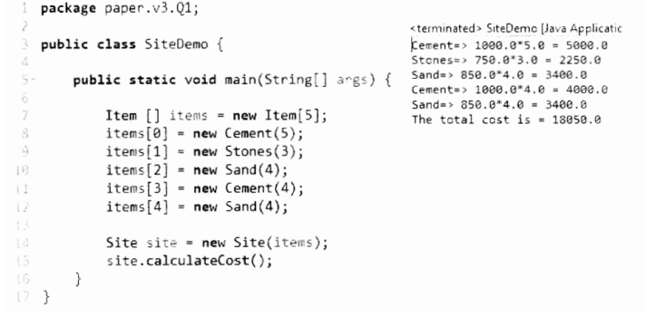

i). First implement the IConstruction interface and declare void calculateCost() method.

ii). Then implement and Item abstract class and declare the methods with return types displayltem( ):String, getCost( ): double, getQuantity( ):double

iii). Create concrete classes called Cement, Sand and Stones and override all abstract methods displayltem( ), getCost() and getQuality() .

iv). Add the property qtylnCubes and overload the constructor of each class (Cement, Sand and Stones) and use the data type double.

v). Similarly create a class called Site and implement the IConstruction interface with in the class and override the calculateCost( ) method. Then overload the constructor to pass the array of Items

(E.g. :-Item [ ])

**Part b)** Site class should calculate the cost in each item and it should print the sub total of each order line and at the end it should print the total cost

i). When calculate the line total it should multiply each item’s cost with the given quantity and use iteration to print item name, cost. quantity and the line total as per the console output.