**Using Styling Sheets**

Using of external styling sheets are very important as the will allow to access common set of classes or id in different HTML pages this will reduces the code duplication as a result I will be more efficient .

How to call a css styling sheet

<link rel="stylesheet" type="text/css" href="style.css"> <!-- css file used-->

**The strategy of the basic page structure**

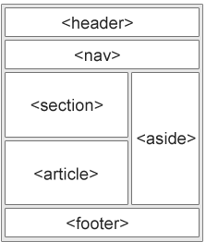These are the most basic things which are needed to an layout .

A header <header>

Navigation <nav>

Section<section>

Article<article>

Footer<footer>

Aside<aside>

This is the layout using the HTML 5.