Name : Lakshitha T.G.R.

Reg. No : 19APSE4279

Academic Period : 3rd Year 2nd Semester

Due Date : 18/11/2024

**LAB SHEET 01**

Sabaragamuwa University of Sri Lanka

Faculty of Computing

Department of Software Engineering

SE6103 - Parallel and Distributed Systems

* **Check docker version**
* docker version

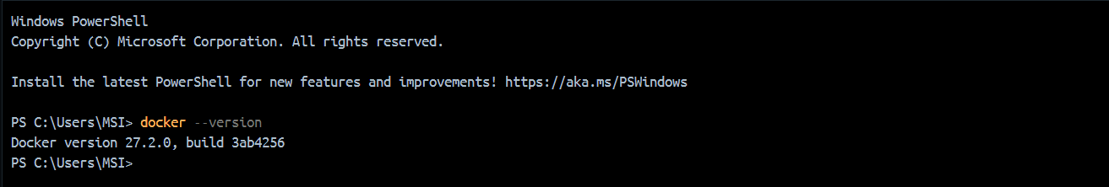

* **Pull and verify the Hadoop image**
* **docker pull bde2020/hadoop-namenode:latest**

* **Run the docker container**
* **docker run -it --name hadoop-cluster-new01 -p 9870:9870 -p 8088:8088 -p 50070:50070 bde2020/hadoop-namenode:latest /bin/bash**

* **Configure the Hadoop file system**
* hdfs namenode -format
* hdfs namenode &
* hdfs datanode &

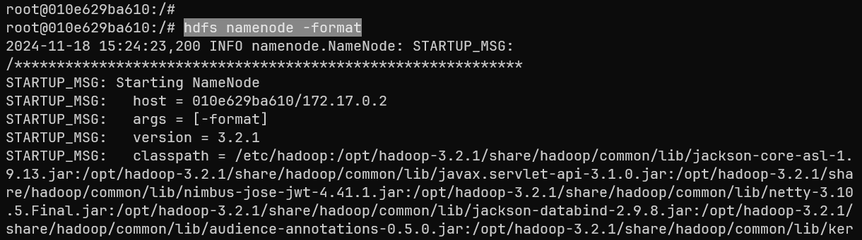

* **Check the Hadoop health using local port**

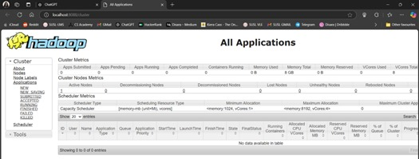

* **Start the node manager and resource manager**
* yarn nodemanager &
* yarn resourcemanager &
* **Upload sample data to HDFS**
* hdfs dfs -mkdir -p /user/hadoop/input

* hdfs dfs -put $HADOOP_HOME/etc/hadoop/*.xml /user/hadoop/input

* **Run the word counter job**
* hadoop jar $HADOOP_HOME/share/hadoop/mapreduce/hadoop-mapreduce-examples-*.jar wordcount /user/hadoop/input /user/hadoop/output

* **Check the output**
* hdfs dfs -cat /user/hadoop/output/part-r-00000

