**Capstone Project**

* **Introduction**

This is the final project of the IBM data science specialization professional certificate course. In this project I will be coming up with a real-world business problem regarding location data and how to obtain certain locations for the better of the business. This project will require a certain problem and data to solve the problem and a code for cleaning and visualizing the data.

* **The Problem**

Coffee shops are somewhat popular in the city of Colombo in Sri Lanka. However, to start a new business of coffee shop it is important for managers to select an appropriate location in the Colombo or Suburb Colombo area. In order to find a new location for a coffee shop in Colombo it is important to identify geographical features such as how many coffee shops are available in that area and to find, since it is important to understand that the more coffee shops that will be situated, the more the competition that will be in the business. By choosing a location that is with not many coffee shops it will able to minimise the competition in the business.

Imagine there was Java Lounge or a Barista next to the location planned to start a coffee shop business. People will wonder which coffee shop they would want to go regarding their preference, whether they will be interested in the menu or which coffee shop is the closest to their homes or based on the features of that location like is the coffee shop close to their favourite restaurant or will it be close to a park, as people will prefer to have a walk and afterwards go for some coffee.

People will want to consider whether they want to come to the coffee shop according to their convenience. Will it be a traffic congested area or whether the location will be at a main road? By obtaining meaningful and necessary data regarding the location to start a coffee business this business will attract stake holders and suppliers willing to help and maintain the business.

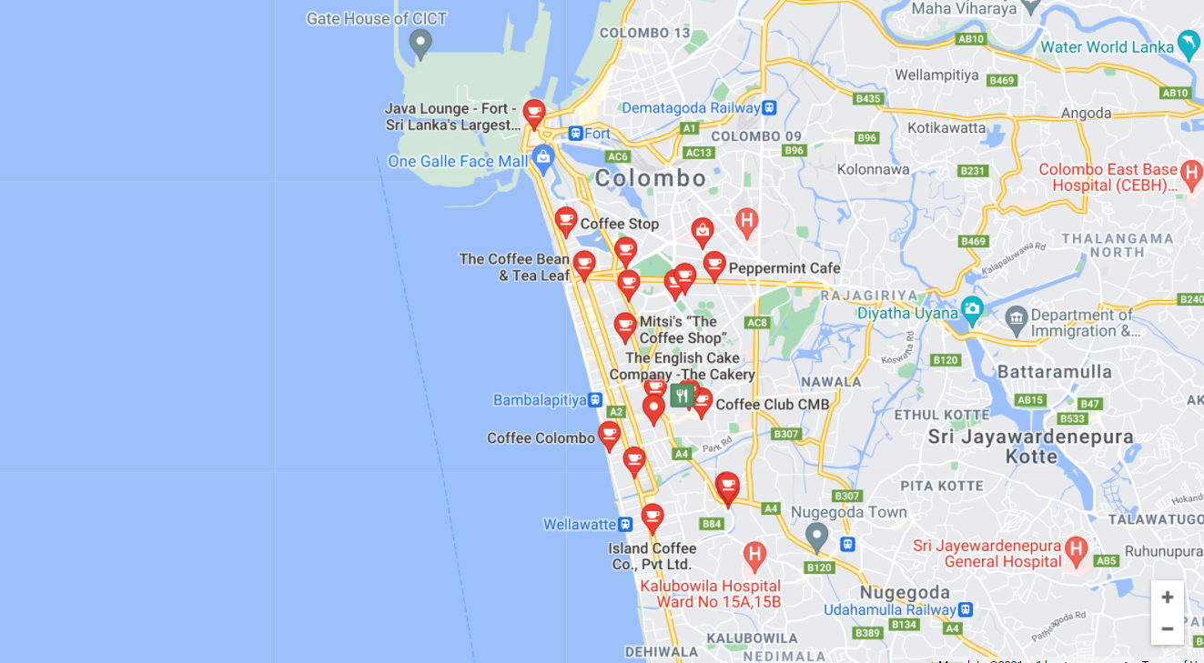

*The above image shows some of the locations of the current areas of coffee shops in the city of Colombo.*

From the above map we can decide the areas that will be suitable for starting a coffee shop business. Stakeholders and suppliers will be keen on knowing the following aspects when starting this business.

* The distance to the workplace from their respective homes
* The area or neighbourhood features of the workplace
* Development or road features in that area
* Usage of public transport in that area
* Whether or not it is a traffic influenced area

Another factor that needs to be considered is the who are the people that live near the area chosen. Basically young, old people are all having interest of having coffee and having snacks in coffee shops. Thus, if the location chosen will be an area majority with older age people, the business may not gain more diversity. Therefore, it is important to choose an area where there is more diversity such as, near an apartment or housing complex.

To have a more consumer friendly business having a delivery service for products produced in the coffee shop is a good thing. Therefore, to not spend more on transportation having a location closer to the main neighbourhoods is a good decision that should be made when starting up this business.

Furthermore, starting a coffee shop business requires rent! Therefore, choosing a perfect city location is required however for city centre locations it will require a higher rent. There are locations in Colombo with different rent rates, but is important to make sure that it will attract customers in that location.

* **The Data**

In order to first start or decide to as to where we want to have our coffee shop, we first should look at the current areas that have coffee shops. This will make us understand the locations that will be more suitable and to try not to start with a location with more coffee shops as it will increase competition.

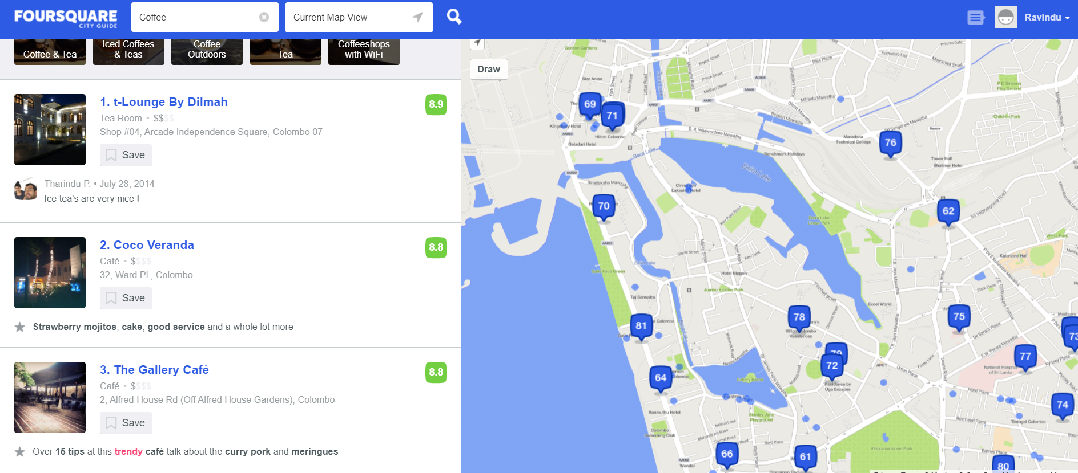

As seen in the above image the Foursquare API shows the name of coffee shop address. By analysing these data, we will be able to identify which place to start up a coffee business. As above map shows there are different clusters where some apart and some are close to each other. Thus, when analysing this we can see that some locations are near a park and some somewhat in the outskirts of the city. Understanding this biographical data, we can know the factors that is required to have a proper location for the coffee shop.

Another interesting fact is to obtain the neighbourhood data of Colombo so we can have an insight of the features of the neighbourhood like the population of that location or geographical feature of that location. By understanding the population rate of different areas of Colombo we will be able to understand the customer rate we may get in that area.

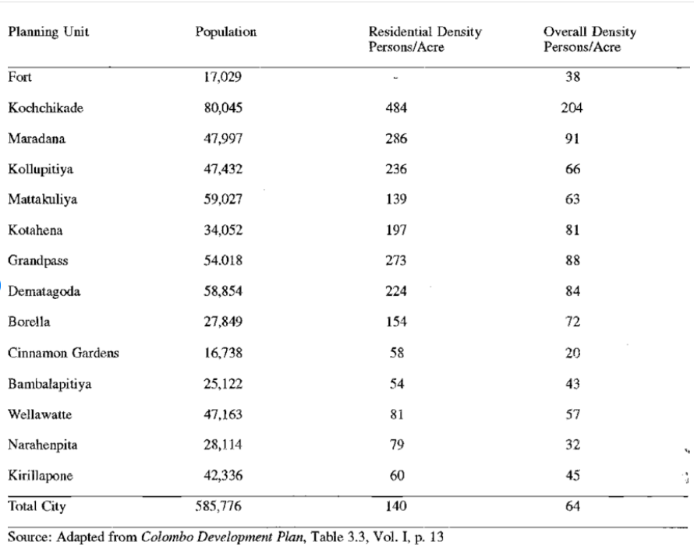

*Above image shows the population and density in different Neighbourhoods in Colombo.*

Another main aspect is the distance from place to place that should be known. For example, the distance of the coffee shop from a nearby popular park or from the city centre or even a highly populated school. If we know the data of distance from such areas to the coffee shop, we may able to find a suitable location. Considering that if the distance is so short that even people will be able to go with walking distance. Therefore, by obtaining co-ordinates of certain areas in Colombo we may able to find the distances that is required to start a coffee shop.

Therefore, by the data such as distance, geographical features are important aspects when starting up a coffee shop business. Thus, visualizing and predicting these data we can get insights on how to make this business a success. Not only for coffee shops but also to open up even a restaurant or a different business choosing the location is a must and beforehand it is important to obtain data to have better insights.

*********