Appendices A–C
ArtVerse — System Manual · User Manual · Management Reports
Appendix A — System Manual 1
A.1 Project Structure 1
A.2 Where Each Requirement Lives 1
A.3 Build Configuration & Dependencies 1
A.4 Connecting to Firebase 2
A.5 Build & Run 2
A.6 Extending the Project 2
Appendix B — User Manual 2
B.1 Art Lover (Customer) 2
B.2 Artist 3
Appendix C — Management Reports 6

Appendix A — System Manual
Reference for a developer continuing this project: how it is organised, what it depends on, and how to connect and run it.

A.1 Project Structure
Package | Contents
auth/ | Splash, role selection, login, registration (both roles).
customer/, customer/fragments/ | Art Lover flow: home/browse, artwork detail, cart, checkout, orders, profile.
artist/, artist/fragments/ | Artist flow: dashboard, add/edit artwork, my art, orders, sales report, profile.
models/ | Plain classes mirroring each Firestore document (User, Artwork, Order, etc.).
adapters/ | RecyclerView adapters binding models to list/grid items.
utils/ | FirebaseUtil (sole Firebase access point) + pure logic: ValidationUtil, QuantitySelector, ArtCategories.
All Firebase access is centralised in utils/FirebaseUtil.java — no Activity or Fragment calls the Firebase SDK directly.

A.2 Where Each Requirement Lives
Requirement | Screen / Class
FR01 / FR02 Registration | auth/CustomerRegisterActivity, auth/ArtistRegisterActivity
FR03 Login | auth/LoginActivity
FR04 Artwork management | artist/AddEditArtworkActivity, artist/fragments/MyArtworkFragment
FR05 Browse & search | customer/fragments/HomeFragment
FR06 Cart management | customer/fragments/CartFragment, adapters/CartAdapter
FR07 / FR08 Order & payment | customer/CheckoutActivity (Firestore transaction places the order and locks stock)
FR09 Sales tracking | artist/fragments/SalesReportFragment

A.3 Build Configuration & Dependencies
Item | Version | Source / Notes
Android Gradle Plugin / Gradle | 8.4.1 / 8.6 | —
compileSdk / targetSdk / minSdk | 34 / 34 / 24 | —
Java compatibility | 17 | —
Material Components | 1.12.0 | github.com/material-components/material-components-android
Firebase (Auth, Firestore, Storage, Analytics) | BoM 33.1.2 | firebase.google.com/docs/android/setup
Glide (image loading) | 4.16.0 | github.com/bumptech/glide
CircleImageView | 3.1.0 | github.com/hdodenhof/CircleImageView
JUnit / Robolectric / Espresso | 4.13.2 / 4.13 / 3.6.1 | test-only — see Chapter 5
+ standard AndroidX libraries | various | AppCompat, ConstraintLayout, RecyclerView, Fragment, SwipeRefreshLayout

A.4 Connecting to Firebase
- Create a project at console.firebase.google.com.
- Add app → Android, package name com.artverse.app (must match app/build.gradle).
- Download google-services.json into the app/ folder (git-ignored; one per developer).
- Enable Email/Password under Authentication → Sign-in method.
- Create a Firestore database and a Storage bucket (production mode), then re-sync Gradle.
SETUP GAP No firestore.rules / storage.rules are checked into this repo. Both products default to fully locked-down access until rules are authored and published — scope them so a user can only read/write their own uid, and artworks where artistId == request.auth.uid.

A.5 Build & Run
- Open the ArtVerse folder in Android Studio (Koala+, JDK 17) and let Gradle sync.
- Run on a device/emulator, Android 7.0 (API 24) or later.
- Release build: Build → Generate Signed Bundle / APK.
gradlew is not committed in this snapshot — regenerate via File → Sync Project with Gradle Files before building from the command line. Automated tests are covered in Chapter 5.

A.6 Extending the Project
Payment gateway: wire a real charge callback into CheckoutActivity.placeOrder() before its Firestore transaction commits. • Multiple images: Artwork.imageUrls is already a list; extend the image picker to accept more than one. • Push notifications: add Firebase Cloud Messaging, triggered from the order-status updates in ArtistOrdersFragment.

Appendix B — User Manual

B.1 Art Lover (Customer)
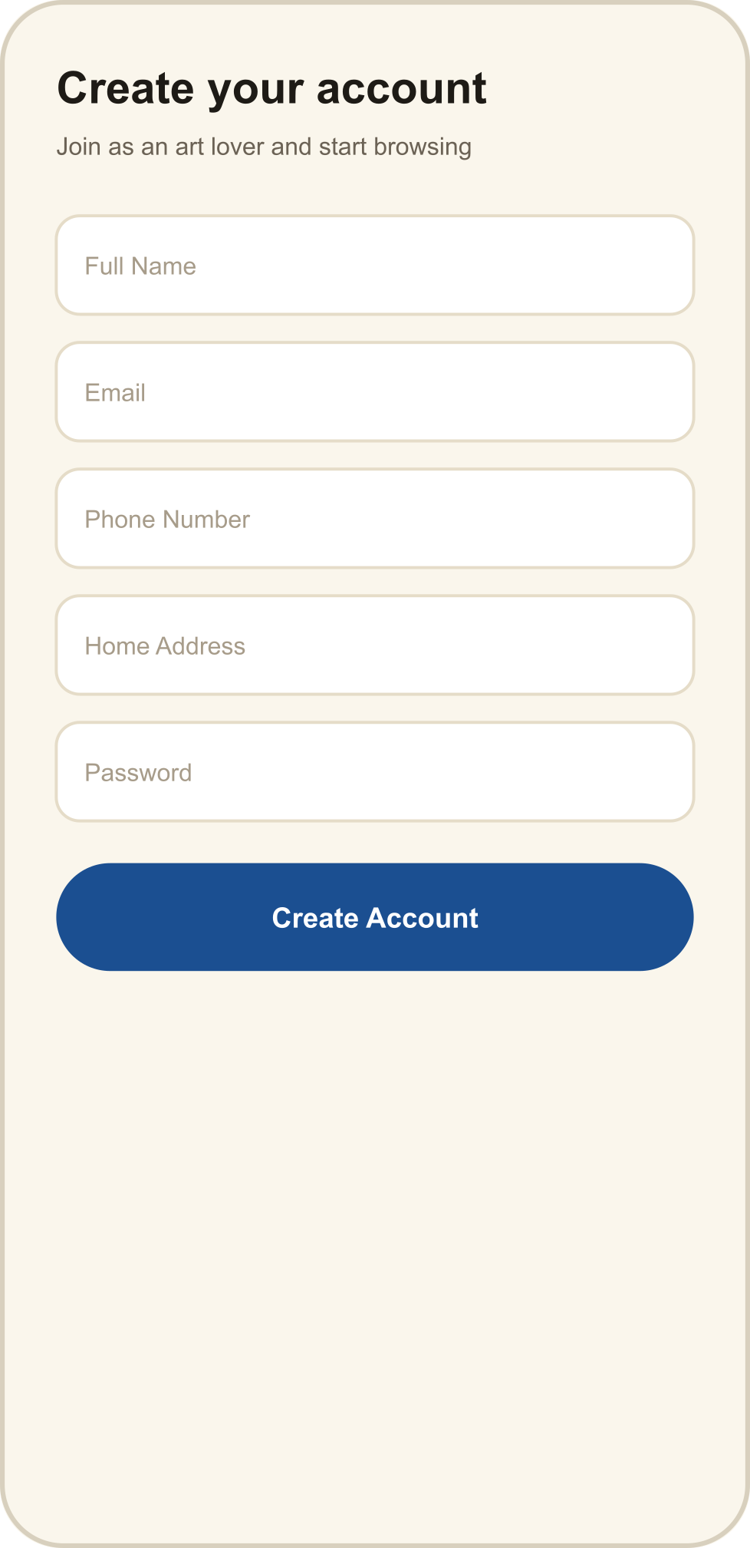 Register - Choose Art Lover on the role screen. - Enter name, email, phone, address, password. - Tap Create Account — you are signed in. | 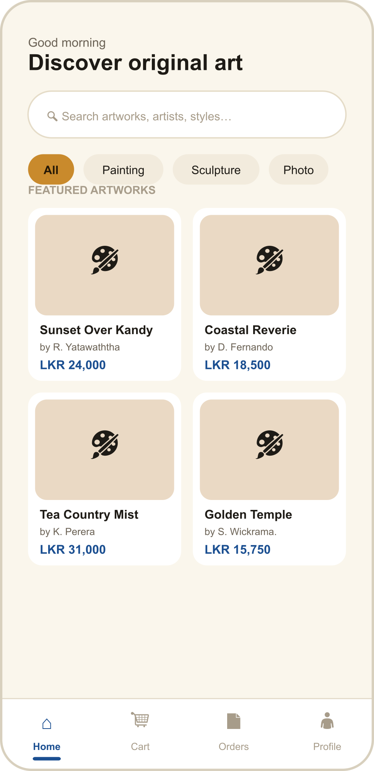 Browse & Search - Type in the search bar to filter live. - Tap a category chip to filter the grid. - Tap a card to open its detail page.
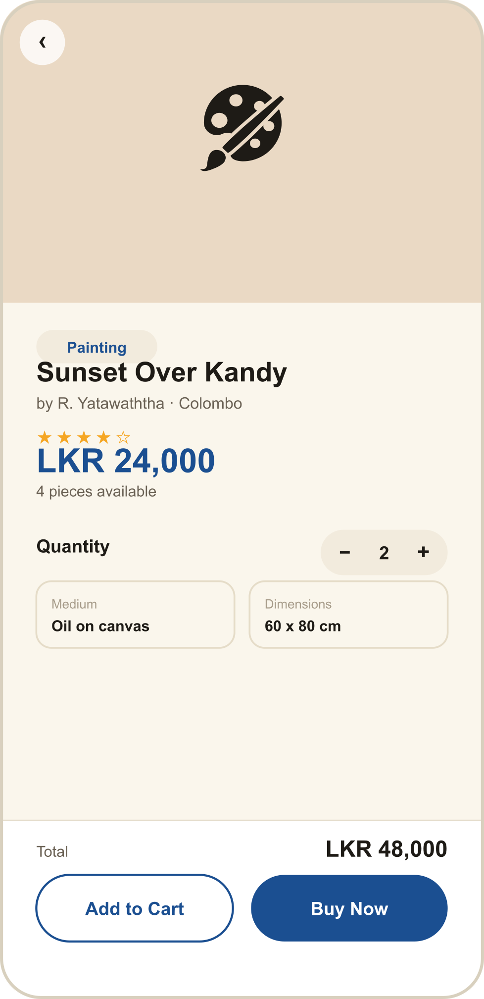 Artwork Detail - Set a quantity with the − / + stepper, capped to live stock. - The total price updates as quantity changes. - Add to Cart, or Buy Now to checkout directly. | 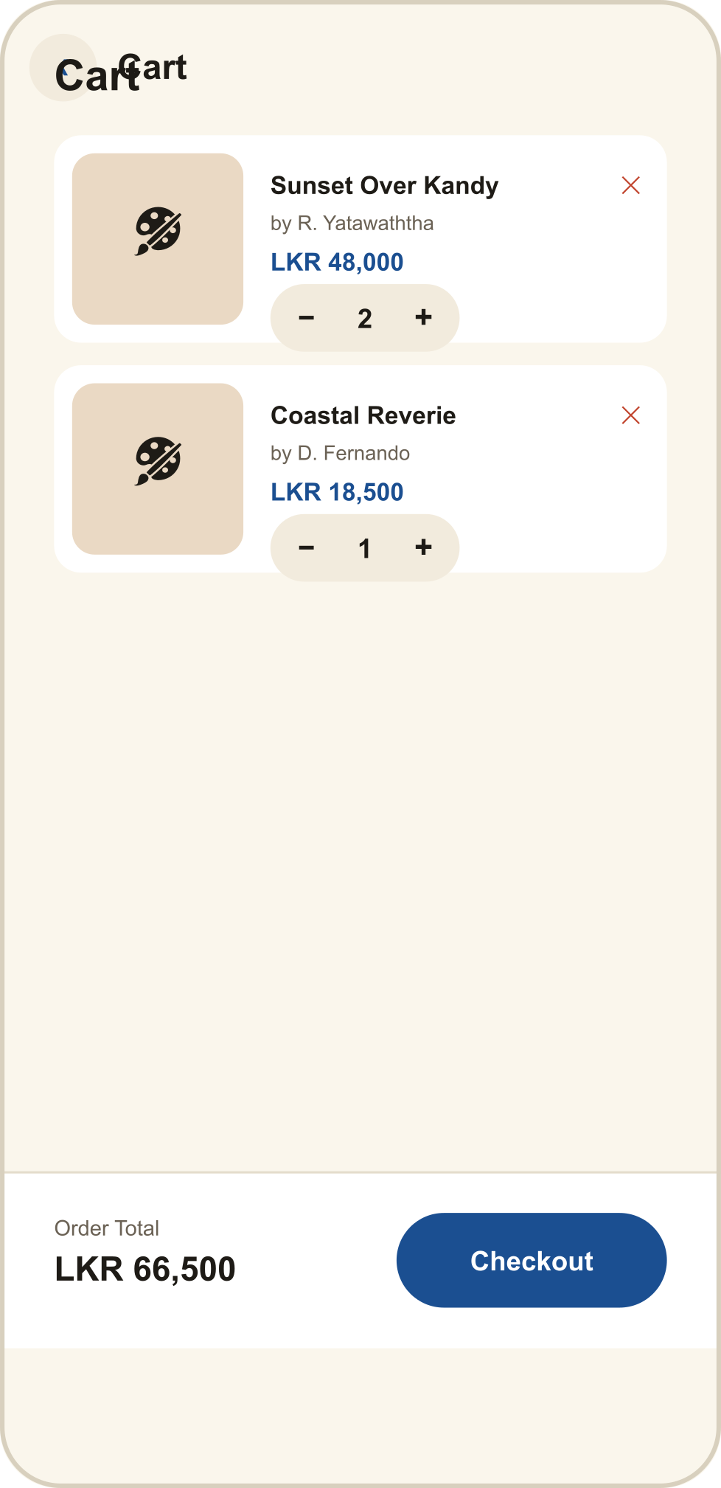 Manage Cart - Adjust quantity with − / + on any item. - Tap ✕ to remove an item. - Order Total updates live.
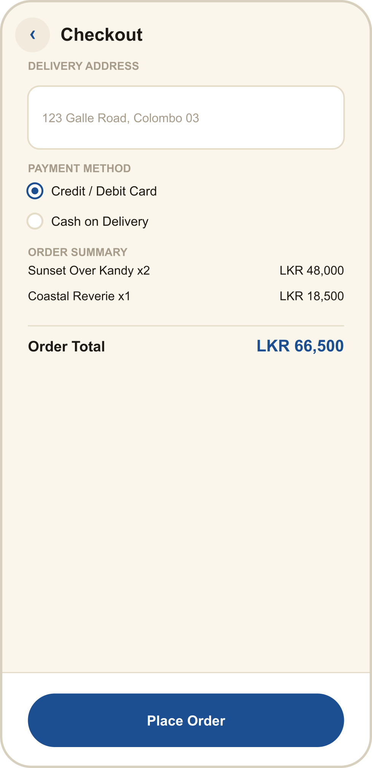 Place an Order - Confirm the delivery address. - Choose Card or Cash on Delivery. - Tap Place Order to confirm. | 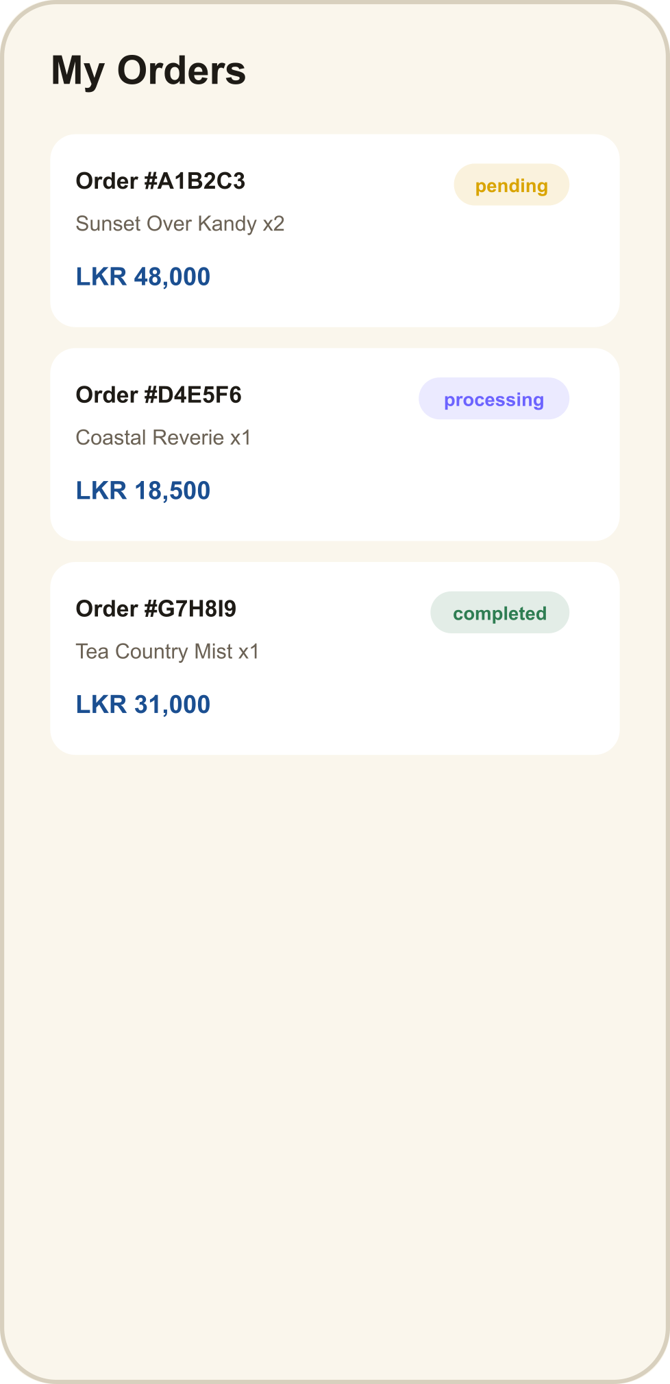 Track Orders - Open the Orders tab, newest first. - Each order shows a status badge: Pending, Processing, Completed, or Rejected. - Tap an order for its full item list.

B.2 Artist
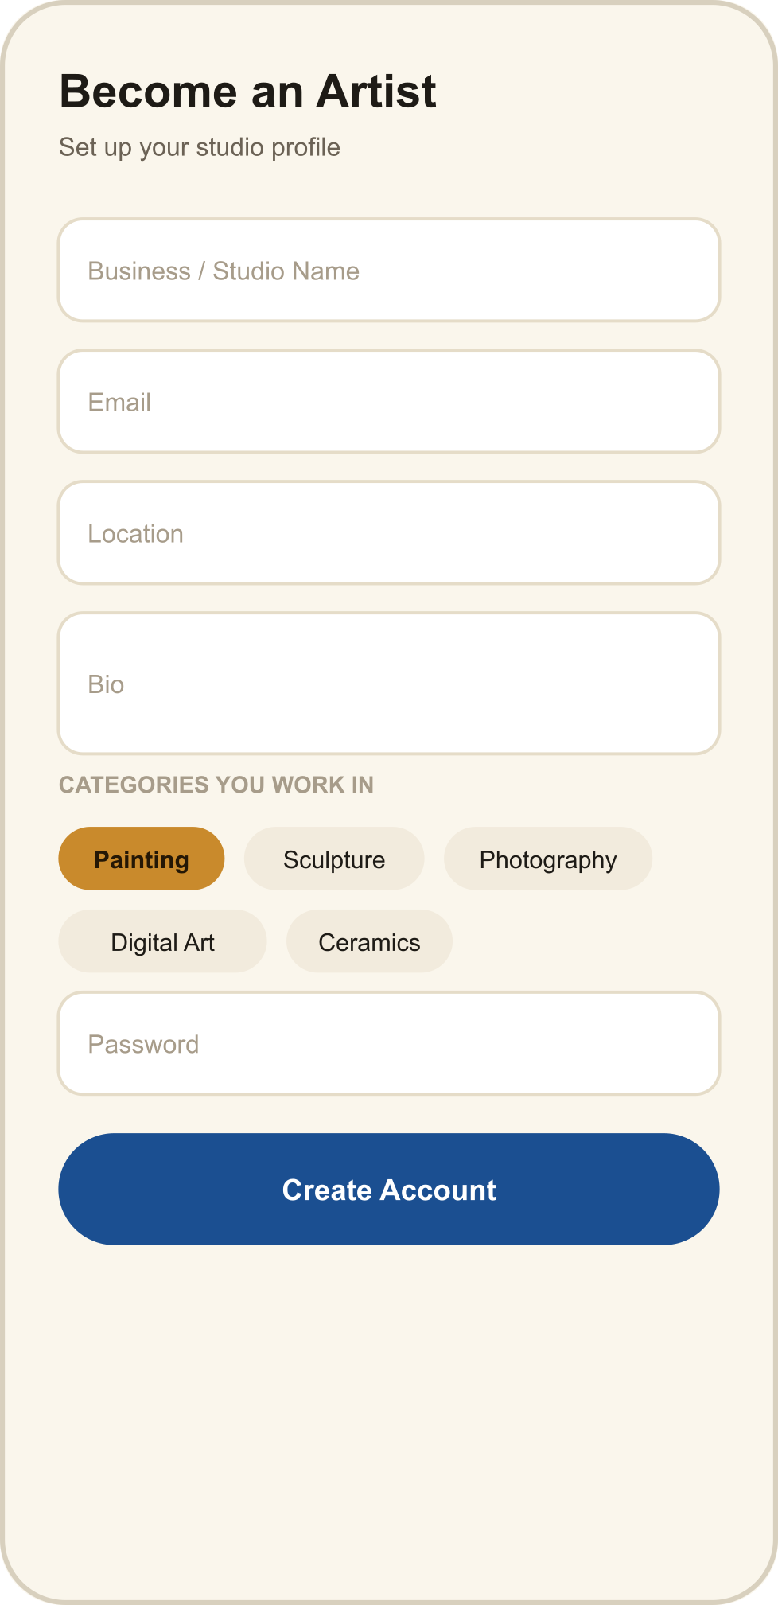 Register - Choose Artist on the role screen. - Enter studio name, bio, location. - Select every category you work in. | 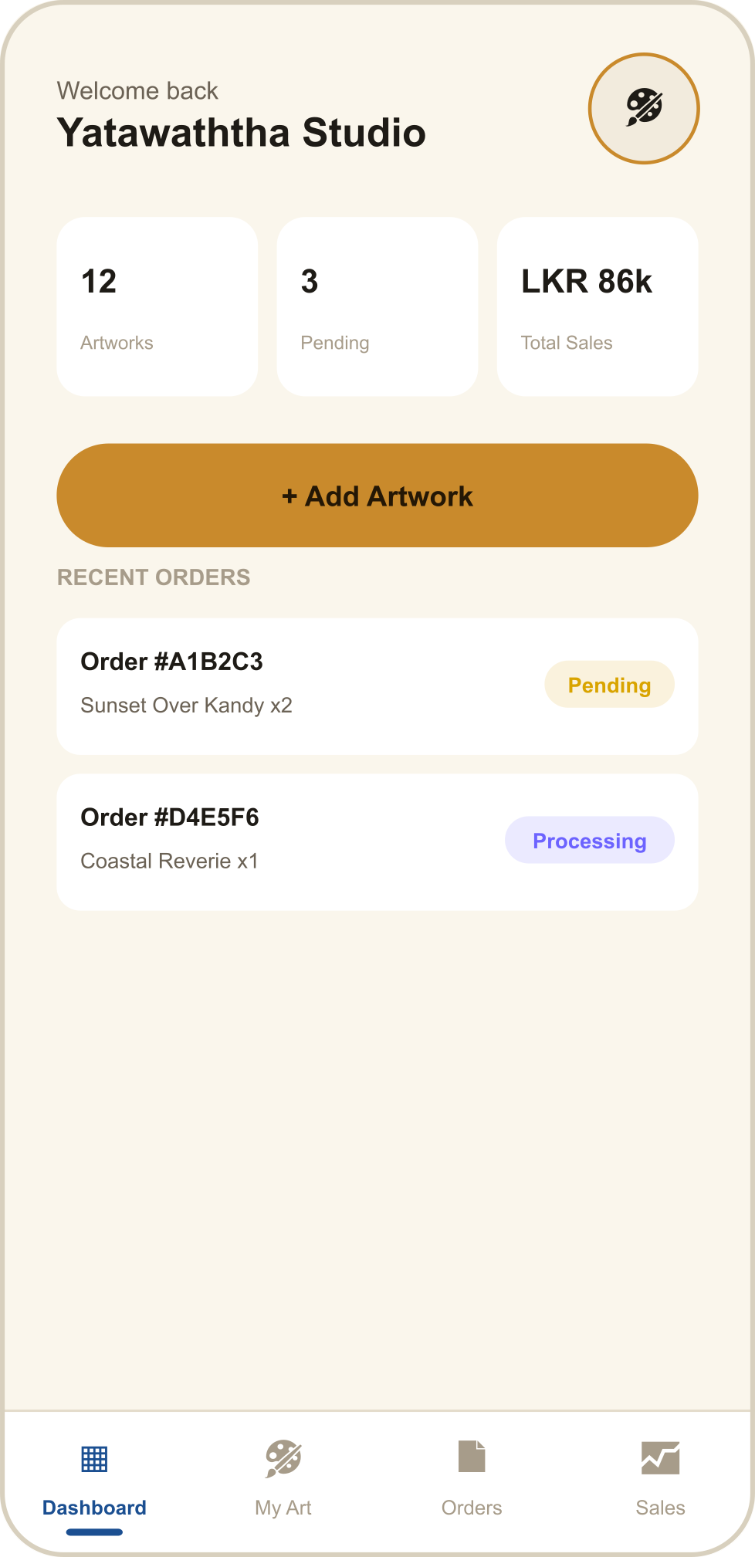 Dashboard - See total artworks, pending orders, and sales at a glance. - Tap the avatar to edit your profile or log out. - Tap + Add Artwork to list a new piece.
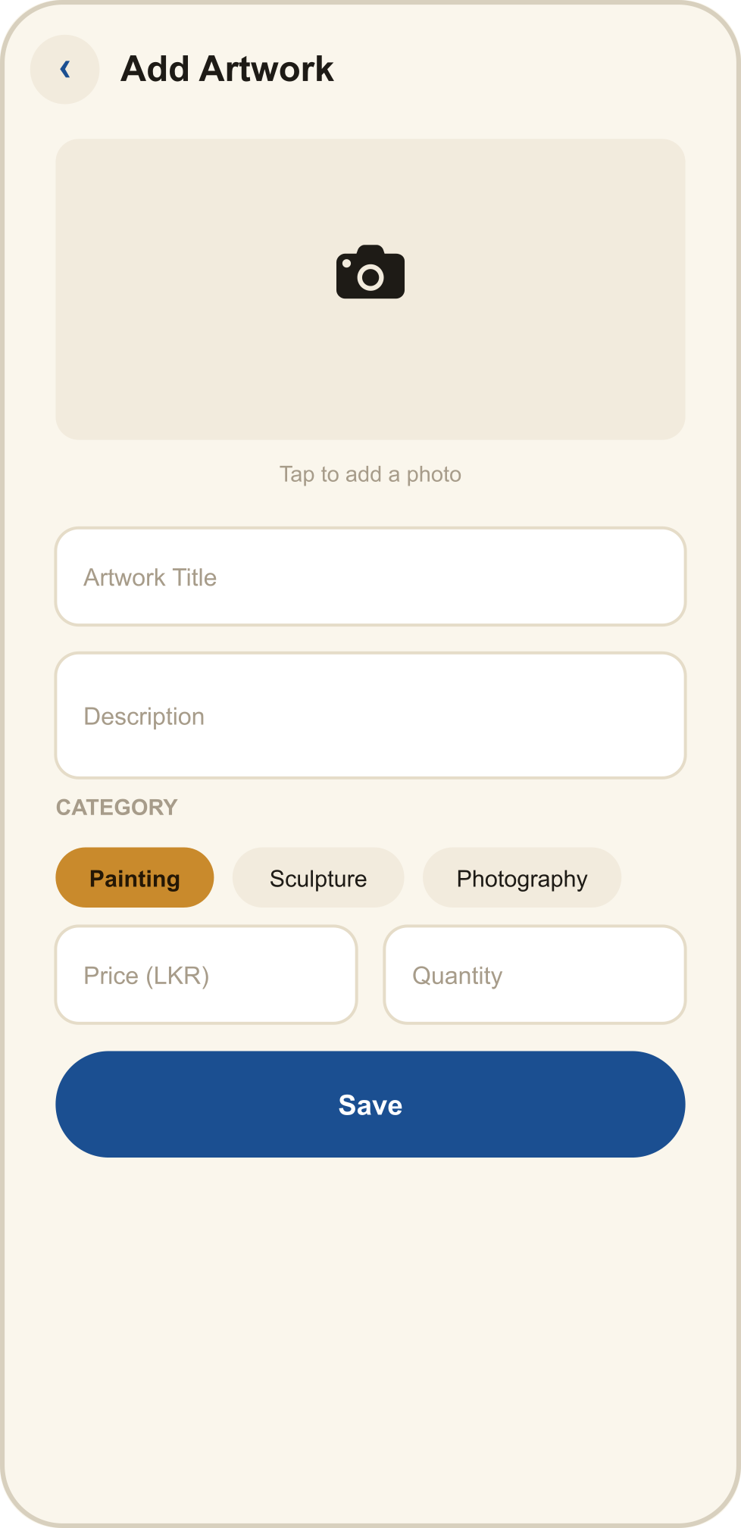 List Artwork - Tap the photo box to choose a cover image. - Enter title, description, category, price, and stock quantity. - Tap Save to publish the listing. | 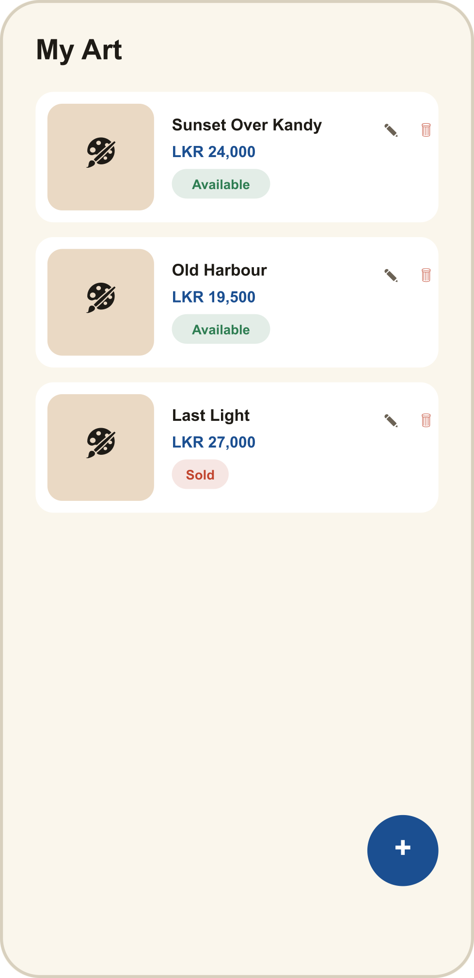 Manage Artwork - Open My Art to see every listing. - Tap ✎ to edit or 🗑 to remove a listing. - Availability badge updates automatically as stock sells.
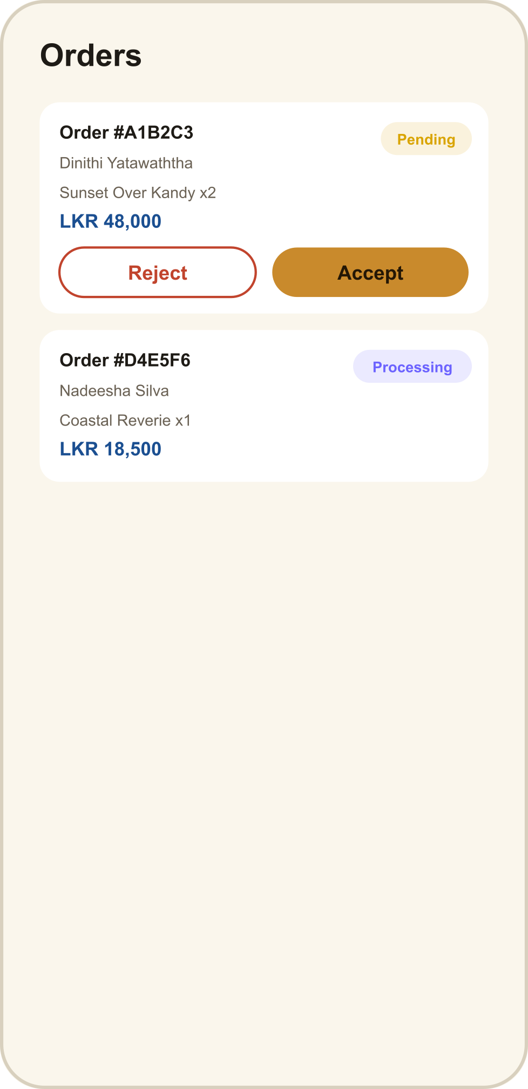 Respond to Orders - Open the Orders tab. - Tap Accept or Reject on a pending order. - Customer sees the status change live. | 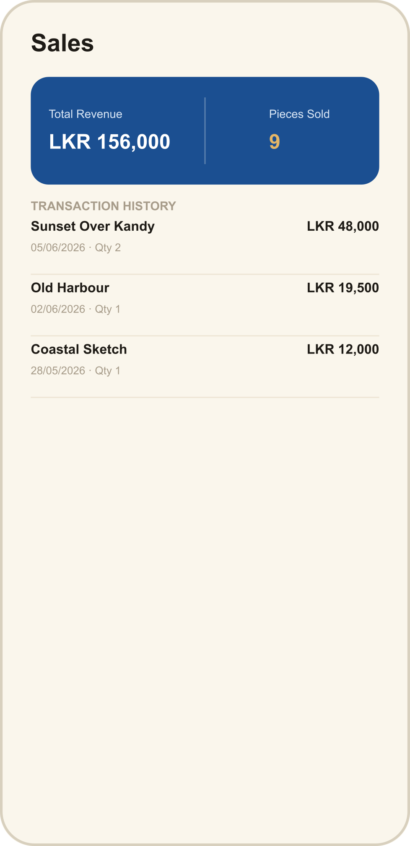 Sales Report - Open the Sales tab. - Total Revenue and Pieces Sold update per sale. - Transaction History lists every sale.

Appendix C — Management Reports
Generated from a representative sample dataset (Q2 2026) to demonstrate the sales-tracking module (FR09 / OBJ 02) ahead of live usage data.
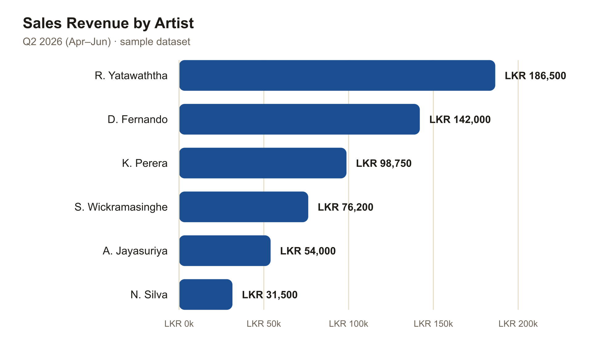  Figure C.1 — Revenue by artist |  | 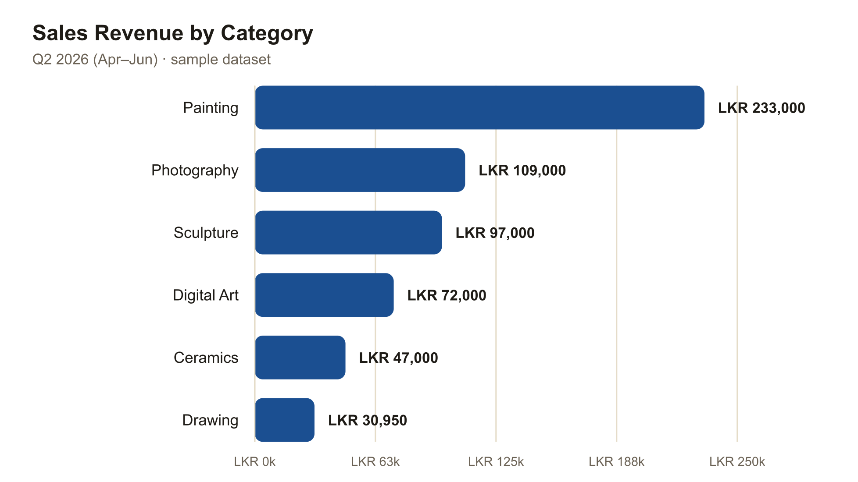  Figure C.2 — Revenue by category
Top Artist | Revenue |  | Top Category | Revenue
R. Yatawaththa | LKR 186,500 |  | Painting | LKR 233,000
D. Fernando | LKR 142,000 |  | Photography | LKR 109,000
K. Perera | LKR 98,750 |  | Sculpture | LKR 97,000

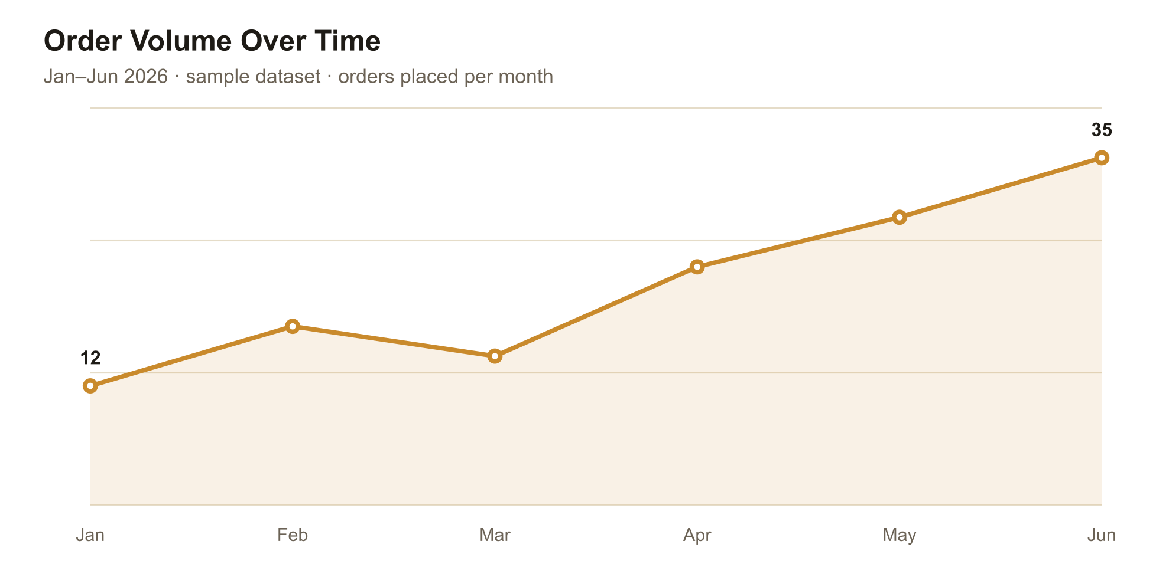
Figure C.3 — Orders placed per month, Jan–Jun 2026
Jan | Feb | Mar | Apr | May | Jun
12 | 18 | 15 | 24 | 29 | 35

Painting leads by category and R. Yatawaththa by artist; order volume nearly trebled over the period. Both revenue views total LKR 588,950, reconciled from the same transactions collection.

