Slide 1: What is an roAp?

* roAp stands for rapidly oscillating Ap star.
  + These can have periods as little as 5 minutes.
* These lie on the delta Scuti instability strip and are usually A:F class stars.
  + The delta Scuti strip is along the main sequence, along with most standard candles.
* Most roAp’s have spectral type Sr (Strontium), Eu (Europium), and Cr (Chromium) and sometimes Si (Silicon) (EX: ApSrEuCr spectral type).
  + Meaning they show strong lines of these ionized metals along with chemical peculiarities. A result of radiative acceleration and gravitational settling.
    - Gravitational Settling: particles falling toward the core due to gravity.
    - Radiative Acceleration: In each layer of the star, the particles move according to a diffusion velocity that involves a term describing the momentum transfer between the radiation field and the various chemical species.

Slide 2: Known roAp’s

* Referencing documentation from TESS observations on ~ 200 known roAp stars, making a database with these.
  + Using cone search with radius 2” to identify the roAp’s in Gaia catalog.
* Then concatenating each roAp table into a database and pair matching starhorse catalog.
  + Starhorse database accounts for accounting for dust extinction
  + Using GMAG vs. BP-RP0
    - GMAG being G broadband filter Absolute Mag
      * Using G filter because it covers more of the spectrum
    - BP-RP0 being B-R color
      * Using this because we want separate indicators, not the same; which would using G filter

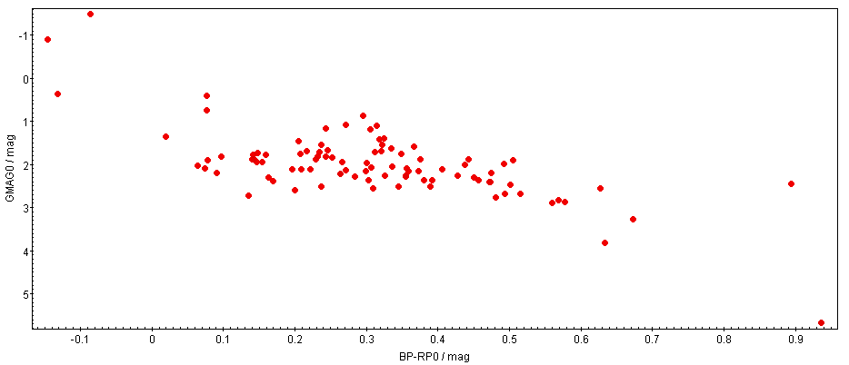

* This is the instability strip for the known roAp’s.

Slide 3: NGC 2264

* Using TopCat with Gaia to plot a 13’ FOV of NGC 2264.
  + NGC 2264, or the Christmas Tree cluster with the cone nebula in it, is in the Monoceros constellation and is an open cluster.
  + It is ~720 pc away from earth with an angular diameter of 20’.
  + Pair matching with starhorse to account for dust extinction.

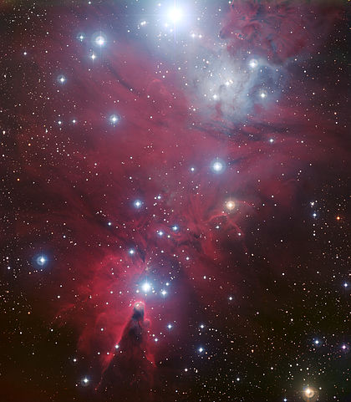

* I selected the dense, pink, group of stars inside the open cluster, fig 2.
  + The other stars in the top right are apart of the galactic disk, which we are not interested in.
  + The pink group is NGC 2264

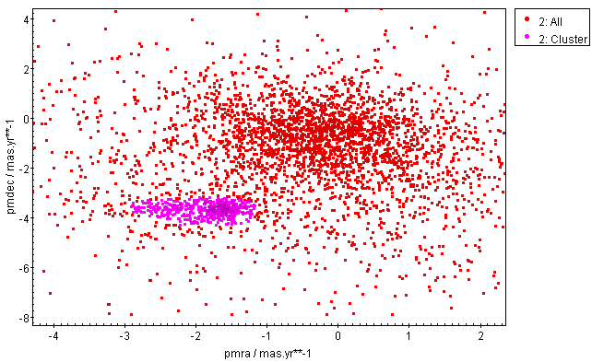

* Then considering the parallaxes, using a histogram, fig 3.
  + We want our stars to be in proximity of one another.
  + Selecting a range from .6 - 2

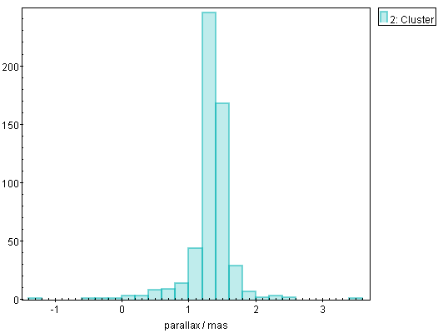

* Now making an HRD with the selected group of stars, fig 4.
  + These are the stars we are looking through to find roAp candidates.

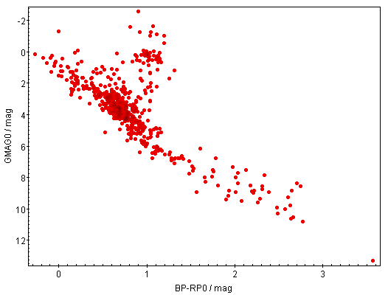

Slide 4: Conclusion

* From NGC 2264 and the known roAp’s, I plotted the candidates and known roAp’s, fig 5.
  + Doing this by choosing only the stars in NGC 2264 that followed the instability strip of the known roAp’s when grouping the plots of fig 1 and 4.

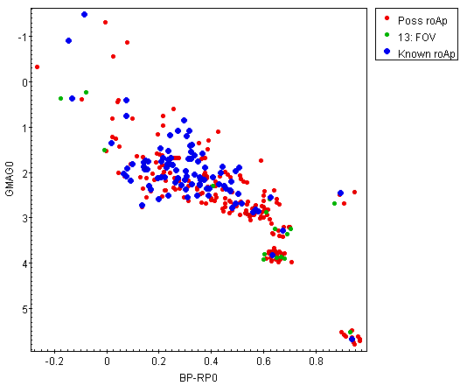

* + The green section being the roAp candidates in our images and the red section being all the possible roAp’s within 13’.

**roAp candidates in our image FOV**

|  |  |  |  |
| --- | --- | --- | --- |
| **#** | **Gaia designation** | **Identifier** | **RA;DEC** |
| **1** | 3326709559553987840 | NGC 2264-153 | 06 41 03.374;+09 40 44.986 |
| **2** | 3326711487994693504 | NGC 2264-169 | 06 41 07.778;+09 44 02.995 |
| **3** | 3326714752169858944 | Cl* NGC 2264 RMS 1872A | 06 40 11.682;+09 45 55.699 |
| **4** | 3326715297630893184 | Cl* NGC 2264 SBL 1534 | 06 40 21.434;+09 48 04.741 |
| **5** | 3326716397142282240 | Cl* NGC 2264 SBL 226 | 06 40 55.183;+09 50 49.753 |
| **%6** | 3326736811121849216 | HD 262066A | 06 41 30.092;+09 49 48.324 |
| **%7** | 3326737051640013952 | HD 262108 | 06 41 34.613;+09 51 37.917 |
| **8** | 3326743614350027008 | Cl* NGC 2264 SBL 392 | 06 41 31.989;+10 00 24.443 |
| **9** | 3326928882059976576 | Cl* NGC 2264 SBL 204 | 06 40 50.862;+09 55 53.029 |
| **10** | 3326929393158941056 | V* V358 Mon | 06 41 03.939;+09 58 09.453 |

* + The **%** stars are the better candidates.