Project technical and user manual

Object oriented programming



|  |  |
| --- | --- |
| Course Identification | |
|  |  |
| Name of programs – Codes: | Programmer-Analyst – LEA.3Q |
| Course title: | Object oriented programming |
| Course number: | 420-CT2-AS |
|  |  |
| Teacher’s name: | Mihai Maftei |
|  |  |
| Semester: | Summer 2020 |
| Student Identification | |
| Name: Ravi patel(2013143) | |

Contents

INTRODUCTION : 3

1.NAME INTRODUCTION: 4

2.NUMBER GENERATION:………………………………………………………………………………………………………………………..4

• Lotto Max: 4

• Lotto 649 : 4

3.CONVERSION : 4

• Money conversion: 5

• Temperature conversion: . 5

4.SIMPLE CALCULATOR: 5

5.IP VALIDATOR: 5

# INTRODUCTION :

The project contains five modules in order to use it for different applications and it is made with different functions, classes, objects and using many other aspects with the help of c# technologies, .NET framework and visual studio 2019.

Defined modules are

1. Introduction
2. Generate code
3. Conversion
4. Simple calculator
5. Ip checker

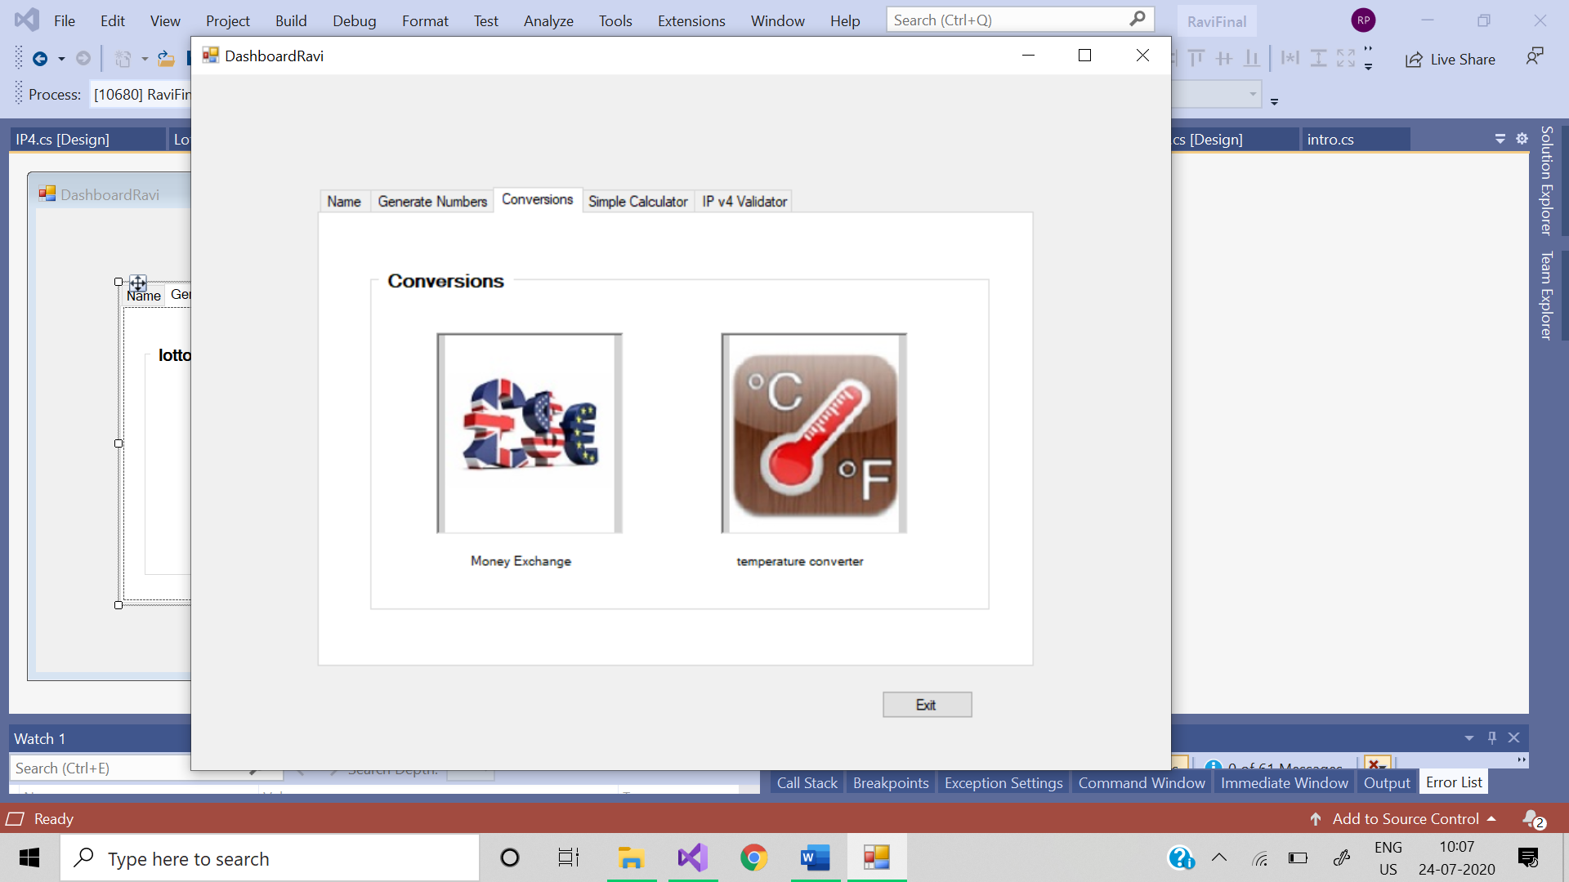

**Code:**

using System;

using System.Collections.Generic;

using System.ComponentModel;

using System.Data;

using System.Drawing;

using System.Linq;

using System.Text;

using System.Threading.Tasks;

using System.Windows.Forms;

namespace Ravi

{

public partial class Dashboardravi : Form

{

public Dashboardravi()

{

InitializeComponent();

}

private void GroupBox1_Enter(object sender, EventArgs e)

{

}

private void groupBox1_Enter_1(object sender, EventArgs e)

{

}

private void pictureBox2_Click(object sender, EventArgs e)

{

Lotto_649 obj = new Lotto_649();

obj.Show();

}

private void pictureBox3_Click(object sender, EventArgs e)

{

MoneyEx obj = new MoneyEx();

obj.Show();

}

private void pictureBox4_Click(object sender, EventArgs e)

{

TempConversions obj = new TempConversions();

obj.Show();

}

private void pictureBox5_Click(object sender, EventArgs e)

{

frm_Cal obj = new frm_Cal();

obj.Show();

}

private void pictureBox6_Click(object sender, EventArgs e)

{

IP4 obj = new IP4();

obj.Show();

}

private void button1_Click(object sender, EventArgs e)

{

int btnValue = -1;

btnValue = Convert.ToInt32(MessageBox.Show("Do you want Quit this application ?", "Exit?", MessageBoxButtons.OKCancel));

if (btnValue == 1) Application.Exit();

}

private void pictureBox1_Click(object sender, EventArgs e)

{

LottoMax obj = new LottoMax();

obj.Show();

}

private void button2_Click(object sender, EventArgs e)

{

intro obj = new intro();

obj.Show();

}

}

}

# 1.NAME INTRODUCTION:

When you click the name module in dashboard it will open a window that shows the detailed information about project developer. The data will be read only so no one can change it.

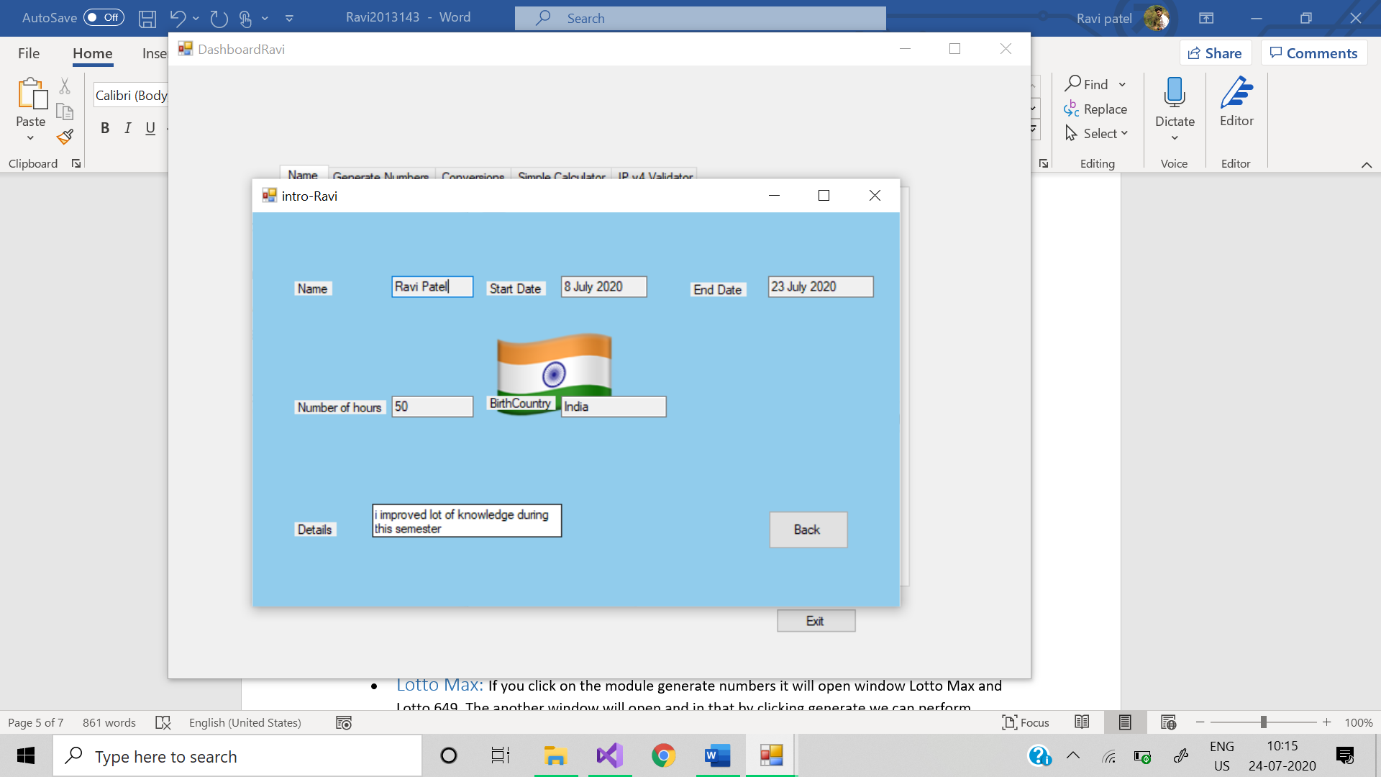

2. NUMBER GENERATION

Number generation is the first working module of the project. When you click number generation it will open new window which will show two different applications inside.

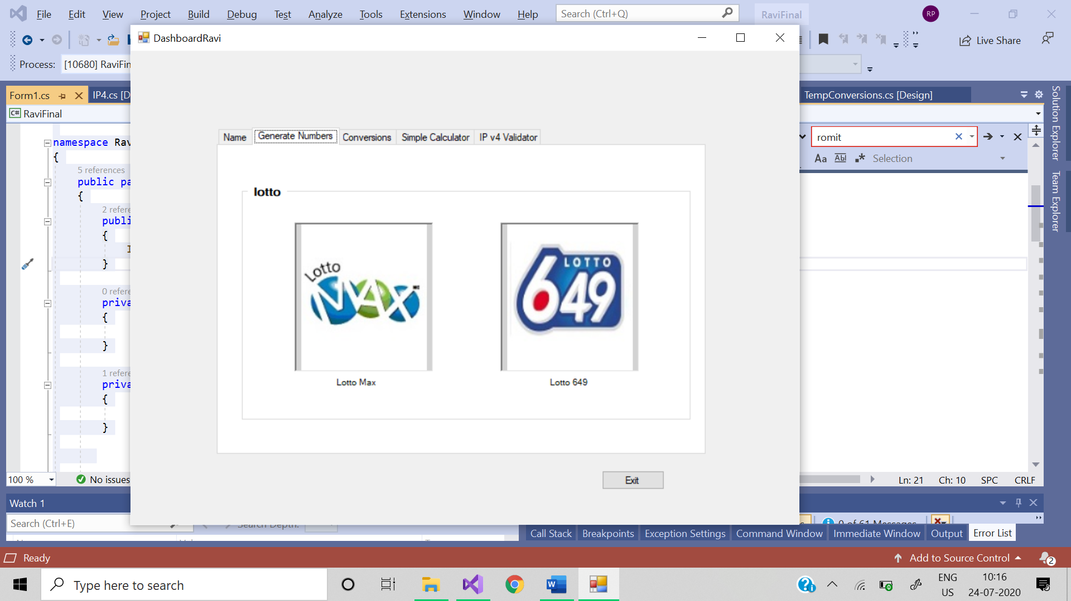

* Lotto Max: If you click on the module generate numbers it will open window Lotto Max and Lotto 649. The another window will open and in that by clicking generate we can perform lottery and for winners it can generate 7 numbers that are different and randomly picked up and are stored in text file. With the read file button we can see the details of winning numbers with bonus number along with date and time of the lottery. If you click exit button you have two choices yes or no and it works accordingly.

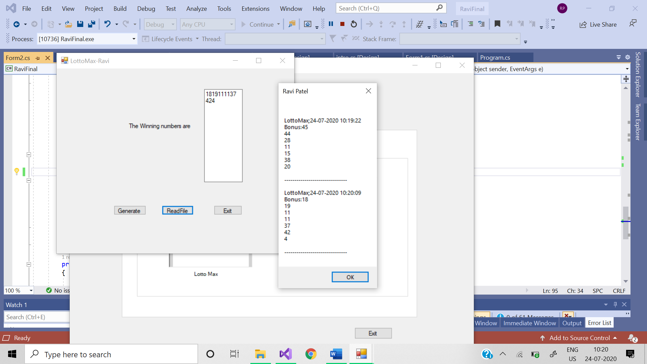

**Code:**

namespace Ravi

{

partial class LottoMax

{

/// <summary>

/// Required designer variable.

/// </summary>

private System.ComponentModel.IContainer components = null;

/// <summary>

/// Clean up any resources being used.

/// </summary>

/// <param name="disposing">true if managed resources should be disposed; otherwise, false.</param>

protected override void Dispose(bool disposing)

{

if (disposing && (components != null))

{

components.Dispose();

}

base.Dispose(disposing);

}

#region Windows Form Designer generated code

/// <summary>

/// Required method for Designer support - do not modify

/// the contents of this method with the code editor.

/// </summary>

private void InitializeComponent()

{

this.textBox1 = new System.Windows.Forms.TextBox();

this.label1 = new System.Windows.Forms.Label();

this.button1 = new System.Windows.Forms.Button();

this.button2 = new System.Windows.Forms.Button();

this.button3 = new System.Windows.Forms.Button();

this.SuspendLayout();

//

// textBox1

//

this.textBox1.Location = new System.Drawing.Point(390, 51);

this.textBox1.Multiline = true;

this.textBox1.Name = "textBox1";

this.textBox1.Size = new System.Drawing.Size(100, 226);

this.textBox1.TabIndex = 0;

this.textBox1.TextChanged += new System.EventHandler(this.textBox1_TextChanged);

//

// label1

//

this.label1.AutoSize = true;

this.label1.Location = new System.Drawing.Point(186, 132);

this.label1.Name = "label1";

this.label1.Size = new System.Drawing.Size(172, 17);

this.label1.TabIndex = 1;

this.label1.Text = "The Winning numbers are";

//

// button1

//

this.button1.Location = new System.Drawing.Point(151, 334);

this.button1.Name = "button1";

this.button1.Size = new System.Drawing.Size(85, 23);

this.button1.TabIndex = 2;

this.button1.Text = "Generate";

this.button1.UseVisualStyleBackColor = true;

this.button1.Click += new System.EventHandler(this.button1_Click);

//

// button2

//

this.button2.Location = new System.Drawing.Point(277, 334);

this.button2.Name = "button2";

this.button2.Size = new System.Drawing.Size(84, 23);

this.button2.TabIndex = 3;

this.button2.Text = "ReadFile";

this.button2.UseVisualStyleBackColor = true;

this.button2.Click += new System.EventHandler(this.button2_Click);

//

// button3

//

this.button3.Location = new System.Drawing.Point(415, 334);

this.button3.Name = "button3";

this.button3.Size = new System.Drawing.Size(75, 23);

this.button3.TabIndex = 4;

this.button3.Text = "Exit";

this.button3.UseVisualStyleBackColor = true;

this.button3.Click += new System.EventHandler(this.button3_Click);

//

// LottoMax

//

this.AutoScaleDimensions = new System.Drawing.SizeF(8F, 16F);

this.AutoScaleMode = System.Windows.Forms.AutoScaleMode.Font;

this.ClientSize = new System.Drawing.Size(626, 450);

this.Controls.Add(this.button3);

this.Controls.Add(this.button2);

this.Controls.Add(this.button1);

this.Controls.Add(this.label1);

this.Controls.Add(this.textBox1);

this.Name = "LottoMax";

this.Text = "LottoMax-Ravi";

this.ResumeLayout(false);

this.PerformLayout();

}

#endregion

private System.Windows.Forms.TextBox textBox1;

private System.Windows.Forms.Label label1;

private System.Windows.Forms.Button button1;

private System.Windows.Forms.Button button2;

private System.Windows.Forms.Button button3;

}

}

## Lotto 649 :If you click on the Lotto 649: Another window will open and in that by clicking generate we can perform lottery and for winners it can generate 8 numbers that are different and randomly picked up and are stored in lottoNbrs.txt. With the read file button we can see the details of winning numbers with bonus number along with date and time of the lottery. If you click exit button you have 2 choices yes or no and it works according to its name.

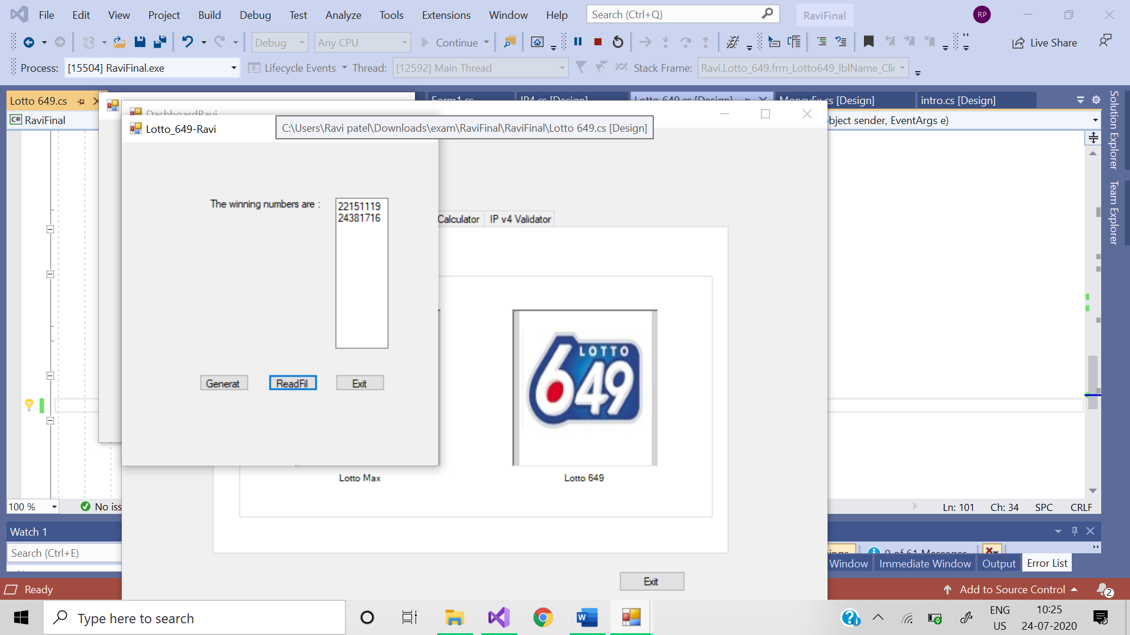

**Code:**

namespace Ravi

{

partial class Lotto_649

{

/// <summary>

/// Required designer variable.

/// </summary>

private System.ComponentModel.IContainer components = null;

/// <summary>

/// Clean up any resources being used.

/// </summary>

/// <param name="disposing">true if managed resources should be disposed; otherwise, false.</param>

protected override void Dispose(bool disposing)

{

if (disposing && (components != null))

{

components.Dispose();

}

base.Dispose(disposing);

}

#region Windows Form Designer generated code

/// <summary>

/// Required method for Designer support - do not modify

/// the contents of this method with the code editor.

/// </summary>

private void InitializeComponent()

{

this.button3 = new System.Windows.Forms.Button();

this.button2 = new System.Windows.Forms.Button();

this.frm_Lotto649_lblName = new System.Windows.Forms.Button();

this.frm_Lotto649 = new System.Windows.Forms.TextBox();

this.label1 = new System.Windows.Forms.Label();

this.lable_welcome = new System.Windows.Forms.Label();

this.SuspendLayout();

//

// button3

//

this.button3.Location = new System.Drawing.Point(322, 324);

this.button3.Name = "button3";

this.button3.Size = new System.Drawing.Size(75, 23);

this.button3.TabIndex = 9;

this.button3.Text = "Exit";

this.button3.UseVisualStyleBackColor = true;

this.button3.Click += new System.EventHandler(this.button3_Click);

//

// button2

//

this.button2.Location = new System.Drawing.Point(222, 324);

this.button2.Name = "button2";

this.button2.Size = new System.Drawing.Size(75, 23);

this.button2.TabIndex = 8;

this.button2.Text = "ReadFile";

this.button2.UseVisualStyleBackColor = true;

this.button2.Click += new System.EventHandler(this.button2_Click);

//

// frm_Lotto649_lblName

//

this.frm_Lotto649_lblName.Location = new System.Drawing.Point(118, 324);

this.frm_Lotto649_lblName.Name = "frm_Lotto649_lblName";

this.frm_Lotto649_lblName.Size = new System.Drawing.Size(75, 23);

this.frm_Lotto649_lblName.TabIndex = 7;

this.frm_Lotto649_lblName.Text = "Generate";

this.frm_Lotto649_lblName.UseVisualStyleBackColor = true;

this.frm_Lotto649_lblName.Click += new System.EventHandler(this.frm_Lotto649_lblName_Click);

//

// frm_Lotto649

//

this.frm_Lotto649.Location = new System.Drawing.Point(322, 77);

this.frm_Lotto649.Multiline = true;

this.frm_Lotto649.Name = "frm_Lotto649";

this.frm_Lotto649.Size = new System.Drawing.Size(79, 210);

this.frm_Lotto649.TabIndex = 6;

//

// label1

//

this.label1.AutoSize = true;

this.label1.Location = new System.Drawing.Point(129, 77);

this.label1.Name = "label1";

this.label1.Size = new System.Drawing.Size(176, 17);

this.label1.TabIndex = 5;

this.label1.Text = "The winning numbers are :";

//

// lable_welcome

//

this.lable_welcome.AutoSize = true;

this.lable_welcome.Location = new System.Drawing.Point(80, 22);

this.lable_welcome.Name = "lable_welcome";

this.lable_welcome.Size = new System.Drawing.Size(0, 17);

this.lable_welcome.TabIndex = 10;

//

// Lotto_649

//

this.AutoScaleDimensions = new System.Drawing.SizeF(8F, 16F);

this.AutoScaleMode = System.Windows.Forms.AutoScaleMode.Font;

this.ClientSize = new System.Drawing.Size(477, 450);

this.Controls.Add(this.lable_welcome);

this.Controls.Add(this.button3);

this.Controls.Add(this.button2);

this.Controls.Add(this.frm_Lotto649_lblName);

this.Controls.Add(this.frm_Lotto649);

this.Controls.Add(this.label1);

this.Name = "Lotto_649";

this.Text = "Lotto_649-Ravi";

this.ResumeLayout(false);

this.PerformLayout();

}

#endregion

private System.Windows.Forms.Button button3;

private System.Windows.Forms.Button button2;

private System.Windows.Forms.Button frm_Lotto649_lblName;

private System.Windows.Forms.TextBox frm_Lotto649;

private System.Windows.Forms.Label label1;

private System.Windows.Forms.Label lable_welcome;

}

}

# 3.conversion :

If you click on the conversion: This will show the pop-up window and in that we have two type of conversions. First is currencies conversion and another is temperature. If you click exit button you have 2 choices yes or no and it works according to its name.

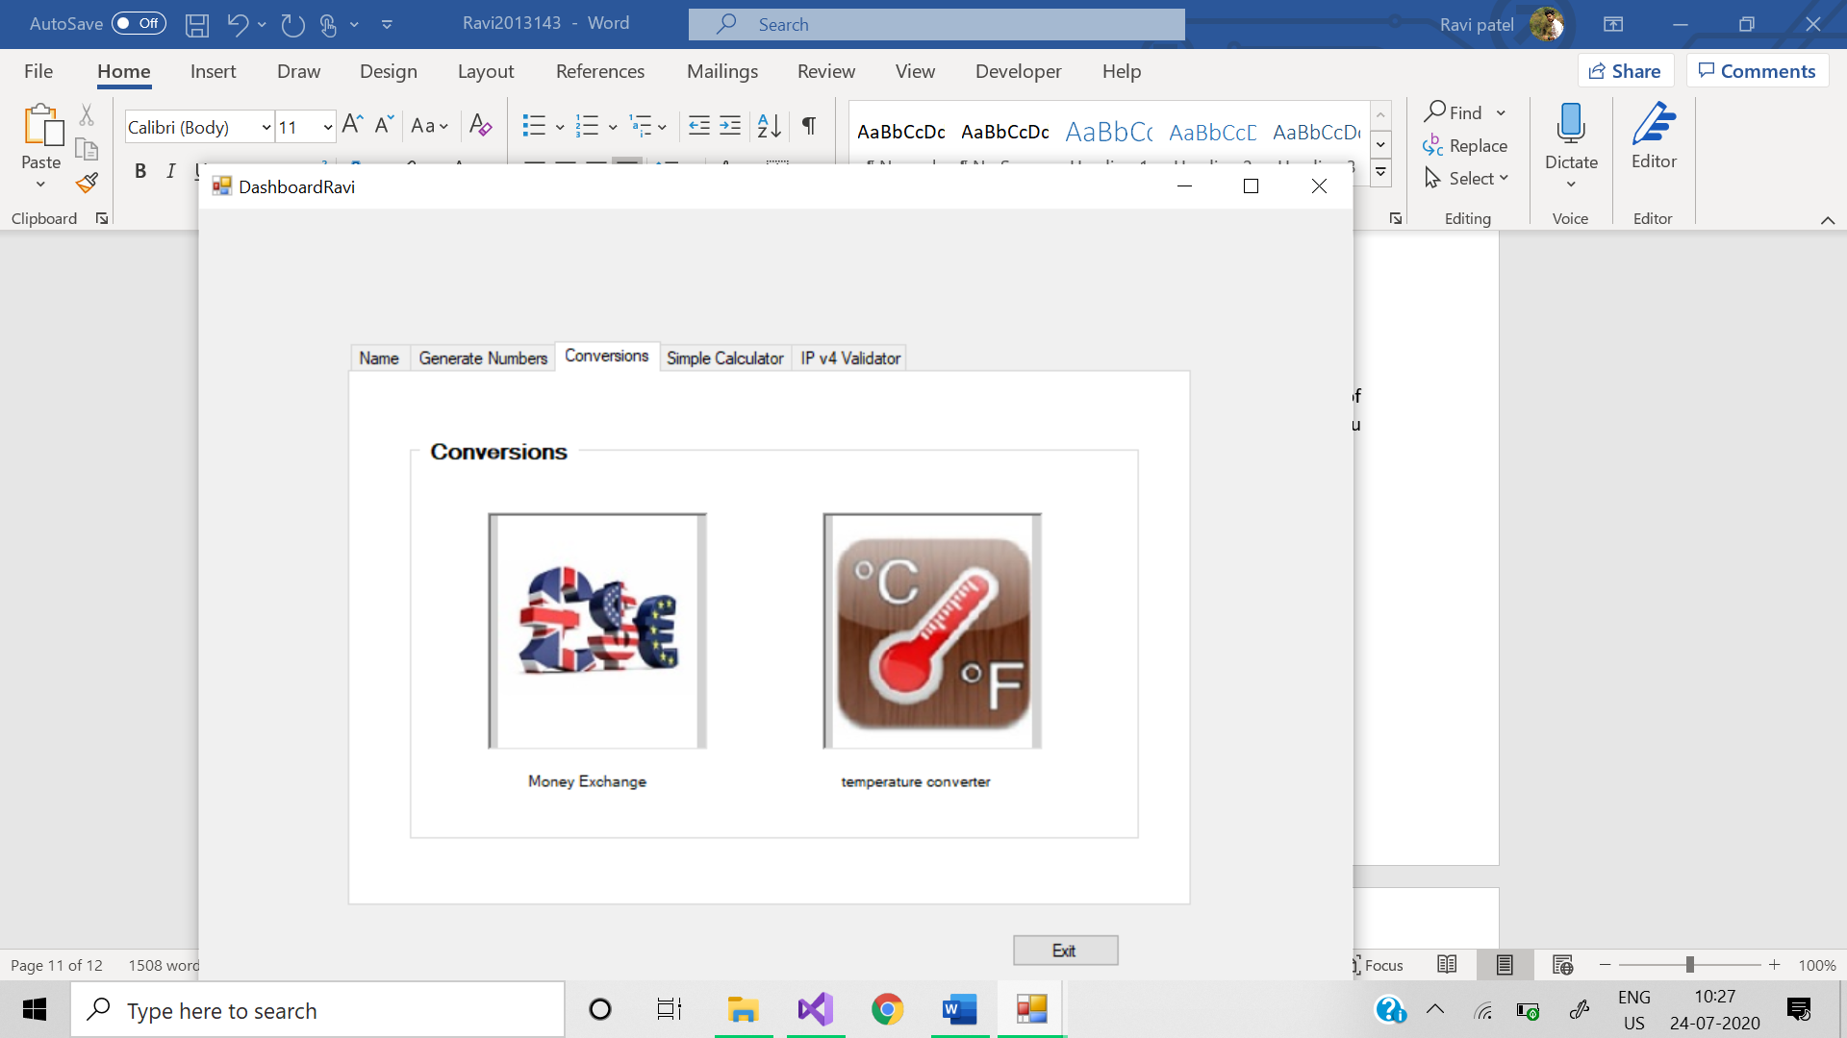

## Money conversion: Money conversion is done with the help of the radio buttons, and by clicking generate we can convert all into all and are stored in text file. With the read file button, we can see all the conversions with date and time.

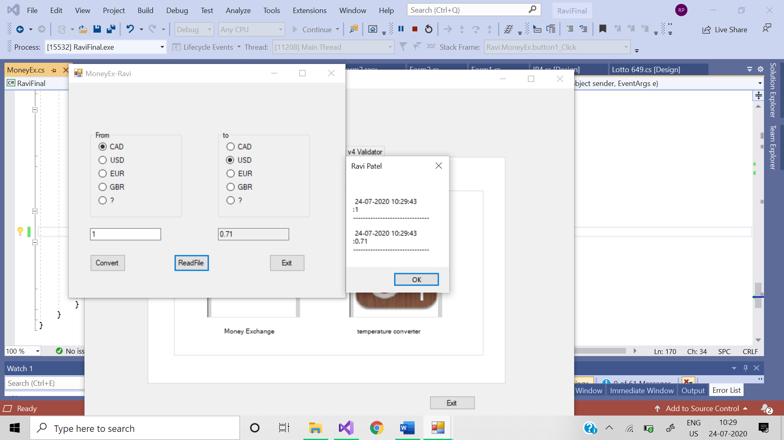

**Code:** using System;

using System.Collections.Generic;

using System.ComponentModel;

using System.Data;

using System.Drawing;

using System.Linq;

using System.Text;

using System.Threading.Tasks;

using System.Windows.Forms;

using System.IO;

namespace Ravi

{

public partial class MoneyEx : Form

{

public MoneyEx()

{

InitializeComponent();

}

private void button3_Click(object sender, EventArgs e)

{

int btnValue = -1;

btnValue = Convert.ToInt32(MessageBox.Show("Do you want Quit this application ?", "Exit?", MessageBoxButtons.OKCancel));

if (btnValue == 1) Application.Exit();

}

private void button1_Click(object sender, EventArgs e)

{

double Ans = 0;

try

{

Ans = Convert.ToDouble(textBox1.Text);

}

catch (ArgumentOutOfRangeException ex)

{

MessageBox.Show(ex.Message, "Enter the Valid numbers");

}

Conv_Cur(Ans);

using (StreamWriter w = File.AppendText(@"E:\final\moneyconversions.txt"))

{

Log(textBox1.Text, w);

Log(frm_Money.Text, w);

}

using (StreamReader r = File.OpenText(@"E:\final\moneyconversions.txt"))

{

DumpLog(r);

}

}

public static void Log(string logMessage, TextWriter w)

{

w.Write("\r\n ");

w.WriteLine($"{DateTime.Now.ToShortDateString()} {DateTime.Now.ToLongTimeString()}");

w.WriteLine($":{logMessage}");

w.WriteLine("-------------------------------");

}

public static void DumpLog(StreamReader r)

{

string line;

while ((line = r.ReadLine()) != null)

{

Console.WriteLine(line);

}

}

//For Performing the Operation

void Conv_Cur(double Ans)

{

double ans1 = Ans;

double ans = 0;

//CAD to CAD

if (radioButton1.Checked && radioButton10.Checked)

{

ans = ans1 * 1;

frm_Money.Text = Convert.ToString(ans);

}

//CAD to USD

else if (radioButton1.Checked && radioButton9.Checked)

{

ans = ans1 * 0.71;

frm_Money.Text = Convert.ToString(ans);

}

//CAD to EUR

else if (radioButton1.Checked && radioButton8.Checked)

{

ans = ans1 * 0.66;

frm_Money.Text = Convert.ToString(ans);

}

//CAD to GBR

else if (radioButton1.Checked && radioButton7.Checked)

{

ans = ans1 * 0.57;

frm_Money.Text = Convert.ToString(ans);

}

//USD to CAD

else if (radioButton2.Checked && radioButton10.Checked)

{

ans = ans1 * 1.4;

frm_Money.Text = Convert.ToString(ans);

}

//USD to USD

else if (radioButton2.Checked && radioButton9.Checked)

{

ans = ans1 * 1;

frm_Money.Text = Convert.ToString(ans);

}

//USD to EUR

else if (radioButton2.Checked && radioButton8.Checked)

{

ans = ans1 * 0.92;

frm_Money.Text = Convert.ToString(ans);

}

//EUR to CAD

else if (radioButton3.Checked && radioButton10.Checked)

{

ans = ans1 * 1.52;

frm_Money.Text = Convert.ToString(ans);

}

//EUR to USD

else if (radioButton3.Checked && radioButton9.Checked)

{

ans = ans1 * 1.08;

frm_Money.Text = Convert.ToString(ans);

}

//EUR to EUR

else if (radioButton3.Checked && radioButton8.Checked)

{

ans = ans1 * 1;

frm_Money.Text = Convert.ToString(ans);

}

//GBP to CAD

else if (radioButton4.Checked && radioButton10.Checked)

{

ans = ans1 * 1.75;

frm_Money.Text = Convert.ToString(ans);

}

//GBP to USD

else if (radioButton4.Checked && radioButton9.Checked)

{

ans = ans1 * 1.25;

frm_Money.Text = Convert.ToString(ans);

}

//GBP to EUR

else if (radioButton4.Checked && radioButton8.Checked)

{

ans = ans1 * 1.15;

frm_Money.Text = Convert.ToString(ans);

}

}

private void button2_Click(object sender, EventArgs e)

{

String filename = @"E:\final\moneyconversions.txt";

using (StreamReader rdr = new StreamReader(filename))

{

String content = rdr.ReadToEnd();

MessageBox.Show(content, "Ravi Patel");

}

}

}

}

## Temperature conversion: Temperature conversion will allow user to convert temperature from Celsius to faherenheit and vice versa. It will show message accordingly. For instance if he temperature is low. The message will be “its cold”. and changes its background color according to temp and stores data in textfile.

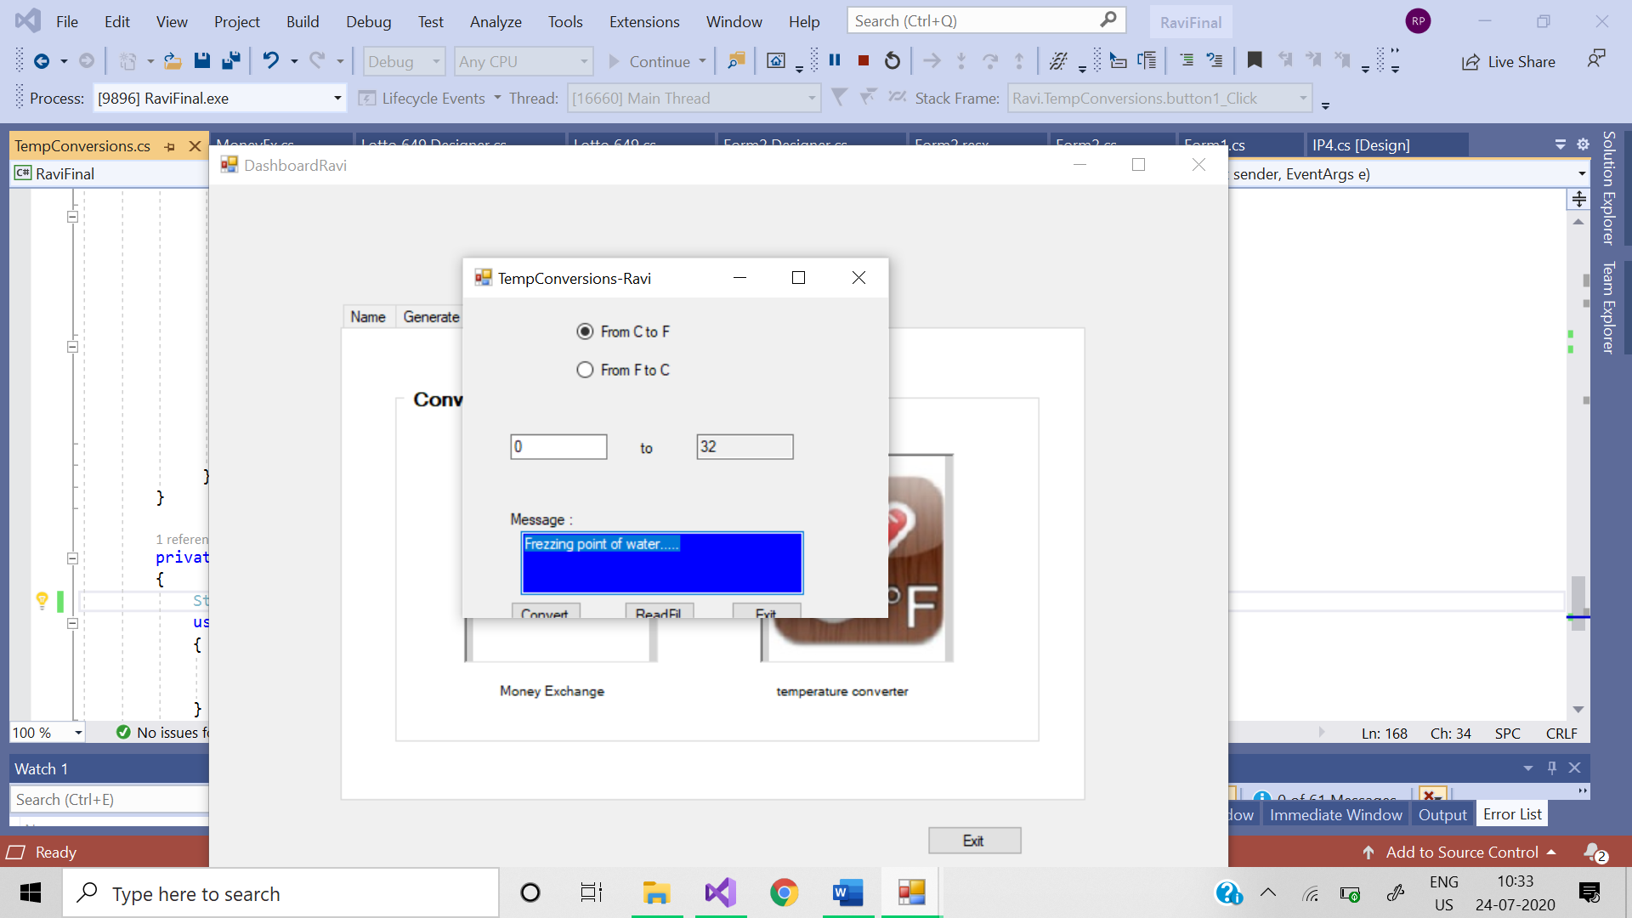

**Code:**

using System;

using System.Collections.Generic;

using System.ComponentModel;

using System.Data;

using System.Drawing;

using System.IO;

using System.Linq;

using System.Text;

using System.Threading.Tasks;

using System.Windows.Forms;

namespace Ravi

{

public partial class TempConversions : Form

{

public TempConversions()

{

InitializeComponent();

}

private void button3_Click(object sender, EventArgs e)

{

int btnValue = -1;

btnValue = Convert.ToInt32(MessageBox.Show("Do you want Quit this application ?", "Exit?", MessageBoxButtons.OKCancel));

if (btnValue == 1) Application.Exit();

}

private void button1_Click(object sender, EventArgs e)

{

double Ans = 0;

try

{

Ans = Convert.ToDouble(textBox2.Text);

}

catch (ArgumentOutOfRangeException ex1)

{

MessageBox.Show(ex1.Message + "Enter the valid NUmbers.");

}

Valid_Temp(Ans);

Valid_Message();

using (StreamWriter w = File.AppendText(@"E:\final\tempconversions.txt"))

{

Log(textBox1.Text, w);

Log(textBox1.Text, w);

Log(textBox3.Text, w);

}

using (StreamReader r = File.OpenText(@"E:\final\tempconversions.txt"))

{

DumpLog(r);

}

void Log(string logMessage, TextWriter w)

{

w.Write("\r\n");

w.WriteLine($" {DateTime.Now.ToShortDateString()} {DateTime.Now.ToLongTimeString()}");

w.WriteLine($":{logMessage}");

w.WriteLine("-------------------------------");

}

void DumpLog(StreamReader r)

{

string line;

while ((line = r.ReadLine()) != null)

{

Console.WriteLine(line);

}

}

void Valid_Temp(double Ans2)

{

double ans1 = Ans2, ans = 0;

//For Converting Celsius to Fahrenheit (°C × 9 / 5) +32

if (radioButton2.Checked)

{

ans = (ans1 * 9 / 5 + 32);

textBox1.Text = Convert.ToString(ans);

}

//For Converting Fahrenheit to Celsius (°F − 32) x 5/9

else if (radioButton1.Checked)

{

ans = ((ans1 - 32) * 5 / 9);

textBox1.Text = Convert.ToString(ans);

}

else

{

MessageBox.Show("Enter Valid Values between -40 to 40.");

textBox2.Focus();

}

textBox3.Focus();

}

void Valid_Message()

{

double ans = Convert.ToDouble(textBox2.Text);

double que = Convert.ToDouble(textBox2.Text);

if (radioButton2.Checked)

{

if (que == 100 | ans == 212)

{

textBox3.Text = "Water Bolis.....";

textBox3.BackColor = Color.Red;

}

else if (que == 40 | ans == 104)

{

textBox3.Text = "Hot Bath.....";

textBox3.BackColor = Color.Red;

}

else if (que == 37 | ans == 98.6)

{

textBox3.Text = "Body Temprature.....";

textBox3.BackColor = Color.Green;

}

else if (que == 30 | ans == 86)

{

textBox3.Text = "Beach weather.....";

textBox3.BackColor = Color.Green;

}

else if (que == 21 | ans == 70)

{

textBox3.Text = "Room Temprature.....";

textBox3.BackColor = Color.Green;

}

else if (que == 10 | ans == 50)

{

textBox3.Text = "Cold Day.....";

textBox3.BackColor = Color.Blue;

}

else if (que == 0 | ans == 32)

{

textBox3.Text = "Frezzing point of water.....";

textBox3.BackColor = Color.Blue;

}

else if (que == -18 | ans == 0)

{

textBox3.Text = "Very Cold Day.....";

textBox3.BackColor = Color.Blue;

}

else if (que == -40 | ans == -40)

{

textBox3.Text = "Extremely Cold....\n Same numbers";

textBox3.BackColor = Color.Blue;

}

else

{

textBox3.Text = "Nothing Good Enough";

textBox3.BackColor = Color.Silver;

}

}

}

}

private void button2_Click(object sender, EventArgs e)

{

String filename = @"E:\final\tempconversions.txt";

using (StreamReader rdr = new StreamReader(filename))

{

String content = rdr.ReadToEnd();

MessageBox.Show(content, "Ravi Patel");

}

}

}

}

# 4.simple calculator: If you click on the Calculator: This will show the window and it provides user to calculate the various operations and this also saves data into file calculator.txt. With the read file button, we can see all the calculations. If you click exit button you have 2 choices yes or no and it works according to its name.

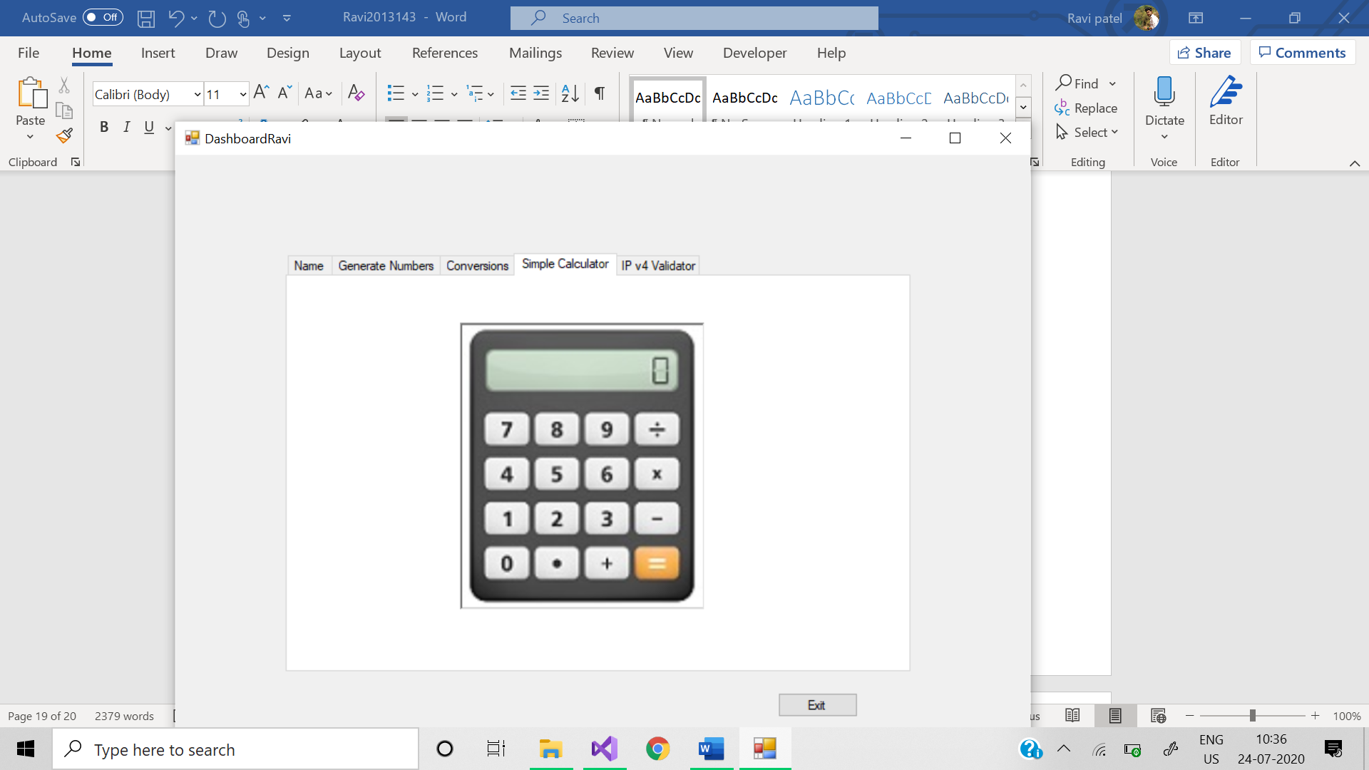

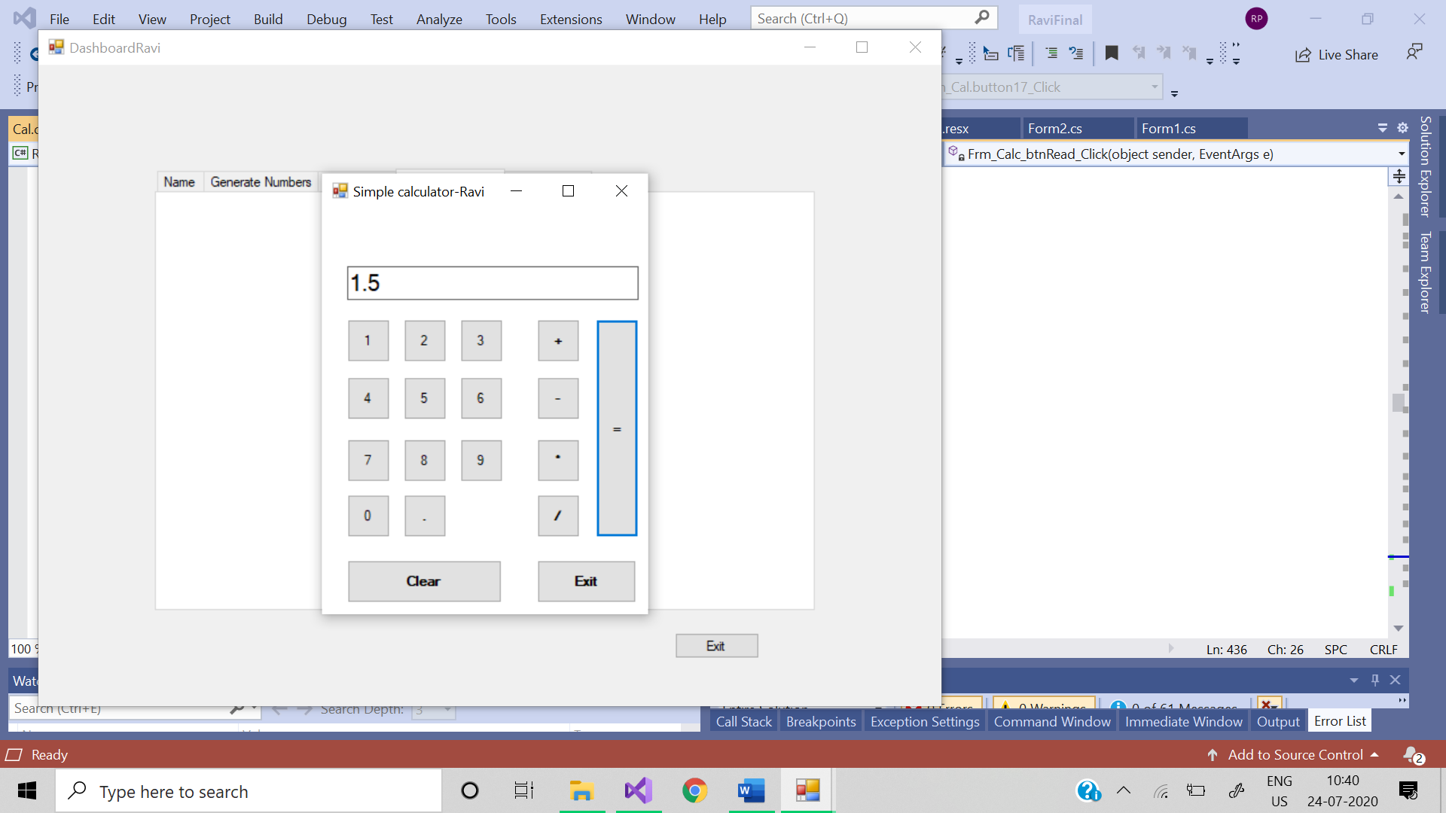

**Code:**

using System;

using System.Collections.Generic;

using System.Linq;

using System.Text;

using System.Threading.Tasks;

namespace Ravi

{

class Calculator

{

public string calc(char op, double num1, double num2)

{

if (op == '+')

{

return (num1 + num2).ToString();

}

else if (op == '-')

{

return (num1 - num2).ToString();

}

else if (op == '*')

{

return (num1 * num2).ToString();

}

else

{

return (num1 / num2).ToString();

}

}

}

}

namespace Ravi

{

partial class frm_Cal

{

/// <summary>

/// Required designer variable.

/// </summary>

private System.ComponentModel.IContainer components = null;

/// <summary>

/// Clean up any resources being used.

/// </summary>

/// <param name="disposing">true if managed resources should be disposed; otherwise, false.</param>

protected override void Dispose(bool disposing)

{

if (disposing && (components != null))

{

components.Dispose();

}

base.Dispose(disposing);

}

#region Windows Form Designer generated code

/// <summary>

/// Required method for Designer support - do not modify

/// the contents of this method with the code editor.

/// </summary>

private void InitializeComponent()

{

this.textBox1 = new System.Windows.Forms.TextBox();

this.button1 = new System.Windows.Forms.Button();

this.button2 = new System.Windows.Forms.Button();

this.button3 = new System.Windows.Forms.Button();

this.button4 = new System.Windows.Forms.Button();

this.button5 = new System.Windows.Forms.Button();

this.button6 = new System.Windows.Forms.Button();

this.button7 = new System.Windows.Forms.Button();

this.button8 = new System.Windows.Forms.Button();

this.button9 = new System.Windows.Forms.Button();

this.button10 = new System.Windows.Forms.Button();

this.btnDot = new System.Windows.Forms.Button();

this.button12 = new System.Windows.Forms.Button();

this.button13 = new System.Windows.Forms.Button();

this.button14 = new System.Windows.Forms.Button();

this.button15 = new System.Windows.Forms.Button();

this.button16 = new System.Windows.Forms.Button();

this.button17 = new System.Windows.Forms.Button();

this.button18 = new System.Windows.Forms.Button();

this.SuspendLayout();

//

// textBox1

//

this.textBox1.BorderStyle = System.Windows.Forms.BorderStyle.FixedSingle;

this.textBox1.Font = new System.Drawing.Font("Microsoft Sans Serif", 15F, System.Drawing.FontStyle.Regular, System.Drawing.GraphicsUnit.Point, ((byte)(0)));

this.textBox1.Location = new System.Drawing.Point(29, 63);

this.textBox1.Name = "textBox1";

this.textBox1.Size = new System.Drawing.Size(343, 36);

this.textBox1.TabIndex = 0;

//

// button1

//

this.button1.Location = new System.Drawing.Point(29, 120);

this.button1.Name = "button1";

this.button1.Size = new System.Drawing.Size(50, 47);

this.button1.TabIndex = 1;

this.button1.Text = "1";

this.button1.UseVisualStyleBackColor = true;

this.button1.Click += new System.EventHandler(this.button1_Click);

//

// button2

//

this.button2.Location = new System.Drawing.Point(96, 120);

this.button2.Name = "button2";

this.button2.Size = new System.Drawing.Size(50, 47);

this.button2.TabIndex = 2;

this.button2.Text = "2";

this.button2.UseVisualStyleBackColor = true;

this.button2.Click += new System.EventHandler(this.button2_Click);

//

// button3

//

this.button3.Location = new System.Drawing.Point(162, 120);

this.button3.Name = "button3";

this.button3.Size = new System.Drawing.Size(50, 47);

this.button3.TabIndex = 3;

this.button3.Text = "3";

this.button3.UseVisualStyleBackColor = true;

//

// button4

//

this.button4.Location = new System.Drawing.Point(29, 183);

this.button4.Name = "button4";

this.button4.Size = new System.Drawing.Size(50, 47);

this.button4.TabIndex = 4;

this.button4.Text = "4";

this.button4.UseVisualStyleBackColor = true;

this.button4.Click += new System.EventHandler(this.button4_Click_1);

//

// button5

//

this.button5.Location = new System.Drawing.Point(96, 183);

this.button5.Name = "button5";

this.button5.Size = new System.Drawing.Size(50, 47);

this.button5.TabIndex = 5;

this.button5.Text = "5";

this.button5.UseVisualStyleBackColor = true;

this.button5.Click += new System.EventHandler(this.button5_Click_1);

//

// button6

//

this.button6.Location = new System.Drawing.Point(162, 183);

this.button6.Name = "button6";

this.button6.Size = new System.Drawing.Size(50, 47);

this.button6.TabIndex = 6;

this.button6.Text = "6";

this.button6.UseVisualStyleBackColor = true;

this.button6.Click += new System.EventHandler(this.button6_Click_1);

//

// button7

//

this.button7.Location = new System.Drawing.Point(29, 251);

this.button7.Name = "button7";

this.button7.Size = new System.Drawing.Size(50, 47);

this.button7.TabIndex = 7;

this.button7.Text = "7";

this.button7.UseVisualStyleBackColor = true;

this.button7.Click += new System.EventHandler(this.button7_Click_1);

//

// button8

//

this.button8.Location = new System.Drawing.Point(96, 251);

this.button8.Name = "button8";

this.button8.Size = new System.Drawing.Size(50, 47);

this.button8.TabIndex = 8;

this.button8.Text = "8";

this.button8.UseVisualStyleBackColor = true;

this.button8.Click += new System.EventHandler(this.button8_Click_1);

//

// button9

//

this.button9.Location = new System.Drawing.Point(162, 251);

this.button9.Name = "button9";

this.button9.Size = new System.Drawing.Size(50, 47);

this.button9.TabIndex = 9;

this.button9.Text = "9";

this.button9.UseVisualStyleBackColor = true;

this.button9.Click += new System.EventHandler(this.button9_Click_1);

//

// button10

//

this.button10.Location = new System.Drawing.Point(29, 311);

this.button10.Name = "button10";

this.button10.Size = new System.Drawing.Size(50, 47);

this.button10.TabIndex = 10;

this.button10.Text = "0";

this.button10.UseVisualStyleBackColor = true;

this.button10.Click += new System.EventHandler(this.button10_Click);

//

// btnDot

//

this.btnDot.Font = new System.Drawing.Font("Microsoft Sans Serif", 7.8F, System.Drawing.FontStyle.Bold, System.Drawing.GraphicsUnit.Point, ((byte)(0)));

this.btnDot.Location = new System.Drawing.Point(96, 311);

this.btnDot.Name = "btnDot";

this.btnDot.Size = new System.Drawing.Size(50, 47);

this.btnDot.TabIndex = 11;

this.btnDot.Text = ".";

this.btnDot.UseVisualStyleBackColor = true;

this.btnDot.Click += new System.EventHandler(this.btnDot_Click);

//

// button12

//

this.button12.Font = new System.Drawing.Font("Microsoft Sans Serif", 7.8F, System.Drawing.FontStyle.Bold, System.Drawing.GraphicsUnit.Point, ((byte)(0)));

this.button12.Location = new System.Drawing.Point(29, 383);

this.button12.Name = "button12";

this.button12.Size = new System.Drawing.Size(183, 47);

this.button12.TabIndex = 12;

this.button12.Text = "Clear";

this.button12.UseVisualStyleBackColor = true;

this.button12.Click += new System.EventHandler(this.button12_Click);

//

// button13

//

this.button13.Font = new System.Drawing.Font("Microsoft Sans Serif", 7.8F, System.Drawing.FontStyle.Bold, System.Drawing.GraphicsUnit.Point, ((byte)(0)));

this.button13.Location = new System.Drawing.Point(254, 120);

this.button13.Name = "button13";

this.button13.Size = new System.Drawing.Size(50, 47);

this.button13.TabIndex = 13;

this.button13.Text = "+";

this.button13.UseVisualStyleBackColor = true;

this.button13.Click += new System.EventHandler(this.button13_Click);

//

// button14

//

this.button14.Font = new System.Drawing.Font("Microsoft Sans Serif", 7.8F, System.Drawing.FontStyle.Bold, System.Drawing.GraphicsUnit.Point, ((byte)(0)));

this.button14.Location = new System.Drawing.Point(254, 183);

this.button14.Name = "button14";

this.button14.Size = new System.Drawing.Size(50, 47);

this.button14.TabIndex = 14;

this.button14.Text = "-";

this.button14.UseVisualStyleBackColor = true;

this.button14.Click += new System.EventHandler(this.button14_Click);

//

// button15

//

this.button15.Font = new System.Drawing.Font("Microsoft Sans Serif", 7.8F, System.Drawing.FontStyle.Bold, System.Drawing.GraphicsUnit.Point, ((byte)(0)));

this.button15.Location = new System.Drawing.Point(254, 251);

this.button15.Name = "button15";

this.button15.Size = new System.Drawing.Size(50, 47);

this.button15.TabIndex = 15;

this.button15.Text = "*";

this.button15.UseVisualStyleBackColor = true;

this.button15.Click += new System.EventHandler(this.button15_Click);

//

// button16

//

this.button16.Font = new System.Drawing.Font("Microsoft Sans Serif", 7.8F, System.Drawing.FontStyle.Bold, System.Drawing.GraphicsUnit.Point, ((byte)(0)));

this.button16.Location = new System.Drawing.Point(254, 311);

this.button16.Name = "button16";

this.button16.Size = new System.Drawing.Size(50, 47);

this.button16.TabIndex = 16;

this.button16.Text = "/";

this.button16.UseVisualStyleBackColor = true;

this.button16.Click += new System.EventHandler(this.button16_Click);

//

// button17

//

this.button17.Font = new System.Drawing.Font("Microsoft Sans Serif", 7.8F, System.Drawing.FontStyle.Bold, System.Drawing.GraphicsUnit.Point, ((byte)(0)));

this.button17.Location = new System.Drawing.Point(322, 120);

this.button17.Name = "button17";

this.button17.Size = new System.Drawing.Size(50, 238);

this.button17.TabIndex = 17;

this.button17.Text = "=";

this.button17.UseVisualStyleBackColor = true;

this.button17.Click += new System.EventHandler(this.button17_Click);

//

// button18

//

this.button18.Font = new System.Drawing.Font("Microsoft Sans Serif", 7.8F, System.Drawing.FontStyle.Bold, System.Drawing.GraphicsUnit.Point, ((byte)(0)));

this.button18.Location = new System.Drawing.Point(254, 383);

this.button18.Name = "button18";

this.button18.Size = new System.Drawing.Size(118, 47);

this.button18.TabIndex = 18;

this.button18.Text = "Exit";

this.button18.UseVisualStyleBackColor = true;

this.button18.Click += new System.EventHandler(this.button18_Click);

//

// frm_Cal

//

this.AutoScaleDimensions = new System.Drawing.SizeF(8F, 16F);

this.AutoScaleMode = System.Windows.Forms.AutoScaleMode.Font;

this.BackColor = System.Drawing.SystemColors.ControlLightLight;

this.ClientSize = new System.Drawing.Size(384, 442);

this.Controls.Add(this.button18);

this.Controls.Add(this.button17);

this.Controls.Add(this.button16);

this.Controls.Add(this.button15);

this.Controls.Add(this.button14);

this.Controls.Add(this.button13);

this.Controls.Add(this.button12);

this.Controls.Add(this.btnDot);

this.Controls.Add(this.button10);

this.Controls.Add(this.button9);

this.Controls.Add(this.button8);

this.Controls.Add(this.button7);

this.Controls.Add(this.button6);

this.Controls.Add(this.button5);

this.Controls.Add(this.button4);

this.Controls.Add(this.button3);

this.Controls.Add(this.button2);

this.Controls.Add(this.button1);

this.Controls.Add(this.textBox1);

this.ForeColor = System.Drawing.SystemColors.ActiveCaptionText;

this.Name = "frm_Cal";

this.Text = "Simple calculator-Ravi";

this.ResumeLayout(false);

this.PerformLayout();

}

#endregion

private System.Windows.Forms.TextBox textBox1;

private System.Windows.Forms.Button button1;

private System.Windows.Forms.Button button2;

private System.Windows.Forms.Button button3;

private System.Windows.Forms.Button button4;

private System.Windows.Forms.Button button5;

private System.Windows.Forms.Button button6;

private System.Windows.Forms.Button button7;

private System.Windows.Forms.Button button8;

private System.Windows.Forms.Button button9;

private System.Windows.Forms.Button button10;

private System.Windows.Forms.Button btnDot;

private System.Windows.Forms.Button button12;

private System.Windows.Forms.Button button13;

private System.Windows.Forms.Button button14;

private System.Windows.Forms.Button button15;

private System.Windows.Forms.Button button16;

private System.Windows.Forms.Button button17;

private System.Windows.Forms.Button button18;

}

}

5.IP VALIDATOR: If you click on the IP: This will show the window and by clicking validate button it provides user to validate the ip address of version 4 and if error accurse then provide the format to enter IPv4.by clicking reset it resets the text box. If you click exit button you have 2 choices yes or no and it works according to its name. If you click on Exit : If you click exit button you have 2 choices yes or no and it works according to its name.

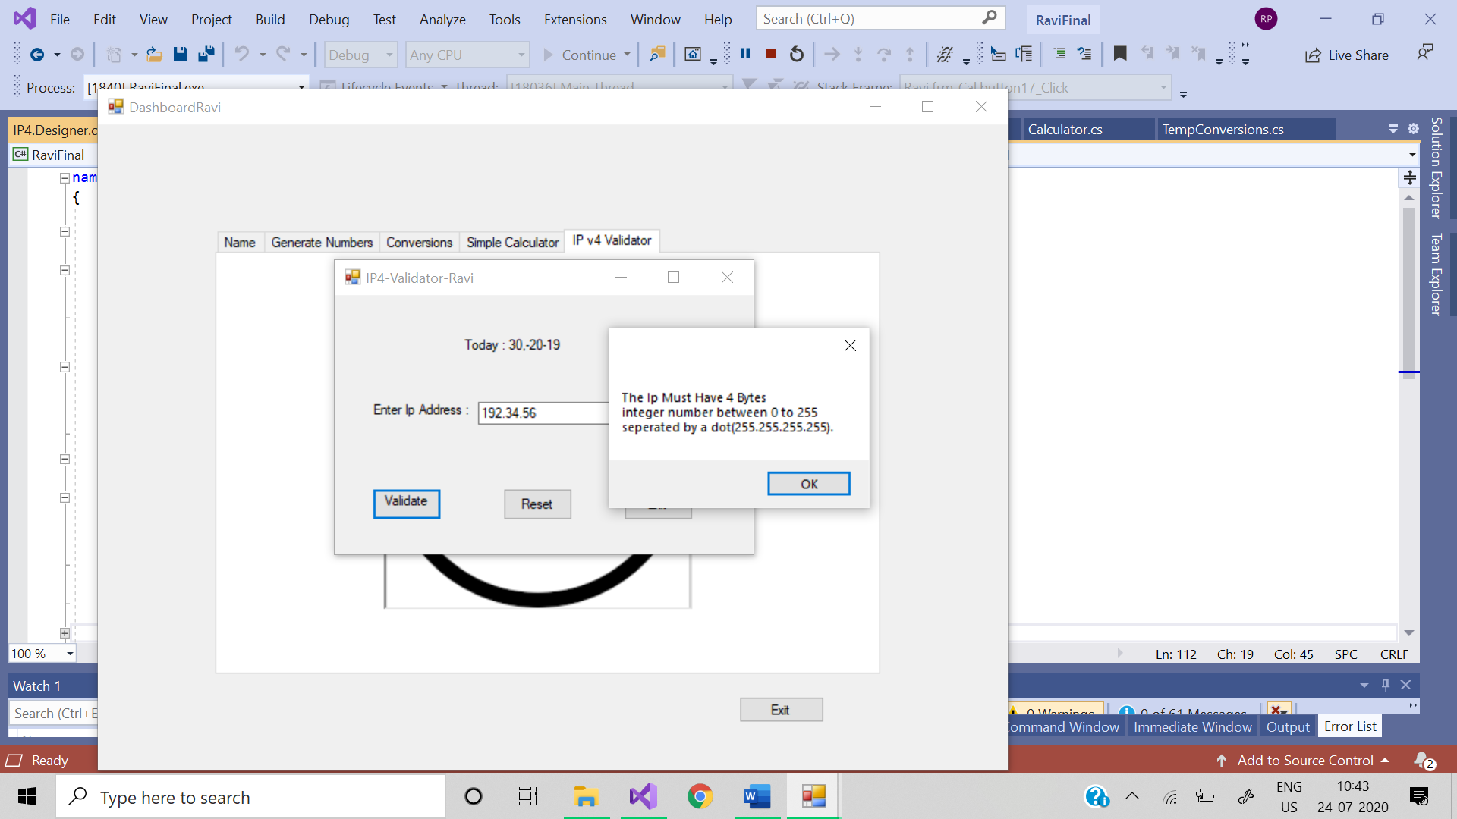

namespace Ravi

{

partial class IP4

{

/// <summary>

/// Required designer variable.

/// </summary>

private System.ComponentModel.IContainer components = null;

/// <summary>

/// Clean up any resources being used.

/// </summary>

/// <param name="disposing">true if managed resources should be disposed; otherwise, false.</param>

protected override void Dispose(bool disposing)

{

if (disposing && (components != null))

{

components.Dispose();

}

base.Dispose(disposing);

}

#region Windows Form Designer generated code

/// <summary>

/// Required method for Designer support - do not modify

/// the contents of this method with the code editor.

/// </summary>

private void InitializeComponent()

{

this.label1 = new System.Windows.Forms.Label();

this.label2 = new System.Windows.Forms.Label();

this.textBox1 = new System.Windows.Forms.TextBox();

this.button1 = new System.Windows.Forms.Button();

this.button2 = new System.Windows.Forms.Button();

this.button3 = new System.Windows.Forms.Button();

this.SuspendLayout();

//

// label1

//

this.label1.AutoSize = true;

this.label1.Location = new System.Drawing.Point(148, 46);

this.label1.Name = "label1";

this.label1.Size = new System.Drawing.Size(122, 17);

this.label1.TabIndex = 0;

this.label1.Text = "Today : 30,-20-19";

//

// label2

//

this.label2.AutoSize = true;

this.label2.Location = new System.Drawing.Point(41, 116);

this.label2.Name = "label2";

this.label2.Size = new System.Drawing.Size(121, 17);

this.label2.TabIndex = 1;

this.label2.Text = "Enter Ip Address :";

//

// textBox1

//

this.textBox1.Location = new System.Drawing.Point(168, 116);

this.textBox1.Name = "textBox1";

this.textBox1.Size = new System.Drawing.Size(221, 22);

this.textBox1.TabIndex = 2;

//

// button1

//

this.button1.Location = new System.Drawing.Point(44, 209);

this.button1.Name = "button1";

this.button1.Size = new System.Drawing.Size(81, 34);

this.button1.TabIndex = 3;

this.button1.Text = "Validate IP";

this.button1.UseVisualStyleBackColor = true;

this.button1.Click += new System.EventHandler(this.button1_Click);

//

// button2

//

this.button2.Location = new System.Drawing.Point(198, 209);

this.button2.Name = "button2";

this.button2.Size = new System.Drawing.Size(81, 34);

this.button2.TabIndex = 4;

this.button2.Text = "Reset";

this.button2.UseVisualStyleBackColor = true;

this.button2.Click += new System.EventHandler(this.button2_Click);

//

// button3

//

this.button3.Location = new System.Drawing.Point(338, 209);

this.button3.Name = "button3";

this.button3.Size = new System.Drawing.Size(81, 34);

this.button3.TabIndex = 5;

this.button3.Text = "Exit";

this.button3.UseVisualStyleBackColor = true;

this.button3.Click += new System.EventHandler(this.button3_Click);

//

// IP4

//

this.AutoScaleDimensions = new System.Drawing.SizeF(8F, 16F);

this.AutoScaleMode = System.Windows.Forms.AutoScaleMode.Font;

this.ClientSize = new System.Drawing.Size(491, 280);

this.Controls.Add(this.button3);

this.Controls.Add(this.button2);

this.Controls.Add(this.button1);

this.Controls.Add(this.textBox1);

this.Controls.Add(this.label2);

this.Controls.Add(this.label1);

this.Name = "IP4";

this.Text = "IP4-Validator-Ravi";

this.ResumeLayout(false);

this.PerformLayout();

}

#endregion

private System.Windows.Forms.Label label1;

private System.Windows.Forms.Label label2;

private System.Windows.Forms.TextBox textBox1;

private System.Windows.Forms.Button button1;

private System.Windows.Forms.Button button2;

private System.Windows.Forms.Button button3;

}

}

**# Present the difficulties that you have faced to develop the project**

EASY: IP Validator

HARD: Lotto max