Q.3) script for bash create a backup of rds mariadb database every 2nd and 4th of each month Friday?

Step1:

Make sure you have the RDS database Craeted

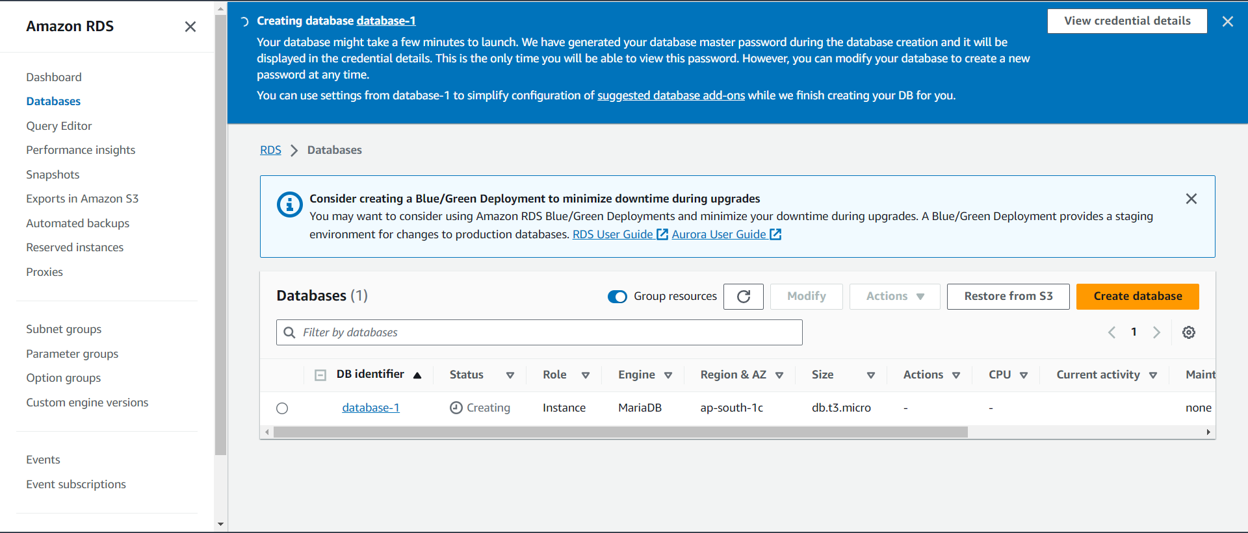

Step2:

Launch an instance in the same AZ

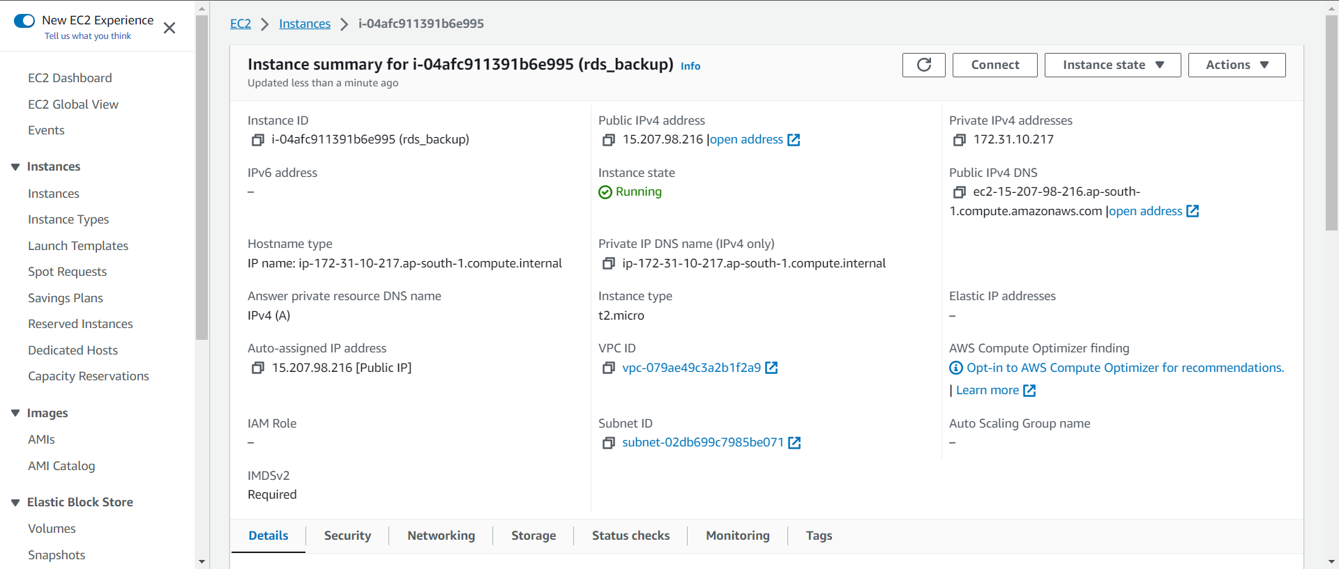

Step3:

Make sure you have configured AWS account so you have permission which you need

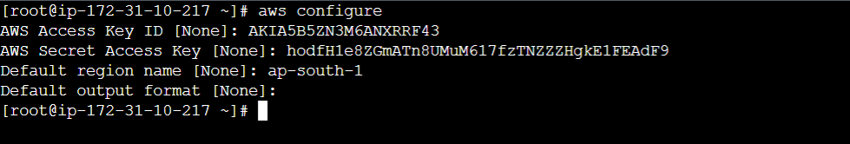

Step4:

Create a .sh file so you can write a script into it

Make sure it has a permission to execute



Write a below script into the file

AWS region

RDS_INSTANCE_IDENTIFIER="my-database"

AWS_REGION="eu-west-1"

SNAPSHOT_IDENTIFIER="Snapshot-$(date +\%Y\%m\%d\%H\%M\%S)"

aws rds create-db-snapshot --db-instance-identifier "$RDS_INSTANCE_IDENTIFIER" --db-snapshot-identifier "$SNAPSHOT_IDENTIFIER" --region "$AWS_REGION"

# Print a message

echo "RDS snapshot created: $SNAPSHOT_IDENTIFIER"e I write following script.

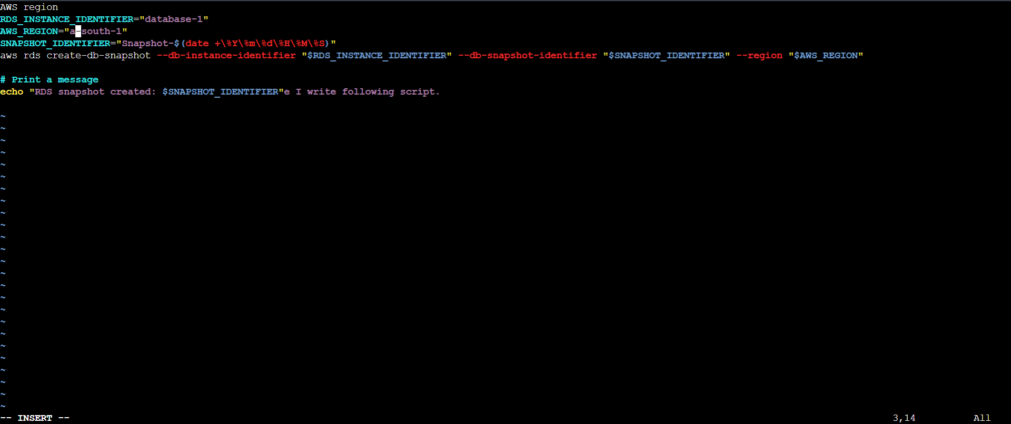

Step5:

Now Schedule job in crontab to take snapshot of RDS database

