**Practical for snowflake:**

1. **Loading the data from local to SF (INTERNAL STAGING)**

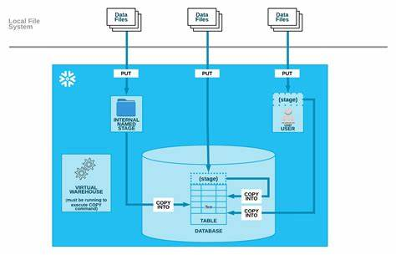

We are create a table for table stage:

(in snowflake worksheet)

create or replace table customer_csv (

customer_pk number(38,0),

salutation varchar(10),

first_name varchar(20),

last_name varchar(20),

gender varchar(1),

marital_status varchar(10),

day_of_birth date,

birth_country varchar(60),

email_address varchar(60),

city_name varchar(20),

zip_code varchar (10),

country_name varchar(20),

gmt_timezone_offset number(10,2),

preferred_cust_flag boolean,

registration_time timestamp_ltz(9)

);

select * from customer_csv;

**--uploading data file to user stage** (in local cmd)

put file://C:\Users\BhandariRaviraj\customer_10k.csv @~/staged;

**--uploading data file to table stage**

put file://C:\Users\BhandariRaviraj\customer_10k.csv @%customer_csv;

**--file format for named stage** (in local cmd)

create or replace file format customer_ff

type='csv', field_delimiter = ',', field_optionally_enclosed_by='\042', skip_header = 1;

**--creating named stage** (in local cmd)

create or replace stage customer_stage

//file_format=(type='csv', field_delimiter = ',', field_optionally_enclosed_by='\042', skip_header = 1);

file_format=customer_ff;

**--upload data file to named stage (customer_stage)**(in local cmd)

put file://C:\Users\BhandariRaviraj\customer_10k.csv @customer_stage;

**--listing from internal stages(**in snowflake worksheet**)**

list @~/staged; --user stage

list @%customer_csv; -- table stage

list @customer_stage; --named stage

**Copying/ loading data files from stages(user, named, table) to table**

**--load data from user stage**

copy into customer_csv

from @~/staged

file_format=(type='csv', field_delimiter = ',', field_optionally_enclosed_by='\042', skip_header = 1);

select * from customer_csv;

**--load data from table stage**

copy into customer_csv

from @%customer_csv

file_format=(type='csv', field_delimiter = ',', field_optionally_enclosed_by='\042', skip_header = 1);

**--load data from named stage (customer_stage)**

copy into cutomer_csv

from @customer_stage/customer_10k.csv;

** If error occurs for column mismatch try to stage with below command:

put file://C:\Users\BhandariRaviraj\test.csv @~/final AUTO_COMPRESS=TRUE OVERWRITE=TRUE;

COPY INTO mytable

FROM @~/test/final.csv.gz

FILE_FORMAT = (type='csv', field_delimiter = ',', field_optionally_enclosed_by='\042', skip_header = 1)

ON_ERROR = 'skip_file';

**-- copy command properties**

**pattern** = '.*/.*/.*[.]csv[.]gz'

**FILES** = ('file_name')

**file_format** = format_name

**ON_ERROR** = {CONTINUE | SKIP_FILE | SKIP_FILE_<num> | 'SKIP_FILE_<num>%' | ABORT_STATEMENT}

**SIZE_LIMIT** = <num>

**PURGE** = TRUE | FALSE

**LOAD_UNCERTAIN_FILES** = TRUE | FALSE

**trim_space** = false | true

**error_on_column_count_mismatch** = true | false;

**-- loading error commands**

--**1. on error => skip the file**

COPY INTO emp.emp_customer_csv

From @/file_name

FILE_FORMAT = emp.emp.customer_tsv_ff

ON_ERROR = 'SKIP_FILE'

PURGE = TRUE;

--**2. on error** **=> abort statement**

COPY INTO emp.emp.customer_csv

FROM @/file_name

FILE_FORMAT = emp.emp.customer_csv_ff

ERROR = 'ABORT_STATEMENT'

PURGE = TRUE;

--**3. on error** **=> skip upto 10 error records**

COPY INTO emp.emp.customer_csv_ff

FROM @/file_name

FILE_FORMAT = emp.emp.customer_c[sv_ff

ON_ERROR = 'SKIP_FILE_10'

PURGE = TRUE;

--**4. On erro**r **=> continue even if there is an error**

COPY INTO emp.emp.cutomer_csv

FROM @/FILENAME

FILE_FORMAT = emp.emp.customer_csv_ff

ON_ERROR = 'CONTINUE'

PURGE = TRUE;

**---loading psv file**

create or replace table customer_psv (

CUSTOMER_PK number(38,0),

SALUTATION varchar(10),

FIRST_NAME varchar(20),

LAST_NAME varchar(20),

GENDER varchar(1),

MARITAL_STATUS varchar(20),

DAY_OF_BIRTH date,

BIRTH_COUNTRY varchar(60),

EMAIL_ADDRESS varchar(60),

CITY_NAME varchar(50),

ZIP_CODE varchar (50),

COUNTRY_NAME varchar(50),

GMT_TIMEZONE_OFFSET number(10,2),

PREFERRED_CUST_FLAG boolean,

REGISTRATION_TIME VARCHAR(30)

);

select * from customer_psv;

**--create ff for csv**

create or replace file format customer_ff

type='csv', field_delimiter =',', field_optionally_enclosed_by = '\042', skip_header=1;

**--stage area**

create or replace stage customer_stg

file_format = customer_ff;

**-- uploading to stage area**

put file://C:\Users\BhandariRaviraj\customer_10k.* @customer_stg;

**-- list**

list @customer_stg;

**-- loading to customer csv**

copy into customer_csv

from @customer_stg/customer_10k.csv.gz

on_error = 'continue'**;**

**-- loading to customer csv with specified file**

copy into customer_csv

from @customer_stg/customer_10k.csv.gz

files = ('customer_10k.csv.gz')

on_error = 'continue';

**--create ff for psv**

create or replace file format customer_ff

type='csv', field_delimiter ='|', field_optionally_enclosed_by = '\042', skip_header=1;

**-- loading to customer psv**

copy into customer_psv

from @customer_stg

files = ('customer_10k.psv.gz')

on_error = 'continue';

**– loading tsv data**

create or replace table customer_tsv (

CUSTOMER_PK number(38,0),

SALUTATION varchar(10),

FIRST_NAME varchar(20),

LAST_NAME varchar(20),

GENDER varchar(1),

MARITAL_STATUS varchar(20),

DAY_OF_BIRTH date,

BIRTH_COUNTRY varchar(60),

EMAIL_ADDRESS varchar(60),

CITY_NAME varchar(50),

ZIP_CODE varchar (50),

COUNTRY_NAME varchar(50),

GMT_TIMEZONE_OFFSET number(10,2),

PREFERRED_CUST_FLAG boolean,

REGISTRATION_TIME VARCHAR(30)

);

**--create ff for tsv**

create or replace file format customer_ff

type='csv', field_delimiter ='\t', field_optionally_enclosed_by = '\042', skip_header=1;

**-- loading to customer psv**

copy into customer_tsv

from @customer_stg

files = ('customer_10k.tsv.gz')

on_error = 'continue';

select * from customer_tsv;

**--- loading multiple csv files in 1 go**

create or replace table customer_multiple (

CUSTOMER_PK number(38,0),

SALUTATION varchar(10),

FIRST_NAME varchar(20),

LAST_NAME varchar(20),

GENDER varchar(1),

MARITAL_STATUS varchar(20),

DAY_OF_BIRTH date,

BIRTH_COUNTRY varchar(60),

EMAIL_ADDRESS varchar(60),

CITY_NAME varchar(50),

ZIP_CODE varchar (50),

COUNTRY_NAME varchar(50),

GMT_TIMEZONE_OFFSET number(10,2),

PREFERRED_CUST_FLAG boolean,

REGISTRATION_TIME VARCHAR(30)

);

select * from customer_multiple;

**-- create a file format**

create or replace file format customer_multi_ff

type = 'csv', field_delimiter = ',', field_optionally_enclosed_by = '\042', skip_header=1;

**-- create a stage to load all data files in 1 go**

create or replace stage customer_multi

file_format = customer_multi_ff;

list @customer_multi;

**-- upload file to stage**

put file://C:\Users\BhandariRaviraj\customer_10k.*csv @customer_multi;

**-- copy file from stage to table**

copy into customer_multiple

from @customer_multi

file_format = customer_multi_ff

on_error = 'CONTINUE'

pattern = ',*[.]csv[.]gz';

select * from customer_multiple;

**—-Loading file for big_data**

**--create a table for big data**

create or replace table customer_bigdata (

CUSTOMER_PK number(38,0),

SALUTATION varchar(10),

FIRST_NAME varchar(20),

LAST_NAME varchar(20),

GENDER varchar(1),

MARITAL_STATUS varchar(20),

DAY_OF_BIRTH date,

BIRTH_COUNTRY varchar(60),

EMAIL_ADDRESS varchar(60),

CITY_NAME varchar(50),

ZIP_CODE varchar (50),

COUNTRY_NAME varchar(50),

GMT_TIMEZONE_OFFSET number(10,2),

PREFERRED_CUST_FLAG boolean,

REGISTRATION_TIME VARCHAR(30)

);

select * from customer_bigdata;

**--create a file format**

create or replace file format customer_multi_ff

type = 'csv', record_delimiter= '\n', field_delimiter = ',', field_optionally_enclosed_by = '\042', skip_header=1;

**--create a stage to load all data files in 1 go**

create or replace stage customer_bigdata

file_format = customer_multi_ff;

**--upload the data**

copy into customer_bigdata

from @customer_bigdata

file_format = customer_multi_ff

on_error = 'CONTINUE'

pattern = '.*[.]csv[.]gz'

purge = true;

select * from customer_bigdata;

**----loading data files with column mismatch**

--create a table for multiple files

create or replace table column_mismatch (

CUSTOMER_PK number(38,0),

SALUTATION varchar(10),

FIRST_NAME varchar(20),

LAST_NAME varchar(20),

GENDER varchar(1),

MARITAL_STATUS varchar(20),

DAY_OF_BIRTH date,

BIRTH_COUNTRY varchar(60),

EMAIL_ADDRESS varchar(60),

CITY_NAME varchar(50),

ZIP_CODE varchar (50),

COUNTRY_NAME varchar(50),

GMT_TIMEZONE_OFFSET number(10,2),

PREFERRED_CUST_FLAG boolean,

REGISTRATION_TIME VARCHAR(30)

);

select * from column_mismatch;

**--create a file format**

create or replace file format customer_multi_ff

type = 'csv', field_delimiter = ',', field_optionally_enclosed_by = '\042', skip_header=1, error_on_column_count_mismatch = false;

**--create a stage to load all data files in 1 go**

create or replace stage column_stage

file_format = customer_multi_ff;

**--upload the data**

put file://C:\Users\BhandariRaviraj\customer_10k.csv @column_stage auto_compress =false;

list @column_stage;

**--copy file from stage to table**

copy into column_mismatch

from @column_stage

file_format = customer_multi_ff

on_error = 'CONTINUE';

select * from column_mismatch;

**----loading data files with special character**

**--create a table**

create or replace table user_email(

id number,

first_name varchar(100),

last_name varchar(100),

email varchar(100),

gender varchar(6),

about_me varchar(500)

);

**--create file_format**

**--create a file format where field_optionally_enclosed_by parameter will take double quote (\042: for double quote)**

create or replace file format csv_double_q_ff

type = 'csv'

compression = 'none'

field_delimiter = ','

record_delimiter = '\n'

skip_header = 1

field_optionally_enclosed_by = '\042'

trim_space = false

error_on_column_count_mismatch = true

escape = '\134';

**--create a file format where field_optionally_enclosed_by parameter will take double quote (\047: for single quote)**

create or replace file format csv_single_q_ff

type = 'csv'

compression = 'none'

field_delimiter = ','

record_delimiter = '\n'

skip_header = 1

field_optionally_enclosed_by = '\047'

trim_space = false

error_on_column_count_mismatch = true

escape = '\134';

**-- create a stage to load all data files in 1 go**

create or replace stage special_char;

list @special_char;

**--upload file to stage**

put file://C:\Users\BhandariRaviraj\snowflakedata\specialchar\*.csv @special_charauto_compress = false;

**--copy file from stage to table(simple csv file )**

copy into user_email

from @special_char/01_sample_user_email.csv

file_format = csv_double_q_ff

on_error = 'CONTINUE';

select * from user_email;

truncate table user_email;

**--- file with double quotes**

copy into user_email

from @special_char/02_sample_email_double_quotes.csv

file_format = csv_double_q_ff

on_error = 'CONTINUE';

**--- file with single quotes**

copy into user_email

from @special_char/03_sample_email_single_quote.csv

file_format = csv_single_q_ff

on_error = 'CONTINUE';

**— file with mixed quotes**

list @special_char;

copy into user_email

from @special_char/04_sample_email_quote_mixed.csv

file_format = csv_double_q_ff

on_error = 'CONTINUE';

select * from user_email;

truncate table user_email;

**--- file with new line character**

copy into user_email

from @special_char/05_sample_email_new_line.csv

file_format = csv_double_q_ff

on_error = 'CONTINUE';

**--- file with new line character and double quotes**

copy into user_email

from @special_char/04_1_sample_email_double_q.csv

file_format = csv_double_q_ff

on_error = 'CONTINUE';

1. **Loading the data from S3 to SF (EXTERNAL STAGING)**

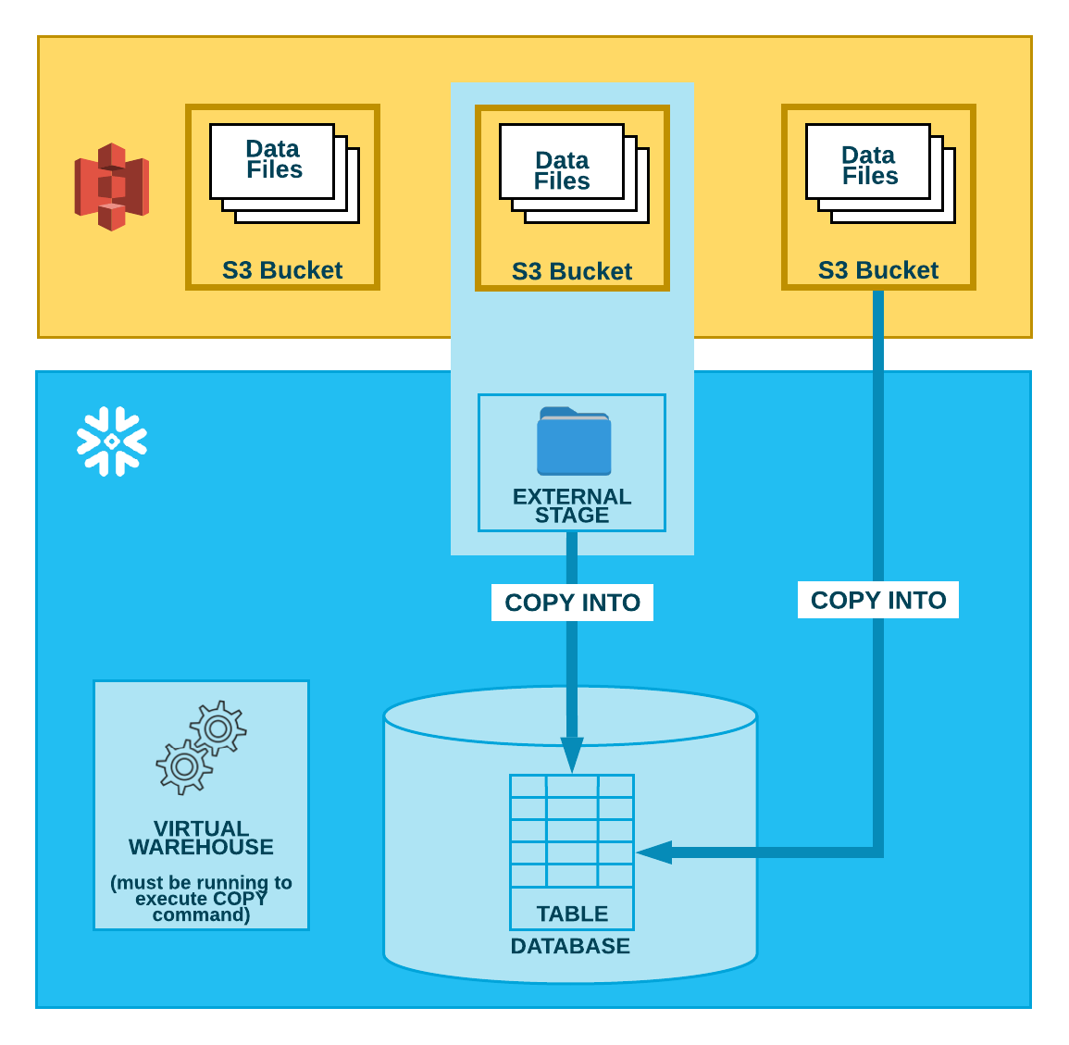

**– Create AWS account**

**–1. Create IAM role**

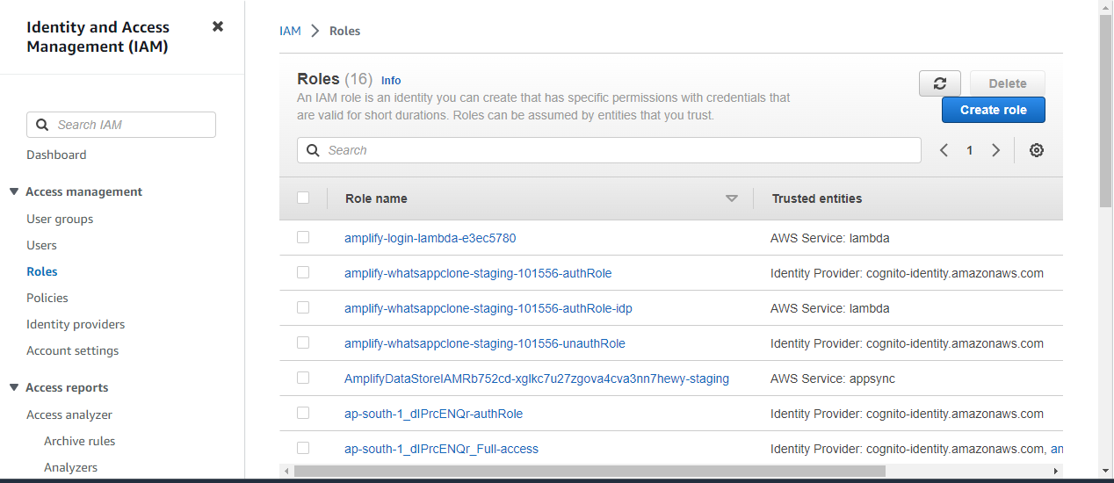

1. Search **IAM** and above page will appear
2. Create a role then page will appear select **AWS account** and next

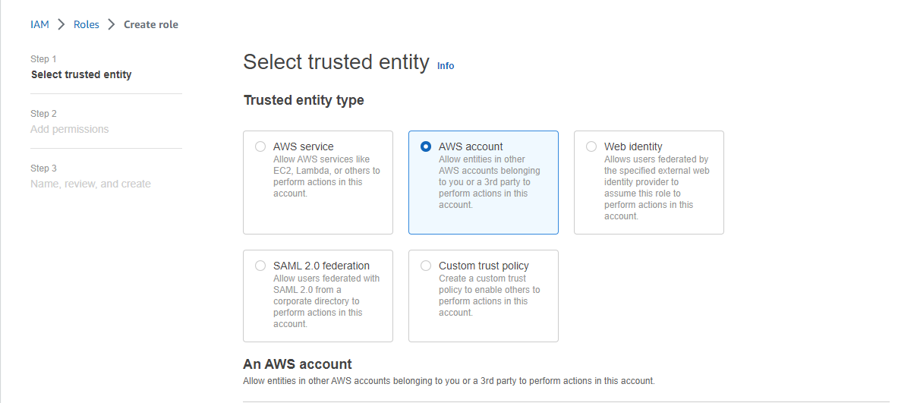

1. Search for **S3 full access** as in below image then click on next

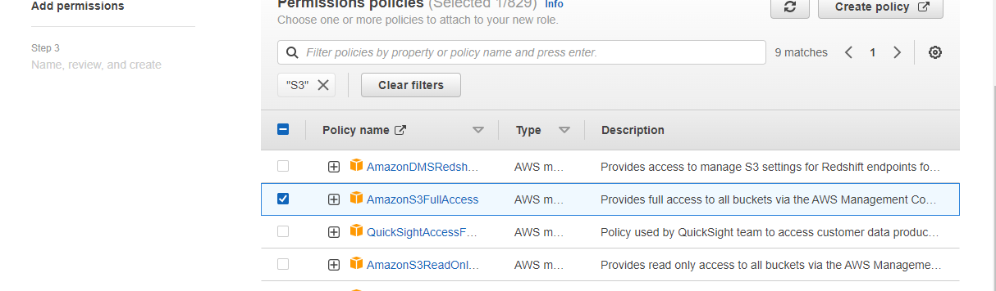

1. After this it will ask for **role name** give a role name and create a role
2. Locate your role and open it their copy the **ARN number** in notepad

* Note: Required services of **AWS:**
* ARN: Amazon resource names
* S3- simple storage service
* IAM- integrated account management
* DMS(Terraform)
* Lambda

Required services of **Azure:**

- Blob Storage

- ADF

- Data bricks

**– Creating storage object and exchanging the ARN’s**

**–create storage integration object**

create or replace storage integration sky_aws_int

type = EXTERNAL_STAGE

STORAGE_PROVIDER = S3

ENABLED = TRUE

STORAGE_AWS_ROLE_ARN = 'arn:aws:iam::973573511884:role/snowpractice21'

STORAGE_ALLOWED_LOCATIONS = ('s3://snowpractice21/csv files/')

COMMENT = 'Integration with aws S3 buckets';

**-- get external_id and update it in S3**

**DESC integration sky_aws_int;**

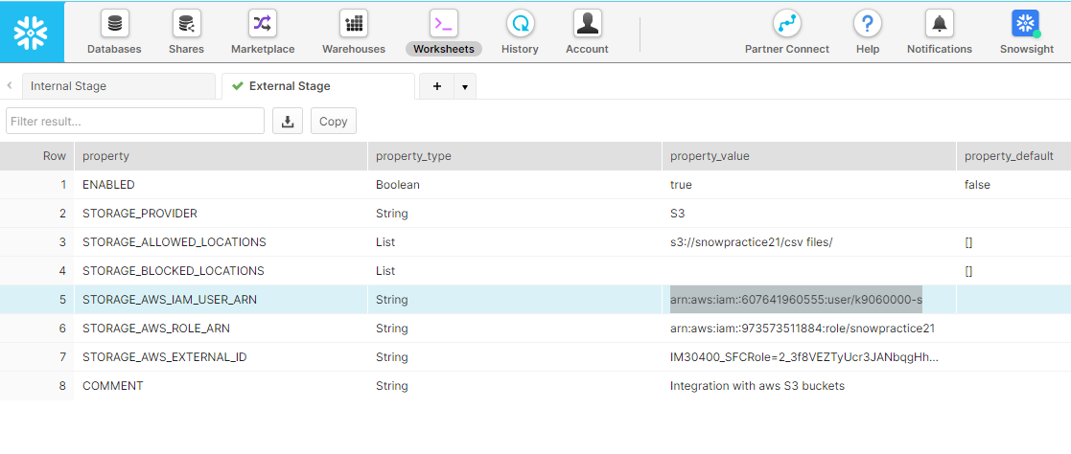

Now copy the **STORAGE_AWS_IAM_USER_ARN** and paste it in the roles

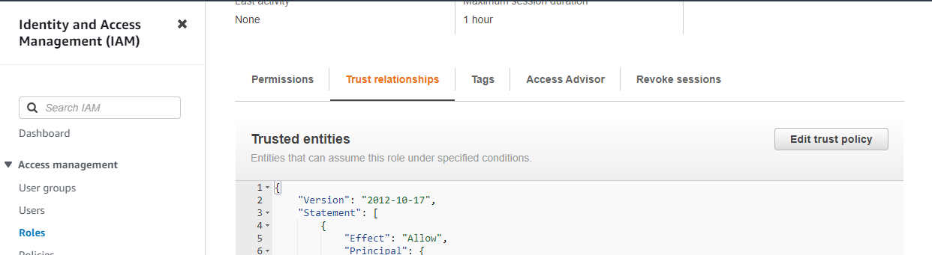

The **edit trust policy** and change the ARn no. that you copied and click on **update the policy**

**-- create a stage**

create or replace stage stage_aws

URL = 's3://snowpractice21/csv files/'

STORAGE_INTEGRATION = sky_aws_int;

list @stage_aws;

**--loading data from aws s3 using copy command**

**--create a table**

create or replace table user_email(

id number,

first_name varchar(100),

last_name varchar(100),

email varchar(100),

gender varchar(6),

about_me varchar(500)

);

select * from user_email;

**--create a ff_object**

create or replace file format emp.emp.aws_ff

type = csv

field_delimiter = ','

skip_header = 1

field_optionally_enclosed_by = '\042'

empty_field_as_null = TRUE;

**--create stage**

create or replace stage stage_aws

URL = 's3://snowpractice21/csv files/'

STORAGE_INTEGRATION = sky_aws_int

file_format = aws_ff;

list @stage_aws;

**--copying data from aws s3**

copy into user_email

from @stage_aws

files = ('01_sample_user_email.csv');

select * from user_email;

**3. Zero Copy Clone**

**--cloning a table**

create or replace table user_email_clone

CLONE user_email;

select * from user_email_clone;

**--cloning a schema**

create or replace schema tasks_clone

CLONE tasks;

**--cloning a database**

create or replace database emp_clone

CLONE emp;

**--updating data in source table and cloned objects and observing both the tables**

**-- making changes in source table**

select * from user_email;

select * from user_email_clone;

update user_email set first_name = 'Zach' where id = 1;

**--listing records of cloned**

select * from user_email where id = 1;

**---Time Travel**

**--setting a tt to a table**

create or replace table time_travel_ex (id number, name string)

DATA_RETENTION_TIME_IN_DAYS = 1;

select * from time_travel_ex

**--setting a tt to schema**

create or replace schema time_travel_ex

DATA_RETENTION_TIME_IN_DAYS = 1;

**--setting tt for db**

create or replace database time_travel_ex

DATA_RETENTION_TIME_IN_DAYS = 1;

**-- altering retention period on table**

alter table time_travel_ex

set DATA_RETENTION_TIME_IN_DAYS = 1;

**--listing a retention period**

show tables like 'time_travel_ex';

show schemas like 'time_travel_ex';

show databases like 'time_travel_ex';

Show parameters like '%retention%' in account;

show parameters like '%DATA_RETENTION_TIME_IN_DAYS%' in table practice2;

show parameters like '%DATA_RETENTION_TIME_IN_DAYS%' in schema practice;

show parameters like '%DATA_RETENTION_TIME_IN_DAYS%' in database practice;

**--querying historical data**

**--case1: updating some data in user_email ---> ““OFFSET””**

select * from user_email where id =1; *---first name was zach*

update user_email set first_name = 'snowflake' where id =1; *---change to snowflake*

select * from user_email where id =1; *---update to snowflake*

*--querying historical data by offset.*

select * from user_email at (offset => -60*5) where id = 1; *— 5 is in minutes*

**--case2: updating some data in user_email ---> ""TIMESTAMP""**

select * from user_email;

update user_email set first_name = 'snow' where id = 1;

**--querying historical data by timestamp.**

select current_timestamp;

select * from user_email at (timestamp => '2023-04-21 05:11:31.768 -0700' ::timestamp);

**--case3: updating some data in user_email ---> ""BEFORE STATEMENT""**

select * from EMPLOYEE;

UPDATE employee set empname = 'Borgave' where empid =1; *---amogh was name change to borgave*

**--querying historical data by offset.**

select * from employee before (statement => '01abc662-3200-b63d-0003-e7120002db62'); --copy query id from history

**--restoring data from table**

create or replace table restore_user_email CLONE user_email at (offset => -60*40);

select * from restore_user_email;

create or replace table res_employee CLONE employee at (timestamp => '2023-04-21 05:11:31.768 -0700' ::timestamp);

select * from res_employee; *–same for schema and database*

create or replace table res_employee CLONE employee before (statement => '01abc662-3200-b63d-0003-e7120002db62');

select * from res_employee;

**--CACHING**

**--Two type of cache**

**--1. result cache**

**--2. local cache**

**----Result cache**

**--query is fetching from storage layer (remote disk) --> 1st time --> more time**

select * from COLUMN_MISMATCH; **--515ms**

**--2nd time -- query -- fetching from result cache**

select * from COLUMN_MISMATCH; **--60ms**

**--3rd time -- sub query -- fetching from metadata**

select count(*) from column_mismatch;  **--92ms**

**--4th time -- sub query -- fetching from remote disk**

select * from column_mismatch where gender = 'F'; **--400ms**

select * from column_mismatch where gender = 'M'; **--422ms**

**---Local Disk cache**

**--turn off result cache**

alter session set use_cached_result = false;

**--query is fetching from storage layer (remote disk) --> 1st time --> more time**

select * from COLUMN_MISMATCH; **--R=515ms L=605MS**

**--2nd time -- query -- fetching from result cache**

select * from COLUMN_MISMATCH;  **--R=60ms L=425MS**

**--3rd time -- sub query -- fetching from metadata**

select count(*) from column_mismatch; **--R=92ms L=27MS**

**--4th time -- sub query -- fetching from remote disk**

select * from column_mismatch where gender = 'F'; **--R=400ms L=406MS**

select * from column_mismatch where gender = 'M';  **--R=422ms L=460MS**

**--Unloading data to EXTERNAL STAGE**

**--unloading options**

-**-OVERWRITE** = TRUE | FALSE - specifies to overwrite existing files

--**SINGLE** = TRUE | FALSE - specifies whether to generate a single file or multiple files

--**MAX_FILE_SIZE** = NUMBER - maximum file size

-**-INCLUDE_QUERY_ID** =TRUE | FALSE - specifies whether to uniquely identify unloaded files by universally unique identifier

--**DETAILED_OUTPUT** = TRUE | FALSE - shows the path and name for each file, its size, and the number of rows that were unloaded to the file

**--create storage integration object**

create or replace storage integration sky_aws_int

type = EXTERNAL_STAGE

STORAGE_PROVIDER = S3

ENABLED = TRUE

STORAGE_AWS_ROLE_ARN = 'arn:aws:iam::973573511884:role/snowpractice21'

STORAGE_ALLOWED_LOCATIONS = ('s3://snowpractice21/unloading/ , s3://snowpractice21/csv files/')

COMMENT = 'integration with aws s3 buckets';

**--altering storage integration**

ALTER STORAGE integration sky_aws_int

SET STORAGE_ALLOWED_LOCATIONS = ('s3://snowpractice21/csv/' , 's3://snowpractice21/unloading/');

**-- get external_id and update it in S3**

DESC integration sky_aws_int;

**--create or replace file_format**

create or replace file format unloading_ff

type = 'csv', field_delimiter = '|', skip_header = 0, empty_field_as_null = true;

**--create a stage**

create or replace stage unload_stage

url = 's3://snowpractice21/unloading/'

storage_integration = sky_aws_int

file_format = unloading_ff;

**--copy command for unloading data to external stage**

copy into @unload_stage

from customer_psv;

list @unload_stage;

**--copy command for unloading data to external stage with data name**

copy into @unload_stage/customer

from customer_psv;

**--copy command for unloading data to external stage with unload properties**

copy into @unload_stage/customer

from customer_psv

max_file_size = 2000000

overwrite = true

single = true  *--when data is big it will create single file*

detailed_output = true;

**-- Unloading data to internal stage**

-**-create file format object**

create or replace FILE FORMAT unload_ff

type = csv

field_delimiter = '|'

skip_header = 0

empty_field_as_null = TRUE;

**-- create a stage**

create or replace stage int_stage

file_format = unload_ff ;

**-- copying file into internal stage by copy command**

copy into @int_stage/customer/

from customer_psv

single = true

overwrite = true

detailed_output = true;

**--list a stage**

list @int_stage;

**-- downloading file from internal stage to local machine by using GET command**

get @int_stage/customer/data file://C:\Users\BhandariRaviraj\snowflakedata;

**--downloading file from table --@% (table stage)**

get @%customer_psv/customer/data file://C:\Users\BhandariRaviraj\snowflakedata;

**--downloading file from user stage --@~**

get @~user_stage/customer/data file://C:\Users\BhandariRaviraj\snowflakedata;

**--DATA SHARING TO SNOWFLAKE USERS**

**--Data sharing properties**

--1. grant usage --> database, schema

--2. grant select --> tables

**--creating database data_sharing**

create or replace database share_db;

use database share_db;

create or replace schema share_db.share;

**--create table**

create or replace table customer_csv_share (

CUSTOMER_PK number(38,0),

SALUTATION varchar(10),

FIRST_NAME varchar(20),

LAST_NAME varchar(20),

GENDER varchar(1),

MARITAL_STATUS varchar(20),

DAY_OF_BIRTH date,

BIRTH_COUNTRY varchar(60),

EMAIL_ADDRESS varchar(60),

CITY_NAME varchar(50),

ZIP_CODE varchar (50),

COUNTRY_NAME varchar(50),

GMT_TIMEZONE_OFFSET number(10,2),

PREFERRED_CUST_FLAG boolean,

REGISTRATION_TIME VARCHAR(30)

);

select * from customer_csv_share;

**-- ff for loading**

create or replace file format fileformat_share

type = csv

field_delimiter = ','

skip_header = 1

field_optionally_enclosed_by = '\042'

empty_field_as_null = TRUE;

**--creating a external stage**

create or replace stage aws_stage

url='s3://snowpractice21/csv files/'

STORAGE_INTEGRATION = sky_aws_int;

ALTER STORAGE integration sky_aws_int

SET STORAGE_ALLOWED_LOCATIONS = ('s3://snowpractice21/csv/' , 's3://snowpractice21/unloading/' , 's3://snowpractice21/csv files/');

list @aws_stage;

**--not loading csv filr from aws to our table**

copy into customer_csv_share

from @aws_stage

file_format = fileformat_share

files = ('customer_1.csv');

select * from customer_csv_share;

**-- we need to do these in providers account (sender's account) who want to share the data**

**--create a share**

create or replace share sky_share;

**--list a share**

show shares;

**-- granting permission to share to use database**

grant usage on database share_db to share sky_share;

**-- granting permission to share to use schema**

grant usage on schema share_db.share to share sky_share;

**-- granting permission to share to use table**

grant select on table share_db.share.customer_csv_share to share sky_share;

**-- granting permission to use complete schema by share**

grant select on all tables in schema share_db.share to share sky_share;

**-- granting permission to use complete database by share**

grant select on all tables in database share_db to share sky_share;

**--showing grants permission to share**

show grants to share sky_share;

**--giving a account name of consumer (receiver)**

alter share sky_share add account = pk83112; -- consumer

-- this account is having the permission to use my db, sc, tb

**--things to do in consumer account (receiver's account: i have taken richa's account)**

show shares;

create or replace database db_share from share im30400.sky_share; ---providers account

select * from db_share.share.customer_csv_share;

**-- TABLES**

**--types of tables**

**--1. permanent**

**--2. transient**

**--3. temporary**

create or replace schema table_types;

**--where to see table type**

SHOW TABLES in SCHEMA EMP;

**--creating trans, temp table**

CREATE OR REPLACE TRANSIENT TABLE table_types.tran_table(id number);

CREATE OR REPLACE TEMPORARY TABLE table_types.temp_table(name string);

SHOW TABLES in SCHEMA table_types;

**--1. PERMANENT TABLES/SCHEMAS**

**create or replace table permanent (id number);**

**--default table type in sf**

**--these are the regular and common tables**

**--tables exists until we drop them explicitly**

**--time travel retention period is 0-90 days depends on sf edition**

**--7 dys of fail safe period**

**--2. TRANSIENT Tables/Schemas**

**--similar to permanent tables but with 1 day retention period**

**--no fail-safe period**

**--tables exist until we drop them**

**--useful when data protection is not required**

**--defining stage tables as Transient**

**--create transient table**

CREATE OR REPLACE TRANSIENT TABLE table_types.tran_table(id number);

**--create transient schema**

CREATE OR REPLACE TRANSIENT SCHEMA table_schema; --all table in transient table will be transient by default

CREATE OR REPLACE table table_schema.tran_table(id number);

show tables in schema table_schema;

**-- we cannot alter the retention period of transient tables its default 1 day**

alter table table_schema.tran_table

set data_retention_time_in_days = 1;

**-- can we undrop table schema, db transient in 24 hr**

drop table table_schema.tran_table;

**--undrop this transient table within 24 hrs**

undrop table table_schema.tran_table;

--same for transient schema

**--3. TEMPORARY tables/schema**

**--table exists only within the session**

**--1 day retention period**

**--no fail safe period**

**--we can only create table**

**--create a temporary table**

CREATE OR REPLACE TEMPORARY TABLE temp_table(id number);

CREATE OR REPLACE TEMPORARY TABLE temp_table2 (name string);

insert into temp_table2 values ('Yogesh');

insert into temp_table2 values ('Atharva');

insert into temp_table2 values ('Varun');

insert into temp_table2 values ('Jeet');

insert into temp_table2 values ('Amogh');

select * from temp_table2; --temp table will only be assessed from 1 session (worksheet)

select * from temp_table2 order by name DESC;

**--drop and undrop**

drop table temp_table2;

undrop table temp_table2;

desc table temp_table2;

**---SENARIO 1**

**---when we drop the temporary table and create another temporary table with the same name**

**---then we can not undrop the table that we dropped so here we can do is:**

**---1. alter table <tablename> rename to <tablename>;**

**---SENARIO 2**

**---if we are creating the table with same name in temporary and permanent, then for —that worksheet it will take temporary**

**---and we need to access permanently from another worksheet.**

**--to check which kind of table**

show schemas in database emp;

**--EXTERNAL STAGE (AMAZON S3 CLOUD)**

use database emp;

**--create a schema for external tables**

create schema if not exists ext_table;

create or replace schema ext_table;

use schema ext_table;

**--create file format object**

create or replace file format csv_ff

type = csv

field_delimiter =','

skip_header = 1

empty_field_as_null = TRUE;

**--create storage integration object**

create or replace storage integration sky_aws_int

type = EXTERNAL_STAGE

storage_provider = S3

ENABLED = TRUE

STORAGE_AWS_ROLE_ARN = 'arn:aws:iam::973573511884:role/snowpractice21'

STORAGE_ALLOWED_LOCATIONS = ('s3://snowpractice21/csv files/')

COMMENT = 'Interagtion with aws s3 buckets';

**-- create stage object with integration object and file format object**

create or replace stage ext_stage

url = 's3://snowpractice21/csv files/'

storage_integration = sky_aws_int

file_format = csv_ff;

--list stage

list @ext_stage;

**--create a external table in simple way**

**--method 1: data will be in json format**

create or replace external table user_email_ext

with

location = @ext_stage

pattern = '.*user.*'

file_format = csv_ff;

select * from user_email_ext;

DESC integration sky_aws_int;

**--method 2: data will be in tabular format**

create or replace external table user_ext (

id number as (value:c1::number),

first_name varchar as (value:c2::varchar),

last_name varchar as (value:c3::varchar),

email varchar as (value:c4::varchar),

gender varchar as (value:c5::varchar),

aboutme varchar as (value:c6::varchar)

)

with

location = @ext_stage

pattern = '.*user.*'

file_format = csv_ff;

select * from user_ext;

**--practice queries for external**

select * from user_ext where gender = 'F';

select * from user_ext where email like '%@gmail.com';

**--to see external tables**

desc external table user_ext;

**--total external tables**

show external tables;

**--to see the files if referring or how many files are loaded**

select distinct metadata$filename from user_ext;

**--SNOWPIPE**

**--loading data from aws S3 using SNOWPIPE**

**--create storage integration object**

create or replace storage integration sky_aws_int

type = EXTERNAL_STAGE

STORAGE_PROVIDER = S3

ENABLED = TRUE

STORAGE_AWS_ROLE_ARN = 'arn:aws:iam::973573511884:role/snowpractice21'

STORAGE_ALLOWED_LOCATIONS =('s3://snowpractice21/csv files/', 's3://snowpractice21/csv/')

COMMENT = 'Integration with aws s3 buckets';

**--create a table**

create or replace table customer_csv (

CUSTOMER_PK number(38,0),

SALUTATION varchar(10),

FIRST_NAME varchar(20),

LAST_NAME varchar(20),

GENDER varchar(1),

MARITAL_STATUS varchar(20),

DAY_OF_BIRTH date,

BIRTH_COUNTRY varchar(60),

EMAIL_ADDRESS varchar(60),

CITY_NAME varchar(50),

ZIP_CODE varchar (50),

COUNTRY_NAME varchar(50),

GMT_TIMEZONE_OFFSET number(10,2),

PREFERRED_CUST_FLAG boolean,

REGISTRATION_TIME VARCHAR(30)

);

select * from customer_csv;

**--create a ff**

create or replace file format aws_ff

type = csv

field_delimiter = ','

skip_header = 1

field_optionally_enclosed_by = '\042'

empty_field_as_null = TRUE;

**--create a stage**

create or replace stage pipe_stage

url = 's3://snowpractice21/csv/'

storage_integration = sky_aws_int

file_format = aws_ff;

**--list stage**

list @pipe_stage;

**--create a pipe**

--new file will be automaticallly loaded in table

create or replace pipe aws_pipe

auto_ingest = True

as

copy into customer_csv

from @pipe_stage;

**--desc pipe**

desc pipe aws_pipe;

--arn:aws:sqs:ap-south-1:607641960555:sf-snowpipe-AIDAY26SIQBVTSB2GUX6B-Ko9-PS

**Paste the above Arn in the aws bucket properties in event notification**

We need to create an event notification and paste the arn copied.

**--2 methods for setting notifications to the snowpipe:**

**--a. SQS Queue --> copy arn of snowflake and paste in event notification**

**--b. SNS Topic --> create a sns topic and create event notification**

**--a. SQS queue ::**

--list the records of the table

select * from customer_csv;

**--check pipe status**

select system$pipe_status('aws_pipe');

Now for SNS we need to create an SNS on aws

Step1. : create an topic and crete standard as in image

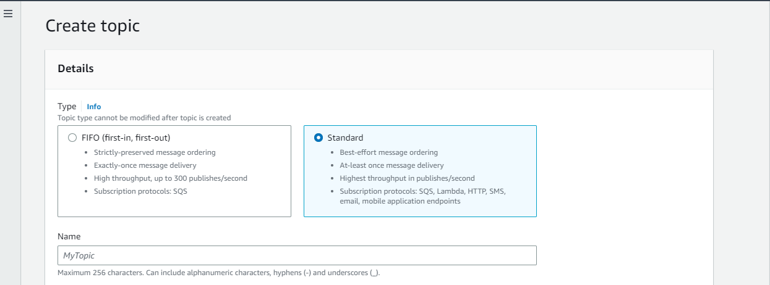

Step2: Go to access policy and select everyone for subscriber and publishers

And create a policy

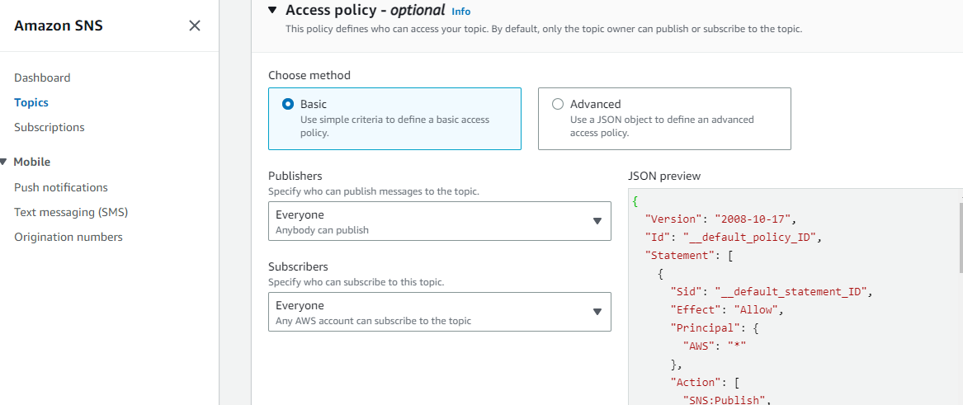

Step3: write the below query

**--b. SNS queue**

select system$get_aws_sns_iam_policy ('arn:aws:sns:ap-south-1:973573511884:snowflake21');

Step4: After this it will generate arn copy that and paste it in our policy that we created in json file as in image below and save changes

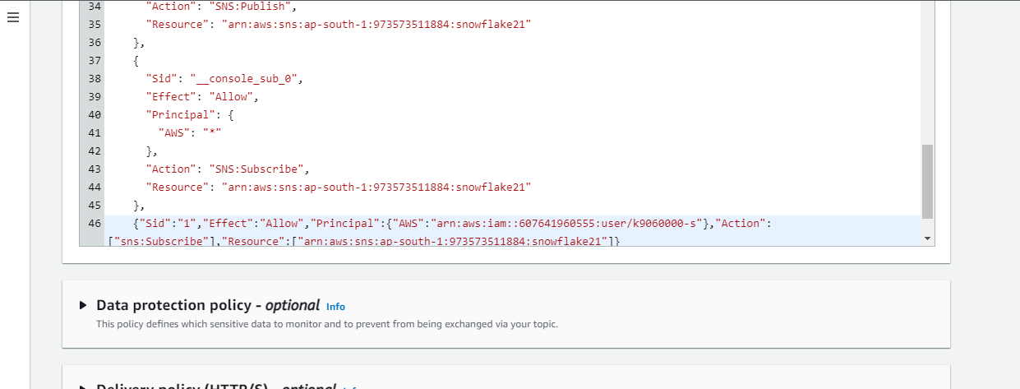

Step5: create a event notification and save changes

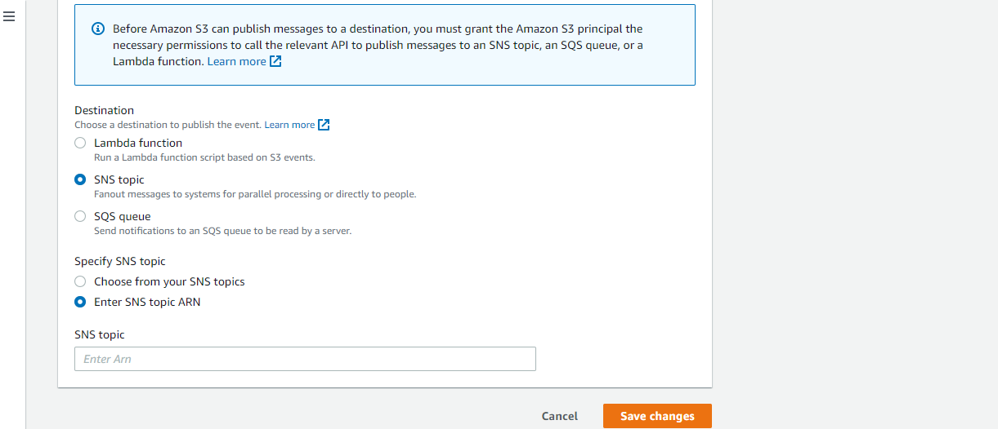

Step6: open worksheet and

**--create a pipe**

**--new file will be automatically loaded in table**

create or replace pipe aws_pipe_sns

auto_ingest = True

aws_sns_topic = 'arn:aws:sns:ap-south-1:973573511884:snowflake21'

as

copy into customer_csv

from @pipe_stage;

**--desc pipe**

desc pipe aws_pipe_sns;

**--listing records of table**

select * from customer_csv;

**--JSON file data**

**--process of loading**

**--a. create a stage that points to json files in AWS?azure**

**--b. create stage table to store the raw data**

**--c.create with single variant column**

**--d. copy data to stage table using copy command**

**--now parse the RAW data based on the json file content**

**--normal json**

**--json with array**

**--json with nested**

**--json with all types**

**--load this parsed data to a table**

**--1. JSON data and variant colum**n

**--variant column: holds all types of data into single column**

**--loading data from internal stage**

**--creating schema**

create or replace schema js_on;

**--create file format**

create or replace file format my_json_format

type = json

strip_outer_array = true;

**--creating internal stage**

create or replace stage stage_json

file_format = my_json_format;

**--list the stage**

list @stage_json;

**--upload file to stage**

put file://C:\Users\BhandariRaviraj\jsondata\internal_stage\author.json @stage_json;

**--creating table with variant column**

create or replace table author (json_data variant);

**--copy command to load json data into author table with variant column**

copy into author

from @stage_json/author.json

file_format = my_json_format;

--file =('')

**--listing records in author stage table**

select * from author;

**--parsing of json data into column format**

**--querying (listing) individual columns with json type data**

select

json_data:AuthorName as AuthorName,

json_data:Category as Category

from author;

**--accessing array json data**

--getting array size

select array_size(json_data:Category[0]:best_edition) size from author;

**--listing records of array**

select json_data:Category[0]:best_edition from author;

**--accessing nested json data**

**--by giving indexing**

**--ex:1**

select

json_data:AuthorName,

json_data:Category[0]:CategoryName,

json_data:Category[1]:CategoryName

from author;

**--ex: 2**

select

json_data:AuthorName,

json_data:Category[0]:Genre[0]:GenreName,

json_data:Category[0]:Genre[0]:Novel[0]:sales

from author;

**--parse json data to get columns and table**

select * from author;

**--parsing json data to columns and it will remove quotes --by giving datatypes of columns and casting to specific data type**

**select**

json_data:AuthorName::String as Author_Name,

json_data:Category[0]:CategoryName::string as Fiction_Category ,

json_data:Category[1]:CategoryName::string as Non_Fiction_Category

from author;

**--more detailed**

select

JSON_DATA:AuthorName::String as Author_Name,

JSON_DATA:Category[0]:CategoryName::string as Fiction_Category ,

JSON_DATA:Category[0]:Genre[0]:GenreName::string,

JSON_DATA:Category[0]:Genre[1]:GenreName::string,

JSON_DATA:Category[1]:CategoryName::string,

JSON_DATA:Category[1]:Genre[0]:GenreName::string,

JSON_DATA:Category[1]:Genre[1]:GenreName::string

from author;

**--2 methods for getting data into our main table**

**--a.by using flattening**

**--b.by just prasing all data and union all**

**--a. Flattening**

**--is a process of unpacking the semi-structured data into a columnar format by converting arrays into different rows of data.**

--using the lateral flatten function we can explode arrays into individual JSON objects.

--flattern data into columnar format --> converting diff arrays into rows -->

**--flattening all data into rows from json arrays**

select

JSON_DATA:AuthorName::string as Author_Name,

Flatten_Category.VALUE:CategoryName::string as Category_Name,

Flatten_Genre.VALUE:GenreName::string as Genre_Name,

Flatten_Novel.VALUE:Novel::string as Novel_Name,

Flatten_Novel.VALUE:Sales::number as Sales_in_Millions

from author

,LATERAL FLATTEN (input => JSON_DATA:Category) as Flatten_Category

,LATERAL FLATTEN (input => Flatten_Category.VALUE:Genre) as Flatten_Genre

,LATERAL FLATTEN (input => Flatten_Genre.VALUE:Novel) as Flatten_Novel

**--loading this flattened data (column type) into our main table**

create or replace table author_data as

select

JSON_DATA:AuthorName::string as Author_Name,

Flatten_Category.VALUE:CategoryName::string as Category_Name,

Flatten_Genre.VALUE:GenreName::string as Genre_Name,

Flatten_Novel.VALUE:Novel::string as Novel_Name,

Flatten_Novel.VALUE:Sales::number as Sales_in_Millions

from author

,LATERAL FLATTEN (input => JSON_DATA:Category) as Flatten_Category

,LATERAL FLATTEN (input => Flatten_Category.VALUE:Genre) as Flatten_Genre

,LATERAL FLATTEN (input => Flatten_Genre.VALUE:Novel) as Flatten_Novel

select * from author_data;

select * from author;

**--b. substr, substring, parse the data in copy command**

**--create a table**

create or replace table home_sales(

city string,

zip string,

state string,

type string default 'Residential',

sale_date timestamp_ntz,

price string

);

**--list stage**

list @stage_json

**--upload file**

put file://C:\Users\BhandariRaviraj\jsondata\internal_stage\sales.json @stage_json;

**--copy command $--accessing the column names, substr --extracting**

copy into home_sales(city, state, zip , sale_date, price)

from (select substr($1:location.state_city,4),

substr($1:location.state_city,1,2),

$1:location.zip,

to_timestamp_ntz($1:sale_date),

$1:price

from @stage_json/sales.json)

on_error = "CONTINUE";

**--list records**

select * from home_sales;

**--working json with table stage**

--create a table by ff properties for stage table

create or replace table home_table(json variant)

stage_file_format = (type= 'JSON');

select * from home_table;

**--list stage**

list @%home_table;

**--upload file to table stage**

put file://C:\Users\BhandariRaviraj\jsondata\internal_stage\sales.json @%home_table;

**--list records from stage only**

select * from home_table;

select * from @%home_table;

**--copy command to load data into table**

copy into home_table;

**-- loading JSON data from external stage**

create or replace schema jj_son;

use schema jj_son;

**--create storage integration object**

create or replace storage integration sky_aws_int

type = EXTERNAL_STAGE

storage_provider = S3

ENABLED = TRUE

STORAGE_AWS_ROLE_ARN = 'arn:aws:iam::973573511884:role/snowpractice21'

STORAGE_ALLOWED_LOCATIONS = ('s3://snowpractice21/csv files/', 's3://snowpractice21/others/')

COMMENT = 'Interagtion with aws s3 buckets';

**--creating ff**

create or replace file format my_json

type = json

strip_outer_array = true;

**--create a stage**

create or replace stage json_stage

storage_integration = sky_aws_int

file_format = my_json

url = 's3://snowpractice21/others/';

**--list stage**

list @json_stage;

**--create a stage table to raw json data**

create or replace table author

(json_data variant);

**--list records**

select * from author;

desc table author;

**--copy command to load raw data to stage table**

copy into author

from @json_stage/author.json

file_format = my_json;

**--parsing of json data into column format**

**--accessing simple json data**

**--using $ for query json data**

select $1:AuthorName from author;

**--accessing data from stage location directly**

select $1:AuthorName from @json_stage/author.json (file_format => 'my_json');

**--querying (listing) individual columns with json type data**

select

json_data:AuthorName as AuthorName,

json_data:Category as Category

from author;

**--accessing array json data**

**--getting array size**

select array_size(json_data:Category[0]:best_edition) size from author;

**--listing records of array**

select json_data:Category[0]:best_edition from author;

**--accessing nested json data**

**--by giving indexing**

--ex:1

select

json_data:AuthorName,

json_data:Category[0]:CategoryName,

json_data:Category[1]:CategoryName

from author;

--ex: 2

select

json_data:AuthorName,

json_data:Category[0]:Genre[0]:GenreName,

json_data:Category[0]:Genre[0]:Novel[0]:sales

from author;

**--parse json data to get columns and table**

select * from author;

--parshing json data to columns and it will remove quotes --by giving datatypes of columns and casting to specific dattype

select

json_data:AuthorName::String as Author_Name,

json_data:Category[0]:CategoryName::string as Fiction_Category ,

json_data:Category[1]:CategoryName::string as Non_Fiction_Category

from author;

**--more detailed**

select

JSON_DATA:AuthorName::String as Author_Name,

JSON_DATA:Category[0]:CategoryName::string as Fiction_Category ,

JSON_DATA:Category[0]:Genre[0]:GenreName::string,

JSON_DATA:Category[0]:Genre[1]:GenreName::string,

JSON_DATA:Category[1]:CategoryName::string,

JSON_DATA:Category[1]:Genre[0]:GenreName::string,

JSON_DATA:Category[1]:Genre[1]:GenreName::string

from author;

**--2 methods for getting data into our main table**

**--a.by using flattening**

**--b.by just prasing all data and union all**

**--a. Flattening**

**--is a process of inpacking the semi-structured data into a columnar format by converting arrys into different rows of data.**

**--using the lateral flatten function we can explode arrays into individual JSON object.**

**--flattern data into columnar format --> converting diff arrays into rows -->**

**--flattening all data into rows from json arrays**

create or replace table authors_data as

select

JSON_DATA:AuthorName::string as Author_Name,

Flatten_Category.VALUE:CategoryName::string as Category_Name,

Flatten_Genre.VALUE:GenreName::string as Genre_Name,

Flatten_Novel.VALUE:Novel::string as Novel_Name,

Flatten_Novel.VALUE:Sales::number as Sales_in_Millions

from author

,LATERAL FLATTEN (input => JSON_DATA:Category) as Flatten_Category

,LATERAL FLATTEN (input => Flatten_Category.VALUE:Genre) as Flatten_Genre

,LATERAL FLATTEN (input => Flatten_Genre.VALUE:Novel) as Flatten_Novel

**--loading this flattend data (column type) into our main table**

create or replace table authors_data as

select

JSON_DATA:AuthorName::string as Author_Name,

Flatten_Category.VALUE:CategoryName::string as Category_Name,

Flatten_Genre.VALUE:GenreName::string as Genre_Name,

Flatten_Novel.VALUE:Novel::string as Novel_Name,

Flatten_Novel.VALUE:Sales::number as Sales_in_Millions

from author

,LATERAL FLATTEN (input => JSON_DATA:Category) as Flatten_Category

,LATERAL FLATTEN (input => Flatten_Category.VALUE:Genre) as Flatten_Genre

,LATERAL FLATTEN (input => Flatten_Genre.VALUE:Novel) as Flatten_Novel

select * from authors_data;

select * from author;

**--b. substr, substring, parse the data in copy command**

**--create a table**

create or replace table home_sales(

city string,

zip string,

state string,

type string default 'Residential',

sale_date timestamp_ntz,

price string

);

**--list stage**

list @json_stage;

**--copy command $--accessing the column names, substr --extracting**

copy into home_sales(city, state, zip , sale_date, price)

from (select substr($1:location.state_city,4),

substr($1:location.state_city,1,2),

$1:location.zip,

to_timestamp_ntz($1:sale_date),

$1:price

from @json_stage/sales.json)

on_error = "CONTINUE";

**--list records**

select * from home_sales;

**--OBJECT CONSTRUCT**

**--creating json object type data with column name and values -- using object_construc function**

select object_construct ('firstName','Raviraj','lastName','Bhandari', 'gender','male','age',22,'number','7030655778','address',null);

**--creating json type data -we get column name -col1, col2**

select object_construct(*) from values ('firstName','Raviraj','lastName','Bhandari', 'gender','male','age',22,'number','7030655778','address',null);

**--parsing json data (create tabular type data by giving column name) (simple 2 columns and no nesting)**

select 'People' as Groupid, 'Raviraj' as FirstName, 'Bhandari' as LastName UNION Select 'People' as Groupid, 'Yogesh' as FirstName, 'Jadhav' as LastName;

**--checking all records in column format of JSON**

select * from (select 'People' as Groupid, 'Raviraj' as FirstName, 'Bhandari' as LastName UNION select 'People' as Groupid, 'Yogesh' as FirstName, 'Jadhav' as LastName);

**--ARRAY_AGG**

**--doing with array_agg to create json data of address of people.json file**

select groupid, array_agg(object_construct('firstname',firstname ,'lastname',lastname)) from (Select 'People' as Groupid, 'Raviraj' as FirstName, 'Bhandari' as LastName UNION

Select 'People' as Groupid, 'Yogesh' as FirstName, 'Jagtap' as LastName )group by groupid;

**--doing with array_agg to get json type of data of ADDRESS of people.json file**

select addressid, array_agg(object_construct('city',city, 'state',state, 'cities',cities, 'states',states))

from(Select 'address' as addressid, 'Mumbai' as city, 'Maharashtra' as state, 'Lucknow' as cities, 'UP' as states

UNION

select 'address' as addressid, 'Pune' as city, 'Maharashtra' as state, 'Gaziabad' as cities, 'UP' as states

UNION ALL

select 'address' as addressid, 'Nashik' as city, 'Maharashtra' as state, 'Noida' as cities, 'UP' as states) group by addressid;

**--parsing json data into tabular format for address**

select * from (Select 'address' as addressid, 'Mumbai' as city, 'Maharashtra' as state, 'Lucknow' as cities, 'UP' as states

UNION

select 'address' as addressid, 'Pune' as city, 'Maharashtra' as state, 'Gaziabad' as cities, 'UP' as states

UNION ALL

select 'address' as addressid, 'Nashik' as city, 'Maharashtra' as state, 'Noida' as cities, 'UP' as states);

**--doing with array_agg to get nested json type data of PEOPLE.json file**

select groupid, array_agg(object_construct('firstname', firstname, 'lastname', lastname, 'gender', gender, 'age', age, 'number', number))

from (select 'Employee' as groupid, 'Raviraj' as firstname, 'Bhandari' as lastname, 'male' as gender, '22' as age, '7030655778' as number

UNION

select 'Employee' as Groupid, 'Yogesh' as firstname, 'Jagtap' as lastname, 'female' as gender, '22' as age, '6969696969' as number) group by groupid;

**--JSON PROCESSING**

**--object construct: converting normal data to json data**

**--array_aggregate: returns the input values (of type array), if the input is empty, an empty ARRAy is returned**

**--parse_json: convert json data to normal data**

**--directly insert json data into table: colon notation "accessing json data"**

**--type_of function**

**--dealing with date and timestamp**

**--flattening JSON data into separate tables:**

**--create json table with variant column**

create or replace table json_table(json_col variant);

**--insert into variant col table**

insert into json_table(json_col) values ('{"firstName" : "Raviraj", "empid": 1}'); *--error accepting variant got varchar*

**-- insert records with parse_json**

insert into json_table(json_col)

select parse_json('{"firstName" : "Raviraj", "empid": 1}');

select * from json_table;

**--insert multiple values in column**

insert into json_table(json_col)

select parse_json(Column1) from values

('{"firstName" : "Yogesh", "empid" : 1}'),

('{"firstName" : "Amogh", "empid" : 2}'),

('{"firstName" : "Jeet", "empid" : 3}'),

('{"firstName" : "Varun", "empid" : 4}'),

('{"firstName" : "Atharva", "empid" : 5}');

select * from json_table;

**--creating & inserting records in json table (employee_table)**

**--directly inserting json data into table**

**--create an employee table with one variant column**

create or replace table employee_table(

emp_json variant);

**-- insert one single record**

insert into employee_table(emp_json)

select parse_json(

'{

"name": "Yogesh",

"age": 22,

"height_in_ft": 5.11,

"married": true,

"has_kids": false,

"stock_options": null

}');

**-- run the select sql**

select * from employee_table;

**--colon notation to access JSON elements**

select

emp_json:name,

emp_json:age,

emp_json:height_in_ft,

emp_json:married,

emp_json:has_kids,

emp_json:stock_options

from employee_table;

**--accessing data with alias notation**

select

emp_json:age::integer as age,

emp_json:name::string as Name,

emp_json:height_in_ft::decimal as height,

emp_json:married as is_married,

emp_json:has_kids as has_kids,

emp_json:stock_options as stock_options

from employee_table;

**--adding typeof() function to check how snowflake treat these name/value pair**

select

typeof(emp_json:name) as "Name",

typeof(emp_json:age) as age,

typeof(emp_json:height_in_ft) as height,

typeof(emp_json:married) as is_married,

typeof(emp_json:has_kids) as has_kids,

typeof(emp_json:stock_options) as stock_options

from employee_table;

**--inserting nested json records for accessing it and practice**

insert into employee_table(emp_json)

select parse_json(

'{

"employee": {

"name":"Yogesh",

"age": 22,

"height_in_ft":5.11,

"married": true,

"has_kids": false,

"stock_options": null,

"phone": [

"69696969777",

"21212121217"

],

"Address": {

"street": "pan-card road",

"city":"Pune",

"state":"Maharashtra"

}

}

}'

);

select * from employee_table;

**--accessing the records in nested json data with (.) notation for nested one and (:) will also work**

select

emp_json:employee.name::string as name,

emp_json:employee.age as age,

emp_json:employee.height_in_ft as height,

emp_json:employee.married as is_married,

emp_json:employee.has_kids as has_kids,

emp_json:employee.stock_options as stock_options,

typeof(emp_json:employee.phone) as all_phone_type,

ARRAY_SIZE(emp_json:employee.phone) as how_many_phone,

emp_json:employee.phone[0] as work_phone,

emp_json:employee.phone[1] as office_phone,

typeof(emp_json:employee:Address) as address_type,

emp_json:employee:Address:street as street,

emp_json:employee.Address.city as city,

emp_json:employee.Address.State as state

from employee_table;

**--apply other function and mathematical operation without casting it**

select

emp_json:employee.age as age,

(emp_json:employee.height_in_ft) * (12*2.54) as height_in_cm

from employee_table;

**--date and timestamp data types in snowflake JSON**

select current_timestamp;

insert into employee_table(emp_json)

select parse_json(

'{

"name" : "Jeet",

"age" : "22",

"height_in_ft" : 5.11,

"dob":"2000-05-01",

"dob_timestamp": "2023-04-27 06:43:45.925 -0700",

"married": true,

"has_kids": false,

"stock_options": null

}'

);

select * from employee_table;

**--access timestamp**

select emp_json:dob::date,

emp_json:dob_timestamp::timestamp

from employee_table order by 1 desc;

**--Flatting JSON data and loading into snowflake tables**

**--create the table**

create or replace table employee_table(

emp_json variant);

select * from employee_table;

**--1st record**

insert into employee_table(emp_json)

select parse_json(

'{

"employee": {"name": "Yogesh", "age": 22, "heighr_in_ft": 5.11,"married":true,"has_kids":false,

"stock_options": null, "email":"yogesh@gmail.com","phone": ["+91 1234567890","+91 0987654321"], "Address": {"street":"passport office", "city":"pune","State":"maharashtra"}

}

}'

);

**--2nd record**

insert into employee_table(emp_json)

select parse_json(

'{

"employee": {"name": "Amogh", "age": 22, "heighr_in_ft": 6.00,"married":true,"has_kids":false,

"stock_options": null, "email":"amogh@gmail.com","phone": ["+91 1234561212","+91 0987652121"], "Address": {"street":"wadgoan sheri", "city":"pune","State":"maharashtra"}

}

}'

);

select * from employee_table;

**--creating sequence object for attaching t3 table (emp, phone, address) for primary and foreign key**

**--create sequence -for incremental number as primary key and foreign key**

create or replace sequence emp_seq

start 1

increment 1

comment = 'employee sequence';

create or replace sequence phone_seq

start 1

increment 1

comment = 'phone sequence';

create or replace sequence address_seq

start 1

increment 1

comment = 'address sequence';

**--create master table to load json data --in column format**

**--employee master table**

**--using seq objects as an auto generated number (nextval)**

create or replace table employee_master(

emp_pk integer default emp_seq.nextval,

name string,

age number(3),

height_in_cm decimal(6,3),

is_married boolean,

has_kids boolean,

stock_options integer,

email varchar(100)

);

**-- child table holding all the phones**

**--having relationship with emp master table**

create or replace table emp_phones(

phone_pk integer default phone_seq.nextval,

emp_fk number,

phone_type varchar(20),

phone_number varchar(30)

);

**-- child table holding all the address**

**--having relationship with emp master table**

create or replace table emp_address(

address_pk integer default address_seq.nextval,

emp_fk number,

street_address varchar(200),

city varchar(50),

state varchar(50)

);

**DATA SAMPLING**

**--a. Bernoulli(or row):** includes each row with a probability of p/100,

--similar to flipping a weighted coin for each row.

**--b. SYSTEM (or Block):** includes each block of rows with a probability of p/100.

-- This method does not support fixed-size sampling.

**--c. Repeatable | SEED (seed):** For identifying the data

--Specifies a seed value to make the sampling deterministic. Can be any integer

--The following keywords can be interchangeably:

**SAMPLE | TABLESAMPLE**

**BERNOULLI | ROW**

**SYSTEM | BLOCK**

**REPEATABLE | SEED**

--The number of rows returned depends on the sampling method specified:

**--1. Fraction based**

-- if no seed is specified, SAMPLE generates different results when the same query is repeated

--if a table does not change, and the same seed and probability are specified, SAMPLE generates the same result.

--sampling on a copy of a table might not return the same result as sampling on the original table, even if the same

--2 methods with example

**--ROW:**: return a sample of a table in which each row has a 20.3% probability of being included in the sample:

select * from test tablesample bernoulli (20.3);

**--BLOCK**:: return a sample of a table in which each block of row has a 3% probability of being included in the sample, and set

select * from testtable sample system (3) seed (82);

**--2. Fixed size**

--if the table is larger than the requested number of rows, the number of requested rows is always returned.

--if the table is smaller than the requested number of rows, the entire table is returned.

**--example:**

select * from example_table sample system (10 rows);

select * from example_table sample row(10 rows) seed(99);

**--sampling with a seed is not supported on view or subqueries**

select * from table1 sample system (10 rows);

select * from table1 sample row (10 rows) seed (99);

**--some example**

1. select * from table_sample row(10); --return a sample with 10% of rows

2. select * from tablename tablesample block(20) --return a sample with data from 20% block

3. select * from tablename sample system (10) seed (111);

--return a sample with data from 10% of blocks and same data set if use seed11 next time

4. select * from tablename tablesample (100) --return an entire table, including all rows into the sample

5. select * from tablename tablesample row (0); -- return an empty sample

6. select * from tablename sample (10 rows); --return a fixed size sample of 10 rows

**--performing data sample on the data**

**--1.On Fixed data**

select * from customer_csv sample row(10); --generate approx data with sampling of 10%

select * from customer_csv sample block (10);

**--just selecting data from sample db**

select * from SNOWFLAKE_SAMPLE_DATA.TPCH_SF10.CUSTOMER;

select * from SNOWFLAKE_SAMPLE_DATA.TPCH_SF10.CUSTOMER sample bernoulli (10);

select * from SNOWFLAKE_SAMPLE_DATA.TPCH_SF10.CUSTOMER sample system (10);

**--now we have sample some data now lets store that data**

**--with row or bernoulli method**

**create or replace table customer_1 as**

select * from SNOWFLAKE_SAMPLE_DATA.TPCH_SF10.CUSTOMER sample (10);

select count(1) from customer_1;

**create or replace table customer_2 as**

select * from SNOWFLAKE_SAMPLE_DATA.TPCH_SF10.CUSTOMER sample row (10);

select count(1) from customer_2;

select count(1) from SNOWFLAKE_SAMPLE_DATA.TPCH_SF10.CUSTOMER;

**--with system or block**

**create or replace table customer_3 as**

select * from SNOWFLAKE_SAMPLE_DATA.TPCH_SF10.CUSTOMER sample block (10);

select count(1) from customer_3;

**create or replace table customer_4 as**

select * from SNOWFLAKE_SAMPLE_DATA.TPCH_SF10.CUSTOMER sample block (10) seed(5);

select count(1) from customer_4;

**--2.On Fixed sampling**

create or replace table customer_5 as

select * from SNOWFLAKE_SAMPLE_DATA.TPCH_SF10.CUSTOMER sample row (1000 rows) ;

select count(1) from customer_5;

**--check the seed is same or not**

select * from customer_3

minus

select * from SNOWFLAKE_SAMPLE_DATA.TPCH_SF10.CUSTOMER sample block (10);

select count(1) from customer_3;

select *from customer_4

minus

select * from SNOWFLAKE_SAMPLE_DATA.TPCH_SF10.CUSTOMER sample block (10) seed(5);

select count(1) from customer_4;

**--User defined function**

**--allows you to perform operations that are not available through the built-in, system defined function.**

**--SF UDF's can return scalar(just a value or a string) and tabular results.**

**--2 types of UDF available in SF**

**--1. SCALAR 2. TABULAR**

**--SCALAR: returns output for each input we are passing (varchar or any string or value).**

**--TABULAR: returns a table (can return zero, one or multiple rows)**

**--SF supports 4 languages for writing UDFs**

**--SQL**

**--JavaScript**

**--Java**

**--Python**

**--Snowflake supports UDF overloading: means support functions with the same name but different params.**

**--– Proc_Calculate_Area() is different from Proc_Calculate_Area(Radius FLOAT)**

**--– Proc_Calculate_Area (Radius FLOAT) is different from**

**--– Proc_Calculate_Area (Length number, width number)**

**--SCALAR UDF**

create or replace schema udf_proc;

**--create a simple UDF**

create or replace function simple_sql_udf()

returns string

language SQL

as

$$

select 'simple sql language udf'

$$ ;

select simple_sql_udf();

**--function for cal area of circle**

create or replace function area_of_circle(radius float)

returns float

as

$$

pi()* radius * radius

$$ ;

select area_of_circle(5.5);

**--function for cal multi**

create or replace function cal_multi(a float, b float)

returns float

as

$$

case

when a is null then 0

else

a*b

end

$$ ;

select cal_multi(5,2);

select cal_multi(5,null);

**--scenario 1- fixed tax of 10%**

create or replace function cust_tax(price float)

returns float

as

$$

(price * 10)/100

$$ ;

**--grant the access on scenario1**

grant usage on function cust_tax(float) to public;

**--listing records and lets the tax**

select O_ORDERKEY, O_ORDERDATE, O_TOTALPRICE, CUST_TAX(O_TOTALPRICE) FROM snowflake_sample_data.tpch_sf1.orders;

**--scenario 2 -variable tax**

create or replace function cust_tax(price float, tax_per float)

returns float

as

$$

(price * tax_per)/100

$$ ;

**--grant the access on scenario1**

grant usage on function cust_tax(float, float) to public;

**--listing records and lets the tax**

select O_ORDERKEY, O_ORDERDATE, O_TOTALPRICE, CUST_TAX(O_TOTALPRICE, 8) FROM snowflake_sample_data.tpch_sf1.orders;

**--TABULAR UDF**

create or replace function tab()

returns table (msg varchar)

as

$$

select 'Raj'

union

select 'Raviraj'

$$;

select msg from table (tab());

Create or replace table employee(

employee varchar (30),

dept_name varchar (20),

salary varchar (20),

manager varchar (20)

);

insert into employee values ('Monika', 'Associate', '1lac', 'Vishal');

insert into employee values ('Vishal', 'Analyst', '1.2lac', 'Niharika');

insert into employee values ('Niharika', 'Manager', '1.4lac', 'Vaibhav');

insert into employee values ('Vaibhav', 'CEO', '1.9lac', 'Vaibhav');

select * from employee;

**--function for like keyword**

create or replace function emp_fun()

returns table(employee varchar, dept_name varchar, salary varchar, manager varchar)

as

$$

select * from employee where employee like '%v'

$$;

select * from table (emp_fun());

**--creating a simple orders table**

create or replace table orders(

order_id number,

customer_id_fk number,

item_id_fk number,

retail_price number(10,2),

purchase_price number(10,2),

sold_quantity number(3),

country_code varchar(2)

);

**--inserting records**

insert into orders values

(1,1,1,99.2,89.6,2,'US'),

(2,8,2,17.1,11,10,'IN'),

(3,5,1,827,900.99,5,'JP'),

(4,10,4,200,172,7,'DE');

select * from orders;

**--function for cal profit**

create or replace function calculate_profit(retail_price number, purchase_price number, sold_quantity number)

returns number(10,2)

as

$$

select ((retail_price - purchase_price) * sold_quantity)

$$;

**--call function by scalar**

select calculate_profit(100, 90, 6);

**--call function by table**

select item_id_fk, retail_price, purchase_price, sold_quantity, calculate_profit(retail_price, purchase_price, sold_quantity)

as profit_udf from orders;

**--call profit without function and observing same profit for both**

select item_id_fk, retail_price, purchase_price, sold_quantity,

((retail_price - purchase_price) * sold_quantity) as profit from orders;

**--creating some more table**

create or replace table countries

(country_code char(2), country_name varchar);

insert into countries(country_code, country_name) VALUES

('FR', 'FRANCE'),

('US', 'UNITED STATES'),

('IN', 'INDIA'),

('SP', 'SPAIN');

**create or replace table user_addresses**

(user_id integer, country_code char(2));

insert into user_addresses (user_id, country_code) values

(100, 'SP'),

(123, 'FR'),

(567, 'US'),

(426, 'IN');

**--create a function to fetch country name of user_id**

create or replace function get_country_for_user(ID number)

returns table (user_id number, country_name varchar)

as

$$

select id, C.country_name from user_addresses A, countries C

where A.user_id = ID

and C.country_code = A.country_code

$$;

**--fetch country name for specified user id**

select * from table (get_country_for_user(123));

**--fetch country name for all user id**

select F. * from user_addresses, table (get_country_for_user(user_id)) F;

--select * from user_addresses, table (get_country_for_user(user_id));

**--desc functions**

show functions like 'get_country_for_user%';

**--desc function**

desc function get_country_for_user(number);

**//table function example 1**

CREATE OR REPLACE table dates_of_interest (event_date DATE);

INSERT INTO dates_of_interest (event_date) VALUES

('2021-06-21'::DATE),

('2022-06-21'::DATE);

select * from dates_of_interest ;

CREATE OR REPLACE FUNCTION record_high_temperatures_for_date(d DATE)

RETURNS TABLE (event_date DATE, city VARCHAR, temperature NUMBER)

as

$$

SELECT d, 'New York', 65.0

UNION ALL

SELECT d, 'Los Angeles', 69.0

$$;

SELECT

doi.event_date as "Date",

record_temperatures.city,

record_temperatures.temperature

FROM dates_of_interest AS doi,

TABLE(record_high_temperatures_for_date(doi.event_date)) AS record_temperatures

ORDER BY doi.event_date, city;

**//table example2**

CREATE OR REPLACE table genders (genderType varchar);

INSERT INTO genders (genderType) VALUES

('male'::VARCHAR),

('female'::VARCHAR);

select * from genders ;

CREATE OR REPLACE FUNCTION ubertaxifares(g varchar)

RETURNS TABLE (genderType varchar, city VARCHAR, fares NUMBER)

as

$$

SELECT g, 'New York', 32.0

UNION ALL

SELECT g, 'Los Angeles', 14.0

$$;

SELECT

gend.genderType as "Gender",

ubertaxirates.city,

ubertaxirates.fares

FROM genders AS gend,

TABLE(ubertaxifares(gend.genderType)) AS ubertaxirates

ORDER BY gend.genderType, city;

**//table function example3**

create or replace table countries

(country_code char(2), country_name varchar);

insert into countries(country_code, country_name) VALUES

('FR', 'FRANCE'),

('US', 'UNITED STATES'),

('IN', 'INDIA'),

('SP', 'SPAIN');

create or replace table user_addresses

(user_id integer, country_code char(2));

insert into user_addresses (user_id, country_code) values

(100, 'SP'),

(123, 'FR'),

(567, 'US'),

(426, 'IN');

**--create a function to fetch country name of user_id**

create or replace function get_country_for_user(ID number)

returns table (user_id number, country_name varchar)

as

$$

select id, C.country_name from user_addresses A, countries C

where A.user_id = ID

and C.country_code = A.country_code

$$;

--fecth country name for specified user id

select * from table (get_country_for_user(123));

**--fecth country name for all user id**

select F. * from user_addresses, table (get_country_for_user(user_id)) F;

--select * from user_addresses, table (get_country_for_user(user_id));

**--desc functions**

show functions like 'get_country_for_user%';

**--desc function**

desc function get_country_for_user(number);

**//table function example4**

CREATE OR REPLACE table lottery(statuss varchar);

INSERT INTO lottery(statuss) VALUES

('couponswon'::varchar),

('foodcardswon'::varchar);

select * from lottery;

CREATE OR REPLACE FUNCTION lotterycoupons(c varchar)

RETURNS TABLE (statuss varchar, couponswon varchar, foodcardswon varchar)

as

$$

SELECT c, 'AmazonCoupons', 'First'

UNION ALL

SELECT c, 'SwiggyCashCards', 'Second'

$$;

select lott.statuss as Statuss,

lotterycoupons.couponswon,

lotterycoupons.foodcardswon

from lottery as lott,

table(lotterycoupons(lott.statuss)) as lotterycoupons

order by foodcardswon;

**//example5**

create or replace function tab()

returns table (msg varchar(50))

as

$$

select 'Raj'

union

select 'Raviraj'

$$;

select msg from table (tab());

**--STREAMS**

**--create schema for schemas**

create or replace schema streams;

**--table for stream**

create or replace table employee

(empid number,

empname varchar,

salary number,

age number,

department varchar,

location varchar);

**--inserting records**

insert into employee values

(1,'Amogh',700001, 22, 'AWS', 'Hubli'),

(2,'Yogesh',700002, 23, 'RPA', 'Latur'),

(3,'Atharva',700003, 22, 'GAD', 'Pune'),

(4,'Varun',700004, 21, 'React', 'Patna'),

(5,'Abeer',700005, 23, 'React', 'Jodpur'),

(6,'Zuzu',700006, 23, 'MS', 'Latur'),

(7,'Shweta',700007, 24, 'AWS', 'Satara');

select * from employee;

**--create a stream on employee table**

create or replace stream employee_stream on table employee;

select * from employee_stream;

**--INSERT some records to employee table**

insert into employee values

(8,'Aniket',700001, 22, 'SQL', 'PCMC'),

(9,'Gaurav',700002, 22, 'Python', 'Prayagraj');

select * from employee;

select * from employee_stream;

**--DELETE some records**

DELETE FROM employee

WHERE empid = 7;

delete from employee where empid = 1;

truncate table employee;

select * from employee;

select * from employee_stream;

**--UPDATE some records**

update employee set salary = 49000 where empid =1;

update employee set location = 'pune' where empid =7;

**--listing stream**

drop stream employee_stream;

create or replace stream employee_stream on table employee;

show streams in schema streams;

desc stream employee_stream;

**--MULTIPLE STREAMS ON SINGLE TABLE**

--we can create multiple streams on single table,

create or replace stream employee_stream2 on table employee;

show streams;

**--INSERT some records to employee tabel**

insert into employee values

(8,'Aniket',700001, 22, 'SQL', 'PCMC'),

(9,'Gaurav',700002, 22, 'Python', 'Prayagraj');

select * from employee_stream;

select * from employee_stream2;

**--APPEND ONLY STREAM**: just capture the data which is being inserted,

--update or deleting will not be updated

**--TABLE FOR STREAM**

CREATE OR REPLACE TABLE employee_append

(

empid number,

empname varchar,

salary number,

age number,

department varchar,

location varchar

);

**--inserting records to source table**

insert into employee_append values

(1,'Amogh',700001, 22, 'AWS', 'Hubli'),

(2,'Yogesh',700002, 23, 'RPA', 'Latur'),

(3,'Atharva',700003, 22, 'GAD', 'Pune'),

(4,'Varun',700004, 21, 'React', 'Patna'),

(5,'Abeer',700005, 23, 'React', 'Jodpur'),

(6,'Zuzu',700006, 23, 'MS', 'Latur'),

(7,'Shweta',700007, 24, 'AWS', 'Satara');

**--create a stream on emp_source**

create or replace stream emp_append_stream on table employee_append

append_only = true;

**--insert some records**

insert into employee_append values

(8,'Aniket',700001, 22, 'SQL', 'PCMC'),

(9,'Gaurav',700002, 22, 'Python', 'Prayagraj');

select * from employee_stream;

select * from employee_stream2;

select * from employee_append;

**--update some records**

update employee_append set salary = 700002 where empid =2;

update employee_append set location = 'pune' where empid =7;

**--delete some records**

delete from employee_append where empid = 1;

show streams;

**-- Consuming data from streams**

CREATE OR REPLACE TABLE emp_source

(

empid number,

empname varchar,

salary number,

age number,

department varchar,

location varchar

);

--inserting records to source table

insert into emp_source values

(1,'Amogh',700001, 22, 'AWS', 'Hubli'),

(2,'Yogesh',700002, 23, 'RPA', 'Latur'),

(3,'Atharva',700003, 22, 'GAD', 'Pune'),

(4,'Varun',700004, 21, 'React', 'Patna'),

(5,'Abeer',700005, 23, 'React', 'Jodpur'),

(6,'Zuzu',700006, 23, 'MS', 'Latur'),

(7,'Shweta',700007, 24, 'AWS', 'Satara');

**--create or replace table -- whatever changes is captured by stream will store into target table**

create or replace table emp_target

(

empid int,

empname varchar (30),

salary float,

age int,

department varchar(20),

location varchar(20)

);

select * from emp_source;

select * from emp_target;

**--create a stream**

create or replace stream emp_stream on table emp_source;

**--insert some records**

insert into emp_source values

(8,'Aniket',700001, 22, 'SQL', 'PCMC'),

(9,'Gaurav',700002, 22, 'Python', 'Prayagraj');

select * from emp_stream;

**begin transaction;**

**--updating (storing) record captured by stream into target table**

insert into emp_target

select empid, empname, salary, age, department, location from emp_stream

where METADATA$ACTION = 'INSERT' AND METADATA$ISUPDATE = False;

**commit;**

select * from emp_target;

**--Streams on External Tables**

**--create a file format**

create or replace file format csv_ff

type = csv

field_delimiter = ','

skip_header = 1

empty_field_as_null = TRUE;

**--create storage integration object**

create or replace storage integration aws_ss

TYPE = EXTERNAL_STAGE

STORAGE_PROVIDER = S3

ENABLES = TRUE

STORAGE_AWS_ROLE_ARN = 'arn:aws:iam::973573511884:role/snowpractice21'

STORAGE_ALLOWED_LOCATIONS = ('s3://snowpractice21/csv files/', 's3://snowpractice21/others/')

COMMENT = 'INTEGRATION WITH S3 BUCKETS';

**--create stage object with integration object and file format**

create or replace stage ext_stage

url = 's3://snowpractice21/csv files/'

storage_integration = aws_ss

file_format = csv_ff;

**--list stage**

list @ext_stage;

**--create table --user email**

create or replace external table user_external (

id number as(value:c1::number),

first_name varchar as (value:c2::varchar),

last_name varchar as (value:c3::varchar),

email varchar as (value:c4::varchar),

gender varchar as (value:c5::varchar),

aboutme varchar as (value:c6::varchar)

)

with

location = @ext_stage

pattern = '.*user.*'

file_format = csv_ff ;

select * from user_external;

**--creating stream on external table**

**--we cannot create standard stream on external table**

**--only insert_only work on external table**

create or replace stream exxt_stream on table external table

insert_only = true; --it will fail

select * from extt_stream;

**--now whenever new data files are arriving on s3 location, stream will capture them.**

**--retention period = 0 for all table**

**--TASKS**

**--1. SIMPLE TASK WITH TIME**

create or replace schema tas_ks;

use schema tas_ks;

**--create a sample table for inserting data using tasks**

create or replace table customer

(

id int autoincrement start = 1 increment =1,

name varchar(20),

location varchar(20),

load_time timestamp

);

**--create task to insert data for every minute to customer table**

create or replace task customer_task

warehouse = employees

schedule = '1 minute'

as

insert into customer (name, location, load_time)

values('amogh', 'hubli', current_timestamp);

**--listing records**

select * from customer;

**--to see tasks**

show tasks;

**--describing the tasks**

desc task customer_task;

**--we have to resume the task so that our task should run and do their work**

**--starting and suspending tasks**

alter task customer_task resume; --to start a task

alter task customer_task suspend; --to stop task

**--lets see if data is inserted or not after 1 mintue**

select * from customer; --running

desc task customer_task;

**--2.USING CORN METHOD**

**--using corn to load the data for every minute**

select current_timestamp;

create or replace task customer_cron

warehouse = employees

schedule = 'using cron * * * * * utc' --0-6 0=sun, 1=mon --- 6=sat, L=last week

as

insert into customer (name, location, load_time)

values ('yogesh','Latur', current_timestamp);

**--describing the tasks**

**--listing records**

select * from customer;

desc task customer_cron;

**--resume and suspend a task**

alter task customer_cron resume;

alter task customer_cron suspend;

**--some more example for cron**

**--every day at 7 am utc timezone --7:00 am**

schedule = 'using cron 0 7 * * * utc'

**--every day at 10 am and 10 pm --10:00 am , 22:00 pm**

schedule = 'using cron 0 10,22 * * * utc'

**--every month last day at 11pm**

schedule = 'using cron 0 23 L * * utc'

**--every monday at 6:30 am**

schedule = 'using cron 30 6 * * 1 utc'

**--LET CLONE THE TASK AND IT WORKS**

create or replace task customer_copy CLONE customer_cron;

desc task customer_copy;

**--DAG OF TASKS**

/*

ROOT TABLE --> EMP_ADMIN

CHILD TABLES --> SALES TABLE, HR TABLE, MARKETING TABLE

first we will create task on emp_admin root table then child tables tasks will be automatically executed in order

we will get sales dept data in sales dept

we will get hr dept in hr dept

we will get market dept data in market dept

*/

**--create a root table**

create or replace table emp_admin

(

empid int autoincrement start = 1 increment = 1,

emp_name varchar(20),

dept_name varchar(44),

load_time timestamp

);

select * from emp_admin;

--root task (DAG task)

create or replace task emp_admin

warehouse = employees

schedule = '1 minute'

as

insert into emp_admin(emp_name, dept_name,load_time)

values ('Atharva', 'sales', current_timestamp);

desc task emp_admin;

**--child task we will create - sales, hr, market /// / root task --> emp_admin**

**--child task for loading sales data into sales table**

create or replace task sales_task

warehouse = employees

after emp_admin

as

create or replace table sales_tble

as

select * from emp_admin

where dept_name = 'sales';

desc task sales_task;

**--child task for loading hr data into hr table**

create or replace task hr_task

after emp_admin

as

create or replace table hr_tble

as

select * from emp_admin

where dept_name = 'hr';

desc task hr_task;

**--child task for loading marketing data into marketing table**

create or replace task market_task

as

create or replace table market_tble

as

select * from emp_admin

where dept_name = 'market';

desc task market_task;

**--add dependencies**

alter task market_task add after sales_task;

alter task market_task add after hr_task;

**--start the tasks: 1st child task 2 parent task**

alter task market_task resume;

alter task hr_task resume;

alter task sales_task resume;

alter task emp_admin resume;

alter task market_task suspend;

alter task hr_task suspend;

alter task sales_task suspend;

alter task emp_admin suspend;

show tasks;

select * from emp_admin;

select * from sales_tble;

select * from hr_tble;

select * from market_tble;

**--altering the task for hr table**

alter task emp_admin suspend;

alter task emp_admin

modify

as

insert into emp_admin(emp_name, dept_name,load_time)

values ('Amogh', 'hr', current_timestamp);

alter task emp_admin resume;

select * from emp_admin;

**--altering the task for market table**

alter task emp_admin suspend;

alter task emp_admin

modify

as

insert into emp_admin(emp_name, dept_name,load_time)

values ('Yogesh', 'market', current_timestamp);

alter task emp_admin resume;

select * from emp_admin;

**--TASK HISTORY**

**--to see all tasks history with last executed task first**

select * from table (information_schema.task_history()) order by scheduled_time desc;

**--TASK ON STORED PROCEDURES**

--employee table for task

create or replace table employee (emp_id number, emp_name varchar, emp_address varchar);

**--sequence**

create sequence if not exists emp_id;

**--create a procedure for inserting records on table**

create or replace procedure employee_insert(name varchar, address varchar)

returns varchar

language javascript

as

$$

var command = "INSERT INTO Employee (emp_id, emp_name, emp_address) values (emp_id.nextval, '"+NAME+"', '"+ADDRESS+"')";

var cmd1_dict = {sqlText: command};

var stmt = snowflake.createStatement(cmd1_dict);

var rs = stmt.execute();

return 'success';

$$;

**--call the procedure**

call employee_insert ('Yogesh', 'Latur');

SELECT * from employee;

**--create task and calling a stored procedure for insertion of records**

create or replace task emp_task

warehouse = employees

schedule = '1 minute'

as

call employee_insert('Amogh', 'Hugli');

alter task emp_task resume;

alter task emp_task suspend;

SELECT * from employee;

**TASK + STREAM**

create or replace database store;

create or replace schema mystreams; --store all streams

create or replace schema stage_tbls; --store all source tables

create or replace schema intg_tbls; --store all the target table

**--stage table (source table)**

create or replace table stage_tbls.stg_empl

(

EMPID INT,

EMPNAME VARCHAR(30),

SALARY FLOAT,

AGE INT,

DEPT VARCHAR(10),

LOCATION VARCHAR(20)

);

--stream on source table

CREATE OR REPLACE STREAM MYSTREAMS.STREAM_EMPL ON TABLE STAGE_TBLS.STG_EMPL;

show streams in schema mystreams;

select * from mystreams.stream_empl;

**--Inserts**

insert into stage_tbls.stg_empl values

(1,'Amogh',700001, 22, 'AWS', 'Hubli'),

(2,'Yogesh',700002, 23, 'RPA', 'Latur'),

(3,'Atharva',700003, 22, 'GAD', 'Pune'),

(4,'Varun',700004, 21, 'React', 'Patna'),

(5,'Abeer',700005, 23, 'React', 'Jodpur'),

(6,'Zuzu',700006, 23, 'MS', 'Latur'),

(7,'Shweta',700007, 24, 'AWS', 'Satara');

select * from stage_tbls.stg_empl;

**--listing capture by stream**

select * from mystreams.stream_empl;

**--target table**

create or replace table intg_tbls.empl

(

empid int,

empname varchar(30),

salary float,

age int,

dept varchar(15),

location varchar(20),

insert_dt date,

lst_updt_dt date

);

select * from intg_tbls.empl;

**--sending (updating) new records (insertion) into target table**

insert INTO intg_tbls.empl

(empid, empname, salary, age, dept, location, insert_dt, lst_updt_dt)

select empid, empname, salary, age, dept, location, current_date, null from mystreams.stream_empl

where METADATA$ACTION = 'INSERT' AND METADATA$ISUPDATE = FALSE;

select * from intg_tbls.empl;

**--UPDATES**

**--doing some of the updation**

update stage_tbls.stg_empl set salary=700001 where empid=2;

update stage_tbls.stg_empl set location= 'Pune' where empid=5;

select * from stage_tbls.stg_empl;

**--listing captured by the stream**

select * from mystreams.stream_empl;

**--sending (updating) the updated data into the target which is captured by the the stream**

MERGE INTO intg_tbls.empl E

USING MYSTREAMS.STREAM_EMPL S

ON E.EMPID = S.EMPID

WHEN MATCHED

AND S.METADATA$ACTION = 'INSERT' AND S.METADATA$ISUPDATE = TRUE

THEN UPDATE

SET E.EMPNAME = S.EMPNAME,

E.SALARY = S.SALARY,

E.AGE = S.AGE,

E.DEPT = S.DEPT,

E.LOCATION = S.LOCATION,

E.LST_UPDT_DT = CURRENT_DATE;

select * from intg_tbls.empl;

**--DELETE**

select * from stage_tbls.stg_empl;

**--deleteing some records**

delete from stage_tbls.stg_empl where empid in (3,4);

**-- sending (deleted) the deleted data into the target table which is captured by the stream**

MERGE INTO intg_tbls.empl E

USING MYSTREAMS.STREAM_EMPL S

ON E.EMPID = S.EMPID

WHEN MATCHED

AND S.METADATA$ACTION = 'DELETE' AND S.METADATA$ISUPDATE = FALSE

THEN DELETE;

--listing captured by the stream

select * from mystreams.stream_empl;

select * from intg_tbls.empl;

**--ALL CHANGES AT A SAME TIME**

**--(updation, deletion & insertion)**

select * from stage_tbls.stg_empl;

**--insert**

insert into stage_tbls.stg_empl values

(3,'Atharva',700003, 22, 'GAD', 'Pune'),

(4,'Varun',700004, 21, 'React', 'Patna');

**--updates**

update stage_tbls.stg_empl

set salary = 700002, location ='Pune' where empid=1;

**--delete**

delete from stage_tbls.stg_empl where empid in (6);

**--listing captured by the stream**

select * from mystreams.stream_empl;

**--sending all insert updates delete to target table**

MERGE INTO intg_tbls.empl E

USING MYSTREAMS.STREAM_EMPL S

ON E.EMPID = S.EMPID

WHEN MATCHED

AND S.METADATA$ACTION = 'DELETE' AND S.METADATA$ISUPDATE = FALSE

THEN DELETE

WHEN MATCHED

AND S.METADATA$ACTION = 'INSERT' AND S.METADATA$ISUPDATE = TRUE

THEN UPDATE

SET E.EMPNAME = S.EMPNAME,

E.SALARY = S.SALARY,

E.AGE = S.AGE,

E.DEPT = S.DEPT,

E.LOCATION = S.LOCATION,

E.LST_UPDT_DT = CURRENT_DATE

WHEN NOT MATCHED

AND METADATA$ACTION = 'INSERT' AND METADATA$ISUPDATE = FALSE

THEN INSERT (empid, empname, salary, age, dept, location, insert_dt, lst_updt_dt)

VALUES (S.EMPID, S.EMPNAME, S.SALARY, S.AGE, S.DEPT, S.LOCATION, CURRENT_DATE, NULL);

select * from intg_tbls.empl;

select * from stage_tbls.stg_empl;

**--DOING WITH TASKS**

**--with tasks**

**create or replace schema mytasks;**

**--creating tasks**

create or replace task mytasks.task_empl_data_load

warehouse = EMPLOYEES

schedule = '1 minute'

when system$stream_has_data('mystreams.stream_empl')

AS

MERGE INTO intg_tbls.empl E

USING MYSTREAMS.STREAM_EMPL S

ON E.EMPID = S.EMPID

WHEN MATCHED

AND S.METADATA$ACTION = 'DELETE' AND S.METADATA$ISUPDATE = FALSE

THEN DELETE

WHEN MATCHED

AND S.METADATA$ACTION = 'INSERT' AND S.METADATA$ISUPDATE = TRUE

THEN UPDATE

SET E.EMPNAME = S.EMPNAME,

E.SALARY = S.SALARY,

E.AGE = S.AGE,

E.DEPT = S.DEPT,

E.LOCATION = S.LOCATION,

E.LST_UPDT_DT = CURRENT_DATE

WHEN NOT MATCHED

AND METADATA$ACTION = 'INSERT' AND METADATA$ISUPDATE = FALSE

THEN INSERT (empid, empname, salary, age, dept, location, insert_dt, lst_updt_dt)

VALUES (S.EMPID, S.EMPNAME, S.SALARY, S.AGE, S.DEPT, S.LOCATION, CURRENT_DATE, NULL);

desc task mytasks.task_empl_data_load;

**--resume and suspend the task**

alter task mytasks.task_empl_data_load resume;

alter task mytasks.task_empl_data_load suspend;

select * from stage_tbls.stg_empl;

**--doing some insert, update, delete**

**--insert**

insert into stage_tbls.stg_empl values

(6,'Zuveriya',700003, 22, 'Sharepoint', 'Latur'),

(8,'Aniket',700004, 22, 'SQL', 'PCMC');

insert into stage_tbls.stg_empl values

(10,'Gaurav',700010, 22, 'Python', 'Prayagraj');

**--updates**

update stage_tbls.stg_empl

set salary = 700007, location ='Laturr' where empid=2;

**--delete**

delete from stage_tbls.stg_empl where empid in (3);

select * from intg_tbls.empl;

select * from stage_tbls.stg_empl;

--listing captured by the stream

select * from mystreams.stream_empl;

**--STORED PROCEDURAL LANGUAGE**

**1. simple hello world procedure**

**2. simple example of using arguments passed to a stored procedure**

**3. using an argument in a SQL statement (Binding) --we use [:] for argument**

**4. Returning tabular data**

**5. calling a stored procedure from another stored procedure**

**6. some more examples**

**--1. simple hello world procedure**

**--creating procedure for hello world**

create or replace procedure output_message (message varchar)

returns varchar not null

language SQL

as

$$

begin

return message;

end;

$$

;

**--call the stored procedure**

call output_message ('Hello Raviraj, its start stored procedure');

**--2. simple example of using arguments passed to a stored procedure**

**--procedure for returning a greater values between 2 values**

create or replace procedure return_greater(num_1 integer, num_2 integer)

returns integer not null

language SQL

as

$$

begin

if(num_1>num_2) then

return num_1;

else

return num_2;

end if;

end;

$$;

**--calling**

call return_greater(10,40);

**--3. using an argument in a SQL statement (Binding) --we use [:] for argument**

create or replace table invoices (id integer, price number);

insert into invoices values (1, 1000);

insert into invoices values (2, 2000);

insert into invoices values (3, 3000);

insert into invoices values (4, 4000);

insert into invoices values (5, 5000);

select * from invoices;

**--stored procedure for returning the data by passing the id**

create or replace procedure find_invoice_by_id (id varchar)

returns table (id integer, price number(12,2))

language sql

as

$$

DECLARE

res resultset DEFAULT (select * from invoices where id = :id);

BEGIN

return table (res);

END;

$$;

**--calling**

call find_invoice_by_id('3');

**--5. calling a stored procedure from another stored procedure**

**--create a table for use in the example**

create or replace table int_table (value integer);

**--stored procedures to insert the values to the table**

**--create first stored procedure to be called from another stored procedure**

create or replace procedure insert_value(value integer)

returns varchar not null

language sql

as

$$

begin

insert into int_table values(:value);

return 'rows inserted:' || SQLROWCOUNT;

END;

$$;

**--create second stored procedure to be called from another stored procedure**

create or replace procedure insert_two_values(value1 integer, value2 integer)

returns varchar not null

language SQL

as

$$

begin

call insert_value(:value1);

call insert_value(:value2);

return 'finished calling stored procedures';

END;

$$;

call insert_two_values(20,21);

select * from int_table;

--sequence

create or replace sequence seq1;

select seqref.a a, seqref.a b from (select seq1.nextval a from dual) seqref;

create or replace table abc(col1 varchar);

insert into abc values ('a'),('b'),('c'),('d'),('e'),('f'),('g'),('h'),('i'),('j');

alter table abc add column col2 number;

create or replace sequence seq1;

update abc set col2 = seq1.nextval;

select * from abc;

--data masking

create or replace masking policy date_mask_idm as (val date)

return date -> case when current_role() in ('admin')

then val

else date_trunc('year', val)END;

select date_trunc('year', current_date);

select current_timestamp;

select date_trunc('year', current_timestamp);

select date_trunc('month', current_timestamp);

select date_trunc('day', current_timestamp);

--how to retrieve undrop table data after rename

create or replace table abcd (col1 int, col2 varchar(5));

insert into abcd values(1,'abc'), (2,'xyz');

drop table abcd;

create or replace table abcd (col1 int, col2 varchar(5), col3 date);

insert into abcd values(1,'abc', current_date);

select * from abcd;

alter table abcd rename to abcd_2;

undrop table abcd;

alter table abcd rename to abcd_day1;

alter table abcd_2 rename to abcd;

select * from abcd;

select * from abcd_day1;

**-- query for listagg**

select FULL_NAME, LISTAGG (LANG,',') as LANG_SPEAK

from EMP_lang

group by FULL_NAME;

create or replace table tab(id int,val varchar(10));

insert into tab values (1, 'a'), (1, 'b'), (1, 'c'), (2, 'x'), (2, 'y'), (3, 'a'), (3, 'b');

select id, LISTAGG(val,'|')AS "values"

from tab group by id;

**–Scripting**

show databases;

create or replace database snowscript;

show schemas;

create or replace schema scripts;

**-- this is format for classic console**

execute immediate

$$

declare

result varchar2 default 'success';

begin

create or replace table emp(empno number, ename varchar2(30));

create or replace table dept(deptno number, dname varchar2(30));

insert into emp values(123, 'Rj'), (456,'Aj');

insert into dept values (21, 'It'), (11, 'Hr');

return result;

end;

$$

**-- now without using $$**

declare

result varchar2 default 'success';

begin

create table if not exists emp(empno number, ename varchar2(30));

create table if not exists dept(deptno number, dname varchar2(30));

insert into emp values(123, 'Rj'), (456,'Aj');

insert into dept values (21, 'It'), (11, 'Hr');

return result;

end;

**--variable**

declare

v_name varchar2(20):='rj';

begin

insert into message_info values(:v_name, 'At the starting of the main block');

end;

**--exception handling**

**--exception is a runtime error or warning condition can be pre defined and used defined**

**--exceptions can be occured declaration section, execution section or even at exception section of anonymous block**

**--predefined exceptions raised imlicitly and user defined execptions need be raised by user explicitly**

declare

v_empno number:=123;

v_ename varchar(10);

begin

select ename into :v_ename from emp where empno=:v_empno limit 1;

return 'name of the employee:-->'||:v_ename||' for the given empno -->'||:v_empno;

end;

**--handling exception that occurs in execution section**

declare

v_empno number:=123;

v_ename varchar(10);

begin

select ename into :v_ename from emp where empno=:v_empno;

return 'Name of the employee: -->' ||:v_ename;

exception

when other then

return object_construct('Error type', 'other Exception', 'SQLCODE', sqlcode, 'SQLERRM', sqlerrm, 'SQLSTATE', sqlstate);

end;

**--but expection can be one of the handle so:**

declare

v_empno number:=123;

v_ename varchar(10);

begin

select ename into :v_ename from emp where empno=:v_empno;

return 'Name of the employee: -->' ||:v_ename;

exception

when EXPRESSION_ERROR then

return object_construct('Error type', 'Expression Exception', 'SQLCODE', sqlcode, 'SQLERRM', sqlerrm, 'SQLSTATE', sqlstate);

when STATEMENT_ERROR then

return object_construct('Error type', 'Statement Exception', 'SQLCODE', sqlcode, 'SQLERRM', sqlerrm, 'SQLSTATE', sqlstate);

when other then

return object_construct('Error type', 'other Exception', 'SQLCODE', sqlcode, 'SQLERRM', sqlerrm, 'SQLSTATE', sqlstate);

end;

**--handling exception that occurs in declaration section**

begin

declare

v_empno number:='empno123';

v_ename varchar (10);

begin

select ename into :v_ename from emp where empno=:v_empno limit 1;

return 'Name of the employee: -->'||:v_ename;

exception

when other then

return object_construct('Error type', 'Inner loop Exception', 'SQLCODE', sqlcode, 'SQLERRM', sqlerrm, 'SQLSTATE', sqlstate);

end;

exception

when other then

return object_construct('Error type', 'Outer loop Exception', 'SQLCODE', sqlcode, 'SQLERRM', sqlerrm, 'SQLSTATE', sqlstate);

end;

**--user defined exception**

declare

date_of_birth date :='2000-10-21';

age_limit_exception exception(-20021, 'Age is out range for this position');

begin

let age number:=datediff(year,date_of_birth,current_date());

if (age>=35) then

raise age_limit_exception;

end if;

exception

when age_limit_exception then

return object_construct('Error type', 'User define loop Exception', 'SQLCODE', sqlcode, 'SQLERRM', sqlerrm, 'SQLSTATE', sqlstate);

end;

**--passing exception from inner block to outer block**

begin

declare

v_empno number:='empno1234';

v_ename varchar(10);

begin

select ename into :v_ename from emp where empno=:v_empno limit 1;

return 'Name of the Employee:-->'||:v_ename;

exception

when other then

raise; --passing exception to outer block

end;

exception

when other then

return object_construct('Error type', 'Outer loop Exception', 'SQLCODE', sqlcode, 'SQLERRM', sqlerrm, 'SQLSTATE', sqlstate);

end;

–-**Cursor**

**--cursor is a pointer which points the records in active set and fetches records one after another till end**

use database snowscript;

use schema scripts;

**--stages in cursor**

**--1. declaration 2. open 3. fetch 4. close**

declare

emp_cur cursor for select * from emp;

v_empno number;

v_ename varchar;

begin

open emp_cur;

fetch emp_cur into :v_empno,:v_ename;

fetch emp_cur into :v_empno,:v_ename;

close emp_cur;

return :v_empno||' '||:v_ename;

end;

**--for loop**

Here we don't need to specify parameters for loop will do that

declare

emp_cur cursor for select * from emp;

– v_empno number;

– v_ename varchar;

– v_counter integer :=0;

begin

-- open emp_cur;

-- fetch emp_cur into :v_empno,:v_ename;

-- fetch emp_cur into :v_empno,:v_ename;

-- close emp_cur;

-- return :v_empno||' '||:v_ename;

for v_for_cursor in emp_cur loop

return v_for_cursor.empno||' '||v_for_cursor.ename;

end loop;

end;