Chapter 1

INTRODUCTION
  - Background:
Wastage of electricity is one of the main problems which we are facing now-a-days. In our home, school, colleges or industry we see that fan/lights are kept on even if there are nobody in the room or area/passage. This happens due to negligence or because we forgot to turn lights off or when we are in hurry.

  - Importance:
In the digital word we need every possible thing around us to be automatic which reduces human efforts. There are increasing electronic circuits that make today’s life easier and simple. Nowadays Energy Crisis is the big problem faced by everyone. So there is a need to conserve energy. This project is very useful for such problems as one generally forgets to turn off lights and fan while leaving a room.

  - Motivation:
The fear of theft and burglary always annoys many people. When lock and keys become less safe, one can seek the help of electronic security systems. Such a portable security system is described here. This electronic setup auto activated whenever the intruder enters to the unauthorized no entry area. It auto activate the landline number and redial the last dialed number from the conventional telephone. All we need is to do minor changes to activate this telephone as it works as to become auto dialer circuit. Thus whenever the intruder enters to the area, it activates the sensor circuit of either sound activation or infrared light beam obstruction circuit, the redial circuit become active and give a ring tone to the receiving end. It may be a mobile phone or any landline phone or even police control room.

  - Scope:
We can use it in very low light intensity. so that it can save the energy. By using this circuit and proper power supply we can implement various applications Such as fans, tube lights, etc.
It can be implemented on a single door. Digital Visitor Counter can be used in various rooms like seminar hall, conference hall where the capacity of room is limited and should not be exceeded. Project will display actual number of persons inside the room.
“Automatic Room light Controller with Visitor Counter” can be used in class rooms, study rooms in colleges.
Bidirectional person counter project can be used in Cinema halls, multiplex, malls as well as in temples to count the number of person entering inside. So that these places should not get over crowded to avoid congestion.

1.5 Objective:
This Project ―Automatic Room Light Controller with Visitor Counter using Arduino is a reliable circuit that takes over the task of controlling the room lights as well us counting number of persons/ visitors in the room very accurately. When somebody enters into the room then the counter is incremented by one and the light in the room will be switched ON and when any one leaves the room then the counter is decremented by one. The light will be only switched OFF until all the persons in the room go out. The total number of persons inside the room is also displayed on the seven segment displays. 8 “AUTOMATIC ROOM LIGHT CONTROLLER WITH BIDIRECTIONAL VISITOR COUNTER” The microcontroller does the above job. It receives the signals from the sensors, and this signal is operated under the control of software which is stored in ROM. MicrocontrollerAT89S52 continuously monitor the Infrared Receivers, When any object pass through the IR Receiver's then the IR Rays falling on the receiver are obstructed , this obstruction is sensed by the Microcontroller.

Chapter 2
Software requirement and Specifications

2.1 Introduction:
The project of “Automatic Room Light Controller with Visitor Counter” is based on the interfacing of some components such as sensors, motors etc. with arduino microcontroller. This counter can count people in both directions. This circuit can be used to count the number of persons entering a hall/mall/home/office in the entrance gate and it can count the number of persons leaving the hall by decrementing the count at same gate or exit gate and it depends upon sensor placement in mall/hall. It can also be used at gates of parking areas and other public places.
This project is divided in four parts: sensors, controller, counter display and gate. The sensor would observe an interruption and provide an input to the controller which would run the counter increment or decrement depending on entering or exiting of the person. And counting is displayed on a 16x2 LCD through the controller.
When any one enters in the room, IR sensor will get interrupted by the object then other sensor will not work because we have added a delay for a while.

2.2 System Requirements:

- Arduino UNO

- Resisters

- IR Sensor module

- 16x2 LCD display

- Bread Board

- Connecting Wires

- Led

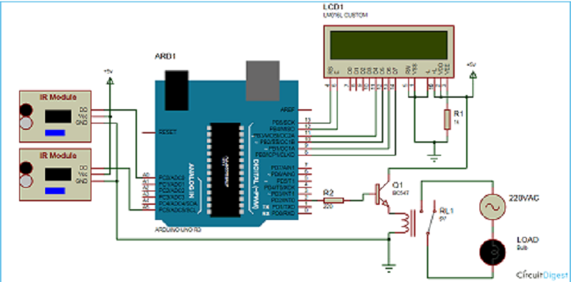

Fig 2.1 : Visitor Counter Circuit

  - Description:

    - Arduino UNO:
Arduino is an open-source prototyping platform in electronics based on easy-to-use hardware and software. Subtly speaking, Arduino is a microcontroller based prototyping board which can be used in developing digital devices that can read inputs like finger on a button, touch on a screen, light on a sensor etc. and turning it in to output like switching on an LED, rotating a motor, playing songs through a speaker etc.
The Arduino board can be programmed to do anything by simply programming the microcontroller on board using a set of instructions for which, the Arduino board consists of a USB plug to communicate with your computer and a bunch of connection sockets that can be wired to external devices like motors, LEDs etc.
UNO is based on ATmega328P microcontroller. There are two variants of the Arduino UNO: one which consists of through – hole microcontroller connection and other with surface mount type. Through-hole model will be beneficial as we can take the chip out in case of any problem and swap in with a new one.
Arduino UNO comes with different features and capabilities. As mentioned earlier, the microcontroller used in UNO is ATmega328P, which is an 8-bit microcontroller based on the AVR architecture.
UNO has 14 digital input – output (I/O) pins which can be used as either input or output by connecting them with different external devices and components. Out of these 14 pins, 6 pins are capable of producing PWM signal. All the digital pins operate at 5V and can output a current of 20mA.
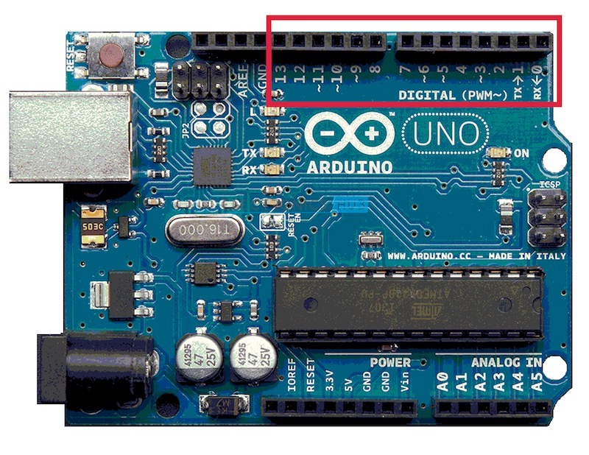
Fig 2.2:ARDUINO UNO

Some of the digital I/O pins have special functions which are describe below.
- Pins 0 and 1 are used for serial communication. They are used to receive and transmit serial data which can be used in several ways like programming the Arduino board and communicating with the user through serial monitor.
- Pins 2 and 3 are used for external interrupts. An external event can be triggered using these pins by detecting low value, change in value or falling or rising edge on a signal.
- As mentioned earlier, 6 of the 14 digital I/O Pins i.e. 3, 5, 6, 9, 10, and 11 can provide 8-bit PWM output.
- Pins 10, 11, 12 and 13 (SS, MOSI, MISO AND SCK respectively) are used for SPI communication.
- Pin 13 has a built-in LED connected to it. When the pin is HIGH, the LED is turned on and when the pin is LOW, it is turned off.
Arduino Uno has 6 analog input pins which can provide 10 bits of resolution i.e. 1024 different values. The analog pins on the Arduino UNO are labelled A0 to A5.

By default, all the analog pins can measure from ground to 5V. Arduino UNO has a feature, where it is possible to change the upper end of the range by using the AREF pin but the value should be less than 5V

    - Resistors:
Resistor is basic component that is used in all the electronic circuits. It is a passive element that resists the flow of electrons. Thus it allows only certain amount of current to pass through it. Remaining current is converted into heat.
The working principle of bulb is that electricity is passed through the filament usually tungsten, which is a resistor. The energy is converted to and released as light and heat.

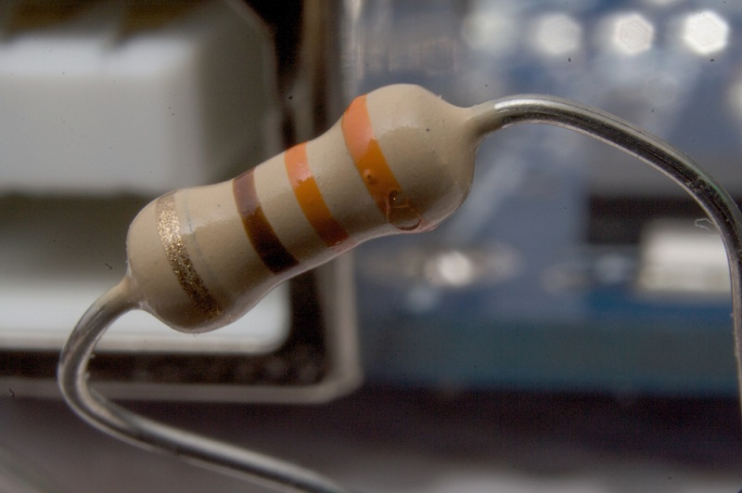
Fig 2.3 :Resistor

Generally there are two standards that are used to denote the symbol of a resistor viz.Institute of Electrical and Electronics Engineers (IEEE) and International Electro Technical Commissions (IEC).

The IEEE symbol of resistor is a zigzag line as shown in the below figure.
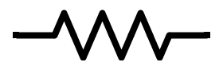

Fig 2.4:Resistor IEEE Symbol

The IEC symbol
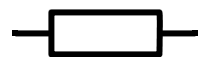
Fig 2.5:Resistor IEC Symbol

Why is a resistor used in a circuit?
Let us take an example to answer this question.
- Consider an LED connected to a battery of 9V. Assume the Forward current of the LED is 3mA.
- If a resistor is connected between the Led and battery the Led will glow.
- If there is no resistor in between LED and battery , Led will glow but after some time it heats up enormously. This is because of the more current(>30 mA) Passing through the LED.
- Thus Resistor is necessary to control the current flow.
- Resistor used in the circuit can be used for many purposes. For example to adjust the voltage levels, to provide biasing to active components, for dividing the voltage levels etc.

    - IR Module:

IR Receiver
Infrared receivers are also called as infrared sensors as they detect the radiation from an IR transmitter. IR receivers come in the form of photodiodes and phototransistors. Infrared Photodiodes are different from normal photo diodes as they detect only infrared radiation. The picture of a typical IR receiver or a photodiode is shown below.
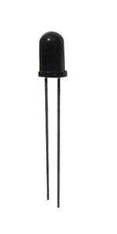
FIG 2.6 : IR
Different types of IR receivers exist based on the wavelength, voltage, package, etc. When used in an infrared transmitter – receiver combination, the wavelength of the receiver should match with that of the transmitter.

Principle of Working
The principle of an IR sensor working as an Object Detection Sensor can be explained using the following figure. An IR sensor consists of an IR LED and an IR Photodiode; together they are called as Photo – Coupler or Opto – Coupler.
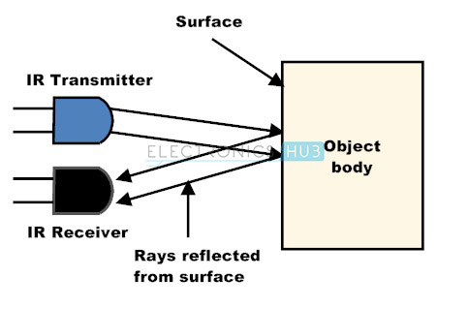
FIG 2.7 : Principle of Working

When the IR transmitter emits radiation, it reaches the object and some of the radiation reflects back to the IR receiver. Based on the intensity of the reception by the IR receiver, the output of the sensor is defined.

    - LCD Display:
The most common type of 16 x 2 LCD display available in the market is JHD162A with either HD44780 or KS0066U Display Controller. HD44780 is manufactured by Hitachi and KS0066U is manufactured by Samsung. Both the controllers are compatible with each other.
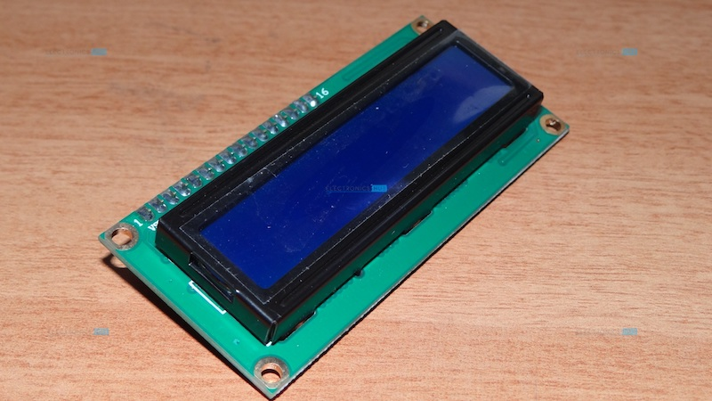
This LCD Module has 16 pins and operates on 5V supply. The standard pin out of a 16 x 2 LCD display is as follows.

Pin Configuration
Pin Number | Name | Function
1 | VSS | Power supply (GND)
2 | VDD | Power supply +5V
3 | VO or VEE | Contrast adjustment: through a variable resistor.
4 | RS | Selects command register when low; and data register when high
5 | R/W̅̅ | Low to write to the register; High to read from the register
6 | E | Sends data to data pins when a high lo low pulse is given
7 | DB0 | Data bus line
8 | DB1 | Data bus line
9 | DB2 | Data bus line
10 | DB3 | Data bus line
11 | DB4 | Data bus line
12 | DB5 | Data bus line
13 | DB6 | Data bus line
14 | DB7 | Data bus line
15 | A | Power supply for LED Backlight (+5V)
16 | K | Power supply for LED Backlight (GND)

2.3.5 Connecting Wires:
Jumper wires are used for making connections between items on your breadboard and your Arduino’s header pins. Use them to wire up all your circuits!
There are 2 types of jumper wires.
1.Male to male
2.Male to female

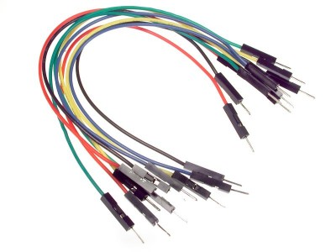
Fig 2.7 : male to male jumper wires

2.3.6 Bread board:
A breadboard is a circuit board that is used to make temporary circuits. It is a device having electronics and test circuit designs. The electronic elements inside the electronic circuits can be interchanged by inserting the terminals and leads into holes and later connecting it with the help of appropriate wires.
The device has stripes of metal below the board that connects the holes placed on the top of the board. The connections of the breadboard are mostly temporary and the elements can further be reassembled and reused without any damage. Breadboards are generally used in electrical engineering. Engineers make use of breadboards in order to test different products made by them. Using breadboard is the most efficient way of testing and also they are cost effective. They can be reused again and again for the purpose of testing. Today, starting from tiny analog, digital circuits to big complicated CPU’s everything can be tested with the help of this.

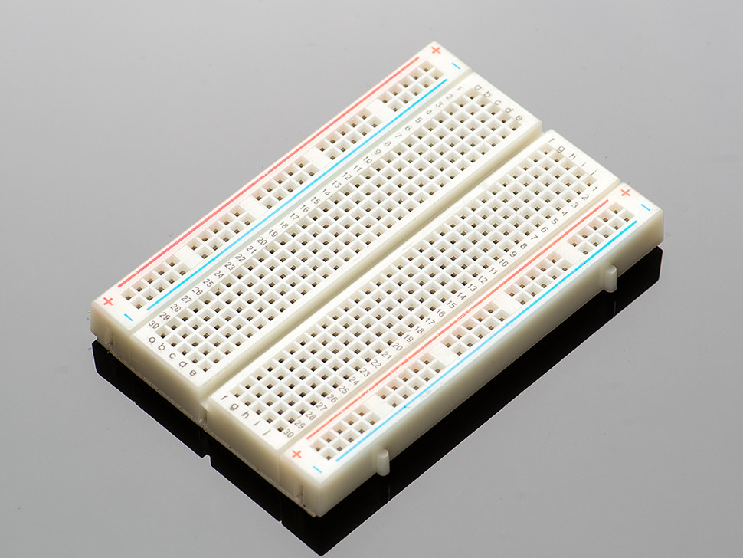
Fig 2.8 :BreadBoard

CHAPTER 3
RELATED THEORY AND PROBLEM DEFINITION
There are 2 transmitters and 2 receivers placed in front of each other. Swap any object (like mobile) or your fingers (not single finger) in front of those sensors.Then Arduino increments or decrements the counter.Once the count is non-zero, the room light is turned on using relay.Now swap object in reverse direction then the system decrements the count. And room light is turned off once the count becomes zero.We have added Light Dependent Resistor (LDR) in this project.
Purpose of LDR:
Light sensor – LDR will detect the sunlight in the room (or we can say LDR is used to detect daytime)
If there is enough sunlight in the room (which means it is a daytime) then the relay will not be turned on even if the person count is greater than zero. In this mode it will work only as a Person counter to save the electricity and works as energy saver. And if there insufficient sunlight in the room then only the relay will be turned on so as to turn on the bulb.

How to place these sensors on door:
Below is the diagrammatic representation on how the two sensors should be placed on the door frame

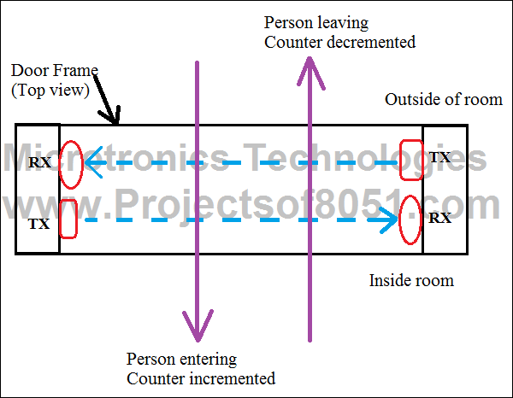
Fig 3.1 : Bidirectional Visitor Counter

Disadvantages:

It is used only when one single person cuts the rays of the sensor henceit cannot be used when two person cross simultaneously

CHAPTER 4
DESIGN METHODOLOGY

4.1 Data Flow and UML Diagrams:
4.1.1 Use Case Diagram:
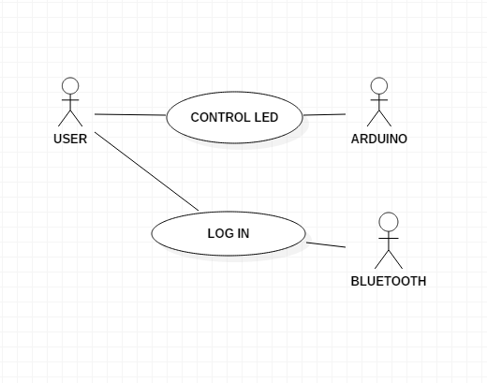
4.1.2 Sequence Diagram:
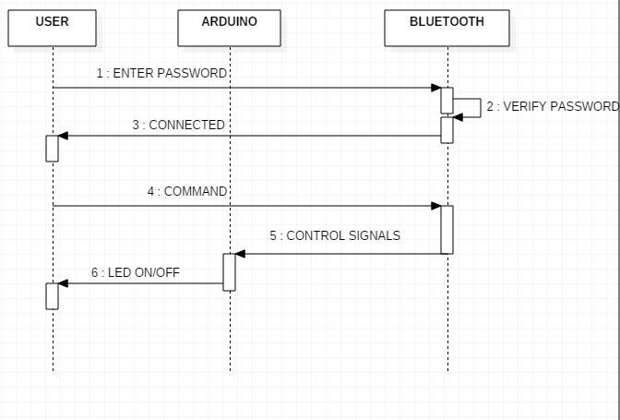
4.1.3 Flow Chart Diagram:
Start
Infrared Signal Transmission
Interrupted from Sensor1
Interrupted from Sensor 2
Turn On Relay
Counter Incremented
Counter Decremented
Counter set to 0
Relay Turn Off
Turn On Light
Turn Off Light

IMPLEMENTATION

5.1 Program:
#include <LiquidCrystal.h> //include LCD library (standard library)
#define redLED 13 //define the LED pins

int position = 0; //keypad position
#define IR1 4
#define IR2 5
#define led 13
int read = 0;
int count = 0;
int v = 2;

LiquidCrystal lcd (A0, A1, A2, A3, A4, A5);
// pins of the LCD. (RS, E, D4, D5, D6, D7)

void setup()
{
lcd.begin(16, 2);
Serial.begin(9600);
pinMode(led, OUTPUT);
pinMode(IR1, INPUT);
pinMode(IR2, INPUT);

lcd.setCursor(0, 0);
lcd.print(" WELCOME");
delay(2000);
lcd.clear();
lcd.setCursor(0, 0);
lcd.print(" PERSON");
lcd.setCursor(0, 1);
lcd.print("COUNT : ");
Serial.print("COUNT :");
lcd.setCursor(9, 1);
lcd.print(count);
Serial.println(count);

}

void loop()
{

if (digitalRead(IR1) == LOW)
{
delay(200);
if (digitalRead(IR2) == LOW)
{
v = 1;
count++;
}
}
else if (digitalRead(IR2) == LOW)
{
delay(200);
if (digitalRead(IR1) == LOW)
{
v = 1;
count--;
}
}

else
{
if (count > 0)
{
if (Serial.available() > 0)
{
char data = Serial.read();

switch (data)
{

case 'U' : digitalWrite(led, HIGH); break;
case 'D' : digitalWrite(led, LOW); break;
case 'L' : break;
case 'R' : break;
case 'C' : break;
case 'a' : break;
case 'd' : break;

default : break;
}

Serial.println(data);
}
}

if ( v == 1)
{
lcd.setCursor(0, 1);
lcd.print("COUNT : ");
Serial.print("COUNT :");
lcd.setCursor(9, 1);
lcd.print(count);
Serial.println(count);
v = 2;
}
}
}

5.2 CONNECTION OF IR SENSOR:

IR SENSOR | ARDUINO
OUT | 4
GND | GND
VCC | GND

5.3 Connection of Bluetooth

BLUETOOTH | ARDUINO
+5V | 5V
GND | GND
TX | RX
RX | TX

5.4 Connections of components to the Arduino:

LCD | ARDUINO
VSS | GND
VDD | 5V
V0 | I/P OF POT
RS | A0
RW | GND
E | A1
D4 | A2
D5 | A3
D6 | A4
D7 | A5
A | 5V
K | GND

5.5 Languages Used:

1. Java
2. Embedded C

CHAPTER 6
RESULTS

6.1 Circuit Connection:
Arduino , Breadboard ,LCD , etc are connected according to connections given in chapter 5.

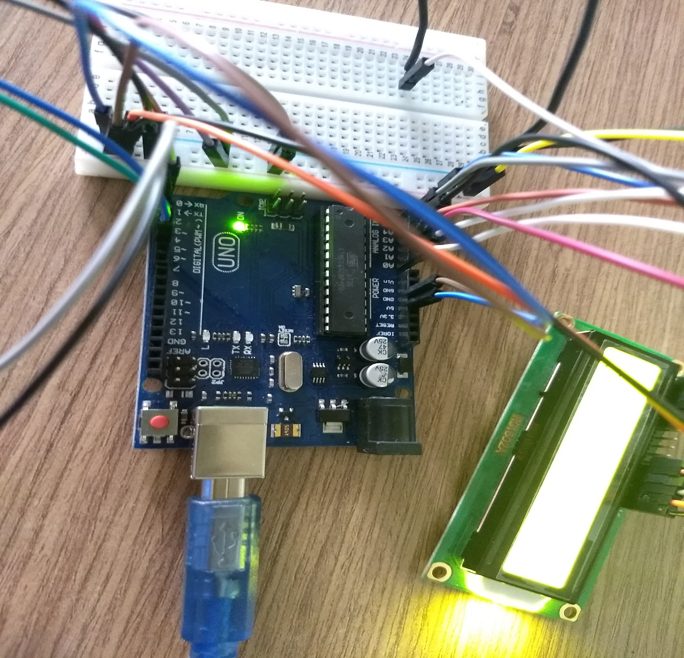

6.2 LCD Display:
When there is no person in the room, LCD will display Person count as 0.
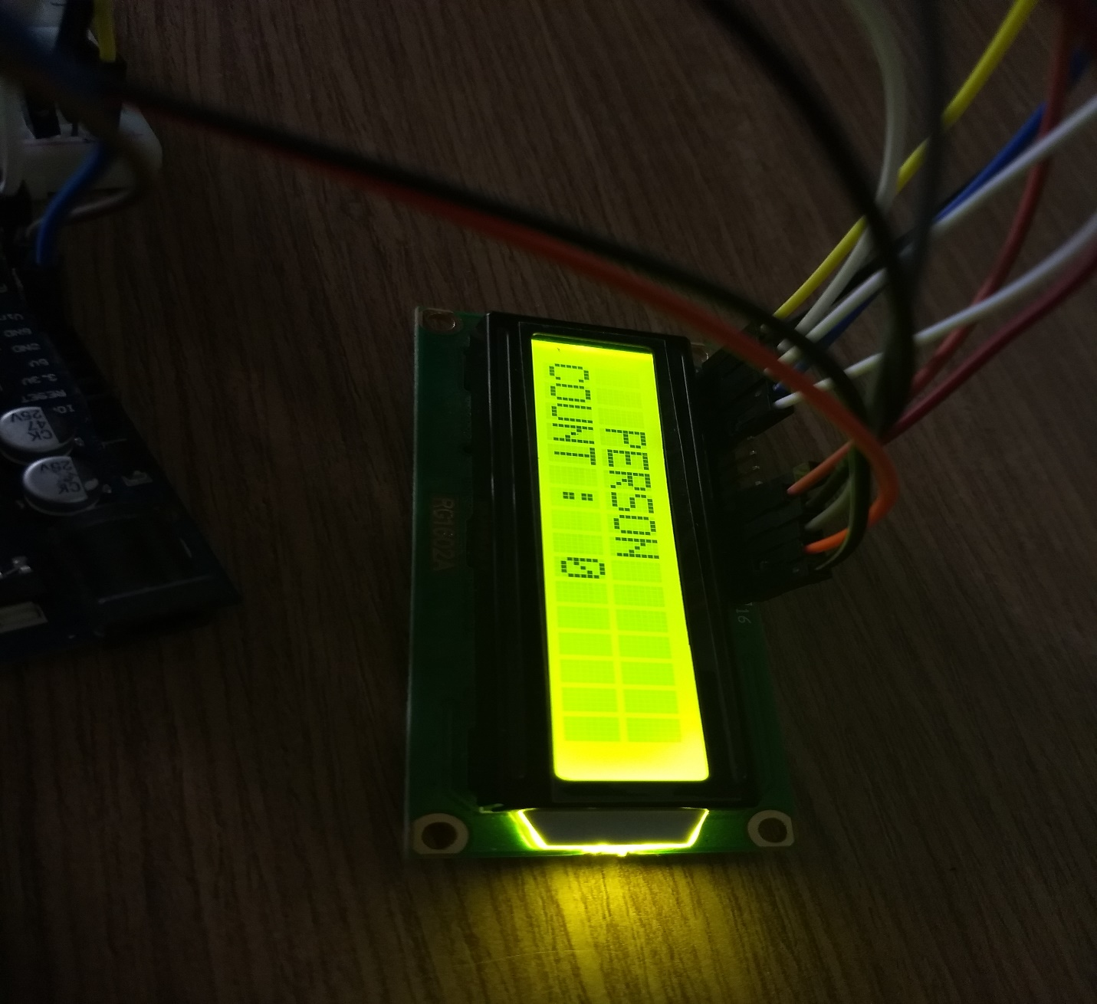

6.2.1 Entry :
When person enters the room , both the IR sensors becomes low & increments the count.
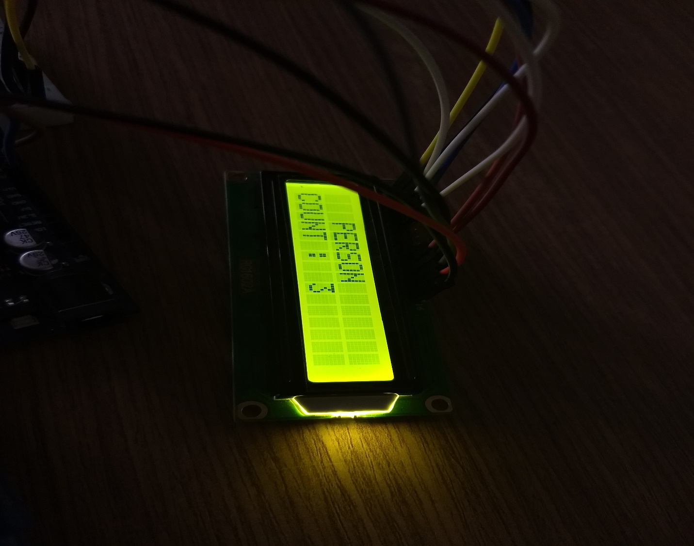

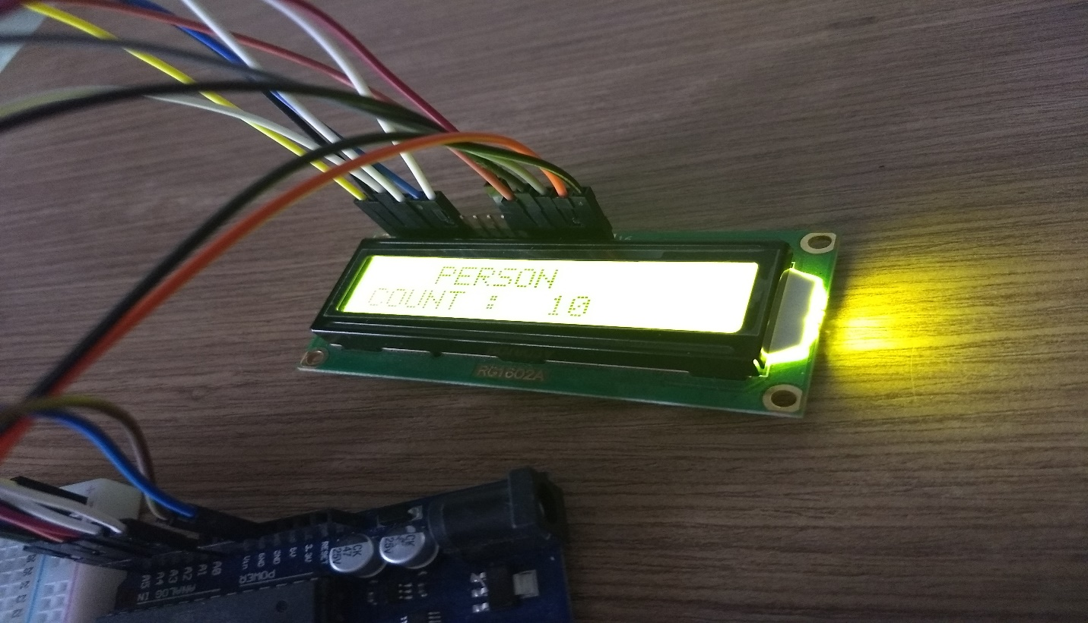

6.3 Serial Monitor:
As the count increments or decrements , person count can be visible on Serial Monitor of Arduino.
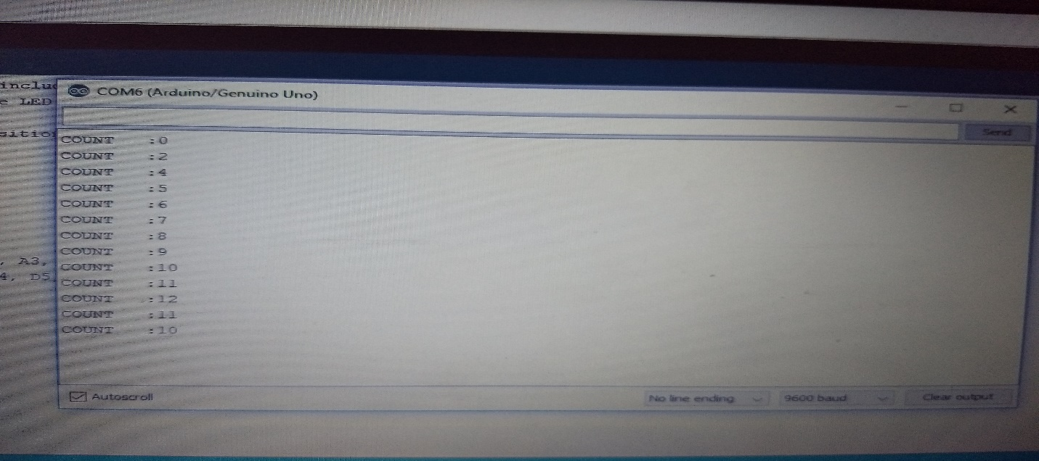

6.2 Android App GUI :
- Application with Minimalistic GUI

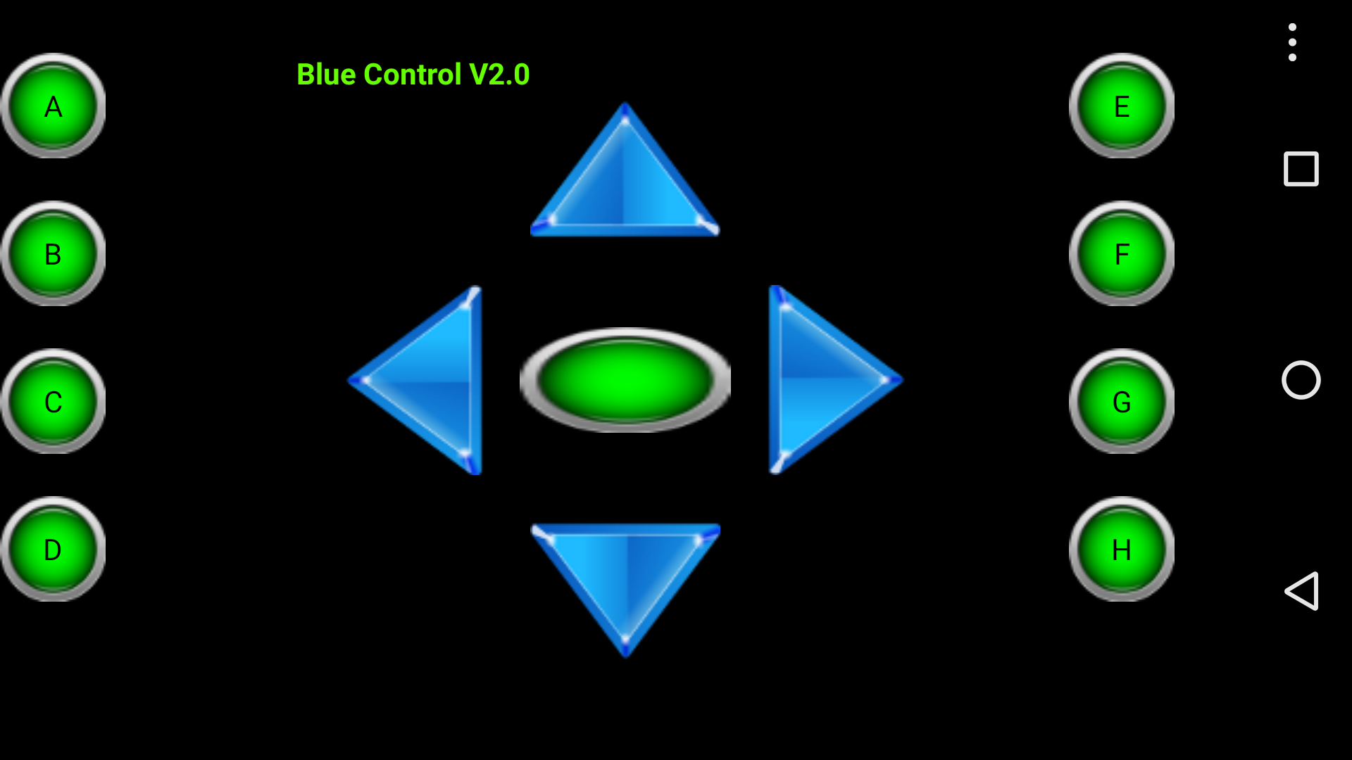

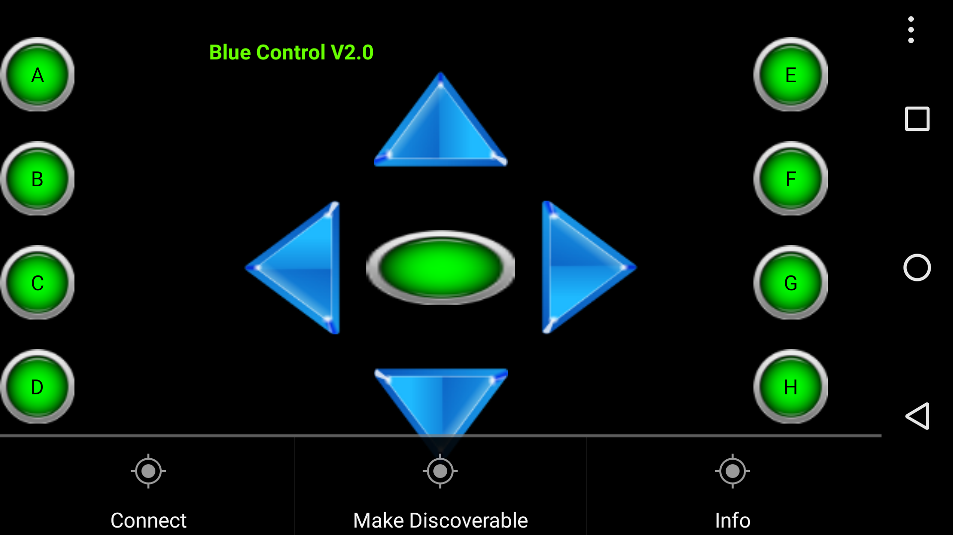

6.2.1 Connecting App with Bluetooth Module:
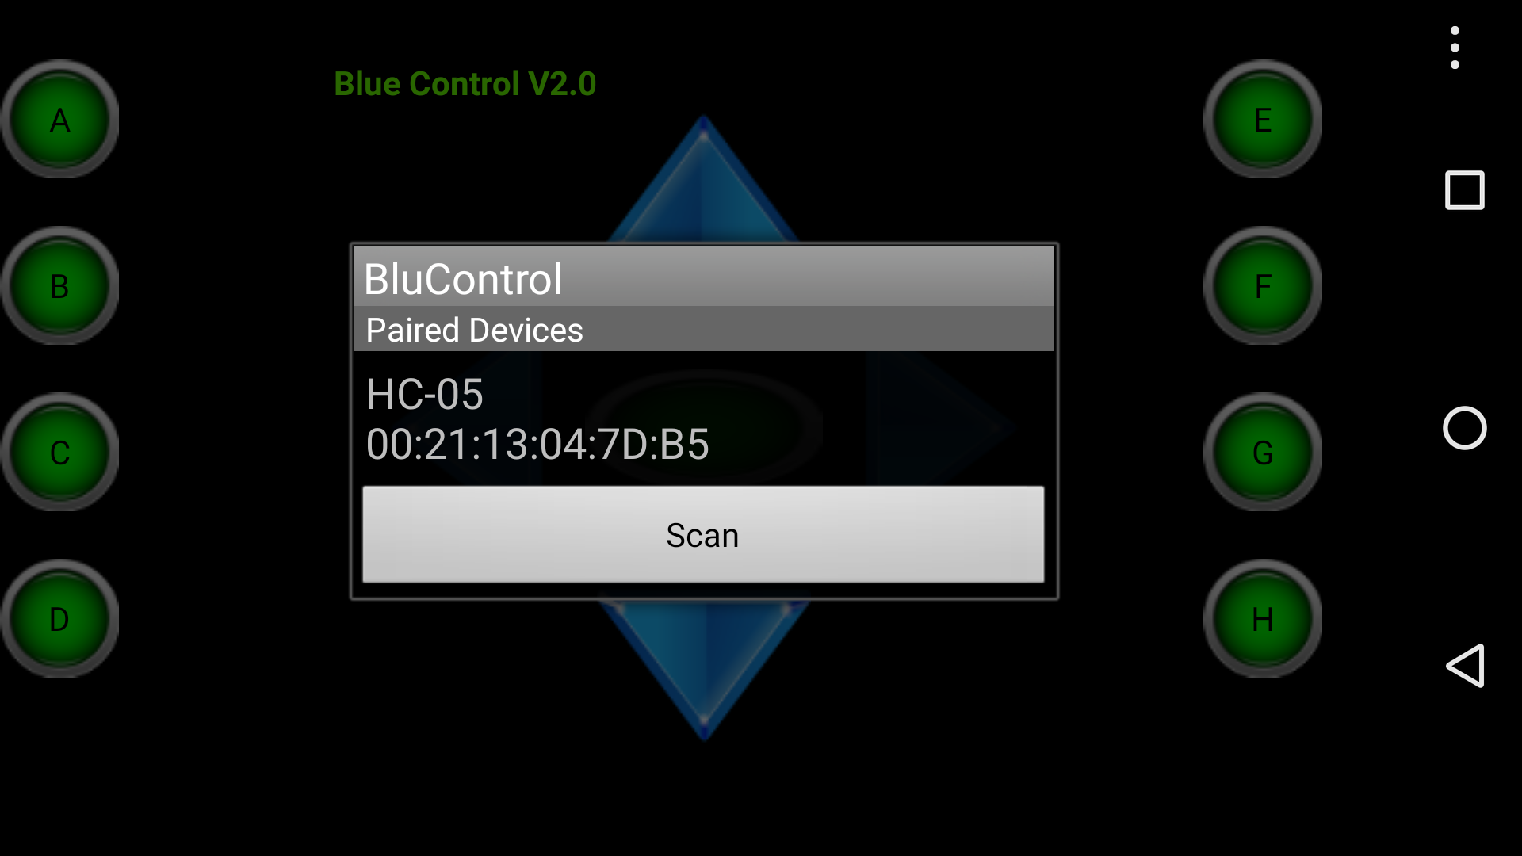

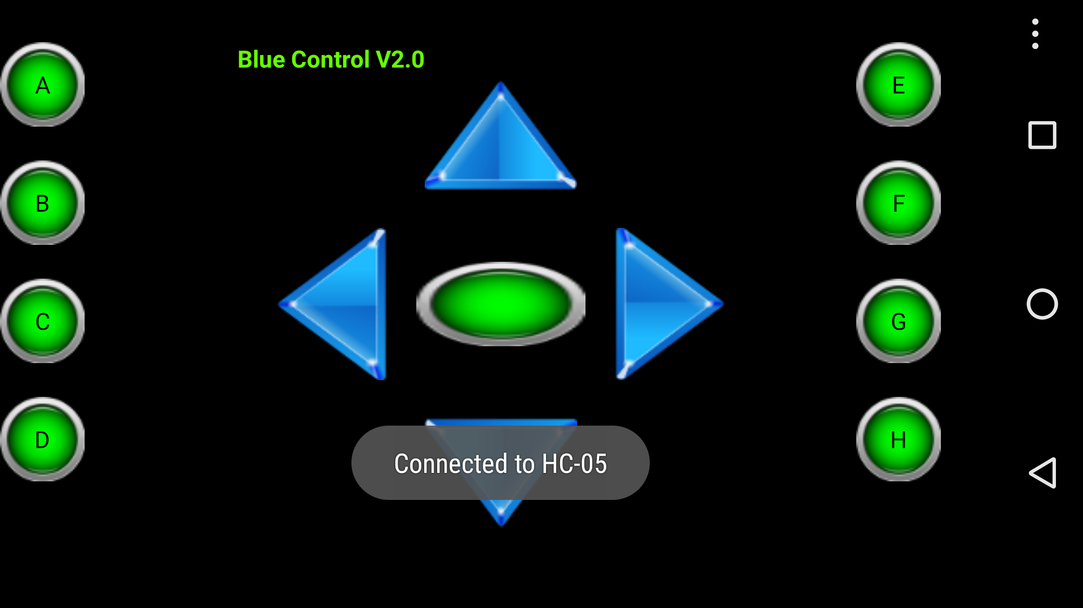

CHAPTER 7
CONCLUSION AND FUTURE SCOPE

7.1 Conclusion:

1. In the digital word we need every possible thing around us to be automatic which reduces human efforts. There are increasing electronic circuits that make today’s life easier and simple. Nowadays Energy Crisis is the big problem faced by everyone. So there is a need to conserve energy. This project is very useful for such problems as one generally forgets to turn off lights and fan while leaving a room.
2. We can use it in very low light intensity.
3. Users can control the Lights using minimalistic UI of Application.

  - Future scope:

It can be implemented on a single door. Digital Visitor Counter can be used in various rooms like seminar hall, conference hall where the capacity of room is limited and should not be exceeded. Project will display actual number of persons inside the room.
“Automatic Room light Controller with Visitor Counter” can be used in class rooms, study rooms in colleges.
Bidirectional person counter project can be used in Cinema halls, multiplex, malls as well as in temples to count the number of person entering inside. So that these places should not get over crowded to avoid congestion.

REFERENCES

1. Embedded Systems - Raj Kamal

2. www.wikipedia.com

3. INFRARED DETECTORS AND EMITTERS - Peter capper and C.T.Elliot

4. http://www.embed4u.com

5. https://www.electronicshub.org

