**TrafficLightControllerForAmbulance**

1. Title: - Controlling Traffic Light for an Ambulance.

2. Software:-

1. Arduino IDE

2. Windows OS

3. MIT app inventor

4. Firebase

3. Hardware:-

1. ESP8266

2. RED, GREEN, YELLOW, BLUE LED

3. JUMPER WIRES

4. USB CONNECTOR

4. Files in repository:-

1. door.ino (Arduino file which you have to upload in ESP8266)

2. ambulance.aia (MIT app inventor file which you have to open through MIT site)

3. ambulance[1].apk (Ambulance Need Good Escape Lane)

5. Description: -

Consider a one way road. Initially ambulance at certain distance from traffic light pole. Some vehicles are in front of ambulance. After sometime there will be Red signal so that all vehicles start to stop one by one I.e. they will make 2 different queues & our ambulance will get stuck in traffic. It won’t get free until all vehicles go. As shown in figure.

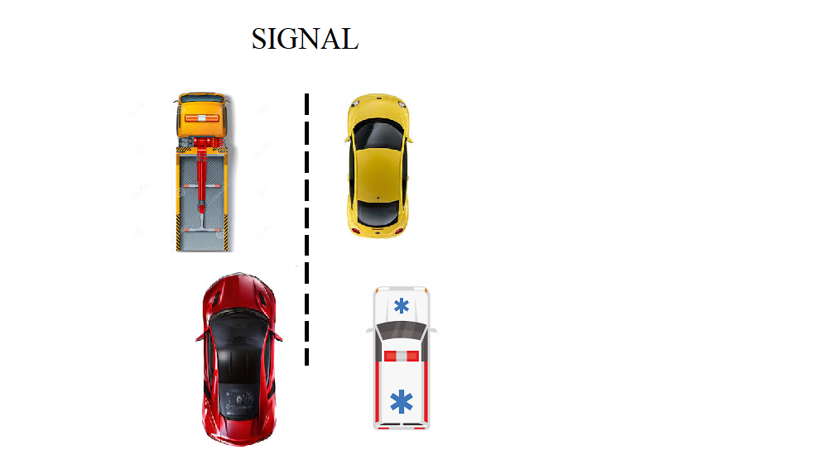

5. Working:-

Here we come to solution. How does it work? Simple solution, we used an app which is created by using MIT app inventor. That app is used by an ambulance driver and how it works let’s see.

1. That app store your current location and verifies with nearest traffic pole.

2. When app gets which is your next traffic pole it will check for distance.

3. we set some distance in that app. consider ambulance is in range of 5 KM to pole then 4th Light will glow so vehicles which are in front of ambulance will get notified ambulance in on same road so please make some space for ambulance.

4. Next when ambulance came in range of 1 KM to pole then it will give green signal to that road and makes all other red so it can easily without any barrier.

5. So ambulance will get way.

I KNOW IT IS TOUGH ENOUGH TO UNDERSTAND THIS REPOSITIORY. IT IS MY MOST COMPLICATED REPOSITORY. I CAN SOLVE YOUR QUERIES JUST MAIL ON [pawarraviraj9160@gmail.com](mailto:pawarraviraj9160@gmail.com) AT ANY TIME.