**ACTIVITY LIFE CYCLE**

Start of the app

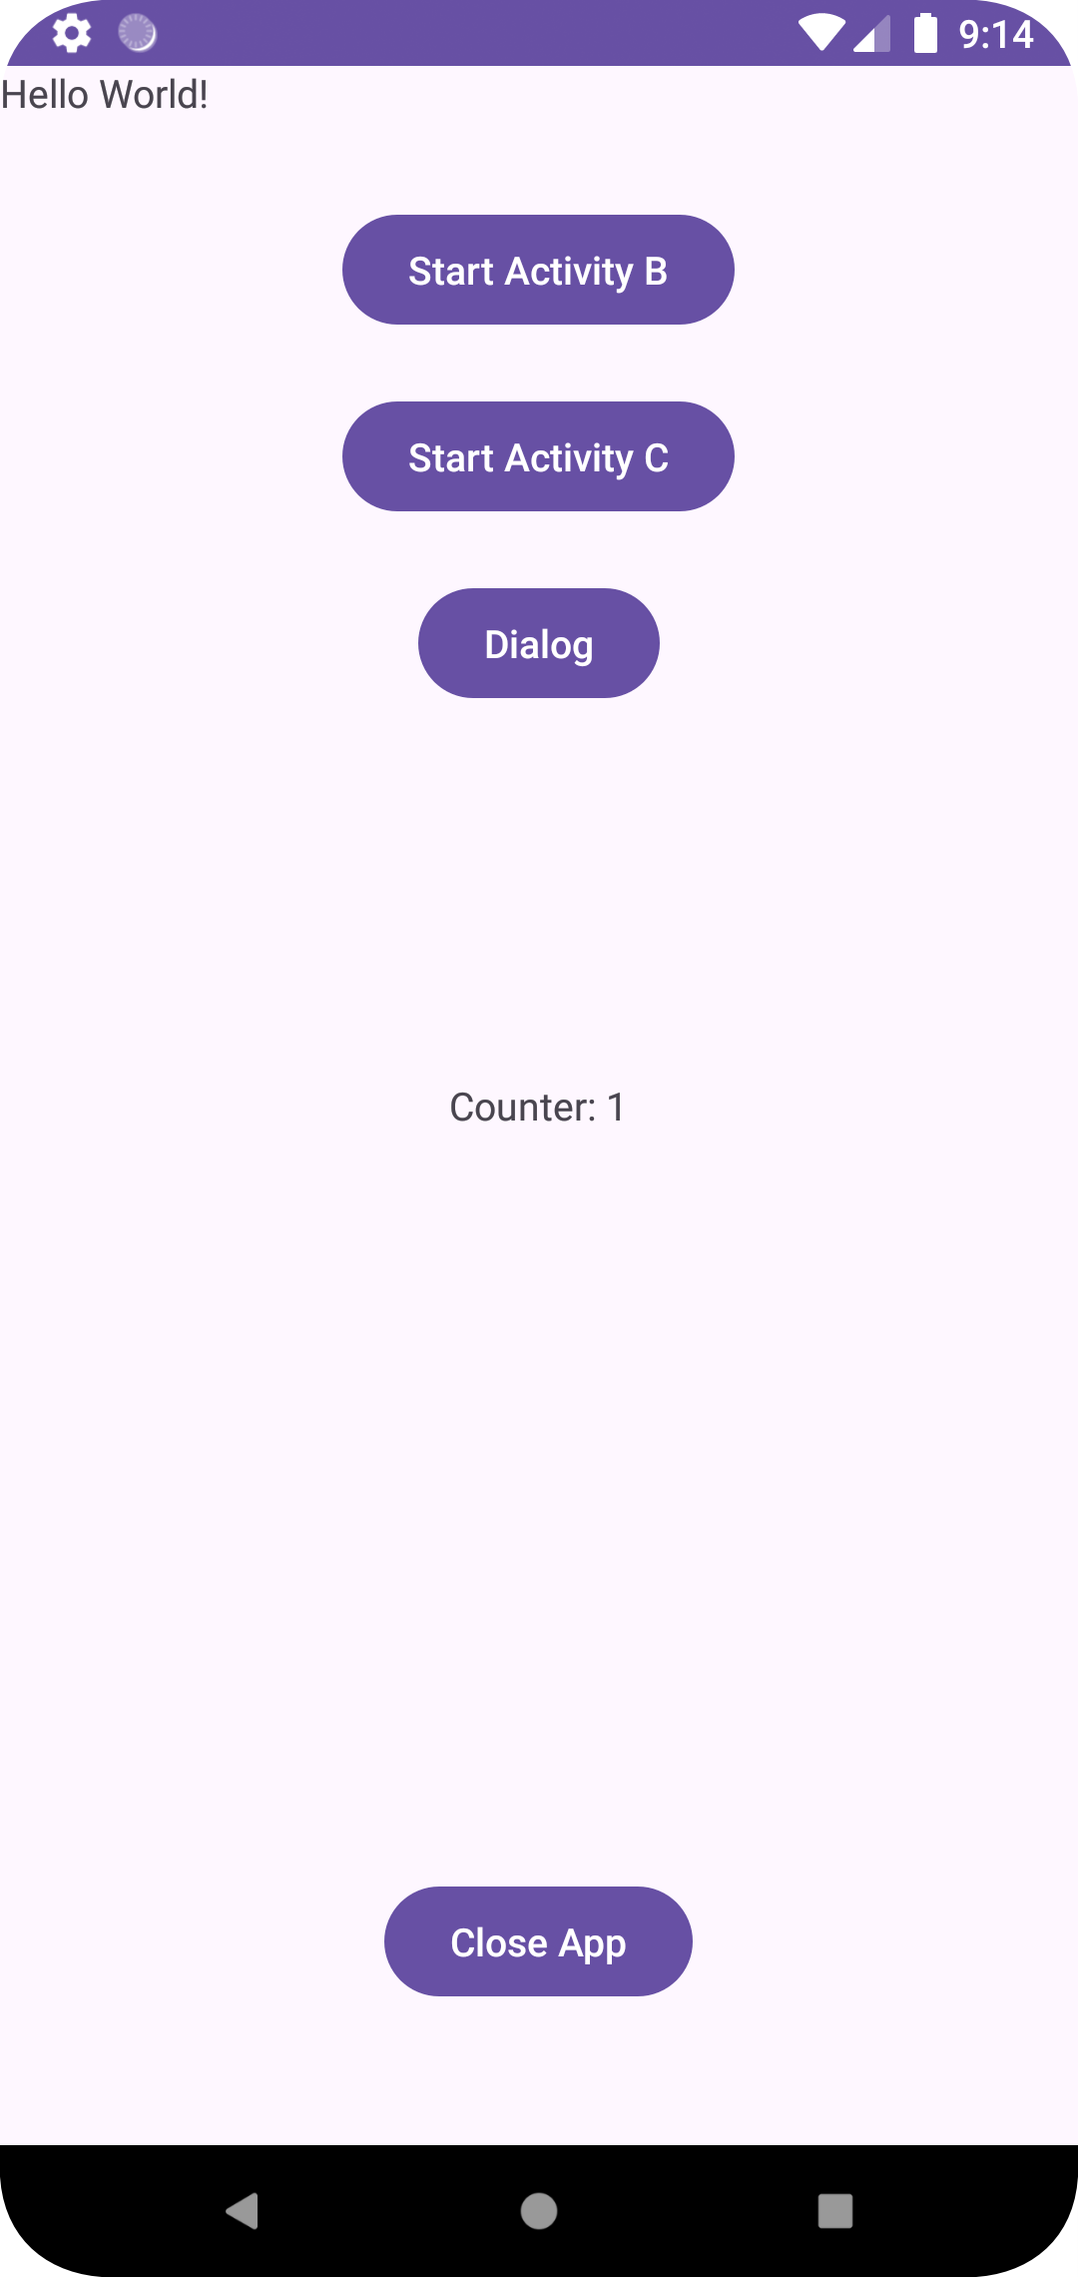

When clicking on Activity B

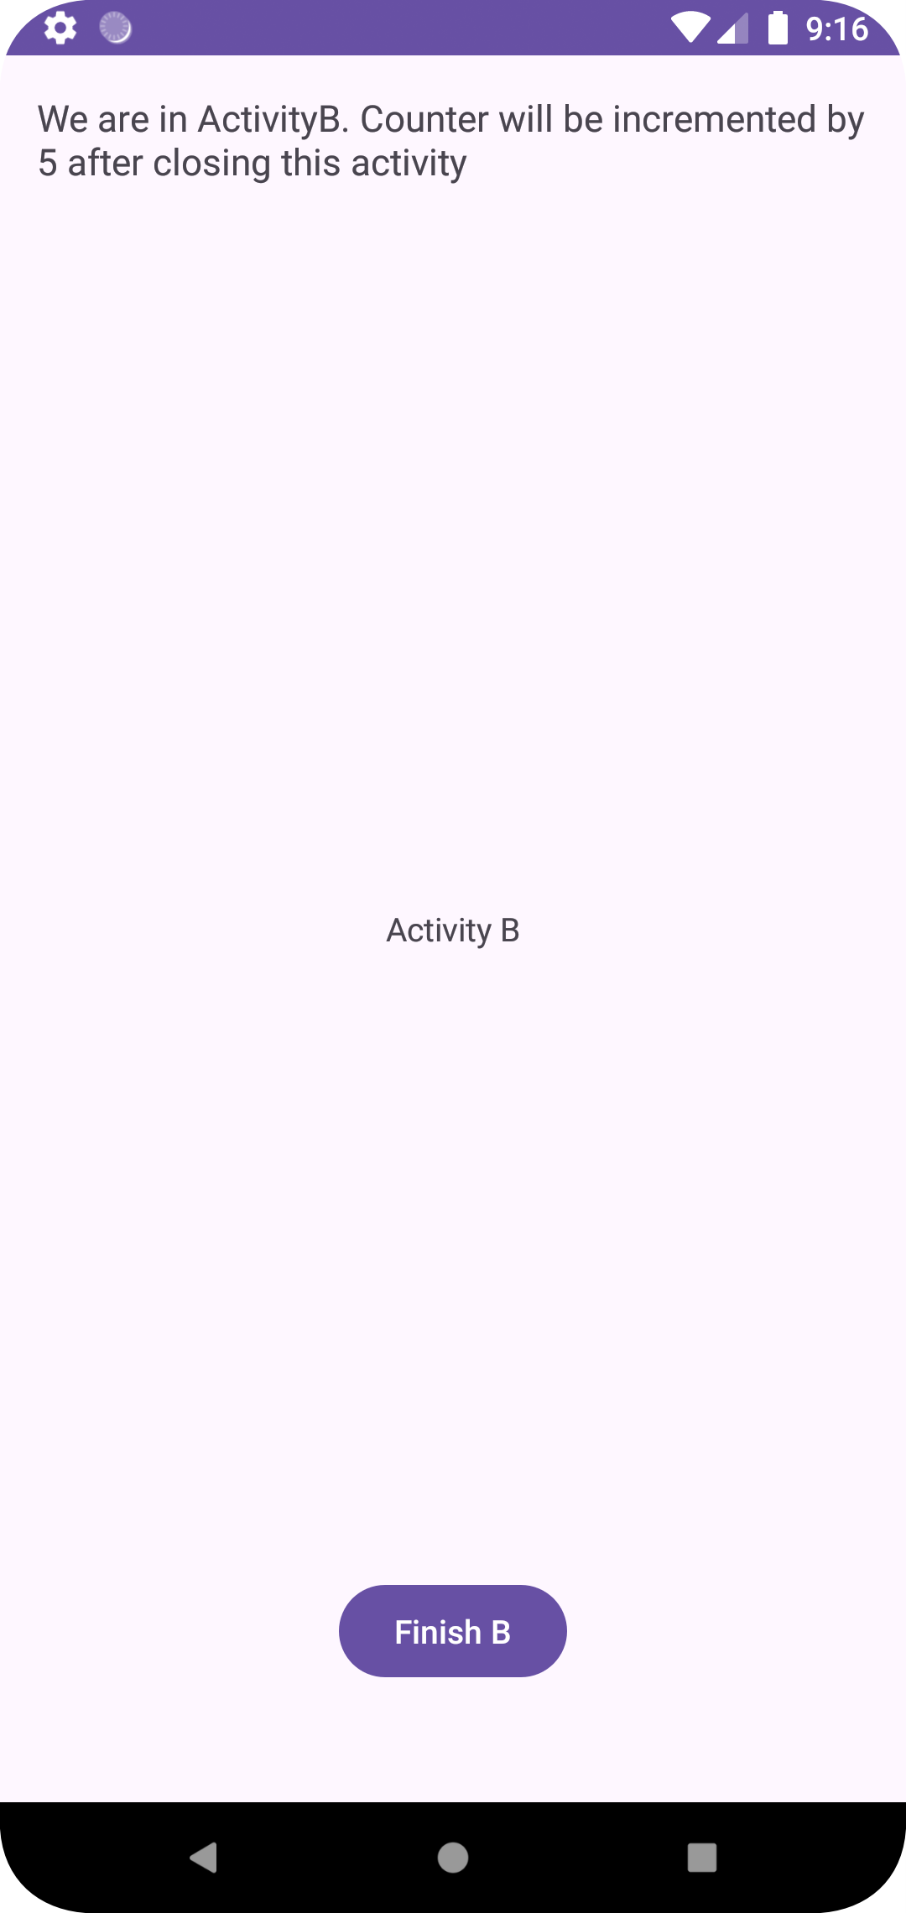

When clicking on Finish B

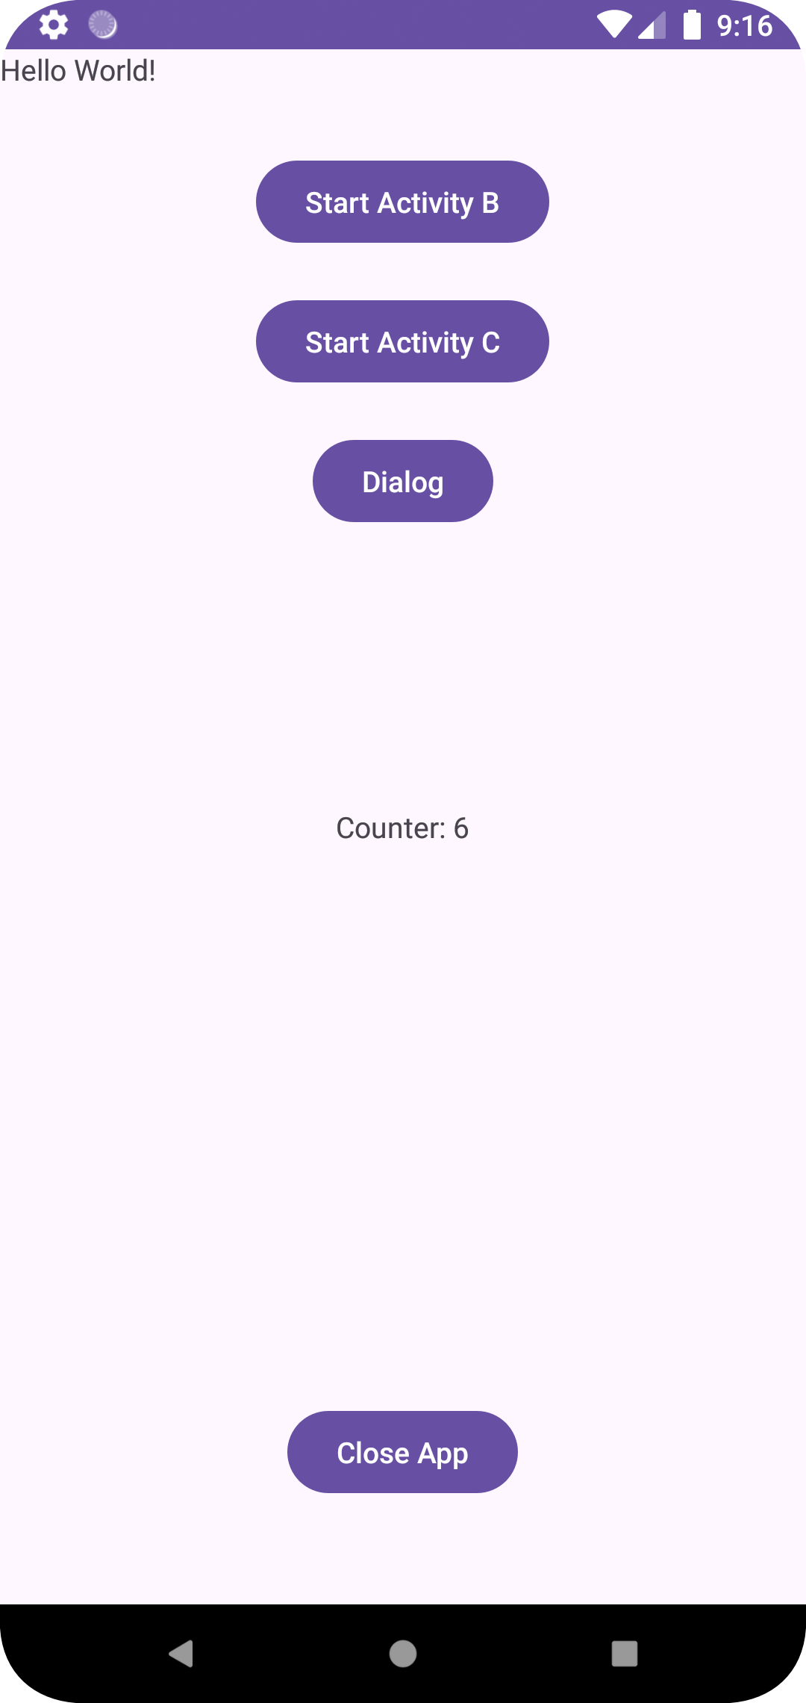

When Start Activity C

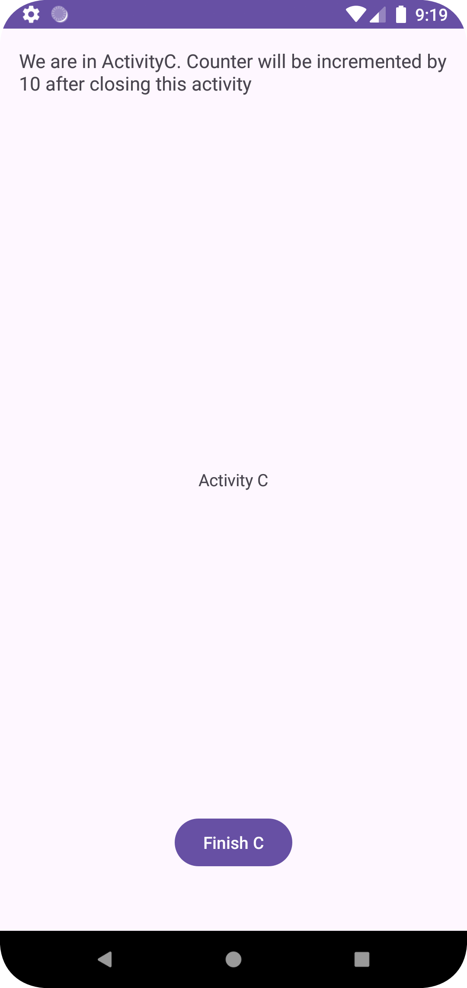

On finishing Activity C

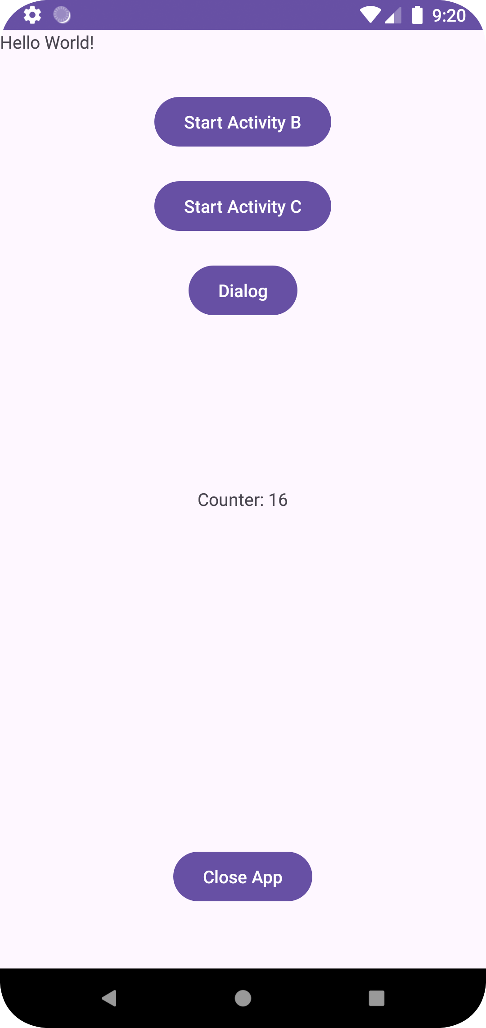

On Closing and restarting the app

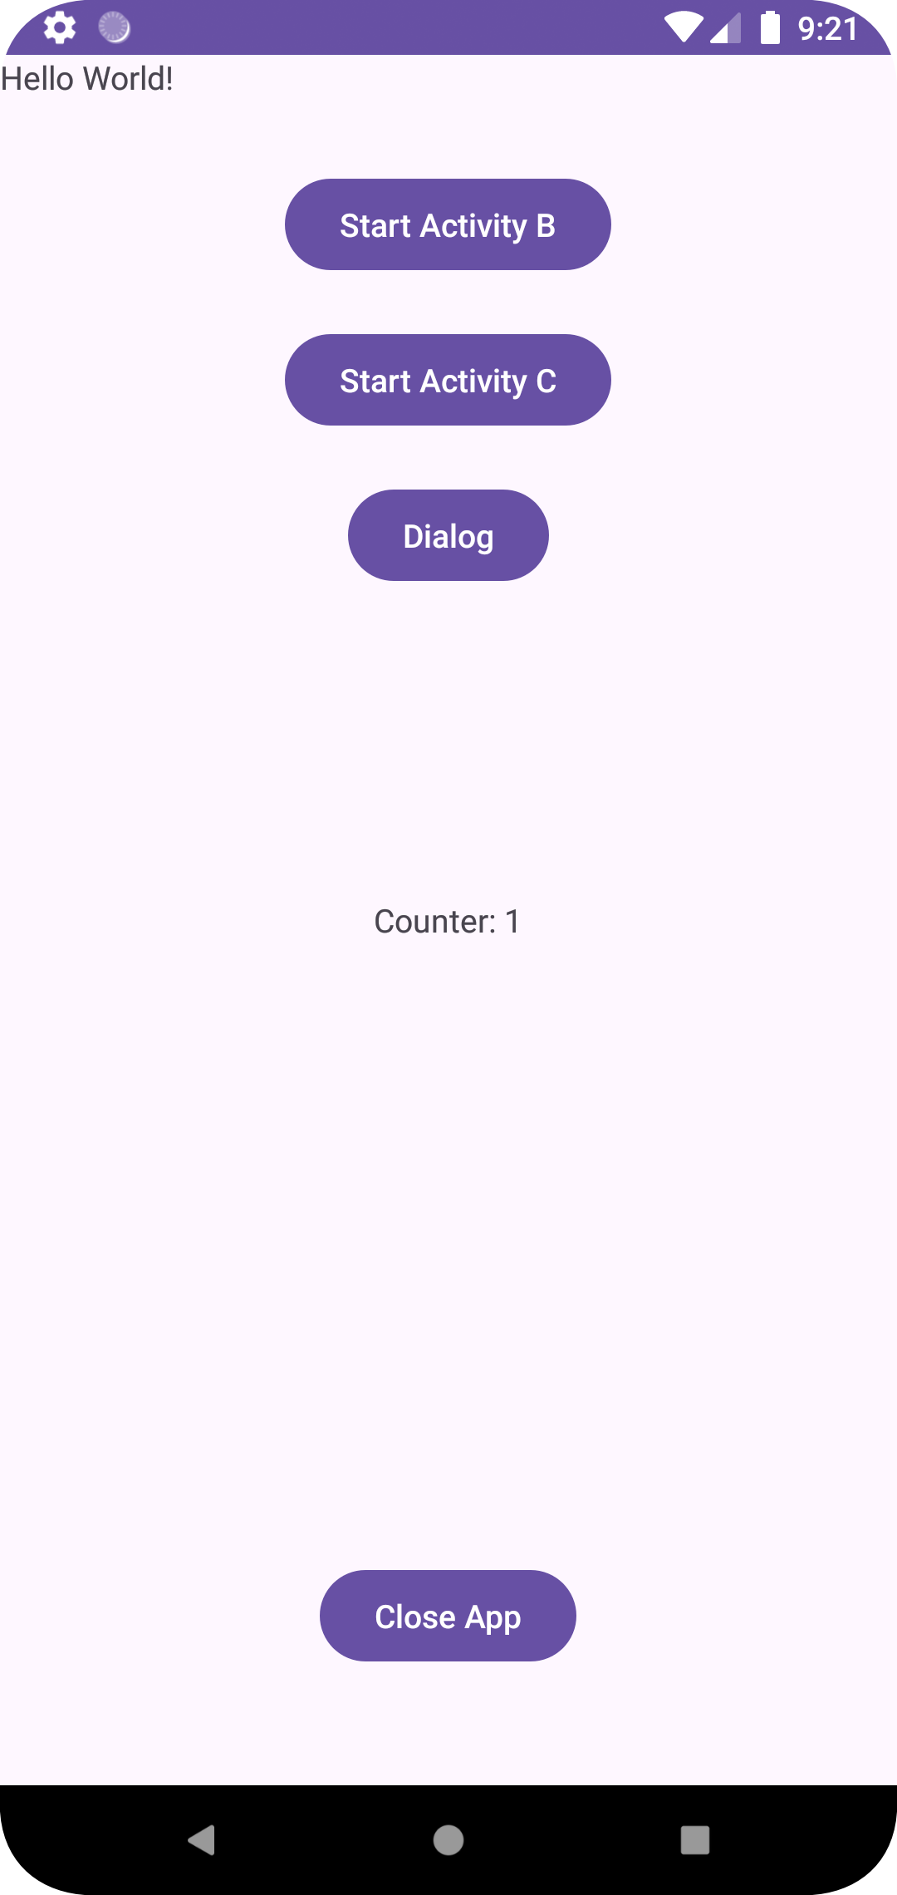

View complete code here: <https://github.com/RavirajWadnerkar/AndroidAcitivityLifecycle>