Contents
Vendor Invoice Reconciliation 1
1. Purpose and Scope 2
2. Trigger and Frequency 2
3. Starting Point and Working File 2
4. Data Sources 2
4.1 Vendor Invoice Source 2
4.2 Approved Catalog Source 3
4.3 Internal CDK Data Sources (Cognos) 3
5. File Handling Standards 4
6. CMF Validation 4
6.1 Vendor CMF vs Master Ship‑To 4
6.2 Vendor CMF vs Monthly CDK Billing 5
7. Approved Catalog Validation 5
8. Recurring Charge Aggregation and Billing Validation 6
8.1 Recurring Charge Subtotaling 6
8.2 Billing Validation 7
8.3 Inconsistent Billing 8
9. Sales Tax Review 8
10. Margin Evaluation 8
11. Final Output Pivot (after Contract Analysis) 8
12. Action Items from Results 9
Contract Analysis & Determination Logic 9
1. Rule Execution Order 9
2. CMF Review in Contracts 10
4. Contract‑Line Eligibility (INS / LSS / ANS) 10
5. Catalog Identification 11
6. Catalog & Recurring Amount Determination 12
7. Outcome Determination 12
Return to Margin Evaluation for ACTIVE Customers 12

Vendor Invoice Reconciliation

1. Purpose and Scope
This document defines the process used to reconcile vendor‑billed charges to CDK customer monthly billing.
The reconciliation process is performed to:
- Confirm that vendor‑billed CMF Ship-To’s and product/sku/catalogs exist on CDK customer billing or is part of a bundle.
  - Identify billing discrepancies i.e. catalog and/or CMF Ship-To’s
  - Calculate margin where the billed amount > $0 on Vendor invoice or CDK Customer Invoice.
  - If you are missing a CMF Ship-To or a product/sku/catalog, proceed to the contract analysis section.

2. Trigger and Frequency
- Reconciliation is performed monthly.
- The process will be triggered upon receipt of the vendor invoice from the AP team (AccountsPayable@cdk.com)

3. Starting Point and Working File
- Upon receipt, the vendor invoice is entered into a reconciliation spreadsheet.
- This spreadsheet is the primary working file.
- All reconciliation steps originate from the vendor invoice data entered in this file.
- See sample reconciliation workbook for starting table structure.
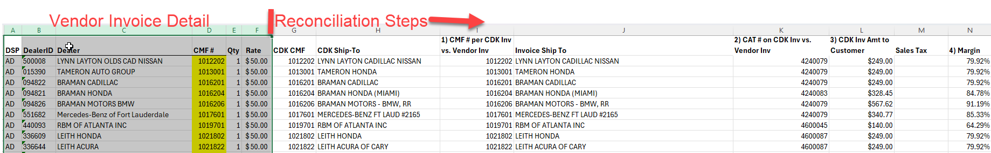

4. Data Sources

4.1 Vendor Invoice Source
- Vendor invoices are obtained from the designated SharePoint site.
  - Invoice must contain CMF Ship-To, and product/sku/catalog.
  - If missing – contact AP team (AccountsPayable@cdk.com)

4.2 Approved Catalog Source
- Approved vendor product/sku/catalogs are sourced from the vendor catalog approval list.
- For questions, see the product marketer (Jason Swiech) or Item Hub/Profisee (as future state)

4.3 Internal CDK Data Sources (Cognos)
The following Cognos reports are pulled: http://cognos.cdk.com/ibmcognos/bi/?perspective=content&folder=.public_folders%2FTemporary%2BShare%2FVendor%2BInv%2BRecon
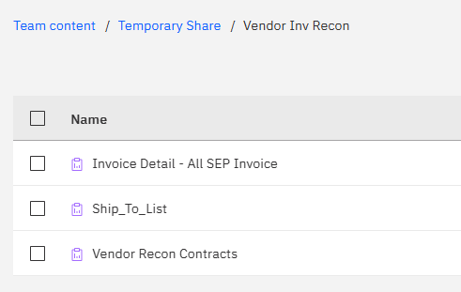
- Master Ship‑To / CMF Report – list of all Ship‑To CMFs and Dealership name.
- Invoice Detail Report – Full Month – all CDK billing for the reconciliation period.
  - Update query filter for month and year of reconciliation period.
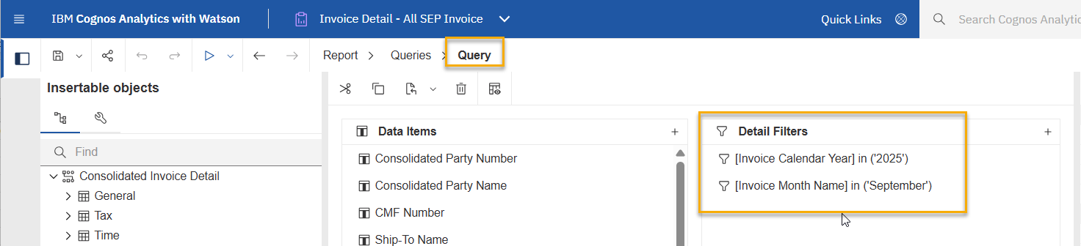
- Invoice Detail Report filtered by contracted product/sku/catalog
  - Use excel vlookup to filter out any unapproved catalog lines
  - Save As new workbook
- Contract Detail Report – All customer contract detail filtered on contracted product/sku/catalogs
  - Apply filter on Cognos report.
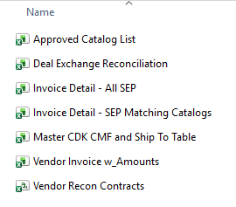

5. File Handling Standards
- All Cognos reports are stored outside the reconciliation workbook.
- All lookups reference external source files.
- Internal worksheet‑to‑worksheet lookups are avoided to control file size and performance.

6. CMF Validation

6.1 Vendor CMF vs Master Ship‑To
- Perform a lookup of the vendor‑provided CMF against the Master Ship‑To CMF list.
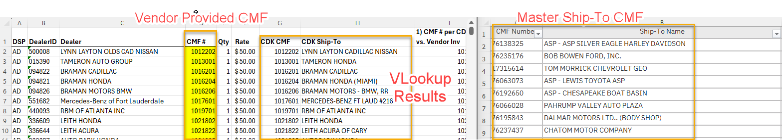
If CMF exists:
- Proceed to monthly billing validation.
If CMF does not exist:
- Apply reconciliation comment: Vendor Billed – No Matching Ship-To CMF Found
- Invoice line is not reconciled and requires contract analysis.

6.2 Vendor CMF vs Monthly CDK Billing
- Validate that the vendor CMF appears in monthly CDK billing by using a vlookup of Ship-To CMF against the CDK Monthly Invoice Report.
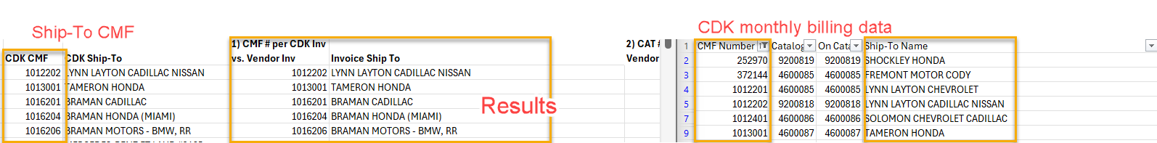
If CMF exists in billing:
- Proceed to catalog validation.
If CMF does not exist in billing:
- Apply reconciliation comment: Vendor Billed – Not on CDK Billing
- Invoice line is not reconciled and requires contract analysis.

7. Approved Catalog Validation
- Validate that at least one approved catalog exists for the CMF in the CDK Monthly Billing report.
- Use =TEXTJOIN(FILTER)) formula on pivot table by catalog, to return all matching catalog #’s
Pivot Table Source: CDK Billing Detail Report Filtered on Approved Catalogs
Pivot Table Structure:
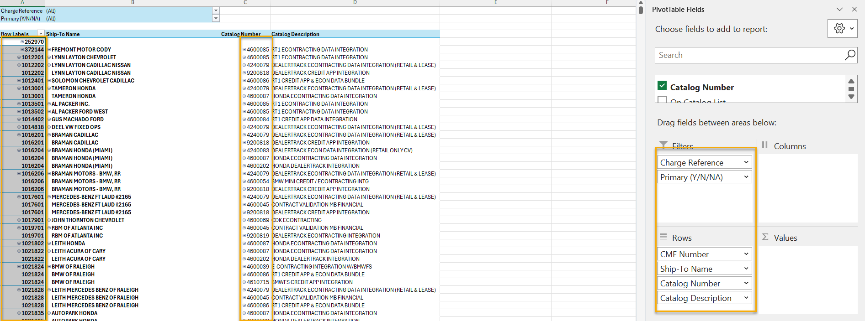
Field Settings for All Rows:
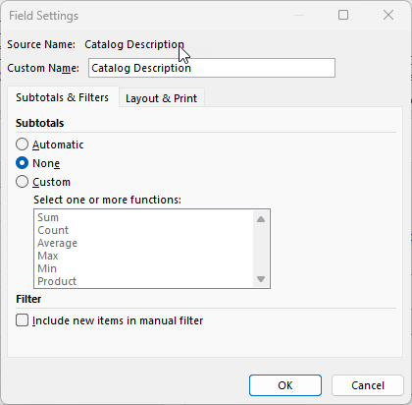
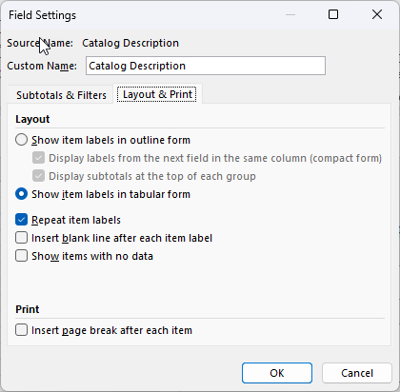

If approved catalog exists:
- Proceed to recurring charge aggregation. 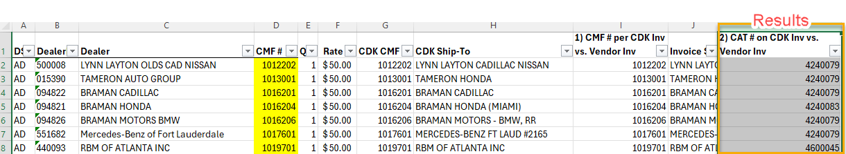
If multiple approved catalogs exists:
- Return/list all approved catalogs. Proceed to recurring charge aggregation.
  - EXPLAIN
If no approved catalog exists:
- Apply reconciliation comment: Vendor Billed/CDK Monthly Billing – No Matching Catalog#
- Invoice line is not reconciled and requires contract analysis.

8. Recurring Charge Aggregation and Billing Validation

8.1 Recurring Charge Subtotaling
- Subtotal recurring charges by CMF using approved‑catalog invoice detail.
- Vlookup the CDK CMF against a pivot table of dealerships by recurring amount.
Pivot Table Source: CDK Billing Detail Report Filtered on Approved Catalogs
Pivot Table Structure:
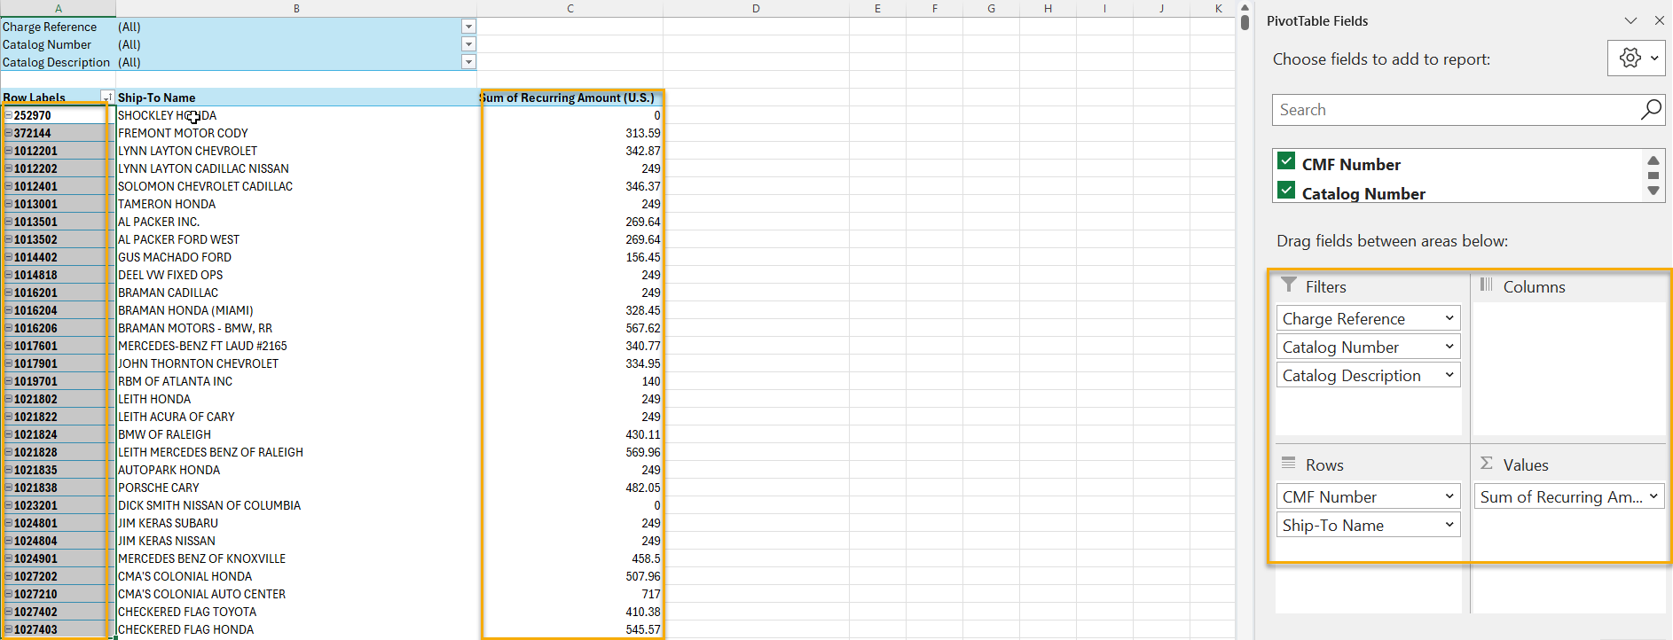
Field Settings for All Rows:
Results:
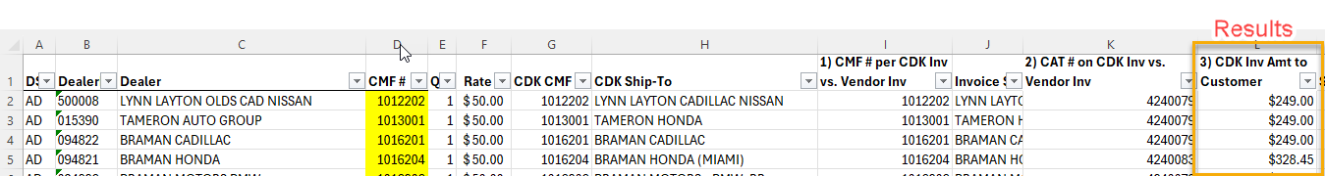

8.2 Billing Validation
If subtotal > $0:
- Proceed to margin calculation (section 10).
If subtotal = $0:
- Validate billing intent against Customer Contract or latest contracting event.
  - If confirmed correct:
    - Insert comment in reconciliation comment column “S”: “Vendor Billed, On CDK Invoice, Billing Customer $0”
    - Identify if part of a bundle which will explain $0 billing.
  - If incorrect → Escalate to Accounts Receivable team or equivalent billing team for correction.

8.3 Inconsistent Billing

- If recurring amounts vary across dealers for the same catalog number, verify against customer contract or latest contracting event before proceeding.
  - If billing amount is incorrect – Escalate to Accounts Receivable or equivalent billing team for correction.
- Proceed to next step

9. Sales Tax Review
- Re-sale products are exempt from City & State sales tax.
- If vendor billed sales tax, escalate to Tax and Procurement (Rich Rios, Sourcing & Procurement)
- Proceed to next step

10. Margin Evaluation
- Calculate margin based on vendor vs customer billing.
- Classify margin in the Reconciliation Comment column as ≥ 50% or < 50% for reporting purposes.

11. Final Output Pivot (after Contract Analysis)
- All Ship-To CMF’s on Vendor Invoice now have the following reconciliation comments:
  - Vendor Billed; No Matching Ship-To CMF on Monthly Billing
  - Vendor Billed; No Matching Catalog #
  - Vendor Billed, On CDK Invoice, Billing Customer $0
  - Customer Lost
  - Customer ANS
  - Customer Active
  - > 50% Margin
  - < 50% Margin
- Create a pivot table from the original reconciliation workbook mentioned in Step 3.
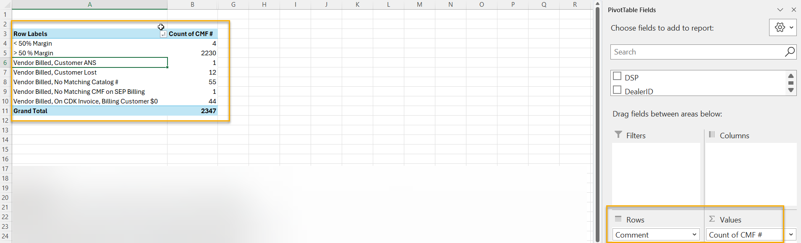

12. Action Items from Results (Work in Progress)
- Vendor Billed, Customer ANS
  - Confirm with Contract Detail Report if product has been installed (CDF Status).
    - If yes = Escalate to billing operations to add to next month CDK Billing.
    - If no = Confirm if 90 days from signed contract has transpired.
      - If yes = Escalate to billing operations to add to next month billing.
      - If no = Recon Comment (Column S): Customer ANS
- Vendor Billed, Customer Lost
  - Confirm with Billing Operations team if customer is lost.
    - If yes = notify vendor to remove from billing.
    - If no = escalate to billing operations to add to CDK billing.
- Vendor Billed, No Matching Catalog #
  - Identify if contracted product/SKU/catalogs are part of bundle.
    - Contact product marketer (Jason Swiech) or Item Hub/Profisee (as future state)
- Vendor Billed, No Matching CMF on Monthly Billing
  - Identify if CMF number changed.
    - If New CMF Number found = repeat reconciliation process.
    - If NO NEW CMF Number found = Leave recon comment as is.
- Vendor Billed, On CDK Invoice, Billing Customer $0
  - Contact Revenue OPS team for confirmation of billing amount.

Contract Analysis & Determination Logic

1. Rule Execution Order
Rules must be executed in the following order for any Vendor Invoice Line that does not have a matching Catalog # or CMF #
- CMF review in contracts
- Contract‑line eligibility
- Catalog identification
- Catalog & recurring amount determination
- Outcome determination

2. CMF Review in Contracts
Goal: Determine whether a contract‑level CMF association exists in the Contract Details Report.
VLookup on contract detail report against Ship-To CMF’s to identify all matching Contract CMF Ship-To’s.
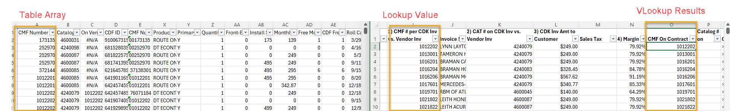
Outcome
- Match Found
  - Proceed to Next Step
- No Match
  - Recon Comment: LEAVE COMMENT AS IS: Vendor Billed No Matching CAT # or Vendor Billed No Matching Ship-To CMF
  - Check for possible change in CMF by filtering on similar Ship-To Names to identify new/changed Ship-To CMF #
    - Dealership Bought/Sold?

4. Contract‑Line Eligibility (INS / LSS / ANS)
Goal: Determine whether contract lines are billable and eligible for the reconciliation period on the Contract Detail Report.
This is a manual review of each CMF and each product on the monthly vendor invoice against the Contract Detail Report.
Rules:
- ACTIVE if any INS exists within the period
- LOST if all statuses are LSS or ANS
- CDF Status “BLG” is treated as ACTIVE unless superseded by a later LSS or ANS
- Apply precedence rules (most‑recent status change then roll-call date wins)

Exception Handling
- INS after vendor invoice billing period. – CMF 76254367
  - Confirm INS within 90 of ANS or Contract sign date
    - If yes = not an exception
    - If no = review contract details or latest contracting events.
  - Customer will be active in future reconciliation.
- ANS w/no INS or LSS date – CMF 8300184
  - Confirm if customer using product with implementation team (add names)
- ANS after LSS Date – CMF76005103
  - Confirm if customer using product with implementation team (add names)
- INS Date in middle of reconciliation month. – CMF 71050802
- INS w/ $0 billing – CMF 71052817
  - Identify if part of bundle
    - If yes = repeat analysis for CMF w/ bundled Catalog #
    - If no = Validate billing using Contract Detail report or latest contracting event.

Outcome
- ACTIVE → Proceed to Next Step
  - Reconciliation Comment: Customer Active
- LOST/ANS → No ACTIVE Lines
  - Reconciliation Comment: Customer Lost/ANS

5. Catalog Identification
Goal: Identify all active contract‑supported catalogs associated to the CMF using the Contract Detail Report.
This is a manual review of each CMF on the contract detail report.
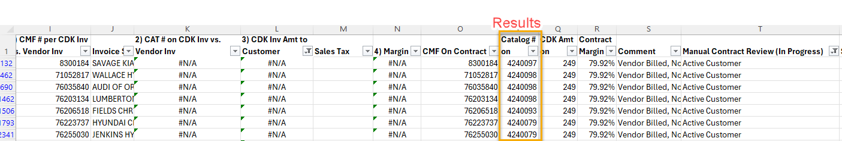
Outcome:
Add all active catalogs to the recon worksheet for charge amount analysis.
Proceed to next step.

6. Catalog & Recurring Amount Determination
Goal: Determine recurring amount to compare against Vendor Invoice charge.
This is a manual calculation of all active product/sku/catalogs on the contract detail report per CMF.
Steps:
- Retain all eligible contract lines
- Retrieve recurring amount per eligible line
- If multiple eligible lines exist, subtotal recurring amounts across all eligible lines
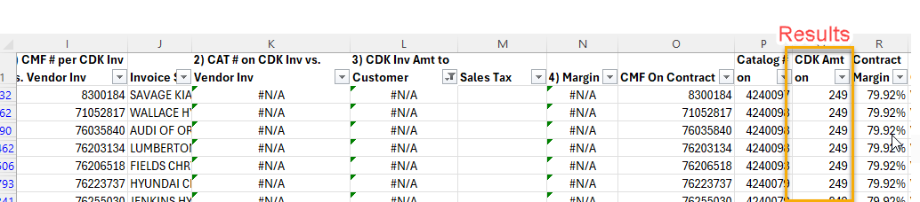

7. Outcome Determination
For each CMF - final outcomes are derived directly from prior execution:
- Customer Active: Margin calculated based on contracted charge amounts.
- Customer Lost or ANS: LOST eligibility; no amount derived
  - Confirm with Revenue Operations (RevenueOperationsandAccounting@GlobalCDK.onmicrosoft.com) if truly lost.
    - If YES = notify third party vendor
    - If NO = Revenue Operations to fix.

Return to Margin Evaluation for ACTIVE Customers

