Raising MoveInSync's Play Store ratings
Recommendation for the MoveInSync Forward Deployed Engineer case study | App: MoveInSync (com.moveinsync.ets) | Data to 9 Oct 2026 | Ravi Ranjan

The short version
- Where we are: The store shows 4.64 stars (114,855 ratings, India). Among written reviews, which skew negative, the last 12 months average 3.83 with 27.0% at 1-2 stars. The last 90 days (3.80, 28.7% negative) are no better than the 90 days before (3.84, 26.5%). There is no sign of improvement.
- What is hurting most: Of 772 one- and two-star reviews in the last 12 months, 106 (14%) are about logging in or OTPs that never arrive. Crashes (40), support that cannot be reached (37) and driver or pickup problems (up to 56 combined) follow. Two thirds of negative reviews name no specific problem at all.
- What to do first: (1) Start answering 1-2 star reviews this week; replies have nearly stopped since 2024 (3.8% of negatives in the last 12 months). (2) Pull OTP and login failure logs and fix first-time login and session drops. (3) Triage crashes by device. Details and owners are below.

1. Where the ratings stand
Period (written reviews) | Reviews | Mean stars | 1-2 star share
All 8,000 most recent (Dec 2023 - Oct 2026) | 8,000 | 3.71 | 29.6%
Last 12 months | 2,857 | 3.83 | 27.0%
Last 90 days | 721 | 3.80 | 28.7%
Prior 90 days | 819 | 3.84 | 26.5%
Why 4.64 on the store but about 3.8 here: people who had a bad trip are much more likely to write a review than people who did not. Monthly averages in the last year moved between 3.56 and 4.03 with no clear direction. Builds 12.10 to 12.12 are the best rated (about 4.0, roughly 21-22% negative), so the team has shipped better releases before; it is worth looking at what changed in them.

2. Why the ratings are low
I counted which specific problems 1-2 star reviews mention (last 12 months, 772 reviews; a review can mention more than one):
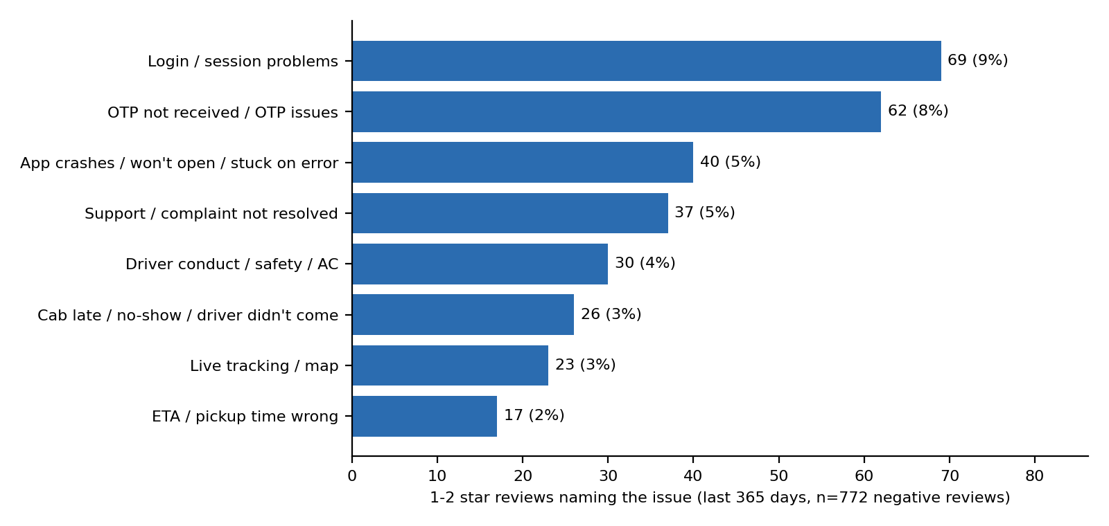
Issue | Reviews | What riders write (short extracts)
Login / OTP | 106 | "not receiving OTPs to phn number, whatsapp or email. i tried nearly 50 times"; "does not save login info"
Crashes / blank screen | 40 | "keeps giving a blank screen everytime i try to open it"; "keeps crashing whenever we click track option" (Samsung S22+)
Support not reachable | 37 | "What's the use of help desk when it's always busy"; "mailed their customer support team multiple times but still no response"
Driver / pickup problems | up to 56 | Rude drivers, no AC, always late, wrongly marked no-show. Mostly operations, not app code.
No issue named | 512 (66%) | "worst app" style reviews. We learn nothing from these, which is itself a finding.
Not a priority right now: the map that zooms out while you pinch (5 reviews in 12 months; the most upvoted zoom complaint, 51 votes, is from version 11.4.13 in early 2024), the forced trip-rating screen (8), and the seat-belt prompt before the OTP (3, one on the newest build 12.19.0, so watch it). They are cheap to fix but will not move the rating by themselves.

3. What to do, in order
1. Answer negative reviews (this week, no engineering needed)
- Why: Developer replies nearly stopped. About 37% of 2024 reviews got one, 4% in 2025 and under 1% in 2026; for 1-2 star reviews in the last 12 months the rate is 3.8%. Most past replies were generic (260 distinct texts across 1,241 replies, largely "thank you for your 5-star review").
- Do: Reply to every 1-2 star review within 48 hours with a specific next step (an app support address, or what to ask the customer's transport desk). A reply invites the rider to update the rating.
- Owner / measure: Product operations or support. Reply rate above 80% and median reply time under 48 hours, tracked in the weekly refresh.
2. Fix first-time login, OTP delivery and session drops
- Why: The biggest named cause: 106 reviews, 14% of negatives. Reviews describe OTPs that never arrive on SMS, email or WhatsApp, new users locked out, and being logged out while a cab is waiting.
- First step (day 1-2): Pull OTP sent / delivered / verified rates for the last 30 days by channel, telecom operator and customer tenant, plus the share of first-time logins that fail.
- Likely fixes to scope: resend with a countdown and automatic channel fallback, plain error messages, longer-lived sessions with silent token refresh, and a saved-login option (a rider asked for fingerprint login). Keep the cab number and OTP visible offline for the active trip.
- Owner / measure: Mobile and auth teams. OTP delivery within 30 seconds, login completion rate, involuntary logouts per user, and the share of negative reviews that mention login or OTP (now 14%).
3. Triage crashes and blank screens by device
- Why: 40 reviews, several naming devices and a "something went wrong" error. Reviews cannot say why, so internal data is needed.
- First step: Open the crash and ANR clusters for builds 12.17 to 12.19, group by device model and Android version, and fix the top three.
- Owner / measure: Mobile team. Crash-free sessions and ANR rate per release; blank-screen reviews per month.
4. Give riders a way to complain inside the app, and learn what the silent two thirds mean
- Why: 37 reviews say complaints go unanswered or there is nowhere to raise one; 66% of negative reviews contain no usable detail.
- Do: Add a "Report a problem" action on the trip screen and at trip end that opens a ticket with the customer's transport desk and shows its status. This is the forward-deployed part: it needs each customer's desk workflow, so start with two or three customers.
- Rating prompt: Ask for a Play Store review through Google's In-App Review prompt after a smooth, completed trip. Do not pre-screen with "do you like the app?"; Google's guidelines discourage that, so check the current policy before building.
- Owner / measure: Product plus the customer-success team. Tickets raised per 1,000 trips, time to first response, and the share of 1-2 star reviews with no detail.
5. Pass operations issues to the people who can fix them
- Why: Driver conduct, AC and lateness are up to 56 reviews and depend on fleet vendors and customer transport desks.
- Do: Send monthly vendor and site summaries from this data to account managers. The app can help with a simple driver-feedback tag and a clearer no-show dispute step.
6. Quick fixes when a sprint has room
- Add Skip to the trip rating screen; stop the tracking map from zooming out while a rider is pinching; keep an eye on the seat-belt step before the OTP on 12.19.0.

4. How I got this, and its limits
- Data: the 8,000 most recent public written reviews for com.moveinsync.ets (English, India storefront) collected with the google-play-scraper Python library, 15 Dec 2023 to 9 Oct 2026. Reviewer names are removed. The store was reported at 4.64 stars from 114,855 ratings when collected.
- Method: pandas for cleaning and trends; keyword rules for issue counts. I tightened the rules after reading random samples of matches. The counts are not human-labelled and are estimates; a review can match several issues.
- Tools: Python, pandas, matplotlib, Streamlit, GitHub Actions. An AI assistant (Claude) was used to help write the code and draft this memo; the numbers come from the scripts in the repository and can be regenerated.
- Limits: written reviews are only a slice of riders and lean negative. Reviews show symptoms, not causes, so the fixes above are hypotheses to check against crash, OTP and ticket data. Languages other than English and other apps (driver and field apps) are out of scope. Reply data is as captured by the scraper.

5. Keeping the answer current
"How are our ratings?" can be answered with one command, python scripts/refresh_monitoring.py, which re-collects reviews, recomputes the figures above, and flags a rise in the 1-2 star share or a drop in the mean. A GitHub Action runs it every Monday, and a Streamlit dashboard (streamlit run dashboard/app.py) shows trend, versions and issues. Success after these fixes: login and OTP mentions below 7% of negative reviews, reply rate above 80%, and a last-90-day mean of 4.0 or better (targets I chose, not forecasts).

