CREATE DATABASE LibraryDB;
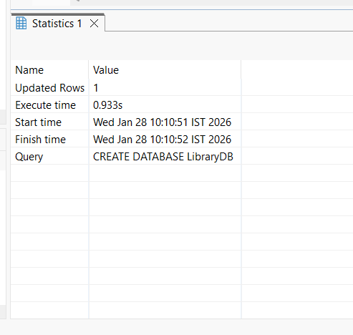
USE LibraryDB;
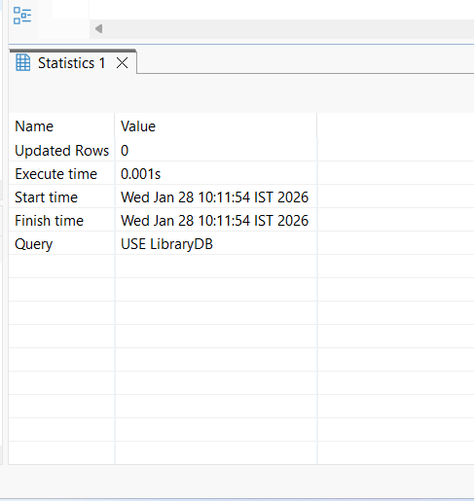

CREATE TABLE books (
book_id INT PRIMARY KEY AUTO_INCREMENT,
title VARCHAR(100),
author VARCHAR(100),
category VARCHAR(50),
total_copies INT,
available_copies INT
);
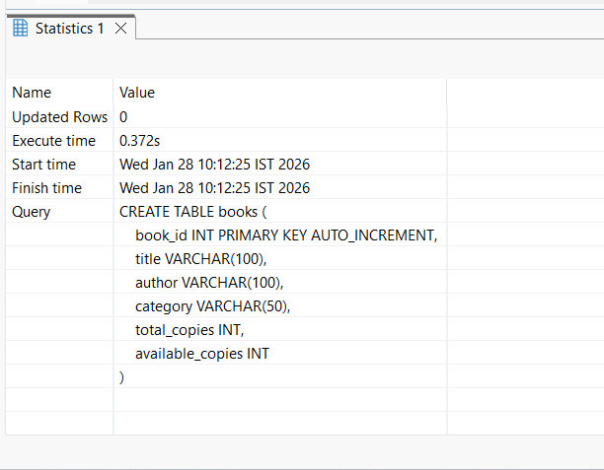
CREATE TABLE members (
member_id INT PRIMARY KEY AUTO_INCREMENT,
name VARCHAR(100),
email VARCHAR(100),
phone VARCHAR(15),
membership_date DATE
);
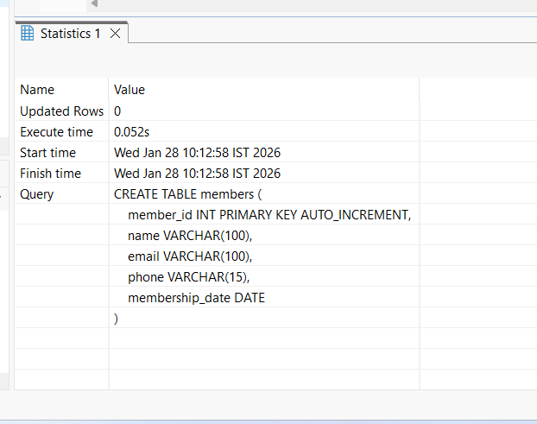

CREATE TABLE borrow_history (
borrow_id INT PRIMARY KEY AUTO_INCREMENT,
book_id INT,
member_id INT,
borrow_date DATE,
due_date DATE,
return_date DATE,
fine DECIMAL(6,2),
FOREIGN KEY (book_id) REFERENCES books(book_id),
FOREIGN KEY (member_id) REFERENCES members(member_id)
);

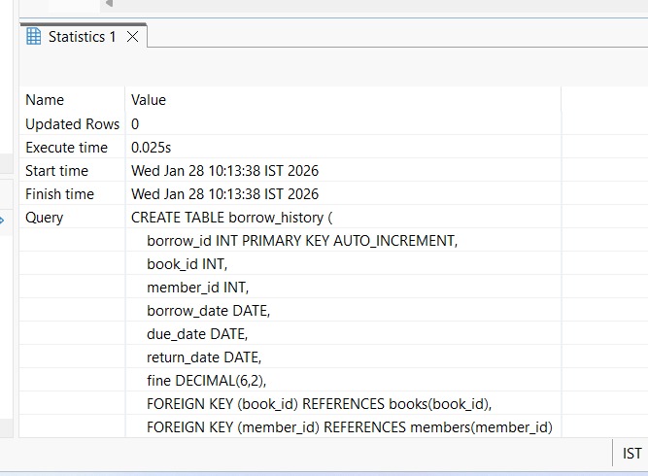

INSERT INTO books (title, author, category, total_copies, available_copies)
VALUES
('Python Basics', 'Guido Rossum', 'Programming', 5, 3),
('MySQL Guide', 'Paul Dubois', 'Database', 4, 2),
('Data Structures', 'Mark Allen', 'Computer Science', 6, 6);

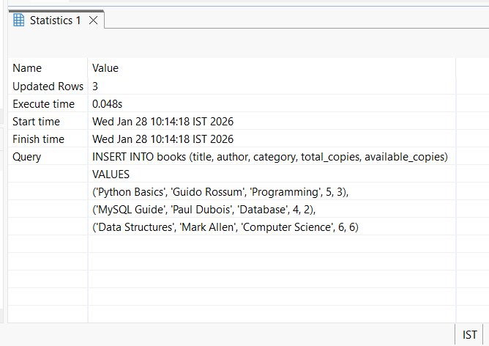

INSERT INTO members (name, email, phone, membership_date)
VALUES
('Ravi Kumar', 'ravi@gmail.com', '9876543210', '2024-01-10'),
('Anita Sharma', 'anita@gmail.com', '9876501234', '2024-02-15');

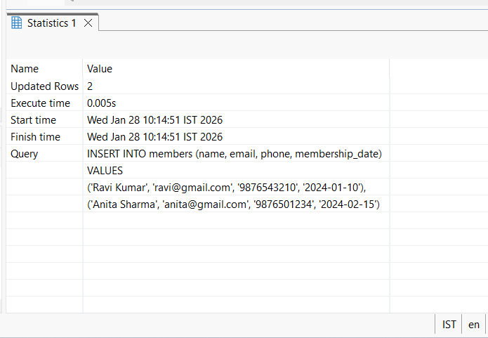

INSERT INTO borrow_history (book_id, member_id, borrow_date, due_date, return_date, fine)
VALUES
(1, 1, '2024-03-01', '2024-03-10', '2024-03-12', 0),
(2, 2, '2024-03-05', '2024-03-15', NULL, 0);

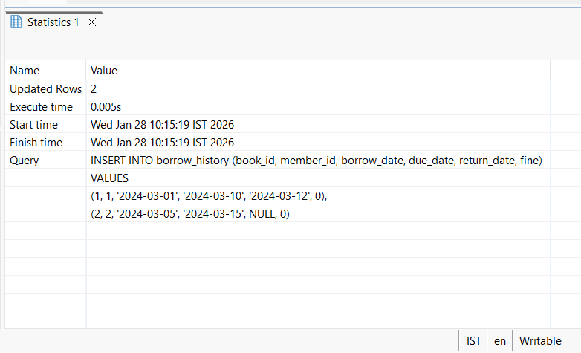
SELECT * FROM books;
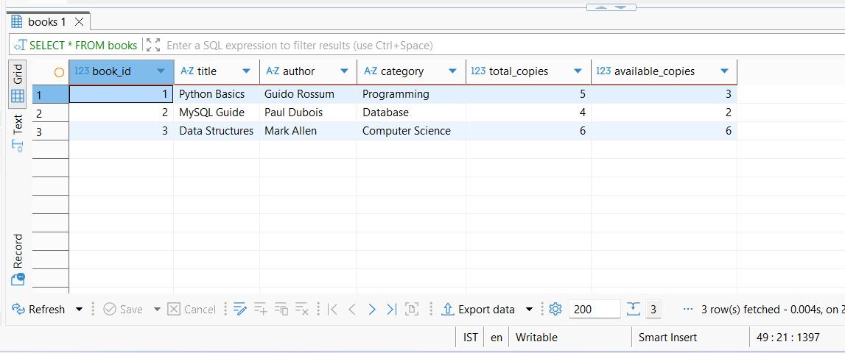

SELECT * FROM members;
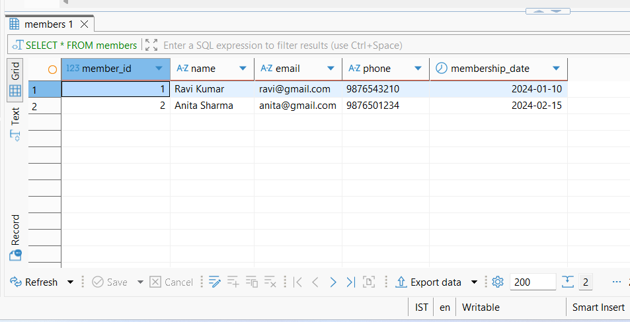

SELECT * FROM borrow_history;
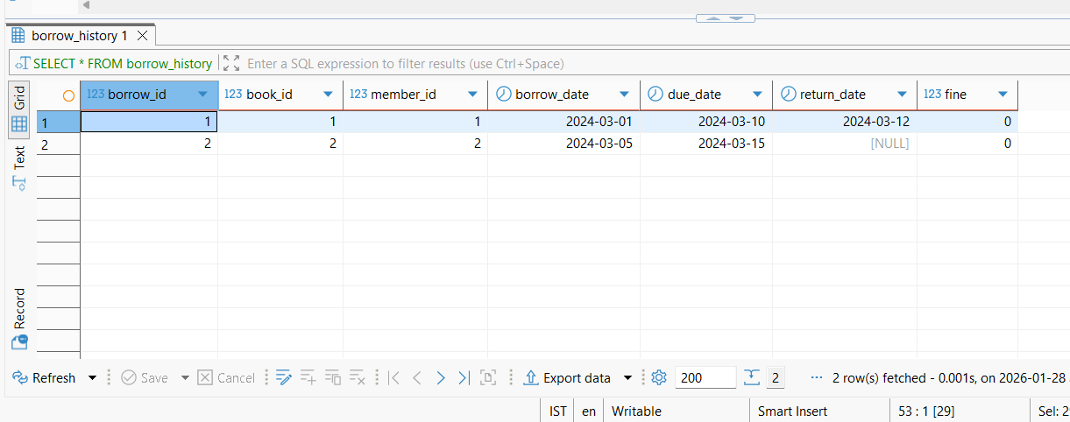

SELECT bh.borrow_id, m.name AS member_name, b.title AS book_title, bh.borrow_date, bh.due_date, bh.return_date, bh.fine FROM borrow_history bh JOIN members m ON bh.member_id = m.member_id JOIN books b ON bh.book_id = b.book_id;
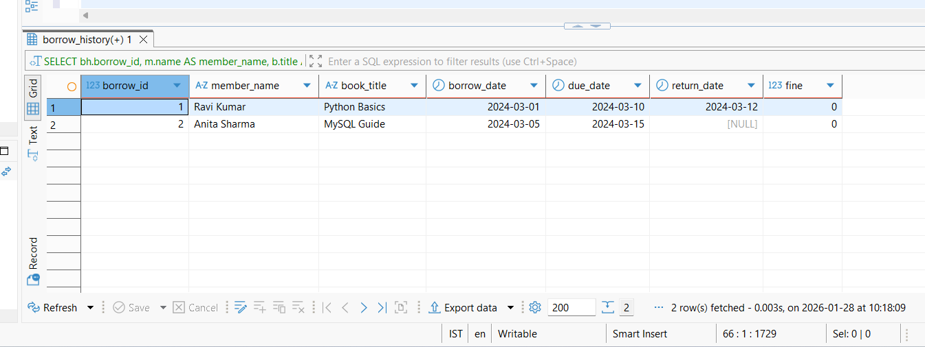
UPDATE borrow_history
SET fine =
CASE
WHEN return_date > due_date
THEN DATEDIFF(return_date, due_date) * 5
ELSE 0
END;
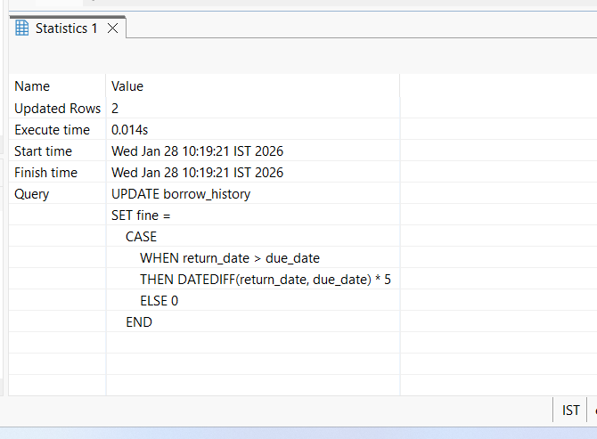

SELECT m.name, b.title, bh.due_date,
DATEDIFF(CURDATE(), bh.due_date) AS overdue_days,
DATEDIFF(CURDATE(), bh.due_date) * 5 AS fine_amount FROM borrow_history bh JOIN members m ON bh.member_id = m.member_id JOIN books b ON bh.book_id = b.book_id WHERE bh.return_date IS NULL AND CURDATE() > bh.due_date;
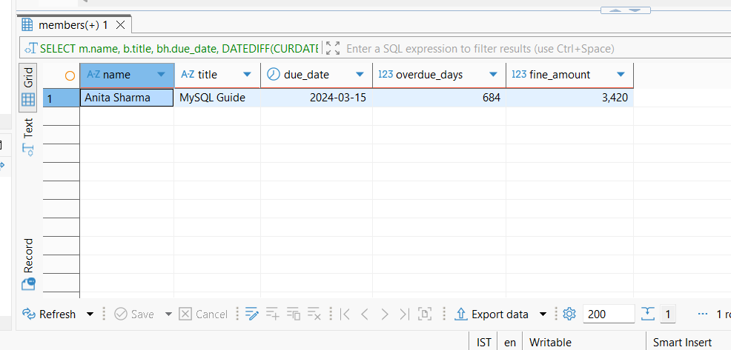

SELECT title FROM books WHERE available_copies = 0;

SELECT member_id, COUNT(*) AS total_books
FROM borrow_history
GROUP BY member_id
HAVING COUNT(*) > 1;

SELECT SUM(fine) AS total_fine FROM borrow_history;
