All India Children’s Educational eContent Competition
(AICEeCC)

Script

Fishing the Numbers

"Fishing the Numbers" is a web-based game where players virtually fish for numbers. The game features three categories: "Identify,""Order," and "Big and Small." The third category is open ended question, so the answer is not unique. Each category contains multiple levels with varying numbers of attempts. Players must catch the correct number based on the question displayed in the top right corner. Catching incorrect numbers will decrease the player's health. If you catch wrong numbers, it will decrease the health. The total score will be displayed as collection of shells next to shell picture. This is developed using HTML, CSS, Javascript.
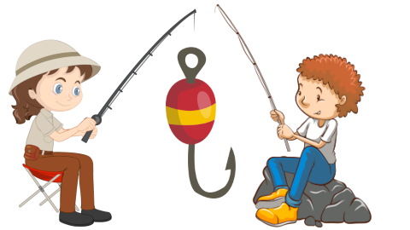
There are two player characters for different levels.

Fishermen Image by brgfx on Freepik
Fishergirl Image by brgfx on Freepik
Hook Image by jcomp on Freepik

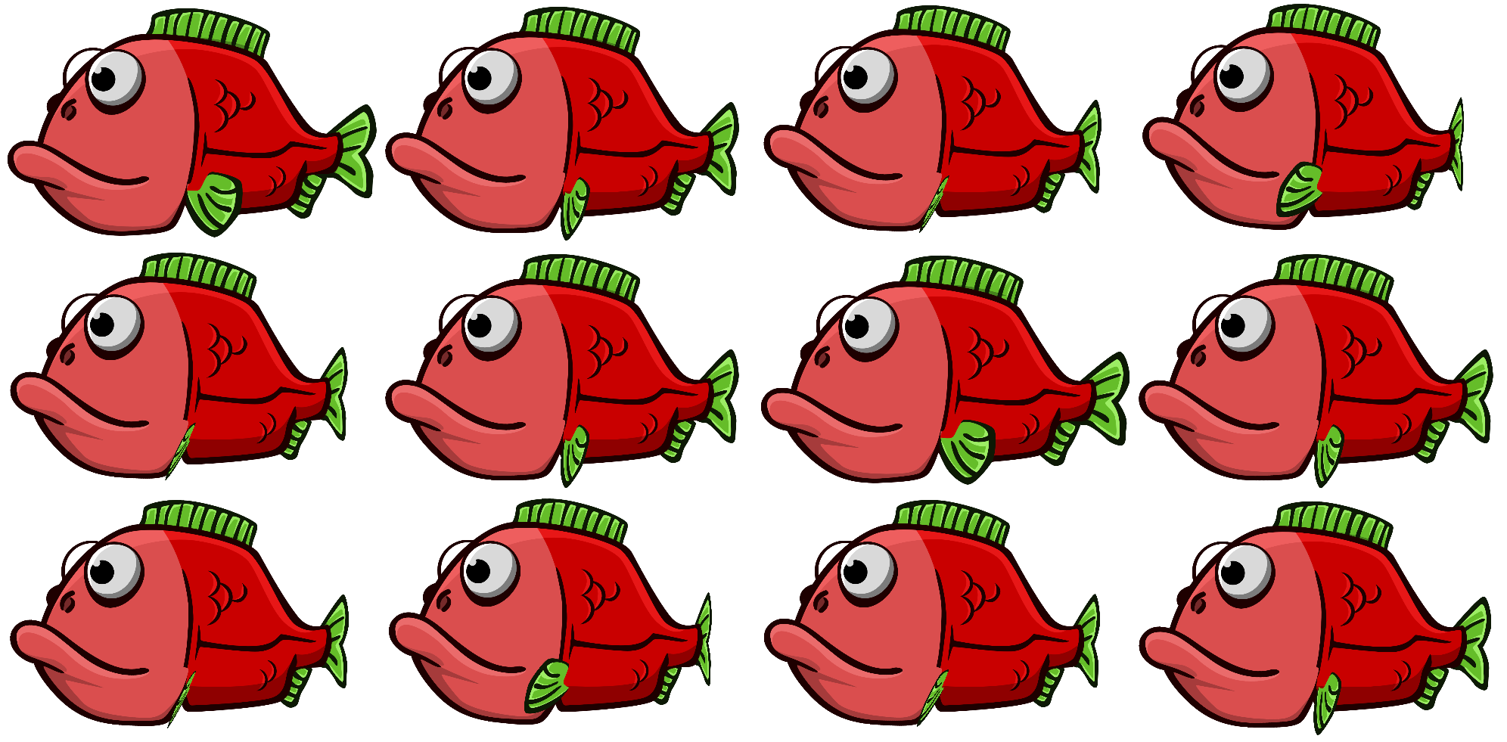
The fish moving animation sprite

Image sprite by Game Developer Studio on opengameart.org

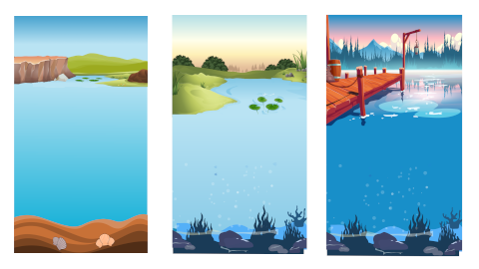
These are background images and edited using inkscape.

Background 1 Image by brgfx on Freepik & by Image
Background 2 Image by brgfx on Freepik & by Freepik
Background 3 Image by upklyak on Freepik & by Freepik
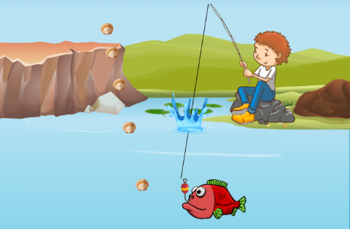
To catch fish:

User can play on any device. On computer user uses mouse to click on bubble.

On touch screen, touch on the fish.

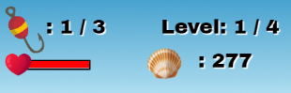
The health will be displayed on top left. If it becomes 0 the game is over, and player lose.

Your collected shells will be displayed on top center. You can carry your score to the next level. It will become 0 if you start to play again from Level 1.

Heart image by freepik.

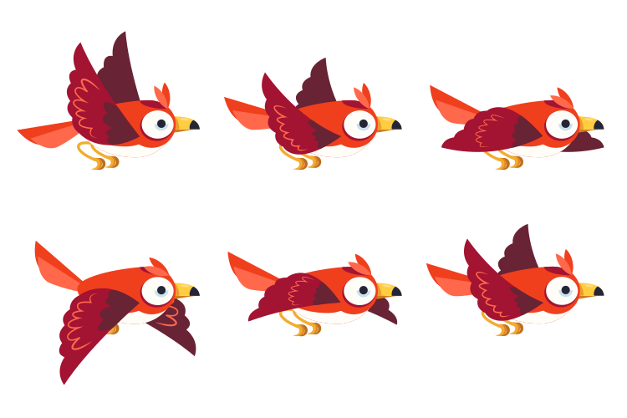


Plants animation sprites are made using inkscape and image source (free licensed) are below

Image by Freepik
Image by Freepik
Image by Freepik
Bird Image by Freepik





Font (fonts are licensed under SIL Open font license)

Archivo Black- Designed by Omnibus-Type
Pacifico -Designed by Vernon Adams, Jacques Le Bailly, et al...

Audio files

Correct answer -On freesound
Stage selection music-On pixabay
Background music-On pixabay
Water splash sound -On freesound
Wrong answer sound -On freesound


Stage selection page will be displayed at first so that player can choose different stages. Image by Brick from Pixabay.

Level will be displayed on top. There are different levels for each category.

Identify – has 4 levels.
L1 – player need to catch fish as per equations like “Catch 2”
question number between 1 to 9
L2 – question number between 10 to 20
L3 – question number between 10 to 100 (multiples of 10)
L4 – question number between 10 to 100
(For L1 & L2 need to fish 3 times and for L3 & L4 need to fish 2 times)

Order – has 6 levels. (In this category each chance has different question)
L1 - player need to fish as per questions like “Before 5”
question number between 2 to 10 (Fishing chances - 3 times)
L2 – question number between 10 to 20 (3 chances)

L3 – player need to fish as per questions like “After 5”
question number between 0 to 9 (Fishing chances - 3 times)
L4 – question number between 10 to 20 (3 chances)

L5 – player need to fish as per questions like “3, ___, 5”
question number between 1 to 10 (Fishing chances - 3 times)
L6 – question number between 11 to 20 (3 chances)

Big & Small – has 4 levels
L1 - player need to find answers for equations like “Catch bigger than 4”, question number between 1 to 9
L2 – question number between 10 to 20
L3 - player need to find answers for equations like “Catch smaller than 9”, question number between 5 to 15
L4 – question number between 10 to 20
All levels have 3 chances

