Educational E-Content Competition 2024-25
SCRIPT
Title of the Programme in Original Language : Numerate Fish
Title of the Programme in English Language : Numerate Fish
Language : English

Entire Script of the Programme :
"Numerate Fish" is a web-based game. The player takes on the role of a fish that catches bubbles containing numbers to solve a question displayed in the top-right corner. The game includes five categories: "Two operand addition", "Three operand addition", “Two operand subtraction”, “Multiples” and "Factors". All the questions are open ended so the answer is not unique. Players have to wait till the required number comes up in the game. If you catch a wrong bubble and if you want to release it then click on the player fish the caught bubble will be released and popped up. Each category has different levels; each level has a different number of attempts. Number of attempts will be displayed on the top left side and the number of levels will be displayed on the top center. If the fish catches wrong numbers, it will decrease the health. This is developed using HTML, CSS, Javascript.

This fish will be playing as the player.

Image sprite by Game Developer Studio on opengameart.org



These are bubble images with numbers.

Image by HorrorPen on opengameart




These are background images and edited using inkscape.
Image by pikisuperstar on Freepik
Image by Freepik
Image by Freepik


This is a worm inside some bubbles. If the fish catches the bubble with worm the player's health will increase by 10.

Designed by Chippyri on Pixabay

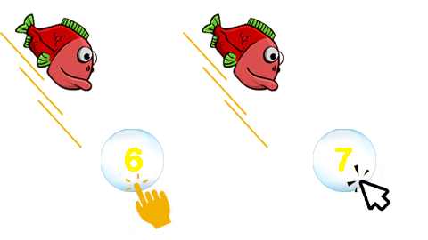
User can play on any device. On computer user uses mouse to click on bubble.

On touch screen, touch on the bubble.

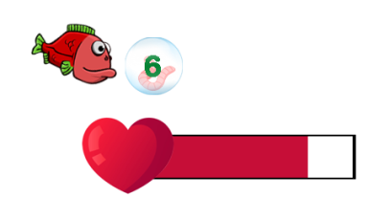
The health will be displayed on top left. If it becomes 0 the game is over, and player lose.

Heart image by freepik.

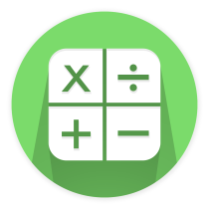
Your score will be displayed here. Your collected coins will be displayed on the top center. You can carry your score to the next level. It will become 0 if you start to play again from Level 1.

Image by freepik

The bubble pop animation sprite

Designed by Robert Brooks


Stage selection page will be displayed at first so that player can choose different stages.
Image by Brick from Pixabay.

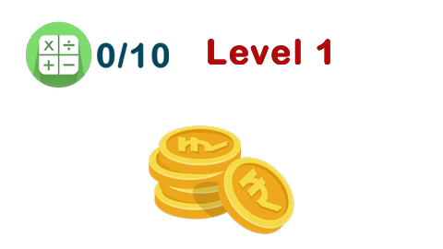
Level will be displayed on top. There are different levels for each category.
Two operand addition – has 6 levels.
L1 – player need to find answers for equations like ? + ? = 3
question number between 1 to 5
L2 – question number between 6 to 10
(For L1 & L2 need to find 3 answers like 3+0 or 2+1 etc… The same can be repeated)
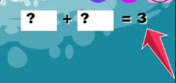
L3 – question number between 11 to 20
L4 – question number between 10 to 100 (multiples of 10)
L5 - question number between 50 to 500 (multiples of 50)
L6 - question number between 50 to 500 (multiples of 25)
(For L3 to L6 need to find 2 answers)

Three operand addition – has 3 levels.
L1 - player need to find answers for equations like ? + ? + ? = 3
question number between 3 to 10 (3 answers like 3+0+0 or 0+2+1 etc… The same can be repeated)
L2 – question number between 10 to 20 (3 types of answers)
L3 – question number between 10 to 100 (multiples of 10) (2 types of answers)

Subtraction – has 4 levels
L1 - player need to find answers for equations like ? - ? = 1
question number between 1 to 5
L2 – question number between 6 to 10
L3 – question number between 60 to 100 (multiples of 10)
(From L1 to L3 need to find three answers)
L4 – question number between 350 to 500 (multiples of 50) (two answers)

Multiples – has 2 levels
L1 – need to find 5 multiples of 2 to 5
L2 – need to find 3 multiples of 6 to 10

Factors – has 3 levels
L1 – need to find 3 factors of 2 to 25
L2 – need to find 3 factors of 12 to 60
L3 – need to find 3 factors of 24 to 100

Audio files

bubble pop sound - https://opengameart.org/content/bubble-sound-effects
Background music - https://opengameart.org/content/4-chiptunes-adventure
Wrong selection sound - https://freesound.org/embed/sound/iframe/590041/simple/small/
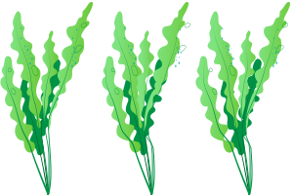
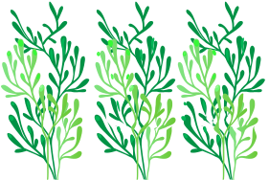


Plants animation sprites are make using inkscape and image source (free licensed) are below

Image by Freepik Image by Freepik Image by Freepik

Font (fonts are licensed under SIL Open font license)

Archivo Black - Designed by Omnibus-Type
Pacifico - Designed by Vernon Adams, Jacques Le Bailly, et al...

