Jet Ski Product Page: Progress Tracker
COAST Insurance · Comprehensive PWC / Jet Ski · mockup review and KoverUI build · prepared 16 Oct 2026
How to use: pick a Status from the dropdown (⬜ Not started · 🟦 In progress · 🟨 Needs review (ask us) · ⛔ Can't be done · ✅ Done), tick Checked once someone has verified it, and write what you need in Notes. Use Word's Highlight or Review → New Comment anywhere in the pages that follow. 🔒 means a deliberate design choice: please check with us before changing it.
# | Item (click to jump to the section) | 🔒 | Status | Checked | Notes / who / what we need to review
Pages: build to final KoverUI standard
1 | Intro and duty acknowledgement | 🔒 | ⬜ Not started
2 | Target Market Determination and decline |  | ⬜ Not started
3 | PWC / Jet Ski Details fields and conditional questions | 🔒 | ⬜ Not started
4 | Owners and skippers block | 🔒 | ⬜ Not started
5 | Additional PWC / Jet Ski units | 🔒 | ⬜ Not started
6 | History questions and claims table | 🔒 | ⬜ Not started
7 | Your Quote layout, cover and summaries | 🔒 | ⬜ Not started
8 | Referral and Email Quote modals | 🔒 | ⬜ Not started
9 | Your Details, identification, trailers, attachments |  | ⬜ Not started
10 | Payment: method and card entry | 🔒 | ⬜ Not started
11 | Confirmation and documents | 🔒 | ⬜ Not started
Look and feel
12 | Design system: palette, progress bar, ticks, panels | 🔒 | ⬜ Not started
13 | Searchable dropdowns, dates, currency and length inputs | 🔒 | ⬜ Not started
14 | Responsive, accessibility and browser testing |  | ⬜ Not started
Make it real (mockup fakes these today)
15 | Switch validation on (remove DEV_BYPASS_VALIDATION) |  | ⬜ Not started
16 | Rating engine and per-unit pricing |  | ⬜ Not started
17 | Address lookup |  | ⬜ Not started
18 | Quote number, save and resume |  | ⬜ Not started
19 | Email: quote and referral |  | ⬜ Not started
20 | PDS, FSG, receipt, Certificate of Currency |  | ⬜ Not started
21 | Payment gateway and surcharge fix |  | ⬜ Not started
22 | File uploads and sign-in |  | ⬜ Not started
Decisions and rules to settle
23 | Full TMD decline rule set |  | ⬜ Not started
24 | History answers: referral or decline? |  | ⬜ Not started
25 | Skipper age and experience rules |  | ⬜ Not started
26 | Instalments: the $172.31 gap |  | ⬜ Not started
27 | Wording fixes (TMD "Vessel(s)", typo) |  | ⬜ Not started
Word cannot add up statuses by itself. For a live count and % complete, use the companion Excel tracker (same 27 items).

1. The product in one page ↑ tracker
Product | Private Vessels · Comprehensive PWC / Jet Ski. Front-end mockup (jet-ski.html, js/jet-ski.js, css/jet-ski.css) with no backend. Shares skipper, checkout, payment and quote-page code with two sibling products (CPWC, TPCP), so a change there affects all three.
Journey | Intro, then 7 numbered steps, then confirmation. Steps: 1 Target Market Determination · 2 PWC / Jet Ski Details · 3 Additional PWC / Jet Ski · 4 History · 5 Your Quote · 6 Your Details · 7 Payment.
Outcomes | Quote → buy online. Referral (roadside / verge / nature strip storage on any unit): quote hidden, enquiry sent for review. Decline (not the owner, or speed over 60 knots): outside target market.
Quote shown | $2,148.89 annual (base $1,746.36, GST $174.64, stamp duty $172.89, fee $50 + $5 GST). Sum insured $10,000. Excess $500 other claims, $2,000 theft. All placeholders.
Switched off | Validation is bypassed for review (DEV_BYPASS_VALIDATION = true): every Continue is enabled. All completeness rules exist and turn on with the flag.
Note on 🔒 items
Many choices here were made deliberately and discussed in earlier chats between you and Claude. I cannot see those chats. The 🔒 flags come only from commit messages (shown as #PR or commit id) and from how the code behaves. If something is flagged that was not deliberate, or something deliberate is missing, tell us and we will correct the document.
Look and feel in brief
- Palette: deep teal #0F766E for buttons, ticks, active states · bright teal #08788B / #079CC0 for accents and the premium banner · navy #09285C for headings · neutral greys on a pale page.
- Layout: one white rounded card per step; icon badge, navy title, grey subtitle, divider; label-left / input-right rows.
- Progress bar: seven numbered circles with connectors, active halo, completed filled, clickable. Spacing tuned over #42 to #44 so it is identical on all products. 🔒
- Controls: True/False and Yes/No pills; "Please Specify" opens in place; every dropdown is searchable; dates typed as DD/MM/YYYY; currency formats as you type; hull length m/ft to 2 decimals. 🔒
- Cover ticks: green circle with a green tick on all three products, after trying red crosses and a solid tick (#11 to #19). 🔒
- Panels and modals: tinted heading bars; Policy Endorsements in a blue accent panel; Email, Referral and Decline modals share one card style with the team email and phone.
- Responsive: breakpoints at 850, 800, 720, 700, 650 px. A full phone/tablet pass has not been recorded.
Shared code (change with care)
skipper-section.js owners/skippers block · quote-checkout.js address, steps, Your Details, Payment, Confirmation · searchable-select.js · date-input.js · length-input.js · quote-page.css quote panels and modals · jet-ski.js / jet-ski.css Jet Ski only.

4.1 Intro: Get Your Quote ↑ tracker
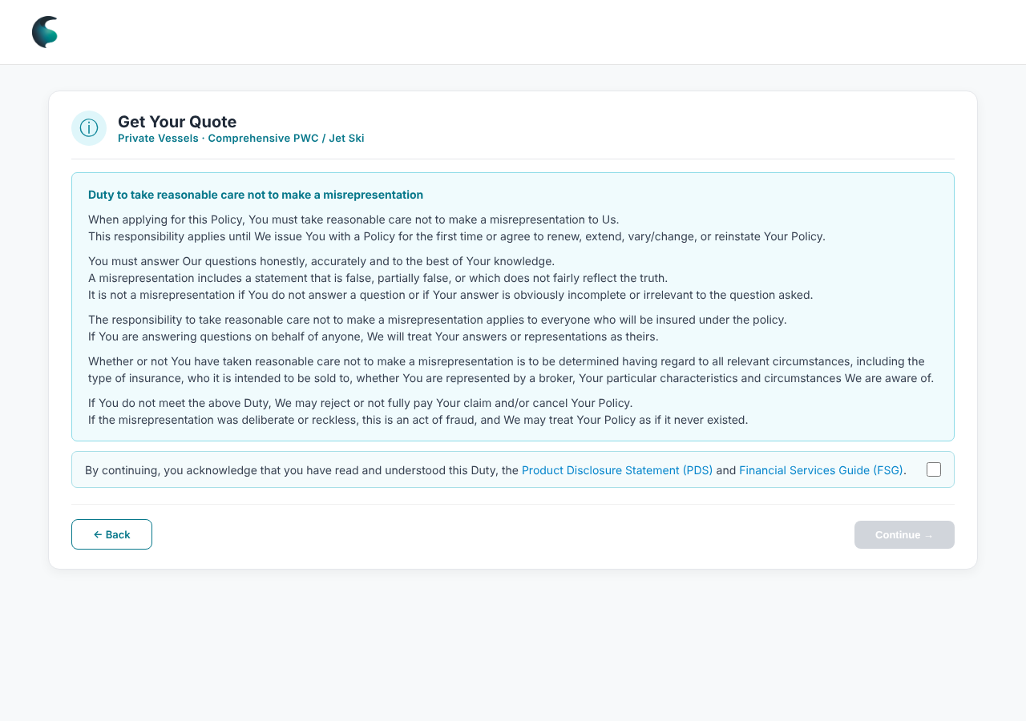  Intro and duty acknowledgement | Built  - Full duty of disclosure in one box. Continue stays disabled until the acknowledgement is ticked (covers duty, PDS, FSG).  - FSG links to the ERM gateway; PDS link is a placeholder ("#").  - Back returns to products.  Styling  - Info badge, "Get Your Quote", policy class tag line under the title (#21).  🔒 Intentional: confirm with us before changing  - Duty wording restored to the approved original (fb1eb7d). Do not reword.  KoverUI: what we want (proposed)  - Link the real PDS. Record acceptance: time, duty wording version, PDS and FSG versions.

4.2 Step 1: Target Market Determination ↑ tracker
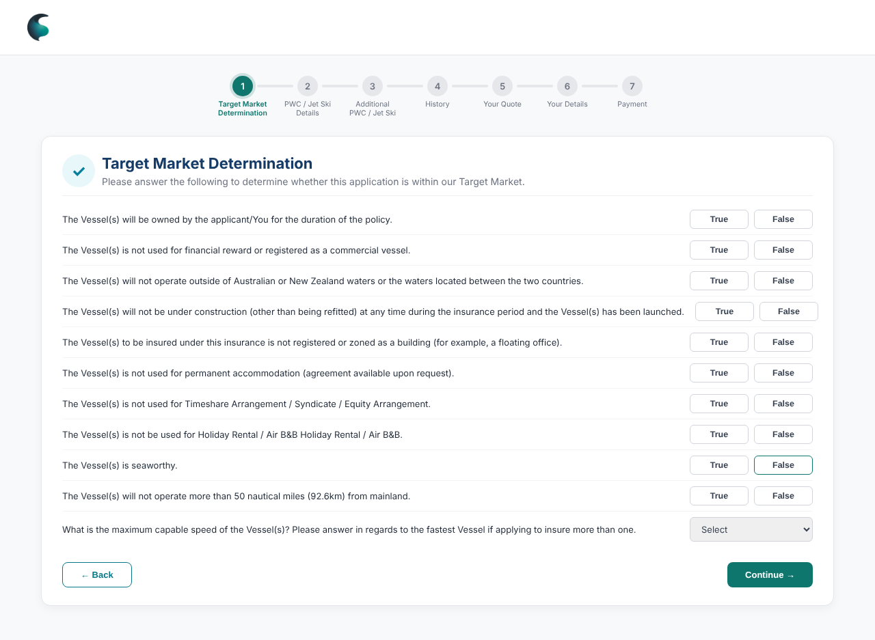  11 eligibility questions  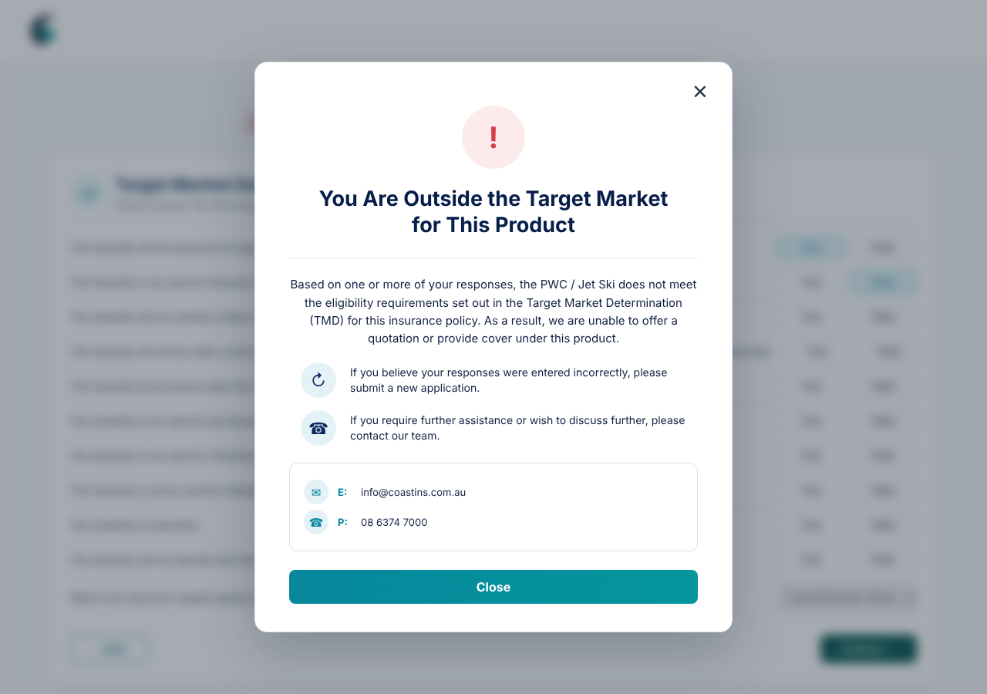  Decline message | Built  - 10 True/False statements plus a maximum-speed dropdown (up to 40 / 40 to 60 / over 60 knots).  - Declines today: "owned by the applicant" = False, or speed over 60 knots. Progress bar takes a declined style; customer can only close.  - Decline message offers a new application if answers were wrong, and gives info@coastins.com.au and 08 6374 7000.  Styling  - Pill toggles, shield-tick badge. Decline modal: warning icon, two guidance rows, contact box.  KoverUI: what we want (proposed)  - Confirm the full decline rule set (tracker 23).  - Store each answer against the quote as target-market evidence.  ⚠ Spotted  - Questions still say "Vessel(s)" where every other page says "PWC / Jet Ski". One reads "is not be used". A False on commercial use, seaworthiness or 50 nautical miles does not decline today.

4.3 Step 2: PWC / Jet Ski Details and skippers ↑ tracker
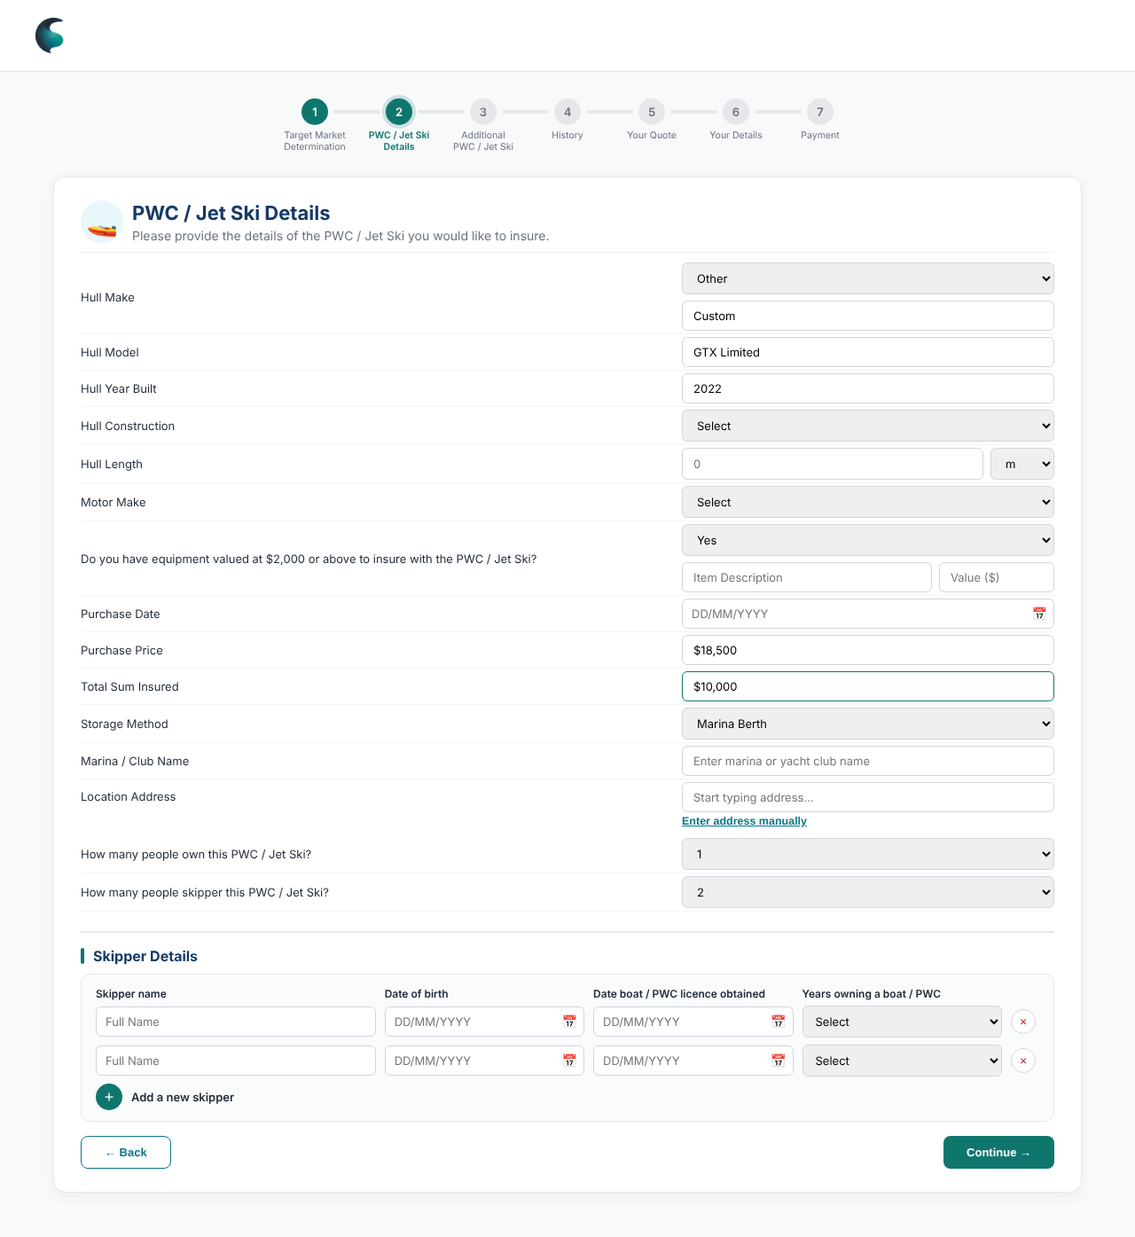  Conditionals opened: Other, equipment, Marina Berth, skippers  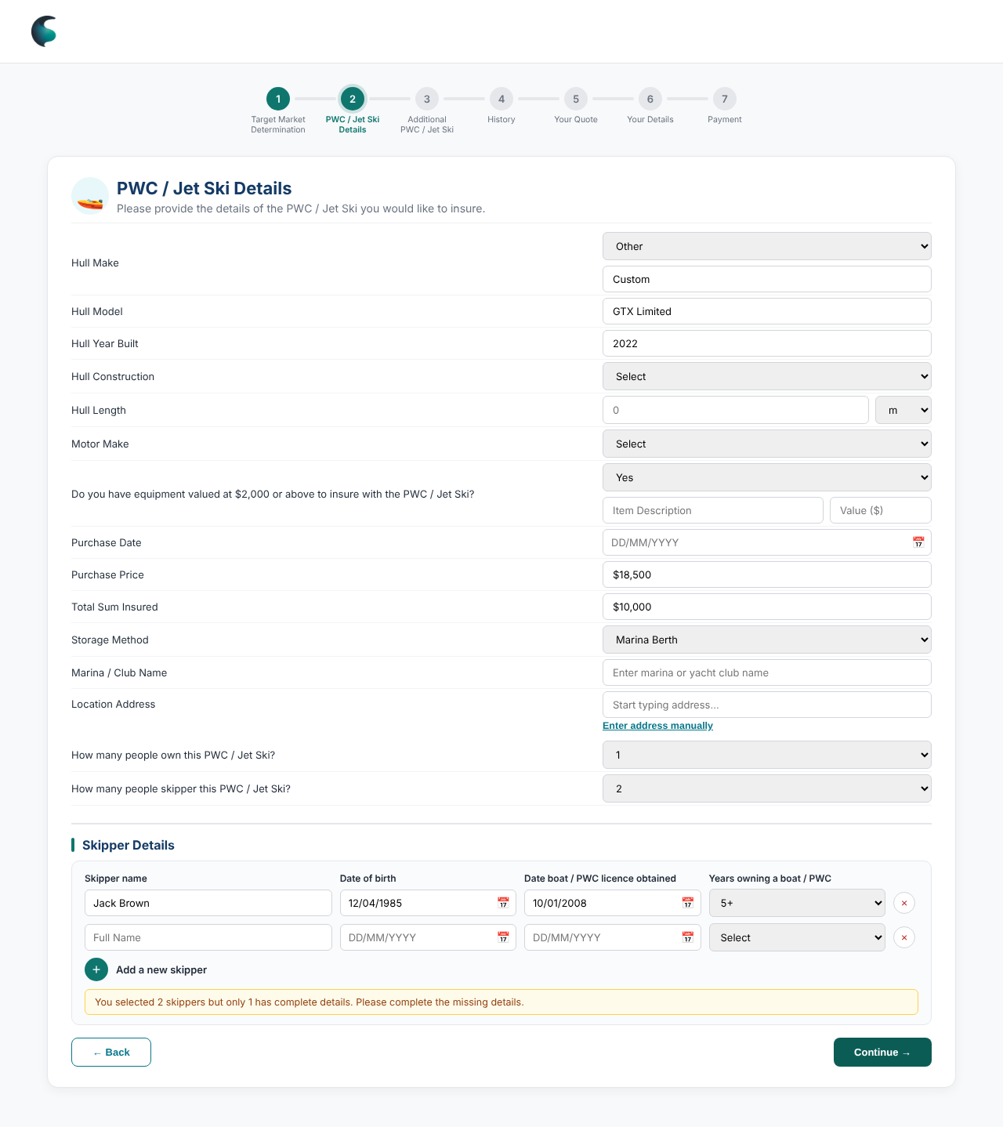  Skipper rows and the one-time warning  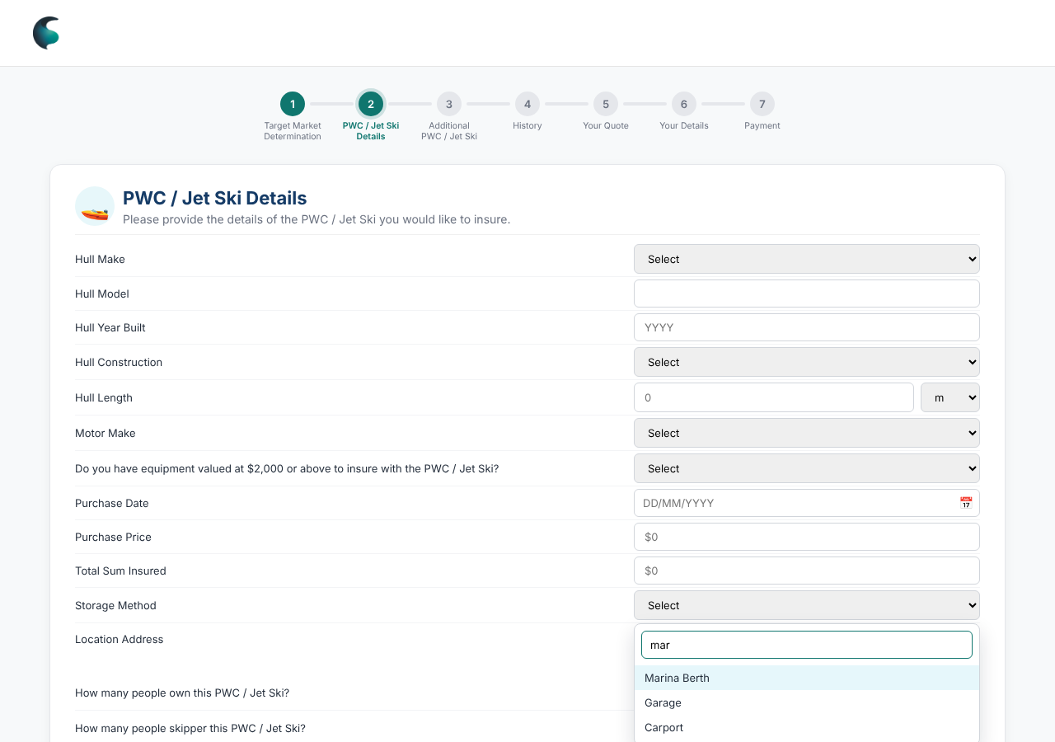  Searchable dropdown ("mar") | Built  - 13 fields: Hull Make, Model, Year, Construction, Hull Length (m/ft), Motor Make, equipment ≥ $2,000, Purchase Date and Price, Sum Insured, Storage Method (10 options), Marina / Club Name, Location Address.  - Other opens Please Specify on make, construction, motor make and storage. Equipment Yes opens description and value. Marina Berth shows Marina / Club Name (cleared otherwise). Roadside / Verge / Nature Strip flags a referral.  - Address: search or "Enter address manually" (street, suburb, state, postcode). Currency fields format as you type.  - Skippers: how many own / how many skipper (1 to 5+). Rows follow the count, add with + or remove with ×, max 20. Name, DOB, licence date, years owning. Warning on first Continue if details are missing ("You selected 2 skippers but only 1 has complete details"); pressing again proceeds.  - Previous-skipper picker on additional units copies a skipper in and locks it.  🔒 Intentional: confirm with us before changing  - "Hull Length" label (#26). Marina / Club Name only for Marina Berth (#28).  - Skipper block sits at the bottom of Vessel Details after several moves (#36, #37, #38, #40). No picker on the first unit.  - Picker lists anyone with a name (#45). Copied skippers locked (a8b1acc). Warning only on first Continue, shorter text (381b6de). No asterisk on the two count questions (e9df421). "Skipper Details" is a subheading (#41).  KoverUI: what we want (proposed)  - Verified address lookup; make/model from a data source; field-level error text; sum insured limits.  - Referral rules from configuration, not code.  - Decide skipper age/experience rules and whether to ask "years on this size and type" (supported, off for Jet Ski).  ⚠ Spotted  - Motor Year pre-fills on Your Details but is never asked here, so it is always blank.

4.4 Step 3: Additional PWC / Jet Ski ↑ tracker
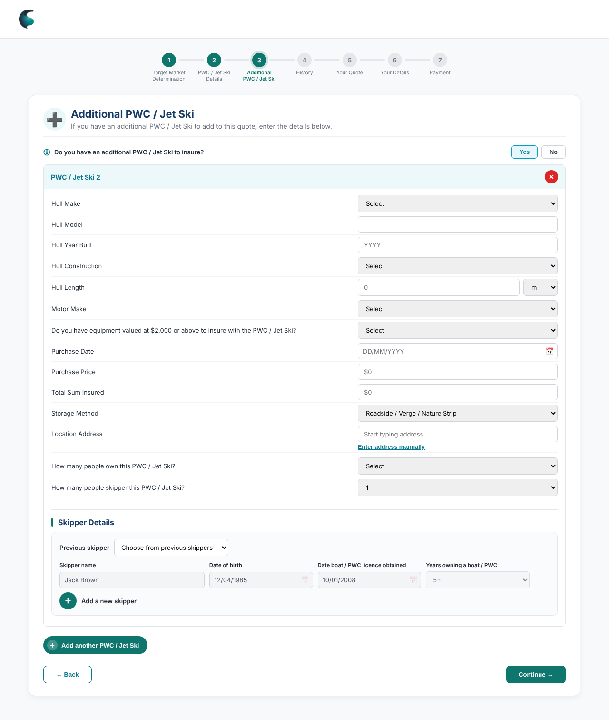  Extra unit with roadside storage and a copied skipper | Built  - Yes opens "PWC / Jet Ski 2" with the same fields, conditionals and its own skipper block; No clears all.  - "Add another PWC / Jet Ski", remove ×, cards renumber. Roadside storage on any extra unit triggers the referral. Also reachable from Your Quote via "+ Add PWC / Jet Ski".  🔒 Intentional: confirm with us before changing  - Numbered from 2, no "#" in card titles (381b6de, 8eb739d). Labelled add-another button with plus badge (311a291). Cards mirror Vessel Details so the form is learned once.  KoverUI: what we want (proposed)  - Price each extra unit and any multi-unit rule; set a maximum number of units.

4.5 Step 4: History ↑ tracker
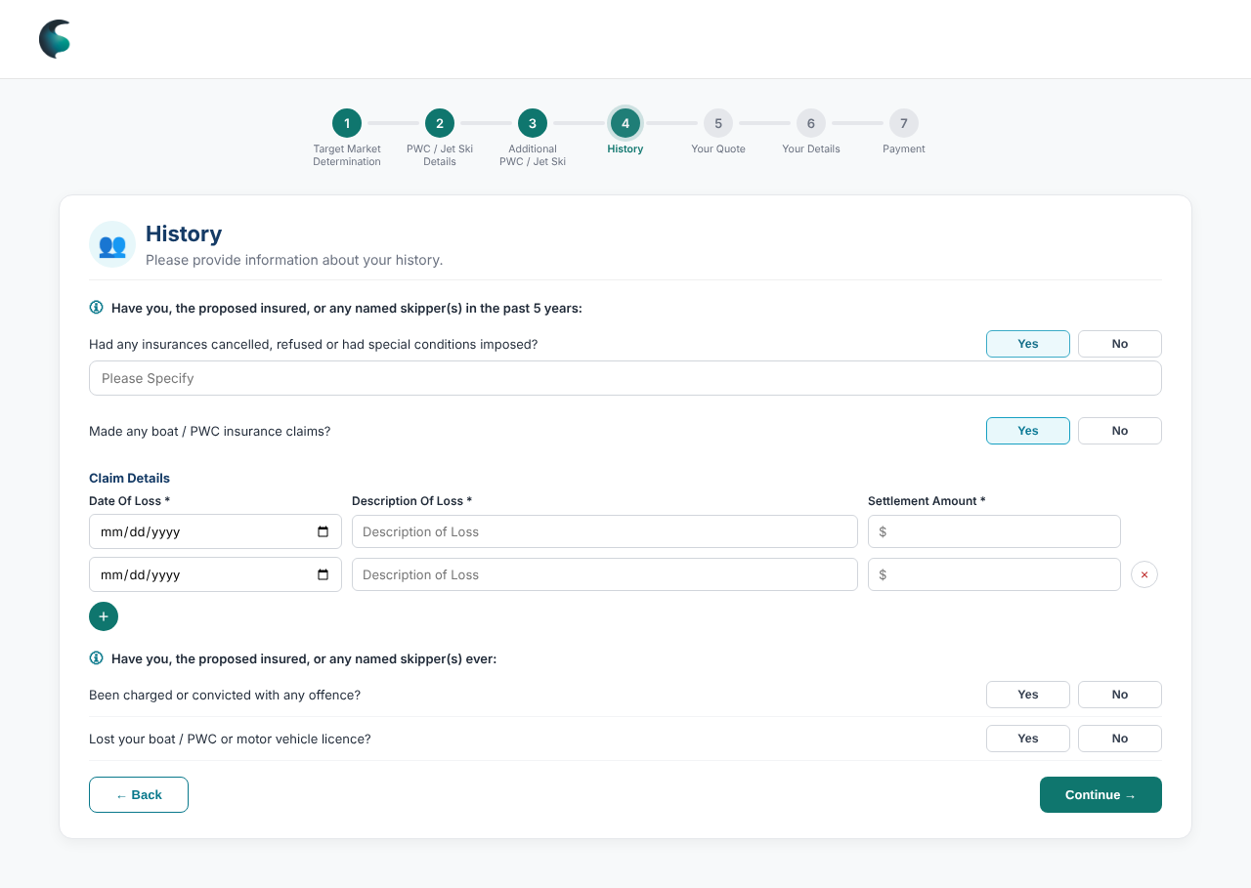  Claims table | Built  - Past 5 years: cancelled / refused / special conditions; made any boat / PWC claims (opens claims table: date, description, settlement, add/remove).  - Ever: charged or convicted; lost boat / PWC or motor vehicle licence. Yes opens Please Specify.  🔒 Intentional: confirm with us before changing  - Step named "History" (8eb739d). "boat / PWC" wording on claims and licence questions (#35).  KoverUI: what we want (proposed)  - Decide what each Yes does (tracker 24). Date-of-loss limit; settlement as currency.  ⚠ Spotted  - Yes to every history question still gives a normal quote.

4.6 Step 5: Your Quote, referral and email ↑ tracker
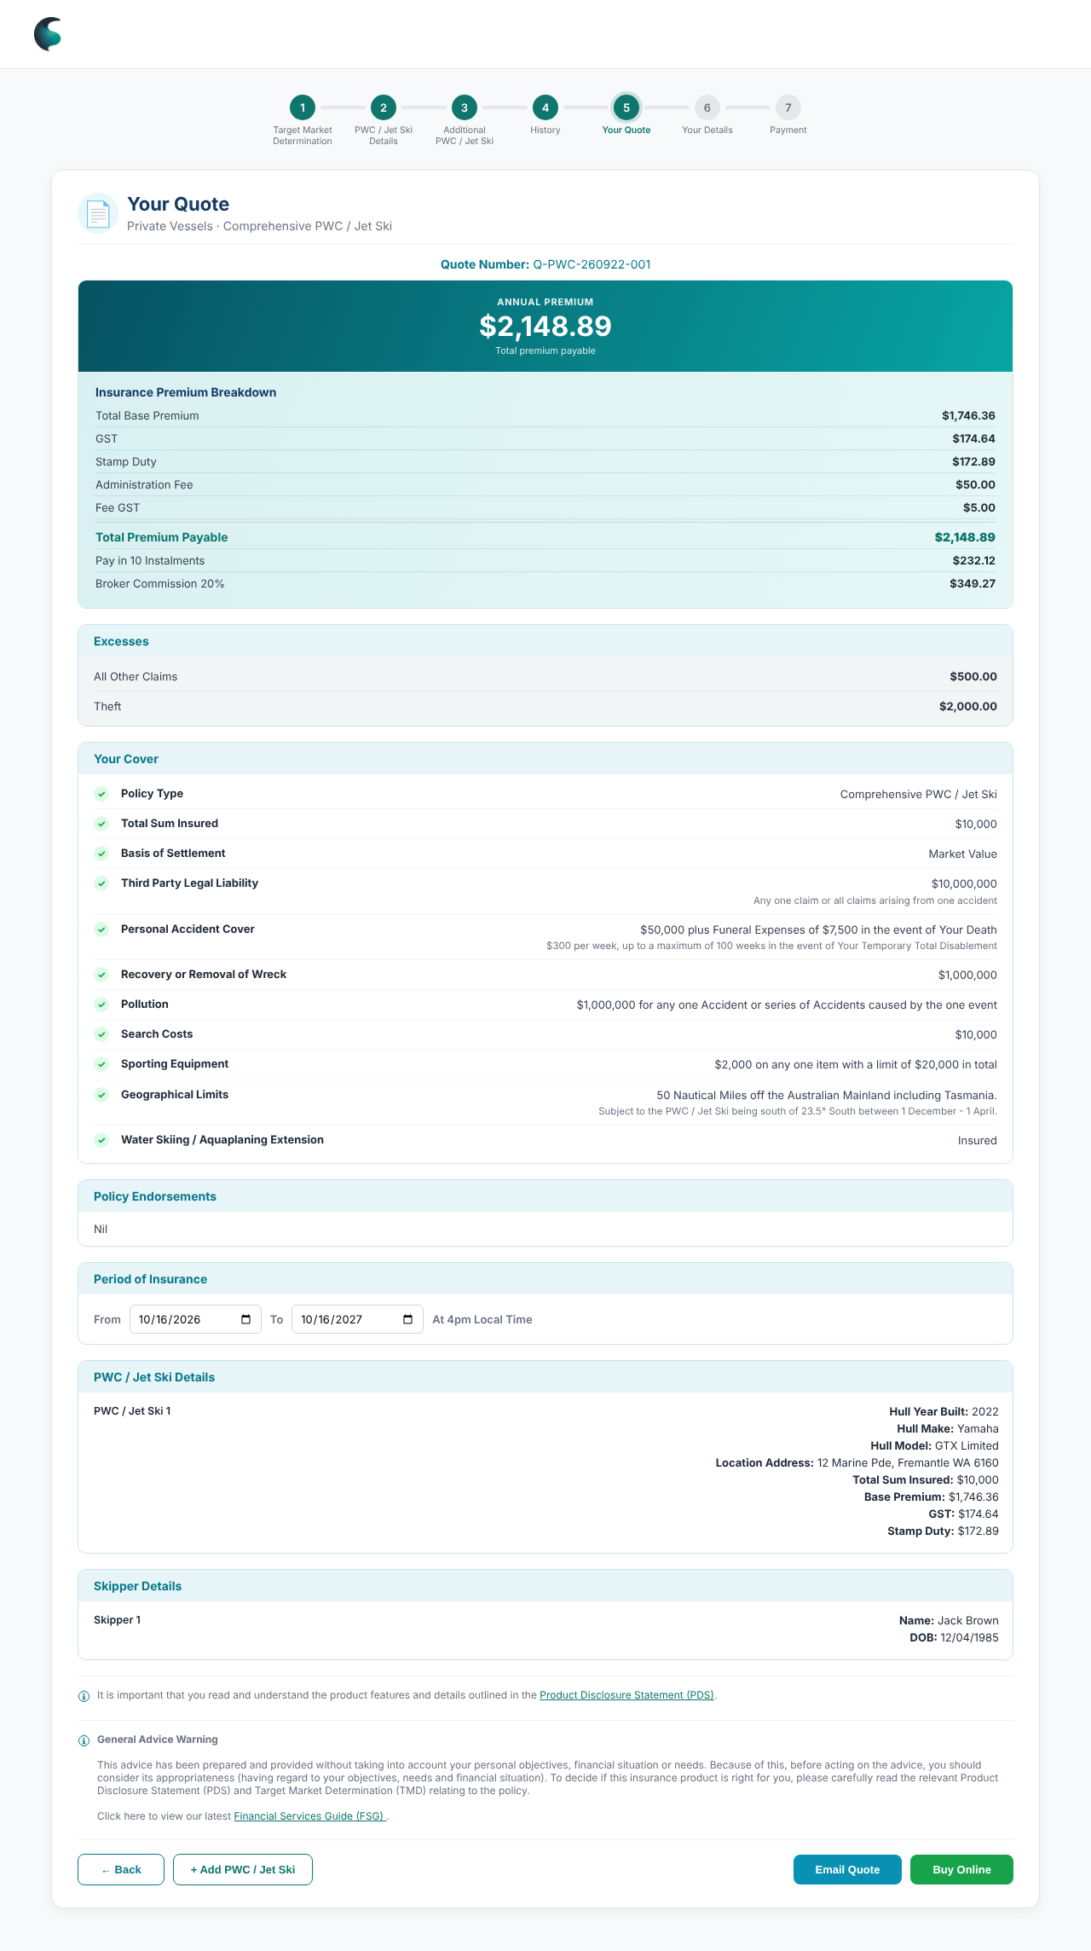  Your Quote  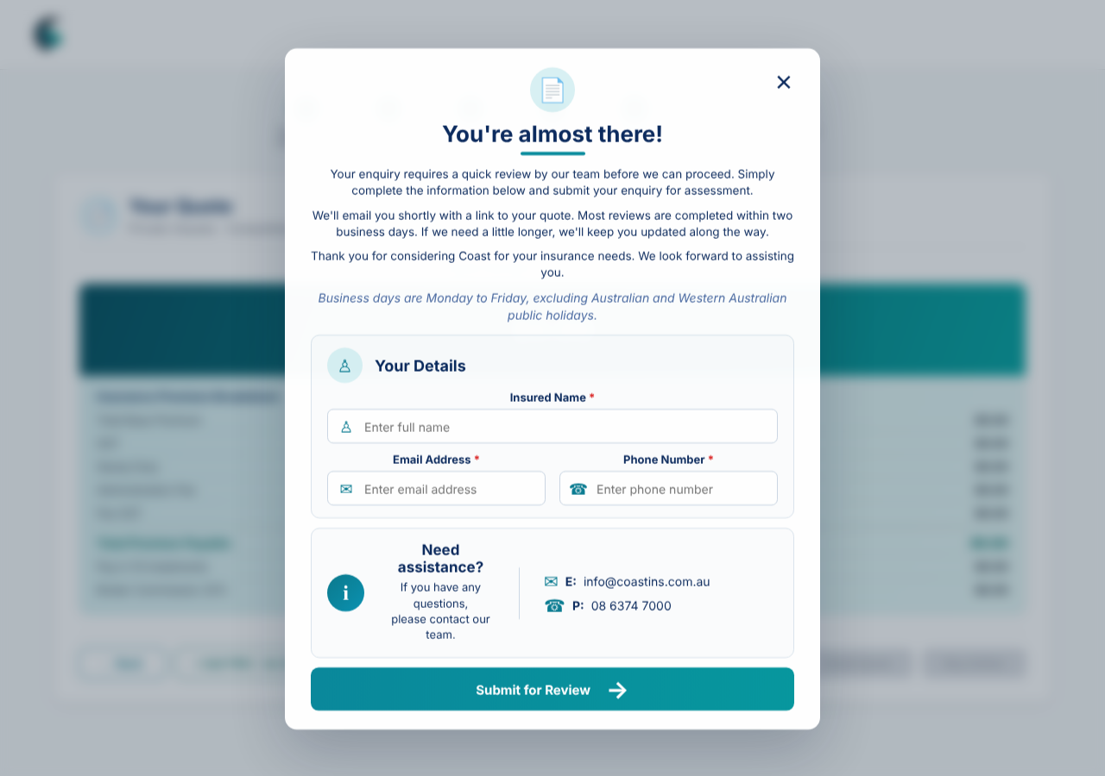  Referral modal | Built  - Premium banner and 7-line breakdown, 10-instalment amount, broker commission 20%. Excesses, 12 cover lines, Policy Endorsements ("Nil"), Period of Insurance (today + 1 year, editable), vessel and skipper summaries, PDS notice, General Advice Warning.  - Actions: Back, + Add PWC / Jet Ski, Email Quote (modal pre-fills known details; on submit returns to products, nothing sent), Buy Online.  - Referral: all amounts become $0.00, everything below the premium is hidden, Email and Buy are disabled, "You're almost there!" modal collects name, email, phone and promises review within two business days.  🔒 Intentional: confirm with us before changing  - Green circle and tick on cover (#19). Excesses panel as CPWC / TPCP (#12). Policy Endorsements blue accent, Nil (#31, #32). Policy class line in grey subtitle style (#25). Water Skiing / Aquaplaning "Insured" (#27). Referral = $0.00 and hide below (#23).  KoverUI: what we want (proposed)  - All numbers from the rating engine, per unit and total; stamp duty by state.  - Real quote number, save and return; real email send; referral to the underwriting queue.  - Excesses and endorsements driven by answers. Broker commission visible to brokers only.  ⚠ Spotted  - Each unit shows the same premium and the total ignores extra units.  - 10 × $232.12 = $2,321.20, which is $172.31 above the annual premium: explain or fix (tracker 26).

4.7 Step 6: Your Details ↑ tracker
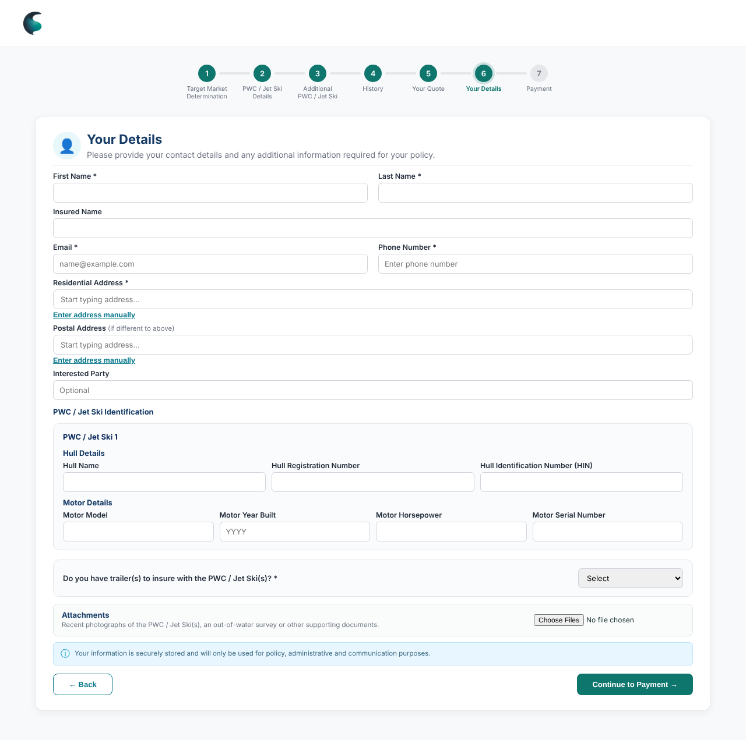  Your Details  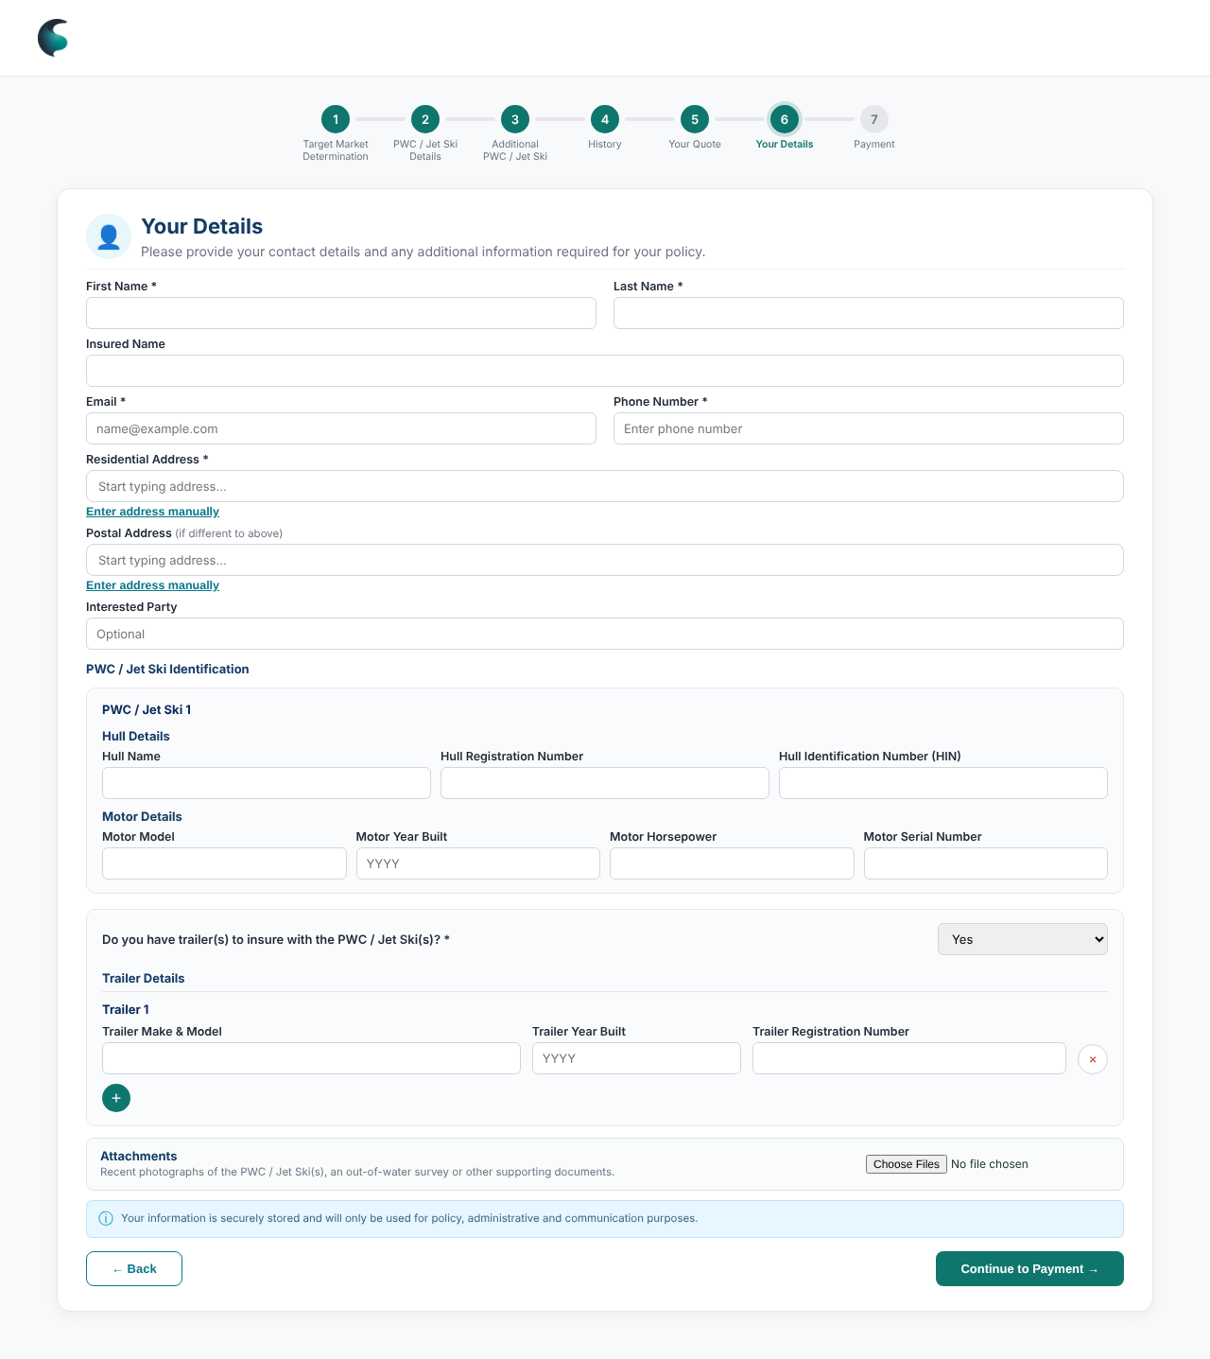  Trailer answered Yes | Built  - First/last name, email, phone (digits and + ( ) - only) required. Insured Name follows First + Last until edited. Residential address required; postal optional; Interested Party optional.  - Identification per unit: hull name, registration, HIN; motor model, year, horsepower, serial.  - Trailers: Yes opens trailer rows (make/model, year, registration), No clears. Attachments: multiple files. Privacy note.  Styling  - Two-column grid, trailer question in an accent box, numbered card per unit.  KoverUI: what we want (proposed)  - Real file storage with limits and a removable list. Duplicate / format checks on rego, HIN, serial. Email confirmation step.

4.8 Step 7: Payment ↑ tracker
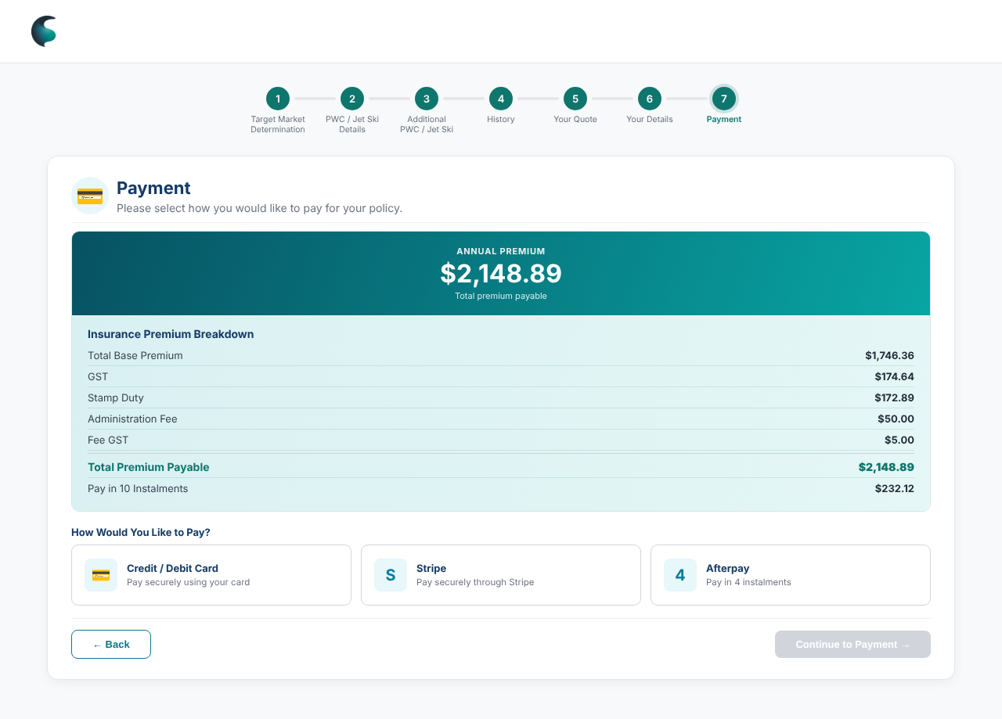  Choose a method  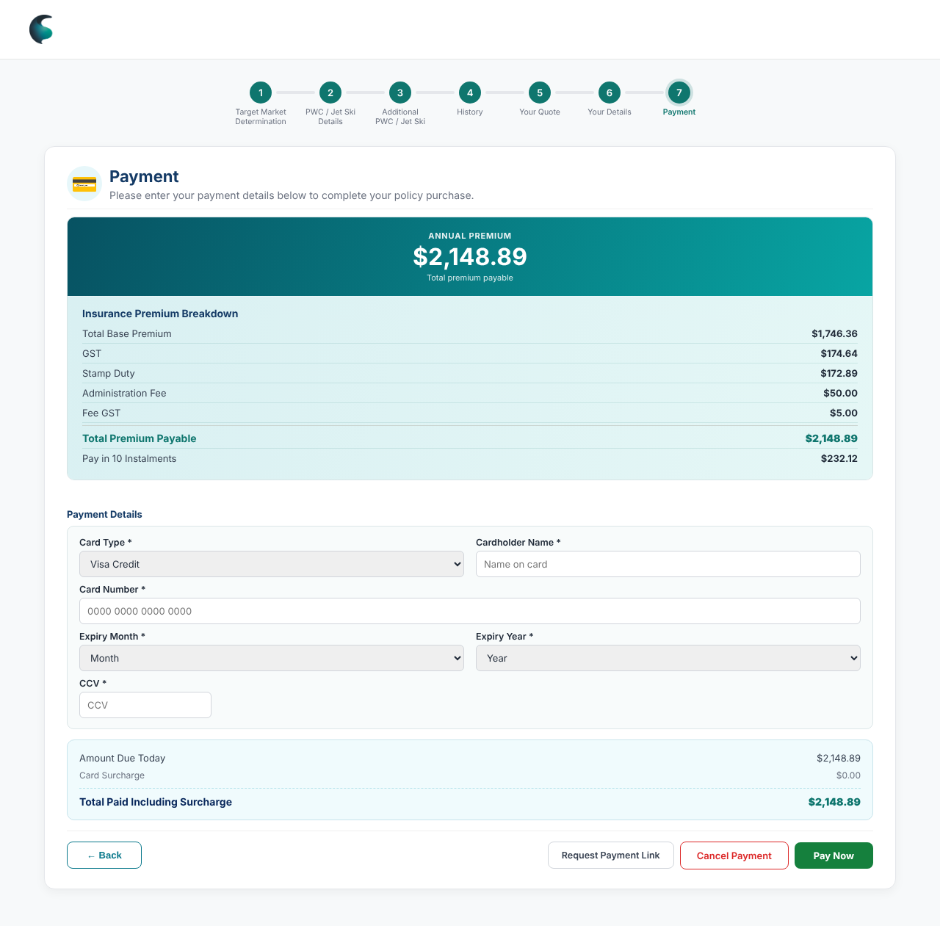  Card details and totals | Built  - Premium summary; methods Card, Stripe, Afterpay (pay in 4); Continue enabled once one is chosen.  - Card type, name, number (auto-spaced), expiry, CCV. Totals: Amount Due Today, Card Surcharge, Total Paid. Buttons: Back, Request Payment Link, Cancel, Pay Now.  🔒 Intentional: confirm with us before changing  - Subtitle changes with the stage: choose method, then enter details (#25).  KoverUI: what we want (proposed)  - Real gateway with tokenised card capture; payment link flow; instalment plan; confirmed surcharge rates (written as Visa 1%, MasterCard 1%, Amex 1.5%).  ⚠ Spotted  - Surcharge is always $0.00: code matches "Visa" / "Mastercard" but dropdown values are "visa-credit", "mastercard-debit" etc.  - Stripe and Afterpay lead to the same card form.

4.9 Confirmation ↑ tracker
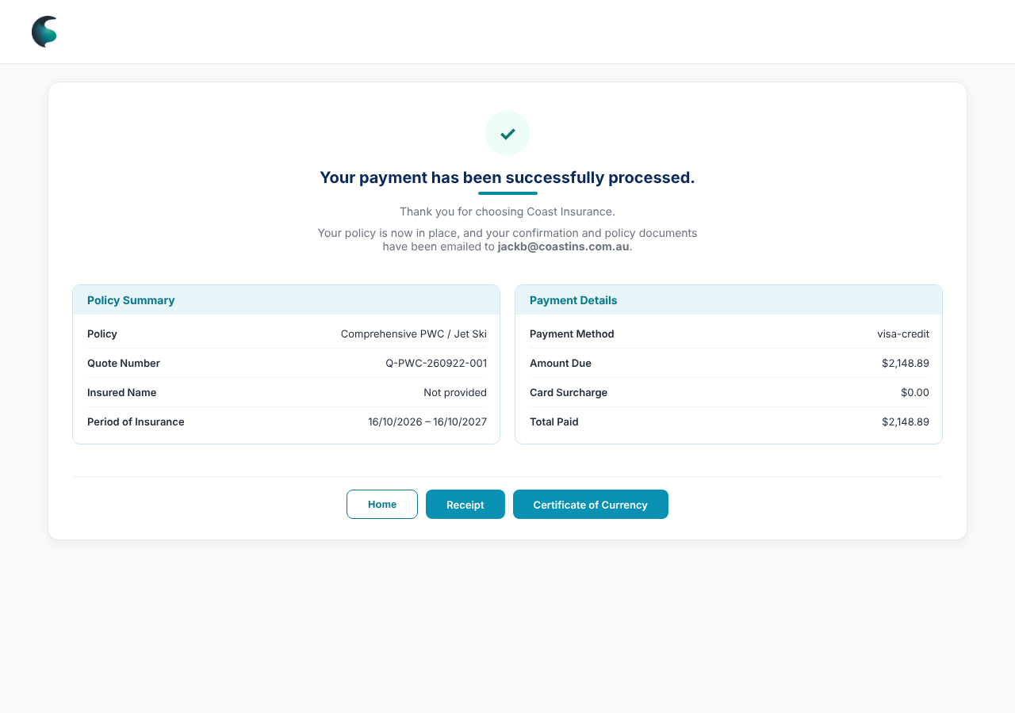  Payment confirmation | Built  - Tick, "Your payment has been successfully processed", "Your policy is now in place" with the email in bold. Policy Summary and Payment Details panels. Home, Receipt, Certificate of Currency (toasts only).  🔒 Intentional: confirm with us before changing  - Confirmation wording and bold email (#7, #8, #22).  KoverUI: what we want (proposed)  - Generate and email receipt, Certificate and policy documents; show the policy number; use the customer's own email (mockup uses a fixed address).

6. Simulated in the mockup, real in KoverUI ↑ tracker
Area | Mockup today | KoverUI (tracker #)
Validation | Bypassed | Switch on (15)
Access | Password hash visible in the page script | Proper sign-in (22)
Pricing | Fixed numbers | Rating engine, per unit (16)
Quote number | Fixed Q-PWC-260922-001 | Unique, saved, resumable (18)
Addresses | Any text accepted | Verified lookup (17)
Email | Modals return to products; fixed confirmation address | Real email service (19)
Documents | PDS link "#"; receipt and certificate are toasts | Real documents (20)
Payment | No gateway; any card accepted; surcharge broken | Gateway, 3-D Secure, surcharge, instalments (21)
Attachments | Held in the browser only | Upload with limits (22)
Persistence | Refresh loses everything | Save as you go (18)

7. Rules and open decisions ↑ tracker
Live today
Rule | Trigger | Result
Decline | "Owned by the applicant" = False, or speed over 60 knots | Outside target market; journey ends
Referral | Roadside / Verge / Nature Strip storage, any unit | $0.00 quote, details hidden, Email and Buy disabled, review enquiry
Marina name | Storage = Marina Berth | Marina / Club Name shown
Specify | "Other" on make, construction, motor make, storage | Please Specify required
Equipment | Equipment ≥ $2,000 = Yes | Description and value required
Skippers | Fewer complete than selected | Warning on first Continue
Not decided yet (suggested owner)
- Full TMD decline set (Underwriting, tracker 23) · History referral/decline (Underwriting, 24) · Skipper age and experience, loadings (Underwriting, 25)
- Instalments: is $232.12 × 10 right, and what is the extra $172.31? (Finance, 26) · Surcharge rates and Stripe / Afterpay flows (Finance, 21)
- Sum insured and craft-age limits, maximum units per quote, per-unit pricing (Underwriting / Rating, 16)
- Geographical limit: quote text says south of 23.5° South between 1 Dec and 1 April; decide if storage location must be checked (Underwriting)
- Wording and documents: fix TMD "Vessel(s)" and typo; supply approved PDS / FSG (Compliance, 27, 20) · Address and vessel data provider (Technology, 17)
Not checked: accessibility (keyboard, screen reader, contrast) and mobile layouts. Screenshots are desktop at 1280 px with dummy data. Behaviour was read from the code and exercised in a browser, not compared with the PDS.

