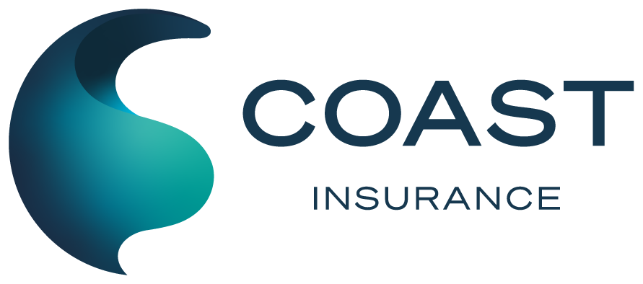 | Coast Insurance Pty Ltd  1st floor, 186 Scarborough Beach Road, Mount Hawthorn WA 6016  PO Box 120, Mount Hawthorn WA 6915  p: 08 6374 7000 · e: info@coastins.com.au · coastins.com.au  ABN 44 108 154 829 · AFSL 268726

Confirmation of what You told Us  Comprehensive PWC / Jet Ski | Policy Number  PV00471P.1

In offering this Insurance Underwriters have relied on the information and statements that You have provided.
The premium has been calculated based on this information.
Please read the following and advise Us of any changes as necessary. Please refer to the policy wording or Product Disclosure Statement (PDS) provided, which outlines important information about your duty to disclose information to us.
Policy Details
Quote number | Q-PWC-261022-001
Product | Comprehensive PWC / Jet Ski
Duty to take reasonable care acknowledged | Yes (PDS and Financial Services Guide read)
Period of insurance | 22/10/2026 to 22/10/2027 at 4pm local time
Number of PWC / Jet Skis insured | 2
Total sum insured | $35,500
Basis of settlement | Market Value
Excess: all other claims | $500
Excess: theft | $2,000
Policy endorsements | Nil

Target Market Determination
Owned by You for the duration of the policy | True
Not used for financial reward or registered as a commercial vessel | True
Will not operate outside Australian or New Zealand waters | True
Not under construction (other than refit) and has been launched | True
Not registered or zoned as a building | True
Not used for permanent accommodation | True
Not used for Timeshare / Syndicate / Equity Arrangement | True
Not used for Holiday Rental / Air B&B | True
PWC / Jet Ski is seaworthy | True
Will not operate more than 50 nautical miles from mainland | True
Maximum capable speed (fastest PWC / Jet Ski) | 40-60 Knots / 75-110 kph

PWC / Jet Ski 1 Details
Hull make | Yamaha
Hull model | VX Cruiser HO
Hull year built | 2022
Hull construction | NanoXcel
Hull length | 3.46 m
Motor make | Yamaha
Equipment valued at $2,000 or above | Yes
Equipment description and value | Garmin ECHOMAP GPS and Fusion audio system, $2,800
Purchase date | 14/03/2022
Purchase price | $17,990
Total sum insured | $16,500
Storage method | Marina Berth
Marina / club name | Northern Coast Marina, Berth C12
Location address | Northern Coast Marina, 1 Harbour Road, Mindarie WA 6030
People who own this PWC / Jet Ski | 2
People who skipper this PWC / Jet Ski | 2
Skipper 1 | Daniel Whitfield, DOB 14/06/1985, licence obtained 03/11/2003, 5+ years owning
Skipper 2 | Priya Whitfield, DOB 02/09/1987, licence obtained 19/05/2008, 2 years owning

Additional PWC / Jet Ski
Additional PWC / Jet Ski to insure | Yes
Hull make | Kawasaki
Hull model | Ultra 310LX
Hull year built | 2021
Hull construction | Other: Sheet moulded composite (SMC)
Hull length | 3.51 m
Motor make | Kawasaki
Equipment valued at $2,000 or above | No
Purchase date | 02/09/2021
Purchase price | $21,500
Total sum insured | $19,000
Storage method | Garage
Location address | 42 Marine Parade, Cottesloe WA 6011
People who own this PWC / Jet Ski | 1
People who skipper this PWC / Jet Ski | 2
Skipper 1 (previously added) | Daniel Whitfield, DOB 14/06/1985, licence obtained 03/11/2003, 5+ years owning
Skipper 2 | Liam Whitfield, DOB 21/03/2001, licence obtained 08/07/2019, 3 years owning

Your History
In the past 5 years: insurance cancelled, refused or special conditions imposed | No
In the past 5 years: made any boat / PWC insurance claims | Yes
Claim 1: date of loss | 12/01/2024
Claim 1: description of loss | Contact with submerged pontoon while docking, gel coat and hull repair
Claim 1: settlement amount | $3,850
Ever charged or convicted with any offence | No
Ever lost boat / PWC or motor vehicle licence | Yes
Licence details | Motor vehicle licence suspended 3 months in 2018 for speeding, reinstated 2018

Your Details
First name | Daniel
Last name | Whitfield
Insured name | Daniel and Priya Whitfield
Email | daniel.whitfield@example.com
Phone number | 0412 345 678
Residential address | 42 Marine Parade, Cottesloe WA 6011
Postal address | Same as residential address
Interested party | Westside Credit Union (finance on PWC / Jet Ski 1)

PWC / Jet Ski Identification
PWC / Jet Ski 1: hull registration number | PWC-WA-48213
PWC / Jet Ski 1: HIN | YAMA4821C122
PWC / Jet Ski 1: motor year, horsepower | 2022, 180 hp
PWC / Jet Ski 1: motor serial number | 6BX-1042877
PWC / Jet Ski 2: hull registration number | PWC-WA-51377
PWC / Jet Ski 2: HIN | KAWB7310E121
PWC / Jet Ski 2: motor year, horsepower | 2021, 310 hp
PWC / Jet Ski 2: motor serial number | UTL310-558214

Trailers & Attachments
Trailer(s) to insure with the PWC(s) / Jet Ski(s) | Yes
Trailer 1: make and model | Marlin Twin PWC Trailer
Trailer 1: year built | 2022
Trailer 1: registration number | 1TRL 482
Attachments | 3 files: photographs of both PWC / Jet Skis and the trailer

Payment
Annual premium payable | $2,148.89
Payment option | Credit / Debit Card
Card type | Visa Credit
Cardholder name | Daniel Whitfield
Card number | **** **** **** 4242

Your Declaration
In accepting this Insurance, You, as the Policy holder
1. Must act with the utmost good faith in respect of any matter relating to this insurance
2. Have a Duty of Disclosure as stated in this form
3. Have provided the correct information on previous losses and insurance history
4. Confirm that all answers and statements in this Proposal are correct and that no information has been withheld which may affect the Insurers decision to accept this Proposal or the terms of the proposed Policy.

