
COAST INSURANCE
Comprehensive PWC / Jet Ski
Online Quote and Buy Journey
UI and front-end reference for the KoverUI build

PRODUCT | Private Vessels · Comprehensive PWC / Jet Ski
DOCUMENT | UI and front-end reference: every page, pop-up and special feature, with the exact text, colours, sizes and spacing used
PREPARED FOR | KoverUI build team
PREPARED BY | COAST Insurance
VERSION | Draft 0.1
DATE | 19 October 2026
STATUS | For review
BASED ON | The Jet Ski mockup website as it stands on the date above

Text inside the green boxes is the final wording from the mockup. Please use it exactly as written. Each topic gives the design with its colour codes, the behaviour, and the copy-ready text.

Contents
OVERVIEW
How to read each page 3
Product in one page 3
Look and feel 3
PAGES AND STEPS
Intro · Get Your Quote 4
Step 1 · Target Market Determination 5
Step 2 · PWC / Jet Ski Details 6
Step 2 · Owners and skippers 7
Step 3 · Additional PWC / Jet Ski 8
Step 4 · Your History 10
Step 5 · Your Quote: premium and excesses 11
Step 5 · Your Quote: Your Cover 12
Step 5 · Your Quote: endorsements, dates and summaries 13
Step 5 · Your Quote: notices and buttons 13
Step 6 · Your Details: contact 14
Step 6 · Your Details: PWC / Jet Ski Identification 15
Step 6 · Your Details: trailers and attachments 16
Step 7 · Payment: choose a method 17
Step 7 · Payment: card details 18
Completion · Payment confirmed 19
POP-UPS
Pop-up · You Are Outside the Target Market for This Product 20
Pop-up · Referral: what the customer sees 20
Pop-up · You're almost there! 21
Pop-up · Your quote is ready! 22
SPECIAL FEATURES
Feature · Skipper details warning 23
Feature · Previous skipper picker 23
Feature · Removing a skipper or PWC / Jet Ski 24

How to read each page REF OV-0
The few symbols used on every page.
Each topic has a picture, a numbered design table with colours, the behaviour, and the copy-ready text:
1 | Red numbered circle and arrow on a screenshot: the item with the same number in the list beside or under it. | ➜ | Teal arrow between screenshots: what the customer sees before and after an action.

COPY-READY TEXT Green box: the exact wording from the mockup. Select and copy from it. It sits under the picture on the same page.

BEHAVIOUR Teal box: what happens when the customer acts, and what is hidden until then. Each rule is stated once and applies everywhere it fits.

MOCKUP vs KOVERUI Amber box: a placeholder in the mockup that must be real in KoverUI.

Product in one page REF OV-1
A guided online journey where a customer gets a quote for Comprehensive PWC / Jet Ski insurance and buys it.
The customer accepts the duty of disclosure, answers eligibility questions, describes the PWC / Jet Ski and its skippers, reviews the quote, enters their details and pays. Use the headings below exactly as they appear.
Step (progress bar) | Heading on the page | Page in this document
Intro | Get Your Quote | 4
Step 1 | Target Market Determination | 5
Step 2 | PWC / Jet Ski Details | 6
Step 3 | Additional PWC / Jet Ski | 8
Step 4 | Your History | 10
Step 5 | Your Quote | 11
Step 6 | Your Details | 14
Step 7 | Payment | 17
Completion | Your payment has been successfully processed. | 19

MOVING BETWEEN PAGES In this mockup you can move freely through every page without answering the questions. In the final product validation is required before a customer can continue. This is covered in the pitch Excel file sent previously.

Look and feel REF OV-2
The colours and controls that give every page the same look. All codes are taken from the running mockup.
Page background  #F7F9FA  Behind every page | Card  #FFFFFF  Every step card. Border #E5E7EB | Body text  #1A2E2E  Default text, 16px | Page heading  #153B66  Step headings, 22px bold
Grey text  #6B7280  Sub-headings and hints, 14px | Deep teal  #0F766E  Continue, active step, add buttons | Bright teal  #08788B  Class line, Back button outline | Selected  #079CC0  Selected True/False. Text #087F9C , fill #E6F7FB
Email Quote  #0891B2  Email Quote button | Green  #16A34A  Buy Online, Pay Now. Tick #16A34A on #DCFCE7 | Warning  #FFFBEB  Border #FCD34D , text #92400E | Alert red  #DC2626  Cancel Payment. Remove × none
Typeface: Segoe UI, falling back to Arial. Buttons, dropdowns and some text boxes show in Arial. Cards: white, 14px corners, 1px border #E5E7EB , soft shadow, padding 26 / 30 px. Outline buttons (Back, Add another…) fill #D3E9EF on hover. Fields and buttons: 6 to 8px corners.

Progress bar

1 | Completed step Circle fill #0F766E , white number. Label #6B7280 . | 3 | Coming step Circle fill #E5E7EB , number #6B7280 . Label #6B7280 .
2 | Current step Circle fill #0F766E with a 4px halo. Label #0F766E bold.

Intro · Get Your Quote REF INTRO-1
The first page. The customer must accept the notice before they can continue.
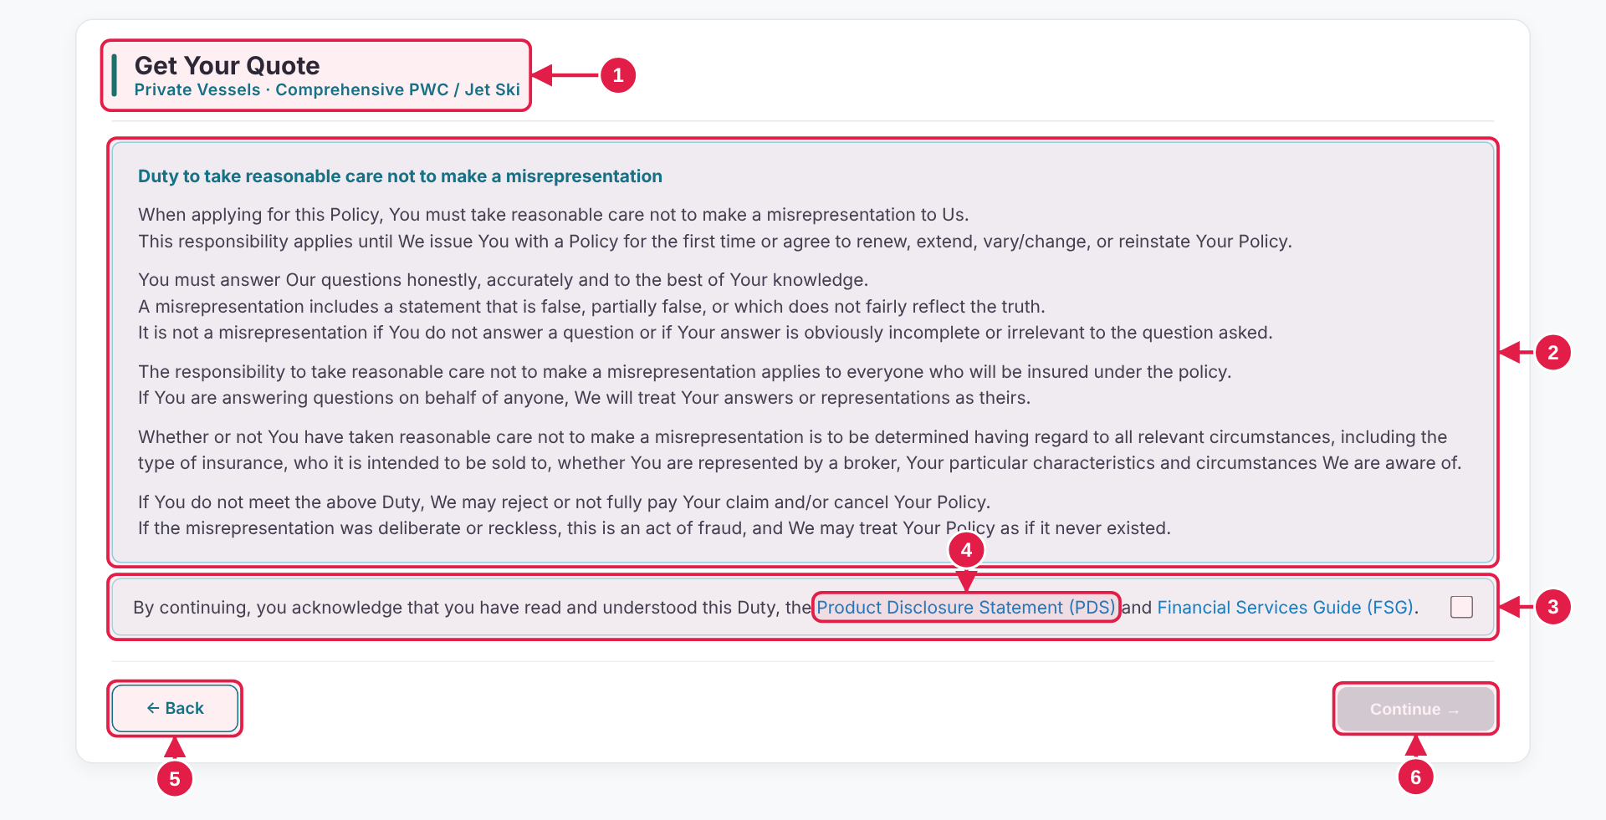

# | Design · what it is | Colours and style
1 | Heading and class line "Get Your Quote" with the product named underneath. | Fill #0F766E · Corner radius 2px · Size 4 × 34 px  20px · bold 700 · #1F2937  13px · semi-bold 600 · #08788B
2 | Notice Duty to take reasonable care. Read before continuing. | 14px · regular 400 · #374151  Fill #F0FBFD · Border 1px solid #8DDBE7 · Corner radius 7px  14px · regular 400 · #374151
3 | Acknowledgement Tick box at the right end of the line. | 14px · regular 400 · #374151  Fill #F4FBFC · Border 1px solid #A8DFE7 · Corner radius 7px
4 | PDS and FSG links Open in a new tab. The PDS link is a placeholder in the mockup. | 14px · regular 400 · #0786CC
5 | Back Returns to the products page. | —
6 | Continue → Greyed out ( #D1D5DB ) until the box is ticked, then #0F766E . | 13px · semi-bold 600 · #FFFFFF  Fill #D1D5DB · Corner radius 8px · Size 124.9 × 35 px  13px · semi-bold 600 · #FFFFFF  Fill #0F766E · Corner radius 8px · Size 124.9 × 35 px

BEHAVIOUR
▸ Continue stays grey until the acknowledgement box is ticked, then turns deep teal. Unticking greys it out again.
▸ PDS and FSG links open in a new tab (placeholders in the mockup). Back returns to the products page.

COPY-READY TEXT · Use exactly as written. Select and copy from this box.
Heading | Get Your Quote | Acknowledgement | By continuing, you acknowledge that you have read and understood this Duty, the Product Disclosure Statement (PDS) and Financial Services Guide (FSG).
Class line | Private Vessels · Comprehensive PWC / Jet Ski | Buttons | ← Back  Continue →
Notice title | Duty to take reasonable care not to make a misrepresentation
Notice text | When applying for this Policy, You must take reasonable care not to make a misrepresentation to Us.  This responsibility applies until We issue You with a Policy for the first time or agree to renew, extend, vary/change, or reinstate Your Policy.  You must answer Our questions honestly, accurately and to the best of Your knowledge.  A misrepresentation includes a statement that is false, partially false, or which does not fairly reflect the truth.  It is not a misrepresentation if You do not answer a question or if Your answer is obviously incomplete or irrelevant to the question asked.  The responsibility to take reasonable care not to make a misrepresentation applies to everyone who will be insured under the policy.  If You are answering questions on behalf of anyone, We will treat Your answers or representations as theirs.  Whether or not You have taken reasonable care not to make a misrepresentation is to be determined having regard to all relevant circumstances, including the type of insurance, who it is intended to be sold to, whether You are represented by a broker, Your particular characteristics and circumstances We are aware of.  If You do not meet the above Duty, We may reject or not fully pay Your claim and/or cancel Your Policy.  If the misrepresentation was deliberate or reckless, this is an act of fraud, and We may treat Your Policy as if it never existed.

Step 1 · Target Market Determination REF TMD-1
Eleven questions that check the application is within the target market.
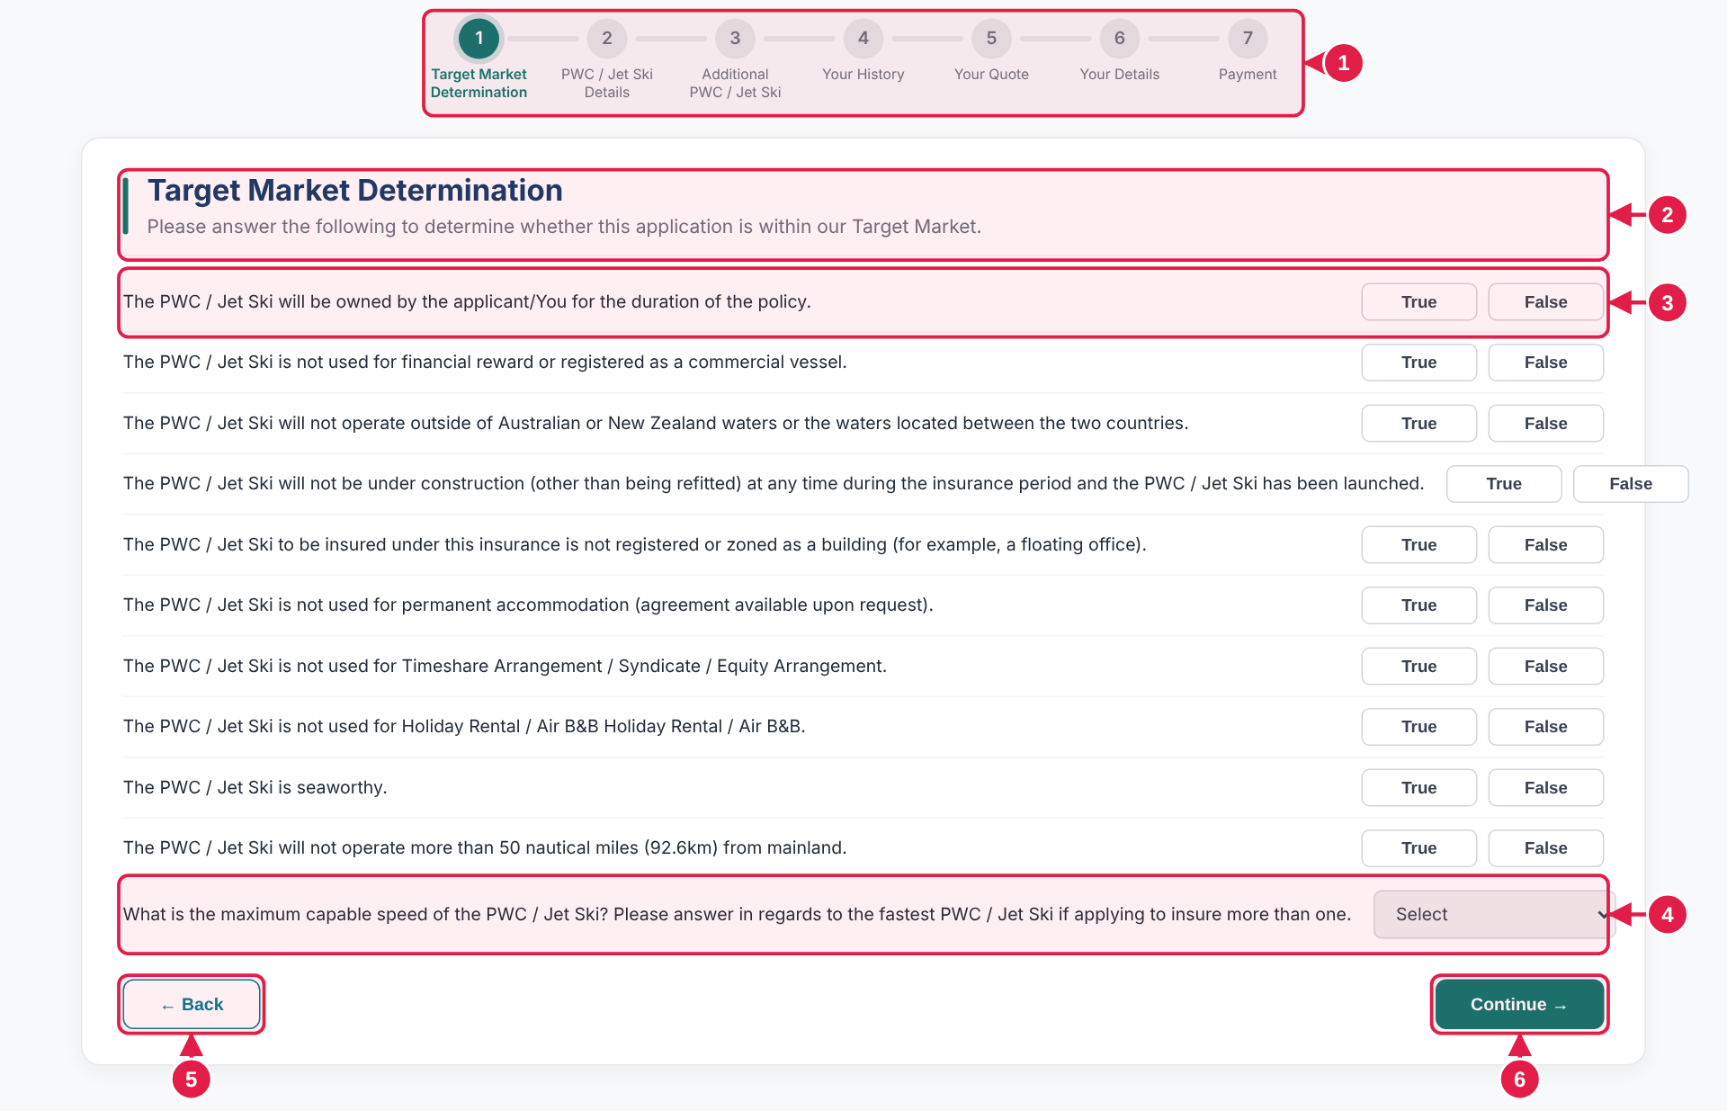

# | Design · what it is | Colours and style
1 | Progress bar Step 1 is highlighted. | —
2 | Heading and sub-heading Side bar, title and one line of guidance. | Fill #0F766E · Corner radius 2px · Size 4 × 42 px  22px · bold 700 · #153B66  14px · regular 400 · #6B7280
3 | True / False statement Customer picks one button. Statements 1 to 10. | 13px · regular 400 · #1F2937  12.5px · semi-bold 600 · #374151  Fill #FFFFFF · Border 1px solid #D1D5DB · Corner radius 6px · Size 86 × 28 px  12.5px · bold 700 · #087F9C  Fill #E6F7FB · Border 1px solid #079CC0 · Corner radius 6px · Size 86 × 28 px
4 | Dropdown question Maximum capable speed. Question 11. | 13px · regular 400 · #374151  Fill #EFEFEF · Border 1px solid #D1D5DB · Corner radius 6px · Size 180 × 36 px
5 | Back Returns to the intro. | —
6 | Continue → Goes to Step 2, or shows the pop-up on page 20 if an answer falls outside the target market. | 13px · semi-bold 600 · #FFFFFF  Fill #0F766E · Corner radius 8px · Size 124.9 × 37 px

BEHAVIOUR
▸ Statements 1 to 10: the customer picks True or False. True is the expected answer. The chosen button changes colour; there is no radio button or checkbox inside it.
▸ Any False, or Over 60 Knots / 110 kph on question 11, shows the Outside Target Market pop-up (page 20) when Continue is pressed. The customer cannot go further.
▸ Continue goes to Step 2.

BUILD NOTE True / False buttons are plain clickable buttons. There is no radio button or checkbox inside them. The chosen button simply changes colour. This keeps the design clean. The same applies to every Yes / No pair.

COPY-READY TEXT · Use exactly as written. Select and copy from this box.
Heading | Target Market Determination | Question 11 | What is the maximum capable speed of the PWC / Jet Ski? Please answer in regards to the fastest PWC / Jet Ski if applying to insure more than one.  (dropdown, shows Select)
Sub-heading | Please answer the following to determine whether this application is within our Target Market. | Buttons | True False (answer buttons)  ← Back  Continue →
Statements 1 to 10 | 1. The PWC / Jet Ski will be owned by the applicant/You for the duration of the policy.  2. The PWC / Jet Ski is not used for financial reward or registered as a commercial vessel.  3. The PWC / Jet Ski will not operate outside of Australian or New Zealand waters or the waters located between the two countries.  4. The PWC / Jet Ski will not be under construction (other than being refitted) at any time during the insurance period and the PWC / Jet Ski has been launched.  5. The PWC / Jet Ski to be insured under this insurance is not registered or zoned as a building (for example, a floating office).  6. The PWC / Jet Ski is not used for permanent accommodation (agreement available upon request).  7. The PWC / Jet Ski is not used for Timeshare Arrangement / Syndicate / Equity Arrangement.  8. The PWC / Jet Ski is not used for Holiday Rental / Air B&B Holiday Rental / Air B&B.  9. The PWC / Jet Ski is seaworthy.  10. The PWC / Jet Ski will not operate more than 50 nautical miles (92.6km) from mainland.

Step 2 · PWC / Jet Ski Details REF VD-1
Thirteen details about the PWC / Jet Ski, then owners and skippers (page 7).
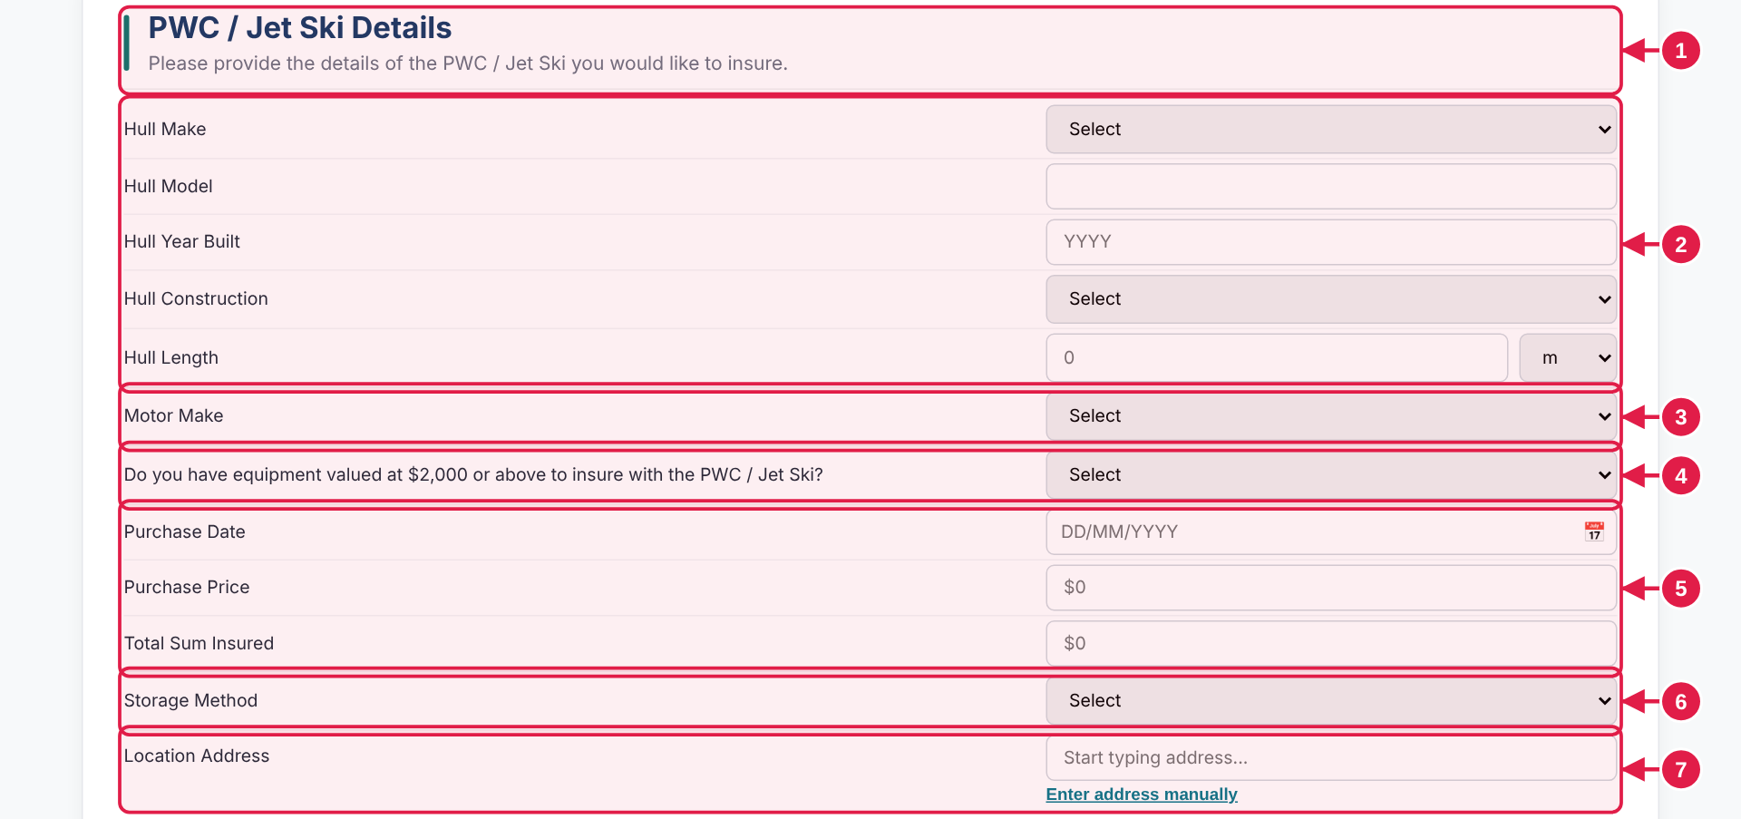

# | Design · what it is | Colours and style
1 | Heading and sub-heading Side bar, title and one line of guidance. | Fill #0F766E · Corner radius 2px · Size 4 × 42 px  22px · bold 700 · #153B66
2 | Hull details Make, model, year, construction, length (m or ft). | 13px · regular 400 · #1F2937  13px · regular 400 · #000000  Fill #EFEFEF · Border 1px solid #D1D5DB · Corner radius 6px · Size 420 × 36 px  13px · regular 400 · #000000  Fill #FFFFFF · Border 1px solid #D1D5DB · Corner radius 6px · Size 420 × 34 px
3 | Motor Make Dropdown. | —
4 | Equipment question Yes opens two boxes (page 6). | —
5 | Purchase details Date, price and sum insured. | 13px · regular 400 · #000000  Fill #FFFFFF · Border 1px solid #D1D5DB · Corner radius 6px · Size 420 × 34 px
6 | Storage Method Dropdown. Marina Berth adds a question (page 6). | —
7 | Location Address Search box with a manual-entry link (page 24). | 12.5px · semi-bold 600 · underlined · #08788B
— | Please Specify box (under any dropdown set to Other) | 13px · regular 400 · #000000  Fill #FFFFFF · Border 1px solid #D1D5DB · Corner radius 6px · Size 420 × 34 px

BEHAVIOUR
▸ Every dropdown set to Other opens a Please Specify box underneath (Hull Make, Hull Construction, Motor Make, Storage Method). Changing the answer closes and clears it. This applies to every dropdown that has an Other option.
▸ Equipment valued at $2,000 or above = Yes opens Item Description and Value ($). Storage Method = Marina Berth opens Marina / Club Name.
▸ Storage Method = Roadside / Verge / Nature Strip sends the quote for review (pages 20 and 21).
▸ Location Address is a search box with an Enter address manually link (page 24).

MOCKUP vs KOVERUI In the mockup: Location Address accepts any typed text.
In KoverUI: Location Address uses a real address lookup.

COPY-READY TEXT · Use exactly as written. Select and copy from this box.
Heading | PWC / Jet Ski Details
Sub-heading | Please provide the details of the PWC / Jet Ski you would like to insure.
Buttons | ← Back  Continue →
Fields | Hull Make · Hull Model · Hull Year Built [YYYY] · Hull Construction · Hull Length · Motor Make · Do you have equipment valued at $2,000 or above to insure with the PWC / Jet Ski? · Purchase Date [DD/MM/YYYY] · Purchase Price [$0] · Total Sum Insured [$0] · Storage Method · Location Address

Step 2 · Owners and skippers REF VD-3
The last block on PWC / Jet Ski Details. The same block repeats on every additional PWC / Jet Ski.
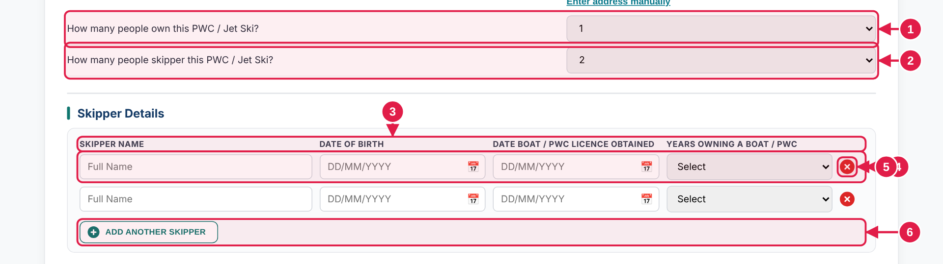

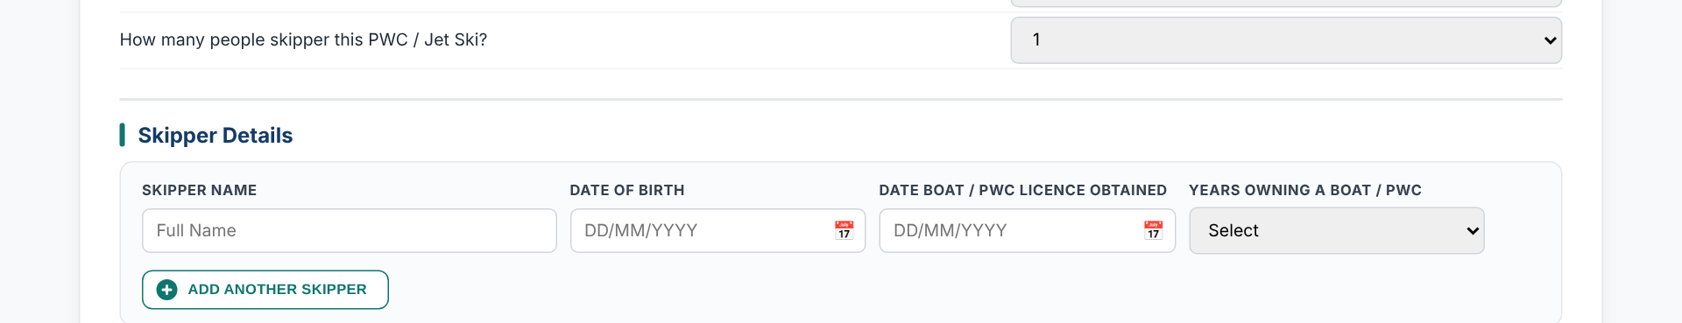  Skippers answer: one shows one row | ➜ | 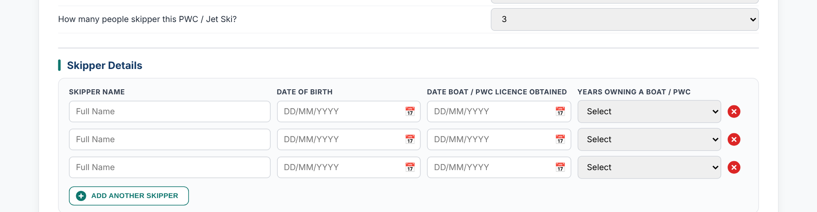  Skippers answer: three shows three rows

# | Design · what it is | Colours and style
1 | Owners question Dropdown. | 13px · regular 400 · #1F2937
2 | Skippers question Dropdown. Sets how many skipper rows show. | —
3 | Column headings Name, date of birth, licence date, years owning. | 11px · bold 700 · UPPERCASE · #374151
4 | Skipper row Type the name; dates are typed as DD/MM/YYYY. | 13px · regular 400 · #000000  Fill #FFFFFF · Border 1px solid #D1D5DB · Corner radius 6px · Size 315.6 × 34 px
5 | Remove × Small red circle; shows when there is more than one row. Asks first (page 24). | Fill #DC2626 · Round (circle) · Size 20 × 20 px
6 | Add another skipper Small outlined button, capitals. Adds one row. | 11px · semi-bold 600 · UPPERCASE · #0F766E  Fill #FFFFFF · Border 1px solid #0F766E · Corner radius 8px  Fill #0F766E · Round (circle)
— | Sub-heading "Skipper Details" | 16px · bold 700 · #153B66  Top border 2px #E5E7EB

BEHAVIOUR
▸ The skippers answer sets the number of rows (1 to 5+). Add another skipper adds a row and greys out at five.
▸ Remove × shows only when there is more than one row. If the row has details, a confirmation bar asks first (page 24). An empty row is removed straight away.
▸ First press of Continue with skipper details missing shows a warning; a second press carries on (page 23).

COPY-READY TEXT · Use exactly as written. Select and copy from this box.
Owners question | How many people own this PWC / Jet Ski? | Name box | Full Name
Skippers question | How many people skipper this PWC / Jet Ski? | Add button | Add another skipper
Sub-heading | Skipper Details | Fields | Both are · Years column
Column headings | SKIPPER NAME  DATE OF BIRTH  DATE BOAT / PWC LICENCE OBTAINED  YEARS OWNING A BOAT / PWC

Step 3 · Additional PWC / Jet Ski REF AD-1
The customer can add more PWC / Jet Skis to the same quote.
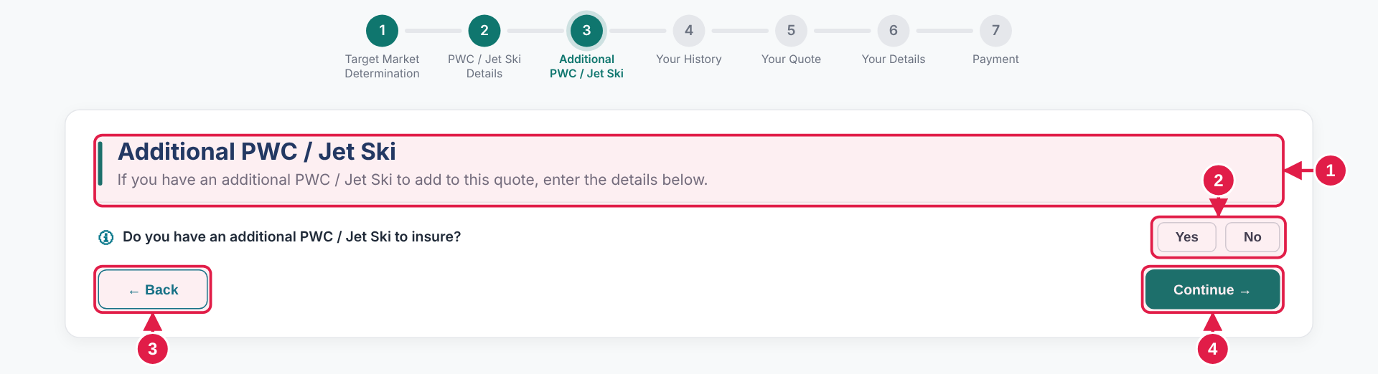
  1 | Heading Side bar, title and one line of guidance.
  2 | Yes / No Customer chooses one. The Add button stays hidden until Yes.
  3 | Back Returns to Step 2.
  4 | Continue → Goes to Step 4.
After choosing Yes
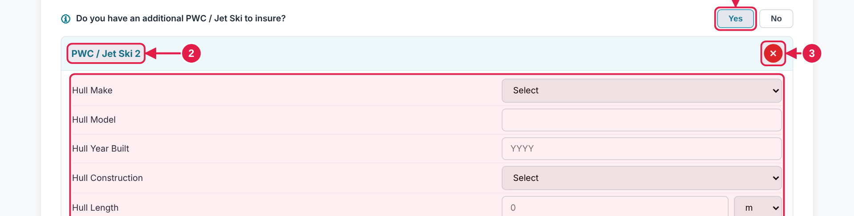
1 | Yes Chosen: border #079CC0 , fill #E6F7FB . | 3 | Remove × Asks first if the card has details (page 24).
2 | Card title Numbered from 2. | 4 | Same questions As Step 2, in the same order.

# | Design · what it is | Colours and style
A1 | Heading side bar | Fill #0F766E · Corner radius 2px · Size 4 × 42 px
A1 | Heading | 22px · bold 700 · #153B66
A2 | Question bar | 13px · semi-bold 600 · #1F2937
A2 | Yes / No button | 12.5px · semi-bold 600 · #374151  Fill #FFFFFF · Border 1px solid #D1D5DB · Corner radius 6px · Size 55.6 × 28 px
B1 | Yes chosen | 12.5px · bold 700 · #087F9C  Fill #E6F7FB · Border 1px solid #079CC0 · Corner radius 6px · Size 55.6 × 28 px
B2 | Card | Fill #FFFFFF · Border 1px solid #DFE5E8 · Corner radius 8px
B2 | Card title | 14px · bold 700 · #08788B
— | Add another button | 13px · semi-bold 600 · #0F766E  Fill #FFFFFF · Border 1px solid #0F766E · Corner radius 8px
— | + circle | Fill #0F766E · Round (circle)

BEHAVIOUR
▸ Yes opens card PWC / Jet Ski 2 with the same questions as Step 2 (page 6) and its own skippers. No changes nothing on the page.
▸ Add another PWC / Jet Ski is hidden until Yes is chosen and stays hidden on No. It adds numbered cards below.
▸ Remove × on a card asks first when the card has details (page 24). Remaining cards renumber.
▸ Each card has a Previous skipper picker (page 23). Roadside / Verge / Nature Strip on any card sends the quote for review.

COPY-READY TEXT · Use exactly as written. Select and copy from this box.
Heading | Additional PWC / Jet Ski | Card title | PWC / Jet Ski 2
Sub-heading | If you have an additional PWC / Jet Ski to add to this quote, enter the details below. | Card questions | The same questions as Step 2 (page 6)
Question | Do you have an additional PWC / Jet Ski to insure? | Add button | + Add another PWC / Jet Ski
Answer buttons | Yes No | Buttons | ← Back  Continue →

Step 4 · Your History REF HI-1
Four Yes / No questions about claims, cancellations and conduct.
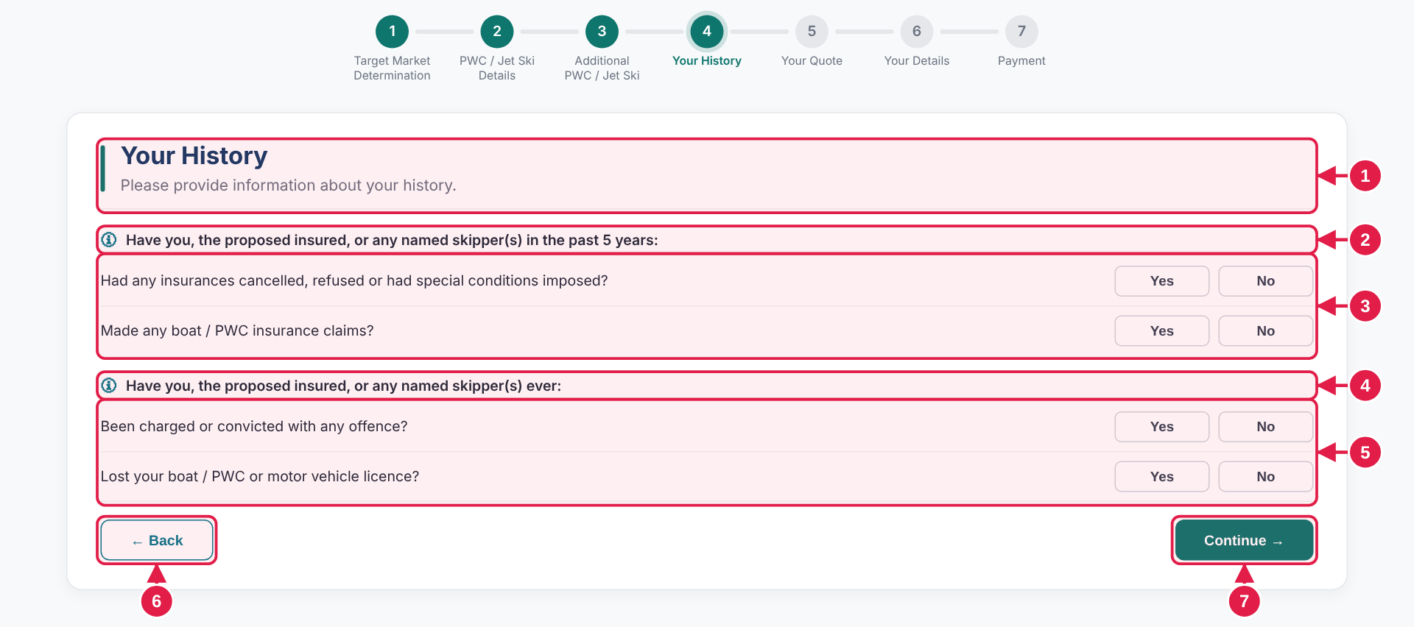

# | Design · what it is | Colours and style
1 | Heading and sub-heading Side bar, title and one line of guidance. | Fill #0F766E · Corner radius 2px · Size 4 × 42 px  22px · bold 700 · #153B66
2 | Lead-in sentence Past 5 years. | 13px · semi-bold 600 · #1F2937
3 | Two Yes / No questions Cancelled insurance; claims. | 13px · regular 400 · #1F2937  12.5px · semi-bold 600 · #374151  Fill #FFFFFF · Border 1px solid #D1D5DB · Corner radius 6px
4 | Lead-in sentence Ever. | —
5 | Two Yes / No questions Convicted; lost licence. | —
6 | Back Returns to Step 3. | —
7 | Continue → Goes to Your Quote. | —
— | Please Specify box | 13.5px · regular 400 · #000000  Fill #FFFFFF · Border 1px solid #D1D5DB · Corner radius 8px · Size 1098 × 36 px
— | Claim table heading text | 12px · semi-bold 600 · #1F2937
— | Add claim row (+) | 18px · regular 400 · #FFFFFF  Fill #0F766E · Round (circle) · Size 30 × 30 px

BEHAVIOUR
▸ Yes opens a Please Specify box. For the claims question it opens a Claim Details table (Date, Description of Loss, Settlement Amount). No hides and clears it.
▸ In the claims table + adds a row and × removes one; one row always stays.
▸ Continue goes to Your Quote.

COPY-READY TEXT · Use exactly as written. Select and copy from this box.
Heading | Your History | Lead-in 2 | Have you, the proposed insured, or any named skipper(s) ever:
Sub-heading | Please provide information about your history. | Question 3 | Been charged or convicted with any offence?
Lead-in 1 | Have you, the proposed insured, or any named skipper(s) in the past 5 years: | Question 4 | Lost your boat / PWC or motor vehicle licence?
Question 1 | Had any insurances cancelled, refused or had special conditions imposed? | Answer buttons | Yes No
Question 2 | Made any boat / PWC insurance claims? | Buttons | ← Back  Continue →

Step 5 · Your Quote: premium and excesses REF QT-1
The top of the quote.
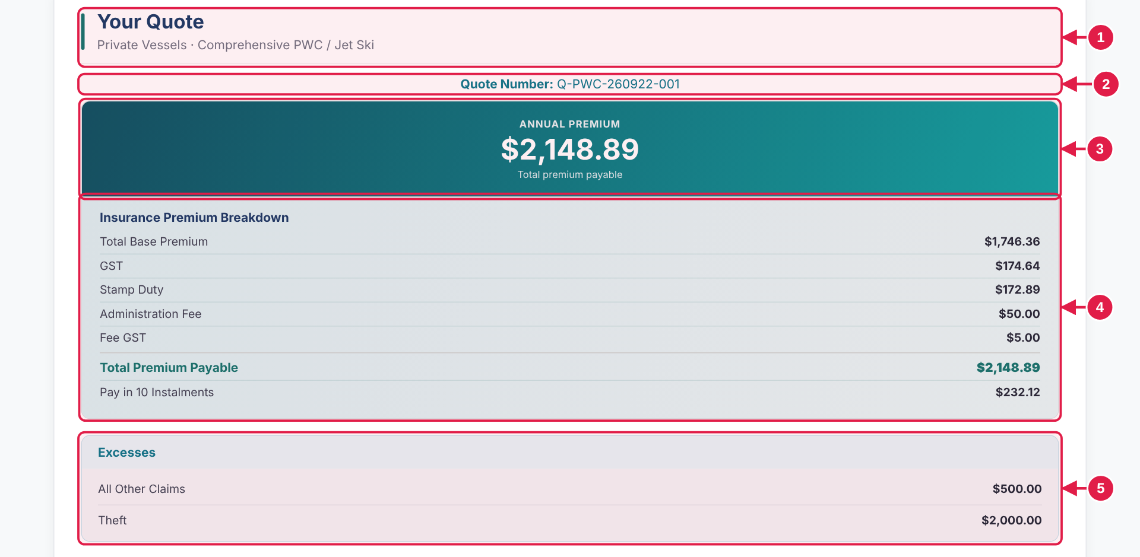

# | Design · what it is | Colours and style
1 | Heading and sub-heading Side bar, "Your Quote" and the product name. | Fill #0F766E · Corner radius 2px · Size 4 × 42 px  22px · bold 700 · #153B66
2 | Quote number Centred above the premium. | —
3 | Annual premium banner Large amount with a note underneath. | Gradient 110°: #075262 to #08A5A3  32px · bold 700 · #FFFFFF
4 | Premium breakdown One line per item, amounts on the right. One grey divider above the total. | 13px · regular 400 · #374151  13px · bold 700 · #1F2937  13px · bold 700 · #374151  Top border 1px #CBD5D1 · Bottom border 1px #0F766E at 12%
5 | Excesses panel Two lines, amounts on the right. | Fill #FFFFFF · Border 1px solid #C8E4EC · Corner radius 10px

BEHAVIOUR
▸ All amounts and the quote number come from rating in the final product. One grey divider sits above the total line.
▸ If the quote is sent for review, every amount shows $0.00 and the rest of the page is hidden (page 20).

MOCKUP vs KOVERUI In the mockup: All amounts and the quote number are placeholders.
In KoverUI: Amounts and quote number come from your rating system.

COPY-READY TEXT · Use exactly as written. Select and copy from this box.
Heading | Your Quote | Breakdown lines | Total Base Premium · GST · Stamp Duty · Administration Fee · Fee GST · Total Premium Payable · Pay in 10 Instalments
Sub-heading | Private Vessels · Comprehensive PWC / Jet Ski | Excesses title | Excesses
Quote number label | Quote Number: | Excess lines | All Other Claims  Theft
Banner | ANNUAL PREMIUM  Total premium payable
Breakdown title | Insurance Premium Breakdown

Step 5 · Your Quote: Your Cover REF QT-2
What the policy covers, one tick per line.
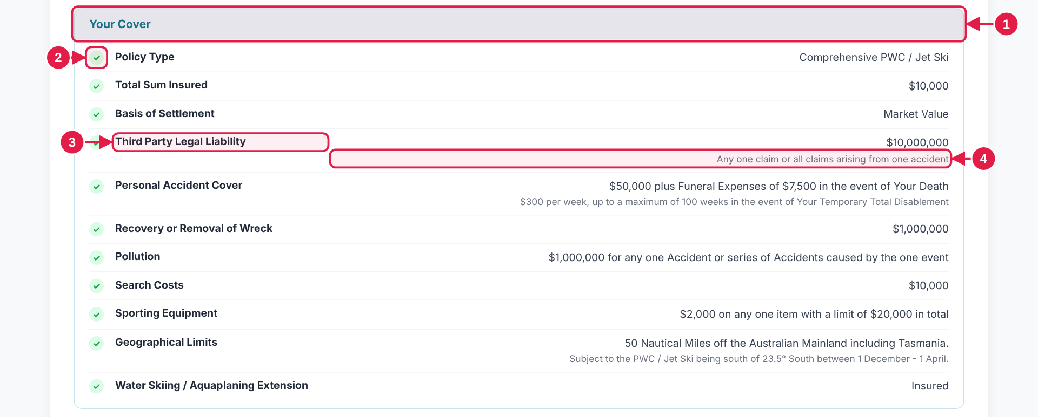

# | Design · what it is | Colours and style
1 | Panel heading "Your Cover". | —
2 | Tick On every line. | Fill #DCFCE7 · Round (circle) · Size 18 × 18 px
3 | Label (bold, left) Value on the right. | 13px · bold 700 · #1F2937  13px · regular 400 · #374151
4 | Small grey line Extra detail under some values. | 11.5px · regular 400 · #6B7280
5 | Last line Water Skiing / Aquaplaning Extension: Insured. | —

BEHAVIOUR
▸ Display only. The tick sits on every line.

COPY-READY TEXT · Use exactly as written. Select and copy from this box.
Panel heading | Your Cover | Recovery or Removal of Wreck | $1,000,000
Policy Type | Comprehensive PWC / Jet Ski | Pollution | $1,000,000 for any one Accident or series of Accidents caused by the one event
Total Sum Insured | $10,000 | Search Costs | $10,000
Basis of Settlement | Market Value | Sporting Equipment | $2,000 on any one item with a limit of $20,000 in total
Third Party Legal Liability | $10,000,000  Any one claim or all claims arising from one accident | Geographical Limits | 50 Nautical Miles off the Australian Mainland including Tasmania.  Subject to the PWC / Jet Ski being south of 23.5° South between 1 December - 1 April.
Personal Accident Cover | $50,000 plus Funeral Expenses of $7,500 in the event of Your Death  $300 per week, up to a maximum of 100 weeks in the event of Your Temporary Total Disablement | Water Skiing / Aquaplaning Extension | Insured

Step 5 · Your Quote: endorsements, dates and summaries REF QT-3
Four panels under Your Cover.
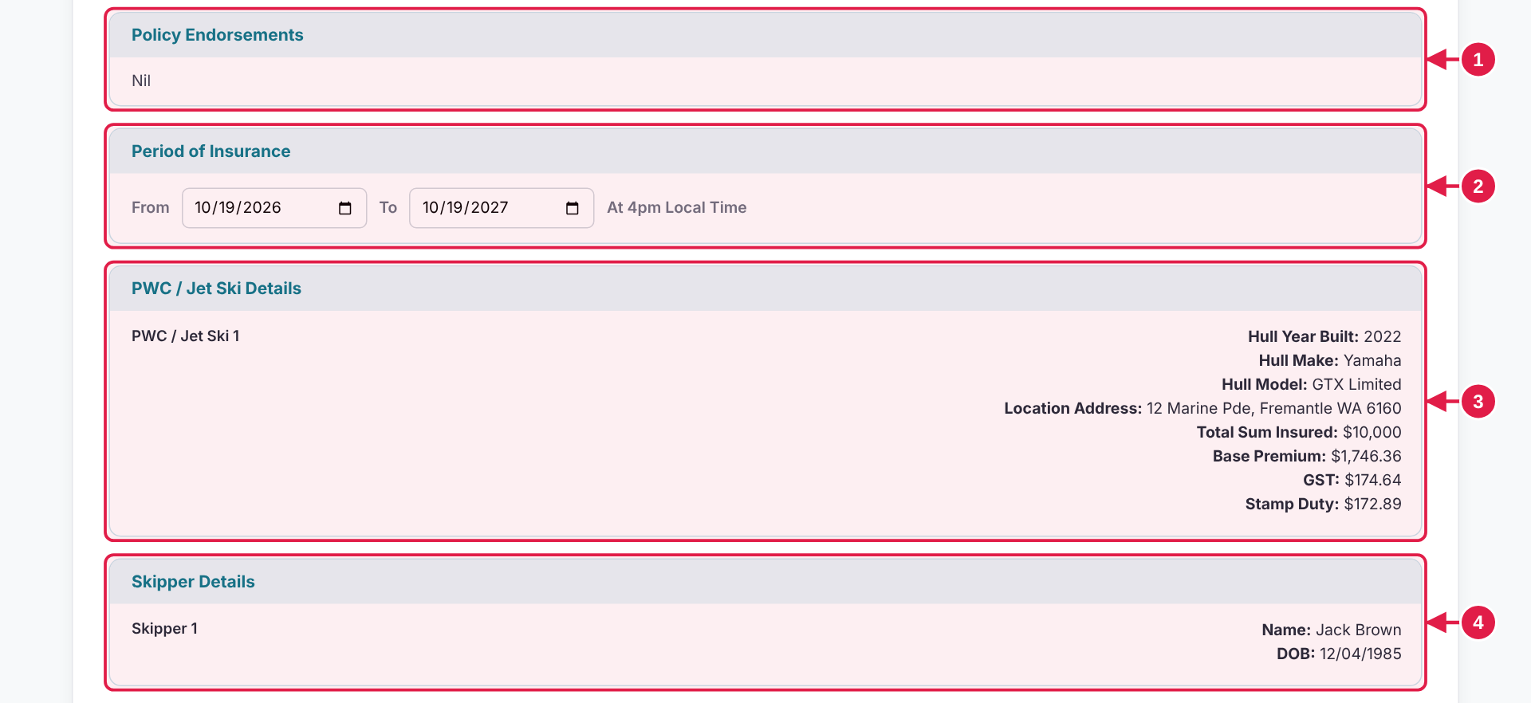

# | Design · what it is | Colours and style
1 | Policy Endorsements Shows "Nil". | —
2 | Period of Insurance From and To dates; customer can change them. | 13px · regular 400 · #000000  Fill #FFFFFF · Border 1px solid #D1D5DB · Corner radius 6px · Size 155 × 34 px
3 | PWC / Jet Ski Details One block per PWC / Jet Ski. | 12.5px · semi-bold 600 · #1F2937  13px · regular 400 · #1F2937
4 | Skipper Details One block per skipper. | —

BEHAVIOUR
▸ Period of Insurance dates can be changed here. They start on today and run one year. One PWC / Jet Ski block and one skipper block appear for each unit and skipper.

COPY-READY TEXT · Use exactly as written. Select and copy from this box.
Panel 1 | Policy Endorsements  Nil | Panel 4 | Skipper Details  Skipper 1  Name: DOB:
Panel 2 | Period of Insurance  From  To  At 4pm Local Time
Panel 3 | PWC / Jet Ski Details  PWC / Jet Ski 1  Hull Year Built: Hull Make: Hull Model: Location Address:  Total Sum Insured: Base Premium: GST: Stamp Duty:

Step 5 · Your Quote: notices and buttons REF QT-4
The bottom of the quote.
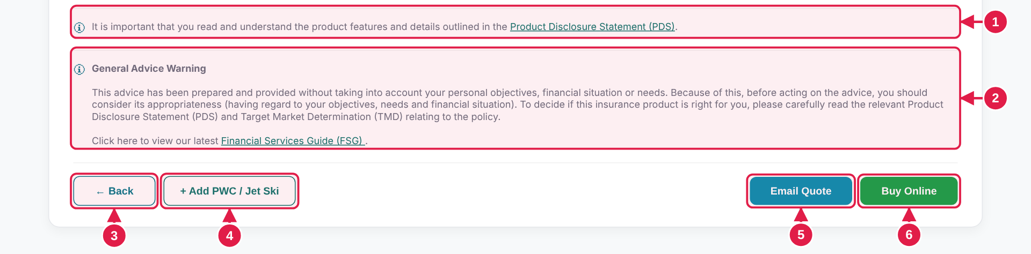

# | Design · what it is | Colours and style
1 | PDS notice Link to the Product Disclosure Statement. | 12px · regular 400 · #6B7280  Top border 1px #F0F0F0
2 | General Advice Warning With the FSG link. | —
3 | ← Back Returns to Step 4. | 13px · semi-bold 600 · #08788B  Fill #FFFFFF · Border 1px solid #08788B · Corner radius 8px · Size 101.7 × 37 px
4 | + Add PWC / Jet Ski Goes to Step 3 to add another. | 13px · semi-bold 600 · #0F766E  Fill #FFFFFF · Border 1px solid #0F766E · Corner radius 8px · Size 164.7 × 37 px
5 | Email Quote Opens the pop-up on page 22. | 13px · semi-bold 600 · #FFFFFF  Fill #0891B2 · Corner radius 8px · Size 127.9 × 35 px
6 | Buy Online Goes to Step 6, Your Details. | 13px · bold 700 · #FFFFFF  Fill #16A34A · Corner radius 8px · Size 120.6 × 35 px

BEHAVIOUR
▸ Back returns to Step 4. + Add PWC / Jet Ski goes to Step 3. Email Quote opens the pop-up on page 22. Buy Online goes to Step 6.
▸ On a quote sent for review, Email Quote and Buy Online are greyed out and cannot be pressed.

COPY-READY TEXT · Use exactly as written. Select and copy from this box.
PDS notice | It is important that you read and understand the product features and details outlined in the Product Disclosure Statement (PDS). | Buttons | ← Back  + Add PWC / Jet Ski  Email Quote  Buy Online
General Advice Warning | General Advice Warning  This advice has been prepared and provided without taking into account your personal objectives, financial situation or needs. Because of this, before acting on the advice, you should consider its appropriateness (having regard to your objectives, needs and financial situation). To decide if this insurance product is right for you, please carefully read the relevant Product Disclosure Statement (PDS) and Target Market Determination (TMD) relating to the policy.  Click here to view our latest Financial Services Guide (FSG) .

Step 6 · Your Details: contact REF YD-1
Who the policy is for and how to reach them. * means required.
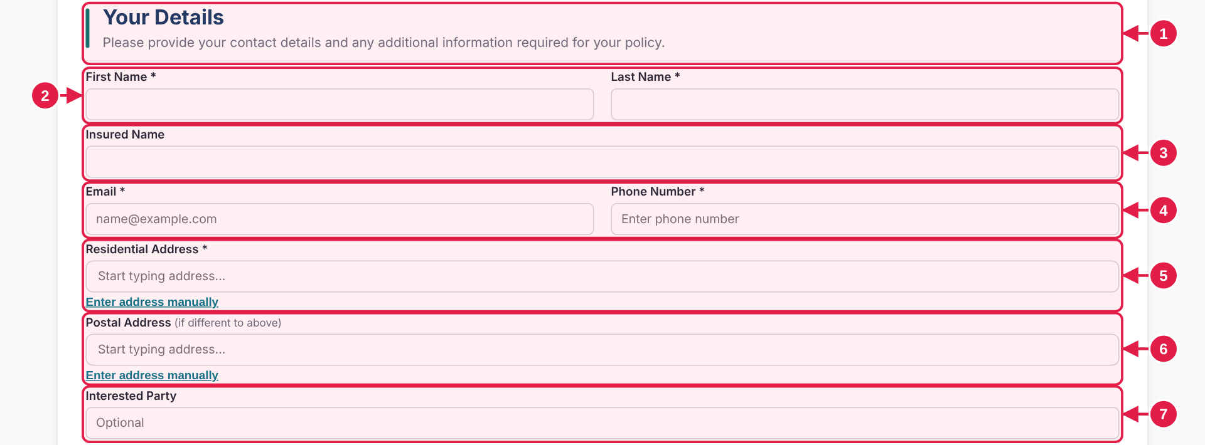

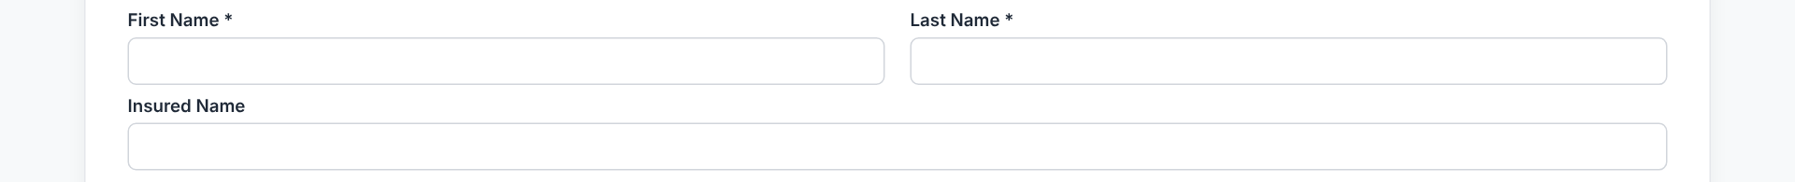  Names empty | ➜ | 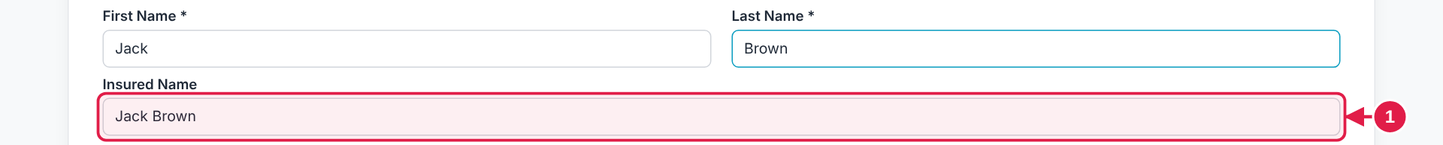  Type Jack and Brown: Insured Name fills in (1). It can then be edited.

# | Design · what it is | Colours and style
1 | Heading and sub-heading Side bar, title and one line of guidance. | Fill #0F766E · Corner radius 2px · Size 4 × 42 px  22px · bold 700 · #153B66
2 | First Name and Last Name Side by side. | 12.5px · semi-bold 600 · #1F2937  12.5px · semi-bold 600 · #1F2937  13px · regular 400 · #1F2937  Fill #FFFFFF · Border 1px solid #D1D5DB · Corner radius 6px · Size 540 × 34 px
3 | Insured Name Fills itself from First and Last Name. | —
4 | Email and Phone Number Side by side. | —
5 | Residential Address Search box with a manual-entry link. | —
6 | Postal Address Optional. | 11.5px · regular 400 · #6B7280
7 | Interested Party Optional. | —

BEHAVIOUR
▸ Insured Name fills itself from First and Last Name and stays editable. Fields marked * are required; Postal Address and Interested Party are optional.
▸ Residential and Postal Address are search boxes with an Enter address manually link (page 24).

COPY-READY TEXT · Use exactly as written. Select and copy from this box.
Heading | Your Details
Sub-heading | Please provide your contact details and any additional information required for your policy.
Fields | First Name * · Last Name * · Insured Name · Email * [name@example.com] · Phone Number * [Enter phone number] · Residential Address * [Start typing address...] · Postal Address (if different to above) [Same as residential address] · Interested Party [Optional]

Step 6 · Your Details: PWC / Jet Ski Identification REF YD-2
One card for each PWC / Jet Ski on the quote.
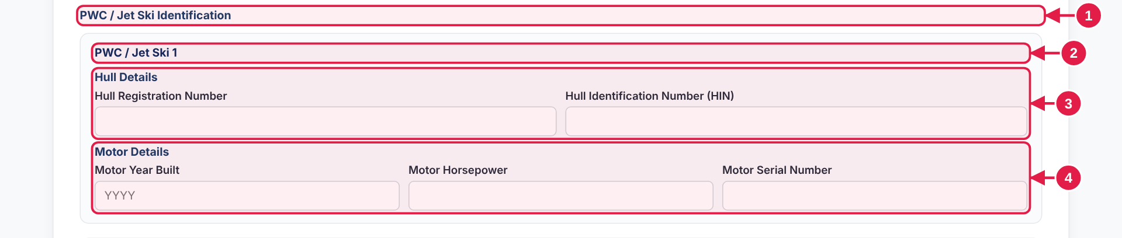

# | Design · what it is | Colours and style
1 | Section label "PWC / Jet Ski Identification". | —
2 | Card heading PWC / Jet Ski 1, 2, 3 … | Fill #FAFBFC · Border 1px solid #E5E7EB · Corner radius 10px  13px · bold 700 · #09285C
3 | Hull Details Two boxes. | —
4 | Motor Details Three boxes. | —

BEHAVIOUR
▸ One card appears for every PWC / Jet Ski on the quote. Hull Name and Motor Model are not asked.

COPY-READY TEXT · Use exactly as written. Select and copy from this box.
Section label | PWC / Jet Ski Identification
Card | PWC / Jet Ski 1 · Hull Details · Hull Registration Number · Hull Identification Number (HIN) · Motor Details · Motor Year Built · Motor Horsepower · Motor Serial Number

Step 6 · Your Details: trailers and attachments REF YD-3
The last part of Your Details.
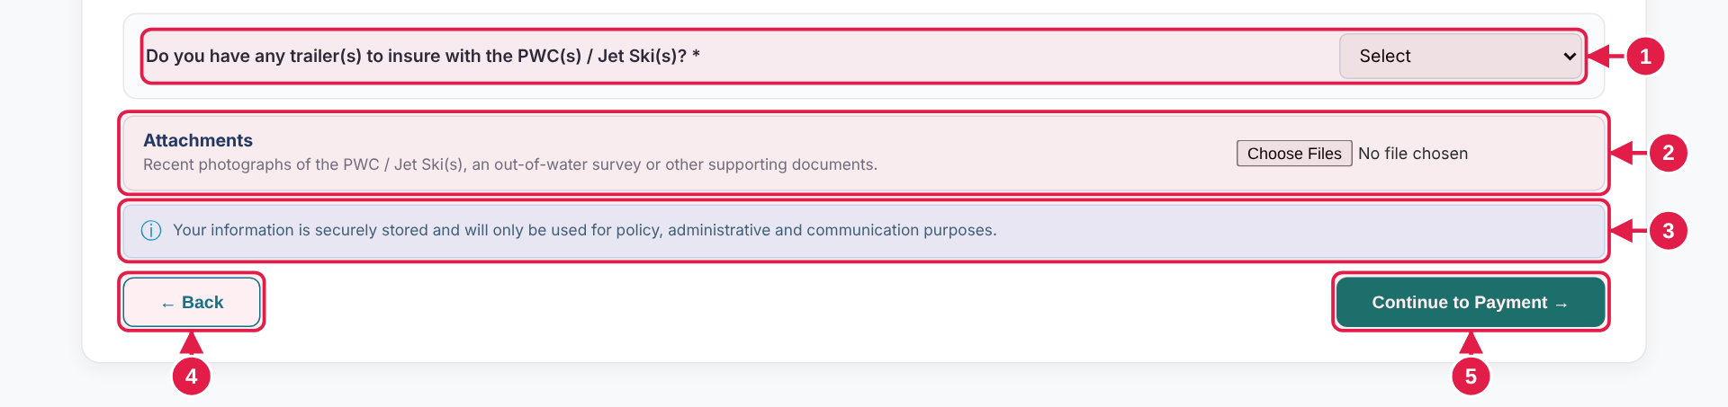

Trailer question shown | ➜ | Trailer 2 with × to remove (2)

# | Design · what it is | Colours and style
1 | Trailer question Dropdown. Required. | Fill #FAFBFC · Border 1px solid #E5E7EB · Corner radius 10px
2 | Attachments Choose one or more files. | Fill #FAFCFC · Border 1px solid #DBE5E7 · Corner radius 8px
3 | Privacy note Small blue-grey line. | 11.5px · regular 400 · #35647D
4 | Back Returns to Your Quote. | —
5 | Continue to Payment → Goes to Step 7. | 13px · semi-bold 600 · #FFFFFF  Fill #0F766E · Corner radius 8px · Size 198.6 × 37 px

BEHAVIOUR
▸ Yes to the trailer question opens a Trailer 1 card. + adds another, × removes one.
▸ Attachments are optional and can be several files. Continue to Payment goes to Step 7.

MOCKUP vs KOVERUI In the mockup: Chosen files are not uploaded anywhere.
In KoverUI: Attachments are uploaded and kept with the policy.

COPY-READY TEXT · Use exactly as written. Select and copy from this box.
Trailer question | Do you have any trailer(s) to insure with the PWC(s) / Jet Ski(s)? * | Privacy note | Your information is securely stored and will only be used for policy, administrative and communication purposes.
Trailer card | Trailer 1  Trailer Make & Model  Trailer Year Built  Trailer Registration Number | Buttons | ← Back  Continue to Payment →
Attachments | Attachments  Recent photographs of the PWC / Jet Ski(s), an out-of-water survey or other supporting documents. | Fields | Dropdown [Select]

Step 7 · Payment: choose a method REF PY-1
The customer picks how to pay.
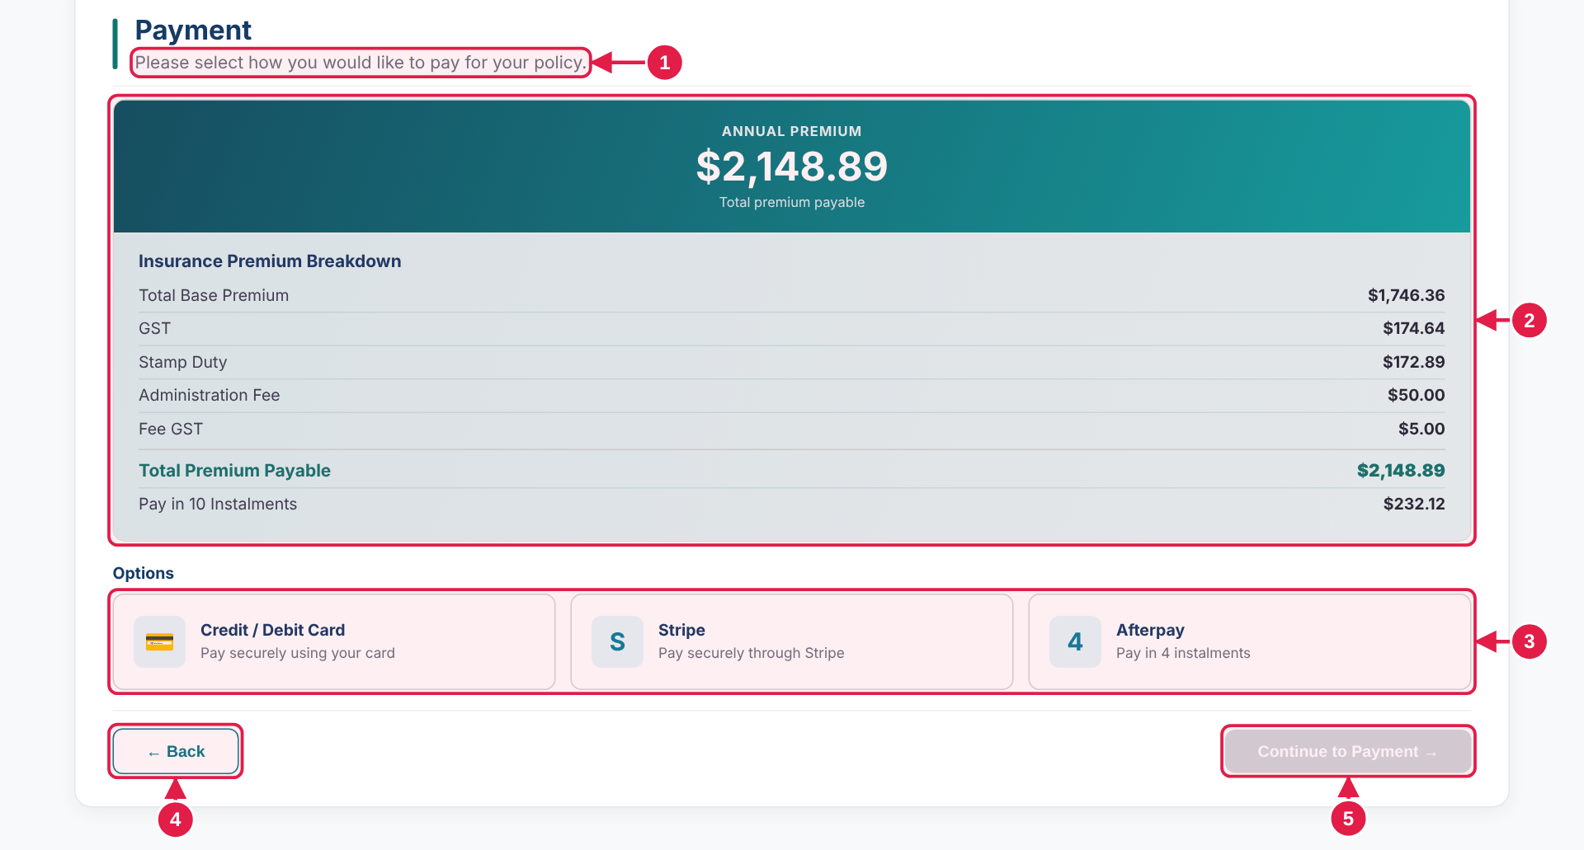

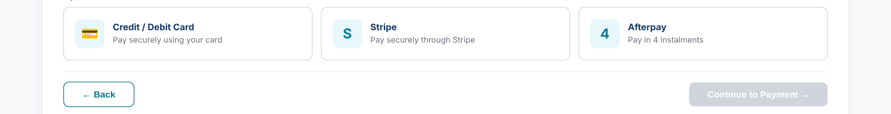  No method chosen: Continue to Payment is grey | ➜ | 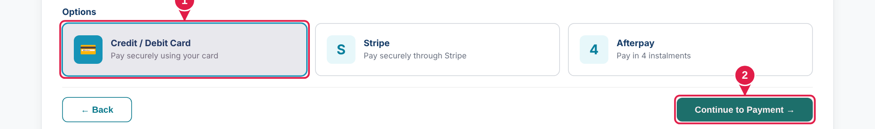  Method chosen: tile border #079CC0 , fill #E9F8FA (1). Continue turns deep teal (2).

# | Design · what it is | Colours and style
1 | Sub-heading Changes on the next screen (page 18). | —
2 | Premium summary Banner and breakdown. | —
3 | Three method buttons Card, Stripe, Afterpay. | 13.3px · regular 400 · #000000  Fill #FFFFFF · Border 1px solid #D1D5DB · Corner radius 9px · Size 358 × 78 px  13.3px · regular 400 · #000000  Fill #E9F8FA · Border 1px solid #079CC0 · Corner radius 9px · Size 358 × 78 px  13px · bold 700 · #153B66
4 | Back Returns to Your Details. | —
5 | Continue to Payment → Grey ( #D1D5DB ) until a method is chosen. | 13px · semi-bold 600 · #FFFFFF  Fill #D1D5DB · Corner radius 8px · Size 198.6 × 35 px  13px · semi-bold 600 · #FFFFFF  Fill #0F766E · Corner radius 8px · Size 198.6 × 35 px

BEHAVIOUR
▸ Continue to Payment stays grey until a method is chosen. All three methods lead to the card form in the mockup.

MOCKUP vs KOVERUI In the mockup: All three methods lead to the same card form.
In KoverUI: Each method opens its own payment step.

COPY-READY TEXT · Use exactly as written. Select and copy from this box.
Heading | Payment | Method 3 | Afterpay  Pay in 4 instalments
Sub-heading | Please select how you would like to pay for your policy. | Buttons | ← Back  Continue to Payment →
Section label | Options
Method 1 | Credit / Debit Card  Pay securely using your card
Method 2 | Stripe  Pay securely through Stripe

Step 7 · Payment: card details REF PY-2
The customer types their card details.
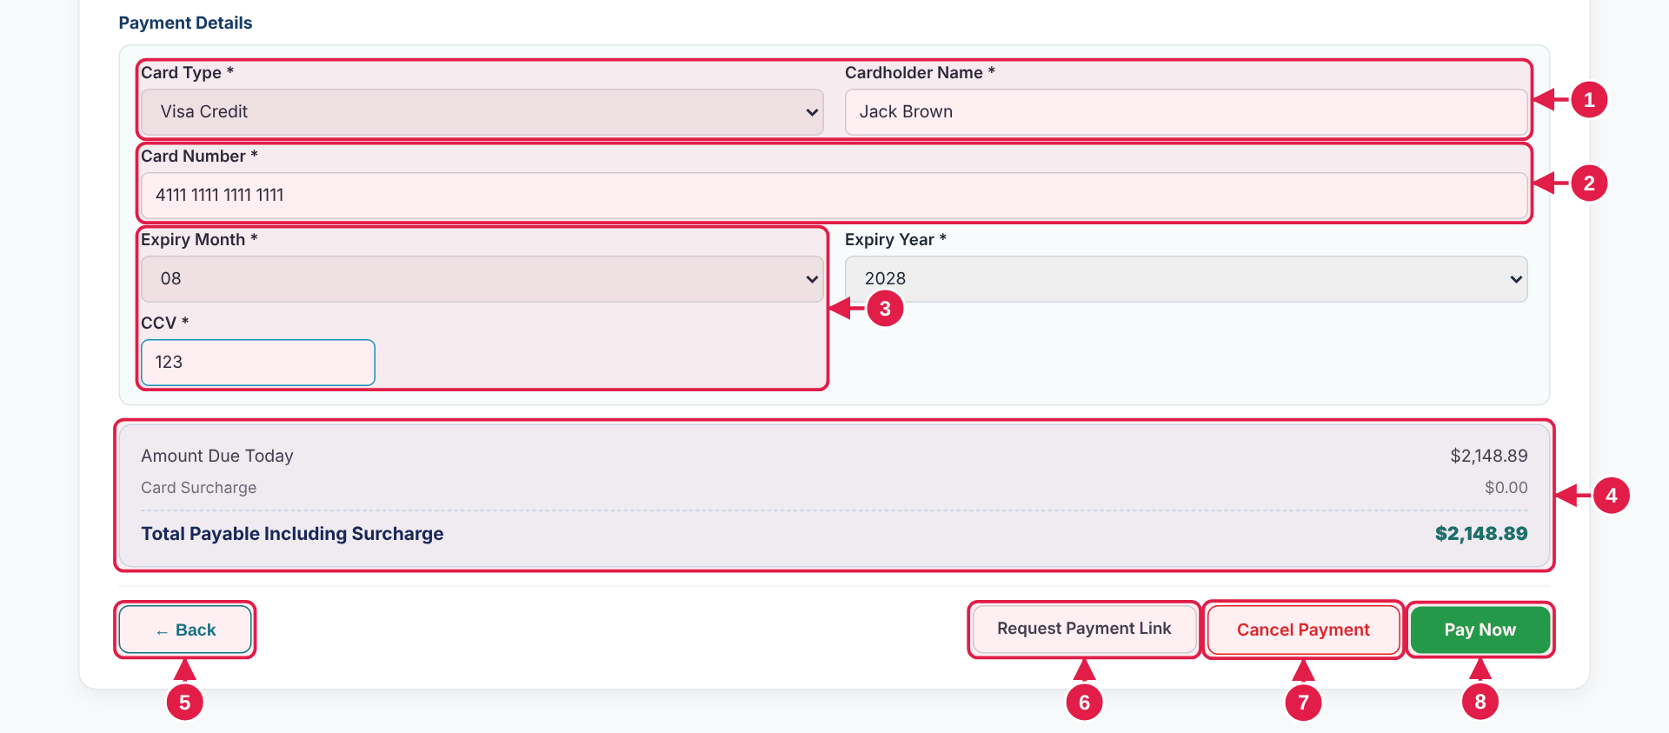

# | Design · what it is | Colours and style
1 | Card Type and Cardholder Name Side by side. | 12.5px · semi-bold 600 · #1F2937
2 | Card Number Spaces added as the customer types. | 13px · regular 400 · #1F2937  Fill #FFFFFF · Border 1px solid #D1D5DB · Corner radius 6px · Size 1064 × 36 px
3 | Expiry Month, Expiry Year, CCV Two dropdowns and a short box. | —
4 | Totals strip Amount, surcharge, total. | Fill #F0FBFD · Border 1px solid #C8E4EC · Corner radius 10px
5 | Back Returns to the method choice. | —
6 | Request Payment Link Outlined grey. | 12.5px · semi-bold 600 · #374151  Fill #FFFFFF · Border 1px solid #D1D5DB · Corner radius 8px · Size 171.9 × 37 px
7 | Cancel Payment Outlined red ( #DC2626 ). | 13px · semi-bold 600 · #DC2626  Fill #FFFFFF · Border 1px solid #DC2626 · Corner radius 8px · Size 148 × 38 px
8 | Pay Now Filled green ( #16A34A ). Goes to the confirmation. | 13px · bold 700 · #FFFFFF  Fill #16A34A · Corner radius 8px · Size 107.3 × 36 px

BEHAVIOUR
▸ The sub-heading changes when the card form opens. Card Number gains spaces as the customer types.
▸ Pay Now goes to the confirmation. Cancel Payment goes back to the method choice. Request Payment Link is a placeholder.

COPY-READY TEXT · Use exactly as written. Select and copy from this box.
New sub-heading | Please enter your payment details below to complete your policy purchase. | Fields | Card Type * · Cardholder Name * [Name on card] · Card Number * [0000 0000 0000 0000] · Expiry Month * · Expiry Year * · CCV * [CCV]
Section label | Payment Details
Totals strip | Amount Due Today  Card Surcharge  Total Payable Including Surcharge
Buttons | ← Back  Request Payment Link  Cancel Payment  Pay Now

Completion · Payment confirmed REF CF-1
The last page. The progress bar is hidden.
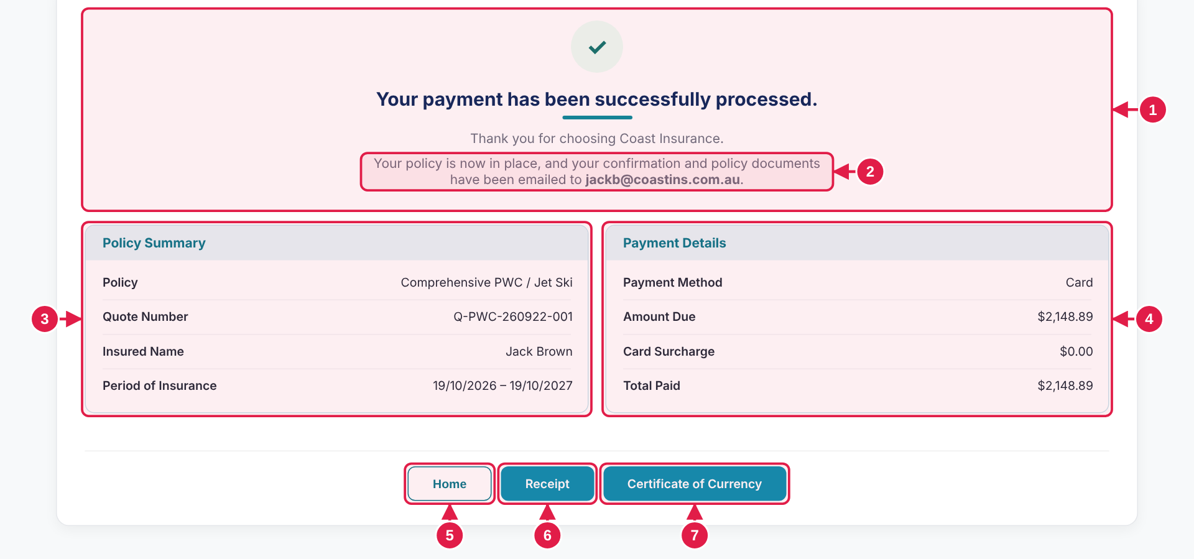


Pressing Receipt shows a message (1). Certificate of Currency shows a similar one.

# | Design · what it is | Colours and style
1 | Tick and message Tick, message and accent line. | Fill #ECFDF5 · Round (circle) · Size 56 × 56 px  20px · bold 700 · #09285C
2 | Email note The email address is bold. | 14px · regular 400 · #6B7280
3 | Policy Summary Four lines. | 14px · bold 700 · #08788B  Fill #E7F5F8  13px · semi-bold 600 · #1F2937
4 | Payment Details Four lines. | —
5 | Home Returns to the products page. | 13px · semi-bold 600 · #08788B  Fill #FFFFFF · Border 1px solid #08788B · Corner radius 8px · Size 90.1 × 37 px
6 | Receipt Shows a message (below). | 13px · semi-bold 600 · #FFFFFF  Fill #0891B2 · Corner radius 8px · Size 99.4 × 37 px
7 | Certificate of Currency Shows a message (below). | —

BEHAVIOUR
▸ The progress bar is hidden on this page. Receipt and Certificate of Currency each show a short message. Home returns to the products page.

MOCKUP vs KOVERUI In the mockup: The email address in the note is fixed and the documents are not produced.
In KoverUI: The customer's own email address is shown, and the receipt and certificate are sent.

COPY-READY TEXT · Use exactly as written. Select and copy from this box.
Message | Your payment has been successfully processed.  Thank you for choosing Coast Insurance. | Buttons | Home  Receipt  Certificate of Currency
Email note | Your policy is now in place, and your confirmation and policy documents have been emailed to jackb@coastins.com.au. | Receipt message | Your receipt has been emailed to you.
Panel 1 | Policy Summary · Policy · Quote Number · Insured Name · Period of Insurance | Certificate message | Your Certificate of Currency has been emailed to you.
Panel 2 | Payment Details · Payment Method · Amount Due · Card Surcharge · Total Paid

Pop-up · You Are Outside the Target Market for This Product REF PU-1
Shown when the customer presses Continue on Step 1 with an answer outside the target market.
Trigger A. Statement 1 answered False, then Continue → | ➜ | Trigger B. Question 11 answered Over 60 Knots / 110 kph, then Continue →
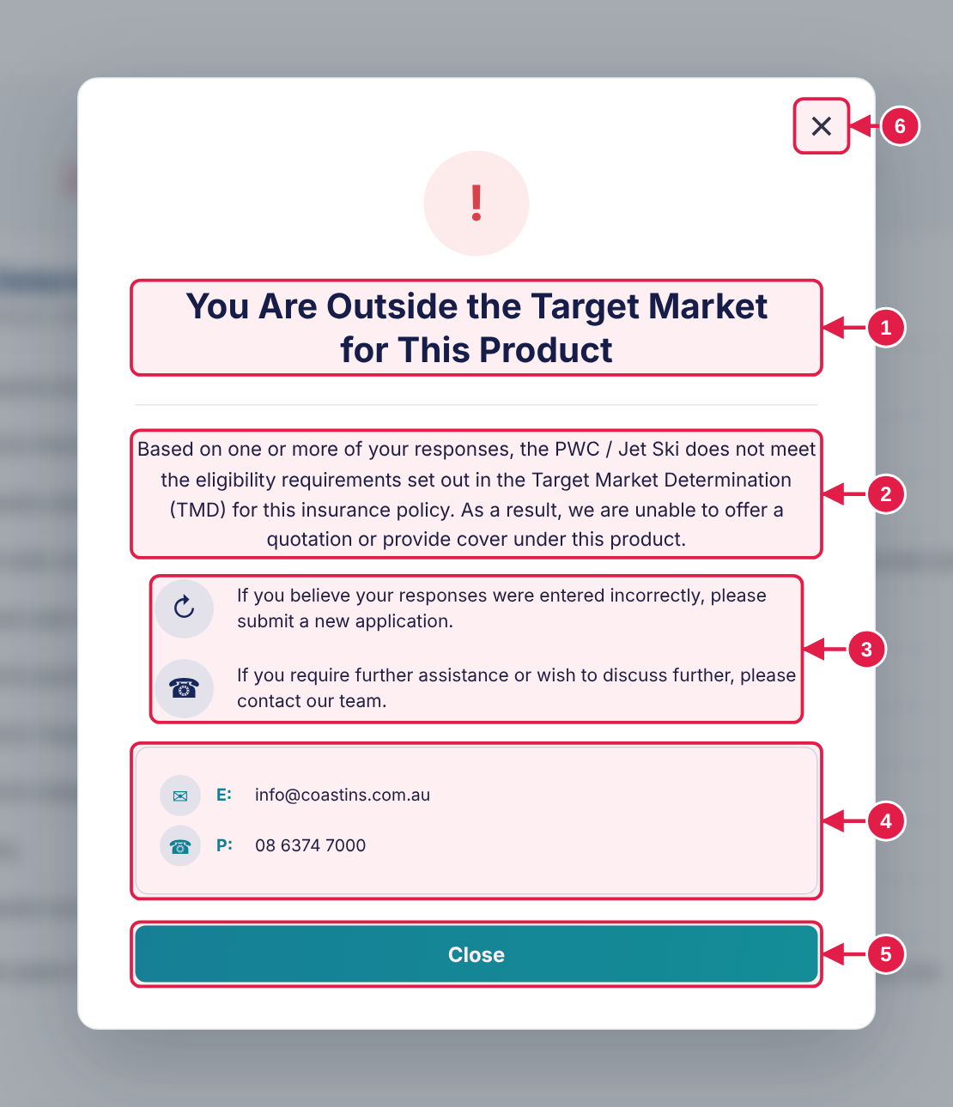  The pop-up opens on top of the page
  1 | Heading Warning icon above.
  2 | Explanation One paragraph.
  3 | Two guidance rows Each with its own icon.
  4 | Contact box Email and phone.
  5 | Close Leaves the quote and returns to the products page.
  6 | × in the corner Does the same as Close.

# | Design · what it is | Colours and style
— | Backdrop (dims the page) | Fill #142332 at 38%
— | Pop-up card | Fill #FFFFFF · Border 1px solid #E1E6EB · Corner radius 16px
1 | Heading | 27px · bold 700 · #071E49
2 | Explanation | 15px · regular 400 · #111F42
4 | Contact box | Fill #FFFFFF · Border 1px solid #D7E1E8 · Corner radius 10px
5 | Close button | 16px · bold 700 · #FFFFFF  Gradient 100°: #07879B to #04969E · Corner radius 8px · Size 530 × 44 px

BEHAVIOUR
▸ Opens when Continue is pressed on Step 1 with an answer outside the target market. Close and the corner × return to the products page.

COPY-READY TEXT · Use exactly as written. Select and copy from this box.
Heading | You Are Outside the Target Market  for This Product | Guidance | If you believe your responses were entered incorrectly, please submit a new application.  If you require further assistance or wish to discuss further, please contact our team.
Explanation | Based on one or more of your responses, the PWC / Jet Ski does not meet the eligibility requirements set out in the Target Market Determination (TMD) for this insurance policy. As a result, we are unable to offer a quotation or provide cover under this product. | Contact | E: info@coastins.com.au  P: 08 6374 7000
 |  | Button | Close

Pop-up · Referral: what the customer sees REF PU-2
Roadside / Verge / Nature Strip storage sends the quote for review instead of showing a price.
1. Storage Method Roadside / Verge / Nature Strip on Step 2, or on any additional PWC / Jet Ski | ➜ | 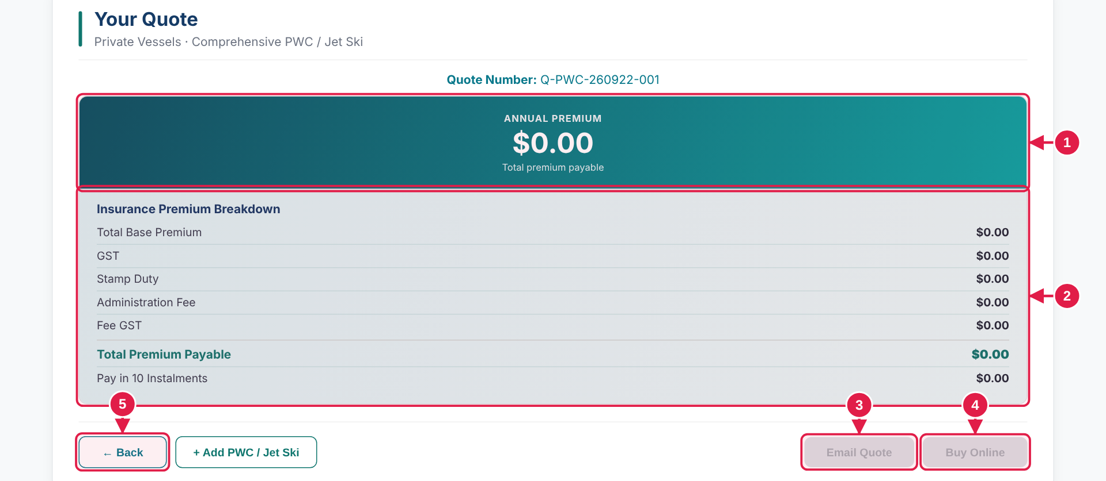  3. After the pop-up is closed, Your Quote shows no price

# | Design · what it is | Colours and style
1 | Annual premium Every amount shows $0.00. | 32px · bold 700 · #FFFFFF
2 | Breakdown Every line shows $0.00. | —
3 | Email Quote Greyed out and cannot be pressed. | 13px · semi-bold 600 · #8B939C  Fill #D1D5DB · Corner radius 8px
4 | Buy Online Greyed out and cannot be pressed. | —
5 | Back Still works. | —

BEHAVIOUR
▸ Triggered by the Roadside / Verge / Nature Strip storage answer. The customer sees no price; everything below the breakdown is hidden. Back still works.

WHAT IS HIDDEN Everything below the premium breakdown is hidden: Excesses, Your Cover, Policy Endorsements, Period of Insurance and the summaries.

Pop-up · You're almost there! REF PU-3
Opens on Your Quote when the quote is sent for review.
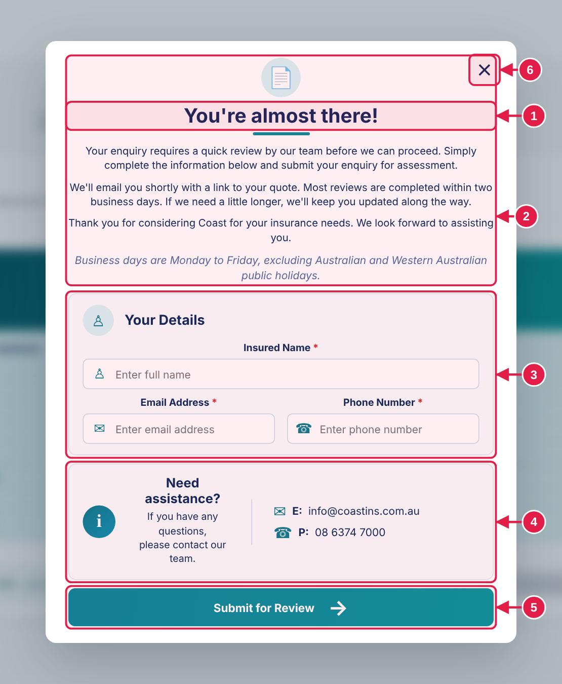
  1 | Heading Document icon above.
  2 | Explanation Four short paragraphs.
  3 | Your Details Insured Name, Email Address, Phone Number. All required.
  4 | Need assistance? Email and phone.
  5 | Submit for Review → Sends the enquiry.
  6 | × in the corner Closes the pop-up.

# | Design · what it is | Colours and style
— | Pop-up card | Fill #FFFFFF · Corner radius 14px
1 | Heading | 26px · bold 700 · #09285C
2 | Explanation paragraph | 13.5px · regular 400 · #09285C
3 | Text box | 14px · regular 400 · #1F2937  Size 478 × 35 px
4 | Assistance card | Fill #FBFCFD · Border 1px solid #DBE5EE · Corner radius 10px
5 | Submit button | 15px · bold 700 · #FFFFFF  Gradient 100°: #07879B to #04969E · Corner radius 9px · Size 560 × 50 px

BEHAVIOUR
▸ Opens on reaching Your Quote when the quote is sent for review. All three fields are required. Submit for Review returns to the products page.

MOCKUP vs KOVERUI In the mockup: Submit for Review returns to the products page.
In KoverUI: Submit sends the enquiry with the whole quote to your team.

COPY-READY TEXT · Use exactly as written. Select and copy from this box.
Heading | You're almost there! | Section | Your Details
Explanation | Your enquiry requires a quick review by our team before we can proceed. Simply complete the information below and submit your enquiry for assessment.  We'll email you shortly with a link to your quote. Most reviews are completed within two business days. If we need a little longer, we'll keep you updated along the way.  Thank you for considering Coast for your insurance needs. We look forward to assisting you.  Business days are Monday to Friday, excluding Australian and Western Australian public holidays. | Fields | Insured Name * Box shows: Enter full name  Email Address * Box shows: Enter email address  Phone Number * Box shows: Enter phone number
 |  | Need assistance? | Need assistance?  If you have any questions,  please contact our team.
 |  | Contact | E: info@coastins.com.au  P: 08 6374 7000
 |  | Button | Submit for Review →

Pop-up · Your quote is ready! REF PU-4
Opens when the customer presses Email Quote on Your Quote.
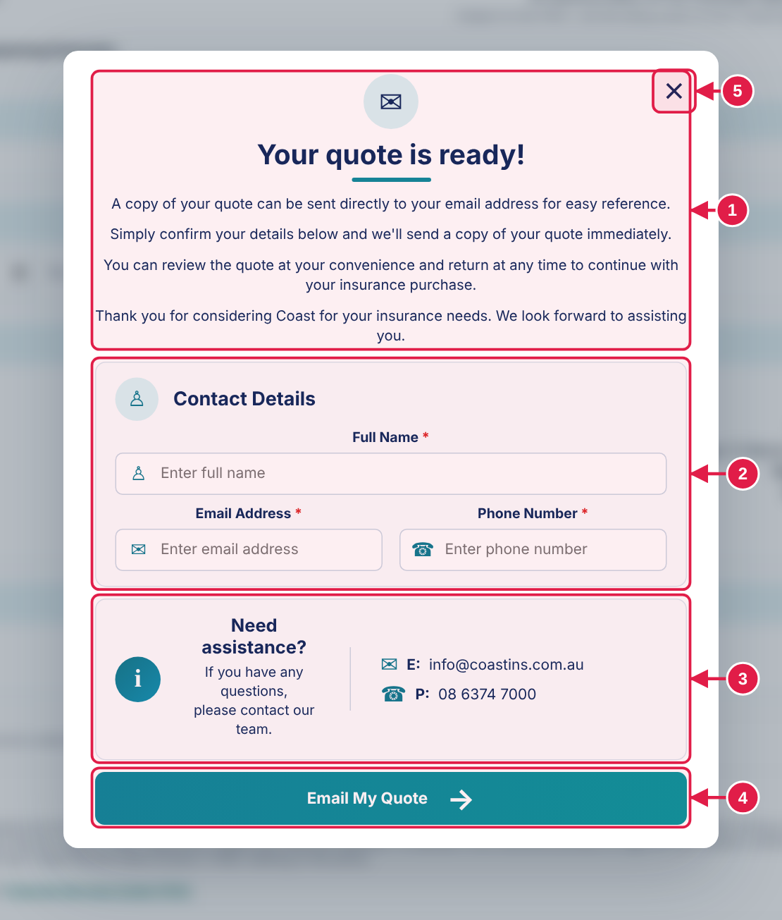
  1 | Heading and explanation Envelope icon above. Four short paragraphs.
  2 | Contact Details Full Name, Email Address, Phone Number. Filled in if already entered.
  3 | Need assistance? Email and phone.
  4 | Email My Quote → Sends the quote.
  5 | × in the corner Closes the pop-up.

# | Design · what it is | Colours and style
— | Pop-up card | Fill #FFFFFF · Corner radius 14px
1 | Heading | 26px · bold 700 · #09285C
2 | Text box | 14px · regular 400 · #1F2937  Size 478 × 35 px
4 | Email My Quote button | 15px · bold 700 · #FFFFFF  Gradient 100°: #07879B to #04969E · Corner radius 9px · Size 560 × 50 px

BEHAVIOUR
▸ Opens from Email Quote. Fields are filled in where already known. Email My Quote returns to the products page.

MOCKUP vs KOVERUI In the mockup: Email My Quote returns to the products page.
In KoverUI: The quote is emailed to the customer.

COPY-READY TEXT · Use exactly as written. Select and copy from this box.
Heading | Your quote is ready! | Fields | Full Name * Box shows: Enter full name  Email Address * Box shows: Enter email address  Phone Number * Box shows: Enter phone number
Explanation | A copy of your quote can be sent directly to your email address for easy reference.  Simply confirm your details below and we'll send a copy of your quote immediately.  You can review the quote at your convenience and return at any time to continue with your insurance purchase.  Thank you for considering Coast for your insurance needs. We look forward to assisting you. | Need assistance? | Need assistance?  If you have any questions,  please contact our team.
Section | Contact Details | Contact | E: info@coastins.com.au  P: 08 6374 7000
 |  | Button | Email My Quote →

Feature · Skipper details warning REF FT-1
Stops the customer moving on with skipper details missing, once.
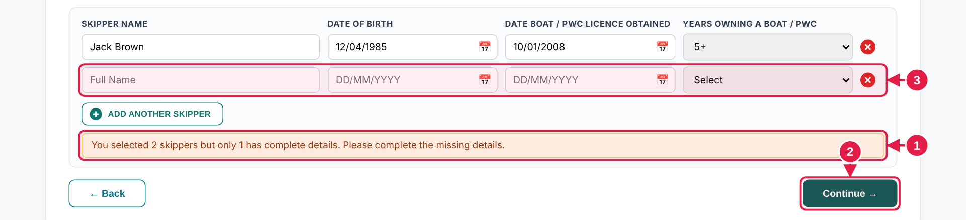  1. Customer chose 2 skippers, filled in 1, and presses Continue → (2). The warning shows (1). The page does not move. | ➜ | 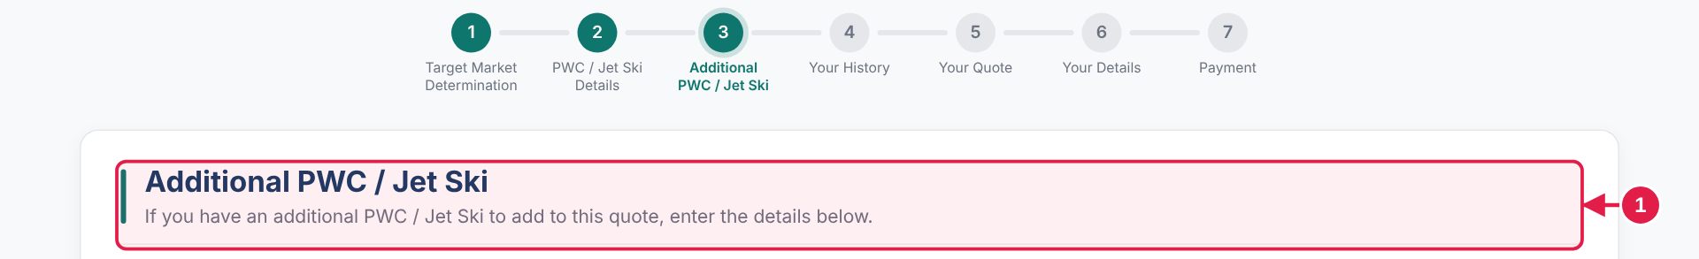  2. Customer presses Continue → again. The page moves on.

# | Design · what it is | Colours and style
1 | Warning Yellow box under the skipper rows: fill #FFFBEB , border #FCD34D , text #92400E . | 12.5px · regular 400 · #92400E  Fill #FFFBEB · Border 1px solid #FCD34D · Corner radius 6px
2 | Continue → First press shows the warning. A second press, with nothing changed, moves on. | —
3 | Empty row The row that still needs details. | —

BEHAVIOUR
▸ The first press of Continue with skipper details missing shows the warning and the page does not move. A second press, with nothing changed, moves on.
▸ The sentence changes with the count of skippers still missing. It appears under every skipper block, on Step 2 and on each additional PWC / Jet Ski.

COPY-READY TEXT · Use exactly as written. Select and copy from this box.
No details done | You selected 2 skippers but no skipper details are complete. Please complete the missing details. | How the sentence changes | You selected [number] skipper(s) but only [number] has / have complete details. Please complete the missing details.  Or: …but no skipper details are complete. Please complete the missing details.
Some details done | You selected 2 skippers but only 1 has complete details. Please complete the missing details.  You selected 3 skippers but only 2 have complete details. Please complete the missing details.

Feature · Previous skipper picker REF FT-2
On an additional PWC / Jet Ski the customer can copy a skipper already entered.
1. A Previous skipper dropdown sits above the skipper rows (1) | ➜ | 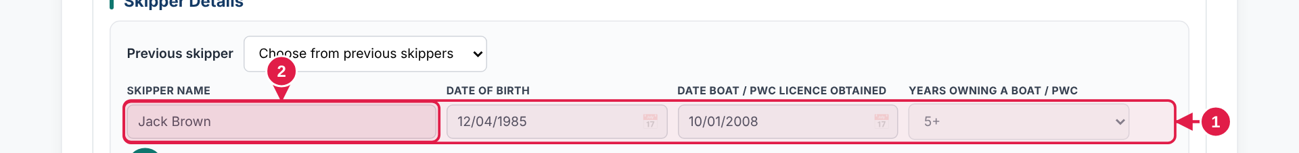  3. Choosing one fills the row. The row is greyed and locked (1, 2).

# | Design · what it is | Colours and style
1 | Picker Plain dropdown, no search. Label PREVIOUS SKIPPER (13px, bold, capitals). Placeholder shown only when closed. | —
2 | Locked row Name, dates and years are greyed out (fill #F3F4F6 , text #4B5563 ) and cannot be edited. Hovering shows the tooltip below. | 13px · regular 400 · #4B5563  Fill #F3F4F6 · Border 1px solid #D1D5DB · Corner radius 6px

BEHAVIOUR
▸ Only on additional PWC / Jet Skis. Choosing a skipper copies the details into the row and locks it; hovering a locked box shows the tooltip.
▸ It is a plain dropdown with no search. With nothing to pick it shows No matches.

COPY-READY TEXT · Use exactly as written. Select and copy from this box.
Label | Previous skipper | When none to pick | No matches
Dropdown text | Select (If Applicable) | Tooltip on locked fields | Details copied from a previously added skipper

Feature · Removing a skipper or PWC / Jet Ski REF FT-5
A short check before details are deleted. It appears in place, never as a pop-up.
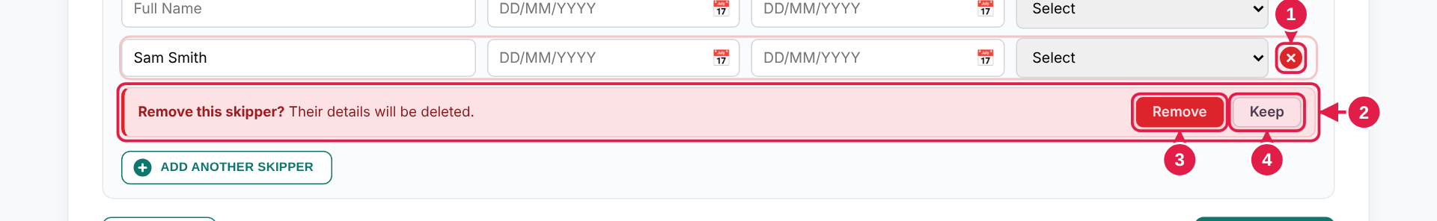  Skipper row. × (1) opens the bar (2) under the row. Remove (3) deletes, Keep (4) cancels. | ➜ | 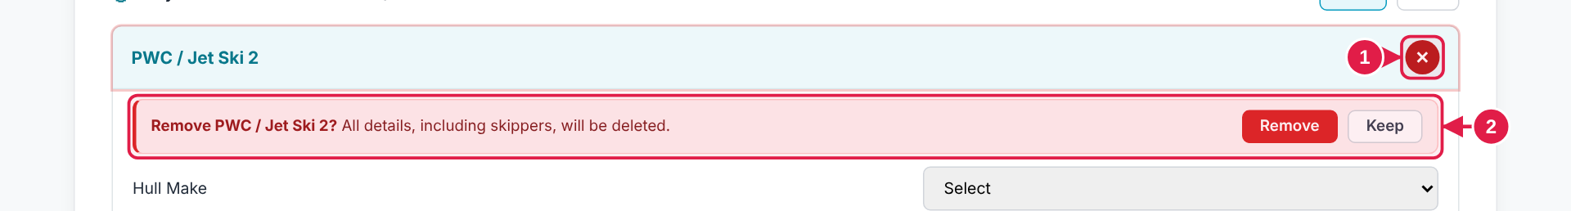  PWC / Jet Ski card. The same bar under the card heading.

# | Design · what it is | Colours and style
1 | × cross Small red circle, white cross. | Fill #DC2626 · Round (circle) · Size 20 × 20 px
2 | Confirmation bar Pale red bar under the row or card heading. | 12.5px · regular 400 · #7F1D1D  Fill #FEF2F2 · Top border 1px #FECACA · Right border 1px #FECACA · Bottom border 1px #FECACA · Left border 3px #DC2626 · Corner radius 8px
3 | Remove Red button. | 12.5px · semi-bold 600 · #FFFFFF  Fill #DC2626 · Border 1px solid #DC2626 · Corner radius 6px
4 | Keep Outline button. Focused by default. | 12.5px · semi-bold 600 · #374151  Fill #FFFFFF · Border 1px solid #D1D5DB · Corner radius 6px

BEHAVIOUR
▸ The bar only appears when the row or card has details in it. An empty row or card is removed straight away.
▸ It closes on Keep, Esc, a click anywhere else, or after about 12 seconds. Only one bar shows at a time.

COPY-READY TEXT · Use exactly as written. Select and copy from this box.
Skipper row | Remove this skipper?  Their details will be deleted. | Buttons | Remove Keep
PWC / Jet Ski card | Remove PWC / Jet Ski 3?  All details, including skippers, will be deleted.

Feature · Searchable dropdowns REF FT-3

# | Design · what it is | Colours and style
1 | Search box Typing narrows the list straight away. | 13px · regular 400 · #000000  Fill #FFFFFF · Border 1px solid #0F766E · Corner radius 6px · Size 402 × 34 px
2 | List Best match first. The highlighted option is the one chosen on Enter. | 13px · semi-bold 600 · #0F766E  Fill #E6F7FB  13px · semi-bold 600 · #0F766E  Fill #E6F7FB

BEHAVIOUR
▸ Every dropdown opens a search box and forgives small typos, except Previous skipper, which is a plain list.

COPY-READY TEXT · Use exactly as written. Select and copy from this box.
Search box text | Type to search | When nothing matches | No matches

Feature · Input formats REF FT-4

BEHAVIOUR
▸ Dates are typed as DD/MM/YYYY, slashes are added as the customer types, and the calendar button opens a date picker. Money boxes show $ and commas. Hull Length shows two decimals. Address is a search box with an Enter address manually link that swaps in four boxes.

COPY-READY TEXT · Use exactly as written. Select and copy from this box.
Address link | Enter address manually  Search for an address instead | Date box | DD/MM/YYYY
Manual boxes | Street address · Suburb · State · Postcode  State is a dropdown | Money box | $0

