Department of Computer Science and Information Technology

CENTRAL UNIVERSTY OF HARYANA

JANT-PALI, MAHENDRAGARH, HARYANA - 123031

**ASSIGNMENT**

ON

DATA STRUCTURES (SBS CS 01 01 01 C 3104)

**MASTER OF COMPUTER APPLICATIONS**

(MCA 1ST SEMESTER)

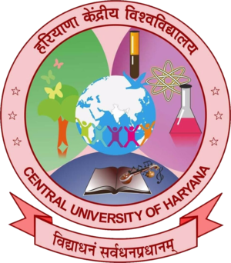

**Submitted to Submitted by**

Dr. Keshav Singh Rawat **Name:** Ravish Ranjan

Associate Professor, CS&IT  **Roll No.:** 240484