Project : Azure Automation Runbooks for VM Start and Stop Schedules
Submitted by: R. Ravi shankar
2400030511, CSE-1
Abstract
The Azure Automation Runbooks for VM Start and Stop Schedules project is designed to automate the starting and stopping of Azure Virtual Machines (VMs) according to predefined schedules. The main purpose of the project is to reduce unnecessary usage of non-production Virtual Machines outside business hours and thereby reduce cloud infrastructure costs.
The project uses Azure Automation Runbooks to execute automated start and stop operations on Virtual Machines at specified times. For example, development and testing VMs can be automatically stopped after working hours and started again before the working day begins. This reduces the time for which non-production resources remain idle and helps in controlling the test environment bill.
The project also addresses important operational and security requirements. Monitoring and alerting are included so that failures of automation runbooks do not go unnoticed. A managed identity is used to authenticate the automation process with Azure resources, while permissions are kept limited to only the operations required for starting and stopping Virtual Machines.
Overall, the project provides an automated, cost-efficient, secure, and manageable solution for scheduling Azure VM operations without requiring users to manually start or stop Virtual Machines every day.

2. Project Architecture Diagram
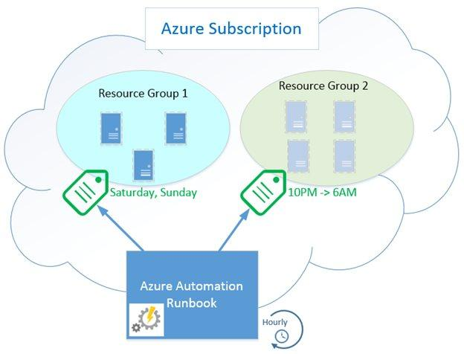
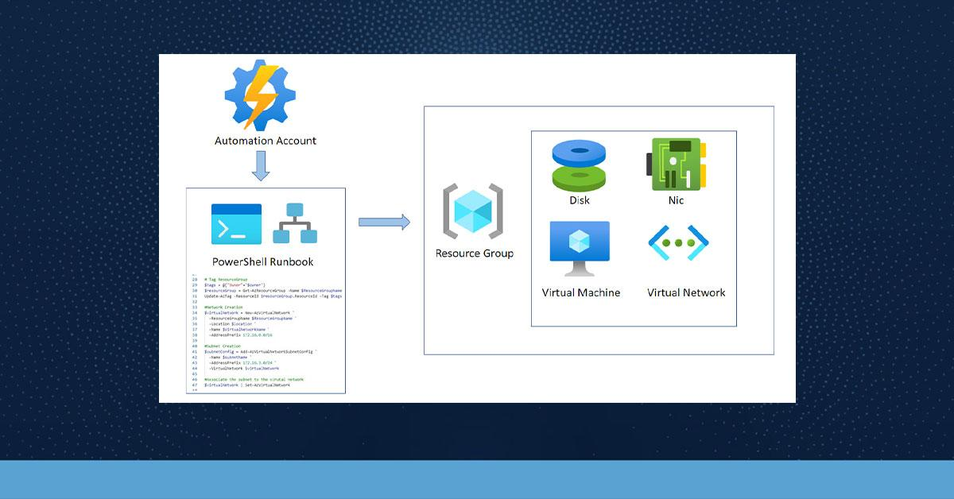
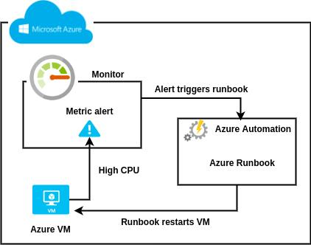

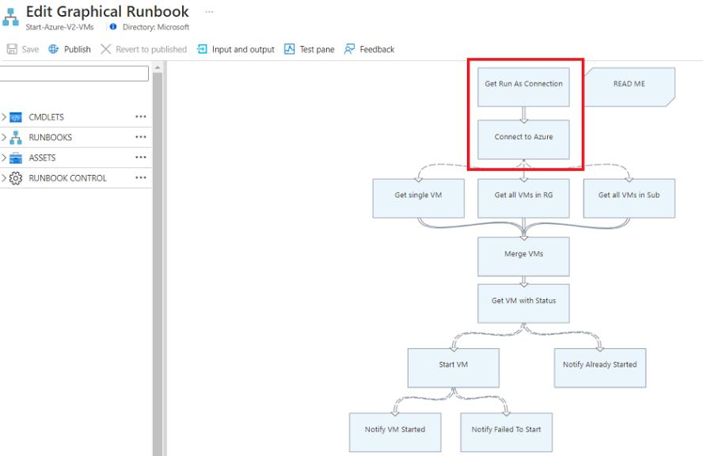
Architecture Explanation
The architecture consists of the following components:
1. Schedule / Trigger
The schedule defines when the Virtual Machines should be started or stopped. For example, VMs can be stopped after business hours and started before business hours.
2. Azure Automation Account
The Automation Account provides the environment for running automation jobs and managing the runbooks.
3. Automation Runbook
The Runbook contains the automation script, such as PowerShell or Azure CLI commands, required to start or stop the selected Virtual Machines.
4. Managed Identity
The Managed Identity allows the Automation Runbook to authenticate with Azure resources without storing usernames, passwords, or access keys. Its permissions should be restricted to the operations required by the project.
5. Azure Resource Manager / VM API
The runbook communicates with Azure resources through Azure Resource Manager to perform the required start or stop operation on Virtual Machines.
6. Non-Production Virtual Machines
These include development and testing VMs. They are automatically stopped when they are not required and started when they are needed.
7. Monitoring and Alerting
The execution status of automation jobs is monitored. If a runbook fails, an alert can be generated so that the failure can be investigated instead of remaining unnoticed.

3. Services / Technologies Required
Service / Technology | Purpose
Microsoft Azure | Cloud platform where the complete solution is deployed
Azure Virtual Machines | Non-production VMs that will be automatically started and stopped
Azure Automation Account | Hosts and manages the automation runbooks
Azure Automation Runbooks | Contains scripts for starting and stopping VMs
Azure Automation Schedules | Defines the specific start and stop times
Managed Identity | Provides secure authentication for the runbook
Azure RBAC | Controls what actions the managed identity can perform
Azure Resource Manager | Provides access to Azure VM management operations
PowerShell / Azure CLI | Used to write the automation commands inside the runbook
Azure Monitor | Monitors automation jobs and resource activity
Azure Alerts / Action Groups | Sends notifications when runbook execution fails
Azure Portal | Used to configure, manage, and monitor the Azure resources
Technologies Used
- Cloud Platform: Microsoft Azure
- Automation: Azure Automation
- Scripting: PowerShell / Azure CLI
- Compute: Azure Virtual Machines
- Authentication: Managed Identity
- Authorization: Azure RBAC
- Monitoring: Azure Monitor
- Alerting: Azure Alerts / Action Groups
- Management Interface: Azure Portal

Simple Project Flow
Scheduled Time → Automation Account → Runbook → Managed Identity → Azure VM → Start/Stop Operation → Monitoring → Alert if Failure
Example
At 7:00 PM:
Schedule triggers the stop runbook → Runbook authenticates using Managed Identity → Azure checks permissions → Non-production VM is stopped.
At 8:00 AM:
Schedule triggers the start runbook → Runbook authenticates using Managed Identity → Non-production VM is started.
This directly addresses your two main use cases:
- Shut down non-production VMs outside business hours.
- Reduce the test environment's VM running cost, targeting approximately 50% savings through scheduled shutdowns.
And it addresses the two identified bottlenecks:
- Runbook failures: Azure Monitor and alerts notify the team when automation fails.
- Over-scoped permissions: Managed Identity + Azure RBAC restricts the runbook to the permissions it actually needs.

