**TACC- Visualization Portal Guide**

1. Google “TACC Visualization Portal” or visit <https://vis.tacc.utexas.edu/>
2. Then you will be able to access a page as shown below.

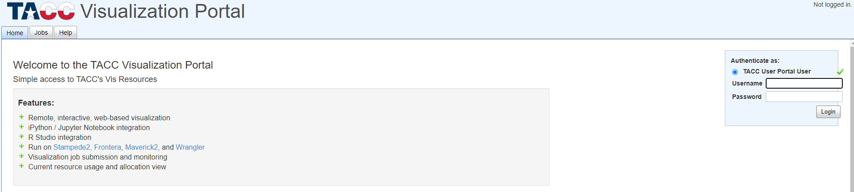

1. Then on the right side, log in to your TACC User Portal by entering your username and password.
2. 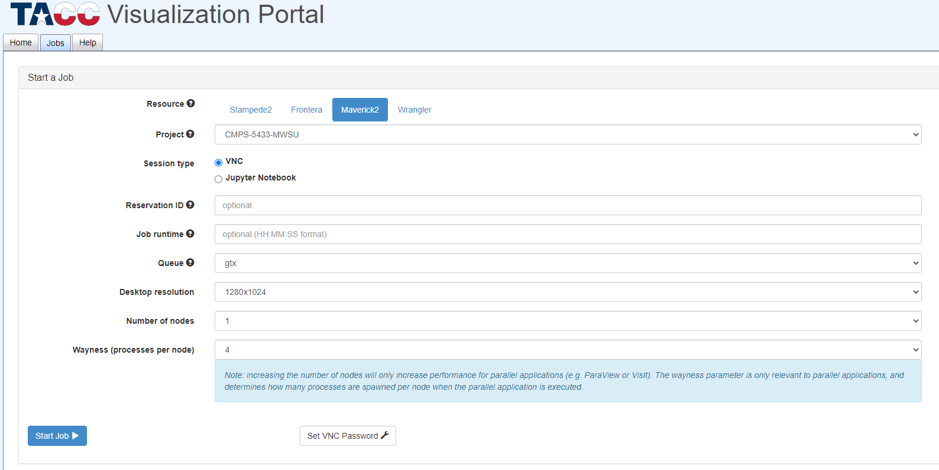After log in, you will be directed to a page as shown below.
3. Then select the cluster you are using under “Resource” which will be “Maverick2”.
4. Then click in the below “set VNC Password”. And set up a password that is preferable for you. You will need to set this up only for the first-time access. (Your TACC User Portal password and VNC password can be the same).
5. After setting up the VNC Password, click “Start Job” button. Then it will start a new job.
6. Once the job begins, it will display a new desktop. And you will have a time period of 4 hours to complete your tasks.

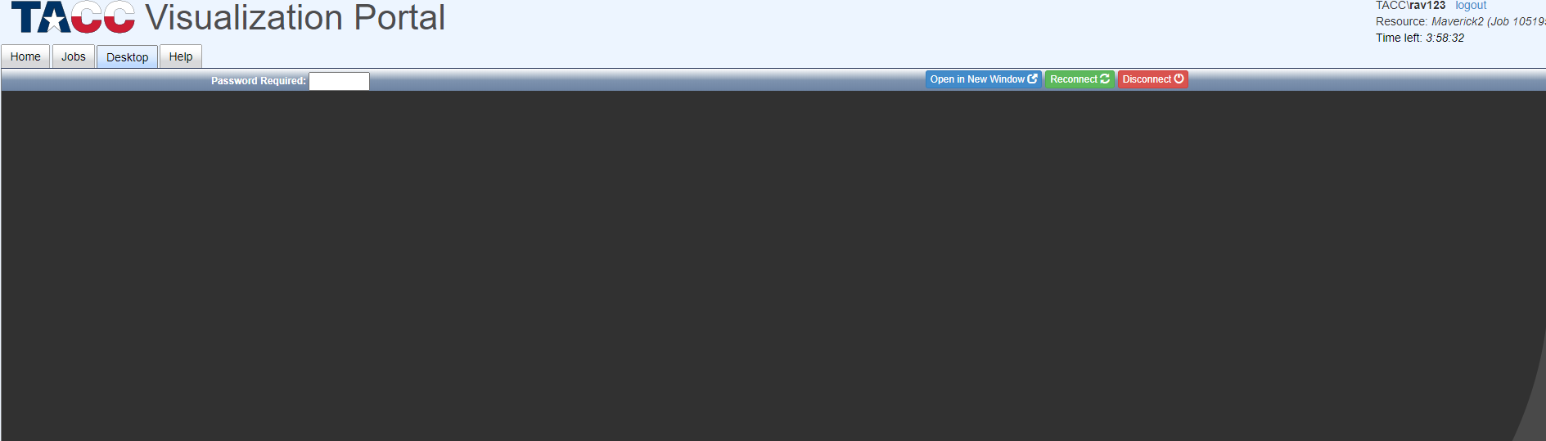

1. 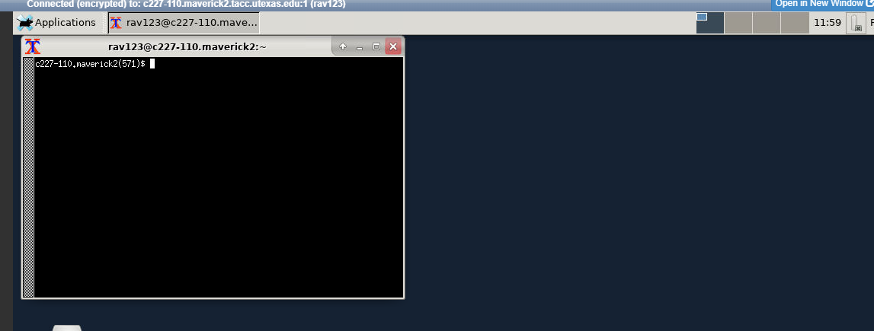Enter your “Password” in the “Password Required” box. Then you will get another command box.
2. To access NVidia Visual Profiler, you need to type two commands.   
   First “module load cuda”. Hit Enter  
   second “nvvp”. Hit Enter

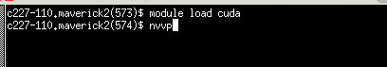

1. You will be asked to pick a workspace. Then you will be directed to Visual Profiler. The page displayed initially is shown below.
2. 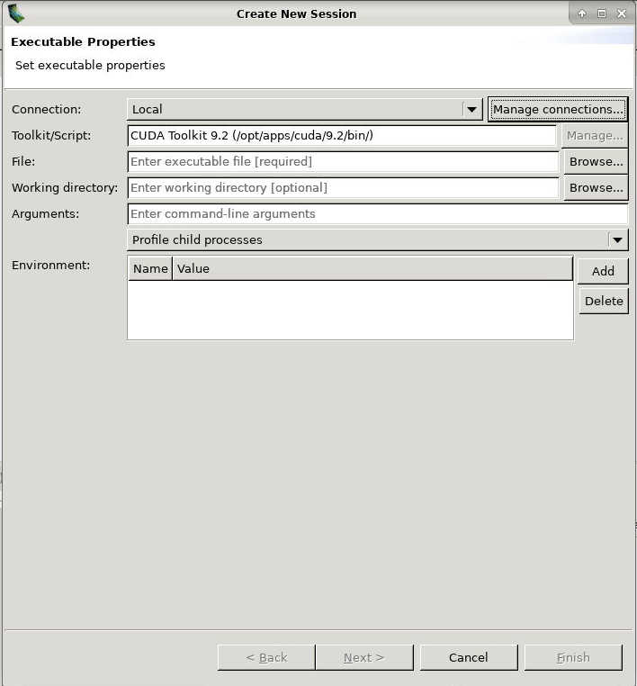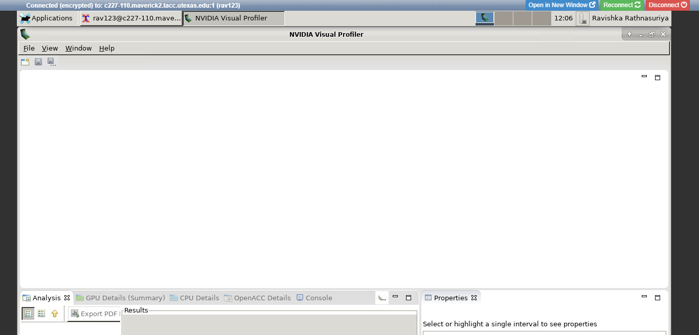Go to files -> New Session, you will get another page shown below.
3. On this page, you need to select **File** by clicking the “browse” that is related to the file. The file you are picking must be an **executable file** (not .cu file, script file).   
   Selecting a working directory is optional. Then hit “finish” button in the below.   
   Then you will get another page as shown below.

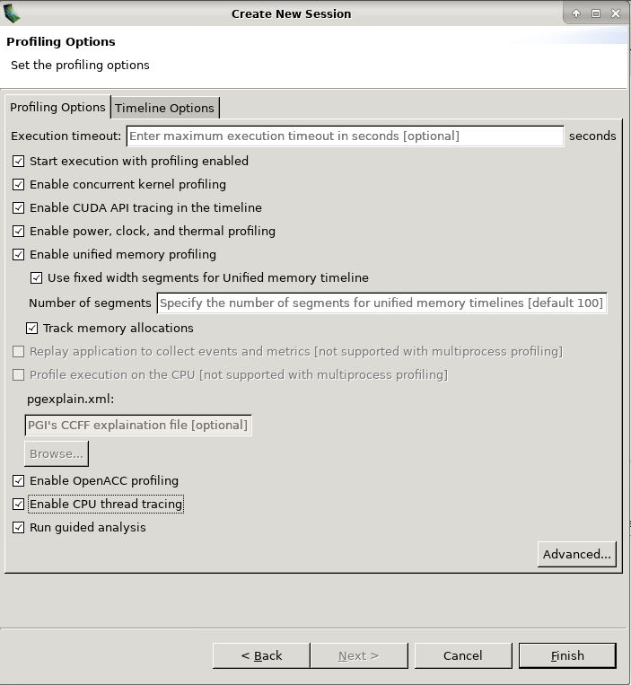

1. You can pick any options you need for profiling. Once you have done, hit “Finish”. Then it will start generating your timeline. Then you will get a profiler. (Something looks alike as below)
2. 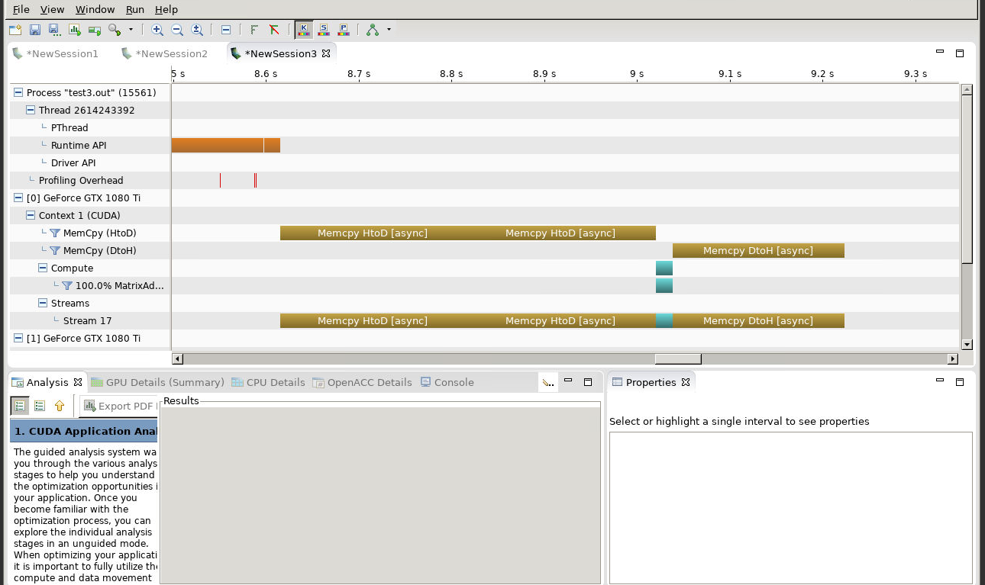There are many features you can identify from this visual profiler. It’s a very helpful tool to analyze your CUDA programs and make improvements.
3. Also, you can limit the program region you need to analyze by including cudaProfilerStart() and cudaProfilerEnd(). Read the link provided below to get more information about using commands and visual profiling using CUDA.

<https://docs.nvidia.com/cuda/profiler-users-guide/index.html>