A PROJECT REPORT ON

**STUDENT ACADEMY**

Submitted in partial fulfillment of the requirements

For the award of the degree of

**BACHELOR OF TECHNOLOGY**

In

Computer Science & Engineering

By

K.KARTHIKEYA, 411530

M.RAVITEJ, 411544

G. NAVEEN REDDY, 411525

G.SHIVA,411535

Under the esteemed guidance of

**Ms G. JAYA LAKSHMI**

**Assistant Professor, CSE Department**



**Department of Computer Science and Engineering**

**NATIONAL INSTITUTE OF TECHNOLOGY,**

**Andhra Pradesh.**

**ACKNOWLEDGEMENT**

I express my deep gratitude and regards to Ms. G.Jayalakshmi , Internal Guide and Assistant Professor, Department of Computer Science & Engineering for her encouragement and valuable guidance in bringing shape to this dissertation.

I am grateful to Ms G.Bhavya, Professor & Head of the Department, Department of Computer Science & Engineering, NIT ANDHRA PRADESH for the encouragement and motivation. I am thankful to all the Professors and Faculty Members in the department for their teachings and academic support and thanks to Technical Staff and Non-teaching staff in the department for their support.

**STUDENT ACADEMY**

**ABSTRACT**

Student Academy system is a project which aims in developing a computerized system to maintain all the daily work of library and work of companies during campus placements and provides complete reference for student education..This project has many features which are generally not available in normal systems as all features are combined at one place .It also has a facility of admin login through which the admin can monitor the whole system. The librarian after logging into his account i.e. admin account can add or remove librarians, companies and book websites.

Overall this project of ours is being developed to help the students, companies, library in the best way possible and also reduce the human efforts.

**TABLE OF CONTENTS**

1. **INTRODUCTION**--------------------------------------------------------------------------------6
   1. Purpose
   2. Project
   3. References and Bibliography---------------------------------------------------7
2. **OVERALL DISCRIPTION-----------------------------------------------------7**
   1. Data flow diagram----------------------------------------------------------------9
3. **FUNCTIONAL REQUIREMENTS------------------------------------------10**
   1. Context diagram----------------------------------------------------------------10
   2. Functional requirements--------------------------------------------------------11
4. **SOFTWARE AND HARDWARE INTERFACES------------------------12**
   1. Interface Requirements---------------------------------------------------------12
   2. Hardware Interfaces-------------------------------------------------------------12
   3. Software Interfaces--------------------------------------------------------------12
5. **NON FUNCTIONAL REQUIREMENTS----------------------------------13**
   1. Communications Interfaces----------------------------------------------------13
   2. Operational Requirements------------------------------------------------------13
   3. Security and Privacy------------------------------------------------------------13
   4. Reliability-------------------------------------------------------------------------13
   5. System Availability-------------------------------------------------------------13
   6. Performance----------------------------------------------------------------------13
6. **SOFTWARE DESIGN----------------------------------------------------------14**
   1. Use case diagram----------------------------------------------------------------14
   2. Class diagram--------------------------------------------------------------------14
   3. Interaction diagram
   4. Sequence diagram---------------------------------------------------------------15
   5. Collaboration diagram
   6. Activity diagram-----------------------------------------------------------------16
   7. Component diagram------------------------------------------------------------17
   8. Deployment diagram-----------------------------------------------------------17
7. **CODING MODULES-----------------------------------------------------------18**
8. **TESTING--------------------------------------------------------------------------23**
   1. Unit testing-----------------------------------------------------------------------23
   2. Integration testing---------------------------------------------------------------24
   3. Alpha and Beta testing----------------------------------------------------------24
   4. Black box testing and White box testing-------------------------------------25

1. **TESTCASES----------------------------------------------------------------26**
2. **SCREENSHOTS-----------------------------------------------------------27**
3. **CONCLUSION AND FUTURE WORK------------------------------32**

\

# Introduction

The introduction of the Software Requirements Specification (SRS) provides an overview of the entire SRS with purpose, scope, definitions and overview of the SRS .The aim of this document is to gather and analyze and give an in-depth insight of the complete **Student Academy software system** by defining the problem statement in detail. Nevertheless, it also concentrates on the capabilities required by stakeholders and their needs while defining high-level product features. The detailed requirements of the **Student Academy** are provided in this document.

## Purpose

The purpose of the document is to maintain all references that are compulsory for the student. The main purpose of the project is to maintain easy circulation system between students and companies and librarian ,to upload resume ,to shortlist students based on resume, to search and reserve book from library, to view workshops and conferences. Moreover if books are not available in library, it provides interface to buy online.

## Scope

The different areas where we can use this application are:

• Any education institute can make use of it for providing information about campus placements, content of the available books, workshops and conferences.

• It can be used by companies during campus placements and modifications can be easily done according to requirements.

* Provide additional flexibility and convenience to the companies during placements.
* The availability of information at any time via internet in pc at any place..

## References

The references are:

* Campus Recruitment System Model(http://nevonprojects.com/campus-recruitment-system)
* Library Management Model
* To-Do List

## Bibliography

Books:

* Software Engineer Practitioner Approach (By Roger Pressman)
* The Complete Reference Java(McGraw-Hill; Herbert Scheldt- reprint 2008)

# Overall Description

This document contains the problem statement that the current system is facing which is hampering the growth opportunities of the company. It further contains a list of the stakeholders and users of the proposed solution. It also illustrates the needs and wants of the stakeholders that were identified in the brainstorming exercise as part of the requirements workshop. It further lists and briefly describes the major features and a brief description of each of the proposed system.

The following SRS contains the detail product perspective from different stakeholders. It provides the detail product functions of **Student Academy** with user characteristics permitted constraints, assumptions and dependencies and requirements subsets.

**2.1 PRODUCT PERSPECTIVE**

A distributed database system for this project stores the following information.

* **Student details:**  
  It includes student’s name, roll number, email id, resume, cgpa etc.
* **Company details:**   
  It includes companies name and other relevant information.
* **Website details:**  
  It includes names of all student friendly websites along with their links.
* **Workshops and Conferences details:**

It includes all workshops and conferences details such as name, location, date and timings etc.

* **Books details:**

It includes all academic relevant books available in college library and also online shopping websites links.

* **To-Do details:**

It includes one week schedule of the student which he/she uploads.

**2.2 OPERATING ENVIRONMENT**

Operating environment for the **Student Academy** system is as listed below.

* distributed database
* client/server system
* Operating system: Windows.
* database: sql+ database
* platform: html/Java/Javascript/JDBC

**DATA FLOW DIAGRAM**

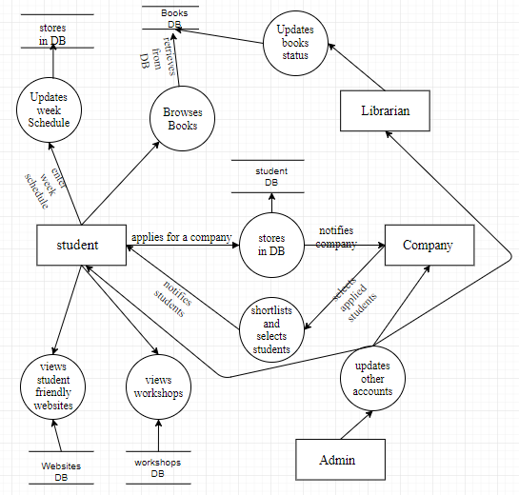

# Functional Requirements

The functional requirements are –

## Context diagram

The following flow chart describes the flow of data in the **Student Academy** system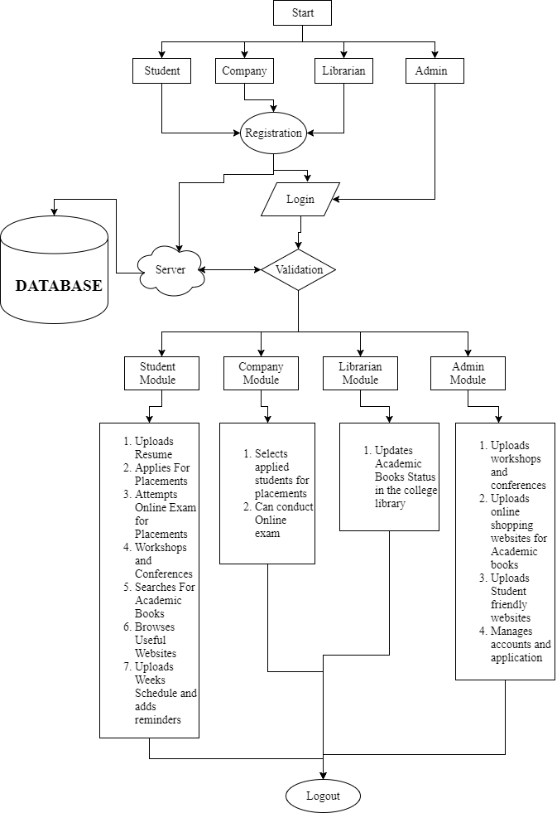

**3.2 Functional Requirements**

This subsection contains the requirements for the **Student Academy**. These requirements are organized by the features discussed in the vision document. Features from vision documents are then refined into use case diagrams and to sequence diagram to best capture the functional requirements of the system.

There are 4 types of logins in Student Academy. They are:

1. Student Login
2. Company Login
3. Librarian Login
4. Admin Login

### **Their Functional Requirements are:**

**Student Functionalities:**

* Registers and logs in
* Uploads his/her Resume
* Applies for placements by selecting the companies
* Attempts Online exam conducted by companies for placements
* Can register for workshops and conferences
* Searches for academic books in library, if not available then he/she can get online shopping websites links for the book
* Can browse for Student friendly websites
* Can upload a week schedule and gets notification about their schedule

### **Company Functionalities:**

* Registers and logs in
* Selects students (whoever applied) and can shortlist them
* Can conduct Online exam for selected students

### **Librarian Functionalities:**

* Registers and logs in
* Updates the status of Academic books in the library

### **Admin Functionalities:**

* Logs in
* Can delete any account
* Uploads list of workshops and conferences
* Uploads online shopping websites for academic books
* Uploads Student friendly websites
* Manages all accounts and application

# Software and Hardware interfaces:

**4.1Interface Requirements:**

* The user interface will be implemented using HTML, JSP, JDBC and SQL Languages.

**4.2Hardware Interfaces**:

* Windows.
* A browser which supports CSS, HTML & JavaScript.

**4.3 Software Interfaces**:

Following are the software used for the STUDENT ACADEMY system

|  |  |
| --- | --- |
| **Software used** | **Description** |
| Operating system | We have chosen Windows operating system for its best support and user-friendliness. |
| Database | To save the Student, company, books, websites, weekly schedule records we have chosen SQL+ database. |
| Javascript, HTML, CSS, SQL | To implement the project we have chosen JavaScript language for its more interactive support. |
| JDBC | For Connectivity to Database. |

**5.Non Functional Requirements**

**5.1 Communication Interfaces:**

This project supports all types of web browsers. User should have connectivity with the server JDBC connectivity.

**5.2 Operational Requirements:**

**Student Academy** Software should run on windows server or Linux server.

**5.3 Security and Privacy:**

System provides User Name and Password for all accounts.

**5.4Reliability:**

1. **Frequency of Failures**:

1.1 Server restarts: Due to some technical problems, if the system is turning off, then user can continue his work once the server is available.

2. **Recoverability**:

2.**1 Backup support**: If the server is crashed due to some technical problems, back up will be stored in the system and Administrator can restore the backup.

**5.5 System Availability:**

System can available at any time then user can able to register at any time.

**5.6 Performance:**

System supports multiple users.

**5. 7 GLOSSARY:-**

**JSP:** Java Script.

**HTML:** Hyper Text Markup Language.

**JDBC:** Java Database Connectivity.

**SOFTWARE DESIGN**

**USE CASE DIAGRAM**

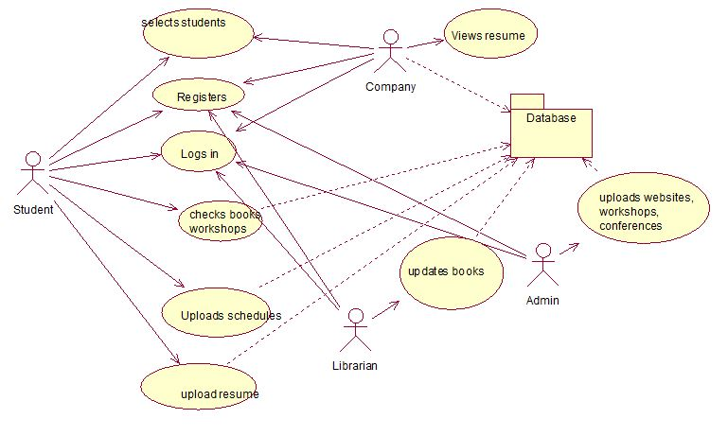

**CLASS DIAGRAM:**

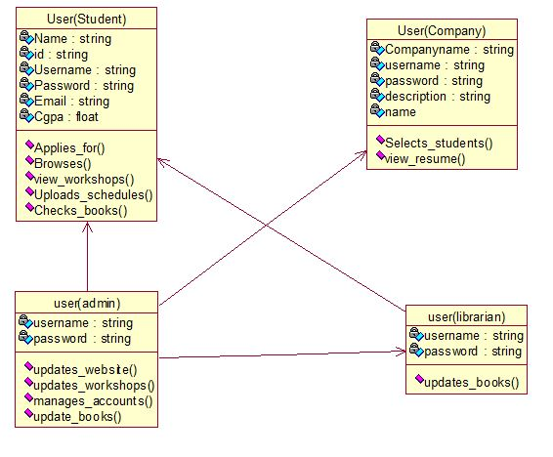

**FIG : SEQUENCE DIAGRAM**

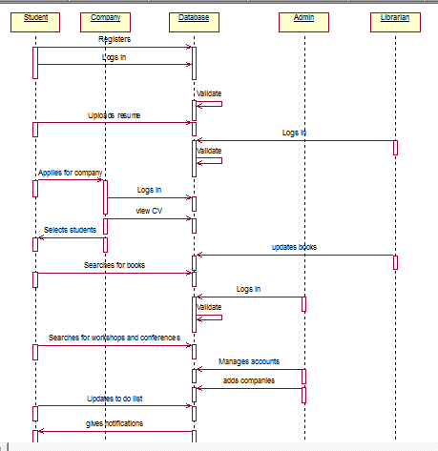

**FIG : ACTIVITY DIAGRAM**

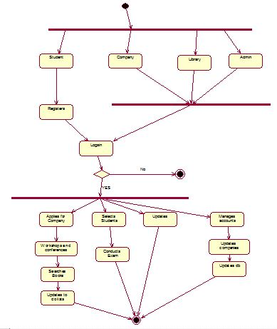

**FIG : COMPONENT DIAGRAM**

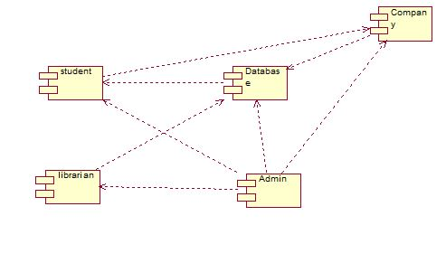

**FIG : DEPLOYMENT DIAGRAM**

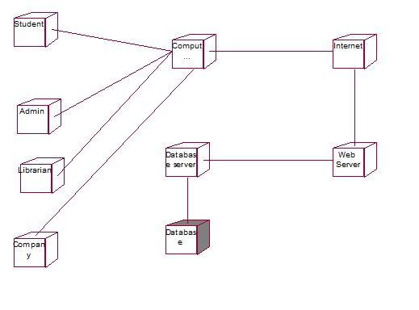

**CODING**

<!DOCTYPE html PUBLIC "-//W3C//DTD XHTML 1.0 Transitional//EN" "http://www.w3.org/TR/xhtml1/DTD/xhtml1-transitional.dtd">

<html xmlns="http://www.w3.org/1999/xhtml">

<head>

<meta http-equiv="Content-Type" content="text/html; charset=utf-8" />

<link rel="stylesheet" type="text/css" href="css/style.css">

<title>WELCOME TO STUDENT ACADEMY</title>

<!-- slider begins-->

<link href="css/js-image-slider.css" rel="stylesheet" type="text/css" />

<script src="js/js-image-slider.js" type="text/javascript"></script>

<!-- slider ends-->

<!-- menu begins-->

<link href="css/menu.css" rel="stylesheet" type="text/css" />

<!-- menu ends-->

<!-- favicon generator begins--->

<link rel="shortcut icon" type="image/x-icon" href="images/favicon.ico">

<!-- favicon generator ends-->

</head>

<body>

<!-- container begins-->

<div class="container">

<!-- header begins-->

<div class="header" >

<div class="head">

<!-- head left begins-->

<div class="headleft">

<a href="index.html" style="height:auto;width:auto;margin-left:-60px;"><imgsrc="images/slider/logo3.png" /></a>

</div>

<!-- head left ends-->

<!-- head right begins-->

<div class="headright">

<!-- head top begins-->

<div class="headtop">

<!-- contact begins-->

<div class="contact">

<a href="registercheck.html"><imgsrc="images/register.png" /></a>

<ahref="registercheck.html"><p>Register</p></a>

</div>

<!-- contact ends-->

<!-- contact begins-->

<div class="contact">

<a href="login.html"><imgsrc="images/login.png" /></a>

<a href="login.html"><p>Login</p></a>

</div>

<!-- contact ends-->

</div>

<!-- head top ends-->

<!-- head bottom begins-->

<div class="headbottom">

<!-- menu begins-->

<div class="menu">

<ul id="nav">

<li><a href="index.html">Home</a></li>

<li><a href="about.html">About Us</a></li>

<li><a href="services.jsp">Services</a></li>

<li><a href="contact.html">Contact</a></li>

</ul>

</div>

<!-- menu ends-->

</div>

<!-- head bottom ends-->

</div>

<!-- head right ends-->

<div class="clear"></div>

</div>

</div>

<!-- header ends-->

<!-- slider begins-->

<div class="slider">

<div id="sliderFrame">

<div id="slider">

<imgsrc="images/slider/slider1.jpg" alt="" />

<imgsrc="images/slider/slider2.jpg" alt="" />

<imgsrc="images/slider/slider3.jpg" alt="" />

<imgsrc="images/slider/slider4.jpg" alt="" />

<imgsrc="images/slider/slider5.jpg" />

</div>

</div>

</div>

<!-- slider ends-->

<!-- content begins-->

<div class="content">

<!-- content left begins-->

<div class="contentleft">

<h1>WELCOME TO STUDENT ACADEMY</h1><hr class="hr" />

<p><b>STUDENT ACADEMY</b> is a student friendly website where every student can update his/her profile(resume),apply for campus placements, can attempt for companies first round exam(written test),can search for academic books and also workshops and conferences, can submit his/her weeks schedule to get reminders. </p>

<p> Student Academy is a professional website where companies can select students based on their resumes and also can conduct an online exam for selected students.</p>

<p>It is a college based website i.e. organized by a college staff.</p>

<div class="clear"></div>

<!-- services begins-->

<!-- services ends-->

</div>

<!-- content left ends-->

<!-- content right begins-->

<div class="contentright">

<!-- latest news begins-->

<div class="batch">

<h1>NOTIFICATIONS</h1>

<marquee onmouseover="this.stop();" onmouseout="this.start();" behavior="scroll" direction="up" scrollamount="3" height="150">

<ul>

<li class="para"><imgsrc="images/indicator.gif" /><a href="#"><span>Welcome to STUDENT ACADEMY</span></a></li>

<li class="para1"><a href="#">New companies have arrived.Check out them.</a></li>

<li class="para"><imgsrc="images/indicator.gif" /><a href="#"><span>Submit your weeks schedule here</span></a></li>

<li class="para1" ><a href="#">Now you can also update your schedule at any time of the week.</a></li>

<li class="para"><imgsrc="images/indicator.gif" /><a href="#"><span>WORKSHOPS AND CONFERENCES</span></a></li>

<li class="para1"><a href="#">Check out new workshops and conferences.</a></li>

</ul>

</marquee>

</div>

<!-- latest news ends-->

</div>

<!-- content right ends-->

<div class="clear"></div>

</div>

<!-- content ends-->

<!-- footer begins-->

<div class="footer">

<div class="foot">

<div class="sharebox">

<h1>Share With Us</h1>

<a href="#"><imgsrc="images/facebook.png" /></a>

<a href="#"><imgsrc="images/twitter.png" /></a>

<a href="#"><imgsrc="images/linkedin.png" /></a>

</div>

<!-- share box ends-->

</div>

<div class="clear"></div>

</div>

<!-- container ends-->

</body>

</html>

**TESTING**

The aim of the system testing process was to determine all defects in our project .The program was subjected to a set of test inputs and various observations were made and based on these observations it will be decided whether the program behaves as expected or not. Our Project went through two levels of testing

1. Unit testing

2. Integration testing

**UNIT TESTING:**

Unit testing is undertaken when a module has been created and successfully reviewed .In order to test a single module we need to provide a complete environment i.e. besides the module we would require

• The procedures belonging to other modules that the module under test calls

• Non local data structures that module accesses

• A procedure to call the functions of the module under test with appropriate parameters

Unit testing was done on each and every module

•**Testing admin login form:** This form is used for log in of administrator of the system. In this we enter the username and password if both are correct administration page will open otherwise if any of data is wrong it will get redirected back to the login page and again ask for username and password

•**Testing librarian login form**: This form is used for login of librarian of the system. In this we enter the username and password if both are correct then only librarian page will open and he can add status of the books that are available**.** Otherwise if any of data is wrong it will get redirected back to the login page and again ask for username and password.

•**Testing student login form**: This form is used for login of students. In this we enter the registered email and password if both are correct then only student page will open and he can check workshops and conferences ,view books, update TO-DO schedule, apply for placements **.** Otherwise if any of data is wrong it will get redirected back to the login page and again ask for username and password.

•**Testing company login form**: This form is used for login of students. In this we enter the registered name and password if both are correct then only company page will open and they can view students resume and shortlist students. Otherwise if any of data is wrong it will get redirected back to the login page and again ask for username and password.

**INTEGRATION TESTING:**

Integration testing is a systematic technique for constructing the software architecture while at the same time conducting tests to uncover errors associated with interfacing. The objective is to take unit-tested components and build a program structure that has been dictated by design.

In this type of testing we test various integration of the project module by providing the input .The primary objective is to test the module interfaces in order to ensure that no errors are occurring when one module invokes the other module.

**VALIDATION TESTING:**

**Alpha testing:**

The alpha testis conducted at the developer’s site by a representative group of end users. The software is used in a natural setting with the developer “looking over the shoulder” of the users and recording errors and usage problems. Alpha tests are conducted in a controlled environment.

**Beta testing:**

The beta test is conducted at one or more end-user sites. Unlike alpha testing, the developer generally is not present. Therefore, the beta test is a “live” application of the software in an environment that cannot be controlled by the developer.

**BLACKBOX TESTING:**

Knowing the specified function that a product has been designed to perform, tests can be conducted that demonstrate each function is fully operational while at the same time searching for errors in each function.

**WHITE BOX TESTING:**

Knowing the internal workings of a product, tests can be conducted to ensure that “all gears mesh,” that is, internal operations are performed according to specifications and all internal components have been adequately exercised. The first test approach takes an external view and is called black-box testing.

Here Logical paths through the software and collaborations between components are tested by exercising specific sets of conditions and/or loops.

**Black box and White box testing:**

|  |  |  |
| --- | --- | --- |
| **Criteria** | **Black Box Testing** | **White Box Testing** |
| *Definition* | Black Box Testing is a software testing method in which the internal structure/ design/ implementation of the item being tested is NOT known to the tester | White Box Testing is a software testing method in which the internal structure/ design/ implementation of the item being tested is known to the tester. |
| *Levels Applicable To* | Mainly applicable to higher levels of testing: [Acceptance Testing](http://softwaretestingfundamentals.com/acceptance-testing/)  [System Testing](http://softwaretestingfundamentals.com/system-testing/) | Mainly applicable to lower levels of testing: [Unit Testing](http://softwaretestingfundamentals.com/unit-testing/)  [Integration Testing](http://softwaretestingfundamentals.com/integration-testing/) |
| *Responsibility* | Generally, independent Software Testers | Generally, Software Developers |
| *Programming Knowledge* | Not Required | Required |
| *Implementation Knowledge* | Not Required | Required |
| *Basis for Test Cases* | Requirement Specifications | Detail Design |

**Test Cases:**

**Admin Module:**

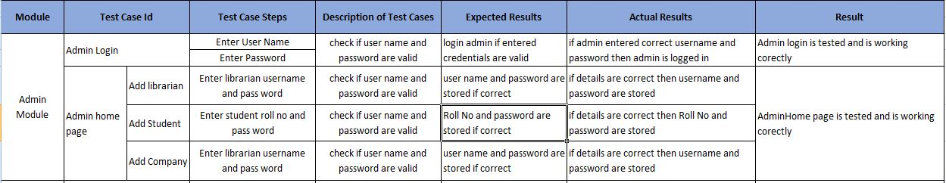

**Student Module:**

**top.JPG**

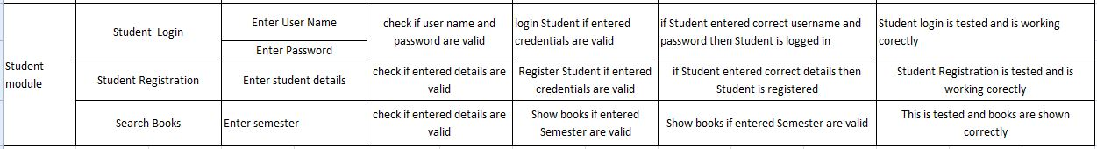

**Librarian Module:**

**top.JPG**



**Company Module:**

**top.JPG**



**Integration Testing:**

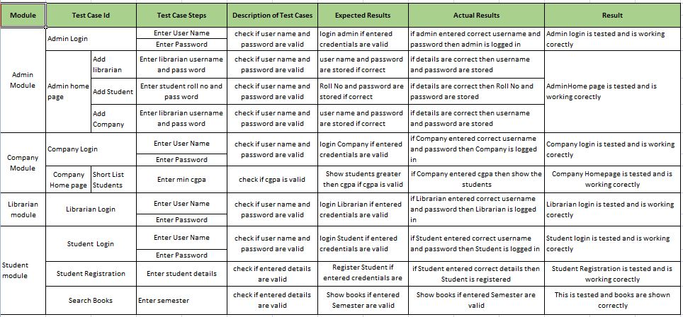

**SNAPSHOTS**

* **HOME PAGE**

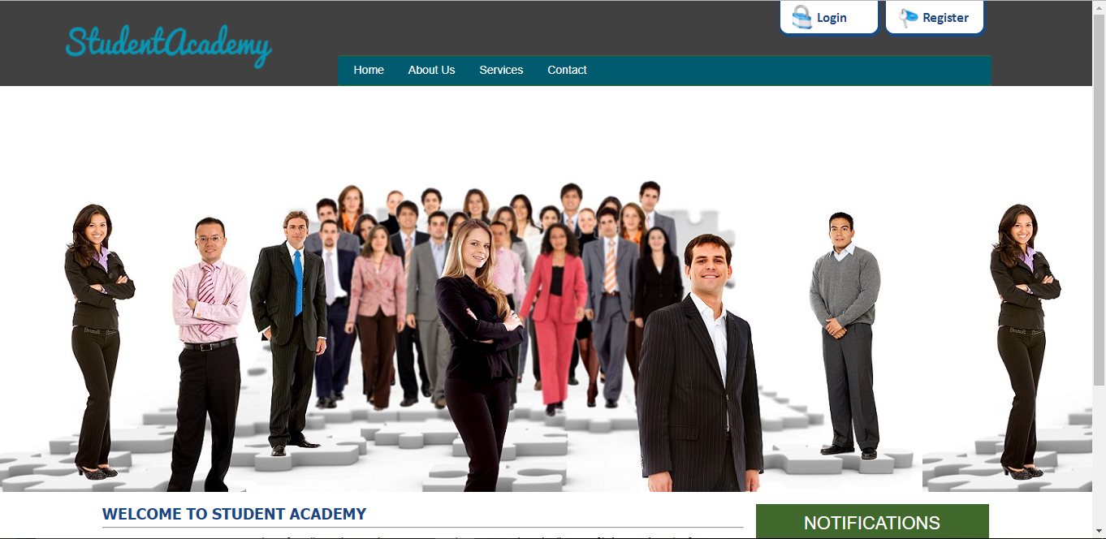

* **Placement section**



* **Students can check useful websites such as coding ,technology news and many useful websites**

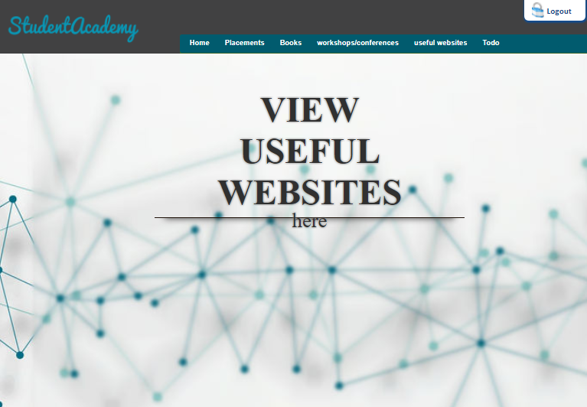

* **TO_DO List**

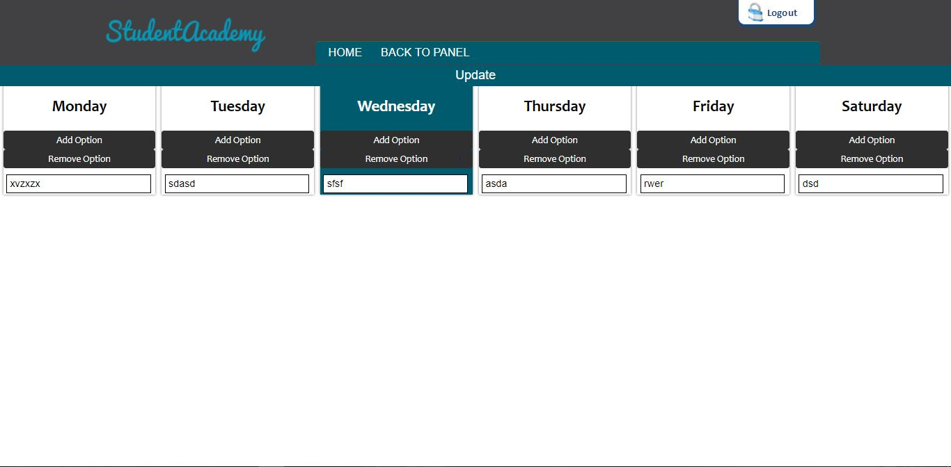

**Update your weekly schedule by entering your activities**

* **Login page**

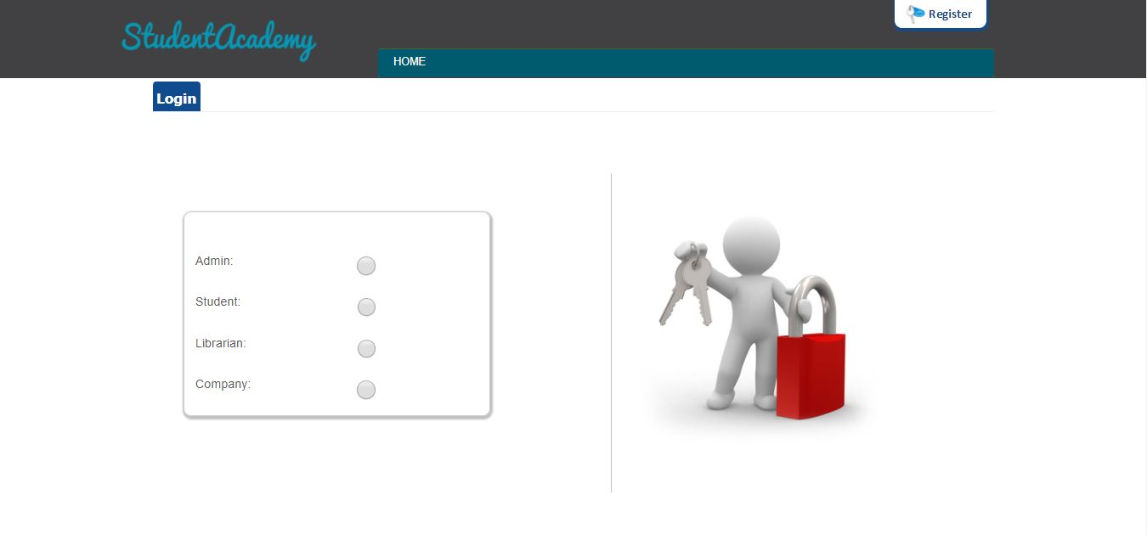

* **COMPANY REGISTRATION**

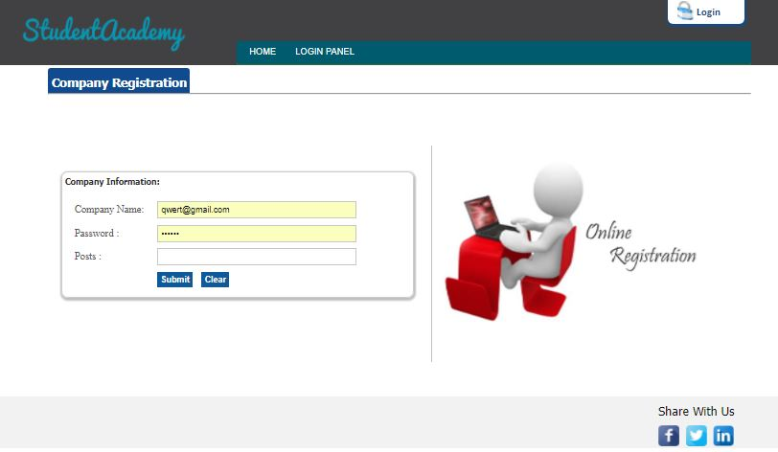

* **ADMIN PAGE**

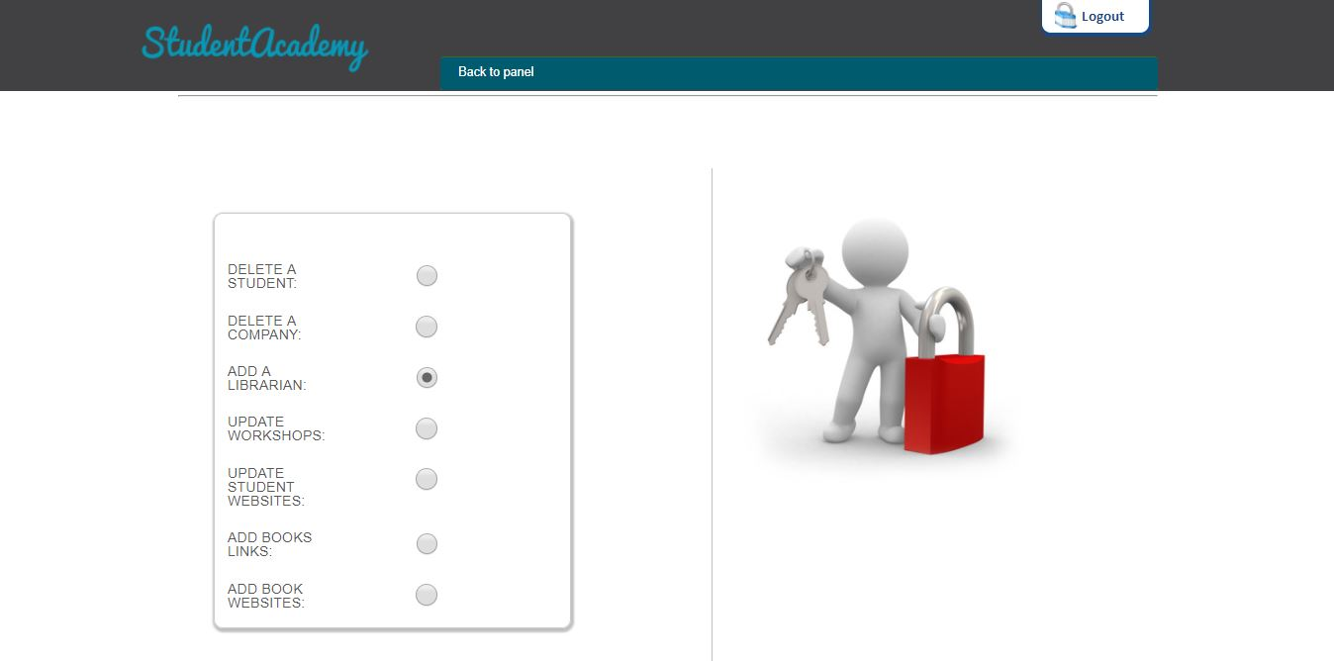

* **STUDENT REGISTRATION**

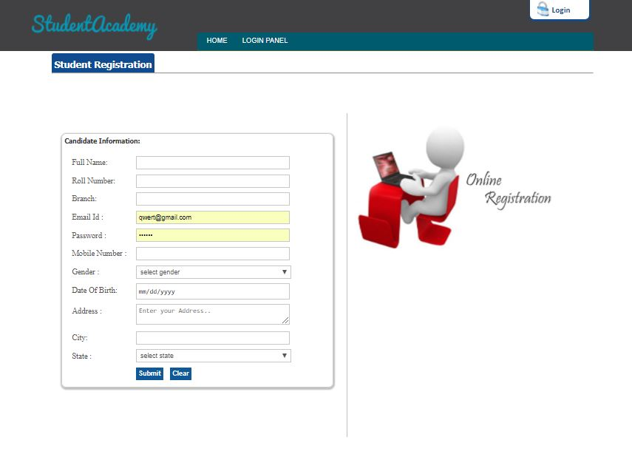

* **Upload CV**

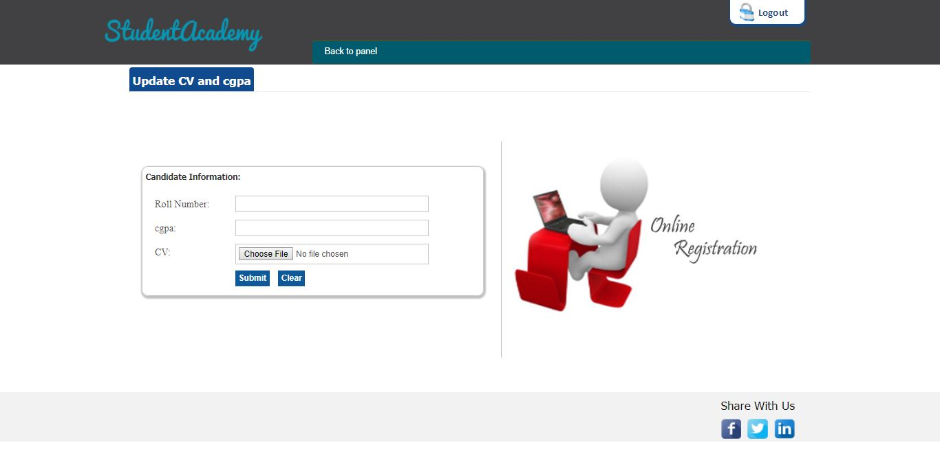

**9. CONCLUSION & FUTURE SCOPE**

* This website provides a computerized version of Student Academy system which will benefit the students, librarian as well as company at the time of placements. It has a facility of providing info about workshops or events happening in our college or nearby college.
* It also contains TO-DO list where students can schedule their daily activities.

There is a future scope of this facility that many more features such as

* online lectures video tutorials can be added by teachers as well as online assignments submission facility
* further extending TO_DO list by sending emails
* A feature of group chat where students can discuss various issues of engineering can be added to this project thus making it more interactive more users friendly and project which fulfills each users need in the best way possible.
* Providing platform for Company to keep written tests, coding tests in the website itself so that students can attend tests online