**Online C Compiler**

**Objective:**

To design a system that would allow users to compile and run c programs on the go.

**Use case:**

Users would be able to compile and run their c programs from anywhere especially from mobile platform.

No hassles of downloading and installing software’s or updating them.

**Approach:**

Designing a browser based application that wold contain an editor for writing code. The code written will be uploaded to a server. On the server side the file would be received and compiled using a C compiler. If compilation is successful the code will be executed and the results will be sent back to the user. Any errors occurred during the process will be reported back to the user.

**Block Diagram:**

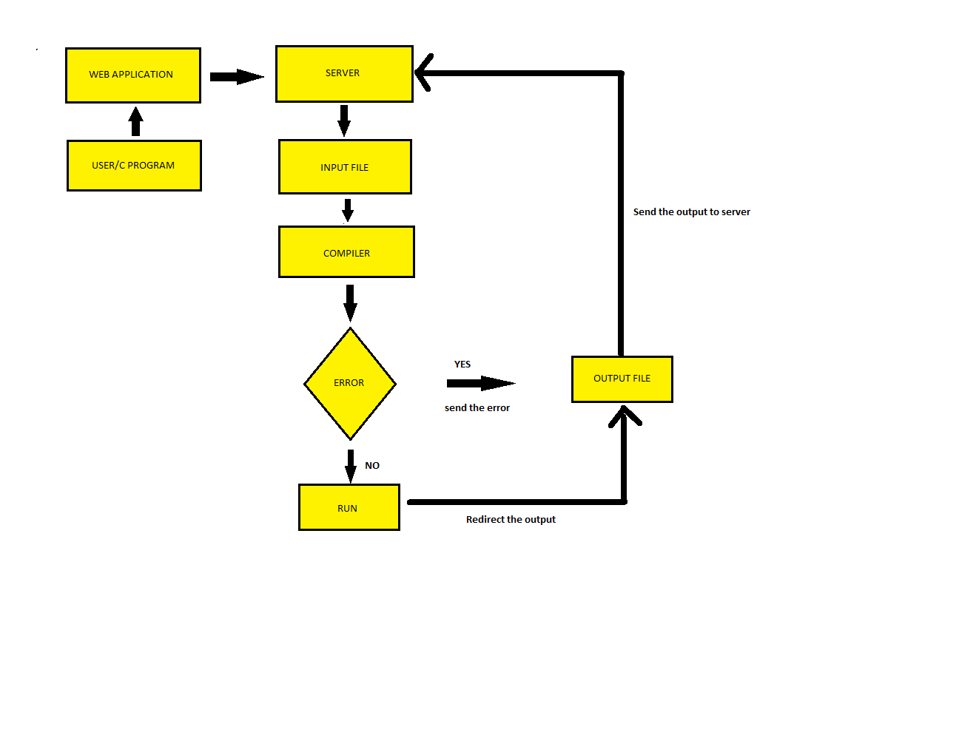

Deliverable:

Towards the end of these project we would be able to implement a system/application that would be able to compline and run c programs from a web browser.

References:

* <http://www.vogella.com/tutorials/ApacheTomcat/article.html>
* <https://stackoverflow.com/questions/25967639/how-to-create-a-web-app-to-compile-and-run-java-c-php-code-online>
* <https://www.w3schools.com/howto/howto_website.asp>