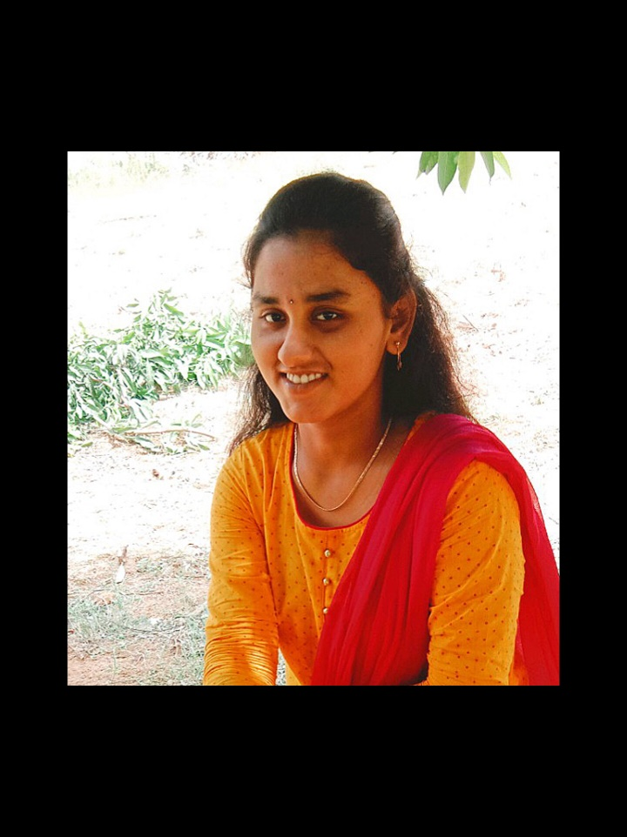**C.RAVITEJAREDDY**

Andhra Pradesh, India

Linkdin: <https://www.linkedin.com/in/ravitejareddy-chennareddy-348736258/>

Top of Form

Bottom of Form

GitHub: <https://github.com/Raviteja-chennareddy>

E-mail: [tejareddy0614@gmail.com](mailto:tejareddy0614@gmail.com)

Phone. No: +91 7093874016

**CAREER OBJECTIVE:**

To achieve a challenging and satisfying position in your company to utilize and enhance my knowledge, skills and innovative thoughts efficiently that leads to develop myself and organisation.

**ACADEMIC QUALIFICATIONS:**

|  |  |  |  |
| --- | --- | --- | --- |
| **Course** | **Institution** | **Year of Completion** | **Percentage CGPA** |
| B. Tech  (ECE) | Annamacharya Institute of technology and sciences, Rajampet | 2025 | 7.39 |
| Intermediate (MPC) | Narayana junior college, Kurnool | 2021 | 6.26 |
| SSC | Bhashyam H.S.N.R.Peta, Kurnool | 2019 | 9.2 |

**PROJECTS:**

1. **BASIC CALCULATOR:**

**Project Description:** Developed a basic calculator application for performing standard arithmetic operations, ensuring accurate calculations and user-friendly interface design.

**Outcome:** Demonstrated programming proficiency and delivered a functional tool for everyday use.

1. Top of Form
2. Bottom of Form

**TECHNICAL SKILLS:**

* M S Office
* Git and GitHub

**TECHNICAL LANGUAGES KNOWN:**

* Basics of Java
* Basics of C++
* Basics Python
* HTML, CSS, JavaScript

**PERSONAL TRAITS:**

* Self-Learner
* Leadership
* Time management
* Communication

**INTERNSHIPS:**

* Two months Internship on Industrial Automation in SSK Delta Design Engineering Private Limited.

**CERTIFICATES:**

* Won the second prize in **technical symposia** on national level CGR TALENT MEET-2024.
* Certificate on introduction to Data Science a course of study offered by IBM.
* Certificate on Java Programming: Object-Oriented Design a course of study offered by Codio.

**WORKSHOPS:**

* Attend a workshop on “MATLAB PROGRAM”
* Attend two days workshop on “ANTENNA DESIGN, FABRICATION AND LINK DEPLOYMENT”

**HOBBIES:**

* Browsing
* Gardening

**PERSONAL DETAILS:**

* Name : Chennareddy Ravi Teja Reddy
* Date of Birth : 10 June 2004
* Father’s Name : C. Sheshasena Reddy
* Languages Known : Telugu, English
* Nationality : Indian

**DECLARATION:**

I hereby declare that the above mentioned are true to the best of my knowledge and belief.

**Place: Signature:**

Kurnool C. Raviteja Reddy