1)

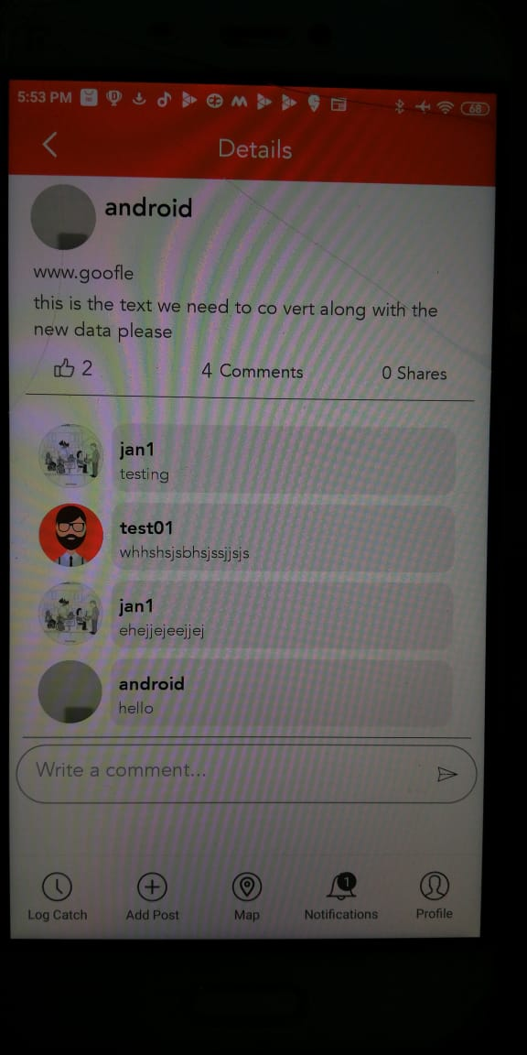

Latest comments have to be down not on the top (Done)

3)

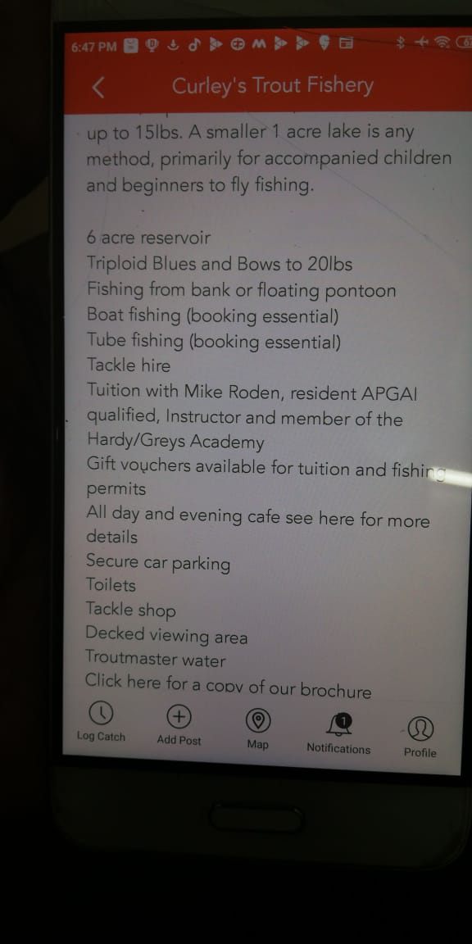

This fishing spots page need some designing content part. Separations, borders, blocks e.tc. Need to make it look nicer

In these case here we showing the data which is an description, if the description is more it is adjusted by scrolling.We made the possible changes to make it look better.

4)

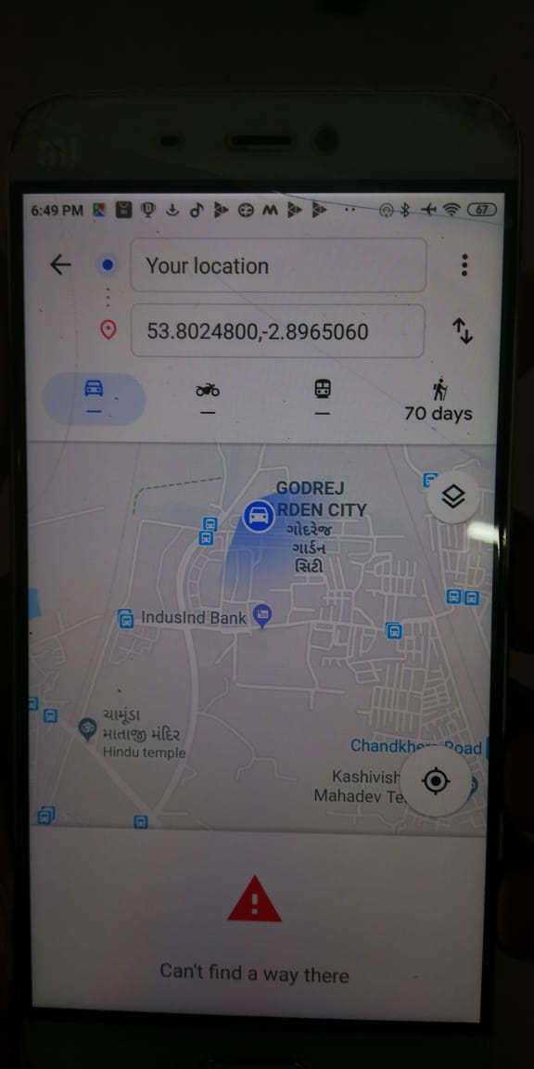

In fishing spots linked to Google maps it's passing coordinates, if there is a possibility to pass a title that will be good

When Transportation facility is available the perfect location is displaying ,When there is no possibility of any route it showing Latitude and longitude.

5)

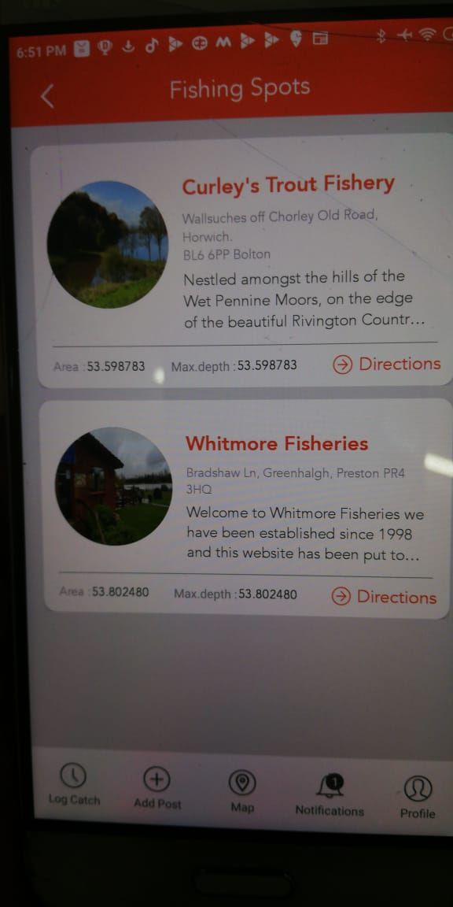

We need units mentioned for Area and max depth. It's just number now. We don't need somany decimals to be displayed. . 000003 of a mtr is not even a milli meter(Done)

6)

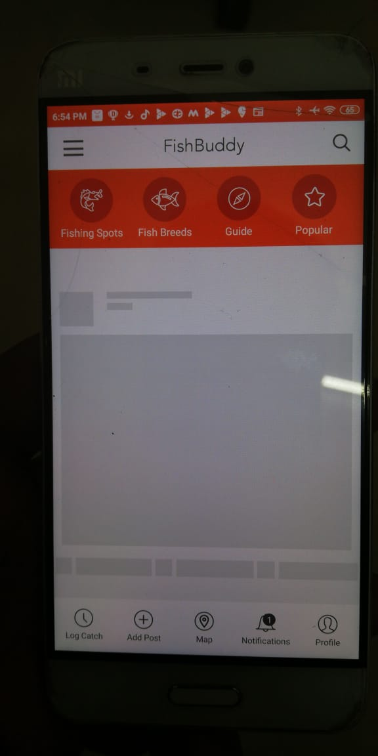

When I go bk it's loading for ever. I need to force stop and reopen(Done)

7)

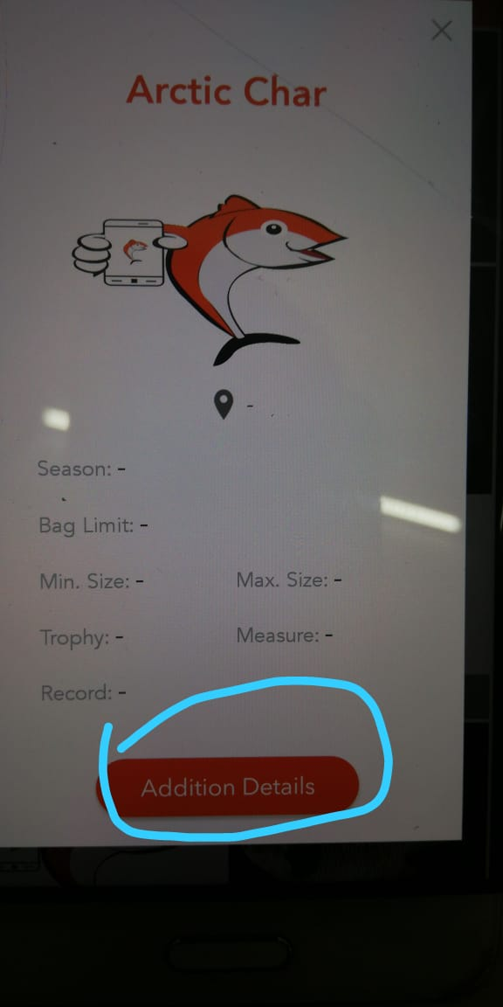

Additional details(Done)

8)

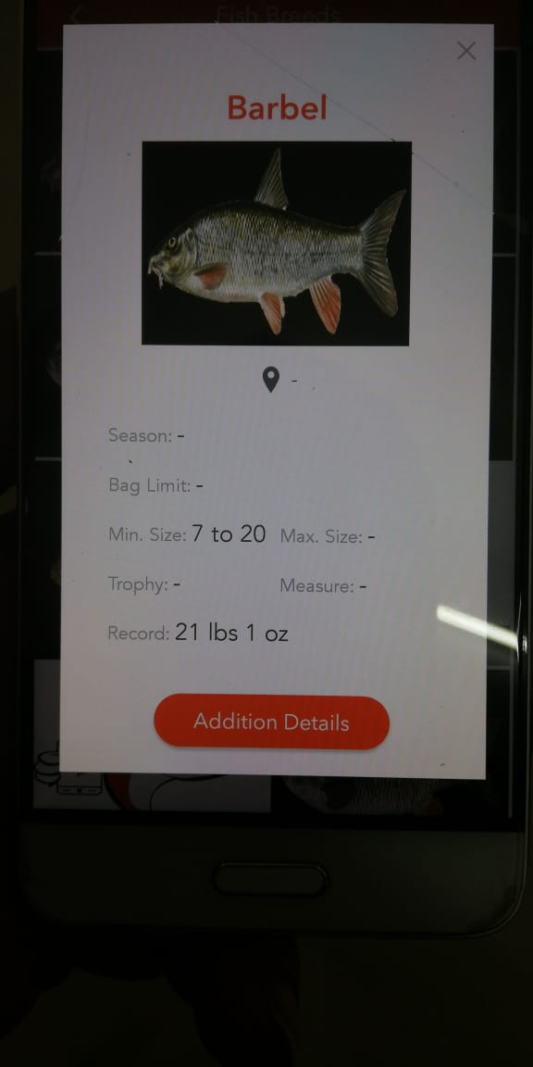

Size does not have units(Done)

9)

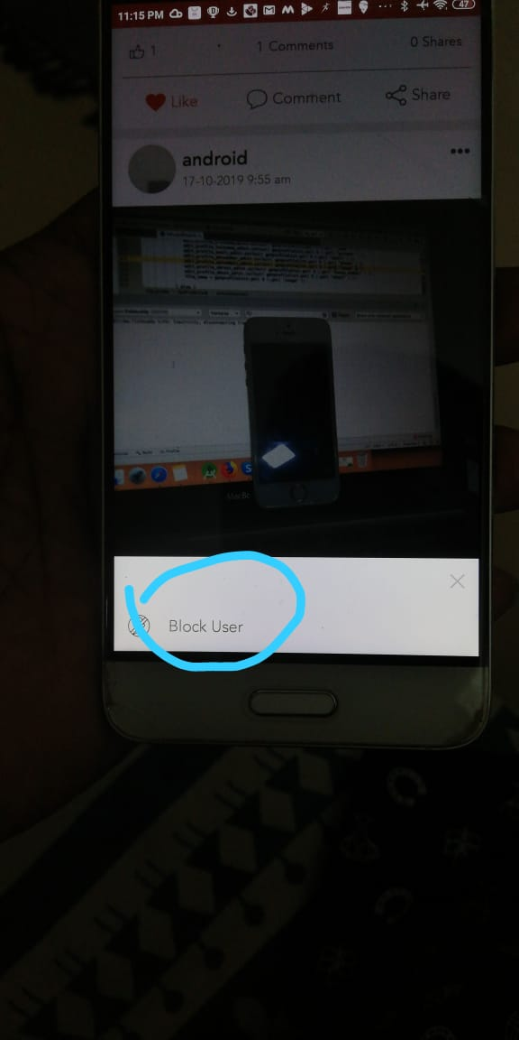

I may not want to block this user. I may only want to delete this post. So need another option

Yes , user allowed to delete and edit his own created post only when he clicks on others post we are showing block user popup ,if this don’t need confirm will remove this

# According to the pdf.

>> Changes were made.

>> We are working on the image stretching issue, so far when the image width is large it happening otherwise it working fine.

#Newly added functionality.

>>Added multiple images functionality.