CareFlow: Emergency Department Efficiency Analytics
The problem
A hospital is experiencing long emergency department waiting times, but its administrators don't know exactly where delays occur or why patients sometimes repeat earlier steps.
Traditional reports show average waiting times and patient counts, but they don't reveal the actual sequence of activities each patient experiences, repeated triage visits, delayed doctor consultations, or deviations from the intended patient pathway.
The proposed solution
CareFlow will analyze timestamped patient activity records using Python, store structured data and analysis results in MySQL, and present operational insights through Power BI dashboards.
The business objective
Identify the activities and transitions associated with the longest delays, investigate repeated visits and workflow deviations, and help hospital administrators prioritize process improvements.
Key business questions CareFlow must answer
- How long does each patient wait between registration, triage, diagnostic tests, doctor consultation, and discharge?
- Which activities and transitions contribute most to total patient journey time?
- What percentage of patients return to triage or repeat a diagnostic activity?
- Do waiting times differ by triage priority, shift, or department?
- Which patient journeys deviate from the hospital's intended pathway?
- Which operational changes should the hospital investigate first?
For your CareFlow project, I recommend building a Power BI dashboard with 6 KPIs and 6 visualizations. This will give your project a strong business focus while using Python for process mining and MySQL for data storage.
CareFlow — Power BI Dashboard Design
CareFlow | Hospital Operations
Dashboard blueprint
Emergency Department · Patient Flow · Waiting-Time Analysis
Total Patients
1,500
Total Events
10,485
Repeat Activity Rate
—
To calculate
The first two values come from your generated dataset. Other KPI values should be calculated from the data before publication.
1. Six KPIs
KPI | What it measures | Business purpose
1. Total Patients | Distinct patient cases | Understand patient volume
2. Average Journey Time | Average time from first to last event per patient | Measure overall flow efficiency
3. Median Journey Time | Median time from first to last event | Reduce the influence of unusually long cases
4. Average Transition Waiting Time | Average gap between consecutive recorded activities | Find delays between departments or activities
5. Repeat Activity Rate | Percentage of patient cases with at least one repeated activity | Identify possible rework or unnecessary loops
6. Pathway Deviation Rate | Percentage of cases that differ from the defined reference pathways | Investigate process variations
Important: Journey duration and transition waiting time are proxies derived from event timestamps. They do not necessarily measure actual queue time, and deviations are not automatically errors.
2. Six visualizations
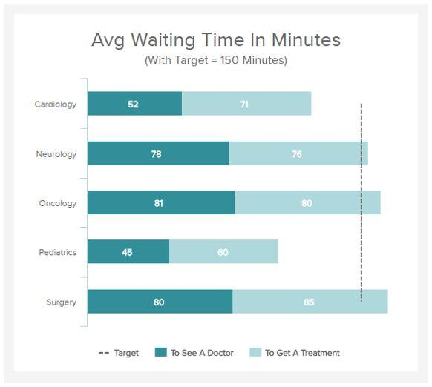
1. Average Waiting Time by Transition
Bar chart
Compare transitions such as Triage → Doctor and Doctor → X-Ray. Sort from longest to shortest to prioritize investigation.
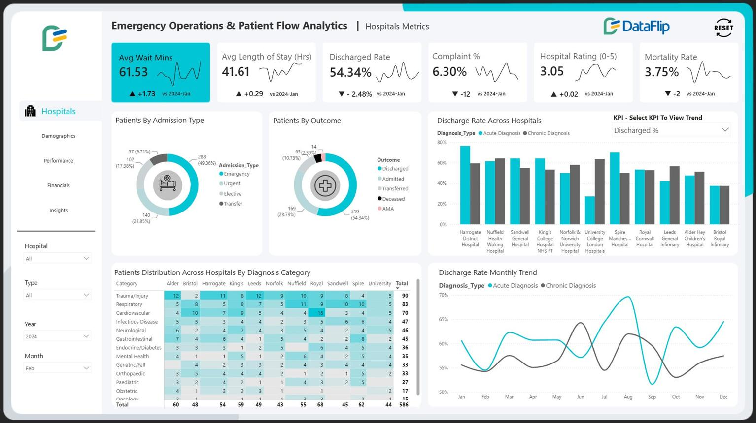
2. Patient Volume by Hour
Line chart
Show arrivals by hour and identify peak-demand periods. Use arrival timestamps from the case details.
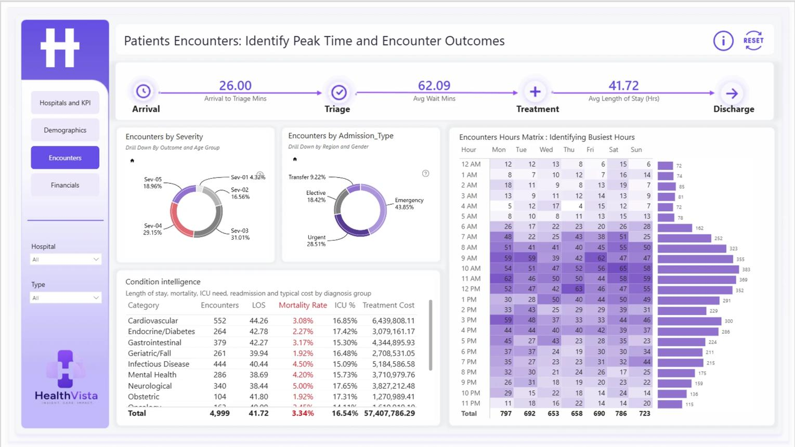
3. Journey Time by Triage Priority
Clustered column chart
Compare average or median journey duration across High, Medium and Low priority cases.
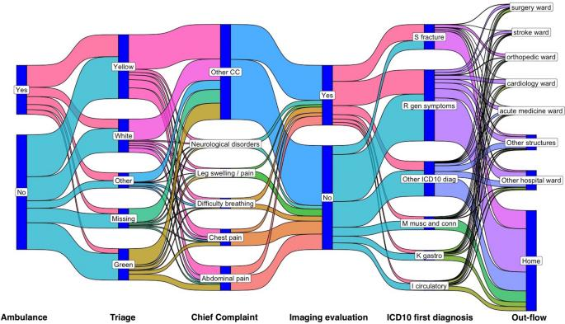
4. Patient Pathway Flow
Flow / Sankey diagram
Display activity-to-activity transitions and how frequently patients follow each route. Python and PM4Py can discover the process; a Power BI custom visual can display it.
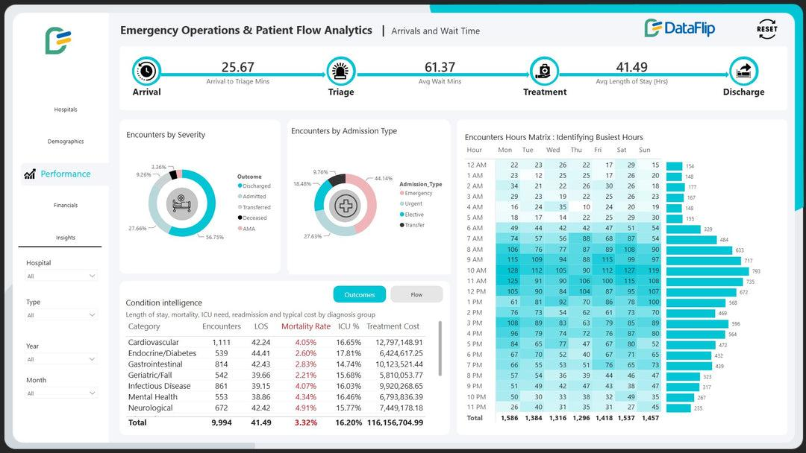
5. Waiting-Time Heatmap
Matrix with conditional formatting
Compare waiting times by department and shift to find operational patterns.
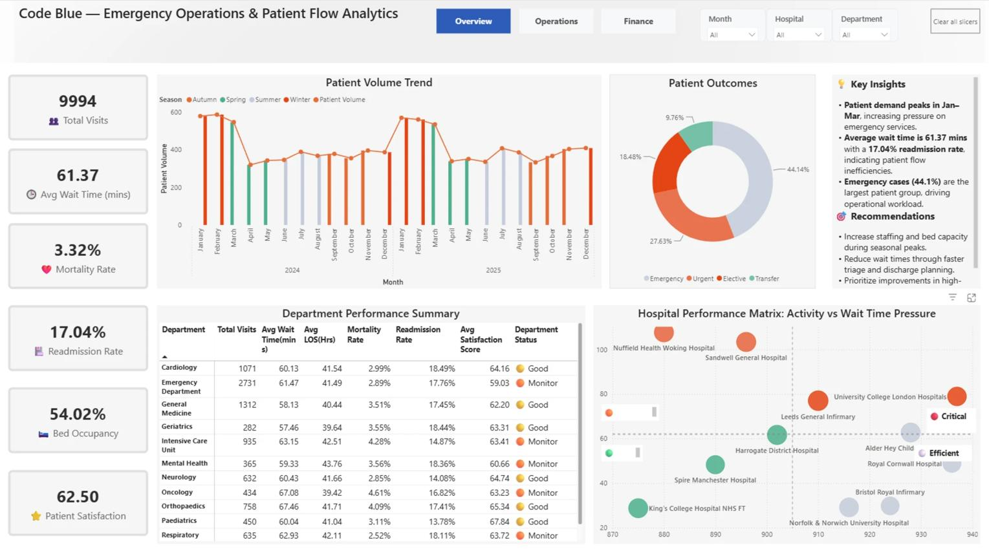
6. Repeat Activities and Pathway Deviations
Stacked bar chart
Compare repeated triage, repeated consultations, and cases following paths outside the reference pathways.
These are recommended visualization designs, not screenshots of your actual data.
3. Recommended dashboard layout
CareFlow — Emergency Department Analytics
Slicers: Date · Department · Triage Priority · Shift
Total Patients
KPI
Avg Journey Time
KPI
Median Journey Time
KPI
Avg Transition Wait
KPI
Repeat Activity Rate
KPI
Pathway Deviation Rate
KPI
Waiting Time by Transition
Patient Volume by Hour
Journey Time by Priority
Patient Pathway Flow
Department × Shift Heatmap
Repeats & Deviations
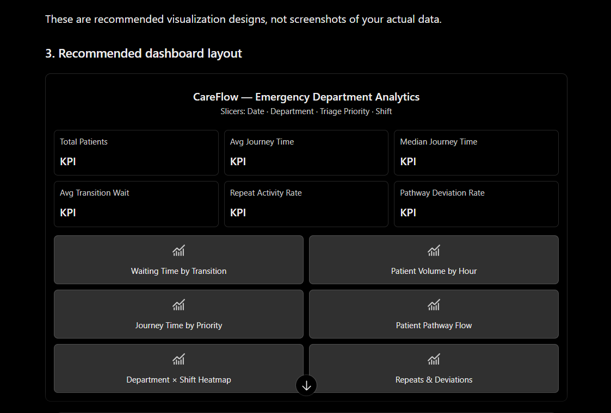

4. How your technology stack supports it
- Python + PM4Py: discover actual patient pathways, detect loops, and calculate process-related metrics.
- MySQL: store the event log, case details, transition metrics, and pathway reference data.
- Power BI: present the six KPIs, six visuals, filters, and drill-through analysis.
My recommendation: Build the KPIs and the first three visuals first. Then integrate the process-mining map and pathway deviation analysis after your Python pipeline is working. That will make CareFlow easier to develop, test, and explain during your project review.

