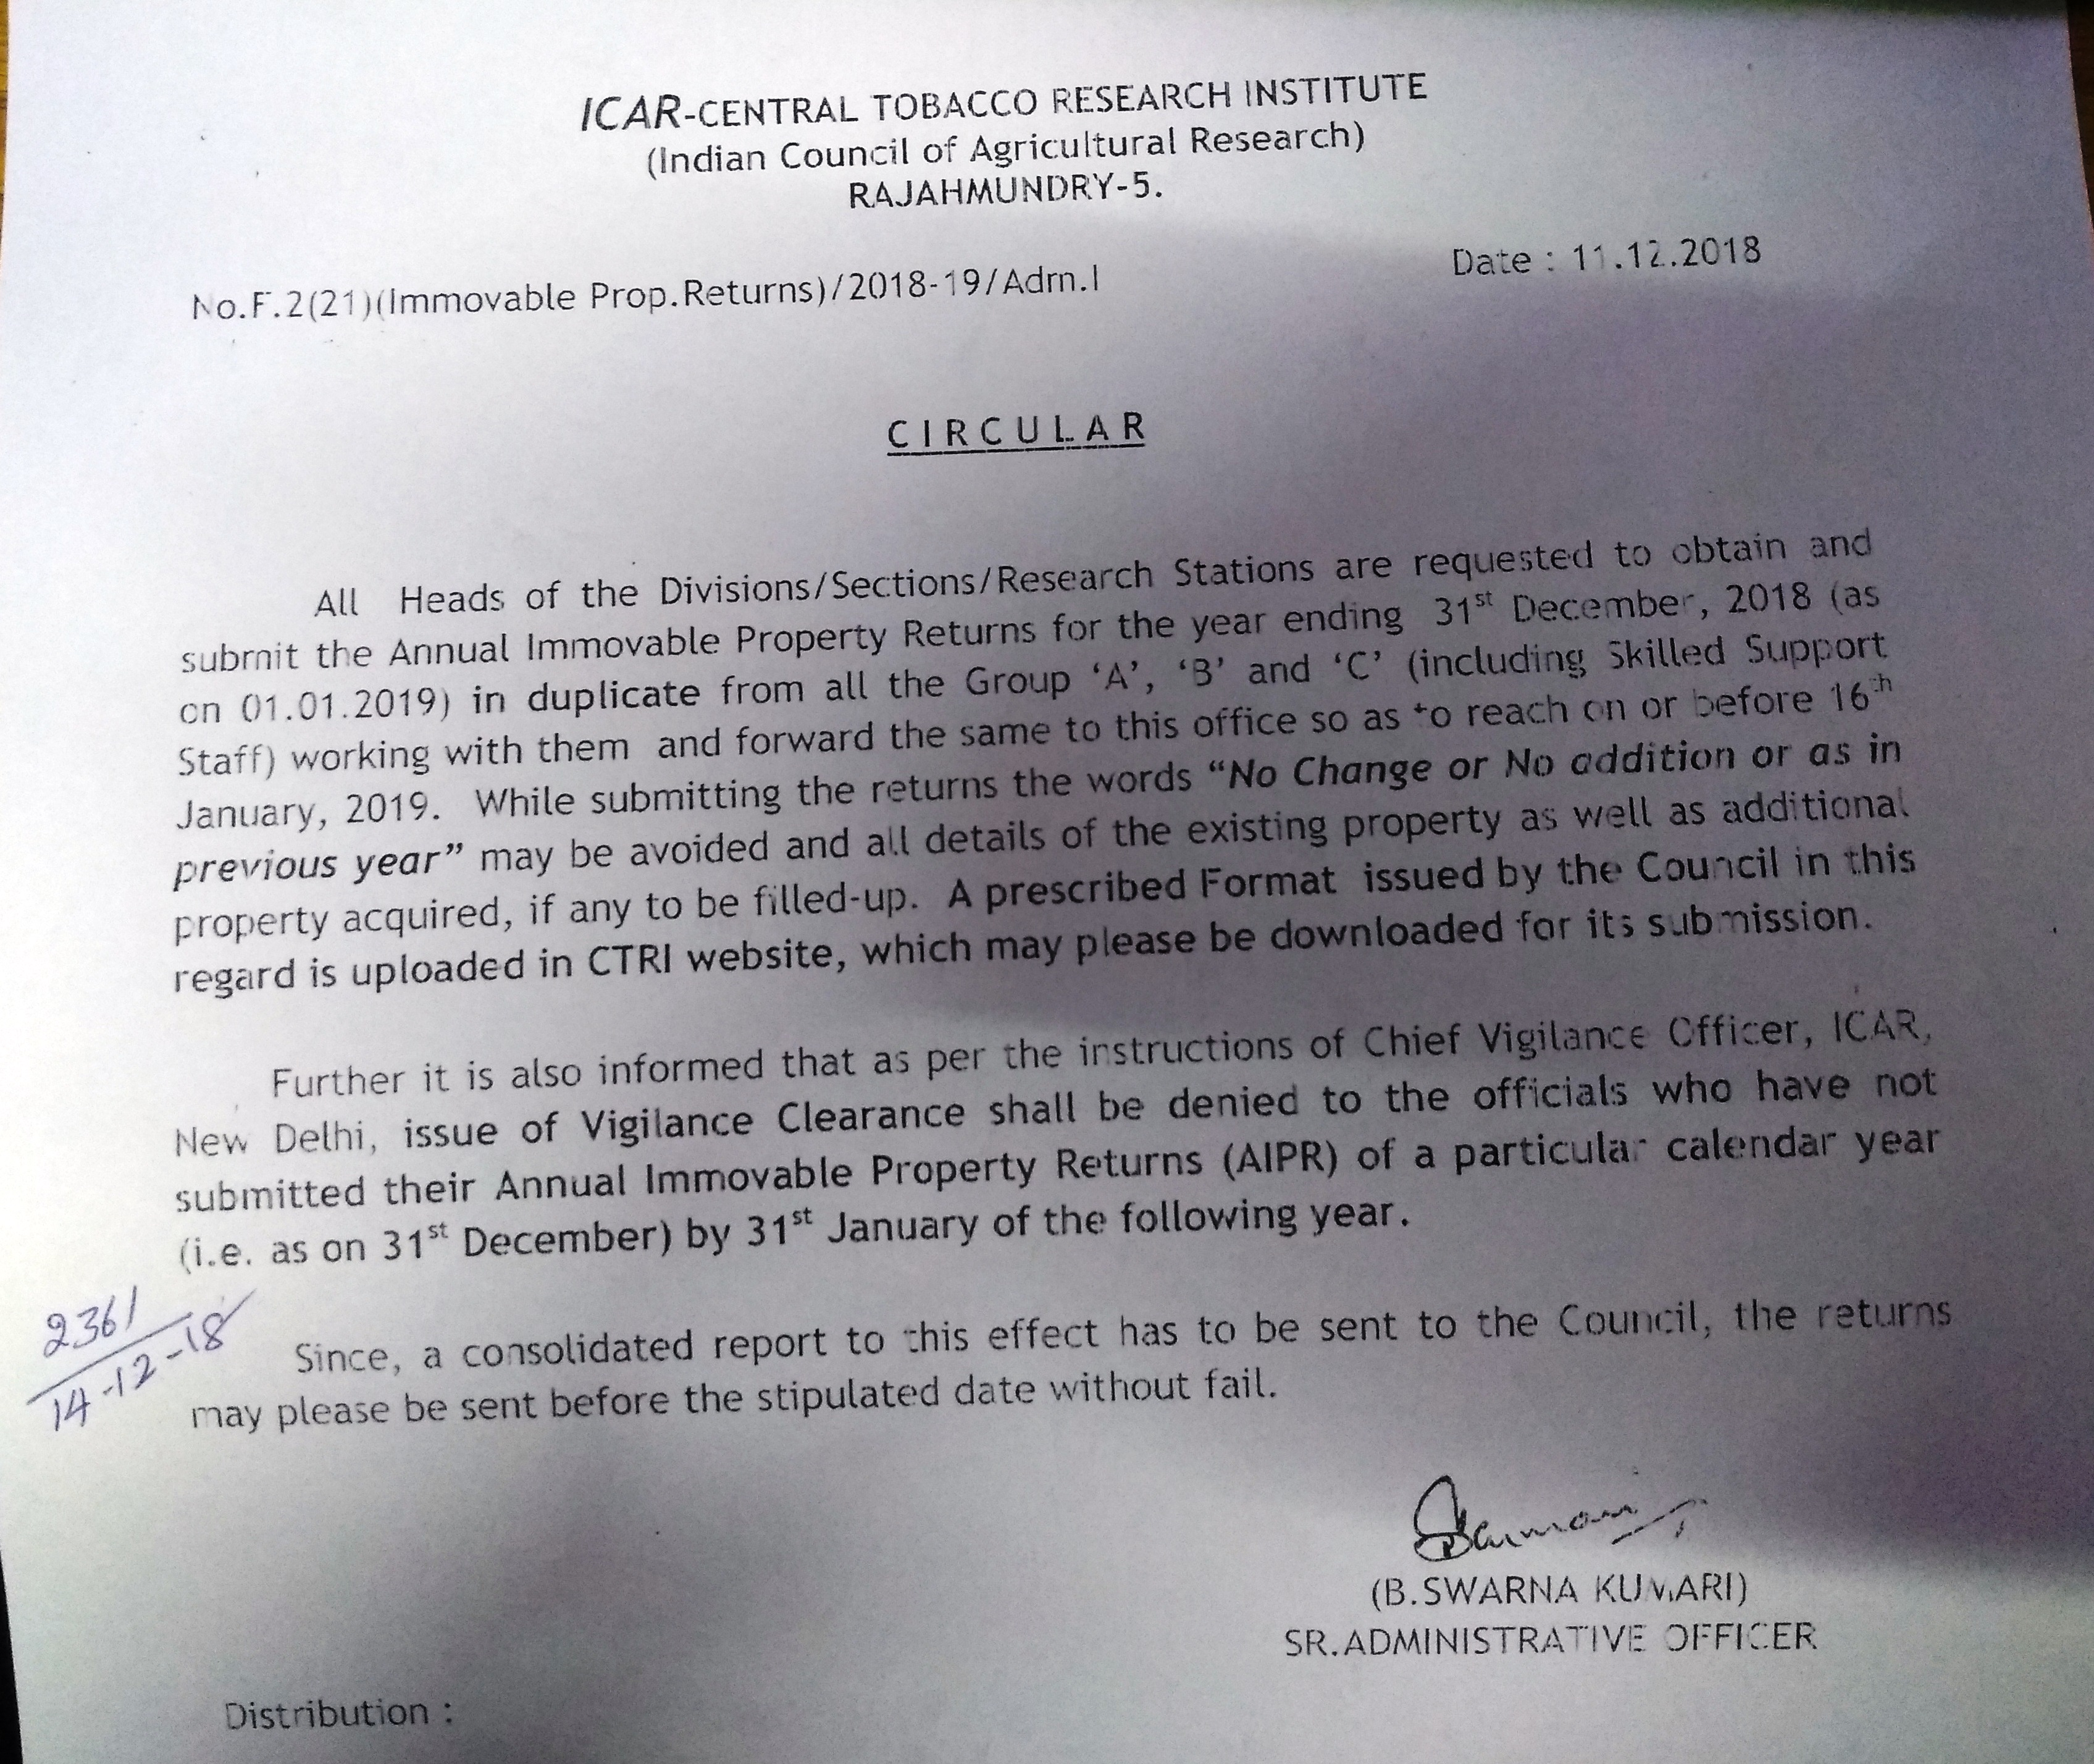

ANNUAL IMMOVABLE PROPERTY RETURN

Statement of Immovable Property for the year 2018 (01st January to 31st December, 2018) as on 01.01.2019

1. Name of the Officer (in full) & service to which the officer belongs :
2. Present post held :
3. Present pay :

Name of District, Sub-division, Tq. & Village in which property is situated | Name & details of property |  | Present value  (`) | If not in own name, status in whose name held & his /her  Relationship to  the Govt. servant | How acquired, whether by purchase, lease, mortgage, in heritance, gift or otherwise with date of acquisition & name with details of person/persons from whom acquired | Annual income from the property | Remarks
 | Housing & other buildings | Lands
1. | 2. | 3. | 4. | 5. | 6. | 7. | 8.

SIGNATURE ………………………….

DATE ………………………………
Inapplicable clause to be struck out
- In case where it is not possible to assess the value accurately the approximate value in relation to present conditions may be indicated.
- Include short term lease also.
- The wording ‘No Change or No addition or as in previous year’ may be avoided and all details filled up.
Note : The declaration form is required to be filled din and submitted by member of Class I and Class II (Group ‘A’
and Group ‘B’) services under Rule 15(3) of the Central Civil Services (Conduct) Rules 1955 (now Rule 18(1) of the CCS (Conduct) Rules, 1964), on the first appointment to the service and thereafter at the interval of every twelve months, giving particulars of all immovable property owned, acquired or inherited by him or held by him in lease or mortgage, either in his own name or in the name of any members of his family or in the name of any other person.

