**Daily Tasks**

* AAD group creation (assigned and dynamic)
* AD group creation ( Security) (universal,Global and distribution list)
* DL creation
* Users addition on to the groups
* Providing the local admin rights to the server
* Providing the IAM roles to the azure resources  
    
    
    
    
    
    
   Change Tickets
* Change approvers, Accenture change manager, EDC change manager and accenture soc manager

1. Need to add the subnet to the DC site

* We need to login to the DC and we need to open the site and services
* Then we need to execute the below commands
* 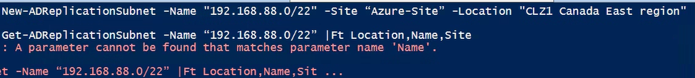
* Check the subnet range got added to the subnet OU or not
* Open any one server with in the subnet range and then login (wheather its identifying the DC reaching or not )
* Nltest /dsgetdc:edc.ca
* Nltest /sc_reset:edc.ca\DCHOSTNAME

1. We need to add one website to trusted site on sharepoint sites

* Need to login to DC
* Open gpmc.msc and navigate to windows > security settings>
* Site-zone assignment ( edit and add the provided site)