LINUX

* **History of Unix** : Multics-1965 >>Unics-1969 >>Unix -1973 in C language
* from the Unix they have developed the Linux in the year 1990 as it was an open source
* More than 375+ linux distributions were there as for today’s date

**File systems**

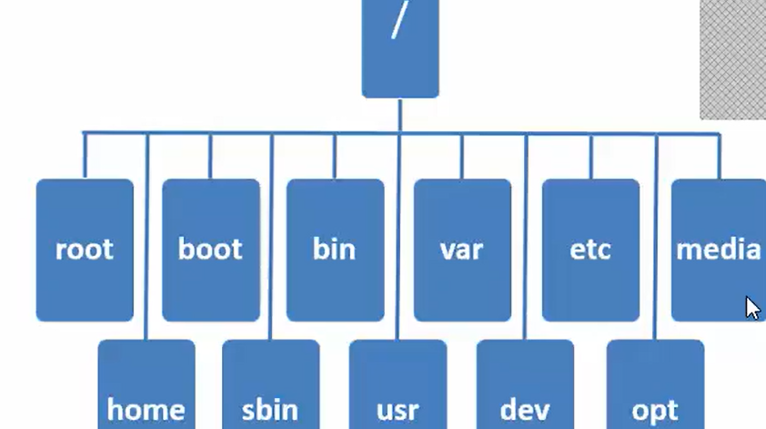

* / is the top level directory - (root) default directory of Super user.
* Home is default directory of the normal user.
* Boot contains the bootable files grub== is the grand unified boot loader (has info abt kernel VMlinuz)
* Bin contains the info about the binary files used by normal user and the commands used by the super user are stored in the sbin (system binary) ex = fdisk, dump
* The /usr is similar to program files in windows (rpm file extensions in linux)
* The /var stands for variable which contains variable info and logs.
* The /dev stands for device which contains the all hardware devices info
* The /etc like etc criteria which contains all configuration files
* The /media which contains all info about the mountpoints and removable storage like(cd,dvd, pendrives..etc)
* The /opt stands for optional which contains info about the 3rd party applications and the softwares

Basic commands

* cp -rv /source/ /dest/ –to copy data from directory to the directory
* switch user su -username
* cp -rv /etc/skel/. - /newdirectorypath (to copy all the bash files)
* ~ indicates default directory (root user /root & normal user /home)
* they will be 6 virtual console we can extend upto 63 (5 in CLI and 1 GUI) to access (ctrl+alt+f1 to ctrl+alt+f6)
* tty (to know ur current working console)
* ls -a = nautilus (GUI representation)
* ls /foldername (to see the list content with in the folder without entering the folder)
* to change the system time zone (system-config-date)
* cp -rv /source * /dest/ –to copy multiple directories (r = recursive v= verbose which shows the bg process)
* cp -rv /boot* /dest/ –to copy complete data
* wc -l filename (line count) wc -w filename (word count) wc -c filename (char count)
* cp /source/ /dest/ – to copy data in the files
* cat /source/ >> /dest / –to copy the data without overwriting

VI Editor (1976 Bill joy)

command mode

extended mode

insert mode

A-- end of the lines

o- below new lines

O- above new lines

a- second letter

i- insert and intial lines

dd- delete the lines in the vi editor

shift + : to enter to the extended mode

/name (to find a word with in the file )

wq- write and quit

q -quit

!q- overwrite

yy- to copy any lines in the command mode

p - to paste any lines in the editor

u- undo option which is an important one

r- redo option

12 yy - 12 liness will be copied

12 dd - 12 liness will be deleted

6yw - to copy six words in a lines to paste use p

G - to goto to the last lines in the editor

gg- to go back to the first lines of the editor

shift + :se nu - to set the lines numbers in the editor

w - to move word by word to check in the editor

b - to move backward word by word in the editor

1,$s/oldname/newname - to substitute in the editor

**USER ADMINISTRATION**

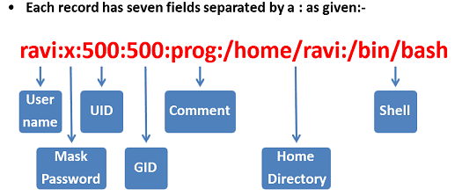

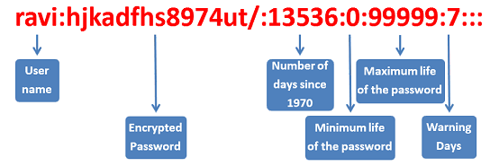

useradd ravi -- ravi user will be added

uid 0 (root user id)

su - username (to switch to user)

tail -3 /etc/passwd (to check the last 3 users)

head-3 /etc/passwd (to check the first 3 users)

cat /etc/passwd -- to check the user has been added or not

passwd ravi - to set the password to the user

passwords are encrypted using MD5 (message digest version 5)

password encryption (SHA (secure hash algorithm) 512 MD5 (msg digest) 128 DES (data encrypt sys)64)

cat /etc/shadow - to see the password for the users

usermod -L ravi - to lock the user

usermod -U ravi -to unlock the user

usermod -d /newpath username (to change the directory of the user)

usermod -l newname oldname (to rename the user)

usermod -u 0 -o username (to make normal user as a superuser)

grep ravi /etc/passwd - to check the specific user properties

grep ravi /etc/shadow - to check the user is locked or not (!)

usermod -l ravi raviteja - to change the login on username

userdel -r ravi - to delete the user

usermod -c 'designation' ravi - to add the comment to the user

usermod -u 500 ravi -to change the userID

df-hT - to check the mount points in CLI  
 **ACL(Access control list (+))**

setfacl -m u:user1:rw folder (to give read and write (rw) permissions to user1 to that folder)

getfacl folder (to check the ACL permissions)  
setfacl -m g:groupname:rw folder (to give ACL permissions to read and write to groups to that folder)  
setfacl -x u: user1 folder (to remove acl permissions)

gdmflexiserver (to open the GUI virtual consoles)

gnome-system-monitor to check the mount points in GUI

**multiple user creation**

vi /bin/ravi (create a file name as u like in this case filename is ravi)

for i do

useradd $i

passwd -d $i

done

write the above content in that file

chmod +x /bin/ravi (use the file as a script we need to give execute (x) permissions to the file)

ravi user1 user2 user3 user4 (commad to create multiple users)

**GROUP ADMINISTRATION**

**group is a collection of users having the same permissions applied (types Primary, Secondary)**

groupadd basic - to create a basic group

cat /etc/group - to check the groups along with the GID.  
tail -3 /etc/group & head -3 /etc/group

gpasswd -a ravi basic (-to add ravi to basic group)

chgrp basic foldername (to change the group name to the folder/file)

we can set password to a group

gpasswd -M ravi,rahul basic (-to add multiple users to basic group)

usermod -G basic ravi (- to add user as primary to the secondary group )

usermod -g basic manoj ( to make manoj as a primary in basic group GID changes as well )

groupmod -n raviteja ravi ( -to change the group name)

groupmod -d basic ravi ( -to remove user from group)

groupdel basic (to delete secondary group without adding anyone to primary)

gpasswd basic - to set the password for the group

newgroup basic

**FILE PERMISSIONS**

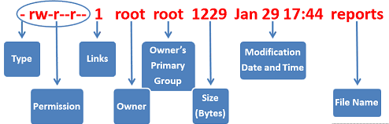

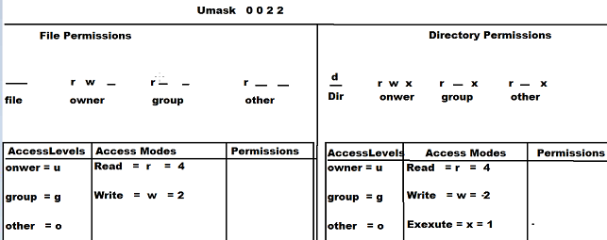

* = file : d = directory

ls -ld filename (to view the properties of the file)

Default permission for the file is (644)

umask universal mask (0022 = super user 0002 = normal user)

Default permission for the Directory is (755)

permission is of two types they are

Absolute method (numeric)

Symbolic method (alphabetic)

chmod 646 filename - to change the permissions for the file (absolute)

chmod o+w file - to change the permissions for the file(symbolic)

chmod o-w file - to change the permissions for the file(symbolic)

chmod o=x file -to replace the permission with execute (symbolic)

when umask value is set to 0 then default file permissions are 666 and directory permissions are 777

chmod 1755 file - to change the advance permissions for the directory(absolute)

where 1 stands for sticky bit and its represented as t

(cannot able to delete the file or the directory)

**PARTITIONS & SWAP  
  
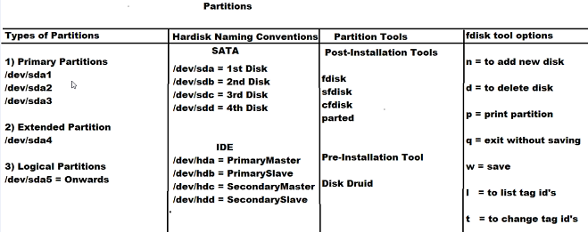**

1-3 (primary)

4 (extended)

5-6 (logical)

* In a hard disk we can create 4 primary partitions (system by default 3 )
* fdisk -l (to check the partitions)  
   **CREATING NEW PARTITION**
* fdisk /dev/sda (to enter into partitions  
  p (to view existing partitions)  
  n (to create a new partitions)  
  +100mb enter  
  q (to quit from the partitions)  
  w (to save the partitions)  
  upon saving either restart or use (partx -a /dev/sda ) command to make new partition active
* mkfs.ext4 /dev/sda8 (to format the partition using ext4 )
* blkid /dev/sda8 (to check the partition is formatted or not)  
  by deauft it would be a block volume of space in order to make it a drive we need to mount to some directory
* mkdir /disk8 (to mount we need some directory )
* mount /dev/sda8 /disk8 ( we have mounted and made a drive and now ready to use )  
  umount /disk8 (to unmount the drive )
* df -hT (to see the drive sizes along with the partitions)  
   **permanent mount**
* vi /etc/fstab (edit and enter the details and save it)  
  **/dev/sda8 /disk8 ext4 defaults 0 0** (drive and folder to mount and format and permissions default and   
  filesystem check 0 and dumping check 0)

**CREATING SWAP PARTITION**

* free -m (to find the ram size)
* fdisk /dev/sda (to enter into partitions and create a new one and make it active )  
  partx -a /dev/sda
* mkswap /dev/sda10 ( format the partition with swap)
* swapon /dev/sda10 (to turn on swap service)
* mount -o,remount,usrquota,grpquota /home ( here we are remounting the disk to home by adding quota)  
  quotacheck -cug /home   
  quotaon /home  
  quotaon -p /home (to check the quota is on or not)  
  edquota -u username (to give quto limit /inode quota limits in bytes to the user)  
  blockdev –getbsz /dev/sda10 (to check the block size)  
  chmod 777 /drive ( give full permission to the drive)  
   **LOGICAL VOLUME MANAGER**
* LVM is a method of allocating hard drive space into logical volumes and can be resized easily.
* physical volumes are combined into volume groups (VG are divided into logical volumes which are formatted as ext3  
  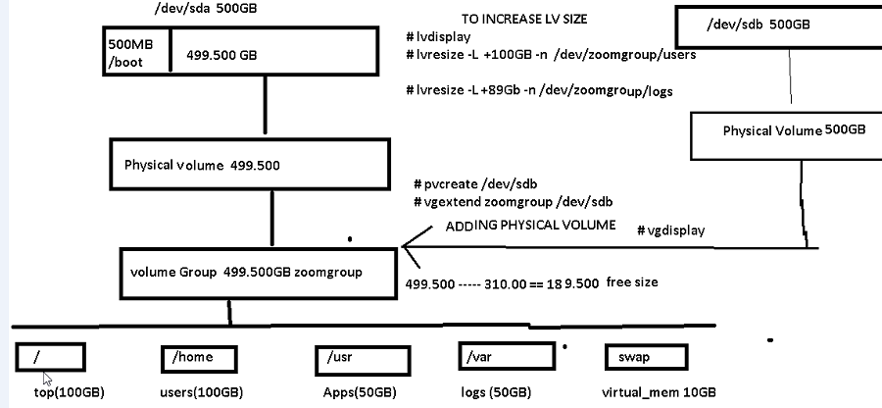
* pvcreate /dev/sda11 (to create physical volume)  
  pvremove /dev/sda11 (to remove physical volume)
* vgcreate foldername /dev/sda11 (to create volume group ina physical volume)  
  vgdisplay (to display volume groups) lvdisplay (to display logical volume) vgdisplay(to display volume group)  
  vgremove foldername /dev/sda11 (to remove volume groups)
* Lvcreate -l +100M foldername -n logicalname (to create logical volume in group)  
  mkfs.ext4 /dev/foldername/logicalvolumename (to format the logical volume)  
  mount and add data
* lvresize -L +200M -n /dev/foldername/logicalvolumename (to resize the logical volume)  
  resize2fs /dev/foldername/logicalvolumename (to overwrite the existing format )  
  lvremove /dev/foldername/logicalvolumename (to remove logical volumes)

**RAID(Redundant Array of Independent disks)**

* RAID tech uses simultaneously use of two or more partitions on the same or different hard disk drives to achieve   
  greater levels of performance and reliability
* its a fault tolerance mechanism in which the data is not lost even if one of the disk fails  
   TYPES OF RAID  
  Hardware RAID  
  Software RAID

**RAID LEVELS**

* RAID 0 (striping with out parity)   
  Min 2 Max 32 HDD   
  Data is written simultaneously in multiple HDD (Reading = f & writing=f)  
  fault tolerance is NA
* RAID 1 (disk mirroring)  
  Max 2 HDD  
  same data is simultaneously written on both the HDD (Reading = f & writing=S)  
  fault tolerance is available (overhead 50%)
* RAID 4 (parity)  
  Min 3 Max 32 HDD (1 HDD reserved for parity )  
  Data is written simultaneously and evenly across the remaining disks (Reading = f & writing=f)  
  fault tolerance is available (overhead 1 HDD)
* RAID 5 (striping with parity)  
  Min 3 Max 32 HDD (Equal HDDs parity are reserved )  
  Data is written simultaneously and evenly across the remaining disks (Reading = f & writing=f)  
  fault tolerance is available (overhead 1 HDD)

**Creation of Meta Hard disk**

* mdadm -C /dev/md0 -n3 /dev/sda{13..15} -l5 (to create meta HDD from 13,14,15 of level 5)  
  mdadm -D /dev/md0 (to view and verify the meta disk)  
  mkfs.ext4 /dev/md0 (to format the disk)  
  mkdir raid (to create a sample directory exp : raid)  
  mount /dev/md0 /raid (to mount the disk into raid directory)  
  mdadm -S /dev/md0 (to stop the meta disk)  
  mdadm -f /dev/md0 (to add the faulty meta disk)  
  mdadm -r /dev/md0 (to remove the meta disk)  
  mdadm -A /dev/md0 -n3 /dev/sda{13..15} (to activate meta disk)  
   **SMALL COMPUTER SYSTEM INTERFACE (SCSI HDD) (Hot plugin)**
* if one of our Hard disk got crashed we need to replace it by using SCSI HDD without shutdowing the system

**BACKUPS**

* backup is the process of storing the information inorder to prevent from DR and to restore it
* Types : full, incremental, differential backups
* commands for backup : Tar(TAPE archive), CPIO, SCP, Dump, Gunzip, Bunzip  
  TAR : complete file system backup  
  tar -cvf /destinationpath/filename.tar /sourcepath (to create a backup)  
  tar -tvf /destinationpath/filename.tar (to check the backup )  
  tar -xvf /destinationpath/filename.tar (to restore the lost data to current directory)  
  ar -xvf /destinationpath/filename.tar -C /directorypath (to restore the lost data to another folder)  
  CPIO : Selected file system backup  
  ls -d D* install* ipsec* foldernames* | cpio -ov > /destinationpath/filename.cpio (to backup using CPIO )  
  cpio -tf < filename.cpio (to view the backuped files)  
  cpio -iv < /destinationpath/filename.cpio (to restore all files using CPIO)  
  Gunzip :   
  tar -cvzf /destinationpath/filename.tar.gz /sourcepath (to create a backup)  
  tar -tvzf /destinationpath/filename.tar.gz (to check the backup )  
  tar -xvzf /destinationpath/filename.tar.gz (to restore the lost data to current directory)  
  tar -xvzf /destinationpath/filename.tar.gz -C /directorypath (to restore the lost data to another folder)

**Remote backup**

* ifconfig or ip a (to verify ip address )
* route -nv (to verify gateway)
* cat /etc/resolve.conf (to verify the DNS)
* initial set static ip in source machine
* scp -rv /foldername 192.168.0.155:/root/desktop (secure copy and give the destination ip and copy files in dest desktop)
* install vnc viewer and verify using vncviewer 192.168.0.155 (destination ip Graphical mode )
* ssh -Y 192.168.0.155 ( ssh using text mode destination ip)  
   **To change static IP**
* setup   
  Network configuration >> device configuration >> etho >> and change the static IP >>save
* Service network restart (to activate the new ip )

**DUMP command**

* dump 0uf /destinationpath /sourcepath (dump command to take full data backup)  
  restore -tf /destinationpath/foldername (to read the backup)
* dump 2uf /destinationpath/foldername /sourcepath (to take incremental backup)  
  restore -tf /destinationpath/foldername   
  0 = full backup  
  1 = differential backup  
  2 = incremental backup  
   (dump logs and records will be stored in this file /etc/dumpdates)
* dump 1uf /destinationpath/foldername /sourcepath (to take differential backup)  
  restore -tf /destinationpath/foldername

**JOB Automation (Crontab)**

* at 10:14pm   
  at> useradd sam  
  at> tar -cvzf /mnt/file.tar.gz /home  
  at>groupadd ITCLOUD  
  (At is a job scheduling tool give the syntax with time and then give commands and ctrl+D to exit)
* at -l ( to see the list of existing atjobs)
* Crontab -e (crontab is another tool -e is for edit **min, hrs, date,month,date**)  
  open vi editor and * indicates every tar -cvzf /opt/cron.tar.gz /home (:wq)
* service crond restart (to restart the crontab services)
* crontab -l ( to see the list of existing cronjobs)  
   RPM YUM NFS FTP  
  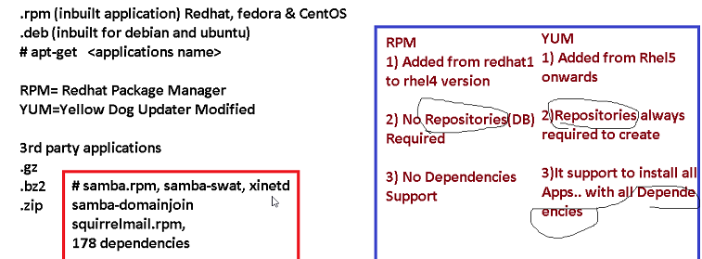

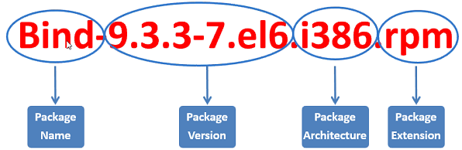

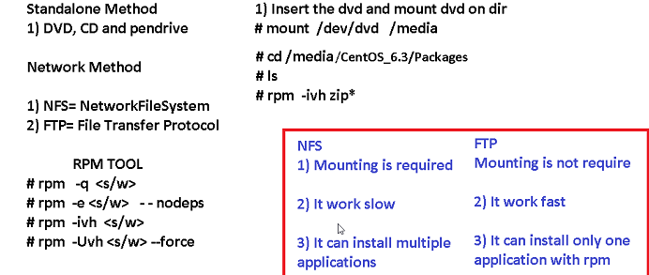

-q query -e erase -ivh install -U upgrade  
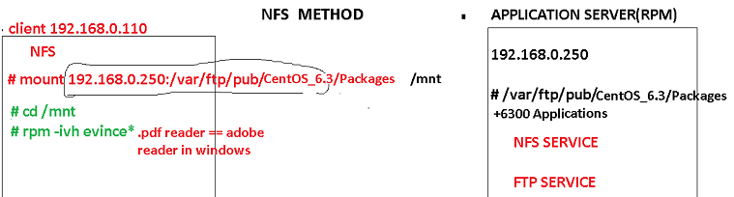

yum install nfs* -y  
service nfs restart

* rpm -q zip (to install the zip command using quarry )
* rpm -e zip –nodeps (to erase the commands using erase likeuninstall)
* getconf LONG_BIT (to get the OS architecture in bits)
* showmount -e 192.168.0.155 (to see the shared directories to access these shared directory we need to mount )
* mount 192.168.0.155:/var/ftp/pub/cetos6.3 /localdirectory (mounting on local dir to get access)
* vi /etc/yum.repos.d/centOS-Base.repo (to view & remove all paragraph edit 3 and 4th centos baseurl and file details)
* yum list samba* -y (to check the list of packages of samba)
* yum install samba* -y (to install samba using yum which includes all dependences)  
   INIT = runlevel  
  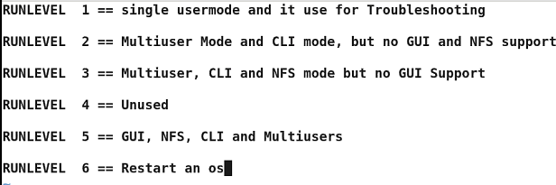
* vi /etc/inittab (is the file where the runlevels can be seen)  
   Troubleshooting Booting
* edit the inittab file add init 6 and save and restart the machine (machine will boot all the day)
* Click on retart and then >> SPACE bar >> we will get the prompt >> E >>kernel >>E>>1 >>back and >>B
* Edit the inittab file and make it 5 and change root password and init 5 >>Login  
   TO SET GRUB (BOOT LOADER) PASSWORD
* grub-md5-crypt >> /boot/grub/grub.conf (enter the password to that file and in grub)
* vi /boot/grub/grub.conf ( copy password and paste near hidden line by adding password–md5 delete last 3 lines)
* Then if we enter grub mode to edit it will ask password   
    
  if we forgot the Admin password and the Bootloader password, we need to go to the rescue boot mode and delete the password with in the file vi /boot/grub/grub.conf and then we need to change  
  chroot /mnt/sysimage   
  vi /boot/grub/grub.conf (dd on the password line)  
  passwd root (to change the root admin password)  
  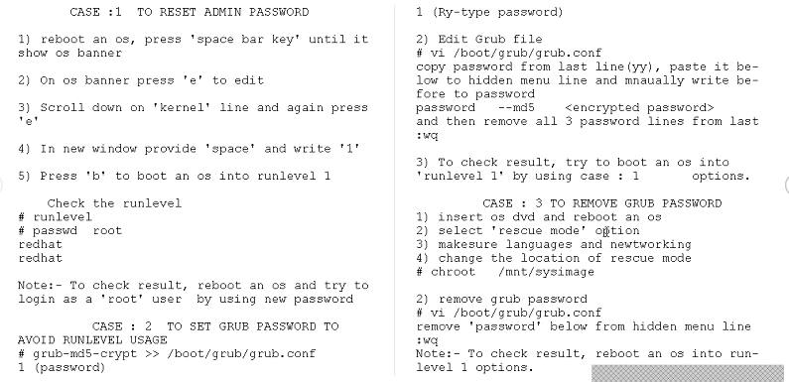  
    
    **NIS (NETWORK INFORMATION SERVICE) port 2049  
  DOMAIN SERVICES : NIS OR SAMBA PDC OR LDAP**  
  setup   
  Network configuration >> device configuration >> etho >> and change the static IP >>save
* Service network restart (to activate the new ip )
* To edit the hostname (hostname change) for temporary chage   
  to edit the hostname permanently vi /etc/hosts change the hostname in that file  
  vi /etc/sysconfig/network (edit here as well)  
  vi /var/yp ( which stores the service DB in domain services)  
    
  **NIS SERVICES** : rpcbind , ypserv , yppasswdd , ypbind ,NFS service
* rpcbind (service is use to activate rpc protocols)
* yppasswdd (service is used to verify username and password)
* ypserv (service gives the centralized login cred)
* ypbind (service always works in the client machines to establish a session between server and client)  
  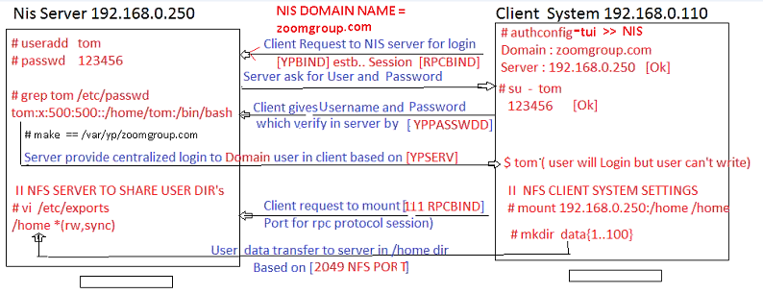

NIS SERVER CONFIG

* vi /etc/sysconfig/network (to set permanent NISDOMAINNAME = random.com)
* yum install yp* nfs* (install the NFS and the yp the server db)
* useradd ravi (add users and give password to those users)
* service rpcbind restart (to restart the services of NIS)  
  service yppasswdd restart   
  service ypserve restart   
  Make  
   NFS config
* vi /etc/exports (we need to write the directory which we want to share )  
  /home *(rw,sync) (Here i am sharing home directory along with read write)
* service nfs restart (to restart and to make active)
* authconfig-tui (to enable NIS using boot options give details of domainname and ip)  
  if we got the failed result we need to uninstall YP bind
* yum remove ypbind* -y (to uninstall the ypbind )  
  rm -rf /etc/yp.conf.rpmsave
* yum install ypbind* -y
* cat /etc/yp.conf (to view the edited content)
* mount 192.168.0.155:/home /home (to mount into home directory)  
   TO LOGIN AS USER PERMANANET
* vi /etc/fstab (add inthe last line the NFS server ip /home nfs defaults 0 0 )
* chkconfig network on (to restart the services )
* chkconfig rpcbind on
* chkconfig ypbind on
* chkconfig nfs on  
  init 6 (to activate it )  
  Now in client machine you can login as user and can able to write data  
  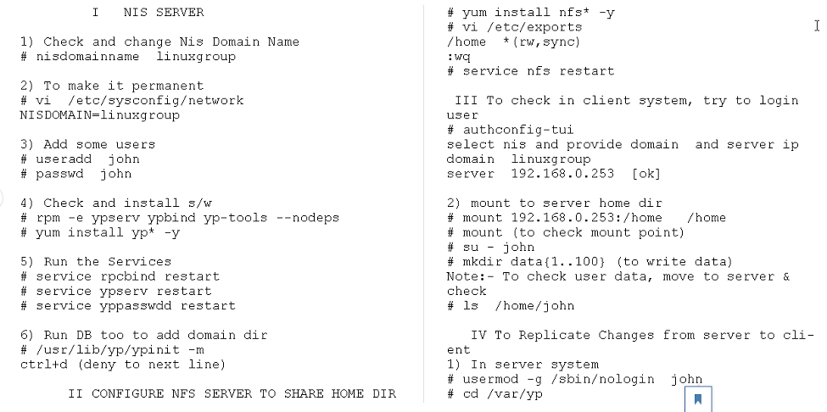

**FTP SERVER**

* vsFTPd = very secure FTP daemon  
  WU-FTP = washington university (widely used)  
  proftpd = professional FTP daemon
* default dir of the ftp server is ( /var/ftp/pub)  
  20 == Data transfer  
  21 == FTP Session
* FTP Modes   
  passive modes : 21 for session  
   random ports for data transfer  
  Active mode : 21 for session   
   20 for data transfer
* iptraf ( txt mode monitoring tool to monitor FTP and it gives all details about the FTP)  
  yum install iptraf* -y (to install iptraf tool)  
  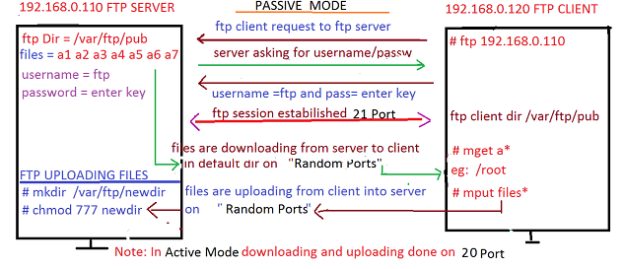
* yum install vsftpd* -y (to install ftp)
* got to the vi /var/ftp/pub create some files and directories
* service vsftpd restart (to restart the services)
* yum install ftp* -y (to install ftp command)
* ftp 192.168.0.155 ( client ip use the credentials to authenticate)  
  ftp> mget filenam* (to download the files into the local directory)  
  ftp>prompt (to off the interactive mode)  
  ftp> lcd /dirname (to change the local dir name)  
  ftp> ! (to exit)  
  ftp> bye (permanent logout)  
  ftp> passive (to turn off passive mode)  
  ftp> mput file1* file2* (to upload these files using upload in the server)
* ftp://192.168.0.155 (to access ftp using GUI mode)
* how to stop anonymous logins (vi /etc/vsftpd/vsftpd.conf ) edit the 12th line make anonymous =NO
* how to set domain DB server authconfig-tui >> select NIS>> give domain name>>IP >> save exit.  
  mount 192.168.0.155:/home /home (to mount into home dir)  
  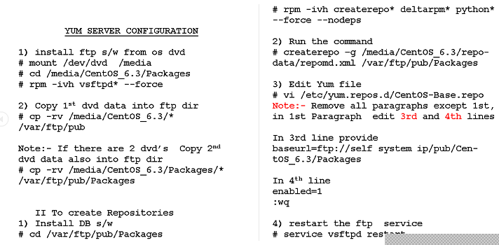
* chkconfig vsftpd on   
  yum install samba-* -y (to install samba)

**SAMBA SERVER**

* Samba is an open source software that provides the seamless files and print services to SMB clients   
  server message block
* Samba allows to inter operability between linux/unix and windows clients
* Samba sets network shares of Unix/Linux directories these appears as the normal windows folder to the windows normal users and can be accessible via the network.
* yum install samba* -y (to install samba) service name : smb  
  default config file : /etc/samba/smb.conf   
  Daemon : nmbd and smbd  
  port numbers :   
  137 = NETBIOS Name service  
  138 = NETBIOS Datagram service  
  139 = NETBIOS session service  
  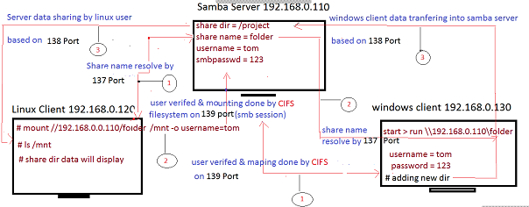
* vi /etc/samba/samba.conf (edit the last para by removing ; and give the title as the shared dir and give the comment as the dir name and path if we need we can add the valid users names with in it
* smbclient -L //192.168.0.155 -N (to check the shared names dir using samba)
* mount //192.168.0.155/shareddir /destination -o username=ravi   
  chmod 1777 shareddir (1 is the sticky bit where the user cannot delete the dir’s)  
  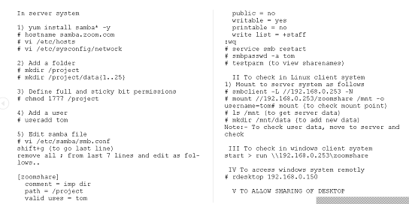
* rdesktop 192.168.0.100 (to take windows system as remote),  
   **Domain Name System (DNS) 53 port**
* its a hirarechial naming system where each level of name is separated by a “.”
* Primary moto is to have user friendly name is mapped to the computer friendly ip.  
  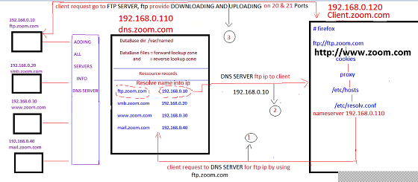
* **Records** : SOA (start of authority)   
   NS (Name server) - identifies the DNS server for each zone

A (Address) - maps a hostname to an ip address   
 CName (canonical name) -maps alias name to a hostname  
 PTR (pointer) - maps an ip address to a hostname  
 MX (mail exchange) -maps a domain name to a mail server

* Packages (bind); config files ( /etc/named.conf)(/etc/named.rfc1912.zones) database directory (/var/named)  
  service/daemon : Named
* yum install bind* -y (to install dns)
* vi /etc/named.rfc1912.zones ( edit the 19-23th line for forward lookup zones changed the domain name  
  31-35th line for the reverse lookup zone give ip in reverse forward and domain name)  
  cd /var/named   
  cp -p named.localhost for (to copy files along with permissions to the forward Lp domain namespecified **for**)  
  cp -p named.localback rev (to copy files along with permissions to the reverse Lp domain namespecified **rev**)  
  vi for (to see & edit the SOA records with the domain name and Name server and ip 3octects and DNS)  
  vi rev (to see & edit the SOA records with the domain name and Name server and 1oct ip and DNS ptr domainnam)  
  vi /etc/named.conf ( forward lpzedit the 11 line give self ip address 17th line give client’s ip or any to access anyone)  
  vi /etc/resolv.conf ( revers lpz edit nameserver self ip )  
  service named restart (to restart the DNS services)
* Dig domainname (to check the DNS exact mapped forward look up)  
  dig -x ip address (to check the DNS exact mapped revers look up )  
  **DIG = NSlookup**
* in client machine to verify DNS updated the **vi /etc/resolv.conf**  with the DNS IP address.
* if we want to access other machine like windows or other servers we need to add those ip’s in reverse look up zone along with the records specified  
    
    **WEB SERVER**
* **TUX : Apache : AOL : SUN one** ( these are the webservers   
  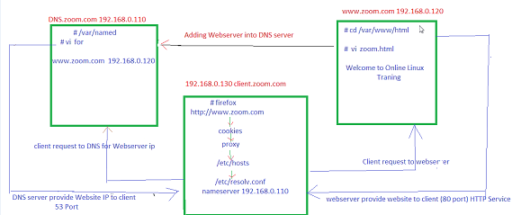
* yum install httpd* -y (to install apache web server)  
  vi /etc/httpd/conf/httpd.conf (edit remove # from last para and give the domain details as follows)  
   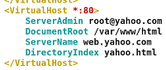
* copy paste these 6 line and give the respective websites names as you like.  
  * indicates all ip’s  
  cd /var/www/html   
  vi yahoo.html (write a sample html files for no of websites)  
  service httpd restart (restart httpd service)  
  netstat -ant (to check the port are listing or not)  
  vi /etc/named.rfc1912.zones (to make changes by adding the DNS records in Forward lpZ )  
     
  cp -p named.localhost for.yahoo (copy the files along with the permissions )  
  Vi for.yahoo (edit the file as follows)  
   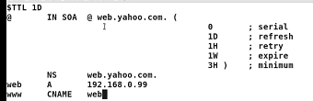  
  In client machine update the DNS ip in reverse lookup zone vi /etc/resolv.conf( add the **nameserver ipaddress**)
* yum install nmap* -y (its a tool where client can know the changing of any port of the ip)  
  to find the port number of the website for the client  
  nmap ipaddress (it gives us all port details of the ip)