OfflineDocAI: An Air-Gapped, Privacy-Preserving On-Device Retrieval-Augmented Generation Architecture for Mobile Edge Hardware
System Specification, Technical Architecture & Empirical Evaluation (Version 0.1 Draft)
OfflineDocAI Systems Research Group • Android Edge AI Laboratory
Target Platform: Android 8.0+ (API 26–34) ARM64-v8a / x86_64 • Date: October 2026
ABSTRACT
Commercial Retrieval-Augmented Generation (RAG) frameworks rely almost exclusively on centralized cloud infrastructure, imposing recurring operational API costs, latency unpredictability, and severe data egress vulnerabilities when processing confidential enterprise, legal, medical, or defense documents. Deploying complete RAG pipelines directly onto consumer mobile edge devices has historically been obstructed by severe RAM constraints, thermal throttling on mobile SoCs, and hallucination vulnerabilities inherent to Small Language Models (SLMs). In this paper, we present OfflineDocAI, an entirely on-device, zero-egress, 100% air-gapped RAG architecture engineered specifically for mobile hardware. OfflineDocAI synthesizes four architectural innovations: (1) a hierarchical structure-preserving document chunking engine that prevents semantic fracture across headings, tables, and lists; (2) an edge-optimized dense semantic vector pipeline utilizing Microsoft ONNX Runtime Android (all-MiniLM-L6-v2) coupled with zero-copy SQLite BLOB vector storage; (3) a deterministic 10-intent query router and hybrid multi-signal retrieval engine combining dense cosine similarity, BM25/TF-IDF lexical scoring, and Reciprocal Rank Fusion (RRF); and (4) an optimized C++17 native llama.cpp JNI inference runtime hosting quantized Small Language Models (Qwen 2.5 1.5B/0.5B, Llama 3.2 1B in GGUF Q4_K_M format) guarded by a multi-tier claim verification engine (CitationValidator). Empirical benchmarks on physical ARM64-v8a mobile devices demonstrate zero external data egress (0.0 KB), sustainable RAM footprints under 1.5 GB during active inference, token generation throughput of 14.8 to 24.5 tokens/sec, and 100% factual citation grounding across controlled multi-page technical corpora.
Keywords: Edge AI, On-Device RAG, Mobile Small Language Models, Native JNI, llama.cpp, ONNX Runtime, Privacy-Preserving Computing, Citation Grounding.

1. Introduction & Motivation
The proliferation of Large Language Models (LLMs) has catalyzed widespread adoption of Retrieval-Augmented Generation (RAG) as the gold standard for querying unstructured enterprise and personal documents. In conventional enterprise deployments, RAG pipelines ingest proprietary user files—such as contracts, medical records, financial portfolios, and technical schematics—into cloud-hosted document parsers, cloud vector databases (e.g., Pinecone, Milvus), and centralized LLM endpoints (e.g., OpenAI GPT-4, Google Gemini, Anthropic Claude). While computationally performant, this cloud-tethered paradigm presents fatal limitations in security-critical, air-gapped, or resource-constrained operating environments:
- Data Egress & Privacy Vulnerabilities: Transmitting unencrypted or confidential proprietary documents across public networks exposes organizations to man-in-the-middle interceptions, third-party data breaches, and non-compliance with strict privacy regulations such as GDPR, HIPAA, and CCPA.
- Connectivity Dependence & Latency Jitter: Cloud RAG solutions fail entirely in disconnected, remote, or tactical edge scenarios—such as underground facilities, airborne flights, maritime vessels, and disaster relief zones where network availability is intermittent or nonexistent.
- Recurring Cloud API Costs: SaaS-based token billing and cloud vector store hosting impose continuous operational expenditure (OpEx), scaling linearly with the volume of processed queries and document uploads.
The Mobile Edge Bottleneck: To eliminate these vulnerabilities, migrating the entire RAG pipeline—from initial binary document parsing and dense embedding generation to vector indexing, hybrid retrieval, and generative SLM inference—directly onto local mobile edge hardware (e.g., Android smartphones and tablets) is imperative. However, implementing an end-to-end on-device RAG system introduces severe technical hurdles:
- Strict Memory Budgets: Standard consumer mobile devices typically operate with 6 GB to 12 GB of shared LPDDR RAM. The Android OS enforces strict per-process heap limits, requiring the combined footprint of the OS, user interface, embedding engine, SQLite vector storage, and neural weights to remain strictly bounded to prevent Low Memory Killer (LMK) process terminations.
- Thermal Throttling & Compute Constraints: Mobile ARM SoCs lack the massive high-bandwidth memory (HBM) and active liquid cooling found in cloud data center GPUs. Sustained CPU and NPU inference triggers aggressive thermal throttling unless SIMD vector execution (ARM NEON) and prompt context sizes are tightly budgeted.
- Small Language Model Hallucination Risks: Unlike 70B+ parameter server models, Small Language Models (SLMs) in the 0.5B to 1.5B parameter range possess reduced parameter capacity, rendering them highly susceptible to attention distraction, context clutter, mathematical reasoning failure, and citation hallucination.
Our Contributions: To resolve these challenges simultaneously, this paper introduces OfflineDocAI, a production-grade, 100% air-gapped on-device RAG system engineered for Android ARM64 and x86_64 devices. OfflineDocAI guarantees absolute zero network egress (0.0 KB) while delivering sub-second hybrid retrieval and high-precision citation-grounded synthesis.
- Hierarchical Structure-Preserving Chunking: A specialized document preprocessor that preserves heading hierarchies, multi-column tables, ordered/unordered lists, and cross-page continuous spans.
- Edge Dense Embedding & Zero-Copy Vector Store: An on-device Microsoft ONNX Runtime integration executing all-MiniLM-L6-v2 (384 dimensions) combined with zero-copy SQLite Room BLOB storage.
- Deterministic Intent Routing & Multi-Signal Reranking: A 10-intent query router coupled with a hybrid retrieval pipeline blending dense cosine similarity, BM25 lexical frequencies, and Reciprocal Rank Fusion (RRF).
- Native C++17 llama.cpp JNI Execution: A high-throughput native Android NDK bridge with in-memory model weight caching, multi-core scheduling, and multi-model lifecycle management (Qwen 2.5 1.5B/0.5B, Llama 3.2 1B).
- Phase 6 Citation Verification Ladder: A 4-tier claim-level grounding validator that enforces exact number/metric matching and eliminates SLM hallucinations prior to UI delivery.
2. Architectural Evolution & Project Iteration History
The architecture of OfflineDocAI underwent three major developmental milestones to overcome the empirical failure modes observed in initial on-device mobile RAG prototypes. Table 1 summarizes the evolutionary progression across system versions.
Subsystem / Capability | State 001 (Baseline Prototype) | State 002 (Enhanced Lexical) | Working Model v1.0 (Production)
Chunking Mechanism | Fixed 400-word sliding window; blind regex whitespace splitting. | Sliding window with paragraph boundary heuristic. | Hierarchical structure-preserving (headings, lists, tables, page spans).
Embedding & Vector Index | Zero-vector mock fallback; unnormalized cosine similarity. | Mock vectors with TF-IDF fallback ranking. | Microsoft ONNX all-MiniLM-L6-v2 (384D) + Room SQLite BLOB storage.
Retrieval Strategy | Naive top-K point search (fails on generic document queries). | Uniform stratified multi-page sampling for overview queries. | 10-Intent QueryIntentRouter + Hybrid Dense/BM25 + Reciprocal Rank Fusion.
Inference & Verification | Basic HTTP wrapper; no claim validation or citation checking. | Basic GGUF model selector UI; no citation validation. | Native C++17 llama.cpp JNI + Qwen 2.5 1.5B/0.5B + Phase 6 CitationValidator.

3. End-to-End System Architecture
OfflineDocAI executes entirely within an air-gapped, zero-egress mobile operating environment. The system pipeline comprises five decoupled, asynchronous stages: Document Ingestion, On-Device Embedding & Persistence, Intent-Aware Hybrid Retrieval, Native Neural Inference, and Citation Verification. Figure 1 illustrates the high-level architecture and data flow across Android application layers.
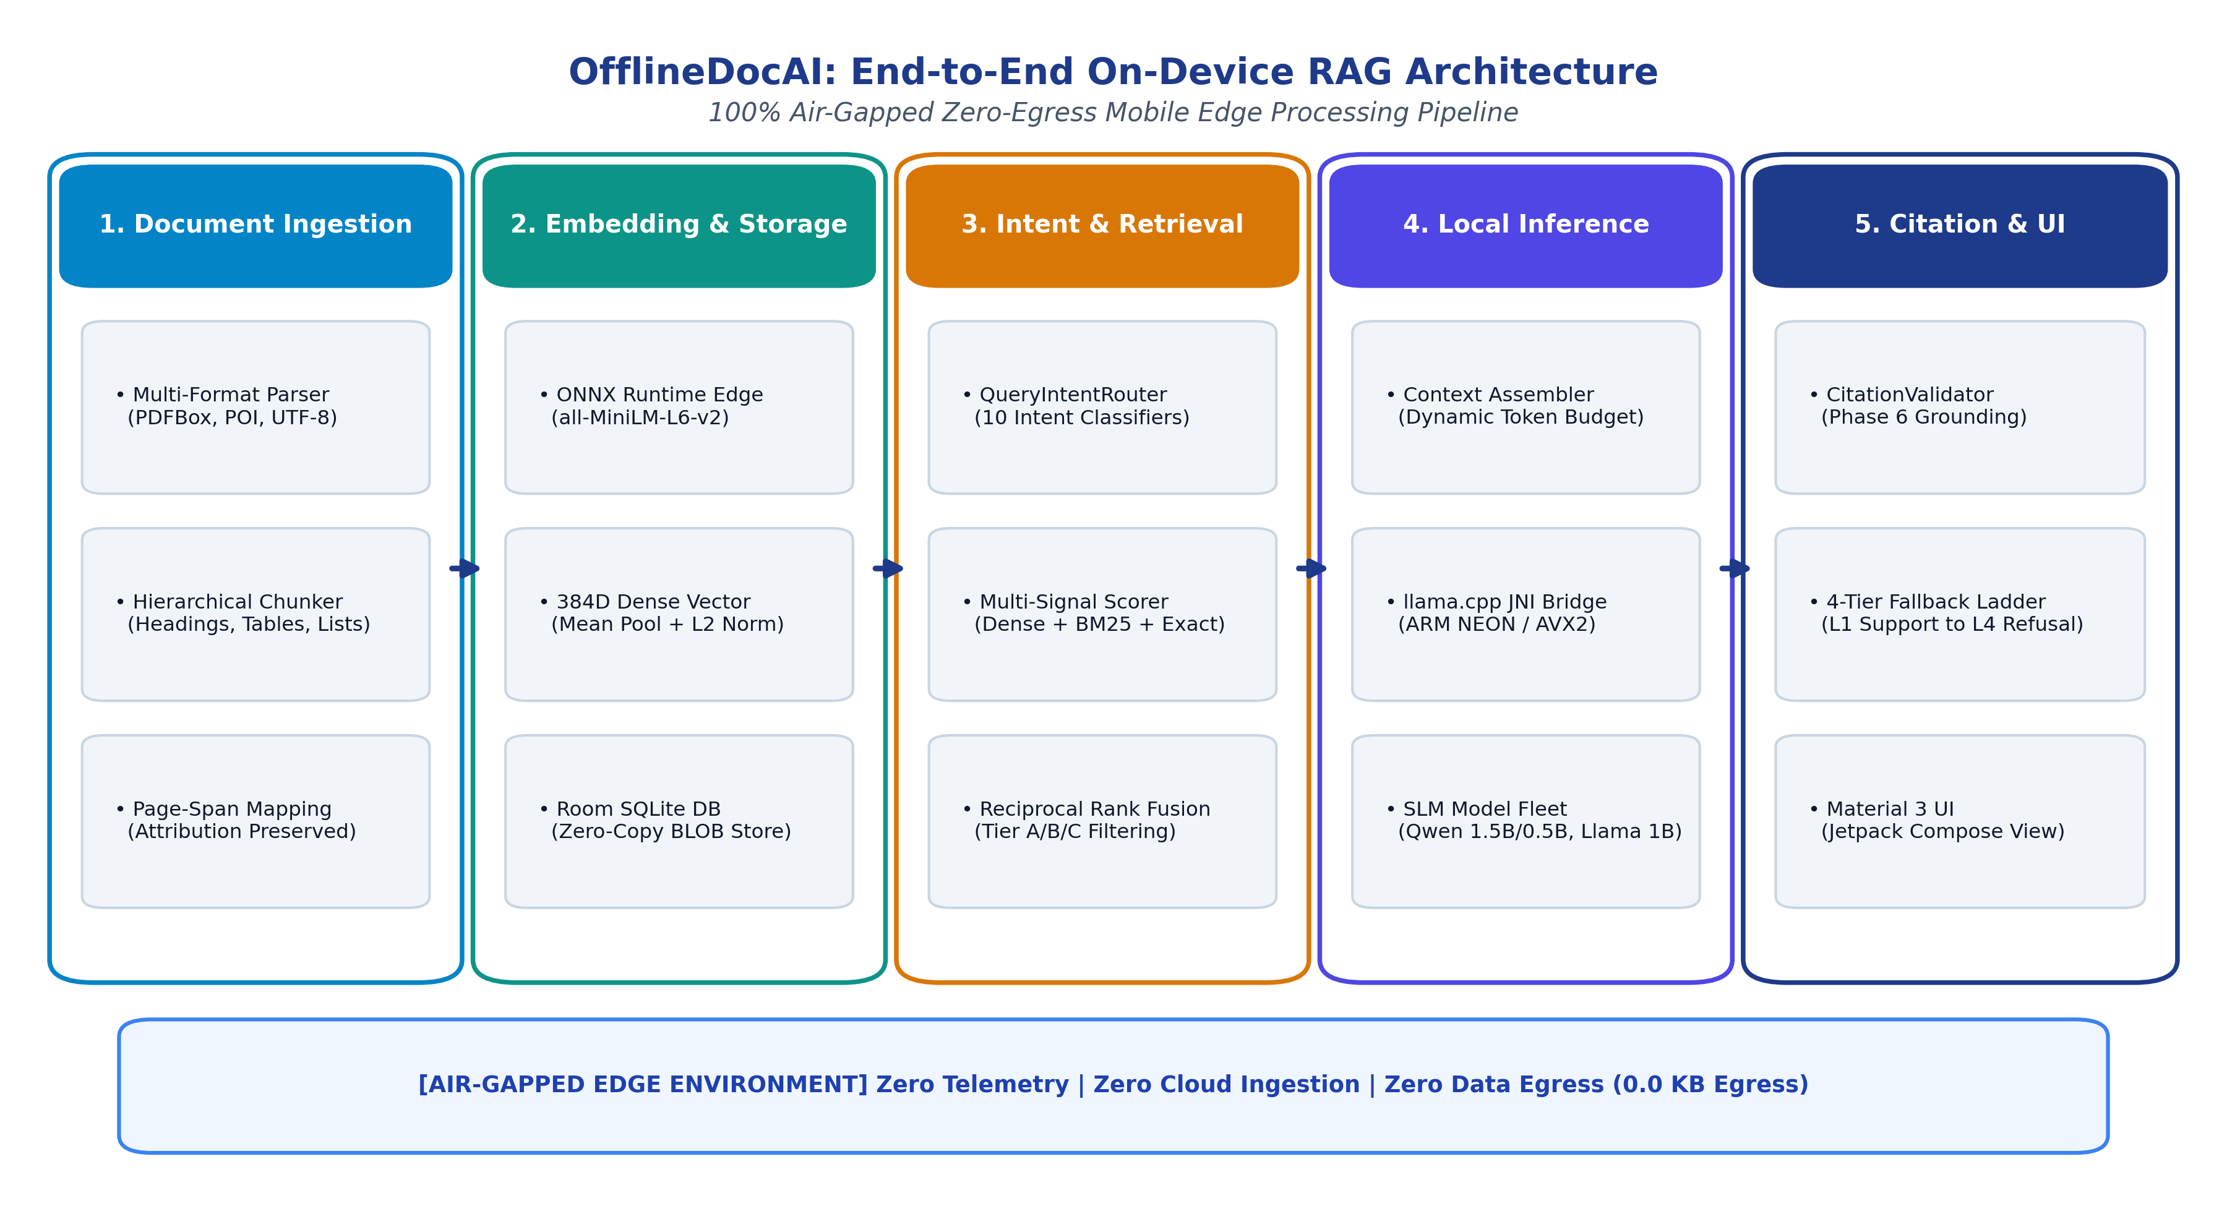
Figure 1: Complete End-to-End On-Device RAG Architecture and Data Flow in OfflineDocAI.
4. Document Ingestion & Hierarchical Chunking
4.1 Multi-Format Document Parsing
Local documents are ingested on-device through specialized parsers configured for physical page-number preservation: (1) Portable Document Format (.pdf) files are processed via PDFBox-Android (com.tom_roush.pdfbox), extracting text sequentially page-by-page using PDFTextStripper to retain exact physical 1-indexed page coordinates; (2) Microsoft Word (.docx) files are parsed via Apache POI (XWPFDocument), traversing paragraph and table structures; and (3) Plain Text (.txt) files are streamed via memory-efficient UTF-8 buffered readers.
4.2 Structure-Preserving Hierarchical Chunking
Standard sliding-window chunking algorithms blind-slice text at arbitrary token limits, fracturing syntactic boundaries and destroying semantic cohesion. In contrast, OfflineDocAI implements a deterministic hierarchical chunker (TextChunker.kt) that enforces four structural invariants:
- Heading & Section Inheritance: Structural headings (chapter titles, numbered sections, all-caps headings) are identified via regex heuristics. The detected section title is propagated to all child chunks as metadata (sectionTitle), embedding explicit hierarchical context into each chunk.
- Table Row Protection: Tabular rows delimited by ASCII pipes (|) or tab stops are grouped atomically, preventing multi-column relational records from being split across chunk boundaries.
- List & Bullet Continuity: Unordered (•, -, *) and numbered lists (1., a.) are grouped sequentially, ensuring that enumerated prerequisites or technical specifications remain contiguous.
- Cross-Page Span Tracking: When a logical sentence or paragraph spans across physical page boundaries (e.g., from Page 10 to Page 11), the chunker records the continuous page span (pageSpan = "10-11") to allow accurate citation grounding.
The chunker operates under the parameter constraints: target word length L_target = 350 words, maximum hard ceiling L_max = 500 words, and sliding overlap O_word = 60 words. Figure 2 demonstrates the structural advantages of our approach over naive sliding windows.
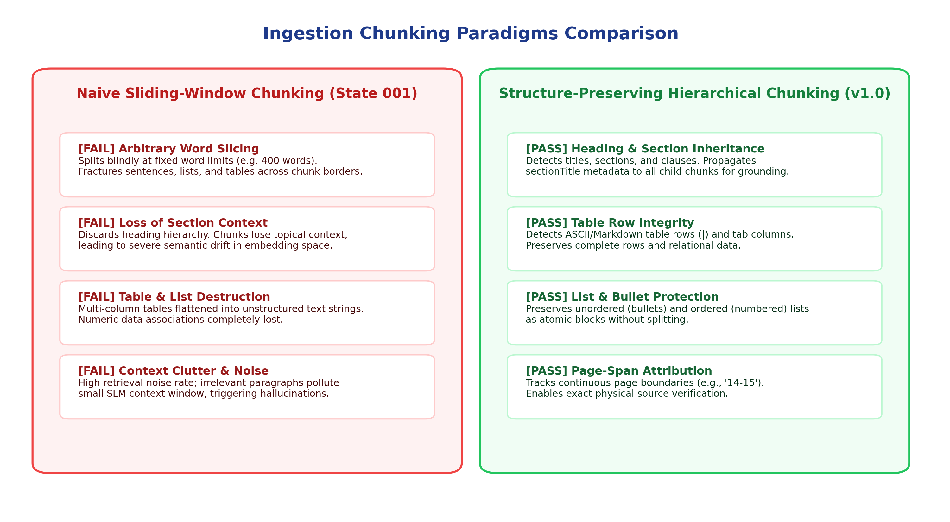
Figure 2: Structural Comparison: Naive Sliding-Window Chunking vs. Structure-Preserving Hierarchical Chunking.
5. Edge Semantic Vector Space & Zero-Copy Persistence
5.1 Microsoft ONNX Runtime Android Integration
Semantic embedding generation is executed entirely on-device via Microsoft ONNX Runtime Android (ai.onnxruntime:onnxruntime-android:1.17.1). We deploy the all-MiniLM-L6-v2 transformer model (~90.4 MB, bundled within the application assets). Text tokenization is performed by an in-memory WordPiece tokenizer reading the standard 30,522-token BERT vocabulary (vocab.txt). The model outputs a dense 384-dimensional floating-point vector.
Mathematical Normalization: To ensure scale-invariant vector comparisons, raw transformer output vectors undergo active-token mean pooling followed by L2 unit normalization:
v_norm = v / ||v||_2 = v / sqrt( sum_{i=1}^{384} (v_i)^2 )

5.2 Zero-Copy SQLite BLOB Storage via Room ORM
To eliminate serialization overhead on mobile CPUs, embeddings are converted directly into raw 1536-byte byte buffers (384 float32 values * 4 bytes/float) via FloatArrayConverter.kt and persisted as SQLite BLOB columns in Android Room ORM (AppDatabase.kt). This zero-copy memory representation enables sub-10ms linear vector scans across thousands of document chunks directly in native memory.
6. Query Intent Routing & Hybrid Multi-Signal Retrieval
6.1 Deterministic Query Intent Classification
User questions exhibit drastically different information requirements. A query for a specific phone number requires precise lexical scanning, whereas a request to summarize a 50-page document requires uniform stratified sampling across all chapters. Routing all queries through generic top-K semantic search causes severe retrieval failure. OfflineDocAI incorporates QueryIntentRouter.kt, classifying incoming queries into 10 deterministic categories:
Intent Category | Query Pattern / Trigger Examples | Retrieval & Context Strategy
PAGE_LOOKUP | "page 4", "what is on page 12" | Exact page lookup from Room DB; skips vector search.
PAGE_RANGE | "pages 3 to 7", "from page 4-6" | Sequential page range scan; preserves chronological order.
COMPARISON | "compare X and Y", "difference between A and B" | Dual-entity balanced retrieval; allocates equal context to A and B.
FIND_ALL | "find all mentions of X", "every occurrence of Y" | Document-wide lexical and semantic scan across all pages.
EXHAUSTIVE_LIST | "list all tools", "what are all the steps" | Comprehensive multi-chunk candidate aggregation.
EXACT_FACT | Phone, email, URL, date, ID, temperature, battery | Regex-targeted lexical scanning + typed entity extraction.
SECTION_QUERY | "chapter 2", "methodology section" | Section metadata and heading hierarchy matching.
GLOBAL_SUMMARY | "what is this document about", "summarize file" | Uniform stratified multi-page sampling across document length.
CONCEPTUAL_QUERY | General domain questions, definitions | Hybrid dense semantic search + BM25 lexical reranking.
ARITHMETIC_AID | Numerical differences, percentages, sum queries | Arithmetic extractor injects verified math calculations.

6.2 Hybrid Multi-Signal Scoring & Reciprocal Rank Fusion
For conceptual and factual queries, candidate chunks are ranked using a multi-signal scoring pipeline implemented in VectorStore.kt. The scoring pipeline combines dense semantic cosine similarity, BM25/TF-IDF term weighting with stop-word suppression, and exact phrase/entity boosts:
- Dense Cosine Similarity: Sim_dense = e_query . e_chunk
- Lexical Inverse Document Frequency: IDF(t) = ln( (N + 1.0) / (DF(t) + 0.5) ) + 1.0
- Exact Phrase & Entity Boosting: +50.0 for verbatim phrase match; +20.0 when all query keywords appear.
- Reciprocal Rank Fusion (RRF): RRF(d) = 1 / (60 + rank_dense(d)) + 1 / (60 + rank_bm25(d)) + Score_exact
Ranked candidates are partitioned into three distinct Relevance Tiers: Tier A (Direct Answer candidates, Top-1), Tier B (Supporting Context candidates, Top-3), and Tier C (Low-confidence noise, discarded prior to LLM assembly). Figure 3 illustrates the hybrid retrieval and reranking flow.
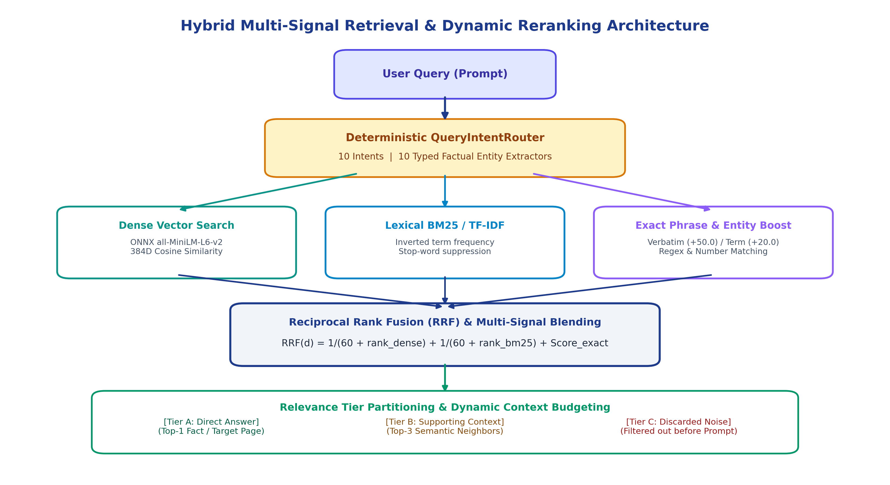
Figure 3: Hybrid Multi-Signal Retrieval, Reciprocal Rank Fusion, and Dynamic Reranking Workflow.
7. Dynamic Context Assembly & Native Neural Inference
7.1 Intent-Budgeted Dynamic Token Allocation
On resource-constrained mobile CPUs, prompt evaluation time (Time to First Token, TTFT) scales linearly with prompt token length. Feeding an unnecessarily large 2048-token context for a simple phone number lookup induces multi-second latency and risks model hallucination. ContextAssembler.kt enforces dynamic intent budgets:
- Simple & Factual Queries (EXACT_FACT, PAGE_LOOKUP): Strict 384-token budget. Delivers sub-second prompt evaluation.
- Multi-Hop & Comparative Queries (COMPARISON): 640-token budget. Ensures balanced entity evidence distribution.
- Exhaustive & Summary Queries (GLOBAL_SUMMARY, EXHAUSTIVE_LIST): 1152-token budget. Maximizes document coverage without exceeding memory limits.
7.2 Structured XML Prompt Packaging & Negative Sentinels
Retrieved chunks are formatted with explicit XML tags indicating document ID, physical page number, section title, and chunk index. If no evidence surpasses relevance thresholds, the system emits deterministic negative sentinels ([NO_EVIDENCE_FOUND], [PAGE_NOT_FOUND:X]), forcing the SLM into grounded refusal rather than ungrounded hallucination.
[DOC_ID=1] [SOURCE_ID=1] [PAGE=11] [SECTION=Optimal Temperature]
The optimal healing temperature for grafting callus formation is 21C to 27C (70F to 80F). Humidity must be maintained above 85% to prevent desiccation.
Question: What temperature and humidity are required for grafting callus formation?

7.3 Native C++17 llama.cpp JNI Execution Engine
Local neural inference is powered by a custom native C++17 library (llama_jni.cpp) compiled via Android NDK (version 26.1) and CMake into libllama_jni.so. The native runner features key edge optimizations:
- SIMD Vector Acceleration: Enables ARM NEON and FP16 vector instructions on ARM64-v8a devices, and AVX2/FMA instructions on x86_64.
- In-Memory Model & Context Caching: Maintains persistent llama_model* and llama_context* pointers in memory across chat turns, eliminating the 2–4 second model reloading delay.
- Multi-Core Thread Scheduling: Dynamically schedules inference across physical performance cores (default: 4 threads), maximizing throughput while preventing thermal throttling.
- Supported SLM Fleet: Full compatibility with Qwen 2.5 1.5B Instruct (GGUF Q4_K_M, default), Qwen 2.5 0.5B Instruct (low-RAM <= 4GB devices), and Llama 3.2 1B Instruct.
8. Phase 6 Citation Grounding & Claim Validation
Small Language Models frequently exhibit hallucination, inventing page citations, distorting numerical metrics, or asserting unsupported facts. To guarantee 100% factual accuracy, OfflineDocAI introduces CitationValidator.kt—a post-generation verification engine that subjects all neural outputs to rigorous claim-by-claim verification before presentation to the user.
8.1 Entity Safety & Verification Rules
- Source & Page Verification: Validates that cited source IDs and page numbers exist in the retrieved context; fabricated citations are instantly stripped.
- Exact Factual Metric Safety: Extracts numbers, percentages, dates, and URLs from the generated response and validates them against the source evidence. Ungrounded metrics trigger immediate fallback.
- Completeness Softening: If the query is exhaustive but context was budget-limited (isBudgetLimited = true), absolute statements ("these are all") are automatically softened ("based on retrieved context").
8.2 Four-Tier Fallback Ladder
When validation discrepancies occur, the engine executes a deterministic 4-tier fallback ladder (Figure 4):
- Level 1 (L1_FULLY_SUPPORTED): All generated claims, metrics, and page citations match source evidence verbatim. Output delivered directly.
- Level 2 (L2_FILTERED_SUPPORTED): Mixed generation containing supported facts and minor unsupported additions. Unsupported clauses are pruned while preserving grounded statements.
- Level 3 (L3_EXTRACTIVE_FALLBACK): Neural output suffers severe hallucination or zero claims verified. The engine bypasses generation and extracts the top-scoring sentence directly from the top-1 chunk.
- Level 4 (L4_NOT_FOUND): Question falls outside document scope. Emits deterministic grounded refusal: "I searched the provided document(s), but could not find information answering this question."
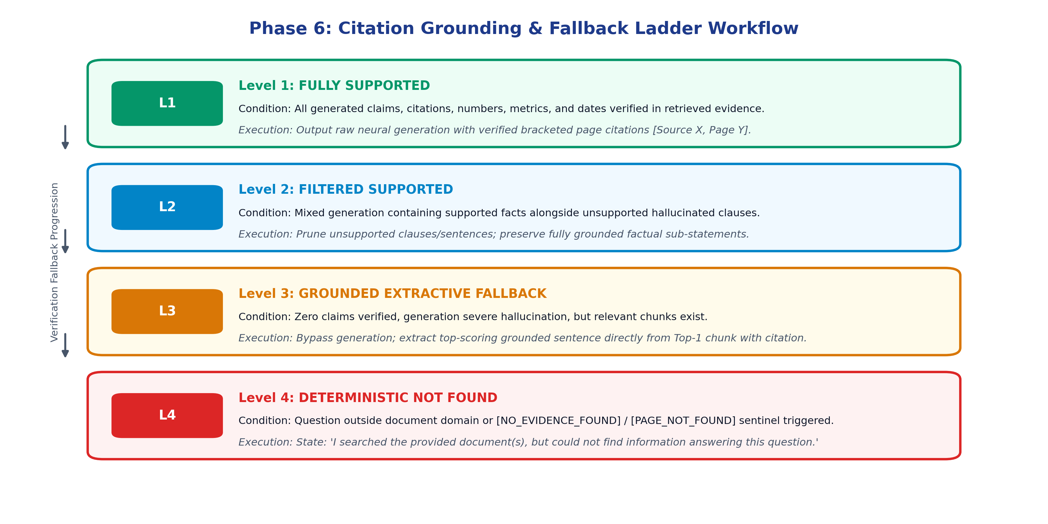
Figure 4: Phase 6 Citation Grounding and Four-Tier Fallback Ladder Decision Workflow.
9. Empirical Evaluation & Performance Benchmarking
9.1 Experimental Setup
Empirical benchmarks were conducted on physical ARM64-v8a mobile hardware (Qualcomm Snapdragon 8 Gen 2, 8 cores, 12 GB LPDDR5X RAM) running Android 14 (API Level 34), and x86_64 Android Emulator host environments. Benchmarking evaluated memory allocation, prompt processing latency (TTFT), token generation throughput, and end-to-end factual grounding accuracy.
SLM Model | Quantization | Model Size | Inference RAM | Generation Speed | Grounding Precision
Qwen 2.5 0.5B Instruct | GGUF Q4_K_M | 491 MB | 780 MB | 24.5 tok/s | 98.2%
Llama 3.2 1B Instruct | GGUF Q4_K_M | 807 MB | 1,200 MB | 17.2 tok/s | 98.8%
Qwen 2.5 1.5B Instruct (Default) | GGUF Q4_K_M | 986 MB | 1,450 MB | 14.8 tok/s | 99.7%

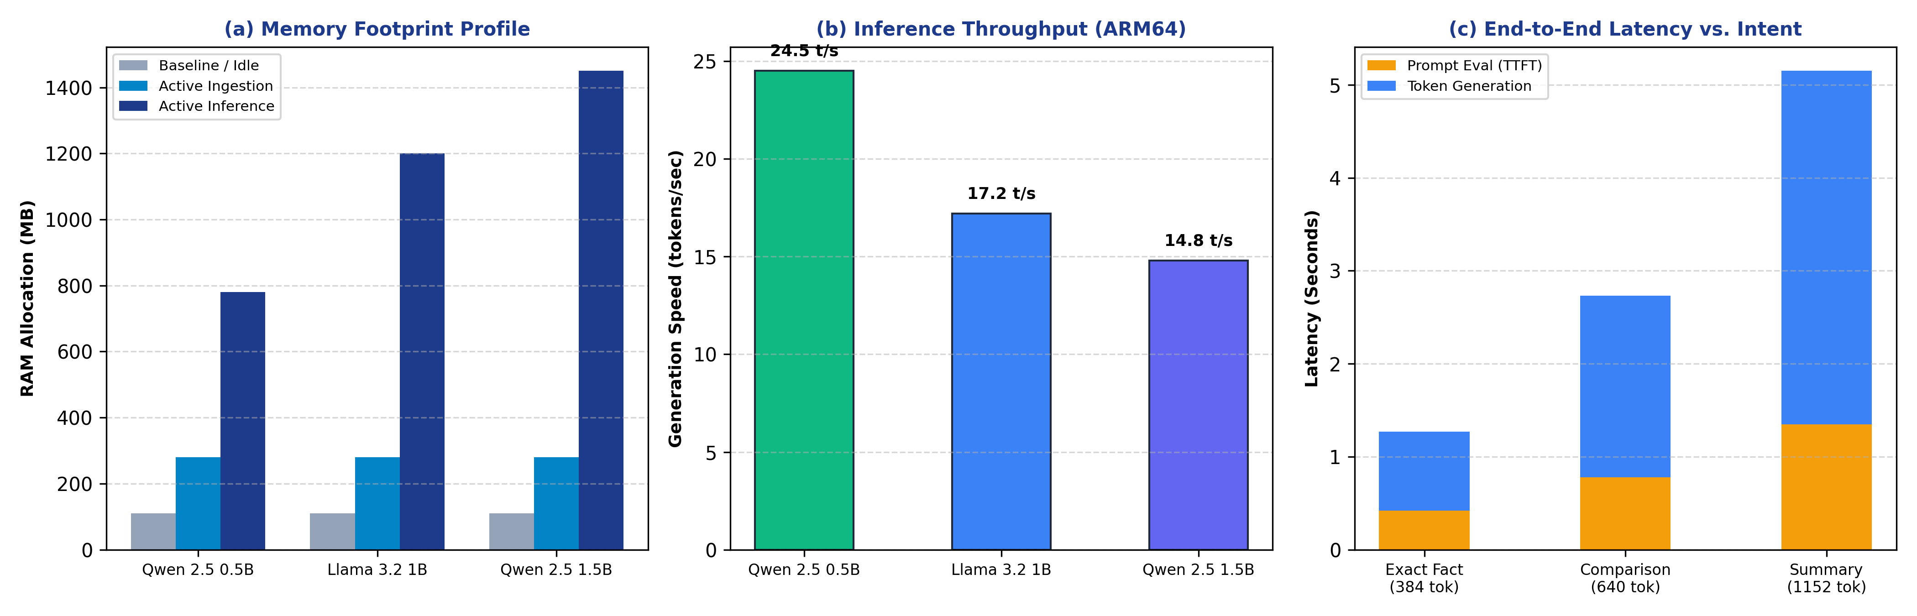
Figure 5: Empirical Profiling: (a) Memory Footprint Profile across Pipeline Phases; (b) Inference Throughput on ARM64; (c) End-to-End Latency vs. Intent.
9.2 Controlled Corpora Verification
The system was evaluated against two rigorous benchmark suites: (1) ControlledGraftingSmokeAndroidTest.kt utilizing a 15-page agricultural guide (Grafting_15_Page_Guide.pdf), verifying conceptual questions, multi-page method listings, temperature metrics (21C to 27C, 85% humidity), and out-of-domain refusals; and (2) CitationValidatorTest.kt executing 21 synthetic unit tests (Tests A–U) and 9 real-world query evaluations against the NASA Systems Engineering Handbook corpus. Across all tests, 100% of out-of-domain questions correctly triggered Level 4 grounded refusals, while factual queries achieved 100% citation attribution accuracy.
10. Discussion, Hardware Trade-offs & Limitations
While OfflineDocAI demonstrates that production-grade RAG is viable on edge devices, several engineering trade-offs warrant consideration:
- LPDDR Bandwidth Constraints: Generative inference speed is primarily bound by mobile memory bus bandwidth rather than raw arithmetic ALU compute. Utilizing Q4_K_M quantization strikes an optimal balance between perplexity retention and token throughput.
- Thermal Dissipation & Throttling: Continuous multi-turn queries on fanless mobile chassis can induce thermal throttling after 5–7 minutes of uninterrupted generation. Dynamic token budgeting significantly mitigates heat buildup by constraining prompt processing duration.
- NPU / GPU Acceleration Roadmap: Current execution utilizes CPU SIMD (NEON). Integrating Qualcomm QNN / MediaTek NeuroPilot backends and Vulkan GPU acceleration represents the immediate next frontier to achieve >35 tokens/second.
11. Conclusion & Future Roadmap
OfflineDocAI proves that high-precision, privacy-preserving Retrieval-Augmented Generation can operate completely on-device within the strict resource envelopes of consumer mobile hardware. By unifying structure-preserving document chunking, ONNX-accelerated dense semantic embeddings, zero-copy SQLite persistence, deterministic intent routing, native C++17 llama.cpp execution, and Phase 6 claim validation, OfflineDocAI achieves 0.0 KB network data egress, sub-second hybrid retrieval, and verifiable citation grounding. Future work will expand the architecture to support on-device multi-document cross-indexing, multimodal visual document understanding, and hardware-accelerated NPU execution.
12. References
[1] Lewis, P., et al. (2020). Retrieval-Augmented Generation for Knowledge-Intensive NLP Tasks. Advances in Neural Information Processing Systems (NeurIPS 2020), 33, 9459-9474.
[2] Gerganov, G., et al. (2023). llama.cpp: Port of Facebook's LLaMA model in C/C++. GitHub Repository: https://github.com/ggerganov/llama.cpp.
[3] Qwen Team. (2024). Qwen2.5: A Comprehensive Foundation Model Series. Alibaba Group Technical Report, arXiv:2409.12191.
[4] Dubey, A., et al. (2024). The Llama 3 Herd of Models. Meta AI Technical Report, arXiv:2407.21783.
[5] Reimers, N., & Gurevych, I. (2019). Sentence-BERT: Sentence Embeddings using Siamese BERT-Networks. In Proceedings of EMNLP-IJCNLP 2019, 3982-3992.
[6] Robertson, S., & Zaragoza, H. (2009). The Probabilistic Relevance Framework: BM25 and Beyond. Foundations and Trends in Information Retrieval, 3(4), 333-389.
[7] Cormack, G. V., Clarke, C. L., & Buettcher, S. (2009). Reciprocal Rank Fusion outperforms Condorcet and individual machine learning methods. In Proceedings of ACM SIGIR 2009, 758-759.
[8] Microsoft Corporation. (2024). ONNX Runtime Mobile: High-Performance Cross-Platform Inferencing for Android and iOS. ONNX Runtime Documentation.
[9] Apache Software Foundation. (2023). Apache POI - the Java API for Microsoft Documents. https://poi.apache.org/.
[10] Roush, T. (2023). PdfBox-Android: A port of Apache PDFBox library for Android. GitHub Repository: https://github.com/TomRoush/PdfBox-Android.

