Deggendorf Institute of Technology
Faculty of Applied Natural Sciences and Industrial Engineering
Applied AI for Digital Production Management
Master's Thesis
Entwicklung und Evaluation eines NLP-basierten Konzepts zur strukturierten Extraktion von Informationen und zur Unterstützung der Planung in Instandhaltungsaufträgen
Development and Evaluation of an NLP-Based Concept for Structured Information Extraction and Planning Support in Maintenance Work Orders

Master thesis to obtain an academic degree:
Master of Engineering (M.Eng.)
submitted by
Ravi Virani
Matriculation number: 22307118
supervisor: Prof. Dr.-Ing. Ralph Hensel-Unger
Submission date: 15.09.2026

Statement of Authorship
I hereby declare that I have written the present master's thesis independently and without the use of any sources or aids other than those indicated. All passages taken verbatim or in substance from published or unpublished works of others have been identified as such. This thesis has not been submitted, either in the same or a similar form, to any other examination authority, and has not yet been published.
Deggendorf, 15.09.2026
Ravi Virani

Abstract
Maintenance work orders contain valuable knowledge about faults, affected components, inspections, and corrective actions, but their short and inconsistent language makes automated analysis difficult. This thesis develops and evaluates an NLP pipeline that transforms noisy aviation maintenance narratives into structured and retrievable historical evidence. The pipeline covers text normalization, information extraction, silver knowledge graph construction, case retrieval, and evidence presentation. Normalization was examined as a supporting step using raw text, frequency-based replacement, deterministic rules, ByT5, Selective ByT5, and a combined rules-ByT5 method. The central information-extraction experiment compared a feature-based CRF with logistic regression, a neural BiLSTM-CRF pipeline, DistilBERT, and the span-based SpERT transformer. On the frozen internal test set, SpERT achieved the strongest performance, with an entity micro-F1 of 0.9520 and a relation micro-F1 of 0.8537. However, the matched representation experiment showed that improved normalization accuracy did not automatically improve downstream extraction, as raw text retained the highest extraction micro-F1. Extracted entities and relations were subsequently organized into a silver knowledge graph and a provenance-preserving collection of complete historical cases. The retrieval stage evaluated lexical, dense, and structured representations together with fusion and reranking methods. Under the locked final protocol, cluster-safe BM25 retrieval achieved Hit@1 of 0.7899 and Hit@5 of 0.9952 across 828 evaluable queries, although results remained weaker for rare action families. These components were integrated into AviMaint-DSS, a prototype that presents related historical problems, recorded actions, outcomes, alternatives, and source evidence. The system supports qualified personnel in locating and comparing previous maintenance experience; it does not determine technical applicability, regulatory approval, safety, or aircraft release decisions.

Keywords: aviation maintenance; natural language processing; text normalization; information extraction; SpERT; knowledge graph; case retrieval; decision support
Table of Contents
1 Introduction 1
1.1 Motivation and Problem Statement 1
1.2 Research Questions 1
1.3 Structure of the Thesis 1
2 Fundamentals 1
2.1 Maintenance Work Orders and the MaintNet Corpus 1
2.2 Text Normalization 1
2.3 Information Extraction: Entities and Relations 1
2.4 Case Retrieval and Uncertainty Calibration 1
2.5 Related Work 1
3 Methodology 1
3.1 RQ1 — Text Normalization 1
3.2 RQ2 — Structured Representation 1
3.3 RQ3 — Information-Extraction Models 1
3.4 RQ4 — Leakage-Safe Case Retrieval 1
3.5 RQ5 — Calibrated Planning Support 1
4 Results 1
5 Discussion 1
6 Summary and Prospects 1
7 Bibliography 1
8 Appendix 1
8.1 A1 Additional Result Tables 1
8.2 A2 Full Schema Definition 1

List of Figures
Figure 1.1. The processing chain examined in this thesis, from a raw work order to graded historical evidence, with the research questions positioned at the stages they address.

List of Tables
Table 1.1. The five research questions, the population each is answered on, and the strength of evidence that population supports.

Index of Abbreviations
▸ Alphabetical. Define each abbreviation in full at its first use in the text as well. Do not list everyday abbreviations (e.g., etc.).
Abbreviation | Meaning
AI | Artificial Intelligence
CER | Character Error Rate
CRF | Conditional Random Field
DSS | Decision-Support System
ECE | Expected Calibration Error
IE | Information Extraction
KG | Knowledge Graph
MRR | Mean Reciprocal Rank
NER | Named-Entity Recognition
RE | Relation Extraction
RQ | Research Question
SpERT | Span-based Entity and Relation Transformer
WER | Word Error Rate

List of Symbols
▸ Optional but recommended if you use equations. Define each symbol at first use in the text too.
Symbol | Meaning
P | Precision (strict, micro)
R | Recall (strict, micro)
F1 | Harmonic mean of precision and recall
n | Number of evaluable queries / records

Introduction
Maintenance work orders serve two purposes. They record completed activities for operational traceability, and, when viewed collectively, they preserve practical experience about recurring faults, affected components, inspection findings, and corrective actions. Their value for analysis is nevertheless constrained by the way the information is written. Entries are usually brief, created under time pressure, and shaped by local abbreviations, inconsistent spelling, compressed grammar, and legacy field limits. Records describing closely related events may therefore look different at the lexical level, whereas identical abbreviations may carry different meanings in different contexts. These characteristics make direct search unreliable and complicate the extraction of structured knowledge.
The potential use of historical records must also be separated from technical authority. A previous action can direct attention to a comparable case and show what was recorded at that time, but it cannot establish that the same action is applicable to another aircraft, component configuration, or operating condition. Maintenance work remains governed by current approved data and qualified judgement. This distinction is reflected in both 14 CFR 43.13 and European continuing-airworthiness requirements, which place responsibility on the use of applicable maintenance instructions and acceptable methods [1, 2]. The purpose of the work presented here is therefore not to automate maintenance approval. It is to make past evidence easier to locate, interpret, and audit before a human decision is made.

Context and motivation
MaintNet was introduced as an open resource for predictive-maintenance language across several industrial domains, including aviation [3]. The aviation portion used in this thesis contains 6,169 paired problem and action records. These entries are particularly demanding for natural-language processing because punctuation often acts as a separator, casing is inconsistent, specialized abbreviations are frequent, and parts of an expression may be missing because the original fields are short. The problem and action fields are limited to 60 and 55 characters, respectively, in the supplied source representation. Surface correction can reduce variation in what is present, but it cannot recover information that was never recorded. This constraint affects every later stage and prevents normalization from being treated as reconstruction of a complete maintenance narrative.
Research on technical language processing has shown that maintenance text can support classification, entity recognition, similarity analysis, and knowledge discovery [4]. More recent resources focus directly on the two central linguistic tasks considered here. MaintNorm provides a maintenance-specific corpus and benchmark for lexical normalization, while MaintIE defines a fine-grained information-extraction schema and benchmark for maintenance short text [5, 6]. These studies demonstrate the importance of domain-specific data and evaluation. A planning-support workflow, however, requires the outputs to remain connected. A normalized phrase must still refer to its source wording; an extracted action must remain bound to its component and issue; and a retrieved action must be presented as part of one historical case rather than assembled from unrelated fragments.
This thesis responds to that integration problem through an evidence-grounded pipeline. Normalization is used to examine and reduce lexical variation. Information extraction converts short narratives into typed entities and directed relations. The resulting model predictions are organized as a silver knowledge graph and as complete historical cases with record-level provenance. Retrieval then ranks cases from the problem description alone, keeping the query record's action hidden during evaluation. AviMaint-DSS presents the ranked evidence, alternatives, outcome information, and uncertainty to the user. The design deliberately favours traceability over free-form generation: a displayed action can be traced to a source record, and the system may abstain when its evidence is weak.

Problem statement
The research problem arises from four connected but distinct uncertainties. Lexical uncertainty occurs when spelling variants, abbreviations, and compressed expressions prevent equivalent terms from matching. Structural uncertainty occurs when the text does not explicitly reveal which issue belongs to which component, which action targets which item, or which observation follows an intervention. Evidential uncertainty is introduced when an extractor is applied to the full corpus: the resulting entities, relations, graph, and case attributes are model-derived silver data rather than verified gold annotations. Applicability uncertainty remains even after a relevant historical case has been retrieved, because the recorded action may be incomplete, unsuccessful, outdated, or unsuitable for the current aircraft configuration.
These uncertainties cannot be evaluated by one end-to-end score. Strong agreement with an expert-normalized reference does not necessarily improve entity or relation extraction. High entity recognition performance does not guarantee that the directed relations between entities are correct. A high retrieval score under an action-family proxy measures recovery of historically associated evidence, not the technical correctness of that evidence. Similarly, confidence calibrated against historical agreement should not be interpreted as a probability of maintenance success. Each stage is therefore evaluated against evidence appropriate to its function, and the status of that evidence is retained when results are interpreted.
A further methodological risk is information leakage. A retrieval system could appear accurate if a query's recorded action, a near-duplicate from the same cluster, or a test-informed parameter were allowed to influence ranking. The evaluation design addresses this risk through cluster-safe partitions, problem-only queries, validation-based selection, locked test sets, and explicit separation of development results from final evidence. This structure supports reproducibility and limits the claims to what the experiments actually measure.

Aim, objectives, and research questions
The aim of this thesis is to design and evaluate an auditable natural-language-processing pipeline that converts noisy aviation maintenance work orders into structured, retrievable historical evidence and presents that evidence as bounded support for human maintenance planning.
The aim is operationalized through the following objectives:
- Compare six text representations using validation-only selection and a locked normalization test;
- define a compact aviation-maintenance schema and construct frozen gold data for entity and relation extraction;
- measure whether normalization changes downstream SpERT performance under representation-matched training and evaluation;
- compare feature-based, recurrent-neural, transformer-pipeline, and joint span-based extraction models on frozen internal data and the separate MaintIE benchmark;
- construct a provenance-preserving silver graph and historical-case library from full-corpus predictions;
- evaluate problem-only case retrieval, ranking, robustness, calibration, and manual evidence quality without using the query's hidden action; and
- demonstrate how historical evidence can be presented with alternatives, outcome status, uncertainty, and an explicit human decision point.
The five research questions follow the order of the pipeline. Each question is stated together with the population used to evaluate it, the concise answer supported by that evidence, and the boundary within which the answer may be interpreted. This format keeps the questions readable while making the connection between the research aim, the experiments, and the later conclusions explicit.
RQ1 - Lexical normalization
Research question. Which of the six text representations most effectively reduces lexical error against the expert-cleaned reference while preserving protected aviation tokens?
Evidence and concise answer. System selection used 926 validation records, after which the six representations were evaluated once on a locked test of 741 records. ByT5 achieved the strongest descriptive reference agreement (WER = 0.0147), whereas the validation-selected Selective ByT5 system achieved WER = 0.0219 and preserved 100% of the protected aviation tokens.
Interpretation boundary. These values measure agreement with the available normalized reference; they do not establish that a rewritten expression is technically complete or operationally correct. The complete evaluation is reported in Chapter 4.
RQ2 - Normalization and downstream extraction
Research question. How does the selected text representation affect entity and relation extraction when SpERT is trained and evaluated on representation-matched frozen data?
Evidence and concise answer. The comparison used the same frozen split for every representation: 1,275 training records, 100 development records, and 225 test records. Raw text retained the highest entity and relation micro-F1, while Selective ByT5 improved relation macro-F1. Lower normalization error therefore did not translate into a general improvement in downstream extraction.
Interpretation boundary. The result is an internal, representation-matched comparison on one frozen test population and should not be generalized to every extractor or maintenance corpus. The complete evaluation is reported in Chapter 6.
RQ3 - Information-extraction architectures
Research question. How do feature-based, recurrent-neural, transformer-pipeline, and joint span-based models compare, and is the resulting ranking pattern reproduced on the MaintIE benchmark?
Evidence and concise answer. The four model families were evaluated on the frozen internal 225-record test; separately trained systems were also assessed on the MaintIE 108-record test. Joint SpERT achieved the strongest entity and relation micro-F1 in both evaluations, although results for rare entity and relation labels remained less certain because their supports were small.
Interpretation boundary. The MaintIE experiment is a separately trained benchmark evaluation, not zero-shot transfer, and the two test sets should not be treated as interchangeable populations. The complete evaluation is reported in Chapter 6.
RQ4 - Historical-case retrieval
Research question. To what extent can problem-only, cluster-safe retrieval recover recorded action evidence, and how robust is the fixed protocol to plausible degradation of the query text?
Evidence and concise answer. Final evidence comprises 828 evaluable locked test queries, a 100-query manual review, and a supplementary fixed-protocol robustness study. The final BM25 configuration achieved Hit@1 = 0.7899 and Hit@5 = 0.9952. Performance remained comparatively stable under the tested spelling and truncation perturbations, but macro action-family recall was only 0.2802.
Interpretation boundary. The experiment measures recovery of historically associated evidence. It does not prove action applicability, technical correctness, or statistically secure superiority over the majority baseline. The complete evaluation is reported in Chapter 8.
RQ5 - Auditable planning support
Research question. How can retrieved historical cases be presented as planning support while preserving provenance, alternatives, uncertainty, and human maintenance authority?
Evidence and concise answer. The answer draws on the prototype functions, the evidence contract, calibration results, manual review, and the explicit limitations of the implemented workflow. AviMaint-DSS demonstrates that ranked historical cases can be presented with their source records, alternative cases, recorded outcomes, confidence information, and an abstention path rather than as an automatically approved procedure.
Interpretation boundary. The prototype has not undergone operational usability, safety, cybersecurity, regulatory, or deployment validation; qualified personnel and current approved maintenance data remain authoritative. The complete evaluation is reported in Chapter 8.

Scope and safety boundary
The empirical scope is limited to English aviation problem and action records from the supplied MaintNet data and to the associated annotated and reference-normalized subsets. The technical scope covers lexical normalization; entity and relation extraction; silver knowledge-graph and case construction; lexical, dense, and structured retrieval; fusion and reranking; outcome-aware filtering; diversification; confidence presentation; and a local decision-support prototype. ByT5 is used only for lexical normalization. Dense encoders and cross-encoders are used only for retrieval or ranking. Direct generation of maintenance procedures by a large language model is excluded, as is the construction of a new procedure by merging steps from different historical cases.
The meaning of each evidence type is restricted. Expert-cleaned or manually annotated data support direct benchmark claims on the corresponding frozen population. Development results support model or threshold selection but are not final performance estimates. Full-corpus entities, relations, graph links, and case attributes are silver outputs and remain subject to model error. Retrieval labels and calibration targets represent agreement with historical records or reviewer judgements under the study protocol; they do not prove technical applicability, safety, or regulatory acceptability.
AviMaint-DSS is consequently an evidence-navigation prototype rather than an approved procedure source. It does not establish airworthiness, choose an authorized maintenance instruction, verify aircraft effectivity, certify a component, calculate an operational failure rate, or release an aircraft to service. Planning fields such as parts, tools, time, cost, due date, applicability, and reference status are workflow information entered or confirmed by a user. Qualified personnel remain responsible for checking aircraft identity and configuration, current approved maintenance data, authorization requirements, and release-to-service conditions.

Contributions
The first contribution is a controlled comparison of six text representations with a transparent selection policy. Validation results are used to select the official system, and a locked 741-record test is used only for final evaluation. This separation makes it possible to report ByT5 as the descriptive test leader while retaining Selective ByT5 as the preselected system and recognizing its complete preservation of protected aviation tokens.
The second contribution is a representation-matched downstream experiment. Five SpERT conditions use identical 1,275/100/225 train, development, and test partitions. The result provides direct evidence that lower normalization error does not automatically produce higher extraction micro-F1, while also showing that selective normalization can affect macro-level relation performance.
The third contribution is a task-specific nine-entity, eleven-relation schema and a controlled comparison of four extraction architectures: a CRF with logistic regression, a BiLSTM-CRF with neural relation classification, a DistilBERT pipeline, and joint span-based SpERT. The study reports frozen internal results, class-level behaviour, and a separately trained evaluation on MaintIE. This design permits comparison across model families while keeping rare-class uncertainty visible.
The fourth contribution is a provenance-preserving route from extraction output to planning support. Model-derived structure is kept as silver evidence, complete cases remain linked to their source records, and retrieval is evaluated on cluster-safe problem-only queries. The final protocol combines quantitative ranking measures, robustness tests, calibration analysis, and manual review. AviMaint-DSS uses these results to present historical alternatives and uncertainty without claiming to generate approved maintenance decisions.

Thesis structure
The thesis is organized around the flow of evidence shown in Figure 1.1. It uses an integrated experimental structure: the method, evaluation protocol, results, error analysis, and RQ-specific interpretation are presented together in the chapter concerned. There is therefore no detached chapter containing all results. Chapter 9 subsequently brings the stage-level findings together and examines what they mean for the complete pipeline.
Foundations and research design (Chapters 1–3). Chapter 1 defines the research problem, questions, scope, safety boundary, and contributions. Chapter 2 develops the theoretical and empirical background for maintenance-language normalization, information extraction, retrieval, and decision support. Chapter 3 records the corpus lineage, annotation process, cluster-safe partitions, frozen evaluation populations, metrics, and evidence-status vocabulary used throughout the experiments.
Controlled language-processing studies (Chapters 4–6). Chapter 4 evaluates the six normalization representations and answers RQ1. Chapter 5 defines the aviation-maintenance entity–relation schema and documents construction and quality control of the gold corpus. Chapter 6 contains both the representation-matched downstream experiment for RQ2 and the four-family information-extraction comparison for RQ3, including the separate MaintIE benchmark.
Evidence integration (Chapter 7). The strongest verified extraction configuration is applied to the full aviation corpus. Its model-derived entities and relations are retained as silver evidence and converted into a lightweight knowledge graph and a provenance-preserving library of complete historical cases. The case library supplies source-linked candidates, while the silver graph supports inspection and exploratory structured matching. The frozen RQ4 ranking itself is lexical and does not use graph features; neither product represents expert-verified facts.
Retrieval and prototype evaluation (Chapter 8). Cluster-safe, problem-only retrieval is evaluated against the frozen protocol, followed by robustness, calibration, and manual-review analyses. The same chapter explains how AviMaint-DSS presents retrieved cases, alternatives, outcomes, uncertainty, and abstention, thereby answering RQ4 and RQ5 within the stated safety boundary.
Cross-stage synthesis (Chapters 9–10). Chapter 9 compares the findings across normalization, extraction, case construction, and retrieval; discusses limitations and validity threats; and identifies the validation still required before operational use. Chapter 10 gives the final answers to RQ1–RQ5 and summarizes the contribution and future work. The appendices retain the detailed schema, class-level results, evidence contract, and artifact register needed for reproducibility.
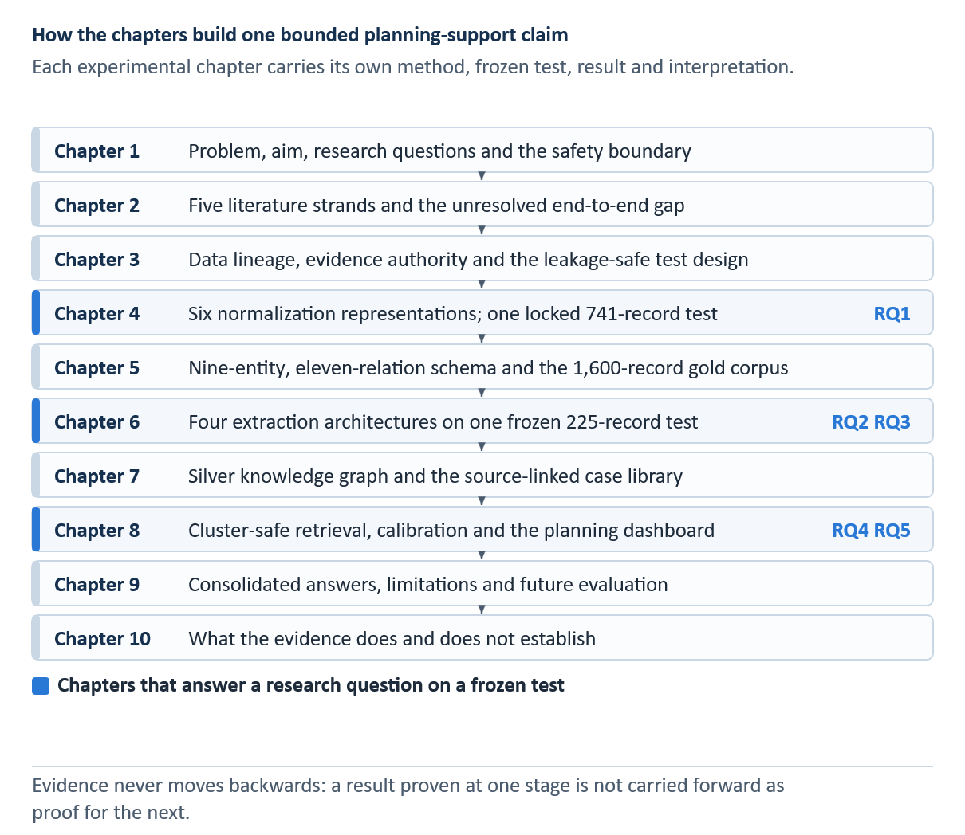
INSERT FIGURE 1.1 HERE — Integrated thesis structure and evidence flow. Add the final visual or table and its automatic Word caption here.

Literature Review
This chapter reviews the research that frames the thesis rather than describing the implementation itself. Its purpose is to compare what earlier work has established about maintenance language, lexical normalization, information extraction, knowledge representation, retrieval, and selective decision support. Detailed model mechanics, equations, training settings, and the experiments conducted for this thesis are developed in Chapters 3–8. Keeping that material outside the literature review makes the distinction between prior knowledge and the present contribution explicit.
The review follows the same chain through which an operational narrative becomes retrievable evidence. A short maintenance record first has to be interpreted despite abbreviations and damaged spelling; relevant entities and relations must then be recovered; the extracted content must be organized as a case; and a retrieval method must return comparable historical material without presenting it as an approved instruction. The literature is therefore assessed not only by headline performance, but also by its data provenance, evaluation population, treatment of uncertainty, and suitability for a traceable human-review workflow. Figure 2.1 sketches the sequence of research traditions and the gap this integrated evaluation addresses.
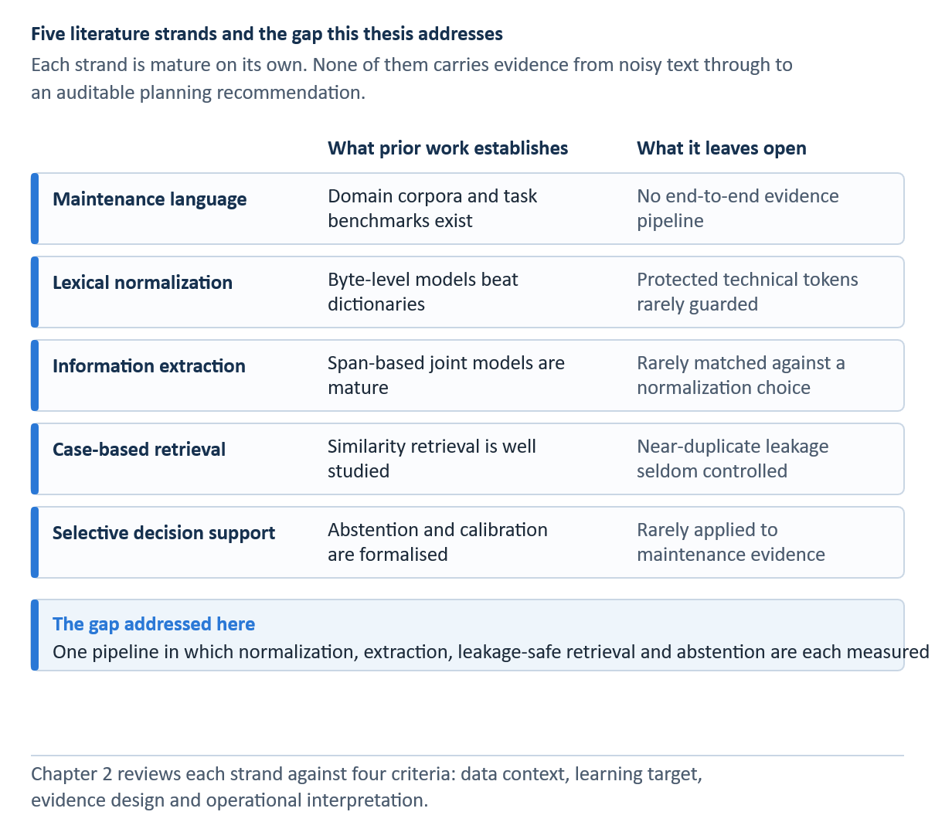

Review scope and comparison criteria
The selected literature combines foundational methods with studies that directly address industrial or aviation maintenance text. Foundational publications are included where they define a model family or evaluation principle used later in the thesis, such as conditional random fields, transformer encoders, span-based joint extraction, case-based reasoning, probabilistic ranking, rank fusion, calibration, and selective prediction [7, 8, 9, 10, 11]. Domain-focused work is then used to judge whether those methods transfer to short, noisy and safety-relevant records [3, 4, 5, 6, 12, 13].
Four comparison criteria guide the review. First, the data context determines whether a method was studied on general language, noisy user text, or industrial maintenance records. Second, the learning target distinguishes reference normalization, entity recognition, relation extraction, similarity estimation, and case retrieval. Third, the evidence design determines whether reported results are based on development data, a held-out test, an external benchmark, silver labels, or human review. Fourth, the operational interpretation asks whether the output is merely predictive or whether it exposes provenance, uncertainty, and an option to withhold a suggestion. These criteria are especially important because evidence produced at one stage cannot be treated as validation of the entire pipeline.
The review is intentionally selective rather than encyclopedic. It prioritizes methods implemented or meaningfully tested in this thesis and studies that clarify the main design choices. Regulatory sources are used only to define the system boundary: continuing-airworthiness and maintenance-performance rules reinforce that approved data and authorized personnel remain decisive [1, 2]. They are not used to claim regulatory conformity of the prototype.

Maintenance language and technical NLP
Maintenance work orders are written for operational continuity, not for natural-language processing. They commonly compress an observed condition, location, component, action and outcome into a few fragments. Local abbreviations, omitted function words, part identifiers, capitalization shifts and repeated templates may all occur in a single line. Brundage et al. [4] describe this setting as technical language processing: the challenge is not simply informal grammar, but a specialized register in which meaning is carried by domain conventions and asset-specific vocabulary.
Earlier maintenance keyword-extraction benchmarks [14] and aviation entity-recognition studies [15] show that the choice of labels, domain and target text matters as much as the encoder. A later aviation-maintenance model combines a BERT encoder, bidirectional sequence modelling and CRF decoding [16]; it informs the architectural context here, not a score-to-score comparison with the distinct AviMaint data.
MaintNet provides one of the clearest open research contexts for this problem. Akhbardeh et al. [3, 12] assembled language resources and tools around predictive-maintenance records, making it possible to study recurring technical expressions at a scale that smaller proprietary collections do not permit. The cleaned MaintNet aviation repository used in the present project improves accessibility to this material, but it does not remove the need to document subsequent filtering, duplicate control, annotations, or split construction [17]. A publicly available corpus is therefore a starting point rather than a complete experimental protocol.
The same shorthand can be useful to an experienced engineer and difficult for an automated system. A code that looks like noise to a general-language model may identify a component or procedure, while an apparently harmless spelling correction may alter that identifier. Conversely, leaving all text untouched can fragment retrieval because equivalent defects appear under several spellings. The literature therefore supports two simultaneous requirements: models must reduce lexical variation, and they must preserve forms whose technical meaning cannot safely be inferred from surface regularity alone [4, 5].
Recent maintenance-language studies have also explored similarity and topic structure as routes to reusable operational knowledge. Sundaram and Zeid [13], for example, apply text similarity and topic modelling to work orders in a prognostics and health-management setting. Such work shows that maintenance narratives can support grouping and search, yet similarity alone does not identify which phrase describes the problem, which describes an action, or whether the retrieved action is applicable to a new aircraft state. This distinction motivates the structured extraction and evidence-bound retrieval stages considered later in the thesis.
Taken together, prior studies establish that maintenance narratives contain reusable information but resist direct reuse. Their central limitation for this project is not a lack of individual algorithms; it is the absence of a common evaluation chain that follows evidence from noisy text through extraction into a traceable historical case. The thesis consequently treats the record identity and its provenance as persistent objects across stages instead of viewing normalization, extraction and retrieval as independent demonstrations.

Lexical normalization for noisy technical text
Lexical normalization maps a non-standard expression to a more regular form while attempting to preserve meaning. In general noisy-text research, evaluation commonly compares a system output with a reference string, and shared tasks such as MultiLexNorm show that the problem spans languages and noise types [18]. General benchmarks, however, do not reproduce the risk profile of maintenance data: replacing an informal spelling and rewriting a component identifier are both string transformations, but the operational consequences of an error are very different.
Fine-tuning ByT5 for multilingual lexical normalization was also examined in MultiLexNorm work [19]. That result motivates the byte-level candidate, but industrial tokens and protected aircraft identifiers require a separate local test; the final representation is selected on validation data rather than borrowed from a different corpus.
Rule-based and dictionary-based systems remain valuable because their decisions are inspectable. A curated mapping can expand a known abbreviation or correct a frequent local misspelling, and a protected list can prevent changes to specified technical forms. The weakness is coverage. Rules written for observed patterns may not generalise to new variants, while frequency replacement ignores context and can choose the wrong expansion for an ambiguous token. These approaches therefore provide meaningful baselines and safeguards, but the literature does not support assuming that more dictionary coverage necessarily produces better text.
Sequence-to-sequence models frame normalization as conditional generation. T5 unifies language tasks by expressing them as text-to-text transformations, while ByT5 performs the transformation directly over bytes rather than relying on a fixed token vocabulary [20, 21]. Byte-level modelling is attractive for corrupted spellings, rare symbols and unseen technical forms because every input can be represented. The same generative freedom creates a preservation problem: a model may confidently rewrite a string that was already correct or technically significant.
MaintNorm is particularly relevant because it supplies a corpus and benchmark designed for industrial maintenance short text rather than social-media noise [5]. Its contribution is both empirical and methodological: it makes normalization and masking decisions observable within a domain corpus. Its scope nevertheless remains a benchmark for a defined dataset and task. It does not establish that the representation with the best reference agreement will also maximize entity or relation extraction on a different aviation corpus.
This downstream question is often overlooked. Reference metrics reward similarity to a cleaned target, whereas an extractor may benefit from regular patterns already present in the raw record or may be disrupted by generated wording. The effect can also differ by task: normalization might reduce entity recall while improving consistency for a rare relation class. A defensible study therefore needs a matched comparison in which only the input representation changes and the extraction split, labels and model remain fixed.
The literature suggests that preservation should be treated as a separate objective rather than hidden inside an average edit score. Selective processing offers one solution: accept a learned transformation only when evidence is sufficient and a safety rule is satisfied, otherwise retain the original input. This design does not turn confidence into a probability of correctness. It creates an explicit trade-off between coverage and intervention, which can be chosen on validation data and then evaluated once on a sealed test [22].

Information extraction from maintenance narratives
Information extraction converts free text into typed spans and relations. In maintenance records, useful entities include the affected item, location, abnormal condition, action, observation and outcome; relations express how those elements belong together. The task differs from document classification because the system must recover boundaries and links within a short record. It also differs from generic named-entity recognition because many labels are functional roles rather than conventional names.
The sequence-tagging lineage runs from chunk-label encodings [23] through LSTM memory cells [24], subword-aware embeddings [25] and transformer self-attention [26]. Domain-adaptive pretraining [27] is relevant when technical vocabulary differs from a general-language training corpus, although it was not an additional evaluated extraction tier here. These sources motivate, rather than supply, the results of the local CRF, BiLSTM, DistilBERT and SpERT comparisons.
Generative extraction surveys and zero-shot entity-recognition experiments describe alternatives to the supervised span-and-relation design [28, 29]. Generation may produce plausible material unsupported by the source [30]; REBEL exemplifies generation-based relation extraction [31]. The present thesis retains source spans, relation direction and case provenance, and does not attribute its frozen IE metrics to any of these unevaluated alternatives.
Conditional random fields provide a strong structured baseline for entity recognition. A CRF scores complete label sequences rather than classifying tokens independently, allowing transition constraints to favour coherent BIO tag patterns [8]. When supplied with lexical, orthographic, affix, shape and neighbouring-token features, the model can exploit regularities that are common in templated work orders. It is transparent enough to inspect, but its coverage is limited by the chosen features and by the amount of context represented in them. Chapter 6 explains the scoring function, feature groups, regularisation and Viterbi decoding used in this thesis. Table 6.1 contrasts the four evaluated extraction families where they are compared.
Neural sequence models reduce dependence on manually specified features. Bidirectional LSTMs combine left and right context, and a CRF output layer can retain sequence consistency [32, 33]. These models learn task-specific patterns from the labelled corpus, but they still depend strongly on sample size and class balance. In a small technical dataset, a recurrent model trained from limited supervision may not acquire the broad contextual knowledge available to a pretrained transformer.
BERT introduced deep bidirectional pretraining based on masked language modelling and self-attention, enabling task-specific fine-tuning from contextual representations [10]. DistilBERT transfers much of that capability into a smaller student model through knowledge distillation [34]. For maintenance extraction, this creates a useful middle ground between a feature-based baseline and a larger joint architecture. Pretraining improves contextual coverage, but it does not eliminate domain shift, boundary ambiguity or the scarcity of certain relation types.
Pipeline extraction first predicts entities and then classifies candidate pairs. Its modularity makes errors easy to locate, yet a missed or mistyped entity removes every dependent relation. SpERT addresses this dependency differently by enumerating candidate spans and jointly scoring span types and relations from transformer representations [11]. The model can share evidence between the two tasks and reason over span pairs directly. Its advantages come with higher computational cost, sensitivity to maximum span width and negative sampling, and a larger candidate space.
MaintIE provides a domain benchmark and fine-grained schema for maintenance short text, offering a stronger point of comparison than general named-entity datasets [6]. It demonstrates that maintenance information can be represented with detailed entities and relations, but external transfer has to be interpreted carefully. A model trained and tested on MaintIE measures performance under that benchmark; a model separately trained on a local aviation schema answers a different question. The present thesis therefore reports an internal frozen comparison and a separately trained external benchmark rather than describing the latter as zero-shot validation.
Annotation design is inseparable from model evaluation. Boundary conventions, overlapping concepts, relation direction and the treatment of implicit information determine what counts as a correct output. Fort et al. [35] emphasise the need for explicit named-entity annotation methodology, while Bayerl and Paul [36] show that agreement depends on task and annotation conditions. A single-reviewer correction workflow can produce a usable gold corpus, but without independent double annotation it cannot support an inter-annotator agreement claim. This limitation has to remain visible even when model-level scores are high.
No single aggregate F1 score adequately describes this setting. Micro-F1 is dominated by frequent labels; macro-F1 gives every class equal weight and therefore exposes weakness on rare types. Exact span matching is stricter than partial overlap, and a relation is correct only when its argument spans, types and direction match the evaluation rule. Confidence intervals and class support are necessary because a perfect score on a relation with one or two instances is not equivalent to stable performance on a common class [37].

Knowledge representation and case-based reasoning
Extracted entities and relations become easier to inspect, link and reuse when they are organised into a stable representation. A knowledge graph offers typed nodes and edges, while a case representation groups the problem, historical action, outcome and provenance belonging to one record. These structures serve different purposes: the graph supports aggregation and exploration across records; the case preserves a retrievable unit of experience.
Provenance models provide a useful distinction between a record and an inference derived from that record [38]. In this study, the graph's typed nodes and edges remain silver predictions linked to source identifiers; a graph traversal does not independently verify the engineering validity of a proposed action.
Case-based reasoning frames problem solving as retrieving and adapting earlier cases [7]. Its appeal in maintenance is practical: a reviewer can inspect what happened in a comparable historical record instead of accepting a generated answer without provenance. The classical cycle also includes reuse, revision and retention. The prototype in this thesis implements retrieval and evidence presentation, but it does not validate technical adaptation or automatically retain a new approved case. Calling it a complete autonomous case-based reasoner would therefore overstate the implemented scope. In a different aircraft-maintenance context, Lin et al. [39] combine case-based reasoning and latent semantic indexing for civil-aircraft structural repair; their work is a domain precedent, not an evaluation baseline for these short work-order narratives.
Graph construction from model predictions introduces a further evidence layer. Canonicalisation can merge lexical variants, and support counts can reveal repeated relations. Nevertheless, a repeated silver edge is still derived from model output. Frequency may raise confidence that a pattern is common in the corpus, but it does not prove that the underlying maintenance action was correct, applicable or authorised. Provenance back to source records is therefore more important than presenting the graph as a verified engineering knowledge base.
The literature does not provide a universal maintenance ontology that can simply be imported into every fleet and documentation environment. Schemas reflect the task, source language and intended decisions. A defensible local schema should consequently define entity boundaries, permitted relation pairs and direction, while reporting how rare classes are supported. External benchmarks can test portability, but they cannot replace an internal schema audit aligned with the actual work-order narratives.

Historical-case retrieval and evaluation
Historical-case retrieval can be approached lexically, semantically or through a combination of rankers. BM25 remains a strong lexical baseline because it balances term frequency, document length and inverse document frequency [9]. In short technical records, exact component codes and distinctive fault phrases can be highly informative. Lexical ranking is also inspectable: a reviewer can often understand why a shared term produced a match.
Dense retrieval represents queries and cases as vectors. Sentence-BERT makes semantic similarity practical by producing fixed-dimensional sentence embeddings that can be compared efficiently [40]. This can connect paraphrases that share few exact words, but embedding similarity may also smooth over differences that are operationally important. A semantically related record is not necessarily a relevant precedent if the asset state, location or action context differs.
Structured retrieval does not treat every word of a case as an interchangeable bag of terms. A field-aware ranker can weight a problem description differently from an item, location, or fault field; Robertson et al. [41] describe a BM25 extension for multiple weighted fields. A knowledge-based alternative compares typed entities and links, making a shared issue–item configuration visible even when the wording differs. In AviMaint-DSS, structure-aware matching is an exploratory channel built from model-predicted historical fields. Missing or incorrect silver relations can therefore suppress an otherwise relevant match. These features support inspection and experiments, but the locked RQ4 result comes from canonical BM25 without a structural contribution to its score.
Hybrid systems attempt to combine complementary evidence. Reciprocal rank fusion merges ranked lists without requiring their raw scores to be on a common scale [42]. Such fusion can improve robustness when lexical and semantic rankers fail on different queries, but each additional component adds tuning choices and makes the final ranking harder to explain. A hybrid method should therefore be accepted only when it improves a fixed evaluation target on development data and retains clean provenance at presentation time.
Evaluation has to match the retrieval claim. Hit@k asks whether a relevant historical family appears within the first k positions, mean reciprocal rank rewards a relevant item appearing early, and nDCG accounts for graded relevance and position [43]. These metrics do not establish that the retrieved maintenance action is correct. They measure agreement with the relevance definition and population used by the experiment.
The relevance definition is especially consequential in a silver case library. If action-family labels are obtained from historical records or assisted labelling, Hit@k measures recovery of that historical family rather than engineering correctness. A high micro-level score can also conceal weak coverage of rare action families; macro family recall gives each family equal influence and therefore exposes this imbalance. The two views answer different questions and should be reported together.
Robustness analysis tests whether a fixed protocol remains stable under plausible input degradation. Truncation reflects incomplete narratives, while controlled spelling noise reflects typographical variation. Such tests are informative only if the clean result exactly reproduces the frozen evaluation and no ranking parameter is changed after observing the perturbations. A post-hoc robustness study must also be labelled supplementary rather than retroactively presented as preregistered confirmatory evidence.
Sundaram and Zeid [13] show the practical value of text similarity and topic modelling for maintenance work orders. Their work supports the general feasibility of retrieving related technical records, but the gap between similarity and decision support remains. An operational interface needs to show the original evidence, its source, alternatives and uncertainty; otherwise a ranking metric can be mistaken for an instruction-generation capability.

Selective and human-centred decision support
Decision support should distinguish between making a prediction and deciding when to present it. Selective prediction introduces a reject option so that the system can withhold an output when its confidence or evidence is insufficient [22]. The relevant trade-off is coverage against conditional risk: increasing the threshold may reduce the number of displayed cases and improve the average reliability of those retained, but only when the score is meaningfully ordered.
Selective classification formalizes the choice to withhold an answer when risk is too high for the available coverage [44]. Conformal prediction offers a different route to statistical coverage under its assumptions [45], but no conformal guarantee is claimed for this system. Research on human interaction with automation warns that apparent fluency can invite misuse or over-reliance [46]. The EASA machine-learning concept paper and NIST AI Risk Management Framework provide governance context [47, 48]; neither is treated as proof that this prototype is certified.
Modern neural scores are often poorly calibrated. Guo et al. [49] demonstrate that high predictive accuracy does not guarantee that stated confidence corresponds to empirical correctness. Calibration measures such as expected calibration error compare confidence bins with observed outcomes, while the Brier score evaluates squared probabilistic error [50]. In this thesis these measures concern historical retrieval agreement; they must not be interpreted as probabilities that a maintenance action is safe or approved.
Human-centred presentation therefore requires more than a confidence badge. A reviewer should be able to inspect the original problem narrative, the retrieved historical action, outcome, source identity and competing alternatives. Low-support cases should be visibly separated from stronger evidence. These design choices make the system auditable and discourage automation bias, although interface transparency cannot compensate for an invalid model or an unrepresentative corpus.
The aviation setting imposes a firm boundary on the claims. Maintenance must be performed with current approved data and under the applicable continuing-airworthiness and performance rules [1, 2]. A research prototype that retrieves historical work orders is therefore an evidence browser for qualified review, not a source of approval or a substitute for manuals, engineering instructions or authorised judgement.

Critical synthesis of prior work
Across the reviewed literature, each technical stage is well motivated in isolation. Maintenance-language research establishes the value and irregularity of the source material; normalization work offers rules and generative models; information-extraction research supplies structured baselines and joint transformers; case-based reasoning and retrieval research provide mechanisms for reuse; and selective prediction provides a principled way to withhold weak outputs. The unresolved problem is the disciplined connection of these stages.
Three recurring weaknesses are particularly relevant. First, data populations are often difficult to compare across studies, and duplicate or near-duplicate records can inflate apparent generalisation. Second, upstream intrinsic improvements are sometimes assumed to benefit downstream tasks without a matched experiment. Third, an accurate retrieval label can be presented too readily as decision quality even when relevance is silver, proxy-based or established by a single reviewer. These weaknesses shape the experimental controls used in Chapters 3–8.
The literature also reveals a tension between generalisation and preservation. Neural models can cover variants missed by rules, but controlled vocabularies and exact identifiers reward deterministic safeguards. Joint extractors can exploit wider context, but their predictions become silver evidence when applied to the full corpus. Dense retrieval can bridge paraphrases, but lexical matches may be easier to audit. The thesis treats these as empirical trade-offs rather than assuming that the most complex model is always preferable.
A further gap concerns interpretive continuity. Published work often reports a model metric without following how that output is transformed, aggregated and shown to a user. In the present study, record IDs, split assignments and provenance are retained across the pipeline. This permits a reviewer to trace a displayed case back to the historical narrative and permits the thesis to state exactly which layer—gold, locked test, silver extraction, calibration or manual review—supports each claim.

Research gap and connection to RQ1–RQ5
The research gap is therefore an evidence-controlled, end-to-end study of noisy aviation maintenance narratives. The project does not seek an autonomous maintenance recommender. It asks how normalization affects both reference agreement and extraction, how alternative extractors recover the local schema, how those predictions can form a traceable silver case library, and how a fixed retrieval protocol can present useful historical evidence with explicit uncertainty and abstention.
RQ1 asks which of six representations best matches the expert-cleaned normalization reference while preserving protected aviation terms. System selection uses 926 validation records, and the chosen representation is evaluated once on the locked 741-record test. Downstream extraction is deliberately asked as a separate question so intrinsic string agreement cannot be taken as its answer. Table 2.1 maps each gap to its corresponding research question and evidence population.
RQ2 asks how text representation affects downstream extraction when the same SpERT design is trained and evaluated on each version of the same 1,275/100/225 record partition. Strict entity and relation micro-F1 answer the main question; macro-F1 reveals whether the effect differs for the less frequent relation types.
RQ3 compares feature-based CRF, recurrent BiLSTM-CRF, distilled-transformer pipeline and joint SpERT extraction under a common local schema and frozen split, with a separately trained MaintIE benchmark for architectural context. The downstream silver graph and historical case library are research outputs of the selected extractor, not an unmeasured sixth research question; their provenance and prediction status are documented in Chapter 7.
RQ4 evaluates whether problem-only queries recover a matching historical action family near the top of a frozen ranking. The action is hidden from the query, all ranking parameters are fixed before final evaluation, and results are reported for the 828 evaluable queries. Macro action-family recall and supplementary perturbation tests are included to expose imbalance and robustness limits.
RQ5 concerns evidence presentation rather than maintenance approval. It evaluates calibrated display rules, abstention behaviour and a one-reviewer manual assessment of whether returned cases provide usable historical-action evidence. The answer remains bounded by the reviewer, corpus and rubric, and it does not establish technical correctness or safety.
Table 2.1 Mapping from literature gaps to the thesis research questions
Literature gap | Research question and test | Evidence boundary
Noisy records versus preservation | RQ1: six representations, 926 validation; 741 locked normalization test. | Reference agreement and protected tokens, not semantic proof.
Upstream scores versus IE | RQ2: five matched SpERT representations on one 225-record test. | Matched descriptive comparison; test not used for selection.
Architecture comparison | RQ3: four IE families on 225 records; separate MaintIE test of 108. | Separately trained models; schemas and populations differ.
Historical evidence retrieval | RQ4: fixed problem-only BM25 on 828 evaluable queries. | Action-family agreement; robustness post-hoc.
Human-facing evidence | RQ5: calibrated agreement and one-reviewer assessment of 100 queries. | Not action correctness, safety, or regulatory approval.
Note. Each row points to an evaluated construct and its evidence population, not to a promise of operational validity.
Source: Author's own illustration, based on the literature reviewed in Chapter 2.

Chapter summary
The literature supports every major component of the pipeline, but it also shows why the components cannot be evaluated with one undifferentiated accuracy claim. Maintenance text requires domain-aware preservation; normalization needs both intrinsic and downstream assessment; extraction requires class-level evidence; silver structures require provenance; retrieval needs a fixed relevance contract; and confidence must be separated from safety. Chapter 3 now turns these conclusions into the data lineage, split rules, evidence vocabulary and leakage controls used throughout the experiments.

Data and Research Design

Data sources and evidence layers
The project contains evidence layers with different authority. The 6,169 source records are observed historical text; the 5,124-record paired normalization subset supports the cluster-safe 3,457/926/741 split; the 1,600-record IE corpus is manually corrected gold data; full-corpus SpERT output and the graph are silver; and the 828-query retrieval test plus 100-query manual review form a separate historical-evidence layer. Figure 3.1 visualizes the permitted derivations and claims, while Table 3.1 records the corresponding datasets, roles, and statuses.
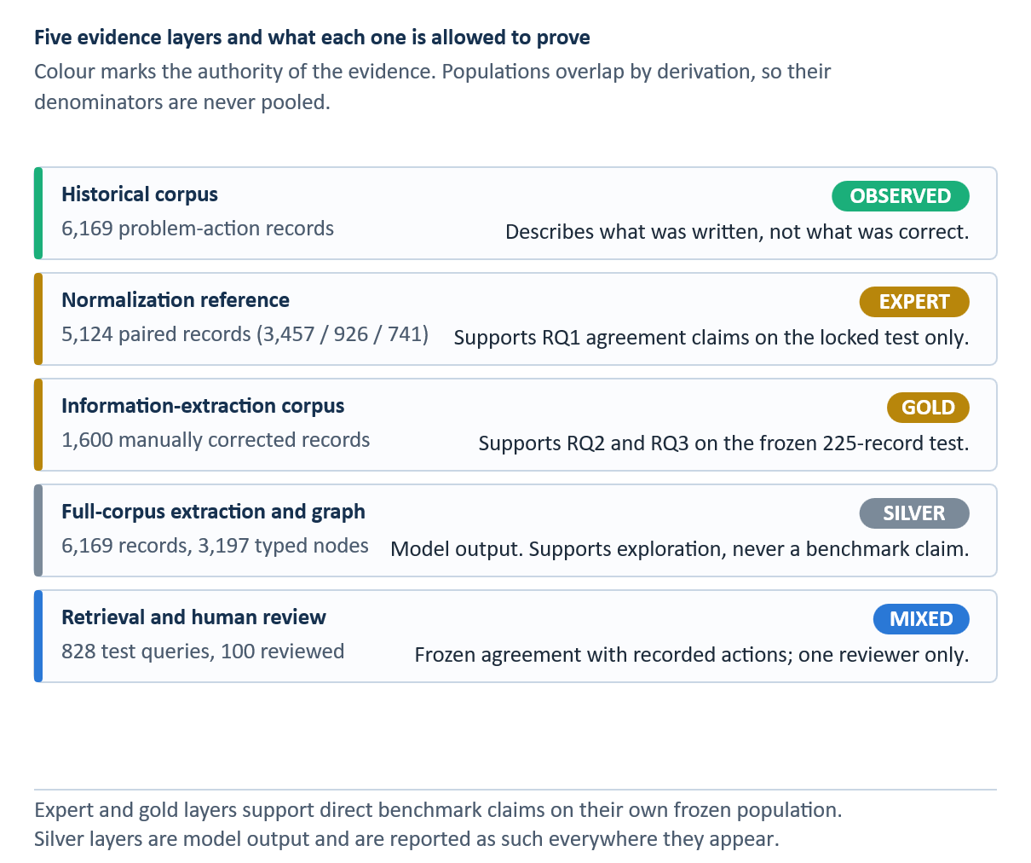
INSERT FIGURE 3.1 HERE — Evidence layers and their permitted claims. Add the final visual or table and its automatic Word caption here.
Arrows indicate derivation, not increasing certainty. Each downstream layer retains the limitations of its source and adds its own modelling assumptions.
Table 3.1 Data and evidence inventory
Evidence layer | Population | Status and legitimate use
Historical corpus | 6,169 problem-action rows | Observed source text for operational case construction.
Normalization reference | 5,124 paired rows; 3,457 / 926 / 741 | Expert-cleaned target; validation selection then locked test.
IE gold | 1,600 annotated rows; 1,275 / 100 / 225 | Manually corrected typed spans and relations; test frozen.
MaintIE | 860 / 108 / 108 | Separate external benchmark; models retrained on its training split.
Operational silver IE and KG | 6,169 rows; 3,197 typed nodes | Model-derived predictions for exploration, not gold claims.
Retrieval and human review | 828 evaluable test queries; 100 reviewed queries | Frozen historical-action agreement; single-reviewer supplemental judgment.

MaintNet corpus profile
The supplied aviation corpus contains 6,169 rows and 3,595 distinct problem strings together with 2,881 distinct action strings in the normalization analysis. Repetition is operationally meaningful—recurring problems and actions reveal common patterns—but it is statistically hazardous. Exact and near-duplicate records can leak between training and evaluation, inflate frequency-based support, and make retrieval appear stronger than it is. The project therefore retains record counts for descriptive analysis while using evidence clusters for recommender splitting and support aggregation.
The source text is constrained. The problem field is limited to 60 characters and the action field to 55 characters; 405 problem strings and 945 action strings reach those exact widths. Some endings are therefore ambiguous: a final token may be complete, abbreviated, or physically truncated. The corpus also contains punctuation artifacts, apostrophe tokenization, directional shorthand, numbers expressed as words, and multiple records with highly similar component and issue descriptions. These features motivate both byte-level normalization and character-level retrieval.
The 6,169-record structured export used by the downstream system contains source identifiers, combined text, extracted item strings, issue strings, and action strings. This export is not treated as an independent ground truth because several columns derive from model output. It is used to build the silver case layer and to support dashboard indexing. The original text and identifiers remain the provenance anchor.

End-to-end research design
The research follows a staged design. Normalization selection is completed on validation data and evaluated once on the locked 741-record test. Representation effects are tested through a matched SpERT ablation. Four IE architectures are compared on the same frozen 225-record test and separately on MaintIE. Operational SpERT predictions are then converted into a silver graph and case library. Final retrieval uses problem-only queries, cluster-safe evidence, canonical BM25, τ_rank = 0.15, and cluster-expanded aggregation; the query action remains hidden.
The stages remain distinct in interpretation. Reference agreement does not prove semantic correctness; the matched ablation measures downstream IE rather than assuming it; gold-test IE F1 does not validate every silver graph record; and retrieval metrics concern recorded action-family or reviewer-rated usable evidence rather than technical applicability, repair correctness, or authorization.

Separation of estimands across the pipeline
Each experiment estimates a different quantity. The normalization study estimates agreement between a transformed string and an expert-cleaned reference. The IE study estimates recovery of annotated spans and relations. The graph stage reports the amount of silver structure produced by the operational extractor. The retrieval study estimates whether a historical action family associated with a held-out problem is recovered near the top of a ranked list. These quantities are related by the software pipeline, but they are not interchangeable measures of system quality.
This separation prevents an attractive upstream score from being used as evidence for a downstream claim. A reduction in WER does not prove improved relation extraction; high relation F1 does not prove that every full-corpus edge is correct; high Hit@5 does not establish technical applicability. The thesis therefore reports the population, target, and evidence status beside every principal result.
System choices and negative results are retained rather than rewritten after test inspection. Selective ByT5 remains the official RQ1 system because it was selected on validation before the 741-record test. The Selective retrieval protocol and prior-tempering exponent τ_rank = 0.15 were likewise frozen before the 828-query evaluation; later robustness analysis uses the same fixed protocol and is labelled supplementary.

Leakage controls and data partitions
The reference-based normalization experiment uses 5,124 paired records grouped into 1,840 clusters and split with seed 42 into 3,457 training, 926 validation, and 741 locked-test records. Cluster similarity threshold 0.90 prevents near-duplicate leakage. Selective ByT5 was chosen using validation only; the six systems were then evaluated without training or retuning after the test was opened.
Active learning can prioritize informative cases for annotation, but sampling decisions must remain separate from frozen evaluation [51]. Agreement between annotators is a separate quality question: the annotation literature distinguishes the reliability of a labeling process from a model's F1 against its resulting reference [35, 36, 52]. The current gold corpus lacks an independently double-annotated subset, so no inter-annotator agreement estimate is reported.

Why record-level random splitting is insufficient
Maintenance corpora contain repeated and near-duplicate records. If two lexical variants of the same underlying case appear in training and test, a model can obtain credit by memorizing the shared wording rather than generalizing to a new case. Cluster-safe splitting assigns all members of an equivalence or near-duplicate cluster to one partition. This makes the unit of independence closer to the operational case rather than the database row. Lee et al. [53] document how duplicated text can contaminate held-out evaluation in language modelling; their task differs from ours, but the shared leakage mechanism motivates assigning near-duplicate maintenance records to the same split.
The normalization selection used 926 validation records and kept the 741-record test sealed. The downstream representation experiment used the same 1,275/100/225 train/development/test identities for every representation. Retrieval used 4,319/925/925 records, of which 828 test queries had evaluable historical evidence. These populations answer different questions and must never be pooled or described as a single test set.
The IE corpus begins with a random pilot. Random rounds increase coverage to approximately 1,100 records, after which rare-class and uncertainty selection enriches training data only. The development set of 100 and test set of 225 are frozen before enrichment. The final training set contains 1,275 records. This design prevents active-learning selection from changing the evaluation distribution. It also means the test set reflects the naturally occurring class imbalance rather than a balanced research sample.
The recommender uses a separate cluster manifest that groups exact and near-duplicate cases. Query clusters are held out from candidate pools, and candidates must come from allowed training partitions. Fingerprints record the case library and split assignment. Tests verify that recomputed near duplicates do not cross splits, that a changed case library invalidates the manifest, and that query solutions do not augment the problem graph. These controls are necessary because conventional random record splitting would allow nearly identical work orders to appear on both sides of evaluation.

Evaluation principles
Metrics are selected for each object. Normalization uses WER, CER, exact match, change F1, and protected-token preservation. IE uses strict typed entity and relation micro/macro F1 and per-class results. Retrieval uses Hit@k, MRR, nDCG@5, macro action-family recall, manual-review evidence rates, calibration error, and fixed-protocol degradation deltas.
Support is always reported alongside per-class F1. A rare class can obtain a high score from a handful of examples, while a frequent class determines much of micro-F1. Macro-F1 gives each class equal weight but becomes unstable when support is small. Bootstrap intervals capture test-sample variation conditional on the trained model; seed experiments capture some training variation but are available only for selected IE tiers. Neither replaces external validation.
For final retrieval, Hit@1, Hit@3, Hit@5, MRR, nDCG@5, and macro action-family recall are reported together. Top-k metrics describe whether recorded evidence is recovered; macro recall prevents the dominant Replace family from hiding weak rare-family performance. Calibration and manual review use separate populations and must not be interpreted as safety probabilities or action approval.

Reproducibility and governance
The reproducibility package contains configuration files, frozen manifests, data fingerprints, predictions, metric tables, evaluation splits, robustness results, screenshots, and source code. Verification scripts confirm the locked normalization and retrieval artifacts without training or retuning. These records distinguish validation selection, frozen-test evidence, and silver output.
Reproducibility does not eliminate governance obligations. MaintNet is an open research resource, but an operational deployment would require data-protection review, organization-specific access controls, retention rules, model and dataset versioning, approved-data integration, human-factor assessment, and monitoring for distribution shift. Historical actions may reflect obsolete procedures, local practice, or incomplete recording. Provenance makes those risks inspectable; it does not remove them.

Text Normalization

Motivation and task definition
Surface variation affects tokenization, exact matching, retrieval terms, and learned representations. This effect is pronounced in short MaintNet records, where one abbreviation or spelling error can determine much of the lexical signal. Aggressive rewriting creates a different risk by removing technical distinctions or extending text beyond a truncated source field. The normalization task is therefore defined as conservative lexical repair against an expert-cleaned reference, with separate measurement of protected-token preservation.
The reference-based experiment uses 5,124 records with paired source and expert-cleaned strings under a frozen cluster-safe manifest. All six systems receive the same shared preprocessing. The full corpus contains 6,169 records and supports operational inference and case construction, but it is not the RQ1 test population.

Experimental conditions
Table 4.1 Normalization conditions
System | Method | Evaluation role
Raw | Shared minimal preprocessing only | Control
Most-frequent replacement | Training-derived token replacement | Frequency baseline
Rules | Deterministic domain resources and protected forms | Transparent baseline
ByT5 | Fine-tuned google/byt5-small | Unconstrained learned normalizer
Selective ByT5 | Validation-selected selective use of ByT5 | Official preregistered RQ1 system
Rules then ByT5 | Deterministic rules followed by ByT5 | Composed hybrid
Note. The six conditions share preprocessing and the same locked scorer.
Source: Author's own illustration.
All six representations use the same scorer. Selective ByT5 was chosen from validation results before the test was inspected. It therefore remains the preselected RQ1 system, even though pure ByT5 has the best descriptive WER and exact-match values on the locked test. This reporting rule prevents model selection from being revised after the test result is known. Table 4.1 defines the six controlled normalization conditions.

Data preparation and reference construction
The 5,124 paired records form 1,840 similarity clusters. A seed-42 split assigns 3,457 records to training, 926 to validation, and 741 to the locked test. Training data support model fitting and training-derived resources, validation data determine the system choice, and the test provides one final six-system comparison. Figure 4.1 shows where validation selection and final test evaluation enter the workflow.
Fixed-width source fields create an unavoidable ambiguity. The expert-cleaned release sometimes reconstructs or regularizes an ending that appears truncated in the observed record. Agreement metrics reward that reconstruction even when the stored text cannot identify a unique completion. The scores therefore measure agreement with this cleaned release rather than recovery of an objectively knowable original sentence.
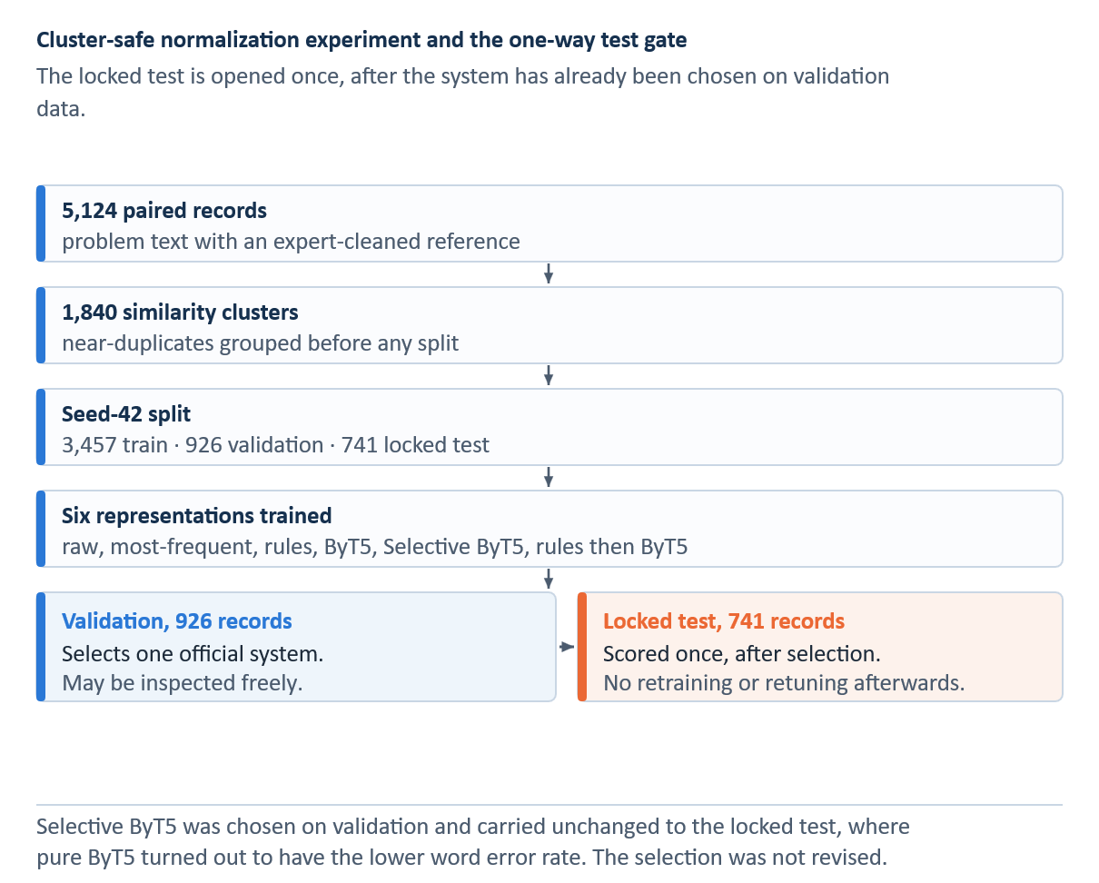
INSERT FIGURE 4.1 HERE — Normalization experiment pipeline. Add the final visual or table and its automatic Word caption here.
Source: Author's own illustration.

Rule-based normalizer
The rule system was constructed from the supplied expert resources and then audited for conflicting or potentially harmful mappings. Its lexicon contains 82 unambiguous abbreviation expansions, four ambiguous entries, ten symbol rules, 88 single-token misspellings, and 19 multi-word misspellings. Seven mappings were suppressed and 26 abbreviations were protected. Longer and multi-word patterns are applied before shorter token rules, and every expansion is logged.
Rules provide deterministic and inspectable edits. A reviewer can identify the mapping responsible for a change, protect an organization-specific term, or approve a revised expansion. Their main limits are finite coverage and weak context sensitivity. A global substitution cannot reliably resolve an abbreviation with several plausible meanings, and an unseen misspelling remains unchanged. Ambiguous entries are therefore preserved rather than expanded without evidence.

Rule ordering and protected forms
The deterministic normalizer first identifies tokens and substrings that must remain unchanged, then applies curated abbreviation and misspelling mappings. Ordering is important: a broad rule applied before a specific technical exception can corrupt the exception. The implementation therefore treats the keep-list as a constraint, records which rule fired, and evaluates preservation separately from reference agreement.
Frequency replacement is intentionally simple. For each observed non-standard form, it emits the most frequent reference replacement found in the training resources. This baseline tests whether the task can be solved by dictionary frequency alone. Its locked-test WER of 0.3582, worse than raw text at 0.2994, demonstrates that context-free replacement can introduce more word errors than it removes.

ByT5 normalizer
The learned normalizer uses google/byt5-small, which processes text at byte level and can model spelling and punctuation without a fixed subword vocabulary [21]. Source and target lengths are capped at 256 bytes. Training uses a learning rate of 1 x 10^-4, weight decay 0.01, a 0.05 warm-up ratio, batch size 1, gradient accumulation over 16 steps, Adafactor, bfloat16 arithmetic, and gradient checkpointing. Training runs for at most 20 epochs with early-stopping patience 3, and the checkpoint is selected by validation WER.

ByT5 optimization and model selection
ByT5 treats both the noisy input and cleaned target as byte sequences. The settings reported above yield an effective batch of 16 examples through gradient accumulation. Gradient checkpointing reduces memory demand by recomputing selected activations during back-propagation, while Adafactor limits optimizer-state memory. Early stopping with patience three uses validation WER to prevent the locked test from influencing either training duration or checkpoint choice.
Byte-level modelling is helpful for misspellings and unusual symbols because it does not require every form to be present in a fixed subword vocabulary. The same flexibility creates risk: the decoder can alter an already correct part number or abbreviation. Selective ByT5 therefore couples the learned proposal with a confidence-and-safety gate rather than accepting every generated string.
The rules-then-ByT5 condition applies deterministic normalization before the learned model. This composition changes the input distribution because abbreviations and misspellings may already be expanded when they reach ByT5. The condition tests whether the two stages complement each other; no monotonic improvement is assumed.

Evaluation measures
The locked evaluation reports WER, CER, exact match, change F1, and protected-token preservation. Together, these measures capture word- and character-level agreement, complete-record agreement, recovery of intended edits, and unintended alteration of protected aviation forms. None of them independently establishes semantic or technical correctness.

Sequence-level error measures
Word error rate aligns the predicted and reference word sequences and counts the minimum number of word substitutions, deletions, and insertions required to transform one into the other, as formalized in Equation 4.1.
 | $$\text{WER}=\frac{S_{w}+D_{w}+I_{w}}{N_{w}}$$ | (4.1)

S, D, and I denote substitutions, deletions, and insertions; the subscript w indicates word-level counts, and N is the number of reference words. Lower WER is better; zero denotes exact word-sequence agreement. Because the denominator is the reference length, WER may exceed one when insertions are numerous.
Character error rate applies to the same alignment principle at character level, as formalized in Equation 4.2.
 | $$\text{CER}=\frac{S_{c}+D_{c}+I_{c}}{N_{c}}$$ | (4.2)

S, D, and I again denote substitutions, deletions, and insertions; the subscript c indicates character-level counts, and N is the reference character count. CER is sensitive to small spelling differences that may count as a full word error under WER. It complements rather than replaces WER because a low character distance can still alter a critical technical token.
Exact match is the strictest record-level measure, as formalized in Equation 4.3.
 | $$\text{EM}=\frac{1}{n}\sum_{i=1}^{n}{1}\left\{{\overset{ˆ}{y}}_{i}=y_{i}\right\}$$ | (4.  3)

For n records, the indicator equals one only when the entire prediction for record i exactly matches its reference. Exact match is easy to interpret but gives the same zero credit to a one-character difference and a completely different output; WER and CER provide the needed graded view.
The 741-record test was scored only after validation selection. WER and CER measure edit distance at word and character level. Exact match requires the complete system output to equal the reference. Change F1 evaluates intended modifications, and protected-token preservation records whether designated aviation forms remain unchanged.

Change detection and preservation
Change precision evaluates whether edited positions truly required an edit, while change recall evaluates whether required edits were found. Their harmonic mean is change F1, as formalized in Equation 4.4.
 | $$\begin{aligned}P_{Δ}&=\frac{{\text{TP}}_{Δ}}{{\text{TP}}_{Δ}+{\text{FP}}_{Δ}}, R_{Δ}=\frac{{\text{TP}}_{Δ}}{{\text{TP}}_{Δ}+{\text{FN}}_{Δ}} \\ F_{1,Δ}&=\frac{2P_{Δ}R_{Δ}}{P_{Δ}+R_{Δ}}\end{aligned}$$ | (4.4)
TPΔ counts required changes made correctly, FPΔ counts unnecessary or incorrect changes, and FNΔ counts required changes left unresolved. High change F1 therefore penalizes both under-normalization and over-normalization. It is more informative than accuracy when unchanged tokens dominate the corpus.
Protected-token preservation isolates the safety-oriented constraint encoded by the keep-list, as formalized in Equation 4.5.
 | $$\text{Preserve}=\frac{\sum_{i=1}^{n}{\sum_{t∈K_{i}}{1}}\left\{\overset{ˆ}{t}=t\right\}}{\sum_{i=1}^{n}{\left|K_{i}\right|}}$$ | (4.5)
Kᵢ is the set of protected token occurrences in record i. The numerator counts occurrences that remain unchanged in the system output. This measure reached 1.0000 for Selective ByT5, whereas unconstrained ByT5 reached 0.9663. Preservation is not proof that every protected form is semantically correct; it shows that the defined protected set was respected.
The relative error-reduction measure used by lexical-normalization benchmarks such as MultiLexNorm [18] expresses improvement relative to a named baseline error, as formalized in Equation 4.6.
 | $$\text{ERR}\left(s;b\right)=\frac{e\left(b\right)-e\left(s\right)}{e\left(b\right)}$$ | (4.6)
Here e(raw) is raw-text error and e(system) is system error. ByT5 reduced WER from 0.2994 to 0.0147, an absolute reduction of 0.2847 and a relative error reduction of approximately 95.1%. Against the stronger rules baseline, the absolute reduction was 0.0916 and the relative reduction approximately 86.2%. Relative reductions are therefore always reported with their baseline.
WER and CER measure different error scales, exact match provides a strict record-level criterion, and change F1 isolates the edits that the system was expected to make. Protected-token preservation captures over-normalization that aggregate error rates may conceal. System interpretation therefore uses the complete metric set.

Results
The validation population contains 926 records and was used for system selection, not for the final performance claim. On that population, ByT5 and Selective ByT5 each achieved WER 0.006177 and exact match 0.935205; protected-token preservation was 0.998920 for unconstrained ByT5 and 1.000000 for Selective ByT5. These development measurements explain figures reported in earlier project materials. The separate locked test reported below contains 741 records, so the two populations are not interchangeable and the locked-test values are the reported result.
On the locked 741-record normalization test, the raw representation had WER 0.2994, exact match 5.94% and change F1 0.0000 because the raw representation makes no proposed edits, and therefore has no true-positive edits. Most-frequent replacement reached WER 0.3582, exact match 2.29% and change F1 0.1905. Curated rules reached WER 0.1063, exact match 29.96% and change F1 0.4856. Unconstrained ByT5 produced WER 0.0147, exact match 93.66%, change F1 0.9542 and protected-token preservation 96.63%. The preselected Selective ByT5 system produced WER 0.0219, exact match 93.25%, change F1 0.9460 and preservation 100%. Rules followed by ByT5 produced WER 0.0178, exact match 91.36%, change F1 0.9425 and preservation 97.03%. These are frozen test observations, not six separate selection trials.
In the separate representation-matched SpERT study, all configurations trained on 1,275 records, used 100 development records and were scored on the same 225-record test. Raw text retained the leading entity and relation micro-F1 (0.9455 and 0.8203). Selective ByT5 yielded entity micro-F1 0.9424 and relation micro-F1 0.8167, but its relation macro-F1 0.7781 exceeded raw text's 0.7511. This contrast prevents the intrinsic WER result from being misreported as downstream extraction improvement.
Table 4.2 Locked normalization-test results
Representation | WER ↓ | CER ↓ | Exact ↑ | Change F1 ↑ | Protected ↑
Raw | 0.2994 | 0.2238 | 0.0594 | 0.0000 | 1.0000
Most-frequent | 0.3582 | 0.1516 | 0.0229 | 0.1905 | 1.0000
Rules | 0.1063 | 0.0623 | 0.2996 | 0.4856 | 1.0000
ByT5 | 0.0147 | 0.0091 | 0.9366 | 0.9542 | 0.9663
Selective ByT5 (selected) | 0.0219 | 0.0143 | 0.9325 | 0.9460 | 1.0000
Rules then ByT5 | 0.0178 | 0.0111 | 0.9136 | 0.9425 | 0.9703
Note. Locked 741-record test after 926-record validation selection. Scores measure expert-reference agreement. Pure ByT5 is descriptively best; Selective ByT5 stays officially selected.
Source: Author's own computation.
Locked test n = 741. All six systems were evaluated with the same scorer after the validation-only selection was frozen.
Table 4.3 Representation-matched SpERT ablation
Representation | Entity micro-F1 | Entity macro-F1 | Relation micro-F1 | Relation macro-F1 | Δ relation macro vs raw
Raw | 0.9455 | 0.9056 | 0.8203 | 0.7511 | —
Rules | 0.9432 | 0.8889 | 0.8151 | 0.7466 | −0.0045
ByT5 | 0.9353 | 0.8753 | 0.8034 | 0.7476 | −0.0035
Selective ByT5 | 0.9424 | 0.8940 | 0.8167 | 0.7781 | +0.0270
Rules then ByT5 | 0.9378 | 0.8715 | 0.8136 | 0.7622 | +0.0111
Note. Representation-matched SpERT, same 1,275/100/225 split. Strict typed F1; raw leads in entity and relation micro-F1.
Source: Author's own computation.
Representation-matched SpERT ablation: 1,275 training records, 100 development records, and 225 frozen test records. Entity and relation scores use strict typed evaluation.

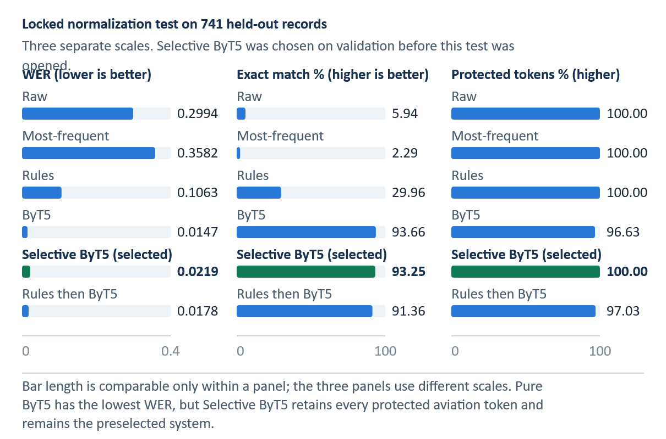
INSERT FIGURE 4.2 HERE — Locked normalization-test performance across six systems. Add the final visual or table and its automatic Word caption here.
WER is lower-is-better; exact match is higher-is-better. Selective ByT5 is the validation-selected system; pure ByT5 is the descriptive test winner.
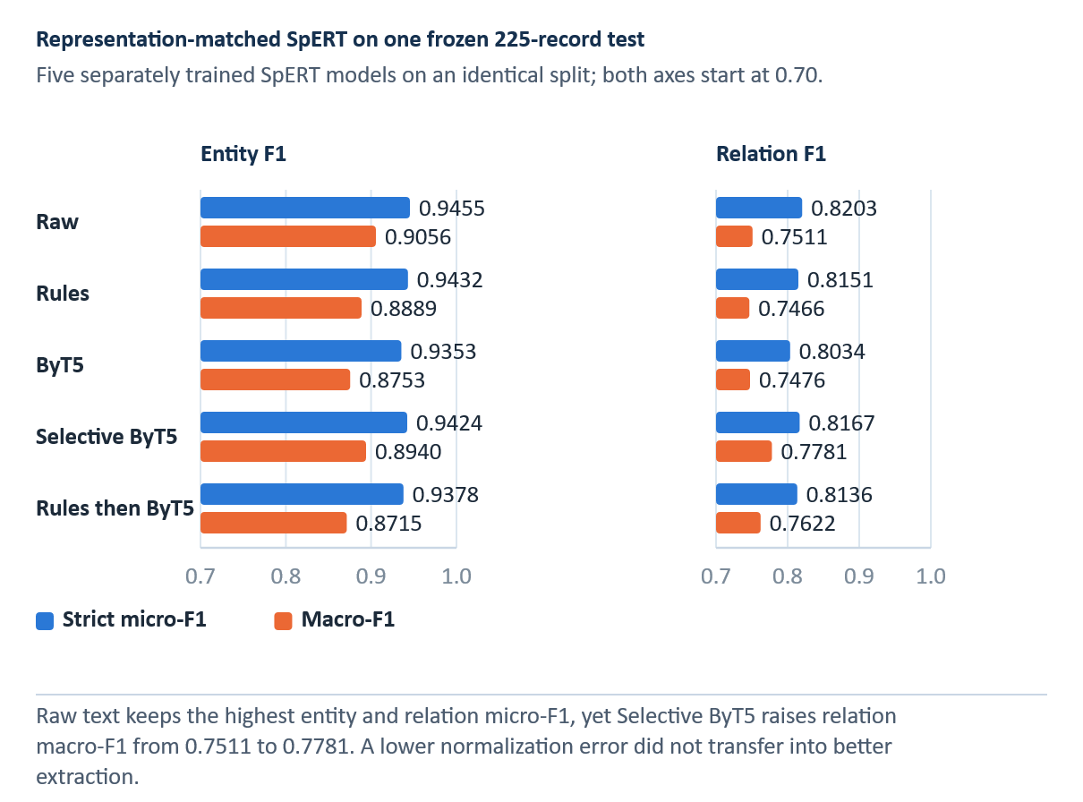
INSERT FIGURE 4.3 HERE — Representation-matched SpERT performance. Add the final visual or table and its automatic Word caption here.
The matched SpERT comparison uses the same 225-record test for every representation. Higher bars indicate higher strict micro-F1.

Error analysis and interpretation
Raw text produced WER 0.2994 and exact match 0.0594. Most-frequent replacement increased WER to 0.3582, while rules reduced it to 0.1063. The learned systems performed substantially better: ByT5 achieved WER 0.0147 and exact match 0.9366, and Selective ByT5 achieved 0.0219 and 0.9325 while preserving all protected tokens. Table 4.2 and Figure 4.2 report the locked intrinsic results; Table 4.3 and Figure 4.3 report the separate representation-matched SpERT ablation.
ByT5 produced the strongest descriptive agreement with the reference. Compared with rules, it lowered WER by 0.0916, an 86.2% relative reduction, and increased exact match by 0.6370, or 63.7 percentage points. This advantage is consistent with byte-level contextual modeling of spelling patterns and forms that cannot be handled by one-to-one replacement.
ByT5 led on WER, CER, exact match, and change F1, but preserved 96.63% of protected tokens. Selective ByT5 preserved 100% and remains the preselected RQ1 system. Rules followed by ByT5 fell between these systems on WER and protected-token preservation. Reporting the descriptive leader separately from the preselected system preserves the validation decision.

Formal selective-normalization rule
The official system accepts a ByT5 proposal only when its confidence reaches the validation-selected normalization threshold θ_norm and the protected-token safety check passes; otherwise it returns the original input, as formalized in Equation 4.7.
 | $$f_{\text{sel}}\left(x\right)=\left\{\begin{matrix}f_{B}\left(x\right), & c\left(x\right)≥θ_{\text{norm}} ∧ S\left(x,f_{B}\left(x\right)\right)=1 \\ x, & \text{otherwise}\end{matrix}\right.$$ | (4.7)
f_B(x) is the ByT5-generated proposal, c(x) is the confidence criterion, θ_norm is the validation-selected threshold of 0.90, and S(x, f_B(x)) equals one when the proposal respects protected tokens in the input. The other branch returns x: the system retains a known noisy string rather than accepting an unsupported alteration.
On the locked test, unconstrained ByT5 was the descriptive leader with WER 0.0147 and exact match 0.9366. Selective ByT5 obtained WER 0.0219 and exact match 0.9325 while preserving every protected token. The difference must not be used to replace the selected system after opening the test. Doing so would convert the test into another model-selection set.
Rules remain useful as a transparent baseline. They achieved WER 0.1063, exact match 0.2996, and complete protected-token preservation with deterministic, auditable edits. Their lower reference agreement shows the cost of limited coverage and context, while their preservation behavior illustrates why accuracy and source fidelity must be evaluated together.

Normalization threats to validity
Reference construction is the first validity threat. The expert-cleaned release was prepared for downstream language processing and may reconstruct text more aggressively than a record-preservation policy would permit. Resource circularity is the second threat because the same release provides both the target strings and lexical material for the rule system. The held-out split prevents ByT5 from training on test records, but it does not make the expert resource independent of the corpus.
Domain specificity is the third threat: one public corpus and one cleaned reference cannot establish semantic validity across organizations or fleets. Selection interpretation is the fourth. ByT5 is descriptively strongest on the opened test, but the preselected result remains Selective ByT5. Finally, the matched ablation shows that lower normalization error does not imply higher downstream entity or relation micro-F1.
Further evaluation should include blinded review of meaning preservation, explicit treatment of truncated endings, independently developed protected vocabularies, and testing across organizations. The downstream ablation is complete; future studies should replicate it with independent annotations and additional extraction architectures rather than select again on the opened test.

Information Schema and Gold-Corpus Construction

Schema design principles
The schema is designed around questions a planner or retrieval system can ask of a short record: What item is affected? What static fault or abnormal process is described? What action was taken, on which item, and for which issue? What measurement, location, operating context, outcome, or reference is explicitly recorded? The schema includes only text-visible information. It does not infer an unmentioned component, outcome, causal mechanism, or procedure.
Entities use minimal informative spans. Relations are typed, directed, and constrained by source and target signatures. Orphan entities are allowed when the text does not express a valid counterpart. This prevents the annotation process from manufacturing a relation merely because two entities occur in the same record. Missing outcome is encoded as unknown, not positive. ACTION_ON_ITEM states the target of an action but does not imply that the action corrected a problem. ACTION_ADDRESSES_ISSUE and ACTION_INVESTIGATES_ISSUE remain distinct. Tables A.1 and A.2 in Appendix A define the entity inventory and the directed relation inventory with its binding signatures.

Entity inventory
The FAULT–ABN_PROC distinction separates static state from dynamic behaviour. This matters for retrieval: ‘cracked bracket’ and ‘engine running rough’ may involve the same broad system but lead to different evidence. TECH_OBS separates a measurement from an interpretation. A compression reading can be recorded neutrally even when the surrounding text identifies a low-compression fault. OUTCOME is action-linked and requires explicit result language; its absence is not evidence of success.

Relation inventory
Directed type signatures make invalid silver predictions detectable. ISSUE_ON_ITEM must begin at a FAULT or ABN_PROC and point to MAINT_ITEM; reversing the argument order changes the relation. Offline graph validation keeps unknown entity types and incompatible edges out of structured case fields while retaining their source identifiers for audit. The deployed query path does not run a live extraction service.

Annotation workflow
The corpus-building workflow starts with a random 300-record pilot. Weak pre-annotations are imported into Label Studio and manually corrected to gold. The correction process can delete false spans, adjust boundaries and types, add missing spans, and create or remove relations. A CRF trained on corrected data then supplies pre-annotations for later rounds. Pre-annotation is an efficiency aid; imported predictions become gold only after review.

Formal annotation object
An annotated record is represented by typed spans plus directed typed relations, as formalized in Equation 5.1.
 | $$\begin{aligned}A\left(d\right)&=\left(E_{d},R_{d}\right), E_{d}=\left\{\left(s_{i},e_{i},t_{i}\right)\right\} \\ R_{d}&=\left\{\left(i,r_{ij},j\right)∣\left(t_{i},r_{ij},t_{j}\right)∈P\right\}\end{aligned}$$ | (5.1)

Each entity is a triple containing start offset sᵢ, end offset eᵢ, and type tᵢ. The second set contains a directed relation rᵢⱼ between entity indices i and j for an allowed pair in P. This formalization explains why exact span boundaries matter: a correct type attached to the wrong character interval is not the same annotation object. It also explains why relation scoring requires both argument spans and direction to match.
Pre-annotation accelerated annotation but did not define the gold label. A human reviewer corrected span boundaries, entity types, and relation links before the record entered the gold corpus. Rare-class enrichment increased coverage for analysis, while the development and test partitions stayed frozen to prevent iterative sampling from changing the evaluation population.
Two random additions bring the cumulative corpus to approximately 1,100 records. The development and test partitions are frozen at that point. Subsequent active-learning rounds rank the remaining pool using uncertainty and rare-class signals and add selected cases to training only. The final corpus contains 1,600 records: 1,275 training, 100 development, and 225 test. The frozen test therefore remains a random sample rather than a rare-class-enriched benchmark.
The supplied annotation-tracking file records rare-class enrichment at cumulative totals of 1,100, 1,400, and 1,600. Early planning figures targeted approximately 1,500; the realized gold corpus contains 1,600 records.

Active learning and frozen evaluation sets
Rare-class acquisition responds to the heavy skew visible in the pilot. Uncertainty sampling alone tends to select ambiguous examples near the current decision boundary; rare-class weighting additionally searches for likely examples of underrepresented types. This improves training coverage but changes the selected distribution. Keeping the random development and test records fixed prevents the enriched training distribution from becoming the reported evaluation distribution.
Active learning can still create bias. The current model determines which unlabelled records appear uncertain or likely to contain rare labels, so systematic model blind spots can remain undiscovered. Rare-class enrichment may also concentrate idiosyncratic wording. Learning curves and per-class support therefore supplement the final scores, and the thesis avoids claiming that active learning alone caused improvement.

Gold-corpus composition
Table 5.1 Gold-corpus entity support
Entity | Mentions
MAINT_ITEM | 4,460
ACTION | 2,840
LOC | 1,902
ABN_PROC | 993
TECH_OBS | 764
FAULT | 683
OUTCOME | 497
OP_CTX | 420
REFERENCE | 67
Note. Gold entity mentions across all 1,600 annotated records, not 225-record frozen-test support. The nine entity types are defined with their inclusion and exclusion rules in Table A.1.
Source: Author's own computation on the annotated gold corpus.
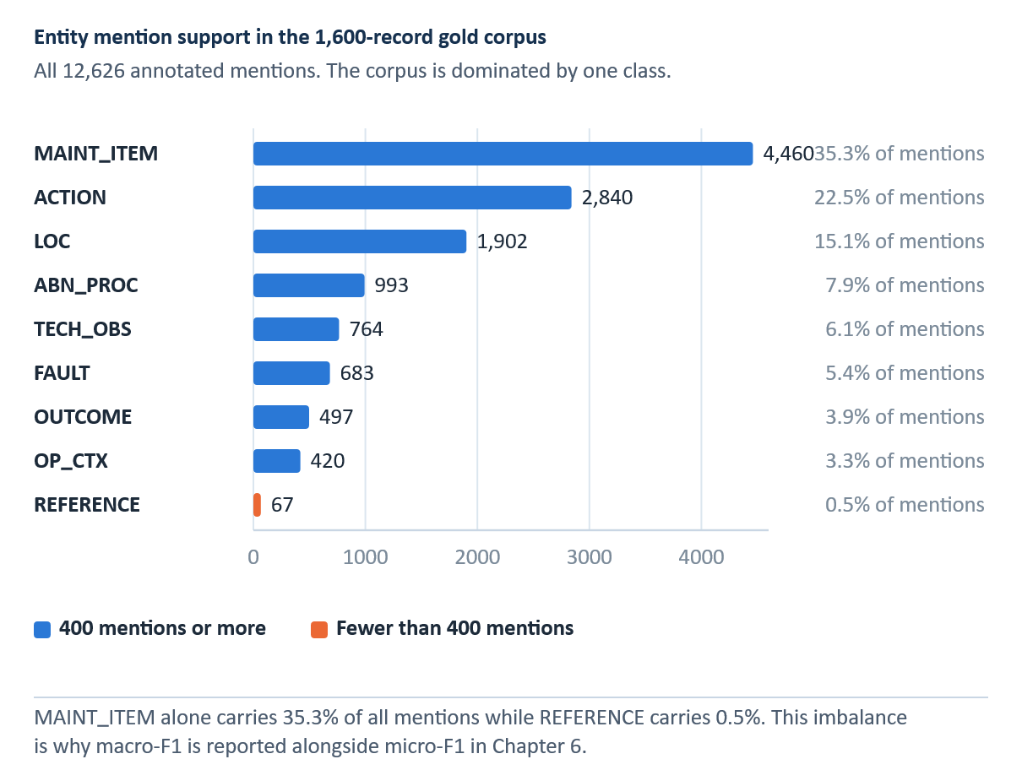
INSERT FIGURE 5.1 HERE — Entity mention support in the 1,600-record gold corpus. Add the final visual or table and its automatic Word caption here.
Counts are entity mentions in the complete 1,600-record gold corpus, not records containing at least one cue.
Table 5.2 Gold-corpus relation support
Relation | Instances
ACTION_ON_ITEM | 2,852
HAS_LOCATION | 1,912
ISSUE_ON_ITEM | 1,645
HAS_PART | 939
ACTION_INVESTIGATES_ISSUE | 898
ACTION_ADDRESSES_ISSUE | 865
OBSERVATION_OF_ITEM | 667
ACTION_RESULTS_IN_OUTCOME | 533
OCCURS_UNDER_CONTEXT | 391
ACTION_FOLLOWS_REFERENCE | 70
ACTION_USES_ITEM | 62
Note. Gold relation instances across all 1,600 annotated records, not knowledge-graph record support. The eleven directed relation types are defined with their source–target binding signatures in Table A.2. HAS_PART 939 and ACTION_ADDRESSES_ISSUE 865 were corrected against the corpus-support CSV.
Source: Author's own computation on the annotated gold corpus.
Full support visualization appears as Figure B.1. Relation counts are directed typed instances.
The complete 1,600-record gold corpus is strongly imbalanced: MAINT_ITEM contributes 4,460 annotated mentions, whereas REFERENCE contributes 67; ACTION_ON_ITEM has 2,852 annotations and ACTION_USES_ITEM has 62. These are whole-corpus support counts, not test metrics. The frozen 225-record test contains very few REFERENCE and ACTION_FOLLOWS_REFERENCE instances, so a class F1 calculated from a handful of cases must not be interpreted as stable evidence. Table 5.1 and Figure 5.1 report entity support; Table 5.2 reports relation support.

Annotation limitations
The principal limitation is the absence of an independently double-annotated subset and an inter-annotator agreement estimate. The available artifacts document correction, schema constraints, and corpus growth, but they do not quantify reviewer consistency. Some distinctions—especially FAULT versus ABN_PROC, ACTION_ADDRESSES_ISSUE versus ACTION_INVESTIGATES_ISSUE, and TECH_OBS versus OUTCOME—require judgment. Model F1 is conditional on those annotation decisions.

Agreement that should be measured in follow-up work
A future double-annotation study should compare two independently produced annotation sets before adjudication. One simple span-level agreement coefficient is the F1-style overlap in Equation 5.2:
 | $$F_{1}\left(a,b\right)=\frac{2\left|M\left(a,b\right)\right|}{\left|A\left(a\right)\right|+\left|A\left(b\right)\right|}$$ | (5.2)

A(a) and A(b) are the annotation objects produced by reviewers a and b, and M(a,b) is the set of exact matches under a predefined span, type, and—when applicable—relation-direction rule. This equation is included as a proposed evaluation method, not as a reported result. The current corpus has one correction workflow and therefore provides no measured inter-annotator agreement.
A second limitation is that pre-annotation can anchor the reviewer. Missing predictions may be less visible than incorrect predicted spans, and the model’s current ontology may influence relation creation. A third is domain and source dependence: the schema is tailored to short English aviation records and does not yet model negation scope, temporal order, conditionality, applicability, or document-level context. A future corpus release should add blind double annotation, adjudication logs, boundary and relation agreement, and explicit quality sampling of pre-annotation omissions.

Information Extraction Methods and Results

Extraction task
The information-extraction task has two outputs. Entity recognition identifies exact spans and assigns one of nine entity types. Relation extraction assigns one of eleven directed types to compatible entity pairs. Entity scoring requires both span boundaries and type to match. Relation scoring additionally requires the correct source entity, target entity, direction, and relation type. A relation error can therefore originate in either entity detection or pair classification.
Micro-F1 aggregates decisions across classes and is influenced most by frequent types. Macro-F1 gives every class equal weight and is more sensitive to rare labels. Both are reported because the test distribution is strongly imbalanced and the rarest entity and relation classes contain only two instances.

CRF and logistic regression
A CRF is a sequence-level label chooser rather than a dictionary of entity names. At each token it combines observable cues, such as lowercase spelling, capitalization, digits, punctuation, prefixes, suffixes and nearby words, with learned preferences for adjacent BIO tags. The Viterbi algorithm finds the highest-scoring complete tag sequence; it can discourage an I-tag after an incompatible O-tag. The separate logistic classifier then scores permissible ordered entity pairs, including entity types, distance and intervening words. A CRF therefore resolves tag consistency, but does not repair an entity it never detected [8, 23].
The first architecture combines a conditional random field for entity sequences with logistic regression for relations. The CRF uses token, orthographic, lexical, contextual, and sequence features, while the relation classifier uses features of candidate entity pairs. This interpretable, low-compute pipeline provides a strong engineered baseline for judging whether neural models add value on a small labelled corpus.

CRF decoding and relation baseline
For a token sequence of length T, the CRF score adds the learned transition score A from the previous to the current label and the emission score P supplied for the current token and label, as formalized in Equation 6.1.
 | $$s\left(x,y\right)=\sum_{t=1}^{T}{\left(A_{y_{t-1},y_{t}}+P_{t,y_{t}}\right)}$$ | (6.1)

The highest-scoring label sequence is obtained with dynamic programming. Hand-engineered lexical, orthographic, and contextual features provide the emissions in the feature-based baseline. After entity prediction, logistic regression classifies candidate entity pairs using their types, surface features, distance, order, and intervening context. Because relation classification is downstream of entity detection, a missed entity also removes every relation that depends on it.

BiLSTM CRF and neural relation classifier
An LSTM's input, forget and output gates decide what information enters memory, persists, and becomes visible at each token [24]. Two LSTMs read the same record from opposite directions; their states are joined so a token representation can reflect words before and after it. A CRF still decodes the BIO sequence. Compared with feature-engineered CRFs, the recurrent layers learn contextual features, but their sequential computation and sparse supervision remain relevant limitations [32, 33].
The recurrent architecture combines bidirectional LSTM representations with CRF decoding and uses a neural classifier for entity pairs. The NER model trains for at most 60 epochs with patience 8; the relation model trains for at most 40 epochs with patience 6. Both use development performance for early stopping.

Bidirectional context
A bidirectional LSTM reads the sequence in both directions and concatenates the two hidden states, as formalized in Equation 6.2.
 | $$h_{t}=\left[\overset{→}{\text{LSTM}}\left(x_{t},\underset{t-1}{\overset{→}{h}}\right);\overset{←}{\text{LSTM}}\left(x_{t},\underset{t+1}{\overset{←}{h}}\right)\right]$$ | (6.2)

xₜ is the representation of token t. The forward state summarizes preceding context, the backward state summarizes following context, and their concatenation hₜ supports token classification. A CRF then imposes sequence-level label consistency. This architecture can represent local technical patterns without manually specifying every feature, but its sequential computation and limited data efficiency can make it less effective than a pretrained transformer on sparse relation classes.
This architecture tests learned sequential representations without transformer pretraining. The small corpus and severe relation imbalance increase the risk of overfitting, so training curves and recorded seed variation are treated as diagnostics rather than substitutes for the frozen comparison.

Transformer and joint span models
Self-attention lets each token compare itself with other tokens in the same record; a pretrained BERT encoder supplies contextual vectors rather than one fixed vector per word [10, 26]. DistilBERT transfers this behavior through a smaller distilled encoder [34]. The evaluated DistilBERT system remains a pipeline: an incorrect entity boundary can remove a correct downstream pair. SpERT instead scores candidate spans and then ordered span pairs with shared contextual representations, learning entity and relation objectives jointly [11]. A joint encoder improves sharing, but cannot make an unsupported rare relation reliable by itself.
The transformer pipeline uses DistilBERT for contextual entity representations and span-pooled relation classification [34]. The fourth architecture, SpERT, jointly classifies candidate spans and their relations with a BERT-base-cased encoder. The comparison therefore separates a transformer pipeline from a joint span-based formulation rather than treating all transformer models as one tier. Table 6.1 compares the four extraction architectures and their training roles.

Span and relation representations
SpERT forms a candidate span feature from max-pooled contextual token embeddings and a learned span-width embedding. For entity classification it adds the sentence-level [CLS] embedding; the ordered relation classifier instead uses span features and pooled local context between the two candidates. Equation 6.3 defines the span and entity features.
 | $$\begin{aligned}e\left(s\right)&=\left[\max_{t∈s}{h_{t}};ϕ\left(\left|s\right|\right)\right] \\ g\left(s\right)&=\left[e\left(s\right);h_{\text{CLS}}\right]\end{aligned}$$ | (6.3)

Here e(s) joins the componentwise maximum of the span’s contextual token vectors with the width embedding, and g(s) additionally includes the sentence-level [CLS] vector for entity classification. The model assigns each candidate span an entity type or a non-entity label. Ordered pairs of the retained spans are then classified using the intervening local context, as formalized in Equation 6.4.
 | $${\overset{ˆ}{r}}_{ij}=σ​\left(W_{r}\left[e\left(s_{i}\right);c_{ij};e\left(s_{j}\right)\right]+b_{r}\right)$$ | (6.4)
Wᵣ and bᵣ are learned relation-classification parameters, cᵢⱼ pools the tokens between the two spans, and σ provides a separate sigmoid score for each relation type. Reversing the order of e(sᵢ) and e(sⱼ) changes the input, so directed relations remain distinguishable. Joint training shares the BERT encoder, but a relation still depends on correct span proposals and adequate examples for its type [11]
Table 6.1 Information-extraction model tiers
Architecture | Entity component | Relation component | Role
CRF + LR | Feature-based CRF | Logistic-regression pair classifier | Transparent baseline
BiLSTM | BiLSTM sequence model | Neural pair classifier | Recurrent-neural comparison
DistilBERT | Transformer token/span model | Transformer pair classifier | Pipeline transformer
SpERT | Joint span classifier | Joint relation classifier | Operational joint span-based model
Note. The four approaches share the same internal test population but have different inductive biases.
Source: Author's own illustration, based on [8, 10, 11, 34].

Training and evaluation protocol
All four architectures use 1,275 training records, 100 development records, and the same 225-record frozen test. The test contains 1,693 gold entity mentions and 1,419 gold relations. This shared population supports direct descriptive comparison; confidence intervals and class support remain necessary when differences are small or labels are rare.

Micro, macro, and uncertainty measures
A confusion matrix counts decisions by true label (rows) and predicted label (columns). A diagonal cell represents agreement; an off-diagonal cell shows which labels were confused. In a one-versus-rest view for class c, TP is a correctly predicted c, FP is a predicted c absent from the reference, FN is a gold c that was missed, and TN is a non-c correctly left as non-c. Strict span-level IE scores usually derive precision, recall and F1 from TP, FP and FN; TN is not included because the number of possible non-entity spans and non-relations is enormous and depends on candidate generation. For entities, a wrong boundary or type can count as both one FP and one FN. For a directed relation, argument spans, direction and relation label must all match.
Micro averaging sums TP, FP and FN across types first and then computes F1; frequent labels consequently exert more influence. Macro averaging computes one F1 for each evaluated type and takes their unweighted mean. Both must name the same class set and the same exact-match policy. For instance, a model can gain on rare relations and improve macro-F1 while losing a few frequent relation instances and reducing micro-F1. Per-class support—the number of gold examples for a type—must accompany either interpretation.
Precision, recall, and F1 are computed from exact true positives, false positives, and false negatives, as formalized in Equation 6.5.
 | $$\begin{aligned}P&=\frac{\text{TP}}{\text{TP}+\text{FP}}, R=\frac{\text{TP}}{\text{TP}+\text{FN}} \\ F_{1}&=\frac{2PR}{P+R}\end{aligned}$$ | (6.5)

Precision answers how many predicted objects were correct; recall answers how many gold objects were recovered; F1 is their harmonic mean. For entities, correctness requires both the span and type. For relations, it additionally requires the correct directed argument pair and relation type.
Micro-F1 pools counts over all classes before computing the score, as formalized in Equation 6.6.
 | $$F_{1,\text{micro}}=\frac{2\sum_{c∈C}{{\text{TP}}_{c}}}{2\sum_{c∈C}{{\text{TP}}_{c}}+\sum_{c∈C}{{\text{FP}}_{c}}+\sum_{c∈C}{{\text{FN}}_{c}}}$$ | (6.6)

Because frequent classes contribute more TP, FP, and FN counts, micro-F1 summarizes overall instance-weighted performance. Macro-F1 instead averages class-level F1 scores, as formalized in Equation 6.7.
 | $$F_{1,\text{macro}}=\frac{1}{\left|C\right|}\sum_{c∈C}{\frac{2{\text{TP}}_{c}}{2{\text{TP}}_{c}+{\text{FP}}_{c}+{\text{FN}}_{c}}}$$ | (6.7)

C is the evaluated class set. Each class contributes equally to macro-F1, so rare-class failure is visible rather than absorbed by dominant labels. This distinction explains why Selective ByT5 could improve downstream relation macro-F1 while raw text retained the best relation micro-F1.
Bootstrap intervals quantify sampling variability by repeatedly resampling evaluation units and recomputing a statistic theta-hat-star [37], as formalized in Equation 6.8.
 | $${\text{CI}}_{1-α}=\left[Q_{α/2}\left({\overset{ˆ}{θ}}^{*}\right), Q_{1-α/2}\left({\overset{ˆ}{θ}}^{*}\right)\right]$$ | (6.8)

Q denotes an empirical quantile of the bootstrap distribution and alpha is the tail probability. The interval describes uncertainty under resampling of the observed evaluation population; it does not incorporate annotation disagreement, distribution shift, or model-training randomness unless those sources are explicitly resampled.
Confidence intervals use 1,000 nonparametric bootstrap resamples of the test predictions [37]. They quantify sampling uncertainty conditional on the supplied models and records. They do not include annotation uncertainty, domain shift, or the full effect of training randomness. Because the canonical artifact does not provide a complete paired significance matrix for all four architectures, the final ranking is reported descriptively.

Overall performance
Table 6.2 Overall frozen-test information-extraction results
Model | Entity micro-F1 | Entity macro-F1 | Relation micro-F1 | Relation macro-F1
CRF + LR | 0.9402 | 0.8822 | 0.8036 | 0.7409
BiLSTM | 0.9385 | 0.8935 | 0.6323 | 0.6165
DistilBERT | 0.9449 | 0.8874 | 0.8296 | 0.6739
SpERT | 0.9520 | 0.9063 | 0.8537 | 0.7898
Note. Internal frozen random 225-record test; strict typed F1. Descriptive point estimates, not pairwise significance results. Per-class scores and gold test support for every entity and relation type are given in Tables B.1 and B.2; the macro-F1 values above are the unweighted means of those per-class columns.
Source: Author's own computation on the frozen internal test.
Frozen random test n = 225; 1,693 gold entities and 1,419 gold relations. Strict typed scoring; all four models use the same population.
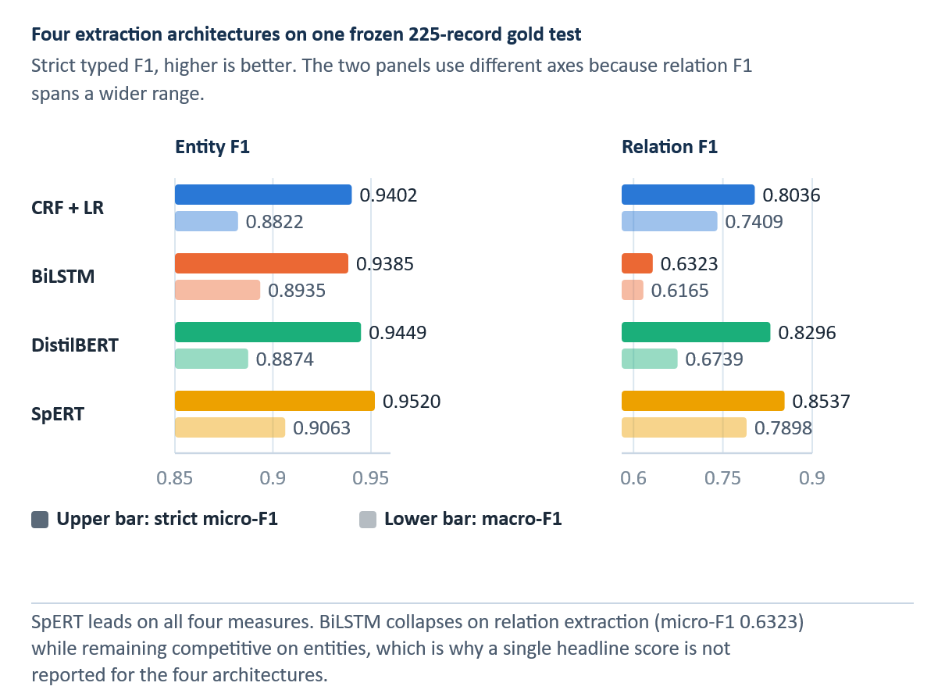
INSERT FIGURE 6.1 HERE — Four-model information-extraction performance on the frozen test. Add the final visual or table and its automatic Word caption here.
SpERT has the highest point estimates; small differences and rare-class scores require uncertainty- and support-aware interpretation.
Entity micro-F1 exceeded 0.93 for every architecture. SpERT had the highest point estimate at 0.9520, followed by DistilBERT at 0.9449, CRF with logistic regression at 0.9402, and BiLSTM at 0.9385. Entity macro-F1 ranged from 0.8822 to 0.9063, indicating a narrower ranking that remains sensitive to rare classes. Table 6.2 and Figure 6.1 compare overall entity and relation performance on the common frozen test.
Relation extraction produced a clearer separation. SpERT achieved micro-F1 0.8537, DistilBERT 0.8296, CRF with logistic regression 0.8036, and BiLSTM 0.6323. The joint span-based model therefore led this frozen comparison, although its test performance cannot be transferred directly to every prediction in the operational silver graph.

Per-class performance
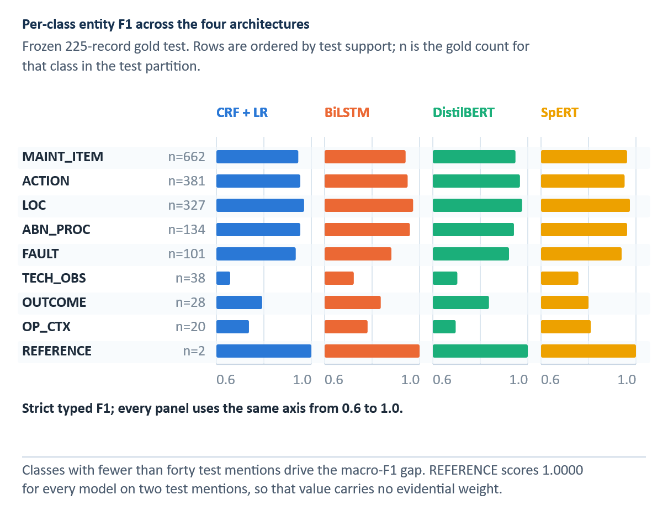
INSERT FIGURE 6.2 HERE — Per-class entity F1 for four architectures. Add the final visual or table and its automatic Word caption here.
Per-class support is uneven; REFERENCE has only two test instances, so perfect F1 is not a stability result.
Frequent entity types were consistently strong, while TECH_OBS and OP_CTX varied more across architectures. SpERT achieved F1 0.7568 for TECH_OBS and 0.8095 for OP_CTX. Every model scored 1.0000 on REFERENCE, but the test contains only two such instances; the perfect value is therefore uninformative about stability. Figure 6.2 exposes the entity-class pattern, and Figure 6.3 exposes relation-class instability for rare labels.
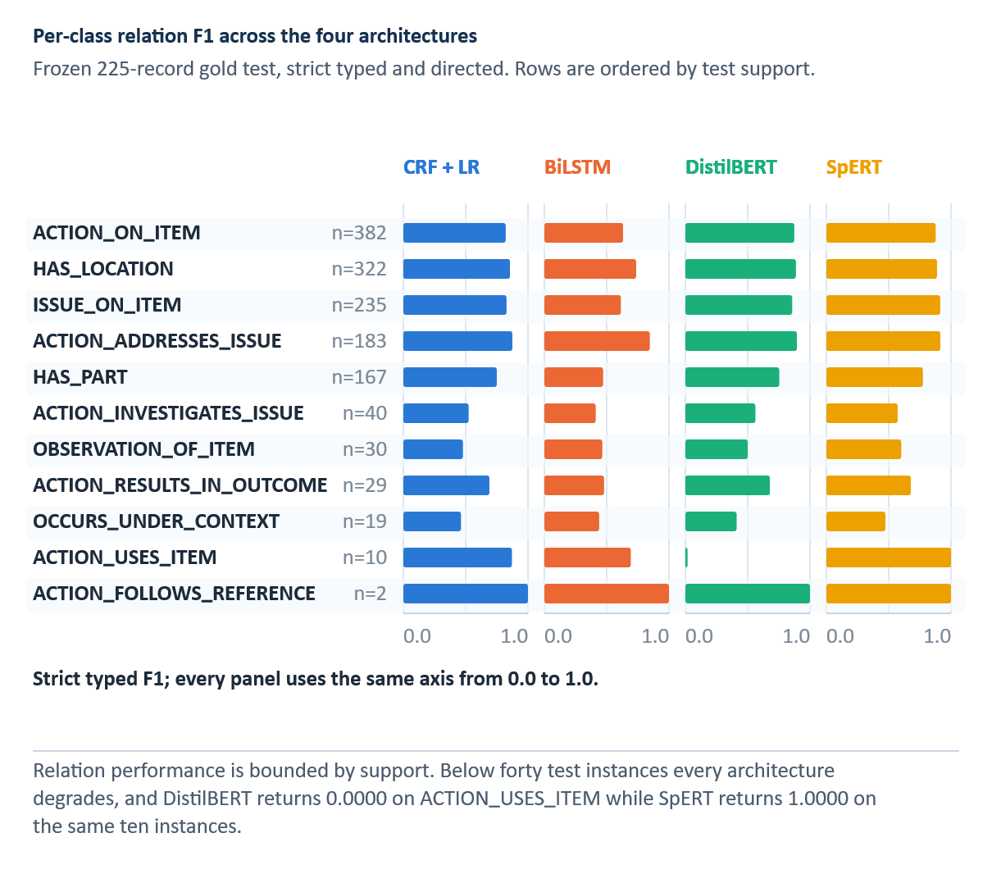
INSERT FIGURE 6.3 HERE — Per-class relation F1 for four architectures. Add the final visual or table and its automatic Word caption here.
The relation task compounds span and pair-classification errors. Detailed four-model F1 values appear in Table B.2.
SpERT led several frequent relations, including ACTION_ADDRESSES_ISSUE (0.9146), ISSUE_ON_ITEM (0.9130), and HAS_LOCATION (0.8872). Rare-relation scores varied sharply. DistilBERT scored 0 on ACTION_USES_ITEM while SpERT scored 1.0000, and every model scored 1.0000 on ACTION_FOLLOWS_REFERENCE with only two test instances. These cases show why per-class F1 must be read with support.
The class-level pattern generally favoured SpERT, but the feature-based baseline remained competitive on frequent, lexically regular relations. BiLSTM was consistently weaker on relation extraction. Macro-F1 summarizes these differences but can change materially when a few rare classes move, so it is interpreted together with per-class support.

Internal and external comparison
For orientation, the frozen internal entity/relation micro-F1 pairs are CRF with logistic regression 0.9402/0.8036, BiLSTM-CRF with a neural relation classifier 0.9385/0.6323, DistilBERT pipeline 0.9449/0.8296, and SpERT 0.9520/0.8537. These results are measured on the common internal 225-record test; they are not estimates of quality on every silver production prediction.
The point estimates in Table 6.2 are descriptive summaries of the common frozen test. They should not be read as pairwise significance results.
Table 6.3 External MaintIE benchmark results
Model | MaintIE entity micro-F1 | MaintIE entity macro-F1 | MaintIE relation micro-F1 | MaintIE relation macro-F1
CRF + LR | 0.7629 | 0.8312 | 0.5101 | 0.5206
BiLSTM | 0.7007 | 0.6114 | 0.2767 | 0.2102
DistilBERT | 0.8288 | 0.8822 | 0.5847 | 0.2808
SpERT | 0.8828 | 0.9045 | 0.6817 | 0.7024
Note. Separately trained MaintIE models; 860/108/108 split and different 5-entity/6-relation schema. Not zero-shot transfer.
Source: Author's own computation on the MaintIE benchmark [6].
MaintIE uses a separate 860/108/108 train-development-test split with five entity and six relation types. Each architecture is trained on that benchmark; the comparison is external replication, not zero-shot transfer.
SpERT had the highest entity and relation micro-F1 in the internal corpus and in MaintIE. DistilBERT ranked second, the CRF-based system third, and BiLSTM fourth on relation micro-F1 in both settings. This repeated ordering supports the architectural comparison, while different schemas, corpora, and training runs prevent direct equality claims across benchmarks. Table 6.2 reports the internal frozen-test result, and Table 6.3 reports the separately trained MaintIE comparison.
Earlier pipeline-specific artifacts contain memorization, OOV, context, seed, and train-test diagnostics. They are retained as development history but are not combined numerically with the canonical four-model results because the reporting pipelines and final model snapshots differ.

Learning-curve analysis
INSERT FIGURE 6.4 HERE — Information-extraction learning curves. Add the final visual or table and its automatic Word caption here.
Historical annotation-acquisition diagnostic. Its endpoints are not the canonical four-model scores in Table 6.2.
The acquisition-stage learning curves show that adding labelled records did not yield monotonic improvements at every stage. They describe the annotation and model-development process rather than the final RQ3 ranking, which is taken from the common four-model test in Table 6.2. Figure 6.4 presents the recorded development trajectories used to diagnose convergence and early stopping.
The neural curves also show that entity and relation components learned at different rates and that relation results varied more. Their purpose is diagnostic: they support fixed-test monitoring and class-aware acquisition but do not replace the canonical final scores.

Operational SpERT layer
SpERT serves two roles. It is one of the four architectures scored on the 225-record gold test, and its operational configuration produces predictions for all 6,169 records. The first role provides comparative evidence; the second creates a silver corpus whose individual predictions remain unverified.
On the internal test, SpERT achieved entity micro-F1 0.9520 and relation micro-F1 0.8537. The representation-matched experiment then trained and evaluated SpERT under five input representations. These artifacts close the earlier comparative-scoring gap but do not convert the operational graph into gold data.

IE findings
Three findings answer RQ3. All four architectures performed strongly on entity extraction, with SpERT producing the highest point estimate. Relation extraction separated the models more clearly: SpERT and DistilBERT led, while the BiLSTM relation classifier was substantially weaker. The same broad ordering appeared in MaintIE, although rare labels and benchmark-specific training limit the scope of generalization.
The matched normalization experiment adds a cross-stage result. No normalized representation improved SpERT entity or relation micro-F1 over raw text, although Selective ByT5 increased relation macro-F1 by 0.0270. The result confirms that reference-level normalization gains cannot be assumed to improve downstream extraction.

Silver Knowledge Graph and Historical Case Library

From extraction output to cases
The operational SpERT model is applied to all 6,169 normalized records. Each prediction preserves the source identifier, original or display text, tokens, entity spans, entity types, relation endpoints, and confidence values. Conversion code validates that relation endpoints exist, that types belong to the nine-entity inventory, and that source–target signatures are compatible with the eleven-relation schema. Invalid or unknown structure can be retained for audit but is excluded from structured scoring.
The conversion produces two related views. The knowledge graph aggregates normalized entity strings as nodes and typed directed relations as edges. The case library preserves record boundaries and keeps the complete problem and action sides together. The graph supports dashboard inspection and an exploratory structured channel, neither of which enters the locked canonical-BM25 ranking; the case is the unit of provenance and recommendation rendering. A graph edge can summarize repeated observations, but a displayed action always points back to one source case.

Knowledge-graph construction
Entity surface strings are normalized within type before aggregation. The final exported graph contains 3,197 typed nodes and 9,331 aggregated edges derived from 45,771 predicted entity mentions and 41,469 relation record-support instances. These counts describe the final silver artifact and are not interchangeable with raw extraction-mention totals; the 43,149 relation mentions the model emitted before graph aggregation reduce to 41,469 record-support associations. Table 7.1 reports the final silver graph counts and their evidence status.
The graph is not an ontology of approved maintenance knowledge. It records what the model extracted from historical text. High-frequency nodes such as engine, cylinder, intake gasket, gasket, and rocker-cover gasket reflect the source corpus and extraction behaviour. Edge frequency represents recorded and extracted co-occurrence or binding, not causal strength, failure probability, or procedure effectiveness.

Typed, weighted, provenance-bearing graph
The operational knowledge graph is represented as specified in Equation 7.1:
 | $$G=\left(V,E,τ_{V},τ_{E},w,π\right)$$ | (7.1)

V is the node set, E the directed edge set, ℓV and ℓE the node- and edge-type functions, w an evidence-support weight, and pi a provenance mapping back to source records. The graph is silver because V and E are derived from model predictions over the full corpus. Type constraints can reject structurally invalid edges, but they cannot guarantee that an accepted prediction is semantically correct.
Repeated occurrences of the same typed triple are aggregated with record support (Equation 7.2):
 | $$w\left(u,r,v\right)=\sum_{d∈D}{1}\left\{\left(u,r,v\right)∈E\left(d\right)\right\}$$ | (7.2)

D is the record collection and E(d) is the edge set predicted for record d. The weight counts distinct supporting records, not causal confirmations or successful repairs. This distinction resolves the two valid corpus totals: 43,149 extraction relation mentions are model outputs before aggregation, whereas 41,469 is the relation record-support count stored by the graph construction.
Table 7.1 Silver knowledge-graph statistics
Quantity | Count | What was counted
Source records | 6,169 | Original problem–action cases used for silver extraction.
Entity mentions | 45,771 | Model-predicted mentions before node aggregation.
Extraction relation mentions | 43,149 | Model outputs before graph aggregation.
Typed nodes | 3,197 | Distinct typed node identities in the operational graph.
Aggregated edges | 9,331 | Distinct typed graph edges.
Relation record-support | 41,469 | Supporting record–relation associations after graph construction.
Invalid entities / relations | 0 / 0 | Skipped by the frozen graph exporter.
Note. Silver operational output: not expert-verified graph facts. Do not equate 43,149 mentions with 41,469 record-support.
Source: Author's own computation.
Counts are reproduced from the final operational KG summary. Relation record-support is distinct from raw extraction relation-mention totals.

Case representation
A case stores the source problem and solution text, extracted problem entities and relations, extracted action entities and relations, derived problem-graph features, action sequence, action family, outcome category, provenance, and evidence-cluster identity. The representation separates observed fields, model predictions, and deterministic derived fields so the dashboard can explain why a candidate matched and what part of the displayed action came from the source.

Case object and evidential completeness
The historical case associated with record i is represented as specified in Equation 7.3:
 | $$c_{i}=\left(p_{i},a_{i},z_{i},G_{i},o_{i},π_{i}\right)$$ | (7.3)
pᵢ is the original problem text, aᵢ the complete recorded action, zᵢ the structured entity–relation representation, Gᵢ the record-local graph, oᵢ the extracted or derived outcome status, and piᵢ the provenance metadata. Keeping the original problem and action intact prevents the interface from composing a new procedure out of fragments from unrelated records.
The case object deliberately stores both raw text and inferred structure. Text is the primary audit evidence; structure supports retrieval and filtering. When a structured field is absent, the record is not silently discarded or completed by generation. Instead, lexical retrieval can still operate and the missing structure remains visible as uncertainty.
Action extraction uses explicit schema relations when available and a conservative verb-based fallback otherwise. Each case records the route used so a reviewer can distinguish schema-supported evidence from fallback evidence. Legacy case-summary percentages are not used as final performance claims.

Provenance, duplicates, and outcome policy
Near-duplicate records can make a frequent action appear to have independent support when it may be a repeated transcription or template. The case library therefore assigns evidence clusters. Retrieval may return record-level candidates, but aggregation and support counts operate over distinct clusters. A repeated record can strengthen evidence that a pattern is common in the source data, yet it does not create multiple independent demonstrations of effectiveness.
Outcome handling is deliberately asymmetric. An explicit negative, no-effect, deferred, or unresolved outcome prevents the associated action from becoming a positive suggestion. The record can still be displayed as relevant historical evidence, because an unsuccessful attempt may help a planner avoid repetition. An explicit positive outcome can support a case, but it does not certify causality or current applicability. No outcome means unknown, not success.
The renderer preserves whole-source fidelity. It may convert a past-tense action phrase into a concise imperative, but it does not add a verification step that was absent, merge an enabling step from one record with a corrective step from another, or replace a specific target with a broader component. When several records support similar action families, the system can show a pattern summary while retaining each exact sequence as separate evidence.

Silver-layer statistics
The offline extraction stage processed 6,169 paired source records and produced 45,771 entity mentions and 43,149 extraction relation mentions. The graph contains 3,197 typed nodes and 9,331 aggregated edges. Its 41,469 relation record-support count has a different unit from the 43,149 extraction relation mentions: the former records support after graph construction, not a corrected extraction count. All graph objects are silver evidence, not expert-verified facts.
The node inventory contains 1,398 MAINT_ITEM, 455 ACTION, 359 TECH_OBS, 259 LOC, 235 ABN_PROC, 202 OP_CTX, 127 FAULT, 122 OUTCOME, and 40 REFERENCE nodes. Distinct nodes and mention support are different quantities: recurring surface evidence can contribute many mentions but one normalized typed node.
The largest relation record-support groups are ACTION_ON_ITEM (11,495), HAS_LOCATION (9,524), ISSUE_ON_ITEM (6,539), ACTION_ADDRESSES_ISSUE (5,409), and HAS_PART (5,074). Smaller groups include ACTION_INVESTIGATES_ISSUE (1,229), OBSERVATION_OF_ITEM (768), ACTION_RESULTS_IN_OUTCOME(616), OCCURS_UNDER_CONTEXT(459), ACTION_USES_ITEM (244), and ACTION_FOLLOWS_REFERENCE (112).
Corrective, investigative, and outcome signals can overlap within one record. Derived action families and roles are retrieval conveniences rather than original annotations, and their frequencies must not be interpreted as independent repairs, success rates, or observed ground truth.

Limitations of the silver layer
Every downstream structured match inherits extraction error. The scored SpERT result reduces uncertainty about the architecture on the frozen gold test, but it does not make the 6,169-record graph gold. Confidence weighting, original-text display, provenance, and reviewer correction mitigate errors without validating the graph record by record.
Entity-string normalization can also merge distinct concepts or split variants that should be identical. The graph lacks fleet configuration, part-number applicability, manual revision, time validity, and organization-specific approval status. It should therefore be treated as a navigation index into historical text. A production knowledge base would require expert validation, controlled vocabularies, temporal provenance, change management, and links to authoritative maintenance data.

Evidence-Grounded Recommender and Planning Dashboard

Decision-support contract
The recommender retrieves historically associated cases for a new problem, explains the match, preserves source evidence, and withholds promoted actions when the evidence criterion is not met. It does not identify an approved procedure or certify that a historical action applies to the new asset. Any displayed action is a deterministic rendering of one complete source record.
The query contains only the new problem and optional planner-entered context; its recorded solution is hidden. The final protocol uses canonical BM25 for problem-text ranking, followed by cluster-expanded evidence aggregation and an action-family support vote tempered by the fixed exponent τ_rank = 0.15. Candidate actions remain attached to their source cases and are presented as historical evidence rather than instructions.

Query structuring
The online–offline boundary matters for interpreting the figures. Entity and relation recognition with SpERT belongs to offline construction of the historical silver case library. A new query in the deployed system reaches the fixed lexical ranking pathway; any figure retained here must be captured from the current deployed version and must not show an obsolete live-extraction service.
In the current deployed dashboard, a newly entered problem is processed by the lightweight query and retrieval path; it does not call SpERT for live entity or relation extraction. SpERT is used offline to build the silver historical corpus and graph. The reviewer may enter or amend context in the interface, but the frozen RQ4 ranking uses the problem text and canonical BM25 rather than live query-side SpERT predictions. Historical structure retains its provenance and remains inspectable.
The original problem text is the input to canonical lexical retrieval. Optional structured fields can help the reviewer inspect or filter evidence in the wider prototype, but they do not contribute to the frozen BM25 RQ4 score. Figure 8.1 shows the deployed problem-entry screen, and Figure 8.2 illustrates source-side structure and reviewer-added context rather than a live SpERT response. The silver graph is not an input to the locked canonical-BM25 rank score.
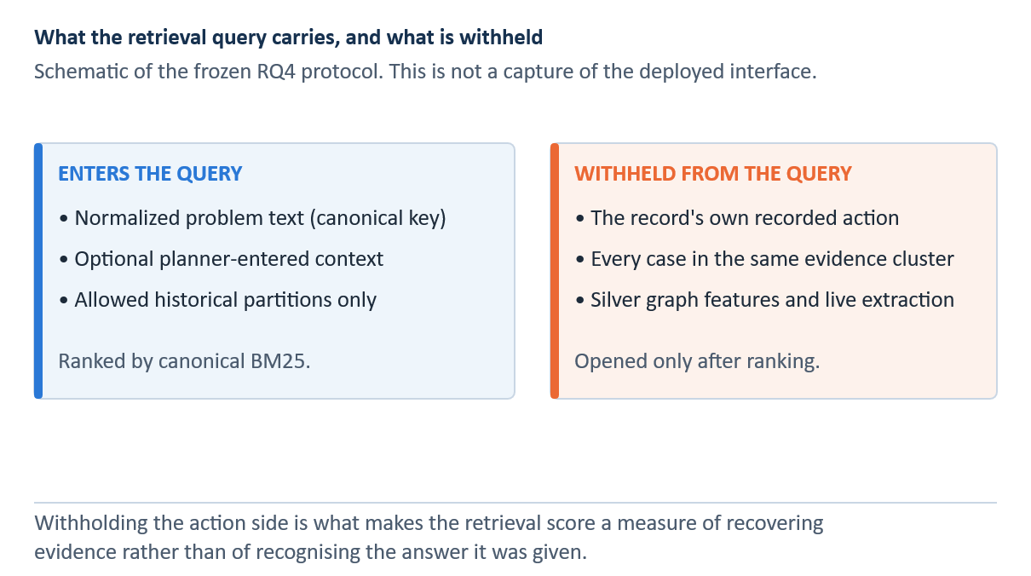
INSERT FIGURE 8.1 HERE — Problem entry and declared retrieval profile. Add the final visual or table and its automatic Word caption here.
The screenshot shows the non-generative evidence workflow. Suggested actions are historical records, not approved instructions.
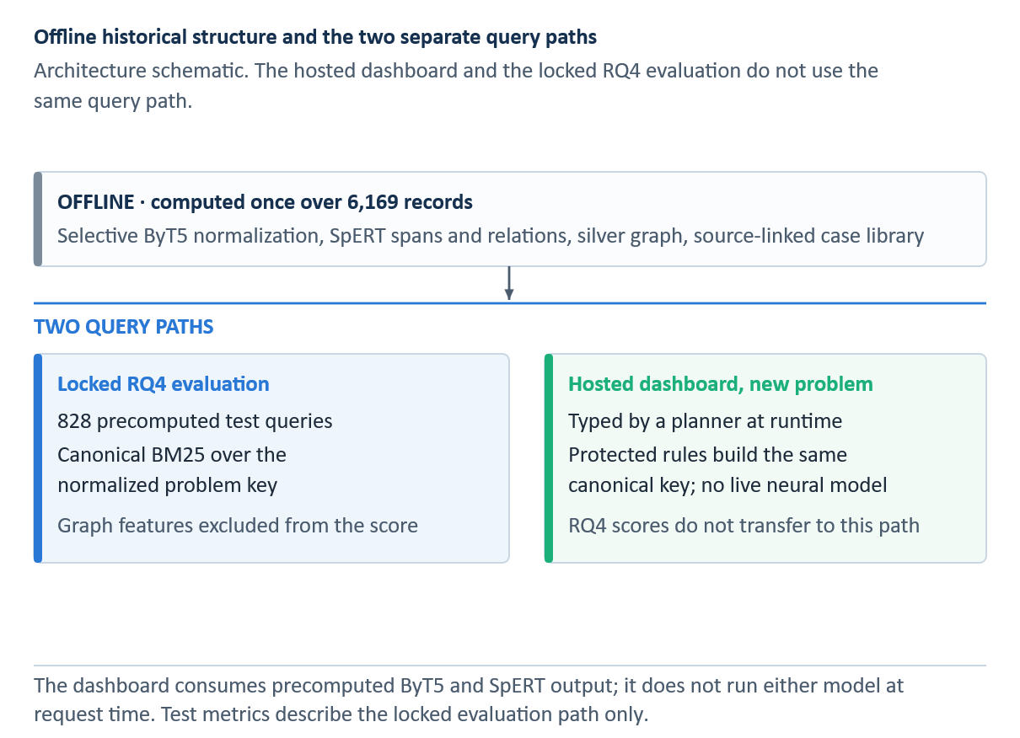
INSERT FIGURE 8.2 HERE — Current dashboard context review and source-side evidence. Add the final visual or table and its automatic Word caption here.
Use a screenshot from the currently deployed dashboard. Do not depict automatic live SpERT query extraction.

Candidate retrieval
The research platform implements BM25, word and character TF-IDF, dense similarity, and structured matching. These channels support experimentation, but the final RQ4 result uses canonical BM25. This separation prevents implementation breadth from being mistaken for evidence that every channel improved the locked test. The graph remains available to explore and filter the historical case library, but does not enter the selected RQ4 ranking or its test metrics.

Sparse and dense similarity
The canonical final retriever uses BM25. For query q and candidate document d, the score is defined by Equation 8.1:
 | $$\text{BM25}\left(q,d\right)=\sum_{t∈q}{\text{IDF}}\left(t\right)\frac{f\left(t,d\right)\left(k_{1}+1\right)}{f\left(t,d\right)+k_{1}\left(1-b+b\left|d\right|/\overline{\left|d\right|}\right)}$$ | (8.1)

f(t,d) is the frequency of term t in d, IDF(t) downweights common terms, |d| is candidate length, avgdl is average candidate length, k₁ controls term-frequency saturation, and b controls length normalization [9]. Exact component names, abbreviations, and rare tokens therefore receive strong evidence, while repeated terms yield diminishing returns.
Dense experimental channels represent a query and candidate as vectors and compare their direction using cosine similarity, as formalized in Equation 8.2.
 | $$\text{cos}\left(q,d\right)=\frac{v_{q}⋅v_{d}}{\left\|v_{q}\right\| \left\|v_{d}\right\|}$$ | (8.2)

The numerator is the dot product and the denominator normalizes both vector lengths. Cosine similarity can connect paraphrases with little word overlap, but it may also blur technically decisive lexical differences. Dense scores were investigated during development; they are not the basis of the final locked RQ4 claim.
The final protocol searches only allowed historical partitions, excludes the query's evidence cluster, and expands cluster members after lexical ranking. These controls prevent near-duplicate leakage while preserving access to record-level evidence within a retrieved cluster. Table 8.1 distinguishes the final canonical retrieval path from the additional experimental channels.

Rank fusion and reranking
Reciprocal-rank fusion combines result lists using rank positions rather than incompatible raw scores [42], as formalized in Equation 8.3.
 | $$\text{RRF}\left(d\right)=\sum_{m∈M}{\frac{1}{k+r_{m}\left(d\right)}}$$ | (8.3)

M is the set of retrieval channels, rₘ(d) is the rank of candidate d in channel m, and k is a stabilizing constant. A candidate ranked highly by several channels receives a larger fused score. The final locked protocol nevertheless selected canonical BM25, so RRF, dense retrieval, graph matching, and cross-encoder reranking are described as development components rather than credited with the reported final result.
Table 8.1 Retrieval and ranking stages
Step | Input / action | Scope and safeguard
1. Query | Problem text only | Hide the query's recorded action.
2. Candidate ranking | Canonical BM25 over allowed historical cases | Selected frozen RQ4 ranker; dense and graph channels are developmental.
3. Split guard | Exclude shared evidence cluster | Prevent duplicate-related train/test leakage.
4. Aggregation | Cluster-expanded evidence | Preserve distinct cluster support and complete source cases.
5. Family vote | Divide support by training prior to exponent τ_rank = 0.15 | Ranking tempering, not a score cutoff or a display gate.
6. Evidence display | Source case, alternatives, outcome, provenance | Do not promote negative/unknown outcome as positive evidence.
7. Planning | Human-selected case and user-entered fields | Qualified reviewer checks current approved maintenance data.
Note. The silver graph is available for exploration but does not enter the selected locked BM25 ranking; the deployed query does not run live SpERT.
Source: Author's own illustration.

Evidence clustering and aggregation
Canonical BM25 ranks cases from the problem text alone. The hidden query action never enters retrieval or evaluation input. Earlier cross-encoder and multi-channel experiments document model development, but they do not determine the final RQ4 result.
The manual assessment separates problem relevance from usable-action evidence. A similar historical problem is therefore not counted automatically as evidence that its recorded action is usable. The assessment covers 100 queries and 500 query-candidate pairs, all judged by one reviewer; no inter-rater reliability estimate is available.
After lexical ranking, evidence is aggregated over distinct clusters and grouped by derived strategy, target, and issue. Exact action sequences remain separate. The interface can display several diagnostic, corrective, inspection, replacement, or service patterns when the retrieved evidence supports them, while the planner retains responsibility for selection.

Outcome-aware filtering and selective abstention
Before display, candidates pass provenance and outcome checks. Explicit no-effect, failed, deferred, or unresolved actions are removed from positive suggestions and retained in a separate evidence ledger. Missing outcomes remain unknown. Record frequency is not converted into a success rate because repeated documentation is neither independent evidence nor a controlled outcome study.
After canonical-BM25 retrieval, the fixed exponent τ_rank = 0.15 tempers each action-family vote by its training-set prior: distinct supporting evidence clusters are divided by that prior raised to τ_rank. This is a ranking adjustment, not a cutoff. The dashboard renders a positive historical option only when an eligible, source-linked pattern exists; otherwise it shows an abstention state and leaves records available for review. The deployed dashboard orders displayed action patterns primarily by distinct-cluster support and location consistency, using adjusted support only later in its tie-breaking order. This presentation order should not be confused with the frozen research ranking. Neither ranking nor display is a probability of a safe or successful repair.

Promotion rule and negative outcomes
The post-retrieval family vote in Equation 8.4 tempers distinct-cluster support by the training prior. Positive display is a separate outcome-eligibility decision: negative or mixed histories cannot become positive suggestions, and the interface abstains if no eligible pattern remains. Neither operation compares a retrieval score with 0.15.
 | $$\begin{aligned}v_{f}\left(q\right)&=\frac{n_{f}\left(q\right)}{π_{f}^{τ_{\text{rank}}}} \\ P_{f}\left(q\right)&=1\left\{∃h∈H_{f}\left(q\right):E\left(h\right)=1\right\}\end{aligned}$$ | (8.4)
Let n_f(q) count distinct retrieved evidence clusters supporting action family f, π_f its smoothed training prior, H_f(q) the historical patterns for that family, and E(h) the binary positive-outcome eligibility of a historical pattern. The first line ranks families using the fixed exponent τ_rank = 0.15; it does not reject candidates with a retrieval score below 0.15. The second line sets P_f(q) to one only when at least one eligible pattern exists. This is a separate display-eligibility check: explicitly negative, mixed, unresolved, or unknown outcomes are not promoted as positive patterns. If no eligible pattern remains, the interface abstains while retaining source records for inspection.
With τ_rank = 0 the prior-tempering factor is one and the family vote is based on unadjusted distinct-cluster support; this comparator reached Hit@1 0.7959. The validation-selected τ_rank = 0.15 setting reached 0.7899, a difference of −0.0060 on the locked test. Development selection balanced near-baseline Hit@1 and Hit@3 with macro-family recall; it did not optimize the opened test or define an abstention threshold. The paired comparison did not resolve the Hit@1 difference.

Planning workspace
The dashboard stores the selected evidence case and planner-entered fields for priority, asset, target dates, parts, tools, personnel, duration, cost, applicability, references, notes, and workflow status. A readiness view identifies incomplete fields. These functions support coordination and audit; they neither change the models nor authorize maintenance.
Historical insights pages separately summarize record and cluster frequencies, entity and relation completeness, and source cases. Record counts and cluster counts are displayed as different quantities. Percentages use explicit denominators so a context filter changes the population rather than presenting a global rate as local evidence.

Evaluation design
A Wilson interval can summarize uncertainty for a single observed hit proportion without relying on the most naive symmetric normal approximation [54]. Hit@1 intervals are percentile bootstrap and the paired difference uses the basic bootstrap, both with 2,000 repetitions and seed 20260907; the Wilson interval is reported alongside the Hit@1 bootstrap because the two methods fall on opposite sides of the majority baseline. An interval for one model does not by itself constitute a paired test of superiority over another model.
The final evaluation uses a cluster-safe split of 4,319 training, 925 development, and 925 test records. After excluding queries without evaluable evidence, the locked test contains 828 queries. The preselected configuration is canonical BM25 with cluster-expanded aggregation and a prior-tempering exponent τ_rank = 0.15 for the family vote, and the query action is hidden throughout retrieval.

Ranked-retrieval measures
Hit@k records whether at least one relevant historical evidence item appears within the first k results, as formalized in Equation 8.5.
 | $$\text{Hit@}k=\frac{1}{N}\sum_{i=1}^{N}{1}\left\{r_{i}≤k\right\}$$ | (8.5)

N is the number of evaluable queries and rank is the position of the first relevant result for query i. Hit@1 measures immediate recovery, while Hit@5 measures whether the reviewer can find evidence after examining a short list. It does not reward placing a relevant result first rather than fifth.
Mean reciprocal rank supplies that rank sensitivity, as formalized in Equation 8.6.
 | $$\text{MRR}=\frac{1}{N}\sum_{i=1}^{N}{\frac{1}{r_{i}}}$$ | (8.6)

The reciprocal is one for a first-ranked relevant result, one half for rank two, and so forth. MRR therefore emphasizes the first relevant item but assumes a single first-relevance position rather than graded evidence quality.
Normalized discounted cumulative gain accommodates graded relevance, as formalized in Equation 8.7.
 | $$\begin{aligned}\text{DCG@}k&=\sum_{j=1}^{k}{\frac{2^{{\text{rel}}_{j}}-1}{\log_{2}\left(j+1\right)}} \\ \text{nDCG@}k&=\frac{\text{DCG@}k}{\text{IDCG@}k}\end{aligned}$$ | (8.7)

relⱼ is the relevance grade at rank j and IDCG@k is the score of the ideal ordering for the same query. Logarithmic discount gives more credit to evidence placed near the top. nDCG@5 of 0.9067 therefore indicates an ordering close to the ideal historical-evidence ranking under the evaluation labels, not a 90.67% probability of correct maintenance.
Macro action-family recall gives every action family equal weight, as formalized in Equation 8.8.
 | $$R_{\text{family,macro}}=\frac{1}{\left|F\right|}\sum_{f∈F}{\frac{H\left(f\right)}{N\left(f\right)}}$$ | (8.8)

F is the evaluated family set, H(f) the number of queries from family f with a hit at the defined cutoff, and N(f) its number of evaluable queries. The resulting value of 0.2802 is substantially lower than the overall Hit@1 of 0.7899 because common Replace cases dominate the instance-weighted result and several rare families remain weak.
Earlier retrieval experiments are retained as development history. The thesis answers RQ4 with the locked final Selective test and answers the empirical part of RQ5 with the final calibration and manual-review artifacts. No training or retuning occurred after the final test was opened.

Locked final Selective retrieval results
Table 8.2 Locked final-protocol retrieval results
Configuration | Hit@1 | Hit@3 | Hit@5 | MRR | nDCG@5 | Macro recall
Selected: canonical BM25; τ_rank = 0.15 | 0.7899 | 0.9686 | 0.9952 | 0.8766 | 0.9067 | 0.2802
Majority family (Replace) | 0.7609 | 0.7609 | — | 0.7609 | — | 0.1429
Canonical BM25; τ_rank = 0 (comparator) | 0.7959 | 0.9698 | 0.9952 | 0.8798 | 0.9091 | 0.2523
Representative-only aggregation ablation | 0.7983 | 0.9698 | 0.9867 | 0.8793 | 0.9063 | 0.2911
Note. Locked test of 828 evaluable queries; the target is the recorded historical action family, not technical correctness. Selected Hit@1 95% query-bootstrap CI 0.7620–0.8188 (percentile method); selected macro-recall 95% stratified-bootstrap CI 0.2484–0.3122. The Hit@1 interval lies marginally above the majority baseline of 0.7609 while a Wilson interval on the same 828 observations gives 0.7608–0.8163, marginally below it, so the Hit@1 difference is not reliably resolved; the macro-recall interval excludes the baseline of 0.1429 outright. Selected-versus-τ_rank = 0 paired difference −0.0060 (95% basic-bootstrap CI −0.0181 to 0.0048; exact McNemar p = 0.4049, 9 versus 14 discordant queries). Bootstrap resampling used 2,000 repetitions with seed 20260907. The majority-family baseline does not define a ranked top-five list, so Hit@5 and nDCG@5 are omitted for that row.
Source: Author's own computation.
Locked final test n = 828 evaluable queries. The target is recorded historical action-family evidence, not technical applicability or maintenance correctness.
On 828 evaluable queries, the selected protocol achieved Hit@1 0.7899, Hit@3 0.9686, Hit@5 0.9952, MRR 0.8766, and nDCG@5 0.9067. The 95% confidence interval for Hit@1 was 0.7620 to 0.8188. These metrics quantify recovery of recorded historical evidence. Table 8.2 reports the locked final-protocol retrieval metrics and their baseline comparison, and Table 8.5 reports Hit@1 for each action family.
The majority-action baseline achieved Hit@1 0.7609 but macro action-family recall 0.1429. The selected system's macro recall was 0.2802. The bootstrap Hit@1 interval (0.7620–0.8188) lies marginally above the majority baseline of 0.7609, whereas a Wilson interval computed on the same 828 observations gives (0.7608–0.8163), whose lower bound lies marginally below it. Because two standard interval methods fall on opposite sides of the baseline, the Hit@1 difference is not reliably resolved at this sample size. The macro-recall interval (0.2484–0.3122) excludes the baseline value of 0.1429 outright, so the increase in macro action-family recall from 0.1429 to 0.2802 is the statistically resolved advantage of the selected system. The Replace family still dominated and several rare families had low or zero Hit@1. Removing prior tempering (τ_rank = 0) raised Hit@1 by 0.0060; McNemar's test did not resolve this difference (p = 0.4049).

Robustness, calibration, and evidence review
The fixed-protocol perturbation experiment is a supplementary post-hoc analysis of 828 evaluable queries, not another round of confirmatory model selection. Under the most adverse tested condition, 10% synthetic spelling noise, Hit@1 fell from 0.7899 to 0.7560, a drop of about 3.4 percentage points. The tested perturbations do not represent all real-world maintenance noise or establish field reliability.
Table 8.3 Fixed-protocol robustness results
Condition | Hit@1 | Hit@3 | Hit@5 | MRR | nDCG@5 | Hit@1 drop
Clean | 0.7899 | 0.9686 | 0.9952 | 0.8766 | 0.9067 | —
10% truncation | 0.7766 | 0.9650 | 0.9879 | 0.8652 | 0.8958 | 0.0133
20% truncation | 0.7754 | 0.9626 | 0.9879 | 0.8625 | 0.8937 | 0.0145
30% truncation | 0.7814 | 0.9614 | 0.9867 | 0.8643 | 0.8948 | 0.0085
5% spelling noise | 0.7729 | 0.9662 | 0.9928 | 0.8638 | 0.8965 | 0.0169
10% spelling noise | 0.7560 | 0.9577 | 0.9915 | 0.8555 | 0.8896 | 0.0338
Missing structure | 0.7899 | 0.9686 | 0.9952 | 0.8766 | 0.9067 | 0.0000
Note. Post-hoc analysis under the unchanged frozen protocol on the same 828 evaluable queries; no retraining or retuning was performed. Hit@1 drop is computed from unrounded scores, so the 10% spelling-noise drop is 0.0338 although the displayed four-decimal values differ by 0.0339. Degradation under truncation is not monotonic: the 30% condition scores above both the 10% and 20% conditions, because removing trailing tokens can also remove low-information terms. Missing structure is a negative control: canonical BM25 consumes no structured query field, so the condition reproduces the clean result exactly.
Source: Author's own computation.
Supplementary robustness uses the unchanged frozen final protocol; no training or retuning was performed.
Performance changed modestly under the tested perturbations. Ten-percent spelling noise produced the largest Hit@1 decrease, from 0.7899 to 0.7560, while Hit@5 remained 0.9915. Thirty-percent truncation reduced Hit@1 by 0.0085. The missing-structure condition matched the clean lexical result by design, because canonical BM25 does not require structured query input. Table 8.3 reports fixed-protocol perturbation results, and Table 8.4 separates calibration from the one-reviewer evidence assessment.

Perturbation robustness and paired comparison
For any retrieval metric m and perturbation delta, degradation is reported as the clean score minus the perturbed score, as formalized in Equation 8.9.
 | $$Δ_{m}\left(δ\right)=m_{\text{clean}}-m_{\text{perturbed},δ}$$ | (8.9)

A positive value indicates worse performance after perturbation. Ten-percent spelling noise produced the largest observed Hit@1 decrease: a 0.0338 decline when computed from unrounded frozen scores (the displayed four-decimal values differ by 0.0339). Hit@5 remained 0.9915. Thirty-percent truncation reduced Hit@1 by 0.0085. These are robustness results for the tested synthetic conditions, not guarantees for every real documentation failure.
The selected τ_rank = 0.15 and untempered τ_rank = 0 predictions were compared on the same queries. There were nine queries correct only for the selected setting and fourteen correct only for τ_rank = 0. The two-sided exact-binomial McNemar calculation is expressed in Equation 8.10; the continuity-corrected chi-squared approximation is not the source of the reported p-value [55].
 | $$p_{\text{exact}}=\min{​}\left\{1, 2\sum_{j=0}^{\min\left(b,c\right)}{\left({b+c \atop j}\right)}\left(\frac{12}{\backslash right})^{b+c}\right\}\right.$$ | (8.10)

b counts queries correct only under the first system and c counts queries correct only under the second. The test uses the discordant pairs because the two systems are evaluated on identical cases. The exact two-sided p = 0.4049 does not prove equivalence; it means the observed discordance did not provide sufficient evidence to reject equal marginal accuracy under the specified test.
Table 8.4 Calibration and one-reviewer evidence assessment
Evidence | Value | Interpretation boundary
Calibration ECE (10 bins) | 0.0505 | Empirical historical-agreement calibration; not a safety probability.
Calibration Brier score | 0.1195 | Fitted on development data and evaluated once on the locked test.
Manual review population | 100 queries / 500 judged pairs | One reviewer; inter-rater agreement cannot be estimated.
Problem relevance (query level) | Hit@1 0.92 / Hit@3 0.95 / Hit@5 0.97 | Reviewer-rated relevance of the retrieved historical problem.
Problem relevance (pair level) | 86.6% relevant or partial; 57.4% clearly relevant; mean nDCG@5 0.9053 | All 500 pairs judged in the blinded first phase.
Usable-action evidence (query level) | Hit@1 0.92 / Hit@3 0.95 / Hit@5 0.97 | Usability of the historical action as evidence, not its technical correctness.
Usable-action evidence (pair level) | 433 problem-relevant pairs revealed; 98.85% applicable or partial; 78.98% clearly applicable | Judged only on pairs already rated problem-relevant in the first phase.
Note. Calibration was fitted on development data and evaluated on the locked test of 828 queries. The manual assessment used one reviewer, 100 queries and 500 query–candidate pairs, so no inter-rater agreement is available. The two query-level rows are identical by construction: the second phase revealed only pairs already judged problem-relevant, and 98.85% of those were rated applicable or partial, so the per-query hit rates coincide. No value in this table may be read as repair success, technical applicability, or airworthiness.
Source: Author's own computation.
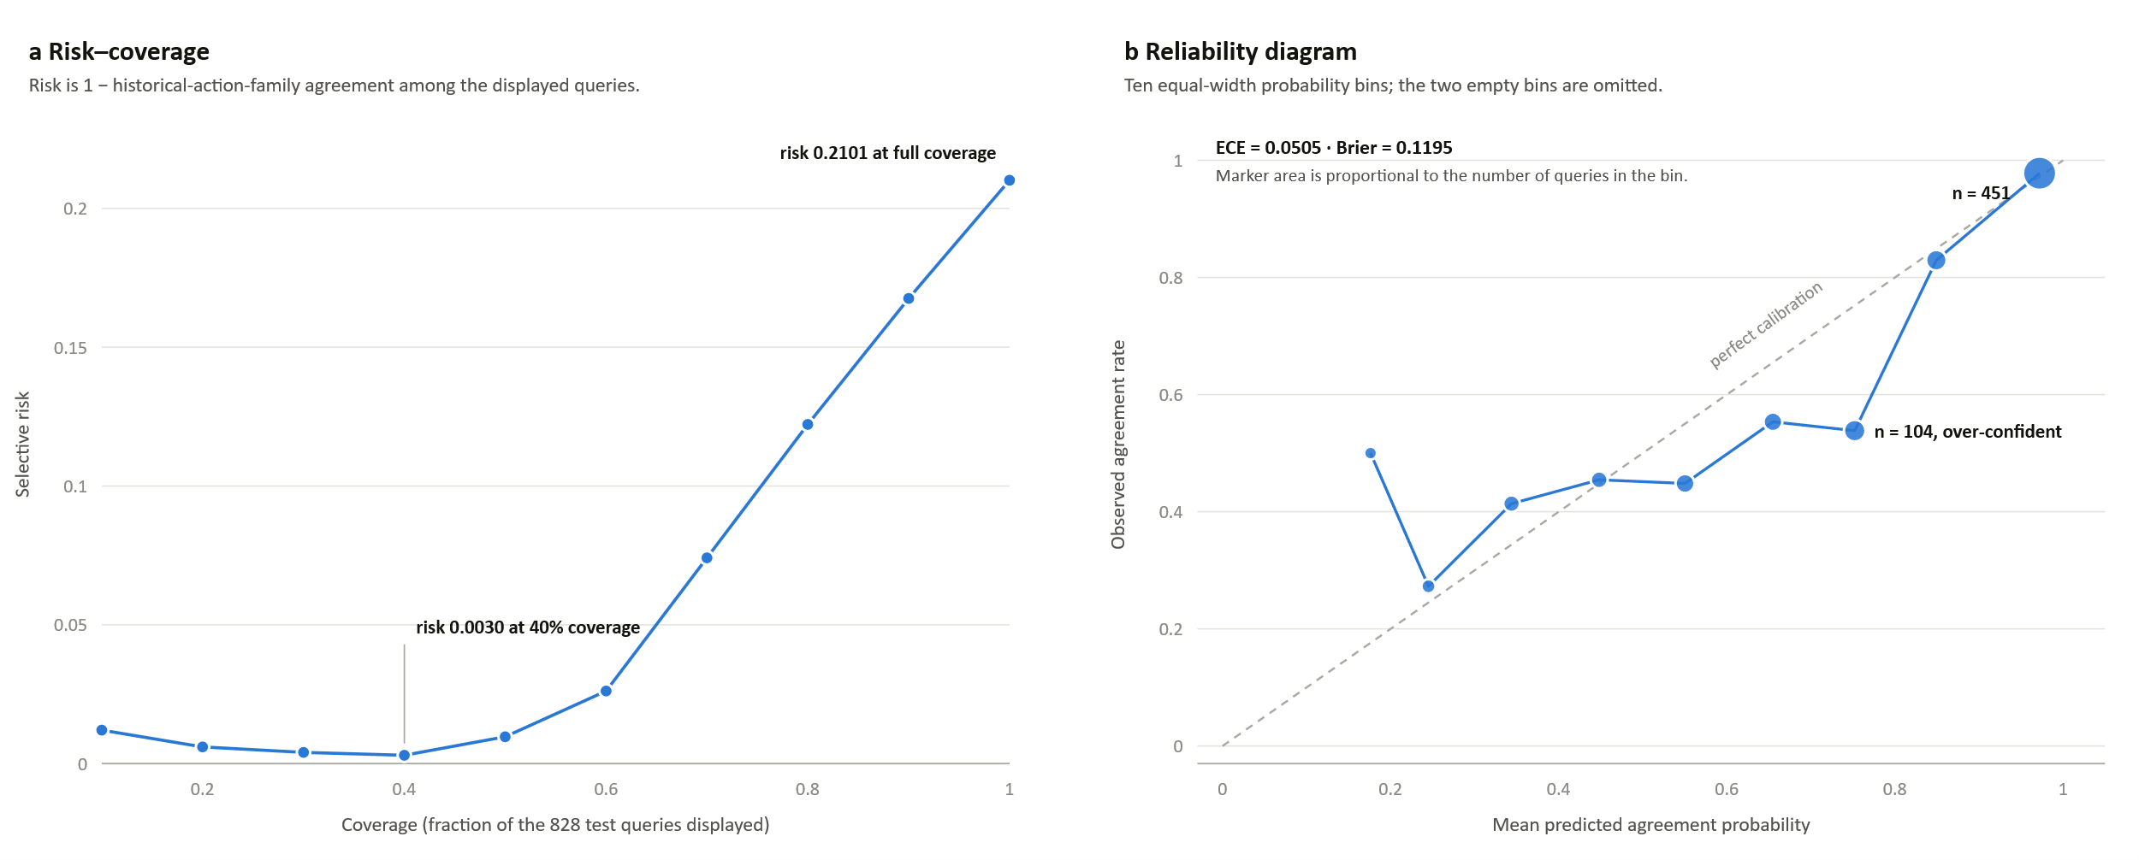
Figure 8.5 Risk–coverage curve and reliability diagram for the calibrated historical-agreement estimate
Note. Locked test of 828 evaluable queries. Panel a plots selective risk, defined as one minus historical-action-family agreement among the displayed queries, against coverage. Panel b plots observed agreement against mean predicted probability in ten equal-width bins; marker area is proportional to bin count and the two empty bins are omitted.
Source: Author's own computation.
Table 8.5 Per-family locked-test Hit@1
Action family | Test queries | Share of test queries | Hit@1
Replace | 630 | 76.1% | 0.9556
Adjust | 66 | 8.0% | 0.4242
Diagnose | 45 | 5.4% | 0.4444
Inspect | 40 | 4.8% | 0.0500
Repair | 23 | 2.8% | 0.0000
Service | 23 | 2.8% | 0.0870
Calibrate | 1 | 0.1% | 0.0000
Macro average (all seven families) | 828 | 100% | 0.2802
Note. Macro action-family recall is the unweighted mean of these seven per-family Hit@1 values, so each family contributes one seventh of the reported 0.2802 regardless of its size. The Calibrate family contains a single query and therefore moves the macro figure by 0.1429 on its own; excluding it, the mean over the remaining six families is 0.3269. The majority-family baseline recovers only Replace and scores exactly 1/7 = 0.1429. Rank-1 agreement is not the operational condition: on the same queries the recorded action-family set is recovered within the top three in 93.94% of multi-family queries and within the top five in 97.85%, so rare-family evidence is generally retrieved but not ranked first.
Source: Author's own computation.
Table 8.6 Reporting thresholds and evidence-tier agreement
Stratum | What it selects | Queries | Share of 828 | Agreement rate
Probability ≥ 0.5 | Calibrated agreement probability at or above the stated reporting threshold | 751 | 90.70% | 0.8283
Probability ≥ 0.6 |  | 693 | 83.70% | 0.8600
Probability ≥ 0.7 |  | 637 | 76.93% | 0.8870
Probability ≥ 0.8 |  | 533 | 64.37% | 0.9550
Probability ≥ 0.9 |  | 451 | 54.47% | 0.9778
Rung B | Near-duplicate problem description | 15 | 1.81% | 0.8667
Rung C | Same component and fault anchors | 684 | 82.61% | 0.8231
Rung D | Closest text or structure matches only | 129 | 15.58% | 0.6047
Note. Locked test of 828 evaluable queries. The upper block is reporting only: the evidence-first dashboard does not hide lower-probability results, so these rows describe what a threshold would yield rather than a display rule that was applied. Agreement rises monotonically as coverage falls, which is the condition under which a selective-prediction trade-off is meaningful. The lower block reports the three evidence rungs the interface shows. Rung D, the weakest tier, has a materially lower agreement rate than rungs B and C, so the displayed tier label carries information rather than merely restating the score. Agreement means agreement with the recorded historical action family, not technical correctness.
Source: Author's own computation.
Historical-agreement calibration produced ECE 0.0505 and Brier score 0.1195. Figure 8.5 shows the risk–coverage curve and the reliability diagram for that estimate: selective risk falls from 0.2101 at full coverage to 0.0030 at forty-percent coverage, which is the ordering condition Section 2.7 identifies as the precondition for a meaningful coverage-against-risk trade-off. Table 8.6 reports what a probability reporting threshold would yield and how agreement varies across the three displayed evidence rungs; the weakest rung has a materially lower agreement rate, so the displayed tier carries information rather than restating the score. In the one-reviewer assessment, both problem relevance and usable-action evidence reached Hit@1 0.92 and Hit@5 0.97. The scores describe evidence retrieval under this review protocol; they do not measure technical action applicability or safety.

Calibration quantities
Calibration compares a score interpreted as confidence with the observed frequency of the historical-agreement label. Expected calibration error partitions predictions into B bins [49], as formalized in Equation 8.11.
 | $$\text{ECE}=\sum_{j=1}^{B}{\frac{\left|I\left(j\right)\right|}{N}}\left|\text{acc}\left(I\left(j\right)\right)-\text{conf}\left(I\left(j\right)\right)\right|$$ | (8.11)
I(j) is the set of predictions in bin j, acc(I(j)) the observed agreement rate, and conf(I(j)) the average confidence. The absolute gap is weighted by the bin population. ECE 0.0505 means that the weighted bin-wise difference was about 5.05 percentage points under this binning; ECE depends on the binning scheme and does not measure discrimination.
The Brier score is the mean squared error of probabilistic predictions [50], as formalized in Equation 8.12.
 | $$\text{Brier}=\frac{1}{N}\sum_{i=1}^{N}{{\left(p_{i}-y_{i}\right)}^{2}}$$ | (8.12)

pᵢ is the predicted historical-agreement confidence and yᵢ is the binary observed label. The reported Brier score of 0.1195 penalizes both overconfident errors and underconfident correct predictions. Neither ECE nor Brier turns the score into a probability of technical applicability, safety, or repair success because those outcomes were not the calibration target.

Software verification
Software verification covers split locks, data contracts, provenance, complete-case rendering, negative-outcome handling, retrieval configuration, evaluation locks, planning persistence, and dashboard behavior. The frozen evidence package separately verifies all 28 expected result files. Software-test counts are not treated as scientific performance measures.
This is implementation evidence, not production qualification, usability validation, or regulatory assurance.
The implementation checks confirm that query actions remain hidden, opened evaluation data are protected by locks, negative attempts are not promoted, action sequences are not assembled across cases, and provenance is retained. Security, usability, human-factors, and regulatory validation remain separate requirements.

Interface walkthrough

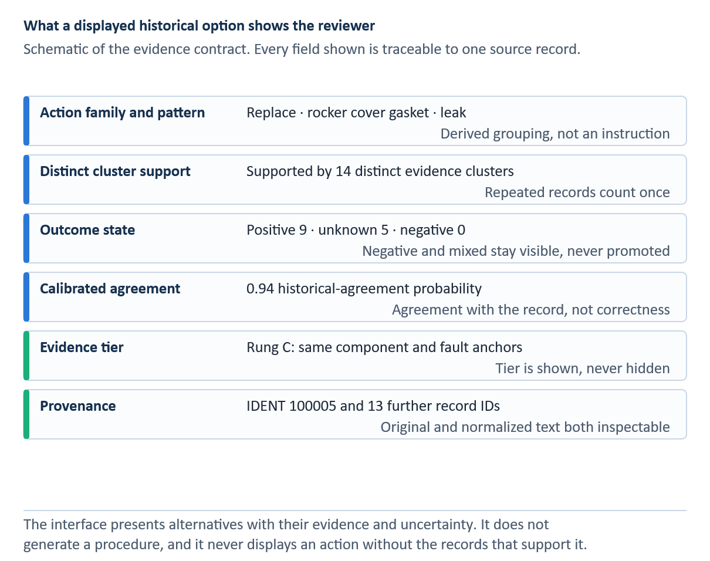
INSERT FIGURE 8.3 HERE — Diverse historical action options with provenance. Add the final visual or table and its automatic Word caption here.
Each option is a complete source case and is not merged with other options. Scores rank evidence; they are not probabilities of repair success.
Each option shows the rendered historical action, derived strategy and target, retrieval score, source case, and expandable evidence. Alternatives remain separate, and the interface labels selection as a planner decision. Provenance is therefore available at the point of review rather than only in a back-end audit record. Figure 8.3 illustrates separate, provenance-bearing alternatives, while Figure 8.4 illustrates abstention and information-improvement prompts.
INSERT FIGURE 8.4 HERE — Selective abstention and information-improvement prompts. Add the final visual or table and its automatic Word caption here.
The system exposes relevant negative evidence while refusing to promote it as a suggestion. The displayed evidence criterion is not a probability of safety or repair success.
When the evidence criterion is not met, the interface states that no action is promoted and explains why. It does not substitute the most frequent action. Unsuccessful historical cases remain visible in a separate ledger, allowing reviewers to inspect prior failures without turning their frequency into a prescription.

Discussion

Answers to the research questions
Table 9.1 Consolidated answers to the research questions
RQ | Evidence-based answer | Qualification
RQ1 | ByT5 has the best descriptive test agreement (WER 0.0147; exact 0.9366), but Selective ByT5 remains the official validation-selected system (WER 0.0219; exact 0.9325) and preserves 100% of protected tokens. | Agreement with one expert-cleaned reference is not proof of semantic or technical correctness.
RQ2 | Raw has the highest entity micro-F1 (0.9455) and relation micro-F1 (0.8203). No normalized representation improves either micro score. Selective ByT5 raises relation macro-F1 from 0.7511 to 0.7781. | Results are representation-matched and descriptive on one frozen 225-record test.
RQ3 | SpERT is strongest internally (entity micro-F1 0.9520; relation micro-F1 0.8537) and on MaintIE (0.8828; 0.6817), reproducing the broad ranking pattern. | MaintIE models were trained on its split; this is external replication, not zero-shot transfer.
RQ4 | On 828 evaluable queries, the selected protocol reaches Hit@1 0.7899, Hit@3 0.9686, Hit@5 0.9952, and MRR 0.8766. The largest tested Hit@1 drop is 0.0338 under 10% spelling noise. | Macro family recall is 0.2802; rare families remain weak. Metrics concern recorded historical evidence, not technical applicability.
RQ5 | The prototype preserves source cases, alternatives, outcome state, calibration information, abstention, and manual selection. One-reviewer assessment reports usable-action-evidence Hit@1 0.92 and Hit@5 0.97. | Usability, inter-rater reliability, safety, security, deployment, and regulatory validation remain open.
Note. Each answer is limited by its named evaluation population and construct.
Source: Author's own illustration.
Table 9.1 summarizes the direct answers. The following subsections explain how each answer follows from its evaluation population and where the claim must stop. Across the five questions, the evidence supports historical-case retrieval and an auditable planning interface, while maintenance authority remains with qualified personnel using current approved data. Table 9.1 is the compact evidence map; Sections 9.1.1–9.1.5 provide the complete answers.

RQ1 Normalization accuracy and preservation
ByT5 produced the lowest WER (0.0147) and highest exact match (0.9366) on the locked 741-record test. Selective ByT5, chosen before the test from the 926-record validation set, achieved WER 0.0219 and exact match 0.9325 while preserving 100% of protected tokens. RQ1 is therefore answered by retaining Selective ByT5 as the preselected system and reporting ByT5 as the descriptive accuracy leader. The result measures agreement with one expert-cleaned reference, not the technical correctness of every edit.
The scale of the improvement is substantial: relative to the rules baseline, ByT5 reduced WER by about 86.2% and increased exact match by 63.7 percentage points. Yet the official choice is not determined by the opened test ranking. Selective ByT5 was selected on the 926-record validation population and was therefore carried unchanged to the 741-record test. Its perfect protected-token preservation provides an operational reason for accepting a small loss in aggregate reference agreement.
The answer is consequently multi-objective. If the objective is only minimum intrinsic WER on this locked test, ByT5 leads. If the objective includes preregistered selection and the defined protected-token constraint, Selective ByT5 is the defensible system. Neither objective demonstrates that the reference or prediction is technically correct in every maintenance context.

RQ2 Downstream effects of normalization
Raw text achieved the highest SpERT entity micro-F1 (0.9455) and relation micro-F1 (0.8203) in the representation-matched experiment. No normalized representation improved either micro score. Selective ByT5 increased relation macro-F1 from 0.7511 to 0.7781, indicating a possible benefit for the class-balanced average. RQ2 therefore shows that better normalization agreement does not automatically improve downstream extraction and that micro and macro effects can differ.
The raw-to-Selective changes are small but directionally different: entity micro-F1 decreases from 0.9455 to 0.9424 and relation micro-F1 decreases from 0.8203 to 0.8167, while relation macro-F1 increases from 0.7511 to 0.7781. This pattern is consistent with normalization helping some less frequent relation classes while introducing changes that slightly harm the instance-weighted total.
Because the experiment retrained and evaluated SpERT on each representation using identical 1,275/100/225 partitions, it isolates representation more cleanly than preprocessing only the test set. The result rejects a simple monotonic pipeline assumption: a representation can be closer to a normalized reference without becoming a better input for a downstream extractor.

RQ3 Information extraction architectures
SpERT produced the highest internal entity and relation micro-F1 (0.9520 and 0.8537). DistilBERT ranked second, the CRF-based baseline remained competitive, and the BiLSTM relation component was markedly weaker. The same broad ordering appeared in MaintIE, where SpERT achieved entity micro-F1 0.8828 and relation micro-F1 0.6817. RQ3 is answered for the two supplied frozen splits; the MaintIE result is a separately trained external replication rather than zero-shot transfer.
On the internal split, SpERT exceeded DistilBERT by 0.0071 entity micro-F1 and 0.0241 relation micro-F1. On the separately trained MaintIE split, its margins were 0.0540 and 0.0970 respectively. The repeated ordering strengthens the architectural comparison, but it does not constitute zero-shot external validity because every model was trained for the corresponding corpus.
Macro and class-level results qualify the headline ranking. The MaintIE REFERENCE and ACTION_FOLLOWS_REFERENCE classes each have support two, so one prediction can change their F1 sharply. SpERT's leading point estimates justify its use for the operational silver layer, while the low-support classes justify confidence filtering, provenance, and a stratified human audit rather than treating every prediction as fact.

RQ4 Retrieval performance and robustness
The selected problem-only, cluster-safe protocol achieved Hit@1 0.7899, Hit@3 0.9686, Hit@5 0.9952, MRR 0.8766, and nDCG@5 0.9067 on 828 evaluable queries. The largest tested Hit@1 reduction was 0.0338 under 10% spelling noise. Macro action-family recall was only 0.2802, revealing weak coverage of rare families despite high top-k performance. RQ4 is therefore answered for recovery of recorded historical evidence, not for the technical applicability of retrieved actions.
The metric pattern is important. Hit@5 of 0.9952 shows that recorded action-family evidence was almost always present in a five-item list, and MRR 0.8766 shows that relevant evidence tended to occur early. The majority baseline's Hit@1 of 0.7609, however, reveals a strong class prior. The selected system's main advantage over that baseline is not a dramatic overall Hit@1 gain but an increase in macro family recall from 0.1429 to 0.2802.
Robustness is correspondingly bounded. The maximum tested Hit@1 reduction was approximately 3.38 percentage points under 10% synthetic spelling noise, while top-five recovery remained high. Missing structure produced clean-equivalent performance because canonical BM25 does not consume structured features; this is a property of the selected lexical protocol, not evidence that extraction quality is irrelevant to the broader prototype.

RQ5 Auditable planning support
The prototype preserves source cases, alternatives, outcome status, uncertainty information, and manual selection. Historical-agreement calibration produced ECE 0.0505 and Brier score 0.1195. One reviewer assessed 100 queries and reported usable-action-evidence Hit@1 0.92 and Hit@5 0.97. RQ5 is answered as an implementation and evidence-presentation result. Usability, inter-rater reliability, technical safety, security, regulatory acceptance, and deployment effectiveness remain unvalidated.
The implementation answer rests on controls rather than on a single predictive score: the action is hidden during retrieval; split and artifact locks prevent post-test tuning; complete cases preserve provenance; negative outcomes are quarantined; alternatives remain separate; and the system may abstain. These mechanisms make the interface auditable because a reviewer can trace every displayed option to its source and contest the intermediate structure.
The empirical user-facing evidence is preliminary. A single reviewer assessed 100 queries and 500 query–candidate pairs, producing problem-relevance and usable-action-evidence Hit@1 of 0.92 and Hit@5 of 0.97. Without a second reviewer, inter-rater agreement, task-time comparison, or technical-applicability judgments, these figures support evidence presentation only. They do not establish usability, safety, or organizational effectiveness.

What the results do and do not establish
The normalization experiment distinguishes reference agreement from downstream value. ByT5 best matches the expert-cleaned target, whereas Selective ByT5 preserves all protected tokens and remains the validation-selected system. The matched SpERT experiment then shows that neither system improves entity or relation micro-F1 over raw text. A normalization metric is therefore insufficient as a proxy for extraction performance.
The retrieval study establishes high top-k recovery of recorded evidence and limited degradation under the tested spelling and truncation perturbations. Macro action-family recall of 0.2802 shows that this performance is concentrated in common families. Calibration and one-reviewer assessment add evidence about historical agreement and evidence usability, but neither evaluates whether an action is technically applicable.
The prototype establishes traceability rather than technical correctness. A reviewer can inspect the source text, extracted structure, evidence cluster, score, outcome state, and source record behind an option. This audit trail makes model errors contestable. It cannot determine whether the historical work was performed correctly, caused the recorded outcome, remains current, or applies to another aircraft configuration.

Design trade-offs
Normalization exposes a trade-off between reference agreement and protected-token fidelity. ByT5 minimizes WER, while Selective ByT5 preserves every protected token. The downstream experiment adds a second trade-off: raw text leads the micro-F1 measures, whereas Selective ByT5 produces the highest relation macro-F1. No single representation dominates every objective.
Text and structure provide different evidence. Structured features expose issue-item and context matches but inherit extraction errors and disappear when relations are missing. Lexical retrieval is transparent and effective for exact technical terms but can miss paraphrases. The final evaluation selected canonical BM25; other channels remain experimental components rather than proven improvements.
Outcome quarantine, distinct-cluster support, and retention of alternatives restrict what the interface portrays as positive historical evidence. The τ_rank exponent balances common-family support with rare-family visibility; it is not the display gate. These design choices avoid promoting explicitly unsuccessful evidence while keeping the underlying records inspectable. The result is a review tool rather than an automatic action selector.
Complete-case rendering favours provenance over fluent adaptation. A generated composite procedure could combine useful fragments, but its source boundaries and unsupported additions would be difficult to audit. AviMaint-DSS instead keeps every option tied to one record and leaves adaptation to the qualified planner.

Safety, governance, and human oversight
Historical work orders are not approved maintenance data. FAA 14 CFR 43.13 and the European continuing-airworthiness framework require applicable current methods and data [1, 2]. A deployed system would need links from each historical case to current manuals, instructions for continued airworthiness, configuration data, and organization procedures. Historical evidence can guide a search for authority; it cannot supply that authority.
A qualified reviewer must check the extracted query structure, compare alternatives and unsuccessful attempts, confirm asset identity and applicability, locate current approved data, and document the basis for the planning decision. Corrections and selections should be logged, but user clicks should become training labels only through a governed review process.
Operational governance would require versioned case libraries, model and split fingerprints, immutable evaluation records, drift monitoring, access controls, security testing, and retirement rules for obsolete records. Frequency and outcome displays need explicit denominators. Human-factors evaluation must also test for anchoring, confirmation bias, and inappropriate reliance on retrieved cases. Table 9.2 consolidates the principal validity threats and the controls or follow-up studies they require.

Threats to validity
Table 9.2 Principal threats to validity and mitigations
Threat | Potential effect | Mitigation / required next step
Expert reference and truncation | Reference agreement can reward a plausible reconstruction. | Retain raw text; add meaning-preservation and truncation review.
Validation-selected versus descriptive winner | Choosing ByT5 after test inspection would bias RQ1. | Keep Selective ByT5 as official; report ByT5 descriptively.
Single-reviewer IE corpus | Annotation inconsistency and anchoring are unmeasured. | Blind double annotation and adjudication.
Rare-class support | Per-class F1 and macro averages are unstable. | Report support; add a separately reported rare-class challenge set.
Silver operational graph | Full-corpus predictions may not match gold-test accuracy. | Treat graph as navigation evidence; validate a stratified sample.
Retrieval label meaning | Action-family agreement can be mistaken for technical applicability. | Keep historical-evidence language and require approved-data review.
Single manual reviewer | Usable-action scores have no inter-rater reliability. | Multi-reviewer, domain-expert adjudication.
Family imbalance | Replace dominates; rare-family macro recall is 0.2802. | Report per-family results and improve rare-family evidence.
One public corpus | Fleet, organization, language, and temporal generalization are unknown. | External multi-organization and drift evaluation.
Prototype deployment | Usability, automation bias, security, and regulatory fit are unknown. | Task-based human-factors and safety assurance before field use.
Note. Mitigations identify next studies; they are not evidence that the threats have been eliminated.
Source: Author's own illustration.

Future evaluation plan
The next empirical priority is a multi-reviewer study with domain experts. Reviewers should judge problem relevance, evidence usability, technical applicability, and compatibility with current approved data as separate constructs. Blinded stages, adjudication, and inter-rater agreement are required, and the existing 828-query test must not be reused for model, prior exponent or future display-threshold selection.
The scored SpERT comparison and matched normalization-to-IE experiment close the main representation gaps in the current thesis. Further work should test whether those results replicate across fleets, organizations, and independent annotation teams, and should include blinded review of normalization meaning preservation and a stratified audit of the silver graph.
Corpus quality remains a separate priority. A stratified sample should be double annotated, with agreement reported for entity boundaries, entity types, and relations, followed by adjudication and guideline revision. External records should cover abbreviations, fleets, and organizations absent from MaintNet, while naturally sampled performance remains separate from a rare-class challenge set.
The low macro action-family recall of 0.2802 warrants a separate study of rare-family candidate retrieval, training support and expert-validated labels. A different question is whether uncertainty can be displayed with comparable coverage across families: future work could evaluate class-conditional conformal prediction sets under exchangeability, with an independent calibration population [45, 56]. Ding et al. [56] note that few labelled examples per class make such coverage difficult to obtain usefully. The study should report per-family coverage and set size as well as abstention on new held-out queries. Prediction-set coverage would neither improve the underlying ranker's macro recall automatically nor certify that a retrieved maintenance action applies to an aircraft.
Qualified planners should complete realistic evidence-finding tasks with and without the dashboard. The study should measure retrieval success, time, sources inspected, correction behavior, response to abstention, trust calibration, and anchoring. Field use should wait until approved-data links, access controls, logging, security responsibilities, and organizational authority are defined.

Conclusion

Summary
This thesis developed and evaluated a pipeline that converts noisy aviation maintenance records into structured historical evidence for planning support. The study compares six normalization representations, measures their downstream effect with matched SpERT training, evaluates four extraction architectures internally and on MaintIE, builds a silver graph and case library, and tests cluster-safe retrieval, perturbation robustness, calibration, and evidence presentation.
The mathematical measures make the boundaries of the conclusion explicit. WER, CER, exact match, and change F1 quantify agreement with normalized reference strings. Micro- and macro-F1 quantify recovery of gold annotations under different class weightings. Hit@k, MRR, and nDCG quantify ranked recovery of historical evidence. ECE and Brier quantify agreement calibration. None contains a variable for approved technical applicability, regulatory currency, repair causality, or airworthiness; those constructs therefore cannot be inferred from the reported values.
The experiments reveal that progress at one pipeline stage cannot be assumed to transfer to the next. ByT5 best matches the cleaned normalization reference, while Selective ByT5 is the validation-selected system and preserves all protected tokens. Raw text nevertheless leads the downstream SpERT micro-F1 measures. SpERT leads both four-model extraction comparisons, but its full-corpus predictions remain silver.
The final retrieval protocol achieved Hit@1 0.7899, Hit@3 0.9686, Hit@5 0.9952, MRR 0.8766, and nDCG@5 0.9067 on 828 evaluable queries. The tested perturbations caused limited top-k degradation, and one reviewer rated the retrieved evidence favourably. Macro action-family recall remained 0.2802, and none of these metrics establishes technical applicability or repair correctness.

Contributions revisited
The main contributions are a validation-selected normalization comparison with a locked test, a planning-oriented nine-entity and eleven-relation schema, a matched normalization-to-extraction experiment, a four-architecture internal and MaintIE benchmark, a provenance-preserving silver case layer, and a frozen historical-evidence retrieval evaluation. The accompanying evidence ledger keeps validation, test, silver, calibration, and manual-review claims distinct.
The engineering contribution lies in the controls that preserve evidential meaning: cluster-safe splits, hidden query actions, typed relation checks, complete-case rendering, outcome quarantine, alternatives, reviewer correction, and abstention. These mechanisms make each displayed option traceable and define where qualified judgment must enter the workflow.

Final conclusion
Noisy maintenance records can support useful historical-evidence retrieval when normalization, extraction, case construction, and ranking are evaluated as separate problems. The study also identifies the limits of that evidence. The preselected normalizer is not the descriptive test leader, normalization does not improve downstream micro-F1, rare extraction and action families remain weak, and the operational graph is model-generated.
AviMaint-DSS should therefore be treated as a research planning aid that helps qualified personnel find, compare, and document historical cases while they consult current approved maintenance data. The next milestone is independent evaluation with multiple domain experts and organizations, including technical-applicability, usability, automation-bias, security, and abstention studies. The locked tests should remain closed to further selection or tuning.

References
[1] Federal Aviation Administration: 14 CFR Part 43.13 - Performance rules (general). Code of Federal Regulations, Washington DC.
[2] European Commission: Commission Regulation (EU) No 1321/2014 on the continuing airworthiness of aircraft and aeronautical products, parts and appliances. Official Journal of the European Union, 2014.
[3] Akhbardeh, F.; Desell, T.; Zampieri, M.: MaintNet: A Collaborative Open-Source Library for Predictive Maintenance Language Resources. In: Proceedings of the 28th International Conference on Computational Linguistics (COLING): System Demonstrations, Barcelona, 2020, pp. 7-11.
[4] Brundage, M. P.; Sexton, T.; Hodkiewicz, M.; Dima, A.; Lukens, S.: Technical language processing: Unlocking maintenance knowledge. In: Manufacturing Letters, Vol. 27, 2021, pp. 42-46.
[5] Bikaun, T.; Hodkiewicz, M.; Liu, W.: MaintNorm: A corpus and benchmark model for lexical normalisation and masking of industrial maintenance short text. In: Proceedings of the Ninth Workshop on Noisy and User-generated Text (W-NUT 2024), San Giljan, 2024, pp. 68-78.
[6] Bikaun, T. K.; French, T.; Stewart, M.; Liu, W.; Hodkiewicz, M.: MaintIE: A Fine-Grained Annotation Schema and Benchmark for Information Extraction from Maintenance Short Texts. In: Proceedings of LREC-COLING 2024, Torino, 2024, pp. 10939-10951.
[7] Aamodt, A.; Plaza, E.: Case-Based Reasoning: Foundational Issues, Methodological Variations, and System Approaches. In: AI Communications, Vol. 7, No. 1, 1994, pp. 39-59.
[8] Lafferty, J.; McCallum, A.; Pereira, F. C. N.: Conditional Random Fields: Probabilistic Models for Segmenting and Labeling Sequence Data. In: Proceedings of the 18th International Conference on Machine Learning (ICML), 2001, pp. 282-289.
[9] Robertson, S.; Zaragoza, H.: The Probabilistic Relevance Framework: BM25 and Beyond. In: Foundations and Trends in Information Retrieval, Vol. 3, No. 4, 2009, pp. 333-389.
[10] Devlin, J.; Chang, M.-W.; Lee, K.; Toutanova, K.: BERT: Pre-training of Deep Bidirectional Transformers for Language Understanding. In: Proceedings of NAACL-HLT, 2019, pp. 4171-4186.
[11] Eberts, M.; Ulges, A.: Span-based Joint Entity and Relation Extraction with Transformer Pre-training. In: Proceedings of the 24th European Conference on Artificial Intelligence (ECAI), 2020, pp. 2006-2013.
[12] Akhbardeh, F.; Desell, T.; Zampieri, M.: NLP Tools for Predictive Maintenance Records in MaintNet. In: Proceedings of the 1st Conference of the Asia-Pacific Chapter of the ACL (AACL-IJCNLP): System Demonstrations, 2020, pp. 26–32. DOI: 10.18653/v1/2020.aacl-demo.5.
[13] Sundaram, S.; Zeid, A.: Technical language processing for Prognostics and Health Management: Applying text similarity and topic modeling to maintenance work orders. In: Journal of Intelligent Manufacturing, Vol. 36, 2025, pp. 1637–1657. DOI: 10.1007/s10845-024-02323-4.
[14] Sexton, T. B.; Brundage, M. P.; Hodkiewicz, M.; Smoker, T.: Benchmarking for keyword extraction methodologies in maintenance work orders. In: Proceedings of the Annual Conference of the Prognostics and Health Management Society, Philadelphia, 2018.
[15] Chandra, C.; Ojima, Y.; Bendarkar, M. V.; Mavris, D. N.: Aviation-BERT-NER: Named Entity Recognition for Aviation Safety Reports. In: Aerospace, Vol. 11, No. 11, 2024, Article 890.
[16] Yue, Y.; Wang, H.; Hou, Z.: A BERT-BiMamba-CRF Based Approach for Risk Entity Recognition and Knowledge Graph Construction in Civil Aviation Maintenance Texts. In: Proceedings of the 2025 5th International Conference on Big Data, Artificial Intelligence and Risk Management (ICBAR), Dongguan, 2025, pp. 267-272.
[17] Amin, N.: Cleaned MaintNet aviation maintenance corpus and lexical resources for low-resource aviation speech research. Online repository. URL: https://github.com/nadine-amin/Cleaned-MaintNet-Aviation-Maintenance-Dataset [accessed 5 September 2026].
[18] van der Goot, R.; Ramponi, A.; Zubiaga, A.; Plank, B.; et al.: MultiLexNorm: A Shared Task on Multilingual Lexical Normalization. In: Proceedings of the Seventh Workshop on Noisy User-generated Text (W-NUT), 2021.
[19] Samuel, D.; Straka, M.: UFAL at MultiLexNorm 2021: Improving Multilingual Lexical Normalization by Fine-tuning ByT5. In: Proceedings of the Seventh Workshop on Noisy User-generated Text (W-NUT), 2021.
[20] Raffel, C.; Shazeer, N.; Roberts, A.; Lee, K.; Narang, S.; Matena, M.; Zhou, Y.; Li, W.; Liu, P. J.: Exploring the Limits of Transfer Learning with a Unified Text-to-Text Transformer. In: Journal of Machine Learning Research, Vol. 21, 2020, pp. 1-67.
[21] Xue, L.; Barua, A.; Constant, N.; Al-Rfou, R.; Narang, S.; Kale, M.; Roberts, A.; Raffel, C.: ByT5: Towards a Token-Free Future with Pre-trained Byte-to-Byte Models. In: Transactions of the ACL, Vol. 10, 2022, pp. 291-306.
[22] Geifman, Y.; El-Yaniv, R.: SelectiveNet: A deep neural network with an integrated reject option. In: Proceedings of the 36th International Conference on Machine Learning, PMLR, Vol. 97, 2019, pp. 2151–2159. URL: https://proceedings.mlr.press/v97/geifman19a.html.
[23] Ramshaw, L. A.; Marcus, M. P.: Text Chunking using Transformation-Based Learning. In: Proceedings of the Third ACL Workshop on Very Large Corpora, 1995, pp. 82-94.
[24] Hochreiter, S.; Schmidhuber, J.: Long Short-Term Memory. In: Neural Computation, Vol. 9, No. 8, 1997, pp. 1735-1780.
[25] Bojanowski, P.; Grave, E.; Joulin, A.; Mikolov, T.: Enriching Word Vectors with Subword Information. In: Transactions of the ACL, Vol. 5, 2017, pp. 135-146.
[26] Vaswani, A.; Shazeer, N.; Parmar, N.; Uszkoreit, J.; Jones, L.; Gomez, A. N.; Kaiser, L.; Polosukhin, I.: Attention Is All You Need. In: Advances in Neural Information Processing Systems (NeurIPS), 2017.
[27] Gururangan, S.; Marasovic, A.; Swayamdipta, S.; Lo, K.; Beltagy, I.; Downey, D.; Smith, N. A.: Don't Stop Pretraining: Adapt Language Models to Domains and Tasks. In: Proceedings of the 58th Annual Meeting of the ACL, 2020, pp. 8342-8360.
[28] Xu, D.; Chen, W.; Peng, W.; Zhang, C.; Xu, T.; Zhao, X.; Wu, X.; Zheng, Y.; Wang, Y.; Chen, E.: Large language models for generative information extraction: a survey. In: Frontiers of Computer Science, Vol. 18, No. 6, 2024, Article 186357.
[29] Xie, T.; Li, Q.; Zhang, J.; Zhang, Y.; Liu, Z.; Wang, H.: Empirical Study of Zero-Shot NER with ChatGPT. In: Proceedings of the 2023 Conference on Empirical Methods in Natural Language Processing (EMNLP), 2023, pp. 7935-7956.
[30] Ji, Z.; Lee, N.; Frieske, R.; Yu, T.; Su, D.; Xu, Y.; Ishii, E.; Bang, Y.; Madotto, A.; Fung, P.: Survey of Hallucination in Natural Language Generation. In: ACM Computing Surveys, Vol. 55, No. 12, 2023, Article 248.
[31] Huguet Cabot, P.-L.; Navigli, R.: REBEL: Relation Extraction By End-to-end Language generation. In: Findings of the Association for Computational Linguistics: EMNLP 2021, 2021, pp. 2370-2381.
[32] Huang, Z.; Xu, W.; Yu, K.: Bidirectional LSTM-CRF Models for Sequence Tagging. arXiv:1508.01991, 2015.
[33] Lample, G.; Ballesteros, M.; Subramanian, S.; Kawakami, K.; Dyer, C.: Neural Architectures for Named Entity Recognition. In: Proceedings of NAACL-HLT, 2016, pp. 260-270.
[34] Sanh, V.; Debut, L.; Chaumond, J.; Wolf, T.: DistilBERT, a distilled version of BERT: smaller, faster, cheaper and lighter. arXiv:1910.01108, 2019.
[35] Fort, K.; Ehrmann, M.; Nazarenko, A.: Towards a methodology for named entities annotation. In: Proceedings of the Third Linguistic Annotation Workshop, 2009, pp. 142–145. URL: https://aclanthology.org/W09-3025/.
[36] Bayerl, P. S.; Paul, K. I.: What determines inter-coder agreement in manual annotations? A meta-analytic investigation. In: Computational Linguistics, Vol. 37, No. 4, 2011, pp. 699–725. DOI: 10.1162/COLI_a_00074.
[37] Efron, B.; Tibshirani, R. J.: An Introduction to the Bootstrap. Chapman and Hall, New York, 1993.
[38] Moreau, L.; Groth, P.: Provenance: An Introduction to PROV. Morgan and Claypool, 2013.
[39] Lin, R.; Wang, H.; Wang, N.; Wang, J.: Civil aircraft structural maintenance decision using case-based reasoning and LSI. In: Proceedings of the Institution of Mechanical Engineers, Part G: Journal of Aerospace Engineering, Vol. 239, No. 11, 2025. DOI: 10.1177/09544100251328581.
[40] Reimers, N.; Gurevych, I.: Sentence-BERT: Sentence Embeddings using Siamese BERT-Networks. In: Proceedings of EMNLP-IJCNLP, 2019, pp. 3982-3992.
[41] Robertson, S.; Zaragoza, H.; Taylor, M.: Simple BM25 Extension to Multiple Weighted Fields. In: Proceedings of the 13th ACM International Conference on Information and Knowledge Management, 2004, pp. 42–49. DOI: 10.1145/1031171.1031181.
[42] Cormack, G. V.; Clarke, C. L. A.; Buettcher, S.: Reciprocal Rank Fusion Outperforms Condorcet and Individual Rank Learning Methods. In: Proceedings of SIGIR, 2009, pp. 758-759.
[43] Jarvelin, K.; Kekalainen, J.: Cumulated Gain-based Evaluation of IR Techniques. In: ACM Transactions on Information Systems, Vol. 20, No. 4, 2002, pp. 422-446.
[44] El-Yaniv, R.; Wiener, Y.: On the Foundations of Noise-free Selective Classification. In: Journal of Machine Learning Research, Vol. 11, 2010, pp. 1605-1641.
[45] Shafer, G.; Vovk, V.: A Tutorial on Conformal Prediction. In: Journal of Machine Learning Research, Vol. 9, 2008, pp. 371-421.
[46] Parasuraman, R.; Riley, V.: Humans and Automation: Use, Misuse, Disuse, Abuse. In: Human Factors, Vol. 39, No. 2, 1997, pp. 230-253.
[47] European Union Aviation Safety Agency (EASA): EASA Concept Paper - Guidance for Level 1 and 2 Machine Learning Applications. Cologne, 2024.
[48] National Institute of Standards and Technology: Artificial Intelligence Risk Management Framework (AI RMF 1.0). NIST, Gaithersburg, 2023.
[49] Guo, C.; Pleiss, G.; Sun, Y.; Weinberger, K. Q.: On Calibration of Modern Neural Networks. In: Proceedings of the 34th International Conference on Machine Learning (ICML), 2017, pp. 1321-1330.
[50] Brier, G. W.: Verification of Forecasts Expressed in Terms of Probability. In: Monthly Weather Review, Vol. 78, No. 1, 1950, pp. 1-3.
[51] Settles, B.: Active Learning Literature Survey. Computer Sciences Technical Report 1648, University of Wisconsin-Madison, 2009.
[52] Artstein, R.; Poesio, M.: Survey Article: Inter-Coder Agreement for Computational Linguistics. In: Computational Linguistics, Vol. 34, No. 4, 2008, pp. 555-596.
[53] Lee, K.; Ippolito, D.; Nystrom, A.; Zhang, C.; Eck, D.; Callison-Burch, C.; Carlini, N.: Deduplicating Training Data Makes Language Models Better. In: Proceedings of ACL, 2022. URL: https://arxiv.org/abs/2107.06499.
[54] Wilson, E. B.: Probable Inference, the Law of Succession, and Statistical Inference. In: Journal of the American Statistical Association, Vol. 22, No. 158, 1927, pp. 209-212.
[55] McNemar, Q.: Note on the sampling error of the difference between correlated proportions or percentages. In: Psychometrika, Vol. 12, 1947, pp. 153–157. DOI: 10.1007/BF02295996.
[56] Ding, T.; Angelopoulos, A. N.; Bates, S.; Jordan, M. I.; Tibshirani, R. J.: Class-Conditional Conformal Prediction with Many Classes. In: Advances in Neural Information Processing Systems 36, 2023. URL: https://arxiv.org/abs/2306.09335.

Appendix A Complete Schema Catalogue
This appendix consolidates the nine-entity, eleven-relation AviMaint-DSS-IE schema used in the frozen internal comparison and operational dashboard. Examples remain illustrative, and only explicit text is annotated. Table A.1 provides the complete entity catalogue, and Table A.2 provides the relation catalogue.
Table A.1 Entity catalogue with inclusion and exclusion guidance
Type | Include | Exclude / boundary rule | Illustrative form
MAINT_ITEM | Aircraft, engine, component, subcomponent, part, material, consumable, or tool explicitly involved. | Do not include locations, values, issues, or document references. Prefer the complete noun phrase. | engine; cylinder; rocker cover gasket
ACTION | Completed, planned, required, attempted, diagnostic, inspection, service, removal, installation, repair, or adjustment expression. | Do not infer an action from a result. Include the explicit action phrase, not surrounding rationale. | removed; replaced; inspected; tried to adjust
FAULT | Static damage, absence, defect, deficiency, or failed state. | Use ABN_PROC for dynamic abnormal behaviour. Do not label a neutral measurement as a fault. | cracked; missing; worn; failed
ABN_PROC | Dynamic event or behaviour outside normal operation. | Use FAULT for persistent static condition. Keep the process phrase concise. | running rough; leaking; vibrating
TECH_OBS | Reading, property, measurement, count, indication, interval, or neutral service datum. | Do not convert the value into a judgment or outcome. | 20/80 psi; low reading; 3 hours
LOC | Side, station, ordinal, zone, position, forward/aft, left/right, inner/outer designator. | Do not duplicate the component name. Annotate the positional expression. | number 4; left-hand; aft
OP_CTX | Operating phase, environmental condition, timing, or detection context. | Not the physical location of a component. | on takeoff; during inspection
OUTCOME | Explicit action result, finding, restored status, no-effect statement, or unresolved status. | Do not infer success from a recorded action or the absence of further text. | ops check good; no change; still leaking
REFERENCE | Named manual, service instruction, maintenance publication, or approved data followed. | A generic unidentifiable mention is insufficient. | per MM 72-00; SB 1234
Note. Inclusion/exclusion rules are annotation guidelines; examples are illustrative.
Source: Author's own illustration; schema design informed by [6].
Table A.2 Relation catalogue with binding signatures
Relation | Source | Target | Decision rule
HAS_PART | MAINT_ITEM | MAINT_ITEM | Annotate explicit whole–part structure; do not infer from world knowledge.
ISSUE_ON_ITEM | FAULT / ABN_PROC | MAINT_ITEM | Bind the issue to the affected item when text supports the association.
ACTION_ON_ITEM | ACTION | MAINT_ITEM | Bind the direct target; this edge alone is not evidence of correction.
OBSERVATION_OF_ITEM | TECH_OBS | MAINT_ITEM | Bind a reading or property to the observed item.
HAS_LOCATION | MAINT_ITEM | LOC | Bind an item to its explicit location or ordinal.
OCCURS_UNDER_CONTEXT | FAULT / ABN_PROC | OP_CTX | Bind an issue to the phase or context in which it occurred or was detected.
ACTION_ADDRESSES_ISSUE | ACTION | FAULT / ABN_PROC | Use for corrective intent; do not equate with a successful result.
ACTION_INVESTIGATES_ISSUE | ACTION | FAULT / ABN_PROC | Use for diagnosis, inspection, test, or troubleshooting intent.
ACTION_USES_ITEM | ACTION | MAINT_ITEM | Bind an explicitly used material, part, or tool distinct from the action target.
ACTION_RESULTS_IN_OUTCOME | ACTION | OUTCOME | Require an explicit result or status attributable to the action.
ACTION_FOLLOWS_REFERENCE | ACTION | REFERENCE | Require explicit wording that the action followed the named reference.
Note. Each relation is directed; ACTION_ON_ITEM is not a success or corrective-intent label.
Source: Author's own illustration; schema design informed by [6].
Appendix B Detailed Information-Extraction Results
Table B.1 Per-class entity F1 and support
Entity | Test support | CRF + LR | BiLSTM | DistilBERT | SpERT
LOC | 327 | 0.9693 | 0.9727 | 0.9757 | 0.9744
MAINT_ITEM | 662 | 0.9445 | 0.9408 | 0.9480 | 0.9622
ACTION | 381 | 0.9525 | 0.9492 | 0.9663 | 0.9518
ABN_PROC | 134 | 0.9524 | 0.9585 | 0.9412 | 0.9624
FAULT | 101 | 0.9340 | 0.8812 | 0.9208 | 0.9394
TECH_OBS | 38 | 0.6575 | 0.7222 | 0.7027 | 0.7568
OUTCOME | 28 | 0.7925 | 0.8364 | 0.8364 | 0.8000
REFERENCE | 2 | 1.0000 | 1.0000 | 1.0000 | 1.0000
OP_CTX | 20 | 0.7368 | 0.7805 | 0.6957 | 0.8095
Note. Strict typed F1 on the same frozen 225-record test; support is the gold test count for that class, not all 1,600 records. Perfect scores for REFERENCE and ACTION_FOLLOWS_REFERENCE have n=2.
Source: Author's own computation on the annotated gold corpus.
Strict entity span-and-type F1 on the frozen 225-record test. Overall gold entity support = 1,693; rare-class scores require support-aware interpretation. Tables B.1 and B.2 provide the retained class-level scores, and Figure B.1 shows full-corpus relation support.
Table B.2 Per-class relation F1 and support
Relation | Test support | CRF + LR | BiLSTM | DistilBERT | SpERT
ACTION_ADDRESSES_ISSUE | 183 | 0.8743 | 0.8450 | 0.8943 | 0.9146
ACTION_ON_ITEM | 382 | 0.8215 | 0.6310 | 0.8731 | 0.8764
ISSUE_ON_ITEM | 235 | 0.8276 | 0.6131 | 0.8571 | 0.9130
HAS_LOCATION | 322 | 0.8551 | 0.7359 | 0.8860 | 0.8872
HAS_PART | 167 | 0.7500 | 0.4716 | 0.7532 | 0.7736
OBSERVATION_OF_ITEM | 30 | 0.4776 | 0.4651 | 0.5000 | 0.6000
ACTION_INVESTIGATES_ISSUE | 40 | 0.5225 | 0.4107 | 0.5607 | 0.5714
ACTION_RESULTS_IN_OUTCOME | 29 | 0.6897 | 0.4773 | 0.6780 | 0.6780
ACTION_FOLLOWS_REFERENCE | 2 | 1.0000 | 1.0000 | 1.0000 | 1.0000
ACTION_USES_ITEM | 10 | 0.8696 | 0.6923 | 0.0000 | 1.0000
OCCURS_UNDER_CONTEXT | 19 | 0.4615 | 0.4400 | 0.4103 | 0.4737
Note. Strict typed F1 on the same frozen 225-record test; support is the gold test count for that class, not all 1,600 records. Perfect scores for REFERENCE and ACTION_FOLLOWS_REFERENCE have n=2.
Source: Author's own computation on the annotated gold corpus.
Strict typed, directed relation F1 on the frozen 225-record test. Overall gold relation support = 1,419; ACTION_FOLLOWS_REFERENCE has only two test instances.
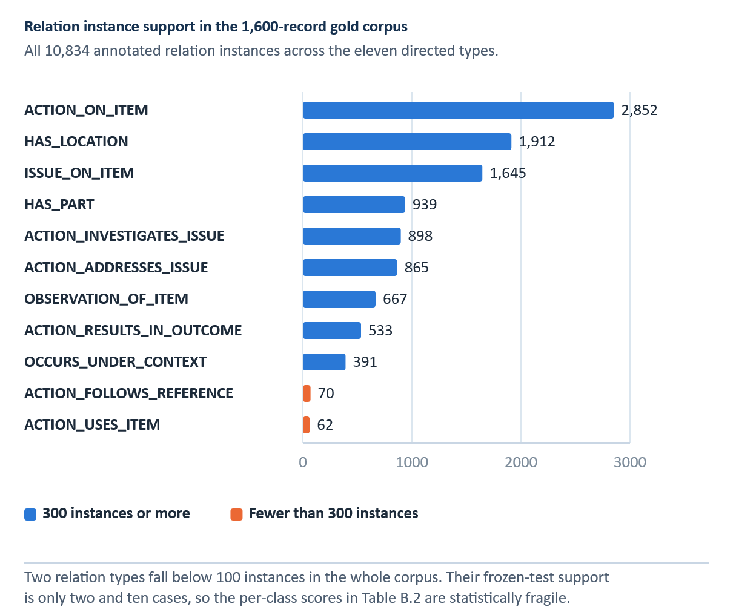
INSERT FIGURE B.1 HERE — Relation support in the gold corpus. Add the final visual or table and its automatic Word caption here.
Full gold-corpus support, not frozen-test support; the overall frozen-test relation support is 1,419.
Appendix C Recommender Evidence and Evaluation Contract
The final Selective contract freezes problem-only canonical BM25 retrieval, the prior-tempering exponent τ_rank = 0.15 for post-retrieval family aggregation, and cluster-expanded evidence, data splits, and evidence manifests before test evaluation. Earlier retrieval studies remain development evidence and are not the basis of the final RQ4 claim. Table C.1 documents the frozen retrieval contract, Table C.2 documents its claim boundary, and Table C.3 records all six retrieval modes scored on the locked test at the selected prior-tempering exponent. Three modes that were not selected reached higher test Hit@1 than the selected configuration; because mode selection was completed on development data under the preregistered rule and the test was opened once, those values are reported as evidence that the protocol was followed rather than as grounds for revising the selected configuration.
Table C.1 Frozen final Selective retrieval contract
Contract item | Frozen final value
Evaluation version | selective_rq4_rq5_final
Representation | Selective ByT5
Input | Problem only; historical action hidden from query
Split | 4,319 train / 925 development / 925 test records; 828 evaluable test queries
Leakage control | Evidence-cluster exclusion and frozen split
Ranker | selective_canonical_bm25; no live SpERT query extraction
Family prior tempering | τ_rank = 0.15 exponent; not a score threshold
Aggregation | Cluster-expanded evidence
Evaluation rule | Frozen before test; no post-test tuning
Graph role | Exploratory navigation / structured development channel only
Note. This contract names the selected RQ4 configuration; the dashboard interface can display supplementary metadata without changing the locked ranker.
Source: Author's own illustration.
Table C.2 Recommender claim boundary
Permitted claim | Prohibited interpretation
Reduces error against an expert-cleaned normalization reference | Does not prove that every edit is semantically or technically correct.
Recovers gold entities and relations on frozen tests | Does not prove that every full-corpus silver prediction is correct.
Retrieves recorded action-family and usable-action evidence | Does not establish technical action applicability, repair success, or approval.
Reports empirical calibration of historical agreement | Does not provide a safety probability.
Preserves source cases, alternatives, outcomes, and uncertainty | Does not replace qualified human judgment or current approved maintenance data.
Abstains when selected evidence criteria are not met | Does not constitute operational risk certification.
Note. Safety and authorization remain outside the evaluated task.
Source: Author's own illustration.
Table C.3 All retrieval modes scored on the locked test at τ_rank = 0.15
Retrieval mode | Development Hit@1 | Test Hit@1 | Test Hit@3 | Test MRR | Test nDCG@5 | Test macro recall
Reciprocal-rank fusion | 0.8275 | 0.8092 | 0.9722 | 0.8882 | 0.9146 | 0.3235
Word TF-IDF | 0.8166 | 0.8056 | 0.9686 | 0.8849 | 0.9118 | 0.2967
Weighted hybrid | 0.8275 | 0.7995 | 0.9746 | 0.8835 | 0.9120 | 0.3109
Surface BM25 | 0.8275 | 0.7911 | 0.9698 | 0.8777 | 0.9072 | 0.2725
Canonical BM25 (selected on development) | 0.8311 | 0.7899 | 0.9686 | 0.8766 | 0.9067 | 0.2802
Structured matching | 0.8239 | 0.7826 | 0.9601 | 0.8697 | 0.8998 | 0.2880
Note. Rows are ordered by test Hit@1. Mode selection was completed on development data under the preregistered rule (maximise macro action-family recall at τ_rank = 0, then MRR, then Hit@1), where canonical BM25 ranked first on both macro recall and Hit@1. The locked test was then opened once. Three modes that were not selected reached higher test Hit@1 than the selected configuration. These values are reported as evidence that the preregistered protocol was followed; substituting a mode on the basis of opened-test performance would convert the test into a second selection population and is therefore not done.
Source: Author's own computation.
C.1 Required external evaluation sequence
1. Preserve the final Selective model, split, prior-tempering exponent, aggregation, checksum, and evaluation manifests without retuning on the locked test.
2. For future external studies, select new query clusters with no overlap with existing training, validation, test, calibration, or manual-review populations.
3. Stage 1: collect blinded problem-relevance judgments without actions, system scores, or ranks; lock the judgments.
4. Stage 2: collect evidence-usability and technical-applicability judgments separately; lock and adjudicate them.
5. Score all systems on the same judged pool with nDCG, MRR, Hit@k, macro family recall, calibration, and paired uncertainty.
6. Report abstention, coverage, calibration, and risk–coverage behavior without selecting thresholds on the new test.
7. Keep technical safety/applicability review distinct from ranking relevance; no metric should be described as approved-procedure accuracy.
Appendix D Reproducibility and Artifact Register
This appendix identifies the principal supplied artifacts used in the thesis. Filenames are preserved so numerical claims can be audited. UUID-named dashboard screenshots are copied into the build workspace under descriptive names, but the original files remain the source. Direct generative-action prototypes and later Gemma/LLM artifacts are excluded from the thesis scope. Table D.1 provides the auditable artifact register.
Table D.1 Artifact register
Artifact name | Supports which claim | Evidence status
normalization_selection_manifest.json | Pre-test 926-record system selection | Validation-only
PHASE2_THESIS_RESULTS.md | 741-record normalization and supplementary robustness | Locked test / post-hoc
matched_normalization_spert_ablation_v2.csv | Representation-matched IE | Frozen 225-record test
overall_metrics.csv (internal) | Four-model internal IE | Frozen 225-record test
overall_metrics.csv (MaintIE) | Four-model MaintIE replication | External 108-record test
summary.txt (final KG) | Final graph inventory | Silver full corpus
RQ4_FINAL_TEST.json | Historical-case retrieval | Locked 828-query test
RQ5_PLANNING_SUPPORT.json | Agreement calibration | Development fit; locked test
MANUAL_REVIEW_RESULTS.json | One-reviewer evidence usability | Single-reviewer supplement
final RQ4/RQ5 and Phase 2 checksum manifests | Artifact freeze and no-retuning checks | Reproducibility control
SELECTIVE_RQ4_RQ5_THESIS_RESULTS.md | Bootstrap intervals, per-family Hit@1, blinded manual review | Locked 828-query test
Note. The separate paste guide lists the full repository-relative locations; identify both overall_metrics.csv files by their labels. The Hit@1 and macro-recall bootstrap intervals quoted in Chapter 8 are recorded in SELECTIVE_RQ4_RQ5_THESIS_RESULTS.md, not in RQ4_FINAL_TEST.json, which stores only the resampling method, repetition count and seed. Do not use a legacy knowledge graph or an old dashboard screenshot as evidence of the final release.
Source: Author's own illustration.
D.1 Reproduction sequence
• Verify the evidence manifests, checksums, split locks, and canonical result register before editing reported values; do not retrain or retune frozen experiments.
• Verify the 5,124-record paired subset, 3,457/926/741 split, validation-only selection manifest, and six locked-test outputs. Keep Selective ByT5 as the official selected system.
• Import and validate the 1,600-record gold IE corpus; confirm 1,275/100/225 train/DEV/test counts and class inventories.
• Verify the four-model 1,275/100/225 internal comparison and the separate 860/108/108 MaintIE benchmark from their frozen artifacts; do not reconstruct missing values from older three-tier reports.
• Verify the scored SpERT test result and representation-matched ablation while retaining the full-corpus operational graph as silver evidence.
• Build cases and graph exports with original identifiers, relation-signature checks, outcome policy, and evidence clusters.
• Rebuild the recommender index from allowed partitions; verify query-cluster exclusion and solution-side exclusion.
• Retain earlier retrieval studies only as documented development history; do not use them as the final RQ4 result or retune on their opened data.
• Verify the final Selective 828-query test, calibration, manual-review, and supplementary robustness artifacts from the immutable evidence freeze.
• Run the complete application test suite in the declared environment, including Streamlit and Plotly smoke/architecture modules, and archive dependency versions.

