Go to localhost:8080 after starting the springboot server:

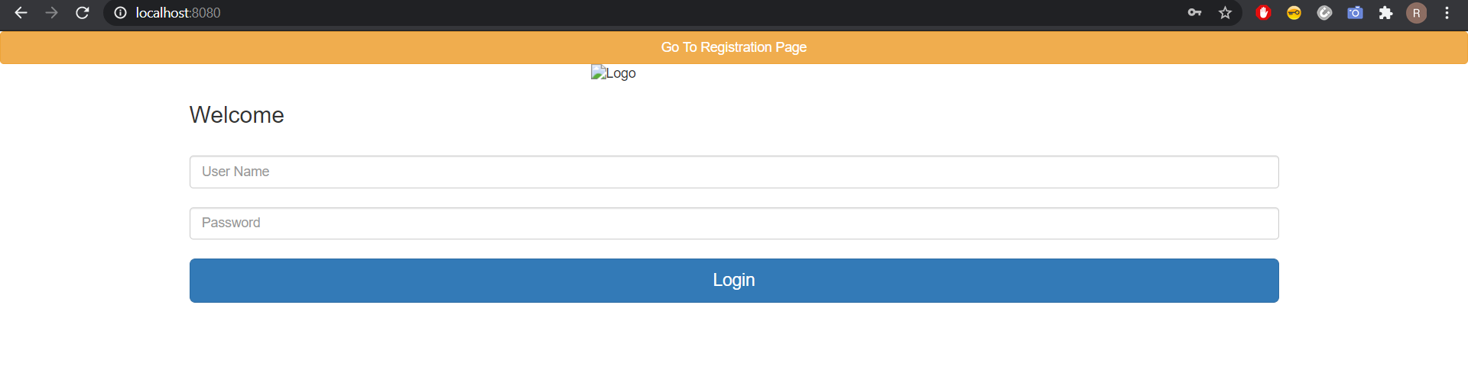

Click on go to registration page to register:

Register:

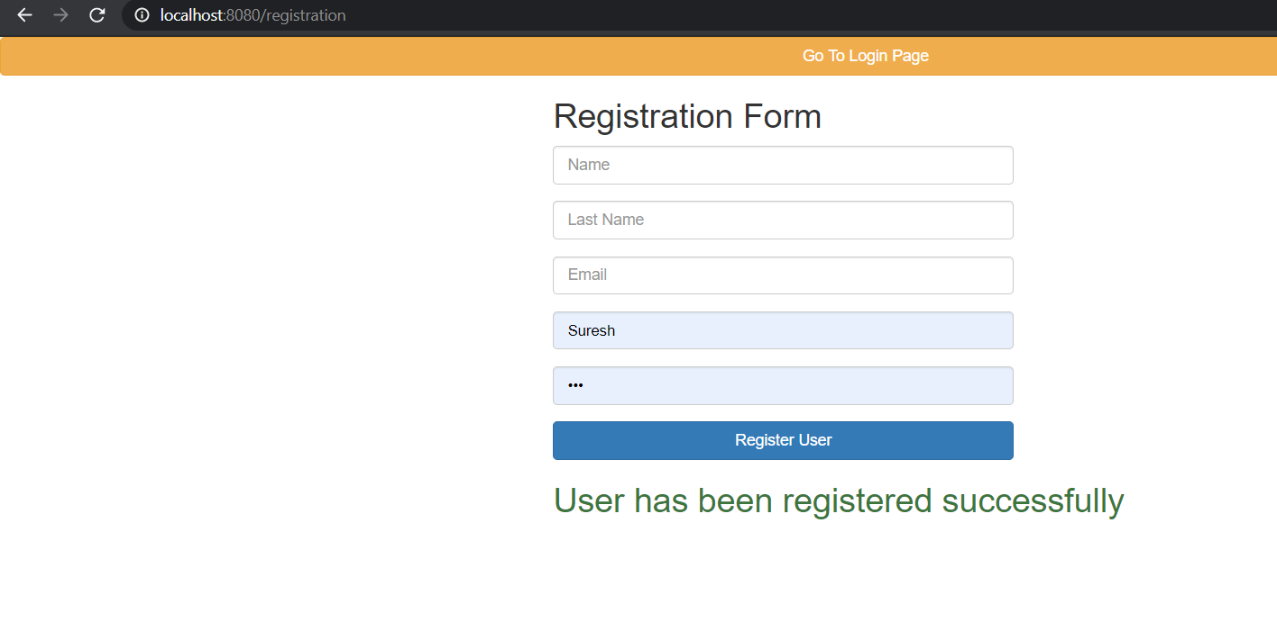

Go back to login page and sign in:

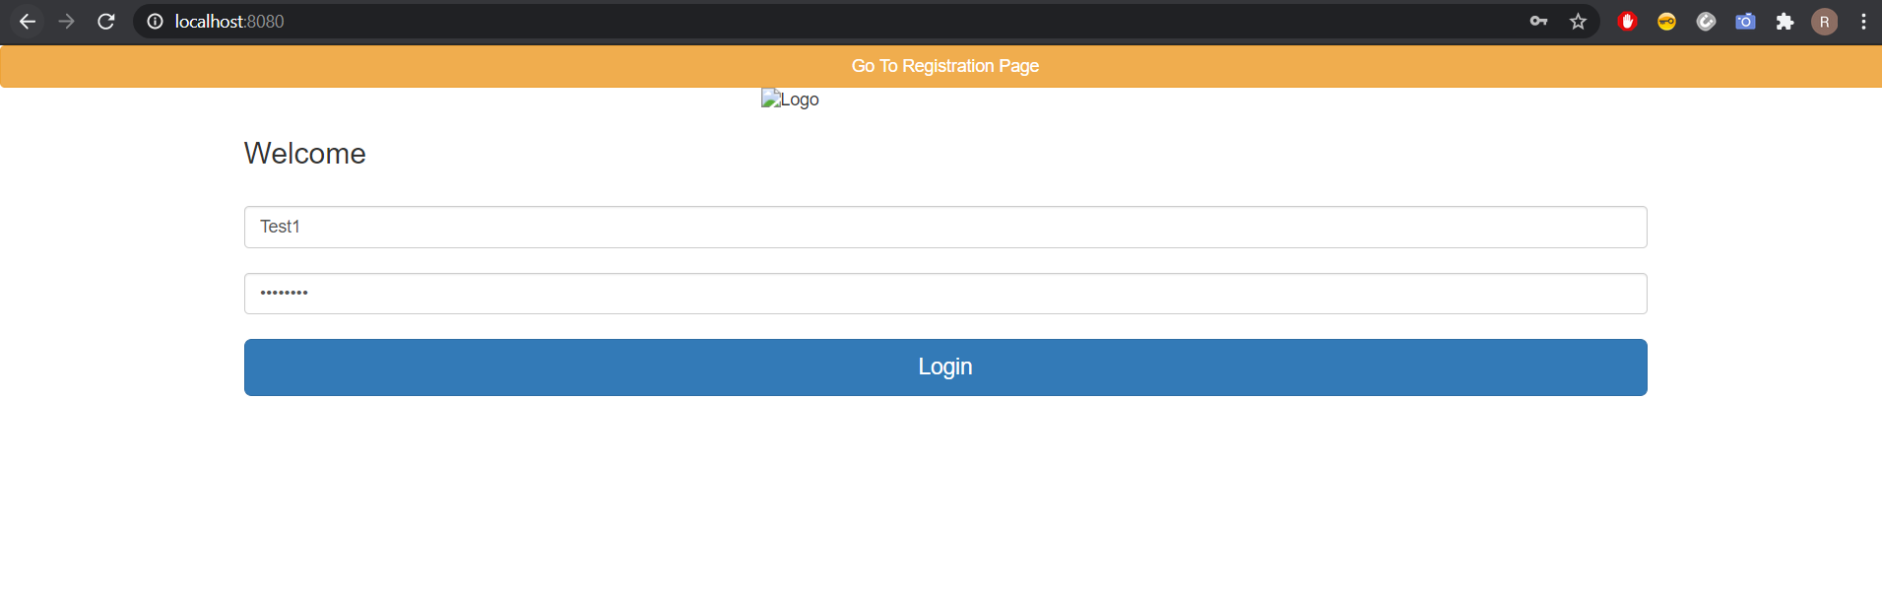

Once you are authenticated you will be redirected to home page:

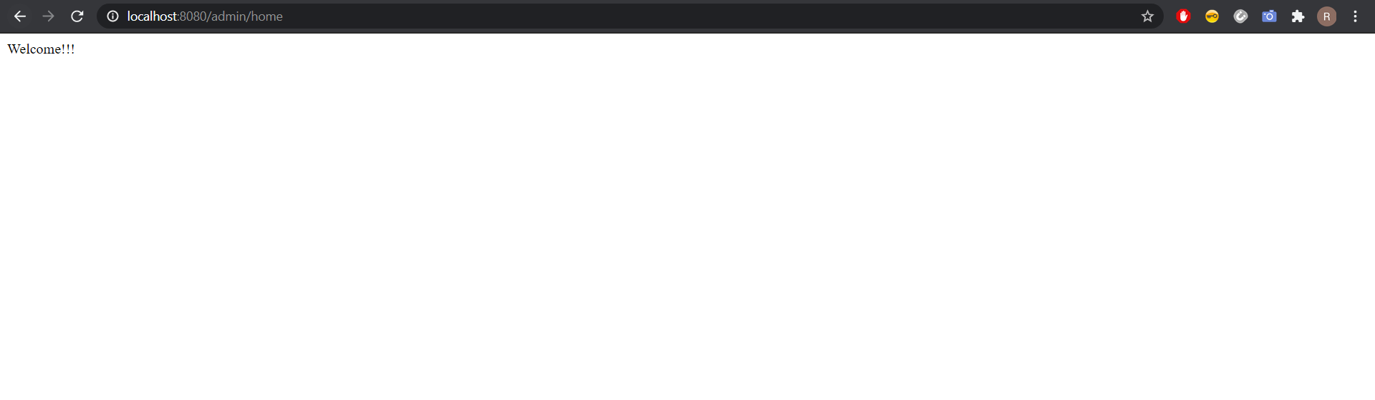

Or else you will see an error.

Once authenticated go to <http://localhost:8080/swagger-ui.html> :

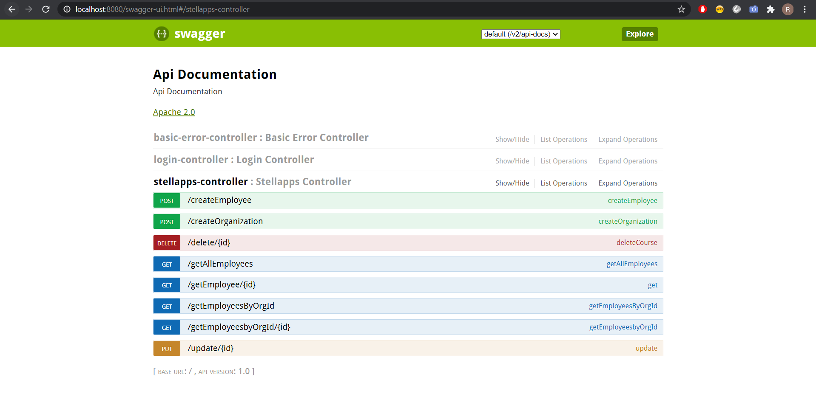

Upon successful insertion of record you will see a 200 response:

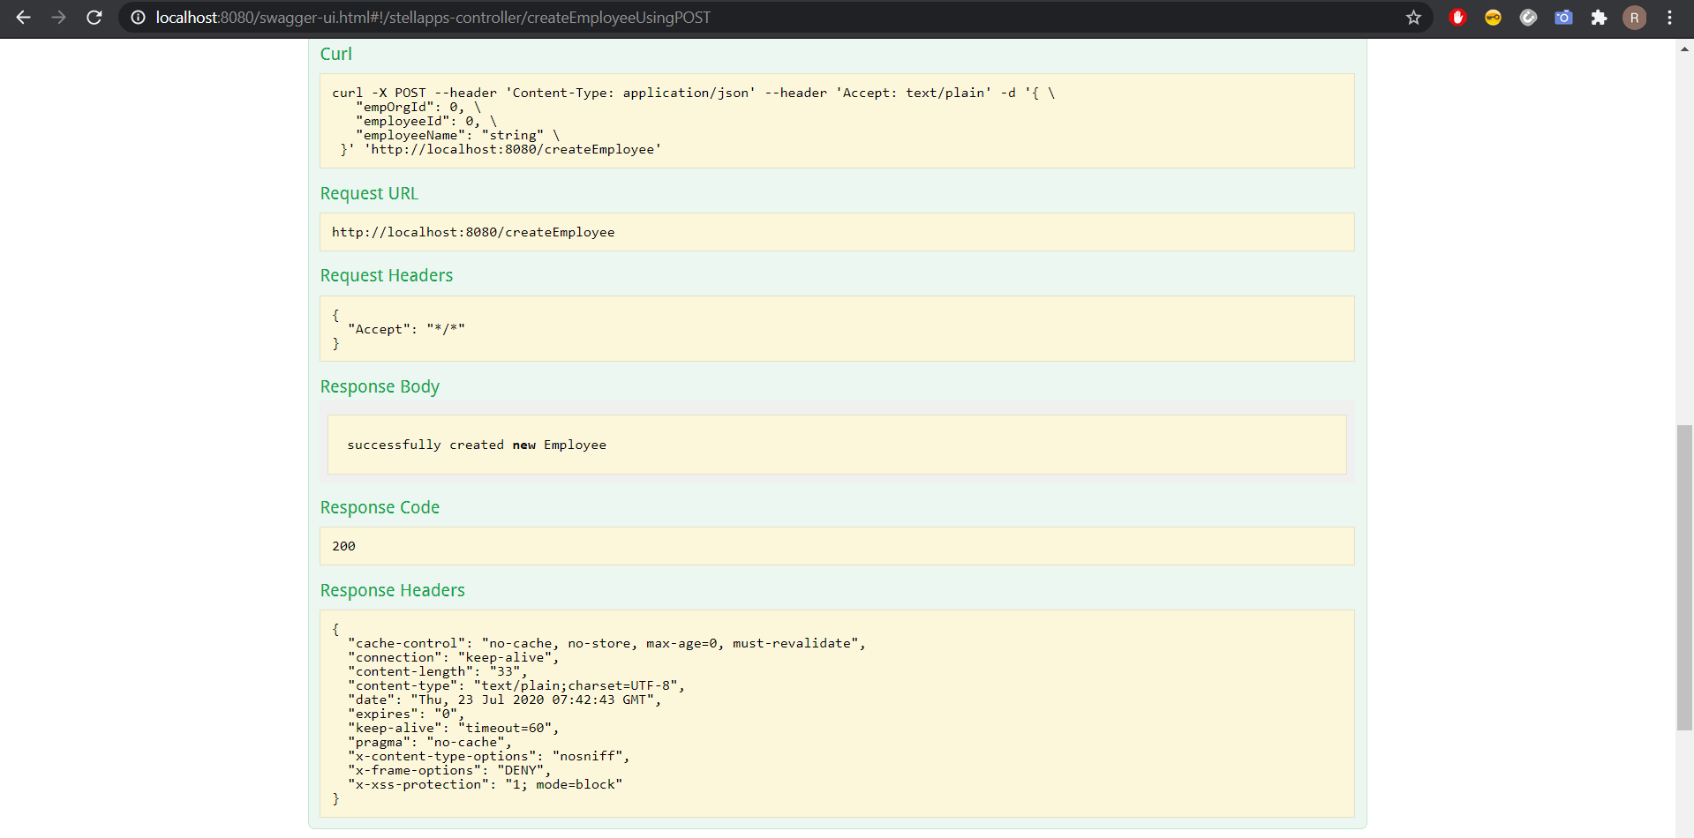

URL to get the employees by org id:

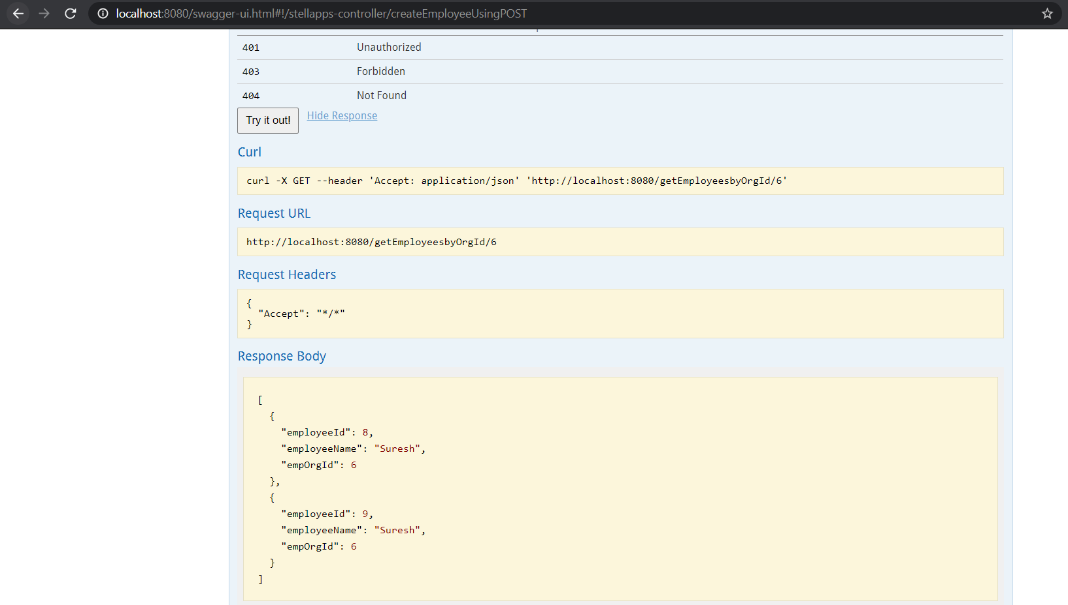

Update:

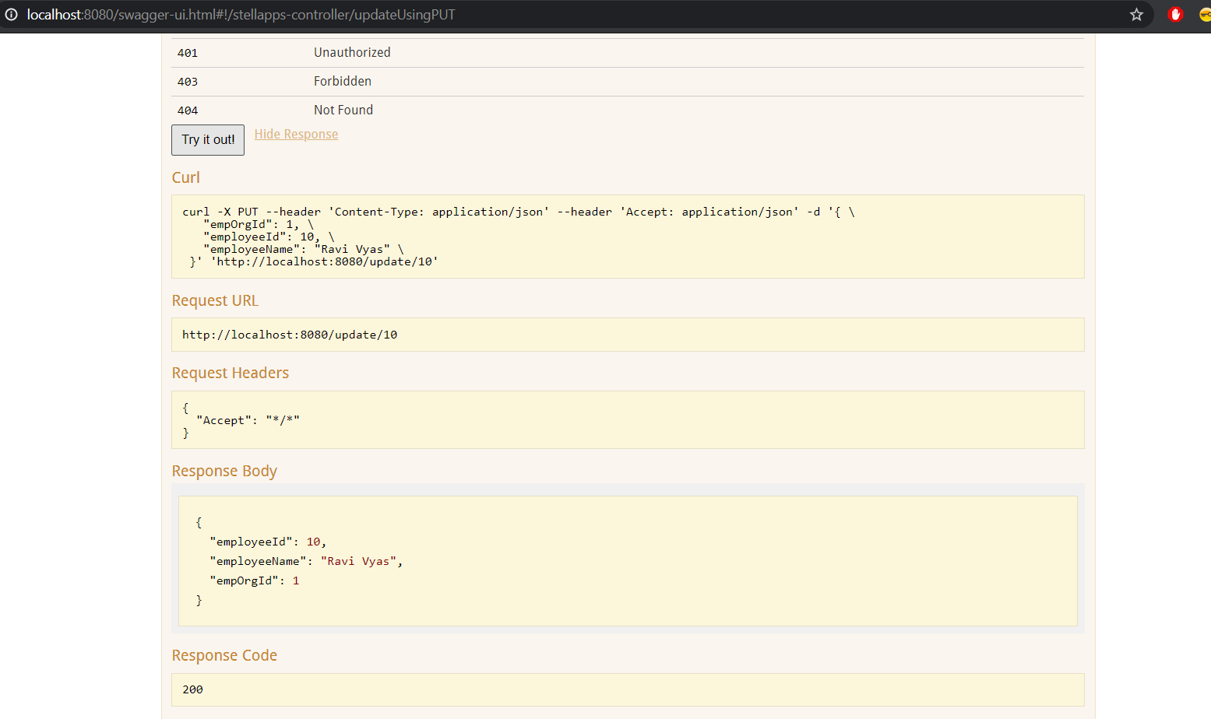

Delete:

