System Architecture & High-Level Design
Real-Time Disaster Relief & Volunteer Management System
Document ID: RDRVMS-04 | Version: 0.1 (draft baseline) | Issued: 08 November 2026
Purpose C4-style views, bounded modules, deployment topology, quality tradeoffs and decisions for a modular monolith.
Status & approvals Proposed design baseline, not signed off. Product owner/team and module supervisor must approve requirements, privacy decisions, service-level targets, and any external integrations before development or real-world use.
Audience Project team, module supervisor, reviewers

Architecture overview
Use a TypeScript monorepo containing React/Vite frontend, Express/Socket.IO API, PostgreSQL database, shared schema/types packages, and Docker Compose deployment. Start with one modular API service, not distributed microservices. Nginx serves the SPA and reverse-proxies /api and /socket.io under one origin.
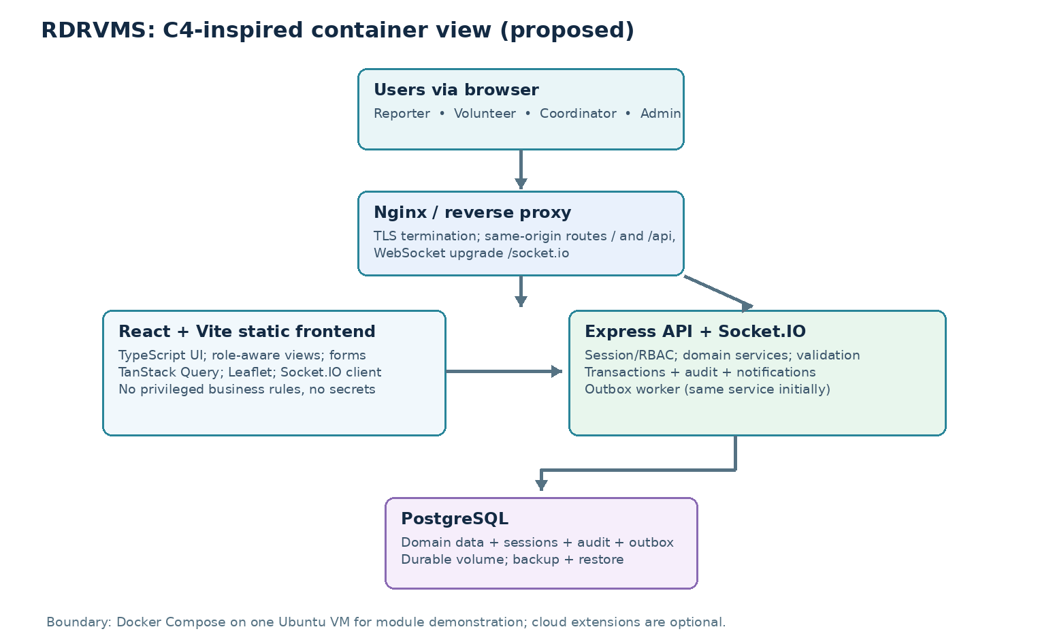

System context and trust boundaries
Actor / system | Direction | Trusted capabilities and boundary
Browser | HTTPS/WSS → web tier | Untrusted input; no credentials in bundles; cookies scoped by browser
Reporter/Volunteer | Browser → API | Authenticated, owns only permitted objects
Coordinator/Admin | Browser → API | Privileged, scoped and audited
PostgreSQL | API ↔ private data store | Not internet-addressable; credential-restricted
Object storage (P1) | API ↔ file store | Signed access / server mediation; malware/type checks
Metrics/Logs | API → ops collector | No private contacts or tokens; access restricted
Email/SMS (later) | Outbound gateway | Optional, provider failure cannot corrupt core state

Logical components
Layer | Module | Responsibilities
Frontend | auth, dashboard, incident, request, volunteer, notifications, admin | UI, forms, cache, route guards (presentation only), accessibility
API routes | REST controllers + websocket gateway | Parse/validate input, enforce auth, uniform errors
Application | incident, relief, assignment, inventory, identity services | Transactions, business rules, permissions, workflows
Data | Prisma repositories + Postgres | Persistence, optimistic versions, unique constraints, audit/outbox
Cross-cutting | observability, jobs, file handling, policy | Correlation IDs, retries, health, guardrails

Core data and event flows
- Client POSTs command with cookie-backed session and CSRF protection; Nginx routes to Express.
- Middleware authenticates and rate-limits; Zod validates payload; service checks membership and resource-level RBAC.
- Domain service performs mutation with optimistic version and relevant audit/notification/outbox writes in a database transaction.
- After commit, API returns authoritative resource; outbox worker asynchronously pushes user-scoped socket event.
- Client refetches authoritative data; after disconnect, inbox REST request reconciles events missed while offline.

Deployment decision
Initial topology: one Ubuntu VM with Nginx, frontend static image, API container, Postgres container with persistent volume, and restricted backup destination. For additional durability, use a managed PostgreSQL service when budget and grading permit. Never publish database port publicly. Multi-VM HA is not part of MVP.

Cross-cutting quality design
Quality | Design choice | Tradeoff
Reliability | DB authoritative; outbox + notification inbox | More tables/work vs lost alerts
Simplicity | Single API service, modular domains | No independent module scaling initially
Security | Secure same-origin cookie session + RBAC | CSRF defense required on mutations
Testability | Dependency-injected services and fixtures | Some upfront structure
Delivery | GitHub Actions + versioned Docker images | Runner setup and secrets management
Scalability | PostgreSQL indexes; stateless API except sessions stored in DB | Socket room coordination needed across replicas

Architecture decision register
ADR | Decision / rationale | Status
ADR-0001 | TypeScript monorepo; shared tooling and contracts | Proposed
ADR-0002 | React/Vite SPA rather than SSR; simpler static hosting | Proposed
ADR-0003 | Express modular monolith; reduce ops complexity | Proposed
ADR-0004 | PostgreSQL/Prisma; normalized relationships and migrations | Proposed
ADR-0005 | Session cookie auth; server-side sessions, CSRF protections | Proposed
ADR-0006 | Socket.IO for best-effort live delivery + durable inbox/outbox | Proposed
ADR-0007 | Compose-first deployment; Kubernetes deferred | Proposed

Boundary and failure considerations
- Socket outage: app remains useful over REST; users see connectivity status and inbox refresh.
- Database outage: readiness degrades, writes fail safely; retries must not duplicate committed commands.
- Delayed notification: outbox worker retries with capped attempts; UI reconciles via REST.
- Misconfigured deploy: readiness/health checks block promotion; rollback images, but never blindly reverse irreversible DB migrations.
- Compromised user: revoke sessions and organization membership; alert operations and preserve audit evidence.

