ML Algorithms

Lasso Regression (mathematical intuition):
The b is same as given in image will find m
And loss function depends on lambda * modulus of m
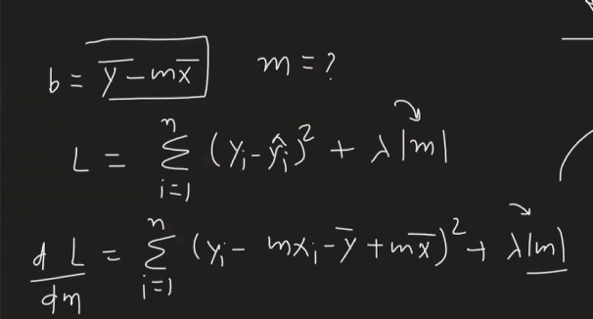

So now we cannot differentiate the modulus of the m so we consider the different m values like first will go with m > 0
Where modulus is m
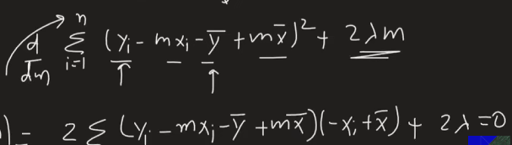

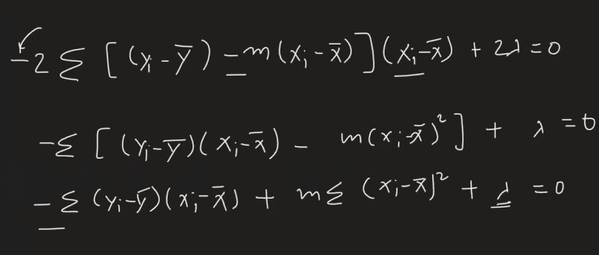
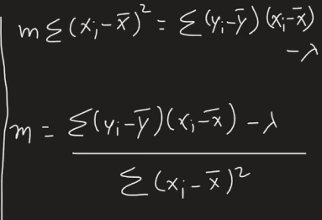If Lambda increases the m value decreases and vice versa
- After gradually decreasing the m, we reach the value zero and after that it stops as the formula for negative value gives more worse answers for m

formula for m when it is a positive number
and for m < 0 the formula is given below
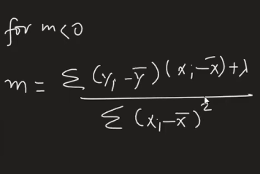

In case of negative it works same and here is the example
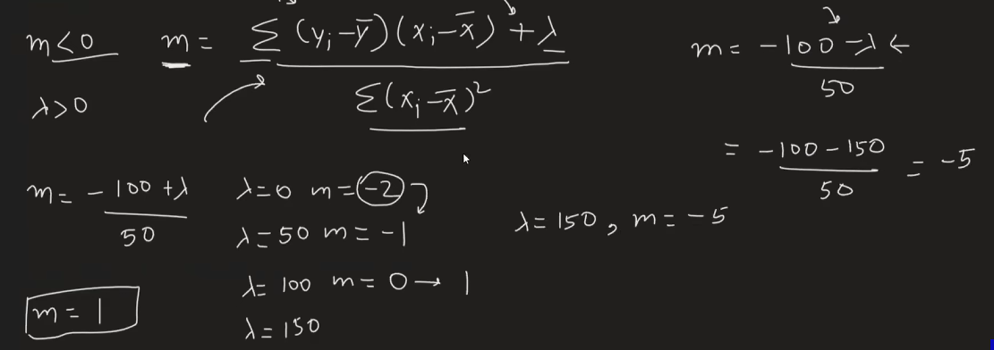

So, in case of lasso the value of coefficient is zero and creates sparsity as m is directly proportional to -+lambda, and it the case of ridge the lambda is inversely proportional

