ML Algorithms

SVM (Support Vector Machine):
Imagine you have a table with Red Balls and Blue Balls mixed together. You want to place a stick (a line) on the table to separate them.
You place the stick exactly in the middle of the widest gap between the two groups. You create the widest possible street (margin) between the red village and the blue village.
Goal: SVM doesn't just want a decision boundary; it wants the optimal boundary that maximizes the safety margin.

Key Terminologies:
- Hyperplane: This is the "stick" or the line that separates the classes. (In 2D it's a line; in 3D it's a flat sheet).
- Support Vectors: These are the specific data points (Red balls and Blue balls) that are closest to the line.
- They are the "pillars" that support the street.
- Crucial Insight: SVM only cares about these specific points. The thousands of other points far away from the line are irrelevant.
- Margin: The distance between the Hyperplane and the Support Vectors. We want to Maximize this.

Decision Rule:
You know SVM draws a line (Hyperplane). The "Decision Rule" is the simple mathematical check it uses to decide: "Does this new point belong to the Red Team or the Blue Team?"
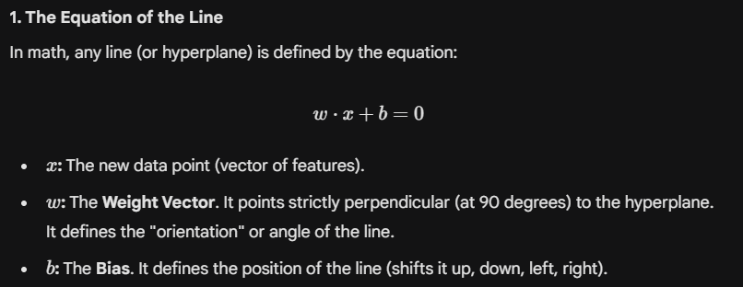
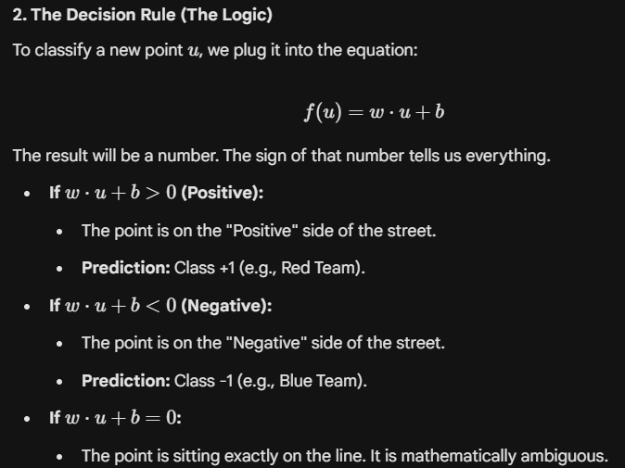

The Goal of Training: Find the best and so that the street is as wide as possible.
There are 2 line which are pi +ve and pi -ve so it can be drawn and given equation as
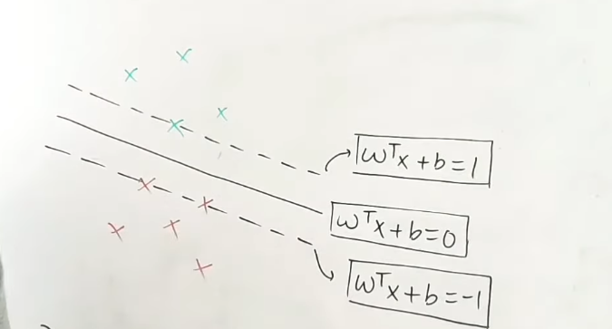
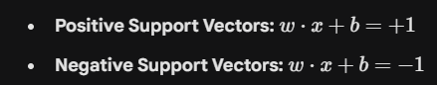

Middle one is Hyperplane, the both of line are equal distance from hyperplane
And the two line has a distance between them is called margin which we need to maximize
We can make decision rule,
As the two sides of points can be identified by
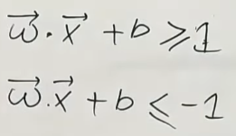
If we take a y_{i} = +1/-1(where +1 and -1 represent +ve and -ve regions) then we can get two equation results in one final equation:
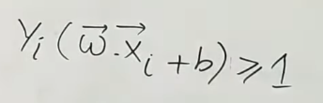
For support vectors equation will become:
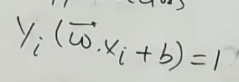

Final Decision rule:
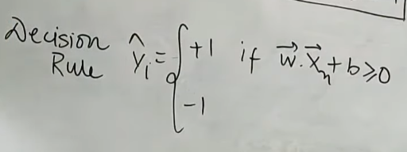

This photo is proof for Distance or margin
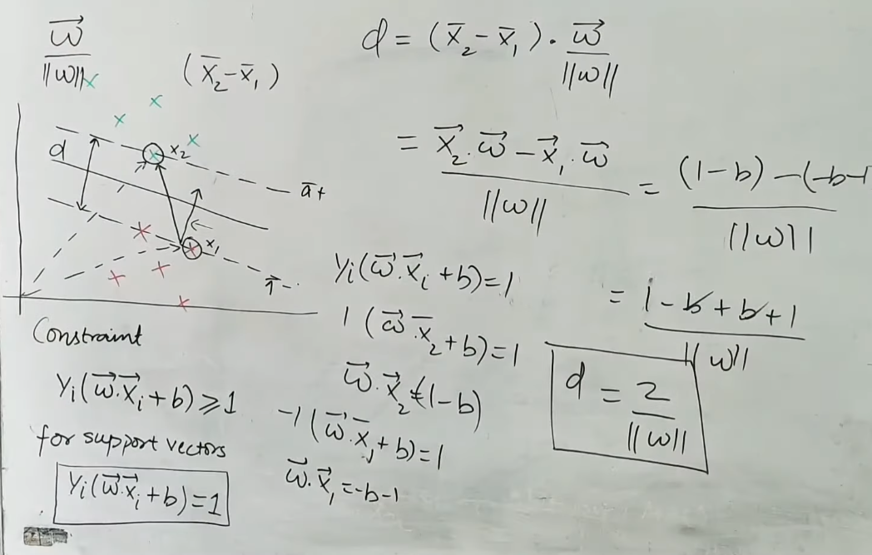

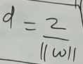
At last, we can say we need to find the values of w and b in such way we maximize the value of:

Such that 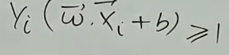 this is always true

So this is the formulation for hard margin which will totally fail on a single data which is -ve present in +ve and vice versa

