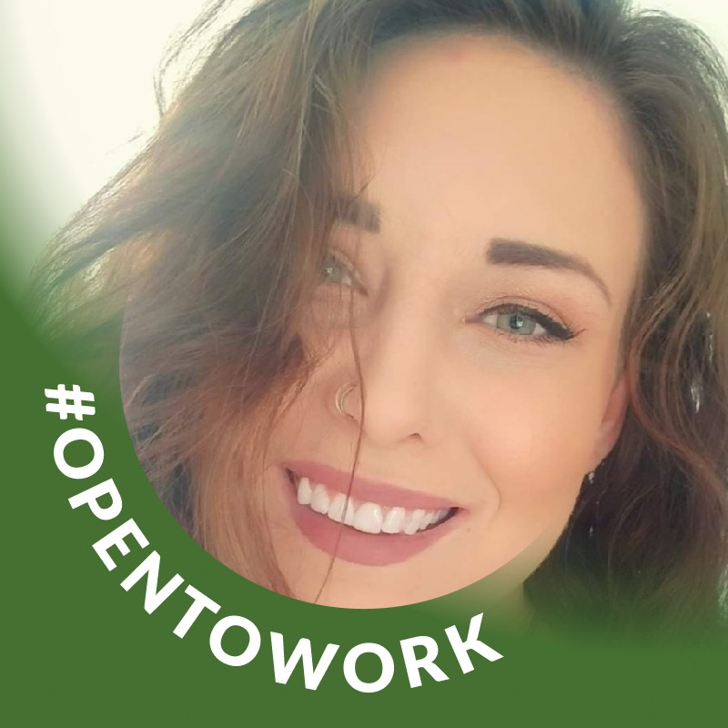
Heather Garrett
Entrepreneur / Virtual Assistant
Greeley, Colorado, United States | https://drive.google.com/file/d/17qndwN-AL6M-vuwm5n1W9kh5umv1WB9r/view?usp=drivesdk

Summary
- I am a very fast learner and have excelled with minimal training in every position I have held.
- I hold myself to very high standards and work ethics.
- I am extremely organized, detailed, creative and motivated.
- I am positive and eclectic and really enjoy meeting people.
- I have a gift and aptitude for dealing with the public.
- I have extensive office management experience and have successfully worn the hat of office manager, team lead, lead focal, lead coordinator, Home Health Aide, Lead Marketer, Personal Assistant, accountant, Patient Education, and many more.
- I am able to answer questions, get to the root of issues, and maintain a friendly and professional attitude at all times.
- I am a team player and work well with others to get things done.
- I'm also capable of working independently and thriving.
- I can work quickly and effectively under a rushed deadline or tight schedule.
- I am flexible enough to change direction at a moment's notice when needed.
- I am always interested in learning and being a part of new ideas, projects responsibilities and fields of work.
https://drive.google.com/file/d/17qndwN-AL6M-vuwm5n1W9kh5umv1WB9r/view?usp=drivesdk

Skills
Customer Service, English, Microsoft Office, Research, Writing, Editing, website design, Social Media, Marketing, Web Development, WordPress, Microsoft Word, Microsoft Excel, Microsoft PowerPoint, Leadership, Social Listening, Penmanship, Time & Attendance

Experience
TechnomancyIT - 9 yrs 11 mos
Mar 2016 - Present
- I work contract to contract, filling the administrative needs of many professionals worldwide.
- I utilize many platforms for these gigs, including upwork.com and digital nomad resources.
- I possess all the technical, hardware, software, network, and skill sets to complete your tasks.
- I oversee ordering, agile project management of app development, scheduling, marketing, and accounting tasks.
- I work directly with owner and project managers to create and maintain virtual reality applications and crypto space workflow applications.

Remote Virtual Assistant / Project Coordinator - Contract
Mar 2016 - Present
- I work contract to contract, filling the administrative needs of many professionals worldwide.
- I utilize many platforms for these gigs, including upwork.com and digital nomad resources.
- I possess all the technical, hardware, software, network, and skill sets to complete your tasks.
- I oversee ordering, agile project management of app development, scheduling, marketing, and accounting tasks.
- I work directly with owner and project managers to create and maintain virtual reality applications and crypto space workflow applications.

Office Manager - Full-time
Feb 2017 - Feb 2020 | United States
Managed daily operations of a busy office, overseeing a team of 10 employees and maintaining efficient workflows. Streamlined administrative processes and implemented new systems to improve productivity and reduce costs.
- Developed and implemented new office policies and procedures, resulting in a 20% increase in efficiency.
- Trained and mentored new employees, resulting in a 50% decrease in onboarding time.
- Maintained accurate records and reports, ensuring compliance with company and legal requirements.
- Managed office budget and expenses, reducing costs by 15% through strategic planning and negotiation with vendors.
- Coordinated and planned company events, including team building activities and holiday parties.
- Communicated effectively with clients and vendors, building strong relationships and ensuring satisfaction with services provided.

Caregiver - Self-employed
Feb 2015 - Dec 2023 | United States
Entrepreneur and virtual assistant with extensive experience as a caregiver. Proven ability to provide compassionate and dedicated care to individuals of all ages. Skilled in managing multiple tasks and adapting to changing environments.
- Provided personalized care to clients, including meal preparation, medication management, and transportation.
- Maintained accurate records and communicated effectively with healthcare professionals and family members.
- Demonstrated strong organizational skills and attention to detail in managing schedules and coordinating appointments.
- Built strong relationships with clients and their families, earning trust and respect through compassionate and reliable care.
- Adapted quickly to new environments and situations, remaining calm and focused in high-pressure situations.
- Continuously sought out opportunities for professional development and growth, staying up-to-date on best practices and industry trends.

Contract Writer - Self-Employed
Aug 2014 - Dec 2023 | Fort Collins, Colorado Area
WordPress Expert Website Design WordPress Content writing and tutorials Blogging Editing Portfolio Pending and available upon request

Front of House / Waitress / Bartender - Texas Roadhouse
Jan 2008 - Dec 2023 | Longmont, Colorado, United States
I have continuously, with little downtime, worked the front of the house in restaurants all over Colorado. I stay calm under pressure and remain focused on why I am at my job. I am friendly and will learn the menu, my side work, the POS system, or written tickets, and bring a smile to people's faces. I have been a shift manager, key supervisor, and shift lead. I have had responsibilities that include but are not limited to inventory ordering, scheduling for teams of 10-15, troubleshooting all POS systems, customer complaint handling, and more. I have 17 years of experience in the food service and restaurant industry.

Team Focal, Knowledge Management. Lead technical writer - IBM
Feb 2007 - Oct 2011 | Boulder, Colorado, United States
I coordinated and performed a range of staff and operational support activities for the unit. I served as a liaison with other departments and operating units in the resolution of day-to-day administrative and operational problems. I operated my personal computer to compose and edit correspondence and memoranda from dictation, verbal direction, and/or from knowledge of established department/division policies. I prepared, transcribed, composed, typed, edited, and distributed job descriptions as well as additional directive documentation to my co-workers. I established, maintained, and updated files, databases, records, and other documents. I also developed and maintained data, and performed routine analyses/calculations in the processing of data for recurring internal reports. I was responsible for sorting, reviewing, screening and distributing incoming as well as outgoing mail

Education
Front Range Community College - Bachelor of Applied Science - BASc, Holistic Health
2013 - 2017
Activities and societies: YTT-200 Certified Several Business Certificates achieved Activities and societies: YTT-200 Certified Several Business Certificates achieved

Certifications
Yoga Instructor Certification - Level I
Yoga Alliance | Issued May 2016

Honors & Awards
Nothing to see for now

