**ATM SECURITY SYSTEM**

# ABSTRACT

The ATM security system developed using Arduino and a vibration sensor offers robust protection against unauthorized access and tampering. By utilizing Arduino as the central controller and integrating a sensitive vibration sensor, the system effectively detects any physical disturbances or attempts to breach the ATM casing. Upon detecting vibrations beyond preset thresholds, the system triggers an alarm to alert nearby security personnel or authorities, thereby thwarting potential theft or vandalism. This setup not only enhances the security measures of ATM installations but also provides a proactive approach to safeguarding sensitive financial infrastructure in public spaces. Future iterations could explore additional features such as remote alerting capabilities via integrated communication modules, further bolstering the system's effectiveness in real-time threat response and prevention.

# CONTENTS

***ABSTRACT ii***

**Chapter No. Title Page No.**

## 1 INTRODUCTION 01

1.1 About the project 01

### 1.2 Objectives 01

### 2 PROJECT DESCRIPTION 02

2.1 Block diagram of project 02

2.2 Description of block diagram 02

2.3 Hardware description 03

2.3.1 Arduino Uno 03

2.3.2 Servo motor 04

2.3.3 Buzzer 05

2.3.4 Vibration sensor 06

2.4 Software description 07

## 3. PROJECT IMPLEMENTATION 10

3.1 Working 10

3.2 Results 11

3.3 Advantages 12

3.4 Disadvantages 12  **4. CONCLUSION**  13

4.1 Conclusion 13

4.2 Future scope 13

**BIBLIOGRAPHY** 14

# CHAPTER 1 INTRODUCTION

## 1.1 INTRODUCTION

In present scenario, ATM has become one of the most important facilities in our day to day

life. This facility enables us to withdraw the money from the authorized account at any time.

Security is the major aspect, as the need of ATM is increasing day by day. Security systems

are the demands of the day, which helps to avoid theft. Although the banks are deploying

security personnel at the ATM spots, but the security arrangement is not quite good enough to

secure the facility in case a group of thieves tries to stole the ATM machine. Recently we

have seen many cases where in a group of people entering into ATM and overpowering the

security personnel and stole the money from the ATM.

Generally a single person is unable to handle the gang of robbers. Thus an automatic security

system plays very important role to avoid robberies. The Idea of Designing and

Implementation of Security Based ATM Security Alert project is born with the observation in

our real life incidents happening around us. In this project we are going to design system that

will help in catching The thieves when an attempt is made to stole the ATM. This system will

also act as a security barrier for the ATM facility. The proposed project consists of an idea of

implementing Vibration Detection sensors. These sensors will generate a signal whenever

someone tries to forcefully open or damage the ATM machine.

## 1.2 OBJECTIVES

➢ The objective of this project, this system also provides ATM anti-theft security using

vibration detection sensor attached to the ATM machine, if anyone trying to open or break

the ATM machine, then this system immediately closes the ATM room door along with

buzzer alarm.

**CHAPTER 2**

**PROJECT DESCRIPTION**

## 2.1 BLOCK DIAGRAM OF THE PROJECT

In the proposed project, we are offering more security for ATM machines and also to identify

the robbery quickly by implementing an embedded system. Whenever someone tries to make

damage or want to lift the ATM machine from its place, automatically vibration sensor

attached to the ATM machine will be activated and sends a signal to controller.

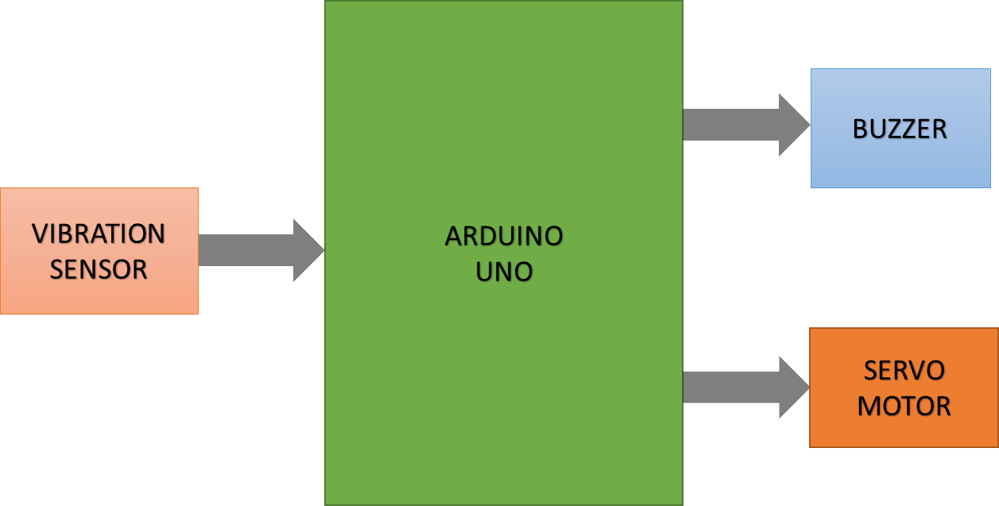

Fig.2.1 Block Diagram

## 2.2DESCRIPTION OF BLOCK DIAGRAM

The vibration sensor, buzzer and the servo motor is connected to the arduino uno. Whenever

there is a vibration, the vibration sensor senses the vibration and then both the buzzer and

servo motor gets activated. Automatically the buzzer produces the beep sound and the servo

motor starts to run. The servo motor is used to close the door.

All the components are connected to the arduino uno in such a way that for a vibration the

buzzer and servo motor starts to run.

## 2.3HARDWARE DESCRIPTION

### 2.3.1Arduino UNO

The Arduino UNO is a micro-controller board based on the ATmega328 (data sheet). It has

14 digital input/output pins (of which 6 can be used as PWM outputs), 6 analog inputs, a

16 MHz ceramic resonator, a USB connection, a power jack, an ICSP header, and a reset

button. It contains everything needed to support the micro controller; simply connect it to a

computer with a USB cable or power it with a AC-to-DC adapter or battery to get started.

The Uno differs from all preceding boards in that it does not use the FTDI USB-to-serial

driver chip. Instead, it features the Atmega16U2 (Atmega8U2 up to version R2) programmed

as a USB-to-serial converter. Revision 2 of the UNO board has a resistor pulling the 8U2

HWB line to ground, making it easier to put into DFU mode. Revision 3 of the board has the

2following new features: 1.0 pin out: added SDA and SCL pins that are near to the AREF pin

and two other new pins placed near to the RESET pin, the IOREF that allow the shields to

adapt to the voltage provided from the board. In future, shields will be compatible both with

the board that use the AVR, which operate with 5V and with the Arduino Due that operate

with 3.3V. The second one is a not connected pin, that is reserved for future purposes.

Stronger RESET circuit. At mega 16U2 replace the 8U2. "Uno" means one in Italian and is

named to mark the upcoming release of Arduino 1.0. The Uno and version 1.0 will be the

reference versions of Arduino, moving forward. The Uno is the latest in a series of USB

Arduino boards, and the reference model for the Arduino platform; for a comparison with

previous versions, see the index of Arduino boards.

Microcontroller ATmega328

Operating Voltage 5V

Input Voltage (recommended) 7-12V

Input Voltage (limits) 6-20V

Digital I/O Pins 14 (of which 6 provide PWM output)

Analog Input Pins 6

DC Current per I/O Pin 40 mA

DC Current for 3.3V Pin 50 mA

Flash Memory 32 KB of which 0.5 KB used by bootloader

SRAM 2 KB (ATmega328)

EEPROM 1 KB (ATmega328)

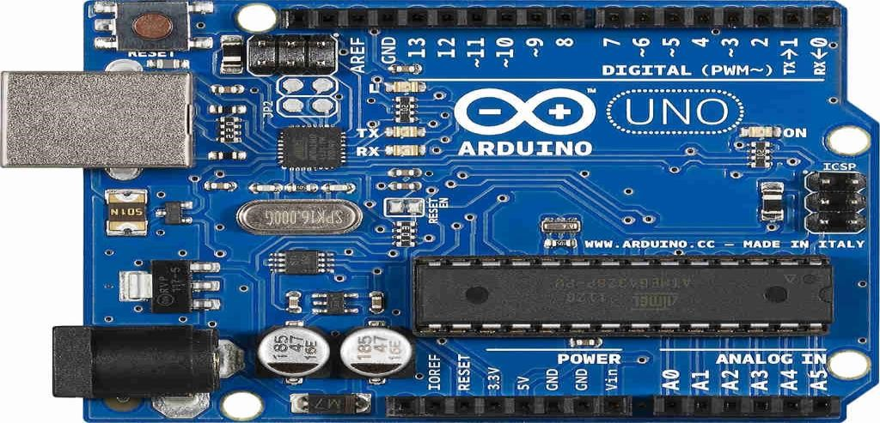

Fig. 2.2 Arduino Uno

**Applications:**

• Xoscillo, an open-source oscilloscope

• Arduinome, a MIDI controller device that mimics the Monome 34

• OBDuino, a trip computer that uses the on-board diagnostics interface found in most modern cars

• Gameduino, an Arduino shield to create retro 2D video games

• ArduinoPhone, a do-it-yourself cellphone

• Water quality testing platform

• Automatic titration system based on Arduino and stepper motor

• Low cost data glove for virtual reality applications

• Impedance sensor system to detect bovine milk adulteration

• Homemade CNC using Arduino and DC motors with close loop control by Homofaciens

• DC motor control using Arduino and H-Bridge

#### 2.3.2 SERVO MOTOR

The servo motor is an assembly of four things: a normal DC motor, a gear reduction unit, a

position-sensing device, and a control circuit. [The DC motor](https://www.elprocus.com/dc-motor-basics-types-application/) is connected with a gear

mechanism that provides feedback to a position sensor which is mostly a potentiometer. From

the gearbox, the output of the motor is delivered via servo spline to the servo arm. For

standard servo motors, the gear is normally made up of plastic whereas, for high power

servos, the gear is made up of metal.

A servo motor consists of three wires- a black wire connected to the ground, a white/yellow

wire connected to the control unit, and a red wire connected to the power supply.The function

of the servo motor is to receive a control signal that represents a desired output position of the

servo shaft and apply power to its DC motor until its shaft turns to that position.

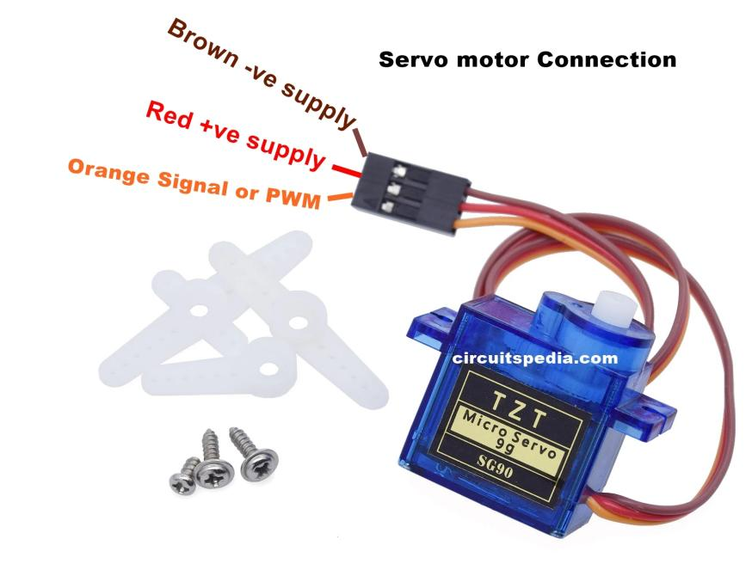

Fig. 2.3 SERVO MOTOR

#### 2.3.3 Buzzer

A buzzer or beeper is an audio signalling device, which may be mechanical, electromechanical, or piezoelectric. Typical uses of buzzers and beepers include alarm devices, timers, and confirmation of user input such as a mouse click or keystroke.

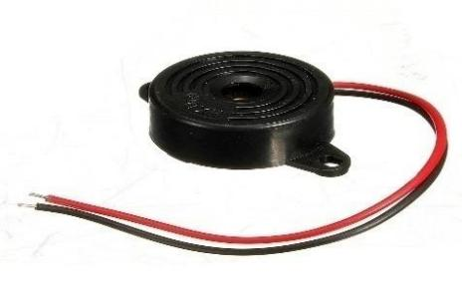

Fig.2.4 Buzzer

**Types of buzzers:**

**1. Electromechanical**

Early devices were based on an electromechanical system identical to an electric bell without the metal gong. Similarly, a relay may be connected to interrupt its own actuating current, causing the contacts to buzz. Often these units were anchored to a wall or ceiling to use it as a sounding board. The word "buzzer" comes from the rasping noise that electromechanical buzzers made.

**2. Mechanical**

A joy buzzer is an example of a purely mechanical buzzer. They require drivers.

**3. Piezoelectric**

A piezoelectric element may be driven by an oscillating electronic circuit or other audio signal source, driven with a piezoelectric audio amplifier. Sounds commonly used to indicate that a button has been pressed are a click, a ring or a beep.

**Applications:**

While technological advancements have caused buzzers to be impractical and undesirable, there are still instances in which buzzers and similar circuits may be used.

Present day applications include:

* Novelty uses
* Judging panels
* Educational purposes
* Annunciator panels
* Electronic metronomes
* Game show lock-out device
* Microwave ovens and other household appliances
* Sporting events such as basketball games

#### 2.3.4 VIBRATION SENSOR

Vibration sensors can be useful for monitoring the condition of rotating machinery, where

overheating or excessive vibration could indicate excessive loading, inadequate lubrication,

or bearing wear. Such sensors are also utilized in geophysical and applications requiring

accelerometers. Piezoelectric vibration sensors used for detecting vibration from various

vibration sources are generally classified into two large types, resonant type and non resonant

type.

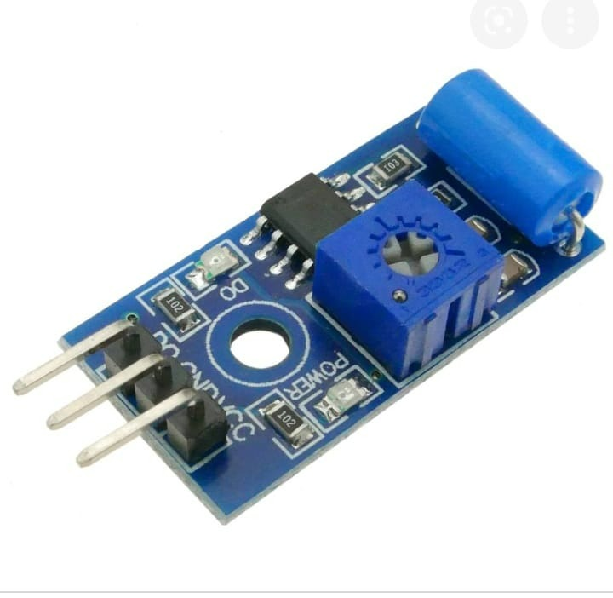

Fig.2.5 Vibration sensor

#### 2.4 SOFTWARE DESCRIPTION

The software used here is ARDUINO SOFTWARE:

The Arduino Integrated Development Environment - or Arduino Software (IDE) - contains a

text editor for writing code, a message area, a text console, a toolbar with buttons for

common functions and a series of menus. It connects to the Arduino and Genuino hardware

to upload programs and communicate with them.

**Writing Sketches:**

Programs written using Arduino Software (IDE) are called sketches. These sketches are

written in the text editor and are saved with the file extension ino. The editor has features for

cutting/pasting and for searching/replacing text. The message area gives feedback while

saving and exporting and also displays errors. The console displays text output by the

Arduino Software (IDE), including complete error messages and other information. The

bottom righthand corner of the window displays the configured board and serial port. The

toolbar buttons allow you to verify and upload programs, create, open, and save sketches, and

open the serial monitor.

**NB:**

Versions of the Arduino Software (IDE) prior to 1.0 saved sketches with the extension pde. It

is possible to open these files with version 1.0, you will be prompted to save the sketch with

the ino extension on save.

Versions of the Arduino Software (IDE) prior to 1.0 saved sketches with the extension pde. It is possible to open these files with version 1.0, you will be prompted to save the sketch with the ino extension on save.

 ***Verify***

Checks your code for errors compiling it.  ***Upload***

Compiles your code and uploads it to the configured board. See [uploading](https://www.arduino.cc/en/Guide/Environment#uploading) below for details.

**Note:** If you are using an external programmer with your board, you can hold down the "shift" key on your computer when using this icon. The text will change to "Upload using Programmer"

***New***



Creates a new sketch.  ***Open***

Presents a menu of all the sketches in your sketchbook. Clicking one will open it within the current window overwriting its content.

**Note:** due to a bug in Java, this menu doesn't scroll; if you need to open a sketch late in the list, use the File | Sketchbook menu instead.  ***Save***

Saves your sketch.  ***Serial Monitor***

Opens the [serial monitor.](https://www.arduino.cc/en/Guide/Environment#serialmonitor)

Additional commands are found within the five menus: File, Edit, Sketch, Tools,and help.

### Programming on arduinouno

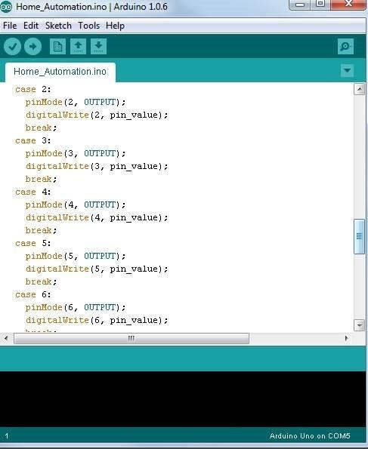

Fig.2.6 Software IDE

In order for the Arduino-Uno board to be able to interact with the application used in this project certain program (code) needs to be uploaded to the Arduino-Uno. Arduino Company provides user friendly software which allows writing any code for any function wanted to be performed by the Arduino-Uno and upload it to the board. Refer to appendix A for the full source code of the Arduino-Uno board.

**CHAPTER 3**

# CIRCUIT DIAGRAM AND DESCRIPTION

## 3.1 Working

In this project, when a thief enters and tried to harm the machine, the vibration sensor

which is attached to the machine get vibrated and sends the signal to the ARDUINO micro

controller. Once the controller receives signal, it locks the door of ATM room by sending

signal to the dc motor. The buzzer will also be getting activated at the same time to alert the

nearby people of ATM system.

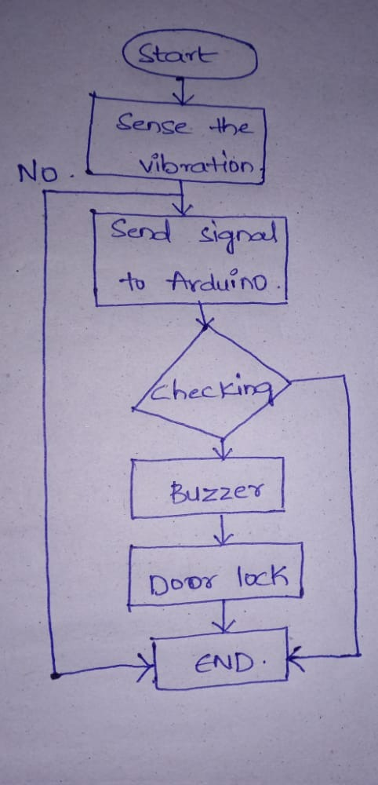

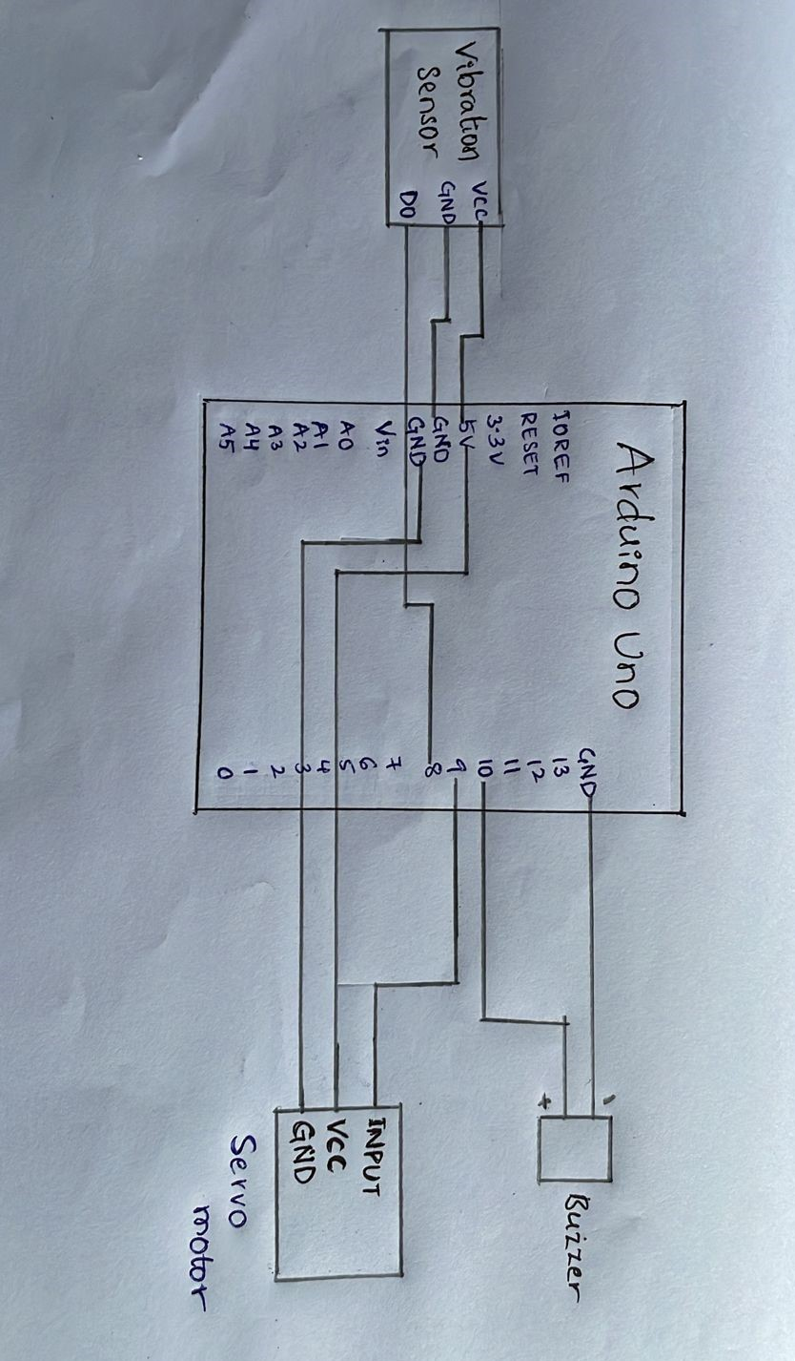

Fig.3.1 Schematic diagram

## 3.2 RESULTS

The experimental result is as shown in below fig. 3.2

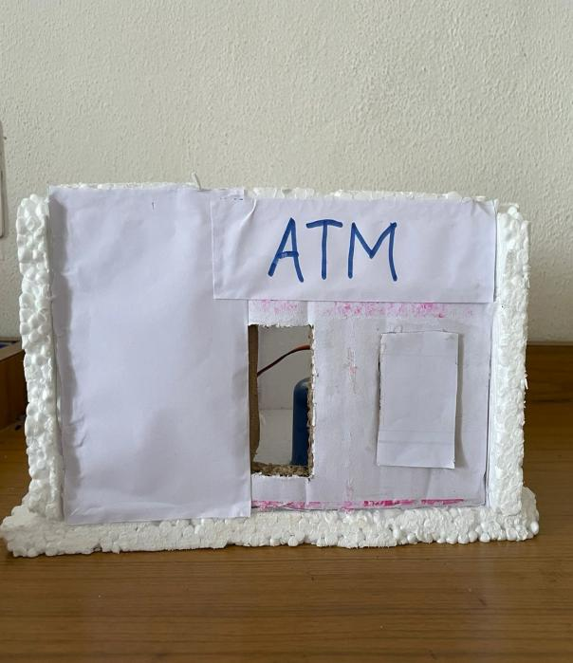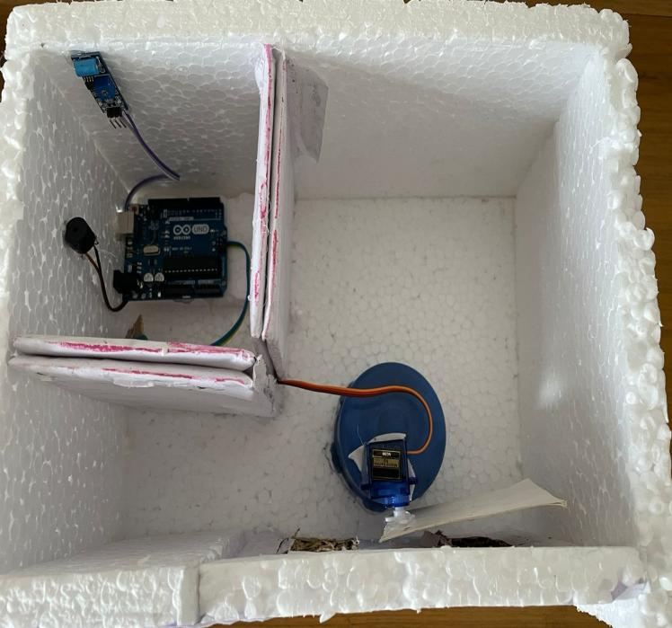

3.2 Experimental result

The experimental result is :

As the thief tries to break the ATM, the vibrating sensor in the ATM senses the vibration then

the buzzer starts to sound, and the dc motor connected to the relay starts to run and it closes

the door.

## 3.3 ADVANTAGES

* This project helps to provide security to ATM and surveillance.
* Whenever someone try to tamper the ATM the sensor which senses the vibration and then the buzzer sounds, automatically the door locks.
* Reduces man power (to protect ATM machine).

## 3.4 DISADVANTAGES

* Equipment and installation cost.
* Human errors.
* Reliability.
* System compatibility.

# CHAPTER 4

# CONCLUSION

## 4.1CONCLUSION

Based on the results obtained, the objective of implementing ATM security system using

vibration sensor has been achieved. This project is used to provide security to ATM.

Whenever a person tries to distract the ATM, the sensor which senses the vibrations & send a

signal to the micro controller. Once the controller receives signal, it locks the door of ATM

room by sending signal to the dc motor. At the same time, the buzzer also gets activated.

## 4.2FUTURE SCOPE

This project is used to provide security to ATM. This project is helpful to catch the thieves

while they try to break the ATM. It also reduces the man power to provide the security. This

project has more scope to avoid the chance of breaking (or) robbery of ATM.

# BIBLIOGRAPHY

1. Joaqun Gutirrez, Juan Francisco Villa-Medina, Alejandra Nieto- Garibay, And Miguel
2. NGEL PortaGndara, ”Automated Irrigation System Using A Wireless Sensor Network
3. And Gprs Module”,IEEE Transactions On Instrumentation And Measurement, Vol. 63,
4. No.1, January2014.
5. Vimal.p, Priyanka.V, Rajyasree.M,Santhiya Devi.P.T, Jagadeeshraja. M, Suthanthira
6. Vanitha.N,”A Novel Approach for Automatic Irrigation and Fustigation Using Embedded
7. System,” International Journal of VLSI and Embedded Systems-IjvesVol05, Article
8. 03257; March2014
9. Sathiyabama P, Lakshmi Priya C, Ramesh Sm, PreethiB, Mohanaarasi M,”Embedded
10. System Design For Irrigating Field With Different Crops Using Soil Moisture Sensor,
11. “International Journal Of Innovative Research In Computer And Communication
12. Engineering Vol. 2, Issue 8, August2014.
13. Liai Gao, Meng Zhang, Geng Chen,”An Intelligent Irrigation System Based On Wireless
14. Sensor Network and Fuzzy Control, “Journal of Networks, Vol. 8, No. 5, May2013.
15. K.Prathyusha, M. Chaitanya Suman,”Design of Embedded Systems for the Automation of
16. Drip Irrigation,”International Journal of Application or Innovation in Engineering
17. Management (Ijaiem) Volume 1, Issue 2, October 2012.
18. Orazio Mirabella, Senior Member, IEEE, and M i c h e l e Brischetto,”A Hybrid
19. Wired/Wireless Networking Infrastructure for Greenhouse Management,” IEEE
20. Transactions on Instrumentation and Measurement, Vol.60, No.2, February 2011.
21. B.Sivakumar, P.Gunasekaran, T.Selvaprabhu, P.Kumaran, D.Anandan, “The Application
22. of Wireless Sensor Network in the Irrigation Area Automatic System”, IjctaJan-Feb2012.

# APPENDIX

#include<SoftwareSerial.h>

#include<Servo.h>

int vb = 8 ;

int buz = 10 ;

Servo myservo;

void setup () {

Serial.begin(9600);

pinMode(vb,INPUT);

pinMode(buz,OUTPUT);

myservo.attach(9);

digitalWrite(buz,LOW);

myservo.write(0);

}

void loop () {

Serial.print("VB:");

Serial.println(digitalRead(vb));

delay(1000);

if ( (digitalRead(vb) == 1))

{

myservo.write(180);

digitalWrite(buz,HIGH);

delay(2000);

}

if ( (digitalRead(vb) == 0) )

{

digitalWrite(buz,LOW);

myservo.write(0);

}

}